 |  | JOURNAL OF ISLAMIC ARCHITECTURE  P-ISSN: 2086-2636 E-ISSN: 2356-4644  Journal Home Page: http://ejournal.uin-malang.ac.id/index.php/JIA
ISLAMIC AESTHETICS IN ARCHITECTURE: FROM EAST TO WEST - THE WORK OF FERNAND POUILLON IN ALGERIA
Ahmed Kaihoul^{a*}, Leila Sriti^{b}, Insaf Boudabia^{c}
ªDepartment of Architecture and Industrial Design, University of Campania Luigi Vanvitelli, Via San Lorenzo 4, 81031 Aversa,
Italy
^{b}Department of Architecture, LACOMOFA Laboratory, Mohamed Khider University of Biskra, Algeria
^{c}Department of Architecture, Amar Telidji University of Laghouat, Algeria
*Corresponding Author: ahmed.kaihoul@unicampania.it
ARTICLE INFO |  |  | ABSTRACT
Volume: 8  Issue: 1  Page: 199-223  Received: July 7th, 2023  Accepted: November 9th, 2023  Available Online: June 15th, 2024  DOI:  http://dx.doi.org/10.18860/jia.v8i1.22931 |  |  | The existing monuments and heritage could inspire the principles of Islamic aesthetics in architecture. We cannot simply copy the same ancient buildings; rather, we should apply the same principles. Western architects always find ways to design Islamic architecture and present its aesthetics. This study offers an overview of Islamic aesthetics in architecture as interpreted by Fernand Pouillon (FP). This study explores the architect through his thoughts, concepts, philosophy, social studies, construction materials, morphology, and selected case studies in the south of Algeria. The methods used for data collection include analyzing the architect’s writings and architectural designs using standardized thematic axes. This proposal aims to provide a comprehensive qualitative and analytical study of a pioneering Western architect influenced by Islamic architecture who worked in Algeria during the 20th decade, specifically focusing on his work in the south of Algeria.  Keywords:  Islamic Aesthetics in Architecture; Fernand Pouillon; South of Algeria; Islamic Principles’ Reinterpretation, Pouillon’s Hotels in Algeria

- INTRODUCTION
We should not merely replicate antiquated structures; instead, we ought to employ identical principles [1].
“I was inspired by vernacular architecture, particularly El-Mekter Hotel from Islamic architecture. Architecture forms a long chain of culture that has continued and cumulated throughout history. It represents a significant aspect of our physical culture. As a result, I am keenly conscious of seeking inspiration from the cultural context during the initial stages of design, whether it pertains to Western Christianity or Eastern Islam.” [2].
The climate and overall atmosphere in Algeria were somehow suitable for me. Firstly, being a Mediterranean person, I had already adapted to Islam. I believe I am accustomed to the work method of embracing Algeria’s character and identity. At times, I find myself engaged in sculpture more than architecture. It becomes challenging to maintain the continuity of forms from the exterior to the interior and to traverse from roofs to gardens and the ground in a straight line. There are instances where you have to rely on flexible and curved lines - this is where sculpture comes into play! [3].
The social context holds immense significance; as an Arab architect, I am compelled to shape architecture. Now, the sense of belonging amplifies tourists' and visitors' emotional and spatial sensitivity. Ideologies and practices warrant veneration as they take architectural form. Consider my work in Algeria, which not only adapts to but also mirrors the unique identity of each region. This endeavor goes beyond conventional notions of a hotel on the international stage, morphing it into a sequence of Oriental-inspired narratives that traverse the spectrum of Islamic identity from East to West [4].
This study seeks to delineate the impact of various variables and indicators on Western architect as they incorporate Islamic aesthetics into their architectural creations within the southern region of Algeria. A qualitative and analytical approach might prove beneficial for prospective investigation concerning Islamic aesthetics in architecture within a particular era and locale.An architect of pioneering stature who operated in Algeria during the 20th century has demonstrated a tangible architectural approach that recontextualizes Islamic aesthetics through regionalism and contextual considerations. It implies that the works of FP offer a harmonious resolution for the local Islamic identity while aligning with the social requisites, traditions, and environmental aspects. In-depth investigations of this nature contribute to the formulation of novel theories concerning Islamic aesthetics in architecture. Such studies empower architects to reassess Islamic principles and architectural identity for the future, a necessity in light of the contemporary challenge of diminishing Islamic roots and idioms.

- METHODS
A qualitative approach was embraced to thoroughly and systematically delve into Islamic aesthetics within FP’s architectural works in Algeria. The novelty of this method resides in dissecting the architect’s philosophy and thought processes, which play a pivotal role in generating Islamic aesthetics in architecture. The analysis encompasses diverse aspects, including the architect’s ideas, concepts, philosophy, sociocultural studies, choice of construction materials, and morphological elements. This exploration of FP’s contribution to Islamic aesthetics in architecture within the southern region of Algeria aims to comprehend his perspective, identify references, and discern how the aesthetics are shaped by the architect’s background, societal traditions, contextual factors, climate, and regional history.
In this study, a sample of three cases from the southern region of Algeria – namely, El-Gourara Hotel in Timimoun, M’Zab Hotel, and El-Djanoub Hotel in Ghardaïa – where Islamic aesthetics in architecture are exemplified, will be subjected to analysis through data collection. This analysis aims to delve into the architect’s intentions and philosophy. The methods employed for data collection involve scrutinizing the architect’s writings and architectural designs using standardized thematic criteria.
This approach encompasses multiple subsequent steps designed to facilitate the comprehension of this study, as illustrated in Figure 1.

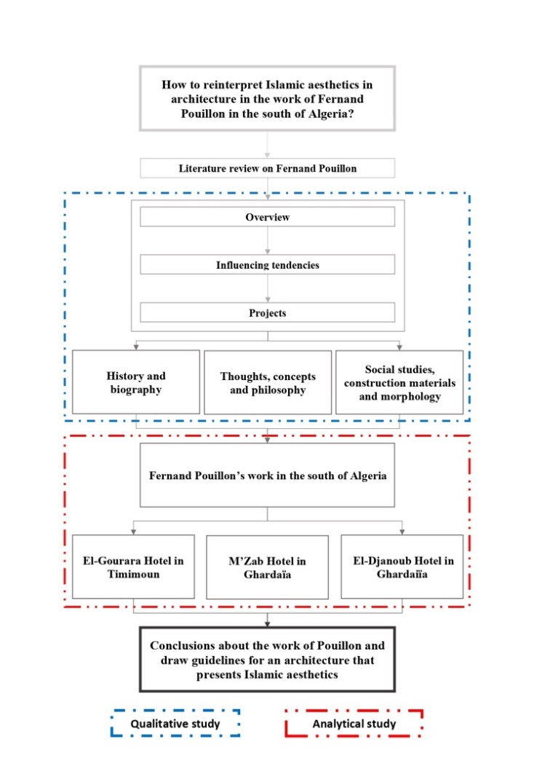
Figure 1. The framework of the study
Firstly, a literature review and a brief overview of FP’s influential inclinations and projects are presented. Secondly, an in-depth exploration of the architect’s monography is conducted, encompassing his philosophy, thoughts, and the distinctive elements derived from local traditional and Islamic architecture, which are then implemented in the designs of El-Gourara, M’Zab, and El-Djanoub hotels. Subsequently, the study’s methodology involves an architectural analysis of the selected case studies employing standardized thematic criteria. Consequently, the ensuing discussion and conclusion aim to illuminate the significance of Islamic aesthetics in architecture, as manifested by a Western architect.

  - LITERATURE REVIEW ON FERNAND POUILLON
    - An Overview and A Brief Presentation
FP (1912-1985), as depicted in Figure 2, was a prolific architect who undertook numerous projects, primarily on housing and hotels, spanning both the colonial and post-independence periods. His journey in Algeria commenced in 1953 when Algiers’ mayor, Jacques Chevallier (Figure 3), commissioned him to design various housing projects, addressing the pressing housing crisis and the prevalence of slums during that era. The architect’s zenith emerged in 1964 when an independent Algeria entrusted FP with the comprehensive design of hotels’ infrastructure nationwide. FP meticulously strove to achieve a harmonious blend of tradition and modernity within his designs. One hallmark of FP’s architectural portfolio is the unmistakable embodiment of his distinct architectural identity, resonating with the diverse regions of Algeria [5].

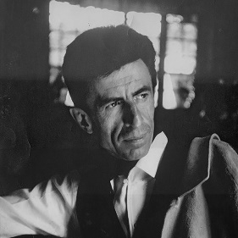 | 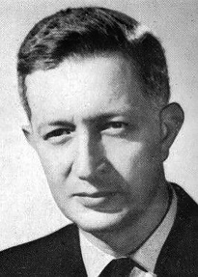
Figure 2. FP | Figure 3. Mayor of Algiers Jacques Chevallier between 1945 and 1956.

The French architect FP, born in Cancon in 1912 and later passing away in Belcastel Castle in 1986, embarked on his architectural journey by commencing studies at a fine arts school in 1929. He eventually earned an architectural degree during World War II (1939-1945). While studying in Marseille, FP gained valuable experience designing and overseeing local projects, primarily focusing on housing apartments. His first notable project as an architect was the construction of the municipality stadium of Aix-en-Provence (as depicted in Figure 4). FP has since been recognized as one of France’s most renowned architects, adapting to seamlessly blending modernity with historical elements in his architectural designs. Notably, he excelled in combining various materials, integrating them with their surroundings, maintaining harmonious proportions, incorporating landscaping, and artistically infusing craftsmanship. These distinctive characteristics of FP’s architectural style paved the way for numerous projects, including reconstructing Marseille’s old port. In 1953, he received an invitation from Jacques Chevallier, the mayor of Algiers, to undertake housing projects, leading to the creation of Diar El Saada, Diar El Mahcol, and Climat de France (as seen in Figure 5 a, b and c). FP’s successful endeavors in Algiers earned him a sterling reputation among Algerians. However, FP faced a setback when the CNL (Comptoir National du Logement) scandal emerged in March 1961, resulting in the removal of his name from the National Order of Architects and forcing him to depart from France. His career took a brighter turn following Algeria’s independence in 1962, with the Algerian government extending another invitation for him to design and oversee the construction of numerous hotels and tourist infrastructure projects across the country. FP left an indelible mark on various regions in Algeria with his unique approach and artistic vision, contributing his architectural contributions until his retirement in 1984 [6].

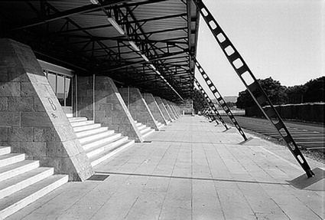
Figure 4. The Municipality Stadium of Aix-en-Provence

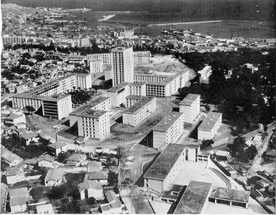 |  | 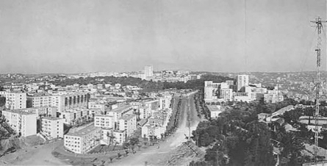
A |  | B
 | 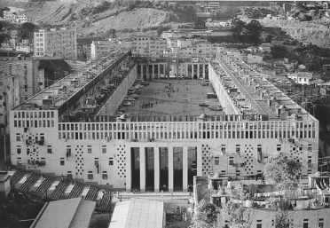
C
Figure 5. (a) Diar El Saada (b) Diar El Mahçoul (c) Climat de France.

    - Influencing Trends
- Fine Arts School (Eugène Beaudouin, Auguste Perret and Auguste Choisy)
FP remained loyal to the School of Fine Arts, a fidelity evident in his artistic approach favoring simple forms and rationalism. Beaudouin's influence manifested itself in the organization of façades, disregarding orientation based on thermal axes. Perret's impact was seen in his rationalism and the inspiration drawn from a rich historical background. Historian Choisy's influence was reflected in the concept of adhering to strict orthogonality in composition, a principle rooted in Greek architectural tradition (as shown in Figures 6 a, b, and c).
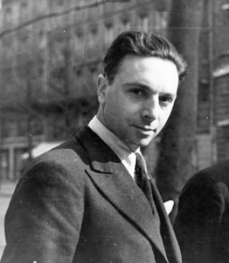
A
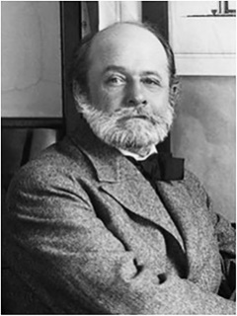 | 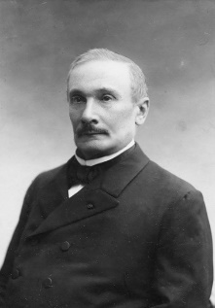
B | C
Figure 6. (a) Shows Eugène Beaudouin (b) Auguste Perret (c) Auguste Choisy

- Modernism
FP rebelled against modernism, rejecting its conventional nature and deeming it a sterile movement devoid of imagination and sensitivity. Concurrently, FP remained up-to-date with modern materials and construction techniques, which he widely incorporated into his work.

- Rationalism
FP is regarded as one of the few rational architects who prioritize practical solutions over more complex approaches. He created straightforward forms by minimizing operational time and material costs to ensure the timely delivery of projects. The diversity of construction materials utilized in FP’s projects serves as compelling evidence of his rational decision-making, relying on the efficient utilization of both traditional high-quality materials and newly manufactured ones.

- Postmodernism
While FP held a deep admiration for historical buildings and their utilization, as well as the reinterpretation of traditional symbols, his approach remained spontaneous. Later, the postmodernism movement emerged, advocating for similar concepts. FP was adept at uncovering original aesthetic solutions inspired by traditional ornamentation and function [6].

- Project
According to Zineddine [6], FP completed 337 projects throughout his career, including realized and unrealized ones. Of these, 59 projects were carried out in Algeria, while 278 were executed abroad, spanning locations in France and Iran. A review of FP’s official website ("Les Pierres Sauvages de Belcastel", 1996) indicates that the number of realized projects in Algeria exceeds 80. Table 1, which follows, provides an overview of the realized projects in Algeria, encompassing both the colonial and post-independence periods from 1953 to 1987. FP’s work spanned various sectors, including tourism complexes, educational facilities (universities and schools), coastal and port development, as well as private and collective housing.
Following an exploration of FP’s monograph, the authors have selected three case studies of his work in the southern region of Algeria for more in-depth investigation. These case studies align with relevant thematic axes related to his thoughts, concepts, philosophy, social studies, construction materials, and morphology, as discussed in the upcoming sections.

Table 1. FP’s realized projects in Algeria (1953-1987)

NO | Sector | Project | year | Location | Total
1 | Touristic complexes and hotels | Le Caîd Hotel - 400 beds | 1966 | Bou-Saada, M’sila | 36
2 |  | Marhaba Hotel - 300 beds |  | Laghouat
3 |  | El-Minzah Hotel - 300 beds |  | Moretti, Algiers
4 |  | El-Manar Hotel - 300 beds | 1967 | El-Kala, El-Tarf
5 |  | Touristic Complex - 3000 beds |  | Moretti, Algiers
6 |  | El-Mountazah Hotel - 300 beds |  | Seraïdi, Annaba
7 |  | Touristic Complex - 4000 beds |  | Zeralda, Algiers
8 |  | El-Mekter Hotel - 150 beds | 1968 | Aïn Séfra, Naâma
9 |  | Plaza Hotel - 500 beds |  | Annaba
10 |  | El-Rym Hotel - 150 beds |  | Béni Abbès, Béchar
11 |  | El-Ziban Hotel - 300 beds |  | Biskra
12 |  | El-Boustan Hotel - 200 beds |  | El-Goléa, Ghardaïa
13 |  | El-Mehri Hotel - 200 beds |  | Ouargla
14 |  | Touristic Complex - 4000 beds |  | Sidi Fredj, Algiers
15 |  | El-Riadh Hotel |  | Sidi Fredj, Algiers
16 |  | Touristic Complex |  | Tichy, Béjaïa
17 |  | El-Hammadïn Hotel - 350 beds |  | Tichy, Béjaïa
18 |  | El-Gourara Hotel - 150 beds |  | Timimoun, Adrar
19 |  | Touristic Complex - 2000 beds |  | Tipaza Beach
20 |  | Touristic Complex - 2500 beds |  | Tipaza Club
21 |  | Oasis Hotel - 200 beds |  | Touggourt, Ouargla
22 |  | The Golden Sands Hotel - 600 beds |  | Zeralda, Algiers
23 |  | Tahat Hotel - 300 beds | 1968 or 1972 | Tamanrasset
24 |  | The Andalouse Tourist Complex - 2000 beds | 1969 | El-Ançor, Oran
25 |  | 600 Beds Hotel |  | Tibaza Matares
26 |  | M’Zab Hotel - 600 beds | 1970 | Ghardaïa
27 |  | El-Zianïn Hotel - 300 beds |  | Tlemcen
28 |  | Mazafran Hotel | 1972 | Zeralda, Algiers
29 |  | 300 Beds Hotel |  | Saïda
30 |  | El-Djanoub Hotel - 600 beds | 1974 | Ghardaïa
31 |  | West Beach Two Hotel - 1500 beds | 1974-1982 | Sidi Fredj, Algiers
32 |  | 152 Rooms Hotel | 1974 | Skikda
33 |  | Amraoua Hotel | 1975 | Tizi Ouzou
34 |  | Plaza Hotel | 1976 | Annaba
35 |  | Grand Hotel - 600 beds | 1978 | Oran
36 |  | El Djazaïr Hotel | 1981 | Algiers
37 | Education complexes | Hotel School - 1600 students | 1968 | Bou-Saada, M’sila | 3
38 |  | Hotel School - 1600 students | 1969 | Tizi Ouzou
39 |  | Craft Village - 150 workshops | 1972 | Sidi Fredj, Algiers
40 | Coastal and port development | Tourism development plan for the Algerian coast | 1966 | Algiers | 5
41 |  | Development of the port | 1968 | Tipasa Club
42 |  | Development of the port | 1974 | La Madrague, Algiers
43 |  | Development of the port | 1974-1982 | Sidi Fredj, Algiers
44 |  | Development of the port | 1974 | Skikda
45 | Housing | Diar El-Saada - 800 housing units | 1953 | Algiers | 27
46 |  | Diar El-Mahçoul - 1800 housing units |  | Algiers
47 |  | Villa des Arcades |  | Algiers
48 |  | Climat de France - 3500 housing units | 1954 | Algiers
49 |  | City of 800 housing units |  | El-Karma, Oran
50 |  | City of Lescure |  | Oran
51 |  | Saharan housing (individual houses) | 1968 | El-Goléa, Ghardaïa  El-Oued  Laghouat  Ouargla  Touggourt, Ouargla
52 |  | Prototype ‘metal house’ at the Bordj of J. Chevallier | 1969-1970 | El-Biar, Algiers
53 |  | Several ‘metal’ houses | 1970 | Ghazaouet, Tlemcen
54 |  | 43 Villas | 1970-1984 | Algiers
55 |  | City of 200 housing units | 1972 | Staouéli, Algiers
56 |  | Apartment rue des Fontaines | 1974 | Algiers
57 |  | Allotment of ‘metal’ houses |  | Cheraga, Algiers
58 |  | Villa Paradou for the Ministry of Higher Education |  | Hydra, Algiers
59 |  | University housing city of females | 1975 | Ben-Aknoun, Algiers
60 |  | Villas Rochmeboisson | 1978 | Ain-Benian, Algiers
61 |  | Villa Citroën | 1987 | Algiers
62 |  | University housing city (3000 beds) | 1979-1982 | Algiers
63 |  | University housing city (5000 beds) |  | Bab Ezzouar, Algiers
64 |  | University housing city (2000 beds) |  | Batna
65 |  | University housing city (2500 beds) |  | Ain El-Bey, Constantine
66 |  | University housing city (2000 beds) |  | Mostaghanem
67 |  | University housing city (2000 beds) |  | Oran
68 |  | University housing city (2000 beds) |  | Sidi Bel Abbès
69 |  | City of 400 housing units | 1980 | Boufarik, Blida
70 |  | Diplomatic quarter ‘villas’ | 1982-1984 | Bordj El-Bahri, Algiers
71 |  | City of 400 housing units | 1982 | Blida
72 | Others | Spa and hotel | 1966 | Saïda | 15
73 |  | Wilaya (prefecture) |  | Tlemcen
74 |  | Algiers Fair Pavilion | 1967 | Algiers
75 |  | Newmarket and renovation of the old market, cinema, and theatre | 1968 | El-Oued
76 |  | Slaughterhouses and Town Hall-Cinema |  | Ghardaïa
77 |  | Prefecture of Oases and Administrative City |  | Ouargla
78 |  | Slaughterhouses |  | Touggourt, Ouargla
79 |  | 27 post offices | 1966-1970 | Over the country
80 |  | Theatre | 1971 | Sidi Fredj, Algiers
81 |  | Spa | 1972 | Hammam Rabbi, Saïda
82 |  | Dar El Alia Cabaret | 1974 | Bouzareah, Algiers
83 |  | West Beach Civic Centre of Animation | 1974-1982 | Sidi Fredj, Algiers
84 |  | Riding center and multipurpose hall | 1975 | Tipaza
85 |  | Shopping and leisure centre |  | Tipaza Beach
86 |  | Bus station | 1980 | Constantine
The shaded tabs represent th realized projects in the south of Algeria.

- MONOGRAPHY OF FERNAND POUILLON
This section offers an overview of the study’s scope, FP’s monograph, and the selected case studies. Specifically, three case studies in the southern region of Algeria have been chosen. This section aims to deliver a comprehensive qualitative and analytical examination of a pioneering architect who operated in Algeria during the 20th century, specifically focusing on his work in the southern part of the country.
Table 2 summarises the architect’s monograph. This section will consist of questions and corresponding answers related to specific discussion points established by the authors. The information and data have been gathered from various sources, including [2]-[19].

Table 2. FP’s monograph summary
Summary | Fernand Pouillon
History and biography | - Born in Cancon, France, in 1912 and passed away at Belcastel Castle, France, in 1986.  - Commenced studies at the Fine Arts School in 1929 and became an architect during World War II (1939-1945).  - Gained initial experience as an architect in Marseille and Aix-en-Provence, focusing on housing apartments and stadiums.  - Emerged as one of the prominent French architects and builders in the post-World War II era.  - Engaged in architectural projects in colonized Algeria between 1953 and 1954, primarily on housing.  - Undertook architectural endeavors in Iran, specifically in Tabriz and Mashed stations.  - Involved in the CNL (Comptoir National du Logement) scandal and subsequently removed from the national order of architects in 1961.  - Resumed architectural work in post-independence Algeria between 1964 and 1984, primarily focusing on hotels.
Thoughts, concepts, and Philosophy | - Considering the duality of time and place inherent to each region, aiming to create forms that symbolize the multi-environmental identity.  - Simulating the essence of old cities by creating well-designed urban spaces, such as plazas, streets, perspectives, a hierarchy of spaces, covered passages, and pedestrian stone pathways, enhances urban quality.  - Preserving the scenic views of the landscape (utilizing a picturesque approach, balancing masses, and establishing a harmonious flow) and respecting the site's topography to achieve a strong integration with nature and the environment.  - Emphasizing the significance of ambiance in architecture is fundamental for crafting enduring structures that convey stories inspired by vernacular architecture.  - Safeguarding historical vocabularies and heritage while incorporating modern construction techniques and engineering to craft architecture that withstands the test of time.  - Embracing rationalism through simple forms, cohesive order, a well-defined hierarchy, scale articulation, sensitivity to climate, consideration of operational needs, cost-effectiveness, and quality.  - Believing that honest architecture is the equitable outcome of mastery over three elements: understanding construction, appreciating the concept of beauty, and skillfully combining composition, materials, and order.  - Advocating against the influences of modernism, postmodernism, trendy styles, or any international trends, and instead striving to find a harmonious balance between rationalism and eclecticism, merging contemporary and archaeological elements.  - Recognizing that the most pivotal aspect lies in the end-user and their social context, including their ideologies, rather than gaining recognition solely from fellow professionals.  - Acknowledging that architecture forms an unbroken chain of accumulated culture, inspiration should be drawn from this rich heritage.  - Viewing architecture as a sculptural art characterized by flexible, flowing, and continuous lines rather than rigid forms defined by straight and articulated lines.
Social studies, construction materials, and morphology | - Collaborating on projects that foster a sense of belonging within society, creating spaces that are sensitive to the user through abstracted archetypes, intricate façade sculptures, well-proportioned design, utilization of noble and sustainable materials, artistic ceramic work, large-scale ensembles, meticulous layout and urban planning of public spaces, and incorporating identical symbols that reflect the unique character of each region.  - Employing cost-effective strategies to reduce material expenses and construction time while emphasizing the importance of mastering local materials, including heavy and durable options like stone, rammed earth bricks, and concrete (avoiding undesirable materials) in load-bearing walls. This approach includes using cross vaults (either spherical or flat) in roofing systems and flat coatings.  - Shaping the morphology and structural elements of projects in response to various factors, including function, the interplay between the quality of urban spaces and the aesthetic aspects of construction, physical and geographical considerations, and social and cultural context.  - Employing abstract elements and reinterpreting the function of traditional ornamental patterns to craft original, rational forms. This approach encompasses interior-centric planning, understated exterior façades that open up to the interior, the integration of fortified village design elements, the presence of a main symmetric axis, architectural promenades, inner courtyards, water features, green spaces, monuments, substantial and imposing structures, regular and concave forms, specialized coatings and flat surfaces, watchtowers, spacious staircases, monumental porticoes, and colonnades.
Selected projects in the south of Algeria | - El-Gourara Hotel - 150 beds (1968) in Timimoun, Algeria  - M’Zab Hotel - 600 beds (1970) in Ghardaïa, Algeria  - El-Djanoub Hotel - 600 beds (1974) in Ghardaïa, Algeria

    - HISTORY AND BIOGRAPHY
• Mr. Pouillon, could you please introduce yourself and describe your career path?
I was considered one of the prominent French architects and builders in the post-World War II era. In 1953, I received an invitation from the mayor of Algiers to undertake several housing projects for Muslim neighborhoods, including Diar El-Saada, Diar El-Mahçoul, and Climat de France. The initiative aimed to address the unplanned expansion of slums in the capital. The mayor and the local inhabitants were pleased with the remarkable architecture characterized by harmonious façade proportions and traditional symbols that mirrored the region's Mediterranean identity. It quickly became a focal point in the capital, standing out among other colonial projects. Later, I expanded my international work and experience to Iran, participating in constructing the Tabriz and Machad stations (as depicted in Figure 7). During this period, I reached the pinnacle of my career, only to be abruptly removed from the National Order of Architects following the financial scandal involving CNL (Comptoir National de Logement) on 5 March 1961. My prospects as an architect in France were abruptly halted. Subsequently, in 1964, I received a second invitation from an old friend, Jacques Chevallier, to embark on the construction of tourism infrastructure and hotels across the country, primarily in the desert regions. I dedicated a significant portion of my career to serving an independent Algeria from 1964 to 1984.

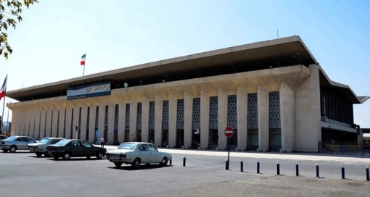
Figure 7. Tabriz station, Iran

    - THOUGHTS, CONCEPTS AND PHILOSOPHY
• As an esteemed professional, Mr. Pouillon kindly elaborates on your thoughts, concepts, and architectural philosophy
I consider the specificities of each location and era while reinterpreting history and its cumulative aspects, aiming to create exceptional architectural and urban spaces. Consequently, the resulting forms symbolize the identity of the region. For instance, the social housing projects in Algiers, such as Diar El-Saada, Diar El-Mahçoul, and Climat de France, reflected the traditional architecture of the Mediterranean while also shaping the colonial era of French Algeria. Regarding the quality of urban spaces, I am highly conscious of crafting spaces, including plazas, streets, perspectives, and spatial hierarchies, that evoke the character of old cities. Additionally, preserving the landscape view and topography of the site establishes a strong relationship with the environment and offers a connection to nature. This approach in my projects enriches Algeria’s folklore and gives rise to enduring architecture.
Consequently, the concept of ambiance in architecture is fundamental to my work. I incorporate cultural elements and identity in colonial or independent Algeria, along the coastal regions, or in the desert. These considerations influence my design process at every stage. While maintaining a historical vocabulary in my designs, I stay updated with construction techniques and engineering principles.
For me, rationalism entails the utilization of simple forms, establishing cohesive order, organizing hierarchies in public spaces, articulating connections across different scales, and embracing the sensitivity of the spaces created. I have firmly rejected modernism's overarching manifestation as a uniform international style lacking sensitivity. I believe that architecture is not merely a plastic object or a machine for living; rather, it represents a rational process that prioritizes crucial aspects of construction, including operational efficiency, cost-effectiveness, and quality, irrespective of the chosen approach or materials.
I preserve old constructions and heritage to repurpose them for other functions. As an illustration, consider the M’Zab Hotel, also known as the Rosthémide Hotel (as shown in Figure 8), which is constructed atop the remnants of a former French prison (the underground portion, including dungeons, has been retained). I extract the function and significance of traditional ornamental patterns to fashion innovative rational forms.

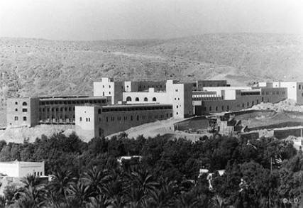
Figure 8. M’Zab Hotel (formerly known as Rosthémide Hotel), Algeria.

I believe that beautiful and honest architecture can manifest through the justice of genius, simple talent, or conscientious and sensitive work. The foremost consideration is the essence of construction, followed by the concepts of beauty and sensitivity, and lastly, the culmination of composition, materials, and arrangements, all of which converge to create the splendor of architecture. My passion lies in the pursuit of harmony and beauty in contemporary architecture. I never aligned with Modernism or Postmodernism, nor did I embrace any fashion styles or international trends under various labels. I remained an architect liberated from any constraints or rigid rules. I sought abstract elements that convey the essence of original architecture through simple forms and enduring materials, such as stone, which stands the test of time. The diversity of references enabled me to strike a balance between eclecticism and rationalism, particularly in Algeria, both before and after independence. I adopted a holistic approach, harmonizing the contextual environment and historical connections and presenting them within a grand yet simple architectural framework. I never pursued recognition from my colleagues; my motivation has always been to satisfy the users of the buildings I create.
From a social context perspective, I firmly believe that exceptional architecture emerges from a profound understanding of local and broader social contexts and ideologies. It involves designing high-quality spaces that convey stories and narratives about history and civilizations. For instance, El-Mekter Hotel drew inspiration from Islamic architecture (as depicted in Figure 9), El-Gourara Hotel from ancient architecture (Figure 10), El-Rym Hotel from classical architecture (Figure 11), and Tahat Hotel from local Ksour architecture (Figure 12). Furthermore, I emphasize integrating landscape and nature seamlessly within the topography, as well as reinterpreting traditional symbols, elements, and ornamental motifs such as patios, substantial structures, and watchtowers.

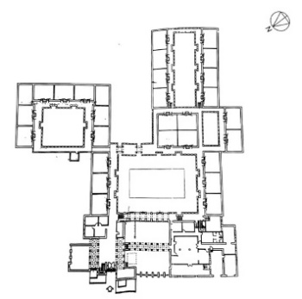 | 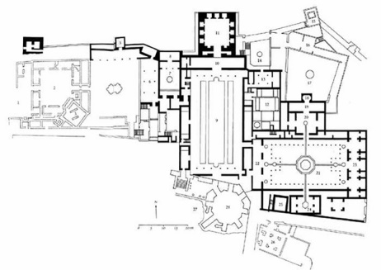
A | B
Figure 9. Floor plans of (a) El-Mekter Hotel in Algeria (b) Alhambra Palace in Spain.

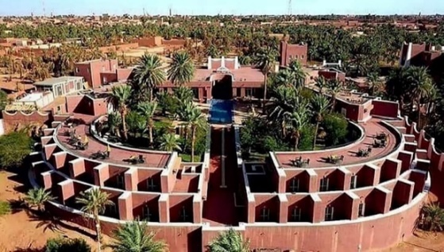 | 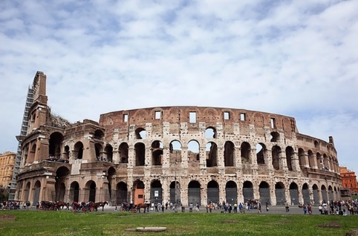
A | B
Figure 10. External views of (a) El-Gourara Hotel in Algeria (b) the Colosseum in Italy.

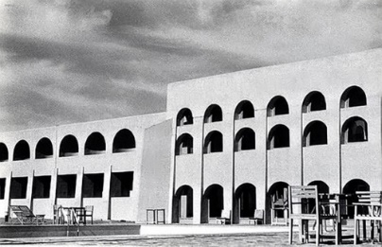 | 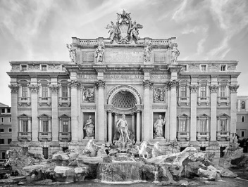
A | B
Figure 11. External views of (a) El-Rym Hotel in Algeria (b) Trevi Fountain in Italy.

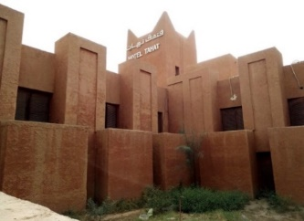 | 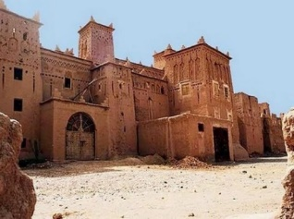
A | B
Figure 12. External views of (a) Tahat Hotel in Algeria (b) Tafilalet Ksour in Morocco

In terms of urbanism and urban design, I place great importance on public spaces, their distinct characteristics, and their hierarchical organization, ranging from public to private. By studying the patterns of old cities and the urban spaces of various human communities, I can discover suitable designs through the interplay of spaces, streets, squares, and simple regular shapes reminiscent of traditional compositions like the Casbah, as exemplified in the reinterpretation within the El-Mountazah Hotel (Figure 13). Additionally, I aim to replicate the quality of urban spaces inspired by ancient cities to ensure a sense of identity, including features like covered passages and stone pedestrian walkways.

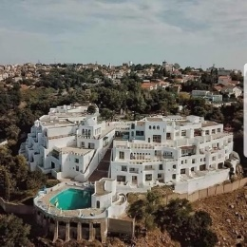 | 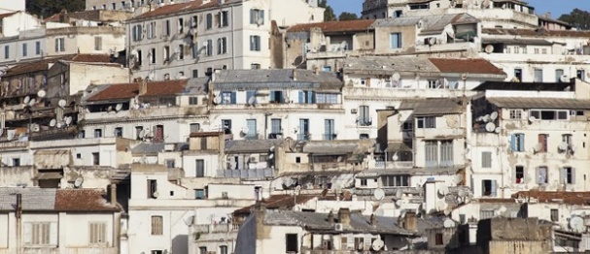
A | B
Figure 13. External views of (a) El-Mountazah Hotel (b) Casbah of Algiers

The façade of the M’Zab Hotel in Ghardaïa draws inspiration from the local vernacular Mozabite architecture, characterized by its curved and irregular lines (as shown in Figure 14).

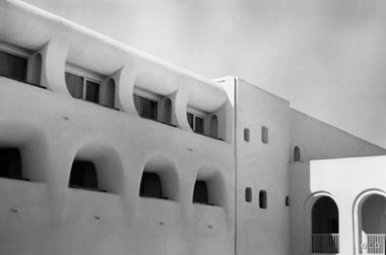
Figure 14. External views of (a) El-Mountazah Hotel (b) Casbah of Algiers

Ultimately, I regard my work as one of the most significant masterpieces of the era. It encompasses diverse volumes and actualized forms that reflect the multifaceted environments in Algeria. The project’s design is inward-focused and modest in its external appearance, with a strong emphasis on achieving climate adaptability and integrating elements of local traditional architecture. All the while, it upholds a picturesque approach through visually balanced masses and a harmonious layout (as illustrated in Table 3).
Table 3. FP concepts and respective examples and illustrations
Criteria | Objective | Example | Illustration
Duality of time and place | Forms representing identity | The social housing in Algiers, including Diar El-Saada, Diar El-Mahçoul, and Climat de France, reflected traditional Mediterranean architecture while embodying the French colonization era in Algeria. | 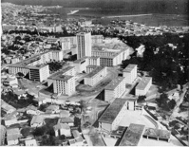 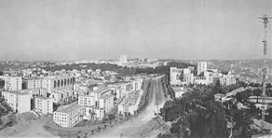 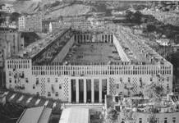Diar El-Saada (1) Diar El-Mahçoul (2) Climat de France (3)
Well-designed urban spaces | Simulate the character of old cities. | The urban spaces (plaza, streets, perspectives, hierarchy of spaces) of El-Mekter Hotel in Aïn Séfra simulate the character of old Islamic cities and their urban spaces. | 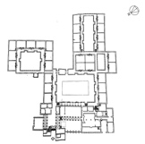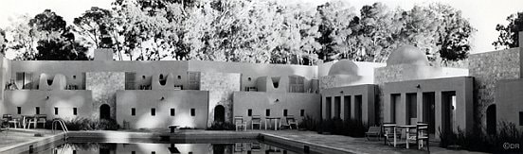  El-Mekter Hotel plan (4) and main patio (5)
Landscape views | Integration with nature and the environment | El-Gourara Hotel in Timimoun preserves the landscape view and topography of the site, including Tademaït Hill. | 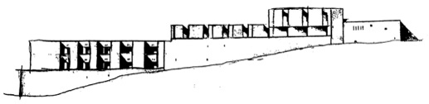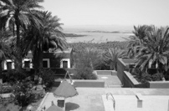  El-Gourara Hotel façade (6) and view towards the landscape (7)
Architectural ambiences | Spaces that convey vernacular stories for eternity | The design of the M'Zab Hotel in Ghardaïa enhances the architectural ambiance by drawing inspiration from the vernacular Mozabite style. | 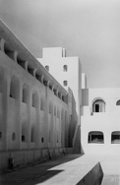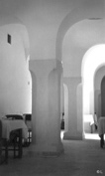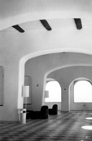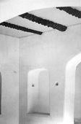  M’Zab Hotel external and internal views (8)
Heritage vocabularies | Create architecture that resists change. | The hotel in Tamanrasset preserves the history of local Saharan Ksours while being updated with construction techniques. | 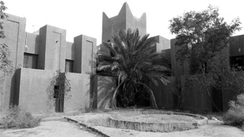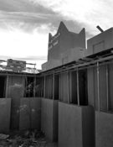  The hotel’s external views (9)
Rationalism | Quality architecture with simple design, reduced operation time, and cost-effective construction | El-Ziban Hotel in Biskra embodies rational architecture with its simple form, cohesive order, well-defined hierarchy, articulated scale, and careful consideration of space in relation to climate. | 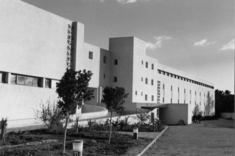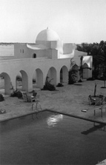  El-Ziban Hotel external views (10)
The essence of construction lies in its meaning, beauty, composition, order, and materials. | Honest architecture | El-Boustan Hotel in El-Goléa showcases the result of mastering architecture through covered galleries, large decorative arabesque panels with ceramics, and beautiful views toward the palm grove gardens. | 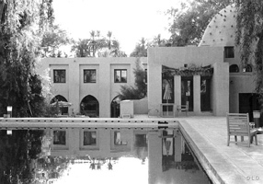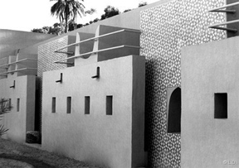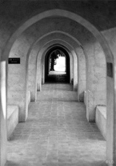  El-Boustan Hotel external views (11)
Against any international or fashionable style | A middle ground between rationalism and eclecticism | El-Rym Hotel in Béni Abbès presents a rational practice of eclecticizing elements that are contemporary and archaeological | 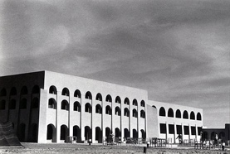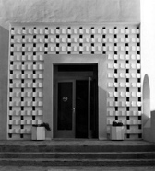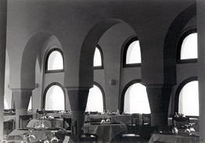  El-Rym Hotel external and internal views (12)
Users and society’s ideologies | A cumulative cultural chain of architecture | El-Djanoub in Ghardaïa highlights the importance of users' ideologies and social context through the concept of privacy in façades and the arrangement of spaces around internal patios and the tower. | 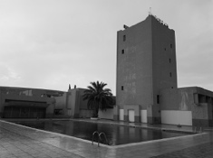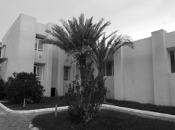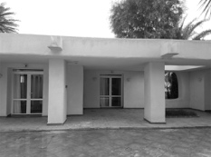  El-Djanoub Hotel external views
Sculptural architecture | Flexible, curved architecture | Marhaba Hotel in Laghouat creates curvilinear internal pathways that generate a labyrinthine effect, allowing for the capture and diffusion of daylight and wind. | 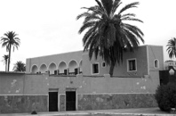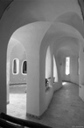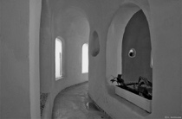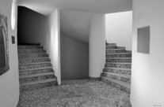  Marhaba Hotel external and internal views (13)
(1) Source: http://alger-roi.fr/Alger/diar_saada/diar_saada.htm
(2) Source: http://wikimapia.org/12980557/cit%C3%A9-Diar-el-Mah%C3%A7oul
(3) Source: https://blogatelieremanence.com/a-lire-climats-de-france/
(4) Source: (Maachi Maïza, 2002)
(5) Source: https://www.fernandpouillon.com/sefrap.html
(6) Source: (Maachi Maïza, 2002)
(7) Source: https://www.fernandpouillon.com/timimounp.html
(8) Source: https://www.fernandpouillon.com/mzabarchp.html
(9) Source: http://fr.fcm.pt/projet/125/rehabilitation_de_l_h%C3%B4tel_tahat
(10) Source: https://www.fernandpouillon.com/biskrap.html
(11) Source: https://www.fernandpouillon.com/elgoleap.html
(12) Source: https://www.fernandpouillon.com/beni_abbesp.html
(13) Source: https://www.fernandpouillon.com/laghouatp.html
(Accessed date: March 20th, 2022)

    - SOCIAL STUDIES, CONSTRUCTION MATERIALS AND MORPHOLOGY
• Mr. Pouillon, could you please describe your criteria for selecting specific construction materials and elaborate on how you incorporate social studies into your design process and its impact on the resulting morphology?
When I was invited to Algiers for the first time, it was quite shocking to encounter such squalid slums, which contradicted the reputation of the French presence. Among the various projects undertaken in the same vicinity and time frame, mine stood out as the most appropriate and in harmony with Muslim society. The intricacies of the façades, the proportions, and the consistent use of symbols reflect both the traditional Mediterranean character and the characteristics of Muslim social housing. This is particularly evident in my meticulous approach to public spaces and urban design layout, including plazas, spatial hierarchies, perspectives, and more. Furthermore, I prioritize providing users with scenic views of the surrounding environment, fostering a seamless integration between my projects and the landscape. The expansive ensembles I crafted in my work generated additional spaces intimately connected to the natural surroundings while maintaining a uniform quality of architectural and urban spaces – a concept not widely embraced during that period.
My projects are distinguished by their integration with both natural and urban surroundings, achieving a balance of masses with harmonious proportions, employing noble and sustainable materials, incorporating sculptural elements in façades, featuring artistic ceramic work, and incorporating carefully designed landscapes. They embraced abstract archetypes without unnecessary embellishments, creating contemporary forms by interpreting the traditional ones from various contexts, regions, and climates. Rationalism pervades every aspect of my work, from the use of straightforward, functional forms that minimize material costs and time to my preferences for optimizing the implementation of older materials like stone and rammed earth rather than relying on new materials.
I am highly conscious of the interplay between morphology and its function, as well as the relationship between the quality of urban spaces and the aesthetic attributes of construction. Stone, which endures time and exhibits remarkable resistance, is undoubtedly my preferred construction material. I express architectural concepts through the utilization of simple geometries and materials. The construction elements and morphology of my work draw influence from various factors, including physical, geographical, social and cultural contexts. Before embarking on the design process, I make it a point to visit the specific context, immersing myself in its unique characteristics and striving to attain a comprehensive understanding. This approach enables me to create optimal morphologies, consider appropriate daylighting solutions, and determine the most advantageous orientation for the project.
I have discovered a harmonious balance between the old and the new, fostering architectural unions seamlessly blending contemporary and archaeological elements. For instance, consider the resemblance of El-Mekter Hotel to the Alhambra Palace, the influence of an ancient temple in the design of El-Gourara Hotel, the incorporation of vertical openings in classical architecture seen in the façades of El-Rym Hotel, El-Gourara Hotel, and Oasis Hotel, and the inspiration drawn from Saharan Ksour in the design of Tahat Hotel.
I am acutely conscious of local architecture as a fundamental source of inspiration, emphasizing a straightforward and enclosed morphology while selecting appropriate construction materials. Additionally, I prioritize the inclusion of repetition and rhythm in façades and forms to ensure that architecture is easily comprehensible. Moreover, I employ substantial walls, incorporate lighter added elements, incorporate monumental porticoes and colonnades, and include generous staircases and steps in my designs.
However, as a general rule, my architectural principles revolve around:
1. Centrality is achieved by incorporating patios, interior gardens, and swimming pools as central focal points.
2. Creating an architectural promenade.
3. Emphasizing monumentality by utilizing large volumes and making extensive use of staircases.
4. Pursuing the purification of forms to enhance architectural expression.
5. Employing closed figures can take the shape of regular forms (as seen in El-Rym and M’Zab hotels) or concave forms (as exemplified in El-Mustazah and El-Gourara hotels).
I have reinterpreted the social interactions observed in old cities and incorporated these elements into my work. For instance, the geometric urban layout of El-Mountazah Hotel is inspired by The Casbah of Algiers. Consequently, the morphology of the project is tailored to suit both architectural and urban contexts. Elements such as patios, covered passages, stone pedestrian walkways, the interplay between volumes, and the establishment of hierarchical spaces ranging from public to private are all considered during the design process.
In Algeria, these same principles were upheld. Despite having similar contextual data, the resulting morphologies differ. When you visit my hotels in Algeria, you will discover distinct structural schemes developed to accommodate specific site requirements. There will be variations in materials, finishes, ornamentation, garden layouts, swimming pools, the relationship between the site and buildings, as well as the incorporation of water features and vegetation.
Tourists seek to witness and experience the essence of the visited region, encompassing both tangible and intangible aspects of its heritage. Consequently, I am acutely conscious of this aspect. I approach the design process by creating uncomplicated morphologies with minimal details in the plans, effectively capturing the traditional way of life in these contexts.
Through my work in the south of Algeria, I have come to recognize the significance of incorporating water features, optimizing natural daylight, integrating vegetation, embracing the concept of a fortified village, and recognizing the central passage as the backbone of the entire system, responsible for distributing all functions. Similarly, I have reinterpreted the use of daylight in the galleries and water features in tunnels, drawing inspiration from the design principles of Saharan Ksours. For instance, Aïn Séfra El-Mekter Hotel reinterprets the layout of local Islamic cities, featuring narrow spaces and irregular divisions and dimensions resembling a Saharan Ksar nestled within palm groves. The watchtowers resemble those found in Beni-Isguen architecture in Ghradaïa, as do the counterfort columns and arcades (as illustrated in Figure 15).
In the northern region of Algeria, the Mediterranean character is preserved through architectural designs characterized by closed forms when viewed from the exterior, contrasting with openings that invite the exterior environment inward. The façades often feature blind openings inspired by Ottoman architecture. Additionally, the concept of promenades, pathways, gardens and patios interweaving throughout the building, creating luminous spaces, is prevalent. The terrace concept draws inspiration from El-Casbah of Algiers, and a white coating, influenced by Mediterranean architecture, is commonly used. Other design elements include covered passages, pedestrian paths, substantial structures, rectangular and straightforward forms, and flat surfaces interacting with natural light.
Regarding construction materials and techniques, I adapt the ancient local concept of expertise to utilize them effectively. Consequently, no singular material is consistently employed, but rather a rational approach tailored to each site and unique circumstance. I have a deep interest in materials and have always been averse to the unattractive nature of plaster. I found that the appearance and use of cement and reinforced concrete posed challenges. Conversely, I also work with local raw materials, which is distinctly evident in the architectural vocabulary of my projects. For instance, I incorporate the use of stone from Laghouat, brick from Nedroma, and soil from Seraïdi, among others.

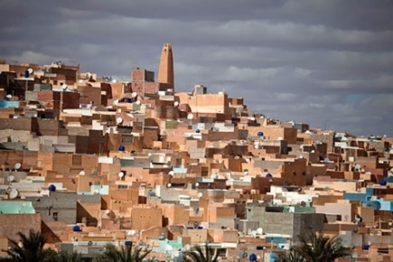 | 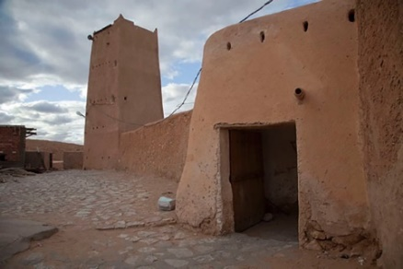
A | B
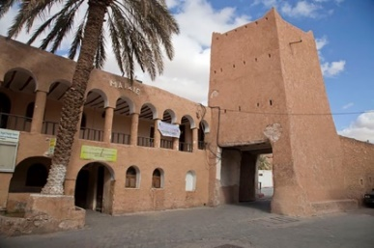 | 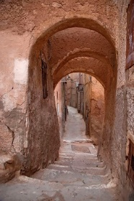
C | D
Figure 15. Beni-Isguen is characterized by its (a) minaret watchtowers, (b) (c) (d) and arcades

The significance of materials lies in their inherent characteristics, encompassing their type, shape, color, texture, and arrangement. The underlying concept is to craft an artistic masterpiece that allows visitors to experience the space and establish direct contact with the building’s surfaces, leveraging the interplay between light and shadow to sculpt the spatial ambiance. To ensure durability and structural robustness, I have incorporated substantial materials in the construction of walls, such as stone and brick, and reinforced the structures with robust components and plinths.
Stones held a special place as my favorite construction material. I opted for this noble material, which is accessible to everyone. Through its use, I crafted an architecture that felt welcoming and familiar to the occupants. However, I did not employ it in all of my projects, as that would have been impractical. Instead, I endeavor to employ this authentic material with both rationality and aesthetic consideration, infusing spaces with its unique character by incorporating it into walls, floors, swimming pools, and more, for instance, in the El-Rym Hotel in Béni Abbès, where the stone was utilized extensively in structural elements and as cut stone cladding, to convey a sense of robustness and massiveness.
In general, brick or concrete blocks are employed for the structural components, including load-bearing interior and exterior walls, while stone is utilized for the exterior load-bearing walls. I have a preference against concrete and cement due to their light-absorbing properties and their impact on overall appearance. As a result, I often apply a layer of white plaster to cover the concrete. Conversely, I find stone to be the more dependable choice.
I firmly believe that architecture and structural unity are inseparable. Consequently, I opted for load-bearing walls, utilizing either stone or concrete. Additionally, I emphasized the importance of achieving equilibrium between load-bearing walls and roofs, relying on traditional techniques. These techniques include the use of cross vaults, as evident in the El-Manar Hotel, El-Mekter Hotel, El-Mehri Hotel, El-Gourara Hotel, and Marhaba Hotel. Spherical vaults were employed in the case of the Marhaba Hotel, while piers and counterfort columns were utilised in the M’Zab Hotel and El-Ziban Hotel. Arcades were incorporated into the design of the Oasis Hotel.

- FERNAND POUILLON’S WORK IN THE SOUTH OF ALGERIA
The majority of FP’s projects encompass residential units and hotels. However, in the southern region of Algeria, FP focused exclusively on hotels and a limited number of individual housing projects. Consequently, the authors have chosen the following projects to serve as a representative and dependable sample of FP’s work in southern Algeria. An overview of the selected case studies analysis is provided in Table 4.

Table 4. FP’s work in the south of Algeria (case studies analysis)
Criteria / Project | Situation | Integration with site | Morphology | Façades | Plans and structure | Materials and colours
El-Gourara Hotel | * Located west of Timimoun (Tademaït hill).  * Accessible from the eastern façade.  * Irregular terrain form.  * Completely within the natural context.  * Oriented along the northern east - southern west axis.  * Northern east for cold winds and southern west for hot winds. | * Land with a steep slope.  * Utilizes red shells in construction.  * Provides views of the palm context and sunset. | * Closed, curved monobloc.  * Features a horseshoe-style design covered by a flat roof.  * Maintains 100% symmetry, with the swimming pool at the center.  * Includes visible counterfort columns reminiscent of a fortified Ksar. | * One accessible façade (the eastern side serves as the principal entrance).  * Features a large arch at the entrance.  * Includes counterfort columns and terraces.  * Minimizes the number of openings.  * Utilizes both vertical and horizontal shading through the use of massive walls and roofs. | * Centrally symmetric plan.  * Comprising a ground floor and two upper floors.  * The swimming pool serves as the central feature.  * Rooms equipped with terraces  * Facilities include a restaurant, swimming pool, conference room, lounge, and internal garden.  * The construction materials consist of shells made of lightly reinforced concrete in the foundation, double adobe walls filled with lightly reinforced concrete in the load-bearing walls (1 m thick), and hollow concrete blocks in the roofs. | * Red oasis environment.  * Constructed using adobe (dried earthen material).  * Exterior covered in red earthen render (regular texture).  * Interior features handcrafted sculptures on walls.
 | 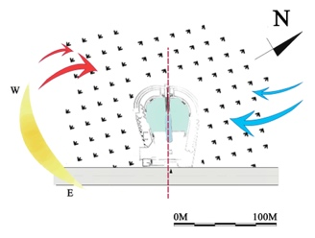 | 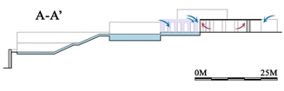 | 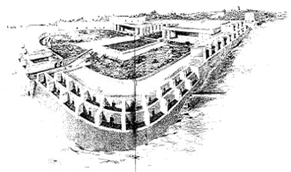  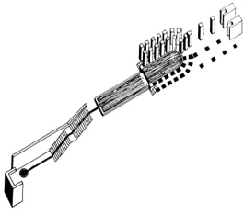 | 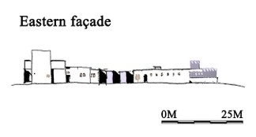  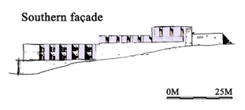  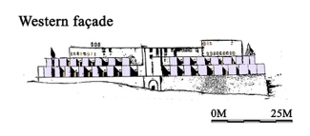 | 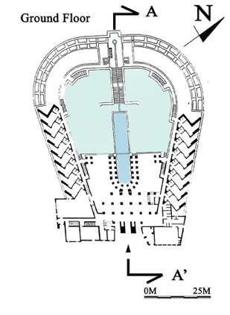  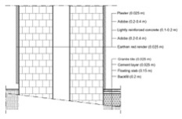  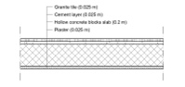 | 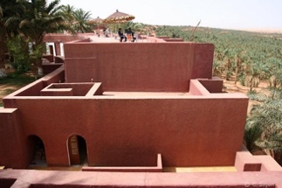  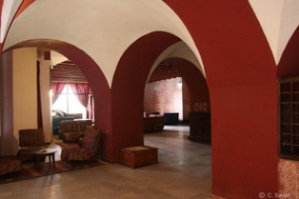
M’Zab Hotel | * Located to the south of M’Zab Valley (in close proximity to the city center and market).  * Accessible from the northern façade.  * Rectangular terrain shape.  * Surrounded by a natural context with limited nearby buildings.  * Oriented along a northeast-to-southwest axis.  * The northern east side is exposed to cold winds, while the southern west faces hot winds. | * Sloped terrain.  * Prominent rocky outcrops.  * Offers views of the arid desert landscape and the historic city of M'Zab. | * Enclosed monobloc.  * Comprises two parallel wings with a simple rectangular style, featuring flat roofs separated by two courtyards.  * Exhibits perfect symmetry, with the lobby at the center.  * Prominent towers reminiscent of fortified Ksars. | * The hotel boasts three accessible façades, with the northern one as the principal entrance.  * A tower and a large arch distinguish the entrance.  * Features Islamic arches and intricately designed curved-surface terraces.  * Utilizes minimal openings.  * Incorporates both vertical and horizontal shading elements, including passages, massive walls, and roofs. | * Follows a linear-symmetric plan.  * Comprises a ground floor and two upper floors.  * Emphasizes the two patios as the central elements.  * Offers rooms with terraces.  * Includes 6 senior suites, 4 junior suites, a restaurant, a lounge bar, a swimming pool, and an internal garden.  * Constructed using shells of lightly reinforced concrete in the foundation, double walls with an air gap in the load-bearing walls (0.6 m), and hollow concrete blocks in the roofs. | * Set in a desertic-rocky mountain environment.  * Utilizes hollow concrete blocks for construction.  * Adorns its exterior with a lime-sand render featuring a regular texture.  * Interior floors are adorned with traditional carpets.
 | 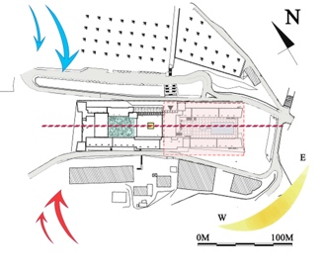 | 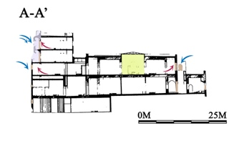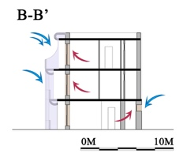 | 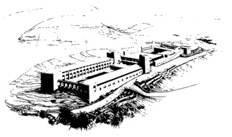  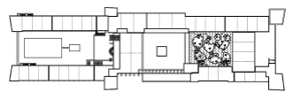 | 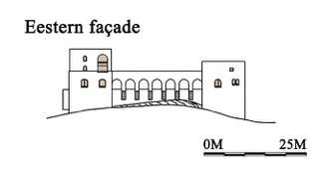  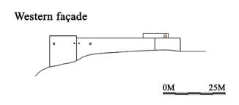  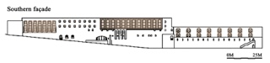  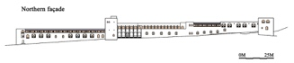 | 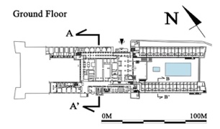  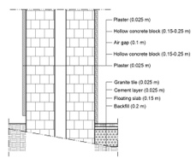  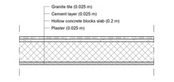 | 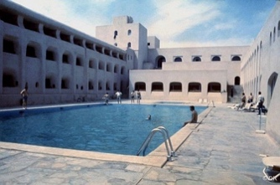  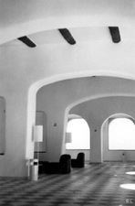
El-Djanoub Hotel | * Located to the north of M’Zab Valley, in proximity to the city center within Bouhraoua.  * Accessible from the western façade.  * The terrain assumes an 'L' shape.  * Situated in an urban context with views of the surrounding rocky hills and mountains.  * Oriented along a northern east to southern west axis.  * Exposed to northern east cold winds and southern west hot winds. | * The land has a slight slope.  * Rectangular building forms are strategically distributed.  * The rooms offer views of the created interior-urban spaces within the expansive terrain. | * An open multiblock design.  * Multiple blocks featuring a simple rectangular style with flat roofs are arranged around ten patios.  * The design exhibits an asymmetric form, with the tower and swimming pool positioned near the center.  * The building incorporates vertical shading devices, and a tower reminiscent of a fortified Ksar is prominently visible. | * The hotel features three accessible façades, with the western façade serving as the main entrance for the public.  * The entrance is marked by vertical parallel columns.  * The overall architectural design includes right-angle forms and terraces, with exceptions such as some arches at entrances and curved shapes inspired by M’Zab architecture in the bungalows.  * The building minimizes the number of openings and incorporates both vertical and horizontal shading elements, including passages, massive walls, and roofs. | * The hotel follows a linear asymmetric floor plan.  * It consists of a ground floor and two upper floors.  * The ten patios within the design serve as the central productive elements.  * Each room is equipped with its own terrace.  * The hotel includes various amenities such as a restaurant, swimming pool, conference room, lounge, and nine internal gardens.  * The construction utilizes shells made of lightly reinforced concrete in the foundation, a double wall system with an air gap in load-bearing walls (measuring 0.6 meters), and hollow concrete blocks in the roofs. | * The hotel is situated in a desertic-rocky mountain environment.  * The construction incorporates hollow concrete blocks in its design.  * Lime-sand render with a regular texture is used for the exterior finish.  * Traditional carpets are employed to cover the internal floors.
 | 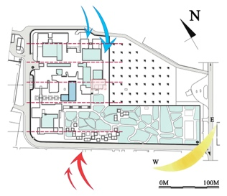 | 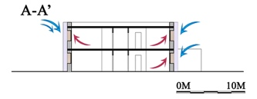 | 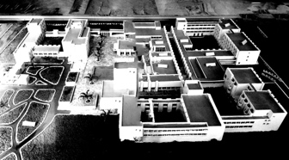 | 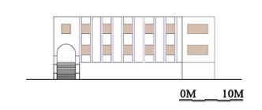 | 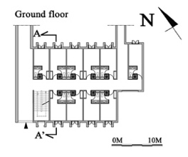  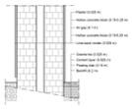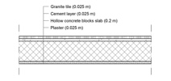 | 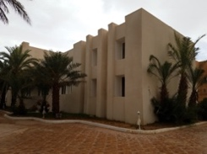  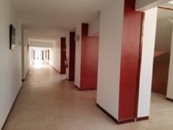

Chosen projects in the south of Algeria:
- El-Gourara Hotel: 150 beds (1968) in Timimoun, Algeria.
- M’Zab Hotel: 600 beds (1970) in Ghardaïa, Algeria.
- El-Djanoub Hotel: 600 beds (1974) in Ghardaïa, Algeria

- EL-GOURARA HOTEL - 150 BEDS (1968) IN TIMIMOUN, ALGERIA
This project was part of the government's initiative to enhance Algeria’s tourism sector and infrastructure across the entire country. In 1968, under the supervision of the Ministry of Tourism, FP meticulously designed this magnificent hotel, treating it as if it were a fortress amidst the desert. The hotel was constructed in the ‘horseshoe’ style on a steep slope in Tademaït hill, in Timimoun, Adrar province. This design choice maximizes panoramic views of the surrounding palm groves and the spectacular sunset. With three floors, a capacity for 150 beds, and a star rating, the hotel is considered a national heritage treasure [5] (as depicted in Figures 16 a, b, c, d and e).

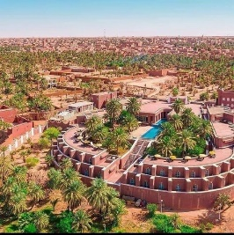 | 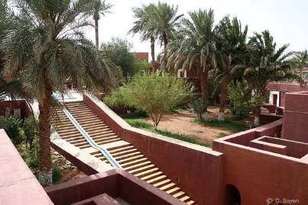 |  | 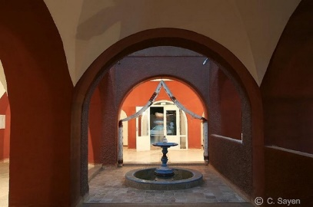
A | B |  | C
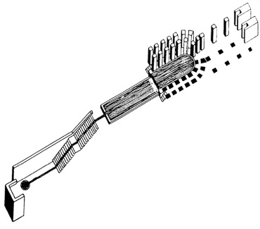 |  | 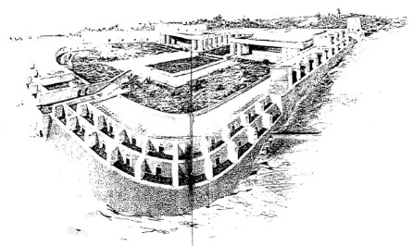
D |  | E
Figure 16. (a) (b) (c) (d) (e) El-Gourara Hotel in Timimoun, Algeria 1968

- Situation (location, accessibility, nature/urban, sun path, and wind)
The hotel is situated to the west of Timimoun on Tademaït Hill. The project is connected by a mechanical road that extends from the main eastern façade and leads to the city center, although the terrain’s topography is irregular. The natural surrounding environment offers picturesque views of the palm grove and the desert sunset. The hotel’s primary axis is oriented towards the northeast and southwest directions. The prevailing monsoon winds come from the northern east (cold wind) and southern west (hot wind) directions.

- Integration with the site (topography and landscape)
The Red Hotel seamlessly blends with its oasis surroundings in terms of form, color, and execution. FP skilfully addresses the steep slope of the land by using lightly reinforced concrete shells. Each hotel room offers a stunning panoramic view of the surrounding palm grove and the natural sunset in the west.

- Morphology (volumetry)
The hotel consists of a closed, curved monobloc designed in a horseshoe style, featuring a ground floor and two additional floors. The symmetric shape of the hotel is maintained perfectly, with the main longitudinal axis dividing the hotel into two sections, each centered around a swimming pool. The balance of masses is achieved through meticulous attention to harmonious proportions. The external façade is adorned with prominent counterfort columns, evoking the ambiance of a fortified Ksar.

- Façades and orientation
The hotel features one accessible façade, with the primary eastern façade serving as the public entrance, distinguished by a large arch that serves as a central focal point for directing circulation towards the main spaces of the hotel. The remaining sides of the hotel are oriented towards the palm grove. These façades incorporate terraces and prominent counterfort columns, which serve the dual purpose of shielding the rooms from direct sunlight while allowing for the ingress of natural daylight. The number of openings in the exterior façades is minimized while maintaining horizontal and vertical shading through substantial walls and roofs.

- Plans and structure
The hotel’s floor plan is centrally symmetric. It consists of a ground floor and two additional floors, with the water and swimming pool serving as the primary focal point and productive element. The rooms are distributed across all three levels and include exterior terraces. These rooms offer relatively generous surface areas. The hotel also features amenities such as a restaurant, a swimming pool (which facilitates water movement across different levels), a conference room, a lounge, and an internal garden. The structural elements used include shells of lightly reinforced concrete in the foundation, double adobe walls filled with lightly reinforced concrete in massive load-bearing walls (the thickness reaching up to 1 meter in several walls) [5], and hollow concrete blocks in the roofing.

- Materials and colours
The prominent presence of red mud in the soil contributes to the prevailing red color in the region (Timimoun is also known as the ‘red oasis’). The primary building material used in masonry is the local adobe or Toub. This dried earthen material is covered with a red earthen render to create a uniform texture on both walls and roofs. The interior surfaces are meticulously hand-sculptured to fashion decorative traditional panels.

- M’ZAB HOTEL - 600 BEDS (1970) IN GHARDAÏA, ALGERIA
Also known as the ‘Rosthémide Hotel’ (named after the Ibadi dynasty that ruled from 776 to 909 over the kingdom of Tahert and was destroyed near Tiaret), the hotel is situated atop a hill in Ghardaïa, under the ruins of a former colonial French prison. Some of the prison cells can still be accessed through the underground of the existing hotel. Since 1970, the hotel has been under the supervision of the Ministry of Tourism. However, in the 1990s, due to political issues and a lack of maintenance, certain hotel parts fell into disrepair and were eventually demolished. Later, with the involvement of the Ministry of Tourism and under the supervision of local tourism management establishment, the M’Zab Hotel was meticulously restored and renovated. The original plans and architectural forms remained unchanged, with only the color of the lime-sand coating being altered to white. Various maintenance works were carried out during the restoration process. According to Insaf Boudabia, the hotel officially reopened and resumed operations on November 1st, 2021 [7]. As typical of FP’s work, the hotel is designed to blend with its natural surroundings harmoniously and offers captivating views of the surrounding desert landscape. The hotel, classified as three stars, spans three floors, features two courtyards, and has a capacity for 600 guests. It stands as a prominent contemporary representation of M’Zab architecture (Figure 17 a, b, c, d, and e).

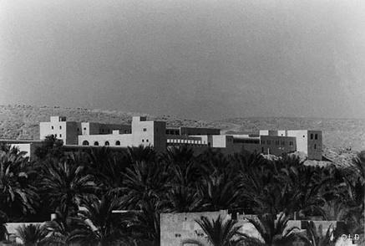 | 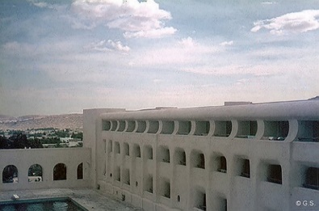 |  | 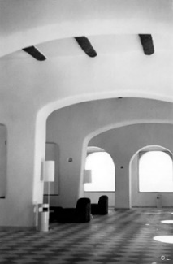
A | B |  | C
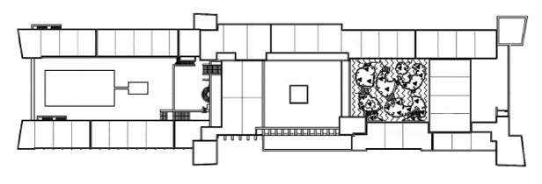 |  | 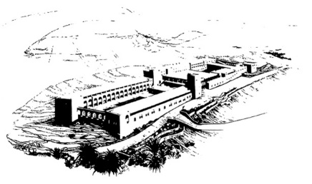
D |  | E
Figure 17. (a) (b) (c) (d) (e) M’Zab Hotel in Ghardaïa, Algeria 1970
- Situation (location, accessibility, nature/urban, sun path, and wind)
The hotel is situated to the south of the M’Zab Valley, not far from the city center and the market, perched atop a rocky hill near the stadium. It is accessible via a mechanical street connecting to the hotel’s northern façade and the communication station. The terrain’s shape is rectangular. The surrounding context is characterized by its natural landscape, with only a few nearby buildings. The hotel enjoys scenic vistas of rocky hills and mountains. Its primary axis is oriented toward the northeast-southwest direction. The prevailing monsoon winds blow from the northeast (bringing cold air) and the southwest (bringing hot air).

- Integration with the site (topography and landscape)
The large hotel is seamlessly integrated into the rocky desert mountainscape, considering its form, color (originally sandy rather than white), and construction. FP skillfully addresses the sloped terrain by adopting a rectangular design that follows the land's natural contours. The hotel’s rooms offer sweeping panoramic views of the surrounding rocky desert landscape and the historic city of M’Zab.

- Morphology (volumetry)
The hotel consists of a single block, characterized by two parallel wings with a simple rectangular design, comprising a ground floor and two upper floors. The symmetrical form of the hotel is meticulously maintained, with the main transverse axis dividing it into two sections centered around the lobby and two main patios – one housing a swimming pool and the other a garden. The balance of masses is achieved through precise and harmonious proportions. The external façade features prominent towers, evoking the impression of a fortified Ksar.

- Façades and orientation
The hotel features three accessible façades. The primary northern façade serves as the public entrance. It is distinguished by a tower and a large arch, which act as central focal points for directing circulation towards the hotel’s main areas. The southern façade serves as the staff’s entrance, while the western and eastern façades face the desertic mountains. These façades incorporate Islamic arches and intricately pierced curved-surface shapes in terraces inspired by M’Zab architecture. These design elements serve the dual purpose of protecting the rooms from direct sunlight while allowing for ample daylighting. The exterior façades minimize openings, particularly in the southern façade, while still maintaining horizontal and vertical shading through the use of passages, massive walls, and roofs.

- Plans and structure
The hotel’s plan is linear and symmetrical, consisting of a ground floor and two upper floors. The two patios serve as the main productive element and central focal points. The rooms are distributed across all three levels and feature terraces overlooking the patios and the exterior surroundings. The hotel comprises six senior suites, four junior suites, a 200-seat restaurant, a lounge bar, a terrace, a swimming pool, and an internal garden. The structural framework consists of shells made of lightly reinforced concrete in the foundation, stone, double walls constructed with hollow concrete blocks separated by an air gap in massive load-bearing walls (with a thickness reaching 0.6 meters in several walls), and hollow concrete blocks used in the roofs.

- Materials and colours
The predominant color of the region is the natural hue of the rocky desert mountains. The primary construction materials used are stone and hollow concrete blocks covered with a lime-sand render that creates a uniform texture on both the walls and roofs. Traditional carpets adorn the internal floors, adding a sense of dynamic movement to the space.

- EL-DJANOUB HOTEL - 600 BEDS (1974) IN GHARDAÏA, ALGERIA
The magnificent hotel is one of FP’s masterpieces in southern Algeria, located in the historical city of Ghardaïa. In 1974, under the Ministry of Tourism's supervision, FP began constructing two blocks of this hotel. Subsequently, he departed, leaving plans to complete the hotel’s construction the following year. Today, the hotel is undergoing a renovation and extension project supervised by the local tourism management establishment, encompassing the entire hotel premises [20]. The hotel belongs to the three-star category, with three floors and a capacity for 600 beds. The climate is hot and dry due to the desertic context of Ghardaïa (Figure 18 a, b, c, d, and e).

  - Situation (location, accessibility, nature/urban, sun path, and wind)
The hotel is situated to the north of M’Zab Valley, close to the city center, specifically in the Bouhraoua quarter near the cemetery. The project is connected by mechanical streets on all three sides, forming an ‘L’ shape, with the primary western façade leading to the city center. The surrounding context is urban, offering views of the adjacent rocky hills and mountains. The hotel’s main axis is oriented towards the northeast to the southwest, with monsoon winds prevailing from the northeastern direction (cold wind) and the southwestern direction (hot wind).

  - Integration with the site (topography and landscape)
The hotel is seamlessly integrated into both its urban and natural surroundings through its form, color, and execution. FP skilfully addresses the gently sloping terrain through the strategic placement of rectangular structures and urban elements such as patios, gardens, and swimming pools, all of which follow the land's natural contours. The hotel’s rooms offer views of the thoughtfully designed interior urban spaces within the expansive grounds.

  - Morphology (volumetry)
The hotel has an open multiblock structure comprising several simple rectangular blocks with a ground floor and two upper floors. The hotel does not possess a symmetric axis; instead, the blocks are arranged around ten main patios, one of which is dedicated to a swimming pool, while the others serve as gardens. The balance of masses is achieved through careful and harmonious proportions. Additionally, vertical shading devices and a central tower near the swimming pool evoke the feeling of a fortified Ksar.

  - Façades and orientation
The hotel features three accessible façades. The main western façade includes the public entrance, accentuated by vertical parallel columns that serve as a central point for guiding circulation toward the hotel’s main spaces through a longitudinal passage. The southern and northern façades face the surrounding streets and neighborhood. These façades predominantly exhibit right-angle forms, with exceptions like arches at entrances and curved shapes inspired by M’Zab architecture in bungalows. To shield the rooms from direct sunlight while ensuring ample daylighting, the façades incorporate vertical shading devices. Openings in the exterior façades are kept to a minimum, maintaining horizontal and vertical shading through the use of passages, massive walls, and roofs.

  - Plans and structure
The hotel’s plan is linear and asymmetric, consisting of a ground floor and two upper floors. The ten patios serve as the primary elements of productivity, with the swimming pool approximately at the center. The rooms are distributed across the three levels and feature openings towards the patios and the exterior. These rooms offer relatively large surface areas. Additionally, the hotel includes a restaurant, a swimming pool, a conference room, a lounge, and nine internal gardens. The structural system comprises shells of lightly reinforced concrete in the foundation, a double wall construction using hollow concrete blocks separated by an air gap in massive load-bearing walls (with thickness reaching up to 0.6 meters in several walls), and the hollow concrete blocks for the roofs.

  - Materials and colours
The dominant color of the region is the natural hue of the desertic-rocky mountains. The materials used in masonry consist of stone and hollow concrete blocks covered by lime-sand render with a regular texture, applied either on the walls or the roof. Traditional carpets adorn the internal floors, contributing to the dynamic ambiance of the space.

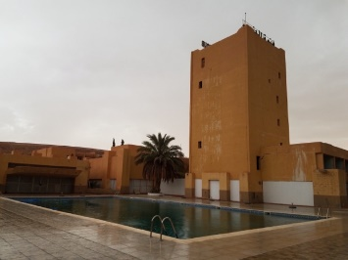  A | 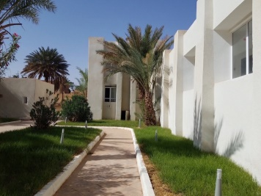  B | 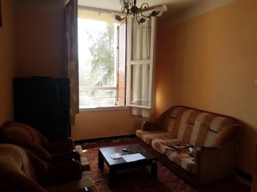  C
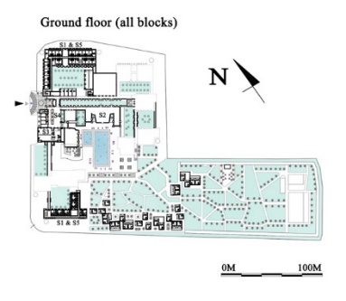  D |  | 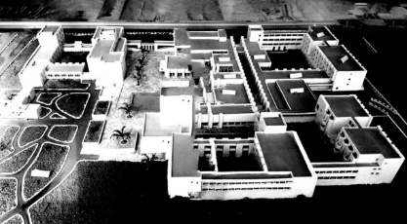  E
Figure 18. (a) (b) (c) (d) (e) El-Djanoub Hotel in Ghardaïa, Algeria 1974 [20]

- RESULT AND DISCUSSION

- RESULT
Fernand Pouillon's architectural legacy in the southern region of Algeria stands as a testament to his exceptional talent and commitment to crafting remarkable, contextually sensitive, and aesthetically pleasing architectural spaces. His work in this region primarily revolves around the construction of hotels and a limited number of individual housing projects, each reflecting a meticulous fusion of historical influences, cultural context, and architectural innovation.
Pouillon's ability to seamlessly integrate his architectural creations with the unique natural landscapes of the southern Algerian region is striking. His designs honor the local topography and environment, offering residents and visitors sweeping panoramic views of the surrounding terrain. His strategic consideration of siting, topography, and landscape ensures that his projects harmoniously blend with their surroundings. In the case of El-Gourara Hotel, nestled in the Tademaït hill in Timimoun, the "horseshoe" design emphasizes the hotel's role as a fortress amidst the desert, capturing the essence of the landscape while providing panoramic vistas of palm groves and desert sunsets.
The architectural volumetry of these structures is another hallmark of Pouillon's work. His designs feature closed, symmetrical forms when viewed from the exterior, akin to fortresses, with internal spaces that open up to inviting patios, pathways, and gardens. These configurations ensure luminous interiors and a distinctive Mediterranean character. Whether it's the curved monobloc design of the El-Gourara Hotel or the open multiblock structure of the El-Djanoub Hotel, Pouillon's use of harmonious proportions and traditional motifs creates architectural forms that resonate with local culture.
Pouillon's approach to materials underscores his commitment to timeless, durable, and contextually relevant construction. He thoughtfully selects materials such as stone, adobe, and lime-sand render, blending them in ways that complement the surrounding natural colors and textures. His strategic use of light and shadow, the sculpting of spatial ambiance, and the interplay between materials create a unique and lasting architectural ambiance. Stone, in particular, held a special place in his heart, as it aligned with his vision of creating welcoming and familiar architectural spaces.
In addition to his architectural choices, Pouillon's focus on structural unity is evident in his load-bearing walls, carefully chosen to provide durability and robustness. In both El-Gourara and M'Zab Hotels, he employed shells of lightly reinforced concrete, stone, and adobe walls. Integrating cross vaults, spherical vaults, piers, counterfort columns, and arcades in his designs showcases his commitment to sound structural principles influenced by the historical and environmental context.
One cannot ignore the significant cultural and historical references Pouillon incorporated into his designs. His work is a delicate balance between old and new, synthesizing contemporary and archaeological elements that seamlessly blend, creating spaces embodying the region's heritage. Pouillon's reinterpretation of Ksar architecture, Islamic arches, and M'Zab motifs in his projects like El-Mekter Hotel and M'Zab Hotel showcases his deep respect for local culture and history.
In addition to the architectural aspects, Pouillon's work in the southern region of Algeria offers a remarkable interplay between the built environment and the local context. His hotels serve as not just structures but as gateways to experiencing the essence of the region's heritage and culture. From narrow passages reminiscent of Saharan Ksours to the central passages that distribute functions within the buildings, Pouillon thoughtfully weaves social interaction and traditional urbanism into his designs.
In conclusion, the architectural work of Fernand Pouillon in the southern region of Algeria is an exceptional blend of aesthetics, cultural sensitivity, and a profound connection to the region's natural landscapes. Pouillon's commitment to preserving the Mediterranean character, innovative use of materials, and meticulous structural choices testify to his architectural genius. Pouillon's work is not just a reflection of his time; it's an enduring legacy that continues to captivate and inspire architectural enthusiasts, historians, and the general public. His ability to harmonize old and new, local and global, and tradition and innovation makes his work in southern Algeria an architectural treasure worth celebrating.

- DISCUSSION
‘Difficulty is one of the surest elements of beauty’[2]. Designing within the Sahara presents a formidable challenge for architects, particularly in an era marked by scientific advancements and the dominance of the 'globalization concept' worldwide. Balancing the demands of social life, respecting heritage and culture, and adapting to the environment and climate in this arid landscape is no easy feat. In this study, we delve into the ideas of a pioneering architect who worked in Algeria and held a deep affection for its deserts and the Sahara. FP embraced the challenge posed by adverse circumstances and a harsh climate, successfully reinterpreting Islamic aesthetics in architecture. To summarize FP's philosophy, several factors influence the architecture in the Sahara. First and foremost, there is a need to explore heritage and leverage it to develop new concepts that honor culture, social structures, and climate; a concept we refer to as 'identity.' This entails amalgamating numerous solutions that have evolved in various regions over time, all drawing inspiration from their respective heritage.

- CONCLUSION
This study presents a monograph of FP, who designed numerous projects in Algeria. It offers a detailed description of his history, thoughts, concepts, philosophy, and selected projects in the southern region of Algeria. It aims to provide an initial source of inspiration for future projects where Islamic identity may have been marginalized in contemporary architectural practice. The research employed a data collection method. It began with an overview of FP, followed by a chronological account of FP's history and biography. His thoughts, concepts, and philosophy in architecture were subsequently explored as an inspiring approach to address various issues in different regions of Algeria. This was followed by an explanation of FP's approach, including a comprehensive description of his social studies, preferred construction materials, and architectural morphology. The study also included a full description of case studies of FP's work in the south of Algeria, supported by tables and illustrations. A qualitative exploration of three selected FP projects was conducted to provide a comprehensive understanding of the key design principles architects employ when addressing the southern region of Algeria. The study identified commonalities among the selected projects through data collection by applying one or more design elements or criteria.
In conclusion, this study underscores the significance of Islamic aesthetics as a source of inspiration in the thoughts and works of FP. The iconic hotels designed by FP in the southern region of Algeria serve as evidence that human habitation can coexist harmoniously with local culture and nature, thereby reinforcing the imperative of preserving Islamic-inspired design in the area.

REFERENCES
[] M. Foroozani, “Principles of aesthetics in Islamic architecture”, Periodica Polytechnica Architecture, vol. 35, no. (3-4), pp.189-199, 1991.
[2] F. Pouillon, Les pierres sauvages, Le Seuil, 1964.
[3] F. Pouillon, Mémoires d'un architecte, Le Seuil, 1968.
[4] F. Pouillon, Mon ambition, Linteau, 2011.
[5] M. Maachi Maïza, La composition architecturale dans l’œuvre algérienne de Fernand Pouillon, cas du Sud-ouest algérien, Master dissertation, Centre universitaire Béchar, 2002.
[6] S. Zineddine, La sensorialité dans l'architecture de Fernand Pouillon en Algérie indépendante, Doctoral dissertation, Université Mohamed Khider-Biskra, 2019.
[7] B.F. Dubord, Fernand Pouillon. Eclecta Moniteur, 1986.
[8] S. Gruet, J. L. Marfaing, F. Pouillon, and C. Sayen, Fernand Pouillon: humanité et grandeur d'un habitat pour tous, Éd. Poïésis, 2013.
[9] S. Lamraoui, and A. Boussoualim, “Les ambiances vécues dans les espaces publics de Fernand Pouillon: une référence ambiantale”, In Ambiances in action/Ambiances en acte (s)-International Congress on Ambiances, Montreal 2012 (pp. 755-758), International Ambiances Network, 2012.
[0] Picard, A., “Architecture et urbanisme en Algérie. D'une rive à l'autre (1830-1962)”, Revue des mondes musulmans et de la Méditerranée, vol. 73, no. 1, pp.121-136, 1994.
[1] J.J. Deluz, L'urbanisme et l'architecture d'Alger: aperçu critique, 1988
[2] S. Mazouz, La crise identitaire dans l’architecture en Algérie, 2010.
[3] M.O. Ratouis, Mémoires d’un architecte / Fernand Pouillon, Master 2 USPMO/PEEPUT, 2017
[4] H. Roy, “Entretien avec Fernand Pouillon”, Vie des arts, vol. 22, no.88, pp.54-59, 1977
[5] R. Merzelkad, L'ensemble immobilier «Climat de France» à Alger: contribution à l’histoire de la pensée urbaine et architecturale de Fernand Pouillon en Algérie, Doctoral dissertation, Paris 10, 2011
[6] J. Lucan, Fernand Pouillon, architecte. Pantin, Montrouge, Boulogne-Billancourt, Meudon-la-Forêt, Paris: Picard/Editions du Pavillon de l'Arsenal, 2003.
[7] J. L. Bonillo, Fernand Pouillon, architecte méditerranéen, Imbernon, 2001
[8] M. Maachi Maïza, L’architecture de Fernand Pouillon en Algérie. Insaniyat, Revue algérienne d'anthropologie et de sciences sociales, vol. 42, pp.13-26, 2008.
[9] G. M. Barazzetta, l'Exigence de la construction, 2001
[20] I. Boudabia, “General and specific information about M’Zab and El-Djanoub hotels in Ghardaïa”, Interview by the author Ahmed Kaihoul in person, August 7th, 2019

Jacques Chevallier (1911-1971) was a liberal Pied Noir mayor of Algiers
Eugène Elie Beaudouin (1898-1983) was a French architect and urban planner.
Auguste Perret (1874-1954) was a French architect and a pioneer in the architectural use of reinforced concrete.
Auguste Choisy (1841-1909) was a French architectural historian and the author of ‘Histoire de l’Architecture’.
Insaf Boudabia is the architect responsible for the renovation works of both M’Zab and El-Djanoub hotels

