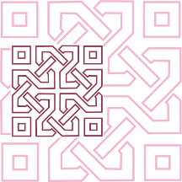 |  | JOURNAL OF ISLAMIC ARCHITECTURE  P-ISSN: 2086-2636 E-ISSN: 2356-4644  Journal Home Page: http://ejournal.uin-malang.ac.id/index.php/JIA
VEGETAL ORNAMENTATION ON MARBLE IN THE ‎OTTOMAN PALACE, AZIZA BEY OF ALGIERS: AN IDENTIFICATION OF THE ARTISTIC ORIGIN
Aicha Bibimoune^{a*}, Samia Chergui^{b}
ªLaboratory ETAP/ IAU, IAU/ University of Blida 1, Algeria
^{b}Laboratory ETAP/ IAU, IAU/ University of Blida 1, Algeria
*Corresponding Author: bibimoune_aicha@univ-blida.dz
ARTICLE INFO |  |  | ABSTRACT
Volume: 8  Issue: 1  Page: 254-268  Received: September 27th, 2023  Accepted: February 19th, 2024  Available Online: June 15th, 2024  DOI:  https://doi.org/10.18860/jia.v8i1.23661 |  |  | Identifying the artistic origin of the vegetal ornamentation on marble characterizing the Aziza ‎Bey palace has become an important issue in a research concerning Ottoman architecture in Algiers. This ‎palace, whose construction dates back to the 16th century, represents a wonderful architectural ‎legacy from an era that was well-known for the cultural exchanges between the two shores of ‎the Mediterranean. Following an original approach, this study aims to provide an answer to this ‎question using observation, literature, and digitization (photogrammetry, CAD). We focused on ‎the vegetal ornamentation of a couple of marble doors and window frames inside the palace in ‎order to interpret them according to two complementary contexts: metaphysical and parametric. ‎This research has revealed completely novel results concerning the oriental origin of floral ‎ornamentation, specifically Anatolian, composed of Rumi and Hatayi. In addition, the occidental ‎origin of fruit, flower, and foliage ornamentation is specific to the Italian Renaissance. These two ‎registers are characterized by symbolic expressions highly significant to each culture.  Keywords:  Algiers Ottoman Palace; Artistic; Marble; Origin; Photogrammetry; Vegetal Ornamentation

- INTRODUCTION
The Ottoman Regency’s capital, Algiers (figure 1), had a remarkable social diversity in the 16th century. Local ‎citizens coexisted with Janissaries and Christian captives from Europe, as well as Moriscos, who had ‎been forced out of Spain [1][2]. The Ottoman authorities constructed the first buildings in the lower part ‎of Medina with the help and participation of this cosmopolitan population. These buildings ‎comprised religious buildings, economic establishments, administrative buildings, and, notably, the ‎Palatine complex of the Dj’nīna ‎ «Dar Al-Sultan » [1][3][4][5][6]‎. This vast palace of governance (figure 2) exhibited a new ‎ornamental style that contrasted with the conventional local architecture [1][7]. This style, which ‎incorporated marble decorative elements (columns or frames), was influenced by local, Western‎, and Eastern origins. ‎‎
The only surviving remnant of the “Dj’nīna” today is the Aziza Bey palace, which escaped the ‎massive destruction operations that French military engineers carried out to restructure the urban ‎fabric of the city [6]. The head of the Constantine Province, Radjeb Bey, built this palace between 1666 ‎and 1672 for his wife Aziza, the daughter of Cayid Ahmed Ben Ramdan [8]. However, some ‎other accounts claim that in the mid-18th century, the Dey Hussein gave this Palace to his favorite ‎daughter, Aziza, as a wedding gift when she married the Bey of Constantine [9][10]. It later ‎became (18th-19th centuries) a residence for beys, ambassadors, and Christian captive redeemers. ‎It was listed as a historic monument in 1887 after the diocese took over [10]. Since 1992, it ‎has been part of the protected area of Algiers’ old city, turned into a museum and classified by ‎UNESCO as a world heritage site.

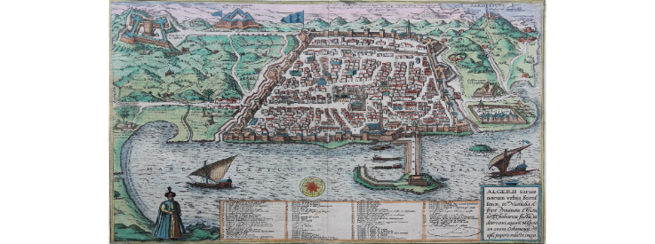
Figure 1. Algiers, engraving by Georg Braun and Frans Hogenberg, 1575-1612 [11]

The marble decoration of the Aziza Bey palace is a promising and underexplored research topic. The ‎reason for this is the lack of historical data to explain the context of this palace, especially its ‎ornamental aspects [8][5][12][1][13][6]. The decoration displays a diverse and sophisticated vocabulary on site. It also ‎shows the cultural influences of various regions that interacted with the Ottoman world in the ‎Mediterranean during its expansion to Europe (16th-17th centuries) [14][15]. It was a transition period ‎in Ottoman architecture, characterized by the introduction of new Western styles, which were also ‎influenced by Eastern artistic trends [16].

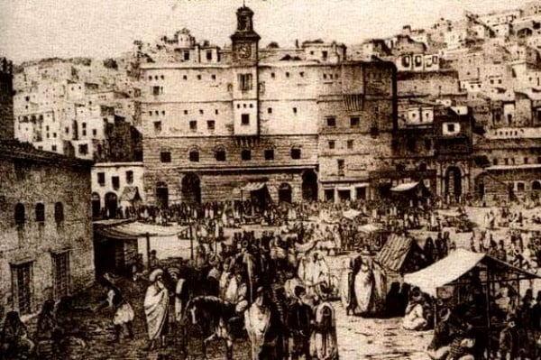
Figure 2. The only illustration of the Dj’nīna ‎and the royal complex, the Aziz palace is on the left appears to be hidden by the building in the front

The origin of marble ornamentation in Ottoman architecture in Algiers is uncertain, but the ‎hypothesis of a Western influence is highly plausible. Most textual sources about this port city ‎mention Italy as the sole supplier of marble and state that it was pre-worked in the workshops of ‎Genoa and Livorno [17][18][19][20]. However, recent studies based on the systematic analysis of the Ottoman ‎administration archives in Algiers reveal valuable evidence of orders for raw marble ‎shaped on-site [21]. Therefore, the question arises: was the marble ornamentation in Ottoman ‎architecture in Algiers either Occidental or Oriental? ‎
This study aims to trace the artistic origin of the Ottoman ornamentation on the marble decorative ‎elements in the Medina of Algiers, with a special focus on the vegetal motifs on the marble frames ‎of the Aziza Bey palace (doors and windows). The study seeks to explore the creative and symbolic ‎significance of these motifs and to identify their artistic sources by examining the ornamentation ‎from the 15th to 18th centuries, a period marked by the Renaissance in the West and Ottoman ‎dominance in the East.

- METHODS
This work’s originality lies in its approach. It aims to examine the vegetal ornament in its complete ‎composition and contextualize it allegorically and stylistically within the various artistic trends ‎that emerged in the history of Ottoman architecture in Algiers. The examination is set in two ‎contexts: ‎
• The metaphysical context: the vegetal ornamentation of the frames will be analyzed ‎metaphysically to identify the allegorical meanings of the main motifs. This analysis ‎requires a systematic review of previous studies [16][22][23] [24][25][26] that explored the symbolic significance of ‎the art of ornamentation, as well as a comparative examination of the models that ‎influenced Ottoman Anatolian ornamentation and the Italian Renaissance. ‎
• The parametric context: this involves examining the geometric tracings and proportional ‎logics, to technically confirm the artistic origin of the frames analyzed. This analysis requires ‎a literature review of the main parameters involved in the tracing of vegetal ornamentation ‎in these two major artistic currents [27][28][29][30], in addition to observation and careful tracing of the ‎frames analyzed. ‎
This study uses photogrammetry as the optimal digital acquisition device. It is an essential software ‎tool for architectural heritage issues, especially for 3D modeling operations [31]. Using an SLR camera ‎and 3D modeling software makes obtaining detailed models of the surveyed object possible while ‎preserving its actual physical state, such as in the case of ornamentation [32]. Our approach starts by ‎cross-referencing photogrammetrically modeled data with CAD tools. The result of this cross-referencing enables us to retrace the modeled ornament to ensure artistic and parametric ‎assessments of its composition [33].

- RESULT AND DISCUSSION

  - RESULT
    - PRESENTATION OF THE STUDY OBJECT
The Aziza Bey palace is located in the Place of Martyrs, opposite the Ketchawa mosque (figure 3). Its current ‎entrance is on the North side. The palace has a slightly elongated square floor plan, with two levels ‎‎ (ground floor and first floor), a basement, and a patio in the middle (Figures 4 and 5). It also has a small garden facing ‎the Place of Martyrs; this green space reflects the history of a vanished part of the Dj’nina. The ‎French occupation of the city caused urban restructuring, especially in the royal ‎quarter (1830 - 1855), which led to the demolition of the Douira, an annex to the Aziza Bey palace (a residential ‎area for servants or foreigners)[8]. Therefore, its main access and some of its interior spaces were ‎modified according to the new road layout and public spaces. Its proximity to the Ketchawa ‎mosque, which was converted into Algiers cathedral, saved it from total destruction and gave it the ‎function of the seat of the Diocese of Algiers in 1832. Its classification as a historic monument in ‎‎1887 was a reaction to preserve its artistic values, especially those of its interior spaces, from ‎further damage [10].
The palace is a prototype of the introverted Moorish residential architecture (figure 6), typical of the ‎Mediterranean region [8] [34]. Its various spaces are arranged around the square-shaped patio, ‎surrounded by galleries on all four sides, forming two vertical layers.

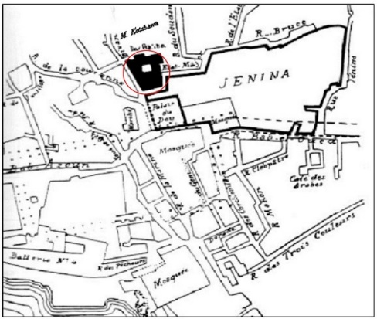
Figure 3. The location of the Dj’nīna royal complex, including the Aziza Bey palace, the plan of the Algiers city dating from 1816 [10].

The first layer consists of ‎horseshoe-arched arcades supported by white marble columns, with Corinthian capitals on twisted ‎or half-twisted shafts on the ground and upper floors, respectively. The second layer ‎comprises four walls that contribute to the interior’s decorative atmosphere through the rhythmic ‎interplay of doors and windows in the main spaces (rooms) facing the patio (figure 4 and 5), as well as the ‎remarkable ornamentation of the finely sculpted marble frames around these openings on three ‎sides.
A careful observation of this ornamentation reveals an artistic language inspired by ‎nature (figure 6). The choice and arrangement of motifs seem to reflect a deeply metaphysical spirit, which ‎has played a crucial role in the development of past arts, especially those that were shaped under ‎religious influence [35], such as Christianity and Islam. Adopting this ideology had one purpose: to use ‎art, even ornamentation in the first place, to memorize historical events, myths, and religious and ‎socio-cultural beliefs effectively [24], [36].

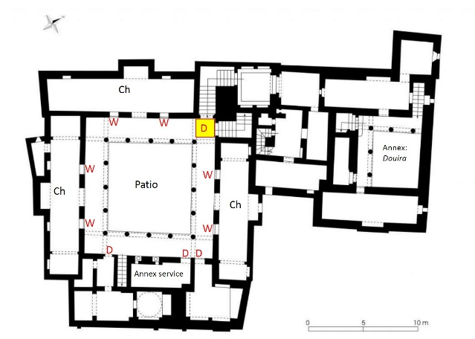
Figure 4. Plan of the ground floor: location of the marble door and window frames overlooking the patio
(W: window frame; D: door frame) [6]

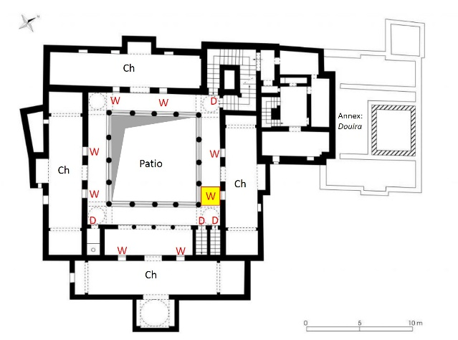
Figure 5. Plan of the first floor: location of the marble door and window frames overlooking the patio
(W: window frame; D: door frame) [6]

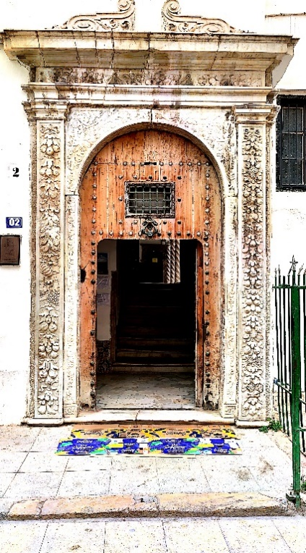 | 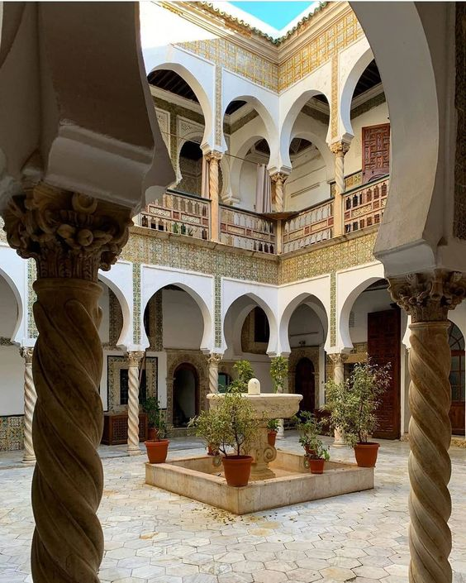 | 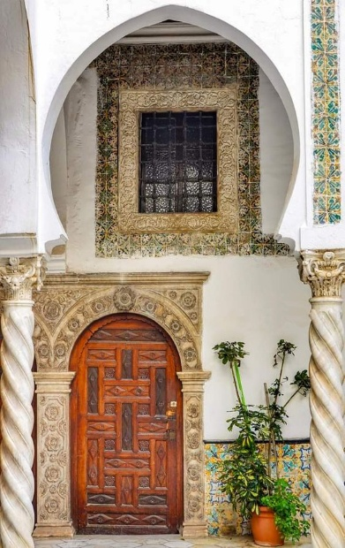
Figure 6. Views of the interior of the Aziza Bey palace: (a) Main entrance door, (b) and (c) Patio and gallery

    - VEGETAL ORNAMENTATION ON MARBLE: THE ART OF EASTERN AND WESTERN INFLUENCES COMBINED
The Quran has influenced the metaphysical context of Islamic vegetal ornamentation, as it contains ‎numerous references to plants, vegetables, fruits, and even flowers [37]. On the other hand, the plant ‎repertoire of Christian ornamentation was inspired by antiquity and shaped by Neoplatonic ‎thought [38]. Its original metaphysical inspiration was strongly expressed in the miniature frames of the ‎illusionist manuscript “Hours of Catherine of Cleves”, published in the late 14th century [25][39][40], as ‎well as in the illustrations created by the protagonist Poliphile [41]. These publications include many mythological ‎expressions about plants and their significant roles in human life, referring to the Christian belief ‎that God created each plant for a specific purpose, whether aesthetic or curative [40].‎
Vegetal ornamentation did not originate with Islam or Christianity. It existed since the Assyrian era ‎and then developed in the classical arts of Egypt, Greece and Rome [22]. With the influence of the ‎Persians and Pagans, and later the Sassanids, the ornamentation gained a rich floral vocabulary [42].‎
However, the Islamic prohibition of depicting living beings was the main driver for creating stylized ‎vegetal ornamentation using geometry, which was initiated by the Seljuks, and advanced by ‎the Ottomans, who enriched this new artistic form [43]. On the contrary, Euclidean theories on divine ‎proportion as a fundamental principle of aesthetic beauty, especially in architecture, led to the ‎establishment of canons for optimal proportions in artworks [30], [44]. Between the 15th and 18th ‎centuries, a group of Western artists known as antique sculptors, such as Pisano, Donatello, and ‎the Della Robbias, introduced a new type of ornamental art [45]. This new style featured the ‎reproduction of antique motifs, conceived in a more realistic and conventional way, using the rules ‎of the golden ratio Phi (Φ) and dynamic ratios (√2 and √5) [27].‎

    - FLOWERS, FRUIT, AND FOLIAGE AS THE MAIN MOTIFS OF VEGETAL ORNAMENTATION ON MARBLE AT ‎THE OTTOMAN PALACE, AZIZA BEY:
The vegetal element, especially floral, in the decoration of a space evokes the feminine realm of ‎the gift of life [46]. It is the case of the Aziza Bey palace, built in honor of a woman. Inside the palace, ‎the carved calligraphic inscription above the upstairs entrance is from an Andalusian poem (figure 7), ‎expressing the building's luxurious status within the Djénina. Indeed, the expression "Saäd Al-‎Sa'ud", referring to the season from February 25 to March 10, when spring begins to blossom [47], ‎provides a perfect illustration of the sophisticated vegetal ornamentation on marble (figure 8).‎

Figure 7. Calligraphic inscription below the upstairs access‎, the poem is translated as follows: "Be for the house you built is good to go down -- In the houses of highness joy. You are a full moon among the people, illuminating -- And it is Saad Al-Sa'ud between the houses"

Therefore, two primordial ornamental registers emerge on most marble frames inside the ‎Aziza Bey palace. The first consists exclusively of floral ornamentation, as in the case of the window ‎frames overlooking the patio, while the second includes fruit, flowers, and foliage, as in the case of ‎most of the doorframes that also overlook the patio.

Figure 8. The marble frames of the doors and windows of the Aziza Bey Ottoman palace in Algiers

  - DISCUSSION
The metaphysical context as a verifying indicator of the artistic origin of the vegetal ‎ornamentation of Aziza Bey palace‎.

    - Register 01: floral ornamentation of a marble window frame
The first frame under the analysis belongs to the window of the upper-floor room (Figures 9 and 10). The floral motifs in ‎this context draw inspiration from Islamic art, particularly the Ottoman tradition, where primary ‎motifs encompass clove or pomegranate flowers, tulips, lotuses, roses, rooster's crests, and various ‎palm leaves [16][23][48]. Undoubtedly, the symbolic context is profoundly embedded in this registry, as the incorporation of vegetal motifs in Islamic art evokes the imagery of paradise and its everlasting ‎gardens [24]. Additionally, Sufism has significantly influenced Ottoman art's spiritual and religious underpinnings. Adhering to the principle of abstaining from depicting living creations, all artworks ‎must reflect the sacred connection between the Creator, Allah, and humanity [24].

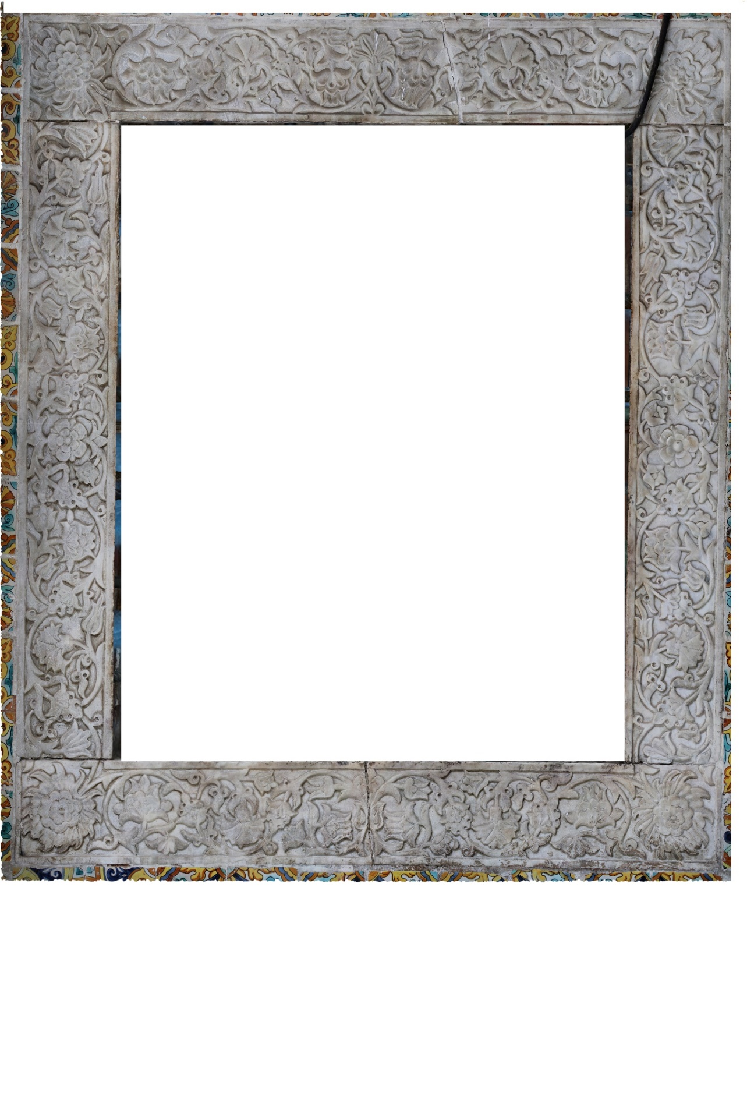
Figure 9. Photogrammetric details of ornamentation - marble window frame in Aziza Bey palace

Conversely, the floral motif symbolizes fertility, and its magnificence parallels the pearls adorning ‎the houris of paradise [24][49]. Among the prominently featured flowers in this registry, the tulip holds a ‎preeminent position. With its physiognomy reminiscent of the letters of the Creator's name, Allah ‎الله‎, the Ottomans gave it the mysterious name Lalleh or lāle, expressing eternal love and human ‎attachment to the Creator [23][50].

Figure 10. A metaphysical reading of the plant ornamentation on a marble window frame

The arrangement of the floral motifs in this frame is subject to a carefully considered logic (figure 10). The ‎artist's message is symbolically justified as follows (table 1): ‎
• A clove, considered a key attribute of Sufism [23], tops the frame's vertical axis of symmetry. ‎
• This clove is situated between two downward-facing tulips, symbolizing the Ottoman ‎world's submission to Sufism [50]. ‎
• The pomegranate flower dominates the four corners of the frame. This flower, reminiscent ‎of paradise [51], is often mistaken for the lotus floating on water, which signifies asceticism, and the basil flower as the secondary attribute of Sufism [23]. In Sufi thought, basil represents the pure soul that ascends to its Creator, like Rihanna. That is why its ornamentation is carved high, looking up to its Creator. It is a plant of paradise [50]. Quranic translators also interpret it in Surah Al-Rahman, verse 12-13: «He laid out the earth for all beings. And grain with husks, and basil. Then which of your Lord's favors will you ˹humans and jinn˺ both deny?» which means that it represents all the sustenance and blessings that God has created for human beings. Other significances of basil in Islamic art are reflected in Surah Al-Waq’iah, verse 88-89: «Then, ‎if he be of the near believers, then for him are Rawh (soul/mercy), Rayhan (basil), and ‎Garden of Delights». Its symbolism here represents all kinds of good smells that are pleasing to the soul and remind us of the heavenly air [52][53].‎‎
• The rose adorns both sides of the frame's horizontal axis of symmetry. It represents the ‎symbol of the Prophet Mohammed (PBUH) in reference to the prophetic Hadith: ‎«Whoever would smell my scent, let him smell the rose». Moreover, the rose known as “Warda” is only mentioned in Surah Al-Rahman 37: ‎ ‎«When the heaven shall be cleft asunder, and become rose red, like stained leather». While the rose known as “Zahra” is often attached to the name of Fatima "Az-Zahra", the only daughter of the Holy Prophet (PBUH), corresponding as inspiration to the light soaring to the heavens [54]. Thus, the word Zahra is exclusively present in Surah Taha 131 in the Quran, in which it signifies the splendor of worldly life through which Gods tested the non-believers. As follows: ‎«Do not let your eyes crave what We have allowed some of the disbelievers to enjoy; the ˹fleeting˺ splendor of this worldly life, which We test them with. But your Lord’s provision ˹in the Hereafter˺ is far better and more lasting» [55].
• Lotus blossoms follow the curved line of the ornamentation's master stem. This line ‎consists of interconnected curves, upon which the lotus blossoms appear repeatedly at the ‎beginning and end of each curve. It symbolizes the pursuit of God and the notion that ‎‎ ‎«He is the First and the Last» (Quranic verse, Surah Al-Hadid, 3) [56]. ‎
• All tulips face inward, signifying Ottoman predominance and submission simultaneously ‎towards the center of the frame. ‎
• The clove and pomegranate flowers face outward, emphasizing their spiritual connection ‎with the divine upper world, symbolized by paradise. ‎
• The cock's crest is also an emblem of Ottoman sovereignty and an attribute of the Sultan. ‎Its shape often leads to confusion with another flower known as "The Sultan's turban"‎ [16].
• The fruiting plants motifs chosen, like pomegranate and grapes, serve as a reminder of God's numerous blessings to human beings, ‎as subjectively mentioned in the Holy Quran, such as in Surah Al-An'am 99: ‎«It is He, Who sends down water (rain) from the sky, and with it, We bring ‎forth vegetation of ‎all kinds, and out of it, We bring forth green stalks, ‎from which We bring forth thick clustered ‎grain. And out of the date-palm ‎and its spathe come forth clusters of dates hanging low and ‎near, and ‎gardens of grapes, olives, and pomegranates, each similar (in kind) yet ‎different (in ‎variety and taste). Look at their fruits, when they begin to ‎bear, and the ripeness thereof. Verily, ‎in these things there are signs for a ‎people, who believe», and in Surah Al-Rahman 88: «Then, ‎if he be of the near believers, then for him are Rawh (soul/mercy), Rayhan (sweet basil), and ‎Garden of Delights » ‎[57].

Table 1. The main floral motifs and their metaphysical expressions in the vegetal ornamentation of the Ottoman Palace’s, Aziza Bey, artistic origins

Flower | Clove | Tulip (Lāle) | Lotus | Rose | Cock's crest ‎ | pomegranate flowers | Palm leaves
Motif on marble
Expression  Signification | Sufism | Ottoman Identity  Divine love | Asceticism  Sufism | Prophet Mohammed (PBUH) | Ottoman supremacy | Paradise | Paradise

    - Register 02: Fruit, flower, and foliage ornamentation on a marble doorframe
Fruit, flowers, and foliage ornamentation can be observed on most doorframes ‎overlooking the palace patio (Figures 8 and 11). This decorative register includes cascades or bouquets along the ‎vertical axis of each pilaster and in scrollwork on each corner of the doorframe. The second marble ‎frame under the analysis is that of the main door leading to the ground floor. The ornamentation on ‎this particular frame (figure 11) exhibits a distinctly Western appearance, as this style of ornamentation ‎reached its zenith during the Italian Renaissance, drawing inspiration from sarcophagi inherited ‎from antiquity [35]. Consequently, the metaphysical context undoubtedly influences the composition ‎of this decorative register, particularly influenced by the Christian theory of "the plant interprets its ‎use." Indeed, Western artists have frequently employed this theory to rationalize their selection ‎and arrangement of motifs in their ornamental works [58].

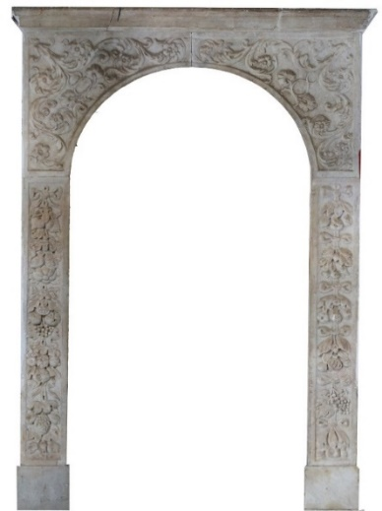
Figure 11. Vegetal ornamentation on doorframes: Fruit, flower, and foliage ornaments gathered in ribbons

A meticulous analysis of this register (figure 12) has allowed us to interpret the symbolic significance of each ‎vegetal motif in accordance with Christian theory as follows: ‎
• On the spandrels: The soft acanthus leaf, paired with its flower, represents the legendary ‎emblem of antiquity. Their interweaving creates an effect of convergence and divergence. ‎
• On the pilasters: Various types of vegetation appear suspended, held together by ribbons at ‎the top of each bouquet. These bouquets convey a sense of readiness for gifting [59]. ‎
• The various fruits employed: These symbolize the emblem of Ceres and signify regeneration. ‎The examples include pomegranates, grapes, and figs [40].‎
• Aromatic fruits, such as lemons, quinces, and apricots, represent the fragrances of paradise. ‎They represent the fruits of the "tree of the knowledge of good and evil", ‎with pinecones symbolizing eternity [60].‎
• The apple represents the fall of humanity, often accompanied by the strawberry as a symbol ‎of Christ's passion [25].
• Floral elements: Emerge at the beginning of the fall with the lily flower, evoking Western ‎Christian identity and representing the Virgin Mary's primary attribute [40]. At the ‎end of the fall, the tulip signifies the Ottoman emblem. These two flowers express the two ‎opposing superpowers that held dominion over the world during that period: Europe and the ‎Ottoman Empire. ‎
• The choice to position the lily at the top, in contrast to the tulip: Likely alludes to political ‎rhetoric. ‎
• The frequent use of triple vegetal motifs: Corresponds to the consecration of the Trinity. ‎
• The arrangement of the ornamental falls into four plant bouquets: Symbolizing the four seasons ‎of the Gregorian year [61].

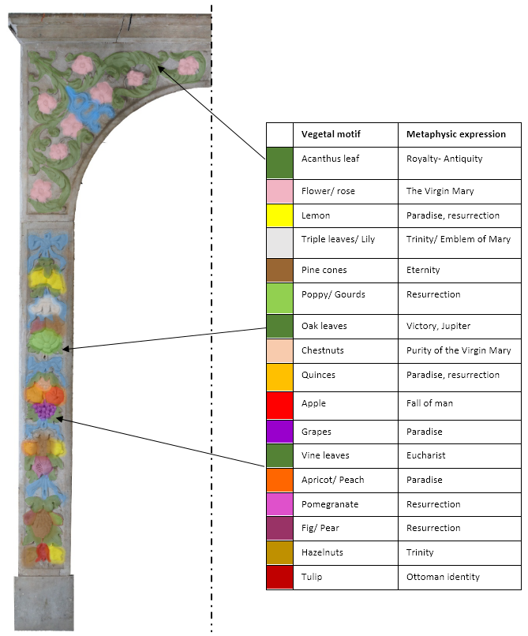
Figure 12. The main vegetal motifs (flowers-fruits-leaves) and their metaphysical expressions in the vegetal ornamentation of marble door frames
The parametric context as a confirmatory indicator of the artistic origin of the vegetal ‎ornamentation of the Aziza Bey palace: ‎

- Register 01: Rumi-Hatayi floral ornamentation as an oriental artistic origin
A parametric examination of the ornamentation on a window-frame entablature confirms its ‎Islamic identity within its register (figure 13), revealing the following characteristics: ‎
• The ornamentation, as a whole, conveys a sense of infinity and limitlessness. The motif remains ‎so repetitive that discerning its precise starting or ending point becomes virtually impossible [56]. ‎
• Its composition reveals a geometric logic, primarily rooted in the circle, which is the ‎fundamental form of Islamic art. The circle symbolizes the universe, with its center denoting ‎Mecca and thus corresponding to the act of pilgrimage [27][62]. ‎
• The banner's surface is rectangular (length = 4 x width) and divided into an orthogonal ‎grid using four identical squares. The intersection of the axes of each square establishes the ‎center of the circle, with the circle's diameter matching the square's side length within ‎which it is inscribed. ‎
• Alternating circles are vertically indented by the tangent, with the indentation measuring a ‎quarter of the circle's diameter. ‎
• The curved line is created using these alternating circles, representing the ornamentation's guiding line.
• Each flower is positioned in the center of gravity of the circle in which it is drawn. ‎
• All ornamentation must ensure a balance between full and empty (full/empty = 50%) [16][29][48]. ‎
• The selection of harmonious motifs, proportionally scaled and interconnected through ‎tangents, is outlined using circles and concentric radial lines. These motifs are gradually ‎integrated into the ornamental composition [16][63]. ‎
• The scrolling of the various motifs follows the guiding line, materializing the master stem from ‎which the minor stems gradually extend [27][64]. ‎
Nonetheless, the Ottoman character prominently manifests itself through the stylistic elements of ‎ ornamentation, whether in the composition of Hatayi-floral forms or the incorporation of palm ‎leaves abstracted from Rumi’s zoomorphic designs. These two styles collectively epitomize the artistic ‎representation of Anatolian vegetal ornamentation [16].

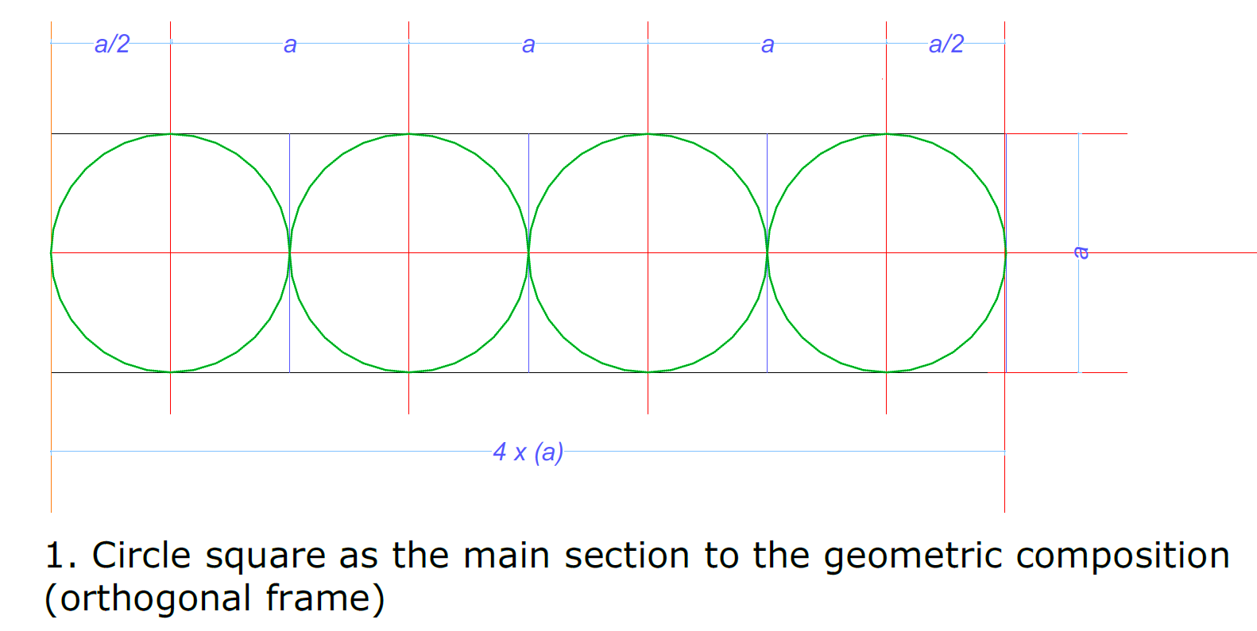 | 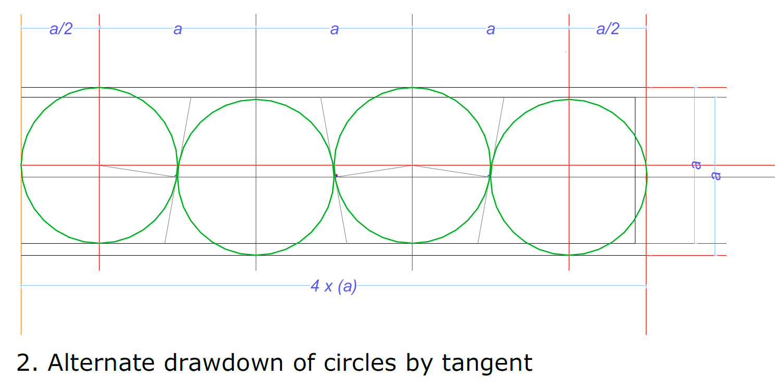
A | B
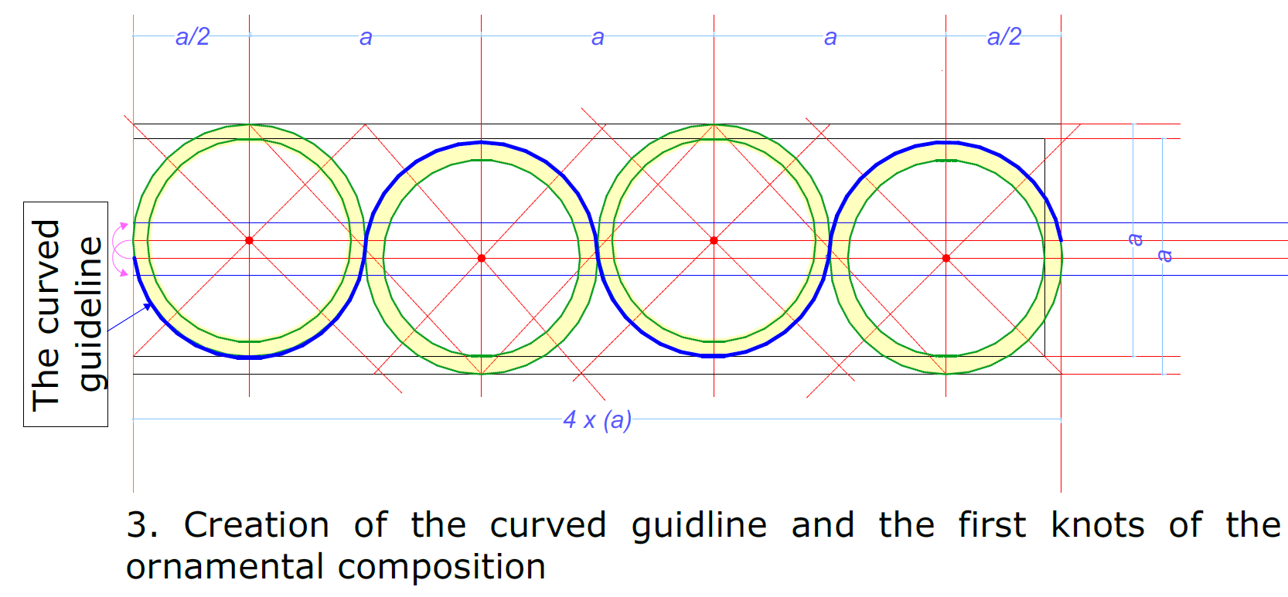 | 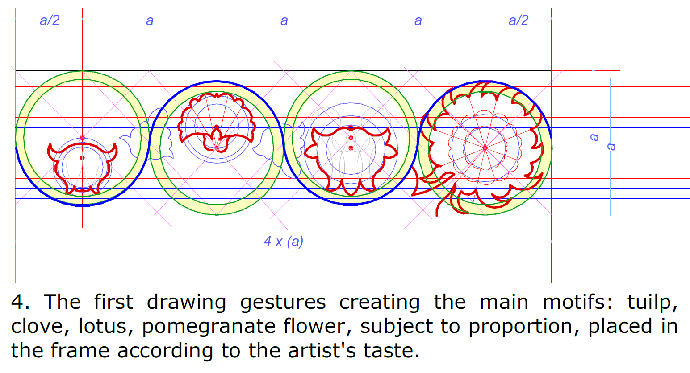
C | D
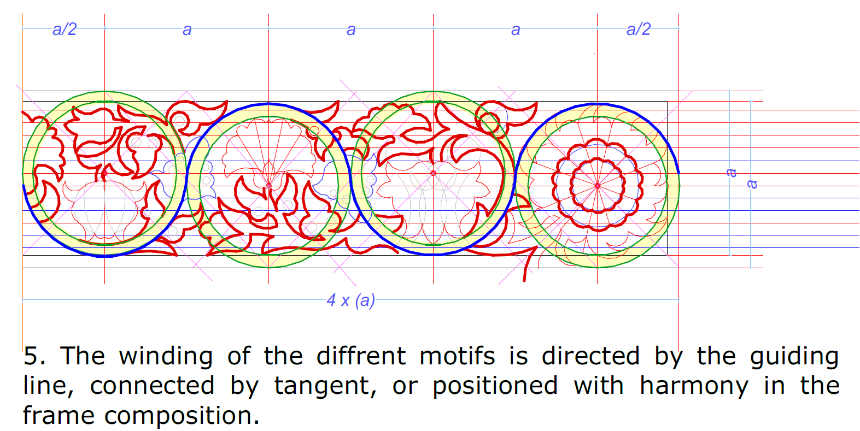 | 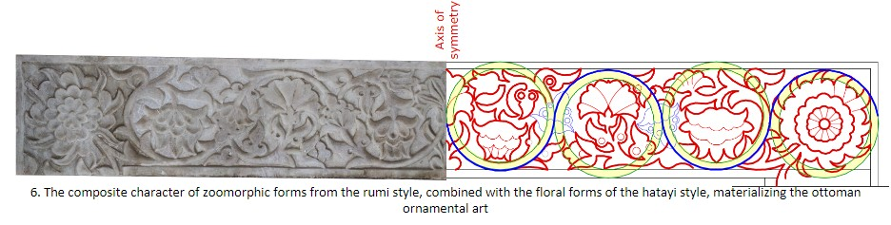
E | F
Figure 13. Parametric analysis of the ornamental composition of the upper entablature of the marble window frame; from figure (a) to (f): ornamental tracing process

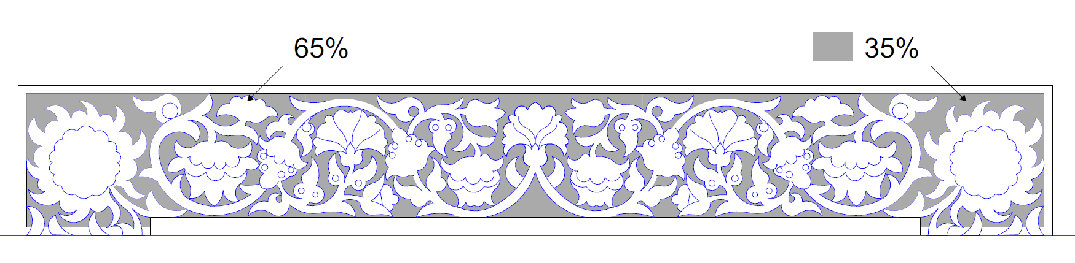
Figure 14. The balance between full and empty in the Ottoman plant ornamentation of a window frame section analyzed, evaluated at 35/65 ≈ 50%

- Register 02: Italian Renaissance vegetal ornamentation as an Occidental artistic origin
A parametric analysis of the ornamental composition of the doorframe (figure 15 and 16) affirms the utilization of ‎mathematical principles derived from the laws of proportion that came back into vogue in the ‎Italian Renaissance [30], [65], explained as follows: ‎
• The incorporation of Doric elements, including dynamic and equilateral triangles in ‎spandrel tracing, employs circles and adheres to bilateral symmetry. ‎
• Mathematical ratios such as (√2 and √5), along with the golden ratio (Φ), play a pivotal role in ‎strategically positioning the primary intersecting lines within the composition, notably in the ‎placement of the floral motifs [27][28]. ‎
• The interlacing of curves is meticulously adjusted, often employing tangents or relying on the ‎artist's expertise, who may influence the shape of the ornamental surface. ‎
• Each pilaster's surface is subdivided into an orthogonal grid using Doric triangles [28]. ‎
• The ratio between full and empty is also conceived proportionally through the use of the ‎golden ratio (Φ) [27][28]. ‎
• The arrangement of motifs within the ornamentation adheres to the principles of decorative ‎composition, encompassing aspects like balance, repetition, alternation, and rhythm [27][28]. ‎
• The number of fruits in the various bouquets increases rhythmically from top to bottom, from ‎two to five, often alternating between three small leaves at the top and two large leaves at the ‎bottom.

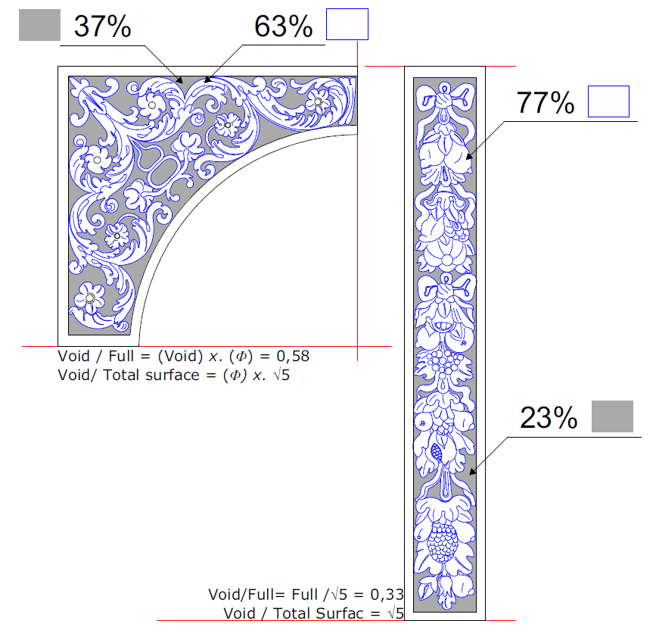
Figure 15. Proportional full/empty ratios in spandrels and pilasters

This rhythmic arrangement is a recurring motif in the vegetal ornamentation of the Italian ‎Renaissance (15th-18th centuries), further confirming the occidental artistic origin of this style. In ‎contrast, the design of vegetal motifs in Occidental art is often characterized as 'hand-drawn,' ‎particularly in the case of fruit, flower, and foliage motifs, which fall under the category of figurative ‎motifs. This complexity justifies the challenge of precisely discerning the tracing process for pilaster ‎ornamentation. Conversely, geometrical motifs are constructed using relatively clear and readily ‎reproducible diagrams, primarily crafted with the aid of a ruler and compass, as exemplified by the ‎motifs inscribed on the spandrel.

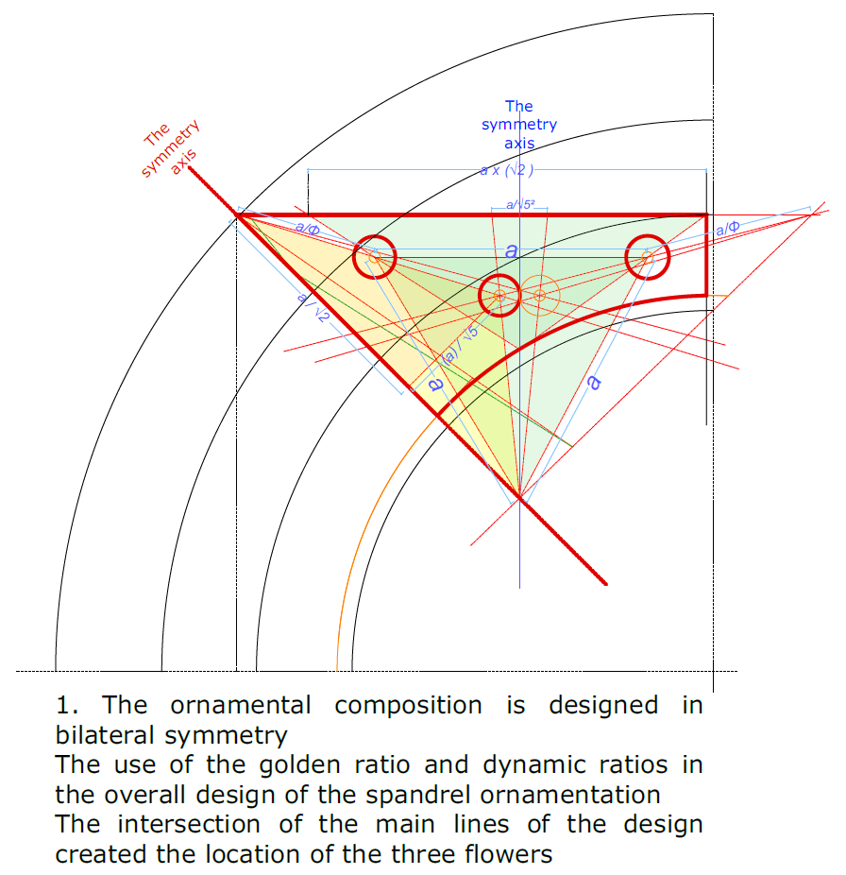 | 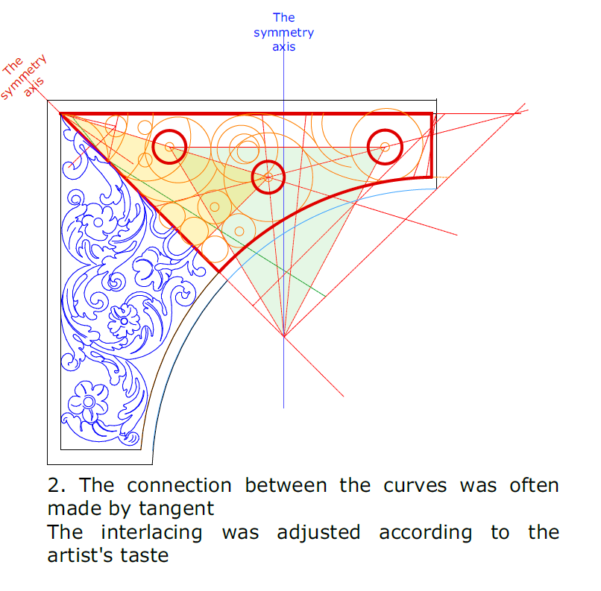
A | B
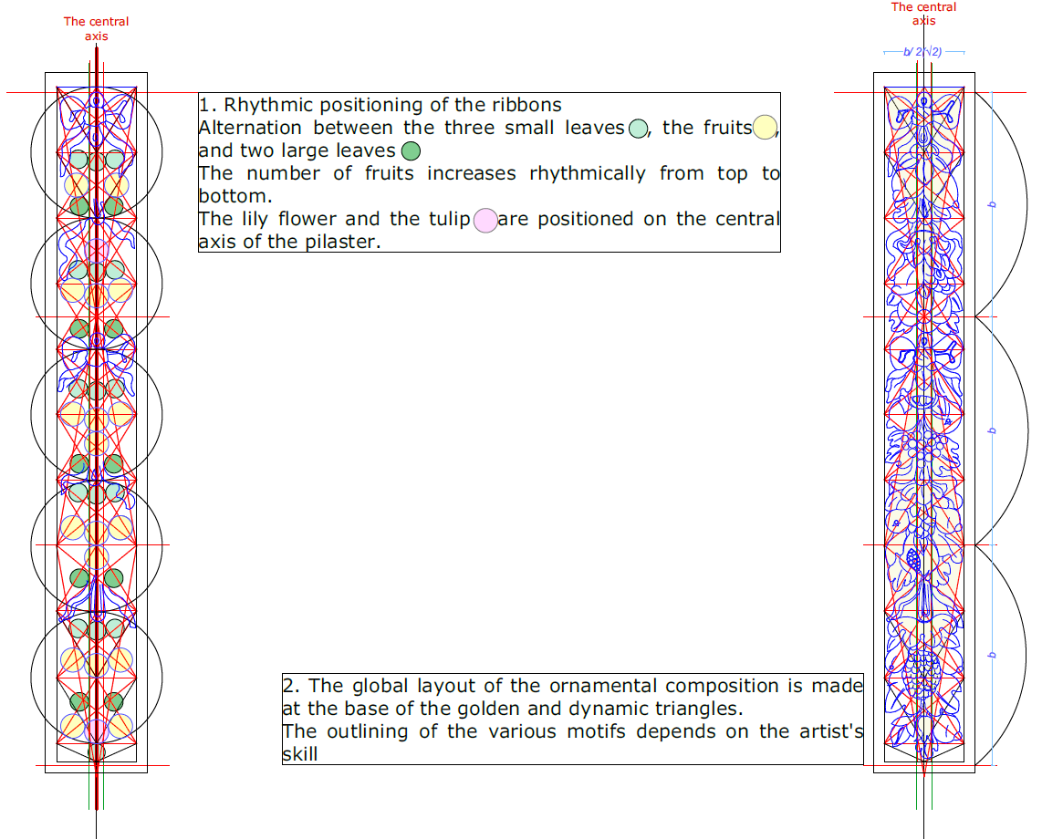
C
Figure 16. (a) parametric spandrel analysis (b) spandrel tracing process (c) parametric pilaster analysis

- CONCLUSION
Although ornament brings no real contribution to the structure or functionality of the element in ‎which it appears, it remains one of architecture's recognized expressions. It remains an ‎indispensable key to the historical and artistic identification of art and artifacts. ‎A detailed examination of the vegetal ornamentation on marble in the Aziza Bey palace, one of the ‎few remaining examples of early palatial architecture in Ottoman Algiers, reveals the careful choice ‎of motifs. Ultimately, it reflects the imaginative and artistic progress of a cosmopolitan ‎workforce. This last was indoctrinated into two transversal arts from the East and the West. ‎Identifying the artistic origin of the vegetal ornamentation on marble in the Aziza Bey palace has ‎long been a crucial issue in research concerning Ottoman architecture in Algiers. It was due to its ‎history, which remained as strange as it was missing.
This study provides an original approach to answering this question using observation, literature‎, and digitization (photogrammetry, CAD). From there, the interpretation of ornament proceeds in ‎two complementary directions: metaphysical and parametric. The object of study was two marble ‎frames for doors and windows inside the Aziza Bey palace. ‎The results objectively affirm that the Aziza Bey palace possesses an ornamental ‎vocabulary combining Oriental and Occidental influences. ‎
Oriental artistic origins appear in the first frame analyzed - register 01 -, inspired by its Anatolian ‎style Rumi-Hatayi, created from zoomorphic stylization and floral abstraction. Its ornamental register ‎is rich in floral motifs, long favored in Ottoman art. It is due to their symbolic value, as in the case ‎of the tulip, the clove, the lotus, the pomegranate blossom, the cock's crest, and many other ‎flowers that identify Ottoman culture as either a religious attribute or a symbol of identity. The ‎thoughtful arrangement of these different motifs has given rise to a metaphysical expression ‎through which the Muslim artist relates his sacred feelings to the spiritual world without adopting ‎the figurative representation that Islam has prevented since its inception. ‎
The parametric analysis of its ornamental composition further confirms its Islamic Ottoman identity ‎through the presence of the orthogonal grid, the exclusive use of the circle, the balance between ‎full and empty, and the perfect symmetry, either bilateral or quadrilateral. ‎
The occidental origin is recognized in the second frame analyzed - register 02 - relating to the main ‎door on the ground floor. This identification reveals the presence of the three main components of ‎the vegetal arabesque (fruit, flowers, and foliage), which came back into vogue in Italian ‎Renaissance art. The doorframe in question features a series of bouquets of vegetal motifs linked ‎together by overlapping ribbons, arranged in various ways, either by repetition, alternation, or ‎variety over the entire scroll. The use of fruit signifies wealth and comfort, and their arrangement ‎follows the succession of the four seasons of the Gregorian year. Meanwhile, flowers and leaves ‎refer to the legendary language of Christian culture, dating back to late antiquity. However, it is not ‎necessarily that every ornament conveys a meaning or message; sometimes, it is simply an effect of ‎artistic diligence or desire.
Divine proportion as the guiding principle in the creation of this register further confirms its ‎occidental Italian identity. The golden ratio (Φ) in the design of basic shapes, such as the ‎triangle and rectangle, and the balance between full and empty, supports this argument. The ‎arrangement of motifs in the falls of pilaster ornaments is a way of imposing the main laws of ‎decorative composition on ornamentation, such as balance, repetition, alternation, and rhythm. ‎
The study of marble ornamentation in the Ottoman architecture of Algiers, particularly the Aziza Bey ‎palace, requires further investigation. These will certainly enable us to refine and improve our ‎knowledge of the history of the ornamentation inherited from a period of intensive cultural ‎exchange around the Mediterranean basin. One of the challenges we face at this research stage is the limited knowledge we have about the precise origins of the Italian Renaissance ‎registers. The question arises as to whether they result from the diligence of Christian ‎captives or just orders given from Italy. On the other hand, the singularity of some other marble ‎registers composed entirely of rosettes within the palace undoubtedly deserves further discussion. ‎Indeed, the important role of Moriscos in the history of the construction of Ottoman Algiers, as well ‎as that of the indigenous Algerians, could provide further insight into identifying these ‎registers.‎.

ACKNOWLEDGEMENT
We would like to thank the Cultural Property Management and Development Authority of Algiers (O.G.E.B.C) for their collaboration in facilitating our observation and photogrammetric survey of the marble frames inside the Aziza Bey palace in Algiers. We are also grateful to the laboratory ETAP/IAU of the University of Blida 1 for acquiring the equipment needed to successfully achieve this research and to the General Directorate for Scientific Research and Technological Development of Algeria (D.G.R.S.D.T) to have funded the research.

REFERENCES
[1] S. Missoum, Alger à l’époque ottomane, La médina et la maison traditionnelle, Edisud: Aix en provance, 2003.
[2] S. Chergui, “Les morisques et l’effort de construction d’Alger aux xviie et xviiie siècles,” Cah. Méditerranée, no. 79, Art. no. 79, Dec. 2009, doi: https://doi.org/10.4000/cdlm.4932.
[3] M. Beaussier, Practical Arabic-French dictionary: all the words used in the Arabic spoken in Algeria and Tunisia, Librairie Adolphe Jourdan, 1887.
[4] S. Chergui, “Le lexique des patrimoines architecturaux dans la Régence d’Alger, support de thésaurus?,” Patrim. Maghreb À L’ère Numér., p. 16, 2015, [Online]. Available: https://patmagh.hypotheses.org/172
[5] M. Vidal-Bué, Villas et Palais d’Alger de XVIIIè à ce jours, Paris: Place des victoires, 2014.
[6] L. Golvin, Palais et Demeurs d’Alger de la période ottomane, EDISUD: Aix en provance, 1988.
[7] S. Chergui, “Construire, gérer et conserver les mosquées en al-Djaz. ’ir ottomane (XVIe–XIXe siècles),” These de doctorat, Paris 4, 2007.
[8] N. Djaalali Drioueche, “Dar Aziza Bey, mémoire d’un lieu: La Djenina d’Alger,” Vie Villes, no. 7, p. 74, 2007.
[9] N. ibn I. M. al-(1823-1865) A. du texte Maʿlūf, French-Turkish dictionary, with figurative pronunciation (2nd edition... corrected and considerably expanded), Paris: Maisonneuve, 1856.
[10] H. Klein, Feuillets d’El Djezaïr du comité du vieil Alger, volume récapitulatif. 1937.
[11] G. Braun, F. Hogenberg, Algiers, CartaHistorica, 1612.
[12] F. Benouis, “Alger: De la médina des Beni Mazghenna à la capitale de la Régence ottomane,” in Un architecture de Lumière. Les arts de l'Islam en Algérie. (version provisoire et incomplète). L’Art Islamique en Méditerranée. Vienna: Museum Ohne Grenzen/Museum With No Frontiers (MWNF), pp. 84-115, 2017
[13] A. Ravérau, M. Roche, and M, "Lacheraf, La Casbah, et le site créa la ville, Sindbad", in Bibliothèque arabe. Paris, 1989.
[14] R. Born, M. Dziewulski, and K. Twardowska, “The Ottoman Orient in Renaissance Culture,” Int. Exhib. Ottomania Ottoman Orient Renaiss. Art Natl. Mus. Krakow, p. 258, 2015.
[15] M. Gharipour, Gardens of Renaissance Europe and the Islamic Empires: Encounters and Confluences, Penn State University Press, 2017.
[16] C. E. Arseven, Les arts décoratifs turcs. Istanbul: Millî Eğitim Basimevi, 1950.
[17] P. Eudel, L’orfévrerie algérienne et tunisienne, A. Jourdan, 1902.
[18] V. De Paradis, Alger au XVIIIème Siècle, E.Fagnan. Typographie Adolphe Jourdan, 1898.
[19] T. Shaw, J. MacCarthy, Voyage dans la Régence d’Alger, Description géographique, physique, philologique, etc de cette Etat, Paris: Chez Marlin, 1830.
[20] F. D. De Haëdo, Topographie et histoire générale d’Alger, Editions Grand-Alger Livres. 1612.
[21] S. Chergui, Les mosquées d’Alger: Construire, gérer et conserver (XVIe-XIXe siècles), Paris: PUPS, 2011.
[22] G. Necipoğlu and A. Payne, “Early Modern Floral: The Agency of Ornament in Ottoman and Safavid Visual Cultures,” in Histories of Ornament. From Global to local, Princeton and Oxford: Princeton University Press, pp. 132–155, 2016.
[23] A. A. M. S. Hind, “Plants ornament on applied arts in Asian Minor in Ottoman period,” PhD thesis, Cairo University - Archeology Islamic, Cairo, 2012.
[24] P. Ringgenberg, L’univers symbolique des arts islamiques, Harmattan, 2009.
[25] R. Williams, “Patterns in the Framing: Patience and The Hours of Catherine of Cleves,” Concept:Interdisciplinary Journal of Graduate Studies, vol.28, 2005.
[26] R. N. Wornum, Analysis of Ornament: The Characteristics of Styles: an Introduction to the Study of the History of Ornamental Art, London: Chapman and Hall, 1860.
[27] A. Bibimoune and S. Chergui, “The geometric appearance of columns and frames in the palatial Ottoman architecture of the Algiers Casbah: What process to create?,” REHABEND Euro-Am. Congr. Constr. Pathol. Rehabil. Technol. ‎Heritage Manag. Granada Univ. Cantab., 2022.
[28] S. Boussmha, S. Chergui, and M. Zouaoui, “An assessment of the aesthetic value of the islamic unversity mosque in Constantine,” J. Islam. Archit., vol. 5, no. 3, pp. 199–128, Jun. 2019. doi: https://doi.org/10.18860/jia.v5i3.4622
[29] Y. Abdullahi and M. R. Emb, “Evolution of abstract vegetal ornaments in Islamic architecture,” Int. J. Archit. Res. Malays., vol. 9, no. 1, pp. 31–49, Mar. 2015.
[30] M. C. de La Souchère, “Le nombre d’or et la divine proportion,” in Les sciences et l’art - Peinture, musique, architecture, cinéma, littérature et science fiction, Ellipses., p. 208, 2016.
[31] J. Beuvier, F. Hivert, and T. Roulet, “ROSER : une base de données numérique pour lire l’ornement sculpté à la Renaissance,” La recherche sur le patrimoine et les outils numériques à l’épreuve de l’expérimentation, Jul. 2020.
[32] M. Higueras, A. I. Calero, and F. J. Collado-Montero, “Digital 3D modeling using photogrammetry and 3D printing applied to the restoration of a Hispano-Roman architectural ornament,” Digit. Appl. Archaeol. Cult. Herit., vol. 20, p. e00179, Mar. 2021, doi: https://doi.org/10.1016/j.daach.2021.e00179.
[33] N. Yazar and T. Y. Yazar, “Re-Generating Continuous Rumî Compositions,” Proc. Bridg. 2018 Math. Art Music Archit. Educ. Cult., pp. 23–30, Jul. 2018.
[34] M. Hocine, “Le palais Aziza bent es soltan : histoire mouvementée du dernier témoin de l’ensemble de la Djenina d’Alger,” Aleph, vol. 10, no. 2, pp. 181–210, 2023.
[35] E.-E. Viollet-le-Duc, Dictionnaire raisonné de l’architecture française du XIe au XVIe siècle. B. Bance, 1859.
[36] J.-C. Bonne, M. Denoyelle, C. Michel, O. Nouvel-Kammerer, and E. Coquery, “Y a-t-il une lecture symbolique de l’ornement ?,” Perspective, no. 1, pp. 27–42, Jun. 2010, doi: https://doi.org.10.4000/perspective.1206.
[37] Y. Abd Al’Nacer, Religious symbolism in Islamic decoration: a study in Metaphysica Islamic art. Cairo: Zah’raa Al’Charq, 2006.
[38] J. Loisy, “Giorgio Vasari and the Terza Maniera’s relief,” Thèse, Art et histoire de l’art, Université de Lorraine, 2021.
[39] H. Deronne, “Signes et symboles dans l’écriture picturale : exemples choisis,” in Langages et communication : écrits, images, sons, M. Corbier and G. Sauron, Eds., in Actes des congrès nationaux des sociétés historiques et scientifiques. , Paris: Éditions du Comité des travaux historiques et scientifiques, pp. 171–176, 2018.
[40] E. R. Schaeffer, “Image and Meaning in the Floral Borders of the Hours of Catherine of Cleves,” Masters Theses of Arts (MA). 1271, Eastern Illinois University, 1987.
[41] F. Colonna, Hypnerotomachia Poliphili: The Strife of Love in a Dream, London: Thames&Hudson, 2005
[42] A. Yoltar-Yıldırım, Ottoman decorative arts, Republic of Turkey : Ministry of Culture and Tourism, 2009.
[43] T. Burckhardt, Art of Islam: Language and Meaning, World Wisdom, Inc, 2009.
[44] P. Gros, “La notion d’ornamentum de Vitruve à Alberti,” Perspective, no. 1, pp. 130–136, Jun. 2010, doi: https://doi.org/10.4000/perspective.1226.
[45] L. de Finance and P. Liévaux, “Le vocabulaire de l’ornement,” Perspective, no. 1, pp. 123–129, Jun. 2010, doi: https://doi.org/10.4000/perspective.1223.
[46] M. A. Kamal, S. Gulzar, S. Farooq, “Exploration of Arabesque as an Element of Decoration in Islamic Heritage Buildings: The Case of Indian and Persian Architecture,” Journal of Xi'an University of Architecture & Technology, vol. 12, issue X, pp. 843–852, Nov. 2020.
[47] E.B., M. Gast, and J. Delheur, “Calendrier,” Encycl. Berbère, no. 11, pp. 1713–1720, Sep. 1992, doi: https://doi.org/10.4000/encyclopedieberbere.2039.
[48] O. Jones, Grammaire de l’ornement: illustrée d’exemples pris de divers styles d’ornement, Paris-Londres: Day et fils, 1865.
[49] S. M. Zwemer and M. C. Zwemer, “The rose and Islam,” Muslim World, vol. 31, no. 4, pp. 360–370, Oct. 1941, doi: https://doi.org/10.1111/j.1478-1913.1941.tb00950.x.
[50] F. Çetinkaya Karafakı and M. E. Yazgan, “Use of plants in ottoman ornamentation art,” Acta Hortic, no. 1002, pp. 283–287, Jul. 2013, doi: https://doi.org/10.17660/ActaHortic.2013.1002.36.
[51] M. S. Hossain, Z. Urbi, F. Z. Evamoni, F. T. Zohora, and K. M. H. Rahman, “A secondary Research on Medicinal Plants Mentioned in the Holy Qur’an,” J. Med. Plants, vol. 15, no. 59, pp. 81–97, Aug. 2016.
[52] M. I. H. Farooqi, Plants of the Quran, Sidrah Publishers, 1992.
[53] M. ibn ʻUthmān al-Ḥilmī, Tafsīr sūrat al-wāqiʻah, 1898.
[54] Y. T. Al-Jibouri, “Fatima (sa), the Daughter of Muhammad (S), a Brief Biography,” Al-Islam.org. Accessed: May 02, 2023. [Online]. Available: https://www.al-islam.org/articles/fatima-sa-daughter-muhammad-s-brief-biography-yasin-t-al-jibouri
[55] M. S. Abdul-Rahman, Tafsir Ibn Kathir Juz’ 27 (Part 27): AZ-Zariyat 31 to Al-Hadid 29 2nd Edition. MSA Publication Limited, 2009.
[56] O. Grabar, The formation of Islamic art. New Haven: Yale University Press, 1973.
[57] D. Sheikh and A. Dixit, “Plants in the Holy Quran: A look,” World J. Pharm. Pharm. Sci., vol. IV, pp. 715–738, Jul. 2015.
[58] M. J. Waters, “Reviving Antiquity with Granite: Spolia and the Development of Roman Renaissance Architecture,” Archit. Hist., vol. 59, pp. 149–179, ed 2016, doi: https://doi.org/10.1017/arh.2016.5.
[59] E. Thomas, Vocabulaire illustré de l’ornement par le décor de l’architecture et des autres arts, Paris: Eyrolles, 2012.
[60] J. Hall and K. Clark, Dictionnaire des mythes et des symboles. Paris: G. Monfort, 1994.
[61] J. Dresken-Weiland, “Christian Sarcophagi from Rome,” in The Routledge Handbook of Early Christian Art, 1st ed., R. M. Jensen and M. D. Ellison, Eds., First [edition], New York : Routledge, pp. 39–55, 2018, doi: https://doi.org.10.4324/9781315718835-3.
[62] S. Cenani and G. Cagdas, “Shape Grammar of Geometric Islamic Ornaments,” Commun. Spaces 24th ECAADe Conf. Proc. 6-9 Sept. 2006, Pp 290-297, Oct. 2013.
[63] G. Necipoğlu and M. Al-Asad, "The Topkapı scroll: geometry and ornament in Islamic architecture : Topkapı Palace Museum Library MS H. 1956", in Sketchbooks & albums, Santa Monica, CA: Getty Center for the History of Art and the Humanities, 1995.
[64] M. Z. Bousy, M. F. Habbatallah, and A. C. Alaam, “Floral ornaments on the entrances of Ottoman buildings,” J. Assoc. Arab Univ. Tour. Hosp., vol. 5, no. 2, pp. 9–13, 2008, doi: https://doi.org/10.21608/jaauth.2008.68344.
[65] C. P. J. Normand, Le Vignole des architectes et les élèves en architecture, Paris: Chez l'auteur : Pillet aîné, imprimeur-libraire : Carillan-Goeury, libraire : Bance aîné, marchand d'estampes : Rey et Gravier, libraires, 1827.

