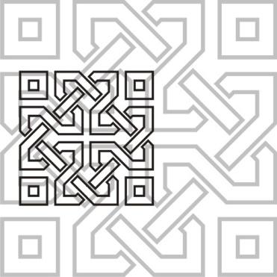 | JOURNAL OF ISLAMIC ARCHITECTURE  P-ISSN: E-ISSN:  Journal Home Page: http://ejournal.uin-malang.ac.id/index.php/JIA
THE FACTORS CONTRIBUTING IN SPIRITUALITY DEFINITION OF IRANIAN MOSQUES
(AN INTRODUCTION TO THE UNDERSTANDING THE GLORY OF IRANIAN MOSQUE IN THE BORDER BETWEEN MATTER & MEANING)

| Received | Accepted | Available online |
| DOI http://dx.doi.org/10.18860/jia.v4i1.3466 |

Sanaz Ahmadzadeh siyahrood  High-Performance Architecture Lab, Tarbiat Modares University, Tehran, Iran  e-mail: sanaz.ahmadzadeh.siyahrood@gmail.com  Arghavan Ebrahimi  High Performance Architecture Lab, Tarbiat Modares University, Tehran, Iran  e-mail: ebrahimi.arghavaan@gmail.com  Javad Ghiasvand  ‎Faculty Member at Islamic Azad University  e-mail: ja.ghiasvand@gmail.com  Mohammadjavad Mahdavinejad  Department of Architecture Tarbiat Modares University, Tehran, Iran  e-mail: Mahdavinejad@modares.ac.ir |  | ABSTRACT  One of the most challenging issues faced by every artist and architect is the relationship between form and meaning. In other words, each meaning can be stated in a certain form where depending on the artist's techniques, some of these forms can more clearly convey the respective meaning. What is examined in current article is related to the manner of applying geometry and components and elements of Islamic architecture in the architecture of mosques as forms to reflect the respective meaning. Achieving the respective meaning is final goal of Muslim architects which is nothing except monotheism. Monotheism is completely reflected in the architecture of mosques as other religious and mythological ideas.  Muslim architect, in his ascension, converts the earth to elixir by geometry. The secrets hidden in this alchemy include the use of perfectionism in form, application of hidden patterns, actualization of all properties of the form (extracting multiplicity from unity), using supplementary forms and homogenous colors to give softness and brightness to surfaces and volumes, symmetric combination of cursive and round lines in geometrical and Arabesque forms or careful and meaningful use of light and other elegant works.  KEYWORDS:  Mosque, Islamic architecture, holy geometry, meaning, form

