Richards Curve Implementation For Prediction of Covid-19 Spread in Maluku Province



Nanang Ondi1, F. Y. Rumlawang2, Y. A. Lesnussa3

1,2,3Department of Mathematics, Faculty of Mathematics and Natural Sciences, Pattimura University, Indonesia

Email: yopi_a_lesnussa@yahoo.com

Abstract

COVID-19 (Coronavirus Disease 2019) was first reported in Wuhan city, China at the end of December 2019 and spread to Indonesia specifically in Maluku Province at the end of March 2020. This study aims to predict the spread of COVID-19 cases in Maluku province as well as explore the phases of its spread using the Richards Curve which is an extension of the Logistic Curve. After estimating the parameters of the Richards Function with cumulative case data of COVID-19 in Maluku province from March 23 to November 4, 2020, the results of the spread of COVID-19 cases in Maluku province reached a turning point on October 22, 2020, and ended on May 25, 2023, with a total cumulative case of 9,451 cases.

**Keywords**: Carrying Capacity; COVID-19; Prediction; Richards Curve; Turning Point

# Introduction

Coronavirus is a group of viruses from the subfamily Orthocronavirinae in the Coronaviridae family and the order Nidovirales. This group of viruses can cause disease in birds and mammals, including humans [1]. In 2002, the SARS-CoV coronavirus (SARS Coronavirus) caused Severe Acute Respiratory Syndrome (SARS) in Guangdong, China [2]. In 2012 the type of Coronavirus MERS-CoV (MERS Coronavirus) caused Middle Eastern Respiratory Syndrome (MERS) which occurred in Saudi Arabia and the Middle East [3].

In early 2020, WHO (World Health Organization) received a report from China that there were 44 patients with severe pneumonia in Wuhan City, Hubei Province, China [4]. Subsequent research showed a close relationship with the Coronavirus that caused SARS in 2002 [5]. On February 11, 2020, WHO inaugurated the term COVID-19 (Coronavirus Disease 2019) which is an infectious disease similar to influenza caused by Severe Acute Respiratory Syndrome 2 (SARS-CoV-2) [6], [7].

The first COVID-19 was reported in Indonesia on March 23, 2020, with two cases. Data on March 31, 2020, showed that there were 1,528 confirmed cases and 136 deaths. In 1839 Verhulst introduced the Logistics Equation to model population growth which became known as the Verhulst equation and was rediscovered in 1912 [8], [9]. in 1959 in research entitled: A Flexible Growth Function For Empirical Use, Richards modified the Verhulst Equation and became known as the Richards Curve [10] or Generalized Logistic Function [11] because it is an extension of the Logistic Model [12], [13]and in some literature, the Richards Curve is also called the Theta Logistic Model [14], [15]. The shape of the Richards Curve resembles the shape of the Exponential Curve [16]. Richards Curve is a model of a population growth curve in conditions where growth is not symmetrical with inflexion points [17], [18].

In 2003 the Rihards Curve was used to predict the spread of SARS in Singapore, Hong Kong and Beijing [19], and besides that, the Richards Curve was widely used in other studies [20]–[22] and in 2020, the Richards Curve was used to predict the spread of COVID-19 in the province of South Sulawesi, Indonesia, with the peak of the spread predicted to occur in mid-June 2020 - July 2020 with a total of 10,000-12,000 cases and the end of the spread is predicted to occur at the end of November 2020.

# Methods

By using data on COVID-19 cases in Maluku province from 23 March 2020 - 4 November 2020 obtained from the Maluku Regional Police, an estimate was made with Richards parameters, namely , ,  and  using the Python programming language from Visual Studio Code (VSC).

In general, the differential form of the Richards Curve is : [10], [23]

|  |  |
| --- | --- |
|  | (1) |

Where  is the population size,  is carrying capacity,  is the growth rate and  is the scaling parameter. The solution to equation (1) is :

|  |  |
| --- | --- |
|  | (2) |

The inflection point is : [24]

|  |  |
| --- | --- |
|  | (3) |

Then the solution of equation (1) is : [25]

|  |  |
| --- | --- |
|  | (4) |

Where  is the population size or the total number of cases that occurred at the time of ,  is the carrying capacity or total of the latest cases,  is the rate of growth of cases,  is the inflexion point or time of the peak of the spread of COVID-19 cases.

# Results and Discussion

COVID-19 cases in Maluku province have continued to increase since it was first reported on March 23, 2020, and as of November 4, 2020, the total cumulative cases of COVID-19 in Maluku province were reported as many as 3,884 cases, including 551 positive patient cases or with a percentage of 14.18%, 3,286 cases of patients cured or with a percentage of 84.6 and 47 cases of patients dying or with a percentage of 1.2%. Cumulative case developments and the addition of daily cases of COVID-19 in Maluku province from March 23, 2020 – November 4, 2020, can be described as follows :

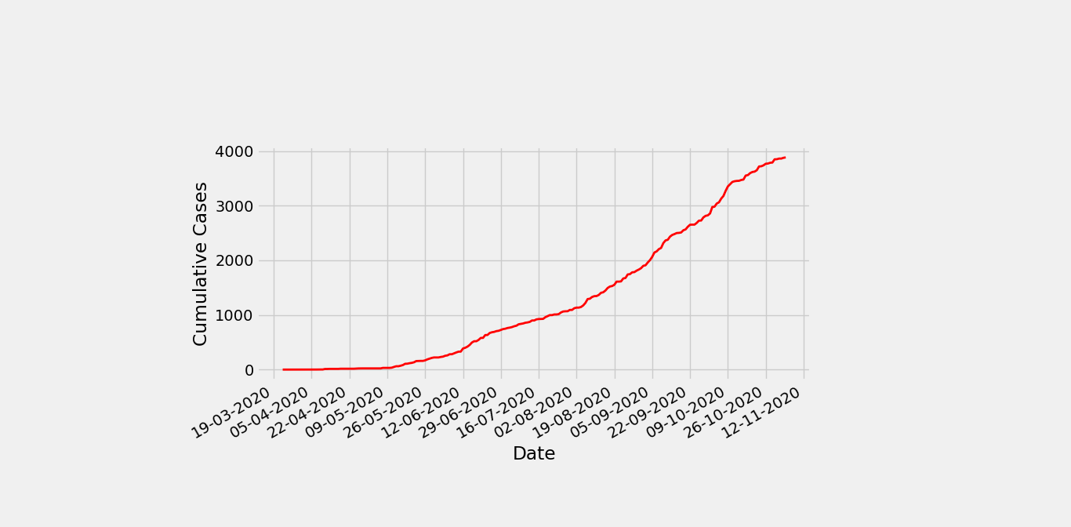

**Figure 1.** Cumulative case development of COVID-19 in Maluku province 23 March – 4 November 2020

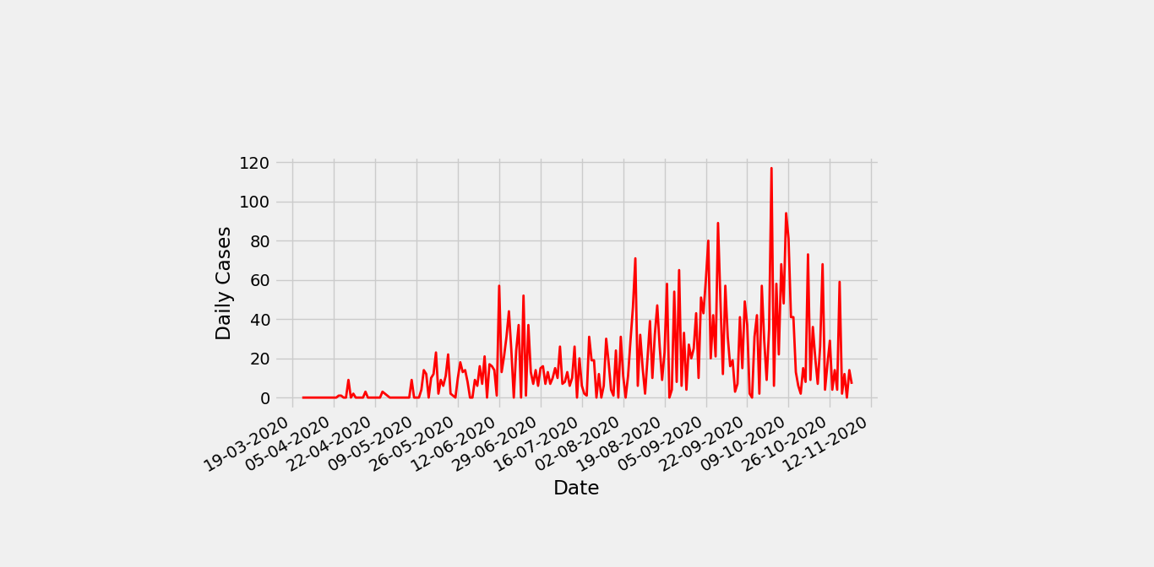

**Figure 2**. Development of daily cases of COVID-19 in Maluku province 23 March – 4 November 2020

Using cumulative case data of COVID-19 in Maluku province from March 23, 2020, to November 4, 2020, an estimate using Richards Curve was obtained, namely :

**Table 1**. Ricards parameter estimation results (RMSE : 75,1057)

|  |  |  |  |
| --- | --- | --- | --- |
|  |  |  |  |
| 9.451,245 | 0,085 | 0,01 | 213,918 |

So by substituting the parameter values , ,  and  in equation (4) obtained the Richards equation, namely :



Then it can be illustrated that the comparison between the cumulative COVID- 19 case data from the Richards Function parameter estimation results with the actual data for is as follows :

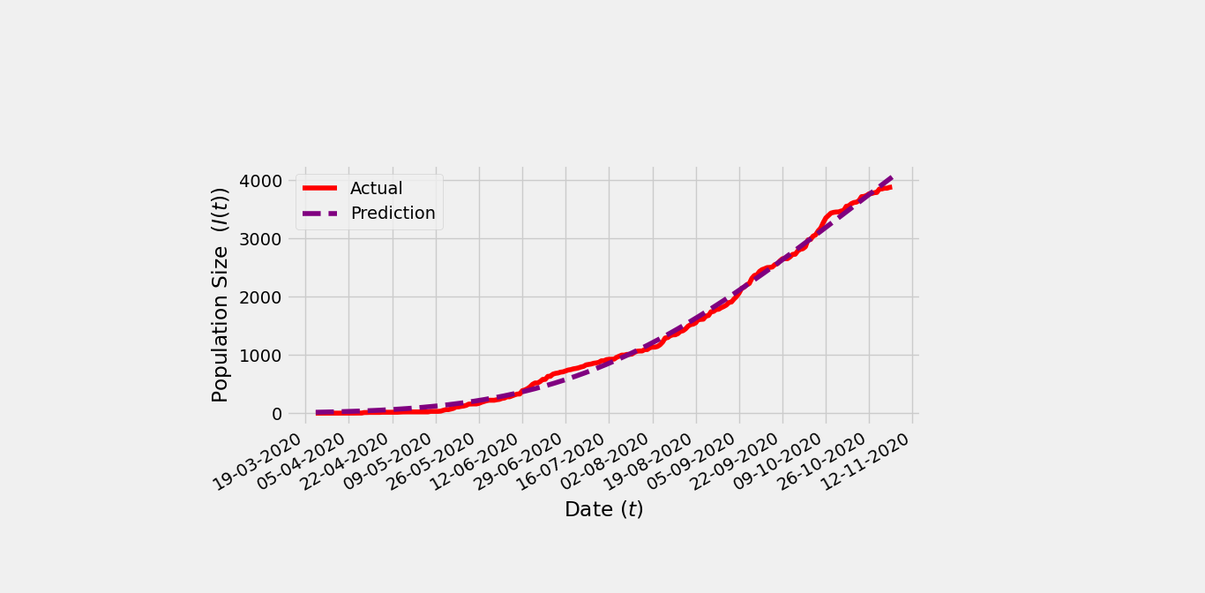

**Figure 3.** Comparison of the results of predictions of cumulative cases of covid-19 in Maluku province with actual data

From Figure 3, the Richards Curve can be described from the estimation results as follows :

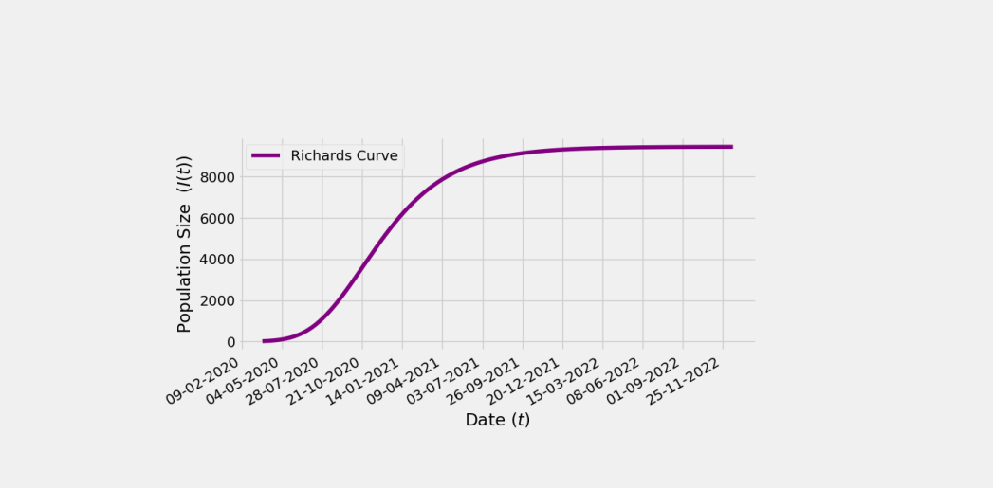

**Figure 4.** Richards Curve of estimation results

From Figure 4, suppose that  is the total cumulative cases on day  and  is the total cumulative cases on day , then the total addition of daily cases can be formulated as follows : [26]

|  |  |
| --- | --- |
|  | (5) |

So the comparison between the predicted data and actual data from daily COVID-19 cases in Maluku province can be described as follows :

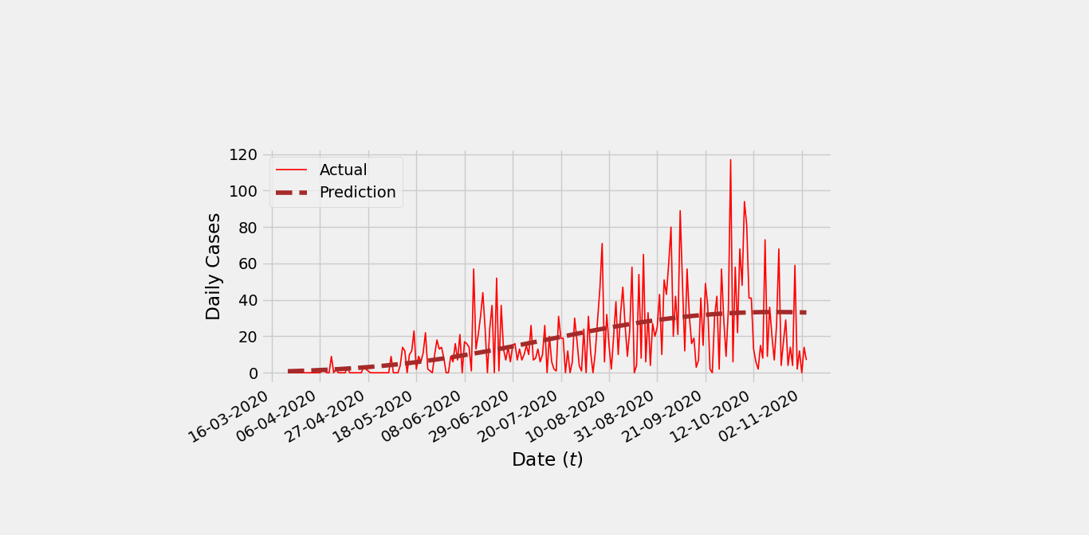

**Figure 5.** Comparison of the results of daily Covid-19 case predictions in Maluku province with actual data

From Figure 5, it can be seen that the results of daily case predictions for COVID- 19 in Maluku province are as follows :

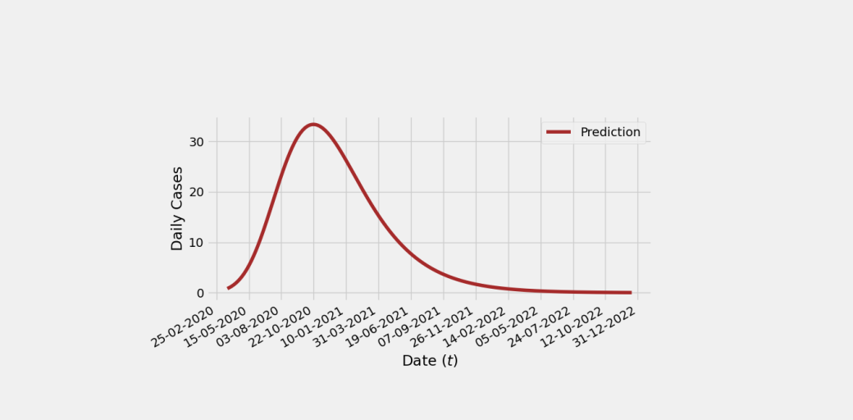

**Figure 6.** Daily cases of COVID-19 in Maluku province from estimated result

**Turning Point of Case Deployment**

From the results of Richards parameter estimation with data on COVID-19 cases in Maluku province, the parameter  value is 213.918, meaning that the time of the turning point for the spread of COVID-19 in Maluku province is predicted to occur on the 214th day, where the total cases on the 214th day are obtained. from the equation :



which is 3.622,654 means that the total cases at the inflection point are 3.623 cases or can be described as follows :

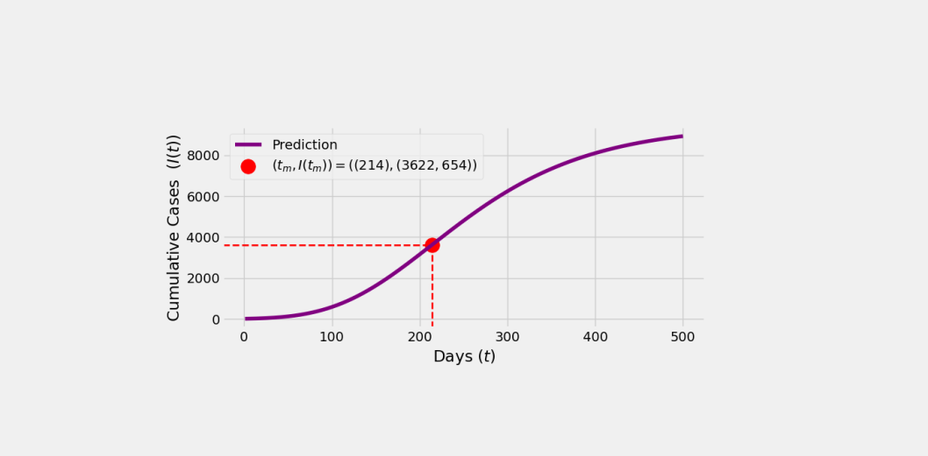

**Figure 7.** Inflection Point

For the addition of daily cases, the total addition of cases can be obtained at the inflexion point or when  namely :





So the total addition of daily cases at the inflection point is 33 cases, so it can be concluded that the turning point of the COVID-19 case in Maluku province is based on the estimation results, namely  or can be described as follows :

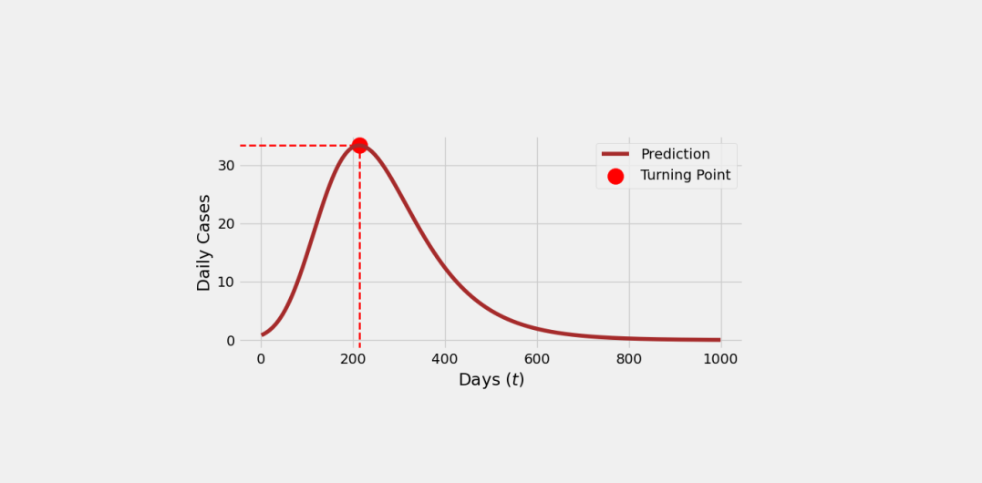

**Figure 8.** Turning Point

**End of Case Deployment**

From Richards parameter estimation results with data on COVID-19 cases in Maluku province, the parameter  value is 9,451,245, meaning that the latest total cases for COVID-19 cases in Maluku province are predicted to be 9,451 cases. For example, if is the end time of COVID-19 cases in Maluku province, with a total of 9,450.5 cases or can be written as = 9.450,5 then the value of can be obtained from the equation:



That is  = 1.158,681 meaning that the time for the end of the COVID-19 case in Maluku province is predicted to occur on the 1.159th day.

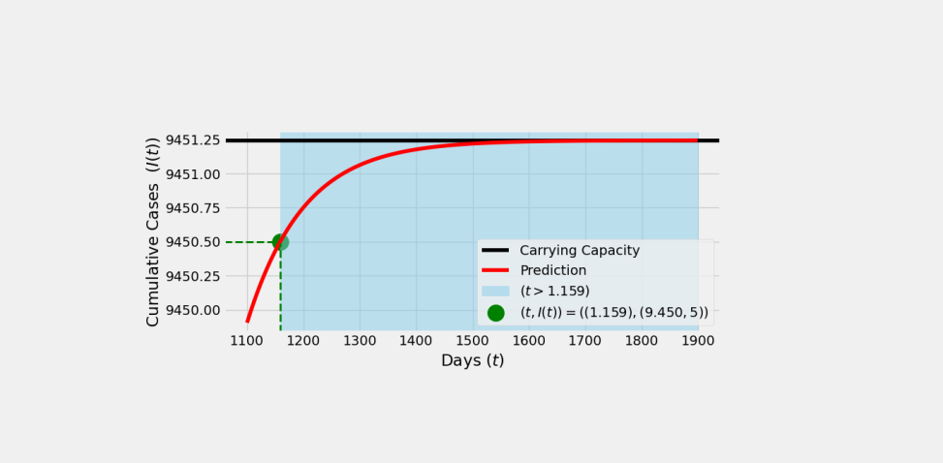

**Figure 9.** Total case when 

From **Figure 9**, when  the population size will always be at number 1.159 and will only move towards the value of  or carrying capacity.

## CONCLUSIONS

From the estimation results of the Richards function parameter with the cumulative case data of COVID-19 in the Maluku province, the Richards equation is obtained to predict the spread of COVID-19 in the Maluku province, namely :



Where, the turning point or peak of the spread of COVID-19 in Maluku province is predicted to occur on October 22, 2020 with a total of 3.623 cases, while the time for the end of the spread of COVID-19 in Maluku province is predicted to occur on May 25, 2023 with 9.451 cases.

# References

|  |  |
| --- | --- |
| [1] | N. R. Yunus and A. Rezki, “Kebijakan Pemberlakuan Lock Down Sebagai Antisipasi Penyebaran Corona Virus Covid-19,” *SALAM J. Sos. dan Budaya Syar-i*, 2020, doi: 10.15408/sjsbs.v7i3.15083. |
| [2] | J. S. M. Peiris *et al.*, “Coronavirus as a possible cause of severe acute respiratory syndrome,” *Lancet*, 2003, doi: 10.1016/S0140-6736(03)13077-2. |
| [3] | A. Zumla, D. S. Hui, and S. Perlman, “Middle East respiratory syndrome,” *The Lancet*. 2015, doi: 10.1016/S0140-6736(15)60454-8. |
| [4] | H. Diah, H. D. Rendra, I. Fathiyah, E. Burhan, and A. Heidy, “Penyakit Virus Corona 2019,” *J. RESPIROLOGI Indones.*, 2020. |
| [5] | C. Ceraolo and F. M. Giorgi, “Genomic variance of the 2019-nCoV coronavirus,” *J. Med. Virol.*, 2020, doi: 10.1002/jmv.25700. |
| [6] | A. E. Gorbalenya *et al.*, “The species Severe acute respiratory syndrome-related coronavirus: classifying 2019-nCoV and naming it SARS-CoV-2,” *Nature Microbiology*. 2020, doi: 10.1038/s41564-020-0695-z. |
| [7] | L. Lin, L. Lu, W. Cao, and T. Li, “Hypothesis for potential pathogenesis of SARS-CoV-2 infection–a review of immune changes in patients with viral pneumonia,” *Emerging Microbes and Infections*. 2020, doi: 10.1080/22221751.2020.1746199. |
| [8] | P. F. Verhulst, “Notice sur la loi que la population suit dans son accroissement,” *Corresp. Mathématique Phys.*, 1838. |
| [9] | A. G. McKendrick and M. K. Pai, “XLV.—the rate of multiplication of micro-organisms: a mathematical study,” *Proc. R. Soc. Edinburgh*, vol. 31, pp. 649–653, 1912. |
| [10] | F. J. Richards, “A flexible growth function for empirical use,” *J. Exp. Bot.*, vol. 10, no. 2, pp. 290–301, 1959. |
| [11] | J. A. Nelder, “182. Note: An Alternative Form of a Generalized Logistic Equation,” *Biometrics*, 1962, doi: 10.2307/2527907. |
| [12] | R. Pearl and L. J. Reed, “The logistic curve and the census count of 1930,” *Science (80-. ).*, 1930, doi: 10.1126/science.72.1868.399-a. |
| [13] | S. Y. Lee, B. Lei, and B. Mallick, “Estimation of COVID-19 spread curves integrating global data and borrowing information,” *PLoS One*, 2020, doi: 10.1371/journal.pone.0236860. |
| [14] | M. E. Gilpin and F. J. Ayala, “Global models of growth and competition,” *Proc. Natl. Acad. Sci. U. S. A.*, 1973, doi: 10.1073/pnas.70.12.3590. |
| [15] | J. V. Ross, “A note on density dependence in population models,” *Ecol. Modell.*, 2009, doi: 10.1016/j.ecolmodel.2009.08.024. |
| [16] | N. R. Lambe, E. A. Navajas, G. Simm, and L. Bünger, “A genetic investigation of various growth models to describe growth of lambs of two contrasting breeds,” *J. Anim. Sci.*, 2006, doi: 10.2527/jas.2006-041. |
| [17] | G. A. F. Seber and C. J. Wild, “Nonlinear Regression. Hoboken,” *New Jersey John Wiley Sons*, vol. 62, p. 63, 2003. |
| [18] | H. Anton, *Calculus: with analytic geometry*, no. QA 303. A57 1980. 1980. |
| [19] | G. Zhou and G. Yan, “Severe acute respiratory syndrome epidemic in Asia.,” *Emerg. Infect. Dis.*, vol. 9, no. 12, pp. 1608–1610, 2003. |
| [20] | H. Nishiura, S. Tsuzuki, B. Yuan, T. Yamaguchi, and Y. Asai, “Transmission dynamics of cholera in Yemen, 2017: A real time forecasting,” *Theor. Biol. Med. Model.*, 2017, doi: 10.1186/s12976-017-0061-x. |
| [21] | R. Zreiq, S. Kamel, S. Boubaker, A. A. Al-Shammary, F. D. Algahtani, and F. Alshammari, “Generalized Richards model for predicting COVID-19 dynamics in Saudi Arabia based on particle swarm optimization Algorithm,” *AIMS Public Heal.*, vol. 7, no. 4, p. 828, 2020. |
| [22] | K. Roosa *et al.*, “Short-term Forecasts of the COVID-19 Epidemic in Guangdong and Zhejiang, China: February 13–23, 2020,” *J. Clin. Med.*, 2020, doi: 10.3390/jcm9020596. |
| [23] | R. B. Banks, *Growth and diffusion phenomena: Mathematical frameworks and applications*, vol. 14. Springer Science & Business Media, 1993. |
| [24] | A. T. Goshu, “Derivation of Inflection Points of Nonlinear Regression Curves - Implications to Statistics,” *Am. J. Theor. Appl. Stat.*, 2013, doi: 10.11648/j.ajtas.20130206.25. |
| [25] | Y.-H. Hsieh, “Richards Model: A Simple Procedure for Real-time Prediction of Outbreak Severity,” 2009. |
| [26] | M. Höök, J. Li, N. Oba, and S. Snowden, “Descriptive and Predictive Growth Curves in Energy System Analysis,” Natural Resources Research. 2011, doi: 10.1007/s11053-011-9139-z. |