THE DEPENDENCE ON ZrO₂ PHASE FORMATION OF PH PRECIPITATION AND TEMPERATURE CALCINATION VARIATION BASED ON KERENG PANGI ZIRCON SAND
Mohammad Abdullah^{1*}, Triwikantoro², Chairatul Umamah³, Herman Jufri Andi⁴
¹Ship Building Technique, Madura state polytechnic, Jl. Raya Taddan km.4 camplong, sampang
²Department of Physics, Institut Teknologi Sepuluh Nopember Surabaya Jl.Arif Rahman Hakim, Surabaya 60111, Indonesia
^{3,4} Department Of Physics Education, Universitas Islam Madura Jl.PP Miftahul Ulum Bettet, Pamekasan
*Corresponding Address: fisabduh04@gmail.com

Received: 2nd Januari 2016; Revised: 10th Februari 2016; Accepted: 31st Maret 2016
ABSTRACT

In this research ZrO₂ has been synthesied from Kereng Pangi zircon sand in Central Kalimantan by Alkali Fusion-Coprecipitation method. Firstly, zirkon sand (ZrSiO₄) purified to reduce impurities by magnetic separation, ultrasonic cleaning, soaking/leaching by HCl 2 M for 12 hours and leaching by HCl at 60 C for 3 hours. Secondly, Alkali fusion was done by KOH as an Alkali. This product then washed by water and dried before leaching in HCl 30% at 90C for 30 minute to precipitate and saperate Silica from Zircon. ZrO₂ filtrat (ZrOCl₂) precipitated by NH4OH with pH 4, pH 7, and pH 10 to be Zr(OH)₄ gel. Zr(OH)₄ gel was dried and characterized by DTA-TGA and then followed by calcination based on DTA TGA results at temperature range 550ºC-700ºC to produce ZrO₂. XRD results showed that single tetragonal phase of ZrO₂ was formed for all variation of precipitation pH and calcination temperature. An analysis using MAUD software showed that crystal size was reduced as the increase of precipitation pH. The crystal size result is 110 nm, 66 nm dan 48 nm for pH 4, pH 7 dan pH 10 at 700ºC, respectively. XRF results showed that ZrO₂ with purity around 95,8 % at pH 4 and 96,3 % at pH 7 and pH 10.
Keywords: Alkali Fusion, Coprecipitation, phase, pH, Crystal size
Introduction
Indonesia has a very wealth of Natural Resources, one example is mineral wealth which the utilization is still in raw material, so that the added value is very small when this mineral is compared to processing raw minerals into pure or alloy material that is ready to enter the industrialization. This just realized by the government by issue a regulation prohibiting the export of deep mining minerals raw material but must be processed first in the country.
One type of mineral that has not been explored is zircon (Zr) which form of Zirconia (ZrO₂) abundant on the Sumatera and Bangka Island. Research on zirconia (ZrO₂) from natural resources has been widely carried out but the amount is still minimal compared to technical or commercial zircon research from companies. Based on the results of XRF, the zircon (Zr) content in Central Kalimantan especially in Kereng Pangi area has 70% of Zr, it is greater than the average of others zircon sand which have Zr around 60% (1). This is very potential to be explored considering that zirconia (ZrO₂) has many advantages including have electrical and thermal conductivity as well as very low thermal expansion, high melting point, high hardness and toughness and better performance than other types of ceramics, it is widely used in the electronics world. automotive, oxygen sensors, fuel cell coatings to extreme applications such as nuclear reactor furnace coatings.
The synthesis process for extracting zirconia from natural zircon sand is very influenced by the synthesis method and heat treatment carried out, so that most of research has focused on these two aspects. Variations and trials against parameters of both aspects are widely used to get the best results. one of method that is widely developed is alkaline fusion-coprecipitation. This methods requires a temperature that is not too high and the process is Simple, so that it supports the aspects of efficiency and effectiveness If applied in the industrialization. The alkaline fusion-coprecipitation method consists of two main component which are zircon sand melting with alkaline materials and the second process is leaching which also consists of two stages, namely water leaching and acid leaching and followed by coprecipitation. In the coprecipitation process the effect of pH and precipitation calcination temperature which is formed from natural material has not widely reported when compared to technical materials (2).
The synthesis process of ZrO₂ with Alkali fusion method which has been reported previously using alkaline NaOH materials such as that carried out by BATAN and a combination of NaOH and KOH by Biswas from natural zircon sand of Bangladesh. Alkali fusion method with Alkali KOH has never been reported before. This research will report the synthesis process of ZrO₂ from natural zircon sand Kereng Pangi with alkaline KOH (3).
Zirconia (ZrO2) is a polymorphy material with 3 different phases, namely monoclinic (<11700ºC), tetragonal (1170ºC - 23400ºC) and cubic (> 23400ºC). This phase change becomes a problem in applications with a high temperature range, so that many studies have been carried out to obtain the phases in a stable form over their stable temperature range. Research on the behavior of ZrO₂ phase change (transformation) is intensively carried out to obtain stable phase ZrO₂ that supports its application. One technique that has been widely developed is by doping ZrO₂ with divalent or trivalent cations like Mg²⁺ ,Ca²⁺, Y³⁺,Sc³⁺ to obtain a stable phase at room and high temperatures (4).
font 12, spacing singgle, font man
Methods
Natural Zircon sand from Kereng Pangi of Central Kalimantan is analysis by XRF and XRD to ensure the elemental content of Zircon and its compound form in the form of ZrSiO₄ followed by a magnetic separation process to reduce magnetic impurities. Reducing the size of zircon sand was carried out until a size of 100 mesh was obtained, then washing it with an ultrasonic cleaner to clean the surface of particles.
The melting process is carried out with a mole ratio of zircon sand: KOH of 1: 4 at a temperature of 700ºC for 3 hours. The results of smelting is to be continue and namely as “frit” are washed with aquadest in 3 times each for one hour of stearing at a rotating speed of 160 rpm to remove any unreacted KOH residues. The melted product was dried and then leached with 10% HCl for one hour at a stearer speed of 160 rpm with a ratio of 1 gram of frit to 30 ml of 10% HCl. the solution is filtered to take the filtrate. The filtrate was precipitated with NH₄OH to pH 4, 7 and 10 overnight. The precipitate was dried and then tested for DTA TGA to determine the temperature of calcination. The results of calcination were tested by XRD and XRF to determine the characteristics of the sample.

XRF Test
Zirkon Sand

Magnetic separation
Washing by ultrasonic cleaner for 30 minute

Reduction of size by Ball milling( 1 hours 180 rpm)
Leaching (pelindian) HCl
2 M 12 hours
Leaching (pelindian) HCl
Temperature 60⁰C 3 hours
Dried
XRF Test
Washing by aquades
ZrSiO₄

Figure 1. Flow Chart of Zircon Sand (ZrSiO₄) Purification

Figure 2. Flowchart Synthesis of ZrO₂ from Zircon sand (ZrSiO₄)
Result and Discussion
The results of XRD and XRF for natural zircon sand of Kereng Pangi as an initial identification of the elements contained as an indication of their potential feasibility for the extraction process. From the XRF results in table 1, it shows that zircon (Zr) content is quite large, namely 70% in the form of ZrSiO₄ in nature. The results of the synthesis of Zirconia (ZrO₂) 86% which will be analyzed for the effect of pH and temperature calcination.
Smelting with alkaline materials for KOH produces different results from NaOH. Namely, in the alkaline NaOH material, the same conditions including temperature (700ºC for 3 hours) and the comparison between 1: 4 mole ratio are able to break the ZrO₂ and SiO₂ bonds in the ZrSiO₄ compound by reaction:
ZrSiO₄ + 4 NaOH → Na₂ZrO₃ + Na₂SiO₃ + 2H₂O
ZrSiO₄ + 2 KOH → K₂ZrSiO₅ + H₂O
NaOH is able to break down ZrO₂ and SiO₂ while KOH has not been able to break it down but also reacts to form K₂ZrSiO₅ which is more reactive with HCl (5).

Table.1 Data on XRF results at each purification stage (A) Initial Conditions, (B) after Magnetic Separation (C) Leaching HCl 600ºC for 3 Hours (D) Leaching HCl 600ºC for 6 Hours (D) ZrSiO₄ Purification Results by the factory
Element | Weight Percent (%)
 | A | B | C | D | E
Zr | 70.40 | 90.90 | 95.20 | 95.30 | 95.80
Ti | 19.40 | 3.59 | 1.29 | 1.30 | 0.54
Fe | 6.34 | 0.27 | 0.099 | 0.077 | 0.09
Hf | 1.23 | 1.27 | 1.41 | 1.36 | 1.42
Si | 0.50 | 2.99 | 1.00 | 1.00 | 0.84

From Table 1. it is shows that the magnetic separation process is very good for reducing magnetic impurities, especially Fe impurity elements. In addition, the zircon sand has a lighter color than before the magnetic separation, which is dark due to the presence of impurities which contain a lot of Fe and Ti. Then, the zircon sand is washed with an ultrasonic cleaner to clean the surface and dried.
The Zr(OH)₄ powder from the synthesis results was analysed by DTA-TGA to determine thermal characteristics and calcination temperature in forming the zirconia phase. The DTA-TGA result process was carried out at rate temperature rise of 100ºC / minute. The DTA-TGA results are shown in Figure 3. below.
The DTA results at each pH show a similar pattern from 0 to 500ºC where an endothermic reaction occurs followed by a mass decrease in TGA. Its indicating that the heat energy in the sample is absorbed as latent heat to evaporate the hydrate element at Zr (OH) 4 to ZrO₂ with vaporize the hydroxyl (OH⁻) bond group. In addition to evaporating OH⁻, it also evaporates the remains of H⁺ ions and the remaining salts from the side reaction (6).
The exothermic peak reaction in the sample with a depositional pH 10 and pH 7 occurred at temperature 668ºC, 655ºC and for pH 4 there were two peaks at 589ºC and 745ºC. This reaction is a reaction to form ZrO₂ crystals in a tetragonal phase. The TGA chart starts to be constant for pH 10, pH 7 and pH 4 starting at temperatures around 650ºC, 707ºC and 750ºC. The TGA graph at pH 4 falls at temperature 834,5ºC, it is possible that mass overflow occurs because of the use Zr(OH)₄ mass that is too large (7).

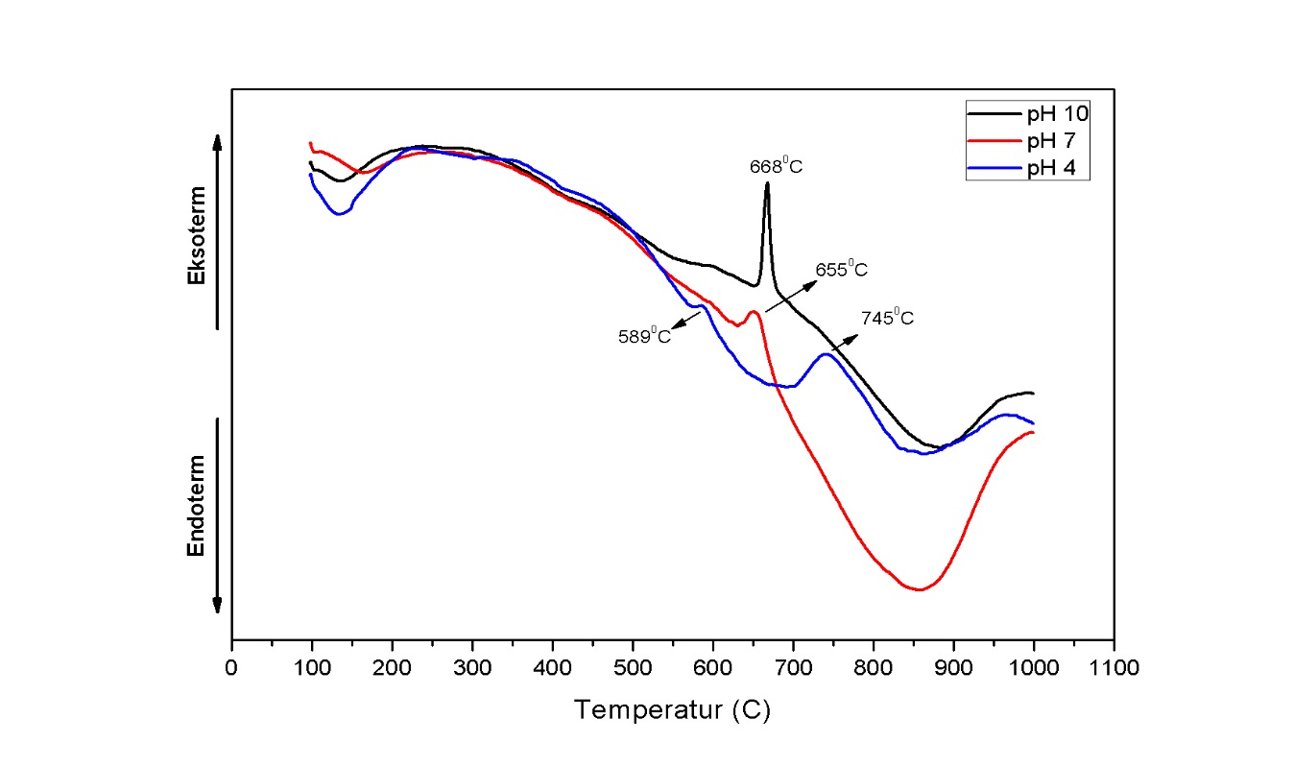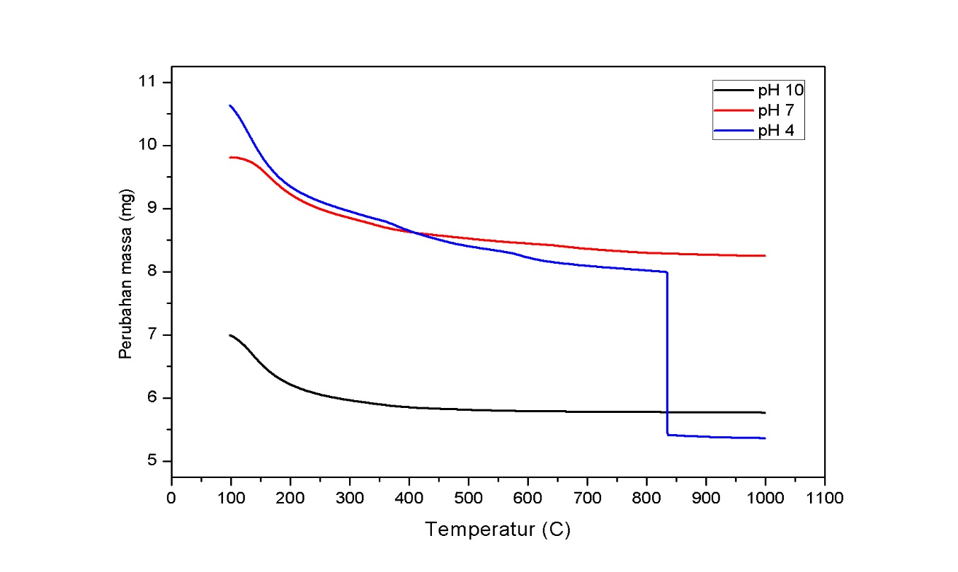

Figure 3. DTA-TGA Zr(OH)₄ results synthesized from Natural Zircon Sand Kereng Pangi (a) DTA (b) TGA.
Based on the results of DTA-TGA analysed, calcinations were carried out with temperature variations of 550ºC, 600ºC, 650ºC and 700ºC with a holding time for 3 hours. The XRD results are shown in Figure 4. below.

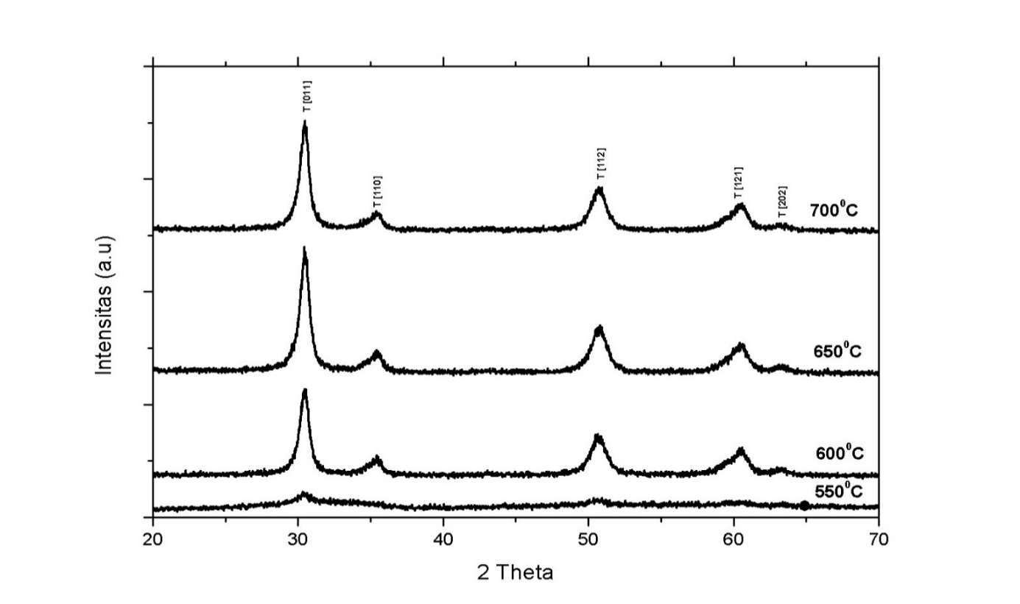
Figure 4. XRD Results of Synthesis ZrO₂ from Natural Kereng Pangi Zircon Sand for Precipitation in pH 10.

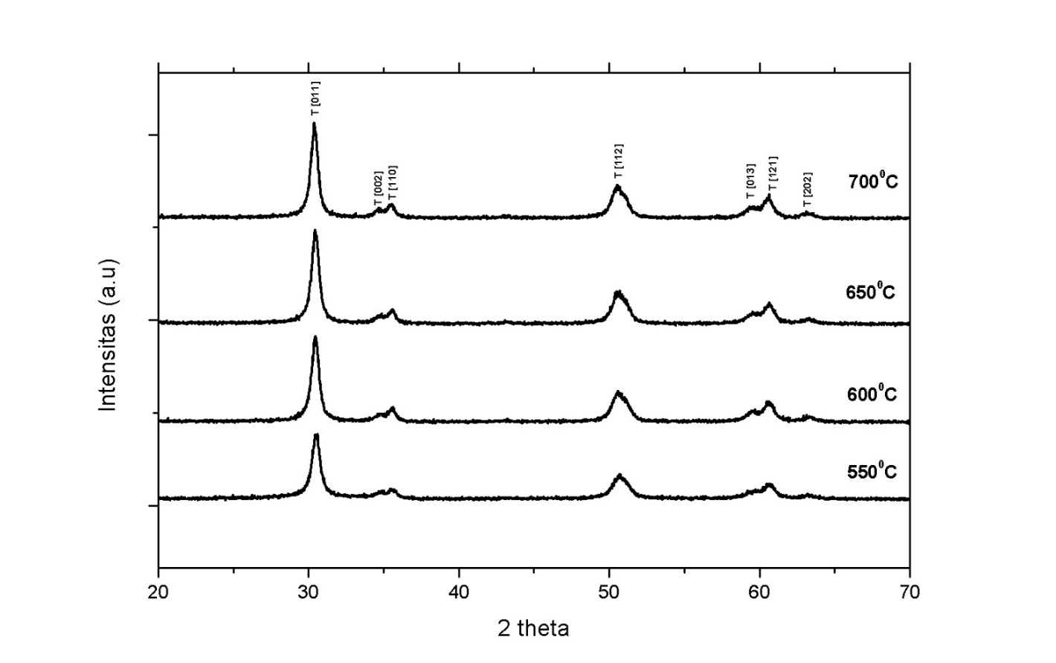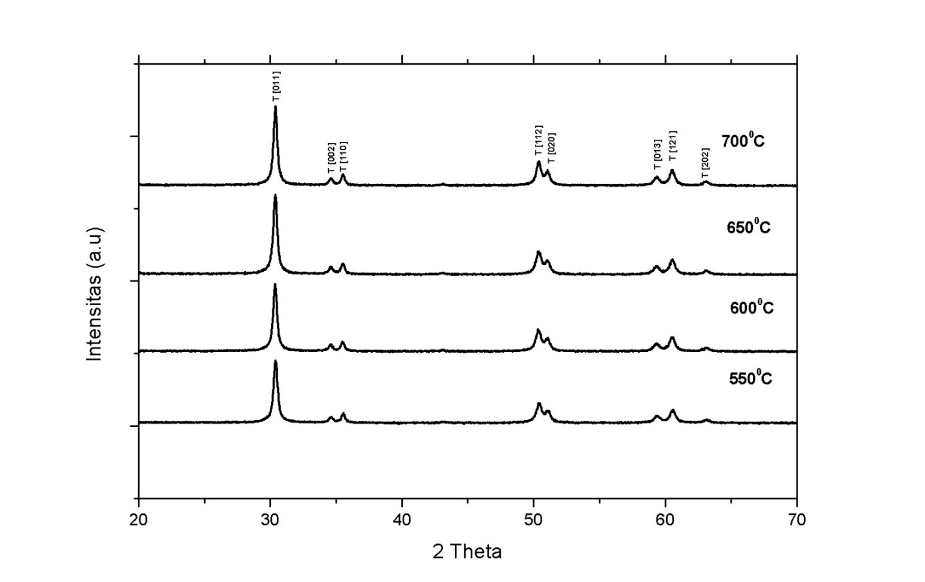
Figure 5. XRD Results of Synthesis ZrO₂ from Natural Kereng Pangi Zircon Sand for (a) neutral depositional pH (pH 7) (b) Acidic depositional pH (pH 4)

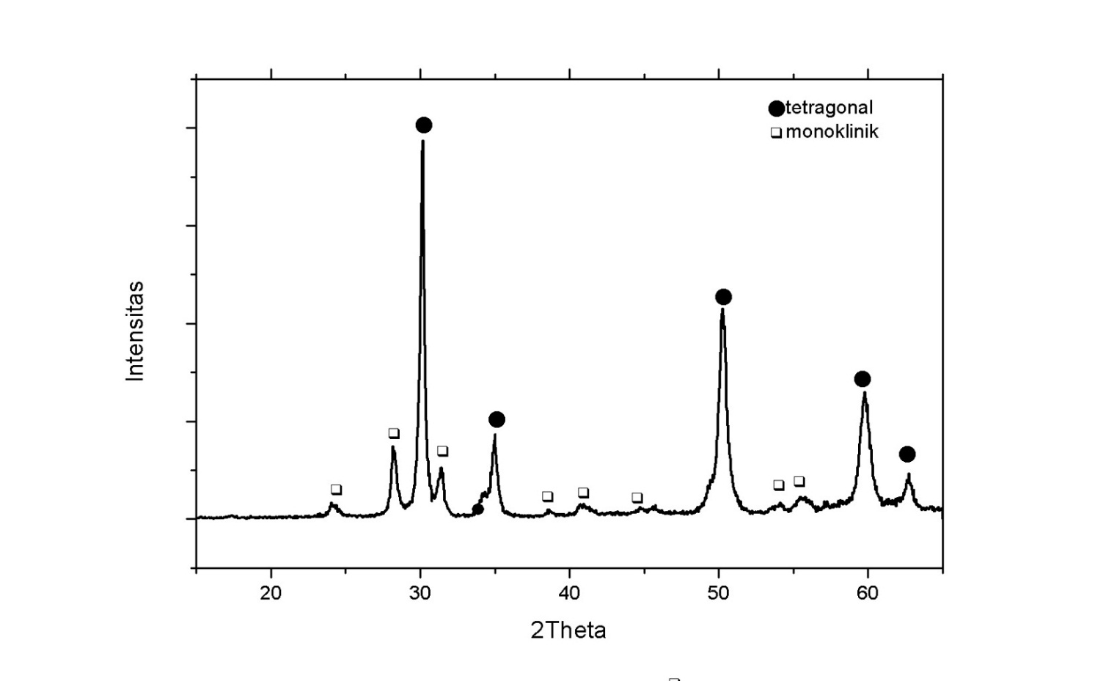
Figure 6. XRD Results for for ZrO₂ Aldric Technical Products (Commercial)

XRD analysis results for all depositional pH showed that the higher calcination temperature make the degree crystallinity of ZrO₂ is higher too, namely the increase in crystal size formed. The crystal size of ZrO₂ is also influenced by pH precipitation, with an increase of pH precipitation, it makes crystal size is smaller. The size of crystallinity and largest number of crystalline fields formed at acidic depositional pH and vice versa, the smallest crystal size at alkaline depositional pH.
ZrO₂ resulting from alkaline deposition (pH 10) still has an amorphous structure at a temperature of 550ºC, while at acidic and neutral pH, tetragonal ZrO₂ crystals have formed, its indicating that the crystallization process at pH 10 is much slower than other. This difference is possible because the deposition process at pH 10 is much faster than other pH, so that it produces more random gel structure than the acidic and neutral pH gel structure so that it is more difficult to form crystals. Gel Zr(OH)₄ at depositional pH 10 is dispersive and soft, characterized by water filtering easier to penetrate the gel. There were 5 crystal fields identified, namely (011), (110), (020), (121) and (202) (8).
The same condition also occurs at pH 7 but the number of crystalline fields formed is more than at pH 10 with 7 crystal fields, namely (011), (002), (110), (020), (112), (013), (121) ) and (202) is possible because the precipitation rate at neutral pH is not as fast as at pH 10 so that the Zr(OH)₄ regularity is better than pH 10.
XRD results showed the crystallinity of ZrO₂ at acidic pH (pH 4) was higher than neutral (pH 7) and alkaline (pH 10). This is because at pH 4 the precipitation rate is very slow compared to other pH because it takes about 12 hours (overnight). The result is the structure of Zr(OH)₄ gel is formed more regularly, marked by a clumpy gel condition because there is a coagulation process in the gel so that it forms a stronger bond, marked with water on the gel, it is more difficult to penetrate the gel and filter paper compared to pH 7 and 10. Therefore, pH 4 is much easier to form crystal structures than pH 7 and 10. The number of crystalline fields formed is at most 8 crystal planes, namely (011), (002), (110), (112), (020), (013), (121 ) and (202).
When compared with the commercial ZrO₂ aldric product, Figure 5. shows that commercial ZrO₂ consists of two phases, namely the tetragonal and monoclinic phases. The monoclinic phase has appeared so that only the recalcination process is needed, the transformation process will occur from a tetragonal to monoclinic phase and in the end, one monoclinic stable phase will be obtained (3).
The XRD results analysis combined with MAUD calculation results at a temperature of 550ºC indicate that pH 4 has a crystal size greater than pH 7 and pH 10. The exothermic peak of pH 10 at 688ºC (DTA-TGA figure) has a high exothermic peak due to only the total crystallization process. Meanwhile, the exothermic peak of pH 7 at 655ºC and pH 4 at 589ºC is smaller due to not only the crystallization process but also the evaporation process, which is marked by the process of decreasing mass on the TGA graph at around that temperature.

Table 2. results calculation the crystal size of ZrO2 synthesized using MAUD software
Calcination Temperature | Crystal size (nm)
 | pH 4 | pH 7 | pH 10
550ºC | 101 | 44 | 8
600ºC | 102 | 47 | 42
650ºC | 104 | 54 | 47
700ºC | 110 | 66 | 48

Garvie reported that maximum crystal size maximum of tetragonal ZrO₂ phase before transforming the monoclinic phase is 30 nm. However, the ZrO₂ synthesized from natural zircon sand of Kereng Pangi produces a tetragonal phase that can survive even though the crystal size is more than 30 nm. The impurity factor inhibits tetragonal to monoclinic phase transformation process. The tetragonal phase is formed to be a metastable phase because it is susceptible to temperature, pressure, crystal size and depositional pH which can withstand the temperature and crystal size ranges of commercial technical precursors that have been reported by previous researchers (9) .

Table 3. PSA results of synthesized ZrO₂ from Natural Zircon Sand Kereng Pangi
Calcination Temperature | Crystal size (nm)
 | pH 4 | pH 7 | pH 10
550ºC | 255 | 301 | 227
600ºC | 238 | 243 | 261
650ºC | 251 | 248 | 262
700ºC | 292 | 261 | 264

The PSA results analysed showed that the particle size was getting bigger with increasing temperature. The relationship between particle size and settling pH was still and very different from the relationship between pH and crystal size as a result of MAUD software analysis. Particles are a combination of several crystals, the relative particle size increases with increasing temperature but for the comparison of particle size with pH, a relationship cannot be drawn, in contrast to MAUD analysis showing that the higher pH precipitation results in smaller crystal size. This is possible because of the large agglomeration of zirconia samples due to the lack of deposition time or the type of dispersant in the form of soap to disperse the ZrO₂ particles so that it is less effective at dispersing the ZrO₂ trenches. The smaller particle size tendency for agglomeration to occur is greater because it has a larger active outer surface. The atoms on this surface have an incomplete coordination site (dangling bond) so that the surface atoms will fill each other with the empty coordination site to form agglomerations (10).
The XRF results analysis in Table 4. show that ZrO₂ levels at pH 4 are around 98,5%, slightly smaller than pH 7 and pH 10 around 96,3%, which is possible because the mass of Zr (OH) 4 or ZrO₂ is less so that the percentage decreases slightly. This is because at pH of acidic precipitation, the quantity of OH⁻ ions from the addition of NH₄OH is less than in neutral or alkaline conditions. The presence of H⁺ ions in acidic conditions also reduces the rate of precipitation process because H⁺ ions also bind OH⁻ ions to form water thereby reducing the concentration of OH⁻ ions to precipitate Zr⁴⁺ from ZrOCl₂ to form Zr(OH)₄. On the contrary, in neutral or alkaline conditions, H⁺ ions as a measure of acidic pH do not exist and the abundant OH⁻ ion concentration makes OH⁻ bonds at each corner of the Zr⁴⁺ bonds, so that all Zr⁴⁺ ions bind perfectly to OH⁻ and precipitate at a fast precipitation rate (6).
The amount of OH⁻ ion concentration greatly affects the quantity of Zr⁴⁺ deposition in the form of Zr(OH)₄ gel. The result is that the mass of Zr(OH)₄ and ZrO₂ at alkaline pH (pH 10) is greater than the neutral and acidic pH. The mass of Zr(OH)₄ is directly proportional to the mass of ZrO₂ with a mass reduction of 20-30% after the calcination process. The mass of ZrO₂ resulting from pH 4 is relatively smaller so that the concentration decreases compared to the mass of impurities and vice versa. This is the reason why the ZrO₂ level at the pH of the depositional pH (pH 4) is relatively smaller than neutral pH (pH 7) and alkaline (pH 10).
The purity level of synthesized ZrO₂ was known through XRF analysis as shown in Table 4. below. XRF analysed results can only produce ZrO2 with an average purity level of 96%. The lowest ZrO₂ level at pH 4 is possible because at pH 4 the concentration of NH₄OH as a precipitant is less than pH 7 and pH 10, so that the ZrO₂ concentration is less than pH 7 and pH 10. Another reason is that the distribution of impurities in Zircon sand is not possible. uniform.
Table 4. XRF results of synthesized ZrO₂ from Natural Zircon Sand Kereng Pangi
element | Weight percent (%)
 | pH 4 | pH 7 | pH 10
ZrO₂ | 95.80 | 96.30 | 96.30
HfO₂ | 1.56 | 1.41 | 1.46
TiO₂ | 2.09 | 1.71 | 1.51
Fe₂O₃ | 0.12 | 0.10 | 0.08
SiO₂ | - | - | -
Conclusion
From the research that has been done, it can be concluded that Synthesis of ZrO₂ from Kereng pangi Natural Zircon Sand using Alkali Fusion-Coprecipitation Method with Alkali KOH has been successfully carried out. The result show that ZrO₂ level under acidic depositional pH conditions (pH 4) was 95.8% while in neutral (pH 7) and alkaline (pH 10) pH conditions was 96,3%. The increase of pH precipitation has the effect of reducing crystal size of ZrO₂ formed with the largest crystal size at calcination temperature of 700ºC, namely acidic depositional pH (pH 4) 110 nm, neutral depositional pH (pH 7) 66 nm and alkaline deposition pH (pH 10) 48 nm. The effect of pH precipitation variations in acidic (pH 4), neutral (pH 7) and alkaline (pH 10) conditions with a calcination temperature range of 550ºC to 700ºC has not yet formed a ZrO₂ monoclinic phase. The ZrO₂ phase formed is a tetragonal single phase which is stable up to in temperature 700ºC
Acknowledgment
This research was partially supported by the Ministry of Education and Culture Republic of Indonesia through Research Agency (LPPM) ITS in the EPI-UNet Research Scheme granted to zirconia research team by TRW.

References
1. Yamagata C, Andrade JB, Ussui V, Lima D, Batista N, Paschoal JOA. High Purity Zirconia and Silica Powders via Wet Process: Alkali Fusion of Zircon Sand [Internet]. Materials Science Forum. 2008 [cited 2020 Oct 15]. Available from: https://www.scientific.net/MSF.591-593.771
2. Habib meedm. A novel method for processing of Bangladeshi zircon. Hydrometallurgy [Internet]. [cited 2020 Oct 15]; Available from: https://www.academia.edu/27772812/A _novel_method_for_processing_of_Bangladeshi_zircon.
3. priyono, slamet. Pemurnian Serbuk Zirkonia dari Zirkon [Internet]. 2012 [cited 2020 Oct 15]. Available from: http://lipi.go.id/publikasi/Pemurnian-Serbuk-Zirkonia-dari Zirkon/8285.
4. Huang H-J, Wang M-C. The phase formation and stability of tetragonal ZrO2 prepared in a silica bath. Ceram Int. 2013;2(39):1729–39.
5. Sudjoko D, Triyono T. peningkatan kualitas zirkonia hasil olah pasir zirkon. Ganendra. 2008 Jan;11(1):11–6.
6. Kurapova O, Konakov V. Phase evolution in zirconia based systems [Internet]. undefined. 2014 [cited 2020 Oct 15]. Available from: /paper/Phase-evolution-in-zirconia-based-systems-Kurapova-Konakov.
7. Masoodiyeh. F, J. Zirconia nanoparticle synthesis in sub and supercritical water particle morphology and chemical equilibria | Request PDF [Internet]. ResearchGate. 2015 [cited 2020 Oct 14]. Available from: https://www.researchgate.net/publication/280714158_Zirconia_nanoparticle_synthesis_in_sub_and_supercritical_water_-_particle_morphology_and_chemical_equilibria.
8. Ran liu, et al. Analysis of water leaching and transition processes in zirconium oxychloride octahydrate production. Ceram Int. 2014 Jan 1;40(1):1431–8.
9. S. Shukla and S. Seal. Mechanisms of Room Temperature Metastable Tetragonal Phase Stabilisation in Zirconia - Thermal Spray Society [Internet]. 2015 [cited 2020 Oct 15]. Available from: https://www.asminternational.org/web/tss/technical-resources/-/journal_content/56/10192/IMR5001P045/periodical-article.
10. Ren, HaiSheng. The structural phase transition and elastic properties of zirconia under high pressure from first-principles calculations. Solid State Sci. 2011 May 1;13(5):938–43.

