TRANSESTERIFICATION OF PALM OIL USING THE TiO₂/nano-MONMORILLORITE (nano-MMT) COMPOSITE CATALYST FROM ACEH TAMIANG BENTONITE IN THE PRODUCTION OF BIODIESEL
Teuku Andi Fadlly^{1*}, Ida Ratna Nila¹, Nirmala Sari¹
¹Department of Physics, Enggenering of Faculty, University of Samudra
Jl. Meurandeh Langsa 24416
ABSTRACT
Transesterification of palm oil using a TiO₂/nano-Monmorillorite (nano-MMT) composite catalyst from Aceh Tamiang bentonite in Biodiesel production has been carried out. Biodiesel is bioenergy obtained from vegetable oils, animal fats, microorganisms, and plants. This is an alternative energy to replace fossil fuels, especially diesel oil. Biodiesel is proven to be more environmentally friendly in reducing hydrocarbon and sulfur emissions. In this study, TiO₂ will be composited with nano-MMT using the solid state method and analyzed using XRD. Both of these materials are used as catalysts for biodiesel production. The transesterification process will be used in the production of biodiesel, where the molar ratio of palm oil to methanol is 1:12. TiO₂/nano-MMT composite catalyst will be varied (2 and 4 grams). Biodiesel samples will be analyzed using GC-MS. The results obtained show that the TiO₂/nano-MMT composite catalyst from Aceh Tamiang bentonite can convert Fatty Acid Methyl Ester (FAME) from palm oil. The 2 grams of composite catalyst produced biodiesel of 89.38% and 4 grams of 64.88%.
Keywords: Palm oil; TiO₂; nano-Monmorillorite; Transesterification
Introduction
Oil reserves are decreasing from year to year, so there is a need for alternative energy. Fossil fuels, especially diesel, can be reduced in use with biodiesel which is proven to be more environmentally friendly, reducing hydrocarbon and sulfur emissions (1). Biodiesel can be produced from animal fats and microorganisms (2). Sivaprakash produces nonocomposite zinc-based iron oxide as a catalyst for the production of biodiesel from extracted Entermorpha intestinalis (3). Akabude uses CaO nanocatalysts for the production of biodiesel from microalgae (4). In addition, it is produced from vegetable oils, such as palm oil fruit. Oil palm plants are very abundant in Indonesia because they can be grown in tropical areas (5). The transesterification process is one of the methods used in biodiesel production, as has been done by Mohammed Danish to produce biodiesel from flaxseed oil using KOH as a catalyst (6). Ana Farias, to get biodiesel from soybean oil, performs the ethanol transesterification process using CuO, ZnO and CeO₂ which are supported on bentonite (7). The results showed that there was a conversion of 88% biodiesel using ZnO on bentonite. In addition, Istadi also produces biodiesel from soybean oil using an active solid acid catalyst from zinc oxide sulfate (SO₄²⁻-ZnO and SO₄²⁻/ZnO) which is characterized (8). Aceh Tamiang has natural bentonite which has been synthesized into nano-Monmorillorite (nano-MMT) by Tisna Harmawan for purifying patchouli oil (9). ZnO is a metal oxide which is a semiconductor and photocatalyst material. Apart from ZnO, TiO₂ is also a semiconductor and photocatalyst material (10). The TiO₂/nano-MMT composite catalyst from Aceh Tamiang, however, has not been studied in terms of the transesterification process for biodiesel production from palm oil.
This article reports biodiesel production using a TiO₂/nano-MMT composite catalyst from Aceh Tamiang natural bentonite from palm oil. The percentage of biodiesel is generated from GC-MS (Chromatography Mass Spectrometry) data from Shimadzu Brand, Type: QP2010 Plus. The study of biodiesel production from palm oil using a TiO₂/nano-MMT composite catalyst from Aceh Tamiang natural bentonite will broaden the prospect of the analysis.an
Methods
TiO₂ analyzer (Emsure) is used in powder form as a catalyst. Nano-MMT powder from Aceh Tamiang natural bentonite obtained from previous research (9), as a solid heterogeneous catalyst. Synthesis of TiO₂/nano-MMT composites will be carried out using the solid state method for 30 minutes (11) with a ratio of 25:75 wt%. The analysis will be carried out qualitatively from the results of the X-Ray Diffraction (XRD) Brand Shimadzu, Type: MAXima_X XRD-7000 in powder form. These results determine the peak crystals of TiO₂ and nano-MMT and the absence of new crystal peaks in the TiO₂/nano-MMT composites. This determines the formation of the TiO₂/nano-MMT composite.
Biodiesel production is carried out through a transesterification process using a three neck flask equipped with a thermometer and condenser. The molar ratio of palm oil to methanol analyst (Emsure) to be used is 1:12 (7). 2 grams of TiO₂/nano-MMT composite catalyst will be mixed with methanol and stirred for 5 minutes at a speed of 250 rpm. This was also done on a variation of the TiO₂/nano-MMT composite catalyst of 4 grams. Furthermore, the liquid catalyst and methanol will be mixed with palm oil. The three mixtures will be refluxed at a reaction temperature of 60 °C for 3 hours and stirred at a speed of 250 rpm. After the process is complete, the liquid will be allowed to stand in a separating funnel to form 2 layers. The bottom layer is glycerol and the top layer is biodiesel. The top layer of the liquid is separated and filtered using whatman paper. Analysis of biodiesel from palm oil will be carried out by GC-MS testing with the concentration parameter (%) against the retention time (minutes) which describes the chromatogram (12).
Result and Discussion
The diffraction patterns of TiO₂, nano-MMT, and TiO₂/nano-MMT composites from XRD results are shown in Figure 1.

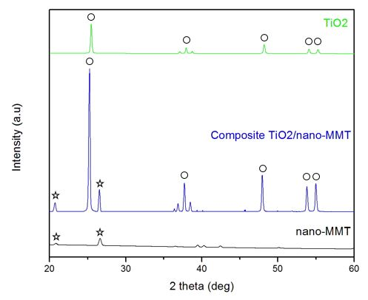
Figure 1. XRD patterns for nano-MMT, TiO₂/nano-MMT composites, and TiO₂

Based on Figure 1, TiO₂ powder has an anatase phase identified (JCPDS number 96-710-3589) and has a diffraction pattern with sharp crystal peaks from the XRD results. In contrast to the nano-MMT powder which has a diffraction pattern with a low crystal peak, SiO₂ is identified as a quartz phase (JCPDS number 96-900-9667). The crystal peak is at 2θ, which is 20.86 ° and 26.62 °. The MMT composition of XRF results from previous studies shows that SiO₂ has the most composition (Si = 25.04 wt%, O = 45.71 wt%) compared to Al, Fe, Ti, Ca, K, S (9). This shows the dominant SiO₂ crystal peak in nano-MMT and the shape of the diffraction pattern is MMT (JCPDS number 96-901-0958). The successful synthesis of TiO₂/nano-MMT composites is shown by the crystalline peaks of TiO₂ and MMT which are separated and no new phase is formed (13).
Intensity versus retention time (minutes) graph depicting the palm oil biodiesel chromatogram using GC-MS is shown in Figure 2. This confirms the formation of the methyl ester.
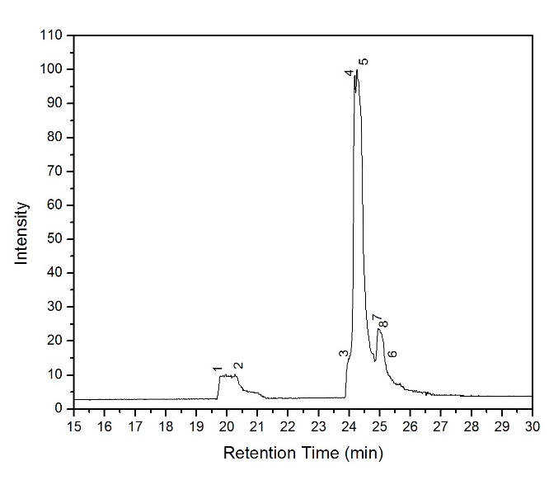
(a)
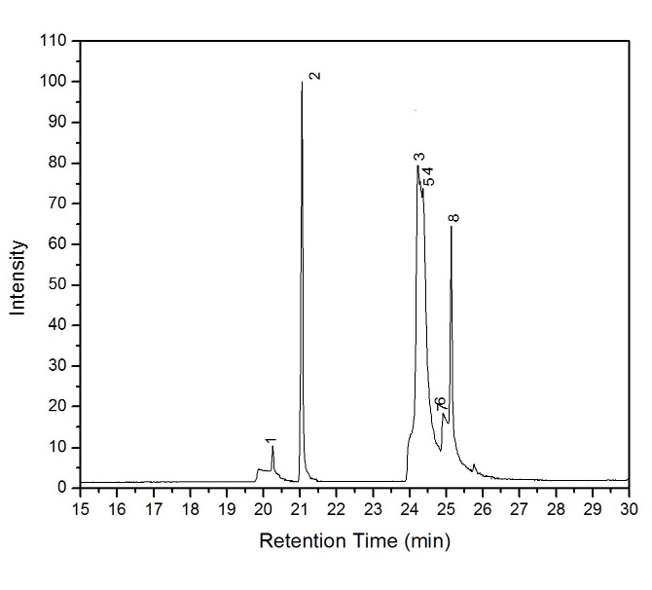
(b)

Figure 2. GC-MS analysis of biodiesel from palm oil using a TiO₂/nano-MMT composite catalyst with variations, (a) 2 grams and (b) 4 grams.

The descriptions of the chromatograms obtained are shown in Tables 1 and 2. Based on Figure 1 (a) and Table 1, most of the biodiesel composition from palm oil is methyl tridecanoate (1.58%), methyl heptadecanoate (0.24%), methyl oleate (81.80%), and methyl dihydrochaumoograte (5.76%). The other composition is linoleic acid (2.58%) and 7.61% unknown. These results indicate the total concentration of Fatty Acid Methyl Ester (FAME) in biodiesel from palm oil is 89.38%. In addition, Figure 1 (b) and Table 2 illustrate the composition of biodiesel from palm oil, most of which are metil palmitate (1.09 %) and metil oleate (63.79%). Another composition is palmitic acid (15.54%), 1-cyclododecene (5,63%), and carbonic acid-(1) (12.21%). These results indicate the total concentration of FAME in biodiesel, which is 64.88%. The use of TiO₂/nano-MMT composite catalyst as much as 2 grams versus 4 grams, increases the production of biodiesel from palm oil. This is due to the formation of the slurry (3).
TiO₂ as a metal oxide can increase catalyst activity in the transesterification reaction (12) and nano-MMT is contained in bentonite from Aceh Tamiang as an adsorbent that can absorb water and impurities in biodiesel production (14). In addition, the catalyst from natural bentonite as pure material no biodiesel conversion was obtained (7).

Table 1. Results of GC-MS analysis on biodiesel from palm oil using 2 grams of TiO₂/nano-MMT composite catalyst.
No Peak | Compound | Structure | Retention Time (min) | Area%
1  2  4  5  8 | Methyl Tridecanoate  Methyl Heptadecanoate  Methyl Oleate  Methyl Oleate  Methyl Dihydrochaumoograte  Total Methyl Esters  Other | C₁₄H₂₈O₂  C₁₈H₃₆O₂  C₁₉H₃₆O₂  C₁₉H₃₆O₂  C₁₉H₃₆O₂ | 19.767  20.267  24.189  24.263  25.050 | 1.58  0.24  20.85  60.95  5.76  89.38  10.60

Table 2. Results of GC-MS analysis on biodiesel from palm oil using 4 grams of TiO₂/nano-MMT composite catalyst.
No Peak | Compound | Structure | Retention Time (min) | Area%
1  3  4  5 | Methyl Palmitate  Methyl Oleate  Methyl Oleate  Methyl Oleate  Total Methyl Esters  Other | C₁₇H₃₄O₂  C₁₉H₃₆O₂  C₁₉H₃₆O₂  C₁₉H₃₆O₂ | 20.254  24.229  24.290  24.365 | 1.09  24.11  12.29  26.72  64.88  35.12

Conclusion
TiO₂/nano-MMT (25:75 wt%) composite from Aceh Tamiang bentonite as a catalyst can convert oil palm fatty acids into biodiesel. In addition, nano-MMT did not undergo acid activation. Comparison of the molar ratio of palm oil and methanol (1:12) and 2 grams of TiO₂/nano-MMT composite catalyst with an optimum reaction temperature of 65 °C for 3 hours to produce Fatty Acid Methyl Ester (FAME) on biodiesel which is 89.38%. Future studies, the catalyst composite TiO₂/nano-MMT should be tested with different raw material for biodiesel.
Acknowledgment
The authors would like to thank the Ministry of Research, Technology and Higher Education, the Republic of Indonesia for research. In addition, the authors would also like to thank the LPPM Samudra University for providing financial support through PDU Program No. 554/UN54.6/PG/2020 given to the authors.
References
1. Pitt FD, Domingos AM, Barros AAC. Purification of residual glycerol recovered from biodiesel production. South African Journal of Chemical Engineering. 2019 Jul;29:42–51.
2. Wong KY, Ng J-H, Chong CT, Lam SS, Chong WT. Biodiesel process intensification through catalytic enhancement and emerging reactor designs: A critical review. Renewable and Sustainable Energy Reviews. 2019 Dec;116:109399.
3. Sivaprakash G, Mohanrasu K, Obeth J, Bora A, Yuvakkumar R, Hossam Mahmoud A, Ibrahim Zein El-Abedein, S. Saravanan, A. Arun. Zinc based iron mixed oxide catalyst for biodiesel production from Entermorpha intestinalis, Caulerpa racemosa and Hypnea musicoformisis and antibiofilm analysis using leftover catalyst after transesterification. Journal of King Saud University-Science. 2020 Mar;32(2):1604–11.
4. Akubude VC, Nwaigwe KN, Dintwa E. Production of biodiesel from microalgae via nanocatalyzed transesterification process: A review. Materials Science for Energy Technologies. 2019 Aug;2(2):216–25.
5. Masykur. Pengembangan Industri Kelapa Sawit Sebagai Penghasil Energi Bahan Bakar Alternatif dan Mengurangi Pemanasan Global. Reformasi : Jurnal Ilmiah Ilmu Sosial dan Ilmu Politik [Internet]. 2013 [cited 2020 Oct 14];3(2). Available from: https://jurnal.unitri.ac.id/index.php/reformasi/article/view/40
6. Danish M, Kale P, Ahmad T, Ayoub M, Geremew B, Adeloju S. Conversion of flaxseed oil into biodiesel using KOH catalyst: Optimization and characterization dataset. Data in Brief. 2020 Feb;29:105225.
7. Farias AFF, Moura KF, Souza JKD, Lima RO, Nascimento JDSS, Cutrim AA, Longo E, Araujo AS, Carvalho-Filho JR, Souza AG, Santos IMG. Biodiesel obtained by ethylic transesterification using CuO, ZnO and CeO2 supported on bentonite. Fuel. 2015 Nov;160:357–65.
8. I. Istiadi, Didi D. Anggoro, Luqman Buchori, Dyah A. Rahmawati, Dinnia Intaningrum. Active Acid Catalyst of Sulphated Zinc Oxide for Transesterification of Soybean Oil with Methanol to Biodiesel. Procedia Environmental Sciences. 2015 Jan;23:385–93.
9. Harmawan T, Amri Y, Fadlly TA. Isolation and Characterization Montmorillonite Nanoparticles of Aceh Tamiang Bentonite as Patchouli oil Bleaching. Oriental Journal of Chemistry. 2019 Oct;35(5):1535–8.
10. Fadlly TA, Putra RA. Current-Voltage Characteristics of Solar Cells p-n Junction ZnO and TiO2 Pararel On Cu2O Layer. Jurnal Neutrino:Jurnal Fisika dan Aplikasinya. 2020 Jan;12(1):1–6.
11. Fadly TA, Fauziyah NA, Rosyidy A, Mashuri, Pratapa S. Degradation activation energy determination of PEG 4000-quartz composites using dynamic mechanical analyzer (DMA) measurements. AIP Conference Proceedings. 2017 Jan;1788(1):030033.
12. Yusuff AS, Owolabi JO. Synthesis and characterization of alumina supported coconut chaff catalyst for biodiesel production from waste frying oil. South African Journal of Chemical Engineering. 2019 Oct;30:42–9.
13. Wati R, Fadlly TA, Harmawan T. Karakteristik Energi Gap (Eg) Komposit ZnO/Karbon Aktif Dari Tandan Sawit (Elaeis guineensis Jack)) untuk Aplikasi Sel Surya. Jurnal Fisika. 2019 Dec;9(2):60–8.
14. Yulanda A, Wahyuni L, Safitri R, Bakar A, Supardan MD. Pemanfaatan Bentonit sebagai Penyerap Air pada Proses Transesterifikasi Minyak Jelantah Menjadi Biodiesel. Jurnal Teknologi dan Industri Pertanian Indonesia. 2018 Oct;10(2):14–9.

