DESIGN OF KEMPLANG CRACKERS DRYER USING TRAY DRYER BY UTILIZING BIOMASS ENERGY
Della Yusfita Sari^{1*}, Mustain Zamhari², Robert Junaidi³
¹Chemical Engineering, Sriwijaya State Polytechnic
Jl. Srijaya Negara, Bukit Lama, Bukit Besar, Palembang 30139
Received: 29nd August 2021
ABSTRACT

The drying process on kemplang crackers is one of the factors that determine the quality of the resulting product. Conventional drying has many disadvantages, namely fluctuating heat and poor hygiene that will affect product quality. So that kemplang crackers can be stored for a long time, it is necessary to reduce the water content of kemplang crackers. Drying kemplang crackers can use a drying rack with a biomass energy source from coconut shells. This study aims to design a tray dryer with biomass energy to obtain dryer performance based on the drying rate and to obtain a product that meets SNI No. 8272-2016. The treatments that were varied were set point temperatures of 55ºC, 60ºC, 65ºC and 70ºC with mass variations of 50 gr, 100 gr and 150 gr. The results showed that the optimum drying conditions at 70ºC for 4 hours with an air velocity of 5.2 m/s² obtained 9,84% moisture content in 50 gr kemplang crackers, 15.39% in 100 gr crackers and 19,2 in kemplang crackers 150 gr and a drying rate of 0,035028 kg/hour m2. The drying process requires 5,24 kg of dried coconut shell to produce heat energy of 95.358,81024 KJ with a by-product in the form of liquid smoke.
Keywords: Kemplang crackers; Tray dryer; Biomass energy

Introduction
Kemplang crackers are a typical food of the South Sumatra region, so that the majority of the people of Palembang City open a business to make kemplang crackers. The kemplang cracker industry in Palembang City, both on a large and small scale, for processing from raw materials to drying, frying and packaging processes is still done conventionally. Kemplang crackers that are sun-dried take 2-3 days to dry and in the rainy season the drying process of the crackers is delayed which can cause the kemplang crackers to be damaged due to overgrown with fungi. In this conventional drying process, many factors must be considered, such as weather factors and the quality of the crackers produced.
Drying is the process of removing the moisture content of a material by evaporating it using heat energy. Drying methods can be carried out using sunlight and artificial drying such as ovens, spray drying, vacuum drying, and others.¹
Tray dryer is a dryer consisting of several trays or cabinets that use a convection dryer system using hot air flow to dry the product. The hot air flow will be in direct contact with the surface of the product to be dried. The design of a tray dryer that is useful for drying kemplang crackers utilizes biomass energy from coconut shells, in addition to its economical price it also has a good calorific value of 2.333 Kj/kgºC. The combustion results from the coconut shell drying process will produce liquid smoke which is useful for preserving wood and as a pest repellent.
Several studies have tried to dry crackers using a tray dryer with various methods such as using an ATMEGA 8535 microcontroller oven, flat mirror concentrator, LPG gas oven and superheated steam.
This condition gave rise to the idea to develop a tray dryer design using biomass energy from coconut shells which is expected to be able to speed up the drying process and not be constrained by weather conditions. The development of this tool will not interfere with the quality of the crackers because the hot air delivered to the drying chamber does not mix with smoke during the coconut shell combustion process and will speed up the drying process because the drying temperature can be controlled. The tray dryer used in this study was able to reduce the water content below 12% so that the cracker products produced were in accordance with SNI No. 8272 – 2016.

The moisture content of the material indicates the amount of air content per unit of material.²
$$\%moisture content=\frac{W_{1}-W_{2}}{W_{1}}x100\%$$

Where :
W1 = Weight of the initial sample (gr)
W2= Weight of the final sample after
dried (gr)
To determine the drying speed, it is necessary to know the drying speed of the material using the equation according to McCabe:³
$Rc=\frac{h (Tbk-Tbb)}{ƛw x 3600}$
Where :
R = drying rate (kg H2O/hour.m²)
Tbb = wet bulb temperature (ºC)
Tbk = dry bulb temperature(ºC)
w = latent heat of vaporization
h = heat transfer coefficient
(W/m².K)12, spacing

Methods
This study uses design and experimental methods. The design method is carried out for the design and manufacture of tray dryers. The experimental method was carried out to test the performance of the tray dryer in terms of the drying rate to variations in mass and temperature.
The tools used are a set of tray dryers, anemometers, stopwatches, thermometers and containers. The ingredients used are kemplang crackers.

Figure 1. Tool Tray Dryer Tool Design
Description :
- Control panel  - Ash container  - Heat transfer pipe  - Furnace  - Oven  - Tray  - condenser | - Chimney  - Condenser pipe  - Condensate pipe  - Blower AC  - Fan AC
- Simple Statistical Treatment and Analysis
For testing the performance of the tray dryer, the parameters observed include the condition of the air inlet, the condition of the air out and the drying rate. Meanwhile, for the drying process, the following variables are used:
- Independent variable
- Drying temperature 55⁰C, 60⁰C, 65⁰C and 70⁰C
- Mass of sample 50 gr, 100 gr and 150 gr
- Control Variable
- Kemplang crackers
- Drying time
- Research procedure
- Water Content Analysis
The water content analysis aims to determine the initial water content contained in kemplang crackers. Water content analysis method using oven (SNI No. 01-2891-1992).⁴
- Tray Dryer Tool Testing
To find out the process flow from the design of the tray dryer to the production of dry kemplang crackers in accordance with predetermined standards, as well as the parameters that will determine the performance of the tool can be seen clearly in Figure 2.
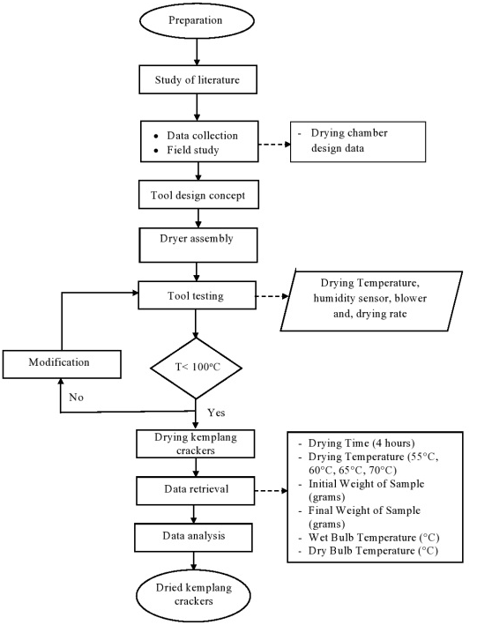
Figure 2. Design Flowchart and Tray Dryer Test
Result and Discussion
In this study, a tray dryer design which has a capacity of 1,02 kg with a combustion chamber size of 40 cm x 40 cm x 38 cm has been made which is made of steel plate where on the inside there is a 1 inch pipe which is useful for flowing air into the drying chamber. The drying chamber measuring 40 cm x 40 cm x 40 cm consists of 4 trays with a distance of 6.5 cm and there is a fan that is useful for maintaining hot air circulation so that it is evenly distributed. Condenser measuring 23 cm x 40 cm x 16 cm which is useful for processing the smoke produced in the drying process which will later be used as liquid smoke. The process of drying kemplang crackers for 4 hours requires 5,24 kg of coconut shell with the required heat energy of 95.358,01024 kJ and a carbon content value of 22,72%.

Relationship between Temperature and Water Content
Water content is one of the chemical properties that shows the water contained in food which greatly affects the shelf life.⁵
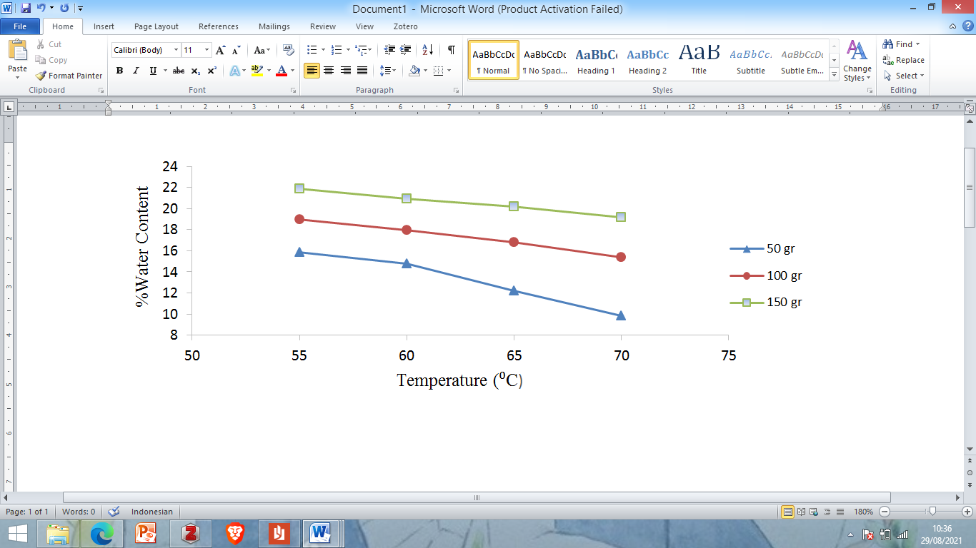
Figure 3. The relationship between temperature and moisture content of Kemplang crackers
Figure 3 shows that drying at a temperature of 55ºC with an initial average moisture content of 65,24% at a weight of 50 g was able to reduce the water content by 15,88%, at a weight of 100 gr it was able to reduce the water content by 18,98%, at a weight of 150 gr can reduce water content by 21,89% which is the lowest water content. At a temperature of 70ºC with an initial average weight of 65,24% at a weight of 50 gr it can reduce the water content by 9,84%, at a weight of 100 gr it can reduce the water content by 15,39% and at a weight of 150 gr it can reduce the water content up to 19,2% which is the highest water content. At a temperature of 70ºC produces the fastest changes in water content compared to drying at other temperatures, so it can be concluded that the optimum operating temperature for drying kemplang crackers is at a temperature of 70ºC.
This is proven from previous research by Fajri et al in the study of fish crackers with a gas-fueled tray dryer that increasing the temperature at the same drying time, the air sample content obtained will be lower.⁶ This shows that the relationship between the set point temperature and the evaporated air is directly proportional. This is because the increase in the temperature of the drying air will evaporate the air on the surface of the material.

Relationship of Temperature, Humidity and Relative Humidity
Humidity and RH values ​​were obtained from the confluence of the wet-bulb and dry-bulb temperature points on the psychrometric chart.
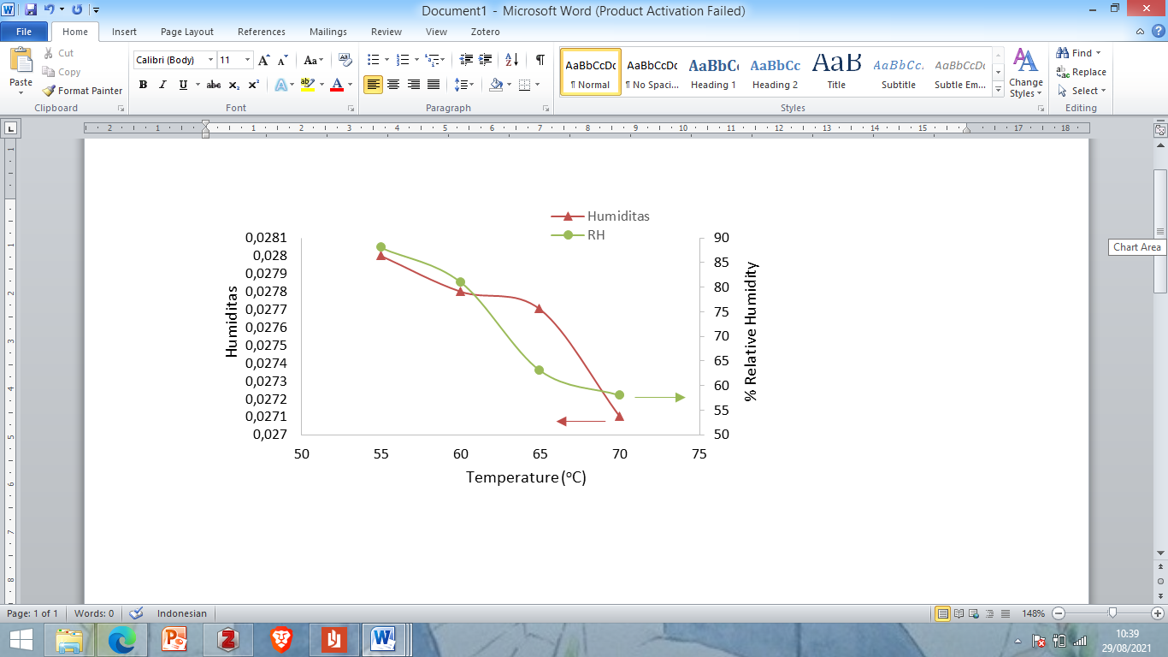
Figure 4. Relationship of Temperature, Humidity and Relative Humidity
Figure 4 shows that at a temperature of 55ºC with a humidity value of 0,0280 it has an RH value of 88%, while at a temperature of 70ºC with a humidity value of 0,0271 it has a RH value of 58%. At a temperature of 55ºC the water vapor content in the material is still quite a lot, resulting in a high humidity value and the relative humidity at 55ºC is higher than 70ºC. The higher the temperature, the lower the humidity value, because the mass transfer of air around the material to the drying air. This is reinforced by previous research by Kunco which concluded that low relative humidity values ​​will cause higher air and energy transfer so as to be able to evaporate the water content on the surface of the material, due to the low value of air humidity around the material.⁷

Relationship between Temperature and Drying Rate
From the drying process of kemplang crackers using this tray dryer, calculating the drying rate is used to describe the drying process of a material in each unit mass.
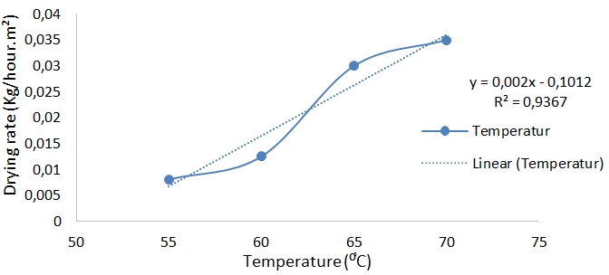
Figure 5. Relationship between Temperature and Drying Rate
Figure 5 shows that at a temperature of 55ºC it has a low drying rate value of 0,008136 kg/hour.m2 and at a temperature of 70ºC a high drying rate value of 0,035028 kg/hour.m². At a set point temperature of 70ºC hot air delivered from the combustion chamber propagates faster to the surface of the material and removes the water content in the surface layer of the material, when the water content on the surface of the material has been exhausted then the water content in the core of the material has been reduced. At a temperature of 55ºC the process of hot air propagation in drying the water content on the surface of the material is not as fast as at a temperature of 70ºC.
This has proven that a high temperature will produce a large amount of energy and the higher the temperature of the drying air, the relative humidity of the air will decrease and the drying speed will be higher, so the energy requirement for drying will be smaller.

Relationship of Temperature, Relative Humidity to Dryer Rate
The drying temperature will affect the humidity values ​​which will determine the drying rate of a material.
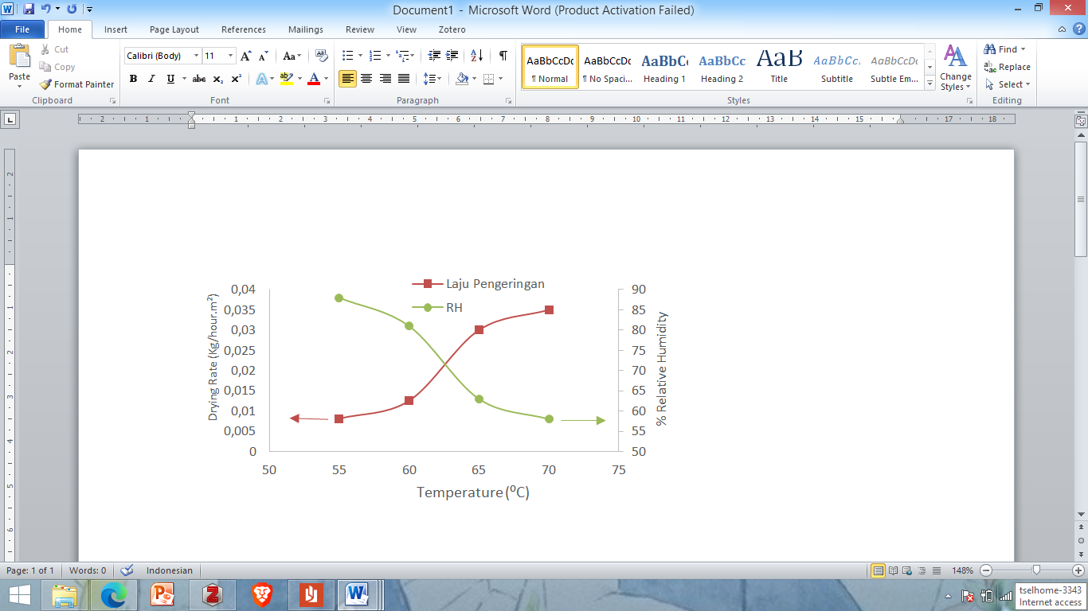
Figure 6. Relationship of Temperature, Relative Humidity to Dryer Rate
Figure 6 shows the increase in drying rate affected by relative humidity at constant airflow. The lowest drying rate occurs at a temperature of 55ºC with an RH value of 88% and a drying rate of 0,008136 kg/hour.m², while the highest drying rate occurs at a temperature of 70ºC with an RH value of 58% and a drying rate of 0,035028 kg/hour.m². This is inversely proportional to where the higher the drying temperature, the lower the relative humidity value, because low relative humidity will increase the driving force for the removal of water content in the material so that the drying rate will increase.
This is reinforced by previous research by Kuncoro who concluded that a low value of relative humidity will lead to greater heat transfer and mass of material into the air, which causes the humidity of the air around the material to decrease and the water on the surface of the material to evaporate.⁷

Comparison with Previous Research
The comparison of the results of the research on the design of the tray dryer for drying kemplang crackers that has been carried out with previous studies can be seen in Table 1.

Table 1. Comparison of Research Results and Previous Research
Ingredients | Drying Method | Temperature (ºC) | Time | Water Content (%) |  | Drying Rate (kg/hour.m²) | Reference
 |  |  |  | Awal | Akhir | Drying Rate (kg/hour.m²) | Reference
Fish crackers | ATMEGA 8535 . microcontroller oven drying | 60 | 3 hour | 23 | 18,75 |  | Syafriyudin & Purwanto, 2009
Fish crackers | Flat mirror concentrator drying | - | 6 hour | 80 | 11,2 | 0,0107 | Burlian & Firdaus, 2011
Fish crackers | Pengeringan uap panas menggunakan energi biomassa sekam | 78 | 3 hour | 55 | 7 | 0,0701 | Kuncoro 2015
Fish crackers | gas oven drying | 113 | 80 minute | - | - | - | Fajri et al, 2017
Prawn crackers | oven drying | 72 | 4 hour | 49,11 | 14,20 | - | Nugroho & Sukmawati, 2020
Fish crackers | Hot air drying using coconut shell biomass energy | 55  60  65  70 | 4 hour | 65,24 | 15,88  14,76  12,24  9,84 | 0,008136  0,012564  0,030024  0,035028 | Research result

Based on Table 2, shows the results of research by Syafriyudin and Purwanto about drying crackers using an ATMEGA 8535 microcontroller oven which is an automatic temperature control chip. The temperature of
the drying room will be detected by a temperature sensor with IC LM 35 then the temperature can be adjusted according to the provisions that apply to the temperature of the drying room. In this study, with a drying chamber temperature of 60ºC and an initial moisture content of 23%, it was able to dry crackers for 3 hours with a final moisture content of 18,75%.⁸ This means that this research has not been able to reduce the water content as determined by SNI No. 8272 – 2016.
Research conducted by Burlian and Firdaus on drying crackers using a flat mirror concentrator that utilizes radiation energy from sunlight with an initial moisture content of 80% is able to reduce water content up to 11,2% for 6 hours with a drying rate of 0,0107 kg. /hour m².⁹ This means that the research has been able to overload the crackers to a predetermined water content, but in this study it took quite a long time.
Kuncoro conducted a study on drying fish kemplang crackers with hot steam that utilizes biomass energy from rice husks with a temperature of 78ºC and an initial moisture content of 55% capable of drying kemplang crackers for 3 hours. With a final moisture content of 7% and a drying rate of 0,0701 kg/hour m2.⁷ This research has been able to achieve a predetermined moisture content with a fairly fast drying rate.
Fajri et al drying crackers using a gas oven with a drying temperature of 113ºC is able to dry fish crackers for 80 minutes to produce clean white crackers, but the use of high temperatures will make the surface of the crackers hard and cracked.⁶ Furthermore, research conducted by Nugroho and Sukmawati on drying shrimp crackers in an oven at a temperature of 72ºC with an initial moisture content of 49,11% for 4 hours was able to reduce the water content to 14,20%.¹⁰ This research has not been able to reach the water content that has been determined by SNI No. 8272 – 2016 which is 12%.
At this time the research conducted on drying kemplang crackers by utilizing biomass energy from coconut shells with an initial moisture content of 65,24% crackers at a temperature of 55ºC was able to reduce water content up to 15,88% with a drying rate of 0,008136 kg/hour.m², temperature of 60ºC can reduce water content up to 14,76% with a drying rate of 0,012564 kg/hour.m², a temperature of 65ºC can reduce water content up to 12,24% with a drying rate of 0,030024 kg/hour.m², a temperature of 70ºC can reduce moisture content up to 9,84% with a drying rate of 0,035028 kg/hour.m². This means that the current research has been able to reduce the water content in accordance with SNI No. 8272 – 2016 which is 12% at an optimum temperature of 70ºC.¹¹ In addition, this research also produces a by-product of the coconut shell burning process, namely liquid smoke which can be used as a wood preservative.
Conclusion
Based on the results of the research that has been done, it can be concluded that:
- Dimensions of the tray dryer where the combustion chamber is 40 cm long, 40 cm wide and 38 cm high, the drying chamber is 40 cm long, 40 cm wide, 40 cm high, has 4 trays and a capacity of 1.02 kg with the distance between the trays. 6,5 cm. The condenser chamber with a length of 23 cm, 40 cm and a height of 16 cm is useful for processing combustion residues in the form of liquid smoke or CO2 as a by-product of the kemplang cracker drying process.
- Based on the calculation of the moisture content, drying with a set point temperature of 70ºC was able to reduce the water content up to 9,84% from the initial moisture content of 65,24% with a weight of 50 gr of wet kemplang crackers and had met the requirements. with SNI No. 8272 – 2026, for a weight of 100 gr of wet kemplang crackers can reduce the water content by 15,39% and for a weight of 150 gr of wet kemplang crackers can reduce the water content by 19,2%.
Acknowledgment
Thank you to the lecturers and staff of the Sriwijaya State Polytechnic, so that this journal can be completed properly.

References
1. Kurniawan I, Martin A. Rancang Bangun Kondenser Pada Pengering Beku Vakum. Proceeding Seminar Nasional Tahunan Teknik Mesin XIV SNTTMXIV. 2015;6.
2. Hawa Lc, Sutan Sm, Turofiq I. Studi Variasi Kadar Air Terhadap Sifat Fisik Dan Mekanik Lerak (Sapindus Rarak). Jurnal Teknologi Pertananian. 2020;21(1):19–28.
3. Mc Cabe, Harriot P, Smith JC. Unit Operations Of Chemical Engineering. Dalam: 5nd Edition. 1993.
4. Badan Standar Nasional Indonesia. SNI 01-2891-1992: Analisa Kadar Air Metode Oven. Balai Besar Industri Kimia Departemen Perindustrian dan Perdagangan Jakarta. 1992.
5. Ikhsan M, Muhsin M, Patang P. Pengaruh Variasi Suhu Pengering Terhadap Mutu Dendeng Ikan Lele Dumbo (Clarias Gariepinus). Jurnal Pendidik Teknologi Pertanian. 7 Februari 2018;2(2):114.
6. Fajri RP, Maimuzar M, Sumiati R. Alat Pengering Kerupuk Palembang Dengan Menggunakan Gas LPG. Jurnal Teknik Mesin. 2019;10(2):31–7.
7. Kuncoro Ea. Desain Sistem Pengering Kerupuk Kemplang Dengan Uap Super Panas Berbahan Bakar Biomasa. Jurnal Buana Sains. 2015;14:29–36.
8. Syafriyudin, Purwanto Dp. Oven Pengering Kerupuk Berbasis Mikrokontroler Atmega 8535 Menggunakan Pemanas Pada Industri Rumah Tangga. Jurnal Teknologi. 2009;2(10).
9. Burlian F, Firdaus A. Kaji Eksperimental Alat Pengering Kerupuk Tenaga Surya Tipe Box Menggunakan Kosentrator Cermin Datar. Jurnal Teknik Mesin. 2011;15.
10. Nugroho Ts. Pengaruh Metode Pengeringan Kerupuk Udang Windu (Paneaus Monodon) Terhadap Daya Kembang Dan Nilai Organoleptik. Jurnal Manfish. 2020;1:8.
11. Badan Standar Nasional Indonesia. SNI No 2872-2016: Kerupuk Ikan, Udang Dan Moluska. Balai Besar Pengujian Penerapan Hasil Perikanan. 2016.

