THE EFFECT OF Mg-Al Wt% FOR PHASE FORMATION OF SPINEL MgAl₂O₄ PRODUCED BY METAL DISSOLVED METHOD
Chairatul Umamah^{1*}, Suminar Pratapa², Herman Jufri Andi³
^{1,3} Department Of Physics Education, Universitas Islam Madura Jl.PP Miftahul Ulum Bettet, Pamekasan
²Department Of Physics, Institut Teknologi Sepuluh Nopember Surabaya Jl.Arif Rahman Hakim, Surabaya 60111, Indonesia
*Corresponding Address: chairatul.umamah@uim.ac.id
Received: 2nd Januari 2016; Revised: 10th Februari 2016; Accepted: 31st Maret 2016
ABSTRACT
Synthesis of magnesium aluminate spinel powder (MgAl₂O₄, abbreviated as MA) were prepared by liquid mixing method. The synthesis of MA involved Mg powders with various weight compositions (4.8; 10; 20; 30; 40; and 60%) and Al powders (95.2; 90; 80; 70; 60 and 40%) as the raw materials, which were independently dissolved in 37% HCl to form MgCl₂ and AlCl₃ solutions. Both solutions were then mixed and stirred for 5 hours and dried to temperature about 100-105°C to produce powders with different weight compositions. Each powder resulted from drying was characterized using DTA-TGA, and then calcined at 650 °C; 750 °C and 850 °C for 1 hour. The calcined powder was characterized by XRD to qualitative and quantitative analyses using Rietica. It was found that MA samples contained only MgAl₂O₄ and MgO as impurity phase. The relative weight fraction of MgAl₂O₄ increased up to 99% for 95.2 wt% Al. Using an extrapolative approach to determine the Mg-to-Al composition, nearly pure MA, as high as 99%, was achieved at 95.2% Al and 4.8% Mg.
Keywords: Metal dissolved Method, MgAl₂O₄, Weight Fraction

Introduction
The development of nanomaterial technology indirectly influences on of nanocrystalline ceramic materials. Nanocrystalline material is expected to improve the properties of the material, especially in physical, mechanical, optical, and others. Magnesium Aluminate spinel (MA) is a well-known ceramics material with good mechanical strength, thermal, chemical and optical. MA has been been widely used in various applications and as a refractory materials because it has high melting temperature (2135 °C). It is, therefore, a good candidate material for high temperature applications (Emad, 2017).
MA is a ceramic with a cubic spinel structure which is based on the oxygen sublattice FCC closed-packed place where the tetrahedral and octahedral sites are filled. In general, the structure of spinel written as AB₂O₄ with A as a divalent cation and B is a trivalent cation. Spinel has two types namely normal and inverted. For normal spinel, like MA, B³⁺ cations occupied 1/4 the positions of octahedral and A²⁺ cations occupied 1/8 of the tetrahedral positions. There are several methods for synthesizing magnesium aluminate such as hydrothermal (Duan et al., 2017), microwave assisted combustion (Torkian n.d, 2019), Thermal Plasma (Dash et al., 2017), and sol gel (Sanjabi and Obeydavi, 2015). Microwave assisted combustion method, however, needs a long processing time to acquire pure MA, and the Thermal plasma spray and hydrothermal techniques are expensive and resulted in MA with MgO and Al₂O₃ impurities. In addition to those, the sol-gel method is also relatively costly. Moreover, these synthesis methods do not have sufficient control on phase formation of MA too.
Analyses of the formation of MA phase in a MgO-Al₂O₃ ceramic composite system were also reported by researchers. It was found that MA abundant will increase with more weight percentage of MgO and reached a maximum value in an equimolar Al₂O₃-MgO system (Baudin, R., 1995). Studies on the synthesis of pure MA are developing, i.e. in finding the most effective synthesis method by studying the formation of MA. Recently, a relatively simple synthesis method, called the metal-dissolved method was introduced . The method consists of mixing of solutions of metal precursors, drying at a temperature of 100-105 ºC and finally calcination at a given temperature to obtain an oxide compound of the constituting elements. This method offers an alternative to produce nanoparticles by bottom-up approach (Pratapa, 2013).
In this study MA spinel powders were synthesized using the metal-dissolved method with Mg–to-Al weight ratio variations to study the formation of spinel.
Methods
Synthesis of MA spinel has been done from Mg and Al powders. Mg and Al powders as the precursors were prepared at various weights composition (4.8; 10; 20; 30; 40 and 60% by weight) - Al (95.2; 90; 80; 70; 60 and 40% by weight ). Synthesis begins by dissolving magnesium powder (Merck) without heating in a 37% HCl and stirred with a magnetic stirrer for 1.5 hours at a constant speed. Then the synthesis was continued by dissolving aluminium powder (Merck) without heating in a 37% HCl and stirred with a magnetic stirrer for 3 hours at a constant speed. All metals (MgCl₂ and AlCl₃ solutions) are mixed and stirred for 5 hours at a constant speed. Then the solution mixture is dried at 100-105 ° C to produce powders with different weight compositions. Each of the dried powder was calcined at 650, 750 and 850 °C for 1 hour. following DSC-TGA results, X-ray diffraction (XRD) was used for phase characterization, including phase composition analysis using Rietica (Rietveld, H. M. 1969), using the 'ZMV' relative method to determine relative weight fraction of each phase:
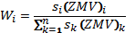 (1)
where W_{i} is the relative weight fraction of phase i (%), s is Rietveld scale factor, Z is the number of chemical formulas in the a cell, M is the mass of the phase and V is the volume of the unit cell.
Result and Discussion
Fig. 1 show the representative DSC-TGA curve for the 40% Mg and 60% Al (MA46) sample taken a heat rate of 10 °C/min up to 1000 °C. The initial sample weight was 20.2 mg. DSC result from the dried MA spinel powder indicated phase transformation at certain temperatures. There are four sharp endothermic peaks at 173, 205, 274 and 479 °C. The peak at 173 °C is addressed to the evaporation of water which is followed by a drastic absolute mass reduction, i.e. up to 1.6013 mg. The peak at temperature 205 °C can be associated with a phase transformation from Al to Al₂O₃ which is accompanied by a mass reduction of 1.8472 mg while that at 273.78°C can be associated with MgO phase transformation. The thermal events above 300 °C are all exothermic which possibly due to the phase formation of MA spinel as a result of the reaction between previously formed Al₂O₃ and MgO (Ghova, 2015). The MA formation completes above 478.68 °C, with its crystallinity should be further observed. Since, in principle there is no reaction or decomposition from 557 °C to 1000 °C. as marked by steady TGA curves, the calcination temperature was focused on 750 °C. Previous researchers (Habibi et al., 2017) with the Sol gel method, showed that at temperatures 500-700ºC the spinel had begun to form but was still amorphous with a larger crystal size and the crystal spinel phase would begin to form at a temperature of 800ºC. Therefore, this study used calcination temperature in the range of 650-850 ° C.

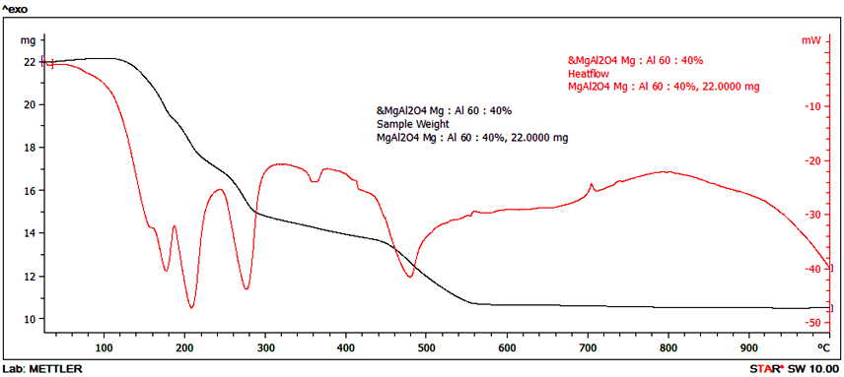

Figure 1. DSC-TGA curve of MA46 (40%:60%) dried sample.
The heat rate was 10 °C/min.

Figure 2-4. shows the X-ray diffraction patterns of MA samples at calcination temperature variations with a holding time of 1 hour. These patterns indicate that the phases identified were only spinel (MA) (MgAl₂O₄ with PDF no. 21-1152) as the main phase and periclase (MgO with PDF no.45-0946) as impurity phase in the absence of the aluminum oxide phase which be identified. The spinel formation as shown in the pictures shows that the method of metal dissolved method with HCl solvent can be used for the synthesis of spinel MA. From the diffraction patterns presented in Figure 2-4, it can generally informed that synthesis of spinel MA on all temperatures, the relative intensity of periclase to spinel decreases with increasing Al composition. This decrease occurred very sharply, which is about four times the composition of Al: Mg = 40: 60 to almost zero in the composition of 95: 4.

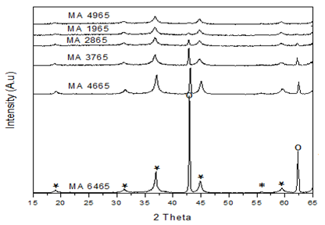

Figure 2. XRD patterns (λ=1.54060 Å) for MA samples with various composition calcined at 650 °C.: * = MA, o = Periklas.

From the diffraction patterns in Figure 2-4. it can also be observed that diffraction patterns have slightly different peak widths. If it is assumed that a bottom-up synthesis method such as metal dissolved method has no residual strain effect on the product material, then the widely of this peak can be assumed to be related only to the size of the crystal. In general, MA intensity is relatively higher than the intensity of periclase, and also MA intensity increases with the increase of Al content. All patterns do not show Al₂O₃-related peak, indicating that the Al precursor has completely reacts with the Mg precursor to form MA spinel. It is believed that MA is formed from a reaction between the oxidized dissolved magnesium and aluminum. Thus, the difference in width of the peak indicates that the size of the crystals in the phases in the samples has a significant difference. Specifically for the MA spinel phase, a fairly large peak widely indicates that the phase is on the nanometer crystal size.

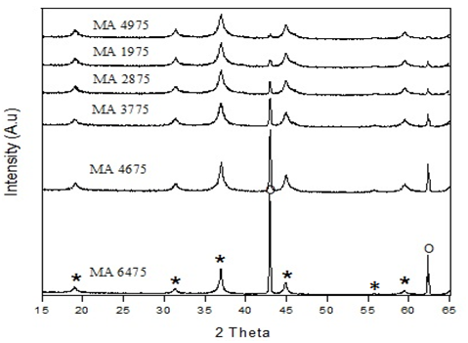
Figure 3. XRD patterns (λ=1.54060 Å) for MA samples with various composition calcined at 750 °C.: * = MA, o = Periklas.

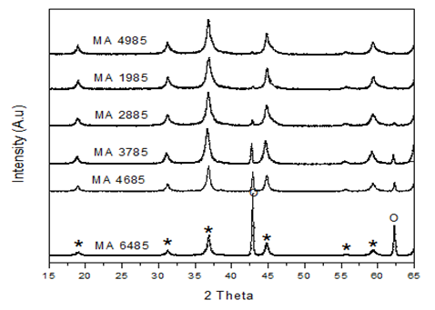
Figure 4. XRD patterns (λ=1.54060 Å) for MA samples with various composition calcined at 850 °C.: * = MA, o = Periklas.

Table 1. presents the Rietveld refinement figures-of-merit (FoM) values for samples with different compositions. Refinement for all sample are acceptable because the value of the GoF (goodness-of-fit) is less than 4% . These refinement results are also supported by the minute difference plot between the calculated and observed pattern as shown in Fig. 3. Then, the refinement outputs can be used for further analyses (Rietveld, H. M,. 1969).
Fig. 5-7 presents the relative weight fraction of each identified phase in the samples, calculated using formula (1) which has been embedded in Rietica software. Clearly the MA and periclase (MgO) weight fractions change complementary as the Mg-to-Al content changes. The more Al the less MA. In other words, within the vicinity of the composition, more Mg is required to form pure MA. The highest MA content is reached at 90:10 Mg-to-Al composition, attaining a value of as high as 98%. This result implies that a certain Mg-to-Al composition can be calculated, obviously by extrapolation, to achieve pure MA. Such extrapolated Mg-to-Al composition was 95.2:4.8%, which should then be used to prepare a new sample with expectedly pure MA.

Table 1. FoMs values from the Rietveld refinements (using Rietica) of XRD patterns.

Sample | Figures-Of-Merit
 | R_{p}(%) | R_{wp}(%) | R_{exp}(%) | GoF
MA4965 | 9,0 | 11,3 | 9,2 | 1,4
MA1965 | 9,0 | 11,3 | 9,3 | 1,4
MA2865 | 9,4 | 12,1 | 9,0 | 1,7
MA3765 | 9,2 | 11,4 | 9,1 | 1,4
MA4665 | 11,5 | 14,3 | 9,1 | 1,9
MA6465 | 12,6 | 13,1 | 9,0 | 1,8
MA4975 | 9,6 | 12,2 | 9,8 | 2,0
MA1975 | 9,8 | 12,1 | 9,8 | 1,7
MA2875 | 9,5 | 12,1 | 8,3 | 1,9
MA3775 | 8,6 | 11,2 | 8,6 | 1,6
MA4675 | 8,6 | 11,1 | 8,3 | 1,7
MA6475 | 9,6 | 12,3 | 9,6 | 1,6
MA4885 | 12,9 | 18,6 | 9,8 | 1,9
MA1985 | 12,5 | 16,9 | 10,9 | 1,6
MA2885 | 13,0 | 16,4 | 9,4 | 2,2
MA3785 | 13,9 | 18,2 | 9,8 | 2,1
MA4685 | 12,4 | 15,8 | 9,8 | 2,1
MA6485 | 12,3 | 18,8 | 10,2 | 2,0

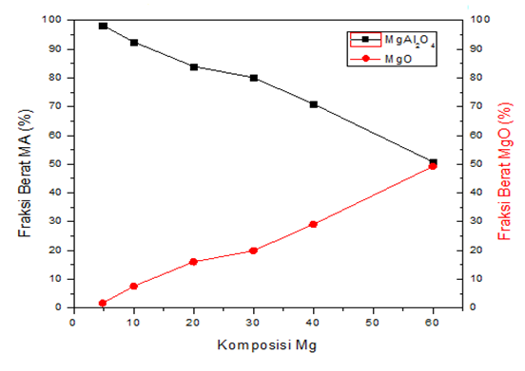
Figure 5. Relative weight fraction of phases for the MA samples for various Mg-to-Al compositions at 650 °C.

Periclase (MgO) phase is formed because most of Mg does not react completely with Al. Theoretically, if the Al³⁺ ions replacing Mg²⁺ ions, the cation vacancy defects (Mg) can be generated. Cation vacancy defects can accelerate the process of cation diffusion which improves densification and grain growth accelerates later (Jeong Yeon et al, 2018). The process of Mg²⁺ ions replacing Al³⁺ ions is accompanied by the formation of oxygen vacancies. Theoretically this flaw does not affect the diffusion of cations which control grain growth. More Al³⁺ cation diffusion will further accelerate the oxidation reaction of metallic Mg and Al. Excess Al composition will facilitate the formation of more homogeneous solution to form MA. Part of the MA formed was probably amorphous, which will diminish by synthesis at higher temperature (above 1000°C).

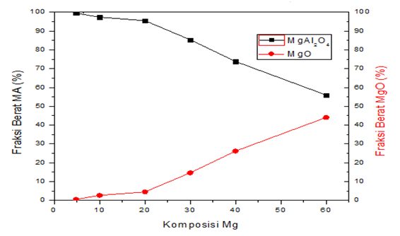
Figure 6. Relative weight fraction of phases for the MA samples for various Mg-to-Al compositions at 750 °C.

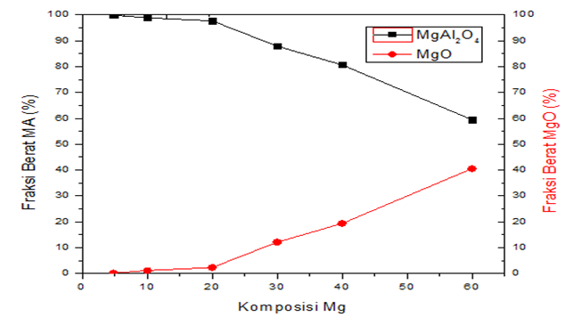
Figure 7. Relative weight fraction of phases for the MA samples for various Mg-to-Al compositions at 850 °C.

The primary phase of spinel is formed due to the reaction between magnesium and aluminum oxidized dissolved. this is suitable with formulation 2.
MgO + α-Al₂O₃ MgAl₂O₄ (2)
Al₂O₃ 2Al¹⁺_{(Mg)} + 3O_{(O)} + V²⁻_{(Mg )} (3)
where, Al¹⁺ is Al ion which site of Mg sublattice, O_{(O)} is oxygen ion which site of oxygen sublattice and V²⁻(Mg) = defect of Mg and
2MgO 2Mg¹⁻_{(Al)} + 2O_{(O)} + Vo²⁺ (4)
where Mg¹⁻ is the Mg ion in the sublattice site of Al while O_{(O)} is oxygen ion in the sublattice site of oxygen and Vo²⁺ is oxygen defect.
Figure 8. showed a phase diagram formed from variations composition of Mg-Al at each calcination temperature variation. Based on the MA spinel phase diagram the MgO-Al₂O₃ system with the solid state reaction method. At temperatures between 650-850 ° C in the composition of 10-60% Al₂O₃ the formed phase is spinel and periclase, and for the composition of 70% Al₂O₃ pure spinel is formed, whereas for 80-90% Al₂O₃ composition, the formed phase is spinel and Al₂O₃.
The results of this study, using comparison of composition from the base material Mg-Al with the metal dissolved method was obtained that at the composition of 95.2, 90, 80, 70, 60 and 40% Al, the phases formed at each calcination temperature variation were the same that spinel as the main phase and periclas as impurity phase.
This phase diagram is confirmed by DSC-TGA data in Figures 1 which explain that at temperatures above 470 ° C the spinel phase has begun to form. The periclas phase that emerged in all samples was confirmed by the exothermic peak in Figure 1 in the temperature range 271-432 ° C. other research confirm that states at temperature of 400-600 ° C, the periclas crystalline phase has been formed perfectly. The absence of a phase change marked by the absence of the Al₂O₃ phase is due to the fact that the alumina phase can crystallize perfectly at temperatures above 1000 ° C, so there is always an excessive periclase phase. Formulation (2) shows that spinel phase is formed due to the reaction between magnesium and aluminum oxidized dissolved which is α-Al₂O₃phase. This is what causes the appearance of periclase in all samples, because not all periclas crystals produced can react with alumina that has not fully crystallized at the calcination temperature used in this study.

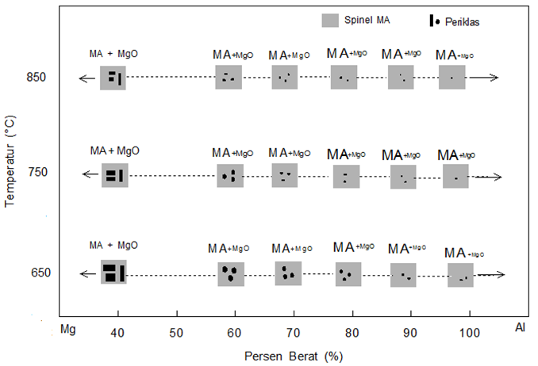
Figure 8. Phase Diagram Of Mg-Al System

Conclusion
It can be concluded from this study that MA spinel formation using the metal-dissolved method with five different Mg-to-Al metal powder compositions contained two phases, namely MA and periclase after calcination of the mixed precursors at 650 °C - 850 °C for 1 hour. The MA-periclase composition depends on the Mg-to-Al composition and between the Mg-to-Al composition range observed, more MA was obtained with increasing Al. The maximum amount of MA was around 99% (by weight) at the 4.8:95.2 Mg-to-Al composition.
Acknowledgment
This research was partially supported by the Ministry of Education and Culture Republic of Indonesia through Research Agency (LPPM) ITS in the EPI-UNet Research Scheme granted to SP.
References
Baudin, R. Martinez, and P. Pena. 1995. “High-Temperature Mechanical Behavior of Stoichiometric Magnesium Spinel” 78, : 1857–1862,.
Dash, Sanghamitra, Rakesh K. Sahoo, Arya Das, Shubhra Bajpai, Debidutta Debasish, and Saroj K. Singh. 2017. “Synthesis of MgAl₂O₄ Spinel by Thermal Plasma and Its Synergetic Structural Study.” Journal of Alloys and Compounds 726 (December): 1186–94. https://doi.org/10.1016/j.jallcom.2017.08.085.
Duan, Jinxia, Shengbo Lu, Xiuhui Wang, Jianlong Yin, Hong Gao, Zhenguo Su, and Jinlong Yang. 2017. “Synthesis and Characterization of Porous Magnesium Aluminate Spinel by Hydrothermal Process.” IOP Conference Series: Earth and Environmental Science 81 (August): 012028. https://doi.org/10.1088/1755-1315/81/1/012028.
Emad, Ewais “Synthesis of Nanocrystalline MgO/MgAl₂O₄ Spinel Powders from Industrial Wastes,” Journal of Alloys and Compounds 691 (January 15, 2017): 822–33, https://doi.org/10.1016/j.jallcom.2016.08.279.
Ghova, Joseph. 2015. “Effects of Calcination Temperature on Properties of Mg-Al Mixed Oxide Nanoparticle.” Materials Today: Proceedings 2 (9): 4328–33. https://doi.org/10.1016/j.matpr.2015.10.020.
Habibi, Narges, Yuan Wang, Hamidreza Arandiyan, and Mehran Rezaei. 2017. “Low-Temperature Synthesis of Mesoporous Nanocrystalline Magnesium Aluminate (MgAl₂O₄) Spinel with High Surface Area Using a Novel Modified Sol-Gel Method.” Advanced Powder Technology 28 (4): 1249–57. https://doi.org/10.1016/j.apt.2017.02.012.
Jeong Yeon et al. 2018. “Reliable Oxygen Transfer in MgAl₂O₄ Spinel through the Reversible Formation of Oxygen Vacancies by Cu²⁺/Fe³⁺ Anchoring.” Applied Energy 219 (June): 138–50. https://doi.org/10.1016/j.apenergy.2018.03.041.
Rietveld, H. M. 1969. “A Profile Refinement Method for Nuclear and Magnetic Structures.” Vol 2: 65–71.
S. Pratapa, M. A. Baqiya, I. Istianah, R. Lestari, and R. Angela,. 2013. “A Simple Dissolved Metals Mixing Method to Produce High-Purity MgTiO₃ Nanocrystals” AIP Conf. Proc. 1586, : 39–42.
Sanjabi, S., and A. Obeydavi. 2015. “Synthesis and Characterization of Nanocrystalline MgAl₂O₄ Spinel via Modified Sol–gel Method.” Journal of Alloys and Compounds 645 (October): 535–40. https://doi.org/10.1016/j.jallcom.2015.05.107.
Torkian, Leila. n.d. “Synthesis of Nano Crystalline MgAl₂O₄ Spinel Powder by Microwave Assisted Combustion | Request PDF.” ResearchGate. Accessed September 17, 2019. https://doi.org/http://dx.doi.org/10.3724/SP.J.1077.2011.10815.

