EFFECT OF DEPRESSION ON THE ABILITY OF PROBLEM SOLVING

Surya Sari Faradiba

FKIP, Universitas Islam Malang

suryasarifaradiba@unisma.ac.id

Abstract

Depression is a problem with mental health. The purpose of this study was to determine the effect of depression on mathematical problem solving abilities. This research is a qualitative research with a cross-sectional approach. The study involved 30 subjects from students of the Department of Mathematics Education, FKIP Universitas Islam Malang. The sampling technique used was convenience sampling. The data collection technique used in this study using a questionnaire from Beck Depression Inventory II (BDI-II) consisted of 21 questions. The mathematical problem solving process is seen from the answer of the subject when working on mathematical problems based on Polya's problem solving steps. The results showed that subjects with normal levels of depression tended to have a complete and sequential characteristic of mathematical problems. Meanwhile, subjects with mild levels of depression tended to resolve problems in sequence but were incomplete. Furthermore, subjects with moderate levels of depression tend to solve mathematical problems in an irregular and incomplete manner. Subsequent research makes it possible to examine the same thing involving more research samples.

Keywords: depression, problem solving, pattern, polya

INTRODUCTION

Depression is a problem with mental health. Depression symptoms experienced by a person are loss of mood, decreased interest in certain activities, the emergence of guilt, experiencing sleep disturbances or disturbances in appetite, decreased stamina, and decreased memory (World Health Organization, 2010). In addition, someone who experiences depression carries out a variety of deviant behaviors such as problems in the social environment (Zaini, Anjum, & Dahlawi, 2018), and academic problems (Heiligenstein, Guenther, Hsu, & Herman, 1996). Ghayas, Shamim, Anjum, & Hussain (2014) showed that there were 53.43% of undergraduate university students in Pakistan who were depressed. Ibrahim, Kelly, & Glazebrook, (2012a, 2012b) stated that students who experienced mild depression were 71% and moderate depression were 37.6% at the University of Egypt.
One of the reasons for students experiencing depression is academic problems. Most students who are depressed cannot concentrate properly while studying and do not do coursework. According to Khurshid, Parveen, Yousuf, & Chaudhry (2015) the academic value of students is influenced by the personality of each student, education, motivation, mental health, and training. This causes a decrease in student academic achievement. The statement was supported by Khaneheshi & Basavarajappa (2011) who argued that there was a significant relationship between academic problems and the level of depression. This can happen because students use poor coping strategies, bad experiences of certain activities and low self-efficacy owned by students that causes depression, feelings of helplessness, anger and violence. As a result of these problems, students get low academic achievement and drop out of college. The study is in accordance with the opinion of Flatt (2013) Furr, Westefeld, McConnell, & Jenkins, (2001) and Mojs, et al. (2012) which stated that stress on academics, academic failure and academic problems correlated with depression in students.
In this study, depression originating from academic problems was observed from the process of solving problems carried out by students. Questions or questions in mathematics are a problem if there is a challenge to solve. The procedure for solving questions or questions in mathematics cannot be done without understanding the underlying theory. The procedure for solving questions or questions requires regular steps as a problem solving. The most common step in problem solving is the model from Polya (1988). According to Polya (1988), there are four stages of problem solving, namely understanding problems, planning problem solving, planning problems, and revisiting the results obtained. The 4 stages of the Polya are as follows: understand the problem (understand the problem), make a plan (devise a plan), implement a plan (carry out the plan), and look back (looking back)
In learning mathematics, students are expected to have the ability to solve mathematical problems. This is in accordance with the objectives of mathematics, problem solving ability is one of the skills that are expected to be mastered by students in mathematics learning. According to Robert L. Solso (in Mawaddah and Anisah: 2015), problem solving is a directional thought to find solutions or solutions to a specific problem. In mathematics the problem solving skills must be possessed by students to solve problems in the problem. The National Council of Teachers of Mathematics or NTCM (2000) states that school mathematics standards must include standard content and process standards. Standard processes include problem solving, reasoning and verification, linkages, communication and representation.

To fulfill the above demands, students need to identify the operations involved and the strategies needed to solve the problem given. This can be done by students in ways such as: guessing, developing a model, sketching diagrams, simplifying problems, identifying patterns, making tables, experiments and simulations, working upside down, testing all possibilities, identifying sub-goals, making analogies, and sorting data / information. Learning mathematics through problem solving is an activity in a class involving students or students. Therefore, the class needs to be given challenges or motivation to students so that they are able to understand the problem, are interested in solving it, are able to use all of their knowledge to form strategies in solving the problem, implement the strategy, and assess whether the answers given by students are correct or wrong. Through problem-based learning, students as prospective mathematics teachers can develop their abilities in problem solving, because one of the mathematics learning objectives for students is so that they have the ability or skills in solving problems or mathematical problems, as a means for him to hone careful, logical reasoning, critical, and creative. Therefore problem solving skills become the focus of learning mathematics at all levels. Especially for a student who is a mathematics teacher, it is certainly not enough if he only has that ability for himself, because later if he has become a teacher, he will have a difficult task which is to make students have the ability to solve mathematical problems. Noting the importance of a mathematics teacher candidate student having problem solving skills, this study aims to determine the effect of depression on mathematical problem solving abilities.

METHOD

This study uses a qualitative method. In this study using a cross-sectional approach. The cross-sectional approach is research carried out at one time. The sampling technique uses convenience sampling technique. In convenience sampling techniques, researchers chose participants because they were willing and available in the study (Creswell, 2012). In this case, researchers can choose samples at a time, place, and situation that has been predetermined (Prasetyo & Jannah, 2012). The selection of research subjects was conducted by looking at the results of the depression questionnaire to classify students who had normal, mild, moderate, and severe levels of depression using the normative reference guidelines proposed by Arikunto (2008), namely by using averages. Then each student has a normal depression level (S1), one student has a mild depression (S2), and one student who has a moderate level of depression (S2), by considering the communication skills of each subject.

The population of the subjects in this study were students of the Islamic University of Malang. The number of samples in this study were 30 people. Methods of data collection in the study were three types, namely Beck Depression Inventory-II (BDI-II) to measure depression.

The Beck Depression Inventory is an instrument from Dr. Aaron T. Beck is designed for individuals aged 13 years and over. This instrument consists of 21 items that have several statements relating to indications of depression such as feelings of despair and anger, cognition symptoms such as feelings of guilt to others or punished, and physical symptoms such as fatigue, weight loss (Beck, 1970). Scores of each category of symptoms displayed on this instrument starts from a score of 0-9 = depressive symptoms that are minimal or still in normal condition, 10-16 = mild depression, grades 17-29 = moderate depression, and 30-63 = severe depression (American Psychiatric Association, 2000).
Data collection techniques used in this study were the provision of written tests and interviews. The research instrument consists of the main instruments, namely the researchers themselves and supporting instruments namely interview guides and written tests that contain the following problems:

Look to the 8 x 8 square chess board as shown in the picture below:

Determine how many squares are there on the chessboard?

Data analysis was carried out by referring to the qualitative data analysis model of Miles and Huberman (1992), namely: data reduction (data reduction), data display (data presentation) and conclusion / verification (conclusion drawing). The credibility testing of the data used in this study is time triangulation, which is the technique of testing data credibility by obtaining data from the same source with the same questions in different times.

RESULTS AND DISCUSSION
The data description for the depression variable can be seen based on the depression category determined by (American Psychiatric Association, 2000). The table explains that the normal category is more dominant than the other categories.

Table 1 Description of Depression Variable Data
Category | Score | The number of students | Persentage
Normal | 0-9 | 15 | 50%
Low | 10-16 | 9 | 30%
Modertae | 17-29 | 5 | 16.67%
High | 30-63 | 1 | 3.33%
TOTAL |  | 30 | 100
Furthermore, three subjects were taken, namely S1, S2 and S3 to find out the problem solving process from each category of depression levels. S1 represents a group of students with normal levels of depression. S1 work results can be seen in Figure 1. S1 resolves the problem by following the Polya problem solving steps in full and sequentially.
In the first step, S1 understands the problem (Understand the problem) by understanding the fact that the square has the same length and width, so in this case the size of the square that might be produced from a chessboard measuring 8 x 8 square units is, 1 x 1, 2 x 2, 3 x 3, 4 x 4, 5 x 5, 6 x 6, 7 x 7, and 8 x 8. Next, S1 plans problem solving (Design a plan). In this case S1 uses a strategy for looking for a pattern, namely S1, trying to find the number of different squares on all sizes of chess boards, starting with the size of 1 x 1, 2 x 2, 3 x 3, 4 x 4, 5 x 5 , 6 x 6, 7 x 7, and 8 x 8 for the next observed pattern found on each chess board size. The third step is to implement problem solving according to plan (Carry out the plan). By paying attention to the pattern, S1 makes generalizations as follows:
Table 2 Patterns generated from S1 work
Size | Type
 | 1 x 1 | 2 x 2 | 3 x 3 | 4 x 4 | 5 x 5 | 6 x 6 | 7 x 7 | 8 x 8
1 x 1 | 1² | 2² | 3² | 4² | 5² | 6² | 7² | 8²
2 x 2 |  | 1² | 2² | 3² | 4² | 5² | 6² | 7²
3 x 3 |  |  | 1² | 2² | 3² | 4² | 5² | 6²
4 x 4 |  |  |  | 1² | 2² | 3² | 4² | 5²
5 x 5 |  |  |  |  | 1² | 2² | 3² | 4²
6 x 6 |  |  |  |  |  | 1² | 2² | 3²
7 x 7 |  |  |  |  |  |  | 1² | 2²
8 x 8 |  |  |  |  |  |  |  | 1²
TOTAL | 1 | 5 | 14 | 30 | 55 | 91 | 140 | 204

The last step is S1 Look Back by ensuring that there are no errors in the answers that have been generated. Thus it can be concluded that, the Polya problem solving process carried out by S1 (normal level of depression) is complete and sequential. Completeness and sequentiality are important in problem solving. According to Newell and Simon as quoted by Darminto (2010: 24), "the problem is a situation where the individual wants to take the necessary actions to get what he wants". According to Saad & Ghani (2008: 119), mathematical problems are defined as situations that have clear goals but are faced with obstacles due to a lack of algorithms that are known to describe them in order to obtain a solution. This algorithm can only be run if the problem solving process is complete and sequential.

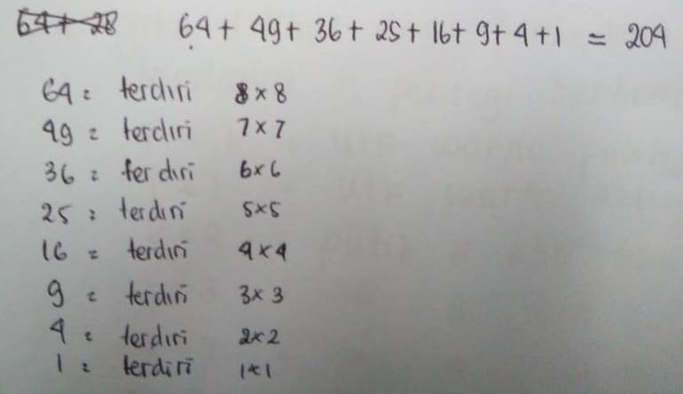
Figure 1 Results of the S1 Problem Solution

Then the S2 represents a group of students with mild depression. S2 focuses by counting the number of squares measuring 1 x 1. In this case, the problem solving process carried out by the S2 is incomplete. The first step is S2 by understanding the problem, this can be seen from the beginning of the S2 answer, namely "there are 2 square types." Next, the second stage is planning problem solving by calculating the number of squares measuring 1 x as many as 32 black squares and 32 white square. In the third stage, S2 displays the sum of all square sizes 1 x 1 square unit which is 32 + 32 = 64. In this case, S2 does not do the fourth stage in resolving the issue of Polya namely checking answers. So the problem solving process carried out by S2 (mild depression) is sequential but incomplete. The incompleteness of the steps in solving this problem is a serious obstacle especially in problems that are seeking solutions. This is in accordance with the opinion of Polya (1988) which explains mathematical problems in two types, namely the problem of finding (problem to find) and the problem of proving (problem to prove). Search problems, namely problems that aim to find, determine, or get the value of a certain object that is unknown in the problem and give the appropriate conditions. While the problem proves that is the problem with a procedure to determine a statement true or false. Masalh is looking for a complete set of problem solving steps to ensure that the answers produced are correct.
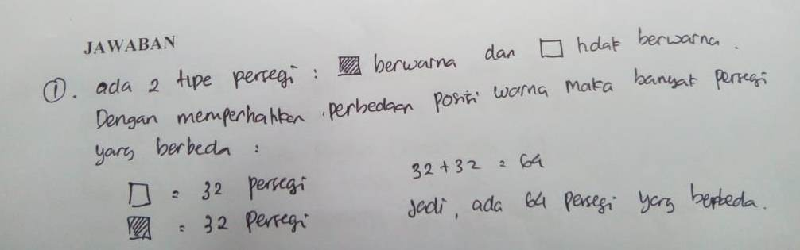

Figure 2 Results of S2 Problem Solution

S3 works on problem solving problems by using the formula for the number of nth term. S3 is a group of students with moderate levels of depression. S3 directly works on the problem using the formula for the number of nth term. In this case S3 passes stage 1 and stage 2 in solving Polya's mathematical problems. S3 directly in stage 3 is to solve problem solving. Thus it can be concluded that the problem solving process carried out by S3 (moderate depression level) is disordered and incomplete. This condition is likely to occur because S3 is faced with several challenges such as difficulties in understanding the problem. According to Saad & Ghani (2008: 120), students need to do a number of things such as accepting challenges from problems, planning strategies for problem solving, implementing strategies, and re-testing solutions obtained. To overcome the problems faced by S3, according to Krulik and Rudnick, as quoted by Carson (2007: 21-22), S3 can be asked to re-read the problems faced and try to explore.

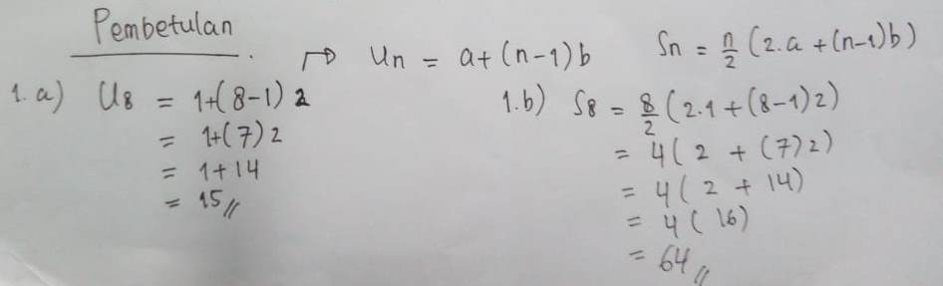

Figure 3 Results of S3 Problem Solution

CONCLUSION
Students with normal levels of depression tend to solve mathematical problems by paying attention to the complete and sequential steps of completion. Subjects with mild levels of depression cander to do problem solving sequentially but not complete. Lastly, subjects with moderate levels of depression tended to resolve problems without medication and were incomplete.

REFERENCES

American Psychiatric Association. (2000). Diagnostic and Statistical Manual of Mental Disorders, Fourth Edition: DSM-IV-TR®. American Psychiatric Association.
Arikunto, S. (2008). Evaluasi Program Pendidikan. Edisi Kedua. Jakarta: Bumi Aksara.
Beck, A. T. (1970). Depression : causes and treatment. Philadelphia, University of Pennsylvania Press. Diambil dari http://archive.org/details/depressioncauses00beck
Carson, J. 2007. A Problem With Problem Solving: Teaching Thingking Without Teaching Knowledge. The Mathematics Educator Journal, 17 (2), 7-14.
Creswell, J. W. (2012). Educational Research: Planning, Conducting, and Evaluating Quantitative and Qualitative Research (4th ed). Boston: Pearson.
Flatt, A. K. (2013). A Suffering Generation: Six factors contributing to the mental health crisis in North American higher education. Seneca College of Applied Arts and Technology, 16(1), 1–11.
Furr, R. S., Westefeld, S. J., McConnell, N. J., & Jenkins, M. J. (2001). Suicide and Depression Among College Students: A Decade Later Professional Psychology. Research and Practice, 32(6), 97–100.
Ghayas, S., Shamim, S., Anjum, F., & Hussain, M. (2014). Prevalence and Severity of Depression among Undergraduate Students in Karachi, Pakistan: a Cross Sectional Study. Tropical Journal of Pharmaceutical Research, 13(10), 1733. https://doi.org/10.4314/tjpr.v13i10.24
Heiligenstein, E., Guenther, G., Hsu, K., & Herman, K. (1996). Depression and Academic Impairment in College Students. Journal of American College Health, 45(2), 59–64. https://doi.org/10.1080/07448481.1996.9936863
Ibrahim, A. K., Kelly, S. J., & Glazebrook, C. (2012a). Analysis of an Egyptian Study on The Socioeconomic Distribution of Depressive Symptoms among Undergraduates. Social Psychiatry and Psychiatric Epidemiology, 47(6), 927–937. https://doi.org/10.1007/s00127-011-0400-x
Ibrahim, A. K., Kelly, S. J., & Glazebrook, C. (2012b). Reliability of a shortened Version of the Zagazig Depression Scale and Prevalence of Depression in an Egyptian University Student Sample. Comprehensive Psychiatry, 53(5), 638–647. https://doi.org/10.1016/j.comppsych.2011.06.007
Khaneheshi, A., & Basavarajappa . (2011). The Relationship Of Academic Stress With Aggression, Depression, And Academic Performance Of College Students In Iran. I-Manager’s Journal on Educational Psychology, 5(1), 24–31. https://doi.org/10.26634/jpsy.5.1.1495
Khurshid, S., Parveen, Q., Yousuf, M. I., & Chaudhry, A. G. (2015). Effects of Depression On Students’ Academic Performance. Sci.Int.(Lahore), 27(2), 1619–1624.
Mawaddah, Siti dan Hana Anisah. (2016). Kemampuan Pemecahan Masalah Matematis Siswa
Pada Pembelajaran Matematika Dengan Menggunakan Model Pembelajaran Generatif (Generative Learning) Di SMP. EDU-MAT Jurnal Pendidikan Matematika, Volume 3, Nomor 2, Oktober 2015, hlm 166 – 175 diakses dari http://download.portalgaruda.org/article.php?article=444169&val=9364&title tanggal 22 November 2017
Miles, M.B. & Huberman, A.M. (1992). Analisis Data Kualitatif: Buku Sumber Tentang Metode-metode Baru. Terjemahan oleh: Tjetjep Rohendi Rohedi. Jakarta: UI Press
Mojs, E., Warchoł-Biedermann, K., Głowacka, M. D., Strzelecki, W., Ziemska, B., & Marcinkowski, J. T. (2012). Are Students Prone to Depression and Suicidal Thoughts? Assessment of The Risk of Depression in University Students from Rural and Urban Areas. Annals of Agricultural and Environmental Medicine, 19(4), 5.
NCTM. 2000. Principles and Standards for School Mathematics. Amerika: NCTM. Inc.
Prasetyo, B., & Jannah, L. M. (2012). Metode Penelitian Kuantitatif: Teori dan Aplikasi.
RajaGrafindo Persada.
Polya, G. 1988. How to Solve It, A New Aspect of Mathematical Method. Oxford:Princeton
University Press Princeton and Oxford.
World Health Organization. (2010). ICD-10: International Statistical Classification of Diseases and Related Health Problems. Geneva: World Health Organization.
Zaini, R. G., Anjum, F., & Dahlawi, H. (2018). Assessment of Depression among Applied Medical Science College Students at Taif University: A Questionnaire Survey. Journal of Psychiatry, 21(1). https://doi.org/10.4172/2378-5756.1000431

