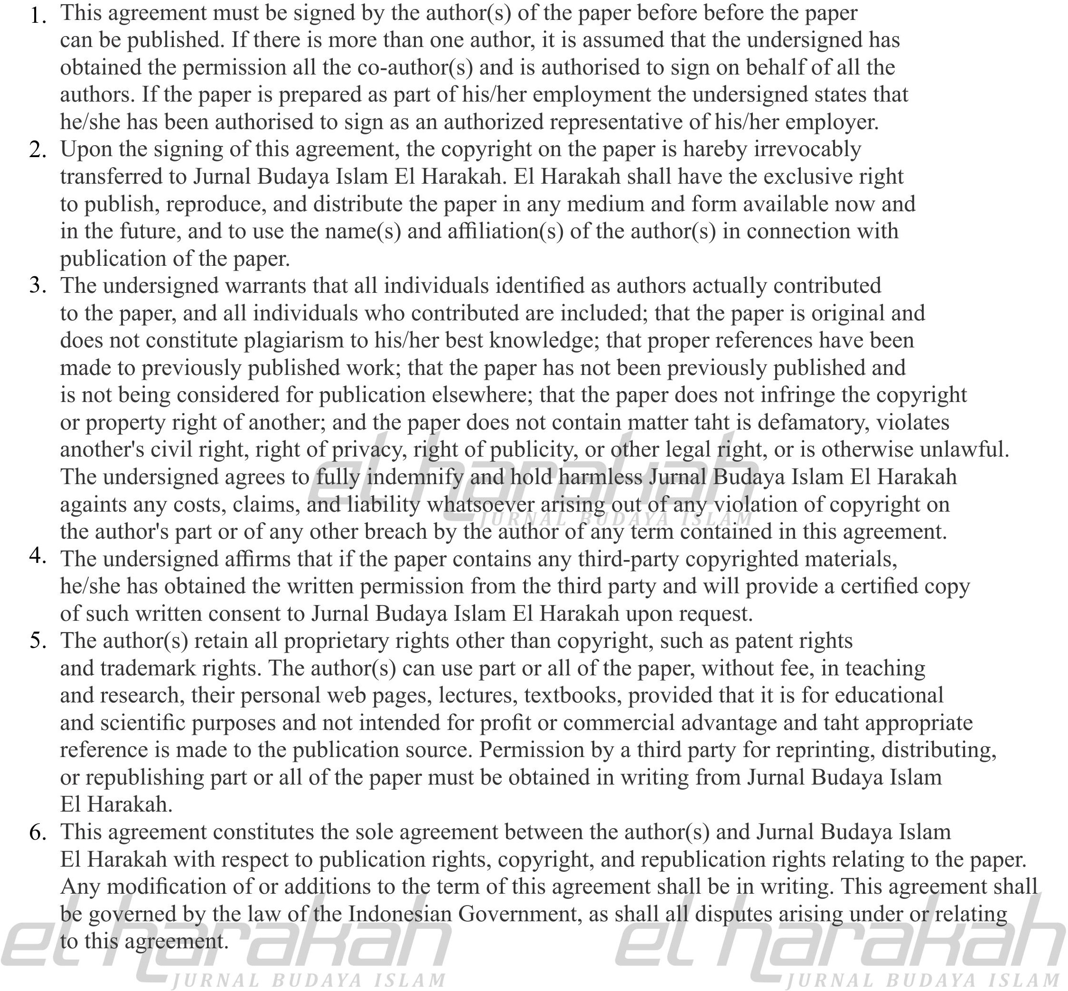
SYMBOLIC MEANING ANALIYSIS OF KESANDINGAN RITUAL IN PROBOLINGGO

Author(s) : Nurhadi, Faisol, Faisal Mahmoud Adam Ibrahim

Paper ID : 10545

Date (day/month/year) : 28 Mei 2021

