

**AUTHOR** **STATEMENT LETTERS**

Title of paper : ANALISIS MUTU PELAYANAN PENGELOLAAN OBAT DI PUSKESMAS X DAN PUSKESMAS Y KABUPATEN SUKOHARJO TAHUN 2022

Name(s) of author(s) : LAURA ANGELICA HANANTO

Name and address of Principal/Corresponding Author:

Name : TRI WIJAYANTI

Affiliation : FAKULTAS FARMASI, UNIVERSITAS SETIA BUDI State : INDONESIA

Contact Number 087727167830

Email : [triwijayanti@setiabudi.ac.id](mailto:triwijayanti@setiabudi.ac.id)

1. I hereby declare that the material being presented by me in this paper is our original work, and does not contain or include material taken from other copyrighted sources. Wherever such material has been included, it has been clearly indented or/and identified by quotation marks and due and proper acknowledgements given by citing the source at appropriate places.
2. The paper, the final version of which I enclose, is not substantially the same as any that I/we have already published elsewhere.
3. I/we have not sent the paper or any paper substantially the same as the enclosed one, for publication anywhere else.
4. Furthermore, the author may only post his/her version provided acknowledgement is given to theoriginal source of publication and a link is inserted to the published article on Biomedical and Pharmacology Journal website
5. The submitted/enclosed camera‐ready paper is thoroughly proofread by me and in conformity with the instructions for authors communicated to me.

Thus, this statement I make with truth and full of honesty.

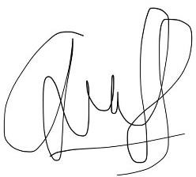Surakarta, 18 Desember 2023 Best Regards,

Laura Angelica Hananto



## COPYRIGHT TRANSFER AGREEMENT

Title of the manuscript:

The authors hereby transfer copyrights in and to the manuscript named above in all forms and media, now or hereafter known, to **Journal of Islamic Pharmacy (JIP)** effective if and when the paper is accepted for publication.

Everyone who is listed as an author in this manuscript should have made a substantial, direct, intellectual contribution to the work and should take public responsibility for it.

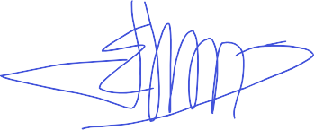This manuscript contains works that have not previously published or not under consideration for publication by another journals.

Sincerely,

Corresponding author: Tri Wijayanti 18 Desember 2023

Authors: Laura Angelica Hananto 18 Desember 2023

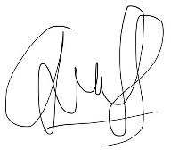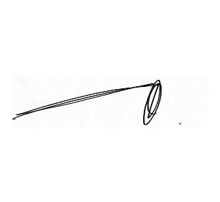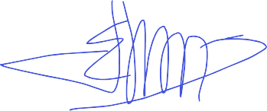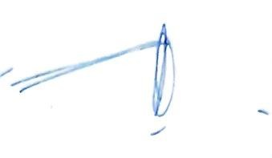

Partana Boedirahardja 18 Desember 2023

Tri Wijayanti 18 Desember 2023

* This form must be signed by all authors in order as appeared in the manuscript.