THE INFLUENCE FINANCIAL KNOWLEDGE AND FINANCIAL ATTITUDE ON FINANCIAL MANAGEMENT BEHAVIOR IN LOCUS OF CONTROL MEDIATED

ABSTRACT
Nur Riska Agustina
Hj. Mardiana, SE, MM
Faculty of Economic
Nur Riska Agustina
Faculty of Economic Financial management behavior becomes an issue that can’t be avoided in this moment, especially in relation to consumptive phenomenon. In fact, the consumptive phenomenon became bad habid now. Therefore, the purpose of this study is to determine the influence of financial knowledge and financial attitude on financial management behavior, and determine the indirect influence financial knowledge and financial attitude on financial management behavior if mediated by locus of control. The population in this study is management students of Economic Faculty at Universitas Islam Negeri Maulana Malik Ibrahim Malang. The sample in this study was taken by purposive sampling technique, which amounted to 270 respondents. Data analysis method used descriptive analysis, and data analysis used Partial Least Square (SmartPLS) 3 with mediation analysis by Sobeltest. The results of the research shows that the financial knowledge and financial attitude have a positive and significant influence to financial management behavior. Other that, financial knowledge and financial attitude have a positive and significant influence to financial management behavior if mediated by locus of control.

Keywords: Financial Management Behavior, Financial Knowledge, Financial Attitude, Locus of Control

INTRODUCTION
Financial management behavior becomes an issue that cann’t be avoided in this moment, especially with regard to the behavior of private consumption. Society tends to think short-term and less responsible financial decisions that ultimately may create some financial problems if it isn’t followed by good financial planning (Kholilah and Iramani, 2013). Financial planning is required to determine the direction of person's financial management, so creating a good financial management behavior in the community. Some of the causes financial stability of individual disturbed which then leads to the endangerment of financial well-being, among others cann’t distinguish between deposits, savings, and investment, debt hobbies, and bad lifestyles (Ghozie, 2016). The survey results Indonesia in 2016, 67.82% of people who use financial services, only 29.66% who understand financial products with a margin of error of 3%. On that basis, the Financial Services Authority provides educational content and financial information via official website of the Financial Services Authority as well as book launches financial education for the college students (Otoritas Jasa Keuangan, 2016).
The first period of the individual experiencing the freedom to manage finances without full parental supervision is the lecture period. In the lecture periode,college students are required to have the financial intellegence through a potential resource management into real wealth, then process again (Tanuwidjaja, 2009: 10). Factsshow that students in big cities like Malang, still priority the up to date life style which caused in consumer behavior. State Islamic University of Maulana Malik Ibrahim Malang (UIN Maliki Malang) is one of the universities in Malang, pay attention to the learning in the lecture bench. According the vision of UIN Maliki Malang that not only instill professional maturity, but also emphasizes the depth of the spiritual, moral grandeur, as well as the breadth of knowledge. It is expected that students have more knowledge, for example a ban on consumer behavior and behaved wisely through better self-control and responsibility.
In this university has many programs study, one of which is management programs. This programs are courses that deepen knowledge management either through the planting of intellectual values and Islamic values. In learning this course also learn financial management has integratedby Islamic concept. Students of the Department of Management should behave better financial management than other majors, so it is expected to be able to implement the knowledge gained about the economy and finance.

LITERATURE REVIEW AND HYPOTHESIS
Financial planning is required to determine the direction of the person's financial management, thereby creating a financial management behavior. Financial management behavior is a person's ability to regulate everyday financial funds (Kholilah and Iramani, 2013). Many considerations must be made individual to create a responsible decision. The theory of financial management behavior disclosed Dew and Xiao (2011) in four main things: consumption, cash flow management, savings and investment, as well as debt management.
Empirical evidence shows that there are several variables that affect the behavior of financial management, one of which is financial knowledge. Sarah (2009) states that the financial knowledge proved to have a significant impact on the financial management and more consistent when various policies are used. Someone who were rational and more confident in terms of financial knowledge affect the financial behavior that is more profitable. Financial knowledge is mastery of a variety of things about the world of finance (Kholilah and Iramani, 2013). Chen and Volpe (1998), disclose the financial knowledge to the four issues: general financial knowledge, knowledge of savings and loans, insurance knowledge, and investment knowledge.
Other variables that affect the behavior of financial management is the financial attitude. Pankow (2003) defined as a state of mind of financial attitudes, opinions, and ratings about finances. An understanding of the financial attitude will help a person to understand what is believed related to her relationship with money. Yamauchi and Templer (1982) states there are five sections in the attitude of finance namely power-prestige (the source of power and status), retention time (money must be managed and cautious in spending), distrust (raised doubts), quality (symbol of success and quality),and anxiety (anxiety causes).
In addition to the above two variables, other variables that influence the financial management behavior is locus of control. The concept of locus of control is defined by Ida and Dwinta (2010) as the cause of an event. Locus of control is able to direct the behavior toward goodness involves physical and psychological functioning so as to have a positive impact. According the Behavioral Finance Theory that began respon their element in the behavior of financial decision-making process, the psychological factors can influence the willingness of a person in financial management. Locus of control is divided into two, namely 1) the internal locus of control, which considers that the ability and attempt to determine what is gained in life, 2)external locus of control, consider that determined life environmental forces (Kholilah and Iramani, 2013). Individuals with high control will be pay attention to the proper ways to behave in various situations (Ida and Dwinta, 2010). Cogent measures in accordance with the theory put forward Ajzen (2002) that the behavior is determined by the desire for someone to perform or not perform the behavior.

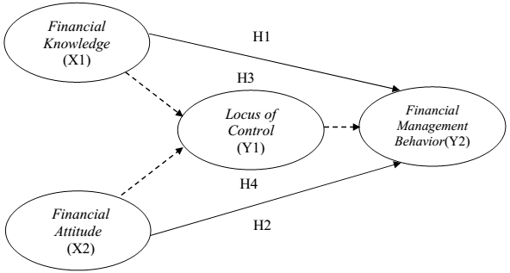
Figure 1. Model Hypothesis
Source: Data Processed, 2017

Hypothesis
H1: The higher financial knowledge, createsthe higher of financial management behavior
H2: The higher financial attitude,createsthe higher of financial management behavior
H3: The higher financial knowledge, creates the higher the financial management behavior through increased locus of control
H4: The higher financial attitude, createsthe higher financial management behavior through increased locus of control
METHODS
This research is an explanatory research with a quantitative approach. The study population was a student majoring in management UIN Maliki Malang. Samples were taken through purposive sampling with the following criteria: (1) Registered as a student of the management programs of UIN Maliki Malang; (2) Being in the semester 1 to semester of 8 academic year 2017/2018; (3) Don’t live with his parents (manage the finance). The results of the sample through a Slovin formula calculation show the total sample are 270 respondents. The data source is the primary research, specifically by distributing questionnaires collected through structured questions regarding the study variables of financial knowledge, financial attitude, locus of control and financial management behavior.
Statistical analysis tools smartPLS research with using software version 3.0.,because this study uses multivariate statistical techniques by using three variables: the independent variables, mediating variables and the dependent variable. PLS suitable to confirm the indicators of a concept / construct / factor. PLS is one of the multivariate analysis techniques with a series of analyzes of some latent variables simultaneously. PLS is a method that is not based on the assumptions (Ghozali, 2014: 10).Consistent with the hypothesis that has been formulated, so in this study starts from the evaluation of the measurement models(outer model),evaluation of the model structure(inner model),hypotheses and mediation test.
RESULTS AND DISCUSSION
- Evaluation Measurement Model(Outer Model)
Evaluation measurement models are needed to assess the variables indicators that reflect a construct. Evaluation model can be done through the test convergent validity, discriminant validity, and reliability composite. Here is the result of the measurement model.
- Convergent validity
Convergent validity is one test that shows the relationship between the reflective items with latent variables. An indicator is said to be sufficient when a value loading of 0.5 to 0.6, the indicators of each construct was great enough (Ghozali, 2014). Here can be seen the value of the loading factor in Table 1.

Variable | Indicator | Loading Dactor | Description
Financial Knowledge | General Knowledge of Finance | 0.799 | Valid
Financial Knowledge | Knowledge of Savings and Loans | 0.752 | Valid
Financial Knowledge | Insurance Knowledge | 0.695 | Valid
Financial Knowledge | Investments Knowledge | 0.778 | Valid
Financial Attitude | Power Prestige | 0.786 | Valid
Financial Attitude | Retention Time | 0.780 | Valid
Financial Attitude | Distrust | 0.712 | Valid
Financial Attitude | Quality | 0.679 | Valid
Financial Attitude | Anxiety | 0.714 | Valid
Locus Of Control | Internal Locus of Control | 0.943 | Valid
Locus Of Control | External Locus of Control | 0.930 | Valid
Behavior Financial Management | Consumption | 0.768 | Valid
Behavior Financial Management | Management of Cash Flow | 0,751 | Valid
Behavior Financial Management | Savings and Investments | 0.815 | Valid
Behavior Financial Management | Debt Management | 0.779 | Valid

Table 1.Result Convergent Validity
Source: Data Processed, 2018

Table 1 shows the value of loading factor the resulting of each indicator variable of more than 0.5. Thus these indicators are considered valid as a measure of the latent variables.
- Discriminant validity
Discriminant validity done to ensure that every draft of every different latent variables with other variables. A model has good discriminant validity if the value of the root of AVE each latent variable is greater than the correlation with other variables. Recommended AVE root value greater than 0.5 (Ghozali, 2014).Here are the results of the calculation of the roots of each variable AVE.
Variable | AVE | √AVE | Correlation of the latent variables
Variable | AVE | √AVE | FA | FK | LoC | FMB
Financial Attitude | 0,573 | 0,757 | 1000
Financial Knowledge | 0,541 | 0,736 | 0,419 | 1000
Locus of Control | 0,606 | 0,778 | 0,647 | 0,463 | 1000
Financial Management Behavior | 0,878 | 0,937 | 0,392 | 0,436 | 0,503 | 1000

Table 2.Result AVE, √AVE, and the Correlation Between the Latent Variables
Source: Data Processed, 2018

Table 2 shows the value of the root of AVE each latent variable is greater than the correlation with the other variables so that the entire instrument is declared valid.

- Composite reliability
Composite reliability is used to test the value reliability indicator of the constructs that make it up. A variable is said to be good if the value of composite reliability $≥$0.7 and value Cronbach's alpha suggested >0.6(Ghozali,2014).Here the value of composite reliability and value of Cronbach's alpha in Table 3.

Variable | Composite Reliability | Cronbach's Alpha | Description
Financial Knowledge | 0,854 | 0,793 | Reliable
Financial Attitude | 0,843 | 0,808 | Reliable
Locus of Control | 0,860 | 0,783 | Reliable
Financial Management Behavior | 0,935 | 0,861 | Reliable

Table 3.Result Composite Reliability and Cronbach's Alpha
Source: Data processed, 2018

Table 3 shows that the score of composite reliability the latent variables $≥$0.7, whilevalues cronbach's alpha latent variables showed values greater than 0.6 so that all variables showed good reliability.

- Evaluation Structural Model(Inner Model)
Tests structural model(inner model) was conducted to see the relationship between the constructs. Here are the results evaluation of structural model.
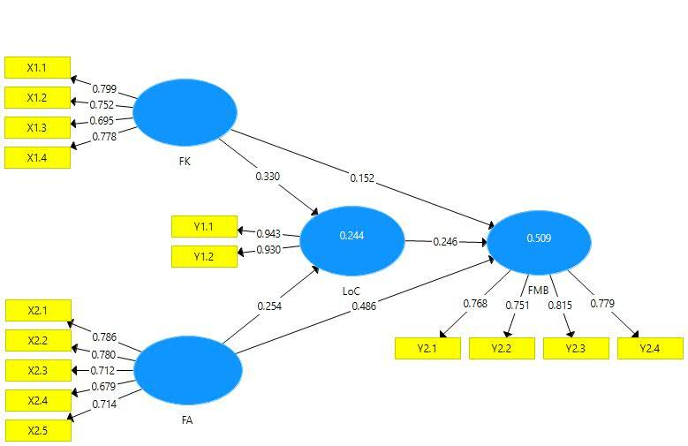
Figure 2.Structural Model
Source: SmartPLS version 3 Processed
Evaluation PLS structural model begins by looking at the R-square each dependent latent variables. Table 4 are approximate R-square by using PLS.

Variable | R-square
Locus of Control | 0244
Behavior Financial Management | 0509

Table 4.Results of Goodness of Fit
Source: Data Processed, 2018

Table 4 shows the value of R² for variable locus of controlis 0,244 or 24.4% and for the variables financial management behavior amounted to 0,509, or 50.9%. Ghozali (2014) said that R-Square (R²)is used to test the structural model for each dependent variable. Next to a model consisting of two or more independent variables, testing the goodness of fit total with Q-Square (Q²). If the Q²more than 0, means the model can be predicted whereas if the model $≤$0 then the model can’t be predicted (Ghozali,2014). Here are the results of the calculation of the Q²:
$$Q^{2}= 1-(1{-R_{1}}^{2)}(1{-R_{2}}^{2})......(1{-R_{P}}^{2})$$
$Q^{2}= 1- (1-0,509) (1-0,244$)
$Q^{2}= 1- (0.491) (0.756$ )
$$Q^{2}= 1 to 0.371$$
$$Q^{2}= 0.639$$

Result Q² shows the value predictive relevance of 0.639 or 63,9%. This indicates that the model is feasible, because the diversity of the data can be explained by the model amounted to 63.9%. And the balance of 36.1% is explained by other variables that haven’t been described in the research model and error.The PLS model is already well formed, being able to explain 63.9% of the total information.
Results Hypothesis and Mediation Test
Structural models evaluated through path coefficient value of each variable relationship. Structural model testing carried out after the model of the relationship is built. The purpose of structural relationship model is explain the relationship between the variables in the study. Structural model testing carried out by t-test. The bases used in testing the hypothesis directly is the image output and the value contained in the output path coefficients and indirect effect. Detailed explanation of testing a hypothesis presented in Table 5.

 | Original Sample (O) | Sample Mean (M) | Standard Deviation (STDEV) | T Statistics (|O/STDEV|) | P Values | Describes
FA -> FMB | 0,486 | 0,498 | 0,059 | 8,179 | 0,000 | Significant
FA -> LoC | 0,254 | 0,257 | 0,052 | 4,912 | 0,000 | Significant
FK -> FMB | 0,152 | 0,144 | 0,056 | 2,718 | 0,007 | Significant
FK ->LoC | 0,330 | 0,333 | 0,056 | 5,861 | 0,000 | Significant
LoC -> FMB | 0,246 | 0,243 | 0,062 | 3,976 | 0,000 | Significant
FA-> LoC->FMB | 0,063 | 0,062 | 0,021 | 3,052 | 0,002 | Significant
FK-> LoC->FMB | 0,081 | 0,081 | 0,024 | 3,336 | 0,001 | Significant

Table 5.Direct and Indirect Effect
Source: Data Processed, 2018
Test mediation conducted to detect position of mediating variables in the model. Mediation test measured by Sobel test with software Free Statistic Calculation for Sobel Test version 4.0 which developed by Sobel(Maharani, 2017). Here is the result of mediation test at table 6.

 | Financial Knowledge | Financial Attitude
A | 0,330 | 0,254
B | 0,246 | 0,246
SEA | 0,056 | 0,052
SEB | 0,062 | 0,062
Sobel test statistic | 3,07973110 | 3,29122894
One-tailed probability | 0,00103594 | 0,00049875
Two-tailed probability | 0,00207188 | 0,00099751

Table 6.Results Mediation Test
Source: Processed Data, 2018
The results of test calculations mediation in Table 6 shows 3,29122894 for relations financial knowledge on financial management behavior, while for the results of mediation relationship financial attitude to financial management behavior is 3,07973110. The result of mediation is greater than t-table so that there is an influence locus of control as a mediating variable. And then, to determine the nature of relationship used inspection method (Solimun, 2012). Inspection method is done by approaching the difference coefficient value and significance as follows:1) examine the direct influence of exogenous variables on the endogen in the model by involving the mediation variables; 2) examine the direct effect of exogenous variables on endogens without involving mediation variables; 3) examine the effect of exogenous variables on mediation variables; 4) test the role of mediation variables with endogenous variables. The resultshow all statement received. And last step is inspection difference coefficient value. The path coefficient indirect effect of financial knowledge and financial attitude (exogenous) to financial management behavior (endogenous) with locus of control (mediation) is 0,152 and 0,486 are less than path coefficient of direct effect without mediation variable that is0,298 and 0,506. So, from the results locus of control can be mediating variable at influence of financial knowledge and financial attitude to management financial behavior.
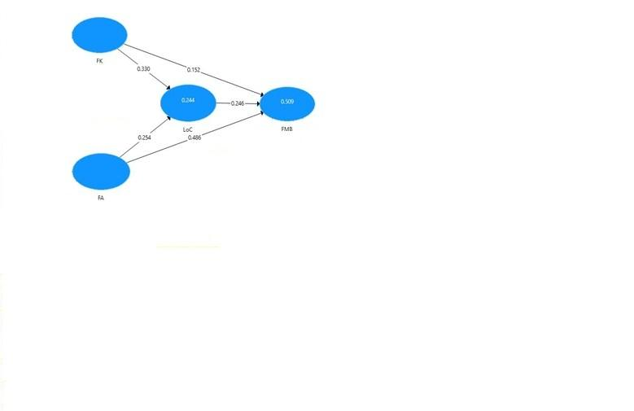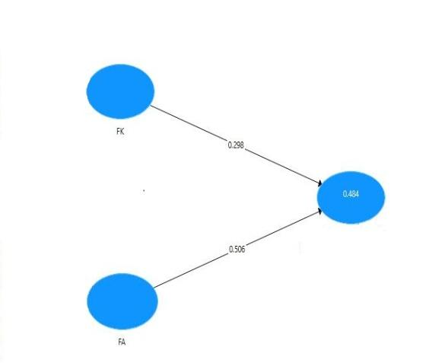
Figure 3. Figure 4.
Direct Effect with Mediation Variable Direct Effect Without Mediation Variable
Source: Output SmartPLS3 Source: Output SmartPLS3
- Influence of Financial Knowledge to Financial Management Behavior
The influence of financial knowledge to financial management behavior showed that coefficientvalue is positive0152, and the p-values 0.007> 0.05 and t-statistic value 2,718> t-table 1.96, so that H1 is accepted. The higher of financial knowledge make financial management behavior be higher. To achieve good financial behavior, need financial knowledge. With the high financial knowledge, can improve own thinking patterns and considerations regarding the financial management should be done, the which in turn will create a better financial management behavior. The results of this research are supported by several previous research. Amanah, Rahadian, and Iradianty (2016), and Mien and Thao (2015) found a positive influence of financial knowledge to financial management behavior.
Research almost same is Gautama and Deyola (2014) who found influence financial knowledge on the decision to save money. Consistent with the results of Arifin (2017), Rabb and Woodyard (2011) and Ida and Dwinta (2010). Also found a significant effect of financial knowledge on financial management behavior. Individuals who have financial knowledge tend to behave in a financially responsibleway, they are more alert of the future so choose to find out how best to manage their assets. As a basic tool and a critical factor making financial decisions, financial knowledge was instrumental in the process of creating a financial management (Ida and Dwinta, 2010). The better financial knowledge, so the chancesof making better decisions are higher. Knowledge acquired during the education period is able to influence the mindset, so that the higher level of education taken will be helpful in taking the right decision.

- Influence of Financial Attitude to Financial Management Behavior
Influence of financial attitude towards financial management behavior showed that coefficient value is positive 0486, p-value 0.000<0.05, and t-statistic 8179>t-table 1.96, so H2 is accepted. The better financial attitude, behavior tends to encourage better financial management. State of mind, financial opinions and judgments about the attitudes represented in the financial dimension. Understanding of the attitudes associated financial help someone understand his relationship with money. The findings support pervious research,Amanah, Rahadian, and Iradianty (2016), and Mien and Thao (2015) who found influence financial attitude to financial management behavior. Better financial management attitude tends to make people wiser in financial behavior than individuals who have bad financial attitude. Financial attitudes directing an individual to be able to have the mindset to regulate financial behavior through their role in the making decision of financial management.

- Influence of Financial Knowledge to Financial Management Behavior Mediated by Locus of Control
Influence of financial knowledge on financial management behavior mediated by locus of control shows that coefficient value is positive 0081, p-values0.001 and t-statistics 3.336 so H3accepted. The higher of financial knowledge make financial management behavior be higherif mediated by locus of control. In this model, the locus of control acts as a partial mediation. Research findings support Kholilah and Iramani (2013) that the locus of control is able to mediate the relationship of financial knowledge on the financial management behavior. This indicates that a person who has a good financial knowledge will form a good self-control as well, so the responsible financial behavior will be formed.
Shefrin (2000) states that the behavioral finance theory, psychology phenomenon capable of affecting a person's financial behavior. An understanding of the patterns of reasons including emotional aspects and the degree of its aspects are able to influence the decision making process. The research concistent with the results of Aydemir and Aren (2017) who used the term financial literacy to represent financial knowledge. The results showed that financial literacy doesn’t directly impact on the behavioral finance risk, so there are other variables that hinder the relationship between them that is locus of control. And as for those who fear the greatness of his God and desire to refrain from his own lust (QS. An-Nazi'at:40). Refrain from lust is the focal point of obedience, since lust is a strong incentive to all violations and actions transgress. People should be able to control himself of impulses passions that can make a person forget the Godand felt fear for his greatness so as not to fall into things that are negative (destruction) and bring astray. (https:/ /tafsirq.com).

- Influence of Financial Attitude to Financial Management Behavior Mediated by Locus of Control
Influence of financial attitude to behavior financial management through the locus of control show that coefficient value is positive 0,063, the p-values of 0,002 and t- statistical value is 3,052 so the higher financial attitude, will make the higher financial management behavior, through increased locus of control. The findings of the researchers in accordance with the Planned Behavior Theory, the which states that the attitude indirect effectt o behavior (Ajzen 2002). These findings answer the research Gautama and Deyola (2014) which no found direct influence on the financial attitudes toward saving decision, despite the attitude can lead to behavior. Smith, Brock, and Colgate (2007) stated that the decision making behavior is the result of a process of reasoning due to attitude.
Theory Behavioral Finance explains that the patterns of reasons including emotional aspects and the degree of its aspects are able to influence a person's decision making process. Theory Behavioral Finance explains that in financial decision making tends to incorporate emotions into decision making. So if correlated with Theory of Planned Behaviorso the locus of control is needed to keep financial management behavior. “And persons when they spend (treasure), they aren’t excessive, and nor miserly, and is (spending it) in the middle it(QS. Al-Furqan: 67). Allah and His Prophet suggest the people to keep the treasure, not scattering the treasure,nor hold without inssuing a slightest so as to sacrifice personal interests, and the needy person. Attitude like that, can create imbalancein society in the economic. Islam regulates this aspect of lives by starting from the individual soul that makes the balance as a single character of code faith (Shihab, 2006: 533).
CONCLUSION
The study aims to determine the significant effect of financial knowledge and financial attitude on financial management behavior. So the higher the financial knowledge and financial attitudes then the higher the financial management behavior. While the effect of financial knowledge and financial attitude on financial management behavior through locus of control showed a significant effect. The higher financial knowledge and financial attitudes make financial management behavior be high, through an increase locus of control.

Suggestions for further research is the use of other variables that theoretically influenceto financial management behavior to perfect the existing model, as well as using other respondents were able to apply financial planning is better to be able to train financial behavior more responsible through the locus of control more good.

REFERENCES
Al-Qur’an surat al-Furqan ayat 67
Al-Qur’an surat an-Nazi’at ayat 40
Ajzen, Icek. 2002. Perceived Behavioral Control, Self-Efficacy, Locus of Control, and the Theory of Planned Behavior 1. Journal of Applied Social Psychology, 32(4), 665–683.
Amanah, Ersha.,Rahadian, Dadan., Iradianty, Ardila. 2016. The Influence of Financial Knowledge, Financial Attitude and Eksternal Locus of Control on Personal Financial Management Behavior Case Study of Bachelor Degree Student in TELKOM University. E-Prosseding of Management, 3 (2), 1228-1235.
Arifin, Agus Zainul. 2017. The Influence of Financial Knowledge, Control and Income on Individual Financial Behavior. European Research Studies Journal, 20 (3A), 635-648.
Aydemir, SibelDinc,.Aren, Selim. 2017. Do the Effects of Individual Factors on Financial Risk-Taking Behavior Diversify with Financial Literacy. Emerald Publishing Limited,46 (10), 1706-1734.
Chen, H., Volpe, R.P. 1998. An Analysis of Personal Financial Literacy Among College Student. Financial Services Review, 7(2), 107-128.
Dew, Jeffery., Xiao, Jing Jian. 2011. The Financial Management Behavior Scale: Development And Validation. Journal of Financial Counseling and Planning, 22 (1), 43-59.
Gautama, Budhi P., Deyola, Yogha. 2014. Pengaruh Pengetahuan Keuangan dan Sikap Keuangan Terhadap Keputusan Menabung Pada Produk Tabungan di Perbankan. Jurnal Keuangan dan Bisnis, 12 (2), 114-141.
Ghozali, Imam. 2014. Structural Equation Modeling, Metode Alternatif dengan Partial Least Square (PLS) Edisi 4. Semarang: Badan Penerbit Universitas Diponegoro.
Ghozali, Imam. 2017. Model Persamaan Struktural Konsep dan Aplikasi dengan Program AMOS 24 Update Bayesian SEM Edisi 7. Semarang: Badan Penerbit Universitas Diponegoro.
Ghufron, M. Nur., Risnawati, Rini S. 2010. Teori-teori Psikologi. Yogyakarta: Ar-Ruz Media.
Gozhie, Prita. 2016. 3 Sumber Masalah Keuangan Yang Mengancam Kesejahteraan Anda dan Keluarga.(Online).(http://m.detik.com, diakses pada 20 September 2017).
https://tafsirq.com/, diakses 1 April 2018 pukul 21.45 WIB, darihttps://tafsirq.com/79-an-nazi’at/ayat-40#tafsir-jalalayn.
Ida.,Dwinta, Chintia Yohana., 2010. Pengaruh Locus of Control, Financial Knowledge, dan Income Terhadap Financial Management Behavior. Jurnal Bisnis dan Akuntansi, 12(3),131-144.
Kholilah, Naila Al, Iramani, Rr. 2013. Studi Financial Management Behavior Pada Masyarakat Surabaya.Journal of Business and Banking, 3 (1), 69-80.
Maharani, Vivin. 2017. Pengaruh Kepemimpinan Transfrmasional Terhadap Organizational Citizenship Behavior Karyawan Dimediasi oleh Kepuasan Kerja dan Organisasional (Studi Pada Perbankan Syariah di Malang Raya). Desertasi (tidak dipubikasikan). Program Pasca Sarjana Universitas Brawijaya, Malang.
Mien, Nguyen Thi Ngoc., Thao, Tran Phuong. 2015. Factors Affecting Personal Financial Management Behaviors: Evidence from Vietnam. Proceedings of the Second Asia-Pacific Conference on Global Business, Economics, Finance and Social Sciences. AP15 Vietnam Conference.
Otoritas Jasa Keuangan. 2016. Siaran Pers: OJK Luncurkan Buku Literasi Keuangan Tingkat Perguruan Tinggi. (Online). (http://www.ojk.go.id, diakses pada 16 September 2017).
Otoritas Jasa Keuangan. 2016. Survei Nasional Literasi dan Inklusi Keuangan. (Online). (http://www.ojk.go.id, diakses pada 16 September 2017).
Robb, Cliff A., Woodyard, Ann S. 2011. Financial Knowledge and Best Practice Behavior. Journal of Financial Counseling and Planning, 22 (1), 60-70.
Shefrin, Hersh. 2000. Beyond Greed and Fear: Understanding Behavioral Finance and the Psychology of Investing. Boston: Harvard Business School Press.
Shihab, M. Quraish. 2006. Tafsir al-Misbah: Pesan, Kesan, dan Keserasian al-Qur’an. Volume 9. Jakarta: Lentera Hati.
Smith, J., Brock., Colgate, Mark. 2007. Customer Value Creation: A Practical Freamwork. Journal of Marketing Theory and Practice, 15(1), 7-23. (Online). (www.proquest.com/pdqweb, diaksespada 6 September 2017).
Solimun. 2012. Pemodelan Persamaan Struktural Generalized Structural Componen Analisys GSCA. Diklat Aplikasi Statistika. Program Studi Statistika FMIPA Universitas Brawijaya.
Tanuwidjaja, William. 2009. 8 Intisari Kecerdasan Financial Edisi Revisi. Yogyakarta: Media Pressindo.
Yamauchi, K. T., Templer, D.I. 1982. The Development of Money Attitude Scale. Jurnal of Personality Assesment, 46 (5), 522-528.

