JOURNAL OF ISLAMIC ARCHITECTURE
P-ISSN: 2086-2636 E-ISSN: 2356-4644
Journal Home Page: http://ejournal.uin-malang.ac.id/index.php/JIA

THE TITLE MUST BE CONCISE, INFORMATIVE, AND NOT EXCEED 10 WORDS (CENTURY GOTHIC 13 CAPITAL BOLD)

| Received May 16th 2016 | Accepted June 17th 2016 | Available online June 30th 2016 |
| DOI http://dx.doi.org/10.18860/jia.v4i1.3466 |

Author1 (Square721 BT 8 Bold)  The Institution name (Square721BT 7)  City, Country  e-mail  Author 2 (Square721 BT 8 Bold)  Department of Architecture  Islamic University of Maulana Malik Ibrahim  Malang, Jawa Timur, Indonesia  journal.islamicarchitecture@gmail.com |  | ABSTRACT (CENTURY GOTHIC 8 CAPITAL BOLD)  The abstract should be written in English (Square721BT 7) and It should be a summary of the paper with line spacing 1. The abstract should consist of a single paragraph containing no more than 200 words. Keywords must be carefully selected to facilitate reader’s search and can be written up to five words and separated by semicolon. Abstract should stand alone, means that no citation in abstract. Consider it the advertisement of your article. Abstract should tell the prospective reader what you did and highlight the key findings. Avoid using technical jargon and uncommon abbreviations. You must be accurate, brief, clear, and specific. Use words which reflect the precise meaning. Abstract should be precise and honest, summarising the significant points of the paper. Xxxxxxxxxxxx xxxxxxxxx xxxxxxxxxxxx xxxxxxxxxxxx xxxxxxxxxxxxxxxxxx xxxxxxxxxxxxxxxxx xxxxxxxxxxx xxxxxxxxxxxxxxxxxxxxxxxxxxx xxxxxx xxxxxxxxxx xxxxxxxxxxx xxxxxxxxx xxxxxxxxxx xxxxx xxxxxx xxxxxxxx xxxxxxxx xxxxxxxxxxxxxxxxxxx xxxxx xxxxx xxxxx xxxxxxx xxxxxx xxxxxx xxxxxxxxxx xxxxxx xxxxx xxxxxxxxx xxxxxxxxx xxxxxxxxxxxxxxxx xxxxxxxxxxx xxxxxx xxxxxxx xxxxxxxx xxxxxx xxxxxxx xxxxxx xxxxxxxxxxxx xxxxxxxxxxxx  KEYWORDS: (CENTURY GOTHIC 7 CAPITAL BOLD)  up to five words; Square721BT 7; xxxxx; xxxxx; xxxxx

INTRODUCTION
(CENTURY GOTHIC 9 CAPITAL BOLD) (NO NUMBERING)

The introduction should clearly state the purpose of the paper. It should include key references to appropriate work but should not be an historical or literature review. The contents of the paper include Introduction, Method (for research based articles), Content, Discussion, Conclusion, Acknowledgement and References. The content of non research based articles may include some sub-chapters with a free title depends on the study.
In Introduction, Authors should state the objectives of the work at the end of introduction section. Before the objective, Authors should provide an adequate background, and very short literature survey in order to record the existing solutions/method, to show which is the best of previous researches, to show the main limitation of the previous researches, to show what do you hope to achieve (to solve the limitation), and to show the scientific merit or novelties of the paper. Avoid a detailed literature survey or a summary of the results. The introduction should clearly state the purpose of the paper. It should include key references to appropriate work but should not be an historical or literature review
The paper has to be written in Candara 9 font, in two column layout, mirror margin; top 3 cm, inside 3 cm, bottom 3 cm, outside 2 cm. Header and footer refer to this template. Essays should be a minimum of 3,000 words in length and no longer than 6,000 words, except in special circumstances. The number of pages are around 7-12 pages.
The placement of the picture is like the Figure 1, i.e. is in the middle with the caption below is written in trebuchet 8 bold font. The caption has to mention the title and the source of the picture. All figure parts must be labeled (a), (b).
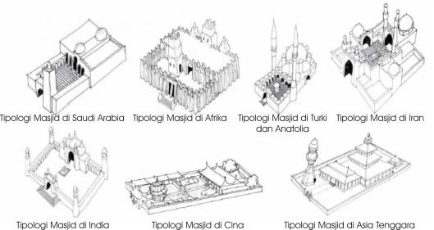

Figure 1. Title [source in IEEE format]

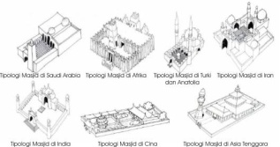 | 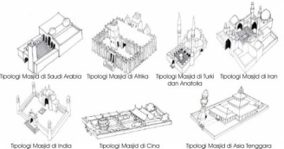
a | b
Figure 1. (a) Title [source in IEEE format] (b) Title [source in IEEE format]

Each table must be typed, and consecutively numbered, just like Table 1. The title is written above the table in trebuchet 8 center bold font, while the source is placed below the table in the same font.
Table 1. Title of Table [4]
Column Header Goes Here | Column Header Goes Here
Row Name Goes Here | x
Row Name Goes Here | x
Row Name Goes Here | x
Row Name Goes Here | x

METHODS
(CENTURY GOTHIC 9 CAPITAL BOLD) (NO NUMBERING)

The methods section describes the rationale for the application of specific procedures or techniques used to identify, select, and analyze information applied to understanding the research problem, thereby, allowing the reader to critically evaluate a study’s overall validity and reliability.

DISCUSSION
(CENTURY GOTHIC 9 CAPITAL BOLD) (NO NUMBERING)
SUB CHAPTER
(CENTURY GOTHIC 7.5 CAPITAL BOLD) (NO NUMBERING)

A freely structured discussion needs to make a clear argument, and it can be very useful to use sub-chapter to structure this argument. You should draw on your own results not just on other literature. A discussion is NOT a literature review, but your work must be at the centre of the argument.
Content is the body of paper, consits of sub title that representing discussion of the paper. Results should be clear and concise. The results should summarize (scientific) findings rather than providing data in great detail. The discussion should explore the significance of the results of the work, not repeat them. A combined Results and Discussion section is often appropriate. Avoid extensive citations and discussion of published literature.
In discussion, it is the most important section of your article. Here you get the chance to sell your data. Make the discussion corresponding to the results, but do not reiterate the results. Often should begin with a brief summary of the main scientific findings (not experimental results). The following components should be covered in discussion: How do your results relate to the original question or objectives outlined in the Introduction section (what)? Do you provide interpretation scientifically for each of your results or findings presented (why)? Are your results consistent with what other investigators have reported (what else)?

CONCLUSION
(CENTURY GOTHIC 9 CAPITAL BOLD) (NO NUMBERING)

Conclusions should answer the objectives of research. Tells how your work advances the field from the present state of knowledge. Without clear Conclusions, reviewers and readers will find it difficult to judge the work, and whether or not it merits publication in the journal. Do not repeat the Abstract, or just list experimental results. Provide a clear scientific justification for your work, and indicate possible applications and extensions. You should also suggest future experiments and/or point out those that are underway.

REFERENCES
(CENTURY GOTHIC 9 CAPITAL BOLD) (NO NUMBERING)

Where explanatory notes and references are relevant, they should be indicated in the text by a superscript number like this [1]. A full list of all notes and references should be provided at the end of the paper. The written of the journal references use IEEE format. Please use a reference software like Mendeley, Zotero, etc to make the citation work easier. Journal references should include all authors' names and initials, year of publication, title of paper, journal titles in full, volume number and first and last page numbers [2]. References to books should include their edition, and all editor(s) and all relevant authors, publisher and place of publication [3]. It is the authors' responsibility to check the accuracy of references. Examples:

[1] S. Hasan and T. Corresponding, “The Contextual Issues in the Islamic Architecture of Bengal Mosques,” GJAT, vol. 3, no. 1, pp. 41–48, 2013.

[2] S. Omer, “Rationalizing the Permissibility of Mosque Decoration,” J. Islam. Archit., vol. 4, no. 1, pp. 14–26, 2016.

[3] T. H. Karyono, Green Architecture: Pengantar Pemahaman Arsitektur Hijau di Indonesia. Jakarta: Rajawali Press, 2010.

