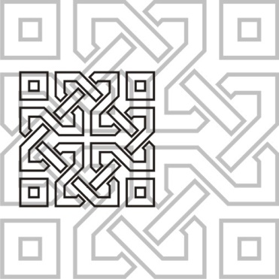 | JOURNAL OF ISLAMIC ARCHITECTURE  P-ISSN: 2086-2636 E-ISSN: 2356-4644  Journal Home Page: http://ejournal.uin-malang.ac.id/index.php/JIA

ISLAMIC BOARDING SCHOOL BUILDING DESIGN with COVID-19 PROTECTION PROTOCOL

| Received …. | Accepted …….| Available online …..|
| DOI http://dx.doi.org/10.18860/jia.v4i1.3466 |

Dyah Nurwidyaningrum  Department of Civil Engineering  Politeknik Negeri Jakarta  Depok, Jawa Barat, Indonesia  dyah.nurwidyaningrum@sipil.pnj.ac.id  Tri Wulan Sari  Department of Civil Engineering  Politeknik Negeri Jakarta  Depok, Jawa Barat, Indonesia  tri.wulansari@sipil.pnj.ac.id  Sujito  Department of Physics  Universitas Negeri Malang  Malang, Jawa Timur, Indonesia  sujito.fmipa@um.ac.id |  | ABSTRACT (CENTURY GOTHIC 8 CAPITAL BOLD)  Islamic Boarding School building has a function as place of education prospective ulama who are expected to be the spreaders of Islamic religious knowledge to the wider community. Coronavirus transmission is very fast, so requires Islamic boarding school to appeal to the government’s way of learning, one of which is to comply with the Covid-19 protection protocol. The purpose is to get Islamic boarding school design with Covid-19 protection protocol. We doing method with survey, and observation to initial research data, then make 1st and 2nd floor plans with Autocad according to ideas of related party and expert. Finally, with sketch up pro, standard building design for the COVID-19 health protocol was obtained such as design of top, 3D, side, and inside view. The design consist 8 x 8 meters bedroom with height of 4 meters any 18 students with adequate ventilation and lighting. Every room and terrace be found Covid-19 health protocol message. Washing hands with soap is located in right and left wings bedroom. The stairs and doors for entry and exit are different.  KEYWORDS: Islamic Boarding School; Covid-19; design; protection protocol

INTRODUCTION
Architecture based on the Qur'an and Sunnah as the main heritage of the Prophet Muhammad is called Islamic architecture [1]. Islamic boarding schools are dormitories or guesthouses or bedrooms as a place to live for students [2]. The Islamic Boarding School building has a function as a transit place before the students get permanent residence or can even be a place to live as long as the students demand an Islamic religion-based education [3]. One of the other functions is to educate prospective ulama who are expected to be the successors/spreaders of Islamic religious knowledge to the wider community [4]. Education in Islamic boarding schools always provides students with knowledge about entrepreneurship in accordance with the form of life skills provided by each Islamic boarding school [5]. A comfortable and quiet Islamic boarding school is needed in the learning process. Calm in terms of mind, heart, soul that is safe and peaceful, while a comfortable Islamic boarding school can be obtained with aspects of the lighting system, acoustic system, and thermal comfort system [6].
In December 2019, the world experienced a global health crisis that spread to all national capitals, cities and small towns. This requires governments, businesses, academics, professionals and workers to find new ways for all of society to control the spread of disease and find vaccines. The ongoing task was, and is, to define the so-called new normal [7]. The corona virus which has a very fast spread rate has prompted people to renovate their homes, especially small and congested houses, by allocating land for their own gardens and food production, providing space for social distancing and installing house components for lighting and air circulation to optimize natural light in their homes [8]. In today's circumstances, staying at home is a good time to realize that gardens are very important in homes, even terraced houses [9] [10]. This is in line with regulations from the Indonesian government to prevent the spread of the corona virus, issuing policies to study from home, work from home, and worship from home [11]. Implementation of green community and green culture in learning methods has obtained maximum results. Governments and health experts suggest doing social distancing, physical distancing and stay at home [12].
Environmentally friendly buildings or green buildings have the concept of creating a construction starting from the planning, implementation and use of construction products that are environmentally friendly, efficient in the use of existing energy and resources, low costs and health aspects are considered, the comfort of the occupants where everything adheres to to the principles of sustainability [2]. In 2009 an independent (non-government) and non-profit (non-profit) institution established the Green Building Council Indonesia (GBCI), which is committed to public education in applying environmental best practices and has one program which is to certify Green Buildings in Indonesia based on a typical Indonesian assessment tool called Greenship [13]. Greenship has 7 (seven) standard aspects of assessment, namely: appropriate site development, energy efficiency and conservation, water conservation, material resource and cycle, indoor health and comfort and management [3]. In the design of this Islamic boarding school, the walls are made as comfortable as possible so that they do not cause dampness on the surface and the floor is also installed with ceramics that are comfortable to live in in the room [14]. Open space consists of green open space (RTH) and non-green open space (RTNH). RTH is an area / area that extends / lanes and / or clusters, which can be used openly, as a place to grow plants, both those that grow naturally or those that are intentionally planted, this is based on Undang-Undang Nomor 26 tahun 2007 [15]. In order for the room to be fully functional, the designer must consider an important factor in the design of the space, namely lighting [16]. Natural lighting is measured using a Luxmeter to plan the optimization of natural lighting in the room, which is more than 300 Lux [17].
The study area is located in Al-Ischakiyah Islamic Boarding School, Nameng Village, Rangkasbitung District, Lebak Regency, Banten 42300. This Islamic boarding school is located in between road, land, and green plants as seen on Google earth Figure 1 [18]. The picture as seen have big area for building a Islamic boarding school, so the leader can building boarding school go green school with Covid-19 protection protocol.
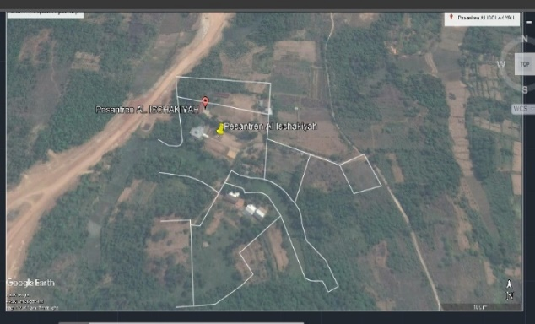

Figure 1 : Google Earth of Al-Ischakiyah Boarding school [Source : [18]]

Based on “Surat Edaran Pimpinan Pusat Muhammadiyah di Jakarta, Desember 2020” regarding Standard Operating Procedures for Islamic Boarding Schools during a pandemic on pages 15-25 [19] which is in line with “Salinan Lampiran Keputusan Bersama Menteri Pendidikan dan Kebudayaan, Menteri Agama, Menteri Kesehatan, dan Menteri Dalam Negeri Nomor 01/KB/2020, Nomor 516 Tahun 2020, Nomor HK.03.01 /Menkes/363/2020 Nomor 440-882 tentang Panduan Penyelenggaraan Pembelajaran di Masa Pandemic COVID-19” [20] regarding the Covid-19 Protection Protocol that must be carried out by Islamic Boarding School residents and managers. Based on the explanation above, namely the needs of Islamic boarding schools, forced by the Coronavirus, then the principle of Greenship so that students get a comfortable environment. So that the author has a goal to Islamic boarding schools design with Covid-19 protection protocol case study in Al-Ischakiyah Islamic Boarding School which is expected to be a reference for Islamic boarding schools around the world.

METHODS
Data source, when data collection is primary data source, namely the data source obtained directly by the author from the Islamic boarding school by observation and survey methods [21]. The observation method used by the writer is visiting directly to the research location and then observing the plans and designs of the existing Islamic boarding school buildings. Meanwhile, the survey method conducted by the author was conducting interviews with related parties regarding the current situation and conditions over there.
The writer use data type; quantitative and qualitative data. The type of quantitative data to get a design in the sketch up pro software requires data on the correct scale so that the building design is obtained before the Covid-19 pandemic. Then with these data and types of qualitative data through interviews and direct observation, the design of the Islamic boarding school building can be obtained in accordance with the standard Covid-19 protection protocol.
We will take steps are in accordance with flow chart in Figure 2. It can be seen that the first thing the author does is a literature study on the idea of ​​green Islamic green school, knowledge of the COVID-19 outbreak / disease, which is strengthened by Salinan Lampiran Keputusan Bersama Menteri Pendidikan dan Kebudayaan, Menteri Agama, Menteri Kesehatan, dan Menteri Dalam Negeri Nomor 01/KB/2020, Nomor 516 Tahun 2020, Nomor HK.03.01 /Menkes/363/2020 Nomor 440-882 tentang Panduan Penyelenggaraan Pembelajaran di Masa Pandemic COVID-19 point XIV tentang Pesantren dan Pendidikan Keagamaan pada SEMUA ZONA [20]. Then look for the required data by survey and observation to the research location, namely the Al-Ischakiyah Islamic boarding school, such as top view plan, height of room, size of CTPS (Wash Hands with Soap), to then be simulated into the Sketch Up Pro software (application) so we get the building design we expect. If the design results are appropriate, then proceed with the next step, namely formulating the results and conclusions.

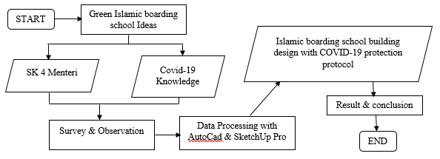

Figure 2 : Research flowchart
Data analysis was carried out based on data obtained during surveys and observations in the research field. The analysis techniques we use are developmental analysis and descriptive analysis. This type of development research is studying the pattern of Islamic boarding schools before the existence of Covid-19, then the building is adjusted to its design according to current developments, in accordance with the standard covid-19 protection protocol.
Author use Descriptive analysis to describe the design of Islamic boarding school building before Covid-19 pandemic and afterwards according to the results obtained using the sketch up pro. In this analysis, the authors provide recommendations on the implementation of designs that have been made suitable to be applied to Islamic boarding schools, especially in it building design that have been adjusted to standard health protocols which are strengthened by Salinan Lampiran Keputusan Bersama Menteri Pendidikan dan Kebudayaan, Menteri Agama, Menteri Kesehatan, dan Menteri Dalam Negeri Nomor 01/KB/2020, Nomor 516 Tahun 2020, Nomor HK.03.01 /Menkes/363/2020 Nomor 440-882 tentang Panduan Penyelenggaraan Pembelajaran di Masa Pandemic COVID-19 point XIV tentang Pesantren dan Pendidikan Keagamaan pada SEMUA ZONA [20].
From survey and observation results to research location, it was found that the current state of the Islamic boarding school, namely the female and male Islamic boarding schools, have adjacent buildings. The location of building is on a higher ground and the surrounding is beautiful because of many plants as shown in Figure 3 below. Even so, the existing building has not shown the Covid-19 health protocol because the dormitory has a size of 8 x 8 inhabited by 27 students, there is no health message on the correct method of CTPS, how to prevent transmission of COVID-19, cough / sneeze etiquette how to use a mask. In the figure marked with a yellow circle is a clothesline for the residents of the boarding school, the green circle shows the place for students to study, and the orange color shows the female student dormitories that are still clustered.
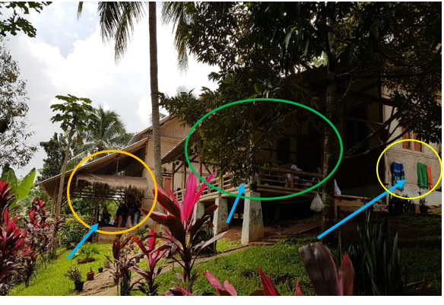
Figure 3 : Al-Ischakiyah Islamic Boarding School (Existing)

DISCUSSION
Based on results of survey and observations author’s in research field, we are get data needs from the Islamic boarding school are related to the size, land and building design models adapted to the Covid-19 Protection protocol in it environment. The design of the male and female Islamic boarding schools has the same design, consisting of 2 floors, there are CTPS facilities at each entrance and messages for proper hand washing, as well as messages to prevent Covid-19 are in the design.
Figure 4 shows plan of 1st floor Covid-19 Islamic boarding school building plan with AUTOCAD.
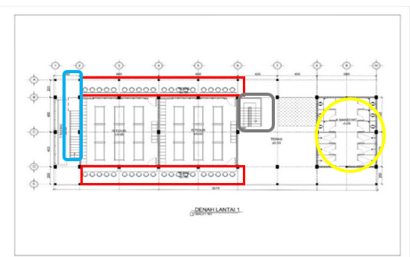
Figure 4 : Plan of 1st floor Covid-19 Islamic boarding school building with AUTOCAD
Figure 5 shows top view design of Islamic boarding school building with COVID-19 protection protocol with sketch up pro.
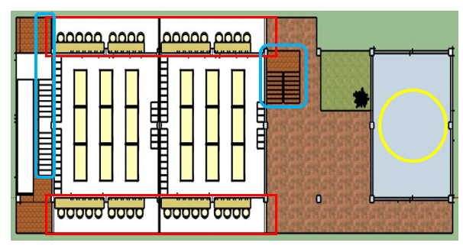
Figure 5 : Top view design of Islamic boarding school building with COVID-19 protection protocol with sketch up pro
Figure 6 shows design of Islamic boarding school building with COVID-19 protection protocol with sketch up pro top view.
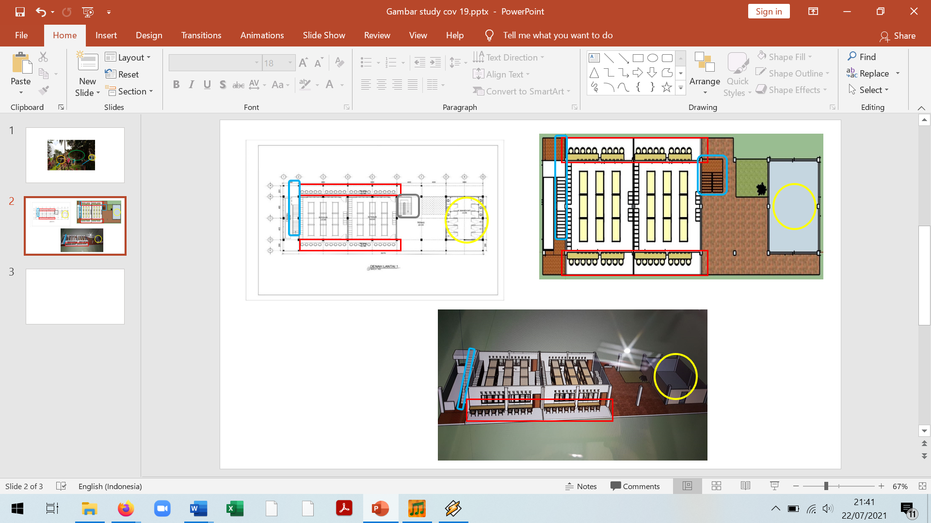
Figure 6: 3D Design of Islamic boarding school building with COVID-19 protection protocol with sketch up pro
Figure 4 shows plan of 1st floor Covid-19 Islamic boarding school building plan with AUTOCAD. Figure 5 shows top view design of Islamic boarding school building with COVID-19 protection protocol with sketch up pro. Figure 6 shows design of Islamic boarding school building with COVID-19 protection protocol with sketch up pro top view. From three pictures show 200-centimeter-wide terrace along the boarding school building indicated by the red color, namely 3260 centimeters or 32.6 meters on the north side and 2660 centimeters or 26.6 meters on the south side. The main room in middle of area, i.e. two bedrooms for students with bedroom size of 8 x 8 meters, with height 4 meters, at the back and front sides of the entrance there are storage areas (drawers / cupboards) for storing students' items. This bedroom has one entrance by south side, an exit by north side of the room and inhabited by 18 students. Along the main room there is a terrace that will be used by the students to study. 9 student’s study on the south side terrace and 9 student’s study on the north side terrace indicated by the red color on the figure, so that the bedroom is only used for rest and sleep. On the right wing there are 6 bathrooms and 6 toilets indicated by yellow color with a total size of 6 x 8 meters, beside it there is share area and also a staircase that connects the 1st floor and 2nd floor indicated by the blue color. Because the design of this building is the standard Covid-19 health protocol so the stair only used to 2nd floor. On the left wing there is a place for ablution with a size of 260 centimeters and there is a stair used to go down indicated by the blue color. Figure 7 show Plan of AutoCad 2nd floor.
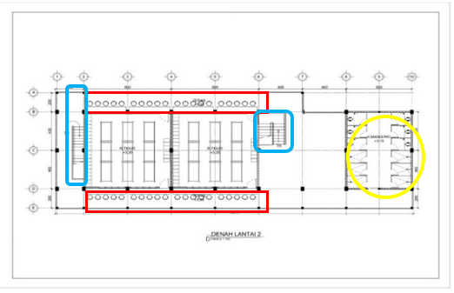
Figure 7 : Plan of 2nd floor Covid-19 Islamic boarding school building with AUTOCAD
Figure 8 shows side view design of Islamic boarding school building with COVID-19 protection protocol with sketch up pro.
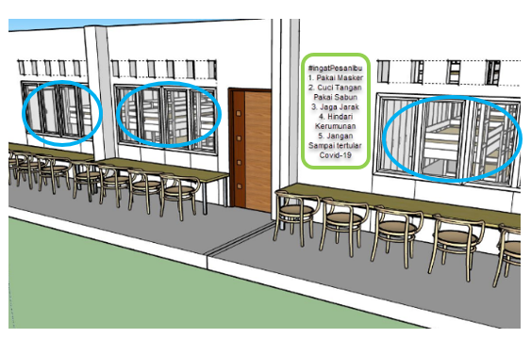
Figure 8 : Side view design building with COVID-19 protection protocol
Figure 9 shows inside view design of Islamic boarding school building with COVID-19 protection protocol with sketch up pro.
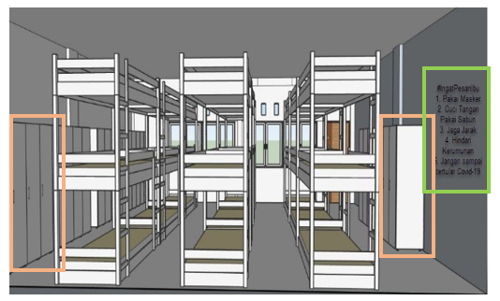
Figure 9 : Inside view design of Islamic boarding school building with COVID-19 protection protocol with sketch up pro
The specifications 2nd floor plan are the same as for 1st floor, the difference is only in function of the stairs. 2nd Floor plan can be seen in Figure 7.
Figure 8 shows side view design of Islamic boarding school building with COVID-19 protection protocol with sketch up pro, a terrace used for learning. From this design, can be seen that ventilation and lighting design used in the bedroom is sufficient for air exchange indicated by the blue color. Orientation of ventilation or windows or openings is one of the factors that influence the penetration of natural light [22]. Plan of natural lighting on the terrace and bedroom according to GBCI Standard, that is light intensity value greater than 300 lux. On each terrace, there is also a Covid-19 health protocol message, which the author took from the government's appeal indicated by the green color. During the learning process, the chairs were also arranged in such a way so that each student would also carry out the government's appeal through a song performed by the “PADI” musician band with the title #IngatPesanIbu, i.e. to keep your distance from people around you.
Figure 9 shows inside view design of Islamic boarding school building with COVID-19 protection protocol with sketch up pro, it can be seen that in front of and behind the entrance be found storage area indicated by the orange color, and the bed is only used by each student, not sharing. In front of entrance room, there is also a Covid-19 health protocol message, which the author took from the government's appeal indicated by the green color. It has the goal of each student also carrying out the government's appeal to comply with the New Normal regarding the standard Covid -19 health protocol. Namely,
- Pakai Masker (Wear a mask),
- Cuci Tangan Pake Sabun (Wash Hands with Soap)
- Jaga Jarak (physical distancing)
- Hindari Kerumunan (avoid the crowd)
- Jangan sampai terular Covid-19 (don't get infected with covid19)

CONCLUSION
Islamic boarding school building design with covid-19 protection protocol and SK 4 Menteri, that the bedroom measuring 8 x 8 meters with a height of 4 meters can accommodate 18 students with sufficient ventilation and plan of natural lighting according to GBCI Standard. The design are shown by 4th Figure until 9th Figure. In every room and terrace there is also a Covid-19 health protocol message. Washing hands with soap can be done on the right or left wing of the bedroom. The stairs and doors used for entry and exit are also differentiated to avoid exposure between students. Suggestions for Islamic boarding school, to prevent transmission of Covid-19 among students, it is hoped that the relevant parties from this Islamic boarding school will carry out the building design that we designed because it has been adjusted to covid-19 protection protocol and SK 4 Menteri.
REFERENCES
[1] | C. A. H. M , S. Ramadhani dan E. Poedjioetami, “Konsep Rancangan Arsitektur Islam Vernakular Pada Desain Bentuk Pesantren Matholi’ul Anwar Lamongan,” Arsitektur ITATS, pp. 254-257, 2020.
[2] | D. Tafana dan Suparwoko, “Redesain Pondok Pesantren Subulana, Kota Bontang, Kalimanta Timur dengan Pendekatan Ramah Lingkungan,” [Online]. Available: https://docplayer.info/197809412-Redesain-pondok-pesantren-subulana-kota-bontang-kalimantan-timur-dengan-pendekatan-ramah-lingkungan.html.
[3] | E. Prianto, B. Sujono dan A. Dwiyanto, “Aplikasi Rancangan Green Pesantren Di Semarang,” Riptek , vol. 2, no. 1, pp. 81-98, 2017 .
[4] | I. I. Shochfah dan W. Nurjayanti, “IDENTIFIKASI KARAKTER BANGUNAN ISLAMI PADA PESMA PUTRI KH MAS MANSUR UMS,” Sinektika : Jurnal Arsitektur, vol. 13, no. 1, pp. 43-51, 2013.
[5] | I. Syafe'i, “PONDOK PESANTREN : Lembaga Pendidikan Pembentukan Karakter,” Al-Tadzkiyyah: Jurnal Pendidikan Islam, vol. 8, pp. 85-103, 2017.
[6] | M. F. Faeza dan M. Tharziansyah, “Pondok Pesantren Modern Putra Di Martapura,” LANTING : Journal of Architecture, vol. 10, no. 1, pp. 240-252, 2021.
[7] | B. Maturana, A. M. Salama dan A. McInneny, “Architecture, urbanism and health in a post-pandemic virtual world,” Archnet-IJAR: International Journal of Architectural Research, vol. 15, no. 1, pp. 1-9, 2021.
[8] | I. D. G. A. D. Putra, “"Stay at home” for addressing COVID-19 protocol: learning from the traditional Balinese house,” Archnet-IJAR: International Journal of Architectural Research, vol. 15, no. 1, pp. 64-78, 2021.
[9] | T. Penulis, Studi Pembelajaran Penanganan COVID-19 Indonesia, Jakarta: KementerianPPN/Bappenas, 2020.
[10] | I. Anshori dan Z. Illiyyin, “Dampak Covid-19 Terhadap Proses Pembelajaran Di Mts Al-Asyhar Bungah Gresik,” Islamic Management: Jurnal Manajemen Pendidikan Islam, 2020.
[11] | Ihsanudin, “KOMPAS.com,” Kompas, 16 Maret 2020. [Online]. Available: https://nasional.kompas.com/read/2020/03/16/15454571/jokowi-kerja-dari-rumah-belajar-dari-rumah-ibadah-di-rumah-perlu-digencarkan. [Diakses 23 Juli 2021].
[12] | A. Abidah, H. N. Hidaayatullaah, . R. M. Simamora, D. Fehabutar dan L. Mutakinati, “The Impact of Covid-19 to Indonesian Education and Its Relation to the Philosophy of ‘Merdeka Belajar,” A. Abidah, H. N. Hidaayatullaah, R. M. Simamora, D. Fehabutar, and L. Mutakinati,, vol. 1, no. 1, 2020.
[13] | P. N. Ratnasari dan D. Nurwidyaningrum, “Kualitas Dan Kenyamanan Udara Pada Gedung Perkantoran Bertingkat Rendah Dengan Studi Kasus Gedung Perkantoran Pt. X Di Jakarta,” Construction and Material Journal, vol. 2, no. 2, pp. 123-129, 2020.
[14] | M. R. D. Pratama, A. Ernawati dan Yulistiana, “Perancangan Pondok Pesantren Modern Dengan Pendekatan Arsitektur Modern Di Depok,” Jurnal DESAIN, vol. 5, no. 2, pp. 86-94, 2018.
[15] | S. Suripto, M. Melatifani dan M. I. Pratama, “Tinjauan Ruang Terbuka Hijau Di Kampus Politeknik Negeri Jakarta,” Construction and Material Journal, vol. 1, no. 2, pp. 201-210, 2019.
[16] | M. E. Alfiana, M. A. Alfares, D. Nurwidyaningrum dan L. S. Wulandari, “Pencahayaan Kombinasi Pada Laboratorium Teknik Elektro Politeknik Negeri Jakarta,” Construction and Material Journal, vol. 2, no. 3, pp. 163-169, 2020.
[17] | A. A. Putri , M. A. Rohman dan C. Utomo, “Penilaian Kriteria Green Building pada Gedung Teknik Sipil ITS,” JURNAL TEKNIK ITS, vol. 1, no. 1, pp. D107-D112, 2012.
[18] | “Google Maps,” 2021. [Online]. Available: https://www.google.com/maps/place/pondok+pesantren+al+ischakiyah/@-6.3479233,106.2636076,11534m/data=!3m1!1e3!4m9!1m2!2m1!1sAl-Ischakiyah+Boarding+school+Rangkas+bitung!3m5!1s0x2e42108ac8ffffe9:0xd6c306768e5f554b!8m2!3d-6.3315206!4d106.2885655!15sCixBbC1J.
[19] | Baedhowi dan A. Amirrachman, “Surat Edaran dan Lampiran Pimpinan Pusat Muhammadiyah di Jakarta,” Muhammadiyah, Jakarta, 2020.
[20] | D. Wahyuni, “Salinan Lampiran Keputusan Bersama Menteri Pendidikan dan Kebudayaan, Menteri Agama, Menteri Kesehatan, dan Menteri Dalam Negeri Nomor 01/KB/2020, Nomor 516 Tahun 2020, Nomor HK.03.01 /Menkes/363/2020 Nomor 440-882 tentang Panduan Penyelenggaraan Pembelaj,” Jakarta, 2020.
[21] | A. C. W. A. dan R. Puspitasari, “Desain Fasilitas Kamar Tidur Pondok Pesantren,” Jurnal Arsitektur ITATS, 2021.
[22] | A. A. Putri dan D. Nurwidyaningrum, “Natural Lighting Of Studio Apartment With East-Oriented Opening,” LOGIC : Journal of Engineering Design and Technology, vol. 21, no. 1, pp. 23 - 30, 2021.

