 | JOURNAL OF ISLAMIC ARCHITECTURE  P-ISSN: 2086-2636 E-ISSN: 2356-4644  Journal Home Page: http://ejournal.uin-malang.ac.id/index.php/JIA
IMPORTANCE OF INTERNAL COURTYARDS IN DESIGNING HISTORICAL AND CONTEMPORARY MASJID

| Received ………………. | Accepted …………….. | Available online …………………………………. |
| DOI http://dx.doi.org/10.18860/jia.v4i1.3466 |

Salma Dwidar  Prince Sultan University  Riyadh, Saudi Arabia  sdwidar@psu.edu.sa  Hala Sirror  Prince Sultan University  Riyadh, Saudi Arabia  hsirror@psu.edu.sa  Amani Derbali  Prince Sultan University  Riyadh, Saudi Arabia  aderbali@psu.edu.sa  Donia Abdelgawad  Fine Arts Alexandria University  Riyadh, Saudi Alexandria, Eygpt donia_abdelgawad@alexu.edu.eg  Amal Abdelsattar  Prince Sultan University  Riyadh, Saudi Arabia  aabdelsattar@psu.edu.sa |  | ABSTRACT  Islamic architecture has spread in different regions with varied climates and natural conditions and on a vast patch of land stretching from Andalusia to India in the east and Yemen in the south to southern Italy in the north. Despite this vast spread and difference in climate, nature, and region, Muslims were able to have a unique characteristic print upon these regions. The Masjid is considered one of the most important buildings distinguishing Islamic architecture. The first forms of Masjids that appeared were large naves surrounded by walls, and there was nothing to block the worshippers' view of the sky. The research paper deals with the importance of internal courtyards in Masjids. They are considered an essential element of the space that forms religious architecture. It links the mosque to the sky in a directly seen and transparent relationship, which makes the symbolism of the Masjid's design evident. The Courtyard has multiple functions: reducing the intensity of light and noise, ridding the air of dust and dirt, storing warmth in winter, mitigating the severity of the heat in summer, and humidifying and ventilating the building.  KEYWORDS:  Masjed; Courtyard; ventilation; lighting; Islamic architecture

INTRODUCTION

Due to the similarity in the climates around the Islamic world, inner courtyards have been used in most heritage buildings as pure and moderate temperate air storage. Even so, today, we witness a change that forces a complete disconnection and cuts our relationship with the past, overturning all concepts and values. Opening to the outside with no selectiveness reached the extent that the ideas of inwards and outwards are clashing. Studies have appeared that favor the traditional architectural heritage of mosques with no openings in favor of other architectural goals of the building, such as energy and its rationalization. But the openness to exterior architecture led to crises regarding energy consumption in Muslim Arab countries, especially within the Arab Gulf, to the extent that the consumption of the urban environment exceeded 70% of the total energy in Arab countries.
In contrast, ¾ of the mosques' energy requirement is expended during summer only due to cooling needs. Around 80% of the mosques' energy consumption is for cooling; this leads to the sacrifice of openings and natural lightning to decrease this energy waste. One of the most important results of inwards architecture is to reduce solar exposure, as direct solar exposure is the main reason for higher temperatures within the buildings, meaning that the benefits of inwards architecture are great.

A. The Importance of Inner Courtyards Within Masjed and Their Human and functional Value
The researcher shall discuss the importance of inner courtyards within Masjid. Such values include symbolic, social, and functional values that comprise natural ventilation and natural lighting.

- Symbolic Value
Inner courtyards are considered an essential element of the internal space that makes up the religious building, as it directly connects with the sky. As in cosmology, the four sides of the inner Courtyard symbolize the four pillars bearing the dome of the sky. (Okasha, T., 1994 p 40) (Figure 1)
And the inner Courtyard combined three intertwining concepts through its symbolism:
- The sky (it is a space open towards the sky)
- The earth (It is a grounded space)
- Light (It spreads and regulates the light within the whole area)
And so, the inner Courtyard symbolizes complete unification (monotheism) "Allah is the light of the heavens and the Earth." And there is a connection between the ground and the heavens, where the mosque's minarets lie higher. The sky descends onto the Courtyard, filling it with mercy within and throughout and in the spaces between the cresting's which are similar in shape. And we see the pairing between the mass and the area as positive and negative. They also symbolize the pairing of the body and soul or the sky and earth. (Okasha, T., 1994 p 40).
Religious buildings were also required to confirm the essential connections within the structure of Islam. So, the inner Courtyard needed to symbolize absolute unification / monotheistic belief between the heavens and life on earth. Figure 2.
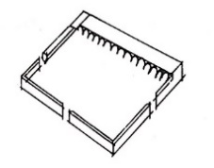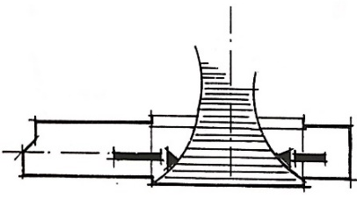
Figure 1. the Mosque of the Messenger of God was built in the year 7 AH. The Courtyard shows the connection of the earth with the sky.
Figure 2. A section that shows the relationship between the covered void and the exposed space (researcher drawings) (Dwidar, S., 1998)
- Social Aspect
The inner courtyards of large mosques acted as the main yard for the Islamic city, where people moved towards prayer and other social activities. Later, these social activities and groupings moved to take place around the palaces of the rulers, and as such, inner courtyards lost some of their importance.
- Functional aspect
The Courtyard was the heart of the Masjed. The Courtyard part was covered to manage the climatic factors and achieve thermal comfort for the building to fulfill the functional requirements. Such as providing natural lighting for the mosque throughout the day, providing natural ventilation without opening up the area due to high temperatures, and providing shade for the inner areas. This achieves thermal comfort within the mosque and minimal noise, providing the quiet needed for worship and prayer.

B. The Evaluation of The Inner Courtyards Design Throughout The Ages
The architecture of Masjid in Arab countries in the ages had similarities between them. Such as their connection to the inner exposed area as the heart of the mosque. The existence of a covered area is what was needed due to environmental and social factors.
- Inner courtyards at the beginning of Islam
The prophetic mosque (Masjid-Al-Nabawi) in Medina-Munawara mainly consists of a rectangular shaded prayer hall, and the mosque does not have a minaret or a courtyard. The doors led directly to the shade. (Sameh, H., 1991 p 10) Fig. 1
And in the age of the righteous caliphs (Khulafa Rashidin), the mosque of Amr-Ibn-Al-‘Aas was built with simple architecture and without a courtyard (Abdel-Wahab, 1994, p 23). Still, in the Amawi era, its area was increased, and it utilized a courtyard.
- Inner courtyards in the Tulunid and Fatimid eras
With increased urbanization in the Tulunid and Fatimid eras, and while cities were building, a new urban formation for mosques appeared, which took from urbanized cities, with the desert environment affecting the design. Masjed in this era expressed welcoming and openness toward the sky through their uncovered courtyard area, and lighting spread fluidly through the mosque, which was present in the mosque of Ibn-Tulun in Cairo Figure 3, the mosque of Al-Hakim Figure 4, the mosque of Al-Salih Tala'I, and Al Aqmar Mosque Figure5
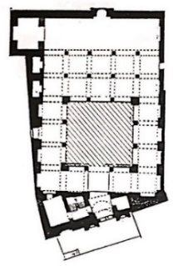
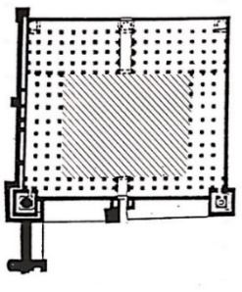
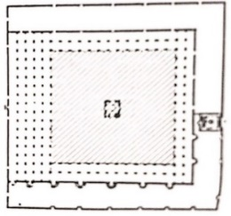

Figure 3. Al Aqmar Masjed | Figure 4.Al-Hakim Masjed | Figure 5 Ibn Tulun Masjed
- Inner courtyards in the Mamluki Bahari era
the design of the horizontal plan of religious buildings was directed inwards, and there are two main patterns:
First Pattern: The Masjed is made up of an uncovered inner courtyard surrounded by four shadows. An example of this is the mosque of Zahir Baybars. Figure 6 Second pattern: Schools consisting of a horizontal plan with four iwans, with the oldest known example of this being the school of Zahir Baybars. This Pattern continued appearing in the schools (Madrasa) Qalawun, Sarghatmish, and Sultan Hassan. Figure 7.
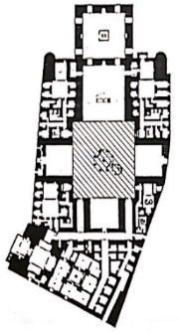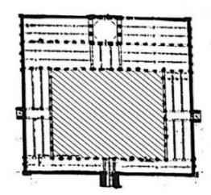
Figure 6. Mosque of Zahir Baybars
Figure 7. Madrasa of Sultan Hassan
- Inner courtyards in the Garsaki-Mamluk period
It is noticed that there are three main patterns of horizontal plans:
First Pattern: Small mosques/schools, in which the mosque or the school was grouped with Sabil, and kuttab. The plan consisted of a shrine (Dargah) with a shokhikha which was preceded by an Iwan facing towards the Qibla.
Second Pattern: It had an uncovered courtyard surrounded by four iwans in the case of mosques, schools, or Khanqahs, like the Khanqah of Faraj-bin-Barquq (Figure 8) and the school and Khanqah of Al-Zahir Barquq (Figure 9).
Third Pattern: The smallest in size of a masjid. It mainly consisted of a shrine (Dargah) placed in the middle, with a ceiling typically a wooden shokhikha and sometimes with a wired web, And Iwans surrounded the Dargah. An example of this Pattern is the school of Sultan Qait-bai.
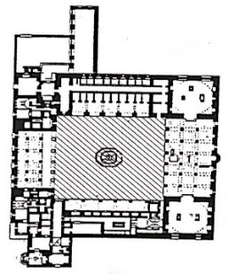 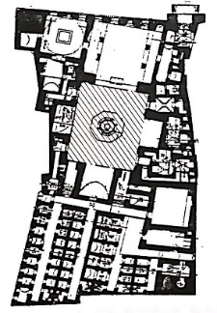Fig. 8. Khanqah of Faraj-bin-Barquq Fig. 9. Madrasa of Sultan Hassan
- Inner courtyards in the Ottoman era
First Pattern: We find that mosques were influenced by the architecture of ottoman mosques in Turkey to deal with the issue of the cold climate. Despite the hot climate, this system was transported entirely to Egypt, changing the concept and method of organizing the inner space for prayer within mosques. So, the prayer house in the Masjed was separated from the Courtyard like Suleiman Basha (Figure 10)
Second Pattern: it became acceptable for the architect not to include a courtyard. In that era, Masjids were formed by transforming the vertical axis of an uncovered space into a covered, roofed one with a dome above it through the vertical axis. The courtyard area kept shrinking until its disappearance, as is seen in the mosque of Sanan Basha (Figure 11) and the mosque of Muhammad Bek Abu El Dahab.
Third Pattern: Schools which consisted of an uncovered courtyard surrounded by four shaded prayer halls, each of them consisting of a room opening into a hallway with windows and overlooking the Courtyard through arched corridors, as in the Sulaymaniyah school Fig 12, and in the school of Sultan Mahmud. Through analyzing the plan, we find that having rooms opening in the hallway which opens up into the Courtyard is similar to the designs of modern school buildings, where classes open up on a corridor and through it onto the Courtyard. (Islamic Capitals Organization, 1990 p 386)
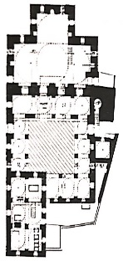 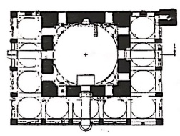 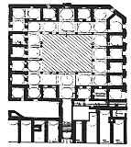Figure 10. Majed Suleiman
Figure 11.Masjed Sanan Figure 12. Sulaymaniyah school
Modern Masjed without an inner courtyard
The absence of the Inner Courtyard is evident from the study of contemporary Majed. There is a tendency toward building modern mosques which do not contain the traditional courtyard element.
This is due to the lack of awareness regarding the importance of the Courtyard. What it represents, and its treatment of climatic and environmental factors. Also, as the human, spiritual, and symbolic meanings, it carries.
This is also due to the small areas of land in modern cities.
The strong need to expand and accommodate the most significant number of worshippers in the mosque led to building mosques of many floors and other functions such as a praying area for women, areas dedicated to Quran memorization and recitation, and a library within the Majed. (Figure 13)

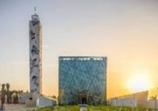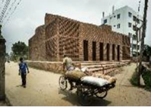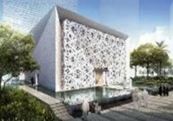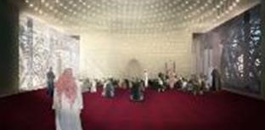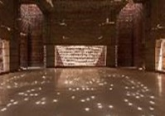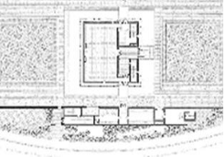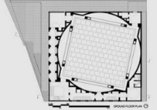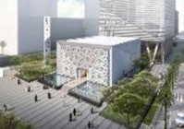

Financial Center Masjed, Riyadh Arch: Foxwell | House of Al Ra'uf Masjed Arch: Marina Tabassum | Petroleum Masjed Arch HOK
Figure 13. Futuristic trends - abstraction, simplicity, and symbolism
C. Functional Elements affecting the importance of having inner courtyards in contemporary and future masjids
The inner Courtyard plays an essential role from the functional side, as it is – besides being an element of the mosque – a space that accommodates some activities. It plays another role due to its openness toward the sky as a way to allow sunlight and fresh air into the areas surrounding it, naturally ventilating and illuminating them. This means that the inner Courtyard had many functions, whether it be ventilation, illumination, noise suppression, or an area to accommodate activities.

Ventilation
It is considered an important factor that influences peoples' comfort and health by directly affecting the air's movement and purification and its effect on temperature and humidity levels. The inner Courtyard helps naturally ventilate the areas of the mosque which surround it as follows:
The ventilation process is the spontaneous motion of air from high-pressure areas (cooler air) into low-pressure areas (warmer air). This motion results as cooler air replaces warmer air which rises upwards, creating this movement within the inner Courtyard and between the other spaces of the mosque. (Figure 14)
Similarly, the wind moves from the shadier roads through passages, entrances, and hallways into the inner courtyards with less shade, to secure constant ventilation between the outside and inside of the mosque, renewing and refreshing the air constantly. The ventilation process leads to the spontaneous movement of are from the narrow space of the entrance towards the vast area of the Inner Courtyard.
This also helps with the absorption of the air and renewing it within the building. (Shafiq, 1989, p 223)
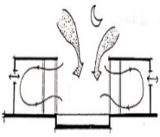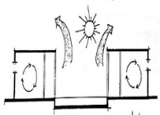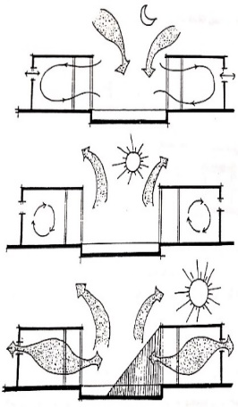
Figure 14. Natural ventilation across the inner Courtyard in an Arab building demonstrates ventilation during the different times of the day in the evening, noon and morning
The Inner Courtyard and Malqaf work to ventilate the inner spaces, as, throughout the day, the Malqaf functions from the left/north, and warm air rises within the area. So the cooler air comes from the Malqaf and passes into the Courtyard through the mosque's spaces. Through the nighttime, cooler air descends to the bottom of the Courtyard and enters nearby areas overlooking it, kicking out the warm air and pushing it towards the Malqaf. Malqafs were used within mosques commonly during the Abasi-era, which helped achieve thermal comfort. (Figure 15)

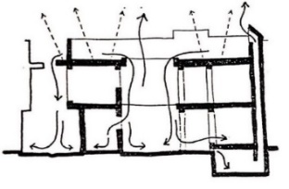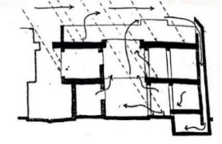
Figure 15. During the day, the maqaf receives the air and works to moderate the temperature. During the night, the cold air falls into the Courtyard and enters the spaces overlooking it to expel the hot air to the maqaf.

Natural Lighting
The reason for having openings in the building is to illuminate the building's spaces. Buildings in areas with hot climates require protection against high temperatures and have to deal with the issues of natural lighting such as dazzling brightness and over-illumination. One of the characteristics of buildings in these regions is having buildings close to one another in a compact form to decrease direct sun ray exposure and increase shaded areas. For this reason, it was necessary to have openings to be used as windows, and the need arose to have inner courtyards such that windows would open up on and overlook the inner Courtyard, shading it and providing protection from direct sunlight. These windows can be considered openings in the roof. (Evan,M, 1980 p123)
Inner courtyards provide natural lighting for internal spaces and solve the issues caused by them as follows:
When utilizing inner courtyards in buildings increases the surface area of the northern facades of the building, allowing the maximum amount of internal lighting with the minimum amount of dazzling brightness and regulating the lighting.
The Inner Courtyard is used to strengthen natural lighting and deflect the light towards the openings which require more illumination. Figure 16 (Evan,1980, P123)
The inner Courtyard prevents the unwanted direct light from entering the openings overlooking it during the midday. This is accomplished by raising one side of the building slightly higher than the other and utilizing the resulting shade from the buildings surrounding the Courtyard or its fences (Evan, M, 190, P123) (Figure 17), confirming the inner Courtyard's use as a protection against over-illumination and highly dazzling light.

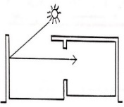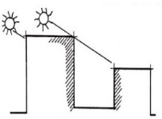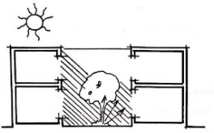
Figure. 16. Enhancing natural lighting by reflected solar rays | Figure17. The height of the walls overlooking the Courtyard protects the openings from rays | Figure8. Resistant to glare and dazzling inside the inner Courtyard
The use of inner courtyards within mosques played a great role in limiting dazzling brightness – which is considered a major annoyance and causes vision problems. It also affects contrast, and the less contrast is present on surfaces, the less dazzling brightness. – they also played a role in securing a comfortable level of natural lighting, where trees and green surfaces played a major role in blocking intense sunlight and minimizing it before it reached the facades and the floors of the Inner Courtyard. Greenery in Courtyard also absorbed and scattered the sunlight, which decreased dazzle and gleaming. (Figure 18)
Water surfaces in the Courtyard center lead to the refection and scattering of light rays falling on them. The water surface leads to a reduction in the light's intensity. This is also greatly affected by the amount of shade the inner Courtyard provides, which has a major role in reducing the sharpness of the illumination and decreasing the glow and dazzle. (Shafiq, 1989, P61)

Noise Reduction
Noise avoidance and reduction are requirements for mosques as worshippers will spend long periods in prayer, away from noise and sound pollution, meaning they need calmness and serenity within the houses of the Divine.
We find that the inner Courtyard is a factor that helps reduce noise as follows: Fig19
A mosque with an inner courtyard consists mainly of an emptied rectangle facing outwards towards the street with walls that have no windows. Its shade falls upon the inner Courtyard. A person will not see anything but the sky. A building of residence that utilizes an inner courtyard combines visual and audial privacy where the building provides isolation and protects the inner Courtyard from the noise and pollution of the streets. This inner Courtyard also adds an atmosphere of calmness and purity, which is a requirement for people while performing their different activities within the Courtyard. (El Touney, 1972. P2)
Traditional dwellings give a calmer environment than houses with an interior courtyard. It can provide an acoustic shadow for the building, and residences with inner courtyards can be placed quite close to noise sources since the closer the Courtyard is to the disturbance, the more the external noise is attenuated (although the weakness arising from a distance is smaller). Reconciling the urban land cost required to overcome the noise (by moving away from the source) and the acceptable noise level will determine the ideal distance for the house with the inner Courtyard from the noise source. Houses with courtyards can be grouped to form a connected wall surrounding the area built, as the wall's continuity is important for protecting the site behind it. (El Touney,1972, P 95-127)
In general, narrow inner courtyards protect the insides of mosques better, with loudness intensities ranging from 10 to 25 decibels (El Touney, 1972 – P95-127), and inner courtyards meant to protect from noise must be no more than 2–4 times the height of the wall to achieve a comfortable audial environment and to protect from outside noise.

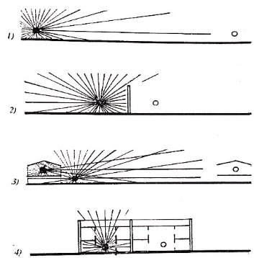
Fig. 19. Some ways to avoid noise and the best being inner courtyards:
- Keep as far away from noise sources as possible.
- Placing suitable barriers in the paths of the noise.
- Longer distances ensure avoiding noise and
METHODS
Research Methodology is a descriptive-analytical study. It will describe and define the importance of internal courtyards in historical mosques and the elements affecting the importance of their presence in contemporary Masjids. In this paper, we will present the results of this study in a summarized and focused form to facilitate its use and benefit in the future.

DISCUSSION
Ways to increase the functionality of masjids And achieve thermal and psychological comfort for the worshipers by using inner.
Returning to the inner courtyard element when designing mosques, the inner Courtyard should be looked at as an architectural concept that achieves many positives in the architectural design operation regarding climatic, social, and formational aspects. It also fulfills different human and spiritual values and affirms the necessity of reviving that beautiful architectural element that the Muslim Arab architect innovated.
This contributes significantly towards reminding and tying people to their history and heritage and raising their cultural awareness.
Other than including a courtyard, there should be environmental treatments that contribute to achieving thermal comfort inside the mosques, in the case of no courtyard being present in the building. Such treatments are as follows:
- Ceilings and their treatment: utilizing insulation for heat and humidity, building arches, or double ceilings to allow air movement between them.
- Walls: looking for building materials that can achieve insulation, building double walls with insulating layers between them, and using materials with high thermal aptitudes such as rocks/stones which absorb heat during the day and release it during the night without allowing it to penetrate the walls due to their thickness, utilizing various plant-based elements on the walls and surrounding the building to minimize the contact with sun rays, and using bright colors to paint the surfaces and inner and outer walls.
- I am researching and utilizing openings in a fashion that encourages ventilation and designing ventilation holes at the top of the inner space to dispose of warm air. Using 0penings decrease the amount of solar radiation permeating into the internal areas. Especially the southern openings, which should preferably be high and narrow, covered by wooden netting, and utilizing a double layer of insulated glass, horizontal and vertical sunlight breakers should also be used. It's also a good idea to have the openings face inwards, toward the inner Courtyard (Confirming the necessity to study the position and orientation of the opening, the dimensions and measurements, and the type of material of which the opening consists).
- Having trees and plantations inside the inner Courtyard ensures having sunlight blockers and contributes to humidifying the air within.
- Providing water surfaces and their aesthetic value plays an essential role in regulating the surrounding area's temperature, which helps create a miniature climate region in and around the building.

CONCLUSION AND RECOMMENDATIONS
A. Conclusion
Since the dawn of civilization, the Inner Courtyard's usage dates back to many ancient eras.
- The Inner Courtyard is one of the most important elements and appearances within Muslim Arab architecture, which the Muslim Arab architect innovated.
- The Inner Courtyard is one of the building's spaces in regions of social and environmental nature, which require its presence within the building; to achieve beneficial environmental, formational, and social goals.
- The Inner Courtyard of the mosque possesses a cultural dimension. Many cultural and study circles and seminars are held in the courtyards of historical mosques in Gaza, making it akin to a cultural center for its residents.
- The Inner Courtyard has a spiritual dimension that gives a person looking up at the sky a sense of comfort; this is an innate sense within humanity as if it is an attempt by the worshippers to find a spiritual connection between them and the Divine through prayer in a place that is not exposed to the sky.
- Mosques of historical areas that contained inner courtyards had many features, as they fulfilled the environmental aspect with their many balances and had a social value. Moreover, they had respect for the worshippers and their traditions and the human and spiritual aspect and authentic formation of those Masjids.
- It was noticed that worshippers headed to the hallways surrounding the Courtyard to recite the Quran to avoid the high temperature within the Masjid.
- As for Masjids that do not contain an inner courtyard, it is noticed that worshippers will seek refuge from the high temperature of the prayer building and head to the outer courtyards or the pavements surrounding the mosque.

B. Recommendations
- It is necessary to raise citizens' awareness to deepen their feelings about the mosque's inner Courtyard's environmental, climatic, human, and spiritual importance.
- Affirming the need to revive the Courtyard, the Muslim Arab architect innovated this architectural element, contributing significantly towards reminding and tying people to their history and heritage and raising their cultural consciousness. It also helps achieve thermal comfort and realizes the spiritual aspect.
- It is essential to study the inner Courtyard throughout the early design stages and incorporate it when designing warming, ventilation, and natural lighting systems.
- They provide suitable shading methods and ventilation for the inner Courtyard and interior spaces during the summer to avoid high temperatures.
- We achieve comfort for man to the greatest extent possible, whether inside or outside the building, through natural methods.
- We utilize trees, plantations, green surfaces, and fountains and ponds.
- We are evaluating the inner conditions which achieve thermal comfort for the residents of the building.
- The small land areas should not be an excuse to cancel and cross out the inner Courtyard from the architectural design. Instead, it should be considered an architectural concept that achieves many positives in the architectural design operation regarding environmental, social, and formational aspects.
- We are designing openings for ventilation at the top of the inner space to get rid of warm air such that it is replaced by cooler air, achieving a thermal balance that contributes toward comfort for humans.
Acknowledgment
The researcher acknowledges the support of Prince Sultan University
REFERENCES
- Abada, G. M.: Future Mosque: Design for spirituality and reverence between originality, imagination, and innovation, First International Conference on Mosque Architecture, Dammam p 2-33 [2016]
- Okasha, T., Aesthetic Values ​​in Islamic Architecture, Cairo: Dar Al-Shorouk, 1994, p. 40
- Sameh, K. A. Architecture in the early days of Islam. Cairo: The General Egyptian Book Authority, 1991, p. 10
- Abdel-Wahab, H. The history of ancient mosques. Cairo: The General Egyptian Book Authority, 1994, p. 23
- Center for Planning and Architectural Studies. Foundations of Architectural Design and Urban Planning, Organization of Islamic Capitals, 1990, p. 277
- Al-Ikabi, M., Content, and Form in the Architecture of the Islamic Residence. The Islamic Curriculum, Fourth Episode, Islamic Capitals Organization, 1991, p. 254
- Al-Wakeel, S.; Al-Sarraj, Mohammed Abdullah. Climate and architecture of hot regions, 3rd floor. Cairo: The World of Books, 1989, p. 22
- Evan, M.. Housing, Climate, Comfort. London: the Architectural press,1980.p62
- El Touney, S. Courtyard Acoustics, Department of Building Sciences, Sheffield University, Sheffield, 1972.p20
- EL Touney, S. The Aerodynamic and acoustic Environments of courtyards, Department of Building Sciences, Sheffield University, Sheffield 197 .p 95
- Dwidar, S.: The Opening in Islamic Architecture, Ms, Alexandria University, Alexandria [1998]
- Financial Center Masjed, Riyadh:http://www.archdaily.com/614616/kapsarc-mosque-hok
- House of Al Ra'uf Masjed http://www.akdn.org/architecture/project/bait-ur-rouf-mosque
- Petroleum research Mosque http://www.fxfowle.com/projects/25/king-abdullah-financial-district-mosque

