 |  | JOURNAL OF ISLAMIC ARCHITECTURE  P-ISSN: 2086-2636 E-ISSN: 2356-4644  Journal Home Page: http://ejournal.uin-malang.ac.id/index.php/JIA
POWER AND KNOWLEDGE IN THE TUATUNU GRAND MOSQUE OF PANGKALPINANG CITY, BANGKA ISLAND
Hadi Jaya Putra^{a*}, Agus Suharjono Ekomadyo^{b}, Alfathri Adlin^{c}
ªArchitecture, Faculty of Engineering, Universitas Presiden, Bekasi Regency, Indonesia
^{b}School of Architecture, Planning and Policy Development, Institut Teknologi Bandung, Bandung, Indonesia
^{c}Faculty of Art and Design, Institut Teknologi Bandung, Bandung, Indonesia
*Corresponding Author: hadi.jaya.putra@gmail.com
ARTICLE INFO |  |  | ABSTRACT
Volume: 8  Issue: 2  Page: 283-294  Received: September 15th, 2022  Accepted: February 12th, 2024  Available Online: December 30th, 2024  DOI: 10.18860/jia.v8i2.17530 |  |  | Apart from encompassing building techniques, functionality, and aesthetics, architecture encompasses power relations and knowledge within a building design. The knowledge embraced by architects manifests itself within the building as a textual message that users can understand. This study explores the interaction between power relations and knowledge that give rise to discourse in the design of the Tuatunu Grand Mosque in Pangkalpinang, Bangka. Employing a descriptive qualitative approach with random probability sampling, this research examines the influence of architects' power relations and knowledge on the architecture of the Tuatunu Grand Mosque. It sheds light on the discourse among its users. The findings of this study reveal that the architect employed two types of knowledge, namely Malay culture and Islamic values. These two types of knowledge are reflected in four concepts encompassing ten architectural elements. The analysis results demonstrate a readability rate of 75% for the discourse among the informants. This figure indicates that the users have a sufficient understanding of the messages conveyed through each architectural element. Malay culture emerges as the dominant and most prominent discourse in the mosque's design compared to Islamic values. Malay culture is applied in seven architectural elements, while Islamic values are only present in three.  Keywords:  Discourse Analysis; Bangka Malay; Power and Knowledge; Religion and Culture; Tuatunu Grand Mosque

- INTRODUCTION
Architecture, as the art of building, originates from implemented knowledge and ways of thinking [1]. Knowledge and architecture are phenomena of the mind (knowledge) generated by the physical processes occurring in the brain (epiphenomenalism) [2]. The dissemination of knowledge is inherently linked to the community, which relies on validating information shared for knowledge-sharing purposes. Information disseminated often carries inherent interests, leading to the conclusion that interests are typically controlled by power [3].
Foucault provides various definitions of knowledge and power, highlighting the power holders' control, selection, organization, and redistribution of knowledge [4]. In his work "The Order of Discourse," Foucault analyzes institutionalized knowledge, suggesting that knowledge and power are dynamic reciprocal processes. Knowledge generates, maintains, and reinforces power, while power must establish a system of truth to gain widespread acceptance of the knowledge it produces. In this context, power refers to the efforts made by those in dominant positions to persuade a larger audience to engage with a system that regulates and encourages compliance with its rules [5]. The power relations within architectural discourse not only reveal dominant forces but also encompass the struggle for public interests or marginalized communities [6], [7], [8], [9].
When knowledge exists, it is constructed to be controlled, selected, organized, and redistributed to the readers [4]. An optimal relationship exists between knowledge and power, where each influences the other [10]. Building upon Foucault's ideas, Sara Mills developed discourse analysis methods and argued that objects of analysis should be approached as texts or language. Discourse analysis aims to examine texts comprehensively and implicitly, considering the perspectives of the speaker or writer and the reader, audience, or listener involved in producing discourse [4]. Mills explores how texts are presented in discourse, the subjects and objects within the text, and the intended recipients of the text. She believes texts and images can indirectly communicate with the audience/reader/listener [11]. Discourse analysis plays a crucial role in opening up new avenues of analysis by examining the controlling nature of power and knowledge within language systems and attempting to interpret the produced texts [4].
Architecture can be understood as a text or language that interacts with the subjectivity of the reader/viewer/listener [12]. The interaction between object-subjects and positions results in architecture functioning as a communication medium through which architects convey messages to users. Different texts provide various fields of meaning, depending on the knowledge carried by the speaker/writer and the interpretation by the reader/viewer/listener. Through discourse analysis, the architect assumes the role of the speaker/writer, while the user of the space becomes the reader/viewer/listener.
Knowledge permeates all aspects of life [13]. In the case of the Tuatunu community, knowledge about Malay Kaffah is essential for adhering to Islamic teachings comprehensively (referring to Kaffah), encompassing both the physical and spiritual aspects of worldly affairs and the afterlife. This belief manifests in the Malay cultural practices observed in Tuatunu, a traditional Malay settlement on Bangka Island, specifically within Pangkalpinang [14][15]. The architectural form arises in response to the Tuatunu people's desire to have a more enormous mosque that can accommodate the entire community [16]. The establishment of the Tuatunu Grand Mosque aims to foster unity among Dalam, Tengah, and Ujung Tuatunu residents for prayer and religious festivities.
The discourse surrounding the construction of the Tuatunu Grand Mosque began in 2005, five years after the establishment of the Bangka Belitung Province. The mosque's establishment unfolded as a collaborative effort involving stakeholders such as the local community, government, and architects, reflecting a dynamic interplay between cultural identity, religious values, and architectural design.
This research delves into the Tuatunu Grand Mosque's architectural discourse, employing discourse analysis inspired by scholars like Foucault, Mills, and Eriyanto. We aim to uncover the nuanced layers of meaning within its architectural elements, shedding light on the dynamic relationship between the architect, stakeholders, and users. By examining how the mosque communicates cultural and religious messages, fostering community identity, our study contributes to the broader understanding of architectural design as a conduit for cultural expression, religious symbolism, and community cohesion. It also investigates the users' ability to interpret the messages embedded in the architectural elements.

- METHODS
The research employed a descriptive qualitative method [17] with random probability sampling [18]. The secondary data sources comprised theoretical studies on discourse analysis by Michel Foucault and Sara Mills and literature reviews related to the Tuatunu Mosque.
It is noteworthy to mention that while Sutanty employed a similar method in their research focused on Javanese-Catholic churches [19], the current study offers a distinctive perspective by investigating the architectural discourse within the context of the Tuatunu Grand Mosque, representing Bangka Malay-Islamic architecture. This divergence in religious and cultural contexts contributes to the broader academic discourse on architectural analysis, providing a novel lens through which to explore the intricate interplay of power, knowledge, and cultural representation in religious structures.
In this study, the researchers used data triangulation techniques by combining 3 data collection techniques (observation, interviews, and documentation) triangulation [20]. The first interview was conducted with Mr Ar. Ir. Hongky Listiyadhi, M.Ars., IAI, to analyze the statements of the autonomous subject as the architect. The second interview presented five mosque users positioned as objects in Pangkalpinang City in early November 2021. The collected data was then analyzed using Foucault's discourse analysis theory, which Sara Mills developed. The analysis revealed how the knowledge possessed by architects can be conveyed as messages embedded within the buildings. Sara Mills described the process of conception and reception used in reading texts [11]. The collaboration between the writer and the reader determines the success of message delivery.
Discourse analysis was employed to interpret texts discussing the Tuatunu Mosque. Architects utilize two types of knowledge in their design process [21]: Islamic values and Malay Bangka culture, which resulted in four concepts and ten architectural elements (Table 1). To simplify respondent answers, the writer grouped the responses into three categories: Unreadable (U) 0%, Partially Readable (PR) 50%, and Readable (R) 100%. The unreadable category (U) refers to the condition where users are unaware of and do not understand the messages conveyed by the building. The partially readable category (PR) indicates that users are aware of messages in the building but do not comprehend the meaning behind those messages. The readable category (R) includes responses from participants who are aware of and understand the messages conveyed by the building.

Table 1. Architectural Elements at Tuatunu Mosque
Concept | No. | Architectural Elements
Building Shape | 1 | Mass Concept
 | 2 | The Dimensions of Terrace
Facade | 3 | Façade Color
 | 4 | Geometric Elements
Roof | 5 | Shape of The Roof Terrace
 | 6 | Dome
 | 7 | Dulang Roof
Decorative Elements | 8 | Column Profile and Roaster
 | 9 | Stained Glass
 | 10 | Railing Stairs and Floor Pattern

- RESULT
- CONCEPT AND BACKGROUND HISTORY OF TUATUNU GRAND MOSQUE
The Tuatunu Grand Mosque, located in Kampong Tuatunu, Gerunggang District, Pangkalpinang City, on Bangka Island, Bangka Belitung Province, Indonesia, had its discourse surrounding construction initiated five years after the establishment of Bangka Belitung Province in 2005. The impetus for establishing the mosque arose from the community's desire to assemble and worship in a central location. Driven by this aspiration, members of the Tuatunu community approached a distinguished architect in Pangkalpinang City for assistance in designing the mosque.
In 2005, parallel to the community's endeavors, the Provincial Government of the Bangka Belitung Islands was also without a mosque of a provincial scale, specifically a Grand Mosque. Consequently, the discourse regarding establishing the Tuatunu Grand Mosque unfolded as a reciprocal development. The land allocated for the construction of the Tuatunu Grand Mosque, now designated as waqf land, encompassed an area of approximately 10,000 m² and was initially owned by the revered figure of Kampong Tuatunu, the late H. Ahmad Saad (Figure 1). Bapak Ahmad Saad, the core traditional leader in Tuatunu, was pivotal in initiating discussions about the mosque's construction.

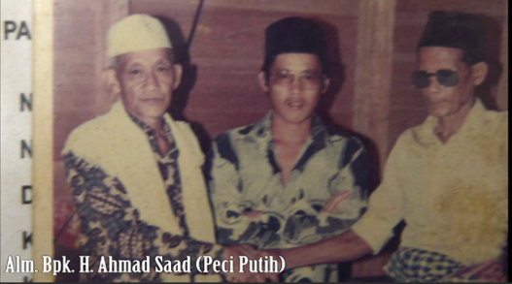

Figure 1. Portrait of H. Ahmad Saad (Left) [Source: Hongky Listiyadhi]

In mid-2005, Ahmad Saad, along with members of the Tuatunu community as stakeholders, visited the residence of Hongky Listiyadhi, an esteemed architect in Bangka. They traveled to Hongky's home in a bus filled with passengers to request his assistance in designing the mosque. The decision to approach Hongky's home was strategic, given his role as the head of Ikatan Arsitek Indonesia (IAI) Kepulauan Bangka Belitung, or the Indonesian Architects Association, during that period.
In a subsequent interview with Hongky (HL), he illustrated the dialogue with Ahmad Saad (AS) upon their arrival at Hongky's home. The initial question posed during this encounter was:

AS: What are you?
[Ka ne orang ape? (Bangka-Malay Dialect)]

HL: If you are asking what I am, as you can see. I have light skin, my eyes are slitted, and, of course, I’m of Chinese descent.
[Misal nanyak ku ne orang ape, cem acak diliat lah. Kulit ku putih, mate ku sipit, jelas ku orang Cina (Bangka-Malay Dialect)]

AS: But, are not you Moslem?
[Tapi ka Islam ken? (Bangka-Malay Dialect)]

HL : Yes I am Muslim.
[Aok ku Islam (Bangka-Malay Dialect)]

HL: Then you are our people.
[Kalo cem tuh ka orang kami (Bangka-Malay Dialect)]

Upon posing these questions, the Tuatunu community stakeholders were assured that Hongky was the suitable candidate for their needs, despite his Chinese roots, given his adherence to Islam. However, Hongky did not explicitly confirm his ability to undertake the monumental project following the meeting. Subsequently, the next meeting was scheduled in Tuatunu Village.
Upon arrival at the meeting in Tuatunu, Hongky, accompanied by the Pangkalpinang City Mayor, was taken aback by the substantial turnout of over 100 attendees. In front of this substantial audience, Hongky formally signed the contract, solidifying his role as the architect of the Tuatunu Grand Mosque.
As an architect, Hongky possessed the liberty to articulate his expertise, as the stakeholders were primarily concerned with the overarching discourse of constructing the mosque. In alignment with the government and community aspirations, Hongky translated this discourse into his design concept. The discourse on architectural design surfaced when the Tuatunu community expressed their ambition to erect a grand mosque representing Islamic Malays in their vicinity. Leveraging his knowledge, the architect formulated the architectural concept as a substantial contribution to this discourse.
Inaugurated in 2008, the Tuatunu Grand Mosque stands as the largest mosque in the Bangka Belitung Islands province. With a capacity to accommodate up to 3000 people during religious events, it has emerged as a source of pride for Pangkalpinang City and Bangka Island residents. Beyond serving as a Muslim worship place, the mosque is a central hub for Islamic religious studies.

- BUILDING SHAPE
- 1. Mass Concept
In a personal interview, architect Hongky Listiyadhi emphasized the close relationship between religion and symbols. He explained that churches commonly utilize crosses as distinctive signs, while mosques often incorporate symbols such as stars and the moon. Consequently, the architect chose a star shape in the mosque's design, specifically an eight-pointed star (Figure 2).

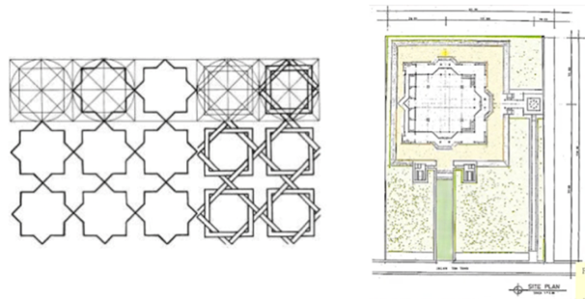
A | B

Figure 2. (a) Eight stars (b) Sketch of site plan [Source: (a) [22] (b) Hongky Listiyadhi]

The six-pointed star holds significant religious symbolism, including in Islam, where it is known as the Seal of Solomon. Solomon and David are mentioned as prophets in the Quran, and they lend this hexagram emblem its Islamic significance. This symbol has been employed in Islamic relics and buildings [23]. The eight-pointed star shape is also frequently observed in Islamic civilization, appearing in various art forms such as architecture, cloth patterns, tiles, and ceramics [22]. The architect drew inspiration from these cultural and artistic elements when incorporating the shape of an eight-pointed star into the mosque's overall structure.

- 2. Dimension of the Terrace
Nganggung, also known as the Sepintu Sedulang custom, is a local tradition with significant cultural and religious importance. This tradition is commonly observed during religious ceremonies such as Eid al-Fitr, Eid al-Adha, Mauludan, Nisfu Sya'ban, and Muharram activities. Furthermore, Nganggung is also practiced to honor and welcome distinguished guests, including governors, regents, and other notable individuals [24]. The execution of this tradition varies, with some choosing to conduct it in mosques, open fields, and prayer rooms, while others opt for traditional houses or halls. The Nganggung activities typically involve spiritual cleansing rituals involving recitations and religious lectures.

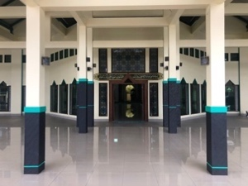 | 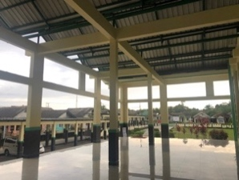
A | B

Figure 3. (a) The south terrace (b) The east terrace [Source: the authors]

Considering the Tuatunu Mosque's intended purpose as a Masjid Raya (grand mosque) to serve users from across Bangka Belitung, the architect incorporated a spacious terrace into the design. This decision aimed to accommodate various activities not only within the mosque but also outside of it [25]. Including a sizable terrace reflects the architect's consideration for the diverse range of activities during religious ceremonies and other gatherings associated with the Nganggung tradition. By providing a flexible outdoor space, the mosque can effectively cater to the needs of its users, fostering a sense of community and facilitating the practice of this important local tradition.

- FACADE
- 1. The Colors
The architect explained the color selection for the Tuatunu Mosque, which includes ivory, white and green. Green has been historically associated with Muslims, dating back to the time of the Prophet Muhammad (SAW), while white symbolizes purity. These two colors were applied to the entire outer wall of the mosque building (Figure 4), and their usage has remained unchanged since the mosque's establishment.

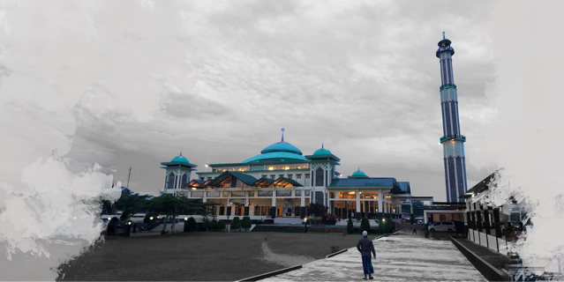

Figure 4. Color of the mosque [Source: the authors]

Green holds significance in Islamic values as it was the Prophet Muhammad's favorite color [26]. This can be observed from the green color of his turban, and green is mentioned eight times in the Qur'an (Surah al-An‘am verse 99, Surah Yusuf verse 43; Surah Yusuf verse 46, Surah Al-Kahf verse 31, Surah Al-Hajj verse 63, Surah Yasin verse 80, Surah Al-Rahman verse 76, and Surah Al-Insan verse 21), symbolizing the number of gates to heaven [27]. In Islamic tradition, white carries multiple meanings, including being associated with light or brightness, symbolizing holiness and cleanliness, and representing victory over darkness.

- 2. Geometric Elements
The architect explained the color selection for the Tuatunu Mosque, which includes ivory, white and green. Green has been historically associated with Muslims, dating back to the time of the Prophet Muhammad (SAW), while white symbolizes purity. These two colors were applied to the entire outer wall of the mosque building (Figure 5), and their usage has remained unchanged since the mosque's establishment.

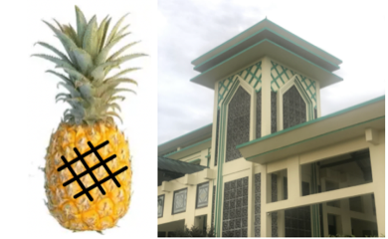

Figure 5. The pattern abstraction of geometric elements [Source: the authors]

- ROOF
The roof terrace of the mosque features five gable roofs on the south terrace (Figure 6a) and another five gable roofs on the west terrace. This architectural choice of gable roofs directly responds to the site's surrounding environment. It is worth noting that gable roofs are commonly seen in the traditional dwellings of the Kampong Tuatunu community (Figure 6b).

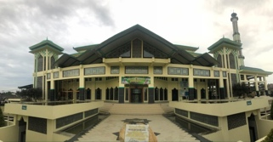 | 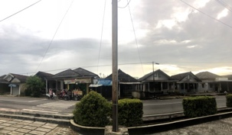
A | B

Figure 6. (a) The roof of the south terrace (b) The residential houses in front of the mosque [Source: the authors]

By incorporating gable roofs into the terrace design, the architect aims to establish a sense of familiarity and harmony with the local context. The mosque intends to seamlessly blend into the surrounding Kampong Tuatunu, ensuring it does not appear foreign or out of place. This deliberate effort is driven by the desire to create a strong emotional connection and a sense of belonging between the community and the mosque.
At the center of the mosque building is a dome with significant symbolism. The inspiration for the dome's shape comes from the rubber fruit, a prominent commodity among the Tuatunu community, known for their involvement in rubber farming in plantations. The architect deliberately chose the shape of the rubber fruit as the fundamental form for the mosque's dome (Figure 7a).

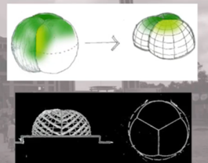 | 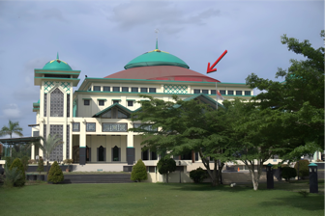
A | B

Figure 7. (a) Draft design of dome (b) The dome of the Tuatunu Grand Mosque [Source: Hongky Listiyadhi and the authors]

To incorporate the dome shape into the mosque's design, certain modifications had to be made to the original pattern of the rubber fruit. The shape of the rubber fruit was divided into two parts, right at the center, and then adjusted to accommodate the load and structural requirements. The resulting dome frame spans a considerable width, with a diameter of approximately 20 meters (Figure 7b).
A distinctive roof style in the form of a dulang is incorporated atop the dome. This dulang roof design is featured on the dome and every corner of the mosque. The dulang, traditionally used as a food tray in the Bangka Malay culture, holds significant cultural significance and is an integral part of the Nganggung tradition (Figure 8a).

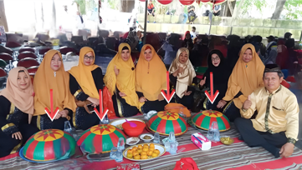 | 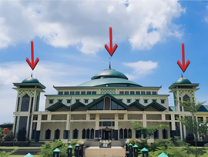
A | B

Figure 8. (a) Nganggung (b) The roof of the Tuatunu Grand Mosque [Source: the authors]

The selection of the Bangka Malay dulang as a prominent roof element carries symbolic meaning, reflecting the Tuatunu community's self-identity within the broader Malay community. This traditional element is embraced and applied to the mosque's architecture, representing the community's cultural heritage. There are five instances where the dulang roof element is employed, located at each corner of the building and above the dome (Figure 8b). Notably, the presence of these five dulang roofs also signifies the five pillars of Islam, further reinforcing the religious significance of the mosque.

- DECORATIVE ELEMENTS
The decorative ornaments on the column profile trim and roaster follow the same underlying pattern as the dome shape derived from the rubber fruit. However, there is a distinction in the implementation of these design elements. The dome roof elements are cut and modified to fit the overall design, whereas the column profile trim and roaster retain the original form of the rubber fruit (Figure 9).

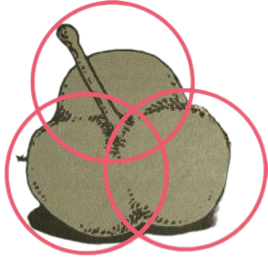

Figure 9. The basic shape of a rubber fruit [Source: the authors]

These obtained shapes are then incorporated into the architectural design as decorative ornaments, specifically in the form of the column profile trim (Figure 10a) and the roaster (Figure 10b). The column profile trim is a decorative embellishment on the lower part of the structural columns supporting the dome. Each of the four large columns features this profile trim, enhancing the aesthetic appeal of the mosque. Similarly, the roaster, which surrounds the exterior of the building, serves as an aesthetic enhancer. Both the column profile trim and the roaster contribute to the overall visual aesthetics of the mosque.

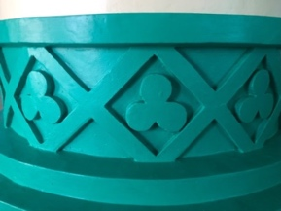 | 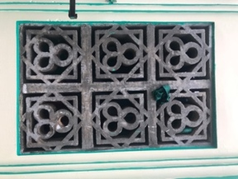
A | B

Figure 10. (a) Column profile list (b) Roaster [Source: the authors]

The stained-glass design incorporates various traditional motifs from the Bangka Malay culture, particularly emphasizing plant patterns. The designer intended to combine several distinctive Malay patterns from the Bangka Belitung region, including the sahang (pepper) motif, the tampuk pinang (betel nut) motif, and rubber fruit patterns (Figure 11a). These motifs are intricately integrated into the stained glass and placed above the mosque's north, South, and east sections (Figure 11b).

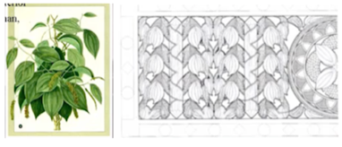 | 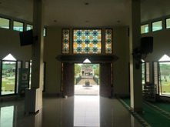
A | B

Figure 11. (a) Stained glass design proposal (b) Stained glass in the mosque [Source: the authors]

The stained-glass decoration predominantly features circular shapes, symbolizing the rubber fruit. The red color represents the betel nut, while the green color represents the shape of the pepper leaf. This combination of colors and motifs in the stained glass reflects the rich cultural heritage of the Bangka Malay tradition.
The concept of incorporating eight stars, also known as rub al-Hizb, was proposed by the architect of the Tuatunu Grand Mosque and implemented in the design of the stair railing and lobby floor (Figure 12). Drawing inspiration from discussions in the Qur'an and hadith, which serve as Muslim guiding principles, the significance of the eight stars holds a symbolic meaning deeply rooted in Islamic art and culture [28]. This symbolism has been widely represented in various artistic works across different mediums within the Islamic community.



Figure 12. Eight stars [Source: the authors]

In the implementation of the design, these star patterns were intricately embedded to enhance the aesthetics of specific areas. The stair railing (Figure 13a), constructed using iron material with a welding installation, features the eight-star pattern, adding a decorative element to the staircase. Similarly, the floor pattern (Figure 13b) is created in the mosque's lobby using granite material that is precisely cut to match the design.

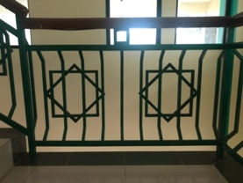 | 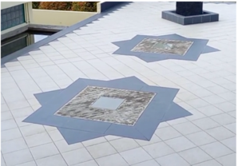
A | B

Figure 13. (a) Stair railing (b) Lobby floor pattern [Source: the authors]

- DISCOURSE ANALYSIS
Table 2 shows that the architectural elements in Tuatunu Grand Mosque are influenced by two sources of knowledge: Malay Culture (*) and Islamic Values (**). Seven architectural elements are derived from Malay culture, while three are derived from Islamic values. The study involved five informants with different backgrounds. The results of the interviews with these informants indicate that the readability of the discourse in Tuatunu Grand Mosque is 75 percent.
Based on the analysis of the findings, it is evident that the architectural elements of the Tuatunu Grand Mosque effectively convey their intended messages to the mosque users. The study's informants consisted of residents living near the mosque and those residing outside the Tuatunu area. Informants 1, 3, and 5 were selected from the local community residing close to the mosque, while informants 2 and 4 represented individuals from outside the Tuatunu region.
The analysis results indicate that the architectural discourse's readability varies between the two groups of informants. The mosque congregation, comprised of residents living near the mosque, demonstrated a higher readability in comprehending the architect's intended message than the outside Tuatunu area. This discrepancy in readability can be attributed to the stronger emotional bond and familiarity that the local community members have with the Tuatunu Malay culture and the mosque itself.

Table 2. Tabulation of Discourse Analysis at Tuatunu Grand Mosque
Text |  | Reader/Viewer/Listener |  |  |  |  |  |  |  |  |  |  |  |  |  |  | Total
Concept | Architectural Elements | 1 |  |  | 2 |  |  | 3 |  |  | 4 |  |  | 5 |  |  | Readability
Concept | Architectural Elements | U | PR | R | U | PR | R | U | PR | R | U | PR | R | U | PR | R | Variable | Concept
Building Shape | Mass Concept** |  | √ |  | √ |  |  |  | √ |  | √ |  |  |  | √ |  | 30% | 65%
Building Shape | Dimensions of Terrace* |  |  | √ |  |  | √ |  |  | √ |  |  | √ |  |  | √ | 100% | 65%
Facade | Façade Color** |  | √ |  |  |  | √ |  |  | √ |  |  | √ |  | √ |  | 80% | 65%
Facade | Geometric Elements* |  | √ |  |  | √ |  |  | √ |  |  | √ |  |  | √ |  | 50% | 65%
Roof | Shape of The Roof Terrace* |  |  | √ |  |  | √ |  |  | √ | √ |  |  |  | √ |  | 70% | 73%
Roof | Dome* |  |  | √ | √ |  |  |  | √ |  |  | √ |  |  | √ |  | 50% | 73%
Roof | Dulang Roof* |  |  | √ |  |  | √ |  |  | √ |  |  | √ |  |  | √ | 100% | 73%
Decorative Elements | Column Profile and Roaster* |  |  | √ |  |  | √ |  |  | √ |  |  | √ |  |  | √ | 100% | 90%
Decorative Elements | Stained glass* |  |  | √ |  | √ |  |  |  | √ | √ |  |  |  |  | √ | 70% | 90%
Decorative Elements | Railing Stairs and Floor Pattern** |  |  | √ |  |  | √ |  |  | √ |  |  | √ |  |  | √ | 100% | 90%
Average Readability |  | 85% |  |  | 70% |  |  | 85% |  |  | 60% |  |  | 75% |  |  | 75%
Legend: *Malay Culture **Islamic Values

The high readability exhibited by the decorative ornament design within the architectural discourse indicates that users can quickly grasp and comprehend the visual forms presented by the architect. This can be attributed to the design's close resemblance to its sources of inspiration. By incorporating shapes such as rubber fruit and the 8-star motif without any form of abstraction, the architect has facilitated identifying and understanding the intended message embedded within the design.
Conversely, when examining the building shape and facade, it becomes evident that their legibility percentage is comparatively lower than that of other design aspects. Specifically, the concept of mass and the implementation of geometric elements present a challenge for users in interpreting their intended meanings. This difficulty arises from the architect's deliberate abstraction of the original reference form. By abstracting these elements, the architect has introduced a complexity that hinders users' ability to grasp these architectural components' underlying significance and intended message.

- DISCUSSION
According to Sara Mills, the discourse surrounding the Tuatunu Grand Mosque in Pangkalpinang City involves two social actors: the architect, who assumes the role of the subject, and the Tuatunu Grand Mosque itself, which serves as the object. In this dynamic, the architect wields significant power and control over the messages conveyed through the architectural design, treating the mosque as a text to be interpreted by users. This is due to his liberty to explore which values or culture he wants to deliver to the user. It is evident that the intended message formulated by Hongky, after being established for 15 years, has achieved a commendable readability rate of 75% of the architectural elements.
The design of the Tuatunu Grand Mosque is characterized by incorporating two distinct bodies of knowledge: Malay culture and Islamic values. Hongky intends to communicate these knowledge domains through his architectural composition, resulting in four key concepts that manifest across ten individual architectural elements. It is crucial to recognize the influence of knowledge selection by the architect, as it significantly impacts the legibility and comprehensibility of the discourse conveyed to the users.
Among the various knowledge domains available to architects, the knowledge of Tuatunu Malay Culture holds a prominent position in shaping the mosque's design. This knowledge encompasses a range of elements, including community commodities, local cultural practices, and the specific contextual factors associated with the mosque's site location. Islamic values are also woven into the architectural design, reflecting the significance of the mosque as a religious institution.
However, it is noteworthy that the Tuatunu Malay knowledge takes precedence over the prominence of Islamic values in shaping the architectural discourse of the mosque. The architect deliberately draws upon the rich knowledge and traditions of the Tuatunu community, recognizing their emotional bond and deep-rooted connection to the Tuatunu Grand Mosque. This assertion is supported by insights from interviews, revealing that users find it easier to comprehend and relate to the discourse surrounding Tuatunu Malay Culture than the discourse centered on Islamic values.

- CONCLUSION
This paper demonstrates the application of discourse analysis in interpreting architectural design discourse. Architects play a crucial role in shaping a better-built environment, drawing upon their architectural knowledge. Collaborating with stakeholders within the community enables the design discourse to capture community aspirations and align the visions of architects and stakeholders for a better future. Architecture transcends spatial creation and embodies the ideologies of architects, thereby triggering discourse influenced by power relations and embedded knowledge.
The Tuatunu Grand Mosque in Pangkalpinang City has played a significant role in reinforcing the image of Kampong Tuatunu as a faithful Islamic Malay community that embraces and embodies Malay culture and Islamic values. Additionally, its establishment has bestowed a new identity upon the Bangka Belitung Province, symbolizing cultural and religious representation. Including the term "Grand" in its name signifies its status as a representative mosque for the province.
During the design process, the architect incorporated two realms of knowledge into the discourse: Islamic values and Tuatunu Malay culture. This discourse is reflected in various design elements, including the building form, facade, roof, and decorative ornaments. Through discourse analysis, it becomes evident that users can comprehend the intended design concepts with a readability rate of 75 percent, indicating the successful implementation of the "Malay Kaffah" discourse, which resonates well with the community.
In conclusion, the architectural discourse of the Tuatunu Grand Mosque exemplifies the dynamic interplay between the architect, the knowledge domains of Malay culture and Islamic values, and the users of the mosque. The meticulous selection and integration of knowledge have effectively conveyed messages to the users, resulting in high readability. Recognizing the ongoing interrelationship between cultural and religious values in the design process is essential. By leveraging the users' familiarity and affinity with the local culture, architects can effectively communicate their intended messages and create meaningful architectural experiences.

ACKNOWLEDGEMENT
The author extends their gratitude to Bapak Ar. Ir. Hongky Listiyadhi, M.Ars., IAI, for providing invaluable insights crucial to the primary research undertaken. Appreciation is also conveyed to the congregations of Masjid Raya Tuatunu and the Tuatunu community for their valuable participation in the study.

REFERENCES
[1] F. Nilsson, “Knowledge in the Making. On Production and Communication of Knowledge in the Material Practices of Architecture,” FormAkademisk, vol. 6, no. 2, Nov. 2013, doi: https://doi.org/10.7577/formakademisk.569.

[2] K. M. Hays, “Critical Architecture: Between Culture and Form,” Perspecta, vol. 21, p. 14, 1984, doi: https://doi.org/10.2307/1567078.

[3] D. Gurteen, “Creating a Knowledge Sharing Culture,” Knowledge Management Magazine, vol. 2, no. 5, Feb. 1999.

[4] S. Mills, Discourse. London: Routledge, 1997, p. 71.

[5] M. S. B. Iskandar, “Relasi Kekuasaan dan Arsitektur: Dari Dekonstruksi ke Sustainable City,” DIMENSI (Journal of Architecture and Built Environment), vol. 30, no. 1, 2002, doi: https://doi.org/10.9744/dimensi.30.1.

[6] M. G. D. Bintana, A. S. Ekomadyo, D. Agumsari, and V. Susanto, “Sea Nomads and Cultural Transformation, Case Study: Kampung Baru Suku Laut, Sungai Buluh Village, Lingga Regency, Riau Islands,” Proceedings of the 3rd International Conference on Dwelling Form (IDWELL 2020), 2020, doi: https://doi.org/10.2991/assehr.k.201009.013.

[7] H. M. Lina and A. S. Ekomadyo, “Ruang Representasional untuk Pencurahan Kasih Sayang pada Pusat Perbelanjaan (Studi Kasus: Festival Citylink, Bandung),” Review of Urbanism and Architectural Studies, vol. 19, no. 2, pp. 28–39, Dec. 2021, doi: https://doi.org/10.21776/ub.ruas.2021.019.02.3.

[8] Z. A. Prabaswara, N. I. C. T. D. Hutagaol, D. O. Viryani, A. S. Ekomadyo, and V. Susanto, “Peran Perancangan dalam Memperjuangkan Right to The City pada Kota Bogota,” Sinektika: Jurnal Arsitektur, vol. 18, no. 2, pp. 179–189, Jul. 2021, doi: https://doi.org/10.23917/sinektika.v18i2.15331.

[9] E. B. Prasetyo, A. C. Putra, B. Rahmaputra, and A. S. Ekomadyo, “Architectural adaptation strategy of shophouses in Jalan Tubagus Ismail, Bandung,” ARTEKS: Jurnal Teknik Arsitektur, vol. 5, no. 1, pp. 1–10, Mar. 2020, doi: https://doi.org/10.30822/arteks.v5i1.72.

[10] A. M. Mudhoffir, “Teori Kekuasaan Michel Foucault: Tantangan bagi Sosiologi Politik,” MASYARAKAT: Jurnal Sosiologi, vol. 18, no. 1, Jan. 2013, doi: https://doi.org/10.7454/mjs.v18i1.3734.

[11] Eriyanto, Analisis wacana: pengantar analisis teks media. Yogyakarta: Lkis Yogyakarta, 2001.

[12] B. Nigianni, “Architecture as image-space-text,” in Models to Drawings: Imagination and Representation in Architecture, London and New York: Routledge, 2007.

[13] S. Mills, Michel Foucault. London: Routledge, 2003, p. 35.

[14] N. Aufia and A. Saputra, “Pembacaan Pola Tata Ruang Hunian Tradisional Melayu Bangka Berdasarkan Lagu Daerah Bangka ‘Yo Miak,’” NALARs, vol. 20, no. 2, pp. 119–130, Jul. 2021, doi: https://doi.org/10.24853/nalars.20.2.119-130.

[15] S. M. Ayu, “Concept of Islam Kaffah in Islamic Education Curriculum,” in Proceeding ISETH (International Summit on Science, Technology, and Humanity), Surakarta, Jawa Tengah: Universitas Muhammadiyah Surakarta, Dec. 2015, pp. 318–330.

[16] A. S. Ekomadyo, A. Nurfadillah, A. Kartamihardja, and A. J. Cungwin, “Becoming Heritage: A Place-Making Study of Old Neighbourhood Marketplace in Bandung,” IOP Conference Series: Earth and Environmental Science, vol. 158, p. 012012, May 2018, doi: https://doi.org/10.1088/1755-1315/158/1/012012.

[17] J. W. Creswell and J. D. Creswell, Research design: Qualitative, quantitative, and Mixed Methods Approaches, 5th ed. Thousand Oaks, California: SAGE Publications, 2018.

[18] R. Kumar, Research methodology: a step-by-step guide for beginners. London: Sage Publications Ltd, 2014.

[19] P. B. B. Sutanty, “Relasi Kekuasaan dan Pengetahuan Pada Arsitektur Gereja Candi Ganjuran,” Nature: National Academic Journal of Architecture, vol. 10, no. 1, pp. 106–117, Jun. 2023, doi: https://doi.org/10.24252/nature.v10i1a9.

[20] Sugiyono, Memahami penelitian kualitatif, 10th ed. Bandung: Alfabeta, 2014, p. 64.

[21] H. J. Putra, P. B. B. Sutanty, and S. Nadia, “David Frank Adjaye Design Thinking,” ATRIUM: Jurnal Arsitektur, vol. 8, no. 2, pp. 149–164, Nov. 2022, doi: https://doi.org/10.21460/atrium.v8i2.192.

[22] R. F. Tennant, “Medieval Islamic Architecture, Quasicrystals, and Penrose and Girih Tiles: Questions from the Classroom,” Symmetry Culture and Science, vol. 19, no. 2–3, pp. 297–304, 2009

[23] Sk. Z. Islam, “Six-Pointed Star Motif in Muslim Architecture of Bangladesh (Past Bengal) and Turkish Influence: An Historical Study,” Bangladesh Journal of Multidisciplinary Scientific Research, vol. 2, no. 1, pp. 40–47, May 2020, doi: https://doi.org/10.46281/bjmsr.v2i1.565.

[24] D. Oktafiani, “Fenomena Nganggung pada Perayaan Hari Besar Islam di Bangka,” Bachelor Thesis, Universitas Pasundan, 2018. Accessed: Dec. 30, 2023. [Online]. Available: http://repository.unpas.ac.id/34403/

[25] H. J. Putra, A. F. Muchlis, and H. E. Kusuma, “A Design Guide for Worship Spaces at Home: Exploring the Influence of Extrinsic Motivation on Intrinsic Motivation in Worshipping,” Journal of Islamic Architecture, vol. 8, no. 1, pp. 244–253, Jun. 2024, doi: https://doi.org/10.18860/jia.v8i1.23185.

[26] A. G. Syafi’i, “Warna dalam Islam,” An-Nida’, vol. 41, no. 1, pp. 62–70, Feb. 2018, doi: https://doi.org/10.24014/an-nida.v41i1.4637.

[27] M. K. N. Zainan Nazri, N. S. bt Hamisan Khair, A. B. M. Yusoff, M. M. Abd Razzak, N. J. Z. Nazri, and M. bt M. Ishak, “Colour From the Perspective of Hadith: an Overview,” SHS Web of Conferences, vol. 18, p. 04005, 2015, doi: https://doi.org/10.1051/shsconf/20151804005.

[28] A. F. Muntazori, “Simbol Bintang Delapan sebagai Identitas Masyarakat Muslim Kajian Semiotika pada Simbol Bintang Delapan,” Deiksis: Jurnal Pendidikan Bahasa dan Sastra Indonesia, vol. 5, no. 1, pp. 58–80, 2013

