Table 1.
Grouping of Home-based Batik Enterprise Samples
Based on Productive House Criteria

Separate type | Batik Ade ayu  (A) | Batik Balong  (B) | Batik pisang Bali  (C) | Batik Khoba  (D)
1 | 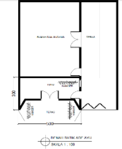 | 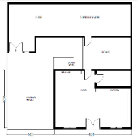 | 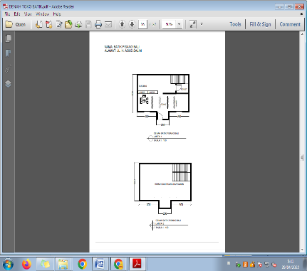 | 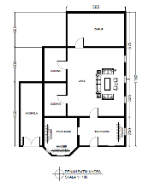
Mixed type | Batik Fifi - Ratu Jawa  (A) | Batik Ghofar  (B) | Batik nur Baiti  (C) | Batik Hadida  (D) | Batik Khanaan  (E)
2 | 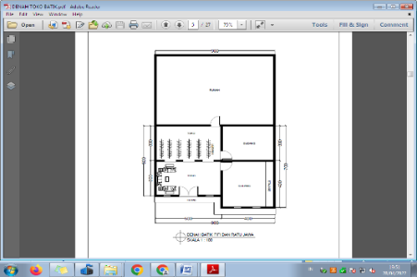 | 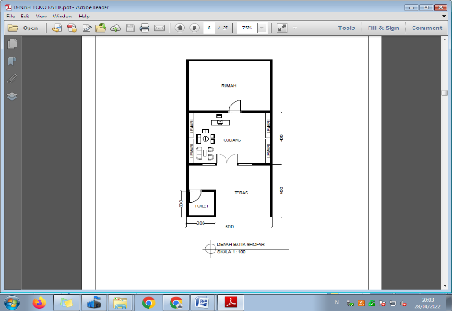 | 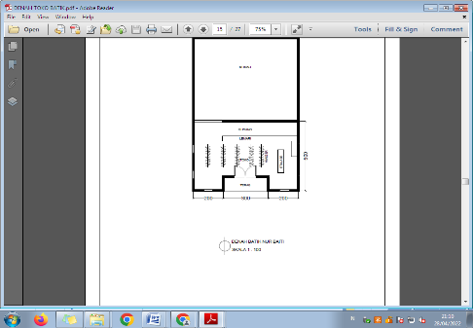 | 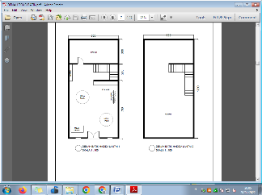 | 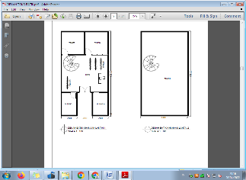
Balanced type | Batik Kuntul Mas  (A) | Batik Madhu Bronto  (B) | Batik Noez  (C) | Mr. Muhammad  (D) | Batik tiga negri  (E)
3 | 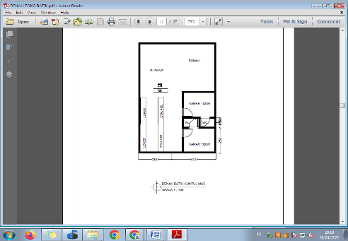 | 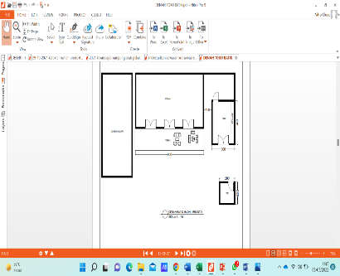 | 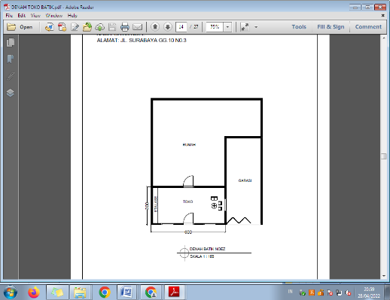 | 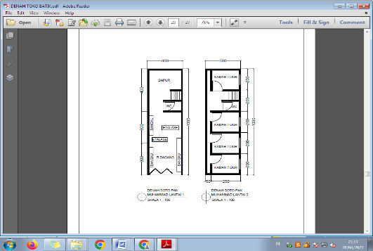 | 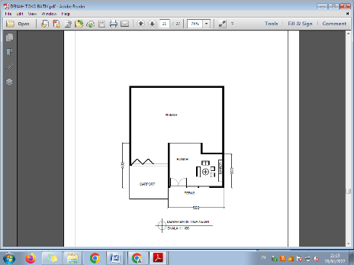
3 | Poen Shop  (F) | Rumman Shop  (G) | Batik Ella  (H) | Yaman Shop  (I)
3 | 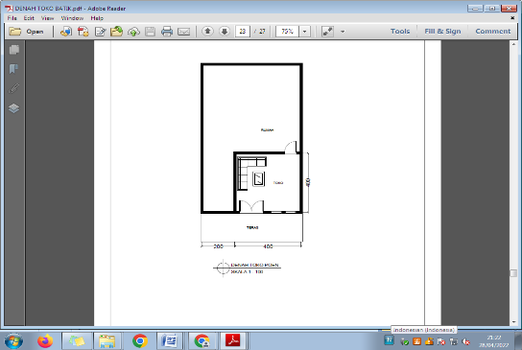 | 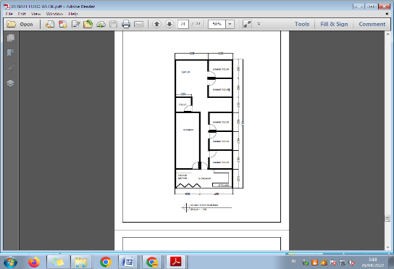 | 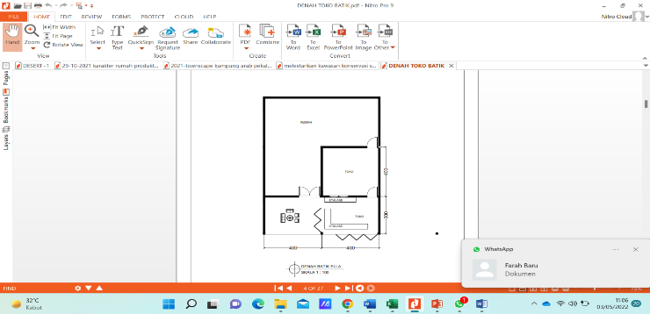 | 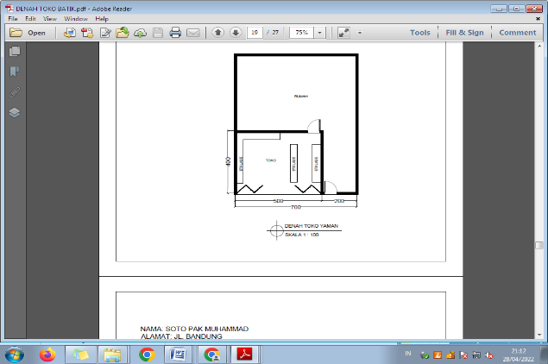
Source: Researcher, 2022

Table 2.
Parameters of hijab Physical and Non physical

Parameter | Physical Hijab Code
Wall | a
Door | b
Furniture | c
Material | d
Zoning | e
Transition Room | f
Height Difference | g
Semi-permanent curtains/ walls | h
Mark | i
Space Orientation | j
Side Door | k
 | Non-physical Hijab Code
Space Arrangement | l
Distance | m
Code/ Body Language | n
Source: Summaries from various literatures

Table 3.
Analyzation the type of space with the type of Hijab used

No | Type | Physical Hijab | Non-Physical Hijab | Space Adaptation
1 | 1 - A | Location of Place  a, b, e, f, k | Time, l | Living room and warehouse in a couple house
2 | 1 - B | Location of Place  a, b, e, f | Time, l, m, n | Residential home
3 | 1 - C | Location of Place  a, b, e, f | Time, l, m, n | Residential home
4 | 1 - D | Location of Place  a, b, e, f | Time, l, m, n | Residential home
5 | 2 - A | a, b, e | Time, m, n | Guest room, bedroom
6 | 2 - B | a, b, e | Time, m, n | Guest room
7 | 2 - C | a, e | Time, m, n | Terrace, Guest room
8 | 2 - D | a, b, e, g | Time, m, n | Guest room and living room
9 | 2 - E | a, b, e, g | Time, m, n | Guest room, living room and bedroom
10 | 3 - A | c, e, | Time, l, n | Guest Room
11 | 3 - B | a, k | Time, l | Garage and Bedroom
12 | 3 - C | a, b, k | Time, l, n | Guest room
13 | 3 - D | a, g | Time, m,,n, l | Guest room and living room
14 | 3 - E | b, e , k | Time, l, n | Guest room
15 | 3 - F | a,b | Time, n | Guest room
16 | 3 - G | a,b | Time, n | Terrace
17 | 3 - H | h | Time, n | Partial Terrace
18 | 3 - I | h, c, e | Time, l, n | Terrace
Source: Researcher’s Analysis

