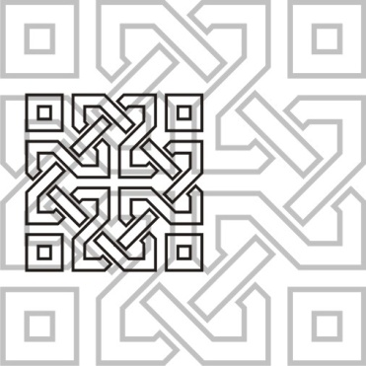 | JOURNAL OF ISLAMIC ARCHITECTURE  P-ISSN: 2086-2636 E-ISSN: 2356-4644  Journal Home Page: http://ejournal.uin-malang.ac.id/index.php/JIA
WOODCARVING PANELS IN JOHOR TRADITIONAL MALAY HOUSES
INFLUENCED BY THE ISLAMIC PRINCIPLE
| Received May 16th 2016 | Accepted June 17th 2016 | Available online June 30th 2016 |
| DOI http://dx.doi.org/10.18860/jia.v4i1.3466 |

Author1 (Square721 BT 8 Bold)  The Institution name (Square721BT 7)  City, Country  e-mail  Author 2 (Square721 BT 8 Bold)  Department of Architecture  Islamic University of Maulana Malik Ibrahim  Malang, Jawa Timur, Indonesia  journal.islamicarchitecture@gmail.com |  | ABSTRACT  Woodcarving can be influenced by numerous aspects including religions and beliefs which may be comprises with the selections of motifs and also woodcarving panels. In Johor, Malay is one of the major ethnic groups and is considered as the majority of the state’s population which contributes to the significant heritage including architecture. Traditional Malay houses in Johor have instilled woodcarving into some placements of the houses including windows on jerejak panel. The objective of this paper is to identify the typology of woodcarvings panels and the percentage of usage among the panels found in Johor Malay houses in order to identify its influence. 72 Johor traditional Malay houses with distinctive woodcarvings were selected to do inventory, photographed and analyzed. Interviews were conducted while the samples taken were discussed and verified by woodcarving experts. Results shown five-piece panels take the highest percentage while six-piece panels come in second of the overall statistic where it is concluded that the Pillars of Islam / Rukun Islam and Pillars of Faith / Rukun Iman have been the influence to the findings. The findings show Islamic religion is the biggest influence that contributes to the justification of the choice. It is hoped that this study can bring recognition to Johor woodcarvings, contribute valuable guides for woodcarvers to apply these panel typologies into their future works to sustain and cherish the Johor houses woodcarving identity.  KEYWORDS:  Wood Carving, Malay Woodcarving, Malay Woodcarving Panel, Johor Traditional House.

INTRODUCTION
Johor is one of the states in Malaysia that also possess various ethnic, having cultural diversity and rich with traditional heritage. Malay is one of the main ethnic groups and is considered as the majority of Johor population which contributes to the significant heritage including art, decoration and even architecture. Woodcarving is an intricate Malay heritage and is the symbol of Malay art that was intended to provide convenience and enhance the art of Malay culture [1].
Johor traditional Malay houses are commonly decorated with woodcarvings that have beautiful motifs, placements and design composition according to their affordability. These woodcarvings should be perceived, appreciated and preserved. Unfortunately, vast urbanisation has actually created such a huge impact where the old houses were being renovated using modern elements and components due to the rapid development of architectural style and recent technology to keep up with the current trend [2][3][4]. Hence, it is important to conduct research on woodcarvings found in the traditional Malay houses.

Issues and Problem Statement
One of the biggest issues that create a challenge in preserving this Malay heritage in Johor is about the abandonment of traditional houses that comes with woodcarving. It is such a waste to see our heritage of woodcarving being destroyed unappreciated and undocumented. More and more traditional Malay houses are being demolished day by day which eventually will make it harder to dig in the historical value from it. Study on motifs has been done and study on woodcarving panel is equally important as the motif. This is because there is more than one type of panels found that may become as typology on woodcarving panels for Johor traditional Malays houses. These typologies are important to be revealed, coded and documented to prevent the loss of Johor identity.
From the motif’s study done in previous research paper, the findings were articulated that the selection of motifs in Johor traditional Malay houses is strongly influenced by the Islamic belief. Apart from motifs, the urge to know whether Islamic belief has also influenced the selection of woodcarving panels design composition in Johor traditional Malay houses as what it did on motifs is significantly desired. Malay woodcarving is an art of having the cultural and belief value where the selections of motif as well as the panel design compositions are associated with the period of carving whether it falls under which era or religion, apart from the status of ownership and skills of craftsmen [5].
The issue on identity crisis as well as the influence occurred because through interviews, it was found that Johor woodcarvers Johor woodcarvers has not made any detailed study related to woodcarving motifs on Johor traditional houses that have existed for more than 100 years [6].

Methodology
The research employed a case study design and the data collection methods involved field study and interviews. The research started with obtaining information about the traditional Malay houses that can be found throughout Johor. Site visits and inventory were conducted to 110 traditional Malay Johor houses and from there, 72 houses were then selected for the case study in which the houses and woodcarvings were examined, observed, photographed and documented.
These 72 Johor traditional Malay houses were chosen based on their age and having woodcarvings at window railing / jerejak tingkap placement. The houses must be aged more than 50 years old. The houses were built as early as 1820. The woodcarvings should be authentic and built around the same age of the house and not a reproduction or additional built during renovation.
The house residents were interviewed to obtain information related to the year the house and the woodcarvings were built, the influences and functions apart from the details of the house owner, address and captured ample related photographs. Interviews and analytic reviews were also conducted with professionals consisting of the local woodcarvers and woodcarving experts around Muar.
Data gathered from the site visits were then analysed with narration and interpretation from these prominent local woodcarvers. The data collected and woodcarving panels were analysed and discussed with experts for verification. The timeline table of the houses were done to generate statistical graphs, bar charts and pie charts to get a typical percentage of statistical analysis review.

Research Findings
All 72 Johor traditional houses possessed interesting woodcarvings. Analysis, findings and interpretations on the results are as follows:

Analysis of Findings on Woodcarving Panels
Based on the investigation on all case study houses revealed that there are seven different type of panels composition. These seven compositions can be recognized as the typology of woodcarving panels in Johor traditional Malay houses. Gathering typologies are important because it can be useful evidence which is an approach to increase the practical value of intervention research. Having typologies also can be the reference for the recent or event future woodcarvers to follow and sustain the existing heritage so that it would not disappear [7].
All 72 case study houses were chosen in respect of having the woodcarvings on their window railings according to the analysis of site inventory seven different types of panels were found.
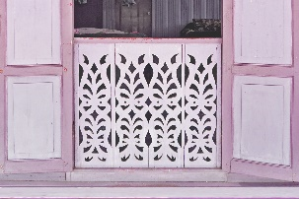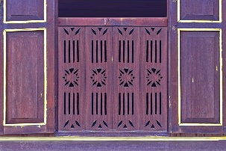
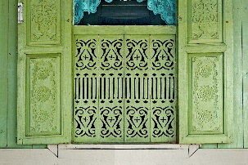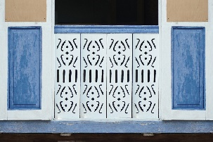
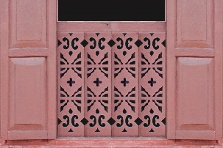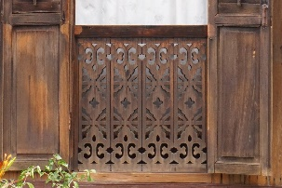
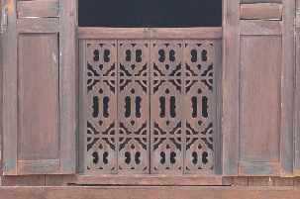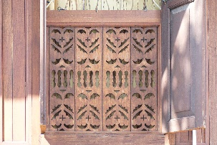
Figure 1. Total of 8 houses have four-piece panels on their window railing / jerejak tingkap.

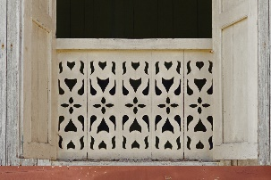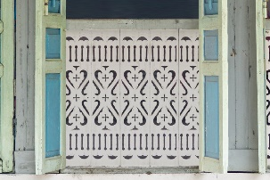
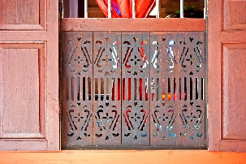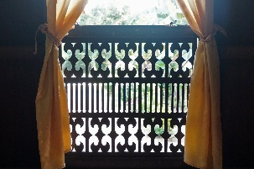
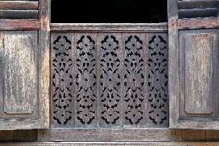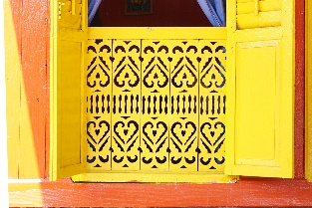
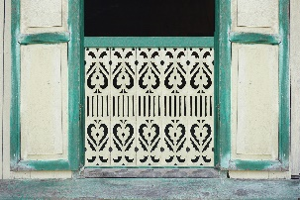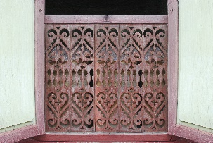
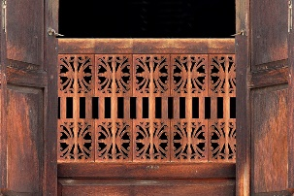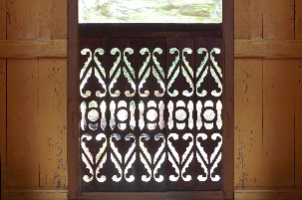
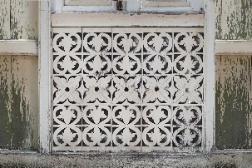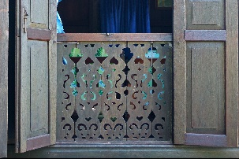
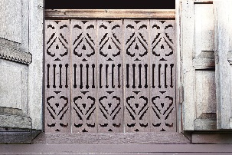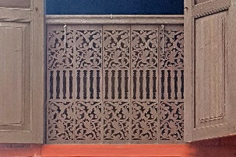
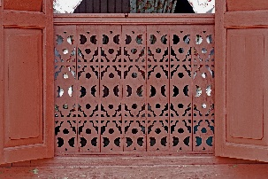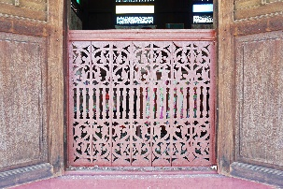
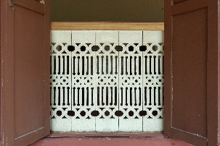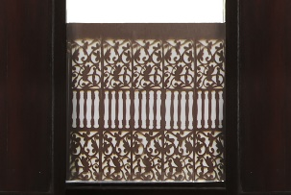
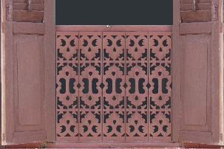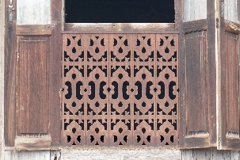
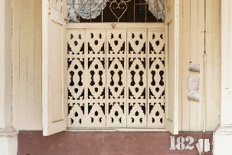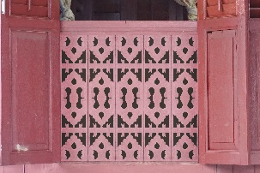
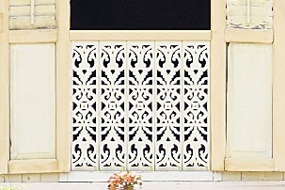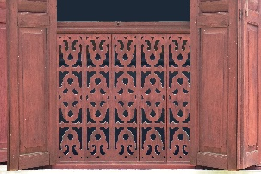
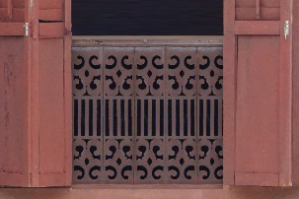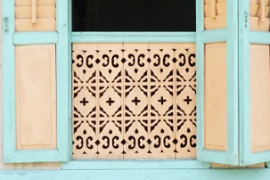
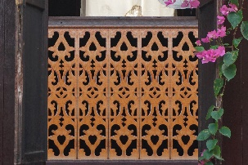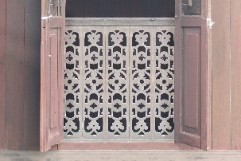
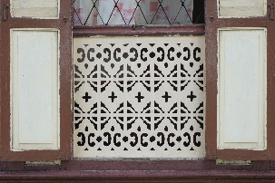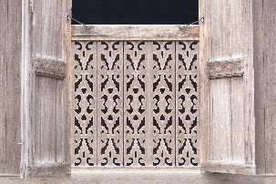
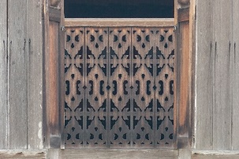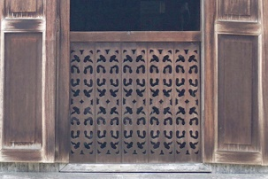
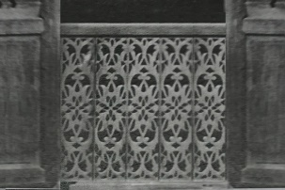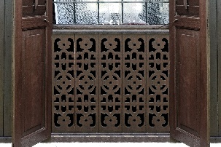
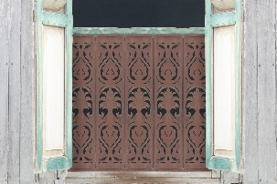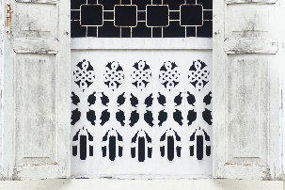
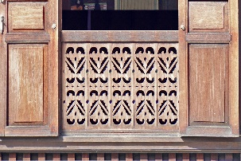
Figure 2. Total of 37 houses have five-piece panels on their window railing / jerejak tingkap.

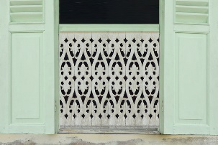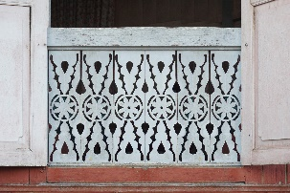
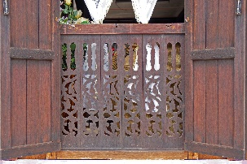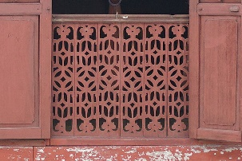
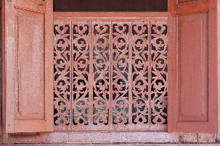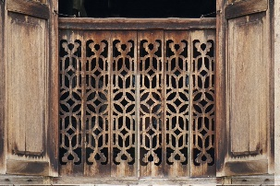
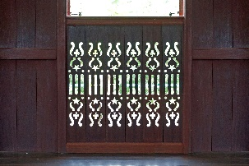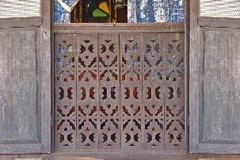
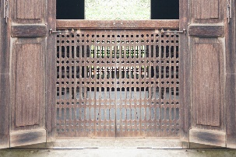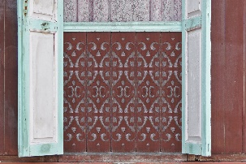
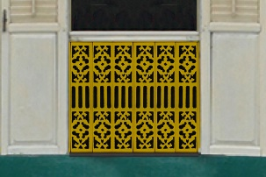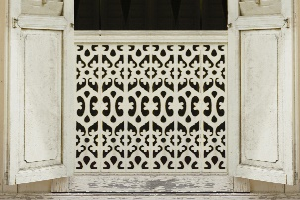
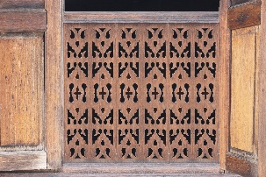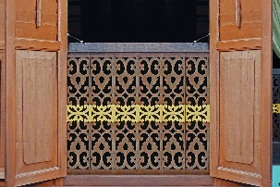
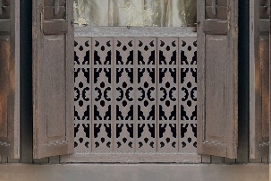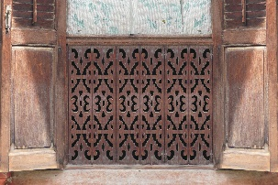
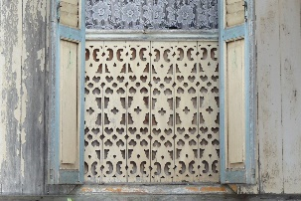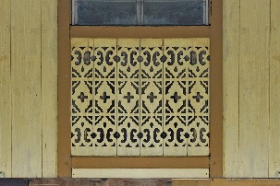
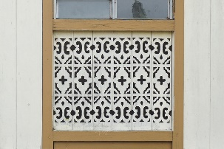
Figure 3. Total of 19 houses have six-piece panels on their window railing / jerejak tingkap.

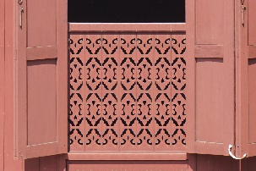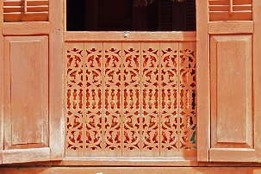
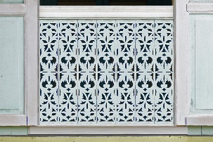
Figure 4. Total of 3 houses have seven-piece panels on their window railing / jerejak tingkap.

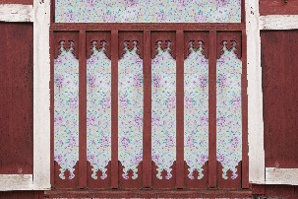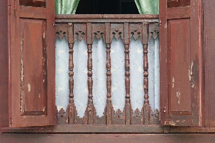
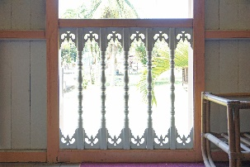
Figure 5. Total of 3 houses have six-piece panels with 5 columns on their window railing / jerejak tingkap.

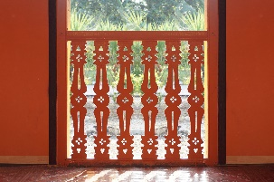
Figure 5. Total of 1 house have six-piece panels of column on their window railing / jerejak tingkap.

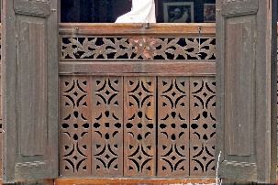
Figure 6. Total of 1 house have five-piece panels with horizontal panel on their window railing / jerejak tingkap.

Figure 1-6 above shown all 72 window railings / jerejak tingkap from 72 case study houses in which have been categorized under 7 different typologies. These 7 typologies were drawn, coded and analyzed the percentage of usage. The drawings and codes are listed as below:
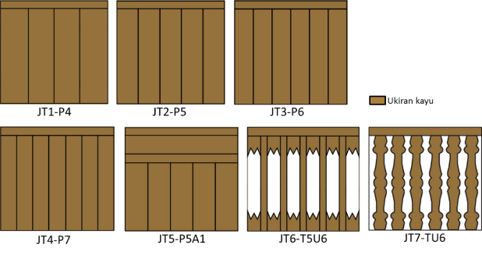

Figure 7. Seven typologies of the woodcarving panel design compositions found on the window railing / jerejak tingkap in the case study houses.

Figure 7 above shown a set of typologies consisting of seven different panel design compositions that have been found on the window railing / jerejak tingkap in 72 case study houses. All seven typologies are drawn and coded for identification purposes and also for further analysis on the percentage of usage.

Figure 8. Pie chart showing seven typologies and the percentage of each existence within the 72 case study houses.

Referring to the pie chart on figure 8 above, percentage for woodcarving panel typologies found in the case study showed the highest is five-piece panels that is being coded as JT2-P5. This JT2-P5 was found to dominate the percentage with 52% followed by six-piece panels coded as JT3-P6 with 27% compared to other panel typologies.
Similar to the choice of motifs that had been discussed in earlier paper, the choice of panels is also believe to be influenced by religious and faith on Islam. This is because the earliest year of woodcarving in Johor was 1800 which was after the arrival of Islam.
According to analysis, five-piece panels are found in 37 houses out of 72 in total which contributes as the highest percentage of 52%. The second highest is six-piece panels found in 19 houses which carries the percentage of 27%. Both five-piece and six-piece panels were discussed with woodcarving experts and the numbers five and six are found to be related to the Islamic belief. Five is the numbers of the Pillars of Islam / Rukun Islam while six is the numbers of the Pillars of Faith / Rukun Iman. Due to these facts, it can be summarized here that the choice of panels used are due to the relationship with the religious belief which is Islam.
It can be articulated here that the selection of panels in Johor traditional Malay houses is strongly influenced by the Islamic belief as the construction of houses and all carvings are upon the arrival of Islam to Johor. All 72 houses were built after the arrival of Islam to Johor where after Islam arrived in the early of 14th century.
Apart from the urged to know where the influence came from, the research also desired to reveal the typologies. Aside from the five-piece panels and six-piece panels, the are five other typologies of the panel design composition. The least / most minimum panels used that has been found is four-piece-panel and is coded as JT1-p4 while the maximum panels used that has been found is seven-piece panels and is coded as JT4-P7. JT1-P4 are found in 8 houses out of 72 while JT74-P7 are found in 3 houses. However, the mostly used is five-piece panels, coded as JT2-P5 found in 37 houses and six-piece panels as JT3-p6 found in 19 houses. All these four typologies of panel design compositions are designed in vertical manner as in align arrangement among the panels. They are drawn and shown in Figure 9-12 below.

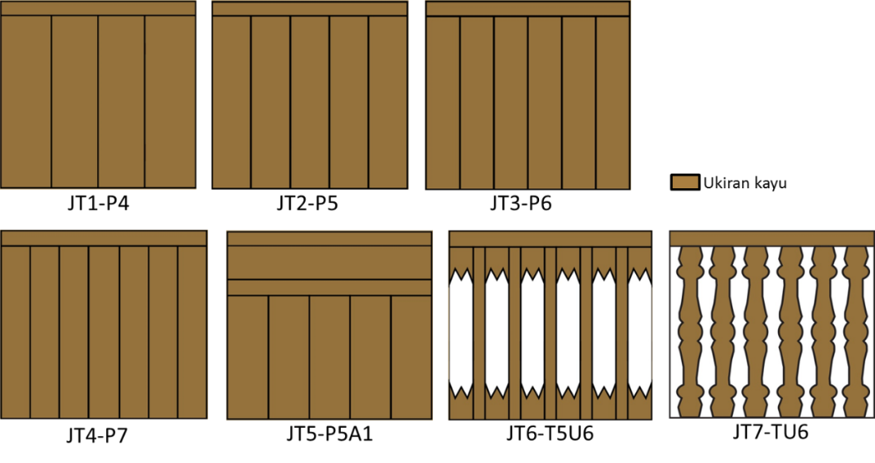
Figure 9. Typology code JT1-P4 of four-piece panels which are found in 8 houses (11%).

Figure 10. Typology code JT2-P5 of five-piece panels which are found in 37 houses (52%).

Figure 11. Typology code JT3-P6 of six-piece panels which are found in 19 houses (27%).

Figure 12. Typology code JT4-P7 of seven-piece panels which are found in 3 houses (4%).

The other three typologies of panel design compositions are slightly varied from the previous four, where one of them has horizontal panels on top of the five-piece vertical panels. This particular typology is coded as JT5-P5A1 found only in 1 house. The typology is drawn and shown in Figure 13 below.

Figure 13. Typology code JT5-P5A1 of five-piece vertical panels with horizontal panels on top which are found in 1 house (1%).
While other two typologies of panel design compositions are designed with more hollow parts than solid panels and they are coded as JT6-T5U6 which are found in 3 houses while JT7-TU6 in only 1 house.
Both typologies are drawn, JT6-T5U6 is shown in Figure 14 while JT7-TU6 is shown in Figure 15.

Figure 14. Typology code JT6-T5U6 of six-piece hollow panels with 5 vertical panels which are found in 3 houses (4%).

Figure 15. Typology code JT7-TU6 of six-piece shaped panels which are found in 1 house (1%).

All seven typologies that have been identified, analyzed, drawn and coded were then being discussed and interpreted with the assist of local woodcarvers.

Research Interpretation on five-piece panels
The finding of five-piece panels as the most found which is 52% can be formulated that it is the most chosen typology among all.
The local woodcarvers as well as the house owners stated that the influence of Johor carving is from Islamic belief that was brought by the traders [8][9]. Hence, religious knowledge becomes a grip in the application of motif and other compositions as it is demanded in daily life.
Since the five-piece panels that is being coded as JT2-P5 is the most favorable woodcarving panel typology in Johor traditional Malay houses, it can be suggested to be the identity of design composition for window railing / jerejak tingkap in Johor.

Research Interpretation on motifs of the panels
Apart from the typologies of panel design compositions, category of motifs was also been identified for all 72 case study houses as below. However, the detail interpretation on each motif found have been done in previous research while this category of motifs is to find the influence.

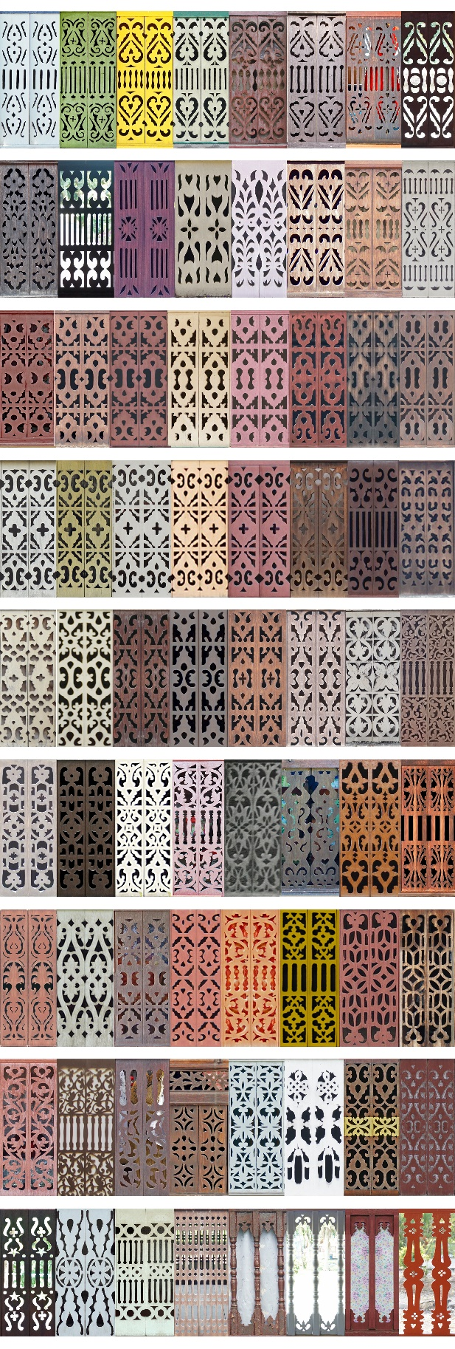
Figure 16. All 72 woodcarving panels from 72 case study houses that falls under the category of floral and abstract motifs.

From the discussions and interpretations with the home owners and local woodcarvers, the findings revealed that Islamic influence has a big influence towards the decision making on the selection of motifs. This can be seen through the motif’s category used in the woodcarvings of the case study houses. Floral motif and geometrical motifs dominated the selections in all case study houses. Even though the evolutions of woodcarvings in Malaysia are being influenced by the adaptations of different religions, however, in the state of Johor, most of the woodcarvings started late not like those in Kelantan and Terengganu. In Malaysia, a series of influences started with Hinduism where most woodcarvings before the 14th Century were depicted by Hindu motifs and followed by the arrival of Langkasuka motifs and from there evolved and transformed to Buddhism motifs after the arrival of Chinese. It was then influence also by the colonial motifs when the westerners came and finally changed to ‘Malay motif’ derived from the Islamic strong influence [10][11]. These influences vary within each state, and the arrival of different religions transported different movements of people from other parts in the world to Malaysia and to each state [12].
According to the analysis of site inventory and triangulated with the historical facts and interviews, floral and geometrical motifs dominated the selection of carvings in all houses because the houses in Johor were built after the arrival of Islam to the region where after Islam arrived in the early of 14th century, the motifs preferences has changed from mythical or mystical or animism motifs to floral and geometrical motifs in line with Islamic influences. There are also no human or animal motifs found in any of the 72 samples proving that it is align with religious rules where Islam forbids portraying human or animal figurine inside buildings [13][14]. Religion has always had a big impact on society and lifestyle of the community. Therefore, religion undoubtedly influences the culture, civilization and beliefs system of the community including in determine the motifs as it did to the panel design compositions. Woodcarving is aforesaid to have various types of design elements containing embedded values of principles, supremacy, hierarchy, religiousness and versatility of its owners [15]. Due to that, it is not surprise that Islamic faith and value influenced the woodcarving as Islam is the religion of all the home owners of the case study houses.
CONCLUSION
The findings revealed that Islamic influence has major contributions towards the decision making on the selection of woodcarving panels in Johor traditional Malay houses as what it did in the selection of motifs. This can be seen through the typology of woodcarving panels design compositions used in the 72 case study houses. Five-piece panels coded as JT2-P5 dominated the percentage statistic.
According to analysis, five-piece panels are found in 37 houses out of 72 in total which contributes as the highest percentage of 52%. The second highest is six-piece panels found in 19 houses which carries the percentage of 27%. Both five-piece and six-piece panels were discussed with woodcarving experts and the numbers five and six are found to be related to the Islamic belief. Five is the numbers of the Pillars of Islam / Rukun Islam while six is the numbers of the Pillars of Faith / Rukun Iman. All 72 panels are carved with either floral or geometrical motifs or in combination of both. Due to these facts, it can be summarized here that the choice of panels and motifs used are due to the relationship with the religious belief which is Islam.
Conferring to the analysis of site inventory and triangulated with the historical facts and interviews, it can be articulated here that the selection of panels in Johor traditional Malay houses is strongly influenced by the Islamic belief as the construction of houses and all carvings are upon the arrival of Islam to Johor. All 72 houses were built after the arrival of Islam to Johor where after Islam arrived in the early of 14th century.
Religion has always had a big impact on society and lifestyle of the community. Therefore, religion undoubtedly influences the culture, civilization and beliefs system of the community including in determine the panel design compositions and also motifs.
It can be articulated here that the woodcarving panels in Johor traditional Malay houses is strongly influenced by the Islamic belief as the construction of houses and all carvings are upon the arrival of Islam to Johor. These findings are really significant to the local architectural heritage of Johor architecture as it portrays the unity of the local people since 1820. It is hoped that the findings will help to acknowledge Johor woodcarving unique identity, to be used for future generations.
In addition, the drawings of all seven typologies have been drawn and coded which could also provide valuable guides for woodcarvers to apply these panel design composition typologies into their future works to sustain and cherish the Johor identity. Therefore, the local identity and the authentic value of the local heritage can be preserved.

ACKNOWLEDGEMENT
This publication was supported by Award Number H751 of the Tier 1 grant from Universiti Tun Hussein Onn Malaysia.

REFERENCES
- Jenkins, W., “Keeping the Traditions of Malay Woodcarving Alive: The mission of Akademi Nik Rashiddin,” In Zawiyah Baba. (Ed.) Warisan Seni Ukir Kayu Melayu. ATMA, Universiti Kebangsaan Malaysia, pp. 59-66, 2010.
- Kamarudin, Zumahiran and Said, Ismail, “Placement of Carved Components in Traditional Timber Houses of Kelantan and Terengganu,” Warisan Seni Ukir Kayu Melayu, pp. 129–142, 2010.
- Kamarudin, Zumahiran and Said, Ismail, “Carving Motifs in Timber Houses of Kelantan and Terengganu: Sustaining Malay Architecture Identity,” Conference on Technology & Sustainability in the Built Environment, pp. 235–256, 2010.
- Mohamad Tajuddin Mohamad Rasdi, “The Discontinued Traditions of Malay Wood Carvings in Modern and Post-Modern Architecture in Malaysia,” Jurnal Alam Bina, Universiti Teknologi Malaysia, Jilid 8, No.2, 2006.
- Shaffee, N., & Said, I., “Types of Floral Motifs and Patterns of Malay Woodcarving in Kelantan and Terengganu,” Procedia - Social and Behavioral Sciences, 105, pp. 466–475, 2013.
- Yusof, H., Wahab, I.A., Utaberta, N., Sabil, A., “Islamic Influence on Woodcarving Motifs in Johor Traditional Malay House” Journal of Islamic Architecture, 6(4), pp. 313-320, 2021.
- Yusof, H., Ibrahim, F.K., Shahminan, R.N.R. (2020). Heritage Identity Conservation of the Woodcarving Placement and Design Composition Typologies on Johor Malay Houses: Planning Malaysia, 2020, 18(2), pp. 12–23.
- Abu Bakar Yatim, “Personal Communication,” Tanjung Gading, Muar, Johor, 2015.
- Tuzelan Ahmad, “Personal Communication,” Galeri Perusahaan Zalikraf, Muar, Johor, 2017.
- Kraftangan Malaysia, “Ukiran Kayu Warisan Melayu,” Kuala Lumpur Perbadanan Kemajuan Kraf Tangan Malaysia, 2009.
- Said, Ismail, & Abdullah, Ahmad Saifuddin, “Species-species Kayu dalam Seni Ukiran Melayu Johor,” Universiti Teknologi Malaysia, 2001.
- Abidin, Nurdiyana & Raja Shahminan, Raja Nafida & Ibrahim, Fawazul, “Influences on Woodcarvings of Negeri Sembilan Traditional Malay Houses,” OS03: Architecture, Urban Planning and Design, 2014.
- Norhaiza Noordin, “Ukiran Kayu Warisan Melayu,” Perbadanan Kemajuan Kraftangan Malaysia. Mantera Communication Sdn. Bhd., 2009.
- Zulkifli Hanafi, “Seni Bina Melayu. Dalam: Nuansa Ukiran Kayu Melayu” Akademi Pengajian Melayu, Universiti Malaya, pp. 17-29, 2015.
- Azmin, Aida Kesuma and Abdullah, Fadzidah and Sanusi, Aliyah Nur Zafirah and Yusof, Zeenat Begam and Asif, Nayeem “Sustainability of Malay Wood Craftsmanship Symbolism in Deciphering Malaysia’s Architectural Identity,” Proceedings of DARCH 2021 1st International Conference on Architecture & Design, 12-13 July, 2021.

