 | JOURNAL OF ISLAMIC ARCHITECTURE  P-ISSN: 2086-2636 E-ISSN: 2356-4644  Journal Home Page: http://ejournal.uin-malang.ac.id/index.php/JIA

VERNACULAR MORPHOLOGY BASED REVITALIZATION IN THE CONTEXT OF ISLAMIC SUSTAINABILITY

Case study: Kampung Adat(customary) Mahmud, Bandung District, West Java

| Received May 16th 2016 | Accepted June 17th 2016 | Available online June 30th 2016 |
| DOI http://dx.doi.org/10.18860/jia.v4i1.3466 |

Marcus Gartiwa  Deaprtment of Architecture, Langlangbuana University,Bandung,Jawa Barat, Indonesia  mgartiwa@yahoo.com  Dede Siti Rosimah  Department of civil engineering, Langlangbuana University,Bandung,Jawa barat, Indonesia  dsrohmah@gmail.com |  | ABSTRACT  The change of urban area is natural process caused by urban development, caused by contemporary demands. On the contrary, there is local community’s effort, such as Kampung Adat (customary kampong) to keep maintaining the area as traditional kampong. Therefore, there is a need to revitalize the area which compromise to traditional culture aspects. Revitalization is an upgrading condition in adaptation to contemporary demands. Meanwhile vernacular wisdom has holistic approach in ordering built enviroment, especially morphology, which local oriented, respect to the harmony of human’s socio-culture, built and environment. Kampung Adat Mahmud in Bandung District, West Java, which refers to Eyang Mahmud as Bandung’s outstanding ulama (scholar), has been revitalized in the spirit of Islamic’s sustainability. Such spirit unite contemporary development and Islamic heritage, is useful to be studied. Therefore. The aim of the research is to get better understanding how vernacular community could implement revitalization in the context Islamic sustainability. The methodology research is qualitative descriptive, which based on observation, which in turn the fulfillment of upgrading condition in level of kampong, neighbourhood, and building. Respectfull to the nature environment, vernacular character, and accommodate contemporary socio-economy activities.  Key words: revitalization, vernacular morphology,Islamic sustainability

INTRODUCTION
Population growth and vegetation area decrease leading to global famine, which the significant effecting on ozone depletion in the atmosphere. Such current environmental issues, especially in urban context, have been examined in evidence to crucial process of environment degradation, especially caused by the growth of urban built development. Recently the way of thinking has taken place in urban area, as an emphasis of the vernacularism morphology, which based on the ecology approach. Such approach in the name of sustainability, has been taken place in revitalization of customary kampong, such as kampong Mahmud, as Muslim heritage place, in urban area of Bandung district. Therefore it is important to understand such revitalization which based on vernacular morphology principles, with its implications to the urban’s future, which cannot be separated from locality and community participation. The result is built environment which local oriented: materials, structural systems, humble, which guided by their ecological wisdom. The word morphology stems from the Greek word morphos, meaning form. Morphology is the branch of biology which deals with the form, structure of animals, plants[11]. Morphology in architecture is the study of form and structure of the space and built environment, such as the plan and builds of habitat, viewed in terms of its origin, growth and function[15] Morphology of kampong is a reflection of its function, the ideas of planning and building, and development. Therefore revitalization of vernacular morphology deals with the process of stand, rise and open of building in the environment [12] [13] [14]. Sustainability becomes a central issue in the context of the development of this century [5], a trend in accord with the global warming issue. The sustainable architecture is promoted to reduce the global warming. Current population increase with narrows green space, is used to meet the housing needs [7], drive the implementation such sustainable. The sustainable architecture has some branches such as ecological architecture, the environment friendly architecture, efficient-energy architecture, bioclimatic architecture, and green architecture[6], which have main aim for better maintaining the nature preservation.
The Qor’an, the Holy Book of Islam, as guidelines for Muslem has explicitly taught the sustainability. In that context, built environment has been developed by human being to fulfill human need, therefore built environment which has close relation to human culture. Such sustainability refer to three main indicators, which are functional (Hasan), good (Thoyib) and aesthetic (Jamil) [10]. Such important values are meaningfull to architecture users. Functional (Hasan) means that it promote purpose of human being to be caliph in the earth. Such implementation is good moral, therefore the built environment should facilitate humans for conducting usefull acitifities. The meaning of Thoyib is that built environment should be rahmatan lil Alamin or a mercy to the world. As in Surah Al Anbiya 107: " And We have not sent you, [O Muhammad], except as a mercy to the worlds." Therefore[15], built environment should be universal, rational, caring, and shaping civilization. The meaning of aesthetic (Jamil) is explained that the built environment should be able to explore built environment elements to produce beautiful work. Yet the aesthetic elements must require Islamic values, which in accordance with its principles. Aesthetic elements must not support the activities of shirk, harming other people, animals and nature, as well as excessiveness which can bring someone to the vanity.
Vernacular built environment such as Indonesian vernacular built environment cannot be separated from locality, especially nature environment. The result is built environment which uses local materials, traditional structural systems, humble, the result of human tradition by trial and error, close to their culture and norm[2]. Forms of vernacular morphology are built to meet specific needs accommodating the values, economies and ways of life [9]. The owner is usually an active participant of the building process [11]. Therefore vernacular morphology have sustainable concepts, such as built environment respect to their environment, accepted by their community, and the building is affordable [3]. Local wisdom of vernacular morphology is stressing universal values, such as ecological wisdom[4]. In that sense, it is a must to have a meek attitude to learn from the ecology wisdom of vernacular architecture, such symbolic, ritual, ethic, realization. The essence of ecology wisdom of customary villages (Kampong Adat) is sustainable architecture, implements technologies which respect environmental sustainability, include: 1) the relationship between living organisms and their environment, 2) Culture such as the ideas, beliefs, customs, skills, arts, etc, 3) technology as the science or study of the practical for handling a specific technical problem. At its highest level, sustainability involves the mediation between ecology and technology, relies on culturally appropriate attitudes. Built environment are treated as a cultural resource, legacy for future generations to come. Therefore revitalization of vernacular morphology in the context of Islamic sustainability, especially nature environment, and socio-cultural aspect must be explored.

THE RESEARCH METHODOLOGY

The methology research is qualitative descriptive, which based on observation. The observation is conducted in three levels, such as; kampong, neighbourhood, and building. The Morphology is evaluated in three scales; kampong, neighbourhood, and building. Morphology kampong is evaluated by evaluation of zone of function, neighbourhood is evaluated by connectivity building which correlates to public space. Finally, building is evaluated by social function of the occupant. The result is overall evaluation of revitalization of vernacular morphology of kampong Mahmud, in the context of Islamic socio-culture sustainability.
DISCUSSION

Urbanization and modernization processes have driven urban-kampong area growing up rapidly. It has caused a nudge among urban modernity and village traditional especially at fringe area. The evidence development tend to replace rural as a settlement physical, which characterized as social- communal forms. Such tendencies at urban transition area and rural at the present, has shown urban modernity to be losing of rural-vernacular character. Fringe area which has agrarian characteristics with its surrounding farming land, also vernacular character, then experience as nudging area which caused by urban development. Such character is an gradual effect of urban kampong transformation [8]. Urban-kampong revitalization in Kampung Adat Mahmud refer to model of Islamic sustainability, which consider principles of functional (Hasan), good (Thoyib) and aesthetic (Jamil) [10]. Therefore such revitalization is a controlled-transformation, which can be achieved by accommodating space as function of social- culture need, in the term of vernacular’s based revitalization. The function of revitalization is accommodating preservation of nature environment and Social-culture and economy in three levels, such as : a) Kampong, b) Neghbourhood, c) Building.
Functional
(Hasan)

Aesthetic
(Jamil)
Good
(Thoyib)

Figure 1 Diagram of Islamic sustainability model

Kampong Morphology

Implementation of vernacular’s revitalization which consider principles of functional (Hasan), good (Thoyib) and aesthetic (Jamil) in level of Mahmud Kampong,Bandung City,West Java,Indonesia[figure 1], can be seen in normalization of Citarum river, as main aspect of Kampong morphology’s revitalization. Citarum river’s normalization has become a significant infrastructure which revitalize the kampong, as a response to environment problem, especially climate, Such as high rainy, flood and high humidity, which often happened in the rainy season at the past.

The location of the kampong is nearby Citarum river. The macro climate is equatorial tropc, which characterized by two season, such as rainy and dry season. The temperature relatively high along the year,especially in dry season. Generally humidity is relatively high, because the rainfall relatively high in the rainy season. Therefore the agriculture-function-character of the location is indicated by nature environment such as agriculture area, as dominant character of the kampong, supporting the kampong as centre Islamic tradition of Bandung city. The contemporary, significant development of Bandung city influence the contemporary development of Mahmud kampong, to be gradually urban kampong. In 1997 the revitalization the kampong is conducted by both region authority and local community in responding to such current development, urban
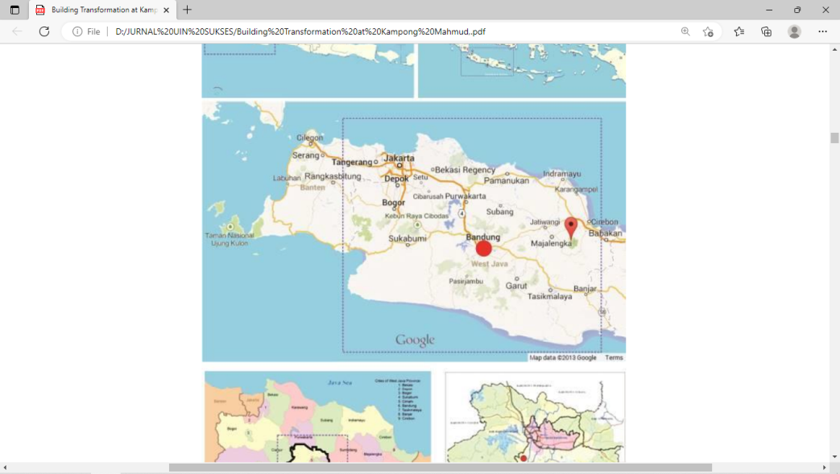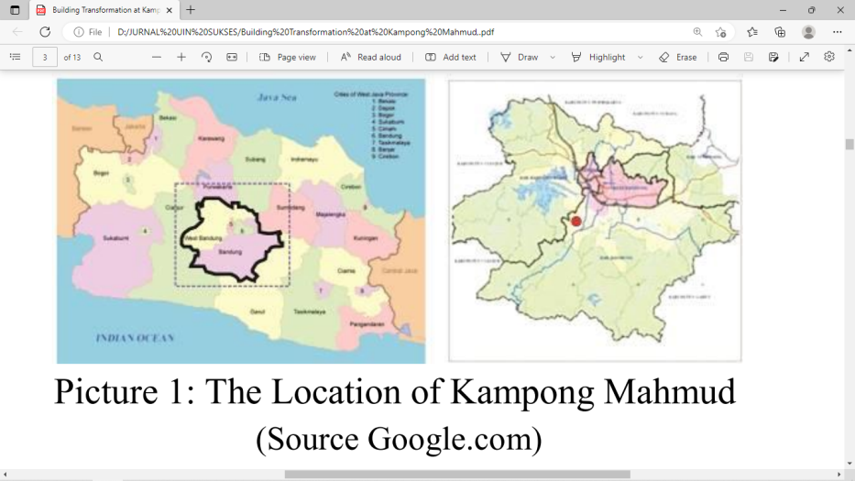

Figure 3 Location of Mahmud Kampong

(source: Google.com)

Such revitalization can be seen in two phases, such as :
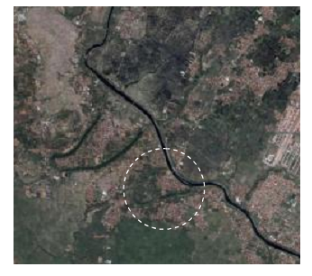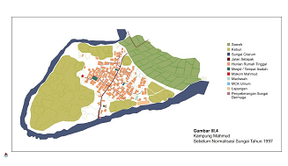1)Kampong morphology before river Normalization. before 1997 the kampong was characterized by the composition of dwellings, agricultural land / plantation and sacre-cemetery of kampong founder. Kampong territory consist of; it has ample rice land boundary on the north, the river on the South, and elements of the funeral on the eastern and western part of the kampong. Residential Units are in the centre of the kampong, which paddy fields in the northern part, the cemetery is in the western part nearby kampong founder and old mosques. Physical distance between buildings can be seen in the area around the old mosque, cemetery. The area around the mosque is also home of the kampong elders. The building occupied by the elders indicate the importance of cemetery and old mosques. Mosque is a religious facility that serves for worship, both locals and visitors from outside the area, who especially intend to do pilgrim. The pilgrim is conducted by Friday prayer and other religious celebrations in the mosque. The mosque is located in the northern part of the village, almost bordered by rice field where the most inhabitants work for daily live (figure 1),

Figure 4 Kampong Mahmud before river normalization
(source: field observation)
2) Kampong morphology after river normalization. There was normalization of Citarum river by local governments in 1997. Such normalization was done in the form of meandering and widening the river, 6-7 times the width of the original. The result of river normalization was the separation of Mahmud kampong into two areas; a) residential centers and funeral homes, b) farmland. After normalization, Mahmud kampong is surrounded by the river Citarum (Fig.3-6). Clear physical boundary changes contained in the northern part of the village, which used to be agricultural areas. Straightening and widening of the river, followed by the construction of the bridge and inspection road along the river banks, reduce the separation of kampong with other kampong, transformed cohesively the kampong morphology in secure area from flood treat, supporting the farmland irigation. Meanwhile,the inhanbitant ‘s farmland still exist, as representation of ecology preservation (figure 2).
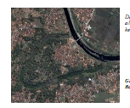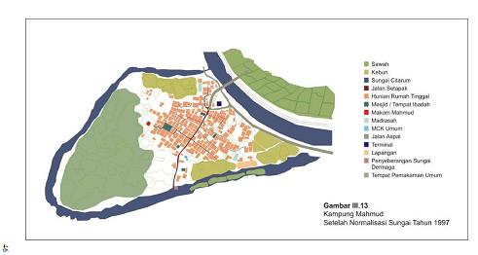

Figure 5 Kampung Mahmud after river normalization
(source: Field observation)

3)Normalization was followed by some steps; a) a road construction for inspectioning river, the street outside the kampong acces into kampong t, b) the development of public - transport terminal at the kamong gate, c) preservation of the raft terminal in the southern part of the kampong,which presereve the river as vernacular infrastructure.
Such development preserverd nature environment which support the farmer activities of most the inhabitant, even open the kamong gradually to accommodate external influences, especially new activities of the kampong inhabitants, such as trader furniture and building component’s home industry which currently recognized by various regions outside the kampong. Finally drive the kampong as a pilgrim place more intensively. The overall revitalizationcan be indicated by such description, such as river normalization has given contribution to sustainsbility socio-culture of the nature environment and agriculture professional of the inhabitant, especially cohesiveness and clearness of kampong morphology; which can be shown by two main function area such as : 1) Dwelling area and public,also the ancestor burial places remain united within the kampong in secure area from flood treat, strengthen the kampong as place for religious pilgrim, 2) farmland such as paddy field area guarantee the ecology of the kampong, the preservation of traditional profession of the most kampong inhabitant as farmer. 3) The existence of local bridges and roads connecting the village with the other regional, has opened opportunities for interaction between the kampong inhabitants with outsider of the kampong, such activity has driven the economy of the kampong more increase, also develop intensively (figure 3).

The element of kampong morphology:
- Paddy field area
- Dwellings area
- Cemetery of kampong founder and kampong inhabitant

Figure 6 Kampong Mahmud :before and after river normalization (source: field observation)
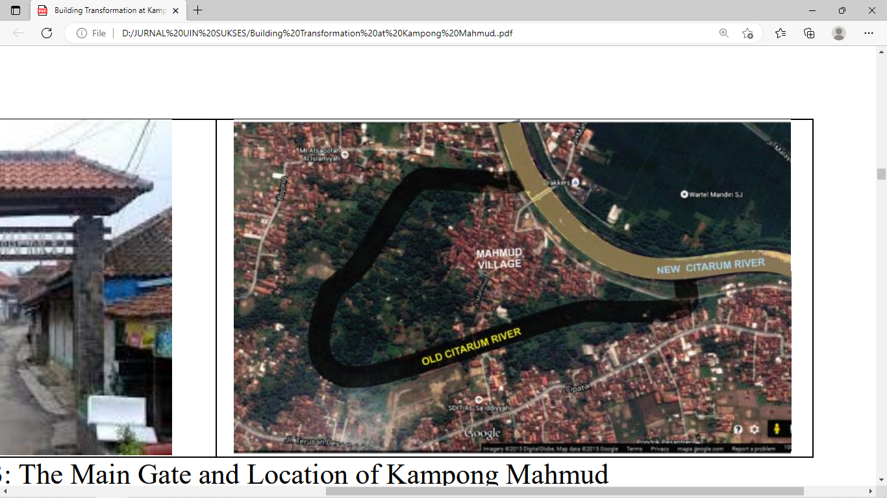
Element of kampong morphology
Paddy field cemetery of ancestor
Plantation area bridge
Citarum river public transportation terminal
Dwellings area
Mosque
Mahmud kampong

Figure 7 Kampong Mahmud : after river normalization
(source: field observation)

The overall result is main road of kampong become significant as generator of Mahmud kampong development, therefore acessibity strengthen. Finally, the kampong become more famous, as a place of religious pilgrim, and centre of wood craftment industry. Pilgrims from all over the area in Bandung and West Java to visit this place on a Friday night every week, and religion events (figure 4).

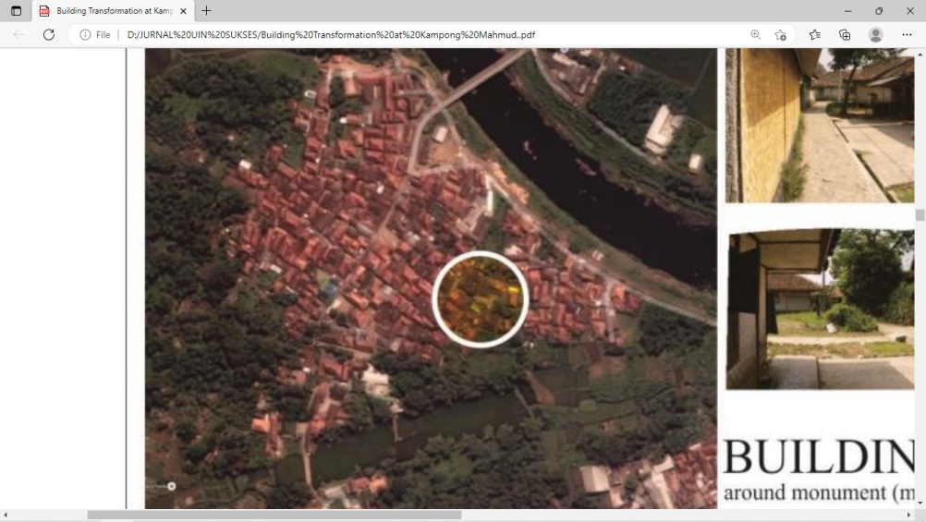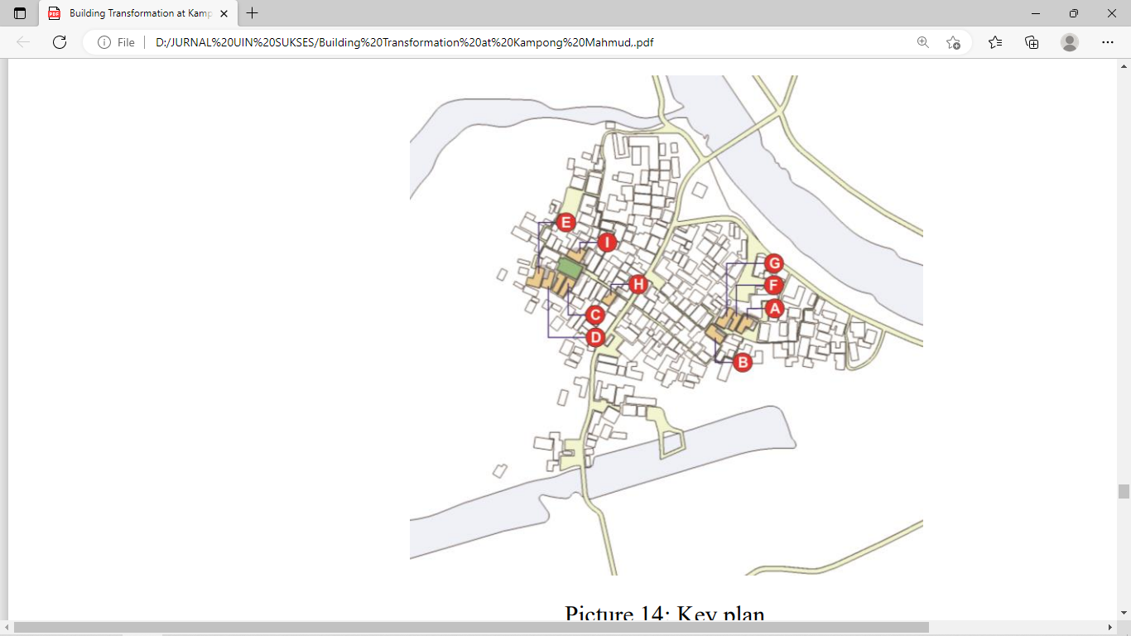

Gate way of the kampong
(modern centre)
Raft dock
(traditional centre)

Figure 8 Kampong development direction
(source: field observation)

The Neighbourhood Morphology

The Neighbourhood Morphology which consider principles of functional (Hasan), good (Thoyib) and aesthetic (Jamil), such as infrastructure, such as road. Some historians have suggested that the quarters of neighbourhood are originally determined by the lines of the principal roads [1] so that the road marks the boundary between adjacent quarters. This condition is in line with the expectations of the proponents of natural neighborhoods. A “weak” version of “natural neighborhoods” anticipates that this condition is not the case, and the road network is to render access from one quarter of the urban.Such condition be overviewed by morphologogy of kampong neuigbourhood. Open land around the dwellings that once has been turned into a garden, home stay. Dwelling house formerly a bamboo wall partially changed permanently brick complete with yard fence, but the customary kampong still preserve the vernacular character. Open space between buildings is used as circulation, also bathroom facility on each side of the house. yard, patio homes began to be replaced by small shop or stall as a place to sell goods, such economic activity changed the previous Mahmud neighborhood. In addition to outdoors comunal spaces, the main circulation that connects the kampong to the entrance gate of pilgrim place became a place to sell. The merchants are the locals, also the traders from outside the kampong, supported by the revitalization street and path as infrastructure (figure 5). Such development has driven new neighbourhood cluster, therefore gradually morphology of kampong wider, because of the increase of the sum of dwellings.

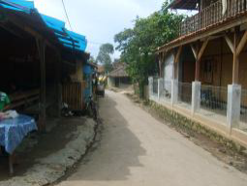
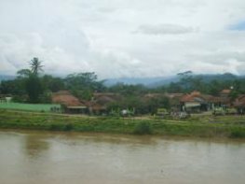

Figure 9 Neighbourhood Infrastructure

(source: Field observation)

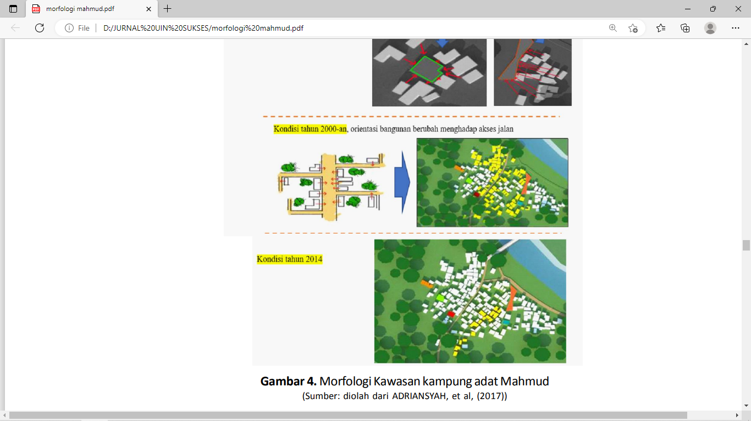

Figure 10 evolution Neighbourhood’s cluster development

(source: Field observation)
Changes in the elements forming the northern part of the kampong has revitalized the physical characteristics of the kampong, also the social identity of the neighbourhood community. Most of the people who have been as farmers have expanded into traders, even furniture craftsmen, lead to the demanding needs of various indoor and outdoo spaces.

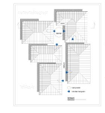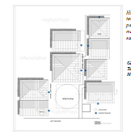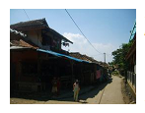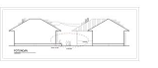

Figure 11 social-interaction and acessibilty in the Neighbourhood’s cluster (source: Field observation)

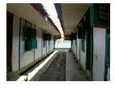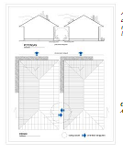Normalization of the river make it easier to receive outside influences, create social interaction between local inhabitants and migrants, spiritual activity such as pilgrim activities, also economy activity, which stimulate other activities in the kampong neighbourhood. Outdoor open space is a main place for social- relationship. Such elements integrate each other as a form of social terrace. Porch or front yard into a dwelling house of each member of the family to interact. Another resident who became his neighbor also take advantage of the role of the terrace as a place to interact with other members of the family. The terrace was used as a place where children play or parents caring for their children in the afternoon and evening. Relatively close distance without physical boundaries between the individual of the dwellings, it easier to interact (fig 8). Dwelling units of residential buildings form buildings cluster, which is connected by open spaces, become residential housing typologies of the kampong.The spatial pattern formed on each residential unit to form a new pattern in the cluster (grouping), following the mass residential building of public facilities / social as complementary. The presence of the buildings gap is still wide enough to allow the creation of sirculation between neighbors. The orientation of adjacent buildings, presence of building’s side become an main infrastructure to accommodate social-function. (fig.9).
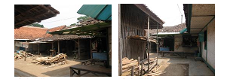

Figure 12 close distance between building
(source:field observation)

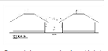
The side of the house is now used also as a small shop or furniture industrial development. Although most of the trail leads to a form of circulation, but the building still has openings such as doors or windows to the side, often faced with the doors and windows of neighbour houses. The condition is created because of a considerable distance between the building masses. As with any open space on the front of new mosques, And-the-pitch blank, in the back of madrassa, the-terrace is transformed into a stall area residents to interact each other. Social relationships formed by accommodated, mediated by enough building distance. Porch, yard and circulation space forming communal social space, where they used to work as a space for furniture craftman activities.

Figure 13 Open space between dwellings for social-economy activities (source:field observation)
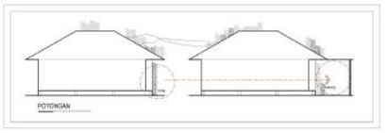

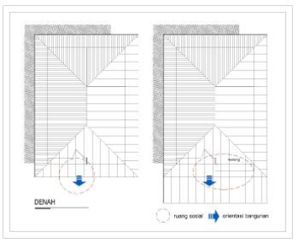

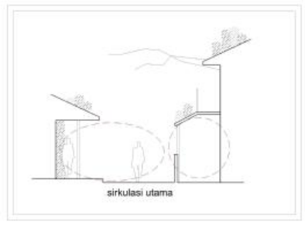

Figure 14 Comunal space
(source:field observation)
There is also the founder village’s tomb which many people do pilgrim, the existence of the oldest mosque located right before entering the tomb, became the center of the kampong community. All religious activities are predominantly Muslim population took place at that place. Although there are other mosques, but for large religious activities, such as Friday prayers and celebrations all done in the old mosque, resembles a bamboo woven wall, building size is 12x24 m², provide religious and social significance. Mosque has been a combination of physical space and the process of religious formation, also symbolic meaning of the objects. Social relations that occur in the mosque formed as facilitated, accommodated by open space. Mosque is a physical limit religious activities of the residents. Religious activities that stimulate social interaction between the inhanbitants exist in open space around the mosque. Mosque became a religious facility that serves as a social space, for kampong community also the visitor who want to do pilgrim. They do worship before and after doing pilgrim to Mahmud tomb, located nearby the mosque in advance. Religious activities that can stimulate social interaction in building mosques(figure 10). The similarity of interests of visitors to go pilgrim enable them to interact, created a social space for visitors who do pilgrim. Public facilities for religious activities available in almost every neighborhood, although the form of a small mosque. The new mosque are only used for daily worship and pray five times a recitation, but the Friday prayers and other religious festivals take place in the old mosque which is in the western part of the village. the mosque as a religious facility, supported by social interaction which take place in madrasa, which locate in the eastern part of kampong. Madrasa also as a place for children's to do recitaling holy Qur’an in every evening. Open space in the form of building’s front yard, formed by the integration of each building in the surrounding areas. Such place become a place for kids playing before and after the class. There is also open space between madrassa and the outskirts of the river, the form of lawn and garden around the madrasah which enable social activities among the children. In the open space was then created territories for the children, form an association of social linked, mediated through the courtyard and open space in such field. The existence of this public facility to be a place also for residents to interact with each other. public toilets in front of the new mosque, as a means of support for religious activities. Social interactions that occur in public sanitation, such as; toilet, makes the facility as part of the village social space. ( figure 10).
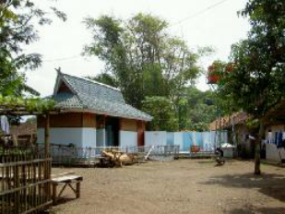

Figure 15 open space for public sanitation area
(source:field observation)

Open space at the front of the madrasa is a result of the integration of orientation that formed in the surrounding buildings. The existence of the space to create harmony with the open space in the form of an empty field on the outskirts of the river where the children play.Open space in the form of an empty field nearby the madrasah is integral part of the open space of a building. Each space is integrated by the same pattern of activity. Buildings and open spaces that become part of the social space formed in the kampong settlements. Order form of mass religious facilities such as buildings with open space was found also in the area where the new mosque was established. Though new but this mosque is physically trying to apply the norms of the village in the form of banning the use of materials of glass in buildings. So the mosque walls were made of wood frame and polycarbonate materials. The mosque became a place of worship for residents and visitors who did the pilgrim (figure 11).
The existence of the mosque’s courtyard make religious activities and other community events can be accommodated here. New mosques and open space in front of it became a place for people carrying out religious activities and the celebration of national holidays. New mosque became a node for village settlements. The existence of open space to the front of the mosque element supports the formation of social space.In addition to the existence of madrassas and mosques as public and social facilities, there is also a formal school madrasah tsanawiyah junior high school level. Although the infrastructure is adequate but its existence has not been able to be an important element forming village settlements. Schools in the western outskirts of the village next to the river Citarum is a educational facility for the villagers who are mostly educated. It lies still in the village settlements into supporting elements forming social relationships hometown. School became a physical space for activities which also accommodate social activitie (figure 12).

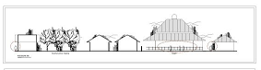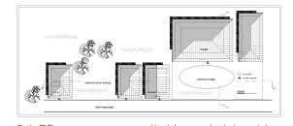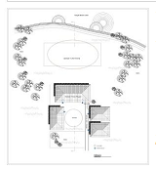

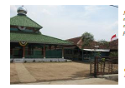

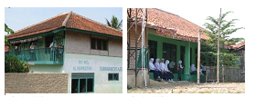

Figure 16 .Open space as infrastructure for religiou activities (source: field observation)

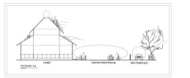

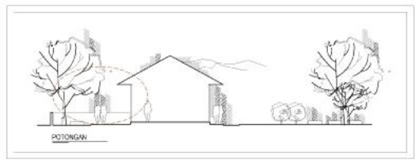

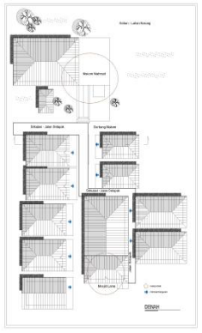

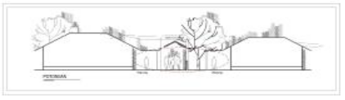

Figure 17 social space for schools

(source:author model)

Building Morphology

Revitalization of Building Morphology which consider principles of functional (Hasan), good (Thoyib) and aesthetic (Jamil),refer to typo-morphology of buildings. Residential part of the kampong population in the form of dwelling buildings are in the centre of the kampong. Residential buildings typology has stilt houses made ​​of bamboo woven for walls[13] The residence is equipped by livestock pens, goat or sheep at the back of the building, and provided by utilization under the house for chicken cage. Space in any dwelling formed by simple division, consist of living room, family room, bedroom next to the kitchen or behind the house.
Residential units in the village kampong range from small size 4 x 6 m², 5 x 7, to 6 x 8 m² . Broader measure is completed by side (pipir) of the building, that form a patio or yard for the kids playing. Houses of Mahmud inhabitant mostly made of bamboo-woven houses on stilts, the main structure is built up of wood, with a height of 30-50 cm from the ground. Degree of homogeneity of mass building which is still largely in the form of bamboo walls, and stylish stage creates a distinctive rhythm to the character of the kampong.
Previous use of roofs of palm fiber / shingle has been changed into roof tiles. Door and window openings made of wood material, is completed with the use of wood jalousie. The population strictly prohibits the use of glass as building material. Low building density indicated also by the scale of the building is mostly a one-story residential dwelling. The comparison illustrates the vernacular character are more human scale, than modern kampong in Bandung city.
Dwelling houses that still leaves room for a courtyard, or patio, initial order of the mass of village settlements widely. Each of these homes was later expanded independently formed group residences. Open space in the form of circulation, patio, yard and garden, become binding elements that make up the order of the mass of the housing. The use of glass in building materials is forbidden, as a form of norm which is still held. Violation of the unwritten rules that can lead to discomfort for the families who occupy, family members can fall sick, even to death.
Normalization of Citarum river has been undergone 1997, but the vernacular characteristics of the kampong still preserved. Citarum river alignment as separate residential dwelling settlements with agricultural land, being the main livelihood, do not too much direct influence on the identity of the kampong, which is still known Mahmud as pilgrim (jiarah) hometown. Physical changes in the real kampong after 1997 did not alter the characteristics of the kampong as spirituality place​​. Still visited by pilgrims from various regions, especially on Friday night. Changes in the function of the patio and yard into stalls (kios) followed by a physical change in residential units. The use of stalls as a result of economic activity of the most community of the kampong, change their home into a two-story building, especially building in a kampong located alongside the main circulation. Mahmud kampong are becoming increasingly open to newcomers, can be shown by several residential buildings that are physically different from the community of customary kampong. At certain angles could be found form the walls of houses are made of bricks, tiles and flooring made ​​from the use of glass as a window or door material. The residents of the customary kampong tend to retain the use of building materials made ​​from wood or bamboo, and avoid the use of glass materials,and other modern materials.

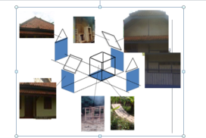

Figure 18. building morphology
(spurce:author model)
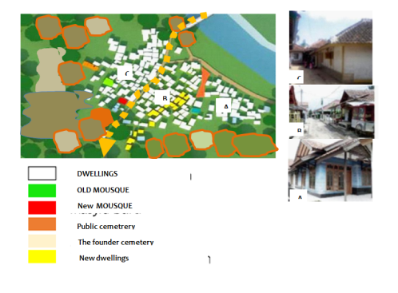

Figure 19 dwelling‘s tipology
(source: field observation)
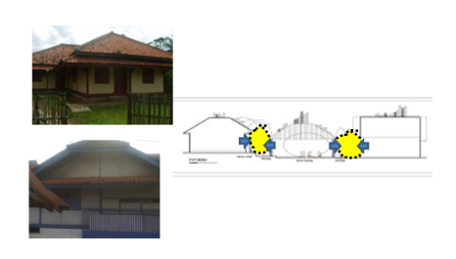

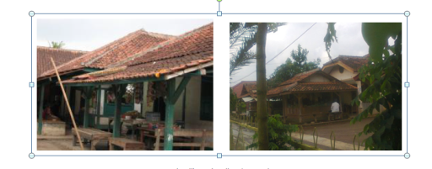

Figure 20 (source: field observation)

Revitalition of the kampong upgrade the ability of the inhabitant, especiaaly addition of work-profesion, which previous profesion is farmer. Nowaday The inhabitant of the kampong expand the profesion, therefore there is addition space of the dweillings, such as addition space for : warung(stall) and kitchen, furniture home industry and storage,small shop,terrace for living room, additional bathroom, additional kitchen, additional for second floor

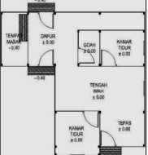

Goah (storage)

Space
for cooking
bedroom
Kitchen

Tengah imah
(living room)

Tepas
(verandah))

bedroom

Figure 21 The origin dwelling
(source: field observation)

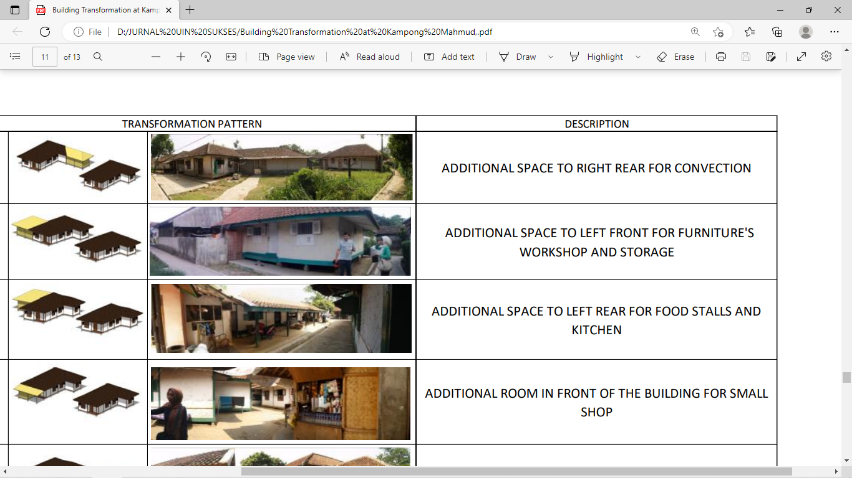

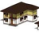

Figure 22 Various addition space of the original dwelling
(source: field observation)

ENVIRONMENT FRIENDLY-MORPHOLOGY
Revitalization of kampong adat Morphology which consider principles of functional (Hasan), good (Thoyib) and aesthetic (Jamil),must consider environment friendly-morphology. The main access to the village entrance Mahmud was getting stronger by the presence of the bridge across the river Citarum that was built after 1997. The main entrance gate of the kampong directly next to the southern tip of the bridge. The main circulating form of the linear order is an important element forming dweling masses. Circulation continued to elongate towards the southern part of the river Citarum, connects the kampong with outside kampong. Old and new Citarum river become a physical boundary which surrounds the kampong. Boundaries of a river that surrounds the village makes Mahmud has a clear physical boundary, which is able to distinguish from other urban kampongs. The usage of soil materials surface influence the environment performance, especially in overcoming problem of climate. Such case is related with albedo, or reflection coefficient, derived from Latin albedo "whiteness" (or reflected sunlight), in turn from albus "white", is the diffuse reflectivity or reflecting power of a surface (table 1).
Table 1 Albedo coefficient of various surfaces
number | Surface’s material | Albedo(%)
1 | Deep water | 5-20
2 | Gray soil-humidity | 6-8
3 | Dry-clear-soil | 16-18
4 | building | 9
5 | vegetation | 10-23
A lot of open spaces in Mahmud kampong use nature surface, the fabricated material is used in condition at least as possible. Such approach is implemented in providing the environment- friendly condition to the kampong ,therefore generally the albedo of the kampong relatively low (Table 2). The sun radiation can be absorbed by natural surface, also supported by the availability green area of of the kampong, such as tree,vegetation, also agriculture area.

Table2 The Surface albedo of the kampong

Number | place of social space | Albedo  Before 1997 | Albedo  After 1997
1 | Terace of residential units | 8-9 | 9
2 | Terace of residentials cluster | 8-9 | 9
3 | Hall/yard for furniture cfratmen work | 8-9 | 9
4 | Rice field/park | 8-15 | 10-23
5 | Tomb of the Kampong founder | 8-9 | 8-9
6 | Places for worship:Mosque,madrasa | 8-9 | 8-9
7 | Public MCK | 9 | 8-9
8 | Small café in local house | 9 | 8-9
9 | sirculation |  | 6-8
10 | Place for raft | 6-8 | 6-8
11 | Open spaces | 6-8 | 6-8
12 | Terminal for public transportation | 8-9 | 9-10

CONCLUSION
Vernacular morphology based revitalization in the context of Islamic Sustainability, can be implemented in upgrading urban kampong morphology, such as; Mahmud kampong, Bandung district, West Java. Vernacularism wisdom is implemented in supporting the function of kampong dwelling’s open space as green area, social space, public function, which accomodate socio-culture activities. Such revitalization in the context sustainability of nature environment, also preserve sosio-culture activities of the kampong as religious pilgrim place. The revitalization was implemented in three levels, such as: 1) Kampong, revitalization of kampong morphology which; the role of the citarum river normalization, a road construction for inspectioning river which evolved into the street outside the kampong, the development of public - transport terminal at the village gate, preservation of the raft terminal in the southern part of the village, which give an easy way to across the river, revitalization kampong morphology has influence the accesibilty of outside into kampong area, 2) Neghbourhood such as the infrastructure for social space, such as: street, path, and open space strengthen social function beween buildings, 3) Building such as maintaining vernacular building: local material, local technology, vernacular enclosure as response to tropical climate. The framework of the vernacularism’s revitalization can be seen in diagram 1. The diagram shows the relationship of the cause factor, the implementation of kampong revitalization , and the result of the revitalization. Such diagram has shown vernacular morphology based revitalization in the context of islamic sustainability, such as urban kampong revitalization how to overcome the environment problem such as flood, preserve agriculuture area, the character of religious activities centre, how to accommodate social function, how to use nature surface materials which has lowest degree of radiation reflection (albedo), the usage organic material of houses, in order to revitalize the kampong, physically and socio-culturally

PROBLEM of kampong morphology
- Flood as main problem
- Preserve agriculture area
- Preserve Character of religious activities centre

KAMPONG morphology REVITALIZATION
1.Normalization Citarum river.
2.Preservation agriculture area
3.Revitalize public terminal and the raft (traditional) terminal
4.Development social-economy space

The morphology AFTER REVITALIZATION
- The flood has been overcome.
- Separation of agriculture area and dwelling area
- The intensiveness of religious activities
- Intesiveness interaction with outside kampong and development socio-culture-economy activities

Diagram 1 Process of the kampong morphology revitalization

In this context, The Islamic values embodied in revitalization of Mahmud kampong are able to respond to the issue of sustainable environment Such revitalization contains element of environmental concern, especially agricultural and green area of the kampong Mahmud, meanwhile respond the contemporary demand as urban kampong which charactized new soio-economy activities. The values will be meaningful to encourage the users to empathize and live in harmony with nature, as it is written in the Koran Sura Al-Araf 56: "And do not do mischief on earth after (God) to fix it, and pray to him fear (not accepted) and expectations (be granted). Verily Allah's mercy is very close to those who do good”. Such realization is revitalization which respond to contemporary demands of urban kampong, but still hamony with nature, also socio-culture of the kampong, especially as Islamic heritage place for most traditional muslem in Bandung. Sustainability of nature environment and socio-culture of the kampong is characterized in the process of kampong revitalization.

REFERENCE
[1] A.H. Hourani, The islamic city in the light of recent research. In: Hourani, A.H., Stern, S.M. (Eds.), The Islamic City (Oxford), 970
[2] A. Rapoport, House Form and Culture Englewood Cliffs, N.J.: Prentice-Hall, 1969.
[3] A.Rapoport, The Meaning of the Built Environment, A Nonverbal Communication Approach, Sage Publications, California, 1982.
[4] A.Rapoport, , Human Aspects of Urban Form, towards a Man-Environment Approach to Urban Form and Design, Pergamon Press,Oxford,1977.
[5] A. B. Sarjono, S. Nugroho, Menengok Arsitektur Permukiman Masyarakat Badui Arsitektur Berkelanjutan dari Halaman Sendiri. 2, Modul, Vol. 14, p. 87, 2014.
[6] B.Sudarwanto, Pandelaki, Edward E, S.Soetomo, Pencapaian Perumahan Berkelanjutan 'Pemilihan Indikator dalam Penyusunan Kerangka Kerja Berkelanjutan'. 2, MODUL, Vol. 14, 2014.
[7] E. Darmawan, Haryanto, Konsep Arsitektur Berkelanjutan Pada Tata Ruang Kota (Studi Kasus : peralihan Fungsi Lahan hijau Menjadi Perumahan). 2, Modul, Vol. 13, p. 49, 2013.
[8] Indrawati. Lanskap Budaya Permukiman Islam-Jawa di Majasto. Semarang : Program Doktor Arsitektur dan Perkotaan Program Pasca Sarjana Universitas Diponegoro, 2015.
[9] J.Gutierrez, Notes On The Seismic AdequacyOf Vernacular Buildings,13th World Conference on Earthquake Engineering Vancouver, B.C., Canada August 1-6, 2004 Paper No. 5011.
[10] M.I.Hasan,T. W Murtini, S.R. Sari Journal of Advances in Agricultural & Environmental Engg. (IJAAEE) Vol. 3, Issue 1 (2016) ISSN 2349-1523, 2016
[11] P. Oliver,ed., Encyclopedia of Vernacular Architecture of the World, vol. 1 (Cambridge: Cambridge University Press,), page xxviii, 1997.
[12] Pearson, M. Parker., C. Richard, Architecture and Order , Approaches to Social Space, Routledge, London, 1994.
[13] R.Krier, Urban Space, Academy Edition, London, 1984.
[14] R.Rose, , Morphology in Architecture (Terjemahan),Arsitektur-UGM, ,Yogyakarta, 1979
[15] J.P .Steadmen, Architectural Morphology: An Introduction to the Geometry of Building Plans, Pion Limited, London, 1983

