THEORETICAL STUDY
DATA COLLECTION
DATA ANALYSIS
DISCUSSION
CONCLUSION

Figure 1 Flow chart of research methodology
(source: author model)

FUNCTIONAl
(Hasan)
GOOD
(Thoyib)
AESTHETIC
(Jamil)

Figure 2 Diagram of Islamic sustainability model
(source: author model)

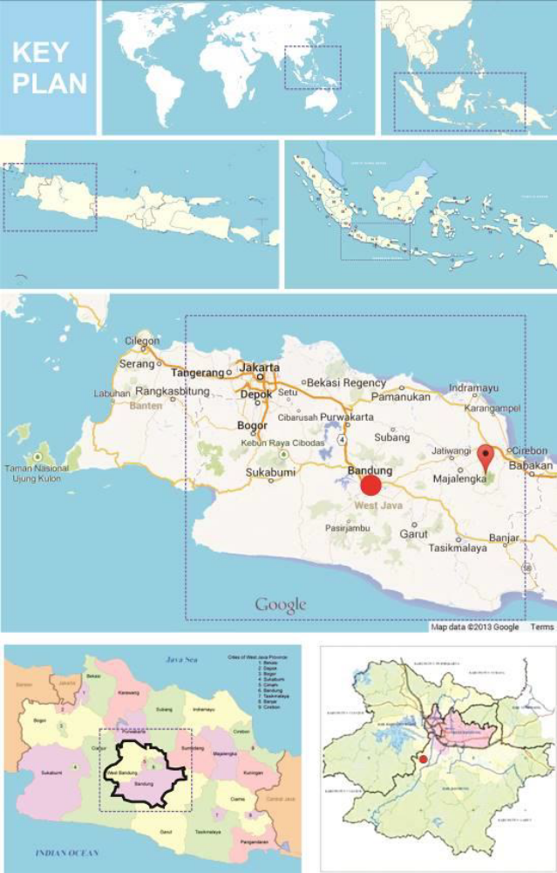
Location of Mahmud kampong
Location of Mahmud kampong
Location of Mahmud kampong

Figure 3 Location of Mahmud Kampong
(source: Google.com)

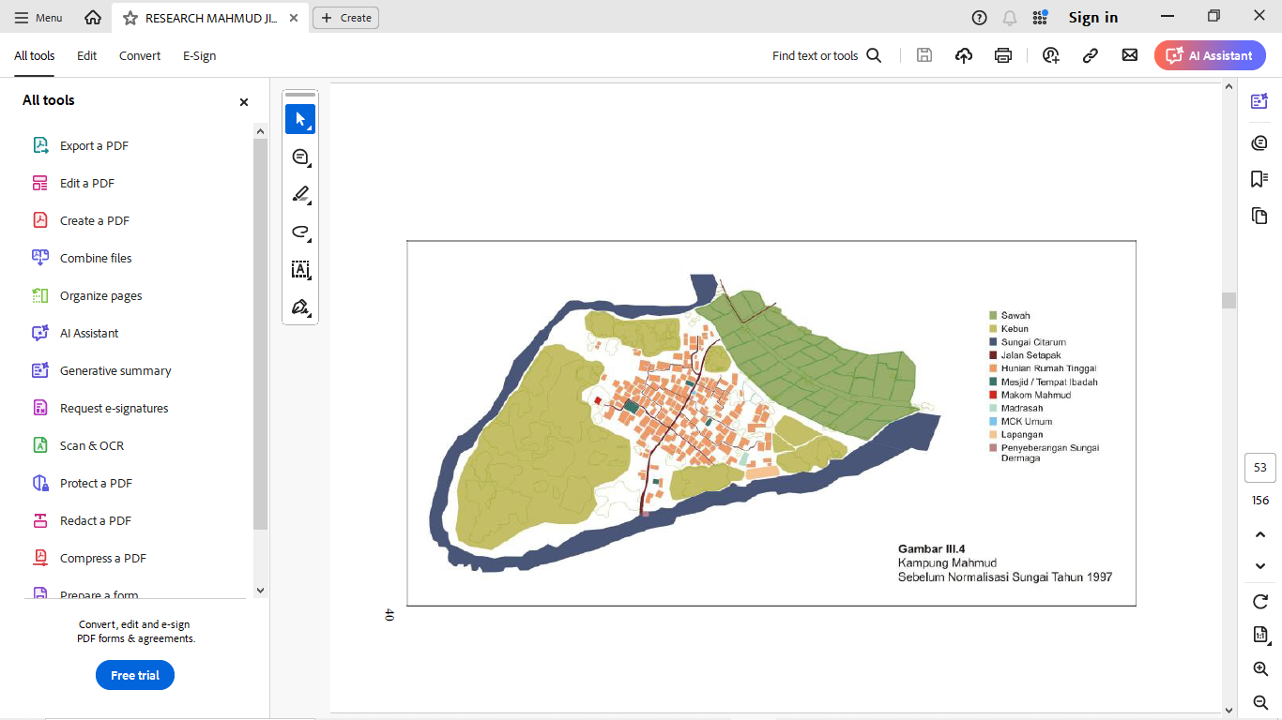
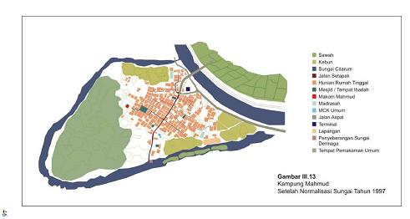
Rice field
Garden
Citarum river
Footpath
Residence area
Mosque
Ancestor cemetery
Boarding school
Public sanitation
Open space(field)
Canoe dock

Figure 4 Mahmud Kampong before Citarum river normalization
(source: field observation)

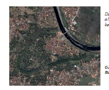
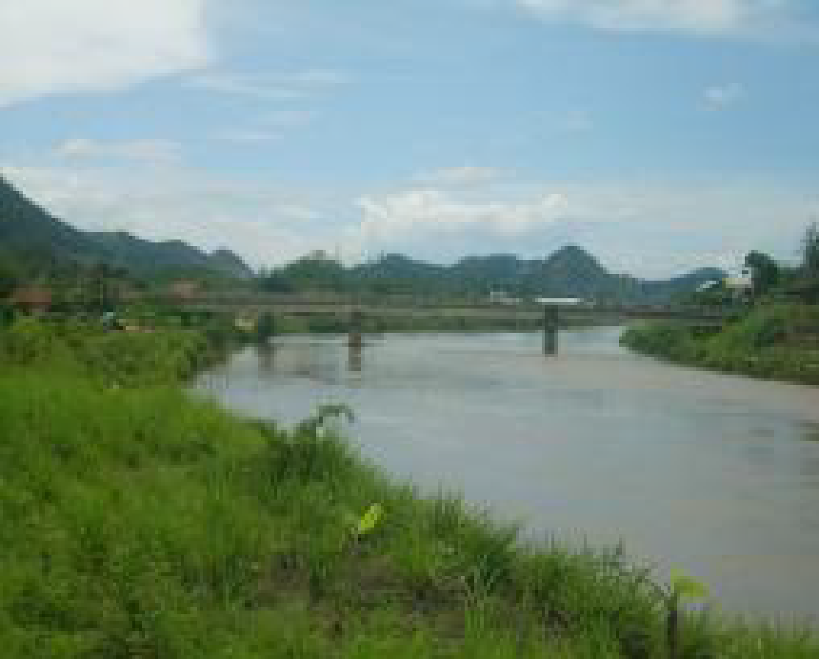

Rice field
Garden
Citarum river
Footpath
Residence area
Mosque
Ancestor cemetery
Boarding school
Public sanitation
Asphalt road
Public transportation terminal
Open space(field)
Canoe dock
Public cemetery

Figure 5 Mahmud Kampong after Citarum river normalization
(source: Field observation)

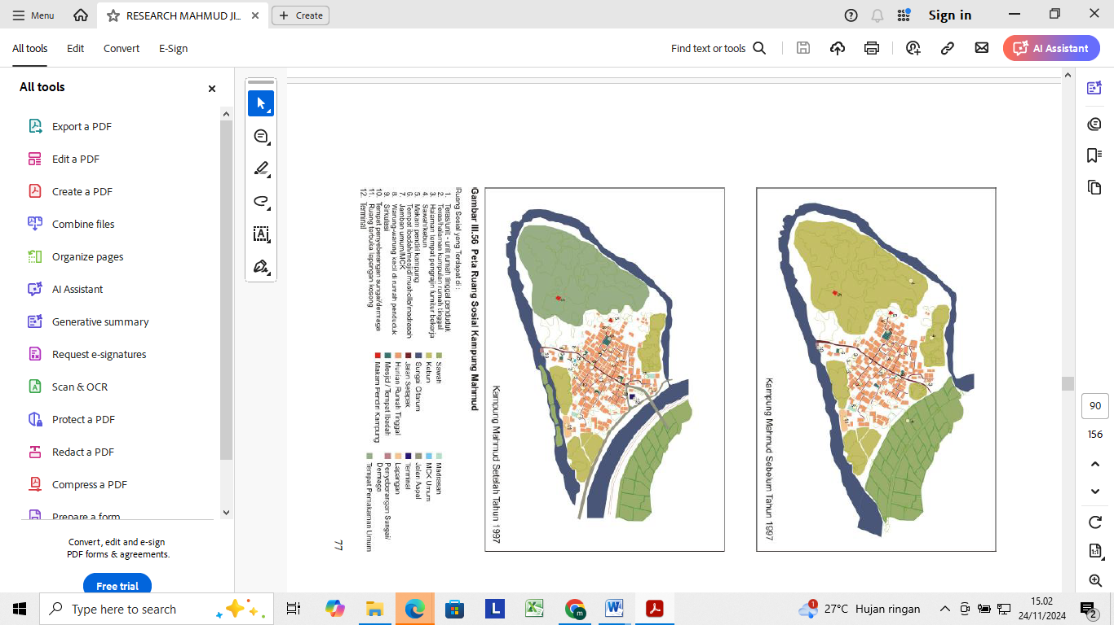
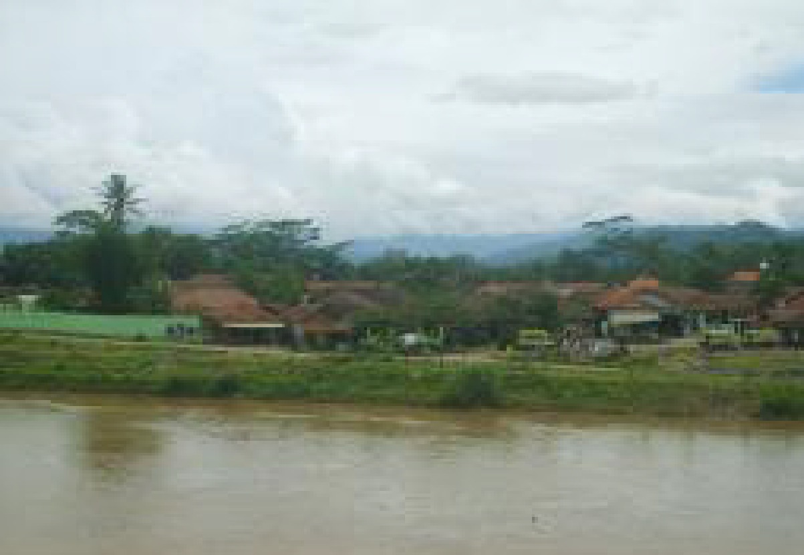

Mahmud kampong before normalization

Mahmud kampong after normalization

Rice field Ancestor cemetery Canoe dock
Garden Boarding school Public Cemetery
Citarum river Public sanitation
Footpath Asphalt road
Residence area Transpotation terminal
Mosque Open space (field)

Figure 6 Kampong Mahmud :before and after river normalisation
(source: field observation)

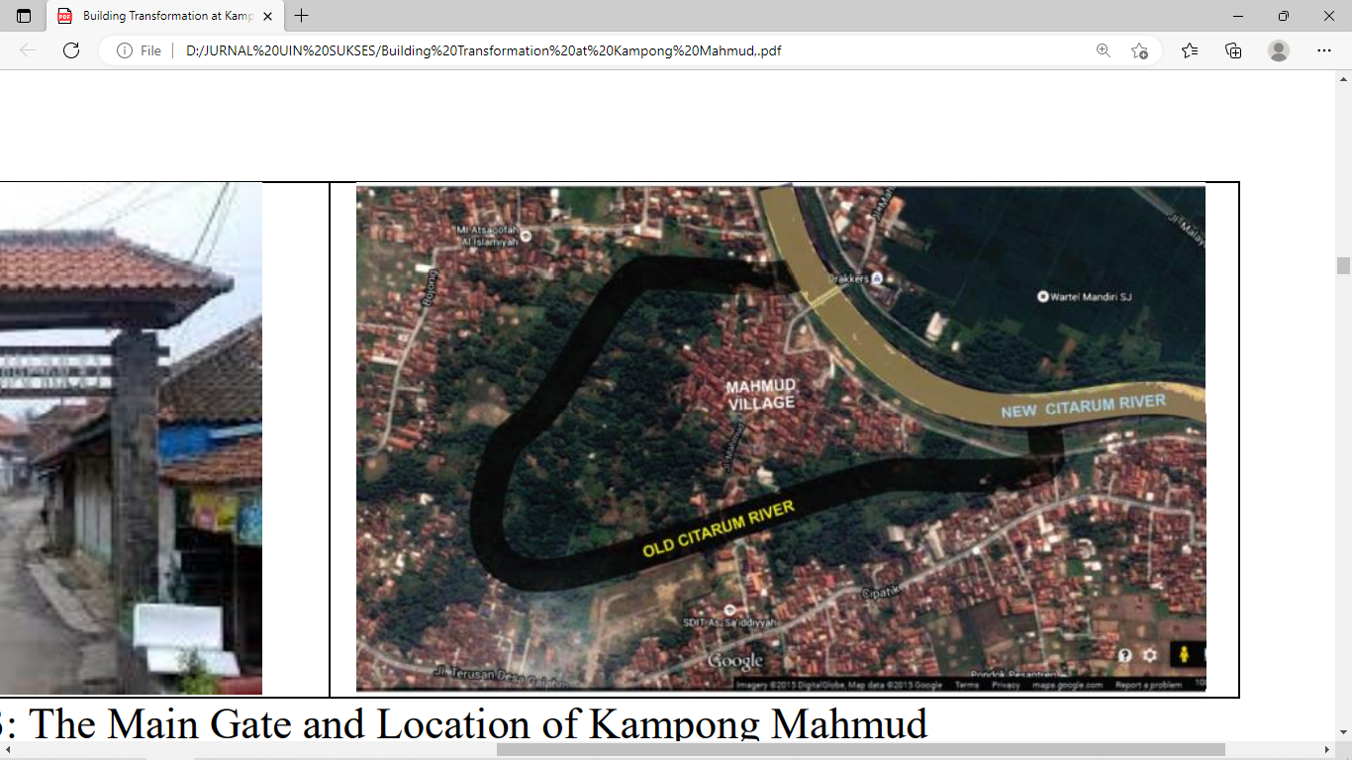

Rice field Ancestor cemetery Canoe dock
Garden Boarding school Public Cemetery
Citarum river Public sanitation
Footpath Asphalt road
Residence area Transpotation terminal
Mosque Open space (field)

Figure 7 Kampong Mahmud morphology after river normalisation
(source: field observation)

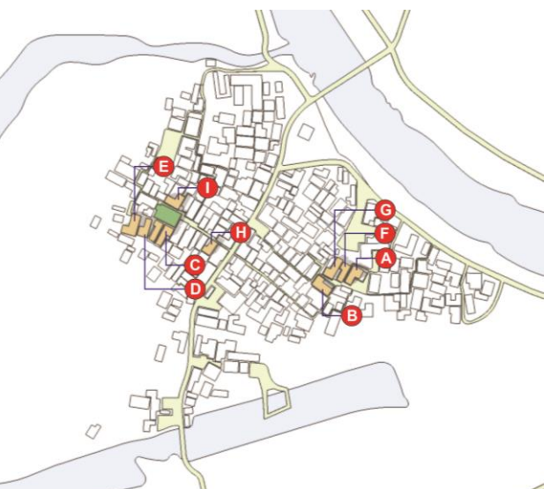
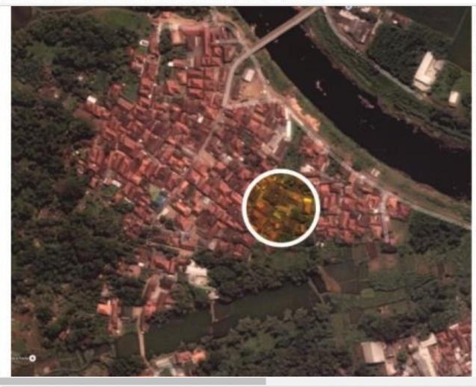

A,B,C,D,E,F,G,H are various tipology of vernacular building

Figure 8 Kampong development direction
(Source: field observation)

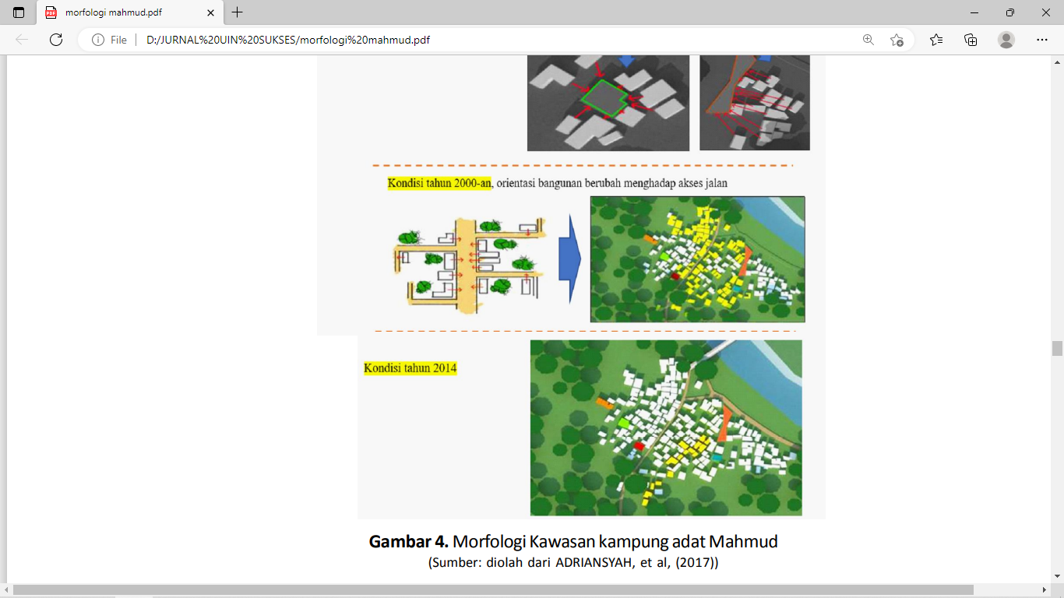

Figure 9 Evolution Neighbourhood’s cluster development
(Source: Field observation)

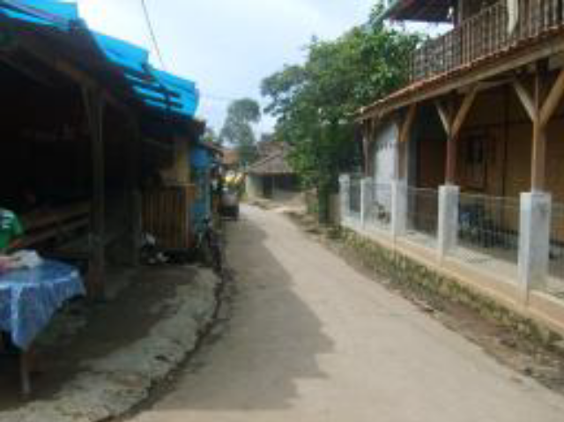

Figure 10 Neighbourhood Infrastructure
(Source: Field observation)

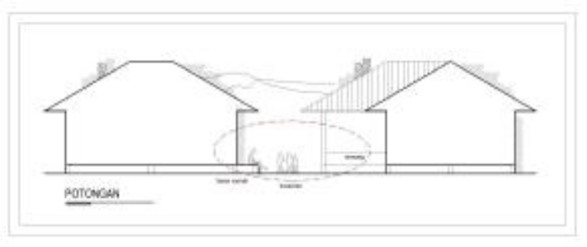

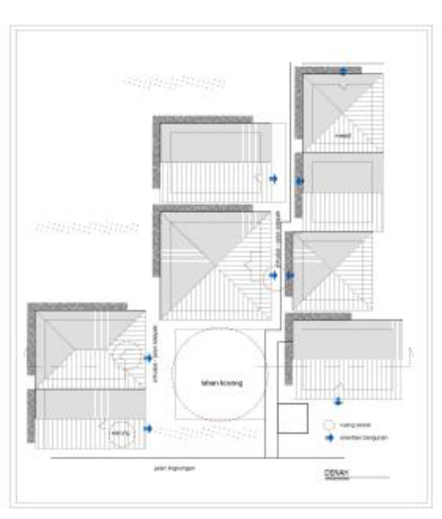
acessibility

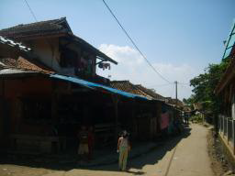

Figure 11 Social-interaction and accessibility in the Neighbourhood’s cluster
(Source: Field observation)

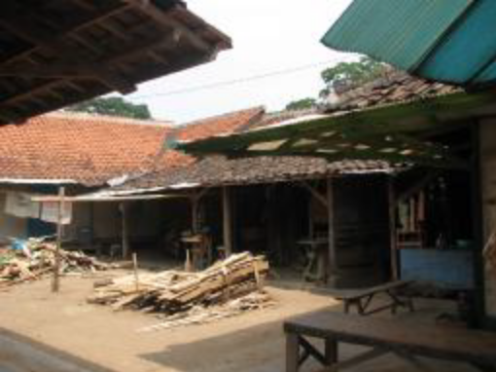
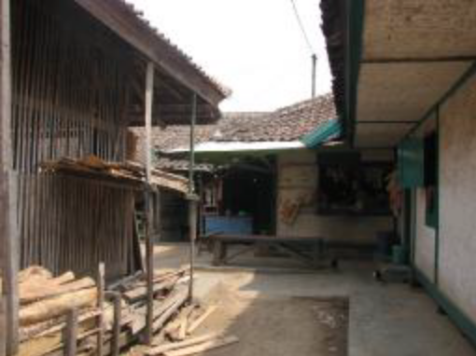

Figure 12 Open space between dwellings for social-economy activities
(Source: field observation)

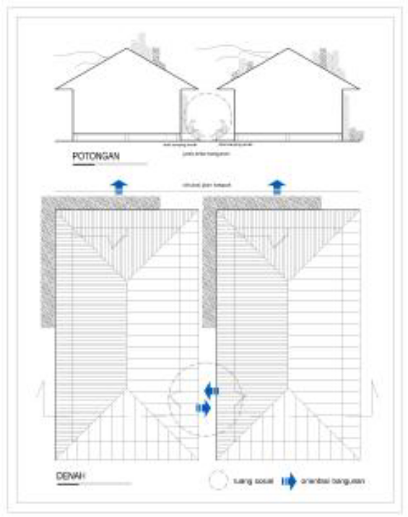
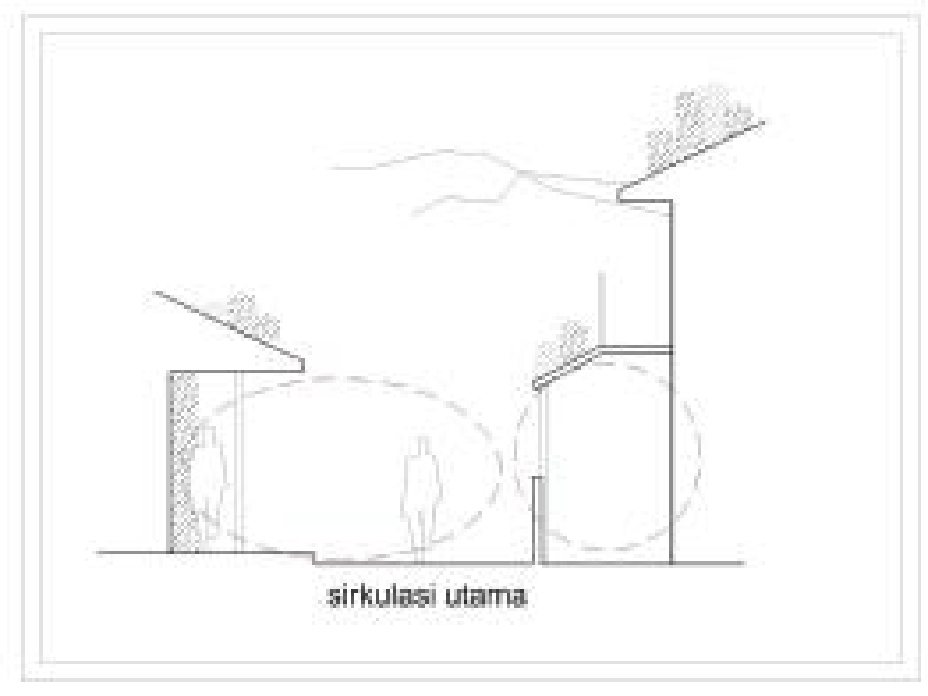

Figure 14 communal space for social accesibilty and interaction
(Source: Field observation)

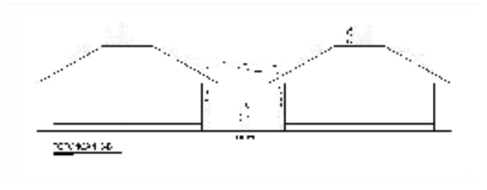

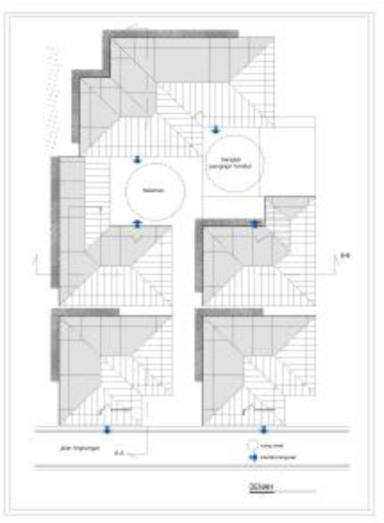
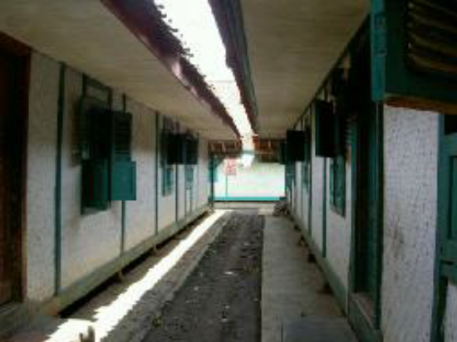

Figure 13 space between dwellings for social interaction
(Source: Field observation)

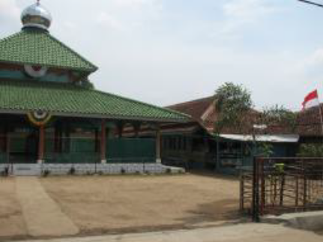

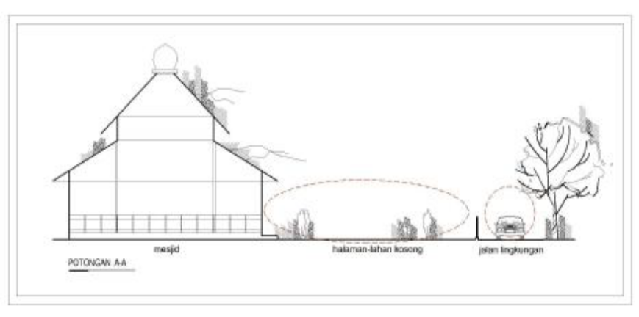

Figure 15 Mosque building and open space
(Source: field observation)

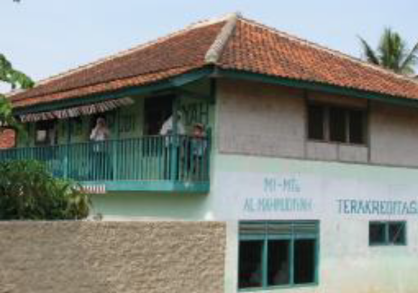
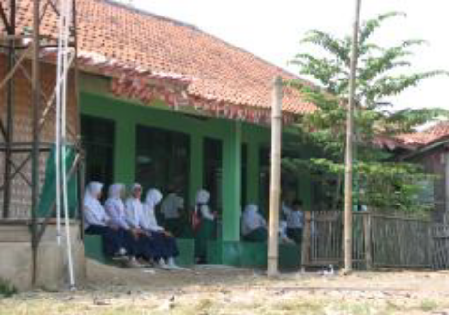

Figure 16 madrassa and open space
(Source: field observation)

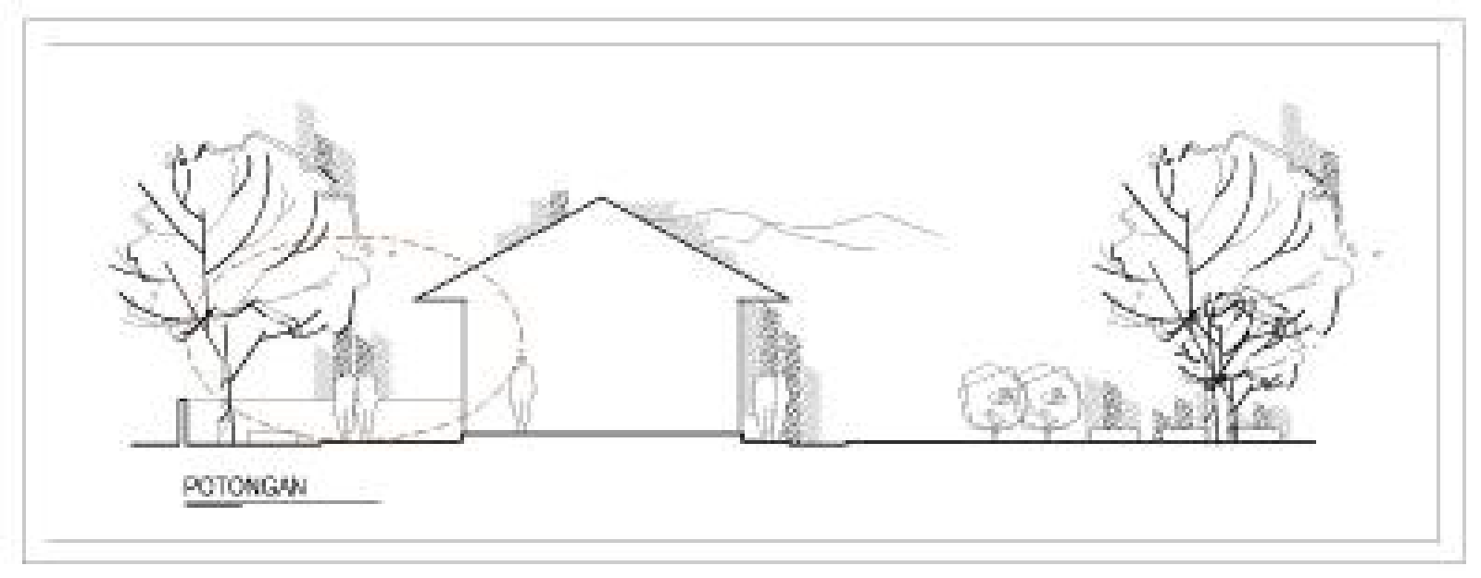
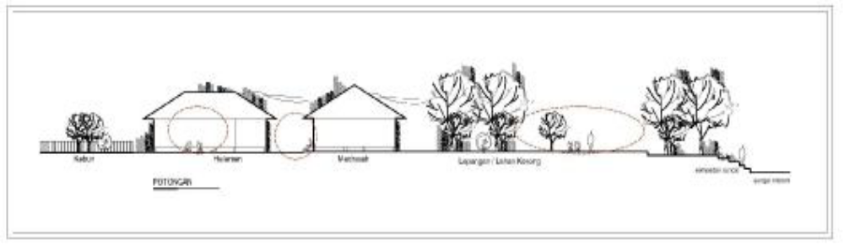
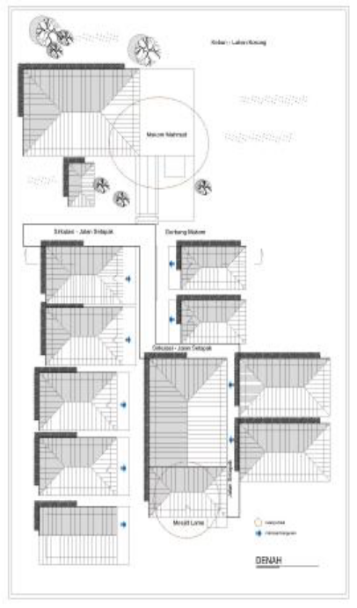

Figure 17 social space for madrassa (school)
(Source: field observation)

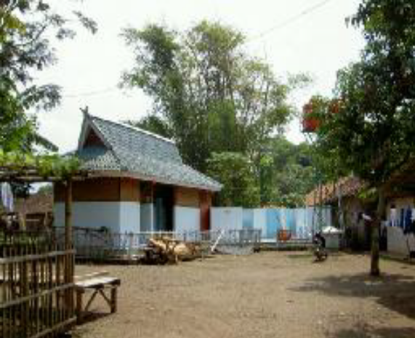
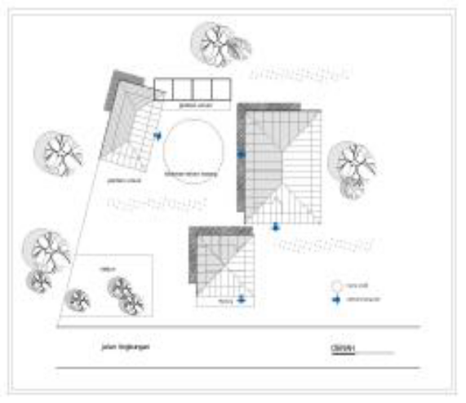

Figure 18 Open space for public sanitation area
(Source: field observation)

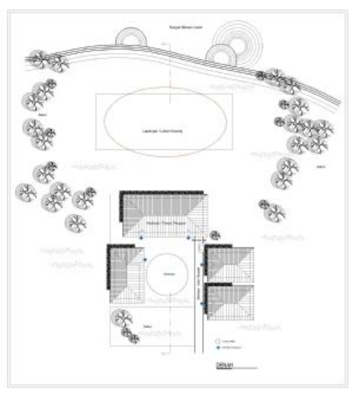
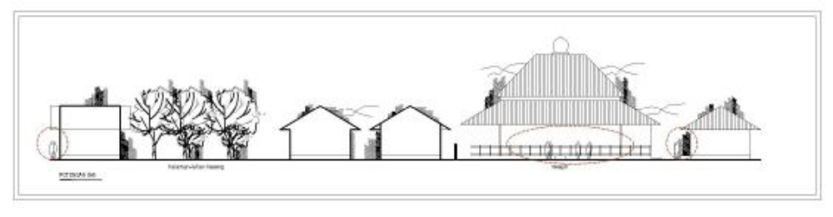
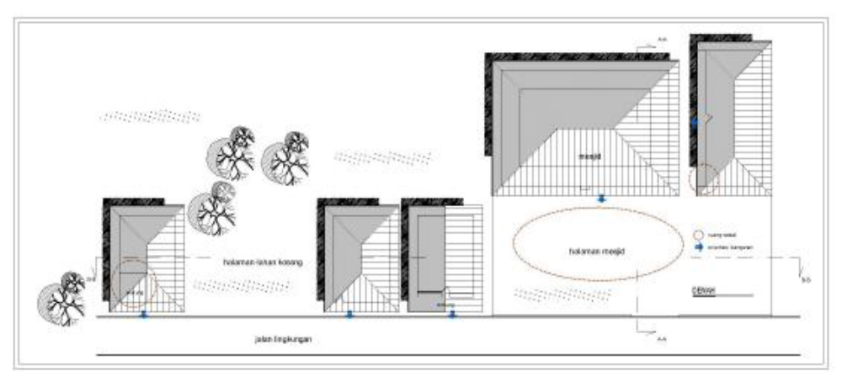

Figure 19 .Open space as infrastructure for religious activities
(source: field observation

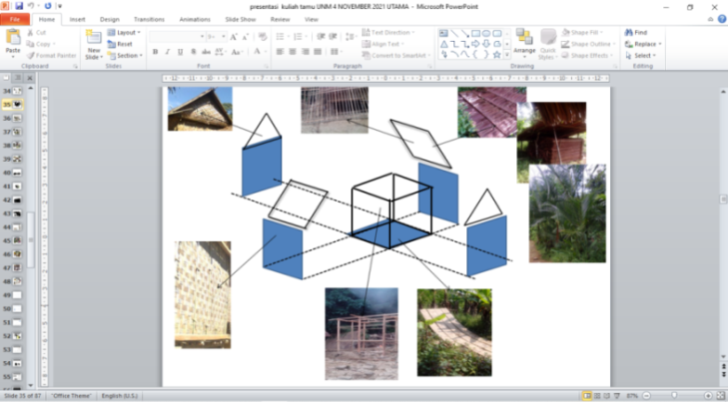
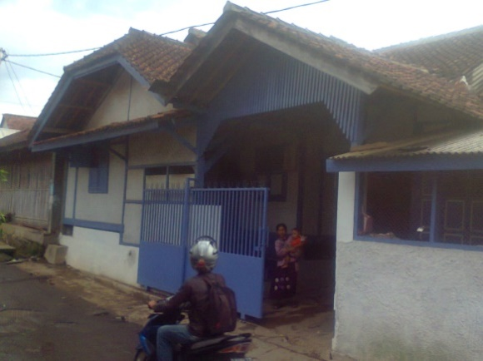
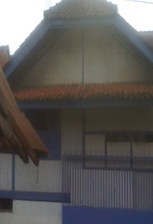
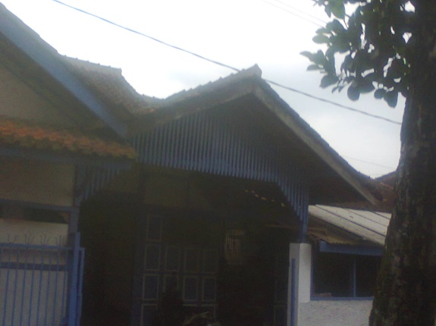
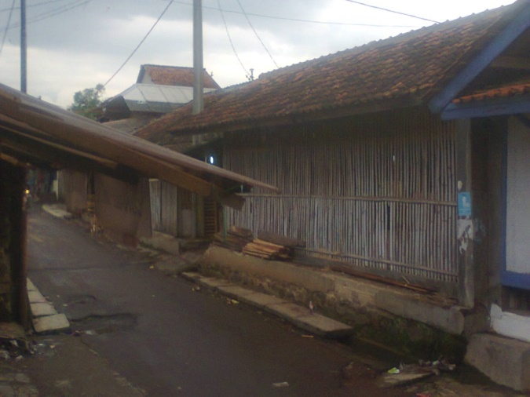

Roof component
Wall component
Rigid frame component
floor component

Figure 20 Dwelling house’s components
(Source: field observation)

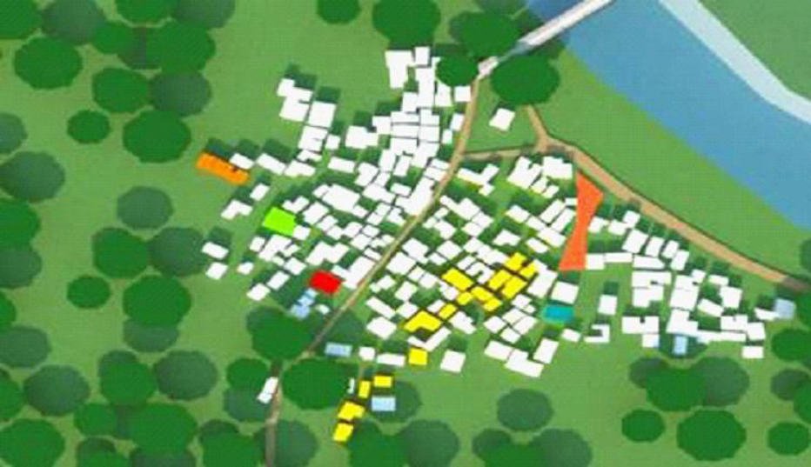
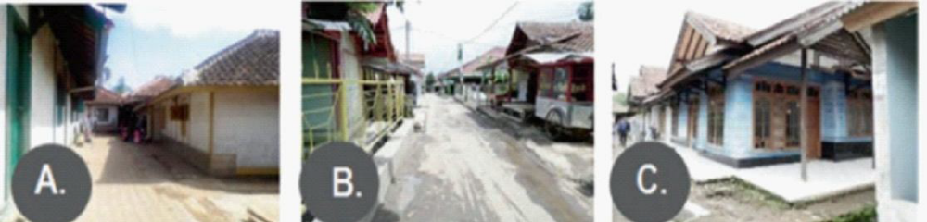
A
B
C

Figure 21 Dwelling house’s typology
(Source: field observation)

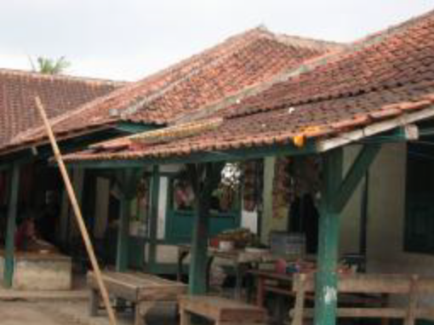

Figure 22 Dwelling‘s typology with warung (stall)
(source: field observation)

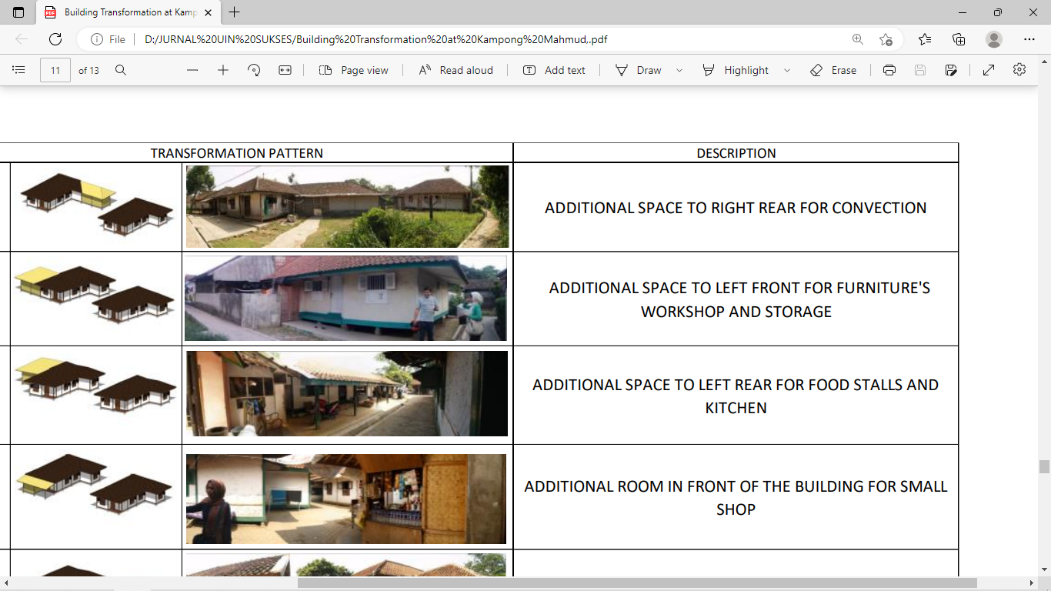
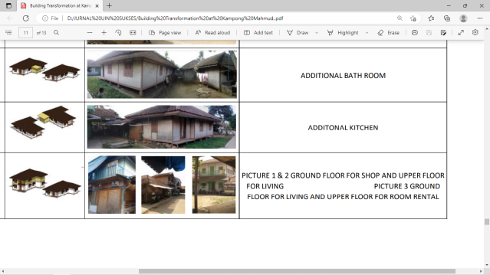

Figure 24 Various addition space of the original dwelling
(source: field observation)

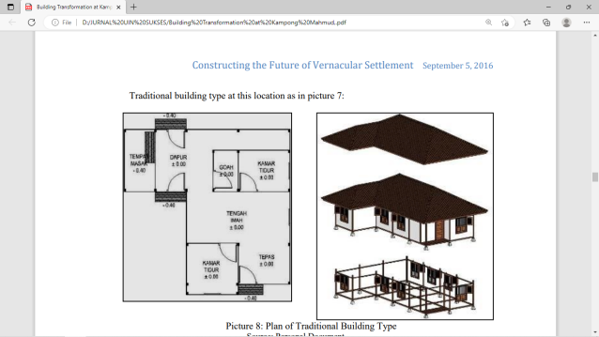

Pawon
(Kitchen)
Space
for cooking
Goah (storage))
Bedroom
Tengah imah
(living room)

Tepas
(verandah

Bedroom

Figure 23 The origin dwelling house
(source: field observation

