 |  | JOURNAL OF ISLAMIC ARCHITECTURE  P-ISSN: 2086-2636 E-ISSN: 2356-4644  Journal Home Page: http://ejournal.uin-malang.ac.id/index.php/JIA
VERNACULAR MORPHOLOGY BASED ON REVITALIZATION IN THE CONTEXT OF ISLAMIC SUSTAINABILITY
Case study: Kampung Adat (Indigenous Village) Mahmud, Bandung District, West Java
Marcus Gartiwa^{a*}, Dede Siti Rohmah^{b}
ªDepartment of Architecture, Langlangbuana University, Bandung, West Java, Indonesia
^{b}Department of Civil Engineering, Langlangbuana University, Bandung, West Java, Indonesia
*Corresponding Author: mgartiwa@yahoo.com
ARTICLE INFO |  |  | ABSTRACT
Volume: 8  Issue: 2  Page: 450-468  Received: September 14th, 2023  Accepted: February 17th, 2024  Available Online: December 15th, 2024  DOI: 10.18860/jia.v8i2.20931 |  |  | The increase in urban areas is a natural process caused by urban development, especially caused by contemporary demand. On the contrary, there is a local community’s effort, such as Kampung Adat (Indigenous village) to maintain the area as a vernacular kampong. Therefore, there is a need to revitalize the area to make it compliant with vernacular cultural aspects. Revitalization is an upgrading condition in adaptation to contemporary demands. Meanwhile, vernacular wisdom has a local-oriented morphology, respectful to the harmony of socio-culture and the built environment. Kampung Adat Mahmud in Bandung District, West Java, is named after Eyang Mahmud, who was Bandung’s outstanding ulama (preacher). The Kampong has been revitalized in the spirit of Islamic sustainability, which united contemporary development and Islamic heritage preservation. Such revitalization is helpful to be studied. Therefore, the research aims to get a better understanding of how the vernacular community could implement revitalization in the context of Islamic sustainability, which contains functional (Hasan), good (Thoyib), and aesthetic (Jamil) values. The research methodology is qualitative descriptive, based on observation, and analyzed by the development of morphology kampong, neighborhood, and dwelling house. The result is the revitalization of the Kampong, which has been conducted by an approach that harmonizes the natural environment, vernacular character, and contemporary socio-economy activities.  Keywords:  Revitalization; Vernacular morphology; Islamic sustainability

- INTRODUCTION
Continuous population growth and loss of vegetation lead to various global problems, one of which is the significant ozone depletion in the atmosphere. Such current environmental issues, especially in the urban context, have been evident as a crucial aspect of environmental degradation caused by the growth of urban development. Meanwhile, increasing urban areas is a natural process caused by contemporary demands. A local community’s effort, such as Kampung Adat (Indigenous village), is to maintain the area as vernacular Kampong, which preserves socio-culture and natural environment. Such conflict of interest is an important topic for society worldwide [1][2]. Moosavi [3] also states that when planning a city's development, it must consider its history, culture, and meaning. The term “revitalization” is the functional activation of an old building complex or old objects by adapting it to a new social function, which is the point of view in this context. The attempt to revitalize history, culture, and identity in the urban area will face two conflicting challenges: preserving the old urban area's unique culture and identity versus contemporary urban life with its technological requirements.
The current way of thinking has taken place in revitalizing urban areas, such as emphasizing vernacular morphology. Such morphology is based on the ecological approach in the name of sustainability. Such sustainability has occurred in revitalizing the Indigenous village of Mahmud. The Kampong is a Muslim heritage site located in the urban area of Bandung district. Therefore, it is important to understand such revitalization, based on vernacular morphology principles, with its implications for the urban’s future. Such revitalization cannot be separated from locality and community participation. The result is a built environment that is locally oriented: materials, structural systems, and humbleness, which is guided by their ecological wisdom.
The word morphology is derived from the Greek word morphos, which means form. Morphology is the branch of biology that deals with animals' and plants' form and structure [4]. Morphology in architecture studies the form and structure of the space and built environment, such as the plan and building of a habitat, viewed in terms of its origin, growth, and function [5]. The morphology of Kampong is a reflection of its function, and the ideas of planning, building, and development. Therefore, the revitalization of vernacular morphology deals with the process of the stand, rising, and open buildings in the environment [6][7][1][2].
Meanwhile, sustainability has become a central issue in the context of the development of this century [8], especially in accord with the global warming issue. Sustainable architecture is promoted to reduce global warming. The current population increase with narrow green space is used to meet the housing needs [9], driving such sustainable implementation. Sustainable architecture has some branches, such as ecological architecture, environment-friendly architecture, efficient-energy architecture, bioclimatic architecture, and green architecture [10], whose main aim is maintaining nature preservation better.
As guidelines for Muslims, the Qur’an, the Holy Book of Islam, has explicitly taught sustainability. Human beings have developed and built environments to fulfill human needs. Therefore, the built environment has a close relationship to human culture. Such sustainability refers to three main indicators: functional (Hasan), good (Thoyib), and aesthetic (Jamil) [11]. Such important values are meaningful to architecture users. Functional (Hasan) means that a built environment promotes the purpose of human beings as the caliph (leader) in conducting the order of the earth, such as good morals in facilitating valuable activities. Thoyib means that the built environment should be rahmatan lil Alamin (a mercy to the world). As in Surah Al Anbiya 107: "And We have not sent you, [O Muhammad], except as a mercy to the world." Therefore, the built environment should be universal, rational, caring, and shaping civilization. The meaning of aesthetics (Jamil) explains that the built environment should be able to explore elements of the built environment to produce beautiful work. The aesthetic elements must require Islamic values, which must not support the activities of shirk, harming other people, animals, and nature, as well as excessiveness, which can bring someone to vanity.
Vernacular built environments cannot be separated from locality, especially nature. The result is a built environment that uses local materials, traditional structural systems, and a humble tradition of trial and error, close to their culture and norms [12]. Forms of vernacular morphology are built to meet specific needs, accommodating the values, economy, and ways of life [13]. The owner is usually actively participating in the building process [14]. Therefore, vernacular morphology has sustainable concepts, such as a built environment concerning an environment accepted by their community, and the building cost is affordable [15]. Local wisdom of vernacular morphology emphasizes universal values, such as ecological wisdom [16]. In that sense, having a meek attitude is necessary to learn from the ecology wisdom - architecture. The essence of ecology wisdom of the Indigenous village (Kampung Adat) is sustainable architecture, which implements technologies that respect aspects, such as 1) the relationship between living organism and their environment, 2) culture, which contains the ideas, beliefs, customs, 3) technology which promote the study of practical for solving technical problem. Sustainability involves the mediation between ecology and technology based on appropriate attitudes. Built environments are treated as cultural resources and a legacy for future generations. Therefore, the research aims to determine how the revitalization of vernacular morphology is conducted in Islamic sustainability, especially how to harmonize with the natural environment, vernacular character, and contemporary socio-cultural aspects. The result of the research is expected to give a better understanding of how the vernacular community could implement revitalization in the context of Islamic sustainability. Such sustainability values consist of functional (Hasan), good (Thoyib), aesthetic (Jamil). Such values can emphasize socio-cultural preservation, which accommodates new functions.

- METHODS
The research’s methodology was qualitative descriptive, which interpreted the phenomena in the field survey using the morphology theory. The first step is theoretical study. The second step was collecting data from data observation such as satellite imagery observation and field surveys. The observation consisted of Kampong, neighborhood, and dwelling. The third step was data analysis. The final step was discussion, which evaluates morphology in three scales: Kampong, neighborhood, and building. Morphology kampong was evaluated by evaluating the zone of function, while the morphology of the neighborhood was evaluated by the connectivity of the building, which relates to public space. The morphology of the dwelling is evaluated by the social function of the occupant. The result is an overall evaluation of the revitalization of the vernacular morphology of Kampong Mahmud in the context of Islamic sustainability.

THEORETICAL STUDY
DATA COLLECTION
DATA ANALYSIS
DISCUSSION
CONCLUSION
Figure 1. Flowchart of research methodology [source: field observation]

- RESULT AND DISCUSSION
Urbanization and modernization processes have driven urban-kampong areas to grow rapidly. It has caused a nudge among urban modernity and kampong tradition, especially in fringe areas. It is evident that urban development tends to replace features of rural settlement, such as physical condition, which is usually characterized by social-communal forms. Such tendencies in urban transition areas and rural areas have shown urban modernity to lose its rural-vernacular character. Fringe areas with agrarian characteristics and their surrounding farming land also have vernacular character, and are experienced as a nudging areas caused by urban development. Such a character gradually affects urban kampong transformation [17]. Urban-kampong revitalization in Kampung Adat Mahmud refers to a model of Islamic sustainability, which considers principles of functional (Hasan), good (Thoyib), and aesthetic (Jamil) [5]. Such a relationship can be seen in Figure 2. Such Islamic sustainability values control the transformation of Kampong, neighborhoods, and buildings, accommodating natural environment preservation, social culture, and economy.

Functional
(Hasan)
Good
(Thoyib)
Aesthetic
(Jamil)
Figure 2. Diagram of the Islamic sustainability model [source: field observation]

Therefore, revitalization can be seen in three levels: kampong morphology, neighborhood morphology, building morphology, and environment-friendly morphology.

  - KAMPONG MORPHOLOGY
Implementation of vernacular revitalization considers principles of functional (Hasan), good (Thoyib), and aesthetic (Jamil) at the level of Mahmud Kampong, Bandung City, West Java, Indonesia [figure 1]. Such implementation can be seen before and after the normalization of the Citarum River. The river is the primary function, a significant natural environment that has greatly contributed to the Kampong inhabitant’s life since the ancestors to the current generation. Therefore, the normalization of the river is the main aspect of morphology’s revitalization and has become a significant infrastructure that revitalizes Kampong as a response to environmental problems. Floods, caused by high rainfall and high humidity, often in the rainy season in the past, are the main problems of Kampong.
The location of the Kampong is near the Citarum river, which has a macro climate background. The location can be seen in Figure 3. The macro climate is equatorial tropic, characterized by rainy and dry seasons. The temperature is relatively high during the year, especially in the dry season. General humidity is relatively high because the rainfall is high during the rainy season. Therefore, the Citarum River has abundant water to support the farm land-area. Such physical conditions indicate that the natural environment is the dominant characteristic of the Kampong. Such a character has been supporting the Kampong as the center of traditional Muslim culture in Bandung, and the surrounding region. Most traditional Muslims have professional backgrounds correlated with farms. The contemporary, significant development of the Bandung district influenced the contemporary development of Mahmud kampong, gradually turning it into urban Kampong, which still sustains Islamic character. In 1997, the revitalization of the Kampong was conducted by both regional authorities and the local community in response to the current development.

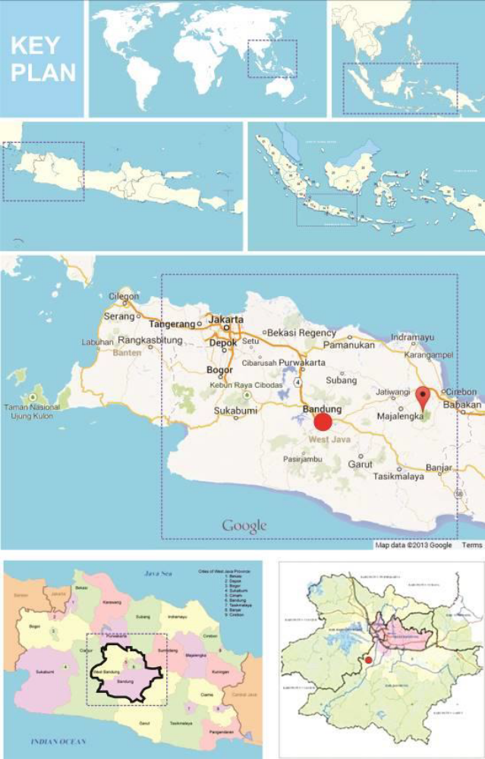
Location of Mahmud kampong
Location of Mahmud kampong
Location of Mahmud kampong
Figure 3. The location of Mahmud Kampong [source: Google.com]

The kampong revitalization can be seen in two phases, such as:
- Kampong morphology before river normalization is shown in Figure 4. The kampong morphology before 1997 was characterized by the composition of buildings, farmland, and sacred cemetery of the Kampong founder. Kampong territory consisted of an ample paddy-field boundary on the north, the river on the South, and a cemetery on the eastern and western parts of the Kampong. Residential units are in the center of the Kampong, surrounded by paddy fields in the northern part. The cemetery is in the western part. The founder cemetery is near the Kampong and old mosques. The physical distance between buildings can be seen around the old mosque and cemetery. The area around the mosque contains the houses of the Kampong elders, which indicate the importance of function and cultural significance of the cemetery and old mosques. Such a historical area refers to the Kampong founder, Eyang Mahmud. The mosque is a religious facility that serves to worship both locals and visitors from outside the area who especially intend to make a pilgrimage to the cemetery of the Eyang Mahmud family. The pilgrimage is conducted by Friday prayer and other religious celebrations in the mosque and the Eyang Mahmud Family cemetery.
- Kampong morphology, after river normalization, is shown in Figure 5. There was normalization of the Citarum River by local governments in 1997.
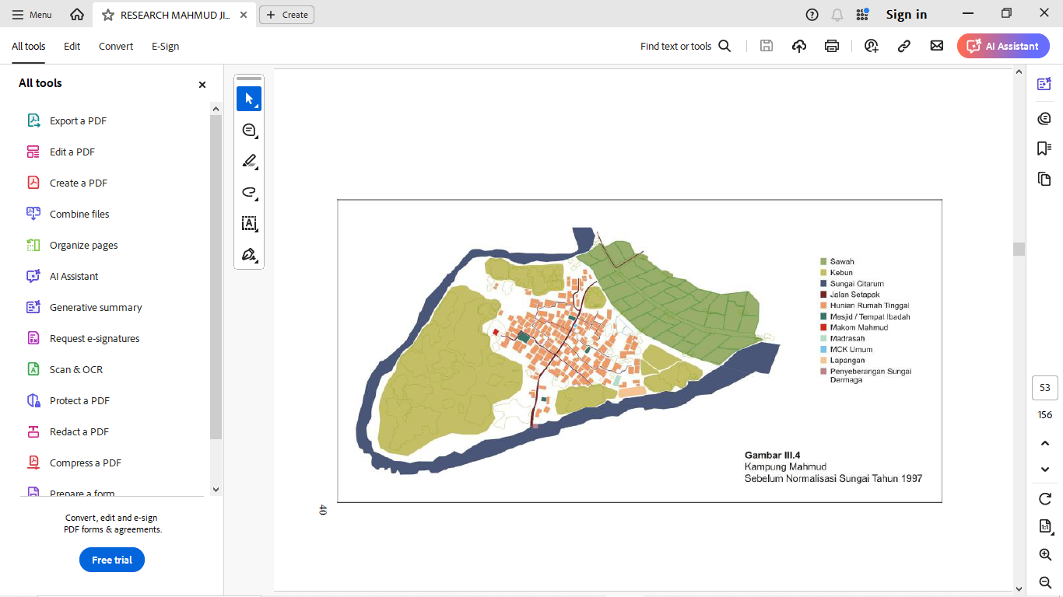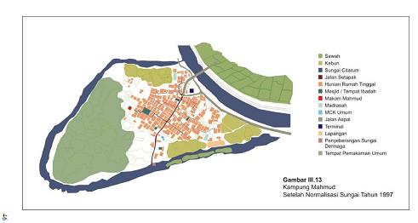
Rice field
Garden
Citarum river
Footpath
Residence area
Mosque
Ancestor cemetery
Boarding school
Public sanitation
Open space(field)
Canoe dock

Figure 4. Kampong Mahmud before Citarum river normalization [source: field observation]

Such normalization was done by meandering and widening the river, about 6-7 times the original width. The result of river normalization was that Mahmud Kampong is surrounded by the Citarum River. It also strengthened the clear separation of Mahmud Kampong into two areas: the built and natural environments. The built environment consists of residential centers, mosques, madrasahs, and cemetery areas, while the natural environment consists of farmland and green areas. The river normalization has made the river a physical boundary between residential and farmland areas in the northern part of Kampong. The normalization consists of river widening, inspection of the road along the river bank, bridge construction, and cohesively transforming the Kampong morphology in a secure area from flood threat. The normalization also supports farmland irrigation, which connects Kampong with the neighboring region. The preservation of farmland is a representation of ecology preservation as the character of vernacular Kampong.
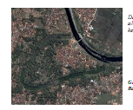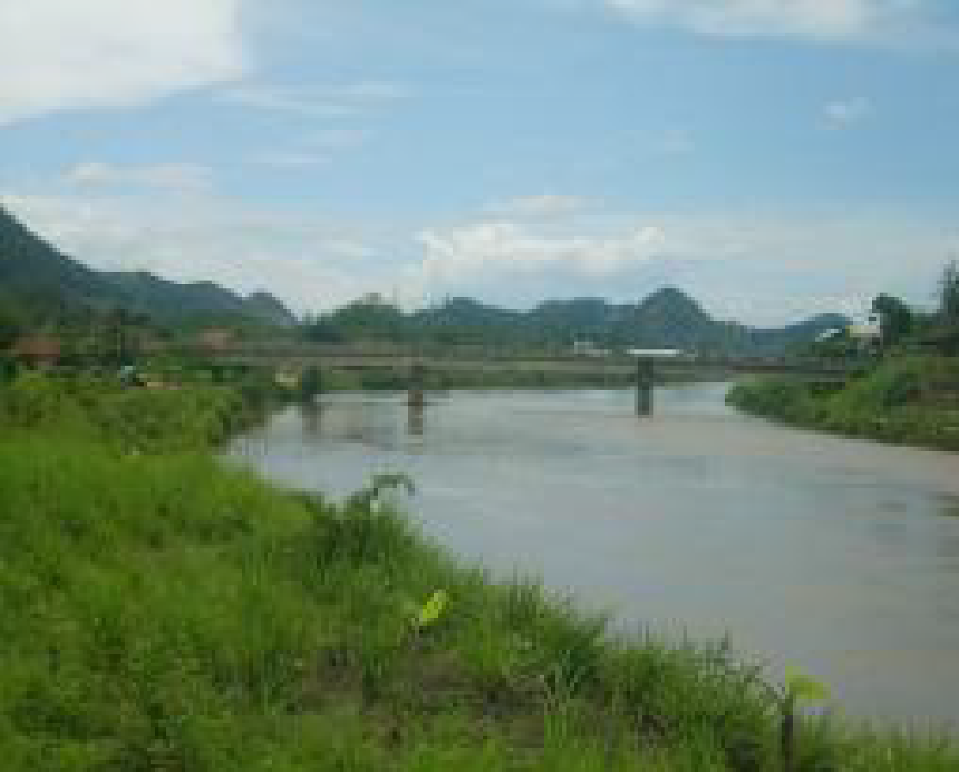
Figure 5. Kampung Mahmud after river normalization [source: field observation]

The normalization was followed by some steps, such as road construction for river inspections, the street outside the Kampong, which has access into the Kampong, the development of a public - transport terminal at the Kampong’s entry gate, and the preservation of the raft terminal in the southern part of the Kampong as vernacular infrastructure.
Such development preserves the natural environment, which supports the farmer activities as the most inhabitant profession, opening the Kampong gradually to accommodate external influences, especially new activities of the inhabitant, such as building component’s home industry. Such a new profession is gradually recognized by various regions outside Kampong. The other result is the enhancement of pilgrim activities of the Kampong, which are conducted by the visitors more intensively. River normalization supports the cohesiveness, and clarity of kampong morphology.
The overall revitalization of kampong morphology can be shown in two areas such as: 1) the central area, which functions as a dwelling house and public area, includes the ancestor cemetery place, in a secure area from flood threat, which strengthens the Kampong as a place for religious pilgrim, 2) nature environment area such as farmland area which guarantee the ecology of the Kampong, which preserve traditional farmer of the Kampong inhabitant. The process of normalization is shown in Figure 6.
The existence of a bridge and road connects the Kampong with the neighboring region. Such development has opened the Kampong to the neighboring region, which is supported by a public transport terminal at the entry-gate of the Kampong. Therefore, Kampong's openness drives its economic activities and intensifies the frequency of pilgrim visitors, as shown in Figure 7.
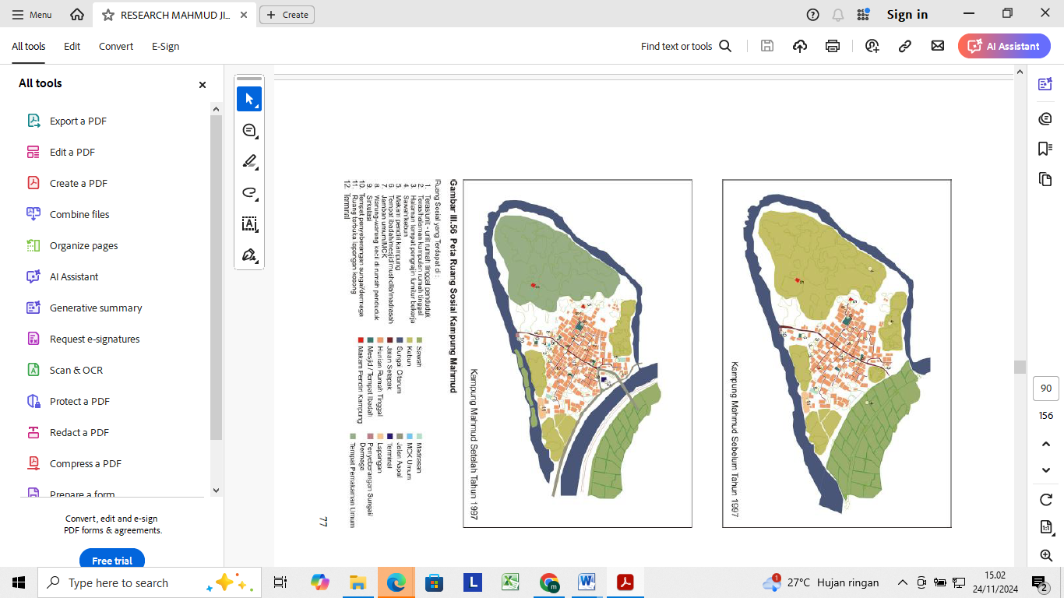
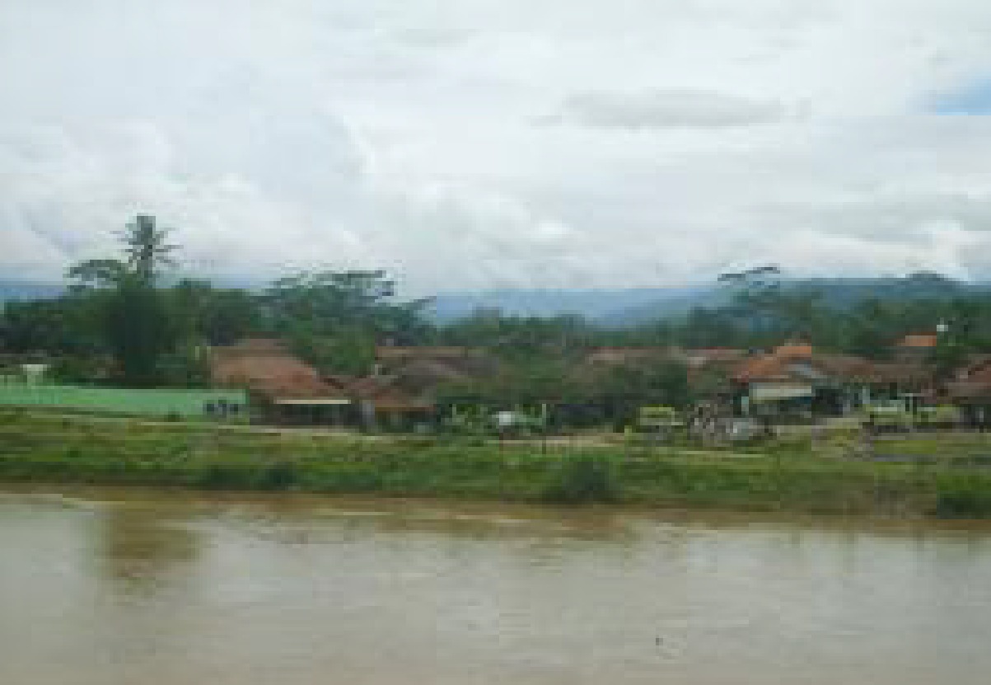

Rice field Ancestor cemetery Canoe dock
Garden Boarding school Public Cemetery
Citarum river Public sanitation
Footpath Asphalt road
Residence area Transpotation terminal
Mosque Open space (field)

Figure 6. Kampong Mahmud: before and after river normalization [source: field observation]

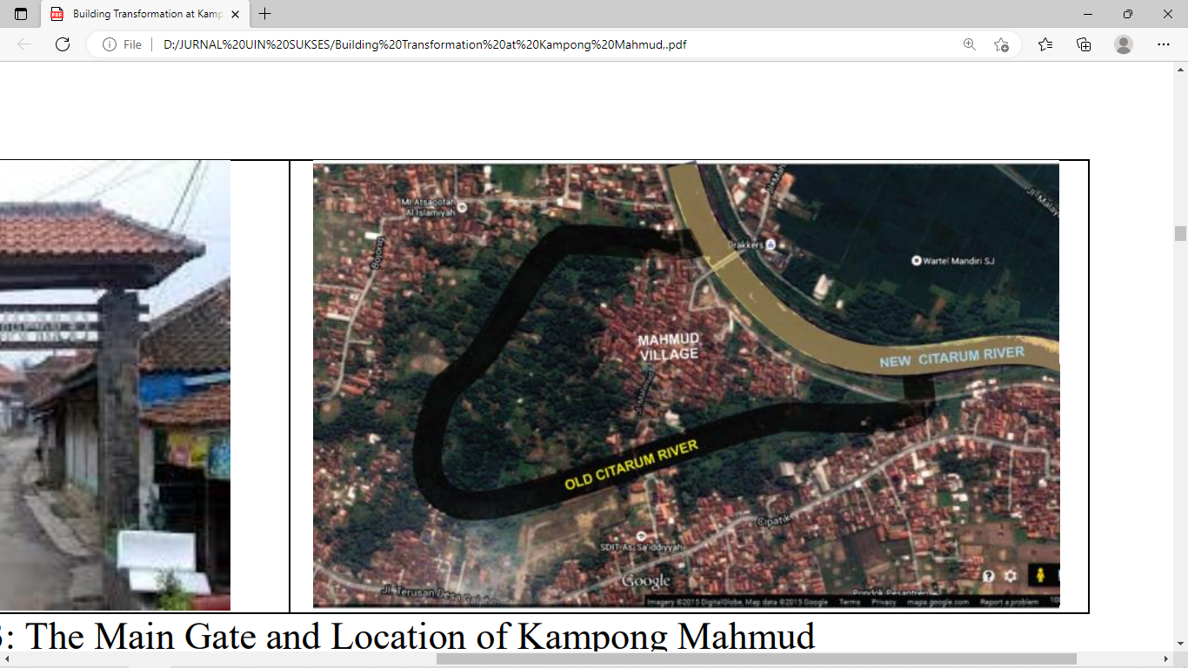

Rice field Ancestor cemetery Canoe dock
Garden Boarding school Public Cemetery
Citarum river Public sanitation
Footpath Asphalt road
Residence area Transpotation terminal
Mosque Open space (field)

Figure 7. Kampong Mahmud morphology after river normalisation [source: field observation]

The other result of river normalization to morphological Kampong is that the main road of the Kampong becomes significant as a generator of Kampong development, which can be seen in Figure 8. The main road strengthened the accessibility to Kampong and became more famous as a place of religious pilgrimage, the center of the woodcraft industry. Pilgrims from all over Bandung district and the West Java region visit the Kampong on a Friday night every week and religious events.

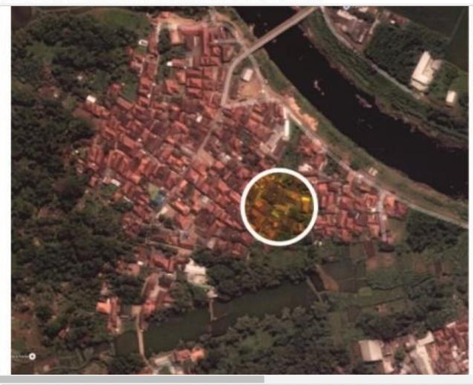 | 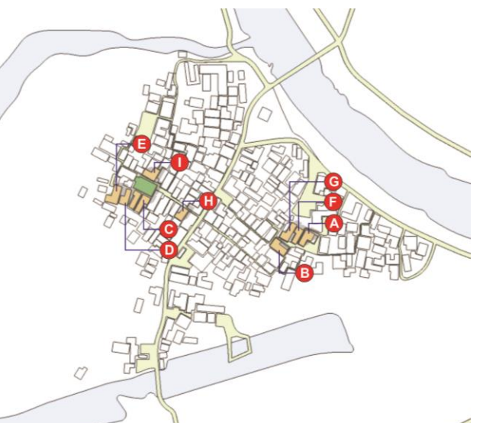  A,B,C,D,E,F,G,H are various tipology of vernacular building
Figure 8. Kampong development direction [source: field observation]

  - THE NEIGHBOURHOOD MORPHOLOGY
The Neighborhood Morphology considers principles of functional (Hasan), good (Thoyib), and aesthetic (Jamil), such as infrastructure development, such as the revitalization of roads, alleys, and open spaces. Some historians have suggested that the quarters of the neighborhood were originally determined by the lines of the principal roads [18] as the functional infrastructure of the neighborhood. Therefore, the natural main road of the Kampong marks the boundary between adjacent quarters. Natural road is the pattern of the road network that follows the social behavior of the inhabitant. Such a road aligns with the expectations of the proponents of natural neighborhoods. The road network is to render access to one location of the neighborhood area naturally. Such road revitalization, as neighborhood infrastructure, can be seen in Figure 9.
Such natural conditions can be overlooked by roads, alleys, and open spaces. Open space around the dwelling houses that once had been turned into a gardens, is provided by homestay. Open spaces between buildings are used for circulation and the inhabitants’ social activities. The contemporary economic activities of the inhabitants influence the neighborhood cluster. Bathroom facilities on each side of the dwelling house, yard, and patio, provided gradually by small shops or stalls, indicate that economic activity has changed the previous neighborhood morphology. The contemporary economic activity can be seen in communal spaces at the gate of pilgrim places, which developed naturally to be a place to sell. The merchants are the Kampong inhabitants and the outside traders. Such development has driven the evolution of neighborhood clusters to increase naturally, which pushes morphology wider. Such evolution can be seen in Figure 10.

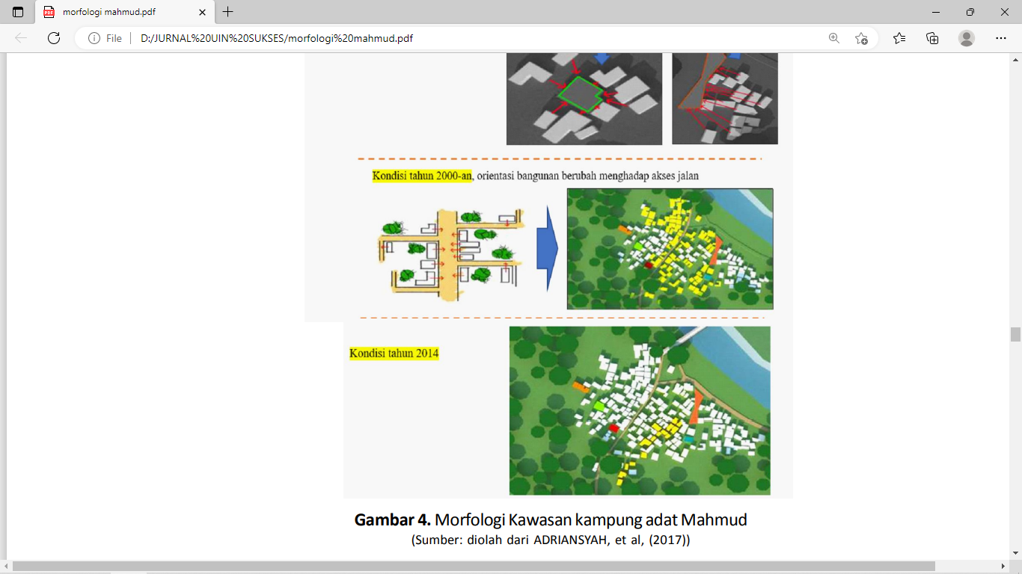
Figure 9 Evolution Neighborhood’s cluster development [source: Field observation]

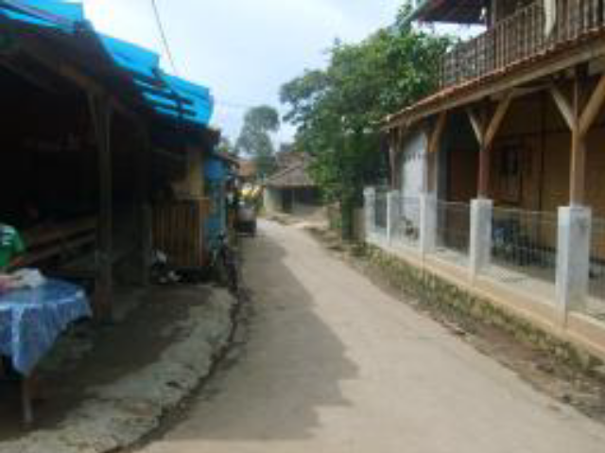

Figure 10. Neighborhood Infrastructure [source: Field observation]

Changes in the natural and physical elements in the northern part of the Kampong have revitalized the Kampong's character and the neighborhood community's social identity. Most of the people who have been farmers have expanded their profession to be traders, especially the furniture home industry. Normalization of the river, supported by bridge construction, makes the Kampong easier to receive the influence of outsiders. Such development creates social interaction between local inhabitants and newcomers, especially those who conduct spiritual and economic activities, such as pilgrim and trade. The revitalization drives social interaction and accessibility in the neighborhood’s cluster, which demands more alleys and outdoor space functions. Such neighborhood elements serve as a social, cultural, and economic function. Such spaces can be seen in Figure 11.

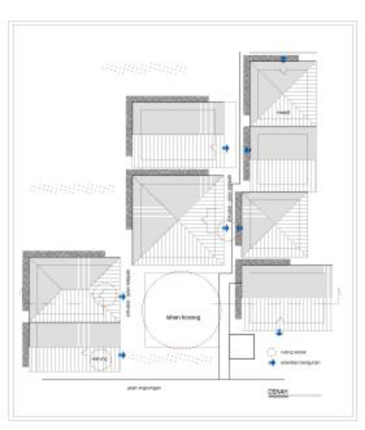  acessibility | 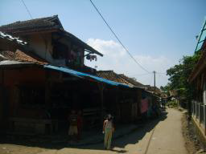  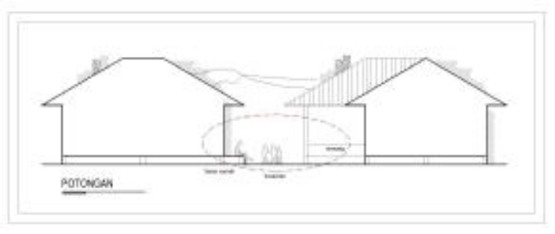
Figure 11. Social-interaction and accessibility in the neighborhood’s cluster [source: Field observation]

Open space is the main place for social interaction in the neighborhood. Such open space is supported by the dwelling house’s front yard. Such elements are integrated as a form of social terrace. A porch or front yard in a dwelling house allows the family members to interact. The neighborhood members also take advantage of the house’s terrace to interact with each other, such as children playing, parents caring for their children in the afternoon and evening, many more activities. Close distance, without physical boundaries between the dwelling houses, enables neighborhood members to interact with each other. Dwelling units form neighborhood clusters, which are connected by open spaces. Such open space for social-economy activities can be seen in Figure 12. Such space is the representation of harmony between social activities and contemporary economic activities.

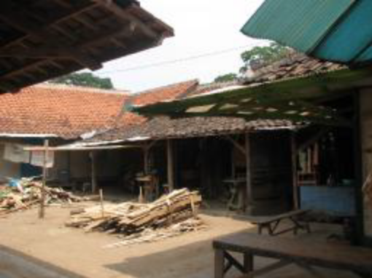 | 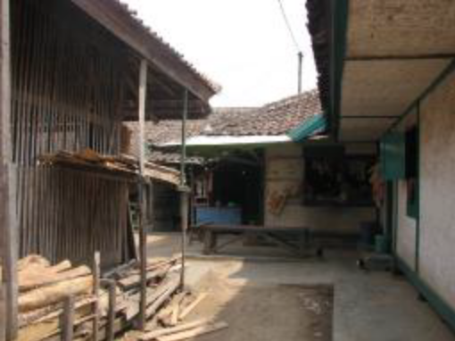

Figure 12. Open space between dwellings for social-economy activities [source: field observation]

Public facilities support the neighborhood spaces formed by the cluster of residential units. The building's gap is still wide enough to allow for circulation between neighbors. The orientation of adjacent buildings enables the function of the building's side as the primary social function. Such social space can be seen in Figure 13. Social relationships are formed by accommodations, mediated by enough building distance. Porch, yard, and circulation space formed a communal social space, where they used to work as a space for furniture crafting activities.

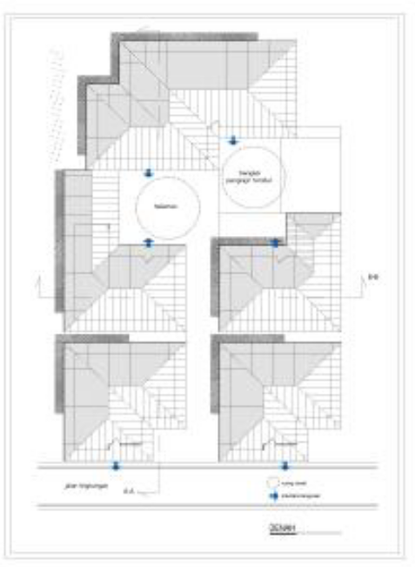  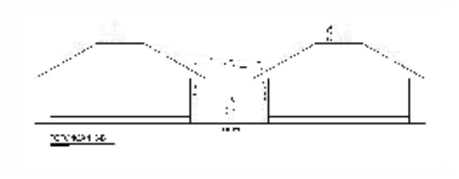 | 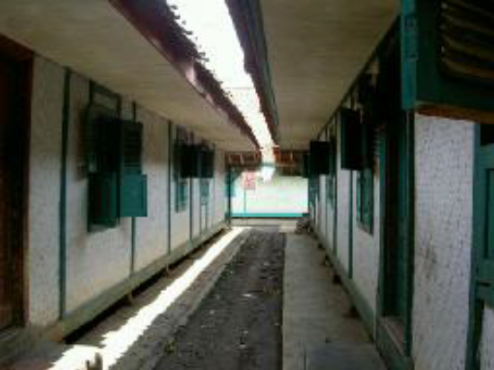
Figure 13. Space between dwellings for social interaction [source: field observation]

The side of the house is also used as a small shop or furniture industrial development. Although most of the trail leads to circulation, the building still has openings, such as doors or windows, often faced with neighboring houses’ openings. The condition is created because of a considerable distance between the building masses. The neighborhood is facilitated by public places, such as mosques and madrasas. The open space exists in the front of new mosques. Such a public place can be used as a communal space, as seen in Figure 14.
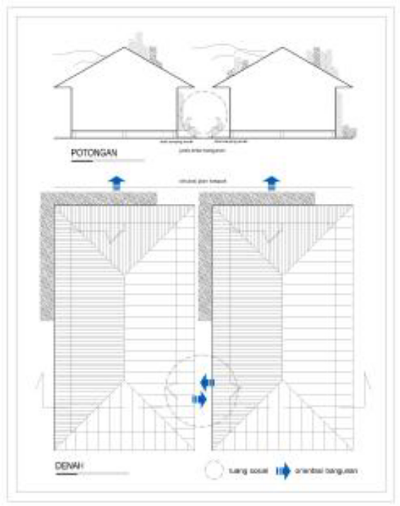 | 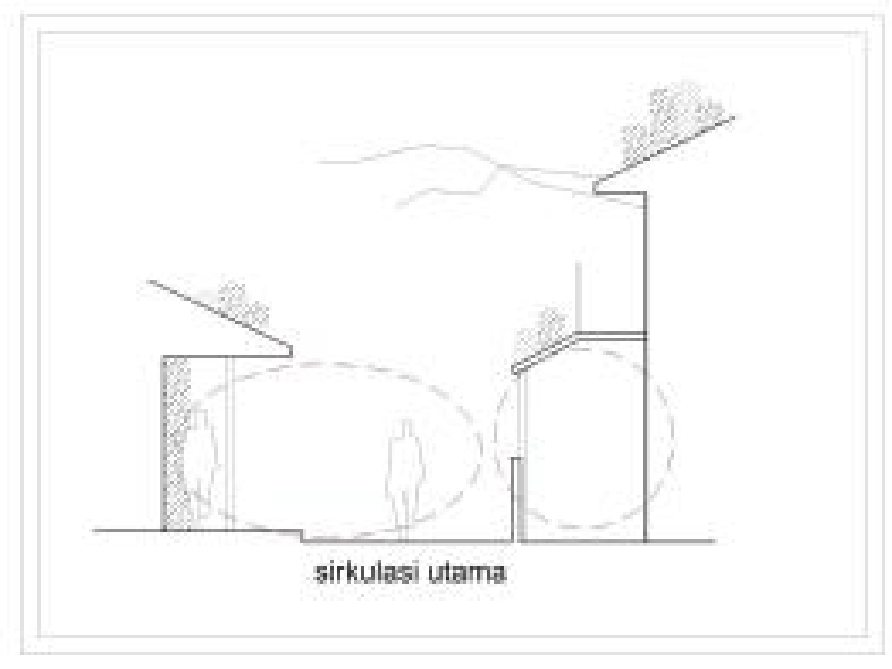
Figure 14. Communal space for social accesibilty and interaction [source: Field observation]

The main public place is the founder kampong’s tomb of the Eyang Mahmud family, where many people conduct the pilgrimage. The old mosque is located at the gate of the tomb, since the ancestor of the Kampong. The place is the center of the Kampong community, which has a historical relationship with the origin of the Kampong. Eyang Mahmud is believed to be the first Islamic scholar to spread the Islam religion to the area of Bandung city. All religious activities of the predominantly Muslim population took place at that place. Although there are other mosques for large religious activities, such as Friday prayers and religious celebrations, all done in the old mosque, constructed from a bamboo woven wall, the building size is 12x24 m², providing religious and social significance. A mosque is a combination of physical space, the process of religious formation, and the symbolic meaning of the object. Open space forms, facilitates, and accommodates social relations in the mosque. Mosques are a physical limit to the religious activities of the residents. Religious activities that stimulate social interaction between the inhabitants exist in open spaces around the mosque. The mosque became a religious facility that serves as a social space, not only for kampong community members but also for visitors who wants to do make a pilgrimage. They worship before and after the pilgrimage to Eyang Mahmud’s tomb near the mosque. Religious activities that can stimulate social interaction were done in the mosque's building's open space, as shown in Figure 15. The similarity of the visitors’ interest in going on pilgrimage enabled them to interact, creating a social space for visitors who make the pilgrimage. Public facilities for religious activities are available in most neighborhoods, although in the form of a small mosque. The new mosque is only used for daily worship and prayers five times every day. The Friday prayers and other religious festivals occur in the old mosque in the western part of the Kampong. It can be seen in Figure 15.
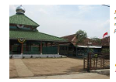
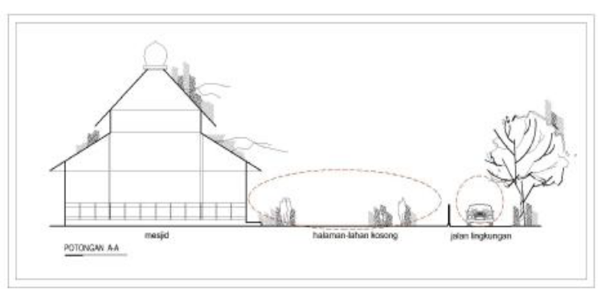

Figure 15. Mosque building and open space [source: field observation]

The mosque is a religious facility supported by social interaction in the madrasa, located in the eastern part of Kampong. The madrasa is also a place for children to recite the holy Qur’an every evening. Open space, in the form of the building's front yard, is formed by integrating each building into the surrounding areas. Such a place becomes a place for kids to play before and after the class. There is also open space between the madrasa and the outskirts of the river, the form of a lawn and garden around the madrasah, enabling social activities among the children. In the open space, territories were created for the children, and an association of social links was formed, mediated through the courtyard and open space in such fields. It can be seen in figure 16.

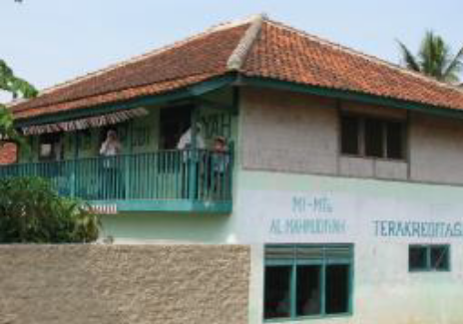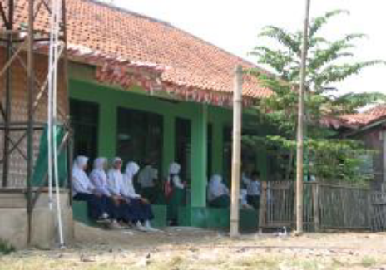

Figure 16. Madrassa and open space [source: field observation]

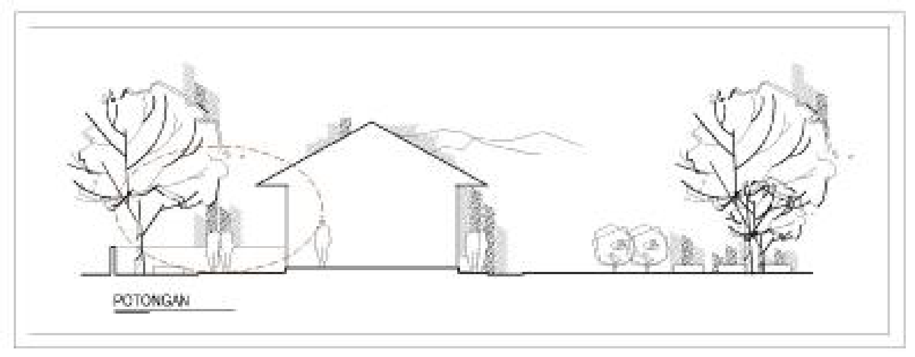
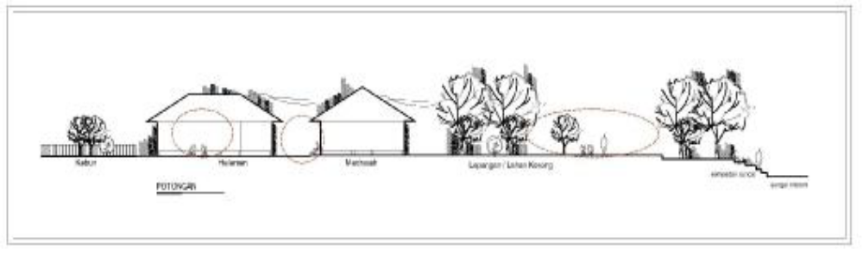
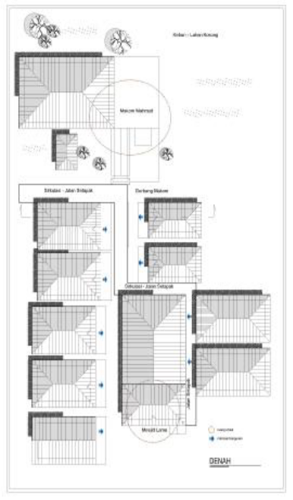
Open space at the front of the madrasa results from the integration of orientation that formed in the surrounding buildings. The existence of the space creates harmony with the open space in the form of an empty field on the outskirts of the river where the children play. Open space in the form near the madrassa is an integrated part of the open space of a building. The same pattern of activity integrates each space. Buildings and open spaces that become part of the social space formed in the Kampong settlements. Well-ordered forms of mass religious facilities, such as buildings with open spaces were also found in the area where the new mosque was established. Though new, this mosque is physically trying to apply the norms of the Kampong by banning the use of glass materials in buildings. So, the mosque walls were made of wood frames and polycarbonate. The mosque became a place of worship for residents and visitors who did the pilgrimage. It can be seen in Figure 17.

Figure 17. Social space for madrassa (school) [Source: field observation]

This public facility is also for inhabitants to interact with each other. Public toilets are in front of the new mosque, as a means of support for religious activities. Social interactions in public sanitation, such as toilets, make the facility part of the Kampong social space. Public facilities can be seen in Figure 18.

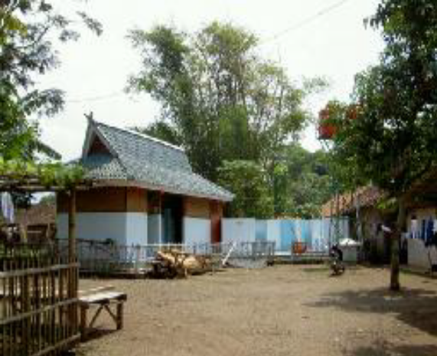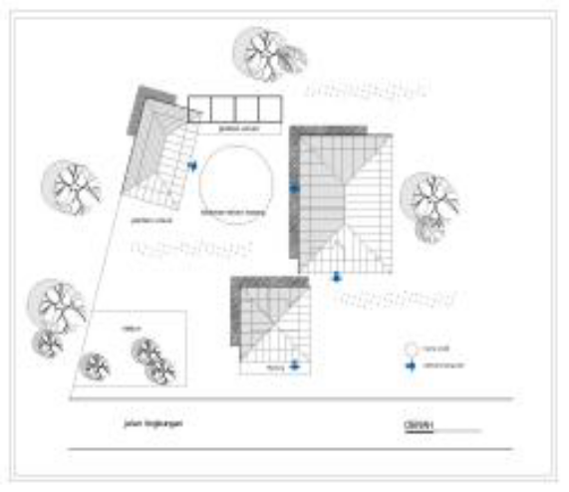
Figure 18. Open space for public sanitation area [source: field observation]

The mosque’s courtyard accommodates religious activities and other community events here. New mosques and open spaces in front of it became a place for people to carry out religious activities and celebrate national holidays. The new mosque became a node for kampong settlements. The existence of open space at the front of the mosque element supports the formation of social space. In addition to the existence of madrasahs and mosques as public and social facilities, there is also a formal school madrasah, tsanawiyah junior high school level. Although the infrastructure is adequate, its existence has not been able to be an important element in forming kampong settlements. Schools on the western outskirts of the Kampong, next to the Citarum River, are educational facilities for the citizens who are mostly educated. It remains in the Kampong settlements into supporting elements forming social relationships in the hometown. School became a physical space for activities that also accommodated social activities, as can be seen in Figure 19.

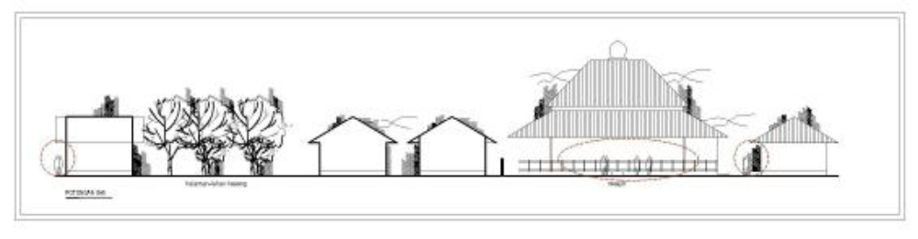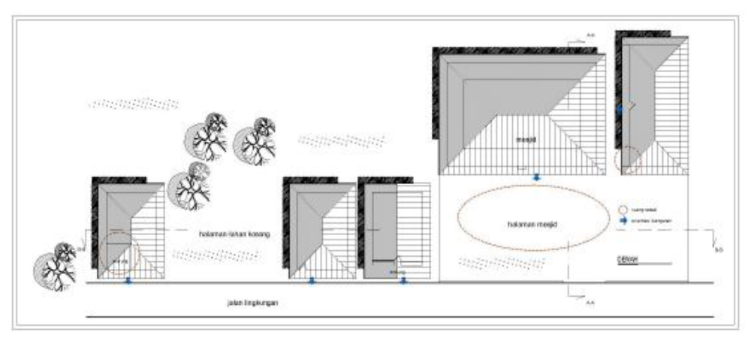 | 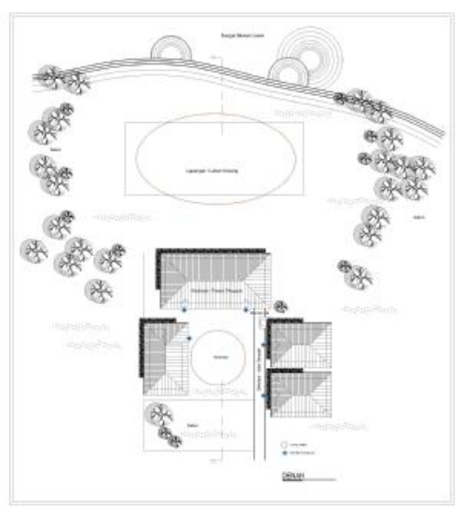
Figure 19. Open space as infrastructure for religious activities [source: field observation]

The revitalization of neighborhood morphology enhances sociocultural space, religious activities, traditional education activities, and contemporary economic activities. Such space accommodates visitors and the neighborhood's inhabitants, indicating increased interaction between visitors and kampong inhabitants on the neighborhood scale.

  - DWELLING HOUSE MORPHOLOGY
Revitalization of dwelling house Morphology, which considers principles of functional (Hasan), good (Thoyib), and aesthetic (Jamil), refers to the typo-morphology of buildings. Residential parts of the Kampong population in the form of dwelling houses are in the center of the Kampong. Residential buildings typology has stilt houses made of bamboo woven for walls. The residence is equipped with livestock pens, goats or sheep at the back of the building, and it is provided by utilization under the house for chicken cages. Space in any dwelling formed by simple division consists of a living room, family room, or bedroom next to the kitchen or behind the house.
Houses in the Kampong range from small size 4 x 6 m², 5 x 7, to 6 x 8 m². A broader measure is completed by the side (pipir) of the building, forming a patio or yard for the kids to play. Houses of Mahmud's inhabitants were mostly made of bamboo-woven houses on stilts. The main structure is made of wood, with a height of 30-50 cm from the ground. The degree of homogeneity of the mass building, which is still largely in the form of bamboo walls and a stylish stage, creates a distinctive rhythm to the character of the Kampong. The previous use of palm fibers/shingle roofs was changed into roof tiles. Door and window openings made of wood, are completed using wood jalousie. A customary rule of the Kampong prohibits fabricated materials such as glass as a building material. The low density is indicated by mostly a one-story residential dwelling. The dwelling house’s components can be seen in Figure 20. Such a house’s material components indicate that the vernacular character is more human than modern Kampong in the Bandung district.

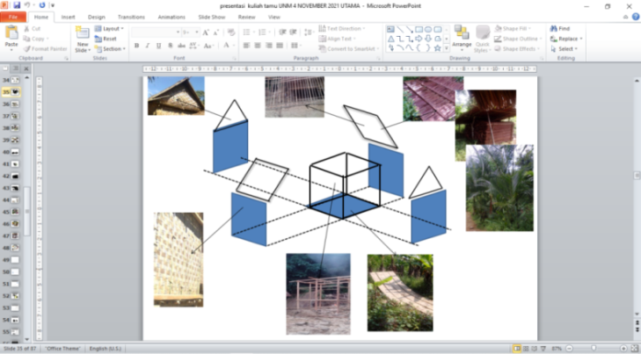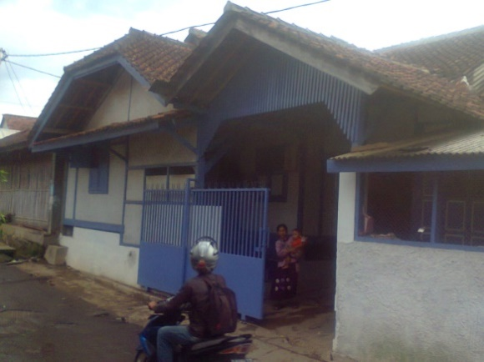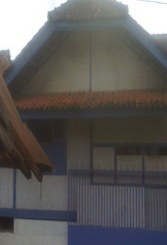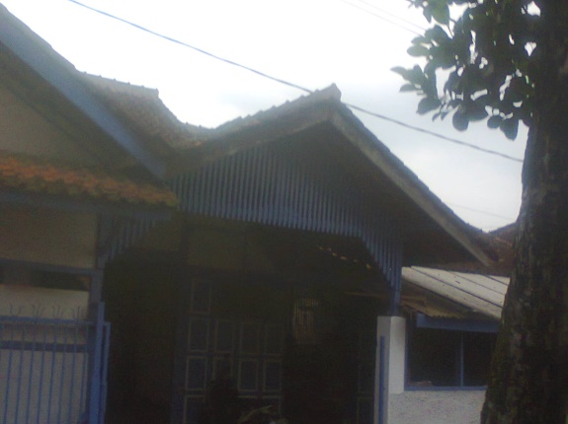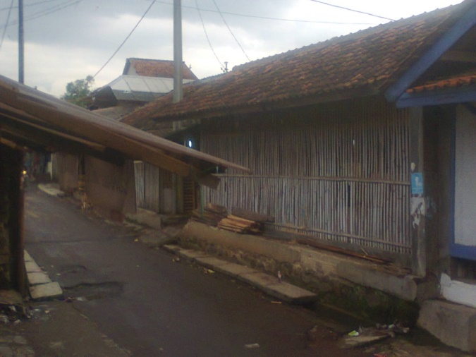

Roof component
Wall component
Rigid frame component
floor component

Figure 20. Dwelling house’s components [source: field observation]

Houses that still maintained room for a courtyard or patio became the initial order of the mass of kampong settlements widely. Each house was later expanded independently into a group of dwelling houses. Open space in the form of circulation, patio, yard, and garden become binding elements that make up the order of the cluster of the dwelling houses. Using glass in building materials is forbidden, as a norm still held. Violating the unwritten rules can lead to discomfort for the families who occupy it. Family members can fall sick, even to death. The typology of the dwelling house can be seen in Figure 21.

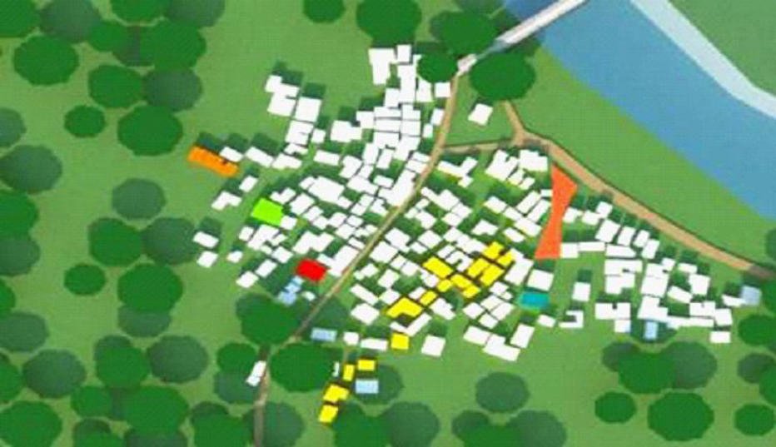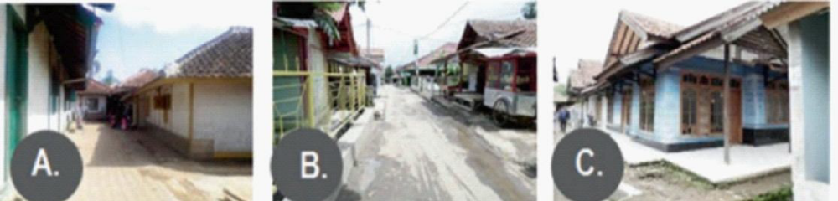
A
B
C

Figure 21. Dwelling house’s typology [source: field observation]

Normalization of the Citarum River has been undergone since 1997, but the vernacular characteristics of the Kampong are still preserved. Citarum River alignment as separate residential dwelling settlements with agricultural land being the main livelihood does not directly influence the identity of the Kampong, which is still known as Mahmud's pilgrimage (jiarah) hometown. Physical changes in the real Kampong after 1997 did not alter the characteristics of the Kampong as a spiritual place. Still visited by pilgrims from various regions, especially on Friday nights.
Changes in the patio and yard function into stalls (kiosks) are followed by a physical change in residential units. The use of stalls, due to the economic activity of most of the Kampong, changed their house into a two-story building, primarily located along the main roadsides. Mahmud Kampong is becoming increasingly open to newcomers, as shown by several dwelling houses in front of the Kampong, which is physically different from the origin of customary Kampong. Such conditions could be found in houses made of bricks, tiles, and glass as a window or door material. Most of the dwelling houses of the Kampong use building materials, which are made of natural materials, such as wood or bamboo, and avoid the use of fabricated materials, such as glass and other modern materials. Such development can be seen in Figure 22.

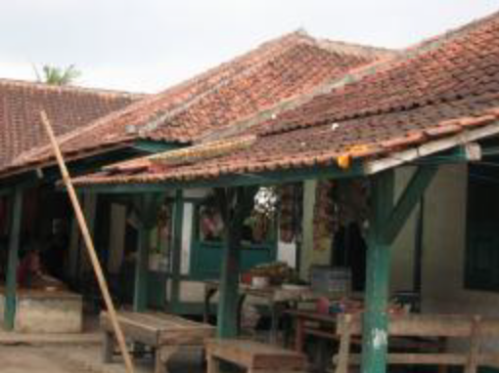

Figure 22. Dwelling‘s typology with warung (stall) [source: field observation]

Revitalization of the Kampong upgraded the ability of the inhabitants, especially the addition of work-profession, such as the home furniture industry. Nowadays, the inhabitants of the Kampong are expanding their profession. Therefore, there is additional space in the dwelling houses, such as additional space for a warung (stall) and kitchen, furniture home industry and storage, small shop, terrace for living room, additional bathroom, additional kitchen, and additional dwelling for a second floor. The revitalization influenced the variation development of dwelling house morphology but still preserved the vernacular character of house form, material, and construction. The addition of houses and variations can be seen in figures 23 and 24.

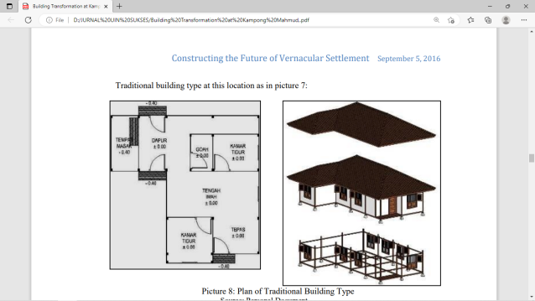  Pawon  (Kitchen)  Space  for cooking  Goah (storage)  bedroom  Tengah imah  (living room)  Tepas  (verandah)  bedroom | 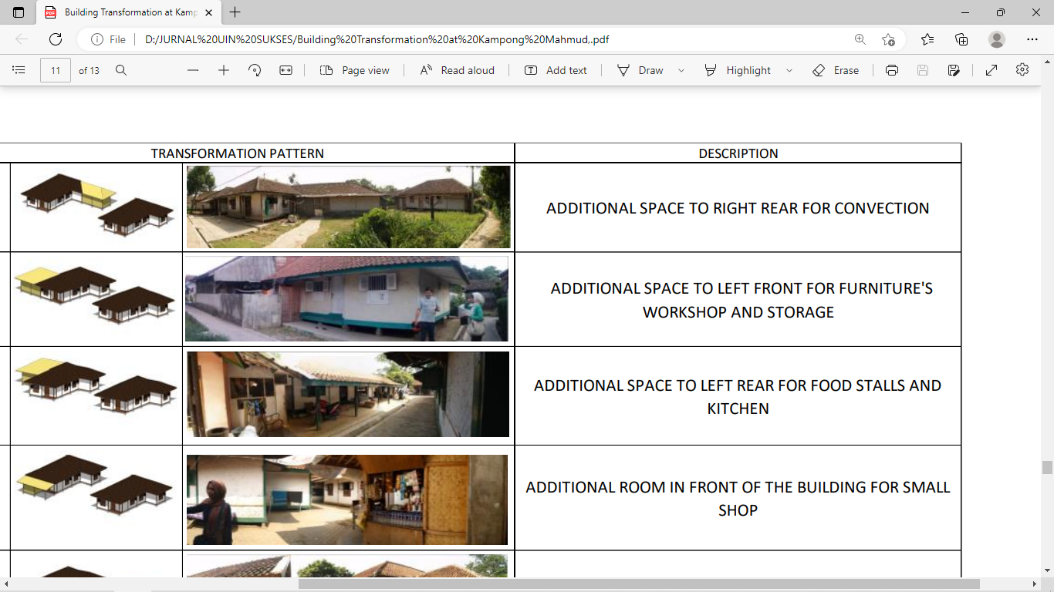  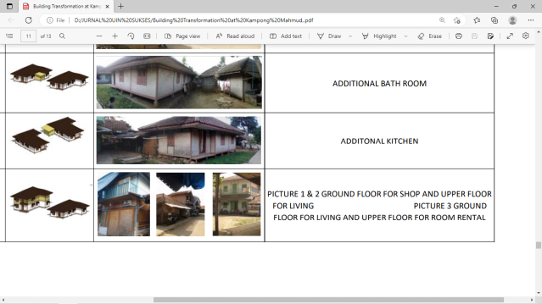
Figure 23. The origin dwelling house [source: field observation] | Figure 24. Various additional spaces of the original dwelling [source: field observation]
  - ENVIRONMENT FRIENDLY-MORPHOLOGY
Revitalization of kampong adat Morphology, which considers principles of functional (Hasan), good (Thoyib), and aesthetic (Jamil), must consider environment friendly-morphology. The primary access to the Kampong entrance Mahmud was getting stronger by the presence of the bridge across the river Citarum that was built after 1997. The main entrance gate of the Kampong is directly next to the southern tip of the bridge. The main circulating form of the linear order is an important element forming dwelling masses. Circulation continued to elongate towards the southern part of the Citarum River, connecting the Kampong with the outside territory. Old and new Citarum Rivers become a physical boundary that surrounds the Kampong. The boundaries of a river as a natural element surrounding the Kampong give Mahmud a clear physical boundary, which can distinguish it from other urban kampongs.
Using soil material surface influences nature's performance, especially in overcoming climate problems. Such a case is related to albedo, or reflection coefficient, the surface’s diffuse reflectivity or reflecting power. The higher the number of albedo, the more reflected the character of the surface. The lower the albedo number, the more absorbed the surface character.
Most house materials are natural, and supported by natural open spaces in Mahmud Kampong. Fabricated material is used at least as much possible. Such material usage provides the Kampong with environment- friendly conditions. Therefore, the albedo of the Kampong is relatively low, as seen in Table 2. The sun's radiation can be absorbed by the natural surface, supported by the availability of green areas of the Kampong, such as trees, vegetation, and vast farmland areas. Such low albedo indicates that the physicality of the Kampong is environment friendly, which gives thermal comfort to the inhabitants.

Table 1. The surface albedo of the Kampong [source: field observation]
Number | Place of Social Space | Albedo  Before normalization | Albedo  After normalization
1 | Terrace of dwelling house | 8-9 | 8-9
2 | Open space for dwelling cluster | 8-9 | 8-9
3 | Hall/yard for furniture home industry | 8-9 | 7-8
4 | Rice field/park | 8-15 | 8-17
5 | Cemetery of the Kampong founders | 8-9 | 8-9
6 | Places for worship and education | 8-9 | 8-9
7 | Public sanitation | 9 | 8-9
8 | Stall within house | 9 | 8-9
9 | Circulation space | 6-8 | 6-8
10 | Terminal for raft transport | 6-8 | 6-8
11 | Open spaces | 6-8 | 6-8
12 | terminal for public transport | 8-9 | 9-10
- CONCLUSION
Vernacular communities could implement revitalization in the context of Islamic sustainability, which contains functional (Hasan), good (Thoyib), aesthetic (Jamil), in the level of Kampong, neighborhood, finally, dwelling house in Mahmud kampong, Bandung district, West Java. The central aspect of revitalization is how revitalization still preserves the socio-culture of the Kampong, which has a background of the natural environment but accommodates new functions of urban development. Both approaches preserve the Mahmud as Islamic customary Kampong, related to Eyang Mahmud, the first preacher who spread Islam in the Bandung district.
Such revitalization is in the context of sustainability of the natural environment, socio-cultural activities of the Kampong as a religious pilgrim place, and accommodating contemporary economic activities. The revitalization was implemented in three scales: 1) Kampong, which was implemented by Citarum River normalization. The result of river normalization was that Mahmud Kampong is surrounded by the Citarum River, strengthening the clear separation of Mahmud Kampong into two areas: the built environment and the natural environment. Overall, Kampong has been in a secure area from flood threats. The construction of the main road and river bridge, supported by a traditional and modern public transport terminal, opened the Kampong to interact with the neighboring region. Such revitalization enhances the Kampong as the center of social culture and economy, especially religious pilgrim and furniture home industry in the Bandung district region. 2) At the neighborhood scale, revitalization influences the lines of the principal roads, alleyways, and open space lines. Such development supports the socio-cultural and economic function of the dwelling neighborhoods, modern mosques, historical mosques and madrasa, and other public facilities. Such development forms various clusters of dwelling houses, 3) dwelling houses. The revitalization influenced the profession of the Kampong inhabitants, which expanded the previous profession of farmers. Therefore, there is additional space in the dwelling house, such as warung (stall) and kitchen, furniture home industry and storage, small shop, terrace for living room, additional bathroom, additional kitchen, and additional for the second floor. The revitalization influenced the variation development of dwelling house morphology but still preserved the vernacular character of house form, material, and construction; 4) environment friendly, the albedo number kampong is relatively low. The albedo number indicates the degree of reflection of sun radiation on the surface.
The Islamic values that embodied the revitalization of Mahmud Kampong can respond to the issue of a sustainable environment. Sustainable, with great respect to environmental concerns, especially the preservation of farmland and green areas of the Kampong Mahmud, meanwhile responds to contemporary demands such as new socio-economy activities. The values will be meaningful in encouraging the Kampong inhabitants to live in harmony with nature, while accommodating contemporary development. Such a spirit is written in the Qur’an Surah Al-Araf 56: "And do not do mischief on the earth after (God) to fix it, and pray to him fear (not accepted) and expectations (be granted). Verily Allah's mercy is very close to those who do good”.
Such realization of Islamic sustainability is the revitalization that responds to contemporary demands of urban development, such as contemporary economic activity, but still in harmony with nature, such as preserving the socio-culture of the Kampong life. The social-culture aspect of the Kampong has a significant relationship to its heritage of the Kampong, as an Islamic pilgrimage center or the most traditional Muslim in the Bandung district.

REFERENCES
[1] R.Rose, Morphology in Architecture, Yogyakarta: Arsitektur-UGM, 1979
[2] V.W.Y. Tam, I. W. H. Fung, and M. C. P. Sing, “Adaptive reuse in sustainable development: An empirical study of a Lui Seng Chun building in Hong Kong,” Renew. Sustain. Energy Rev. vol. 65, pp. 635–642, 2016. Doi: https://doi.org/10.1016/j.rser.2016.07.014
[3] M. S. Moosavi, “An Analysis to Challenges and Contradictions in Revitaiisation of Historic Center of Cities in Iran,” Interdiscip. Themes J. vol. 3, no. 1, 2011.
[4] P. Oliver,ed., Encyclopedia of Vernacular Architecture of the World, vol. 1, Cambridge: Cambridge University Press, page xxviii, 1997.
[5] J. P. Steadmen, Architectural Morphology: An Introduction to the Geometry of Building Plans, London: Pion Limited, 1983
[6] M. P. Pearson, C. Richard, Architecture and Order, Approaches to Social Space, London: Routledge, 1994.
[7] R.Krier, Urban Space, London: Academy Edition, 1984.
[8] A. B. Sarjono, S, Nugroho, “Menengok Arsitektur Permukiman Masyarakat Baduy Arsitektur Berkelanjutan dari Halaman Sendiri”, Jurnal Teknik Sipil dan Perencanaan. Vol. 19, no. 1, pp. 57-64, 2014. Doi: https://doi.org/10.15294/jtsp.v19i1.9499
[9] E. Darmawan, H. Haryanto, “Konsep Arsitektur Berkelanjutan Pada Tata Ruang Kota (Studi Kasus: peralihan Fungsi Lahan hijau Menjadi Perumahan)”, Modul, Vol. 13, No. 2, pp. 49-56, 2013. Doi: https://doi.org/10.14710/mdl.13.2.2013.49-56
[10] B. Sudarwanto, E. E. Pandelaki, S. Soetomo, “Pencapaian Perumahan Berkelanjutan 'Pemilihan Indikator dalam Penyusunan Kerangka Kerja Berkelanjutan'”, MODUL, Vol. 14, no. 2, pp. 105-112, 2014, doi: https://doi.org/10.14710/mdl.14.2.2014.105-112
[11] M. I. Hasan, T. W. Murtini, S.R. Sari, “Sustainable Architecture Responsed by Islamic Architecture for Better Environment”, Journal of Advances in Agricultural & Environmental Engg. (IJAAEE), Vol. 3, no. 1, 2016.
[12] A. Rapoport, House Form and Culture, Englewood Cliffs, N.J.: Prentice-Hall, 1969.
[13] J. Gutierrez, “Notes On The Seismic AdequacyOf Vernacular Buildings”, 13th World Conference on Earthquake Engineering, pp. 1-6, 2004.
[14] Ņ. Natalija, “Basic principles of revitaiisation of degraded territories, creating new identity and image of place, social values, public participation”, Project of the Interreg Latvia-Lithuania cross border cooperation programme 2014-2020, Ludza, Latvia,2019.
[15] A. Rapoport, The Meaning of the Built Environment, A Nonverbal Communication Approach, California: Sage Publications, 1982.
[16] A. Rapoport, Human Aspects of Urban Form, towards a Man-Environment Approach to Urban Form and Design, Oxford: Pergamon Press, 1977.
[17] Indrawati, “Lanskap Budaya Permukiman Islam-Jawa di Majasto”, Program Doktor Arsitektur dan Perkotaan Program Pasca Sarjana Universitas Diponegoro, 2015.
[18] A. H. Hourani, “The islamic city in the light of recent research”, The Islamic city. A colloquium, Oxford, 1970.

