 |  | JOURNAL OF ISLAMIC ARCHITECTURE  P-ISSN: 2086-2636 E-ISSN: 2356-4644  Journal Home Page: http://ejournal.uin-malang.ac.id/index.php/JIA
THE ARCHITECTURE OF LANGGAR DHUWUR IN JAVA: VERNACULAR FORMS IN RELIGIOUS ARCHITECTURE
Arif Budi Sholihah^{a*}, Asrul Mahjuddin Ressang^{b}, Wisnu Setiawan^{c}
ªDepartment of Architecture, Universitas Islam Indonesia, Yogyakarta, Indonesia
^{b}Department of Architecture, University of Malaya, Kuala Lumpur, Malaysia
^{c}Department of Architecture, University Muhammadiyah Surakarta, Surakarta, Indonesia
*Corresponding Author: arif.sholihah@uii.ac.id
ARTICLE INFO |  |  | ABSTRACT
Volume: 8  Issue: 1  Page: 106-116  Received: May 10th, 2023  Accepted: November 28th, 2023  Available Online: June 30th, 2024  DOI:  http://dx.doi.org/10.18860/jia.v8i1.21107 |  |  | Research on Friday Mosques dominates the study of religious buildings in Java. Meanwhile, research on small mosques, particularly Langgar Dhuwur, remains limited. The purpose of this study is to examine two Langgar Dhuwur in Kauman Yogyakarta from architectural and narrative perspectives in order to reveal the architectural characteristics as well as their role in society. Direct visual observations, measured drawings, and narratives about the study’s context were conducted. Five major themes from the observations were analyzed and discussed to draw significant conclusions. It is concluded that Langgar Dhuwur is a unique architectural type that preserves Indonesia’s vernacular and pre-Islamic architecture. Langgar Dhuwur in Kauman designated the second floor as a sacred area following the Hindu-Buddhist concept of Triloka (Svarloka). As a public building, Langgar Dhuwur serves as a place of worship as well as a cultural and social center. Therefore, it can be regarded as one of Indonesia’s religious architectural treasures due to its distinctive architectural style and rich history. It is recommended that the existence of Langgar Dhuwur, which has a multifunction role in community development, be preserved. Future designs needs to emphasize an architectural typology that follows residential architecture, flexible space, and an open plan to accommodate various activities in the micro-scale community area.  Keywords:  Religious architecture, Langgar Dhuwur, vernacular architecture

- INTRODUCTION
Friday Mosque continues to be the primary research focus on mosques in Java. Few studies have been conducted on small mosques, commonly as called Langgar. The typology of Langgar is comparable to that of surau in Sumatra or Malaysia and tajug in West Java. We argue that the existence of Langgar in Java is not limited to its function as a private place of worship for the owner's family or the surrounding community but is also related to the emergence of a pesantren (Islamic Boarding School) or madrasa (Islamic School) in the early stages of its development. In many cases, Langgar also serves as a community gathering place, with women and children spending most of their time there. Adult men spend most of their time at the Friday Mosque.
Now that more mosques are being constructed, the existence of Langgar is dwindling, or Langgar is being replaced by the term musholla (a place for prayer in Arabic). In Indonesia, the term musholla is more commonly used to refer to a place of worship, whether it be a dedicated building or a prayer room included in the regular living quarters of a Muslim household. The term Langgar, on the other hand, is still commonly used, particularly in older city or rural areas. Langgar Dhuwur or Langgar Tinggi (Dhuwur in Javanese or Tinggi in Indonesian means High) is one of the typologies whose existence is on the verge of extinction. The wooden prayer room on this structure’s second floor exemplifies the building’s unique character. Kauman in Yogyakarta is one of the Javanese Islamic districts that has preserved the Langgar Dhuwur architectural style. Since the establishment of Yogyakarta as the capital of the Ngayogyakarta Hadiningrat Sultanate in the eighteenth century, this region has been inhabited by Muslims.
This study aims to examine two Langgar Dhuwur in Kauman from an architectural and narrative perspective to reveal the architectural characteristics as well as the function of the Langgar Dhuwur in society so that it can be considered one of the architectural treasures of Nusantara architecture with an Islamic pattern and typology, as well as one of the architectural treasures of Indonesian architecture. Moreover, according to a literature review conducted in certain nations, Islamic religious architecture is primarily or exclusively referred to as a mosque or mosque complex. No other building type is comparable to the Langgar building, and this study will reveal its cultural significance, enabling it to be recognized as a cultural heritage that must be preserved architecturally and socio-culturally.

  - MOSQUE ARCHITECTURE IN JAVA
The form of the earliest Indonesian mosques on Java, constructed in the fifteenth century, was determined by a combination of Islamic and indigenous ideas. The origins of multi-tiered roofs (tajuk) can be traced back to pre-Islamic temple reliefs and are directly related to Balinese Meru roofs [1]. The mosque architecture in Java may have been derived from the local community buildings that can be seen today as Pendapa in Java and Wantilan in Bali [2], and a sacred building with a five-roof overlap as seen in relief in several temples, including Candi Sukuh in Central Java. The relief from the Sukuh Temple depicts a sacred building with a five-tiered roof and a four-pole building as a public gathering place, which was likely an architectural reference for mosques design.

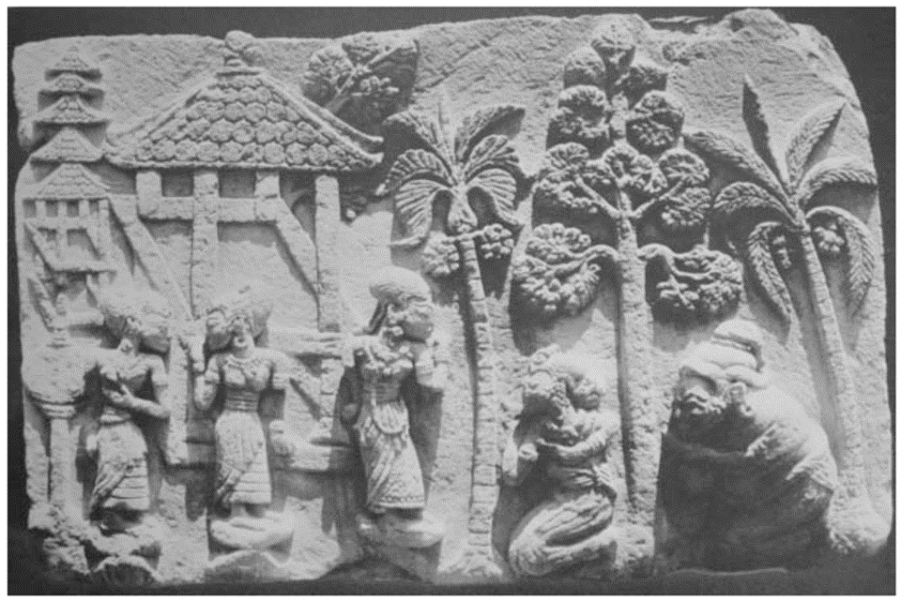
Figure 1. Scene from the Sudamala, Sukuh Temple, Central Java, 15th century [3]

  - LANGGAR DHUWUR AS A VERNACULAR FORM OF RELIGIOUS ARCHITECTURE
Langgar is a small prayer house, typically attached to an individual house or a separate structure [4], used for five times daily prayer but not for Friday prayers [5], [6], a merchant-built small mosque on a pole [2], [7]. The term Langgar is related to Sanggar (the Sanskrit word for a place for learning, studio, or place of worship) [8], which refers to a place of worship that is part of an ancient Javanese home or within the scope of a family [9].
Langgar is frequently interchanged with Surau (in Sumatra and Malaysia) and Tajuk (in West Java). In addition, due to the development of the language, the term Musholla is more commonly used to refer to small mosques in Indonesian (from the Arabic word musholla, which means a place for prayer). Walisongo (refer to Nine Pioneer Wali or Ulama who spread Islam in Java in the 15th century) did not necessarily change the cosmography of a Sanggar or Langgar to Musholla to make it more “Islamic”. Instead, they kept their original vocabulary as an acculturative preaching strategy towards the existing Javanese belief culture (Kapitayan or Kejawen) and Hindu Buddhist communities [9].
According to [10], there are four styles of Langgar architecture in Java, including the Langgar Tropo or Angkringan, consisting of a wooden house on stilts, bamboo booths, and a saddle roof. Langgar Gedong is frequently a variant of Langgar Tropo. The structure is no longer a stilted house but has a stone foundation, brick walls, tiled floors, and a pool for bath (Blumbang). The final is the Langgar Meru, so named because the roof is three-tiered (Tajuk), permanent, with a mix of masonry and exquisitely carved teak wood walls, a tiled roof using Mustaka with flower bud motifs, and the Langgar room is decorated with numerous ornaments and calligraphy, typically built by wealthy people of his time.

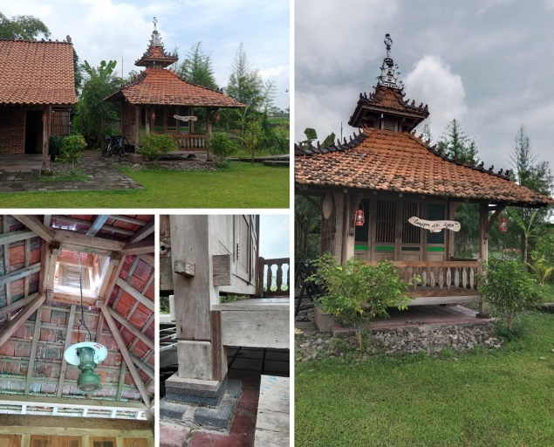
Figure 2. A Replica of Langgar Tropo Nearby Yogyakarta

Functionally, Langgar is the smallest religious building entity or Islamic institution in Javanese society [11]. Madura Island (a small island to the north of Java) is designated as a neighborhood school where children learn fundamental religious lessons, such as reciting the Qur'an and performing rituals such as daily prayers [12]. According to Geertz [4], Langgar serves as a school, a place of worship, and a location for religious brotherhood, all connected to the Javanese and the larger Islamic society. Tarekat was another form of mysticism practiced by the Langgar. In terms of ownership, Langgar is typically constructed by aristocrats (Priyayi) and Hajj (Haji), who are wealthy individuals who endow (waqf) their land to be used as a place of worship as part of the community's responsibilities that wealthy individuals must assist the less fortunate [1].

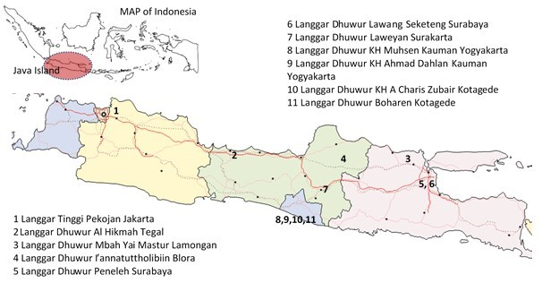
Figure 3. Map of Langgar Dhuwur in Java

Langgar Dhuwur is a family mosque located within a compound for family or community prayers [13], with a simple wooden platform architecture and a traditional Hip roof (Limasan)[14]. Figure 3 demonstrates the distribution of Langgar Dhuwur in Java. From Jakarta in West Java to Surabaya in East Java, at least 11 Langgar Dhuwur still exist today, according to a review of the relevant literature. A Langgar Dhuwur in Tegal and Jakarta, cities on Coastal Java, was constructed to conduct religious activities for seafarers from Arab (Moors), Indian (Koja), and Gujarati seafarers [6] [15]. Langgar Dhuwur in Lamongan (constructed in the 1920s) is the birthplace of Pesantren (Islami Boarding School) Tahfidhul Qur'an, which was established by Kyai Haji Mastur Asnawi [14]. Langgar Dhuwur's role as the birthplace of Pesantren was also played out in Langgar Dhuwur Kyai Haji Muhsen Kauman Yogyakarta.

- METHODS
As a starting point for this investigation, we conducted direct visual observations of religious structures in Kauman, Yogyakarta. In the next section, we will examine the two case studies, Langgar Dhuwur Kyai Haji Muhsen and Langgar Dhuwur Kyai Haji Ahmad Dahlan, in greater detail. Our direct observations allowed us to understand the area's context better, and our outputs of photographs, building sketches, and measured drawings allowed us to see in detail the existing condition of the two Langgar Dhuwur structures' form and spatial organization. The attention to detail and ornamentation were also considered to identify the building's distinguishing features. During the measured drawing process, there was extensive communication with the building's owner/manager to collect information about its history, function, form, and significance to the local community. Open-ended interviews were conducted with critical questions prepared in advance, and dynamic development occurred on the ground. After collecting primary data through field observation, we organized it into the five major themes explained in Table 1.

Table 1. Parameter of Langgar Dhuwur as Religious Architecture [modified from [16],[17]]

No | Parameter
1 | Langgar Dhuwur and Religious Architecture in Kauman
2 | Langgar Dhuwur and Vernacular Architecture in Indonesia
3 | Langgar Dhuwur as Public-Private Prayer Space
4 | Langgar Dhuwur as Gathering Space of the Society
5 | Langgar Dhuwur as Architectural Heritage

- RESULT AND DISCUSSION

- LANGGAR DHUWUR AND RELIGIOUS ARCHITECTURE IN KAUMAN
Kauman is in the heart of Yogyakarta, close to the Great Mosque Complex. Spatially, Kauman is an inseparable part of the four main elements of Yogyakarta. Yogyakarta was founded in 1755, adhering to the ancient city planning inherited from the Kingdom of Majapahit, specifically the Catur Gatra Tunggal city planning concept. This concept identifies the Palace, the City Square, the Great Mosque, and the Market as the four major elements of the city. Kauman’s location is west of the city square, around the mosque complex.
The term Kauman comes from the word Pakauman or the land where the Kaum lives, which in Javanese or Indonesian are scholars and leaders in Islamic society [18]. It is believed to have evolved after the Kingdom of Demak and Islamic Mataram [19]. Kauman district is found in several Central and East Java cities. It specifically refers to a residential area inhabited by a devout Muslim community. Therefore, Kauman is typically close to the mosque as the hub of Muslim community activities. Spatially, Kauman is usually located behind the mosque (on the west side of the mosque) of the city, which is usually not far from the city center and is characterized by elements of the city square, Palace, and market. Although Kauman’s location is very close to the Palace, both the Mosque and Kauman are outside the Yogyakarta Palace Wall.

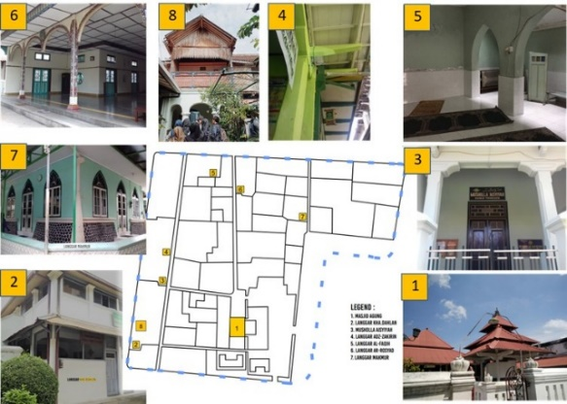
Figure 4: Religious Architecture in Kauman Yogyakarta, Indonesia [20]

At least ten mosques and Langgars are in Kauman, as shown in Figure 4, although only eight are currently in use. Figure 5 depicts the distribution of religious buildings in Kauman with various facades and their current state. Despite community’s building size and distance differences, the distribution appears relatively even throughout the area. According to the appearance of the buildings, there appears to be a variety of architectural styles that can be classified in Figure 5.

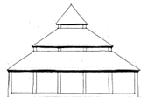 | 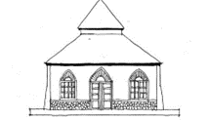 | 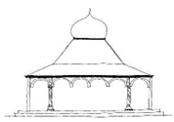
Kauman Great Mosque  - square configuration  - three-tier pyramidal roof (tajuk)  - timber construction | Langgar Al Makmur  - square plan  - double-tier pyramidal roof (tajuk)  - brick and stone construction | Langgar Lor/Al Rosyad  - rectangular plan  - double-tier and dome roof  - concrete structure  - floral ornamentation on the column
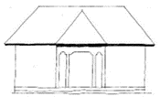 | 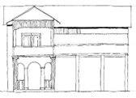
Langgar Aisyiyah  - rectangular plan  - hip roof (limasan)  - brick and pilaster construction | Langgar Dhuwur KH Muhsen  - rectangular plan, attached to the landlord's dwelling  - saddleback roof (pelana)  - timber construction (2nd floor), brick and pilaster construction (1st floor)  - Javanese architecture (especially on the layout) and Indies style (especially on the ornaments)
*not to scale

Figure 5. Morphology and spatial arrangement of religious structures in Kauman

Figure 5 depicts the variety of religious architectural styles in Kauman. The largest entity is the Great Mosque of Kauman. The great mosque retains the three-tiered pyramidal roof typology (Tajuk), which is an acculturation of the previously developed Hindu-Buddhist culture in Java [7], [21]. In the era following Islamization in Java, the pyramidal roof, or Tajuk roof, developed into a building typology "exclusively" intended for religious structures, particularly mosques, even though the pyramidal roof was a typology of Hindu-Buddhist temples that represented Meru as the eternal peak where the gods lived in a previous cultural era. Langgar Makmur, on the other hand, has a two-tiered pyramidal roof, indicating a lower hierarchy than the Great Mosque. Meanwhile, Langgar Lor and Langgar Al Rosyad combine a pyramidal roof with an additional dome in an imported style (Arabic) atop the roof. This is significant because, in addition to preserving the typology of the archipelago's mosque roofs, Langgar adheres to the growingly popular dome-shaped mosque style in Indonesia. Langgar Aisyiyah and Langgar Dhuwur KH Ahmad Dahlan are both Langgar Dhuwur with a Hip roof (Limasan). There are three additional Langgars in Kauman. In contrast, Langgar Dhuwur KH Muhsen has a saddleback roof. Hip and saddleback roof styles are utilized more frequently in residential construction than religious structures.

- LANGGAR DHUWUR AND RELIGIOUS ARCHITECTURE IN KAUMAN
Figure 6 depicts the Langgar Dhuwur Kyai Haji Muhsen, and Ahmad Dahlan employs the Indies architecture typology, which refers to Indonesian colonial architecture based on Dutch architecture that has been adapted to the tropical climate. Langgar Dhuwur Kyai Haji Muhsen has a rectangular floor plan that blends with the owner's house. The ground floor is a passageway to the outside Kauman area and an ablution area under the stairs leading to Langgar. On the first floor, the prayer room with a wooden mihrab wall jutting from its rectangular plan. The style is an indie building with classic Doric columns, while the first floor is equipped with a Javanese wooden ornamentation style.
Langgar Dhuwur KH Muhsen's architecture is influenced by the Kalang architectural style, a synthesis of traditional Javanese and classical colonial architecture that developed in the early twentieth century in several bourgeois areas of Yogyakarta, including Kauman and Kotagede [22]. The Kalang architecture is designed to reflect the social status of merchants, such as batik merchants and silver artisans.
The plan of Langgar Dhuwur Kyai Haji Ahmad Dahlan is rectangular, with the addition of a rectangular mihrab protrusion in the direction of the Qibla. This building is attached to the owner's U-shaped residential building. The ground floor is used to receive guests of the homeowner, and the first floor is a prayer room area. A gable roof with brick construction and pilasters is used with eaves to protect the building from tropical heat and rain. The ornamentation on this building is minimal or non-existent, so it gives the impression of an Indies building in the modern architectural era of the early 20th century.

Langgar Dhuwur KH Muhsen | Langgar Dhuwur KH Ahmad Dahlan
Architectural Features
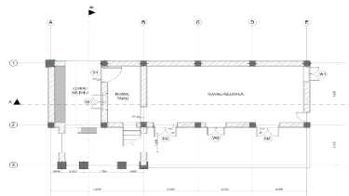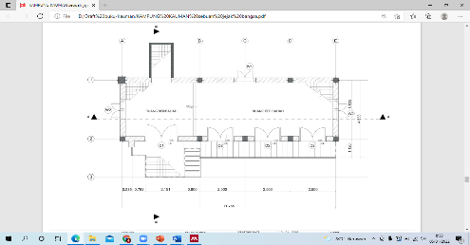  Ground Floor First Floor | 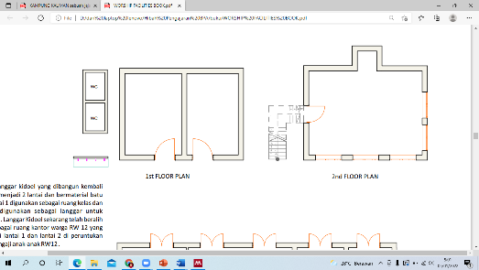  Ground Floor First Floor
Elevation
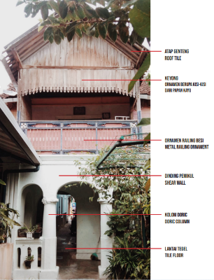 | 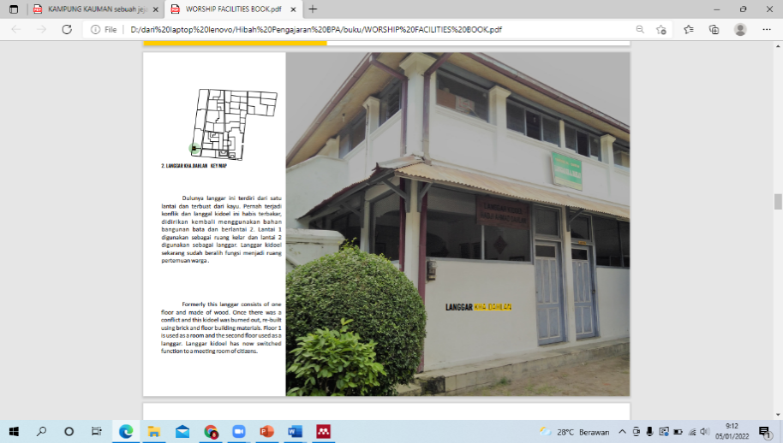
Details
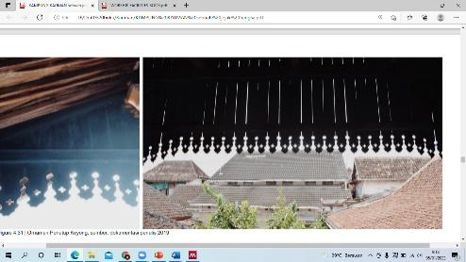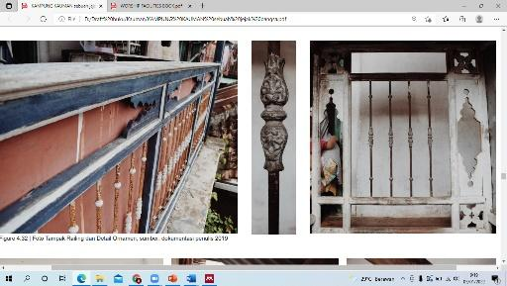 | 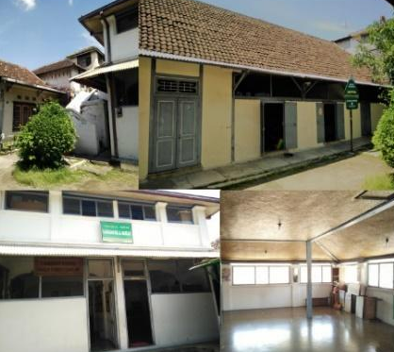
Architectural Style
Kalang Architecture  Javanese architecture (especially on the layout) and Indies style (especially on the ornaments) | Indies Architecture  Originally Langgar Dhuwur Kyai Haji Ahmad Dahlan was built with a timber structure. Still, it was burned during the early establishment of Muhammadiyah and rebuilt in the Indies architectural style, a combination of Colonial (Dutch) and tropical architecture.
Year of Built
Early 20th century | Early 20th century

Figure 6. Architectural Characteristics of Langgar Dhuwur in Kauman [22]

Langgar Dhuwur Kyai Haji Ahmad Dahlan's architectural representation is relevant to his view of progressive Islam, which he represents in his daily life by wearing western-style clothing (suits) combined with Javanese Sarong and Sorban. The minimalist Indies architectural style with no ornamentation appears to have been chosen with this perspective in mind.

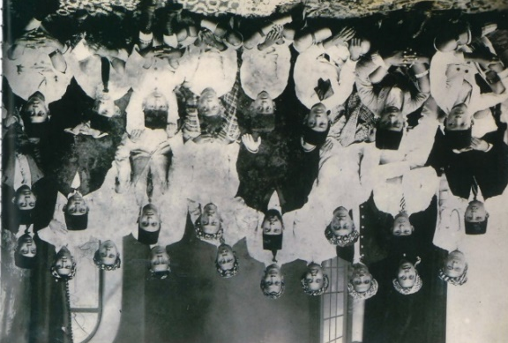
Figure 7. KH Ahmad Dahlan (middle row, fourth from the right) receiving his fellow Alhasimi and students in 1919 [23]

The architecture of Langgar Dhuwur adheres to the platform house architectural tradition of the Indonesian archipelago, with the ground floor serving as domestic and service areas and the upper floor as a prayer room. This typology of space is reminiscent of the Triloka concept found in Hindu-Buddhist temples in Indonesia [24], which developed during the classical era (8-12 centuries AD), as well as the Indonesian archipelago's architecture, which features a vertically divided building figure. Symbolically, the building is divided into three sections, reflecting the archipelago community's understanding of the universe, which divides nature vertically into three parts [25], with the upper universe serving as the most sacred area due to its use by worshipers. The upper universe (Svarloka) is home to ancestors or gods, the middle universe (Bhuvarloka) is home to purified humans, and the lower universe is home to humans, lower forces, and animals (Bhurloka). This demonstrates the adoption and adaptation of Langgar architecture during the previous period of Indonesian vernacular architecture. This finding is consistent with previous research indicating that Javanese architecture, specifically Joglo architecture, appears to have been developed in Java during the previous Hindu Buddha [26]. However, Javanese domestic architecture has evolved from a platform house with a space below the first floor to a house with no such space. Indeed, the architecture of Langgar Dhuwur is based on the archipelagic type of platform architecture, with service rooms on the ground level and prayer rooms on the upper level. Figure 8 depicts panel no. 65 in the Karmawibhangga relief section of the ninth-century Borobudur Temple reveals that Javanese houses are constructed on the platform, with the ground floor serving as a service room and pet cages.

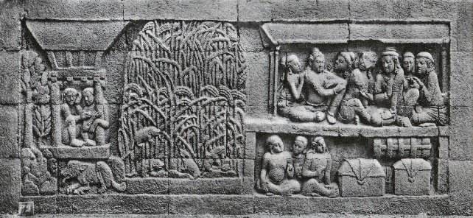
Figure 8. Hindu Buddhist Temple and Traditional Indonesian House [35]
Generally, the house in Kauman is a single-story building. Meanwhile, a second floor is added for the prayer room in both cases. This strengthens Langgar Dhuwur's position as a symbol of the most sacred area in Java's Hindu-Buddhist temple structures, known as Svarloka. However, Langgar Dhuwur does not use two or three-tiered pyramidal roofs as a typology for mosques in the Indonesian archipelago, but rather Hip Roof (Limasan) and Gable Roof (Pelana), which are commonly used as traditional roofing for dwellings, not religious buildings.

- LANGGAR DHUWUR AND RELIGIOUS ARCHITECTURE IN KAUMAN
According to the interviews with current homeowners, the existence of Langgar Dhuwur KH Ahmad Dahlan and KH Muhsen is strongly influenced by the two landlords or Kyai Haji. In the early twentieth century, most clerics in Kauman established educational institutions such as the small Pesantren (Indonesian term for Islamic Boarding School). The Langgar turns into a classroom led by a Kyai using the Sorogan system, a method of learning classical manuscripts (Kitab Kuning) in which students offer the Kyai the lesson they wish to study [27].
After returning from Mecca to study, KH Ahmad Dahlan established an Islamic organization called Muhammadiyah and began teaching Islam in Kauman. In addition to being a preacher, KH Ahmad Dahlan is a batik merchant, contributing to his wide acceptance in the community [28]. Langgar, which he established next to his house, played a significant role, particularly during the early stages of Muhammadiyah's establishment, if not earlier. Meanwhile, Langgar Dhuwur KH Muhsen established Jam'iyyah Matla'ul Anwar, a boarding school in his Langgar. In contrast to KH Ahmad Dahlan, KH Muhsen maintains a traditional Islamic understanding and continues to practice various traditions originating from pre-Islamic Java. This divergence of views frequently results in friction between the two. However, KH Muhsen retained his position to carry out Islam traditionally by developing his Pesantren in Kauman until his death. Langgar's close relationship with the house's owner was confirmed in a previous study on Langgar in Pati, which revealed Kyai Langgar's role as a 'patriarch' who guided the people in various aspects of life, both as an imam and a local Islamic community leader [29].

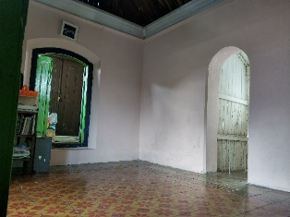 | 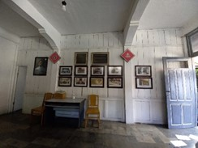
Figure 9. Prayer Room in Langgar Dhuwur KH Muhsen and Family Room on the Ground Floor of Langgar Dhuwur KH Ahmad Dahlan.

In addition, Figure 9 shows Langgar Dhuwur, which is attached to the owner's house in his capacity as Kyai or leader of the Islamic community, is a private place of worship, particularly during the month of Ramadan. In Islamic history, it is recorded that Prophet Muhammad PBUH began his spiritual activities in the Cave of Hira', ultimately designated as the site of the first revelation [30]. Though many Sufis continue to worship individually after the prophetic period of the Prophet [31], the tradition of worship in more private mosques has been preserved by many Sufis, including those in Indonesia [4],[32]. This also aligns with findings [34], which stated that public spaces for worship in Langgar then move to homes through Tahlilan and Yasinan, and some recite Qur’an activities. So, it can be stated that Langgar Dhuwur is a place for public and private prayer.

- LANGGAR DHUWUR AS A SOCIETY GATHERING SPACE
The two Langgar Dhuwur served as centers for the five daily prayers and as small Islamic boarding schools founded by KH Ahmad Dahlan and KH Muhsen. In addition, the Langgar serves as a meeting place for various activities, including celebrating Islamic holidays and other social gatherings. In the evenings, it is typically used as a gathering place for men to discuss various issues concerning residents' problems. During Ramadan, residents, primarily children and women, will concentrate their activities in Langgar, beginning with five daily prayers: night prayer (Tarawih), dawn lectures, breaking the fast, reciting the Qur’an (Tadarus), and so on. If a mosque is in the immediate vicinity, adult men will concentrate their activities there rather than in the Langgar. Thus, Langgar can be confirmed as a Muslim institution in Java that serves multiple religious, cultural, and social functions [10].
After the deaths of KH Ahmad Dahlan and KH Muhsen, the roles of the two Langgar Dhuwur changed. With the construction of classrooms for Muhammadiyah schools to the east and south of KH Ahmad Dahlan's residence, the Education function at Langgar Dhuwur KH Ahmad Dahlan continues to grow and develop. Langgar Dhuwur KH Ahmad Dahlan continues to serve as a place for children to study the Qur'an (Taman Pendidikan Al Qur'an), even though it is no longer regularly used for the five daily prayers. This result is consistent with the findings of previous research [34], [35], which contend that Langgar is the oldest educational institution in the Islamic community in Indonesia, even though its role is shifting with the emergence of the Al-Quran Educational Park (TPA). Interestingly, Langgar Dhuwur KH Ahmad Dahlan changed his education pattern to TPA, consistent with the Progressive Islam Movement slogan of Muhammadiyah [36].
The Langgar's ground floor has been repurposed as a Muhammadiyah Photo Gallery, a new function for the historic site and the organization. Langgar Dhuwur KH Muhsen is now fully functional as a family prayer space frequently used for rest. Even though this structure no longer serves a social purpose, the local people refer to it as Langgar Dhuwur to reflect its original purpose as a place of worship.

- LANGGAR DHUWUR AS ARCHITECTURAL HERITAGE
Langgar Dhuwur and its surroundings have the potential to be architecturally and historically significant cultural heritage sites that must be preserved. The Langgar Dhuwur building is unique because it represents a typology of Islamic religious buildings attached to the kyai's residence that cannot be found in mosque buildings outside Java or other parts of the world. This construction carries on the tradition of the Prophet Muhammad PBUH, who built the Nabawi Mosque near his home before expanding it into a larger structure. Langgar Dhuwur did not undergo the same transformation as the Prophet's Mosque, particularly after the death of its founding figure, and has remained an integral part of the residence to the present day.
Langgar Dhuwur, according to the second argument, is a house with three vertical figures that characterize Langgar, who is continuing the tradition of vernacular and Hindu-Buddhist architecture in Indonesia, which is represented by a house with three vertical figures. According to the architecture of the period, both Langgar Dhuwur followed the architectural trends of the early twentieth century, specifically Indies architecture and Kalang architecture. These two architectural styles have significantly contributed to the history of architecture, particularly in Java.
In addition, these structures have been crucial to the historical evolution of Islam in Indonesia, which is the third point of contention. Langgar, like Surau in Sumatra and Malaysia, contributed significantly to the spread of Islam in Java and the surrounding area. It serves multiple purposes as a place of worship, a hub for social and cultural activities, and a public gathering space. Langar serves an essential purpose as a social gathering place and informal school "institution" for the surrounding community.

- CONCLUSION
Langgar Dhuwur in Kauman is a distinctive architectural style that preserves Indonesia's vernacular architectural tradition. With the development of Langgar architecture in the form of a freestanding structure known as the Musholla in Indonesia, the prevalence of this type began to decline. Due to Java's larger Muslim population, numerous Langgar have expanded to become mosques that serve the five daily prayers and Friday prayers.
This study demonstrates that Langgar Dhuwur in Kauman placed a prayer space on the second floor, consistent with the pre-Islamic concept of Triloka in Java, namely, designating the upper floor as a sacred area (Svarloka). This is a concept that the Mosque typology does not share, as it places prayer space on the ground floor without leaving any space beneath. However, Langgar Dhuwur's typology demonstrates its Gestalt by combining traditional architecture with imported styles (colonial architecture), now used for residential architecture, instead of utilizing a dome as a mosque architectural style, which became a new trend in Java.
As a religious structure, Langgar Dhuwur serves a dual purpose, both public and private. As a public structure, Langgar Dhuwur serves not only as a place of worship but also as a cultural and social center. Langgar Dhuwur can serve as a private prayer space or contemplative space, continuing the Prophet Muhammad PBUH and Javanese Sufi tradition of residing in mosques. Finally, this study demonstrates the significance of Langgar Dhuwur as a cultural heritage site that must be preserved. It is one of the architectural treasures of the Indonesian archipelago and one of the architectural treasures of Indonesian architecture due to its distinctive architecture and rich history.
Langgar Dhuwur, as an architectural entity, needs to continue its role in the development of Islamic society. As an architectural entity close to the community, design recommendations must be considered to maximize its role. However, the typology of Langgar Dhuwur as part of residential architecture should not need to be too symbolic with a three-tiered roof, for example, similar to the Friday mosque. The position of Langgar Dhuwur on the top floor has shown its symbolic significance as a holy place, as in the Triloka. We suggest that Langgar Dhuwur's design should be flexible, with a simple open-plan layout accommodating various community activities. Regarding dimensions, it also does not require a large gathering space because the number of users is relatively small, usually children and women. After all, adult men generally spend more time at the Friday mosque for community activities.

ACKNOWLEDGEMENT
Special thanks to the students of the Heritage Conservation Class, Department of Architecture Universitas Islam Indonesia, for providing raw data on the measured drawing of Langgar Dhuwur architecture in Kauman.

REFERENCES
[1] A. Kusno, “Invisible geographies in the study of Islamic architecture,” Int. J. Islam. Archit., vol. 5, no. 1, pp. 29–35, 2016. doi: https://doi.org/10.1386/ijia.5.1.29_1
[2] B. S. Budi, “A Study on the History and Development of the Javanes Mosque_Part1,” Journal of Asian Architecture and Building Engineering, vol. 3, no.1, pp. 189–195, 2004.
[3] B. Kempers, Ancient Indonesian Arts. Amsterdam: C.P.J. van der Peet, 1959.
[4] C. Geertz, The religion of Java. Chicago: University of Chicago Press, 1976.
[5] A. Annistri, “Sejarah Langgar, Masjid Kecil untuk Beribadah?,” Cekaja, November, 2022 (online) Accessed: April 10th,2023. Available at https://www.cekaja.com/info/Langgar-adalah-masjid-kecil-untuk-beribadah.
[6] L. Lasmiyati, “Penyebaran Agama Islam Di Jakarta Abad Xvii - Xix,” Patanjala J. Penelit. Sej. dan Budaya, vol. 1, no. 1, p. 76, 2009. doi: http://dx.doi.org/10.30959/patanjala.v1i1.234
[7] B. S. Budi, “A Study on the History and Development of the Javanese Mosque Part 3: Typology of the Plan and Structure of the Javanese Mosque and Its Distribution,” J. Asian Archit. Build. Eng., vol. 5, no. 2, pp. 229–236, 2006. doi: https://doi.org/10.3130/jaabe.5.229
[8] N. Istikhari and U. Rahmah, “NGAJHI KA LANGGHÂR: The Educational Nursery of Moderation of Islam in Madura,” Islam. J. Stud. Islam, vol. 7, no. 2, pp. 106–124, 2020. doi: https://doi.org/10.19105/islamuna.v7i2.2278
[9] A. Sunyoto, “Eksistensi Islam Nusantara,” Mozaic Islam Nusant., vol. 2, no. 2, pp. 31–42, 2016. doi: https://doi.org/10.47776/mozaic.v2i2.82
[10] K. Mawardi, “Langgar: Institusi Kultural Muslim Pedesaan Jawa,” J. Kebud. Islam, vol. Vol. 12, N, no. 1693–6736, pp. 50–61, 2014. doi: https://doi.org/10.24090/ibda.v12i1.435
[11] T. Saxebøl, “The Madurese ulama as patrons: a case study of power relations in an Indonesian community,” Dissertation, Institute of Political Sciences, University of Oslo, 2002.
[12] I. A. Mansurnoor, Islam in an Indonesian World: Ulama of Madura, Yogyakarta: Gadjah Mada University Press, 1990
[13] J. S. Ryeong, K. D. Yeon, S. R. Budi, "Dualism in the Javanese House and Transformation With focus on the houses of Kotagede, Yogyakarta", Journal of Asian Architecture and Building Engineering, vol. 17, no. 1, pp. 71-78. doi: https://doi.org/10.3130/jaabe.17.71
[14] H. R. Agustapraja, “Pelestarian Arsitektur Langgar Dhuwur Mbah Yai Mastur Lamongan,” J. Tek., vol. 10, no. 2, p. 1050, 2018. doi: https://doi.org/10.30736/teknika.v10i2.243
[15] M. Khoeroh, “Skripsi Program Studi Sejarah Peradaban Islam,” 2019.
[16] M. J. Crosbie, Houses of God: religious architecture for a new millennium. Images Publishing, 2006.
[17] O. Verkaaik, Religious Architecture: Anthropological Perspectives, Amsterdam: Amsterdam University Press, 2013.
[16] A. Mulyati, Pola Spasial Permukiman di Kampung Kauman Yogyakarta, Universitas Gadjah Mada, 1995.
[17] Wijanarka, Teori Desain Kawasan Binaan, Palangkaraya: Universitas Palangkaraya, 2001.
[18] A. B. Sholihah, A. M. Ressang, (editors), “Kampung Heritage Kauman: Jejak Sebuah Bangsa,” Conference on Heritage Conservation, 2019.
[19] B. . Sukada, “Early Muslim Places of Worship,” in Indonesia Heritage: Architecture, G. Tjahjono, Ed. Archipelago Press, 1998, pp. 88–89.
[20] M. Widianingtias, S. Pramudito, and G. O. I. Cahyani, “Identifikasi unsur-unsur arsitektural rumah kalang di kotagede yogyakarta,” Arteks J. Tek. Arsit., vol. 5, no. 1, pp. 39–52, 2020. doi: https://doi.org/10.30822/arteks.v5i1.85
[21] P. S. Muhammadiyah, Muhammadiyah dalam Narasi Foto Tempo Doeloe. Yogyakarta: Suara Muhammadiyah, 2018.
[22] C. Sedyawati, E., Santiko, H., Djafar, H., Maulana, R., Ramelan, W. D. S., & Ashari, Candi Indonesia: Seri Jawa: Indonesian-English (Vol. 1). Direktorat Jenderal Kebudayaan, 2013.
[23] R. Schefold, P. Nas, & G. Domenig, Indonesian Houses: Tradition and transformation in vernacular architecture (Vol. 1). NUS Press, 2004.
[24] N. C. Idham, “Javanese islamic architecture: Adoption and adaptation of javanese and hindu-buddhist cultures in indonesia,” J. Archit. Urban., vol. 45, no. 1, pp. 9–18, 2021. doi: https://doi.org/10.3846/jau.2021.13709
[25] K. Junaidi, “Sistem Pendidikan Pondok Pesantren di Indonesia (Suatu Kajian Sistem Kurikulum di Pondok Pesantren Lirboyo),” ISTAWA J. Pendidik. Islam, vol. 2, no. 1, pp. 95–110, 2016. doi: https://doi.org/10.24269/ijpi.v2i1
[26] A. Mu’thi, K.H. Ahmad Dahlan (1868-1923), Jakarta: Kementerian Pendidikan dan Kebudayaan. 2015.
[27] P. Dirdjosanjoto, Memelihara Umat; Kiai Pesantren-Kiai Langgar di Jawa. LKIS Pelangi Aksara, 1997.
[28] A. Agus Sifa, “JEJAK DAN PERKEMBANGAN TASAWWUF DALAM ISLAM (Sebuah Penelusuran Sejarah dan Metode),” J. Ilm. Mhs. Raushan Fikr, vol. 5, no. 1, 2017. doi: https://doi.org/10.24090/jimrf.v5i1.968
[29] Mundir, “Competency and Innovation: Two Critic Aspects for Developing of Teachers Quality,” Int. J. High Educ. Sci., vol. 1, no. 1, pp. 18–35, 2020. doi: https://doi.org/10.1234/.v1i1.84
[30] J. D. Howell, “Indonesia’s Salafist Sufis,” Mod. Asian Stud., vol. 44, no. 5, pp. 1029–1051, 2010. doi: https://doi.org/10.1017/S0026749X09990278
[31] I. SAFI’I, “MELIHAT ULANG FUNGSI MASJID DAN LANGGAR SEBAGAI RUANG PUBLIK DI KECAMATAN TANGGUNGGUNUNG, TULUNGAGUNG,” UIN Satu Tulunggagung, Indonesia, 2020.
[32] M. Atika, “Penguatan Peran Langgar Sebagai Medium Keluarga Dalam Upaya Pembentukan Pendidikan Karakter Anak Di Madura,” Personifikasi: Jurnal Ilmu Psikologi, vol. 10, no. 2, 2019.
[33] M. Wardi, “Pilihan Belajar Al-Qur’an Di Madura; Konversi Dari Langgar Ke Taman Pendidikan Al-Qur’an,” Kabillah (Journal of Social Community), vol. 1, no. 1, pp. 93–114, 2016.
[34] Z. Qodir, H. Jubba, M. Hidayati, I. Abdullah, and A. S. Long, “A progressive Islamic movement and its response to the issues of the ummah,” Indones. J. Islam Muslim Soc., vol. 10, no. 2, pp. 323–352, 2020. doi: https://doi.org/10.18326/ijims.v10i2.323-352
[35] N.J. KROM, and T. van ERP. Beschrijving van Barabudur. II: Bouwkundige Beschrijving. The Hague: Mattinus Nijhoff,1931.

