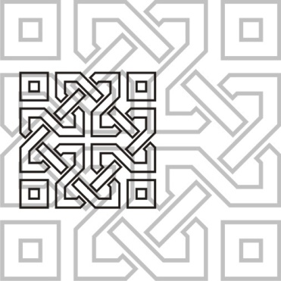 | JOURNAL OF ISLAMIC ARCHITECTURE  P-ISSN: 2086-2636 E-ISSN: 2356-4644  Journal Home Page: http://ejournal.uin-malang.ac.id/index.php/JIA
READING AL JABBAR GREAT MOSQUE BANDUNG INDONESIA: STRENGTHENING THE MEANING OF WORSHIP WITH A NEW SPIRIT
| Received May 16th 2016 | Accepted June 17th 2016 | Available online June 30th 2016 |
| DOI http://dx.doi.org/10.18860/jia.v4i1.3466 |

Imam Santosa  Department of Interior Design,  Faculty of Art and Design  Institut Teknologi Bandung  Bandung, Indonesia  J. Jamaludin  Department of Interior Design,  Faculty of Architecture and Design  Institut Teknologi Nasional  Bandung, Indonesia  corresponding author  jamal@tenas.ac.id |  | ABSTRACT (CENTURY GOTHIC 8 CAPITAL BOLD)  In the city of Bandung now stands a magnificent mosque which is named Masjid Raya Al Jabar (Al Jabbar Great Mosque). This naming is a symbol of the province where it is located, namely Jawa Barat (West Java), which is usually abbreviated as Jabar. The presence of this mosque has attracted many residents even from outside Bandung to visit. The design of this mosque is different from other conventional mosques and certainly invites questions from the laity about various aspects of the mosque, especially the form that is applied. This paper examines the form elements that exist in the mosque with a symbolic interpretation method approach and a comparative study with conventional mosques or Middle Eastern model mosques that are commonly built. With this understanding, it is hoped that the public can better understand the context of the mosque. Even though it looks like a contemporary mosque, the meanings of the forms that exist still carry the meanings of the forms that exist in conventional mosques. Many innovations were made in the design of this mosque but the context still refers to the meaning of the mosque as a place for Muslims to worship, especially prayer.  KEYWORDS: (CENTURY GOTHIC 7 CAPITAL BOLD)  Mosque architecture, contemporary design, symbolic meaning

INTRODUCTION
(CENTURY GOTHIC 9 CAPITAL BOLD) (NO NUMBERING)

The presence of a new mosque in the city of Bandung named Al Jabbar Great Mosque (Masjid Raya Al Jabbar-MRAJ), which was inaugurated on December 30 2022, has attracted public interest in visiting it (Figure 1). This was supported by media publications which welcomed it enthusiastically. The mosque, which was built on an area of about 25 hectares, has a capacity of around 30,000 people, with details of 10,000 people in the indoor area and 20,000 people in the plaza area. The inauguration was carried out by the governor of West Java Ridwan Kamil who is also the architect of the mosque. Ridwan Kamil, who is indeed an architect who graduated from the Bandung Institute of Technology (ITB) and got Master of Urban Design from the University of California at Berkeley, designed the mosque when he was mayor of Bandung City (2013-1918) at the request of the governor at that time, Achmad Heryawan (2008-2018).
Prior to designing this mosque, Ridwan Kamil had designed many other mosques spread across various cities in Indonesia, apart from his other architectural works such as high-rise office buildings and museums. The mosque designs by Ridwan Kamil are generally contemporary in style in the sense that they are different from conventional mosques which are influenced by the style of Middle Eastern mosques with domes as their trademark.
Of course the presence of a mosque with a unique design, in contrast to conventional designs, invites questions from the public regarding the unusual design made by the architect. Part of this was explained by Ridwan Kamil himself in the media that covered him, who asked about the design concept so as to produce works that were different from the existing ones. One of the things the architect revealed was that the mosque has 27 doors which symbolize 27 regencies and cities in West Java which are symbolized by the batik designs of each city and regency. The name of the Al Jabbar mosque itself is taken from three things, the first is from one of Asmaul Husna (99 beautiful names of Allah), Al Jabbaru, meaning Almighty, second the name of the mathematician, Al Jabbar (English: Algebra) whose formula was used for the construction of this mosque. Third, from the abbreviation for the province of West Java in Indonesian language that is Jawa Barat, namely Jabar [1].
The basis for the discussion of this paper is the description of William White [2] that architecture as a visual form has a meaning or interpretation. The process of understanding a work of architecture is more or less the same as the process of reading, that architecture can be understood by analogy with language. The elements in an architectural work can be understood as a code or the intention of the architect in conveying his design concept. This paper will discuss the elements of the forms or shapes found in the AL Jabbar Great Mosque (MRAJ) which are different from conventional mosques in general. The first is the form of the mosque itself, the second is the object in interior design and the shape aspects in it. This paper also will try to examine the elements of form that exist in MRAJ and critically analyze them with symbolic aesthetic meanings. The interpretation of this form is based on general concepts both in the meaning of the elements of the mosque and in local Indonesian culture.
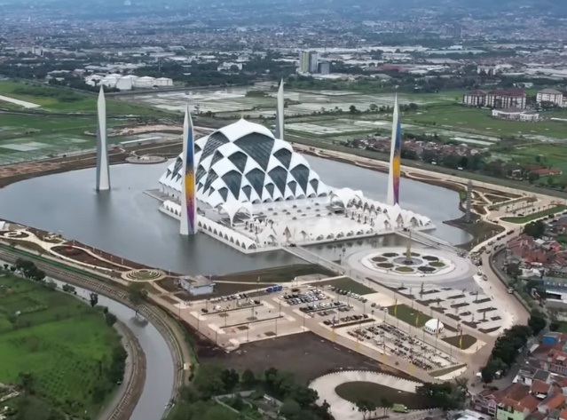
Figure 1. Aerial View of Masjid Raya Al Jabbar. (Photo: Akcdn.detik.com)

METHODS
To understand the novelty of the MRAJ being discussed, it seems important to conduct a comparative study with the conventional mosque model to see the differences between the two. What is meant by a conventional mosque here is a mosque that uses the style or influence of a Middle Eastern model mosque [3], [4]. To interpret the concept of form or shape in the Al Jabbar Mosque, the approach used is a formal and symbolic aesthetic approach [5], [6].
Existing objects are studied with an understanding of aesthetic elements and principles, both formal and symbolic. The method of interpretation of art used refers to what Robert Stecker disclosed [7]. He explains that the method of interpretation of art is to understand or appreciate a work of art or to increase degree of appareciation and understanding. Two views in the interpretation method used in this study are actual intentionalism, namely that the correct interpretation of a work can identify the purpose of the artist's or architect's expression in his work, both symbolically or semantically.

DISCUSSION
GLASS DOME AS THE MOSQUE BUILDING
Dome is one of the main elements or common feature of the mosque which is generally found in conventional mosque architecture or Middle Eastern models. The dome is often seen as a representation of the heavens or the celestial realm. In Islamic culture, the dome represents the perfection and beauty of Allah's creation, and the aspiration of the faithful to reach a higher spiritual level [3]. In mosque buildings, domes are generally mounted on the roof of the building with several variants (Figure 2). The dome is considered one of the feature of the mosque so that the Istiqlal mosque in Jakarta, for example, although built in a modern style, still uses the dome as the identity of the mosque (figure 3). Recent developments in mosque design show the use of colored ornaments on the dome as can be seen in the Lombok Islamic Center mosque (Figure 4).
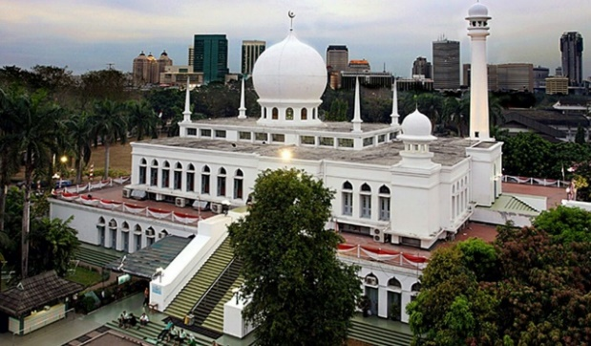

Figure 2. Al Azhar mosque in Jakarta with dome in te center of roof (photo: pinterest.com)
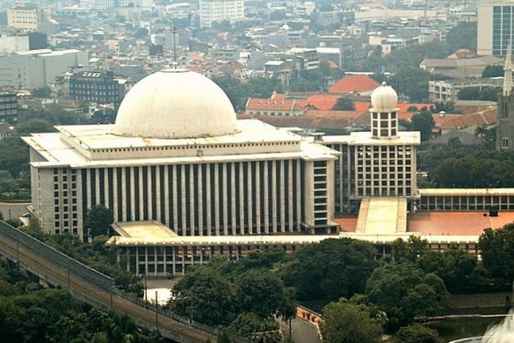
Figure 3. Masjid Istiqlal mosque in Jakarta (Photo:scout.id)
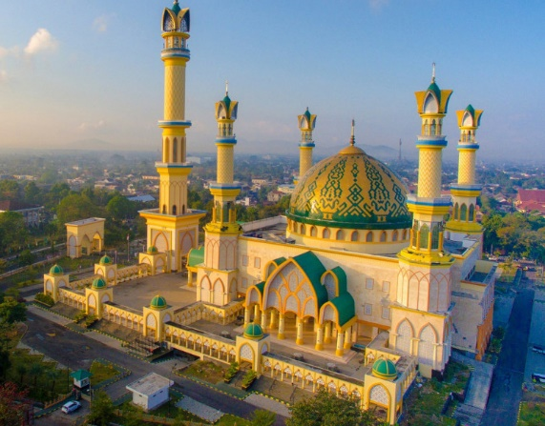
Figure 4. Islamic Center Mosque with decorated domes in Mataram Lombok (Photo: karpetpersia.com)

In MRAJ, the dome is no longer attached to the roof of the mosque but becomes the mosque building itself (Figure 5) . Perhaps rarely do people realize that the shape of the MRAJ mosque building is or resembles a dome shape. This dome shape can be seen from the absence of vertical walls and a separate roof. The walls and the roof are a single unit and this is a feature of a curved building, which in a convensional mosque is usually a dome on the roof of the building.
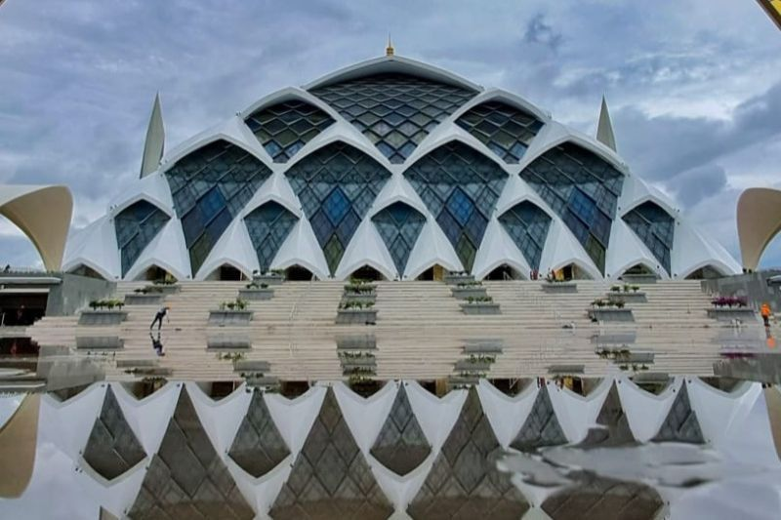
The impression of a dome cannot be seen immediately because the entire surface of the dome is filled with kite-shaped windows of various sizes, giving the impression of being transparent. The MRAJ building can be called a glass dome, because the entire dome is made of glass modules arranged like fish scales. This decorative glass module is diamond-shaped with space frame construction and at a certain distance is given a curved canopy made of white Aluminum Composite Panel (ACP).
Figure 5. The diamond-shaped glass dome of the mosque is partly covered by a canopy roof (Photo: Antara)

Dome which is used as the main building of the mosque does not seem new. In Karachi, Pakistan, there has long been an architect who dared to design a mosque using a dome as the main building of the mosque. Masjid-e-Tooba which means “the mosque of goodness and virtue” also known as the Gol Mosque, was designed by Babar Hamid Chauhan in the form of a dome (Figure 6). This mosque uses a massive, intact dome shape with no openings at all, making it easier for observers to directly refer to the shape of the dome, which is generally a part or feature of mosque building. The diameter of dome is 72 meters with pure white marble and there is no column inside. The mosque compeletely built in 1969 [8], [9].
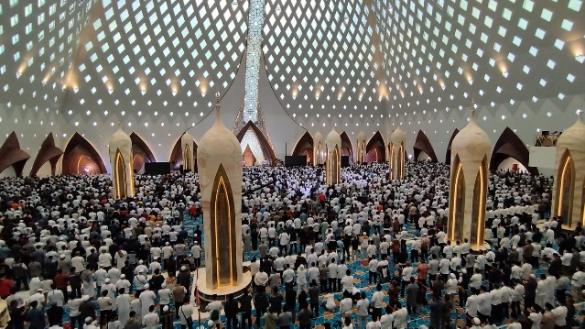
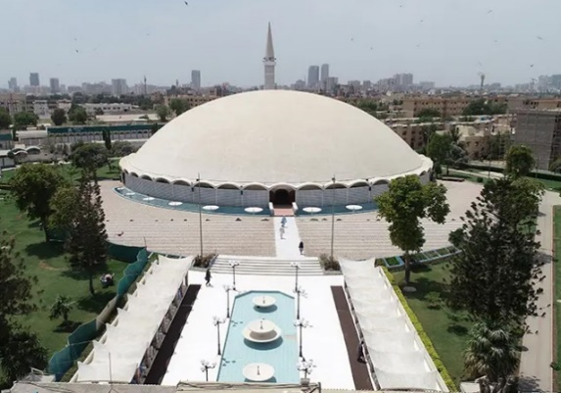
Figure 6. Pakistan e-tooba mosque karachi with dome as mosque shape (Photo: Saleha Ali)

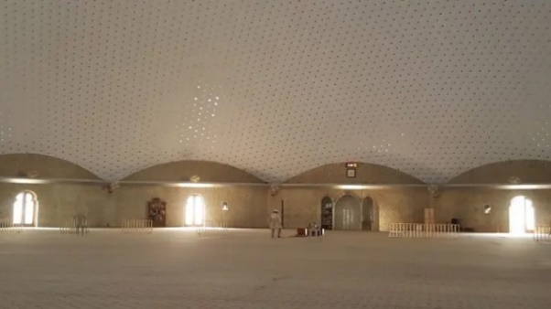
Figure 7. the interior of the e-tooba mosque as a consequence of the dome shape (Photo: Saleha Ali)

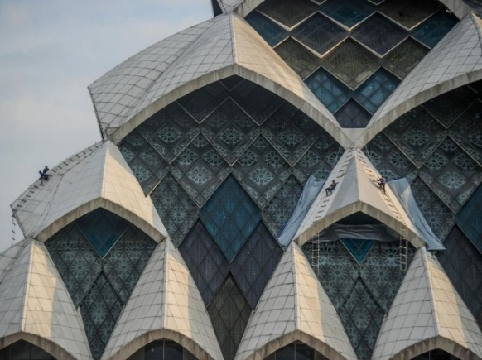
Unlike the domed mosques in Pakistan, which are massively covered with marble, and are only used as roofs with the walls still vertical, in this MRAJ Ridwan Kamil as an architect went further. He not only removed the dome from the roof of the mosque and enlarged it to make the mosque itself without separate walls, but made the dome with glass materials stacked in a diamond shape (Figure 8).

Figure 8. The canopy roof covering part of the dome is composed of diamond-shaped decorative glass modules, creating a kite-shaped window.

Uniqueness occurs in this window. On the outside, there are rows of windows in the shape of a kite framing an arrangement of diamond-shaped glass ornaments. Inside the mosque, in the prayer room to be precise, the window display is completely different. The impression of a kite-shaped window is completely absent. There are diamond-shaped windows arranged in a repeating curved line. This diamond shape is getting closer and closer to the top (figure 9).
Figure 9. openings in the walls of the dome in the form of diamond shape (Photo: jppn.com)
THE MEANING OF DIAMOND SHAPE AND KITE A new form that is unusual in conventional mosques and found in MRAJ is the diamond shape of the glass module and the canopy roof which is like a window and makes it look like a kite. The presence of diamond-shaped glass and kite windows looks dominant, which means they are an important part of the architect's design. Thus it is necessary to look for its meaning contextually, meaning it is connected with the mosque as a place of worship. The shape of the diamond can be searched for its symbolic meaning, especially those related to religious or spiritual elements. In some spiritual traditions, diamonds are believed to help facilitate spiritual awakening and evolution and represent spiritual enlightenment and divine energy [10]. Diamond also simbolize or associate with purity and innocence, and are used in many cultures to symbolize the unblemished, untarnished, and uncorrupted aspects of the human spirit [11]. Diamonds are the hardest substance on earth, and as such, they symbolize endurance, resilience, and strength. Diamonds are known for their brilliance and clarity, and as such, they symbolize enlightenment, awareness, and truth. Diamonds are millions of years old and have endured the test of time, making them a symbol of eternity, continuity, and immortality.
The array of windows which are like kites of various sizes can be read symbolically about kites. The symbolic meaning of a kite can vary across different cultures and contexts, but let’s take some common interpretations Kites are often associated with a sense of freedom and liberation, as they soar high in the sky, unrestricted by earthly constraints. Flying a kite can represent the pursuit of personal freedom or the release of burdens and limitations. In some spiritual traditions, kites are seen as a symbol of connecting with higher realms or spiritual transcendence. The act of flying a kite can be interpreted as an expression of reaching out to the divine or expanding one's consciousness. Kites are often associated with childhood and playfulness, representing the imaginative and creative spirit. Flying a kite can symbolize tapping into one's creativity, embracing a sense of wonder, and exploring new possibilities [12].

CALLIGRAPHY: BALANCE IN A NEW WAY One of the aesthetic principles, also known as design principles, is balance. Balance is formed from the composition of the symmetry. Symmetry plays a significant role in architecture and design, where it is often used to create visually appealing and harmonious compositions. It provides a sense of balance, order, and proportion, which can evoke a feeling of stability and elegance. Bilateral symmetry, also known as mirror symmetry, is a common form of symmetry in architecture. It involves dividing a structure or design into two equal halves that are mirror images of each other. This type of symmetry is frequently seen in buildings, such as palaces, temples, and classical facades, where the central axis acts as the dividing line. Erzen [4] stated that a mosque is a heavenly symbol in the sense that a mosque is a place where conditions must be able to create ideal things, such as a peaceful and tranquil atmosphere. Symmetrical composition can help create such conditions. What happened to the calligraphic compositions of Allah and Muhammad on both sides of the mihrab of a conventional mosque is to achieve this balance. Although hierarchically, of course Allah is higher in rank than the Prophet, but for the sake of balance, Muhammad's calligraphy is equal to Allah's calligraphy. The calligraphy of Allah and Muhammad in this case is to create left-right balance and not to mean alignment.
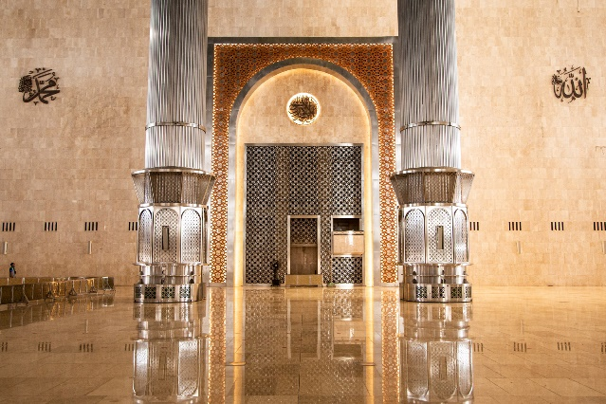
Calligraphy is considered a sacred art form in Islamic culture, and it is used to adorn the walls, domes, and arches of many mosques. The words and phrases used in Islamic calligraphy are often taken from the Quran or Hadith, and they are intended to inspire worshippers and remind them of Allah's teachings [13]. The beauty and elegance of calligraphy are believed to reflect the beauty of Allah's words and inspire a deeper connection with the divine.
Figure 10. Callygraphy of Allah and Muhammad in Masjid Istiqlal Jakarta

Calligraphy featuring the name Allah and Mohammad (in Arabic letters) is a common decorative element in mosques, especially on the walls at the front of the prayer hall [13], around the wall near the mihrab (Figure 10, Figure 11)

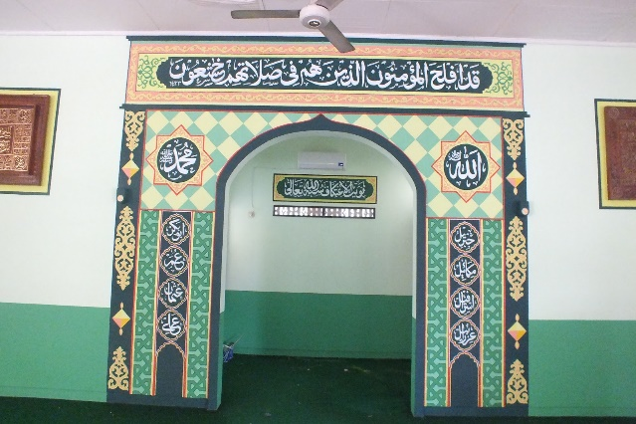
Figure 11. Callygraphy of Allah and Muhammad in the right and left side of mihrab wall (photo: Belgeuse.com)

At the front of the MRAJ, on both sides of the mihrab, there are no calligraphy of Allah and Muhammad as in conventional mosque interiors. Leaving only a symmetrical composition created by the upward curved mihrab frame (Figure 12).
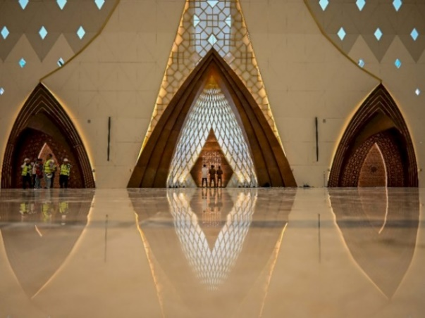
Figure 12. Mihrab without the calligraphy of Allah and Muhammad on both sides (Photo: indozone.com)

A surprise happened. The calligraphy of Allah is in the middle of the ceiling of the mosque. The location where the dome of the mosque is usually located, at MRAJ is the place for Allah's calligraphy. All of the dome openings are diamond shaped which are arranged following a curved line. the opening of this diamond shape is getting closer to the apex and finally approaching the calligraphy of Allah. From the top of the mihrab there is a line in the form of an ornamental glass that extends towards the calligraphy of Allah. The location of Allah's calligraphy is in the form of a box from the center of the dome that tapers to the bottom. The meaning is very clear, Allah is very close (Figure 13).
From a symbolic reading this seems very clear. Even though the direction of prayer is towards the Kaaba in Mecca, Muslims worship Allah the Most Merciful. Reading from aesthetic principles, the location of Allah's calligraphy which is in the upper center creates radial symmetry, symmetry that is centered towards the center. Radial symmetry creates a sense of harmony and order. This design seems logical and reasonable, that Allah is the center of everything. Allah is above all and protects all (Figure 14).

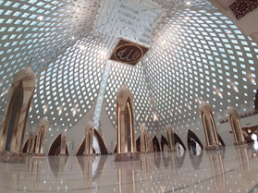
Figure 13. Allah's calligraphy is in the center of the ceiling, in the usual location of domes found in conventional mosques (Photo: jpnn.com)

The novelty as well as the difference between this MRAJ and conventional mosques is that: radial symmetry centered on Allah. Conventional mosques use bilateral or mirror symmetry in the form of Allah and Muhammad calligraphy on both sides of the mihrab, while the MRAJ uses radial symmetry with Allah's calligraphy as the center which is placed in the center of the ceiling of the prayer room. This radial symmetry is formed by the four walls of the dome that will structurally meet in the center and also the openings in the dome in the form of a diamond-shaped arrangement rotating to the center.

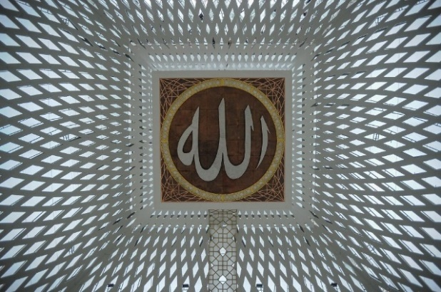
Figure 14. The Allah's calligraphy in the center above the interior of the mosque (photo: pikiran-rakyat.com)

The existence of a white line on the glass that starts from the top of the mihrab towards Allah's calligraphy emphasizes the concept of prayer worship. That the direction of prayer to the Kaaba in Mecca is only so that all Muslim prayers lead to one place, but worship only to Allah. Figure 15 can perhaps illustrate the meaning of the white line in the MRAJ prayer service.
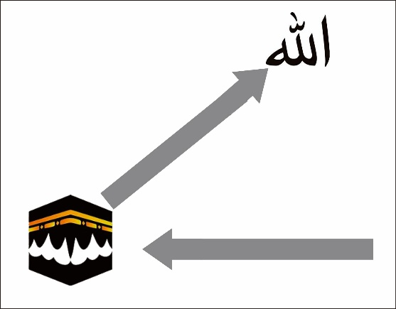
Figure 15. Diagram diagram of the direction of prayer and worship from MRAJ (by author)

The new forms that exist in MRAJ all have meaning to strengthen faith. The existence of a diamond shape that dominates around the room is expected to help people to increase their faith strength, devotion in worship and also belief in Allah. The presence of a kite shape on the outside window is expected to help people come to the mosque and feel freedom by praying and worshiping Allah. Allah's calligraphy which is in the top center but in a lowered position gives the meaning that Allah is close to mankind. The following table (Table 1) summarizes the meaning of the new forms in MRAJ.
Table 1. The Meaning of Form in MRAJ
Feature | Meaning
Diamond shape openings | to help facilitate spiritual awakening and evolution and represent spiritual enlightenment and divine energy
Kite-shape windows | represent the pursuit of personal freedom or the release of burdens and limitations
Calligraphy Allah in the center | Allah is the center of everything. Allah is above all and protects all
Line from top of Mihrab to Calligraphy Allah | Prayers facing the Kaaba, worship only to Allah.

From the description above it appears that in MRAJ apart from bringing the forms and meanings found in conventional mosques it also presents new things with meanings that aim to strengthen the mosque as a place of worship. The table below shows a simple comparative study between conventional mosques and MRAJ. In both there are similarities in form and meaning, and in MRAJ there is an expansion of meaning and there are new forms and meanings that strengthen the mosque as a place of worship to Allah.

Table 2. Simple Comparative Study
Mosque Feature | Convensional Mosque | Al Jabbar Great Mosque (MRAJ)
Dome | In top of the mosque roof | The mosque building
Minaret | the number of minaret varies | Four minarets near each corner of the mosque
Opening | Arc window | Diamond shape glass with kite-shape window
Calligraphy of Allah and Muhammad on both sides of the mihrab | Bilateral symmetry | Radial symmetry. Only Allah's calligraphy is in the middle above the prayer room as the center of everything.
Direction of prayer to the Kaaba in Mecca | Mihrab, where the priest leads the prayer | where the imam leads the prayer and from the mihrab there is a line leading to the calligraphy of Allah, a symbol of the purpose of worship.

CONCLUSION
It becomes very clear in the discussion above that one of the creative efforts in developing mosque architecture is to make new breakthroughs in the contemporary context, which shows developments in the world of Islamic architecture, especially mosque architecture. The innovation shown at Masjid Raya Al Jabar (MRAJ) Bandung Indonesia shows a new spirit which will ultimately enrich the repertoire of mosques and Islamic architecture in general and also shows that the dynamics of mosque architectural design is still ongoing.
The design of the mosque is not only a repetition of the existing one but there are further efforts. Even so, the innovations made by architects in contemporary mosque designs basically still carry symbolic meanings that already exist in conventional mosque elements. This shows the awareness that the meaning in the context of the mosque remains the same and applies forever.
The presence of MRAJ shows the existence of creative efforts by architects who are continuously rolling to create novelty in the spirit of enriching Islamic architectural culture towards a brighter future for Muslims. The emergence of various contemporary-style mosque designs such as MRAJ is seen as important in order to offset mosque design models that appear stagnant or simply repeat existing models. In the hands of these young architects who have foresight, it seems that Islamic design culture continues to move with the times.
the existence of various new forms in mosques brings new meanings which in essence are meant to strengthen the mosque's position as a place of worship for Muslims and at the same time, the design of mosques with a new approach, can be used as a marker of its era.

REFERENCES
[1] Yayan A. Brilyana, Masjid Raya Al Jabbar Diresmikan, Ikon Baru Jawa Barat Kini Hadir di Kota Bandung, retrived from https://www.bandung.go.id/news/read/7453/masjid-raya-al-jabbar-diresmikan-ikon-baru-jawa-barat, december 2022.
[2] William Whyte, "How Do Buildings Mean? Some Issues Of Interpretation In The History Of Architecture", History and Theory, Volume 45, Issue 2, 04 May 2006
[3] Kendra Weisbin. “Introduction to mosque architecture”, https://www.khanacademy.org/humanities/art-islam/beginners-guide-islamic-art/a/introduction-to-mosque-architecture, retreived August 7, 2021
[4] Jale Nejdet Erzen, “Reading Mosques: Meaning and Architecture in Islam”, The Journal of Aesthetics and Art Criticism, Volume 69, Issue 1, 2011. Pp 125–131, https://doi.org/10.1111/j.1540-6245.2010.01453.x.
[5] Lang, J. (1988). Symbolic aesthetics in architecture: Toward a research agenda. In J. L. Nasar (Ed.), Environmental aesthetics: Theory, research, and applications (pp. 11-26). New York: Cambridge University Press.
[6] Jack L. Nasar, Urban Design Aesthetics: The Evaluative Qualities of Building Exteriors. Environment and Behavior, 1994, 26(3), 377–401. https://doi.org/10.1177/00139165940260030
[7] Stecker, Robert, “Interpretation”, in Gaut, Berys, Dominic, McIver Lopes, Stecker, (Eds.), Routledge Companion to Aesthetics, 2nd edition, Routledge, Oxon. 321-334, 2002.
[8] Saleha Ali, Masjid-e-Tooba: A Symbol of Islamic Architecture, March 21, 2023, https://www.graana.com/blog/masjid-e-tooba
[9] Maryam Majidi, Modernity Vs Tradition in the Mosque of Pakistan Revisited, http://www.jaco-sj.com/jufile?ar_sfile=1742674&lang=en
[10] Christopher F. Neil, Diamonds Meaning: What Do Diamonds Symbolize?, https://diamond101.com/what-do-diamonds-symbolize/, retrieved in February 12, 2023
[11] Linda Callaway, Diamond: Symbolism, Meanings, and HistoryOctober 4, 2022, https://symbolgenie.com/diamond-symbolism-meanings/
[12] Kristen Santonin, Kite Symbolism & Meaning (Freedom+Focus), https://meaningsymbolism.com/kite-symbolism-meaning/, accesed on February 7, 2023.
[13] Department of Islamic Art. “Calligraphy in Islamic Art.” In Heilbrunn Timeline of Art History. New York: The Metropolitan Museum of Art, 2000–. http://www.metmuseum.org/toah/hd/cali/hd_cali.htm (October 2001)
[14] Lukman Fajariyah, Quranic Values On The Jamik Mosque Architecture In Sumenep, J. Islam. Archit., vol. 6, no. 3, pp. 187-–195, 2021. https://ejournal.uin-malang.ac.id/index.php/JIA/article/view/9921/pdf_1, retrieved 10 February 2023

