 |  | JOURNAL OF ISLAMIC ARCHITECTURE  P-ISSN: 2086-2636 E-ISSN: 2356-4644  Journal Home Page: http://ejournal.uin-malang.ac.id/index.php/JIA
GENESIS AND EVOLUTION OF MUZAFFARIYYA COMPLEX WITH EMPHASIZING TABRIZ`S GOY-MASJID
Ahad Nejad Ebrahimi^{a*}, Aylar Javadpour^{b}
ªTabriz Islamic Art University, Iran
^{b}Faculty of Architecture and Urbanism, Tabriz Islamic Art University, Iran
*Corresponding Author: ahadebrahimi@tabriziau.ac.ir
ARTICLE INFO |  |  | ABSTRACT
Volume: 8  Issue: 1  Page: 54-67  Received: May 23th, 2023  Accepted: October 25th, 2023  Available Online: June 15th, 2024  DOI:  http://dx.doi.org/10.18860/jia.v8i1.21265 |  |  | Goy-Masjid of Tabriz is the only remaining architectural trace from the Muzaffariyya-complex of the Turkomans period of Qaraquyunlu, which displays the grandeur of its architecture. To This valuable historical structure, factors such as destructive earthquakes caused severe damage throughout history, and only from the historical documents and the ruins left, the greatness of its primal understood somehow. Even later, repairs and restorations were made for its protection. Some of these operations and other factors have caused changes in the mosque and its surroundings. According to historical documents, the research purpose was to describe the early condition and elements of the Muzaffariyya complex and changes in the mosque and its environs throughout history. For this purpose, the research question: What factors and conditions throughout history have caused changes in the Muzaffariyya-Complex and Goy-Masjid? The descriptive-analytical method was used for the research. The results showed that the damages caused to the Muzaffariyya complex and the Goy-Masjid have occurred throughout history due to natural and human factors. It has caused main changes to the architecture of the complex, and the current state of the Goy-Masjid and its surroundings is different from the initial state of the complex.  Keywords:  Goy-Masjid of Tabriz; Muzaffariyya complex; Turkomans of Qaraquyunlu; Architectural and environmental changes

- INTRODUCTION
As a religious-educational complex that includes various elements and buildings, the Muzaffariyya complex has a special place in Iranian architecture with unique architectural features, especially the Goy -Masjid . The Masjid is the only remaining element of that complex, which has a significant role in understanding the architecture of the Turkoman period of Qaraquyunlu . Since only the Goy-Masjid remained from that complex until modern times and is not seen in its original form, the damage and repair results differ from the genesis period. Only with historical documents can one understand the overall design of the complex and its elements and identify the factors affecting its structure and the changes that have occurred.
This research is specifically focused on understanding the condition and elements of the Muzaffariyya complex in its original state, and the changes that have occurred in the mosque and its surroundings over time. By examining characteristics outlined in the historical documents, we aim to pinpoint the factors that have led to these changes. The description of the initial conditions of the complex is crucial in determining significance and unique place in the history of architecture.

  - PREVIOUS STUDIES OR RESEARCH
Numerous research has been dedicated to understanding of the architectural features of the Muzaffariyya complex and the Goy-Masjid. These studies have played a crucial role in establishing the importance of the Goy-Masjid and other elements of the complex in the history of Iranian architecture. In Table 1, we summarizes of some critical research that has contributed to our understanding of the complex and its Elements.

Table 1. Some of the previous studies or research
Research title
Authors and Publication Year | Research question or purpose | Research content - results
Imaginary reconstruction of Tabriz's Muzaffariyya mansion complex (Goy-Masjid) based on historical documents and texts - (Journal of Pazhohesh Honar)
Ahad Nejad Ebrahimi – Farzin Hag Parast (2014) [1] | The purpose of the research is to clarify the relationship between the architectural elements of the Muzaffariyya complex and their urban relations | It is stated that the complex belongs to the Turkoman period and the introduction of this government. Based on historical writings and images, the location, architecture, and related elements of the mosque from before the Qajar to the Pahlavi period have been investigated and analyzed. The position of the elements around the mosque is specified. In conclusion, the elements of the complex and its changes have been identified
The Goy-Masjid or Muzaffariyya Mansion - (Journal of Faculty of Literature and Human Sciences, University of Tabriz)
Hossein Nakhjovani (1947) [2] | - | It describes the current state of the mosque, the Qaraquyunlu, praises the embellishments and inscriptions inside and outside the mosque, and the writings of travelers
The Goy-Masjid yesterday-today - (From the collection of articles of the 3rd Congress of the history of architecture and urbanism of Iran)
Abdul Rahman Wahabzadeh (2006) [3] | - | Described the founder of the complex, history, the mosque's deed of endowment, the writings of historians and travelers, the causes of the damages, repairs, the characteristics of the dome, comparison of the mosque with examples of the Islamic world, the architecture of the mosque, restoration, archaeological research, and exploration around the mosque.
The relationship between the Muzaffariyya complex and the spatial organization of Tabriz city from the Qaraquyunlus period to the Qajar period - (Bagh Nazar Journal)
Shabnam Mohammadzade – Seyyed Amir Mansori (2018) [4] | How was the Muzaffariyya complex related to the spatial organization of Tabriz city from the Qaraquyunlus period to the Qajar period? | The spatial organization of the city, the Muzaffariyya complex, and its relationship with the territory and structure of the city have been discussed. As a result, the effectiveness and reciprocal influence and importance of the Muzaffariyya complex and the spatial organization of Tabriz city on each other and the essential role of this complex in the resident’s perception of the city and the formation of a single identity
The importance of knowing the background of the site in the approach of comprehensive conservation, a case example: the site around the Goy-Masjid of Tabriz - (Arman Shahr Journal)
Mahnaz Peyrovi – Mohammad Bager Kabirsaber (2013) [5] | Neglecting scientific investigations to obtain a thorough understanding of the history of the place has led to what consequences for the area around the Goy-Masjid? | Overview of the historical process of the formation of Tabriz, the recognition of the historical periods of the site around the Mosque.  As a result, it has been stated that in the decisions, it was necessary to deal scientifically and architecturally with this context, and with a design strategy appropriate to the area, future problems were prevented. The twenty-year crisis in the construction situation of this area is another manifestation of the confrontation of development and conflict following hasty decisions
Recognition of the Dignity of the Goy-Masjid in Tabriz City – (Honarhaye Ziba Journal)
Isa Hojat - Peyman Nasirinia  (2013) [6] | About: The status and position of the Goy-Masjid in the structure of Tabriz city in different historical periods - Time and reason for a change in position - The actions being taken to restore the dignity of the Goy-Masjid | Discussed the issues of recognizing the position of the Goy-Masjid in the structural evolution of Tabriz city and contemporary Tabriz.  Finally, the optimal way of revitalizing the Goy-Masjid, considering the historical quality of the city and in connection with the historical-cultural axis of Tabriz, by creating a symbolic opening in front of the Goy-Masjid as an urban space, which was the crossing point of the Silk Road, trying to restore the historical identity of the mosque, context, and the Tabriz city.

- METHODS
The descriptive-analytical method has been used to answer the questions and achieve the goals. The history and architecture of the Muzaffariyya complex have been described by examining library documents. The operations and changes that occurred in the following periods are mentioned.

- RESULT AND DISCUSSION

- TURKOMANS AND TURKOMANS ARCHITECTURE
The complex of the Muzaffariyya mansion, which the Goy-Masjid was a part of, is a monument belonging to the Quyunlu Turkoman period . Turkomans had migrated from Central Asia. In the 15th century AD, this imperial occupied most of Iran and became neighbors with the Timurid s, who had political and cultural relations with each other [1]. Two powerful clans of this imperial originating from Anatolian land were Aqquyunlu in Diyarbakir and Qaraquyunlu in the north of Lake Van [7].
Qaraquyunlus (also known as Baranians) ruled Azerbaijan and a large part of Iran in the 15th century AD [8]. The Qaraquyunlus Imperial was formed with the death of the last Ilkhanate and the removal of Al Jalair to the center of Tabriz, and it ended in a way with Jahanshah's attack on Diyarbakir (Anatolia) in 1466 AD and his defeat of Uzun Hassan, the king of Aqquyunlu [9]. This branch of Turkoman imperial lasted for 63 years, and Jahanshah bin Qarayousef was its third king. After he was killed in 1467 AD, he was also buried in the Muzaffariyya complex [2]. While during his reign, the Qaraquyunlus were at the peak of their power. Moreover, Azerbaijan (Northwest of Iran) had become one of the centers of culture and civilization [3].
After Iskander was killed by his son, Jahanshah was engaged in the construction and settlement of Tabriz, and a complex of beautiful buildings was built in Tabriz during his time [10]. With the decline of the Qaraquyunlu imperial, Uzun Hassan founded the Turkoman government of Aqquyunlu. Knowing the history of Qaraquyunlus is more complicated than that of Aqquyunlus. The reason is probably the imperial lack of stability, and there was no opportunity for the presence of scribes to write history and record events in the court [11].

- MUZAFFARIYYA COMPLEX
Most of the architectural traces of Turkoman imperial are in Tabriz and the center of Iran. The sāheb-Abad collection from the Aqquyunlus Imperial and the Muzaffariyya complex from the Qaraquyunlus Imperial in Tabriz are among the most essential Turkoman traces. During the Turkoman era, the bazaar in the city center was developed towards them (an important spot in the east and north of the city) by building these two complexes [4]. The Muzaffariyya complex was one of the traces of the third king of Qaraquyunlus, Jahanshah, in their capital, Tabriz. The complex was named after his name (Abu-Al-Muzaffar Jahanshah), the Imaret of Muzaffariyya, because Jahanshah titled himself Abu-Al-Muzaffar and Muzaffar-Addin [3]. According to Lisa Golombek, among the monuments of the lustrous period of the Turkomans in Tabriz, there are no works left except the Goy-Masjid, which should be considered the same as Timur 's Samarkand and Shahrukh 's Herat [12]. It was located outside the city and the khiyābān gate next to the historical road (the Kohne Khiavan) for caravans from the direction of Ray and Isfahan [3][1]. The northwest-southeast axis of the Silk Road was also located in the north of the complex, which connected the Muzaffariyya complex and the Hasan Padeshah complex to the city center [13]. Peyrovi and Kabirsaber (2016), regarding the location of this road (Silk Road) in the Muzaffariyya complex, have considered it more logical to pass through the Meydan than inside the Goy-Masjid Sahn [5].
In the construction of the complex, its location was chosen outside the residential area and within the urban territory, which can be explained by the tradition of building tombs and religious complexes inside the garden, as well as the existence of sacred springs attributed to the goddesses Mehr (sun) and Anahita (goddess of water), which are Its location had given it a high status and the existence of a religious building nearby was mentioned [4]. Notably, the ideologies and thinking of the expansion of the imperials are the main features of distinguishing the capital from the prominent cultural and political cities due to a higher level of cultural and construction activities in the imperial center [14]. The architecture of this complex has been magnificent and has a special place in the architecture of this government from this perspective.
Based on historical documents and analysis, the Muzaffariyya mansion complex was built as a religious-educational complex, and during the Ilkhanate period, such buildings were known as Abvab-al-bar [1]. This complex belonging to Qaraquyunlu included a Masjid, Maqbareh , storage, library, Sufi Khangah , Zāviye , Sahn, Howz-Khaneh , Madrasa , Caravanserai, Qanāt , Imam Juma's house, Zemestani & Tabestani Qorfes , vast Bāqāt , etc. [3][1][15]. During the period of Aqquyunlus, the daughter of Jahanshah Saleheh Khatoon, endeavored to complete and build buildings of the Muzaffariyya complex, and the Hammam building was added to the complex [16]. Zokā also mentioned the existence of Ziyāfat Khaneh in the complex [17]. Along the city's main axis, the complex Meydan has been used for service and educational activities and religious ceremonies [4]. With these descriptions, the complex has religious, educational, service, and welfare parts [1]. In the deed of an endowment belonging to the complex, information is also given about allocating the income of hundreds of gardens, shops, and Hammam to the complex. Also, the Khangah of the complex is in a garden full of flowers and basil, and the Bāq-haye of Fefgaein, Pahlavan Piri, and Tanakru-Mash-Ben-Monkeli around the complex are mentioned in the deed of endowment [18] (Figure 1).
Since the accidents and damages happened to this complex, nothing has been left but ruins, Except for the Goy-Masjid, which is also not in good condition. Furthermore, since the complex has yet to reach the contemporary era or there is no such detailed drawing and map of the elements related to the past, its condition can only be described based on the remaining historical information. In research based on the analysis of the deed of endowment of the mosque and the comparison of historical documents and evidence, the status of the Muzaffariyya complex and its elements have been determined as follows.

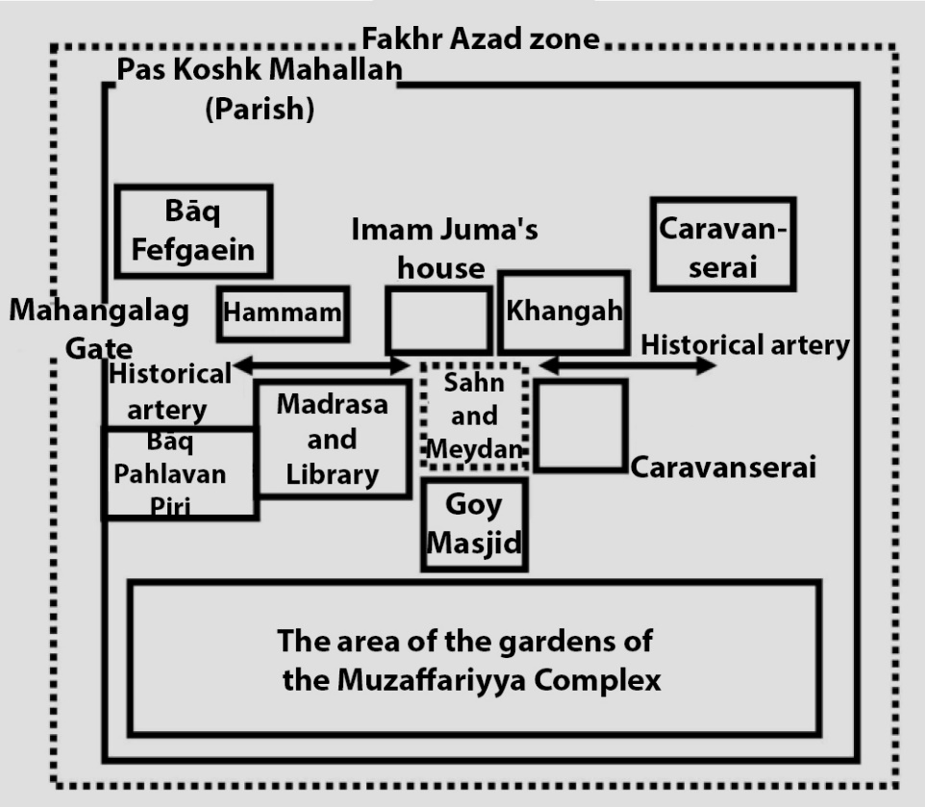

Figure 1. Forecasting the overall situation of the Muzaffariyya complex based on documents [1]

Table 2. The elements of the Muzaffariyya complex are based on historical documents and writings

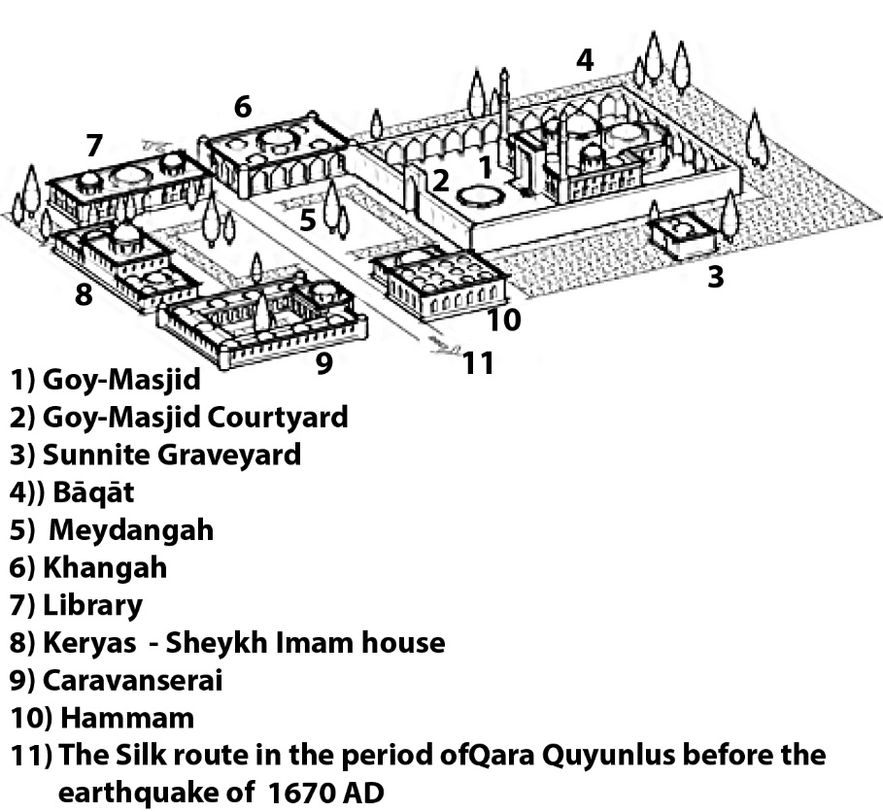

Figure 2. Reconstruction and hypothetical design of the Muzaffariyya complex in the Qaraquyunlus period in another research [8]

- GOY-MASJID (BLUE MOSQUE)
The Goy-Masjid is one of the buildings of the Muzaffariyya complex and it owes its name to its unique Kashi-Kari in history, based on inscriptions and documents made before 1468 AD, in the area of Tabriz Khiyābān outside the Māhānqalaq gate by Jahan Khatun Jan Begum (Jahanshah wife) with Jahanshah order [1]. The mosque's name is after the color of its Kashi-Kari in Turk. Goy-Masjid (and in Persian, Masjid-Kabud) is also known as the Firuze-ye Islam . The Muzaffariyya complex, built near the Silk Road east of the city, made the Goy-Masjid blazon in the eyes of the caravans on this route [19].
The building of the Goy-Masjid is a Maqbareh that was built in combination with the mosque. This building was also known as Jahanshah's mosque and tomb. Nevertheless, it also had other elements that in the deed of endowment of the mosque, in addition to the Maqbareh, the existence of a Khangah with summer and winter rooms in the garden for Ulemas, a Ganāt and two Howz under its dome is mentioned [3].
The architect of this construction was Mir Shams-Addin Memar from Tabriz or Khāje Ali-Ibn-Osman Kujaji under the management of Ez-Addin Qāpuči [1]. According to Hossein Ibn-Karbalaie, Khatun Jan Begum called the crucial masters of Tabriz to the palace to build the Muzaffariyya complex. Among them, she chose Khāje Ali Ibn-Osman (Ostad Ali - Ali Kujaji) [20]. Its Gonbad is considered one of the most giant brick constructions of the 15th century AD in Islamic architecture [21]. With its unique features, this mosque has been able to house a large part of Turkoman art [1]. Nuri Seçgin has considered the mosque one of the most important buildings in the history of Turk architecture due to its planning and decorative features, which represent a school that is reflected in many buildings of its time in the context of cultural, social, and economic relations [20].

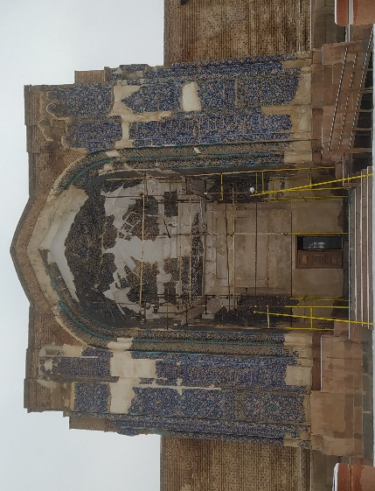 | 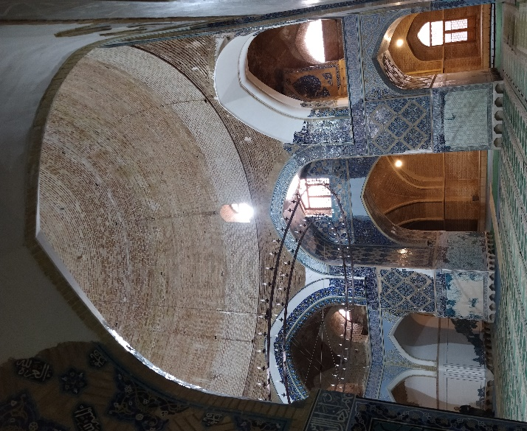
Figure 3. The entrance of the Mosque (North view) (Jan 2023) | Figure 4. View of the Gonbad-Khāneh of Mosque (Dec 2022)

In addition to the elements that were included in the Muzaffariyya complex, the mosque itself also had a Maqbareh, Caravanserai, Hammam, Bāq , Sahn, Revag , Howz Khaneh, etc., which has been exposed to serious damage and destruction for political, economic, natural and religious reasons throughout history [2][1]. Today, the building of the Goy-Masjid only includes a mosque and a Maqbareh, which means it has two functions. As the family tomb of Jahanshah, the tomb is in complete connection with the mosque. Jahanshah himself, his wife, and his children are buried in the Maqbareh [3]. The Goy-Masjid is the only remaining building of the Qaraquyunlus rule in Tabriz [8]. The Goy-Masjid was built with two connected Gonbad-Khāneh , the largest one belonging to the mosque and the other smaller dome belonging to the Maqbareh (in the south of the building), with a minaret on the sides of the portal or entrance porch and without a Miyansara . The entrance to the mosque is from the porch of the entrance portal in the north of the building, and access to the Maqbareh is from inside the mosque, which is after entering the mosque from the sides of the mosque's mihrab.

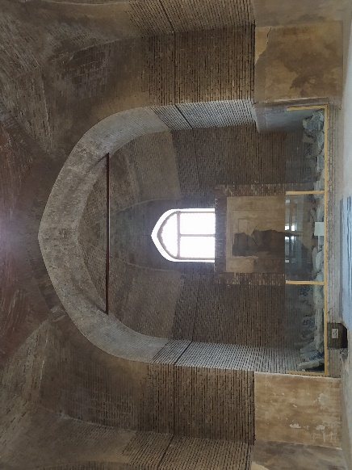 | 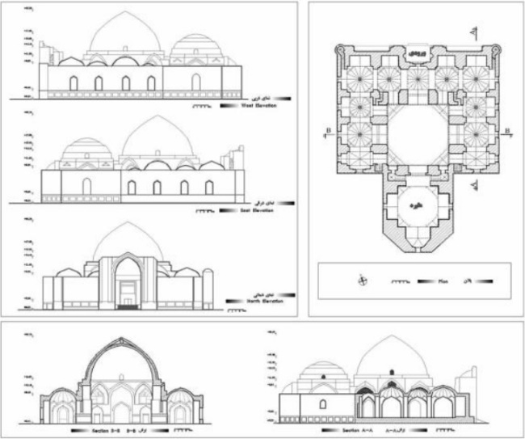
Figure 5. View of the small Gonbad-Khāneh of Maqbareh  (Dec 2022) | Figure 6. Plan, sections, views of the Goy-Masjid [1]

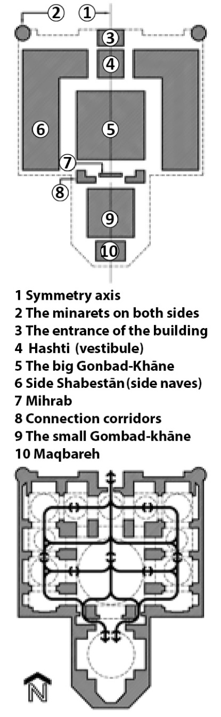
Figure 7. The connection between the spaces of the Goy-Masjid [8]

This mosque's greatness, splendor, and glory are abundantly mentioned in the writings and travelogues of European and Iranian historians and travelers [2]. Among these works, the writings that mentioned the condition of the complex and its surroundings are discussed below. Old pictures of the city show the state of the Goy-Masjid. The miniature of the Ottoman painter Matrakçı Nasuh during his trip to Iran in the 16th century AD with the Ottoman army of the Safavid period displays the oldest image of the mosque (figure 8). After that, we can see the mosque in Jean Chardin's drawing from Tabriz in the 17th century AD (Figure 9).

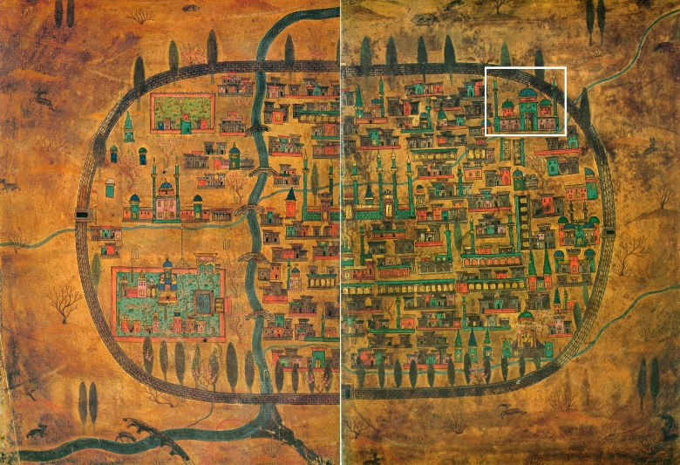 | 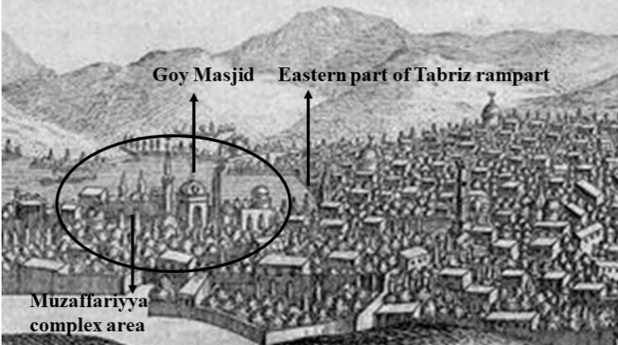
Figure 8. The Goy-Masjid in the miniature of Matrakçı Nasuh in the 16th century AD [22] | Figure 9. Chardin's drawing from Tabriz city [1][23]

- CHANGES IN THE SURROUNDING ENVIRONMENT OF GOY-MASJID (IN AQQUYUNLU, SAFAVID, QAJAR, PAHLAVI, CONTEMPORARY PERIOD)
Since the construction of the complex, there have always been changes in the environment and surrounding buildings, as well as in the elements and context of the Muzaffariyya complex and the Goy-Masjid, due to political, economic, natural, and religious reasons. In the past, the Goy-Masjid was located in a relatively large Bāq inside the Muzaffariyya complex [1]. The existence and description of the surrounding buildings, which also belong to the Muzaffariyya complex, are mentioned in old documents and historical writings. The existence of three Bāq around the complex was also mentioned in the deed of the dedication of the complex. After the Qaraquyunlu period, parts of the Muzaffariyya complex were repaired and completed in the Aqquyunlu period [2]. After Uzun Hassan, during the reign of Sultan Yaqub (Aqquyunlu), the development of the Muzaffariyya complex was completed by the daughter of Jahanshah Sālehe Khātun, and along with it, it returned to its past prosperity and greatness [3]. Among the reasons for the changes in this complex, the severe damage caused to the complex, which was related to the destruction and damage to the mosque and its surroundings due to frequent earthquakes, can be seen in the writings of that time. Mirza Muhammad Ali Mudarris Tabrizi only mentions the remaining Tāq of the mosque's entrance through the north [1]. This means that only the mosque's ruins were left out of the elements of the Muzaffariyya complex during that time. After the rule of the Turkomans in the Safavid era, the neglect and lack of maintenance and protection of the complex due to the perception that Jahanshah was Sunni added to the deterioration of the mosque [3]. Later, Monsieur Tavernier mentions only the mosque and Sheikh Imam's house among the remaining elements of the complex. Nevertheless, the statements that the builders of the mosque were Sunni were mentioned by by some of the travelers from the 17th to the 19th century AD, the reason for that has been discussed in the research, "With a superficial knowledge of the realities of Iranian society, they have expressed incorrect opinions about the quality of maintenance and the survival of the mosque, Without searching and understanding the truth of the matter, they have linked the abandonment of the mosque after the destruction to religious beliefs and prejudices and to Shiite and Sunni issues, including the fact that the founder of the mosque was a Sunni." [11]. Moreover. Mashkur's writings state that "Jahanshah was a Shiite king who was proud of having that religion [18].
In total, many earthquakes have occurred throughout the history of this city, and severe earthquakes, along with their damage and destruction, have also occurred after the construction of the Muzaffariyya complex. In the devastating earthquake of 1779 AD, the main Gonbad and a part of the mosque's hull were destroyed, and then heavy winters caused significant damage to its decorations and Kashi-Kari [21]. In the history of Olād Athār, after the earthquake of 1779, it is described that the city turned into a pile of dust, and nothing was left of the historical monuments except for a part of the Goy-Masjid, Arg-e Alishah, and the Ostād-va-Shāgerd Mosque [3].

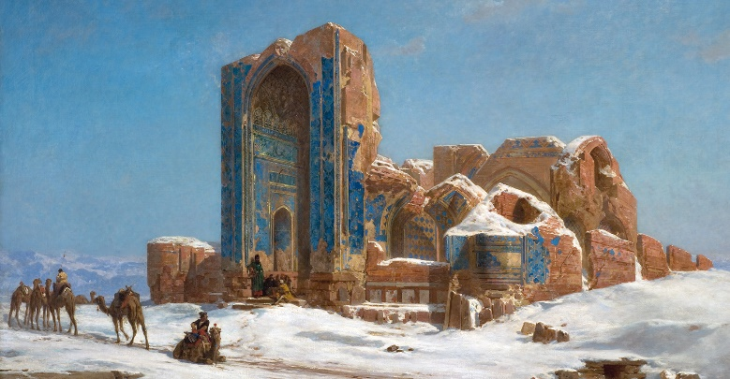 | 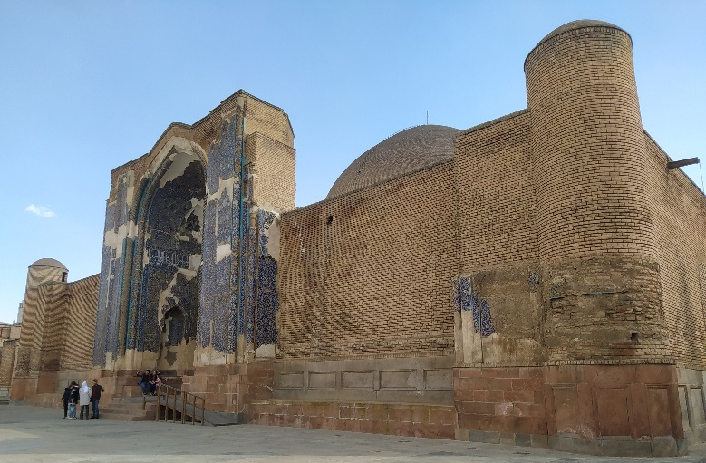
Figure 10. Goy-Masjid in the period of Fath-Ali Shah (King) Qajar 1872 AD, along with ruins around it (Jules Laurens) | Figure 11. Entrance view of the mosque (Mar 2023)

From the Qajar period, in two drawings related to the map of the French mapping group (1828 AD) and the Dār-Ul-Saltane map of Tabriz (1879 AD), the surrounding buildings of the Goy-Masjid have been identified [1]. It can be seen in the drawing of the map of the French group around the mosque, graveyard, Bāq-Shomal, etc. During this period, the area around the mosque was turned into a graveyard.

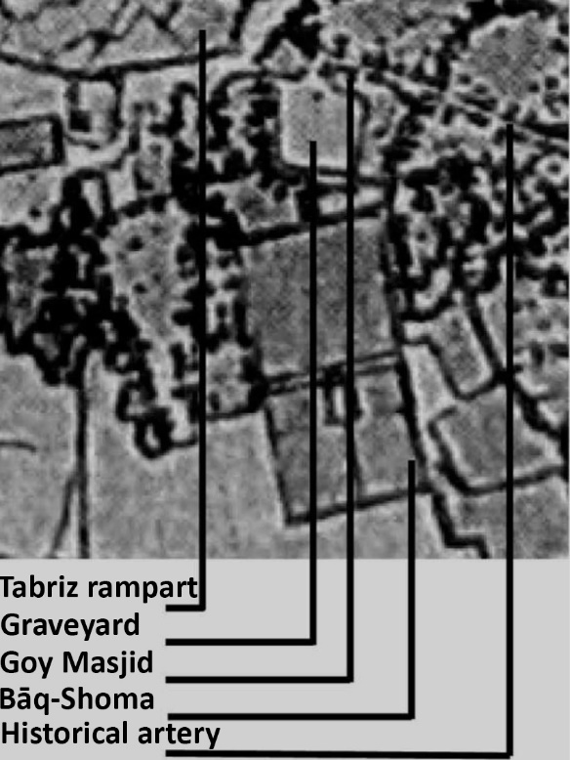 | 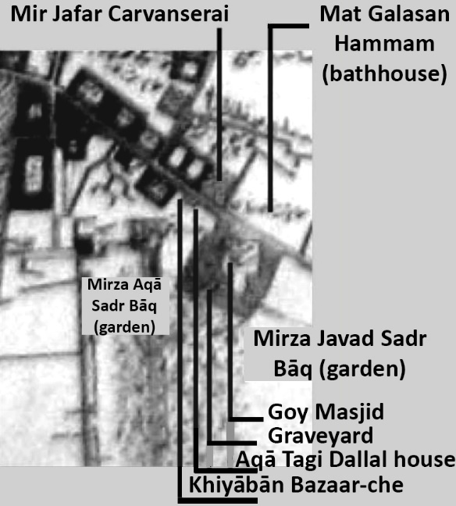
Figure 12. 1828 AD map of French surveyors and the location of the mosque and surrounding buildings [1] | Figure 13. In the 1879 AD Dār-Ul-Saltane map, the location of the mosque and surrounding buildings [1]

Figure 14. In the 1909 AD Asad-Allah Khan Maraghei map, the location of the mosque and surrounding buildings [1] | Figure 15. Eugène Flandin's picture of the ruins of the Goy-Masjid in the 19th AD century during the era of Mohammad Shah Qajar [24]

Travelers and historians have discussed the architectural features of the Goy-Masjid and its surroundings in countless writings. In the pictures of Pascal Coste and Eugène Flandin during the Qajar period, 1841 AD, the ruins caused by earthquakes and the lack of protection and repair of the mosque can be seen. Only the portal and a few foundations remain [3]. In 1841 AD, the writings of Jane Dieulafoy also mention the destruction of the mosque by the nearby residents, the looting of the exquisite materials thrown from the building in the form of a pile, the occupation of the building environs by the residents, and the existence of a large graveyard for Sunnis around the mosque [10][1]. Also stated these things regarding the initial state of the mosque from the large courtyard surrounded by Tāq-Nama and a large Howz for ablution in the center [6]. In the state of destruction of that era (Qajar), the decorative elements and marble stones of the mosque were exposed to looting by profiteers. With the development of the city, bazaars with traditional style covered with Tāq and Gonbad were parallel to the mosque and then continued without covering and around the mosque and bazaar, a warehouse (in a part of the graveyard) and a residential structure have been built [3]. As mentioned, since the Safavid period, these conditions have continued with the occupation of the surrounding buildings and related to the mosque. In 1931 AD, the mosque was registered in the list of national monuments during the first Pahlavi period. Later, the graveyard next to the mosque (a yard of the complex) was turned into a Bāq Delgosha (Delgosha garden) by the then Mayor Mohammad Ali Tarbiat during the organization of the mosque and its surrounding ruins [3]. Schmitt 's 1937 AD aerial image shows the state of the mosque and the garden.

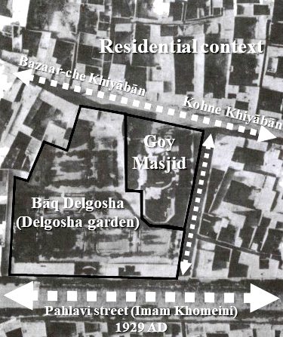 | 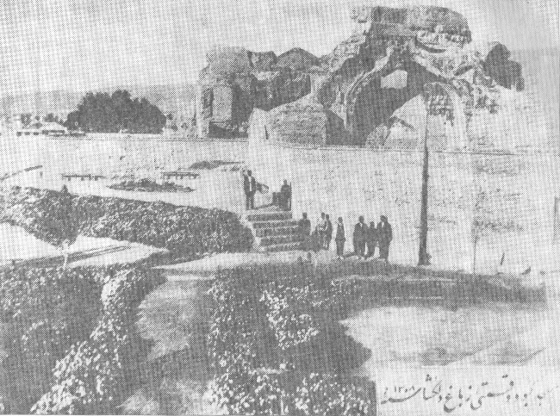
Figure 16. Schmitt’s aerial image and the location of the mosque and surrounding buildings [1] | Figure 17. Delgosha garden and mosque ruins in the picture of 1929 AD, [25]

During Jalal Homai 's visit to Tabriz in 1931 AD, he expressed his regret with a poem about the state of deterioration of historical monuments. also mentioned the Goy-Masjid. Pahlavi Street (now Imam Khomeini Street) was built south of the Goy-Masjid in the same period. Because of this, important parts of city’s the historical context were destroyed. With this action, the Kohne Khiyābān (the historical and cultural axis of the Silk Road in the north of the mosque) has lost its dynamism and growth [6]. At the same time, the entrance to the Goy-Masjid was originally on the north side of the Kohne Khiyābān. With the construction of the new street, the view of the city changed from its entrance facade to its back, and later, the Goy-Masjid, with its surrounding walls, was separated from the city life flow [6]. The 1931-1956 AD development plan destroyed Bāq Delgosha and built the Timsar Fakuri School. In 1957 AD, under the supervision of Andre Godard, the Azerbaijan Museum was built by Ali Sadegh (architect) next and part of the school [1].

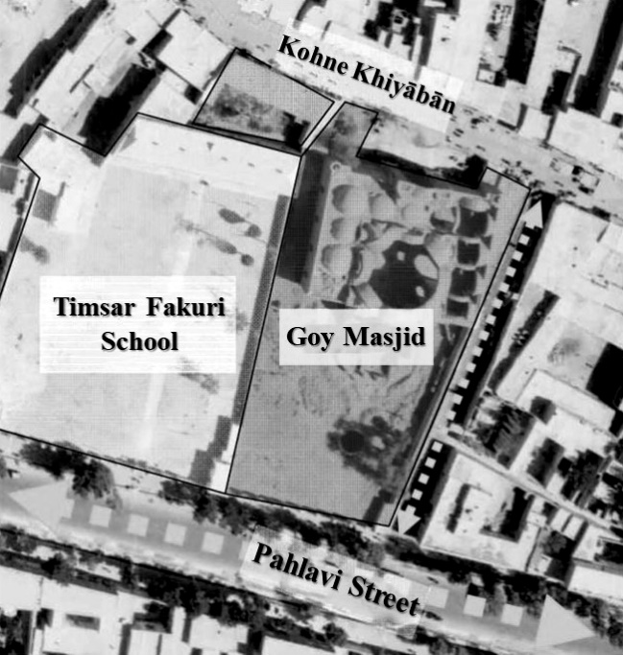 | 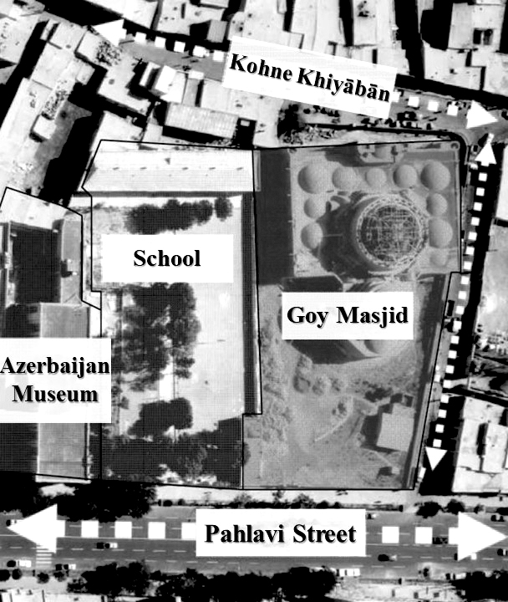
Figure 18. Aerial image 1956 AD Mapping Organization [1] | Figure 19. Aerial image 1975 AD Mapping Organization [1]
As mentioned, for some reasons, there are no remains of this Muzaffariyya complex and around the mosque, except for the Goy-Masjid, which cannot provide detailed information about its architecture. After the Iranian Revolution from 1978 to 1990 AD, due to the conflict and outbreak of war in Iran, no construction and restoration activities were carried out in the mosque. The context around it: with the end of the war, the cultural heritage organization decides to design and organize the context around it. It starts based on a design by Dr. Shirazi and its approval in the Article 5 Commission of the Supreme Council of Architecture and Urban Planning. However, economic and political issues prevented the implementation of this plan, which was a traditional and national approach and included a library, school, Rasteh , Timche , and museum. In the eastern and northern parts of the complex, a plan in 1993 AD, including a "commercial complex," was designed and implemented by Bavand consulting engineers. This plan is implemented by ignoring the technical and landscape privacy of the building and by excavating and digging deep foundations. A part of the historical site, belonging to the first millennium BC, was destroyed in the lower layers of the Goy-Masjid area. With the filing of lawsuits by the Cultural Heritage Organization in Iran's judicial assemblies, the implementers of this plan were condemned in 1999 AD and required to adjust the plan's height and facade following the traditional-Iranian patterns.

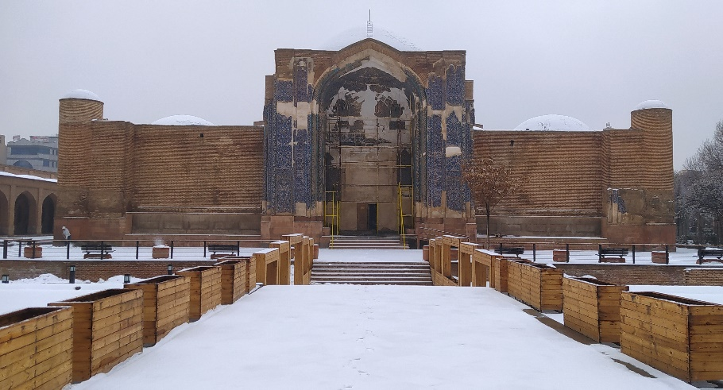 | 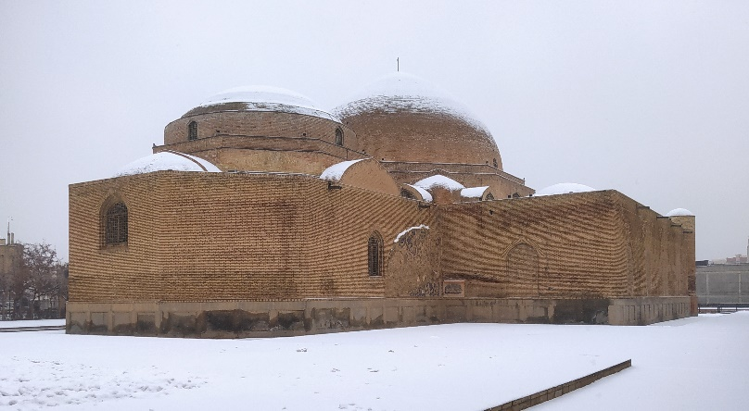
Figure 20. View from the north (Jan 2023) | Figure 21. View from the southeast (Jan 2023)

Table 3. The Result of The Implementation Plans Around the Goy-Masjid Environs
Year  (AD) | Implemented plan | Designer, Advisor, or Founder | Executive | Results and consequences
1929 | Organizing the area and conversion of the graveyard into a Bāq Delgosha (Delgosha garden) | Mohammad Ali Tarbiat, Mayor of Tabriz | Municipality of Tabriz | Although the surrounding context was provided for public use, the remaining parts of the historical traces were destroyed.
1949 | Converting a part of Bāq Delgosha (Delgosha garden) to Timsar Fakuri Elementary school | - | The Education | The open area around the site was destroyed, and the connection between the Goy-Masjid and the Azerbaijan Museum was severely damaged.
1957 | Construction of the National Museum of Azerbaijan | Ali Sadegh, under the supervision of Andre Godard | The Ministry of Culture and Arts | With the construction of this museum and the start of renovations of the Goy-Masjid, The use of this urban complex became educational and cultural usage.
1990 | The porches around the inner yard and the Zemestani (hibernal) mosque in the southern part of the yard | Baqer Ayat-allah zadeh Shirazi | Cultural Heritage Organization | With the implementation of this plan, the Sahn (courtyard) was defined for the Mosque, but this plan does not have a reference format or historical document.
1998 | Commercial complex on the east side of the complex | Bavand Consulting Engineers | Civil and Improvement Organization of Tabriz | The project was implemented without considering the complex's historical values and privacy (Harim) and severely destroyed the surrounding context
2003 | Construction of Khaqani Park on the west side | - | Municipality of Tabriz | It prevented the implementation of the whole design of the mosque courtyard on this side
2007 | Creation of the Tabriz Iron Age and Gray Pottery Archaeological Museum site | Behrouz Omrani | Cultural Heritage Organization | A part of the revealed civilization of the 1st millennium BC was displayed at a depth of 8 meters from the floor of the Goy-Masjid
2009 | Azerbaijan Carpet Museum on the North Front | Bavand Consulting Engineers | Cultural Heritage | This year, part of the physical and executive operations started.

After the excavations carried out in 1999 AD in the area of the Goy-Masjid and the discovery of several graves belonging to the Iron Age in 2007 AD, The Cultural Heritage Organization used this site, which is eight meters deep from the floor of the Goy-Masjid, as the site of Tabriz Archeology Museum. Based on the new actions taken in 2003 AD, on the north side of the mosque and in front of its entrance portal, the Azerbaijan Carpet Museum was designed and is about to be built by Bavand Consulting Engineers. The same year, Timsar Fakuri Elementary School, located between the Azerbaijan Museum and the Goy-Masjid, was destroyed and turned into a park named after the famous Iranian poet Khaqani Park.
In the renovation project of the timeworn context, called the Atiq project, which included a large part of the surrounding area of the mosque, the Kohne Khiyābān, in line with it, has been destroyed under renovation and complete reconstruction [6]. With the implementation of this project, the demolition and leveling of the context, and the construction of the commercial project, the historical appearance of the environment has been transformed [5]. Wahabzadeh wrote the following about the implementation of this project: “In the implementation of the plan without architectural expression, Samadi's historic house was destroyed and the civilizational layer of the first millennium BC was destroyed at a depth of 6 meters, and by neglecting the privacy of the mosque, the commercial density of the area has increased, and the density of service spaces has decreased [3]. As a result of the plan’s implementation, irreparable damages have been reached. These recent changes and developments have turned the Goy-Masjid into a single element on the city's border, which once had an essential place in the city's structure and the flow of life [6].

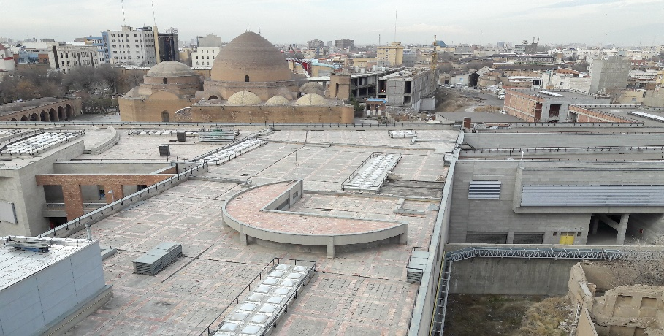 | 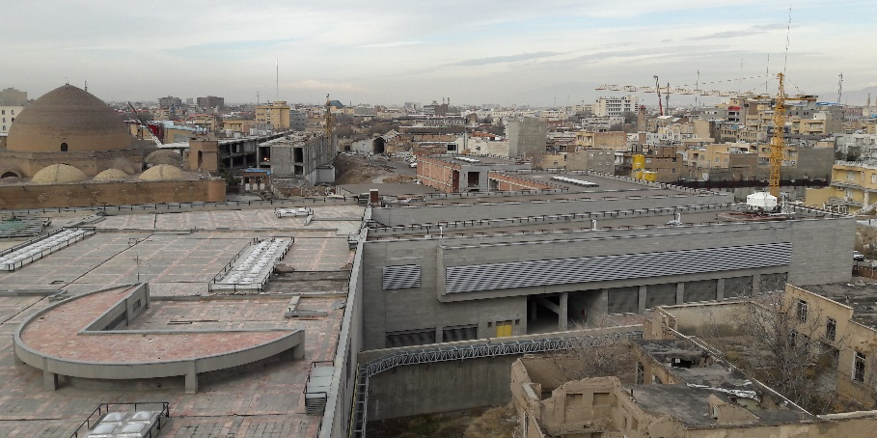
Figure 22. East view of the mosque from Atiq project (Mar 2016) | Figure 23. East view of the entrance area of the mosque from Atiq project (Mar 2016)

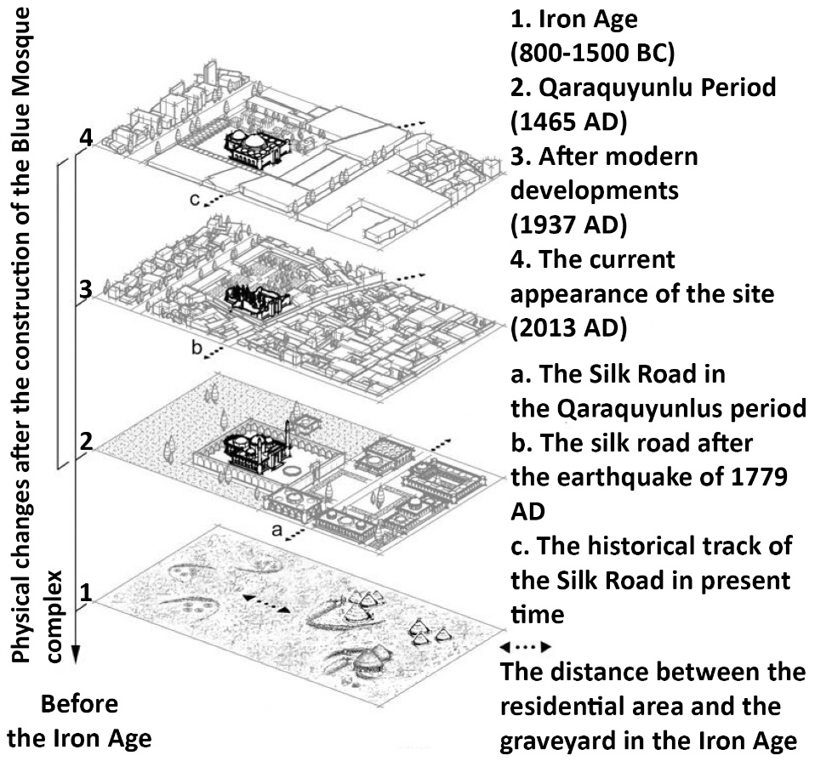
Figure 24. Physical changes of the site around the mosque in several historical periods [5]

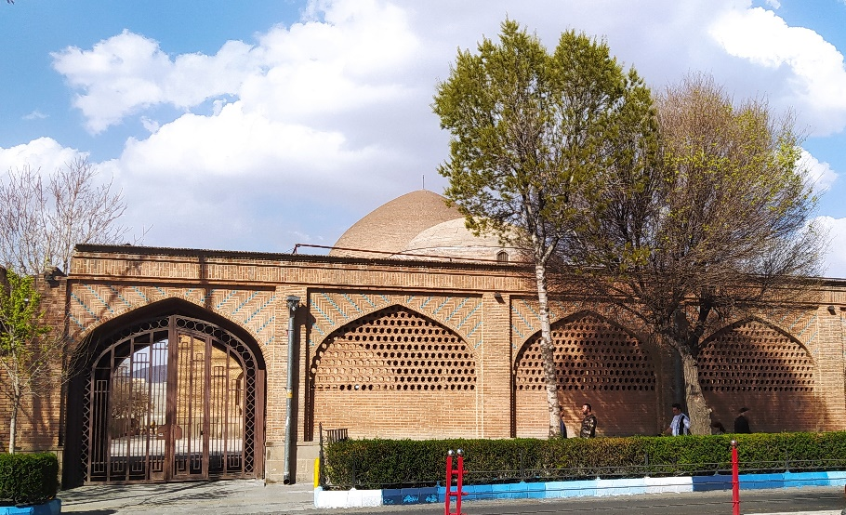 | 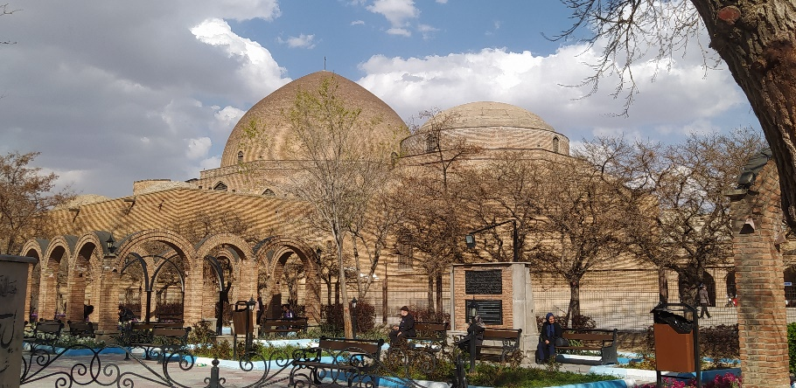
Figure 25. South view of the mosque from the Emam Khomeini (Pahlavi) street (Mar 2023) | Figure 26. Southwest view of the mosque from the Khaqani Park (Mar 2023)

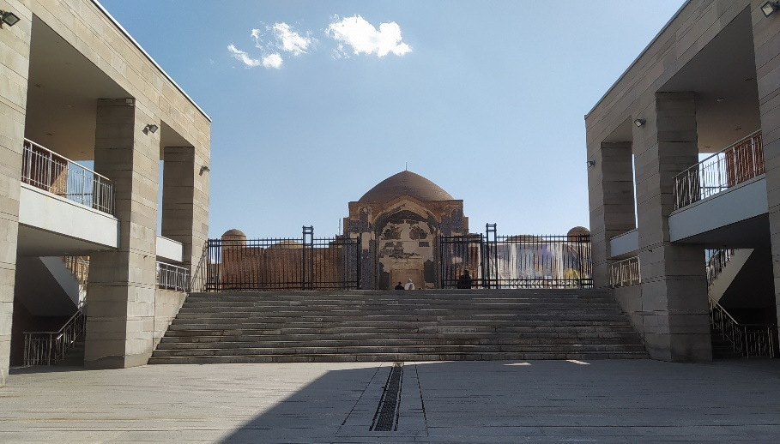 | 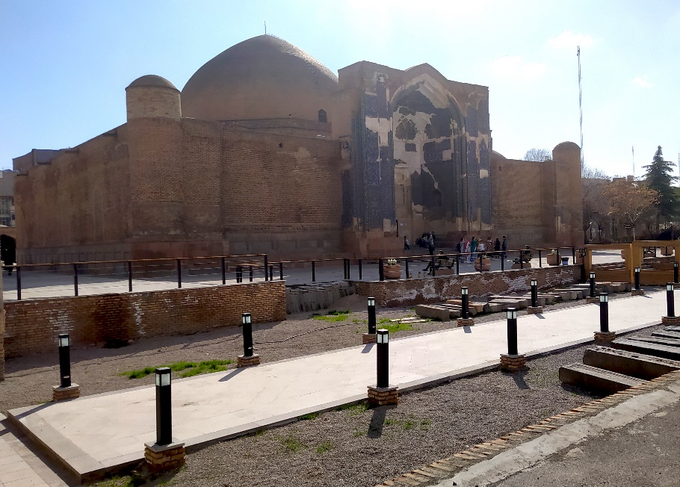
Figure 27. North view of the mosque from Roshanayi Street at North (Mar 2023) | Figure 28. Northeast view of a mosque (Mar 2023)

- CONCLUSION
The Muzaffariyya complex is one of the most important complexes of the Turkoman era of Qaraquyunlu, which is a continuation of the complexes that started with the complex of Abvab al-Bari , such as Rab'-e Rashidi and Ghazaniyya . This complex, which includes various buildings, has undergone many changes and transformations due to natural and human factors, especially the frequent earthquakes in Tabriz. No traces of that valuable complex have been left after the havoc, demolition, and damage, except for the Goy-Masjid. The mosque was placed within the complex and next to the other elements in the early construction period. Still, during the time and alterations, it became a solitary element in the city. According to the plans and projects implemented to revive this complex, the Goy-Masjid and its surroundings have not successfully changed or improved this situation. Based on the documents, the combination and connection of the elements of this collection with each other and its connection with the surroundings and the city can be seen. There is also an essential and valuable example of the complex's close connection with the Silk Road. Considering the importance and place of the Muzaffariyya complex and the Goy-Masjid in the history of Iranian architecture, the surrounding area of the mosque should be formed to revive the place of the Goy-Masjid in the modern city structure. A solution can be found according to the purpose and primary use of the complex and its place in the old city.

REFERENCES
[1] F. Hag parast and A. Nejad Ebrahimi, “Imaginary reconstruction of Tabriz’s Muzaffariyya mansion complex (Goy-Masjid) based on historical documents and texts,” Journal of Pazhohesh Honar, vol. 2, no. 7, pp. 89–94, 2014.
[2] H. Nakhjovani, “The Goy-Masjid or Muzaffariyya Mansion,” Journal of Faculty of Literature and Human Sciences, no. 3, pp. 11–20, 1947.
[3] A. R. Wahabzadeh, The Goy-Masjid yesterday-today, vol. 2, Tehran: Cultural Heritage Publications, 2007.
[4] S. Mohammadzadeh and S. A. Mansori, “The relationship between the Muzaffariyya complex and the spatial organization of Tabriz city from the Qaraquyunlus period to the Qajar period,” Bagh Nazar Journal, vol. 15, no. 68, pp. 15–24, 2018. Doi: https://doi.org/10.22034/BAGH.2019.81651.
[5] M. Peyrovi and M. Kabirsaber, “Recognition of Site Precedent from the Perspective of Integrated Conservation, Case Study: Tabriz Blue Mosque Surrounding Site,” Arman Shahr Architecture & Urban Development, vol. 9, no. 17, pp. 11–24, 2017.
[6] I. Hojat and P. Nasirinia, “Recognition of the Dignity of the Goy-Masjid in Tabriz City,” Honarhaye Ziba Journal, vol. 19, no. 3, pp. 67–74, 2013.
[7] H. Javadi, “Iran from the eyes of the Venetians (from the time of Uzun Hasan to the Shah Tahmaseb period),” Journal of Barresi-haye Tarikhi, no. 49, pp. 87–136, 1973.
[8] M. B. Kabirsaber, H. Mazaherian, and M. Peyrovi, “Architectural Morphology of Tabriz Goy-Masjid,” Journal of Motaleat Memari Iran, no. 6, pp. 5–23, 2013.
[9] S. H. Hashemi, “The religion of the Qaraquyunlus,” Journal of Roshd – History Education, vol. 13, no. 47, pp. 50–53, 2012.
[10] H. Sultanzadeh, Tabriz a Solid Cornerstone of Iranian Architecture, Tehran: Cultural Research Office, Second Edition, 2010
[11] M. B. Kabirsaber and M. Peyrovi, “Architecture Heritage through the Understanding of Foreign Tourists from 15th to 16th Century AH - Case study: Analyses of anatomic resistance quality in the Goy-Masjid based on rereading the historical documents,” Journal of Research in Islamic Architecture, vol. 3, no. 6, pp. 68–83, 2015.
[12] L. Golombek and D. Wilber, Timurid architecture in Iran and Turan. Tehran: Publications of the Cultural Heritage Organization, 1994.
[13] S. A. Mansori, S. Mohammadzadeh, “The Changes of Tabriz Spatial Organization from Early Islamic Era to Gajar Era,” Baq Nazar journal, vol. 14, no. 51, pp. 21–32, 2017.
[14] E. Ökten, “Imperial Aqquyunlu Construction of Religious Establishments In The Late Fifteenth Century Tabriz,” Politics, Patronage and the Transmission of Knowledge in 13th - 15th Century Tabriz, vol. 8, pp. 371–385, 2014.
[15] S. Blair, Islamic Art and architecture. Tehran: Surush Publications, 2002.
[16] M. Dehghani Tafti, Z. al-Sadat Modarreszadeh, and G. H. Memarian, “The Origin of the Architectural Model of the Goy-Masjid in Tabriz,” Journal of Motaleat Memari Iran, vol. 10, no. 19, pp. 5–23, 2021.
[17] Y. Zokā, The formation of Tabriz - Iranian cities, 1st ed. Tehran: Jahad Daneshgahi Publications, 1989.
[18] M. J. Mashkur, The history of Tabriz until the end of the 9th century AH. Tehran: Publications of the National Art Association, 1973.
[19] M. B. Kabirsaber and A. A. Mohammadi, “Nature Politics and Architecture; Reading out the interaction of nature politics and cultural components in the architecture-creating process of Tabriz Goy-Masjid,” Journal of Research in Islamic Architecture, vol. 7, no. 22, pp. 89–107, 2019.
[20] N. Seçgin, “Tebriz Gök Mescid’in Türk Mimarlık Tarihindeki Yeri ve Son Durumuna İlişkin Gözlemler,” 8 Uluslararası Türk Kültürü Kongresi Bildiriler, II, pp. 1025–1045, 2013.
[21] Golestan Quran, “The main report: The essence of the tune of verses in the melodies form of the Goy-Masjid,” Golestan Quran Journal, no. 20, pp. 21–26, 2000.
[22] N. Matrakçı, Bayane Manazel, 1st ed. Tehran: Publications of Iran’s Cultural Heritage Organization, 2000.
[23] J. Chardin, Chardin’s travelogue, vol. 2. Tehran: Tos Publications, 1995.
[24] E. Flandin, Eugene Flandin’s travelogue. Tehran: Eshraghi Publications, 1977.
[25] T. Tabatabaie, Kabud Mosque “Firuze Islam,” 1st ed. Tabriz: Mahd Azadi Publications, 2000.

