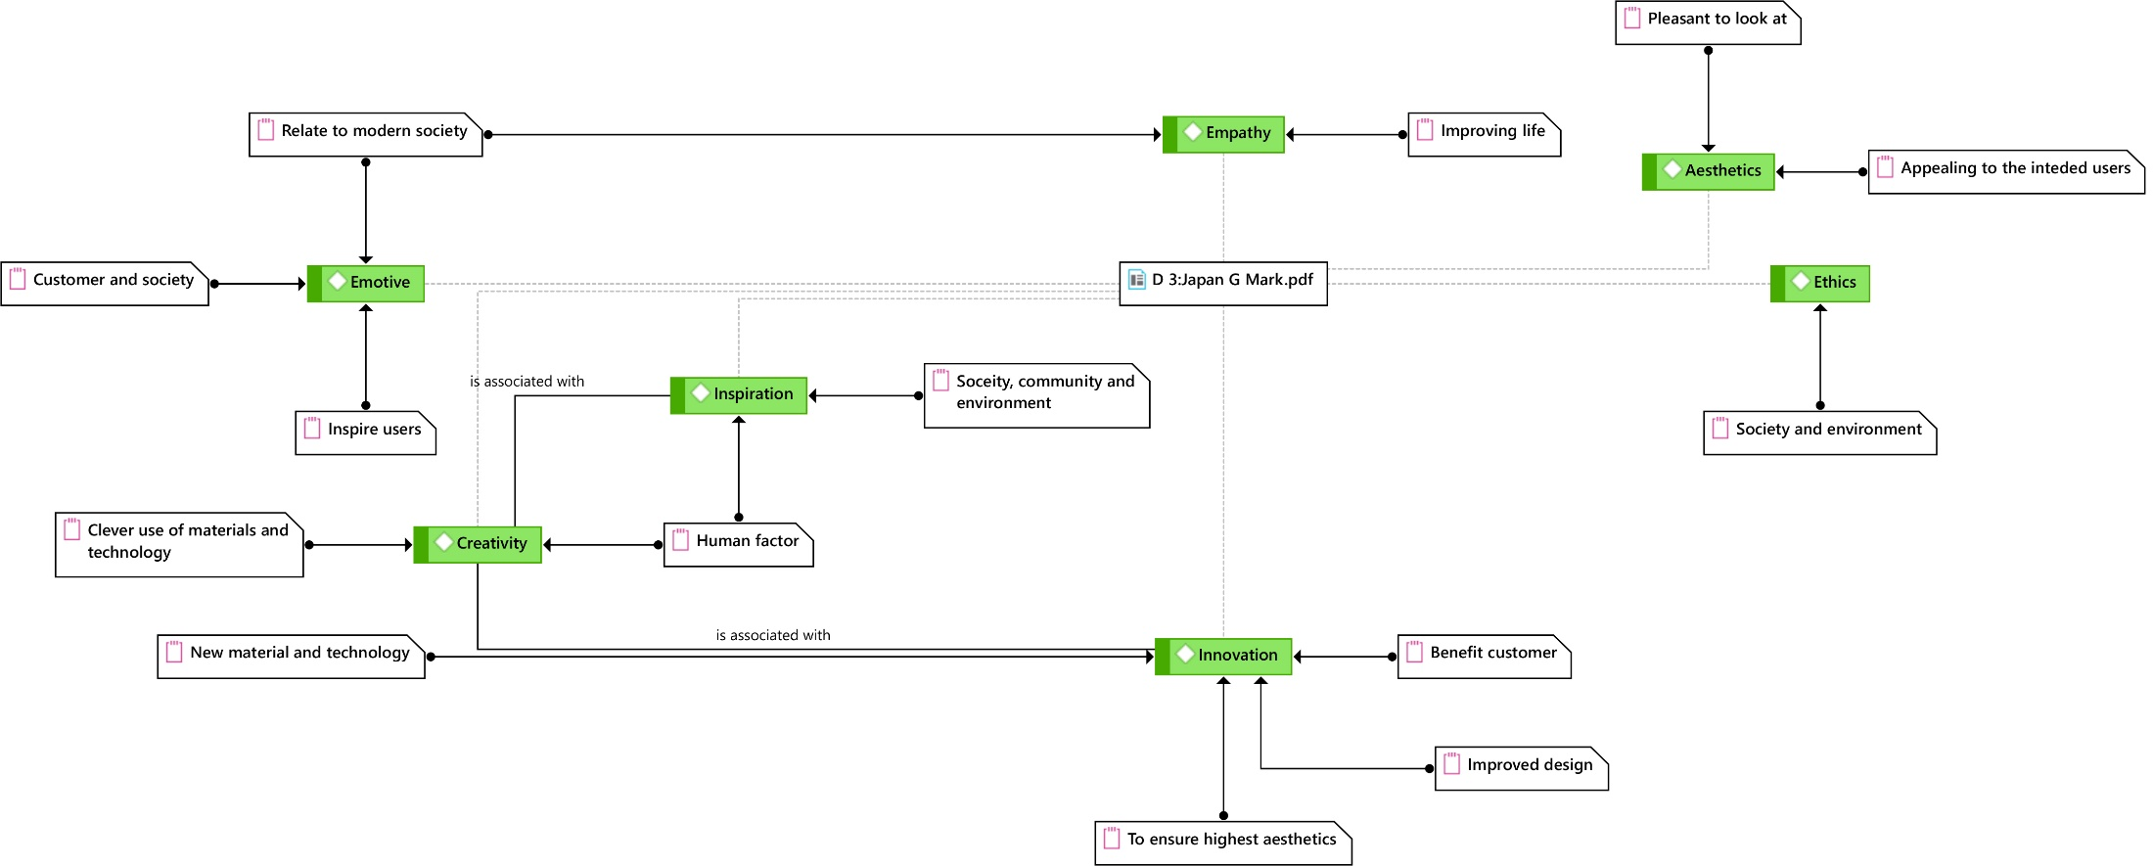
Figure 1: Evaluation criteria Japan G Mark (Green colored tabs are keywords with additional memos explaining the intended meanings)

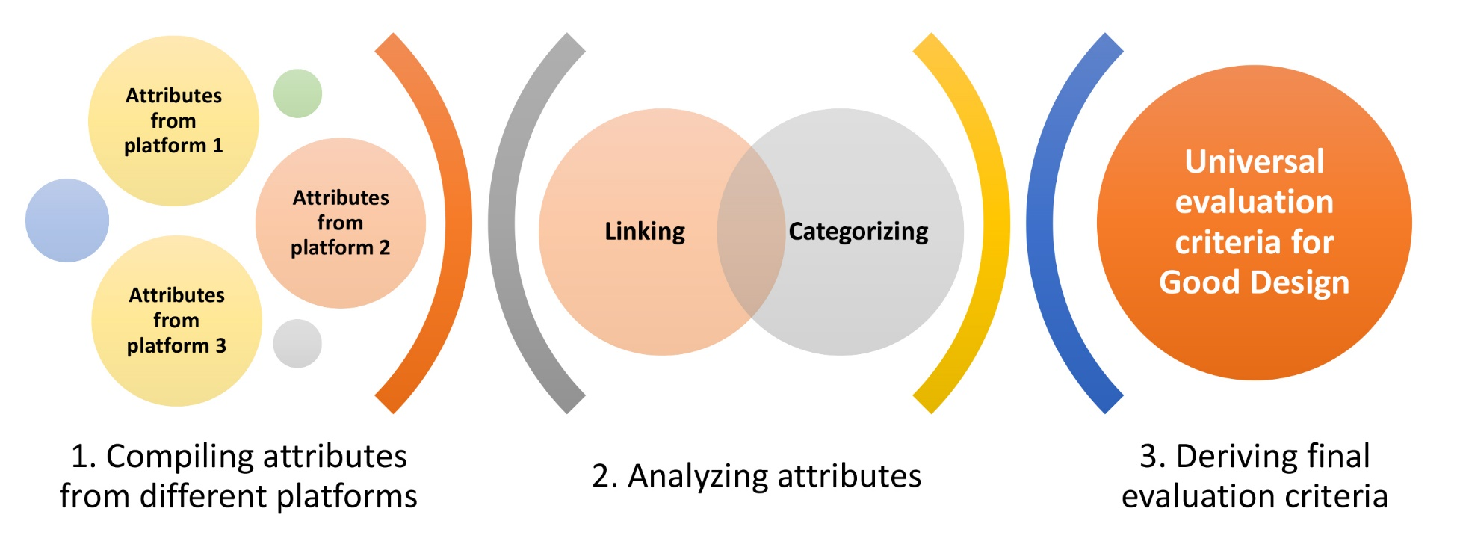
Figure 2: Research Design Diagram

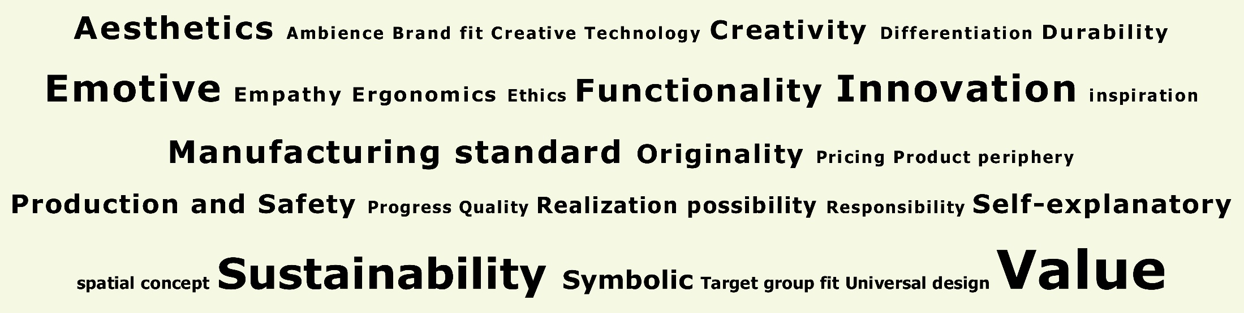
Figure 3: Word cloud for keywords showing their relative significance according to the occurrence

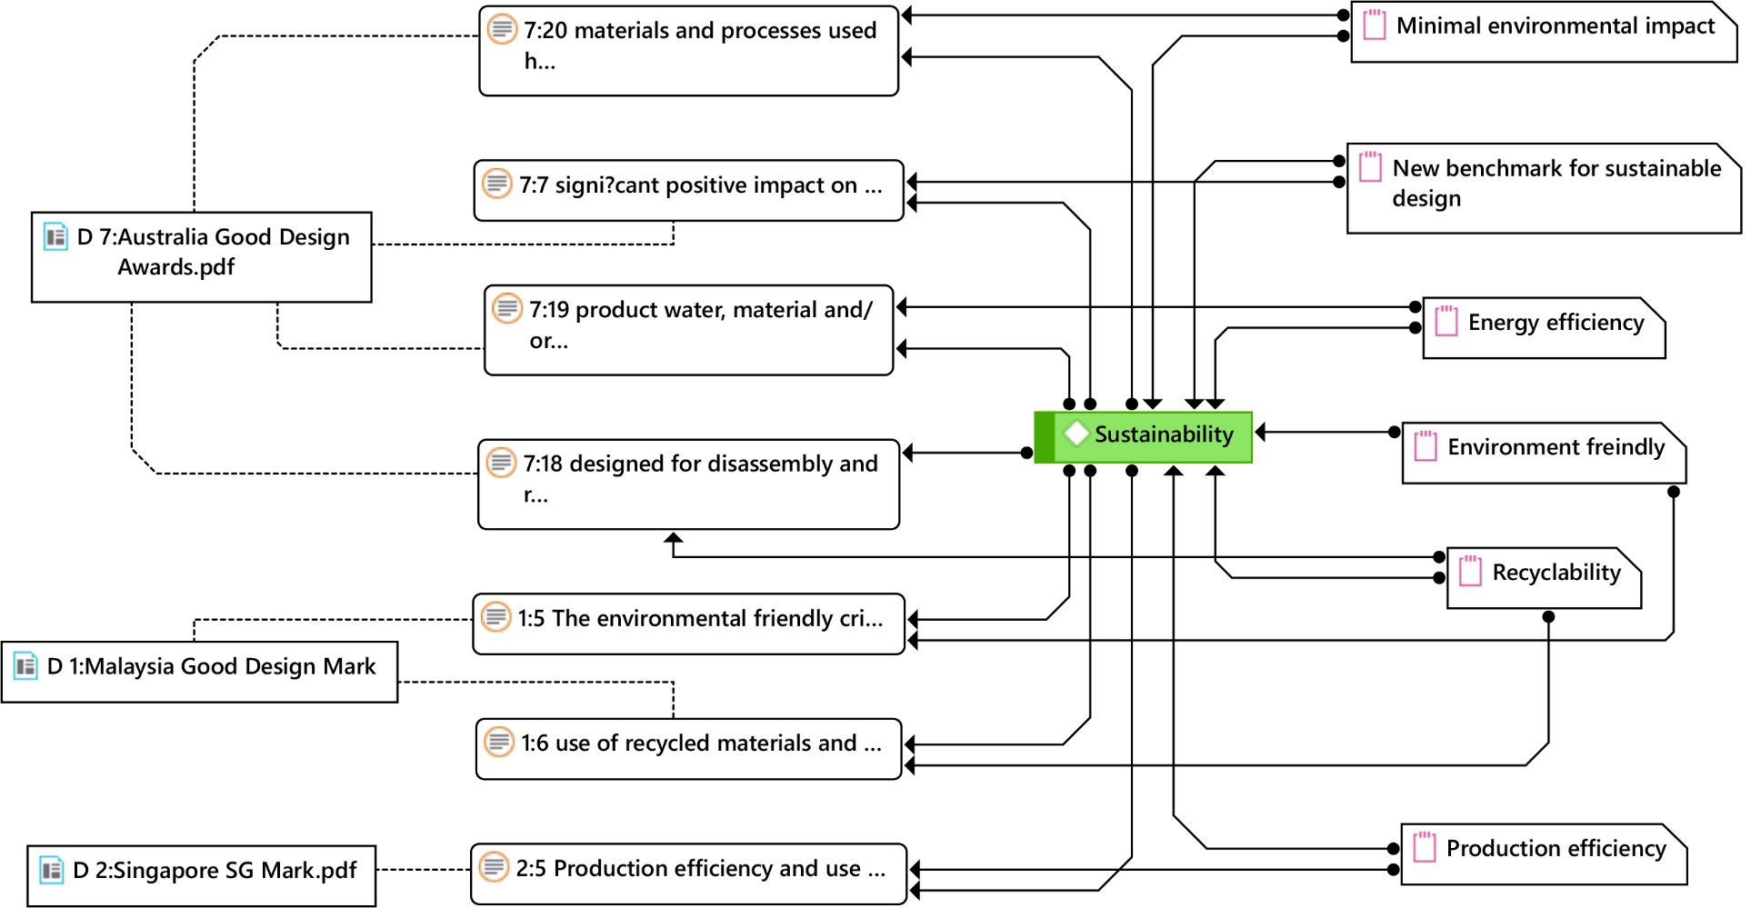
Figure 4: The notion of “Sustainability” and its different interpretations

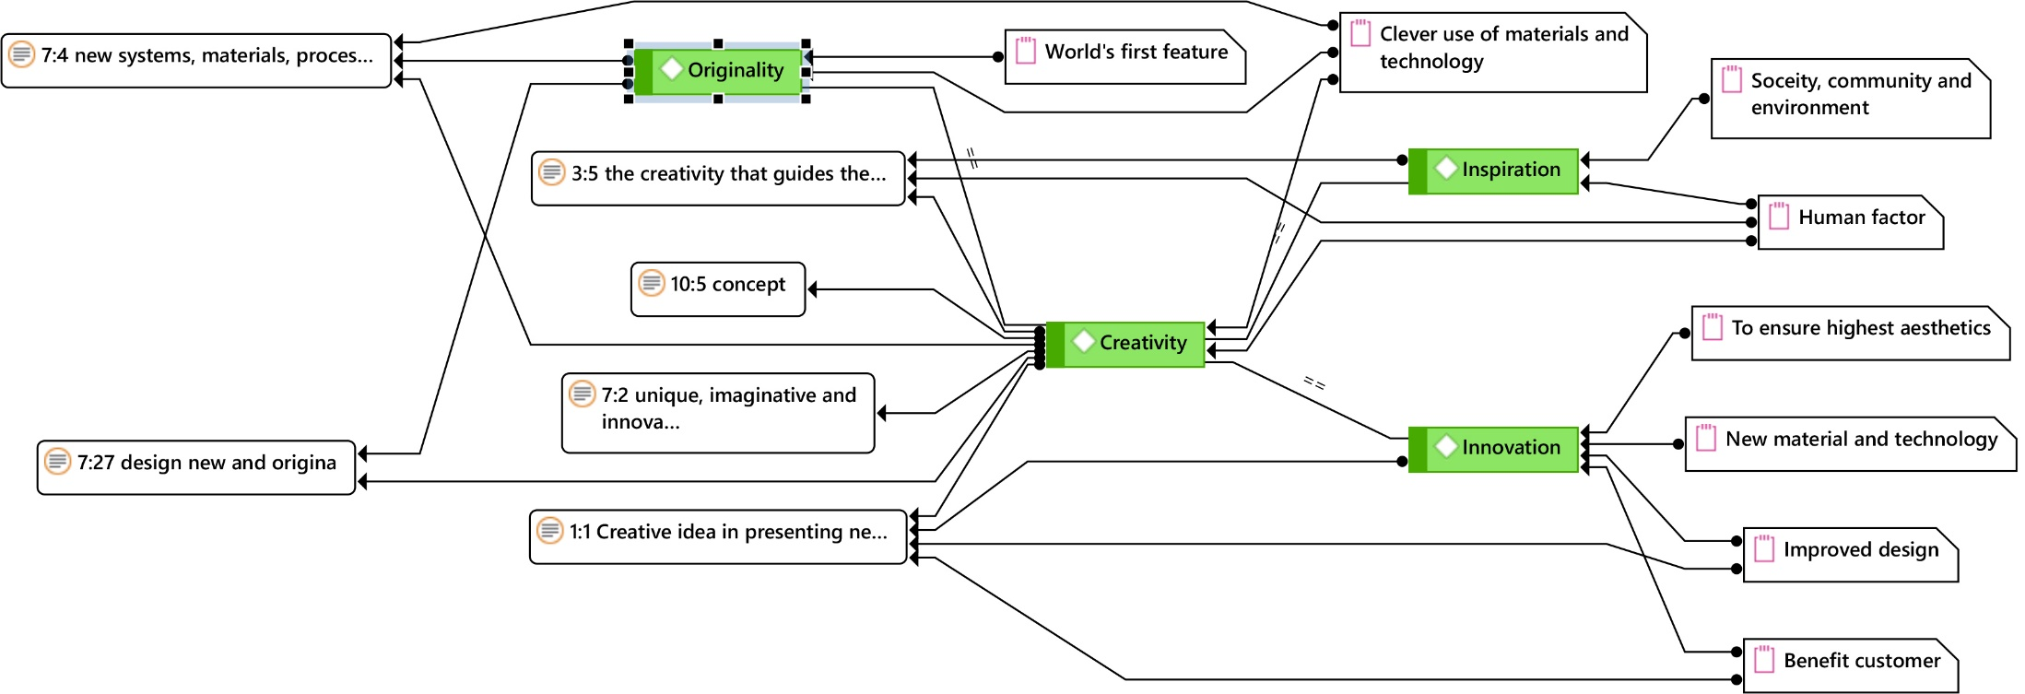
Figure 5: The notion of “Creativity,” its different interpretations and relation to other keywords

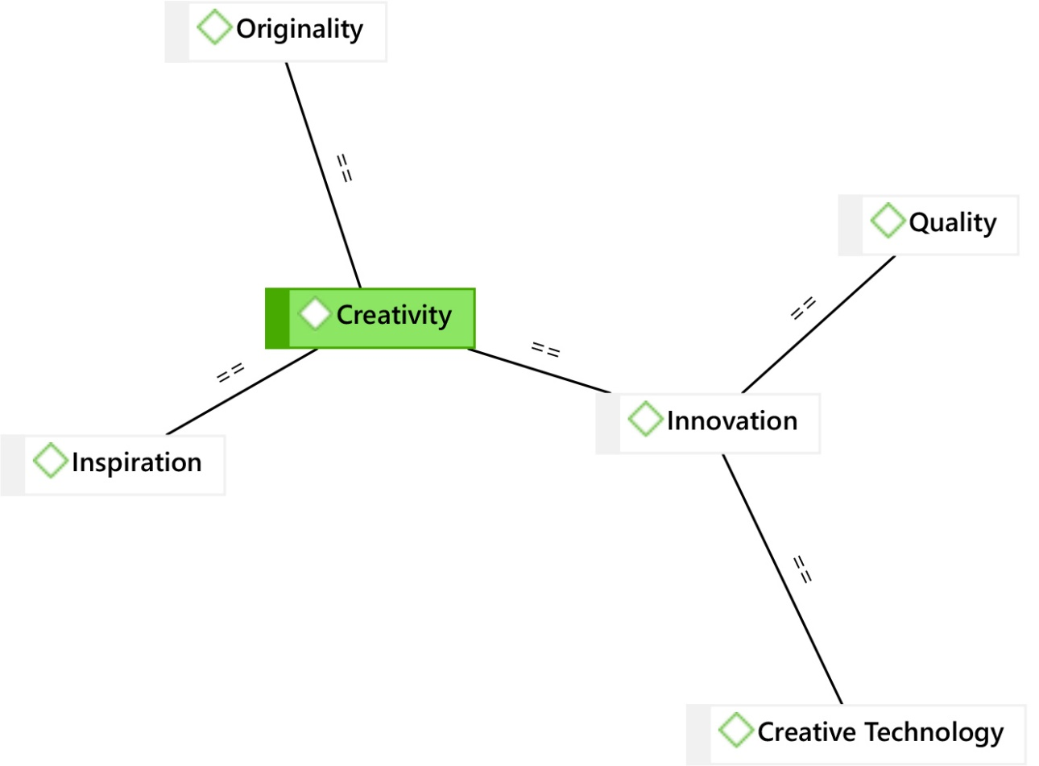
Figure 6: Hierarchical relation of keyword “Creativity” with related keywords.
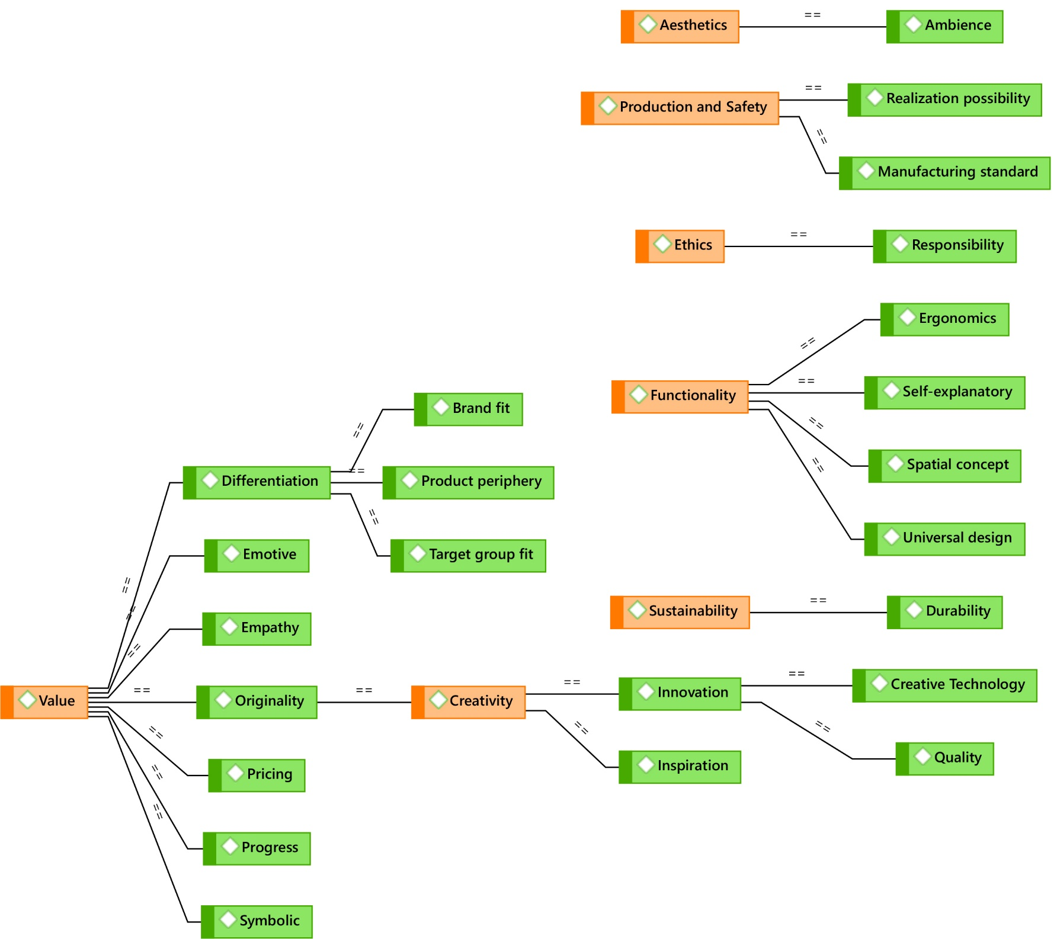
Figure 7: Inter-linked keywords showing the seven themes highlighted in Orange color

