 |  | JOURNAL OF ISLAMIC ARCHITECTURE  P-ISSN: 2086-2636 E-ISSN: 2356-4644  Journal Home Page: http://ejournal.uin-malang.ac.id/index.php/JIA
EXPLORING GOOD ISLAMIC DESIGN ATTRIBUTES THROUGH THE LENS OF ASMA-UL-HUSNA: TOWARDS A UNIVERSALLY UNDERSTOOD GOOD DESIGN EVALUATION FRAMEWORK
Khairul Aidil Azlin Abd. Rahman^{a*}, Nor Ziratul Aqma Norzaman^{b}, Nazlina Shaari^{c}, Nangkula Utaberta^{d}, Nayeem Asif^{e}, Wahyuni Zahrah^{f}
ªFakulti Rekabentuk dan Senibina, Universiti Putra Malaysia, Selangor, Malaysia
^{b}Fakulti Rekabentuk dan Senibina, Universiti Putra Malaysia, Selangor, Malaysia
^{c}Fakulti Rekabentuk dan Senibina, Universiti Putra Malaysia, Selangor, Malaysia
^{d}School of Architecture and Built Environment, UCSI University, Malaysia
^{e}Kulliyyah of Architecture and Environmental Design, International Islamic University Malaysia, Gombak, Malaysia
^{f}Department of Architecture, Universitas Sumatera Utara, Indonesia
*Corresponding Author: drkhairulazlin@gmail.com, nangkula@ucsiuniversity.edu.my
ARTICLE INFO |  |  | ABSTRACT
Volume: 8  Issue: 1  Page: 1-9  Received: May 26th, 2023  Accepted: February 13th, 2024  Available Online: June 15th, 2024  DOI:  http://dx.doi.org/10.18860/jia.v8i1.21292 |  |  | This paper addresses the challenge of defining and evaluating good design, considering the different ways of thinking about what constitutes good Islamic Design in different populations and market segments. The lack of a standard definition raises important issues, such as limiting evaluation tools without a shared understanding. To address this issue, this paper examines the characteristics of good design and the evaluation criteria used by design competition platforms worldwide. The research is based on a qualitative methodology; keyword coding and linking analysis the evaluation criteria of seven prominent design competition platforms. By creating a common understanding of these attributes inspired by the divine attributes of Asma-ul-Husna, this paper will improve communication between designers and critics, allowing them to explore innovative design ideas more freely and confidently. It is intended for perceptions of good design to evolve and be influenced by changing aesthetics, as well as user needs brought about by technological advances. This study reveals a cyclical pattern in which design preferences emerge periodically, as seen in movements such as postmodernism. Therefore, the attributes of good design must be timeless and universal to ensure lasting relevance. This paper proposes an evaluation criterion that considers existing global standards and identifies seven timeless themes universally applicable to evaluating good design. This result highlights the need for further research, including expert opinion, to refine the proposed criteria. Creating a common basis for interpreting the hallmarks of good design from the perspective of the divine attributes of The Creator benefits designers and critics. It contributes to the enduring importance of good design in an evolving design environment.  Keywords:  Good Islamic Design Mark; Islamic Design attributes; Design competition; Islamic Design evaluation; Islamic Design excellence; Islamic Design aesthetics; Islamic Design functionality.

- INTRODUCTION
Defining Good Design is challenging as different demography, market segments, and even individual beings can have a different perceptions of what a good design is. The question that arises in this regard is how to evaluate the design of any product if there is no standard definition of good design. Despite the complexity, identifying attributes of good design can help set up criteria for design assessment. Regarding attributes, Klemp, Maan, and Mattie believe that Dieter Rams had a remarkable impact on shaping the overall concept of good design as it is known today. Dieter Rams proposed ten principles for good design: innovation, usefulness, aesthetics, self-explanatory, discreetness, honesty, long-lasting, attention to minute details, environmentally friendly, and minimalism [1][2]. However, some platforms label good design around the world through design competitions. Such platforms include Malaysia Good Design Mark, Germany Red Dot Award, Japan G Mark, and Singapore SG Mark. These platforms have good design attributes or criteria for assessing the design.
Interestingly, despite sharing common keywords as evaluation criteria (i.e., innovation, value, etc.), different platforms define or describe the same keyword differently. It necessitates studying the meaning of these keywords to derive a standard definition for each so that a shared understanding prevails among the designers and the critics when it comes to achieving good design characteristics for various products. In this regard, his paper aims to establish a common understanding of the attributes of good design and propose evaluation criteria for design competition platforms. By doing so, it enhances communication between designers and critics and ensures the relevance and universality of good design over time.
While the different design evaluation criteria are used to assess creative designs from various angles, it is crucial to establish a common ground of understanding for these assessments in this globalized world. Incorporating the concept of Asma-ul-Husna in the field of creative design offers a profound opportunity to infuse designs with divine qualities such as mercy, wisdom, and creativity. By aligning design processes and outcomes with these attributes, designers can aspire to create products that reflect the perfection and beauty inherent in the divine realm. This innovative approach not only elevates the aesthetic and functional aspects of design but also imbues them with deeper meanings and purposes, fostering a sense of connection and resonance with broader spiritual ideals.

  - THE CONCEPT OF GOOD DESIGN
The design is a creative process. In his essay on the fundamentals of good design, Simmons states that a good design offers a competitive product, which implies the power of a brand where the user develops loyalty for the brand and tends to recommend each other [3]. Hertenstein, Platt, & Veryzer stated that user experience is crucial for good design. It is only achieved when the user can experience its goodness, from aesthetics to ease of use and quality to emotional connection [4]. This approach can be termed a user-centered design. Good design takes account of the human condition [5].
A user-centered approach to designing products ensures stable market demand for the products. User-centered design can be defined as the strategy in developing a product or service that puts the user in the focus of its developmental effort [6] [7]. The goal is to please the customer and maintain the brand image and market demand. The idea of perceiving good design should be more emphasized due to the complexity of defining its attributes. However, criteria of good design or good design attributes recognized by the users and the company are highly significant as they work as a bridge between the designers and the users through which the designer reaches out to satisfy the customer’s needs through design. Good design plays a crucial role in identifying and articulating viable solutions, with Gjoko Muratovski’s “Research for Designers: A Guide to Methods and Practice” highlighting the evolution of design as a human-centric model for problem-solving and the significance of research in validating and improving design outcomes [8].

  - ASMA-UL-HUSNA AND ITS IMPLICATIONS IN UNDERSTANDING GOOD ISLAMIC DESIGN ATTRIBUTES
Asma-ul-Husna, or the Beautiful Attributes of the Creator, refer to Allah's 99 names or qualities in Islamic tradition, each reflecting an aspect of His perfection and beauty. These attributes embody ideals of perfection, encompassing mercy, wisdom, and creativity. The implications of these attributes are profound in the realm of design, particularly in industrial and product design. They inspire designers to strive for excellence, guiding them towards achieving near-perfection in their creations [9].
In the creative design industry, such as industrial and product design, the principles of Asma-ul-Husna hold significant implications. These attributes serve as guiding principles for designers, inspiring them to infuse their creations with the divine qualities of mercy, wisdom, and creativity. For example, the attribute of Al-Badi, signifying the Incomparable Creator, encourages designers to approach their work with innovative thinking and originality, striving to produce designs that stand out amidst the crowd. Similarly, Al-Hakeem, the Wise, prompts designers to incorporate wisdom and foresight into their designs, ensuring that they meet functional requirements and resonate with deeper meanings and purposes.
Furthermore, the existing design evaluation criteria worldwide can benefit from re-interpretation through the lens of Asma-ul-Husna. A universal understanding of good design can be established by aligning these criteria with the divine attributes of beauty, excellence, and perfection. This re-evaluation allows for a more holistic approach to evaluating designs, considering not only their aesthetic appeal and functionality but also their alignment with higher principles and values. As a result, designers can aspire to create designs that meet human needs and reflect the divine qualities inherent in Asma-ul-Husna.

  - GOOD DESIGN EVALUATION CRITERIA AND THE NEED FOR A COMMON GROUND OF UNDERSTANDING
A good source for compiling information on good design attributes is to study the evaluation criteria of prominent design competition platforms worldwide. Usually, the evaluation criteria set up by these platforms are definitive and concise, even though their interpretation varies from platform to platform. One such platform is Japan’s Good Design Award hosted by the Japan Institute for Design Promotion to label selected good design products. Not only aiming to fund, label, and acknowledge good design products, Japan’s Good Design Award also looks forward to advancing its global reputation through collaboration with various organizations in Asian countries such as Thailand, India, and Singapore [10]. This type of collaboration requires understanding good design attributes among different organizations in different countries to share a common definition to maintain a standard and fair evaluation process. Figure 1 is an example of good design evaluation criteria. Deininger and Hansen examine the influence of emotional responses on design strategies by investigating how potential customers rank and evaluate design proposals, highlighting the need to explore the decision-making process in design reviews further [11]. Another study by Sameti et al. highlights the importance of good design as a problem-solving process, emphasizing the perspective of professional product designers and their viewpoint of design as a verb rather than a static noun, which contributes to improving understanding between marketers and designers and enhances the evaluation criteria for good design [12].
A study by Demirbilek and Park shows that different platforms for labeling good design share some common attributes, each with unique design evaluation characteristics. Their study attempted to identify patterns and trends among the evaluation criteria to establish common ground to define good design [13]. Design traditions are grounded in different appreciations of goodness [14]. However, the study compared four platforms and compiled shared and unshared attributes for good design evaluation. Some ambiguity remains in that approach, where the compilation of 15 shared and 15 unshared design attributes presents a challenge for the designers to prioritize and follow each attribute in achieving good design. Therefore, this study attempts to proceed beyond compiling good design attributes of prominent design competition platforms by comparing them according to their intended definition, grouping them into appropriate categories, and recommending concise and definitive evaluation criteria that are easy to implement and follow.
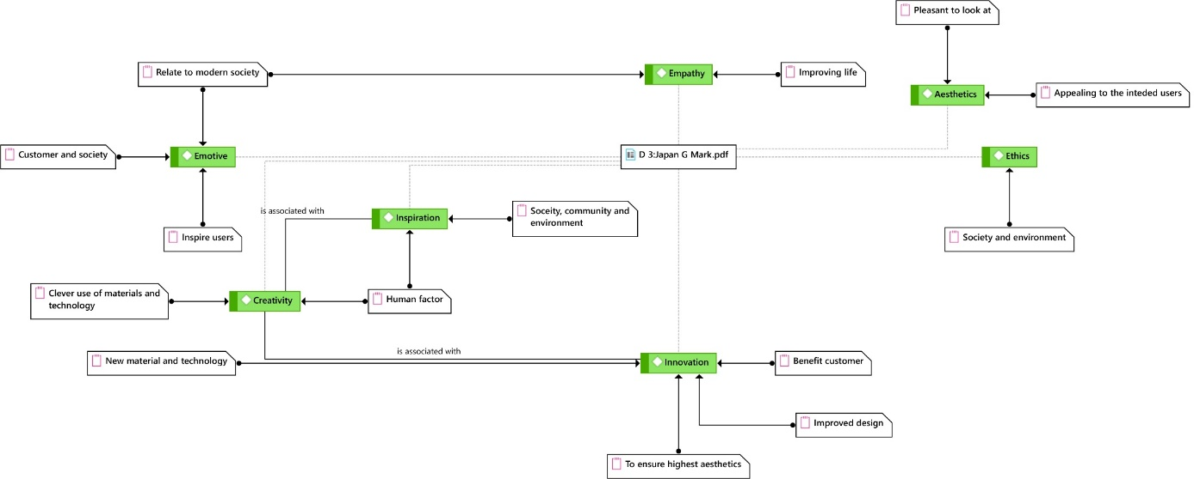
Figure 1. Evaluation criteria Japan G Mark (Green colored tabs are keywords with additional memos explaining the intended meanings)

- METHODS
This study adopted a qualitative strategy to study and analyze the evaluation criteria for good design. Seven prominent design competition platform worldwide and their evaluation criteria for good design are selected as the source for data. The data are collected from the respective websites of the selected platforms. The names of these platforms and their establishment period are mentioned in the table 1.

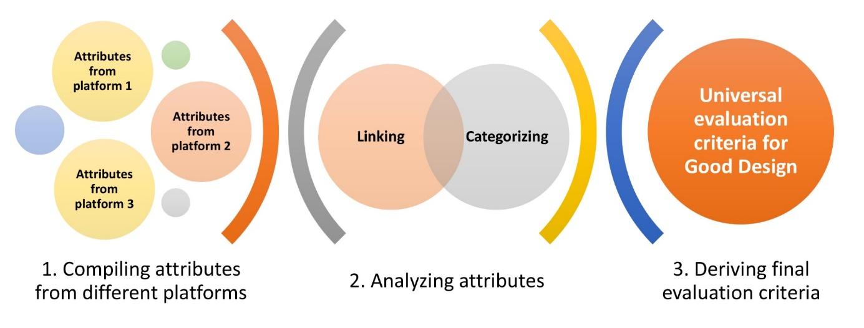

Figure 2. Research Design Diagram

Table 1. Selected design competition platforms
No. | Platform | Organization | Est. period
1 | Malaysia Good Design Mark | The Malaysia Design Council (MRM) | 1993
2 | Singapore SG Mark | Design Business Chamber Singapore (DBCS) | 2013
3 | Japan G Mark | Ministry of International Trade and Industry, Japan | 1957
4 | Australia Good Design Award | The Industrial Design Council of Australia (IDCA) | 1958
5 | Germany Red Dot Award | Verein Industrieform, Germany | 1954
6 | USA Chicago Athenaeum Good Design Award | The Chicago Athenaeum: Museum of Architecture and Design, USA | 1950
7 | Germany iF Design Award | iF Design Foundation, Germany | 1953

Each platform’s evaluation criteria are initially studied separately by coding the keywords using Atlas.ti. Additional memos are noted wherever applicable to elaborate the brief definition of those keywords. As stated earlier, the same keyword might refer to a different meaning for a different platform and the memos act as a guide to interlink similar keywords while storing their intended meanings. After completing the coding for all seven platforms, the keywords are interlinked, prioritized, and categorized into specific groups according to their meanings. Lastly, the groups are further developed into broad themes under which interrelated attributes are organized as an elaboration of the intended meaning of each theme. The derived themes are hoped to create a common understanding of attributes for evaluating good design regardless of the regional boundary. Figure 2 illustrates the process in a simplified way.

- RESULT AND DISCUSSION

- UNIVERSAL EVALUATION CRITERIA FOR GOOD DESIGN
While exploring the evaluation criteria of good design within the selected platforms, some criteria appear more often than others, establishing their relevant significance as attributes for good design. For example, the keyword “Value” appeared the highest number of times (14) while the keyword “Sustainability” appeared ten times, followed by “innovation” (8 times), “Emotive” (7 times), and so on. Some keywords only appeared once for a particular platform, such as “Creative Technology,” “Brand Fit,” “Universal Design,” and so on. This phenomenon established how to initially form a diagram showing keywords according to their relative appearance in different platforms’ evaluation criteria.
However, this word cloud fails to interlink between related keywords, such as “Innovation” and “Creative Technology,” which refer to similar attributes, but the inference is absent in this word cloud. Moreover, it also creates a challenge to categorize the keywords into specific groups for easier understanding.
The selected platforms share some of the evaluation criteria. However, the interpretation of the criteria varies from each other. For example, “Sustainability” refers to different aspects of different platforms (Figure 3). Australia Good Design Award emphasizes setting up a new benchmark for sustainable design, while Malaysia Good Design Mark only refers to recyclability through sustainability [15] [16]. Singapore SG Mark, in this regard, focuses on production efficiency under the sustainability criteria [17].
This example illustrates how various platforms use the same keyword as evaluation criteria for good design while emphasizing entirely different aspects of that keyword. Another similar example is the keyword “Creativity,” which refers to the clever use of materials and technology and interrelates to “Originality” in the Australia Good Design Award and emphasizes a human factor by interrelating with “Inspiration” in the Japan G Mark Award. Both interpretations focus on a completely different aspect of the keyword “Creativity”.

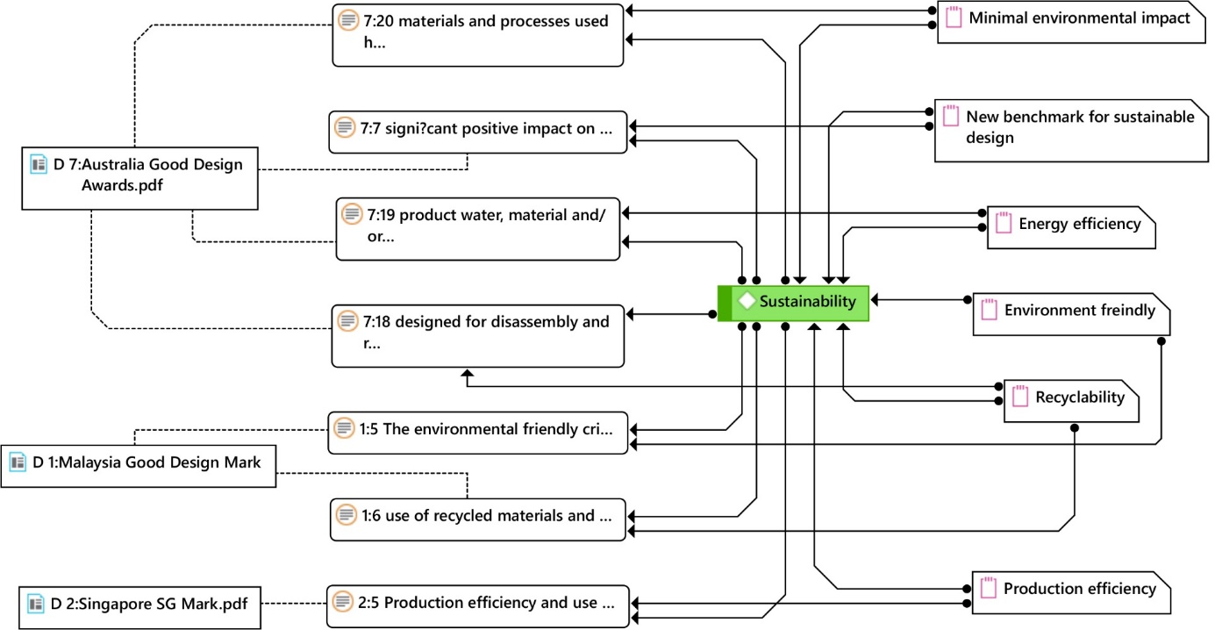

Figure 3. The notion of “Sustainability” and its different interpretations

Related memos are compiled from all the selected platforms to reach a common understanding for each keyword. The memos represent different interpretations by different platforms, and interestingly, in some cases, different keywords refer to the same memo or interpretation. For example, the memo “Clever use of materials and technology” is interpreted in two keywords: “Originality” and “Creativity.” It opens up a way to inter-relate different keywords with similar meanings and simplifies the evaluation criteria by grouping them under one theme. For example, considering the connections among the keywords in Figure 5, it is evident that “Creativity” and “Innovation” have links to the highest number of other keywords, while “Originality” and “Inspiration” are related to a few keywords. Thus, a hierarchy of significance becomes apparent, following which the keywords can be categorized. Figure 5 shows a simplified version of this hierarchical relationship for the keyword “Creativity.”
By repeating this process, thirty keywords are interrelated according to their intended meaning and similarity, and seven themes have been derived as standard evaluation criteria for good design. Figure 6 shows the interlinked keywords, with the theme name highlighted in Orange.
Now, each theme will be elaborated on below to define their interpretation and create a shared understanding that remains the same regardless of the regional boundary or the barrier of a different platform. It is noted that, wherever applicable, the elaboration refers to the standard definition of the design dictionary provided by the Board of International Research in Design (BIRD) [18]. The description will be kept concise to make it easy for the designers to follow it without any challenges.

- VALUE
The design is recommended to serve the customer and society by creating a positive social impact and enhancing user experience. The design must inspire users and provide a unique experience through originality, pricing, and empathy. It will uphold the brand value and ensure design investment return, benefiting users and companies. From Asma-ul-Husna, two attributes reflecting the concept of value in good design are Al-Kareem (The Generous) and Ar-Rahman (The Most Merciful).
The design, embodying the attribute of Al-Kareem, seeks to serve society generously, enriching user experience and fostering positive social impact. Similarly, guided by the attribute of Ar-Rahman, the design is empathetic towards its users, providing a unique and compassionate experience that upholds both brand value and societal welfare.
- CREATIVITY
Creativity is evident in all aspects of human endeavor. It ensures that the design outcome has originality so that market demand can easily be created. It also requires that the design implements new ideas and innovative ways to materialize the product. From Asma-ul-Husna, two attributes reflecting the concept of creativity in good design are Al-Badi (The Incomparable Creator) and Al-Jameel (The Beautiful).
Guided by the attribute of Al-Badi, the design embodies originality and innovation, introducing novel ideas and inventive approaches to product realization. Furthermore, inspired by the attribute of Al-Jameel, the design aims to create beauty and aesthetic appeal, captivating the market with its unique and visually pleasing features.

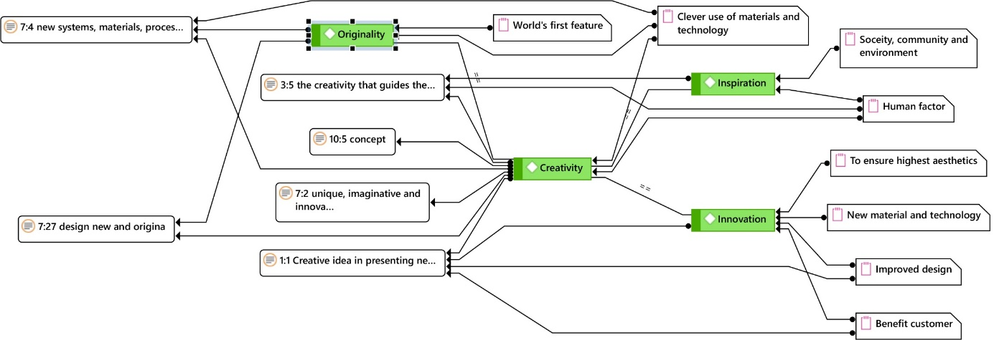

Figure 4 The notion of “Creativity” and its different interpretations in relation to other keywords

- PRODUCTION AND SAFETY
The design must have feasible production possibilities. [19] The production process must follow standard manufacturing regulations and safety standards as instructed by related authorities. From Asma-ul-Husna, an attribute reflecting the concept of production and safety in good design is Al-Hafeez (The Guardian).

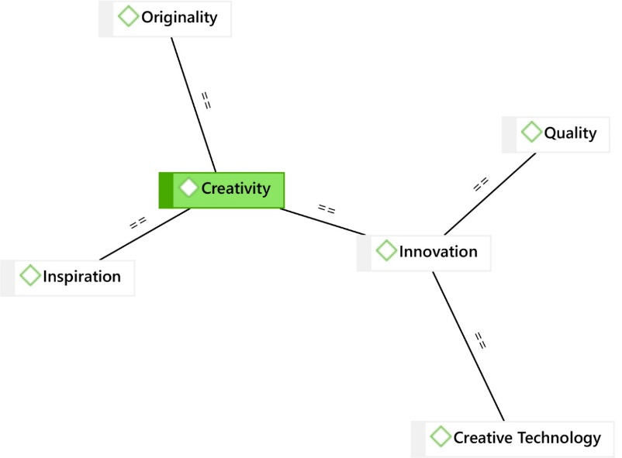

Figure 5 Hierarchical relation of keyword “Creativity” with related keywords.

Upholding the attribute of Al-Hafeez, the design ensures that production processes adhere to strict safety standards and regulations, safeguarding both workers and end-users throughout the manufacturing journey. Additionally, it oversees the implementation of feasible production possibilities, ensuring efficient and effective manufacturing methods and prioritizing quality and safety.
- FUNCTIONALITY
The product must perform its intended function properly. A product that is easily operable without complex instructions, ergonomically designed for users’ comfort, and universal in its use is considered a good design product in terms of functionality. An attribute reflecting the concept of functionality in good design is Al-Khaliq (The Creator).
Al-Khaliq guides the design process to ensure the product fulfills its intended function properly, reflecting the divine attribute of creating things with purpose and functionality. This attribute inspires designers to create user-friendly, intuitive, and seamlessly integrated products into users' lives, enhancing their overall experience.

- ETHICS
A design that realizes and transforms the society, environment, and people positively is considered a responsive design. It must be an inherent quality of any good design. From Asma-ul-Husna, an attribute reflecting the concept of ethics in good design is Al-Adl (The Just).
Al-Adl inspires designers to create morally and ethically sound designs, ensuring fairness, justice, and responsibility towards society, the environment, and people. This attribute encourages designers to consider the broader impact of their designs and strive to contribute positively to the well-being of all stakeholders, aligning with the divine attribute of justice and righteousness.

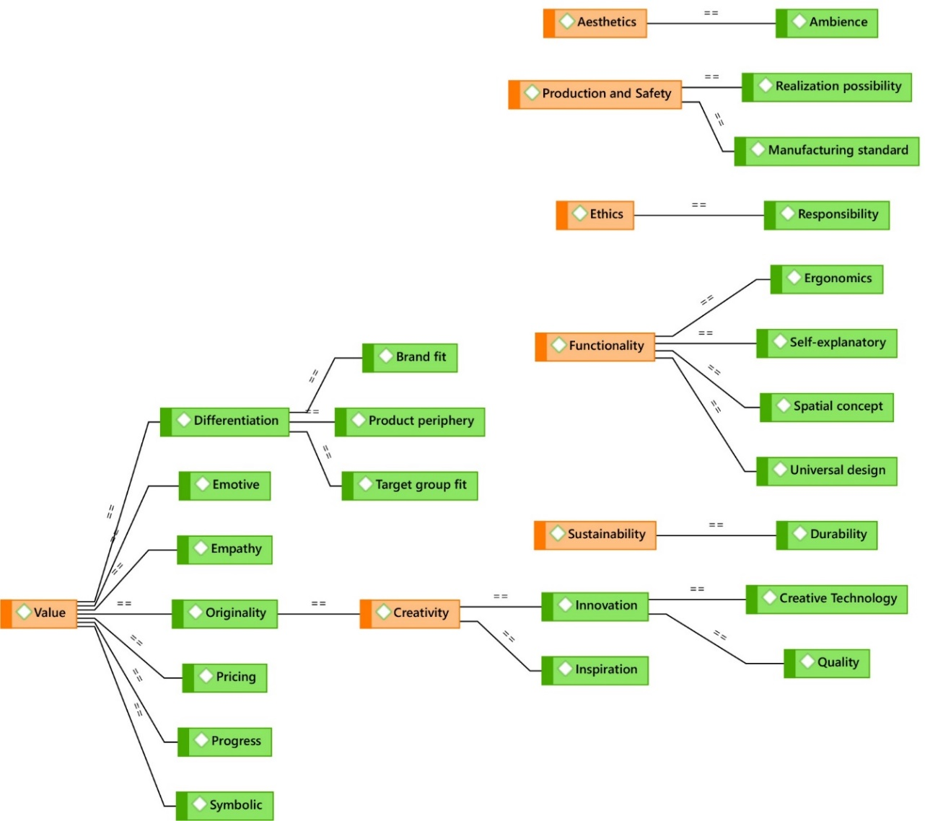

Figure 6 Inter-linked keywords showing the seven themes highlighted in Orange color

- SUSTAINABILITY
A sustainable product has minimum effect on its surrounding environment from its production and use until its decomposition to the environment again. The minimal effect during production requires efficient use of energy and material, while after production, its energy consumption, recyclability, and decomposition period become crucial to ensure sustainability. [20], [21]. From Asma-ul-Husna, an attribute reflecting the concept of sustainability in good design is Al-Muhaymin (The Guardian).
Al-Muhaymin inspires designers to create designs that serve as guardians of the environment, ensuring the preservation and protection of natural resources for future generations. This attribute encourages designers to incorporate eco-friendly materials, energy-efficient processes, and recyclable components into their designs, aligning with the divine attribute of being a protector and guardian.

- AESTHETICS
This attribute can be such that the design must be pleasant to look at and create appeal in the eyes of the intended users to ensure its market demand and improved user experience. From Asma-ul-Husna, an attribute reflecting the concept of aesthetics in good design is Al-Jameel (The Beautiful).
Al-Jameel inspires designers to infuse beauty and elegance into their designs, captivating the senses and evoking admiration from users. This attribute encourages designers to prioritize visual harmony, proportion, and balance in their creations, reflecting the divine attributes of beauty and perfection.
A universal understanding of good design attributes also enables young designers worldwide to identify the knowledge and skills they are required to gain. Often, young designers need to gain the appropriate knowledge and skills to reach the expectations level of their employers. It creates a dilemma for employers to compete in the industry and young graduates to land a suitable job to be trained in suitable knowledge and skills. [22]

- CONCLUSION
Establishing a common ground to interpret attributes of good design paves the way for better communication between designers and critiques. It allows the designer to explore innovative design ideas with more freedom and confidence that the concept of his design will be interpreted in the same manner as the designer intended. The divine attributes of Asma-ul-Husna provide a profound framework for understanding and implementing attributes of good design, ensuring that designs reflect qualities such as generosity (Al-Kareem), creativity (Al-Badi), and ethical responsibility (Al-Adl). Despite its simplicity, this paper has established a way to study, understand, and implement attributes of good design in the form of evaluation criteria for design competition platforms. The perception of “good design” evolves over time. Still, by anchoring design evaluation criteria in timeless and universal attributes such as those found in Asma-ul-Husna, designers can ensure the relevancy and longevity of their creations.
Further study is recommended to refine and expand upon the proposed criteria, incorporating expert opinions and insights from various design disciplines. This study proposes good design evaluation criteria, considering existing popular standards around the world and linking the inherent attributes. Finally, it highlights seven timeless themes applicable for good design evaluation universally through the lens of Asma-ul-Huna. Further study is recommended in this regard, which may consider experts' opinions for fine-tuning the criteria described in this paper.

ACKNOWLEDGEMENT
This study was conducted with the aid of FRGS 2016-1 [Vote no: 5524934], which was granted by the Ministry of Higher Education, Malaysia (MoHE). The authors also acknowledge the support of INSIDE and WARIS Research Group and the Faculty of Design and Architecture (FRSB), Universiti Putra Malaysia.

REFERENCES
[1] K. Klemp, J. Maan, and E. Mattie, Dieter Rams: Ten Principles for Good Design, National Geographic Books, 2017.
[2] N. Z. A. Norzaman, N. Shaari, K. A. A. Abd. Rahman, N. Utaberta, and J. M. Jaafar, “Integrating Asma ul Husna Values for Design Excellence,” Pertanika Journal of Social Sciences and Humanities, vol. 25, no. Special, pp. 33–40, 2017. http://www.pertanika.upm.edu.my/pjssh/browse/special-issue?article=JSSH-S0621-2018.
[3] R. Simmons, Good design: the fundamentals, London: Commission for Architecture and the Built Environment, 2009.
[4] J. H. Hertenstein, M. B. Platt, and R. W. Veryzer, “What Is ‘Good Design’? An Investigation of the Complexity and Structure of Design,” Design Management Journal, vol. 8, no. 1, pp. 8–21, Oct. 2013.
[5] P. Jagger, “Good by Design,” ITNOW, vol. 60, no. 1, pp. 62–63, Mar. 2018. https://doi.org/10.1093/itnow/bwy028.
[6] S. P. Ylirisku and J. Buur, Designing with video. London: Springer London, 2007. https://doi.org/10.1007/978-1-84628-961-3.
[7] M. A. Hersh, “The design and evaluation of assistive technology products and devices Part 1: Design,” in International Encyclopedia of Rehabilitation, 2010.
[8] M. del Mar Navarro, “Research for Designers: A Guide to Methods and Practice,” Design and Culture, vol. 15, no. 1, pp. 130–133, Jan. 2023. https://doi.org/10.1080/17547075.2022.2138144.
[9] N. Z. A. Norzaman, K. A. A. Abd Rahman, M. Y. Mohd Yunos, and N. ‘Atiah Ismail, “Adaptation of Asma’ul Husna in Existing Design Practice,” Pertanika Journal of Social Sciences and Humanities, vol. 29, no. 4, pp. 2785–2798, Dec. 2021, https://doi.org/10.47836/pjssh.29.4.37.
[10] Japan Institute of Design Promotion, “About Good Design Award.” Accessed: Feb. 15, 2019. [Online]. Available: http://www.g-mark.org/about/
[11] M. Deininger and C. T. Hansen, “HOW DESIGN PROPOSALS ARE EVALUATED - A PILOT STUDY,” Proceedings of the Design Society, vol. 1, pp. 1715–1724, Aug. 2021.
[12] A. Sameti, S. Koslow, and A. Mashhady, “Are product design researchers and practitioners on the same page? The way professional product designers view creative design,” Journal of Product & Brand Management, vol. 31, no. 6, pp. 951–970, Jun. 2022. https://doi.org/10.1108/JPBM-07-2021-3560.
[13] O. Demirbilek and M. Park, “A survey of criteria for the assessment of " Good Product Design ",” in The fourth European Academy of Design Conference, 2001. https://doi.org/10.26190/unsworks/406.
[14] S. Ylirisku and M. Arvola, “The Varieties of Good Design,” Advancements in the Philosophy of Design, pp. 51–70, Springer Link, 2018. https://doi.org/10.1007/978-3-319-73302-9_4.
[15] Good Design Australia, “Categories and criteria.” Accessed: Feb. 15, 2019. [Online]. Available: https://good-design.org/good-design-awards/categories-criteria/
[16] Malaysia Good Design, Malaysia Good Design Mark (MGDM) Rules and Regulations, Majlis Rekabentuk Malaysia, Kuala Lumpur, 2018.
[17] Singapore Good Design, “SG Mark Criteria.” Accessed: Nov. 15, 2018. [Online]. Available: http://www.sgmark.org/participation/#participation_eligibility
[18] M. Erlhoff and T. Marshall, “Design Dictionary - Perspectives on Design Terminology”, Board of International Research in Design, Birkhäuser, 2008. https://doi.org/10.1007/978-3-7643-8140-0.
[19] B. Covolan and J. L. Bender, “Product Safety - the Importance and Impact of Ethical Compliance Practices,” in 2022 IEEE International Symposium on Product Compliance Engineering (ISPCE), IEEE, pp. 1–4, Sep. 2022. https://doi.org/10.1109/ISPCE54918.2022.10017194.
[20] M. Watkins, J. L. Casamayor, M. Ramirez, M. Moreno, J. Faludi, and D. C. A. Pigosso, “Sustainable Product Design Education: Current Practice,” She Ji: The Journal of Design, Economics, and Innovation, vol. 7, no. 4, pp. 611–637, 2021, https://doi.org/10.1016/j.sheji.2021.11.003.
[21] E. Delaney, W. Liu, Z. Zhu, Y. Xu, and J. S. Dai, “The investigation of environmental sustainability within product design: a critical review,” Design Science, vol. 8, p. e15, May 2022.
[22] H. Ying Ying and A. M. Othman, “Expected Competencies of Companies towards Designers in Malaysia,” International Journal of Business and Technology Management, vol. 2, no. 1, Apr. 2020.

