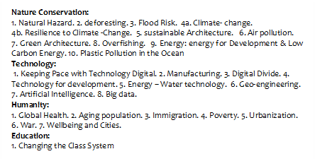
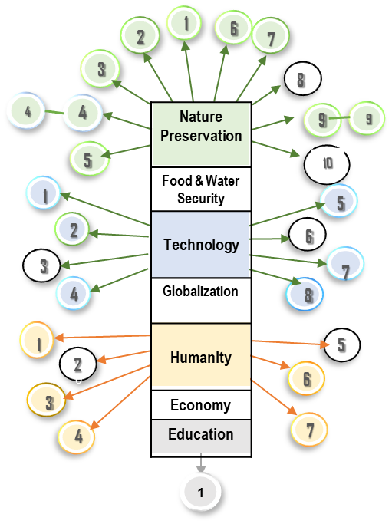

Figure 1. Challenges of the 21st Century

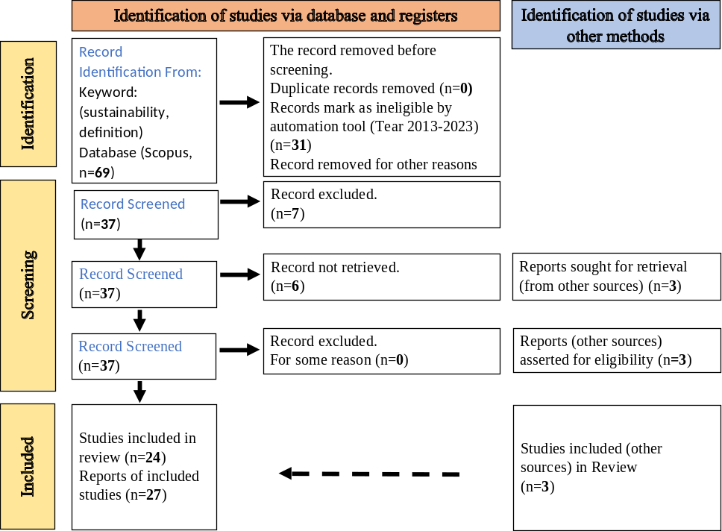

Figure 2. Diagram of the use PRISMA protocol

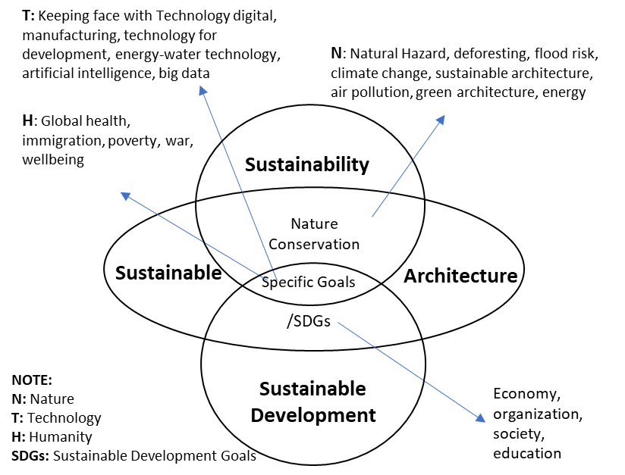

Figure 3: Sustainability, Sustainable Development,
Sustainable Architecture, and 21st-Century Challenges

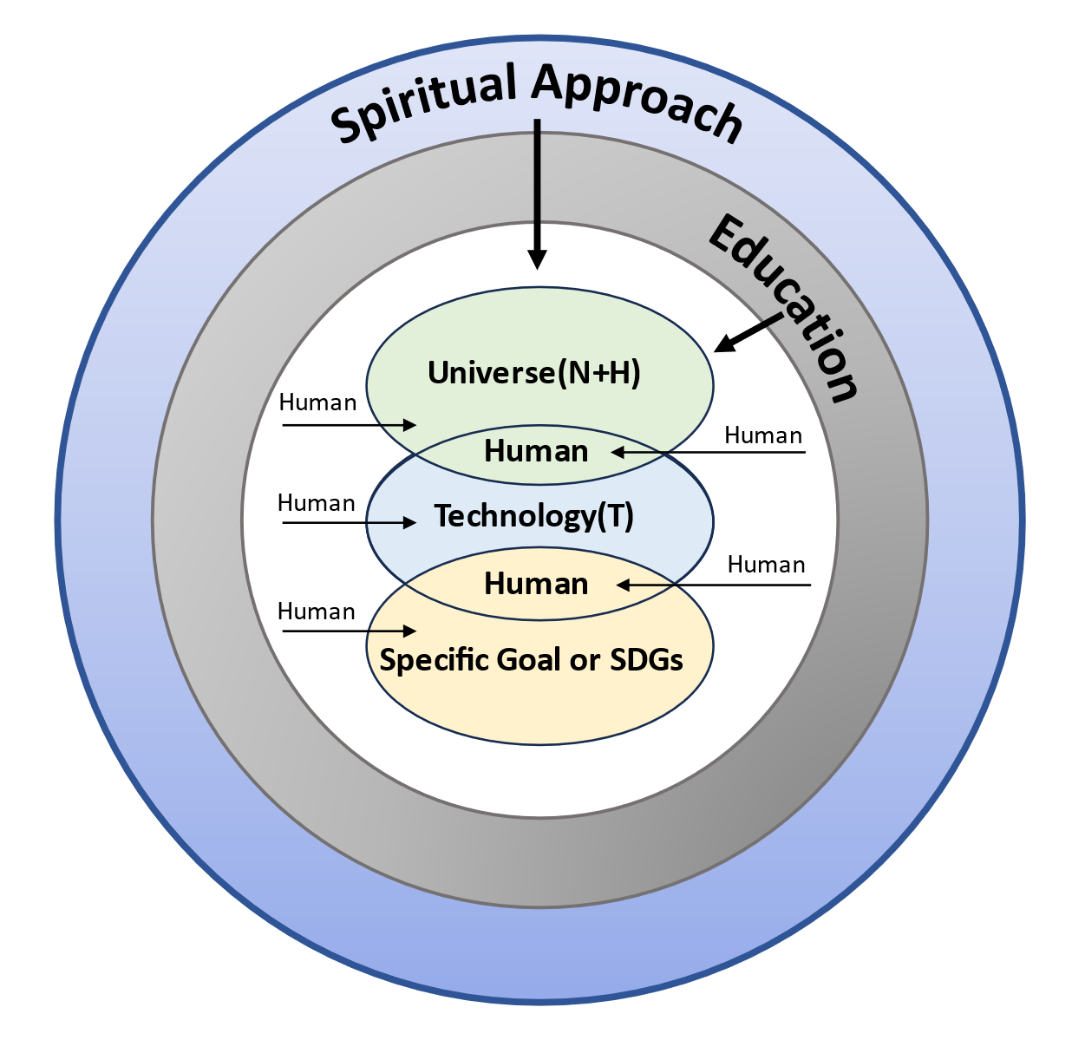
Figure 4: Facing the Challenges of the 21st Century in
Sustainable Architecture Context, from an Islamic Perspective

Table 1. IDENTIFYING DEFINITION
Ref. | DEFINITION (S/SD)
^{[4]} | ^{SD matched Brundtland’s report}
^{[5]} | Based on Brundtland’s, S: as a driver of corporate innovation
^{[6]} | S: as a set of economic, environmental, and social conditions related to many things.  SD: the application of these resources to improve security, well-being, and quality of life for the whole community.
^{[7]} | SD: economic activities for human interests that depend on the availability of environmentally friendly and socially beneficial energy
^{[8]} | S: focus on Natural Resources and the environment  SD: Focus of particular focus (SDGs)
^{[9]} | S: is flexible and can be used by a variety of stakeholders for several different purposes.  ^{SD: to fulfill SDGs goals}
^{[10]} | ^{SD}
^{[11]} | S: the ability to maintain over an indefinite period certain qualities of human well-being, social justice, and environmental integrity.  SD as “protecting and maintaining natural and cultural resources for the future and mitigating change” and highlighting some concrete sustainability efforts
^{[12]} | SD: (SDGs) cannot and should not be considered universal due to differences in concepts and morals among different communities and societies.
^{[13]} | S: context-sensitive, depending on context.
^{[14]} | S: depending on the nature and goals of the organization --> organizational sustainability
^{[15]} | sustainability of informal settlements
^{[16]} | For a specific purpose: agricultural sustainability
^{[17]} | Sustainable city: combines three dimensions of sustainability: environmental, economic, and social dimensions.
^{[18]} | S: balance of economic, social, and environmental goals and the impact of human activity. Focusing in Project
^{[19]} | S: long-term survival without endangering the future. In the context of gender, the long-term existence of the human species
^{[20]} | ^{corporate sustainability}
^{[21]} | industrial sustainability by considering environmental impacts and other aspects
^{[22]} | ^{specific context}

Note: S = Sustainability; SD = Sustainable Development

