 |  | JOURNAL OF ISLAMIC ARCHITECTURE  P-ISSN: 2086-2636 E-ISSN: 2356-4644  Journal Home Page: http://ejournal.uin-malang.ac.id/index.php/JIA
21st Century Challenges in Context of Sustainable Architecture from Islamic Perspective
Murni Rachmawati^{a*}, Nur Endah Nuffida^{b}
ªDepartment of Architecture, Institut Teknologi Sepuluh Nopember, Surabaya, Indonesia
^{b}Department of Architecture, Institut Teknologi Sepuluh Nopember, Surabaya, Indonesia
*Corresponding Author: murnirach@arch.its.ac.id
ARTICLE INFO |  |  | ABSTRACT
Volume: 8  Issue: 1  Page: 10-20  Received: June 4th, 2023  Accepted: October 02nd, 2023  Available Online: June 20th, 2024  DOI:  http://dx.doi.org/10.18860/jia.v8i1.21439 |  |  | Many world issues are faced and then become challenges of the 21st century. This study aims to define these challenges and how to overcome them as alternative solutions in architecture, with the context of sustainable architecture from an Islamic perspective. The methods used are literature review and logical argumentation. The results show that the challenges of the 21st century in the context of sustainable architecture include fundamental issues, namely nature conservation, related to humanity and technology as specific objectives, and several other objectives of the Sustainable Development Goals. Challenges can be faced by integrating the handling of each aspect, focusing on humans. In the view of Islam, integrated solutions are carried out within the spirituality framework, where humans act as caliphs. Through education, a means of accelerating human knowledge is obtained; through a spiritual approach, humans will think twice about destroying the universe and its contents.  Keywords:  Issues; Sustainability; Islam

- INTRODUCTION
As time passes and the world gets older, many problems are faced. It challenges humans to try to find a way out of each of the problems they face. The challenges of the 21st century are increasing and changing rapidly according to world conditions and the needs of human inhabitants. To find out what the challenges are and how to overcome them, Rachmawati [1] stated that in dealing with world problems according to the challenges of the 21st century, integration of the three major issues faced at that time was needed, which were grouped into nature conservation, humanity, and technology. Twenty-three years have passed in the 21st century, and many new problems have become challenges for immediate solutions. Many studies discuss sustainable architecture, but not much has aligned it with the real challenges humans face in the 21st century based on a spiritual approach. For this reason, research was carried out to help find answers to these challenges as alternative solutions in the context of sustainable architecture from an Islamic perspective.

- METHODS
This study will answer the two questions above by using the method of literature study and logical argumentation, according to Groat [2]. The steps taken are:
1. The first step is identifying the world's challenges in the 21st century.
2. The second step, according to the characteristics of the logical argumentation method, is to clarify the term's meaning. For this reason, the definition of the term sustainability architecture is identified by looking at two related definitions: sustainability and the SDGs. The definition search was performed using the PRISMA protocol.
3. The third step narrates the relationship between the results of the definition of sustainability in the architectural context and its relation to the challenges of the 21st century and how to solve them.
4. The results in the architectural context are then studied from an Islamic point of view by using several verses of the Qur'an as references.

- RESULT AND DISCUSSION

  - 21ST CENTURY CHALLENGES
A search was carried out based on websites generated by Google using the keywords architecture, challenge, and the 21st century in 2008 [1]. These results are then categorized based on the central issues discussed in the article. There are four main classifications, namely: (1) nature conservation, including environmental responsiveness, sustainable architecture, and green architecture, which gets the highest percentage (2) Technology, including IT and digital (3) Humanity and Society (4) Globalization and Economy. The search of similar issues that were carried out in 2012 by the same author shows that the issues mentioned above are still a critical challenge, as was the case with previous searches, but this time with additional challenges regarding the importance of education, which is expected to be able to answer the problems faced by humans. A search in 2018 added to the need for architectural intelligence.
Similar work was done by interviewing figures and experts in their respective fields regarding the challenges humans face in the 21st century [3]. The results are grouped into several major issues: artificial intelligence, cities and global Development, health and humanity, energy, the future of the internet, media, and democracy. Meanwhile, other groups also solicit expert opinions, facts, videos, and interviews on environmental, social, and economic challenges of the 21st century for the benefit of the UK, all supported by the latest geographic research [4].
From the challenges of the 21st century mentioned above, which are obtained in various ways within the scope of the world and the country, a synthesis of the issues faced together can be made. By dividing it into major and minor issues, which are explained in more detail, the result can be seen in Figure 1.

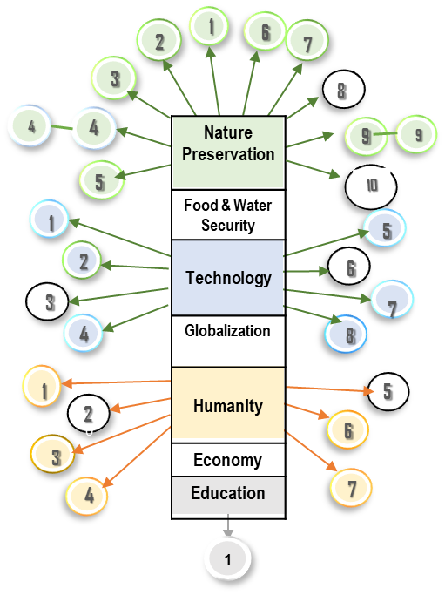
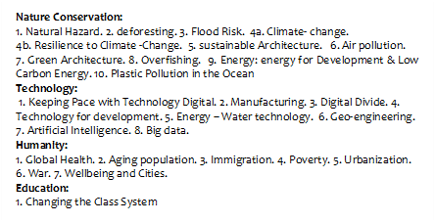
Figure 1. Challenges of the 21st Century

Grouping is done based on the relevance and similarity of the issues discussed. The division is based on the three largest groups according to [1], namely nature, technology, and humanity. Other aspects that cannot be grouped can stand alone outside the group.

  - IDENTIFY THE DEFINITION OF SUSTAINABILITY: SUSTAINABILITY AND SUSTAINABLE DEVELOPMENT
The notion of sustainability began to be discussed in 1987. It began to be widely discussed in 2018 until now. The discussions were held in various contexts and with very diverse interests. In searching for a definition at this stage, what is sought is a clear definition of sustainable architecture, which cannot be separated from the definition of sustainability and Sustainable Development Goals (SDGs).
An in-depth search regarding the definition of sustainability was carried out using the PRISMA protocol by tracking international journals Q1, Q2, Q3, and Q4 were published from 2013 to 2023. The identification process to produce several articles reviewed can be seen in Figure 2.

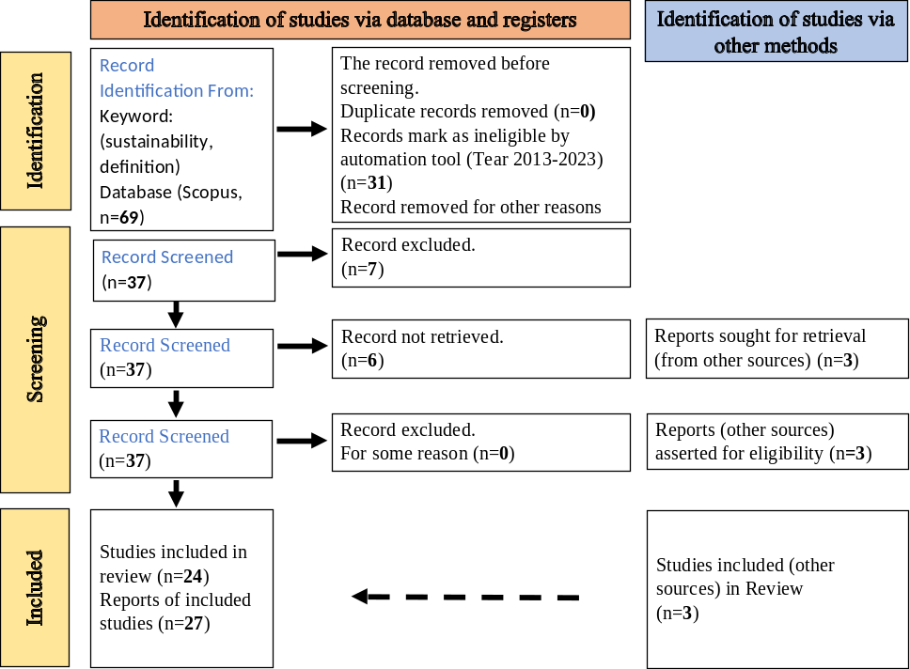

Figure 2. Diagram of the use PRISMA protocol

Through the identification of the keyword’s sustainability and definition, 69 articles were obtained. Several articles were removed before screening because they were duplicates, marked as ineligible by the automation tool, without abstract, and removed for other reasons; 37 articles were obtained. Through screening, 7 were excluded, and not retrieved was 6. So, we got 24 articles plus 3 articles from other data sources. The number of articles ready for review was 27.
From the reading results, some write only the definition of sustainability, others write only the definition of Sustainable Development, and some write both. Still, some do not have both. The latter will be removed from the list. Thus, both will be traced to show the position between the two definitions. The identification results can be seen in Table 1.
The most widely cited definition of sustainability comes from the Brundtland Commission's 1987 report, which described Sustainable Development (SD) as “development that meets the needs of the present without compromising the ability of future generations to meet their own needs.” Sustainability (S) is defined as “the ability to maintain for an indefinite period certain qualities of human well-being, social justice, and environmental integrity” or the primary goal of sustainable Development (SD) as “protecting and preserving natural and cultural resources for the future and mitigating change.” It highlights some tangible sustainability efforts such as “reducing consumption of carbon and other natural resources, increasing biodiversity, protecting artifacts material heritage, and revitalizing culture and traditions” [5], [6].
Sustainability (S) is a set of economic, environmental, and social policies in which all people can indefinitely maintain and improve their quality of life without reducing the quantity, quality, or availability of natural, economic, and social resources. Sustainable Development (SD) is the application of these resources to improve the safety, well-being, and quality of life for the whole society [7], [8]. The term “sustainability” recently lost its meaning. These terms have similar meanings and are interchangeable. Sustainability is a general paradigm, while Sustainable Development implies specific actions aimed at achieving it; the concepts of sustainability and Sustainable Development have no relationship because they are different. Sustainability only focuses on environmental issues, while Sustainable Development focuses on achieving SDGs [9], [10], [11].
In certain domains, the narrowest definition of sustainability is "to maintain the status quo and not disappear," which serves a specific purpose: maintaining the status quo. So, this notion of sustainability sometimes translates into a tendency to reduce or avoid change. Another definition of sustainability, which is so broad, is “everything that ensures the welfare of society and the environment” or “the ethical concept that things should be better in the future than they are today.” Thinking of sustainability as "longevity" is also another way to approach the concept, meaning "the longer a system can be maintained, the more sustainable it is" [12].
Table 1. Identifying Definitions
 | Ref. | Definition (S/SD)
 | [4] | SD matched Brundtland’s report
 | [5] | Based on Brundtland’s, S: as a driver of corporate innovation
 | [6] | S: as a set of economic, environmental, and social conditions related to many things.
 |  | SD: applying these resources to improve the community's security, well-being, and quality of life.
 | [7] | SD: economic activities for human interests that depend on the availability of environmentally friendly and socially beneficial energy
 | [8] | S: Focus on Natural Resources and the environment
 |  | SD: Focus of particular focus (SDGs)
 | [9] | S: is flexible and can be used by a variety of stakeholders for several different purposes.
 |  | SD: To fulfill SDG goals
 | [10] | SD
 | [11] | S: the ability to maintain certain qualities of human well-being, social justice, and environmental integrity over an indefinite period.
 |  | SD as “protecting and maintaining natural and cultural resources for the future and mitigating change” and highlighting some concrete sustainability efforts
 | [12] | SD: (SDGs) cannot and should not be considered universal due to differences in concepts and morals among different communities and societies.
 | [13] | S: Context-sensitive, depending on context.
 | [14] | S: Depending on the nature and goals of the organization ^{-->} organizational sustainability
 | [15] | Sustainability of informal settlements
 | [16] | For a specific purpose: agricultural sustainability
 | [17] | Sustainable city: combines three dimensions of sustainability: environmental, economic, and social dimensions.
 | [18] | S: balance of economic, social, and environmental goals and the impact of human activity. Focusing in Project
 | [19] | S: Long-term survival without endangering the future. In the context of gender, the long-term existence of the human species
 | [20] | Corporate sustainability
 | [21] | Industrial sustainability by considering environmental impacts and other spects
 | [22] | Specific context

Note: S = Sustainability; SD = Sustainable Development

Some communities use terms like 'sustainability,' which they describe as healthy living, considering skills, reflexivity, competence, and emotional, spiritual, economic, and social well-being to encourage respectful coexistence. Maintaining ability can be seen as the capacity of a particular community to create and maintain communal existence by managing local natural resources to ensure survival and interrelationships between members of the community and the environment [13].
Each article refers to the main keyword, namely sustainability. Adding the word Development indicates a direction or focus related to the SDGs. In contrast, the other words behind 'Sustainable' indicate another focus that one wants to make sustainable beyond the Sustainable Development Goals. The added words are organizations, human species, agriculture, informal settlements, corporate, and other specific goals [14]-[23].
In general, most of the definitions of sustainability involve conserving nature or natural resources. Sustainable Development refers more to the interest in fulfilling the SDGs. Changes to the many goals to be achieved began to be widely discussed in 2018, including goals outside the SDGs. There is much talk about sustainability tailored to specific interests.

  - SUSTAINABLE ARCHITECTURE
Sustainable architecture means buildings that will last and function long [24]. In this view, sustainable architecture brings together at least five main characteristics: 1) environmental sustainability – this approach avoids depletion of natural resources and avoids environmental pollution; 2) technical sustainability – skills are introduced and passed on to others, along with tools that are also accessed; 3) financial sustainability – money or exchange of services can be accessed to pay for the work that needs to be done; 4) organizational sustainability – there is a structure that allows one to bring together the required range of participants, without the need to call in external experts at every opportunity; 5) social sustainability – overall processes and products are appropriate and meet the needs of society. In practice, there is almost always some compromise between these characteristics. Financial sustainability may, in fact, only apply to particular socio-economic groups. However, considering the local context, the aim is to achieve a fair balance between all criteria.
Sustainable architecture considers the importance of creating architecture that improves the quality of life and ensures that quality is sustainable [25]. Sustainable architecture is also considered an awareness of environmental, social, and economic issues related to the contemporary architecture industry. Most architects who are sensitive to sustainability issues try to do more by designing buildings that use energy and resources more efficiently [26].

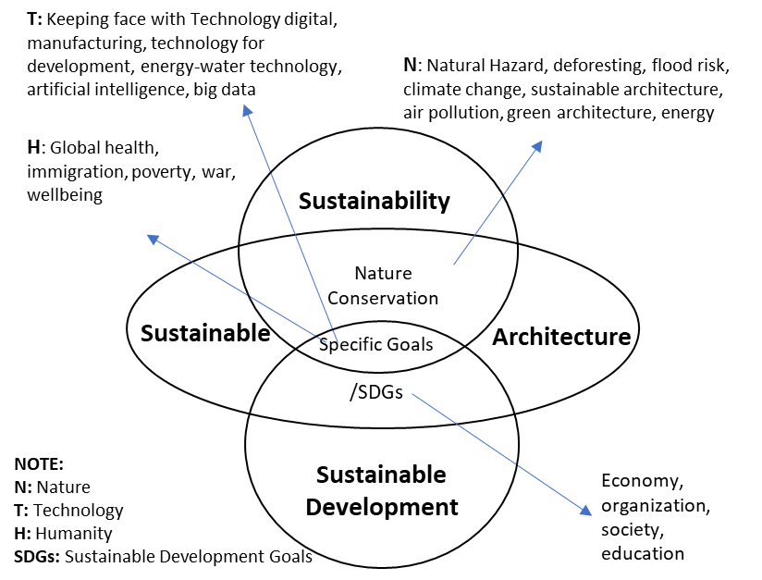

Figure 3. Sustainability, Sustainable Development, Sustainable Architecture and 21st Century Challenges

Based on the results of identifying the definitions of sustainability and SDG, with the definition of sustainable architecture stated by several experts, there are several overlapping issues. Two aspects sometimes stand alone and sometimes mixed with other definitions. These two aspects are nature conservation in a broad scope and specific sustainability goals, including the Sustainable Development Goals. Meanwhile, sustainable architecture includes both definitions, but in the field of architecture in general and buildings. Nature conservation is one of many issues addressed in sustainable architecture. There is a relationship with other interests such as quality of life, organizational sustainability, social needs, economy, etc. The linkage between the three terms of sustainability and challenges of the 21st century can be seen in Figure 3.
The results above show that the problems in sustainable architecture according to the challenges of the 21st century are nature conservation, which is associated with several specific goals, namely humanitarian and technological issues, as well as several issues originating from the SDGs, including economy, organization, society, and education.

  - FACING THE CHALLENGES OF THE 21ST CENTURY IN THE CONTEXT OF SUSTAINABLE ARCHITECTURE
The discussion was carried out based on the challenge groups from previous discussions, namely nature conservation as the main goal, humanity and technology as specific goals, and several SDGs, namely economy, organization, society, and education. In Nature Conservation, several issues are often discussed: Natural Hazards, deforestation, flood risk, climate change, sustainable architecture, air pollution, green architecture, and energy.
The issue of Nature Conservation emerged in architecture due to the energy crisis that first emerged in the early 1970s and was seen as an anticipation of a possible crisis in the future. This later became the beginning of the ecological and sustainable theory movement [26]-[29] and the proposed ecological design movement [30], [31]. Therefore, it can be recognized that preserving the natural environment is necessary, especially in architecture. The perspectives and views of humankind have changed concerning the management of nature in architecture.
Before the 21st century, the handling of nature was solely intended to fulfill human needs and interests in any way, even if this resulted in damage to nature. Architects design and build buildings for the sole purpose of human comfort and happiness. This shift in perspective began in the 21st century when the utilization of nature was still intended to meet human needs and interests but began to place more importance on nature conservation.
The 21st-century challenges grouped under Humanity (H) are Global Health, immigration, poverty, urbanization, war, and Prosperity. All humanitarian problems are related to humans and cannot be solved without the intervention of humans, who have the authority to regulate the policies of a group or country and regulate themselves. For that, human beings who are sensitive and knowledgeable about health, poverty due to disasters, war, or other issues that refer to human welfare are needed.
In terms of humanitarian issues, many architects do not want to reconcile humanitarian interests with architecture. According to them, humans can only solve human problems, not architecture. Until the Architecture for Humanity group deals more with humanitarian problems due to war and natural disasters and seeks to provide simple housing for the victims [32]. Architects often forget that they are human beings who control the results of their architecture. Their design should suit the needs of its users who may not have much money or poor groups who need the help of fellow human beings.
Ideas for a revolution in human thought began to be put forward, intending to restructure 21st-century architecture through human intelligence [33], [34]. Through human intelligence, it is hoped that it can improve life or make the world a better place. What is meant here is also exploring the human intelligence that our ancestors already possessed. Humans need not be well served with all their needs, safety, and health. The local community should be greatly appreciated by involving them in building architecture with the hope that the local community will be able to make replicas of previous works. Therefore, no matter how much the local community can build, that much must be done. Thus, continuity will be maintained [24].
In designing, architects are not only based on human needs but also must consider other aspects of living together between humans and humans with nature comfortably. To develop and improve humanity, we must not fail to renew our commitment to living as part of the earth by understanding sustainable development and growth, not over-exploiting nature. Humans must also use ancient knowledge and wisdom to achieve it [26].
The 21st-century challenges related to technology include keeping face up with digital technology, manufacturing, technology for development, energy-water technology, artificial intelligence, and big data. It is undeniable that nowadays, digital technology is very familiar with all aspects of human life. The attachment of architecture and IT is a must to produce the desired design quickly, and AI is no exception, as it has started to be widely used.
In Architecture, technology is often equated with construction techniques. It is also said that architects are always dealing with technology. In the field of technology, some changes are seen in human behavior. First, traditional technologies have been modified into high-tech due to the Industrial Revolution and the urgency of building a rapid supply to keep pace with population growth. Technology exists to complete the transition from ‘handmade’ manufacturing to industrial ‘mass production.’
Architects’ concern for technology associated with nature has begun to appear by following the analogy trend in architectural design, analogizing architecture to nature, including building technology. This can be seen in Hugo Haring, with “The House as an Organic Structure”; Lewis Mumford, with “Toward an Organic Ideology”; Karel Honzik, with “Biotechnics”; J. Frederick Kiesler, with “On Correalism and Biotechnique,” Siegfried Gideon with “Factory as Organism,” Richard Neutra with “Building with Nature,” and so on [35].
Technology should be sensitive to ecology, or ecological technology, which does not hurt nature. This ecological technology can be obtained from the most sophisticated to the simplest, from digital to analog. The speed of IT and AI development is sometimes faster than human readiness to accept it. Therefore, technology should also be sensitive to existing humanitarian problems. The technology must be adapted to the conditions, location, and culture of the community group that will use the technology. Besides knowledge or technology, humans as creators and operators of technology are also essential elements to be discussed.
Specific goals linked to sustainable architecture in the previous discussion point to several issues, namely the economy, globalization, society, organization, and education. This problem can change according to the challenges of human life. Each issue has a specific goal that follows the wishes of certain groups, be it organizations, communities, or professional groups such as economics, education, health, and others. The tasks given to architects are adjusted to their respective goals, and the extent to which architects can carry them out is each architect’s responsibility.
What is the role of the architect in this problem? In the context of sustainable architecture, the challenges related to the sustainability of this special objective must also consider to the preservation of nature in all its aspects. Innovations and methods have been tried to solve this, such as economics. In the economic field, what is known as the Circular Economy has begun.
The circular economy is nature-oriented as its role model. The circular economy concept aims to keep raw materials in a closed circle. This way, resources are used to the maximum, the need for new ones is reduced, waste is avoided, and the product life cycle is increased. In other words, today’s waste becomes tomorrow’s raw materials – just like in nature. With this principle, architects can play a role not only in the field of economic savings but also in natural resources. Participate in maintaining economic and natural sustainability at the same time. In this way, a circular economy differs from the current economic system, a linear system where products are produced, used, and disposed of. However, do humans, as owners or architects, understand or want to do this?
The problem in the aspect of globalization is the occurrence of homogenization, which has led to spaces being built similarly and has separated humans from the built environment. Architecture that responds to its context forms something more meaningful. There is a dialogue between the architecture and its surroundings, between the user and the architecture. We must preserve what has been built before, interpret it, and respond to it in the present context. Currently, many have begun to explore the local wisdom that each region has.
Another challenge of the 21st century is related to the organizations; this depends on the type and purpose of each organization. So, the architect’s ability to adopt all organizational goals depends on everyone. Once again, the human problem becomes the main determinant. Humans as building owners or organizational owners and humans as architects. Cooperation among human beings must be mutually beneficial and bring goodness. Employer satisfaction is a measure of success, but architects can provide input so as not to add to the damage in the world.
Then, what is the role of education in sustainable architecture? Education must be adapted to needs such as nature conservation, humanity, ecological technology, circular economy, etc., to ensure the sustainability of every aspect. Challenges related to the need to change learning systems, such as distance classes due to changes that must be made during a pandemic, can be solved with the help of technology. With the end of the pandemic, existing learning models can be developed to make them more attractive and communicative. Through formal and informal education, the knowledge needed to solve specific problems significant to human life will be well understood and applied by humans.
An element that is always present in issues of sustainable architecture, with a focus on addressing issues of nature conservation, as well as specific goals and several SDGs, is humans. In nature conservation, the natural problem is nature itself and humans. In humanitarian issues, the element that is always present is humans with all their needs and life problems. Meanwhile, in matters of technology, humans are also central figures as creators and operators of technology. Meanwhile, economic issues, globalization, society, organizations, and education depend on human will and desires. Each problem has a specific goal that follows the wishes of a particular group, be it an organization, community, or professional group in economics, education, health, and others. From these results, everything depends on humans as the central figure in handling sustainable architecture.

  - FACING THE CHALLENGES OF THE 21ST CENTURY IN THE CONTEXT OF SUSTAINABLE ARCHITECTURE FROM ISLAMIC PERSPECTIVE
The elements involved in the problems faced by the challenges of the 21st century cannot be separated between humans, nature, and technology with all their needs and abilities. What still needs to be fought for is how humans are willing and able to protect nature, how all human needs are met, and the hope that humans pay attention to the conservation of nature and the role of humans with all their abilities can act as holders of technology control.
Handling in the field of nature conservation, starting from the definition of nature in Islam. Nature in Islam can be interpreted in two ways. The first meaning of nature is the universe. The argument is in Surah Asy-Syuara verses 23 to 28. This verse is a dialogue between Pharaoh and Prophet Musa. Pharaoh asked Musa about the universe and its owner. Then, Prophet Musa explained it. Nature in this context includes nature for God's creatures, including humans, animals, plants, jins, angels, seas, mountains, and stars. These realms are subdivided into smaller realms. For example, the animal world is still divided into reptiles, wild animals, birds, and aquatic biota.
The second meaning of nature is that every rational being obtains the burden of law from God. The evidence is mentioned in Surah Al-Furqan verse 1, Surah Yusuf verse 104, and Surah Al-Anbiya verse 107. These three verses are related to sending the Prophet Muhammad with the Qur'an as a messenger to the whole world. The two definitions above, when combined, can mean that everything other than God is called nature, including the world, organisms, and species (such as humans, plants, animals, and other things that reside in the universe). Regarding physical nature, nature is defined as the universe, while in the spirituality framework, nature is the universe and its contents.
According to Islam, the natural elements are different from those used by experts in architecture. In architecture, it is said that the elements of nature include earth, air, water, and 'fire' [28]; some say it is the atmosphere (air), sea (water), and climate [36]; others refer to it as soil, water, vegetation, and climate [26]; some call natural elements, among others, land, water, air, and others. According to Islam, the elements above are only part of the elements of the universe. The definition includes an architectural sense coupled with natural and human aspects from the previous discussion that can be combined.
Islam emphasizes that humans always protect nature and avoid all forms of destruction (Q.S Al-A'raf verse 56). This is different from the reality that happened. Natural Hazards, deforestation, flood risks, climate change, air pollution, and energy crises are common worldwide. Damage and disasters that occur because of arbitrary human activity. This can be considered as destructive behavior. Islam also teaches that humans must learn from events in the past so that they do not experience the bad consequences of their actions like their predecessors. This is shown in QS Ar-Rum verses 41-42, although in a different context.
The word technology refers to scientific methods used to achieve practical goals, applied science, or the overall means of providing goods necessary for the continuity and comfort of human life. Humans created technology to make life easier, more efficient, and more comfortable.
The Islamic perspective of science and technology can be seen through the position of knowledge on the same level as faith, as reflected in Surah Al-Mujadalah verse 11, which states that surely God will elevate those who believe among you and those who are given knowledge of several degrees. So, Islam strongly encourages people to seek knowledge as highly as possible, create technology, and innovate.
Regarding technological challenges, what needs to be considered is the position of humans as part of nature and their role as creators of technology and operators who will run the technology. The role of humans as technology operators is crucial, whether to protect nature or destroy it.
To face humanitarian problems, it is necessary to respect human values. In Islam, this is closely related to moral and ethical principles, according to the word of Allah SWT in QS. Al-Hujarat verse 13. Apart from that, God also commands His people to behave fairly. Because justice is a form of piety towards Allah (QS. Al-Maidah verse 8). The keywords obtained are "know each other" and "fair." Fair means not being biased, proper, impartial, impartial, stick to the truth. If humans can act fairly, then humanitarian problems can be handled.
As discussed earlier, nature, technology, and humans are interrelated, getting justification from an Islamic perspective because human control whether the world will be damaged or improved. Humans must understand their position as caliphs who are tasked with protecting nature and its contents to be used for human welfare. Other orders regarding the prohibition of humans from doing quite a lot of destructive actions, including in Surah Al Baqarah: 11, 12, 60; Surah Al A'raf Verse 74; Surah Al Qasas Verse 77; and Surah Yunus Verse 41.
In sustainable architecture, several specific goals that must be carried out by architects according to the results of the previous discussion so that they can be appropriately completed will still require rules and prohibitions to do damage in various aspects of life, including the need for a code of ethics to deal with these problems. Like it or not, education is a driving aspect of accelerating the handling of 21st-century problems. Education is about all the things needed for a good, sustainable life. Education must be given early from childhood, with the hope that all humans understand and are aware of their duties in the world as caliphs, not to destroy but to protect nature and its contents as commanded by Allah in Surah Al A'raf verse 74. The meaning of the caliph has three elements, namely (1) the human being himself who is named caliph, (2) the universe as the earth, and (3) the relationship between humans and nature and everything in it, including humans. The next human relationship with nature is the relationship as a caretaker who needs each other. So, the task of humans is to maintain and prosper nature [37].
From the discussion, all problems in the world are always inseparable from human existence. Likewise with sustainable architecture in the 21st century. What still needs to be fought for is how humans are willing and able to protect nature, how all human needs are met, and the hope that humans pay attention to nature conservation and the role of humans with all their abilities can act as holders of technological control and by organizational, economic, and other sustainability goals. It can be seen here that those who can overcome the many and varied problems are fair humans who can understand the problems of other humans and can control technology for the good of nature and humans.
The challenges of the 21st century cannot be solved by indifference and apathy. This can only be solved with innovation and integrity from our leaders and every individual on this earth. Therefore, strengthening self-ability and integrity is very important. Ability can be achieved through education; integrity can be achieved with a spiritual approach. How we face the challenges of the 21st century from an Islamic perspective can be summarized in Figure 4.
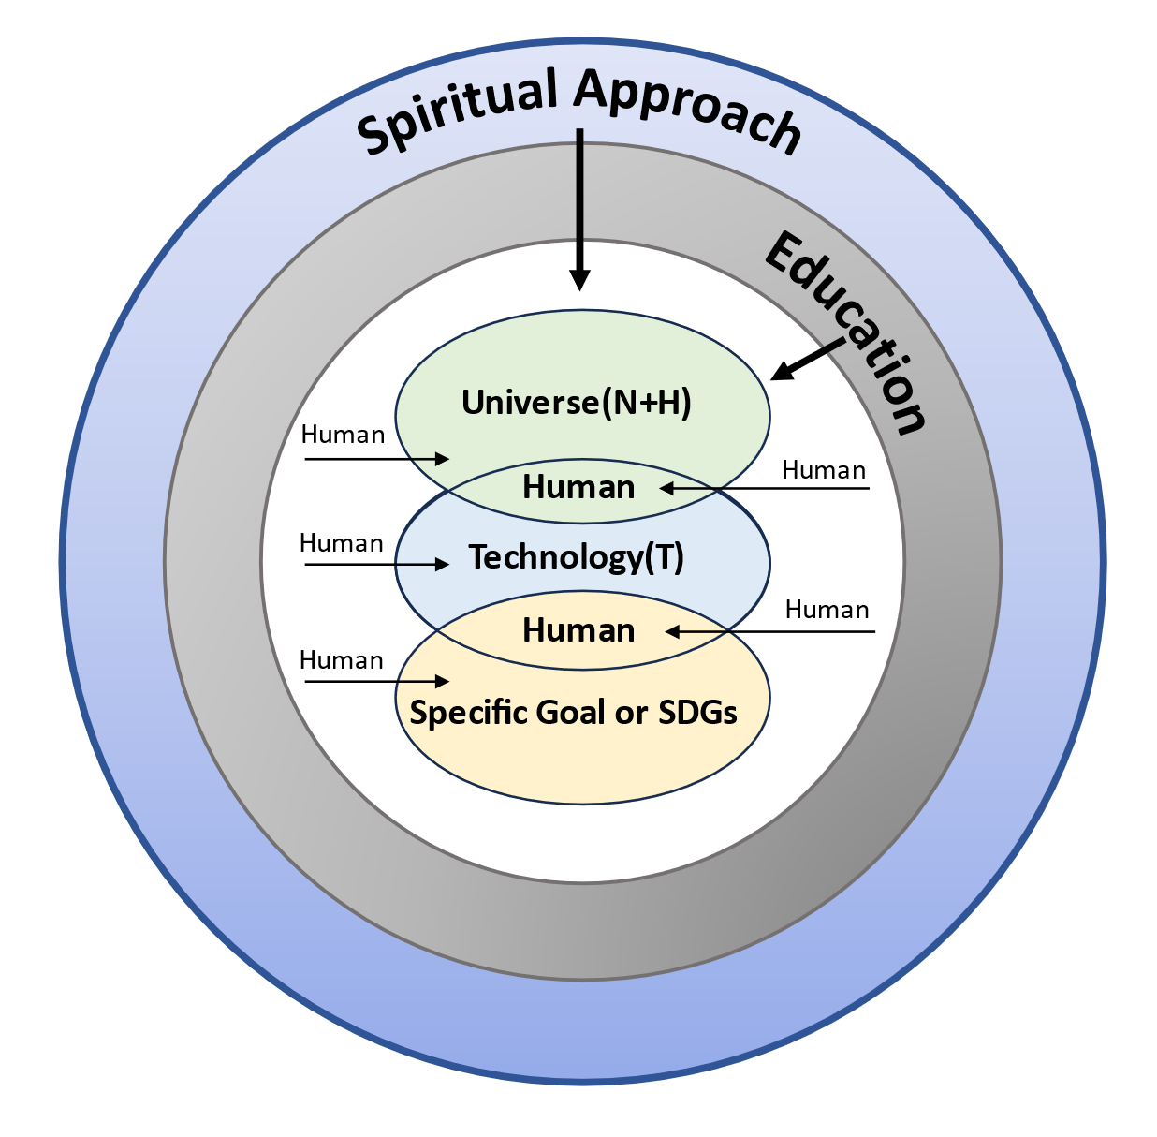

Figure 4. Sustainability, Sustainable Development, Sustainable Architecture and 21st Century Challenges

- CONCLUSION
The main element present in every problem in sustainable architecture is humans. Sustainable architecture can be faced by integrating the handling of every aspect, such as nature, humans, technology, and other specific goals, focusing on humans and prioritizing human intelligence. Innovation in all fields needs to be integrated so as not to cause negative impacts. Education can be a means of accelerating human knowledge to face challenges.
From an Islamic perspective, instructions have been given to solve this in an integrated manner through the Qur'an, always remembering that the task of humans created by God is as caliphs, guardians of nature who look after nature with great affection, not destroying and not depleting natural resources. With a spiritual approach, humans will think twice about destroying the universe and its contents because, in the future, every human being will be held responsible for their life on earth. Thus, what is needed now is intelligent and innovative humans who are kind and fair to all of God's creatures.

REFERENCES
[1] M. Rachmawati, “Tantangan Arsitektur Abad XXI: Tanggap Lingkungan?” in Seminar Nasional, Peran Arsitektur Perkotaan dalam mewujudkan Kota Tropis, Undip Semarang, 2008.
[2] L. Groat & D. Wang, Architectural Research Method, New Jersey: John Wiley & Sons, 2013
[3] Royal Geography Society with IBG. Informed discussion from the Royal Geographical Society (with IBG).
[4] B. Lufkin, “50 grand challenges for the 21st Century”, BBC Future, April 1st, 2017. Accessed: May 4th, 2021. [Online]. Available: https://www.bbc.com/future/article/20170331-50-grand-challenges-for-the-21st-century.
[5] A. Jørgensen, I. T. Herrmann, and A. Bjørn, “Analysis of the link between a definition of sustainability and the life cycle methodologies,” Int. J. Life Cycle Assess., vol. 18, no. 8, pp. 1440–1449, 2013. Doi: https://doi.org/10.1007/s11367-013-0617-x.
[6] B. Wilkerson and L. K. L. Trellevik, “Sustainability-oriented innovation: Improving problem definition through combined design thinking and systems mapping approaches,” Think. Ski. Creat., vol. 42, no. August, p. 100932, 2021. Doi: https://doi.org/10.1016/j.tsc.2021.100932.
[7] B. M. Ayyub, “Infrastructure Resilience and Sustainability: Definitions and Relationships,” ASCE-ASME J. Risk Uncertain. Eng. Syst. Part A Civ. Eng., vol. 6, no. 3, pp. 4–7, 2020. Doi: https://doi.org/10.1061/AJRUA6.0001067.
[8] E. Grigoroudis, V. S. Kouikoglou, Y. A. Phillis, and F. D. Kanellos, “Energy sustainability: a definition and assessment model”, Operational Research, vol. 21, no. 3, pp/ 1845-1885, 2021. Doi: https://doi.org/10.1007/s12351-019-00492-2.
[9] M. Nik Bakht, T. E. El-Diraby, and M. Hossaini, “Game-based crowdsourcing to support collaborative customization of the definition of sustainability,” Adv. Eng. Informatics, vol. 38, no. March, pp. 501–513, 2018. Doi: https://doi.org/10.1016/j.aei.2018.08.019
[10] M. Drury, J. Fuller, and J. Hoeks, “Embedding animals within a definition of sustainability,” Sustain. Sci., no. 0123456789, 2023. Doi: https://doi.org/10.1007/s11625-023-01310-7
[11] C. A. Ruggerio, “Sustainability and sustainable development: A review of principles and definitions,” Sci. Total Environ., vol. 786, p. 147481, 2021. Doi: https://doi.org/10.1016/j.scitotenv.2021.147481
[12] S. Roostaie, N. Nawari, and C. J. Kibert, “Sustainability and resilience: A review of definitions, relationships, and their integration into a combined building assessment framework,” Build. Environ., vol. 154, pp. 132–144, 2019. Doi: https://doi.org/10.1016/j.buildenv.2019.02.042
[13] P. K. Virtanen, L. Siragusa, and H. Guttorm, “Introduction: toward more inclusive definitions of sustainability,” Curr. Opin. Environ. Sustain., vol. 43, pp. 77–82, 2020. Doi: https://doi.org/10.1016/j.cosust.2020.04.003
[14] M. U. Ben-Eli, “Sustainability: definition and five core principles, a systems perspective,” Sustain. Sci., vol. 13, no. 5, pp. 1337–1343, 2018. Doi: https://doi.org/10.1007/s11625-018-0564-3.
[15] R. Lozano, “Proposing a definition and a framework of organizational sustainability: A review of efforts and a survey of approaches to change,” Sustain., vol. 10, no. 4, 2018. Doi: https://doi.org/10.3390/su10041157
[16] J. Montoya, I. Cartes, and A. Zumelzu, “Indicators for evaluating sustainability in Bogota’s informal settlements: Definition and validation,” Sustain. Cities Soc., vol. 53, no. 51, 2020. Doi: https://doi.org/10.1016/j.scs.2019.101896
[17] M. V. Eitzel et al., “Indigenous climate adaptation sovereignty in a Zimbabwean agro-pastoral system: Exploring definitions of sustainability success using a participatory agent-based model,” Ecol. Soc., vol. 25, no. 4, p. 1, 2020. Doi: https://doi.org/10.5751/ES-11946-250413.
[18] A. M. Toli and N. Murtagh, “The Concept of Sustainability in Smart City Definitions,” Front. Built Environ., vol. 6, no. June, pp. 1–10, 2020. Doi: https://doi.org/10.3389/fbuil.2020.00077
[19] D. Kuchta and J. Mrzygłocka-Chojnacka, “An approach to increase the sustainability of projects and their outcomes in the public sector through improving project definition,” Sustain., vol. 12, no. 12, 2020. Doi: https://doi.org/10.3390/su12124804
[20] A. Odrowaz-Coates, “Definitions of sustainability in the context of gender,” Sustain., vol. 13, no. 12, 2021. Doi: https://doi.org/10.3390/su13126862
[21] M. Pazienza, M. de Jong, and D. Schoenmaker, “Clarifying the Concept of Corporate Sustainability and Providing Convergence for Its Definition,” Sustain., vol. 14, no. 13, 2022. Doi: https://doi.org/10.3390/su14137838
[22] G. Contini and M. Peruzzini, “Sustainability and Industry 4.0: Definition of a Set of Key Performance Indicators for Manufacturing Companies,” Sustain., vol. 14, no. 17, 2022. Doi: https://doi.org/10.3390/su141711004.
[23] C. Dazzi and G. Lo Papa, “A new definition of soil to promote soil awareness, sustainability, security and governance,” Int. Soil Water Conserv. Res., vol. 10, no. 1, pp. 99–108, 2022. Doi: https://doi.org/10.1016/j.iswcr.2021.07.001
[24] J. Norton, Sustainable architecture: is a process for achieving shelter that will keep going, Development Workshop France, 1999.
[25] P. F. Smith, Architecture in a Climate of Change, A Guide to Sustainable Design, Architectural Press. 2002
[26] W. McDonough, “Hannover Principles”, in Jencks (eds), Theories and Manifestoes of Contemporary architecture, Charles Academy edition, Chichester, pp: 160, 1997.
[27] J. Steele, Sustainable Architecture. Principles, Paradigms, and Case Studies, McGraw, 1997
[28] R. Vale, and Brenda, Green Architecture, Design for energy-Conscious Future, Singapore: A Bulfinch Press Books Little Brown and Co, 1991
[29] K. Frampton, Ten Shades of Green: Architecture and the Natural World, eds. 1st edition, The Architectural League of New York, 2005.
[30] S. Van der Ryn, S. Cowan, Ecological Design, USA: Island Press, 1996.
[31] K. Yeang, The Green Skyscraper, The Basis for Designing Sustainable Intensive Buildings, Munich: Prestel, 1999
[32] Stohr, Kate, “100 Years of Humanitarian Design in Architecture for Humanity (eds)”, Design Like Give You a Damn, Architectural Responses to Humanitarian Crises”, Metropolis Book, New York, 2006
[33] D. J. Hali, “Humanisme dan Peradaban Global”, in Humaniora dan Relevansinya Bagi Pendidikan, cetakan I, Yogyakarta: Jalasutra, 2008.
[34] N. A. Salingaros, & K. G. Masden, “Restructuring 21st Century Architecture Through Human Intelligence”, Archnet-IJAR, International Journal of Architectural Research, Vol. 1, no. 1, March 2007.
[35] W.W. Braham & J. A. Hale, Rethinking Technology, Oxon: Routledge, 2007.
[36] P. Buchanan, Ten Shades of Green, Architecture and The Natural World, The Architectural League of N. York, 2000.
[37] D. Rodin, Dede, “ALQURAN DAN KONSERVASI LINGKUNGAN: Telaah Ayat-Ayat Ekologis”, Al-Tahrir, Vol. 17, No.2, pp. 391-410, 2017. Doi: https://doi.org/10.21154/altahrir.v17i2.1035

