 |  | JOURNAL OF ISLAMIC ARCHITECTURE  P-ISSN: 2086-2636 E-ISSN: 2356-4644  Journal Home Page: http://ejournal.uin-malang.ac.id/index.php/JIA
DESIGN OF PEDESTRIAN WAYS BASED ON TOURIST CHARACTERISTICS IN THE RELIGIOUS TOURISM AREA OF MENARA KUDUS
Anita Ratnasari Rakhmatulloh^{a*}
ªDiponegoro University, Indonesia
*Corresponding Author: anita.ratnasari.rakhma@gmail.com
ARTICLE INFO |  |  | ABSTRACT
Volume: 8  Issue: 2  Page: 396-407  Received: August 9th, 2023  Accepted: January 27th, 2024  Available Online: December 15th, 2024  DOI: 10.18860/jia.v8i2.21617 |  |  | Providing pedestrian pathways in tourist areas that align with the type of tourism and its typology is an effort to maximize the service for tourists. Tourists in religious areas have distinct characteristics, often arriving in groups. This study aims to analyze the design of pedestrian pathways based on the tourist typology of Menara Kudus Religious Tourism in order to facilitate circulation and support the mobility of visiting tourists. The research method to achieve this objective combines quantitative and qualitative methods, utilizing descriptive and cross-tabulation analysis techniques to determine the typology of tourists, the existing condition of pedestrian pathways, and the circulation of tourist patterns. This study shows that the existing condition of pedestrian pathways does not align with the typology of tourists due to narrow paths and the lack of differentiation between pedestrian pathways, motorcyclists, and street vendors. Additionally, the circulation patterns of tourists within the tourist area show that they enter and exit through the same pathways. These factors hinder the circulation and mobility of tourists during their visit. Therefore, the design of alternative pedestrian routes is recommended to address the hindrances to circulation and mobility and provide safe and comfortable pedestrian pathways for tourists.  Keywords:  Religious tourism, pedestrian ways, tourist typology, mobility, Menara kudus

- INTRODUCTION
Tourism and mobility are closely interconnected as the safe and comfortable movement of visitors from one tourist attraction to another is essential in tourism activities [1, 2]. Several studies in European cities found that there is a correlation between urban mobility and sustainability elements such as social, economic, and environmental [3]. These things are interrelated and need to be considered when designing a tourism activity system in the area.
Fromel et al. [4] state walking is a fundamental mobility requirement in tourist areas, including religious tourist areas. Walking can be used to connect different tourist attractions [5]. To enhance visitor comfort, it is necessary to provide pedestrian pathways suitable for the type of tourism and the characteristics of its visitors. The provision of pedestrian pathways can be determined based on the number of pedestrians using the pathway, in line with the characteristics and activities of tourism [6]. Pedestrian paths are one of them at tourist locations and are one of the assessment indicators in evaluating street spaces such as tourist locations [7, 8, 9]. On the other hand, to understand the typology of tourists, one can look at their socio-demographic characteristics and the characteristics of their tourism activities.
The Menara Kudus tourist area is one of the religious tourism potentials in Kudus Regency because it features the Al-Aqsa Mosque or Al-Manar Mosque, as well as the Kudus Tower, which was established by Sunan Kudus, one of the Walisongo or Islamic scholars who pioneered the spread of Islam in Java Island. The tomb of Sunan Kudus and his descendants is also a pilgrimage site in Kudus Regency. The presence of the Menara Kudus Tourist Area, renowned for its pilgrimage tourism and its unique architecture that combines Hindu-Javanese-Islamic cultures, is the main reason for attracting more visitors to the Kudus Regency. Furthermore, the area surrounding Menara Kudus also offers other tourism potentials, including heritage tourism, supported by the availability of souvenir and culinary services, such as Kauman Village, known as Kampong Lama Kudus, Kudus typical craft stores, Kudus traditional cuisine, and evening culinary delights along Sunan Kudus Street.
Religious tourism is a form of specialized tourism where visitors engage in travel activities driven by specific motivations, one of which is to undertake a pilgrimage to sacred and revered places [10]. As a destination for religious tourism, the activities commonly carried out in the Menara Kudus tourist area include pilgrimage, meditation, performing prayers, and reciting the Quran. The Menara Kudus tourist area already has pedestrian pathways, but they are only available in a few specific locations. Furthermore, the narrow width of the pathways forces tourists to share them with motorized vehicles, disrupting the movement and circulation of tourists. Considering the characteristics of their journey, visitors who come to Menara Kudus are usually part of pilgrimage groups and tend to walk together in their respective groups. Therefore, it is necessary to provide pedestrian pathways suitable for these tourists' characteristics, including accommodating group visits.
Based on the results of research regarding the design of pedestrian paths in the Ampel religious tourism area, it is stated that there is a need to provide pedestrian pathways, especially by paying attention to the entry and exit routes for goods, trade, and service activities, as well as the potential for street vendors along the corridors [11]. Based on research by Latifah et al. [12] found that the arrangement of religious tourism corridors, including pedestrian pathways components, must increase the sense of place and strengthen identity as a distinctive characteristic of the area. That is in line with Bott et al. [13], which states that all components of heritage tourism areas must reflect the characteristics of their heritage identity.
The pedestrian pathways component is very important for developing religious tourism areas because it connects various regional activities and provides a platform for improving physical health. On the other hand, tourism mobility in Austria is linked to climate change. The increase in motorized vehicles due to tourist activities produces more CO2 than usual, negatively impacting the environment [14-16]. Therefore, increasing walking activities and other non-motorized mobility is very important.
Good pedestrian pathways have four criteria that need to be achieved: safety, convenience, comfort, and attractiveness [17-20]. Tourists should be safe from accidents and criminal threats, have easy access to pedestrian pathways, encounter no obstacles, and feel comfortable. Therefore, well-connected pedestrian pathways are needed as they help enhance tourism activities in the area [21, 22]. Providing pedestrian pathways that align with the characteristics of tourists will facilitate the circulation and mobility of tourists in visiting the attractions within the area [23]. On the other hand, if pedestrian pathways in the tourist area do not match the characteristics of their users, it will hinder the circulation and mobility of tourists in determining their movement [24]. Thus, this research aims to analyze the design of pedestrian pathways based on the typology of tourists in the religious tourism area of Menara Kudus in order to facilitate circulation and support the mobility of visiting tourists.

- METHODS
This research combines qualitative and quantitative methods with descriptive and crosstab data analysis techniques. The quantitative research data on tourist typology was collected through questionnaires administered to 65 respondents. Meanwhile, the qualitative data pertains to the existing conditions of pedestrian paths and tourist circulation patterns, gathered through field observations and documentation by the researcher. Data was collected through questionnaires to obtain information, including the socio-economic characteristics and travel profiles of the respondents.
Direct field observations were carried out to gather further information on the quality and completeness of pedestrian path elements, as well as the entry and exit routes of tourists in the Menara Kudus Tourism Area. Documentation was conducted to obtain visual data on the existing conditions of pedestrian paths or pedestrian ways.
This research was conducted along the main roads of the Menara Kudus tourist area, namely Jalan Menara, Jalan Sunan Kudus, and Jalan Madurekso. The Menara Kudus Tourism Area is religious in the urban center of Kauman Village, Kota District, Kudus Regency. The activities around the Menara Kudus tourism area are predominantly residential and commercial. The object of study in this area is the existing pedestrian paths or pedestrian ways. The study examines the physical and non-physical conditions of the pedestrian paths or pedestrian ways available in the Menara Kudus tourism area based on the characteristics of tourists to support the smooth circulation of visitors and serve as visitor mobility infrastructure.

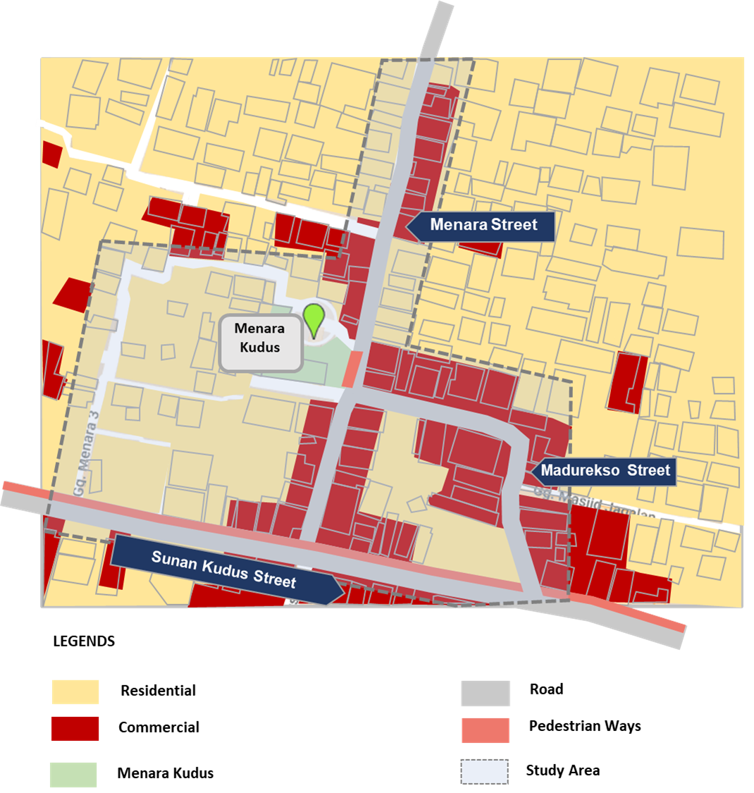

Figure 1. Study Area [source: Author,2023]

- RESULT AND DISCUSSION

  - TYPOLOGY OF TOURISTS IN THE MENARA KUDUS TOURISM AREA
The characteristics of tourists in the Menara Kudus tourism area are divided based on socio-demographic characteristics, including place of origin, gender, age, marital status, income, and occupation, as well as travel characteristics, including travel motivation, travel companions, mode of transportation, and duration of travel.

  - SOCIO-ECONOMIC CHARACTERISTICS
Based on the research findings, the Menara Kudus tourist area is predominantly visited by tourists outside the city. This indicates that as a religious tourism potential, the Menara Kudus tourist area has attracted many tourists, even from beyond the Kudus Regency. When examined based on gender and marital status, the research results show that visitors to the religious tourist area of Menara Kudus are predominantly married women, accounting for 66.1% and 75.8%, respectively.

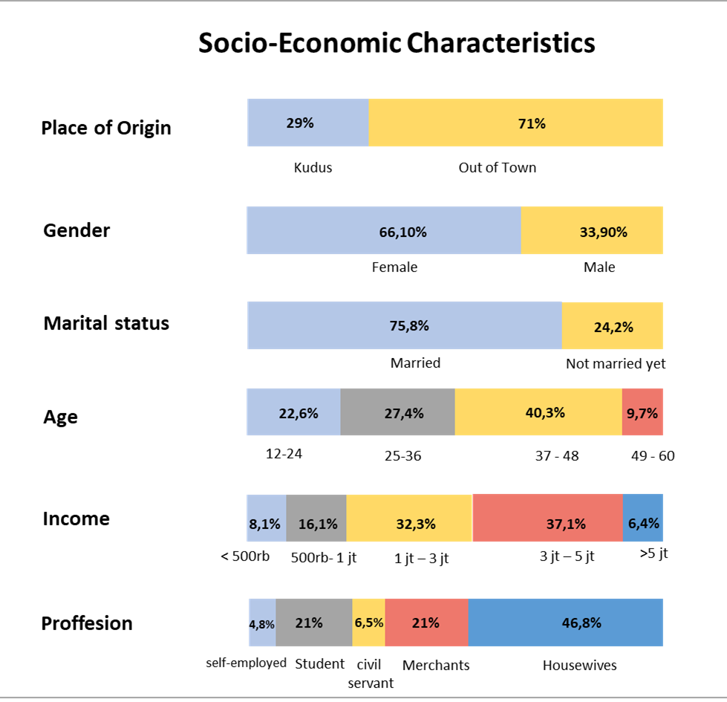

Figure 2. Socio-Economic Characteristics [source: Author,2023]
Tourists visiting the religious tourist area of Menara Kudus come from diverse age groups. The research findings indicate that most visitors are within the age range of 37-45 years and the age range of 25-36 years, accounting for 40.3% and 27.4%, respectively, as seen in Figure 3. This indicates that adult tourists predominantly favor religious tourism. Additionally, 22.6% of the visitors fall within the age range of 12-24 years, with the majority being a group of students from Islamic boarding schools.
Most tourists who visit the Menara Kudus tourist area are housewives. The research findings indicate that 46.8% of the tourists are housewives, while 21% are students and traders. Furthermore, the average monthly income of the visiting tourists is predominantly within the range of IDR 3,000,000 to IDR 5,000,000.

  - TRAVEL CHARACTERISTICS
Travel characteristics can be observed from the travel motivation, travel companions, transportation modes used, and the duration of tourists' visits to the tourist site. Most tourists who visit the Menara Kudus religious tourist area have the main motivation for pilgrimage. According to the research findings, 88.7% of visitors come to Menara Kudus for pilgrimage purposes. Meanwhile, 11.3% have the motivation for rest and relaxation. Visitors motivated to rest and relax are mostly from the Kudus Regency, who stop by to perform prayers or rest before continuing their main activities.

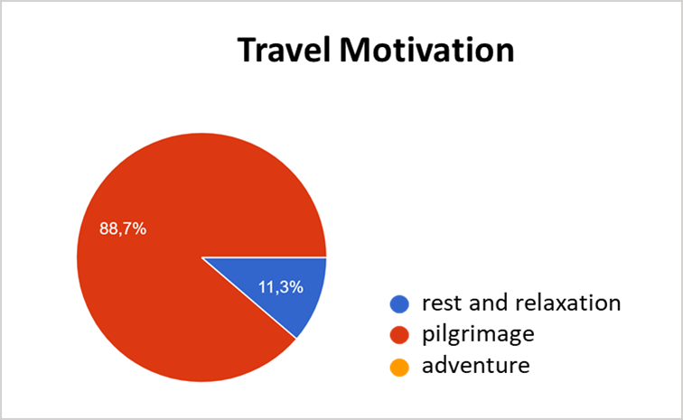 | 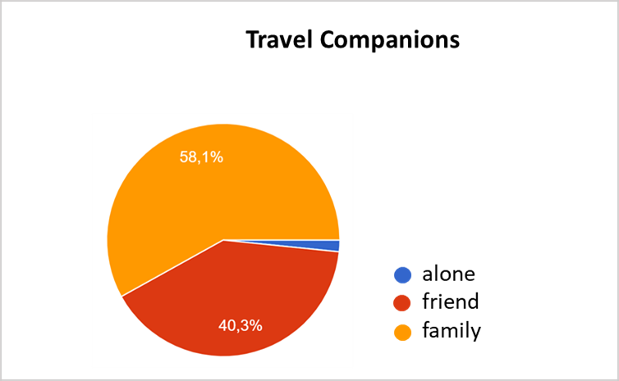
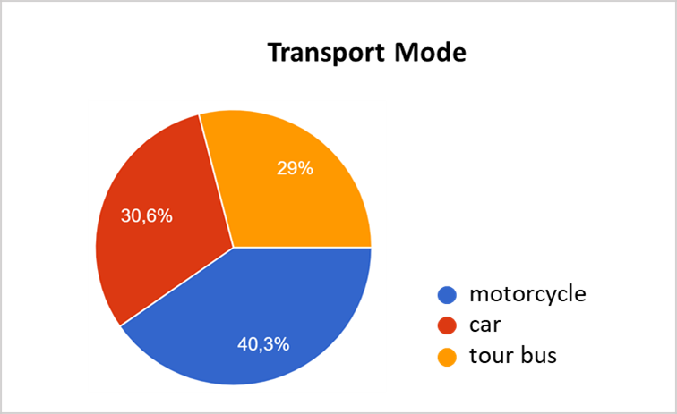 | 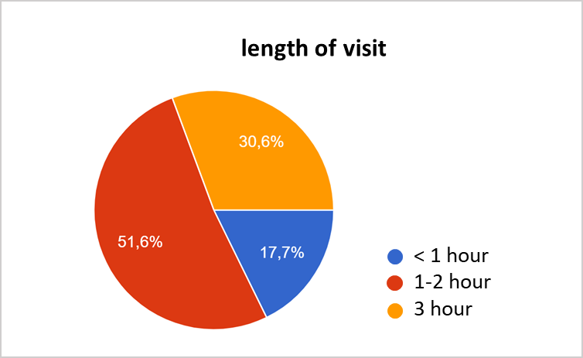
Figure 3. Tourist Travel Characteristics [source: Author,2023]

When looked at based on travel companions, most tourists who visit come with their families and friends. About 58.1% of visitors come with their families, while 40.3% come with friends. Visitors with friends are usually in groups of more than 5 people. The modes of transportation tourists use when visiting Menara Kudus include motorcycles, private cars, and tourist buses. Most tourists from Kabupaten Kudus still use motorcycles and private cars.
On the other hand, tourists from outside the city who come in groups usually use tourist buses as their transportation mode. Typically, visitors' stay is an average of 1-2 hours. This is because most tourists come specifically for pilgrimage purposes, so they do not spend more than 2 hours there.

  - ANALYSIS
Crosstab analysis was conducted to examine the typology of tourists based on their socio-economic and travel characteristics.

Table 1. Crosstab Analysis of Travel Motivation
 | Travel Motivation
 | Pilgrimage | Rest and Relaxation
Place of Origin | Out of Town | Kudus
Gender | Female | Male
Marital Status | Married | Not Married Yet
Age | 37-48 | 12-24
Profession | Housewives | Student

Based on the analysis of tourist typology in the religious tourism area of Menara Kudus, tourists with the motivation of pilgrimage are mostly from outside of the Kudus Regency. On the other hand, tourists with the motivation of rest and relaxation are dominated by tourists from within the city, predominantly students who come to perform prayer and relax after school.

Table 2. Crosstab Analysis of Travel Companion and Transport Mode
 | Travel Companions |  |  | Transport Mode
 | Alone | Family | Friend | Motorcycle | Car | Tour Bus
Place of Origin | Kudus | Out of Town | Out of Town | Kudus | Out of Town | Out of Town
Gender | Male | Female | Female | Female | Female | Female
Marital Status | Not Married Yet | Married | Married | Married | Married | Married
Age | 12-24 | 37-48 | 37-48 | 12-24 | 37-48 | 37-48
Profession | Merchants | Housewives | Student | Housewives | Housewives | Housewives & Student

Regarding travel companions, solo travelers are still predominantly from the Kudus Regency and use motorbikes as their mode of transportation. Meanwhile, tourists who come with their families and friends are mostly from outside the Kudus Regency and use private cars and tour buses as their modes of transportation. This indicates that group travelers are predominantly married individuals aged between 37 and 48 from outside the area. The majority of these group travelers are housewives and students.

  - CORRIDOR WITH PEDESTRIAN PATH IN THE MENARA KUDUS TOURISM AREA
Menara Kudus tourism area has a main access road called Jalan Menara, which is approximately 500 meters long and 2-3 meters wide. An archway is a marker when entering the Menara Kudus tourism area, located on Jalan Sunan Kudus. Additionally, there is an alternative road to reach Menara Kudus through Jalan Madurekso.

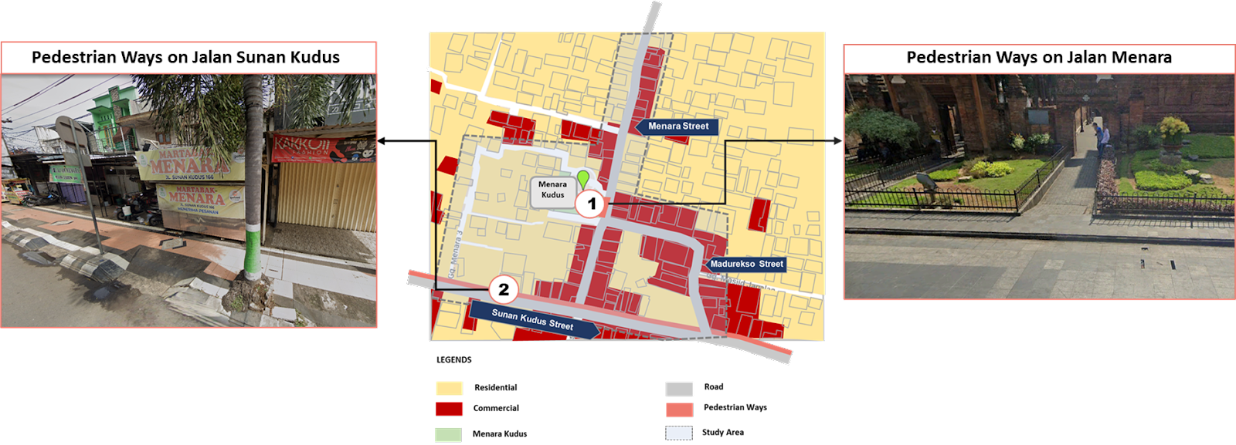

Figure 4. Pedestrian Ways Points at Menara Kudus Tourism Area [source: Author,2023]

Only two pedestrian paths are available in the Menara Kudus tourism area, namely on Jalan Menara and along Jalan Sunan Kudus. The pedestrian path on Jalan Menara Kudus is only present along the buildings of Menara Kudus and Al Aqsa Mosque or Al Manar, with a length of less than 1 meter. Meanwhile, the pedestrian path along Jalan Sunan Kudus consists of a sidewalk with a width of approximately 2 meters.
The pedestrian path on Jalan Menara Kudus is frequently used by tourists visiting Menara Kudus. Additionally, visitors often utilize it for taking selfies with the backdrop of Al Aqsa Mosque and Menara Kudus, which tends to cause pedestrian circulation disruptions as people must queue if other visitors are passing by. This is due to the narrow width of the pedestrian path, which can only accommodate one person at a time.
The quality of the pedestrian paths, both on Jalan Menara and Jalan Sunan Kudus, is good, and the roads are paved. There are several essential elements of the pedestrian paths, including lighting lamps and signage, as well as covered drainage channels underneath the pedestrian paths, as seen in Figure 5 and Figure 6. However, these two pedestrian path points do not have other essential elements of pedestrian paths, such as trash bins, benches, and shade plants. Only decorative plants are present along the pedestrian path on Jalan Sunan Kudus. Additionally, informal street vendors are in some areas along these pedestrian paths.

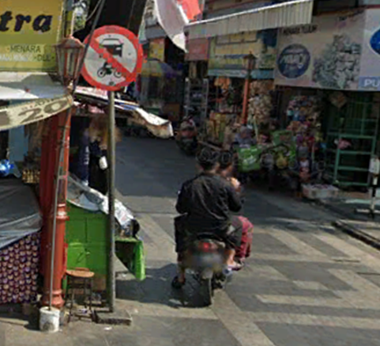 | 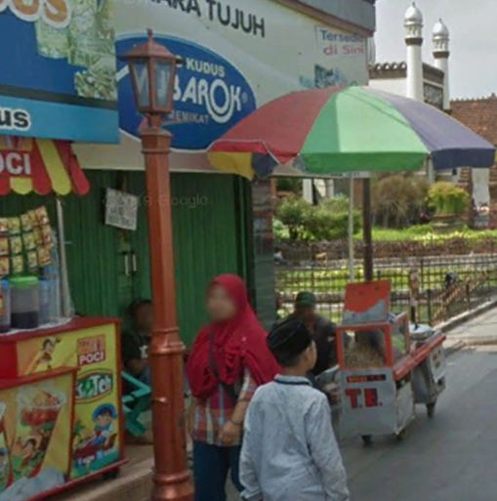 | 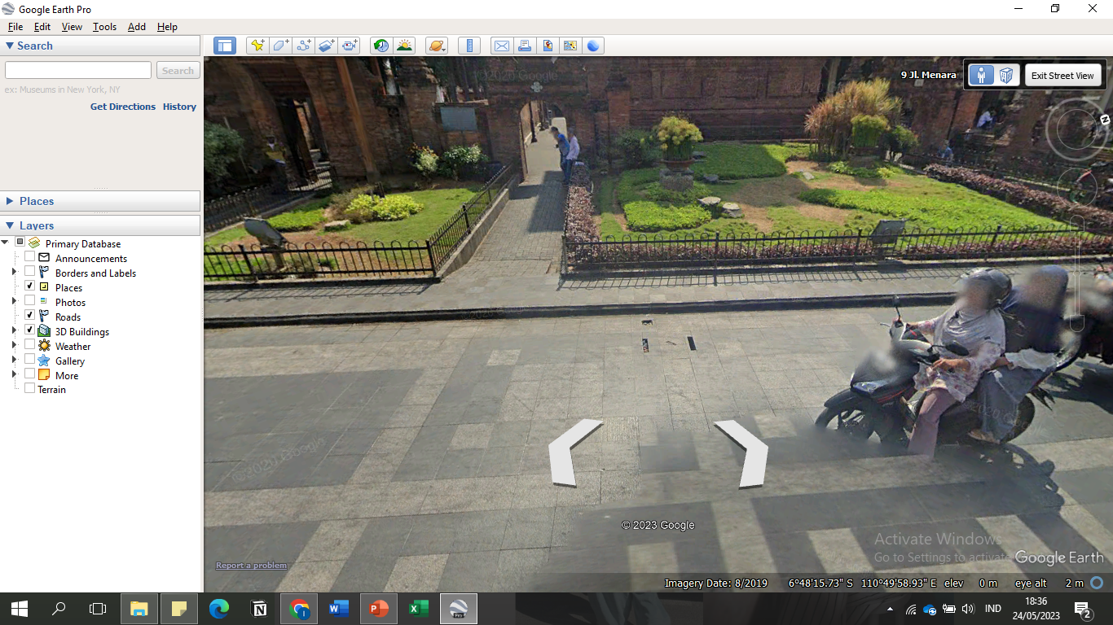
Figure 5. Elements of Pedestrian Ways at Jalan Menara [source: Author,2023]

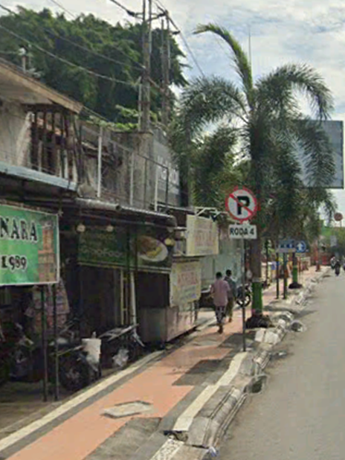 | 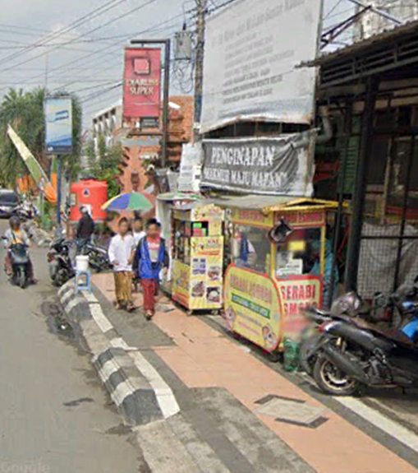
Figure 6. Elements of Pedestrian Ways at Jalan Sunan Kudus [source: Author,2023]

On the other hand, the corridor of Jalan Menara, which lacks pedestrian paths and along Jalan Madurekso, is dominated by trading activities such as street vendors and souvenir shops, as seen in Figure 7. This indicates no segregation between pedestrian routes and motorized vehicles or street vendors.

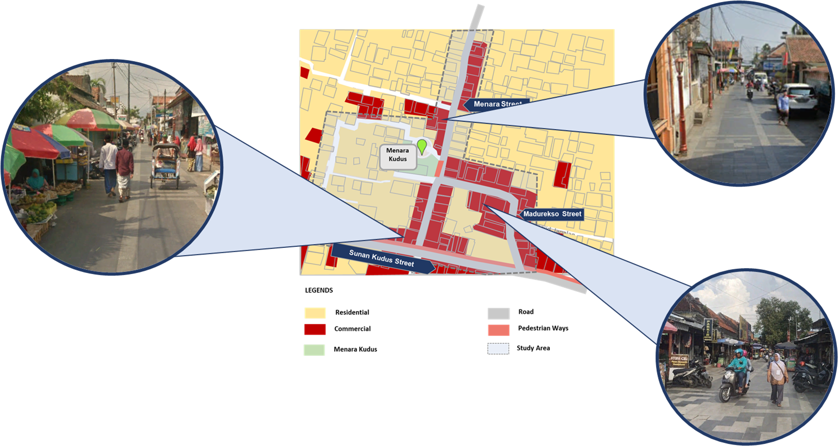

Figure 7. Activity on Jalan Menara [source: Author,2023]

  - TOURIST CIRCULATION
Tourist groups arriving by tour buses disembark at the Menara Kudus Tourism Terminal. From the tourism terminal, these groups usually travel to Menara Kudus via Jalan KHR Asnawi, which is 1.5 km away, using tourist motorcycles or becaks, and alight at Jalan Sunan Kudus. Then, they enter Jalan Menara from Jalan Sunan Kudus to reach Menara Kudus. After completing their pilgrimage activities, the tourist groups return to the tourism terminal by following Jalan Menara, then Jalan Sunan Kudus, and passing through Jalan KHR Asnawi. A few tourists exit by taking Jalan Menara to a small alley on Jalan Menara and then continue to Jalan KHR Asnawi to return to the tourism terminal.

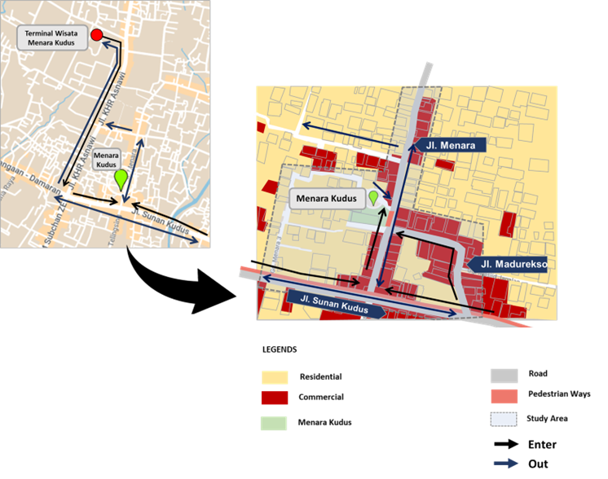

Figure 8. Tourist Circulation [source: Author,2023]

Private car visitors usually park along Jalan Sunan Kudus and proceed directly to Menara Kudus via Jalan Menara. Meanwhile, visitors using motorcycles enter Jalan Menara directly from Jalan Sunan Kudus and park them at parking spots available at several points along Jalan Menara and Jalan Madurekso. A few visitors enter from Jalan Sunan Kudus to Jalan Madurekso to reach Menara Kudus. When they want to leave, tourists usually exit through Jalan Menara and head directly to their parked vehicles along Jalan Sunan Kudus and the motorcycle parking pool on Jalan Madurekso.
On the other hand, within the Menara Kudus tourism area, two tourist attractions are the main destinations: the Al Aqsa Mosque and the Tomb of Sunan Kudus, along with its caretaker. The Tomb of Sunan Kudus, the main pilgrimage site, is located directly behind the main building of the Al Aqsa Mosque. Usually, pilgrims enter through a separate entrance gate at the front near Jalan Menara, as seen in Figure 1. On the other hand, tourists who want to visit the Al Aqsa Mosque first usually enter through the Butulan Gate from the left side of the mosque. After entering through the gate, a few dozen steps away, there is the Paduraksa Gate, which serves as the entrance for pilgrims. From the Paduraksa Gate, tourists enter through the regol (gate) to reach the tomb area.
In the tomb area, several cungkup (domed structures) contain burial plots in an elongated area with a width of about 8 meters and a length of 30 meters, as seen in Figure 2. The cungkup in this area shelters several graves of the Sunan Kudus family, including Pangeran Pontjowati, the highest military commander and the son-in-law of Sunan Kudus. Usually, tourists quickly head towards the main tomb, often causing congestion due to the limited capacity of the space to accommodate many visitors. When at the main tomb or the tomb of Sunan Kudus, pilgrims usually sit respectfully facing the burial site, covered by a white kelambu (mosquito net), as seen in Figure 3.
In the Al Aqsa Mosque area, tourists usually come to perform prayers, recite the Quran, and study religious texts. There is a small number of tourists who come to rest after performing their prayers, as seen in Figure 4. Male tourists who want to perform prayers usually take ablution at the ablution area near the exit door. As for female tourists, the ablution and prayer area is located on the right side of the Al Aqsa Mosque.
The same entrance and exit route for the tomb area causes tourists who want to leave to queue first, waiting for pilgrims to enter. Additionally, the regol or gate openings, both the front gate and the Butulan Gate, can only accommodate 2 to 3 people at a time, causing congestion. Furthermore, the characteristics of tourists in Menara Kudus tend to be in groups. These factors often result in circulation obstacles for tourists, especially during peak visiting times such as holidays and Islamic festivals.

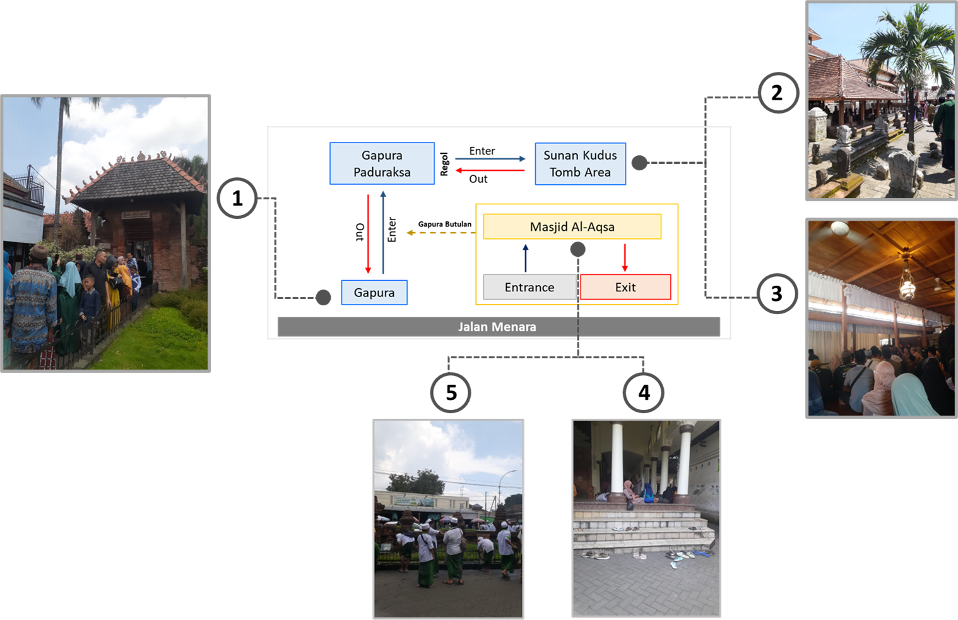

Figure 9. Tourist Circulation in the Menara Kudus Area [source: Author,2023]

  - ALTERNATIVE TOURIST ROUTES
Research results show that tourists who visit religious tourism areas have their characteristics, namely tending to come in groups. Based on the existing conditions, the quality of pedestrian paths available in the Menara Kudus tourism area is already good. However, it has not been adjusted to the characteristics of tourists in religious tourism areas who tend to come in groups. The lack of separate paths for tourists and pedestrians from motorcyclists often causes congestion in the circulation of tourists on Jalan Menara. Street vendors along Jalan Menara and Jalan Madurekso also contribute to circulation obstacles for pedestrians.
In order to provide optimal services to tourists, it is necessary to provide facilities suitable for their characteristics, including for tourists visiting the religious attraction of Menara Kudus. One way is by providing alternative routes for tourists visiting the Menara Kudus tourism area to prevent circulation obstacles. The alternative routes for tourists visiting the Menara Kudus tourism area are more clearly shown in Figure 10.

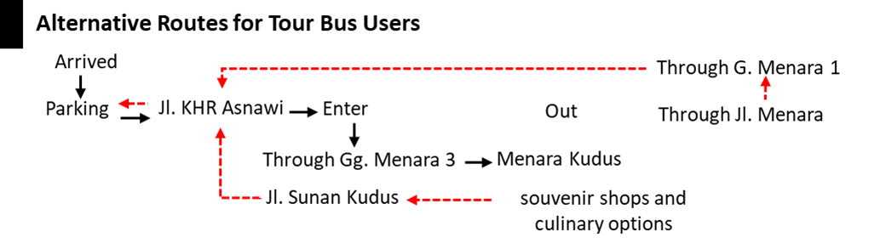

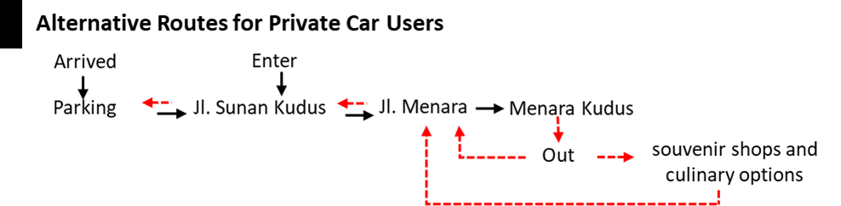

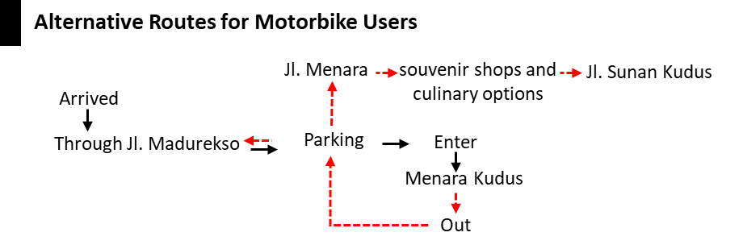

Figure 10. Alternative Tourist Routes [source: Author,2023]

Tourists who arrive by tourist buses can take Jalan KHR Asnawi from the tourist parking area to reach the Menara Kudus tourism area and then take an alternative route through Gang Menara 3 to enter Menara Kudus. This is because there is a low volume of motorized vehicles along Gang Menara 3, allowing tourists to walk safely in groups. After finishing their pilgrimage, tourists can exit through Jalan Menara. Tourists who want to shop before leaving can visit souvenir shops along Jalan Menara, enjoy culinary delights along Jalan Sunan Kudus, and then return to the tourist terminal. If tourists want to go straight home after visiting Menara Kudus, they can take Jalan Menara and exit Jalan Sunan Kudus to return to the tourist parking area.
Tourists who come by private car can park along Jalan Sunan Kudus and enter Menara Kudus through Jalan Menara. When they want to leave, tourists can pass through Jalan Menara and stop by souvenir shops and culinary establishments along Jalan Menara and Jalan Sunan Kudus. As for motorbike users, they can enter Menara Kudus through Jalan Madurekso to park their vehicles at the available parking area. They can directly exit from the tourist parking area through Jalan Madurekso or Jalan Menara when they want to leave. However, tourists visiting souvenir shops or enjoying culinary delights can pass through Jalan Menara towards Jalan Sunan Kudus.
In addition to alternative routes to enter the Menara Kudus tourism area, there are also alternative routes within the Mosque and Tomb area to alleviate the congestion of tourists and improve circulation.

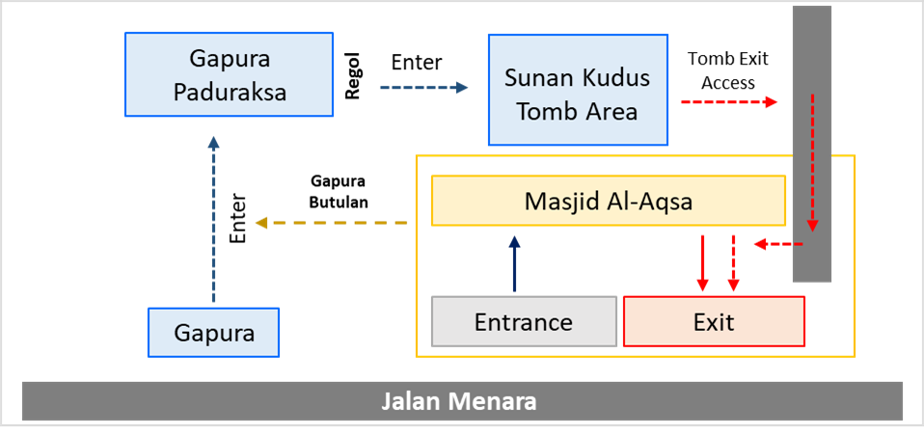

Figure 11. Alternative Route Within Menara Kudus Area [source: Author,2023]

Tourists who want to enter the Tomb area can pass through the front gate near Jalan Menara towards Paduraksa Gate. However, tourists visiting the Mosque can enter through the mosque entrance and proceed to the Tomb area through Butulan Gate. From Paduraksa Gate, tourists can enter the Tomb area through the available regol. After completing activities in the Tomb area, tourists can exit through a small path on the mosque's right side. This path is a small alley connected to the mosque's exit gate. Alternative activities that tourists can do while in the Mosque and Tomb area can be seen in the provided Figure 12. These alternative activities can enhance the exploration of religious attractions in the Menara Kudus tourism area.

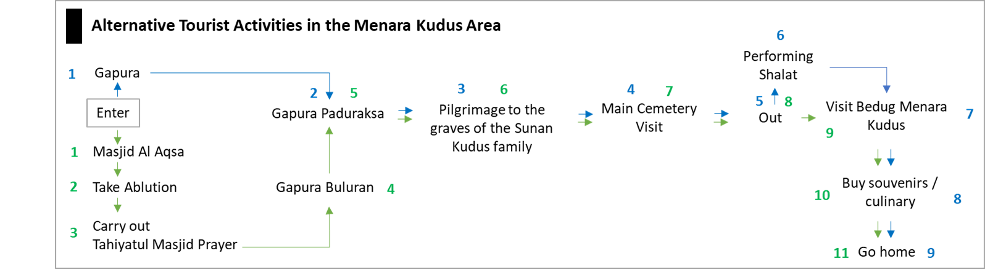

Figure 12. Alternative Tourist Activities in the Menara Kudus Area [source: Author,2023]

Tourist groups visiting the Tomb can head to Paduraksa Gate through the front gate. As for other tourist groups, they can visit the Masjid Al Aqsa (Al Aqsa Mosque) first to perform the Tahiyatul Masjid prayer while waiting for their turn to enter Paduraksa Gate. Usually, from taking ablution to performing the Tahiyatul Masjid prayer, tourists need around 20 minutes, and this time frame is sufficient until their turn to enter the Tomb area.
Furthermore, while waiting for their turn to enter the main tomb, tourist groups can visit the surrounding tombs, such as the tomb of Pangeran Pontjowati. After visiting the main tomb, tourist groups who haven't performed their prayers can proceed to Masjid Al Aqsa while waiting for their turn to visit the Menara Kudus drum. Tourists can visit souvenir shops and culinary establishments as supporting activities while waiting in line to return home.
The presence of alternative routes and activities in the Menara Kudus tourism area not only helps alleviate tourist congestion but also provides pedestrian paths that accommodate various tourism activities. Moreover, it enhances the exploration of religious activities available in the Menara Kudus tourism area. Overall, the alternative routes that visitors can take, from entering the Menara Kudus religious tourism area to being inside the Mosque and Tomb area can be seen in the provided Figure 13.
This is relevant to previous research that links pedestrian path design with regional identity and tourist needs [12, 13]. Using design simulations based on regional geographic and demographic characteristics can make design recommendations more comprehensive and tailored to needs. The Menara Kudus Tourism Area is thick with Islamic historical characteristics that it wants to convey to tourists. Therefore, landmarks and regional branding must also maintain the goal of spreading Islam.
Increasing connectivity and accessibility of road functions, including pedestrian paths, is crucial to increase tourists' desire to walk. The same thing was found in research by Noraffendi and Rahman [21] in the Georgetown Heritage Tourism Area, Penang, Malaysia. The research found a need to improvise aspects of accessibility, connectivity, and regional continuity to increase walkability. This can help minimize the use of motorized vehicles, which triggers CO2 production, which causes climate change because tourism mobility and transportation in the last few decades has become one of the causes of increasing global hot climate [14-16].
On the other hand, this research still lacks attention to aspects of corridor safety and comfort, such as the completeness of corridor facilities. According to the research results of Latifah et al. [12] in Sekumpul Religious Tourism, comfort and safety aspects can be improved by providing special zones for public transportation and pedestrian paths. Arranging outdoor space, adding facilities to support religious activities, and designing complementary activities at each tourist attraction can strengthen the identity of religious tourism.

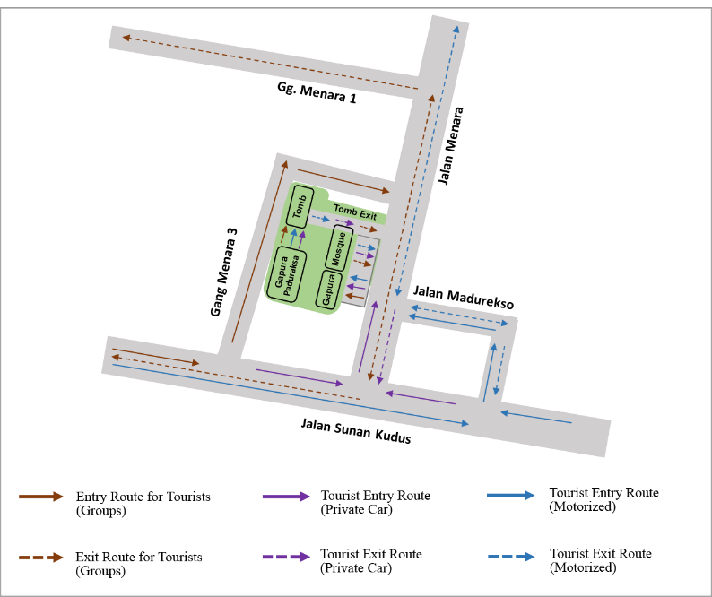

Figure 13. Alternative Pedestrian Route in Menara Kudus Tourism Area [source: Author,2023]

- CONCLUSION
This study concludes that the typology of tourists visiting the religious tourism area of Menara Kudus has its characteristics: tending to come in groups with the main purpose of pilgrimage. However, the mobility and circulation of tourists within the Menara Kudus area are often hindered due to the provision of pedestrian pathways that do not match the typology of the tourists. Although the physical condition of the pedestrian pathways is good, the obstruction of tourist circulation is caused by the lack of differentiation between the entrance and exit routes of the area, as well as the pedestrian pathways and motor vehicle lanes. The design of alternative routes for tourists aims to provide pedestrian pathways in the Menara Kudus tourism area suitable for their typology through adjustments to the entrance and exit routes and alternative activities. This research focuses heavily on improving routes and connectivity and spatial integration between pedestrian paths, road space for motorized vehicles, and tourist attractions. Therefore, further research can carry out a more in-depth analysis of the characteristics of the outdoor space and supporting facilities of the Built Environment in accordance with the demographic characteristics and topography of the Menara Kudus religious tourism area.

ACKNOWLEDGEMENT
The authors are grateful to the Directorate of Research and Community Service, Deputy of Strengthening Research and Development of the Ministry of Technology/National Research, and the Innovation Agency of the Republic of Indonesia (2021 fiscal year Number 8/E1/KPT/2021 and Number of SPK. 225-99/UN.7.6.1/PP/2021) for funding this research.

REFERENCES
- R. A. L. Rocca, “Tourism and mobility. Best practices and conditions to improve urban livability,” Tema J. L. Use, Mobil. Environ, vol. 8, no. 3, p. 311–330, 2016. DOI: https://doi.org/10.6092/1970-9870/3645

- S. Page, Transport and Tourism: Global Perspectives, Harlow: Pearson Education, 2005.

- E. Pieralice, and L. Trepiedi, "Città europee e mobilità urbana: impatto delle scelte modal," Rivista di Economia e Politica dei Trasport, vol. 2, no. 2, 2015.

- K. Fromel, M. Kudlacek, D. Groffik, Z. Svozil, A. Simunek, and W. Garbaciak, "Promoting healthy lifestyle and well-being in adolescents through outdoor physical activity," Int. J. Environ. Res. Public Health, vol. 14, no. 533, pp. 1-15, 2017. Doi: https://doi.org/10.3390/ijerph14050533

- R. Zainol, F. Ahmad, N. A. Nordin, and A. W. M. Aripin, “Evaluation of users’ satisfaction on pedestrian facilities using pair-wise comparison approach,” IOP Conf. Ser. Earth Environ. Sci, vol. 18, no. 1, 2014, doi: 10.1088/1755-1315/18/1/012175

- L. Zhang, R. Zhang, and B. Yin, “The impact of the built-up environment of streets on pedestrian activities in the historical area,” Alexandria Eng. J, vol. 60, no. 1, p. 285–300, 2021. Doi: https://doi.org/10.1016/j.aej.2020.08.008

- Y. Ye et al., Landscape Urban Plan, vol. 191, 2019.

- J. Montgomery, "Making a city: urbanity, vitality and urban design," Journal Urban Design, vol. 3, no. 1, pp. 93-116, 1998. Doi: https://doi.org/10.1080/13574809808724418

- I. Bentley et al., Responsive Environments, A Manual For Designer, Dalian University of Technology Press, 2002.

- Z. Thalia and R. Sugiyarti, “Pengembangan Wisata Budaya Berbasis Wisata Ziarah sebagai Wisata Minat Khusus di Kabupaten Karanganyar,” Progr. Stud. Kaji. Budaya Fak. Sastra dan Seni Rupa Univ. Sebel. Maret, 2011.

- G. Fajarwati, K. A. L. H. Sari, and F. S. A. Ishak, "Ampel Heritage Tourism Area in The Context of Sustainability," Architecture and Environment, vol. 19, no. 1, pp. 53-86, 2020.

- N. Latifah, B. Soemardiono, and M. Faqih, "The Arrangement of Religious Tourism Corridor in Sekumpul Martapura Based on Livable Street," "International Journal of Scientific and Research Publications,", vol. 8, no. 7, pp. 459-464, 2018. Doi: http://dx.doi.org/10.29322/IJSRP.8.7.2018.p7973

- S. Bott, J. G. Cantrill, and O. E. Myers, "Place and the promise of conservation psychology," Human Ecology Review, vol. 10, no. 2, p. 100–112, 2003.

- A. Gühnemann, A. Kurzweil, and M. Mailer, "Tourism mobility and climate change: A Tourism mobility and climate change," Journal of Outdoor Recreation and Tourism, vol. 34, pp. 1-14, 2021. Doi: https://doi.org/10.1016/j.jort.2021.100382

- J. L. Campa, R. Arce, M. E. Lopez-Lambas, and B. Guirao, "Can HSR mobility of international tourists visiting Spain? Territorial evidence derived from the Spanish experience," Journal of Transport Geography, vol. 73, p. 94–107 , 2018. Doi: https://doi.org/10.1016/j.jtrangeo.2018.10.014

- S. A. R. Khan, D. Qianli, W. SongBo, K. Zaman, and Y. Zhang, "Travel and tourism competitiveness index: The impact of air transportation, railways transportation, travel and transport services on international inbound and outbound tourism," Journal of Air Transport Management, vol. 58, pp. 125-134, 2017. Doi: https://doi.org/10.1016/j.jairtraman.2016.10.006

- N. Ginting, N. V. Rahman, S. Subhilhar, and J. Wahid, “The Role of Place Identity in Planning Heritage Tourism," Indones. J. Plan. Dev, vol. 3, no. 2, p. 56, 2018. Doi: http://dx.doi.org/10.14710/ijpd.3.2.56-66

- N. Ginting, "How self-efficacy enhance heritage tourism in Medan historical corridor, Indonesia," Procedia - Social and Behavioral Sciences, vol. 234, p. 193–200, 2016. Doi: https://doi.org/10.1016/j.sbspro.2016.10.234

- A. D. Nasution, and W. Zahrah, "Public open space’s contribution to quality of life: Does privatisation matters?," Asian Journal of Environment-Behaviour Studies, vol. 3, no. 9, p. 59–74, 2012. Doi: DOI: https://doi.org/10.21834/aje-bs.v2i5.224

- J. Gehl, Life between buildings: Using public space, Washington DC: Island Press, 2011.

- B. Q. B. M. Noraffendi and N. H. A. Rahman, "Tourist expectation and satisfaction towards pedestrian walkway in Georgetown, a World Heritage Site," IOP Conf. Ser. Earth Environ. Sci, vol. 447, no. 1, 2021. DOI 10.1088/1755-1315/447/1/012072

- T. H. Karyono, Green Architecture: Pengantar Pemahaman Arsitektur Hijau di Indonesia, Jakarta: Rajawali Press, 2010.

- N. Asriana, "Pedestrian Behavior for Developing Strategy in Tourism Area; Agent-Based Simulation," DIMENSI, vol. 48, no. 1, pp. 65-74, 2021, doi: https://doi.org/10.9744/dimensi.48.1.65-74

- A. Crooks, A. Croitoru, X. Lu, S. Wise, J. M. Irvine, and A. Stefanidis, "Walk This Way: Improving Pedestrian Agent-Based Models Through Activity Analysis," ISPRS International Journal of Geo-Information, vol. 43, pp.1627–1656, 2015, Doi: https://doi.org/10.3390/ijgi4031627

