 |  | JOURNAL OF ISLAMIC ARCHITECTURE  P-ISSN: 2086-2636 E-ISSN: 2356-4644  Journal Home Page: http://ejournal.uin-malang.ac.id/index.php/JIA
THE RELATIONSHIP OF ISLAM AND LOCALITY IN THE ARCHITECTURE OF THE WAPAUWE ANCIENT MOSQUE IN MALUKU
Wuri Handoko^{a*}, Isman Pratama Nasution^{b}, Wanny Raharjo Wahyudi^{c}, Herry Yogaswara^{d}, Muh Subair^{e}, Nurman Kholis^{f}, Kadir Massoweang^{g}, Alfan Firmanto^{h}, Ali Akbar^{i}
ªRC. for Treasures of Religion and Civilization, Jakarta, Indonesia
^{b}University of Indonesia, West Java, Indonesia
^{c}University of Indonesia, West Java, Indonesia
^{d}RO. for Archeology, Language, and Literature, Jakarta, Indonesia
^{e}RC. for Treasures of Religion and Civilization, Jakarta, Indonesia
^{f}RC. for Treasures of Religion and Civilization, Jakarta, Indonesia
^{g}RC. for Treasures of Religion and Civilization, Jakarta, Indonesia
^{h}RC. for Treasures of Religion and Civilization, Jakarta, Indonesia
^{i}RC. for Treasures of Religion and Civilization, Jakarta, Indonesia
*Corresponding Author: wuri002@brin.go.id / muh.subair@brin.go.id
ARTICLE INFO |  |  | ABSTRACT
Volume: 8  Issue: 1  Page: 184-198  Received: June 12th, 2023  Accepted: September 09th, 2023  Available Online: June 15th, 2024  DOI:  http://dx.doi.org/10.18860/jia.v8i1.21729 |  |  | The Wapauwe ancient mosque in Maluku is historically and culturally significant, symbolizing the enduring bond between religion and the local community. This qualitative archaeological study examines the mosque's architectural aspects to explore this connection. The mosque is considered a result of careful thought and reflects origin-related factors and human behavior through its architectural elements. The Wapauwe Mosque shares similarities with ancient mosques found throughout the archipelago. Its three-tiered roof typology, supported by four pillars and a distinctive peak, represents the three stages of Islamic development, showcasing the integration of Islamic principles with local culture. The two-tiered roof of the Wapauwe Kaitetu mosque signifies an ongoing dialogue between religious scholars and the indigenous people, leading to architectural adaptations. Furthermore, the mosque's design elements carry symbolic meanings. The peak symbolizes monotheism and male fertility, while the pineapple-shaped pegs embody the fusion of animal carvings and flora. The rectangular plan signifies the influence of customs and religion, and the mimbar type reinforces the growth and development of religious traditions. Architecturally, the Wapauwe mosque features 12 supporting pillars, corresponding to the 12 fundamental values of Islamic teachings—comprising the five pillars of Islam, six pillars of faith, and Ihsan. This alignment also mirrors the concept of deliberative custom, which includes 12 institutional structures. These structures coexist and interact with the religious hierarchy and its apparatus, demonstrating a balanced and inclusive relationship between religion and locality within the governance of Maluku. Ultimately, the typology of the Wapauwe mosque emphasizes the deep connection between Islam and local culture. It serves as a testament to the culturally inclusive religious character of the community. This cultural Islamic society respects differences and embraces diversity as an integral aspect of religious teachings.  Keywords:  Wapuwe Ancient Mosque, Islamic Tradition, Local Culture

- INTRODUCTION
During the development of Islam, the mosque was one of the monumental proofs that local community accepted Islam. The construction of a mosque in a kingdom marks the official acceptance of Islam as the kingdom’s religion [1]. The Wapauwe Mosque in Maluku is a rare and authentic example of an ancient mosque withstood architectural transformations. Its typological and morphological characteristics witness the multicultural influences of Islam and the local community, showcasing the region's dynamic evolution of architectural forms. The use of fragile building materials in ancient mosques has contributed to the unique tradition upheld by the Wapauwe Mosque, acting as a tangible bridge between the past and present. The preservation and study of this ancient mosque are of utmost importance in comprehending the diverse heritage of Islamic traditions and their interplay with local customs. The mosque's significance lies in its representation of cultural exchange and the ongoing interconnectedness between religion and the local community.
The mosque architecture stems from a long journey of construction that traverses various generations, periods, and societal cultures. Mosques have become typical objects used to depict the evolving character of Islam in different regions worldwide. Consequently, there are various styles of mosques today, including the Mamluk style, Hispano-Moresque style, Persian style, Ottoman style, Indian style, Chinese style, and Nusantara style [2]. Each style is influenced to some extent by the natural environment, local surroundings, and the cultural heritage of the supporting community or through acculturation with other cultures, adding to the richness of cultural diversity [3], [4]. The farther the construction of a mosque is from the initial center of Islamic civilization in Arabia, the greater the wealth of experiences and meanings encapsulated within it [5], [6]. However, consistency remains in the direction of the qibla and the square typology of mosque buildings, reflecting the continuity of Islamic traditions since Prophet Muhammad (SAW) [7]. Mosques are pivotal in Islamic society, serving as more than mere religious structures [1].
The study of mosques in the context of the relationship between Islam and locality can be categorized into three main areas. Firstly, mosques are examined as archaeological and historical objects, where their construction materials, age, and techniques are described [8], [9], [10]. Additionally, studies delve into the historical development of mosques and efforts made to conserve them [11]. Furthermore, some previous studies focused on the preservation of mosques through measured renovations [12], [13], [14].
Secondly, there are also studies on mosques that examine the effectiveness of their architectural functions [15]; for instance, temperature control can be achieved through natural cooling methods or technology-assisted cooling systems that are customized to accommodate the congregation’s capacity [16] [17].
Thirdly, various studies explore mosques in the context of their social, cultural, economic, and political dimensions. Mosques are not merely places of worship; they also serve as multifunctional facilities that play significant roles in the community [18]. However, mosques also serve as facilities that connect communities in addressing social issues [19], [20], [21]. Mosques can serve as a solution for the development of an area and can be utilized as the axis of the local economy and as objects of religious tourism [22], [23]. Similarly, in the cultural aspect, various forms of mosque-based traditions emerge based on the ethnic, linguistic, and societal identities of the community [5], [24]. Moreover, mosques are seen as representations of the political dynamics within Islamic communities [25], [26], [27]. This article, however, focuses on studying the ancient Wapauwe Mosque in Maluku, unveiling the relationship between Islam and locality by examining its typological and morphological aspects.
Scholarly investigations have addressed the cultural aspects of mosques, such as the influence of Hindu culture on the Kudus Mosque [28] and the hybrid cultural identity of the Sang Cipta Rasa Grand Mosque in Cirebon [29]. However, previous articles have not explored the local cultural aspects of mosques based on their typological and morphological features, such as the local aspects found in the Trusmi Mosque in Cirebon. This mosque's focus on local culture is limited to the Kliwonan tradition (based on the Javanese calendar), which positions the mosque as the center of its activities [30]. This study examines the distinct characteristics of local elements in mosque architecture influenced by different ethnic, regional, and cultural factors. Another essential distinction lies in reflecting the relationship between Islam and locality, which this article explores through mosque buildings' typological and morphological aspects.

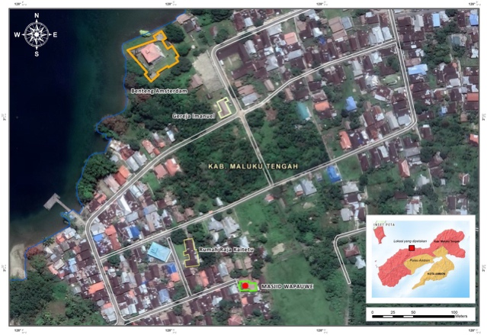
Figure 1. Map of the location of the Wapauwe Ancient Mosque in Kaitetu Village, Central Maluku Regency in Ambon Island [1]

- METHODS
This study qualitatively explores the significance of an ancient mosque in the context of the local community, employing an archaeological and anthropological approach. The mosque is examined not only as a symbol of Islamic religiosity but also as a socio-cultural and political entity within the local governance framework. The research employs a qualitative descriptive method to investigate mosque architecture and its role in the socio-cultural construction and Islamic identity of the Kaitetu people in the Central Maluku Regency. The study adopts an architectural typology approach to elucidate the form of local cultural accommodation and political relations reflected in the architecture of the Wapauwe Mosque [31]. Architectural typology involves classifying and grouping buildings based on shared characteristics. Typology also examines the origins and evolution of architectural forms. Both typological and morphological studies are vital for understanding architectural typology. This research combines these approaches to uncover mosque units’ physical and spatial structures and their cultural connections.
Additionally, comprehending the figuration and spatial hierarchy within mosque architecture is crucial. The spatial figuration system reflects societal perceptions and expectations of various building functions. The study integrates anthropological investigations to understand community perspectives, daily religious practices, and cultural interactions between local traditions and the development of Islam.

- RESULT AND DISCUSSION

  - TIERED ROOFS: DIALOGUE ULAMA AND COMMUNITY
The architectural feature of tiered roofs appears to be a typical representation of ancient mosques in the Nusantara region. The form of roofs layered with two, three, or even five tiers emerged in the late 16th century CE, a distinctive structure referred to as a triangular superstructure or pyramid. Interestingly, tiered roofs in mosques can be found in various regions of the Nusantara, including Aceh, Demak, Banten, Kudus, and Ternate [32]. In the Maluku region, a similar construction model is also found in other areas, such as the Hatuhahamarima Mosque on Haruku Island, situated within the Hatuhaha Kingdom.

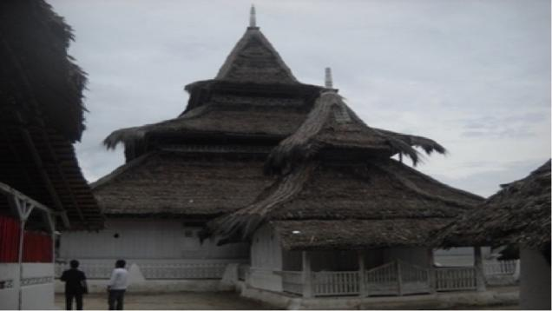
Figure 2. Three-tiered Roof Design [1]

In terms of locality, the three-tiered roof design of mosques represents the three stages of the introduction of Islam. First, there is the presence of one or several foreigners practicing Islam in a specific region. Second, some local inhabitants in that region converted to Islam. Third, Islam was established as the dominant religion and institutionalized within the community. Based on the timeline of Islam's arrival in Maluku, particularly in Hitu, the following can be formulated: Firstly, during the late 13th and early 14th centuries, Maluku, including Hitu, was visited by Islamic individuals (traders or religious propagators). Secondly, from the late 14th to the early 15th centuries, many Hitu people embraced Islam. Thirdly, from the 15th century onwards, Islam became the religion of the community, even becoming the official religion of the Hitu kingdom. This was marked by the establishment of religious institutions such as the qadhi, which became an integral part of the Islamic community in Hitu [33].

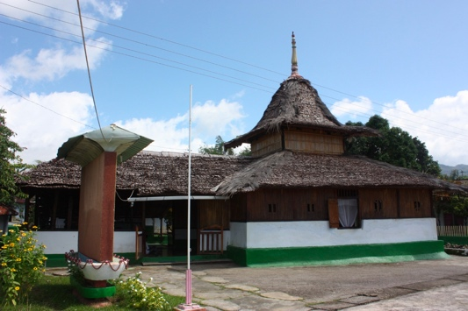
Figure 3. Two-tiered Roof Design

The arrival of Islamic scholars and the introduction of Islamic teachings did not entail the eradication of local customs, traditions, and practices within the community. Many local traditions have been preserved and upheld, particularly regarding creative expressions and behaviors that support social order. This is evident in the process of mosque construction, which is supported not only by the Muslim community but also by members of the Christian community.
The two-tiered roof design of Masjid Wapauwe differs from the three-tiered roof design of Masjid Hatuhahamarima, illustrating the integration of religious concepts and local characteristics. Islamic scholars who introduced the three-tiered mosque model in Nusantara did not impose it as a mandatory form for the community. The community was allowed to incorporate creative elements in determining the mosque roof type, showcasing a dialogue between Islam and local customs. This led to the emergence of the roof design of Masjid Wapauwe, which combines the Nusantara-mosque style with the elongated triangular shape of the traditional Baileo house in Negeri Kaitetu.

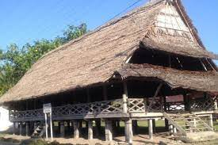
Figure 4. Traditional Baileo House

The fusion of the traditional Baileo house form with the typical three-tiered design of Nusantara mosques holds significant cultural implications for the entire Kaitetu community. The mosque has evolved to become not only a place of worship for Muslims but also an inclusive space for people of all faiths. From the outset, the Christian community has actively participated in the traditional ceremony of mosque construction, particularly in installing the rumbia roof, by providing or donating their skillfully woven sago palm leaves. According to custom, both the pastors and the builders play a direct role in the roof installation, both ceremonially and culturally. Such practices of communal collaboration are often associated with the widely known pela gandong tradition in Maluku society, reflecting the commitment to live in a bond of brotherhood despite religious differences.

  - TYPE OF APEX: MASCULINITY AND DIVINITY
Another distinctive feature is the presence of the 'alif pillar' at the pinnacle of the tiered or topmost roof, known as mustaka or memolo. De Graaf asserts that the prototype of mosques can be found throughout the region, from Aceh to Ambon, and they share a common characteristic, with the roof architecture being the primary focus. These mosques exhibit a tiered roof design with three to five levels, where each level progressively decreases in size as it ascends [34].

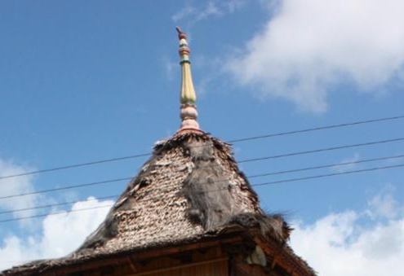
Figure 5. Kemuncak “Tiang Alif” of Wapauwe

The apex (kemuncak/mustaka) of Masjid Wapauwe measures 2.5 meters. It symbolizes the Arsh (the Creator), the primary protector of the mosque and its community, also known in Maluku as the "Tiang Alif" (Alif Pillar). In Central Maluku, the symbol of the Alif Pillar is generally understood as a concept related to Sufi mysticism, representing the belief in the Oneness of God (Tawhid). In the Maluku Islamic community, it is believed that the "Tiang Alif" symbolizes the spiritual progression of a Muslim who has followed the stages of sharia, tariqa, haqiqa, and ma'rifah, ultimately leading to the highest level of perfection, the attainment of the Divine Unity.
Regarding the "Tiang Alif," Pijper describes it as the highest and smallest roof adorned with an ornamented spear and one or more balls or cubes [35]. Fundamentally, the general form of mosques in the Nusantara region bears striking similarities and continuity with the Hindu-Javanese past. Thus, the "Tiang Alif" philosophy is also understood as a concept influenced by local beliefs, symbolizing fertility, masculinity, and the protector of the community. This fact reminds us of the phallic symbol in the traditional megalithic religious concept. The phallic symbol (kelakian) has been a tradition for thousands of years, dating back to the flourishing megalithic traditions.

  - PINEAPPLE PEG AS A SYMBOL OF FERTILITY
Ancient Wapauwe Mosque exhibits another distinctive feature, such as the presence of pineapple-shaped carved pegs at the junction of the upper tier and the first roof ridge, serving as supports for the lisplang (Lisplang is a slat board installed on the roof's edge to beautify the building and hide the roof structure). Regarding the symbolism of the pineapple ornament, some oral traditions suggest that it represents fertility (Interview with JL, Ambon 2016).
Regarding the symbol of fertility, it is also related to the local understanding of cosmology, where the mosque is seen as a symbol of the mother and simultaneously as a representation of the earth, referred to by Bartels as "mother earth" or Ibu Pertiwi [36]. This forms the fundamental understanding of the local Maluku community, who perceive the mosque as a symbol of purity. A single entrance door represents the sanctity of the mosque. Generally, ancient mosques in Maluku have only one door, symbolizing the womb of a mother.

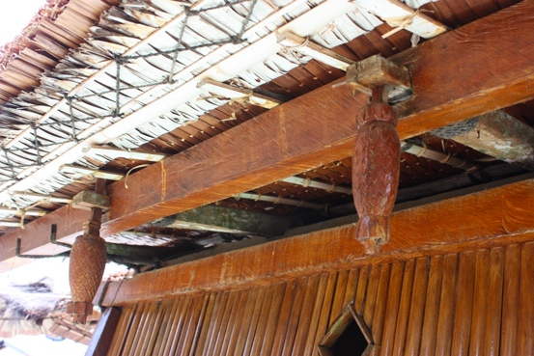
Figure 6. Pineapple Peg

  - RECTANGULAR: RELIGION-CUSTOM OPENNESS
The unique architectural design of ancient Indonesian mosques sets them apart from mosques in other countries. This distinction arises from the universal principles inherent in the mosque concept, as outlined in Hadith, since the Quran does not provide specific guidelines for mosque construction, except for the qibla direction [37].

Table 1. Similarities between Mosque Types and Baileo Traditional Houses
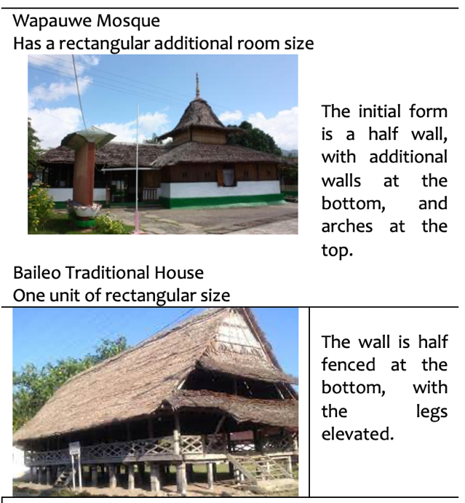

The Wapauwe Mosque, with a main building measuring 10m2 and an additional veranda of 6.35 x 4.75m, exhibits a square floor plan, a prominent characteristic of mosques constructed from the 16th to the 17th century [38]. The square floor plan is also commonly found in ancient mosques throughout the Nusantara region, particularly in Javanese mosques. It is believed that this design originated from pre-Islamic structures like the Balinese "wantilan," a square, open-air structure adapted for mosque construction by adding walls and a mihrab.
The square-shaped floor plan refers to the traditional Javanese building model called "pendapa." This model originated from pre-Islamic Hindu architecture and was subsequently embraced by the Nusantara community alongside the introduction of Indian architectural knowledge [2] [32]. Hasan Muarrif Ambary often uses the "Majapahit style" rather than Hindu-Buddhist or pre-Islamic [39]. In various examples of ancient mosques, construction was typically designed without nails. Instead, wooden pegs were employed and lashed with coconut fiber ropes, connecting beams to beams and pillars [40].
In the local context of Maluku, the square-shaped building form represents a continuation of the traditional long rectangular shape of indigenous houses. The traditional baileo house type and the Wapauwe mosque not only share a similar square shape but also have open interiors without partitions, symbolizing the openness of the space to embrace all forms of human differences. Over time, the Wapauwe mosque has been frequently used for social activities involving followers of other religions. The Christian community's tradition of welcoming January 31st with day-long singing specifically involves the Islamic ruler of Kaitetu. The presence of the ruler signifies the mosque as the central gathering place, prompting the Christian community to visit the mosque and sing to invite the ruler to attend the pinnacle of the event. Such processions have become customary for the people of Kaitetu, fostering an enduring sense of brotherhood. Even during the 1999 riots, the bond between Islam and Christianity in their land remained unbroken.

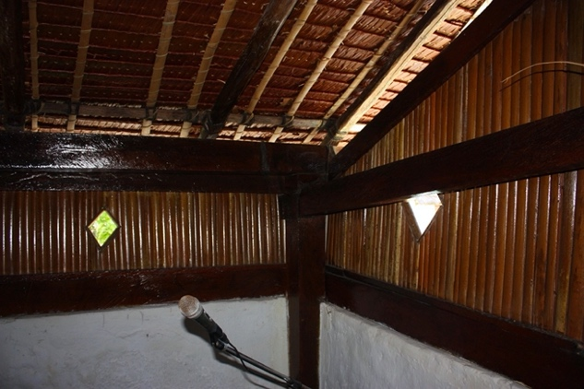
Figure 7. Arrangement of gaba-gaba

Gaba-gaba refers to dried sago palm fronds used as house construction material. Typically, they are used for house walls by either being tied or attached using small sago stalks cut to resemble regular nail sizes. These gaba-gaba fronds are tightly arranged to form the walls of houses and mosques.
The mosque framework consists of various components. The lower part comprises the foundation, typically half a meter deep into the ground. The veranda foundation is positioned lower than the main mosque foundation. The central section is the wall, featuring lower wall structures and vertically arranged gaba-gaba fronds, enclosed by four pillars on each side. The upper section is an open, single-level space with wooden beams and a steep pyramid-shaped roof. The tower walls atop the main building are made of gaba-gaba. The tower lacks floors as it stands on the four main pillars. At the top left corner of the old door, a brass plate shaped like a turtle is present, bearing the Thoyibah and Shahada phrases: "Allahuma Shaliwassallim alai" and "Lailaahaillallah Muhamaddarasulullah."
The mosque floor comprises cement layers covered with prayer mats or carpets. The entrance to the mosque includes doors and windows, with the main entrance (to the main prayer hall) typically having only one door at the front. This is a common feature of ancient mosques, particularly in Maluku. The mosque roof consists of two tapering levels. The overlapping roof style is also a characteristic of ancient Nusantara mosques. The roof structure is made of redwood, forming a steep pyramid shape. It is covered with rumbia leaves, with ijuk palm fibers lining the ridges, and topped with a carved wooden dome.
The sokoguru construction consists of strong and durable nani or blackwood logs with a diameter of 30x30 cm, while the supporting posts have a diameter of 25x25 cm. The four sokogurus directly support four beams that support the upper-tier overlapping roof. Below the beams of the upper-tier roof, stacked beams support the first-tier overlapping roof. Twelve pillars measuring 2.5 m long support the first-tier overlapping roof. The outer part of the twelve pillars is covered with lower walls, and the upper part is made of gaba-gaba, as an additional feature.

  - MIMBAR: ISLAM'S ACCEPTANCE AND TRADITION
The mimbar (pulpit), considered one of the main components of the Wapauwe Mosque, is believed to be as old as the mosque itself. It is located inside the main prayer hall on the western side, adjacent to the mihrab. It is constructed using nani and lara wood, measuring 180 cm in length, 86 cm in width, and 220 cm in height [41]. The photo of the mimbar is taken from the northwest direction, revealing the staircase in front of it. At the top of the mimbar, where the Khatib stands, there is a yellow split curtain that the Khatib can enter after climbing the stairs. Additionally, red and white flags are installed on the left and right sides of the mimbar. Morphologically, the mimbar of Wapauwe Mosque is compared with the sketch of the mimbar of Peringgit Mosque in Melaka, Malaysia [42].
The typology of the mimbar in Wapauwe Mosque retains the concept of the mimbar based on Hadith, etymology, and historical records from the time of Prophet Muhammad until the present. Based on the provided photos, it is observed that the mimbar features a set of stairs positioned in front of it. These stairs visually represent the narration of Prophet Muhammad during his ascent to the mimbar for the sermon. As he steps on the first stair, he utters "Amin," repeated when he ascends the second and third stairs. This narration is documented in various hadith collections, including Majma'uz Zawaid and Adabul Mufrad no. 644 [43].

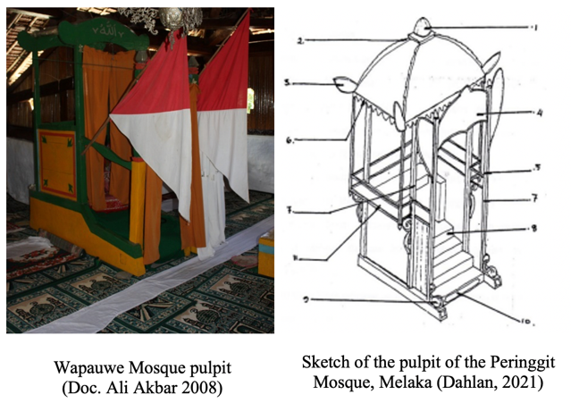
Figure 8. The typology of the mimbar

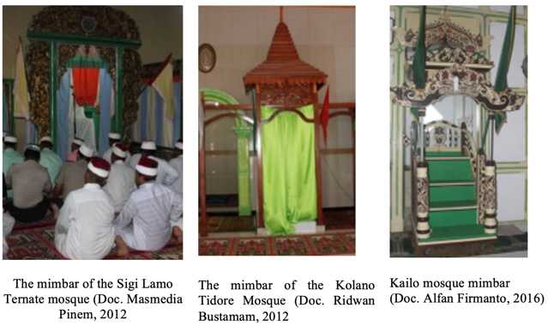
Figure 9. The mimbar of the Sigi Lamo Ternate mosque

The Mimbar of Wapauwe Mosque has unique features that are different from traditional mosques in Indonesia. One of them is the installation of a hijab (curtain) in front of the mimbar. This ensures that the body of the Khatib is not visible while delivering the sermon, as the curtain covers it. To determine if this uniqueness exists in ancient mosques, a comparison is made with photos of mimbars in other mosques, especially those in Maluku and North Maluku. The installation of a curtain in front of the mimbar can also be found in Sigi Lamo Kesultanan Ternate Mosque [44] and Kolano Tidore Mosque [45]. However, the mimbar of Kailolo Mosque is not covered with a curtain [46], which differs from the standard practice in mimbars across Indonesia.
The curtain installation in front of the mimbar of Sigi Lamo Ternate Mosque is intended to emphasize that the most crucial aspect of Friday sermons is the message delivered by the Khatib, not the person delivering it. Likewise, the curtain conceals the Khatib, signifying the avoidance of arrogance, ostentation, and pride. Instead, the Khatib should embody humility [44]. Similarly, the installation of a curtain in Kolano Tidore Mosque is based on the proverb, "Do not look at who is speaking, but listen to what is being said." This ensures that the Khatib who delivers Islamic advice or preaching must exemplify the personality of Prophet Muhammad, maintaining secrecy and protecting the Khatib from potential "fitnah" in their daily interactions with society [45].
The Wapauwe mimbar reflects cultural influences and religious understanding. The choice between a mimbar and a podium signifies religious organization affiliation. Mimbars are associated with traditional Islam, while podiums are used in modern contexts. Both may be used without organizational preference. Mimbars are linked to traditions like reciting prologues and using ceremonial weapons. Fabric screens above the mimbar create a visual barrier between the preacher and the congregation, which is impossible with a podium.

  - TYPOLOGY OF MOSQUE: LOCAL POLITICS
The Wapauwe ancient Mosque serves as an icon and cultural manifestation that has endured over time, reflecting the social relations and local governance structure inherited from the Kaitetu people’s ancestors. The mosque’s typology identifies these enduring traditions. Throughout history, various customs associated with the mosque have been passed down, making it a meeting place for people from diverse backgrounds, thus contributing to the local customs and traditions (Interview, UN Ambon 2019).
In the context of the inheritance of Islamic values, there are symbols integrated with the local governance structure (adat), such as the relationship between the number of mosque support pillars, which is 12, and the adat institutional structure of Tukang 12 (Tukang Husa Lua). Through personal conversations with informants, it was revealed that the position of Tukang 12 (Tukang Husa Lua) historically represents the symbolism of Islamic teachings regarding Islam, Iman, and Ihsan. The symbolism of the number 12 is an elaboration of the core teachings of Islam, namely the 5 (five) Pillars of Islam, the 6 (six) Pillars of Iman, and Ihsan, which emphasize the understanding and belief in the Oneness of Allah. The 5 Pillars of Islam include declaring faith, establishing prayer, fasting in Ramadan, paying Zakat, and performing Hajj if possible. The 6 Pillars of Iman include belief in Allah, belief in the angels, belief in the holy books, belief in the prophets, belief in the Day of Judgment, and belief in predestination. Ihsan represents the highest achievement for a Muslim, receiving goodness from Allah. In the archaeological context, this symbolism is manifested through 12 support pillars in the Wapauwe Ancient Mosque, representing Soa Nukuhaly as the adat tradition.
Thus, the elaboration of symbolic meanings of Islam, Iman, and Ihsan as the three core teachings of Islam, totaling 12 teachings or beliefs, represents a symbolism that has traditionally become part of the cultural transformation process. This cultural transformation refers to adapting the symbolic meanings of Islam, Iman, and Ihsan into the institutional structure of customary practices, where each structure component has its own tasks and roles within the customs. Therefore, the existence of the Tukang 12 (Tukang Husa Lua) historically signifies the influence of Islamic teachings, which later integrated into the cultural transformation process, becoming a part of the inherited customs and an enduring tradition to this day.
The role of the tukang (craftsman) existed long before the arrival of Islam but underwent dynamic changes after Islam's introduction, assuming a different structure and function. The adat (custom or tradition) structure of Tukang 12 (Tukang Husa Lua) represents the relationship between Islam and adat, as a form of ancestral tradition inheritance, where both Islam and adat are integrated, influencing and complementing each other as an integral part of the local Kaitetu community's tradition. Tukang Husa Lua (Tukang 12), in the context of the mosque, can also be depicted through adat messages, emphasizing their institutional position in establishing the mosque and their involvement in various adat activities. Apart from their role in the institution governing all mosque-related work led by Tukang Ela (Master Craftsman) based on hereditary lineage, they also participate in adat activities such as the coronation of kings, ritual replacement of mosque roofs, baeleo, and other traditional ceremonies.
This understanding implies that the social structure of the Kaitetu community has been formed to play a role and function that structurally integrates with the religious (Islamic), customary, and governmental systems. These systems have been institutionalized or undergone a systematic institutionalization process. Within this formed social structure, each component appears as a cohesive and inseparable part of the religious (Islamic), customary, and governmental structures, forming an equal and balanced functional relationship. Through the institutionalization process of both structure and system, the institutional structures of Islam, customary practices, and governance represent the orderly functioning of the cultural system, as they are established within their respective parts to maintain the existing social structure.
The Atorang system provides guidelines for the construction process of the mosque as a sacred building, which can only be carried out by Tukang 12 (Tukang Husa Lua). On the other hand, the Atorang system also positions Tukang 12 within the adat institutional structure, akin to ministers in the current cabinet of the Republic of Indonesia. In this context, the mosque is not only understood as a place of worship but also as an adat and governmental institution. The presence of a King and the Council of Advisors (Amaumenhaha), consisting of Sahuema, Lepalu, and Lepali, further exemplifies this. The role of amaumenhaha is similar to that of a legislative council, which provides advice and considerations to the King in decision-making processes. Amaumenhaha also serves as a link between the adat government and religion. During the coronation of the King, Sahuema is responsible for placing the crown on the King during the inauguration. At the same time, Lepalu assists Sahuema, and Lopeli performs adat requests, allowing the adat staff to take their respective seats in the Baeleo or the mosque.
Inside the mosque are designated areas for critical figures involved in Islamic rituals. As the prayer leader, the Imam stands in the mihrab while the Khatib delivers the sermon from the mimbar. The Modhim occupies a space in the center of the mosque. These roles play a significant part in the Islamic worship process within the mosque. However, the mosque also accommodates adat and governmental structures, including the Raja (Upu Itu), the head of government and adat. The mosque also defines the positions of the Amaumenhaha, serving as a legislative body and advisory council to the king. The Tukang 12, Raja, and Amaumenhaha have designated positions within the mosque. The Tukang 12 holds the executive role within the adat structure and oversees all mosque-related tasks while participating in adat activities such as the king's coronation and ceremonial events. This system mirrors the ministerial positions in the government cabinet. The Raja (Upu Itu) and Amaumenhaha are situated on the right side of the Mihrab and Mimbar.
The institutional structures governing the mosque also apply to the Baeleo, a traditional building. The mosque and Baeleo's social space demonstrate a balanced and integrated role of the Islamic, adat (customary), and governmental institutions. Although the Baeleo does not have specific areas designated for the Islamic institutional roles of the Imam, Khatib, and Modim, it accommodates Islamic principles by including the Tukang Sufi among the Tukang 12. The Tukang Sufi takes care of religious matters and serves as the executive body within the adat governance structure. Hence, the representation of the adat institutional structure in both the mosque and Baeleo highlights their roles as symbols of Islam and adat, respectively, while also serving as social spaces that house the adat governance structure, as passed down by ancestors to maintain social order.

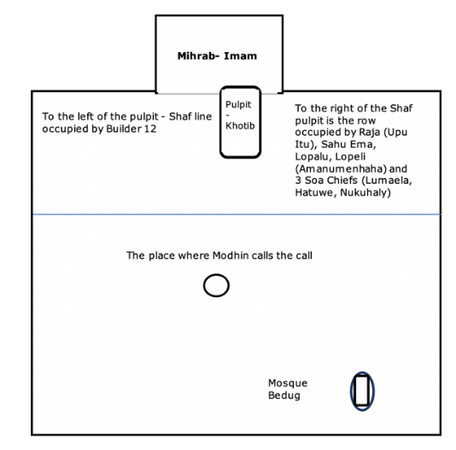
Figure 10. The Position of the Traditional Government Structure within the Mosque [47]

Based on the interview conducted in Figure 10, it is revealed that the position of the Imam is part of the customary role held by the Soa Hatuwe, representing the Soa Agama. This is supported by historical sources indicating that the first Imam of the Wapauwe Old Mosque was Imam Arikupelessi in the 15th century, who belonged to the Hatuwe lineage and was also a descendant of Kapitang. The interpretation of the position of Soa Hatuwe, as a descendant of Kapitang, entitled to perform the Luma Ana ritual, signifies the continuity of institutional traditions that place Mauweng or Muela within the governance structure of Kaitetu. This indicates that the position of Imam Ela or Imam Besar in the Kaitetu region is a continuation of the Mauweng institution. However, the institution is no longer recognized since it predates the colonial period.
The historical background of the establishment of Wapauwe Mosque, based on oral sources, reveals that in the past, the inhabitants of the Bukit Wawane region, consisting of five territories, namely Essen, Wawane, Atetu, Nukuhaly, and Tehala, were already familiar with Islam around the 1400s. Perdana Jamilu, one of the Four Prime Ministers of Hitu, developed Islam. Together, they constructed the Wawane Mosque, also known as Wapauwe Mosque, in 1414. Initially, the Ancient Wapauwe Mosque was built on Mount Wawane. In 1464, Kyai Pati or Pati Tuban, a preacher from Gorom, arrived on the shores of Nukuhaly near the Wa Olan River and was invited by Jamilu to reside in Wawane. Under the guidance of Kyai Pati, Arikulapessy served as the first Imam, while Syahrukka became the Modin (muezzin).
Based on the illustration in Table 2, the development of mosques in the Nusantara region during the 16th and 17th centuries exhibited their distinctive forms. The architecture had common elements, from Aceh in the west to Maluku in the east. The main buildings were square-shaped and often featured a porch on the east side, with thin walls and four large wooden pillars supporting the layered thatched roof. A substantial brick wall usually surrounded the entire complex. The origin of this pattern is not widely debated, particularly whether the layered roof is a continuation of the depiction of Mount Meru in Hindu-Javanese traditions, as seen in Bali, or a pattern derived from Muslim China, such as in Demak and Jepara in the 15th century. While it is possible that the Chinese contributed to the construction of some large mosques, the same mosque style would not have been accepted throughout the Southeast Asian archipelago in the 16th century unless it incorporated religious and architectural patterns from older traditions.
The development of mosques in the Nusantara region during the 16th and 17th centuries displayed distinctive forms. The architecture shared common features from Aceh to Maluku. The main buildings had a square shape and an eastern porch supported by thin walls and four large wooden pillars. A solid brick wall typically surrounded the entire complex. The origin of this architectural pattern is debated, particularly whether the layered roof was influenced by the depiction of Mount Meru in Hindu-Javanese traditions or derived from Muslim China. While the involvement of Chinese artisans in constructing some large mosques is possible, the widespread acceptance of this mosque style across the Southeast Asian archipelago in the 16th century would require the incorporation of religious and architectural elements from older traditions[1], [47], [48].

Table 2. Typology of Nusantara Mosques
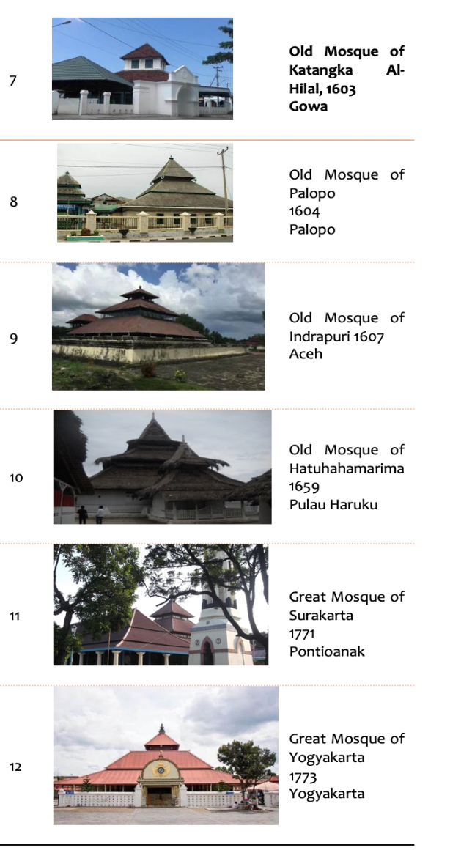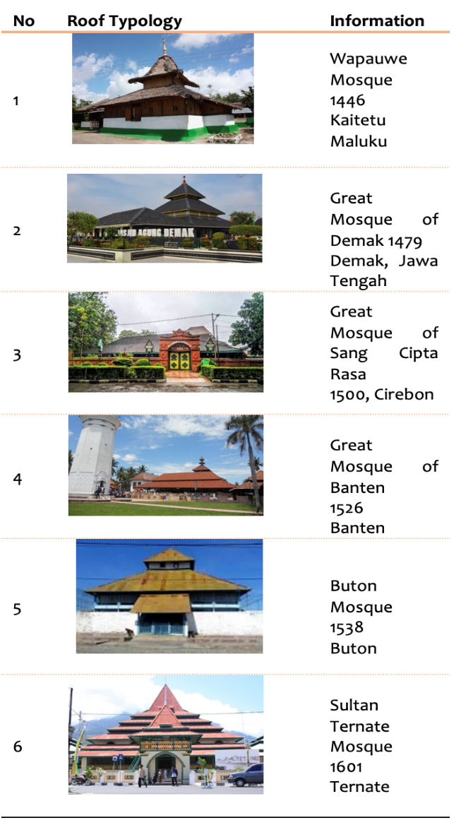

Regarding the Wapauwe Mosque, it is recounted that before the outbreak of the Wawane War in 1634, the Dutch had disrupted the peace of the five villages on Wawane Hill, namely Essen, Wawane, Atetu, Nukuhaly, and Tehala, which had already embraced Islam. Due to the lack of security, the mosque was relocated to Tehala Village, which was 6 km away from Wawane. The relocation occurred in 1614 in a plain abundant with wild mango trees known as "Wapa" in the Kaitetu language. Under these trees, the Wawane mosque was reconstructed and renamed the Wapauwe Mosque, meaning a mosque built under the wild mango trees. (Interview, JL 60 years old, Wapauwe 2019).
When the Dutch gained control of the Kingdom of Tanah Hitu in 1646, the community was relocated to the coast. It is further recounted that when Tehala, Atetu, and Nukuhaly communities descended to the coastal area and merged to become the Kaitetu Regency, the Wapauwe Mosque remained in the Tehala plain. One morning, when the people woke up, they saw that the mosque had been erected amid the settlement, complete with all its equipment and facilities [48].
The mosque's establishment seems to be connected to the existence of ancient manuscripts within the Hatuwe Family. One popular ancient manuscript is the ancient Quran manuscript, which, according to information, was purportedly written by Nur Cahya, the granddaughter of Imam Arikualpessy, and completed in 1590 CE. [49]. Based on oral accounts, in the early 15th century CE, Perdana Jamilu, one of the Four Prime Ministers of Hitu, spread the teachings of Islam in the Wawane hill area, inhabited by five villages, namely Essen, Wawane, Atetu, Nukuhaly, and Tehala. According to oral sources, Wawane Hill was the first center of dissemination when the people of Kaitetu lived in the hills. In addition to the five villages mentioned earlier, the first Wapuwe Mosque was built in this area in 1414 CE, later named Masjid Wawane, also known as Masjid Wapauwe [47].
The archaeological analysis of the Wawane hill site reveals significant findings, such as stone tables and European cannons, likely plundered during the Wawane War (1634-1643) against colonial forces. Moreover, scattered foreign ceramics and pottery attest to active settlement and external interactions. The flourishing trade indicates the period of Islamization. These foreign ceramics primarily functioned as everyday household containers, providing evidence of residential activities in the region. Most of these ceramics, identified as dating from the 15th to the 19th century CE, originate from Chinese kilns during the Ming (16th-17th centuries) and Qing Dynasties (18th-19th centuries). Oral accounts describe Tehala Hill in the ancient village as a former dwelling of the Kaitetu people who now reside along the coast. Notably, a tomb discovered at this site is believed by locals to be the resting place of the first muezzin of Masjid Wapauwe, Modin Syahrukka, indicating it as the presumed location of the former Wapauwe Mosque. The toponym "Mangga Berabu" refers to a tiny flat land area of around 10 square meters within this site, characterized by forest trees. Consequently, the mosque established in this location became known as Masjid Wapauwe.

- CONCLUSION
Wapauwe mosques in Kaitetu, Maluku, exemplify the narrative of Islam and local identity. The local term "tiang alif," used for the mosque's pinnacle, also known as "mustaka" in other Nusantara regions, symbolizes recognizing God's oneness and masculine power. This interpretation aligns with the Islamic understanding that acknowledges human agency in sustaining life on earth.
Wapauwe Mosque also demonstrates the adaptation of local customs to Islamic traditions. For instance, the use of pineapple-shaped ornaments on pillars continues the traditional ornamental practices, which have been integrated into Islamic wood carving as floral motifs. The square-shaped layout, inclusion of walls, and choice of mimbar types align with the Nusantara-mosque typology. These practices are grounded in arguments derived from hadiths and Quranic verses.
Furthermore, the morphological aspect of Wapauwe Mosque, featuring 12 supporting pillars, reflects the institutional structure of the adat community comprising 12 artisans . This arrangement symbolizes the foundation of Islam, including the five pillars of Islam, six pillars of faith, and ihsan. The 12 adat craftsmen represent the institutional framework of the Kaitetu community responsible for mosque construction. This integration of Islam into local governance demonstrates the ongoing dialogue between Islam and local identity.
In conclusion, Wapauwe Mosque showcases architectural typological similarities with Nusantara mosques. It embodies the common Islamic character and accommodates of local customs. The mosque's design reflects the negotiation process between the ulama and the indigenous community, incorporating local symbolism and adapting traditional practices to Islamic traditions.

REFERENCES
[1] W. Handoko, “Karakteristik Arsitektur Masjid Kuno dan Perkembangan Islam di Maluku,” Amerta, vol. 31, no. 1, pp. 39–52, 2013. doi: 10.24832/amt.v31i1.152
[2] I. Z. M. Wiryoprawiro, Perkembangan Arsitektur Masjid di Jawa Timur. Surabaya: Surabaya: PT Bina Ilmu, 1986.

[3] N. C. Idham, “Javanese Islamic Architecture: Adoption and Adaptation of Javanese and Hindu-Buddhist Cultures in Indonesia,” J. Archit. Urban., vol. 45, no. 1, pp. 9–18, Feb. 2021. doi: https://doi.org/10.3846/jau.2021.13709
[4] N. S. Widayat, Rahmanu, Prameswari, “Acculturation of Javanese Culture and Islam in the Great Mosque of Surakarta Historical Site, Indonesia,” ISVS e-journal-Center Cities, Univ. Moratuwa, vol. 9, no. 2, pp. 78–96, 2022.
[5] D. Song, “Ummah in Seoul: The Creation of Symbolic Spaces in the Islamic Central Masjid of Seoul,” J. Korean Relig., vol. 7, no. 2, pp. 37–68, 2016.
[6] Headley, Durgas mosque: Cosmology, conversion and community in Central Javanese Islam. Singapore: nstitute of Southeast Asian Studies, 2004.
[7] N. M. Nawawi, P. S. Jahn Kassim, and S. Hamat, “A Historiography of the Mosque: Reconciling a Renaissance of Spirituality in the Material Forms of Islamic Architecture,” Adv. Sci. Lett., vol. 22, no. 9, pp. 2164–2169, Sep. 2016. doi: https://doi.org/10.1166/asl.2016.7558
[8] R. Maulida, N. M. Siahaan, and I. F. Pane, “Eclecticism on the masjid building (case study: Baiturrahman Great Masjid, Banda Aceh City),” IOP Conf. Ser. Earth Environ. Sci., vol. 452, no. 1, p. 012006, Apr. 2020. doi: 10.1088/1755-1315/452/1/012006
[9] G. Simsek, O. Unsalan, K. Bayraktar, and P. Colomban, “On-site pXRF analysis of glaze composition and colouring agents of ‘Iznik’ tiles at Edirne mosques (15th and 16th-centuries),” Ceram. Int., vol. 45, no. 1, pp. 595–605, Jan. 2019. doi: https://doi.org/10.1016/j.ceramint.2018.09.213
[10] S. A. Abd Rahim, N. H. Ismail, and N. S. Abd Latip, “Analysis of Current Condition of Heritage Masjid in Negeri Sembilan,” Plan. MALAYSIA, vol. 20, no. 1, pp. 184–195, Jul. 2022. doi: https://doi.org/10.21837/pm.v20i21.1102
[11] S. Johar, H. Yahiya, A. I. Che-Ani, N. M. Tawil, and A. G. Ahmad, “Defects Investigation in Old Timber Building: Case Study of Masjid Lama Mulong, Kelantan,” Res. J. Appl. Sci. Eng. Technol., vol. 5, no. 12, pp. 3354–3358, Apr. 2013.
[12] Y. P. Lim, “Virtual Reality as a Means for Preserving Digital Heritage: Masjid Jamek,” Int. J. Interdiscip. Soc. Sci. Annu. Rev., vol. 5, no. 9, pp. 119–128, 2011.
[13] A. Aşıkoğlu, Ö. Avşar, P. B. Lourenço, and L. C. Silva, “Effectiveness of seismic retrofitting of a historical masonry structure: Kütahya Kurşunlu Mosque, Turkey,” Bull. Earthq. Eng., vol. 17, no. 6, pp. 3365–3395, Jun. 2019. doi: https://doi.org/10.1007/s10518-019-00603-6
[14] K. D. Dalgic, M. A. N. Hendriks, A. Ilki, and W. Broere, “A two-stage numerical analysis approach for the assessment of the settlement response of the pre-damaged historic Hoca Pasha Mosque,” Int. J. Archit. Herit., vol. 13, no. 5, pp. 704–724, Jul. 2019. doi: https://doi.org/10.1080/15583058.2018.1469174
[15] F. A. Mustafa and A. S. Hassan, “Mosque layout design: An analytical study of mosque layouts in the early Ottoman period,” front. Archit. Res., vol. 2, no. 4, pp. 445–456, Dec. 2013. doi: https://doi.org/10.1016/j.foar.2013.08.005
[16] A. G. Mohammed, A. F. Abdel Gawad, and M. M. Nassief, “Computational and Experimental Investigations of the Impacts of Window Parameters on Indoor Natural Ventilation in ‘Sultan Al-Ashraf Qaytbay’ Mosque,” J. Adv. Res. Fluid Mech. Therm. Sci., vol. 69, no. 2, pp. 19–41, Apr. 2020.
[17] N. Göle, “The public visibility of Islam and European politics of resentment: The minarets-mosques debate,” Philos. Soc. Crit., vol. 37, no. 4, pp. 383–392, May 2011. doi: https://doi.org/10.1177/0191453711398773
[18] I. Usman, “Revitalizing the Role and Function of the Mosque as a Center for Da’wah Activities and Community Development,” SAMARAH J. Huk. Kel. dan Huk. Islam, vol. 4, no. 1, p. 1, Jun. 2020. doi: http://dx.doi.org/10.22373/sjhk.v4i1.7050
[19] R. Turaeva, “Imagined mosque communities in Russia: Central Asian migrants in Moscow,” Asian Ethn., vol. 20, no. 2, pp. 131–147, Apr. 2019. doi: https://doi.org/10.1080/14631369.2018.1525529
[20] S. McLoughlin, “Mosques and the Public Space: Conflict and Cooperation in Bradford,” J. Ethn. Migr. Stud., vol. 31, no. 6, pp. 1045–1066, Nov. 2005. doi: https://doi.org/10.1080/13691830500282832
[21] L. Nyhagen, “Mosques as Gendered Spaces: The Complexity of Women’s Compliance with, And Resistance to, Dominant Gender Norms, And the Importance of Male Allies,” Religions, vol. 10, no. 5, p. 321, May 2019. doi: https://doi.org/10.3390/rel10050321
[22] A. Oktarina and A. Asnaini, “Developing Models of Productive Waqf Masjid Agung Syuhada Yogyakarta,” QIJIS (Qudus Int. J. Islam. Stud., vol. 6, no. 1, p. 103, Jul. 2018. doi: http://dx.doi.org/10.21043/qijis.v6i1.3719
[23] Zulkarnaini and Nawari, “Land suitability and economic value of ecotourism development in Masjid Lake of Kuantan Singingi District, Indonesia,” IOP Conf. Ser. Earth Environ. Sci., vol. 865, no. 1, p. 012039, Oct. 2021. doi: 10.1088/1755-1315/865/1/012039
[24] S. Naylor and J. R. Ryan, “The mosque in the suburbs: Negotiating religion and ethnicity in South London,” Soc. Cult. Geogr., vol. 3, no. 1, pp. 39–59, Jan. 2002. doi: https://doi.org/10.1080/14649360120114134
[25] K. M. Dunn, “Representations of Islam in the politics of mosque development in Sydney,” Tijdschr. voor Econ. en Soc. Geogr., vol. 92, no. 3, pp. 291–308, Aug. 2001. doi: https://doi.org/10.1111/1467-9663.00158
[26] A. Jamal, “The Political Participation and Engagement of Muslim Americans,” Am. Polit. Res., vol. 33, no. 4, pp. 521–544, Jul. 2005. doi: https://doi.org/10.1177/1532673X04271385
[27] H. Ahmed, “Mosque as Monument: The Afterlives of Jama Masjid and the Political Memories of a Royal Muslim Past,” South Asian Stud., vol. 29, no. 1, pp. 51–59, Mar. 2013. doi: https://doi.org/10.1080/02666030.2013.772814
[28] M. R. Supriyadi, Slameta; Prameswari, Nadia Sigib; Widiyastuti, Endanga; Athian, “Hindu Culture at the Menara Kudus Mosque, Indonesia and Its Influence on Society,” ISVS e-journal-Center Cities, Univ. Moratuwa, vol. 9, no. 4, pp. 31–55, 2022.
[29] R. D. Kartika, Nyaia, Piliang, Yasraf Amira, Santosa, Imama, Dienaputra, “The visual arts of masjid agung sang cipta rasa cirebon: Hybrid culture identity,” Harmon. J. Arts Res. Educ., vol. 20, no. 1, pp. 95–107, 2020. doi: https://doi.org/10.15294/harmonia.v20i1.17525
[30] M. A. Rokhimawan, “The integration of science and culture on indonesian archipelago kliwonan around masjid and buyut trusmi’s tombs in cirebon,” Int. J. Sci. Technol. Res., vol. 8, no. 8, pp. 1073–1080, 2019.
[31] M. S. B. Iskandar, “Tradisionalitas Dan Modernitas Tipologi Arsitektur Masjid,” Dimens. Tek. Arsit., vol. 32, no. 2, pp. 110–118, 2004. doi: https://doi.org/10.9744/dimensi.32.2.%25p
[32] H. M. Ambary, Menemukan peradaban: jejak arkeologis dan historis Islam Indonesia. Logos Wacana Ilmu, 1998.
[33] Basman, Sejarah sosial kerajaan Hitu Ambon. Puslitbang Lektur dan Khazanah Keagamaan, Badan Litbang dan Diklat, 2012.
[34] G. Pijper, “The Minaret in Java” in India Antiqua. Leiden: E.J. Brill, 1947.
[35] D. Bartels, Di Bawah Naungan Gunung Nunusaku: Muslim Kristen Hidup Berdampingan di Maluku Tengah. Jakarta: Kebudayaan. PT. Gramedia, 2017.
[36] U. Tjandrasasmita, Arkeologi Islam Nusantara, Cetakan I. Jakarta: KPG (Kepustakaan Populer Gramedia), 2009.
[37] C. Guillot, Banten, Sejarah dan Peradaban Abad X-XVII. Jakarta: Kepustakaan Populer Gramedia, 2008.
[38] A. Hakim, “Akulturasi Budaya Bangunan Masjid Tua Cirebon Studi pada Masjid Kaliwulu, Plered,” Suhuf, vol. 4, no. 2, pp. 289–314, 2011
[39] W. Handoko, “Perkembangan Islam Di Pulau Ambalau: Kajian Atas Data Arkeologi Dan Tradisi Makam Islam Berundak,” Kapata Arkeol., vol. 8, no. 1, pp. 25–34, 2012.
[40] Paisal, “Masjid TLA Wapauwe: 598 Tahun Merentang Zaman,” Alqalam J. Penelit. Agama dan Sos. Budaya, vol. 18, no. 1, pp. 90–99, 2012. doi: http://dx.doi.org/10.31969/alq.v18i1.247
[41] N. D. Dahlan and M. S. Abd Manan, “‘Architecture is Gesture’: The Ornamentation of Mimbars in Selected Old Mosques of Melaka,” J. Kejuruter., vol. 33, no. 3, pp. 691–698, Aug. 2021.
[42] N. Kholis, “Mimbar dan Podium: Kajian atas Masjid Kuno di Nanggroe Aceh,” J. Lekt. Keagamaan, vol. 10, no. 2, pp. 431–446, 2012. doi: https://doi.org/10.31291/jlk.v10i2.190
[43] M. Pinem, Sigi Lamo Kesultanan Ternate: Sejarah Masjid Tua di Maluku Utara, dalam Rumah Ibadah Bersejarah. Jakarta: Puslitbang Lektur dan Khazanah Keagamaan Badan Litbang dan Diklat Kementerian Agama RI, 2013.
[44] R. Bustamam, Masjid Kolano Tidore Maluku Utara, dalam Rumah Ibadah Bersejarah. Jakarta: Puslitbang Lektur dan Khazanah Keagamaan Badan Litbang dan Diklat Kementerian Agama RI, 2013.
[45] A. Firmanto and others, “Masjid Kuno di Pulau Haruku Propinsi Maluku (Kajian Sejarah, Bentuk dan Fungsi),” J. Lekt. Keagamaan, vol. 14, no. 1, pp. 1–28, 2016. doi: https://doi.org/10.31291/jlk.v14i1.470
[46] A. Firmanto and others, “Masjid Kuno di Pulau Haruku Propinsi Maluku (Kajian Sejarah, Bentuk dan Fungsi),” J. Lekt. Keagamaan, vol. 14, no. 1, pp. 1–28, 2016. doi: https://doi.org/10.31291/jlk.v14i1.470
[47] W. Handoko, “Islam Negeri Kaitetu: Relasi Islam, Tradisi dan Pemerintahan Adat,” Universitas Pattimura, 2016.
[48] W. Handoko, “Naskah Kuno Dan Perkembangan Islam Di Maluku Studi Kasus Kerajaan Hitu, Maluku Tengah Abad XVI-XIX M,” Berk. Arkeol., vol. 35, no. 2, pp. 169–182, 2015. doi: 10.30883/jba.v35i2.64
[49] W. Handoko, “Menelusuri Jejak Peradaban Islam Kerajaan Hitu, Kecamatan Leihitu, Kabupaten Maluku Tengah,” Ambon, 2012.

The Hatuwe family comes from the descendants of the Hatuwe clan, which is the clan that represents the captain, a name for the title of warlord in the traditional structure of government in Kaitetu Country. In Kaiteu State or village, there are 14 clans: Hatuwe, Lumaela, Nukuhaly, Lain, Iha, Yahehet, Tanasi (vanished), Titapuli, Titisana, Sia, Tane, Wala, Olol, and Eli.

