 |  | JOURNAL OF ISLAMIC ARCHITECTURE  P-ISSN: 2086-2636 E-ISSN: 2356-4644  Journal Home Page: http://ejournal.uin-malang.ac.id/index.php/JIA
THE ART OF REVERENCE, A STUDY OF COGNITIVE AND METAPHORICAL INSIGHTS INTO DESIGN OF RELIGIOUS PRAYER MAT
Afaq Chohan ^{a*}, Jihad Awad ^{b}, Julahi Bin Wahid ^{c}, Wael Hamdan^{d}
ªDepartment of Architecture, Ajman University, UAE
^{b}Department of Architecture, Ajman University, UAE
^{c}University Srawak Malaysia
^{d}Department of Interior Design, Ajman University, UAE
*Corresponding Author: a.chohan@ajman.ac.ae
ARTICLE INFO |  |  | ABSTRACT
Volume: 8  Issue: 1  Page: 21-38  Received: June 15th, 2023  Accepted: October 25th, 2023  Available Online: June 15th, 2024  DOI:  http://dx.doi.org/10.18860/jia.v8i1.21977 |  |  | This study ventures into the interrelation of religious tradition and the design of floor coverings, specifically, the prayer mats utilized in the mandatory quintuple daily prayers by Muslims worldwide. Its primary focus is the relatively unfamiliar area of how religious sensitivities intersect with, and at times challenge, the development of patterns in mat design. Delving into the enigmatic metaphors intricately woven into these designs, the research reviewed the literature and illuminated the profound interplay between symbolic religious representation and the language of aesthetics. It additionally scrutinizes the potential conflicts that can emerge when sacred symbols are used unintentionally, underscoring the pivotal role of cultural consciousness and sensitivity in the realm of design. An extensive analysis of various prayer mats was conducted, dissecting their design composition to decipher any underlying symbolism. Upon its conclusion, the study proposed a set of 11 well-rounded recommendations, including the use of Artificial Intelligence (AI). These guidelines are drafted through understanding of concept and design development, within the domain of Islamic aesthetics and religious sensitivities. These adaptable suggestions, backed by thorough research, hold the potential to act as valuable guidance for those involved in the designing and manufacturing industry of prayer mats, thus shaping the future direction of this art form.  Keywords:  Reverence art; cognitive leaning; religious sensitivity; ambiguous metaphors; pattern geometry, Islamic art

- INTRODUCTION
In the rich tapestry of human civilization, geometric shapes and symmetrical patterns have often served as potent symbols, frequently encapsulating various abstract concepts. Among these, the metaphoric representation of mythological creatures stands out, reflecting the human desire to express and understand the enigmatic world around us. These mythological beings, born from the depths of human imagination and cultural tradition, have found their way onto various artistic platforms, one of them being building frescos and surface relief work.
Delving into a myriad of cultures worldwide, one can observe an abundant use of mythological creatures in architectural artwork. Greek mythology is replete with examples: the fearsome Minotaur, the stunningly beautiful Medusa, and the majestic Pegasus, all frequently featured in ancient frescoes. Chinese mythology offers its unique repertoire, with the powerful dragon and the phoenix symbolizing imperial authority and renewal, respectively. Norse mythology, too, has its share of fantastical beings like the world serpent, Jörmungandr and the trickster, Loki, depicted in various relief works. These mythological beings are not just artistic expressions but also profound metaphors of societal values, beliefs, and aspirations. They exist not merely for decorative purposes but also to tell a story, teach a moral, or symbolize a certain aspect of life. They bridge the earthly realm and the divine, manifesting concepts and ideas that are often too complex to understand or abstractly grasp [1]-[4].
However, not all cultures embrace the depiction of living beings, especially in religious and sacred contexts. A prime example is the Islamic tradition, which places specific restrictions on artistic representation in an attempt to avoid any form of idolatry. Islamic teachings discourage the representation of animate beings, particularly God and angels. This prohibition stems from the core Islamic belief in monotheism and the unseen, emphasizing the impossibility of capturing the divine essence in any worldly form [5].
Given these restrictions, Islamic art has developed a distinct aesthetic that shuns the portrayal of living beings; instead, it chooses to celebrate the divine through intricate geometric patterns, symmetrical designs, and stylized calligraphy. This emphasis on geometry is not a mere artistic choice but a profound metaphorical language. The endlessly repeating patterns symbolize the infinite nature of God (Allah), while the perfect symmetry reflects divine balance and order [6] [7].
The discussion above suggests that the contrast between these two artistic traditions underscores the diverse ways in which cultures understand and represent the divine. Where one finds meaning in depicting mythological creatures, the other finds it in abstract geometric patterns. These differing approaches to artistic representation serve as a window into the socio-cultural and religious contexts that shape them, illuminating how human societies perceive and express the divine.
Whereas, floor coverings, including carpets, rugs, and particularly prayer mats, are integral components in the Islamic lifestyle, which often display intricate designs and symmetrical patterns. While the Islamic tradition restricts the direct depiction of living creatures, metaphorical representations can sometimes subtly emerge in these designs. These can include allusions to mythological creatures and figures, albeit abstracted and stylized. A prayer mat or a carpet is not merely a functional entity but a canvas where artistic creativity, religious symbolism, and cultural traditions intertwine. The symmetrical patterns often found in these items serve both an aesthetic and metaphorical purpose. They create a visual harmony pleasing to the eye while symbolizing the divine order and balance in Islamic belief.
However, in geometric shapes and repetitive patterns, one might discern motifs that is reminiscent of mythological creatures and figures. These are not overt or literal representations but abstract and metaphorical ones. For example, a certain combination of geometric forms might subtly hint at the wings of a bird or the scales of a mythical beast. These could potentially be drawn from pre-Islamic cultural traditions or common motifs in the broader regional context.
It is, thus, crucial to closely scrutinize these patterns within the framework of metaphor formation. This is an exercise in aesthetics, cultural anthropology, and religious studies. By doing so, we can unravel the complex layers of symbolism embedded within these designs and understand how Islamic art negotiates its religious restrictions while engaging in a rich visual dialogue. Studying these designs and patterns on Islamic floor coverings and prayer mats can provide valuable insights into the dynamic interplay between artistic expression, religious sensitivity, and cultural heritage within the Islamic world.
Indeed, the fascinating realm of geometric shapes, symmetrical patterns, and mythological creatures provides a rich ground for exploring the interplay between art, culture, and religion. By studying these elements, we can gain valuable insights into the diverse ways human societies understand and represent the complex world around them. Whether through the fierce gaze of a mythological creature or the serene symmetry of a geometric pattern, these artistic manifestations enrich our understanding of the world and our place within it.
The paper body has to be written in Calibri Light 10 font, in a one-column layout, with mirror margins: top 2,5 cm, left 2,5 cm, bottom 2,5 cm, right 2,5 cm. The header and footer refer to this template. Essays should be a minimum of 3,000 words in length and no longer than 6,000 words, except in special circumstances. The number of pages is around 7-12 pages.
The placement of the picture is like Figure 1. It is in the middle of the page with the caption below written in Calibri Light 8 font. The caption has to mention the title and the source of the picture. All figure parts must be labeled (a), (b), and so on.

  - SCOPE OF RESEARCH
Patterns and depictions of mythological entities serve as profound reminders of the repercussions that follow our actions. Despite technological advancements, the core human emotions of fear and desire remain unaltered, as reflected in the age-old myths that have persisted through centuries. Familiarizing ourselves with ancient myths and their connections to contemporary events aids in ethical discernment and encourages critical evaluation of our perceptions and interpretations. It reinforces the principle that every action instigates a corresponding reaction. Therefore, mythology transcends the simple acquisition of historical knowledge and discussions about bygone civilizations. It provides a mirror to our own selves, facilitating a deeper understanding of our individual identities [8]-[11].
Whereas, Islamic lifestyle is distinguished by an aesthetics that merges spiritual reverence and artistic expression, with the botanical motif being a key element. With their repeating leaves, flowers, and vines, botanical patterns often adorn Islamic artifacts, including architectural elements, manuscripts, and textiles such as prayer mats. These designs do more than merely appeal to the eye; they inspire spiritual contemplation and offer a visual metaphor for divine creation. The infinite variety in nature is often paralleled with the limitless nature of the divine, subtly infusing daily life with a sense of spirituality [12][13].
However, the complex world of Islamic design does not stand solely without any challenges. Intricate patterns on prayer mats, created with good intentions to inspire and uplift, can sometimes unintentionally generate mystical allusions. For instance, an abstract design may inadvertently resemble a creature or figure from mythology, or a complex interlacing of lines and shapes may suggest hidden meanings. While artistically compelling, these designs might not align with the Islamic prohibition against depicting living beings, especially in a religious context.
These unexpected designs can lead to a paradoxical situation. On the one hand, they enhance the aesthetic appeal of the prayer mat, turning a simple item of daily use into a work of art. On the other hand, they might inadvertently distract the user during formal prayers. Instead of aiding in spiritual focus, these designs could stimulate the imagination, leading the mind away from prayer and into the realm of imagery and symbolism.

  - SCOPE OF RESEARCH
The discussion above in section 2.0 highlights the importance of mindful design in Islamic artifacts, particularly those used in religious practices. Designers must walk a fine line, creating visually pleasing patterns while adhering to Islamic artistic principles. They must ensure that their designs enhance, rather than detract from, the spiritual experience. This requires not just artistic skill but also a deep understanding of Islamic culture and religious sensitivities.
In this context, the designer's role goes beyond creating aesthetic appeal. They are also responsible for promoting spiritual focus and connection during prayer. They must create designs that guide the mind toward the divine rather than diverting it toward worldly imagery. This complex task requires a delicate balance of form, function, and spirituality.
This study considers that the design of prayer mats in the Islamic lifestyle is a fascinating study of the interplay of art, religion, and culture. It demonstrates the power of design to inspire spiritual contemplation while highlighting unintended symbolism's potential pitfalls. As such, it serves as a compelling example of the importance of mindful design in religious artifacts, reminding us of the profound impact that design can have on our spiritual experiences.

  - RESEARCH AIM & OBJECTIVES
This research aims to create awareness about designs for prayer mats that augment spiritual focus, directing the mind toward divine contemplation while abating distractions from worldly imagery.
1. To analyze the prevailing designs of prayer mats regarding their aesthetic appeal and potential for distraction during prayer.
2. To understand the elements in Islamic art that encourage spiritual reflection and align with religious sensitivities.
3. To propose design concepts for prayer mats that enhance spiritual concentration and foster a connection with the divine.
4. To refine the proposed concepts on the users’ feedback and cultural as well as religious considerations, ensuring their suitability for promoting spiritual focus during prayer

- METHODS
Regarding the analysis (case studies) of prayer mat designs, the research starts with a non-empirical investigation of the prevailing prayer mat designs available in the market. We conduct a comprehensive qualitative analysis, focusing on the aesthetic appeal of these designs and their potential to distract the user during prayer. Both physical and online stores are considered, and photographs are taken for documentation and further analysis. Each design is evaluated on a scale of aesthetic appeal and potential for distraction, considering factors such as color intensity, pattern intricacy, and symbolic references.
As the literature review on islamic art elements, a brief literature review is conducted to identify the basic principles of Islamic art that are perceived to encourage spiritual reflection and are in alignment with religious sensitivities. This review includes academic articles, books, online publications, and other relevant sources. The review aims to provide a theoretical foundation for the design process, identifying motifs, patterns, colors, and styles that resonate with the spiritual objectives of prayer in Islam.
The conceptualization of Prayer Mat Designs is based on the findings from the analysis of current designs and the literature review, we propose new design concepts for prayer mats. These focus on designs that enhance spiritual concentration and foster a connection with the divine. Each concept is sketched and annotated to explain the design elements and their intended impact on the users' spiritual experience.
As the refinement of proposed concepts, finally, they are refined based on user feedback and considerations related to culture and religion. We will conduct focus groups with potential the users to gain insights into their perceptions and preferences. These focus groups will also provide an opportunity to understand if any elements of the proposed designs might be distracting or either culturally or religiously inappropriate. Adjustments are made to the proposed designs, ensuring they are both aesthetically pleasing and conducive to spiritual concentration.
This methodology guides our research and design process, ensuring that our proposed prayer mat designs are both appealing and beneficial to the spiritual practices of potential users. The flow of methodology has been portrayed in Figure 2.

- RESEARCH MATRIX
This study has proposed the following research matrix in Table 1 as an essential tool for conducting rigorous, structured, and systematic research. In the context of a study on religious sensitivity and pattern design in rugs and prayer mats, it provides a valuable framework to ensure that all relevant factors are considered and that the research process is thorough, transparent, and methodologically sound.

Table 1. Research Matrix
 | Research Questions | Data Required | Data Collection Method | Column Header Goes Here
 | What are the prevailing designs of prayer mats, and how do they rank in terms of aesthetic appeal and potential for distraction during prayer? | Detailed information and images of current prayer mat designs. | Both observational and participation research at physical sales outlets, peer involvement, and personal photography | Qualitative content analysis, evaluating each design on a scale of aesthetic appeal and potential for distraction
 | What elements in Islamic art encourage spiritual reflection and align with religious sensitivities? | Academic articles, books, and online publications about Islamic art | Literature review, internet search, library research | Thematic analysis to identify patterns, colors, and styles that resonate with the spiritual objectives of prayer in Islam.
 | What design concepts for prayer mats could enhance spiritual concentration and foster a connection with the divine? | Derived from the analysis of prevailing designs and the literature review | Design scheme and annotation based on insights from previous steps | The iterative design process, analyzing each concept's potential to enhance spiritual concentration and divine connection.
 | How do the proposed designs resonate with potential users, and are there cultural or religious considerations to be made? | Feedback from potential users, cultural and religious guidelines pertaining to prayer mats | Focus groups, interviews, and discussions with religious scholars | Qualitative data analysis to identify patterns in users’ preferences, potential distractions, or religiously inappropriate elements; refinement of designs based on feedback

The matrix in Table 1 describes four important aspects of this study; Firstly, a research matrix provides a clear outline of the research objectives, allowing researchers to stay focused on the study's goals. Secondly, the matrix identifies the data required to answer each research question and the data collection methods.
Thirdly, the matrix outlines the methods of data analysis that is used for each data type. This ensures that the research process is transparent and replicable, enhancing the credibility and reliability of the findings. Finally, a research matrix helps to manage and coordinate the research process, particularly in multi-disciplinary studies or those involving several researchers.

- PRINCIPLES OF MYTHICAL ART AND DESIGN
Scholars and researchers have extensively explored the sphere of Mythological Art and Design, venturing deep into the captivating universe of myth and its tangible manifestations across a spectrum of artistic mediums. Their exhaustive body of work compiles an array of artistic masterpieces that elegantly encapsulate the heart of bygone narratives and legends. Many studies have adeptly curated a broad selection of mythological themes, inviting readers to traverse through the luxuriant cultural fabric spanning eras and geographies. From the myths of Greece and Rome to the folklore of the Norse and Indians, their work offers a comprehensive view of mythology's role in shaping our collective imagination.
Mythological art and design are a riveting tribute to the perpetual potency of myth within the sphere of artistic creativity. Its content testifies to the capacity of human imagination to eclipse temporal and spatial confines, resonating with readers, desirous of unearthing the enigmas and wisdom shrouded within ancient stories. It discloses a realm of awe and wonder where humanoid beings, champions, and mythical creatures freely roam. With its impeccable fusion of visual pleasure and intellectual provocation, this anthology is bound to impact all who embark on this enthralling expedition [14]-[16].
Other studies have conscientiously arranged the collections of mythological art and design, steering readers through an intriguing journey across a diverse pantheon of deities, legendary beings, and mythical creatures. Whether the grand narratives of ancient civilizations or the lesser-known tales of indigenous cultures, the studies consider mythological art and design a rich anthology of stories that stoke up the imagination. These studies’ meticulous curation are the results of the gathered variety of mythological stories from around the world. Whether it is the heroic deeds of gods and goddesses or the captivating tales of legendary beasts, each piece of artwork offers a visual narrative that propels the viewer into a world where Gods and mortals are intricately intertwined [17]-[19].

- PRINCIPLES OF ISLAMIC ART & DESIGN
Islamic art has a rich history of various art forms, expressions, and principles, which are intricately woven to create visual manifestations of the Islamic faith's spiritual ideals. The essential tenets of Islamic art are profoundly interlinked with the principles of the Islamic worldview, and understanding this interrelation offers a deeper insight into this art's intricate beauty.
A significant principle underlying Islamic art is aniconism, the avoidance of representing sentient beings. This is born out of the religious injunction against idolatry [20]. It is not merely a prohibition but rather an impetus towards exploring alternate forms of artistic expression that diverge from the human-centric approach commonly found in many Western art traditions. This principle fuels the exploration of the abstract and the geometric, paving the way for the mesmerizing patterns and intricate tessellations that Islamic art is renowned for. However, while this aniconic principle predominates in Islamic religious art, it is important to note that in secular contexts, the depiction of human and animal figures can often be found, illustrating the flexibility and adaptability of Islamic art principles across different contexts [ 20-22].
The use of vegetal (botanical) ornaments and calligraphy is another central principle of Islamic art. Arabic script, especially the Qur'anic verses, is revered and used extensively in Islamic art, embellishing architecture, ceramics, textiles, and manuscripts. It is more than just a method of written communication; it is a form of aesthetic expression and a means of visualizing the divine word. The versatility of Arabic script lends itself to an enormous range of artistic creativity, from angular Kufic to flowing Naskh, each style imbued with its own unique beauty and spiritual resonance [23].
In addition, Islamic art is also characterized by its remarkable geometric complexity. The precise, mathematical patterns that permeate Islamic artistic works, from architecture to ceramics, are not merely decorative but reflect a profound appreciation for the inherent order and symmetry in the natural world. These patterns are often infinitely repeatable, representing the unending nature of God's (Allah) creation. It is a testament to the mathematical prowess of Islamic scholars and artisans and their ability to capture the divine essence through geometric forms [24-25].
The principle of balance is also a significant aspect of Islamic art, reflecting the Islamic belief in harmony and equilibrium in the universe. This balance can be seen in the careful juxtaposition of calligraphy, geometric patterns, and naturalistic motifs in a single work of art. There is often a keen sense of proportion and scale that contributes to the overall harmony of the piece, whether it is a detailed miniature painting or an expansive architectural façade [26]. Finally, the use of color in Islamic art is not arbitrary. It is governed by principles aimed at evoking specific aesthetic and emotional responses. The rich blues in Persian ceramics or the vibrant hues in Moroccan zellige tilework create a visual language that transcends cultural and geographical boundaries [27].
In conclusion, the principles of Islamic art are deeply grounded in Islamic spiritual and philosophical worldview. They celebrate the divine as manifested through the beauty of form, balance, and color. Understanding these principles provides a greater appreciation of Islamic art's uniqueness and, more importantly, the civilization and faith that inspired it. It also points to the potential of these principles in informing contemporary artistic practices, highlighting their enduring relevance. Further studies could delve deeper into how these principles have evolved over time and across different Islamic cultures, providing an even richer understanding of this captivating artistic tradition.

- COMPARATIVE ANALYSIS OF ISLAMIC AND MYTHICAL ART
The analysis and appreciation of patterns and designs in art and architecture are crucial for understanding the cultural and philosophical nuances they embody. Two compelling areas of focus within this field are Mythological Patterns & Design and Islamic Patterns & Design. Both these categories embody profound symbolic and cultural significance. This essay aims to perform a comparative analysis of these two distinct design categories.
Mythological Patterns & Design primarily draw upon the rich tapestry of global mythologies, rendering narratives and ideologies through geometric forms and patterns. These designs often represent mythological creatures, gods, or narratives from a particular culture, with the patterns often symbolizing various elements of these myths. For instance, in Greek mythology, the labyrinth pattern is a direct reference to the myth of the Minotaur. These designs, therefore, act as a visual language, narrating stories and legends that have been passed down through generations.
On the other hand, Islamic Patterns & Designs are characterized by their intricate geometries, arabesque patterns, and a profound absence of figural representations, in accordance with the aniconic philosophy prevalent in many strands of Islam. These designs, often found in embellishing mosques, madrasas, and other Islamic architectural marvels, embody the principles of unity, logic, and balance. They are essentially abstract and emphasize infinite repeat and complexity, symbolizing the infinite nature of God (Allah).
A key difference between Mythological Patterns & Design and Islamic Patterns & Design lies in their approach to symbolism. Mythological patterns are often more explicit, utilizing recognizable figures and elements from various myths. They employ a symbolic language that refers to the physical and the tangible one, acting as metaphoric representations of divine beings or mythological narratives. Conversely, Islamic patterns, in adhering to Islamic prohibitions against the depiction of living beings (animals, birds, humanistic figures, etc.), especially divine entities, lean towards the abstract. The patterns in Islamic art are not meant to represent something concrete; instead, they invite contemplation of the infinite, the spiritual, and the divine. This abstraction imbues Islamic designs with a universal quality, transcending cultural and geographical boundaries.
Another differentiating factor is the cultural and philosophical underpinnings of the designs. Mythological patterns, by their nature, are deeply rooted in the specific cultural contexts from which the myths originate. They are an artistic reflection of a culture’s belief system and worldview, with each pattern serving as a visual narrative of a specific myth. In contrast, while culturally significant, Islamic designs primarily embody religious and philosophical principles. They are visual representations of Islamic concepts of unity (Tawhid), order, and the infinite nature of God (Allah). It emphasizes less on narrative and more on expressing these abstract principles.
While there are significant differences, it is essential to acknowledge a shared characteristic between Mythological Patterns & Design and Islamic Patterns & Design as well as their profound use of geometry. Both utilize geometric forms as a means of expression, even though to different ends. In Mythological patterns, geometry is used to form recognizable figures or symbols from myth. In Islamic patterns, geometry creates complex designs that symbolize religious and pious concepts without even a meager impression of idolatry, animism, or polytheism.
In conclusion, both Mythological Patterns & Design and Islamic Patterns & Design offer rich, visually compelling forms of artistic expression. They share a common use of geometry but differ significantly in their approach to symbolism, representation, and their cultural, philosophical, and religious underpinnings. Each offers unique insights into the cultures and beliefs they represent, enriching our understanding of the diverse ways art can reflect and communicate human beliefs and values.

- HUMAN MIND & COGNITIVE IMAGE LEARNING
There is a consensus that the human brain is particularly attuned to recognizing human forms, but the precise mechanisms underlying this process remain somewhat elusive. Some theories suggest the involvement of specialized areas in the brain, such as the fusiform face area (FFA), which is thought to play a significant role in face recognition. Nonetheless, there is ongoing debate regarding the exact functions of the FFA and whether its role is exclusively dedicated to facial recognition or if it serves broader object recognition purposes. Moreover, the influence of cultural, social, and individual factors on the recognition of humanistic figures is an area that warrants further exploration. It is well-documented that our cultural backgrounds and personal experiences can profoundly shape our perceptions and interpretations of human figures. However, the exact interplay between these factors and how they shape our recognition abilities remains under-researched [28]-[32].
In this context, this study adds that Muslims typically gaze toward the prayer mat during prayer. The worshippers’ attention initially gravitate toward the symmetrical designs on the mat. Utilizing their intelligence quotient (IQ) and cognitive abilities, they subconsciously begin to identify any potentially distracting or misleading patterns. This can include patterns or figures resembling mythological entities or geometric arrangements resembling facial features. Symbolism and visual representation play pivotal roles in shaping our perception and cognition. For example, a symmetrical arrangement can effortlessly allude to a human face and allied expressions. Such a design, characterized by two circles with a centrally positioned square or diagonal square encapsulated within a circular or square boundary, can summon the image of a facial structure, as exemplified in Figure 1 (a). Similarly, the formation of two circles along a neutral axis coupled with two lines at 90-degree angles at the base can suggest a smiling face, as depicted in Figure 1 (b). Whereas as in Figure 1 (c), a combination of a triangle, two circles, and two lines meeting at a right angle depicts a face with mustaches.


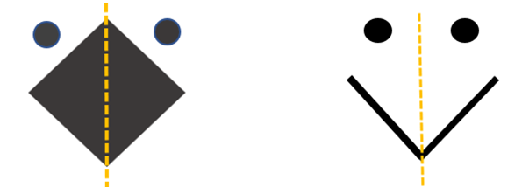
A | B | C
Figure 1. (a) (b) (c) A symmetrical arrangement

These instantaneous interpretations of pattern design can significantly impact an individual's focus, especially in settings requiring meditative concentration, like prayer. While these design cues might not have inherent distractions, their interpretation based on our cognitive conditioning can involuntarily shift our attention. In the context of a worshippers’ prayer experience, these ostensibly innocent patterns can, surprisingly, become sources of distraction. The act of recognizing these patterns, even subconsciously, can momentarily divert the individual's attention away from the prayer, thus disrupting the spiritual communion one is engaged in. This underlines the criticality of design and pattern choice in objects used in spiritual practices like prayer mats.

- CASE STUDIES (ANALYSIS OF PRAYING MATS)
As of the latest data, there are approximately 2.01 billion Muslims worldwide, making Islam the world's second-largest religion after Christianity. The distribution of the Muslim population spans every geographic region, with the most significant concentration residing in the Asia-Pacific region [33]. Given this demographic distribution, the prayer mat industry holds enormous potential for business expansion throughout the Muslim world [34]. The production of prayer mats is a significant industry, with most of the production currently occurring in China. China leads the industry with an estimated 90 to 100 factories dedicated to manufacturing Muslim prayer mats and carpets for mosques. Turkey holds the second position in this industry, housing approximately 20 known factories engaged in prayer mat design & production. The Arab region, which includes countries like Syria, Jordan, Egypt, and Saudi Arabia, comes next with around 20 factories scattered across various countries.
Figure 2. Praying Mat Production Regions

Further down the line, India contributes to this industry with approximately 10 factories, while Pakistan hosts around five factories producing prayer mats. This distribution indicates the global spread of the prayer mat industry and highlights the opportunities for growth and expansion, considering the large and geographically diverse Muslim population [35-38]. Figure 1 (a) depicts the regions engaged in designing and producing prayer mats.
Our study, based on careful observation of prayer mats, has identified a noteworthy trend: prayer mats originating from East Asia and Southeast Asia [39] seem to have a higher propensity to cause distraction than those from other regions. It is speculated that this could be attributable to the fact that other major prayer mat producers are primarily located within predominantly Muslim regions, thereby having a deeper understanding and appreciation of Islamic culture and values.
This discrepancy underscores the critical need to comprehensively analyze the designs of prayer mats from various global regions. By doing so, we aim to identify and understand the variations in the aesthetic appeal of these designs, as well as to detect any potentially misleading figures or patterns that may be present. The goal is to gauge their potential for causing a distraction during prayer, an aspect of paramount importance considering the spiritual significance of these items.
In essence, this research is driven by a desire to align the artistic expression inherent in prayer mat design with the profound spiritual ethos of Islam. By identifying the factors that can cause distractions, we hope to create prayer mats that uphold Islamic aesthetic principles and foster an environment conducive to focused prayer and contemplation.

- CASE 1. ABSTRACT IMAGE FORMATION
Prayer mats, integral to Islamic worship, frequently feature abstract imagery that can sometimes include animal faces and representations of deities from diverse cultural and religious backgrounds, as exhibited in Pallets 1 and 2. Pallet 1 displays a central design resembling an animal's face, complete with a pair of eyes, two protruding ears, and a short horn. However, it is important to note that Islamic principles prohibit incorporating any form of animal imagery, pattern, or abstraction, especially within religious artifacts, making the design a point of potential contention.

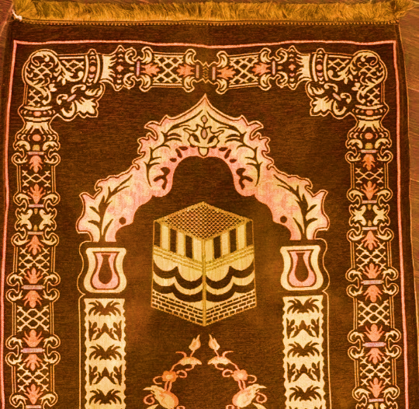 | 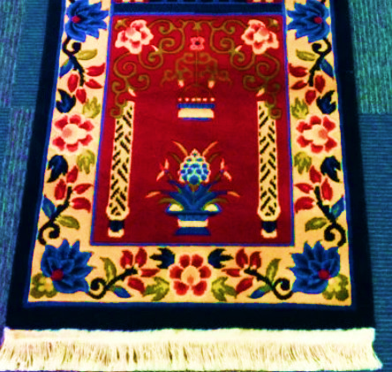
A | B
Figure 3. (a) Pallet 1. Abstract Animal Face (b) Pallet 2. Abstract Idol with Multiple Hands

In Pallet 2, an abstract figure with multiple arms commands the lower portion of the prayer mat. This image could potentially be interpreted as a multi-armed deity, a motif often seen in Southeast Asian religions, symbolizing the deity's omnipresence and supremacy. Though perhaps unintentional, these incorporated symbols and metaphors present challenges when viewed through the lens of Islamic principles.

- CASE 2. MASKS FORMATION
Pallets 3 and 4 strikingly feature illustrations of masks positioned at key points where a worshipper’s gaze would naturally rest during prayer. Pallet 3 reveals an oval-shaped mask, emphasized by a stark black backdrop. This mask is characterized by two protruding circular eyes and dual pointed horns at the top. Its facial features are further distinguished by a line depicting the nose, a stylized inward-curving mustache, an oval mouth, and an elongated, pointed chin. This design bears resemblance to certain cultural attires seen in tropical and African nations.

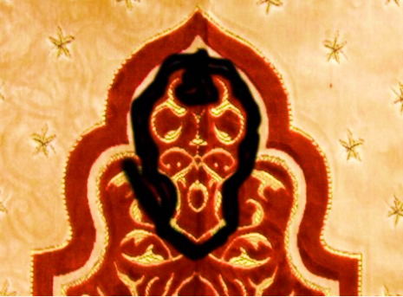 | 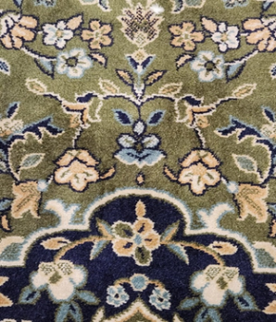
A | B
Figure 4. (a) Pallet 3. Mask with Horns (b) Pallet 4. A Bunny Face Cartoon Character

Pallet 4 presents a more complex design, integrating a floral pattern but subtly concealing the bunny (rabbit), which appears to be a floral bouquet prominently displayed on the prayer mat. The bunny figure, detailed in Figure 2, showcases a cartooned rabbit face framed by two long ears and pop-up eyes over full cheeks, flanked by complementary flowers.
These distinct mask and animal designs subtly embedded within the prayer mat design might be interpreted differently by observers and users. They highlight the intricacy of pattern design within religious artifacts, showing how multiple layers of symbolism can be woven into the fabric, sometimes aligning with, and at other times diverging from, the intended spiritual focus of the object. This tricky intersection of art, culture, and religious devotion underscores the challenge of creating designs that disrespect religious sensitivities. Still, for others, it could be a showcase of artistic innovation and diversity.

- CASE 3. HUMANOID BOTANICAL FORMATION
In Pallet 5, the central design appears to be botanical and floral but interestingly takes on the semblance of a fashionable face cover (party) mask. A similar floral pattern sans the facial features surrounding this primary design further accentuates the face-like attributes of the central motif. Spreads all over the prayer carpet in a mosque, this design may act as an unintended source of distraction, potentially stimulating cognitive processes within the minds of many worshippers that veer away from the intended spiritual concentration.

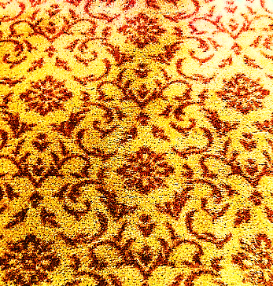 | 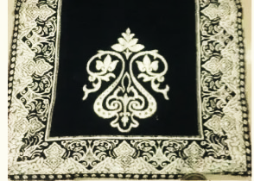
A | B
Figure 5. (a) Pallet 5. Humanoid Mask (b) Pallet 6. Wand & Facial Expression

Pallet 6 presents a design with elements that resemble a wand, an object often associated with idols in Southeast Asian religious practices. Furthermore, nestled within the core of this design is a set of spiral eyes accompanied by a defined line for the nose and nostrils, giving rise to a humanoid impression. The initial interpretation of this design leans towards an object that holds associations with supernatural applications, while the second reading hints at a face characterized by spiral eyes and a prominent nose. This combination of design elements may inadvertently provoke a line of thought in the worshipper that deviates from the focus of prayer, leading to reasoning and contemplation that may be incongruous with the spiritual context of the prayer mat's use.
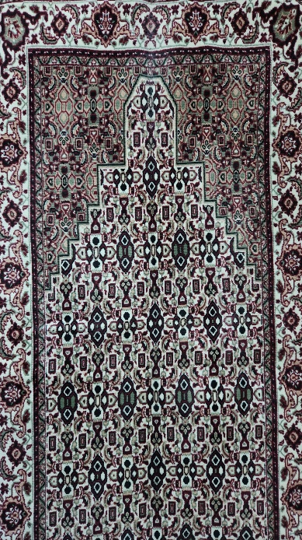 | 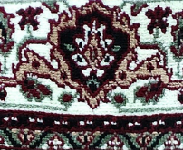  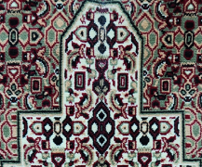
A | B
Figure 6. (a) Pallet 7. Wooden Mask (b) Details P7a & P7b

Pallet 7 introduces a remarkable occurrence of anthropomorphic imagery, peculiarly resembling monkey face masks situated at key junctures, where the eyes of a worshipper might naturally fall during prayer. At first glance, Pallet 7 reveals a geometrical ensemble, where an arrangement of white triangles on a dark backdrop generates the illusion of eyes. Flanked by eyes, an oval shape imitates the appearance of a nose, while shapes akin to ears protrude on either side of the rectangular figure. This unique combination of patterns and colors mirrors certain living creatures' characteristics, as highlighted in Pallet P7b.
Moreover, the periphery of the mat is graced with a recurring decoration, an abstract figure resembling a person crowned with a floral diadem. A particularly striking element is the figure's large, expressive bug eyes, portraying the head of a stick grasshopper, as shown in Pallet P7a. The presence of these riveting figures holds a considerable potential to command the attention of worshippers, regardless of their intellectual capacity, thereby possibly leads to an unintentional diversion from their spiritual focus during prayer. In addition to the abovementioned information, this study has observed and photographed the praying mats with the following patterns (Pallets: 8-9) that create the perception of certain living creatures or idols contrary to Islamic values.

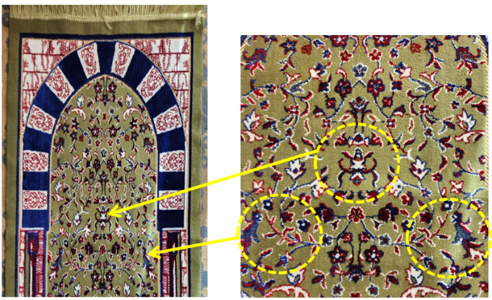 | 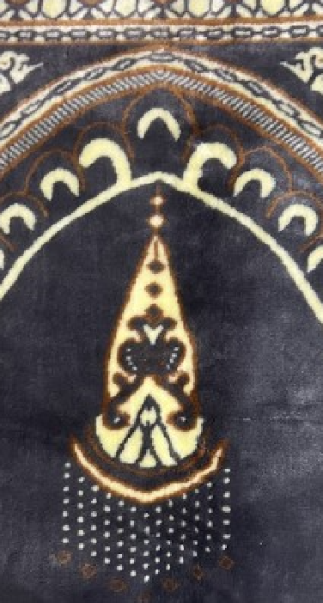
A | B
Figure 7. (a) Pallet 8. Flower pattern but depicts the perception of any bug (b) Pallet 9. Lantern pattern but depicts a humanoid face with headgear

Apparently, Pallet 8 looks like a flower pattern but depicts the perception of any bug in the center on the main axis of the mat and humanoid figures flanked at both the left and right edges of the matt; Pallet 9 appears as a lantern but depicts a humanoid face with headgear.
The discussion above can be summarized as the incorporation of disguised imagery that strays from the tenets of Islam can potentially lead to a sense of unease, given Islam's firm stance against the portrayal of idols and creatures. This highlights the necessity for meticulous attention to detail when creating designs for religious artifacts, ensuring they align with the principles and teachings of Islam while concurrently maintaining an aesthetic allure.
The process of integrating elements of varied cultural origins into the design presents a multifaceted challenge. It requires harmonizing these diverse influences while steadfastly respecting and adhering to the fundamental beliefs of Islam. Careful consideration is needed to strike a balance between fostering artistic ingenuity and observing religious sensitivities. This is crucial, particularly within the Islamic framework, emphasizing focused and devoted prayer engagement.
Interpretations of abstract designs, albeit reflective of artistic depth, may inadvertently cause disruptions if it is not aptly managed during the crafting of religious artifacts. The profound essence of art lies in its subjective interpretation. Still, when it comes to religious artifacts such as prayer mats, it is of utmost importance to prioritize the preservation of their inherent sanctity and purpose. Such artifacts play a pivotal role within the Islamic faith. Thus, their design should align seamlessly with the intention of fostering a serene and undisturbed environment for prayer, unmarred by potential distractions from intricate or abstract designs.

- RESULT AND DISCUSSION
Discussion in section 9 suggests that the complex interplay between perception, depiction, and cognitive learning shapes our human experience, subtly manipulating our interpretation of reality. Illusions, both of visual and sensory nature, fabricate our understanding, presenting a reality skewed from its objective truth. These illusions exemplify the brain's proficiency in generating understanding from known knowledge, bridging gaps between objective existence and our subjective perception. Perception, a multifaceted mechanism influenced by personal experiences, cultural context, and brain structure, critically determines our interpretation of reality. This personalized viewpoint guides how we represent the world in artistic, verbal, or conceptual forms. Consequently, depiction reflects one's individual perception rather than a mere mimetic reproduction of reality.
Cognitive learning, the framework that allows us to decode these individual perceptions, is central to our understanding. It influences our interaction with our surroundings, shaping our abilities to solve problems and comprehend complex ideas. This learning model is crucial for interpreting illusions and subjective representations, facilitating categorizing and comprehending diverse stimuli we encounter.
Many studies highlight the interplay of reflexes and their background and mention that illusions signify a distortion in our sensory perception, altering our understanding of reality. They epitomize the brain's capabilities to infer from prior knowledge and bridge gaps in information. On the other hand, perception involves interpreting sensory data to comprehend and engage with our surroundings. Influenced by personal experiences, culture, and neurological factors, perception forms the basis for our unique worldview. The depiction is the visual or verbal representation of reality, reflecting a subjective interpretation shaped by individual perceptions. Meanwhile, cognitive learning is a dynamic process of building understanding through thought, experiences, and sensory information, crucial for interpreting illusions, subjective depictions, and varied stimuli, thereby shaping our interaction with the world [40], [41].
This research's outcomes have identified an array of patterns (as referenced in section 9) that are crafted in a manner that instigates illusionary perceptions. These perceptions manifest distinct images that resonate with the viewer's knowledge and personal background. The process of recognizing these images, in turn, largely depends on the viewer's intellectual quotient (IQ) and cognitive abilities. These abilities help to assemble the figures mentally and surrounding objects, thereby facilitating the perception of these elusive designs.
Our study also includes a tabulated representation, demonstrating the dichotomy between the perceived images and Islamic values. This table presents specific patterns and figures that may inadvertently convey representations discordant with Islamic principles and prohibitions. The cognitive process involved in recognizing these patterns indicates a potential conflict between the intended design and the viewer's perception. This highlights the crucial role that individual cognitive abilities play in interpreting design elements, particularly those steeped in religious and cultural symbolism.
Therefore, it becomes evident that pattern design, particularly in religious artifacts, is not merely an aesthetic consideration but also a cognitive challenge. The designs should harmoniously integrate the aesthetic appeal without compromising the underlying religious tenets, ensuring they align with the viewer's expectations and religious sensitivities.
In summary, the intricate nexus between illusion, perception, depiction, and cognitive learning demonstrates the richness of human cognition. It highlights the complexities in perceiving our surroundings, interpreting them, and representing these perceptions. These processes are shaped by and further enrich our continuous cognitive learning, contributing to our understanding of human cognition, perception, and fascinating subjective experiences.

Table 2. Figures and Depiction
Pallet No | Original pattern/Design | Illusion/ Perception | Depiction
P7a | 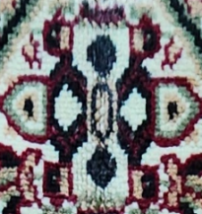 | Perception of wooden mask | 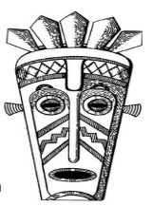
P7b. | 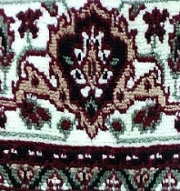 | The illusion of bug eyes and grasshopper head | 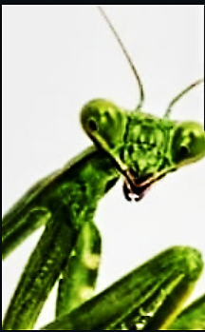
P3 | 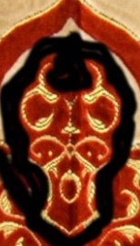 | Perception of African mask | 
P6 | 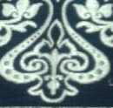 | The illusion of a wand is employed to reflect self-claimed power. | 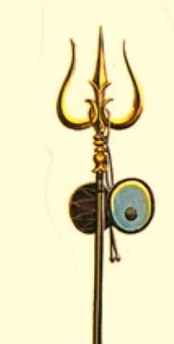
P2 | 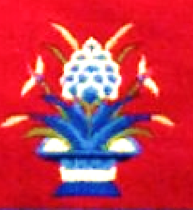 | The illusion of a doll/idol with many arms. | 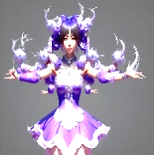
P1 | 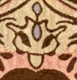 | The illusion of lamb/goat’s head | 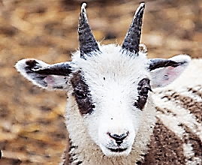
P5 | 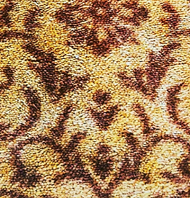 | The illusion of fashion party mask | 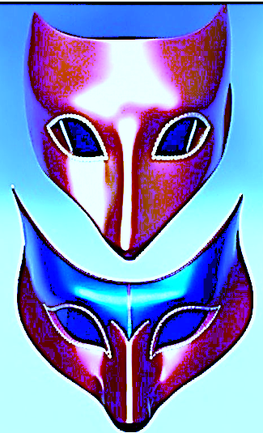
P10 | 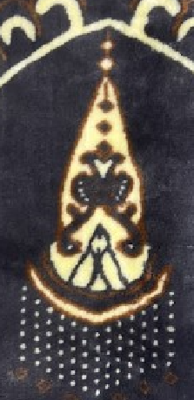 | The illusion of a mustached face with deep eyes wearing a long witch hat. | 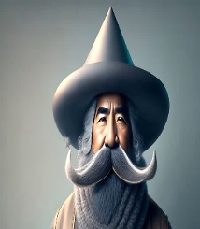

- DESIGN ANALYSIS
This study segment evaluates selected cases based on their conceptual development and geometric composition. Further, it will assess their alignment with Islamic mandates and sensitivity toward religious observances. The goal is to ascertain the appropriacy of these design elements within the framework of Islamic traditions and customs.
An in-depth exploration conducted in the prior section 10 reveals that all considered patterns are constructed based on symmetry principles. Pattern evolution is designed to occur on either side of the Y-axis, with additional development set along the X-axes at the upper and lower parts of the pattern, as demonstrated in Figure 8a. This particular configuration inadvertently induces the illusion of facial features, hinting at specific forms of living creatures.
A potential strategy to circumvent this issue would be to initiate the design development off-center, possibly around or at the sets of the Y-axis and X-axis. Implementing this principle would foster the creation of asymmetrical figures, which are less likely to stimulate the perception of facial expressions, as depicted in Figure 8b.

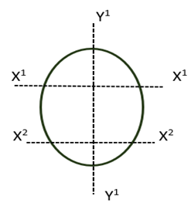 | 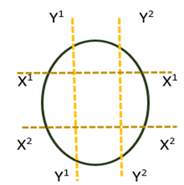
A | B
Figure8. (a) (b) Pattern evolution

A meticulous examination of Pallet 7a, as presented in Table 2, provides evidence that the design adheres strictly to symmetry principles, utilizing the framework outlined in Figure 8. Consequently, the specific arrangement and placement of elements in the pattern have created an illusion suggestive of a face mask.
This illusion is primarily achieved through the strategic positioning of an ellipse (interpreted as a nose) at the intersection of the Y1 axis and X1. Additionally, a pair of arrows (serving as eyes) are arranged along the X1 axis, distanced from the Y1 axis. Two outward-pointing arrows (symbolizing ears) are then positioned along the X1 axis at a more distant location. Finally, a solid black rhombus at the junction of the Y1 axis and X2 axis adds the final touch, depicting the mask's mouth, as shown in Figure 9. This calculated placement of symbols has successfully rendered a convincing facial expression in the design.

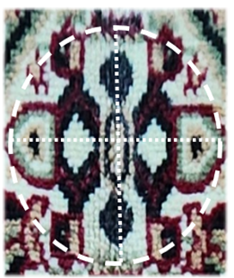
Figure 9. A solid black rhombus at the junction of the Y1 axis and X2 axis adds the final touch, depicting the mask's mouth

Another interesting observation is the presence of certain patterns, notably in Palette 8, that bear an uncanny resemblance to the head of a specific living creature, such as a goat or lamb. Upon analyzing the pattern, one discovers its foundation in symmetrical design principles, with the figure unfolding symmetrically along both sides of the Y1 axis.
Beginning from the top, two triangles, suggestive of horns, lean outward and are connected via a curve on the X1 axis. An eclipse-like pattern, reminiscent of ears, juts outward on the same X1 axis. Below the X1 axis, two solid, curvy, black arrow shapes bring the creature's eyes to mind. The overall design is complemented by introducing a protruding ellipse (representing the creature's nose and mouth) positioned along the X2 axis. The curved outlines connecting the X1 and X2 axes on either side of the Y1 axis add the final touch to the striking image of a goat or lamb's head, as shown in Figure 10.

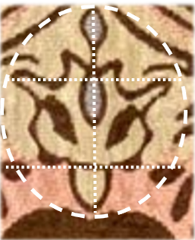
Figure 10. The curved outlines connecting the X1 and X2 axes on either side of the Y1 axis add the final touch to the striking image of a goat or lamb's head

However, placing such a conspicuous figure at the prayer mat's focal point raises concerns. Not only does it generate potentially distracting perceptions, but it also prompts scrutiny of the user's intellectual quotient and cognitive responses, raising questions about the appropriateness of this design choice in the context of Islamic prayer rituals.

- DESIGN RECOMMENDATION
In the sphere of Islamic art and crafts, a core tenet to be upheld is the premise that these art forms are primarily purposed for adornment and enhancement, not for conveying religious messages or symbolizing divine entities through idol forms. Therefore, caution must be exercised in creating or choosing Islamic art to ensure that no image or design is reminiscent of a living being. Therefore, this research suggests the 2 sets of recommendations grouped as Design Development and Concept Development, as shown in Figure 11.

Figure 11. Design Recommendations

The following are the recommendations for the development of Islamic art and crafts, with a particular focus on prayer mat design:
a) Respect the Purpose of Islamic Art: Islamic art serves primarily as an adornment, not as a vehicle for preaching or idol representation. Ensure that the designs do not include images reminiscent of living beings.
b) Exercise Caution with Symmetry: Symmetrical designs can unintentionally depict life-like forms. Consider designs that deviate from strict symmetry to prevent this.
c) Explore Radial Patterns: Radial designs can be a viable alternative, as they naturally avoid replicating life-like forms and lend themselves to creating rich, captivating patterns.
d) Avoid Images of Holy Edifices: Representation of holy structures may distract a worshipper's focus during prayer. Such images should, therefore, be avoided in prayer mat designs.
e) Mindful Micro Detailing: While micro detailing can demonstrate impressive skill, it can also create unintentional illusions resembling life-like forms. Approach such detailing with caution, or better yet, avoid it whenever it is possible.
f) Consider the Impact of Colour: The color palette chosen can shape perceptions and highlight design details. Use colors mindfully, avoiding vibrant or contrasting colors that may accentuate details and unintentionally depict images.
g) Embrace Larger Geometric Patterns: Larger geometric patterns such as squares, polygons, circles, and curved lines can serve as an optimal design strategy. These designs celebrate the aesthetic elegance inherent in Islamic art while avoiding the replication of life-like forms. They strike a balance between artistic allure and essential Islamic principles, ensuring prayer mats facilitate focused, undisturbed worship.

Considering the evolution of Islamic art and crafts and the room for innovative design within the boundaries of religious principles, the following immaculate design concepts can also be considered for the design of a prayer mat:
- Incorporation of Galaxy Images: Given the significant underrepresentation of celestial themes in Islamic art, incorporating galaxy-inspired motifs could provide a fresh approach to prayer mat design. Cosmic elements can serve as a subtle reminder of the vastness of the universe and the omnipotence of the creator (ALLAH swt).
- Integration of Abstract Natural Themes: Integrating abstract themes inspired by tropical plants, deserts, and mountains could offer a novel perspective in prayer mat design. These elements can evoke a sense of tranquillity and connection with nature, reinforcing the spiritual atmosphere.
- Use of Day-Night Cycle Imagery: Including natural scenes depicting sunrise, sunset, and the full moon phases could add a dynamic and meaningful element to prayer mat designs. This might serve as a subtle reflection of the passage of time and the rhythm of five obligatory daily prayers in Islam.
- Inclusion of Ocean, Clouds, and Valleys: Themes inspired by oceans, clouds, and valleys are not commonly seen in the design of prayer mats. These elements could add depth and expansiveness to the design, fostering a serene ambiance conducive to focused worship

Supplementing the guidelines, this study considers that using artificial intelligence (AI) can substantially impact the design process of prayer mats. Through AI generative design, the designer or prompt operator can retain and manage control over the design output. The design outcomes can be effectively directed using text-based commands, ensuring adherence to Islamic principles and values. This research applied AI generative design in creating prayer mat patterns, yielding designs through succinct text prompts. The primary author used a paid subscription to 'https://deepdreamgenerator.com' to produce the following designs. Table 3 illustrates the AI-generated design of the prayer mat with the respective design prompt.

Table 3. AI Generated Design
 | Research Questions | Data Required | Design Text Prompt
 | AI 1 | 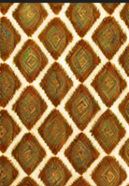 | Give a rhombus lattice pattern in brown and ivory white shades. Maintain the same size of the rhombus and avoid interlacing
 |  | 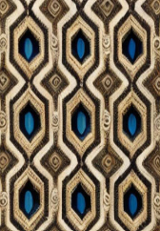 | Give a pattern combining regular hexagons and rhombuses in shades of brown, milky white, and rich blue. Maintain parallel lines and uniform size of figures and avoid details
 |  | 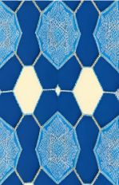 | Give an Arabesque pattern combining irregular hexagons and octagons in shades of rich blue. Maintain uniform size of figures and avoid overlapping

However, it is important to note that while these recommendations explore new aesthetic possibilities, they must be implemented with due care to ensure that the primary purpose of prayer mats - facilitating focused prayer - is preserved. The designs should avoid forming explicit life-like images or causing unnecessary distractions for the worshipper
- CONCLUSION
As the research concludes, it is evident that art and craft significantly influence religious practices, forming an intrinsic part of the cultural fabric and playing a substantial role within Islamic customs. The nuance of art within Islamic tradition is not merely about aesthetic grandeur but acts as an embodiment of faith and devotion, reflecting a profound spiritual dimension.
The study navigated the bedrock of cognitive learning, unraveling how cognitive processes shape our interaction with the environment and our understanding of it. It revealed the influence of illusions and subjective perceptions, demonstrating how these elements can unwittingly divert the attention of a Muslim worshipper during prayer. An image on a prayer mat may be unintended, yet it can form a distraction, highlighting the importance of context and cognitive perception in religious art.
Moreover, the study identified metaphorical symbols used across different religions, illuminating their role in highlighting divine events and God's authority. It noted that while many religious traditions employ metaphorical depictions to represent divine beings or events, Islam imposes explicit boundaries on such depictions. This religious practice strictly prohibits the portrayal of Allah, angels, living creatures, and idols, reiterating that the artistry within Islamic tradition lies in its aesthetic value rather than conveying any religious doctrine.
An in-depth examination of prayer mats was conducted as part of the study, bringing the subtle complexities of their design to the fore. This included meticulously analyzing their intentional symmetries and artistic nuances, underlining how certain designs might unintentionally trigger visual illusions, causing potential distractions during prayer. This underscores the need for careful consideration when designing religious artifacts, emphasizing a balance between creative artistry and religious decorum.
The research culminated in the proposal of recommendations for prayer mat design, ensuring that the design aspects align with the core values of Islam. In this context, 11 recommendations have been outlined for both the design and concept development stages. The aim is to strike a fine balance - a harmonious blend of aesthetics and tradition that maintains the sanctity and purpose of these important artifacts. The prayer mat is not just a piece of cloth; it symbolizes faith, a spiritual platform facilitating devout worship. Unintended distractions on such a platform could hinder a worshipper's concentration, compromising the very purpose of the prayer mat.
The research advises adhering to design principles that align with Islamic teachings when creating prayer mats to avoid such pitfalls. Such an approach ensures that the prayer mats serve as spiritual conduits, focusing the worshippers' attention toward divine contemplation rather than unintentionally diverting it. In essence, the research emphasizes the need to recognize and respect the sensitive interplay between art and faith, highlighting the potential of religious artifacts to bridge the gap between aesthetic allure and spiritual devotion.
The scope of this study was limited to analyzing the design of prayer mats; however, future research could be planned for studies such as “Design of carpets and rugs for mosques and other religious places” or “Setting design standards for the design of Muslim prayer mat and floor coverings”.

ACKNOWLEDGEMENT
The authors are thankful to Ajman University, UAE, and Healthy Building Research Centre Ajman University for providing the essential support required for this study.

REFERENCES
[1] A. H. Whiteford, "Mystic and decorative art of the Anishinabe (Chippewa/Ojibwa)," Arctic Anthropology, vol. 28, no. 2, pp. 74-83, 1991.
[2] K. Kilinski, Greek myth and Western art: The presence of the past. Cambridge: Cambridge University Press, 2013.
[3] J. Campbell and B. Moyers, The power of myth, B. S. Flowers, Ed. New York: Doubleday, 1988.
[4] L. Yang and D. An, Handbook of Chinese mythology. Abc-clio, 2005.
[5] R. Latif and G. Haider, "Spatial geometry in Islamic art and architecture," Islamic Heritage Architecture and Art, vol. 159, pp. 73-82, 2016.
[6] S. K. Hasan, "Genesis of Islamic architecture in Sindh," Journal of the Pakistan Historical Society, vol. 42, no. 3, pp. 249-268, 1994.
[7] J. M. Nejad, E. Zarghami, and A. S. H. Abad, "A study on the concepts and themes of color and light in the exquisite Islamic architecture," Journal of Fundamental and Applied Sciences, vol. 8, no. 3, pp. 1077-1096, 2016. Doi: https://doi.org.10.4314/jfas.v8i3.23
[8] J. Chowdhury, "Basic pattern in myth-making: Myths of Arunachal tribes," in Folklore in North-east India, Omsons Publications, pp. 17-29, 1985.
[9] R. C. Perumalil, "Style transfer for visual storytelling: A case study: The Hindu mythological character, Yamah, in the style of the American film director, Tim Burton," Texas A&M University, Doctoral dissertation, 2012.
[10] N. Daryaie, "The interface of myths in the form of shape and design in Iranian-Azerbaijani carpets," in YOCOCU 2014: Professionals' Experiences in Cultural Heritage Conservation in America, Europe, and Asia, Newcastle: Cambridge Scholars Publishing, pp. 160-171, 2016.
[11] A. Tyagi, Let's know handicrafts of India, Star Publications, 2008.
[12] N. Yazdani and M. Lozanovska, "The design philosophy of Edenic gardens: Tracing "Paradise Myth" in landscape architecture," Landscape History, vol. 37, no. 2, pp. 5-18, 2016.
[13] J. Allen, Islamic Metal Art, London: Philip Wilson Publication, Ltd., 1999.
[14] M. Bull, The mirror of the Gods: Classical mythology in Renaissance art, UK: Penguin, 2006.
[15] C. T. Hodge, "Myths through the generations: Influence beyond reason and logic," Rogers School USA, Ed., [Online]. Available: https://uh.edu/honors/Programs-Minors/honors-and-the-schools/houston-teachers-institute/curriculum-units/pdfs/2007/world-mythologies/day-07-myths.pdf [Accessed May 15, 2023].
[16] T. Hodge, "Indonesian batik design: Transmitter of culture," California State University, Dominguez Hills, Unpublished doctoral dissertation, 1999.
[17] S. Woodford, An introduction to Greek art: Sculpture and vase painting in the archaic and classical periods, Bloomsbury Publishing, 2015.
[18] K. K. Murthy, Mythical Animals in Indian Art, Abhinav Publications, 1985.
[19] J. R. Senseney, The art of building in the Classical world: Vision, craftsmanship, and linear perspective in Greek and Roman architecture, Cambridge: Cambridge University Press, 2011.
[20] S. S. Blair and J. M. Bloom, "The mirage of Islamic art: Reflections on the study of an unwieldy field," The Art Bulletin, vol. 85, no. 1, pp. 152-184, 2003. Doi: https://doi.org/10.1080/00043079.2003.10787065
[21] Y. Abdullahi and M. R. Embi, "Evolution of abstract vegetal ornaments in Islamic architecture," Archnet-IJAR: International Journal of Architectural Research, vol. 9, no. 1, pp. 31-46, 2015.
[22] J. Bloom, S. Blair and S. Blair, Eds., Grove Encyclopedia of Islamic Art & Architecture: Three-Volume Set, vol. 2. Oxford: Oxford University Press on Demand, 2009.
[23] Z. Baydoun, N. A. Alghamdi, and Z. Kamarudin, "The Islamic art and design elements applied in the Islamic city, a case study of Putrajaya Islamic City," Planning Malaysia, vol. 21, pp. 42-54, 2023. Doi: https://doi.org/10.21837/pm.v21i25.1241
[24] C. S. Kaplan, "Islamic patterns," in ACM SIGGRAPH 2008 art gallery, pp. 45-45, 2008.
[25] J. Bonner, Islamic geometric patterns: Their historical development and traditional methods of construction, Springer, 2017.
[26] T. A. El-Akkad, "The aesthetics of Islamic architecture & the exuberance of Mamluk design," Universitat Internacional de Catalunya, Doctoral dissertation, 2013.
[27] H. Hamid, "Color in Islamic Architecture and its impact on interior design," Journal of Architecture Arts and Humanistic Sciences, vol. 4, no. 14, pp. 582-598, 2019. Doi: https://doi.org.10.21608/MJAF.2019.25805
[28] N. Kanwisher, J. McDermott, and M. M. Chun, "The fusiform face area: A module in human extrastriate cortex specialized for face perception," The Journal of Neuroscience, vol. 17, no. 11, pp. 4302–4311, 1997. Doi: https://doi.org/10.7551/mitpress/3077.003.0021
[29] I. Gauthier, P. Skudlarski, J. C. Gore, and A. W. Anderson, "Expertise for cars and birds recruits brain areas involved in face recognition," Nature Neuroscience, vol. 3, no. 2, pp. 191–197, 2000. Doi: https://doi.org/10.1038/72140
[30] J. V. Haxby, E. A. Hoffman, and M. I. Gobbini, "The distributed human neural system for face perception," Trends in Cognitive Sciences, vol. 4, no. 6, pp. 223–233, 2000. Doi: https://doi.org/10.1016/S1364-6613(00)01482-0
[31] P. Sinha, B. Balas, Y. Ostrovsky, and R. Russell, "Face recognition by humans: Nineteen results all computer vision researchers should know about," Proceedings of the IEEE, vol. 94, no. 11, pp. 1948–1962, 2006. Doi: https://doi.org/10.1109/JPROC.2006.884093
[32] J. W. Tanaka and M. J. Farah, "Parts and wholes in face recognition," The Quarterly Journal of Experimental Psychology Section A, vol. 46, no. 2, pp. 225–245, 1993. Doi: https://doi.org/10.1080/14640749308401045
[33] World Population Review, "Muslim Population by Country 2023," [Online]. Available: https://worldpopulationreview.com/country-rankings/muslim-population-by-country. [Accessed 2023].
[34] Thomson Reuters and Dinar Standard, "State of the Global Islamic Economy Report: 2018/19," [Online]. Available: https://ded.ae/DED_Files/StudiesAndResearch/SGIE-Report-2018-19_Eng_1540649428.pdf. [Accessed June 6, 2023].
[35] List of Companies, "Turkey Prayer Mat Manufacturers," [Online]. Available: https://www.listofcompaniesin.com/turkey/prayer-mat/. [Accessed May 15, 2023].
[36] List of Companies, "Pakistan Prayer Mat Manufacturers," [Online]. Available: https://www.listofcompaniesin.com/pakistan/prayer-mat/. [Accessed May 15, 2023].
[37] List of Companies, "India Prayer Mat Manufacturers," [Online]. Available: https://www.listofcompaniesin.com/india/prayer-mat/. [Accessed May 15, 2023].
[38] List of Companies, "China Prayer Mat Manufacturers," [Online]. Available: https://www.listofcompaniesin.com/china/prayer-mat/. [Accessed May 15, 2023].
[39] Asia Society, "East Asia," [Online]. Available: https://asiasociety.org/countries-regions/east-asia. [Accessed May 17, 2023].
[40] E. S. Paik and G. Schraw, "Learning with animation and illusions of understanding," Journal of Educational Psychology, vol. 105, no. 2, pp. 278-287, 2013. Doi: https://doi.org/10.1037/a0030281
- J. D. Lewis-Williams, "Cognitive and optical illusions in San rock art research," Current Anthropology, vol. 27, no. 2, pp. 171-178, 1986. Doi: https://doi.org/10.1086/203415

