 |  | JOURNAL OF ISLAMIC ARCHITECTURE  P-ISSN: 2086-2636 E-ISSN: 2356-4644  Journal Home Page: http://ejournal.uin-malang.ac.id/index.php/JIA
SOCIAL, RELIGIOUS, AND ECONOMIC INTERACTION SPACES AS A COMMUNITY REPRESENTATIONAL SPACE
Ima Rahmawati Sushantiaª, Purwanita Setijanti^{b*}, Dewi Septanti^{c}
ªDepartment of Architecture Institut Teknologi Sepuluh Nopember, Surabaya, Indonesia
^{b}Department of Architecture Institut Teknologi Sepuluh Nopember, Surabaya, Indonesia
^{c}Department of Architecture Institut Teknologi Sepuluh Nopember, Surabaya, Indonesia
*Corresponding Author: psetijanti@arch.its.ac.id
ARTICLE INFO |  |  | ABSTRACT
Volume: 8  Issue: 1  Page: 39-53  Received: June 30th, 2023  Accepted: November 30th, 2023  Available Online: June 30th, 2024  DOI: 10.18860/jia.v8i1.22767 |  |  | Place identity relates to the meaning and importance of a place to its residents and users and how these meanings contribute to an individual's self-conceptualization. The order of Islamic values in a place as spirit can move the community to practice them daily to create identity, which will easily observed in public spaces. Islamic values in religious traditions are suspected to underlie ongoing social and economic activities in this space. This research aims to determine the identity of public spaces in urban settlements based on Islamic values on a city scale. The research paradigm is naturalistic, with case studies and qualitative descriptive research methods. The research location is the corridor of Sekarbela district, Mataram city, where most people are Muslim. Data collection involves interviews, observation, and documentation of activities. The analysis used behavior setting and spatial and micro activities techniques. Research results show that the representation of public space is practicing Islamic values through local traditions in spider networks centered on the mosque. The community agrees and works together to practice Islamic values for social togetherness, economic independence, and environmental comfort so that local traditions can continue and become the color of public spaces.  Keywords:  Activities, Local Traditions, Islamic Values, Place Identity, and Public Spaces

- INTRODUCTION
Public spaces in urban areas are usually associated with places for relaxing, carrying out sports activities, and gathering places [1]. People use public spaces to meet, gather, work, and carry out religious activities in its development. It is related to the characteristics of the place as a symbolic space. Like individuals, cities need to have character and identity formed by several characteristics and elements that can be identified [2].
The concept of public space in an Islamic city is representative of the principles of an integrated dynamic system and respect for God's creation. This system is always related to Islamic cultural, physical, geometric, and natural principles [3]. Space in residential areas has through the basic principles of unity and the manifestation of social dimensions. Moreover, the space can also be determined by activities that occur as a product of social translation, transformation, and experience [4]. Several researchers say that public space in settlements consists of communal space that accommodates social activities and benefits people in residential areas, especially in urban areas [5][6][7]. Community groups independently use and manage shared outdoor places to control their environments, such as community halls, mosques, and open spaces in public facilities [6]. Social space forms the relationship between social and cultural activities and community members' relationships in settlements, but it is only sometimes in the form of parks. Still, it can also be on sidewalks, alley gates, or village alleys [8][9]. However, for some communities, public spaces can also be used as places to carry out religious activities.
The Muslim community is built on faith with a spiritual basis, La ilaha il Allah. This implies that society is a community based on identical faith and beliefs. Religious traditions have formed a system of values that cannot be separated from the lives of the people who adhere to them [10]. Like other communities that need quality and meaningful places as a color of place [11]. Islamic communities usually use places of worship (mosques) as public spaces [12]. In its development, mosques prioritize open and inviting designs, facilitating interaction and exchange among Muslims and visitors from various backgrounds. Mosques symbolize universal Islamic values, emphasizing hospitality, tolerance, and shared humanity [13]. Group leaders usually use public spaces to shape community character. There is no doubt that each stakeholder brings its own interests, which may differ from one stakeholder to another [14]. The role of primary stakeholders is to be implementers, coordinators, implementers, and accelerators. Meanwhile, secondary or supporting stakeholders act as facilitators [15]. Leaders in the Islamic community provide Islamic examples in behavior and lifestyle so that the morals and exemplary life of the community are maintained [16]. Islamic behavior is the center of attention in the relationship between humans, the environment, and their activities. This is done when they discuss and resolve daily life problems at every routine religious meeting.
Changes in physical settings created by society as a solution to fulfill space needs [17]. In the behavioral architectural approach, 'setting' emphasizes interrelated human activities in a system, even though they have different functions [18]. In this research, the 'setting of public space' is a concern to ensure that community activities with a religious spirit can be reflected. The identity of public spaces is not only related to similarities with other places in terms of function but also the unique things that an area has that differentiate it from other places. Interactions occur in cognitive, behavioral, and emotional dimensions [19]. The relevance of the three can be so strong that it creates a bond between the individual and the component. Social space is formed by social actions, both individually and collectively. Social actions give 'meaning' to how a spatial space is conceptualized by those who fill and animate that space [20]. Therefore, public spaces must continue demonstrating their existence by building a sense of community, identity, and culture [21].
Traditions that persist in a place as a legacy from generation to generation are the legitimization of a value order and a symbol of collective identity [22]. Tradition strongly indicates the dynamic development of architecture and urban design [23]. Likewise, the tradition in Indonesia involving community participation as active and direct participation [24] greatly influences the identity of the place. Religious values are not only limited to the level of relationship with God but also include relationships with fellow creatures and the surrounding environment [25]. Local wisdom is a cultural treasure that can be used as a basis for developing the values of Islamic teachings in Indonesia, where most of the population is Muslim, with the characteristics of having a diverse culture [26].
The Sasak people of Lombok, located in West Nusa Tenggara Province, Indonesia, still adhere to their inherited customs and traditions. The Sasak tribe makes their culture one of the primary sources of values that guide their lives [27]. The people of Lombok believe that they can practice various aspects of the teachings of the Islamic religion, which they obtain from religious recitations and other ongoing religious ceremonial activities [28]. One of the religious ceremonies or religious traditions widely carried out is the celebration of the birthday of the Prophet Muhammad SAW. This tradition is still routinely carried out and preserved, showing gratitude and fostering good character in society and future generations [29]. Behavior regulation plays a role in building identity and community. Based on this, this research reveals the behavioral aspect as a dimension that also determines the identity of a place through the representation of user interaction patterns as an indication of the symbolic function of a place. The strength of the built environment can influence the nature of a community in terms of building place identity [30].
To achieve a place’s existence, ongoing community involvement must continue to be produced and shaped according to needs and goals [31]. Existence can be realized and strengthened through values closely related to the place’s user experience. The research was conducted on the Sekarbela residential corridor, where social, religious, and economic activities occur, to discover the identity of public spaces with Islamic values from community activities.

- METHODS
This research uses a naturalistic paradigm by describing and emphasizing the observation of 'setting' [32]. The qualitative research strategy is done through a case study approach, with qualitative descriptions in real-life contexts [33][34]. Qualitative descriptive research examined corridors as public spaces, a phenomenon with factual and accurate circumstances [35].
The corridor as a public space in the Sekarbela settlement, Mataram City on the island of Lombok, was chosen as a case study because it displays religious behavior that is in many ways different from the surrounding Islamic community, which underlies the ongoing social and religious and economic activities or traditions. Local traditions that continue to this day show that the community still maintains and preserves the strength of Islamic values. The traditions of recitation and trading characterize the Sekarbela community. The corridor is a symbolic space for community interaction, symbolizing the function and value of the area. Identifying changes in activities that occur dynamically is essential to consider when determining the sustainability of Islamic values.
The data collection techniques used were interviews, observation, descriptive, and documentation with primary and secondary data collection methods. In this case, an attempt was made to discover the identity of public space in urban settlements by examining the role of place and corridor community in history, tradition, and space production processes. The analysis used is behavior setting analysis, spatial analysis, and microanalysis to evaluate the use of corridor space based on user interactions with the place as well as the order of social values and meanings so that community representational space was identified as a form of social agreement for users to carry out activities in that place.
The spatial perspective is the scope of this research, namely the existence of public space in city residential areas. This perspective partially describes the characteristics and function of public space at the city scale. The spatial dimension is used as a scale of attachment that involves a sense of place, such as a house, apartment, neighborhood, city, or country [36].
Direct observation is the primary tool of this type of study of public life. As a general rule, users are not actively involved in being questioned but rather are observed. Their activities and behavior are mapped to understand better user needs and how urban space is used. Direct observation helps to understand why some spaces are used and others are not [37].
Participant sampling was carried out using purposive sampling with in-depth searches and interviews. The participant sample will established by determining specific characteristics that follow the research objectives. The sample will consist of residents who live in the research location and government or private apparatus participants. Each member of the population has the same opportunity to be sampled [34]. Participants comprised residents in four neighborhoods in Karang Pule sub-district, Sekarbela district in Mataram, and government or private apparatus participants.
The stages to achieve the research objectives are:
1. The role of place is determined through the use of space in the corridor based on changes in activities carried out by the community.
2. Examining the practice of Islamic values and their relationship to social, religious, and economic activities as a space for community representation through the community's active role at the family and neighborhood scale.
3. The corridor's identity as a community representational space is found through the practice of Islamic values in local traditions.

- RESULT AND DISCUSSION

  - RELIGIOSITY, TRADITIONS, AND THE SASAK VALUE ORDER
To better understand the characteristics of the object of study, start by looking at history in a geographical context (earth landscape, people, place, and environment). Lombok is an island in Indonesia located east of Bali, one of the islands in West Nusa Tenggara Province. Lombok is inhabited by three indigenous tribes: Sasak, Samawa, and Mbojo. Sasak is the dominant one. In the book Negarakertagama, the word Sasak is said to be one with Lombok Island, namely 'Lombok Sasak Mirah Adhi', which is not just a name, but also the basis of social and religious life. Most of the Sasak community is Muslim, which can be seen from the many mosque buildings in each village, which makes the island of Lombok nicknamed 'the island of a thousand mosques'.
Initially, the mosque was a place for prayer, and was also used as a gathering place to carry out da'wah and friendship, which later became a religious tradition. These activities take the form of recitation, where Tuan Guru plays a vital role in the continuity of social and religious activities. The community regularly carries out the tradition of recitation on a massive scale.
The object of study was taken in one of the villages in the city of Mataram, Lombok, called Sekarbela. From a historical and sociological aspect, Sekarbela is synonymous with Islam. The identification and characterization of the community as 'defenders of Islam' took place at a relatively constant tempo and spirit. This is due to the historical strength of the community, characterized by the presence of religious figures as the dominant factor in building group solidarity and identity through the guidance of sustainable social, economic, and environmental life that breathes Islam. It has become a binding view of life, namely 'Tindih, Malik, and Merang'.

  - PUBLIC SPACES IN MATARAM CITY SETTLEMENTS
Togetherness in carrying out social life takes place not only in religious facilities but also in public spaces. As observed, public spaces in the city of Mataram are used to accommodate gathering activities, work activities, recreational activities, creative arts activities, festival activities, and several other optional activities. The use of this public space depends on and is influenced by the surrounding area.
The creation of the Sekarbela area cannot be separated from the historical background and location of the village. Sekarbela was the center for the spread of Islam by a cleric from Java around the 1800s. The teachings of Islam in the Sekarbela area are experiencing very rapid development. Sekarbela's strategic location, namely close to the Ampenan port, makes Sekarbela a center for the development of Islamic teachings. Many Arabs who initially came to trade chose to settle there and marry native Sekarbela residents, so to this day, most entrepreneurs engaged in gold crafts are of Arab descent. The location of the Sekarbela area between the port of Ampenan and the center of Mataram city at that time can be seen in Figure 1.

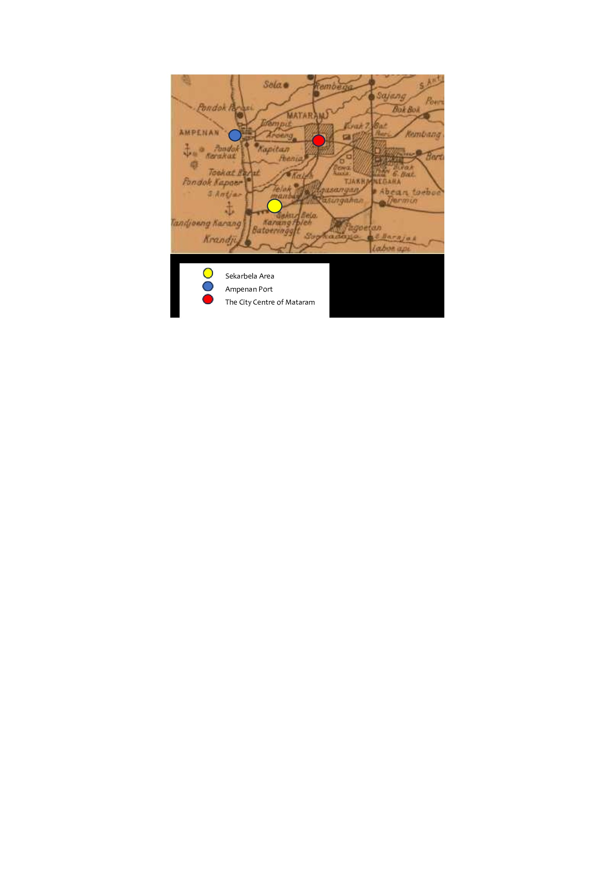

Figure 1. The location of Sekarbela area as a center for the development of Islamic teachings in Mataram City
(Source: Mataram City Archives, 1958)

Since 2011, Sekarbela has been designated as a pearl, gold, and silver shopping tourist area based on the area's potential. This government policy focuses on the Sultan Kaharudin corridor previously used by the local community and its surroundings as public space. The corridor is a destination for window shopping, culinary delights, sightseeing, recreation, family entertainment, religious events, and even buying and selling crafts or primary materials.

  - PUBLIC SPACES IN MATARAM CITY SETTLEMENTS
Sekarbela corridor space is currently used as a public space along roads, pedestrian paths, alley gates, and mosques. Especially for mosques, they are used as places for people to gather and hold discussions. The continuity of social and religious activities with Islamic value traditions in mosques shows that mosques are not only used as worship facilities but also accommodate the religious activities of local communities through the tradition of sharing with the elderly (Figure 2A), sharing with orphans (Figure 2B), the activity of reciting the Qur'an (Figure 2C), and the local tradition of dulangan (Figure 2D). It makes the mosque a communal space because it has social and religious beneficial values, especially in the community's efforts to preserve the tradition of recitation of the Qur'an, which all groups have carried out for generations.

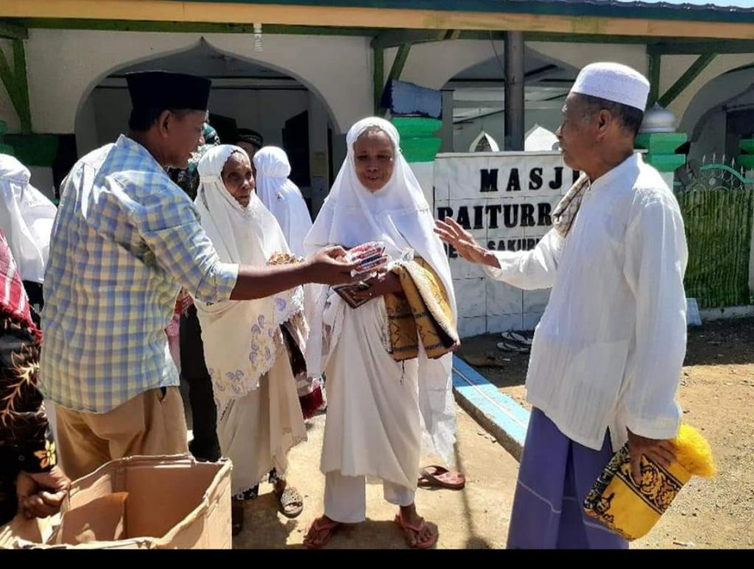 | 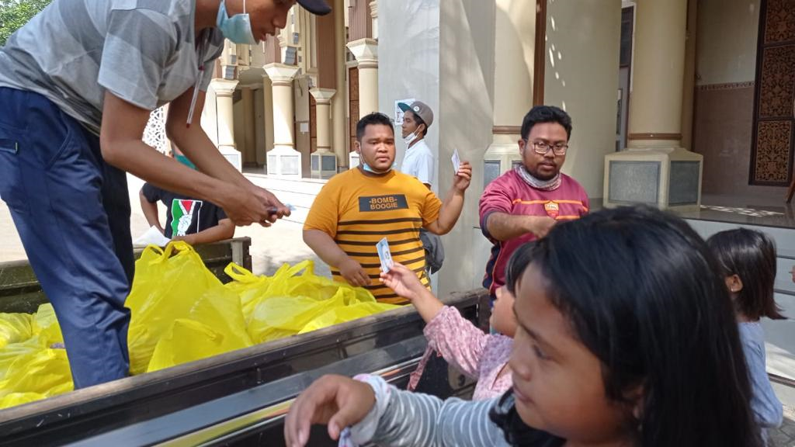 | 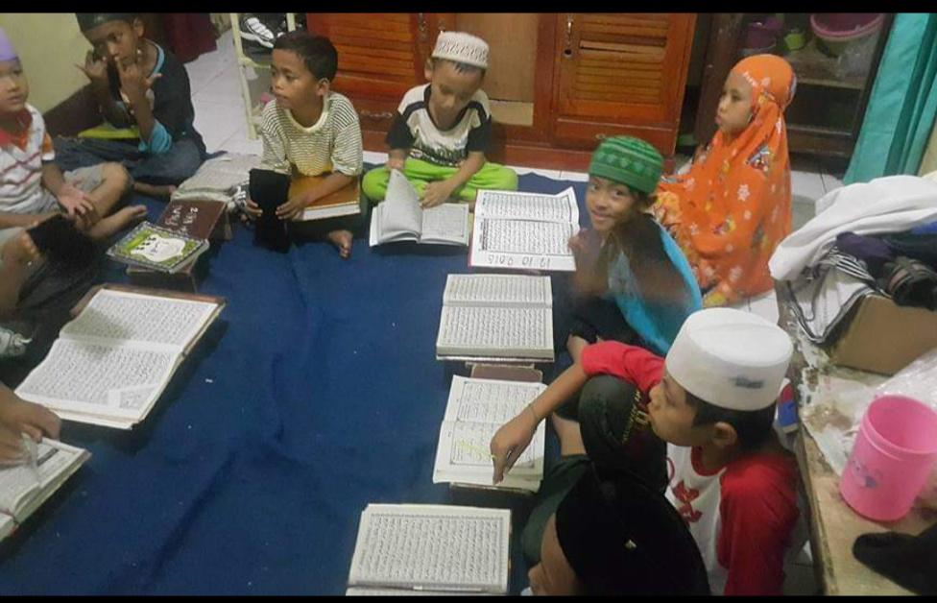 | 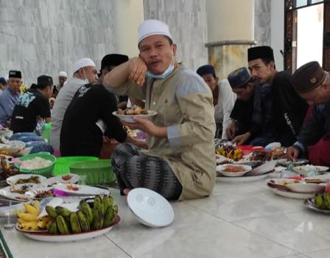
A | B | C | D
Figure 2. (a) Sharing activities with the elderly in the mosque yard (b) Sharing activities with orphans in the mosque yard
(c) Children's Qur'an activities at the mosque (d) The tradition of dulangan at the mosque

The recitation tradition is a religious activity carried out by the community regularly within the environment, while the dulangan tradition is carried out yearly to celebrate Mawlid. The study results show that the Prophet's birthday not only shows love towards the Prophet Muhammad SAW but also awakens the fighting spirit and sense of brotherhood among Muslims. Finally, the dulangan tradition takes place in Sekarbela, and the community does it every birthday of the Prophet.
The ongoing recitation tradition gives rise to social and economic activities or traditions. Social solidarity and strong group identity allow the community to build areas with activities that have Islamic values. The tradition of recitation is carried out individually and in communities at mosques. Individually, this is usually done by the Fajr congregation when conducting or listening to Fajr studies from local ulama or teachers. Meanwhile, the mother's recitation community, 'Bunda Sholehah, ' conducts recitations every afternoon. The mosque's youth group 'Mas Mutiara' holds recitations in rotation at residents' homes and every Friday at the mosque.
Understanding Islamic knowledge that society obtains from these recitations results in social agreement. The agreed activities are the ongoing social tradition of cleaning the mosque and its surrounding environment every Friday, carried out from morning until noon before Friday prayers are held. The tradition of making a living as a gold and silver pearl craftsman has been going on for a long time. However, this was predominantly done by people who lived in residential areas, not in the corridor, until 1995. In 1995, the community made a social agreement so that people living in the corridor area gradually began to sell handicraft products from surrounding craftsmen. This is done to increase the income of individual people and the community in the Sekarbela area. The high social solidarity in the community in Sekarbela ultimately led to the location becoming a center for gold and silver pearl crafts.
Changes in the function of the area due to economic activity in the corridor finally occurred from 1995 to the present. The main factor that causes changes in community activities is the consideration of the proximity of the location of pearl artisans or sellers to be able to produce or sell their products directly from their residence or along the corridor compared to previously, which had to be sold at the large market in the Cakranegara area which is about five kilometers away from where they live.
The sidewalk is not only used by the community to carry out social activities but also for parking, turning it into a communal space. This change in activity occurred due to the conversion of residences located along the corridor into shops, so buying and selling activities impacted the use of the surrounding space.

Table 1. Use of Social Interaction Space and Religion Before 1995 in the Corridor
No | User | Activity | Place | The Role of Place
1 | Individual
a | Local Residents (Lurah, Tuan Guru, Kaling, and Local Community) | Social:  discussion,  cleaning mosque and surrounding environment | Mosque and surrounding environment | Sharing space
 |  | Religious:  worship (prayer); precitation celebration of islamic holidays; dulangan tradition during mawlid; | Mosque and surrounding environment | Communal space
 |  | Optional:  Sit around, chat | Alley gate | Social space
 |  | Economy:  Transaction | Alley gate | Communal space
b | Outside Residents | Economy  Purchasing products; Order products | Shops | Communal space
 |  | Optional:  Walk, sit, chat, and make transactions | Alley gate | Communal space
 |  | Optional:  Window shopping, chatting, and parking | Sidewalk | Communal space
2 | Community
a | Internal Social Community (Mothers Recitation Group 'Bunda Sholehah' and Mosque's Youth Group' Mas Mutiara') | Social:  discussion,  cleaning mosque and surrounding environment | Mosque and surrounding environment | Sharing space
 |  | Religious  Worship (Prayer); Precital; Celebration of Islamic holidays | Mosque and surrounding environment | Communal space
b | Internal Community of Sellers and Craftsmen | Economy:  Sales, making/designing craft products | Shops | Communal space
c | External Community (Government, Private,  Financing Institutions, Academics, and Associations) | Social and Economic:  Providing capital and equipment assistance, management and quality training, promotions, information and strategy services, and policy support | Shops | Communal space

Changes in activities cause changes in room settings, types of activities, and types of users. This changing spatial setting indicated the changing role of the corridor, which was previously used as a space for social and religious interaction and has become a space for social, religious, and economic interaction. It has happened since 1995, when the residential functions along the corridor changed to residential and business functions. Communities along the corridor began selling gold and silver pearl craft products previously only produced by artisans living in residential areas. The ongoing economic activity causes changes in the function of mosques, residences, sidewalks, and alley gates in corridors, including the presence of outside residents, both individuals as potential buyers, buyers, tourists, and external communities. However, social and religious activities have existed since 1995 and are ongoing. The use of corridor space, which shows the current role of corridors, can be seen in Table 1 and Table 2.
The space production process is related to the use of space, representation of space, and representation of space. Space use shows the activities carried out by corridor users towards the location of their activities. Space use shows the activities carried out by corridor users towards the location of their activities.
As a space for social and religious interaction, the mosque still plays its role as a communal space, especially for the community to carry out social and spiritual traditions that have been going on for generations. The role of the mosque as a space for social and religious interaction, which is still ongoing today, even with the presence of economic activity in the surrounding area, can be seen in Figure 3.

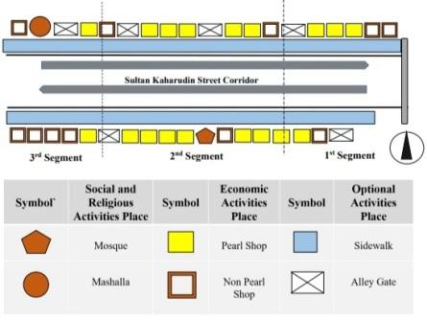

Figure 3. Placed - Centered Mapping of User Activities on the Corridor Segment of Sultan Kaharuddin Street

Maps of the location where activities occur in the corridor represent the function of the place, which is used as a space for social, economic, and religious activities and is divided into three segments. Social, religious, and economic activities are dynamic activities that influence the surrounding environment. Meanwhile, optional activities support social, religious, and economic continuity. The social and spiritual interaction space, a social symbol in this area, can also be easily recognized as representing meaningful social and religious activities through mosques and prayer rooms. The mosque is in Segment 2 (Figure 4A), and the prayer room is in Segment 3 (Figure 4B). The mosque's existence is on the north side, and the prayer room is on the south side, amidst the dominance of shops that serve as social control for the surrounding environment, as seen in Figure 4.

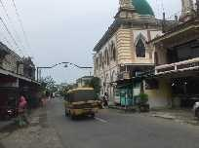 | 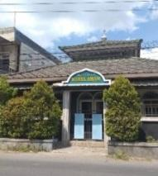
A | B
Figure 4. Placed-Centered Mapping of User Activities on the Corridor Segment of Sultan Kaharuddin Street

Figure 5 shows how corridor space can be used by paying attention to users’ activity.
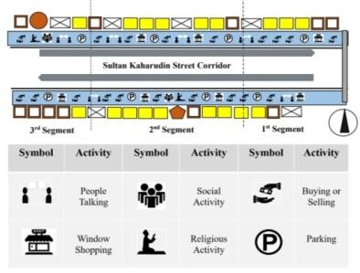

Figure 5. Person-Centered Mapping of User Activities on the Corridor Segment of Sultan Kaharuddin Street

Users' activities in the corridor based on behavior mapping show ongoing social, religious, economic, and optional activities. Social, religious, and economic activities are dynamic activities that can influence the surrounding environment. The tradition of reciting the Qur'an, carried out regularly by individuals and communities in mosques, results in social activities, such as gathering and deliberation, cleaning the mosque and the environment together, and livelihood traditions.
Economic activities, which are ancestral livelihood activities for the Sekarbela community, involve local communities and individuals and external communities as buyers or related stakeholders, such as government, academics, financing institutions, and associations. Optional activities are static activities that do not impact the surrounding environment. For more details, the use of social, religious, and economic interaction spaces (routine) based on person and place-centered mapping can be seen in Figure 6.

Figure 6. Corridor Space Usage Diagram

Based on behavior mapping and the intensity of the use of corridor space in Figure 6, the community carries out social activities on Fridays in mosques and mosque courtyards. Religious activities are mainly carried out by residents, who attend and are directly involved in mosques or prayer rooms for worship or recitation traditions. Economic activities involve all users, especially those working in shops selling or designing products and purchasing. Even though the community uses the corridor during its development for economic activities, social and religious traditions continue. In environmental terms, this tradition is carried out in Darul Taqwa mosques and courtyards with optional activities supporting the continuity of social, economic, and religious activities involving all users on sidewalks and alley gates. It shows that local and surrounding communities use the corridor to carry out harmonious social, religious, economic, and optional activities.

  - THE ROLE OF COMMUNITIES AS A FORM OF SPATIAL PRACTICE
The existence of a kinship system within the family sphere, namely 'Amaq' or father, 'Inaq' or mother, and 'Ego' or children who pass on to the next generation about social, livelihood, and religious traditions show the ongoing Islamic value system 'Merang' which contains the meaning of a system of social solidarity as the primary system of Sasak society that takes place in good kinship relations and social structure.
Within the family sphere, 'Amaq' is essential as a policymaker and accelerator of social and religious activities. Inaq is indispensable as the coordinator, while 'Ego' is the implementer. Within the environment, the 'Tuan Guru' is a religious figure who plays an essential role in maintaining religious traditions' integrity. 'Tuan Guru' was a policy maker and accelerator responsible for maintaining religious traditions. For the Sekarbela community, 'Tuan Guru' is a central figure who is a reference in various matters, not limited to religious matters alone. In community affairs, the' Tuan Guru' is a partner and a source of legitimacy for local formal leaders. 'Tuan Guru' is the leading actor in the Mawlid ceremony. The Head of the Environment, usually called 'Kaling', is essential in maintaining the continuity of social activities, including security, order, and environmental cleanliness. 'Kaling' acts as coordinator of the ongoing social activities. Women recitation groups and mosque youth as implementers of social and religious activities. Village cadres act as facilitators of social and religious activities.
In the family sphere, the inheritance of knowledge and livelihood skills as a craftsman or seller of pearls, gold, and silver, which later becomes an economic activity, is taught directly and from generation to generation by parents, namely 'Amaq' and 'Inaq' to 'Ego'. It is done since 'Ego' is ten y 'Amaq' holds the highest policy, 'Inaq' is the coordinator who supports the livelihood tradition activities, and 'Ego' is the implementer who inherits the livelihood tradition. In the environmental scope, groups of artisans or sellers of pearl, gold, and silver handicraft products play a role as policymakers and implementers. Other stakeholders are more like accelerators and facilitators of economic activity.
Several ongoing activities show that the community's regular recitation tradition can greatly influence the sustainability of increasingly developing social, economic, and religious activities.

  - REPRESENTATION OF ISLAMIC VALUES AND ITS INFLUENCE ON USER BEHAVIOR
The behavior shown by users when carrying out activities in the corridor indicates that the type of activity represents the Islamic values taught and passed down from generation to generation. The mosque corridor as a place agreed upon by the community to carry out the tradition of reciting the Qur'an so that social, religious, and economic activities can occur. The recitation tradition carried out at the local mosque reflects the Islamic values that the community believes to be binding religious values related to faith, worship, and muamallah, where the local community believes in provisions that have the core of Tawheed, namely the attitude of affirming Allah SWT accompanied by actions because of His pleasure, both words and actions that are based on the teachings of the Qur'an and As-Sunnah as well as maintaining the relationship between humans and the environment.
When the recitation tradition is carried out, the community is given an understanding of many things related to Islam, including discussing social, religious, and economic activities so that these activities or traditions can run smoothly in the future. Islamic knowledge and the vital principle of independence in the minds of the people of Sekarbela underlie the ongoing activities. Religious activities are carried out individually and in communities by residents by conducting recitations by mothers (Figure 7A) and teenagers (Figure 7B) at the mosque and carrying out Fajr studies by prayer congregations (Figure 7C).

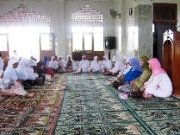 | 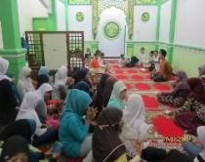 | 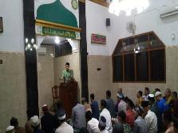
A | B | C
Figure 7. (a) Recitation by the 'Bunda Sholehah' mothers group, (b) Recitation by the 'Mas Mutiara' mosque youth group,
(c) Study of the morning prayer congregation

The community's tradition of recitation in mosques impacts the development of social activities, such as gathering to discuss regional developments or activities that take place from various aspects, including socio-cultural elements of the community and economic and physical factors. With the continuation of the dominant recitation tradition carried out by residents, both individuals and communities in the mosque, the community is always connected dynamically with Islamic values that are always maintained.
The tradition of recitation has implications for not utilizing the momentum of the Friday prayer ceremony as a medium for conveying religious messages like other mosques. During Friday prayers, the sermon is in Arabic. This was done only to fulfill the formal requirements for the validity of a Friday sermon, considering that many of them were on business and wanted to go home quickly. If you lecture a lot, you waste much time. Salespeople are waiting for customers, so they want to come out quickly. People spend more time studying the Qur'an and doing business. They agreed to close the shop every Friday until after Friday's prayers. Their shops or places of business will reopen after Friday prayers.
They do this because they have gained a more solemn understanding and deepening of Islam through the tradition of reciting the Qur'an every afternoon or evening, including the community's house-to-house recitation. Every night, there are rotations at the mosque, free of charge, at Maghrib ba'dal. It shows that religious nuances are locally embedded throughout the history of Islam in Sekarbela. Including in implementing the Friday sermon, the speaker or Khatib uses people from within Sekarbela. It is scarce to use people from outside Sekarbela. They assume their knowledge and the lecturers are the same.
The recitation tradition carried out regularly by the community provides benefits in understanding Islam as a whole, including in social life. The recitation tradition as a form of existence of the 'ngumpul' tradition carried out by the community creates Islamic social, economic, and religious activities. The community carries out the tradition of 'ngumpul' or gathering to this day, before activities or traditions occur, both within the family and the environment. The tradition of 'ngumpul' is carried out not only as a moment of meeting or friendship with residents but also as a moment of deliberation or opinions to agree on traditional activities. Without the tradition of 'ngumpul' carried out by the community and not carried out together, any activity or tradition will not work. The tradition of gathering to carry out religious traditions is carried out by ulama, traditional leaders, and residents (Figure 8A). Community leaders, officials, and residents carry out the tradition of gathering to carry out social traditions and livelihoods (Figure 8B). The tradition of gathering is to carry out social and religious traditions by the groups of mothers (Figure 8C) and groups of teenagers (Figure 8D).

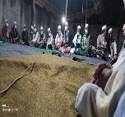 | 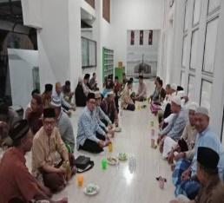 | 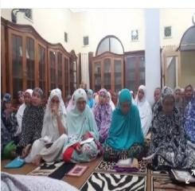 | 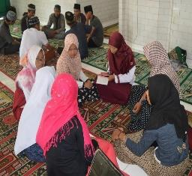
A | B | C | D
Figure 8. (a) The tradition of 'ngumpul' with the cleric, leaders, and residents (b) The tradition of 'ngumpul' with community leaders, officials, and residents (c) The tradition of 'ngumpul' with mother’s groups (d) The tradition of 'ngumpul' with youth groups

The community conducts social activities by cleaning the mosque, yard, and the surrounding environment, maintaining order and security, and helping those experiencing a disaster together. The cleaning of mosques, mosque grounds, and the environment is carried out every Friday before prayers are held at the mosque, called 'Jum'at Bersih' or 'Clean Friday' (Figure 9A). The internal community carries out activities to maintain order and security (Figure 9B). Meanwhile, mutual aid activities occur whenever residents are in trouble or have experienced a disaster (Figure 9C). Social activities carried out in cooperation represent the values of 'Merang' Islam and show a value system of social solidarity, which means the attitude of feeling together, both happiness and hardship, is also a supporting value in the fundamental value system of Sasak society. On this occasion, groups of sellers or artisans use the moment to gather, find out market trends or consumer desires, plan cooperation with stakeholders, and determine contracts in the buying and selling process using the principles of Islamic business ethics.

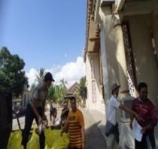 | 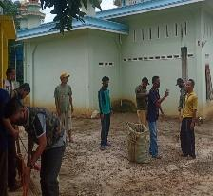 | 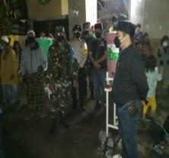
A | B | C
Figure 9. (a) People clean the mosque (b) The community takes care to maintain order and security (c) The community collects aid and helps those affected by the disaster
The dulangan tradition aims to reminisce about the life stories and struggles of Rasulullah Muhammad SAW and how he built his community, which was carried out for four days starting from the 12th of Rabiul Awal. The tradition is carried out in turns at four mosques in Sekarbela and Karang Pule.
In many cases, the ability to maintain and develop ceremonial traditions is supported by economic independence factors. With a household economic base engaged in gold crafts, the people of Sekarbela are a few examples of a community that has and carries out relatively high ceremonial traditions and costs money.
The dulangan tradition represents the Islamic values of 'Maliq', which shows the greatness of Islam. The deep meaning for society is to foster an attitude of fanaticism towards Islam as the best religion in the sight of Allah SWT. The series of dulangan traditions include:
1. In the tradition of dulangan at home, the host will entertain guests with dishes ranging from rice and side dishes to a menu of snacks with various flavors served on a large tray (Figure 10A). One tray, or what is usually called a tray, contains a minimum of 10 kinds (Figure 10B). In the dulangan tradition, a special food is always made from sticky rice, usually called 'Nasi Rasul' (Figure 10C).

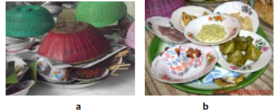 |  | 
A | B | C
Figure 10. (a) Serving in a tray (b) Various kinds of dishes (c) 'Nasi Rasul' made from sticky rice

Guests are invited to one village by several people depending on the invitation. Guests visiting usually bring luggage to give to the host (Figure 11A). The baggage contains rice and sugar, placed in a basin or plastic container. The event continued the next day. If guests cannot attend in the evening, they can attend the next day, depending on the opportunity for guests to visit or attend invitations (Figure 11B).

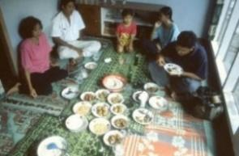 | 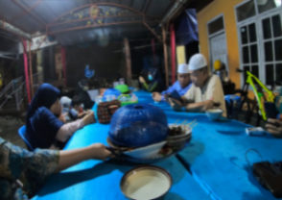
A | B
Figure 11. (a) Guests enjoy the dishes served (b) Guest visits to residents' homes

- Dulangan tradition at the mosque is held on the day of the Mawlid celebration, where every house in the village brings food and snacks to the mosque as a treat for invited village guests or community leaders or 'Tuan Guru' (Figure 12A). Every resident brings a tray to the mosque (Figure 12B) so that in one mosque, there are hundreds of trays containing food (Figure 12C). Guests invited to the mosque receive one tray of food. The birthday committee distributed trays to each guest to take home (Figure 12D).

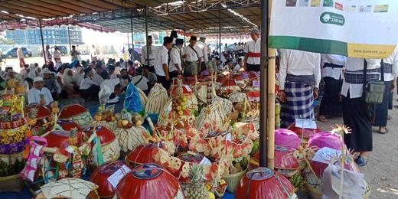 | 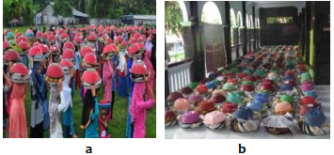 |  | 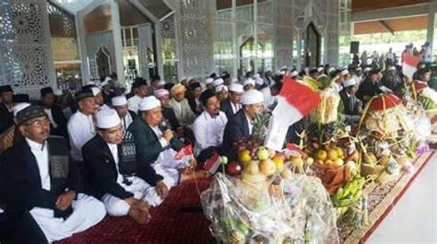
A | B | C | D
Figure 12. (a) Preparation for Mawlid activities (b) Residents bring food to the mosque (c) Food at the mosque
(d) Religious leaders, guests, and residents carry out the dulangan tradition to celebrate Mawlid
3. The tradition of giving donations is carried out at the mosque on the day of the Mawlid celebration. Compensation is given as a form of compassion from people who can afford it to those less fortunate. The committee gave compensation to orphans and older adults (Figure 13A). At this moment, compensation was also given to poor people without charge in mass circumcision activities or what is usually called 'nyunatan' (Figure 13B)—including the process of cutting a little of the baby's hair by a Tuan Guru or local community leader, called a ‘ngurisan’ (Figure 13C).

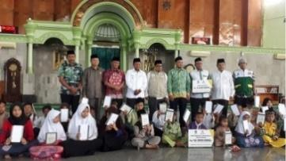 | 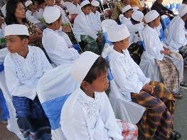 | 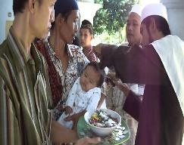
A | B | C
Figure 13. (a) Providing compensation to orphans and elderly people during the Mawlid celebration
(b) Mass circumcision or 'nyunatan' procession (c) Hair cutting or 'ngurisan' procession

The community of artisans and sellers carries out economic activities by making and selling pearl, gold, and silver handicraft products using Islamic business ethics principles per the Qur'an and Hadith instructions. In Islam, trading is not only about profit and loss. It was also exemplified by the Prophet Muhammad SAW when trading. The principles of Islamic business ethics implemented by the Prophet Muhammad SAW are selling good quality goods, being honest and not giving up easily, taking profits reasonably, building consumer trust, and choosing the right marketing strategy. By carrying out the trading method inherited by the Prophet Muhammad SAW well, you will benefit yourself, others, and the surrounding environment, namely getting a smooth fortune, a blessed income, being trusted by consumers, and peace of mind because you have done the best for consumers.
In the process of trading pearl, gold, and silver products, the community of artisans (Figure 14A) or sellers must follow Islamic guideline when they conduct business with prospective customers: by not selling prohibited goods explaining the type of product frankly, product timely delivery based on the agreed time, product accurate quantity, accurate size product, and accurate quality product according to the type and quality of the pearl, gold and silver products as well as the agreed materials (Figure 14B).
Systems and mechanisms for group solidarity with religious enthusiasm in economic activities are well maintained. The Sekarbela community prefers to raise capital independently. The tendency to stick to conventional patterns in viewing banking institutions is primarily due to factors other than attachment to religious norms and because compensation for gold savings can be safer. They can develop capital independently or as a group by saving their money.
While carrying out their traditional livelihood as artisans or sellers of pearls, gold, and silver, they also share activities with others. Economic activities with Islamic business ethics carried out by craftsmen artisans and sellers represent the Islamic values of 'Tindih and Merang', showing a sense of submission and obedience to religious rules and social solidarity. It implies that the Sasak people believe and believe that Islam is the path of truth, goodness, and nobility to become human beings whose attitudes and behavior are blessed before Allah SWT.

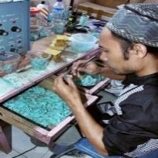 | 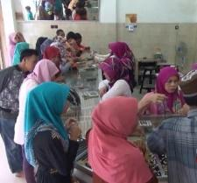
A | B
Figure 14. (a) Craftsman making pearl, gold, and silver craft products
(b) Sale and purchase transactions between sellers and buyers of pearl, gold, and silver craft products

- CORRIDOR AS A SPACE FOR SOCIAL, RELIGIOUS AND ECONOMIC INTERACTION
Corridors represent spaces for social, religious, and economic interactions. The corridor representing a space for social and religious interaction is the mosque on the north axis of the road. Residents and outsiders can access this mosque to conduct social and spiritual activities with open control as a semi-public zone. The corridor representing the space for economic interaction is along the north-south axis. It is dominated by shops selling pearls, gold, and silver connected to distributing craftsmen's residences in residential areas. Local and foreign residents and communities who buy and sell gold and silver pearl craft products with closed controls as a private zone can only access these shops.
The spatial organization in Figure 15 shows the relationship between spaces in the corridor involving users, behavior, and places as social, religious, and economic representation spaces.

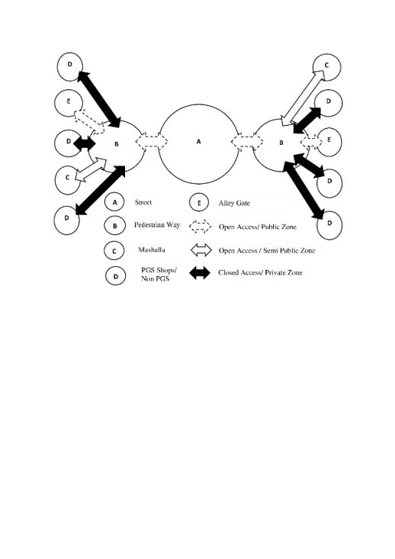

Figure 15. The relationship between social, religious, and economic interaction space as a community representational space

This spatial organization shows that ties between spaces make the corridor a binding area around it. The connection of the corridor with surrounding settlements through the presence of sidewalks, alleys, mosques, and shops creates a sense of community in the area, which mobilizes the community to carry out activities and use the corridor as a space for sustainable social and economic interaction to strengthen the identity of the place. It shows that a sense of community is built not only because of the intensity or togetherness of the community when interacting with the place [38] but also because of the community's obedience in implementing the value system that applies in that place.

- CORRIDOR AS A COMMUNITY REPRESENTATION SPACE
The existence of a community-oriented place shows that a place with a particular identity is interpreted as a manifestation of the user's existence through their experience and connection with the place based on the agreed Islamic values of 'Tindih, Maliq, Merang'—space for social, religious and economic interactions as identity. The corridor shows the community's functional attachment and emotional involvement, which provides users with an experience through the existence of the Qur'an recitation tradition. This indicates that a higher level of public and user relations can strengthen the existence of a place in and help it achieve its identity.
The corridor as a communal space synergizes Islamic values that contain social meaning to preserve local traditions as an existence that builds the corridor's identity. The recitation tradition is a community activity that is a form of local traditions that shows community observance and compliance in maintaining the Islamic value system that applies in society and the region, thus producing a social agreement to build or develop a place's identity. Social agreements present Islamic social, religious, and economic traditions as symbolic values of the region. The practice of Islamic values in local traditions shows religious values, the value of togetherness, the value of mutual assistance, the value of independence, and the value of aesthetics, as shown in Figure 16. The continuation of the recitation tradition and dulangan demonstrates high religious value. The higher the intensity of activity, the higher the Islamic values that are practiced, representing a corridor that practices Islamic values.

Figure 16. Practice of Islamic values in the corridor as a space for social, religious, and economic interaction

The practice of Islamic values in the corridors shows public space in urban settlements as a space for Islamic social, religious, and economic interaction. It shows the uniqueness of the continuity of local traditions in Sekarbela. The continuation of the recitation and dulangan traditions shows the dominant religious values in the corridor. The tradition of recitation, which began with the existence of spiritual traditions, continues today in the community. The dulangan tradition, as this manifestation of love for the greatness and example of the Prophet Muhammad SAW, resulted in the spirit of Islam Rahmatan Lil Alamin, which encourages people to love fellow human beings by strengthening ties of friendship. The majority's value of togetherness is demonstrated by the continuing tradition of cooperation every Friday to clean the mosque and its surrounding environment before it is used for Friday prayers. The value of helping is demonstrated by compensating orphans and older people, providing financial assistance for nyunatan activities, and facilitating the ngurisan procession. In economic activities, the value of independence is demonstrated by preserving skills as artisans, or sellers of pearls, gold, and silver. The value of beauty is shown by continuing local traditions through mutually supportive social, religious, and economic activities between individuals and society, thereby reflecting positive social relations. The positive relationship between users, behavior, and places shows the existence of building the corridor's identity as an Islamic public space with the function of social, religious, and economic interaction space.

- CONCLUSION
Islamic values are not only limited to beliefs but also reflect the unique collective actions of the people through the value of religion, the value of togetherness, the value of helping, the value of independence, and the value of aesthetics. The practice of Islamic values is not only limited to the level of relationship with God but also includes relationships with fellow creatures and the surrounding environment;
The principles of Islamic life based on the Qur'an and Al-Hadith exemplified by the Prophet Muhammad SAW provide a good and positive role model for the community in carrying out social, religious, and economic life arrangements in the area. The existence of the local tradition, 'ngumpul', reflects the value of Muslim harmony, namely 'Ukhuwah Islamiyah' in maintaining, preserving, and developing the identity of a place through the tradition of recitation of the Qur'an, the tradition of cooperation, social service, the tradition of dulangan and the tradition of livelihood as craftsmen artisans or pearl sellers, gold, and silver.
Thus, the representation of public space in the corridor is practicing Islamic values. The identity of public space in urban settlements is demonstrated by the active involvement of users in places that represent public space as a space for social, religious, and economic interaction. Social, religious, and economic interaction spaces are essential in synergizing with Islamic values so local traditions can continue building Islamic public spaces.

REFERENCES
[1] J. T. Spartz, "Place Meanings Surrounding an Urban Natural Area: A Qualitative Inquiry," Journal of Environmental Psychology, vol. 31, no. 4, pp. 344-352, 2011. Doi: https://doi.org/10.1016/j.jenvp.2011.04.002
[2] D. Oktay, "The Quest for Urban Identity in The Changing Context of The City of Northern Cyprus," Cities, Vol 19, No.4. pp. 261-271, 2002. Doi: https://doi.org/10.1016/S0264-2751(02)00023-9
[3] A. Molaei, "Definition of the Principles and Laws of Islamic Urbanism based on Unchangeable Rules," Social Theories of Muslim Thinkers, vol. 13, no. 1, pp. 127-144, 2023. Doi: https://doi.org/10.22059/jstmt.2023.348163.1555
[4] M. Y. Khemri, A. Q. Melis, and S. Caputo, "Sustaining the Liveliness of Public Spaces in El Houma through Placemaking", Journal Public Space. vol. 5, no, 1, pp. 129-152, 2020. Doi: https://doi.org/10.32891/jps.v5i1.1254
[5] N. Yuliastuti and A. M. Sukmawati," Creative Urban Kampung Based on Local Culture, A Case of Kampung Bustaman Semarang," Journal of Architecture and Urbanism, vol. 44, no. 2, pp. 128–137, 2020. Doi: https://doi.org/10.3846/jau.2020.11450
[6] C. C. Marcus, "Shared Outdoor Space and Community Life," Places, vol. 15, no. 2, pp. 32-40, 2003.
[7] E. Y. Titisari, "Meaning of Alley as Communal Space in Kampung Kidul Dalem Malang," Journal of Basic and Applied Scientific Research, vol. 2, no. 10, pp. 10087- 10094, 2012.
[8] R. Kumar, "Overview: Social Spaces in Urban Areas", International Journal Engineering Technology, vol. 4, no. 4, pp. 1032–1039, Apr. 2017.
[9] D. A. Lindarni and W. Handayani, “Transformasi Kampung Kota di Kawasan Segitiga Emas Kota Semarang (Studi Kasus: Kampung Sekayu dan Kampung Petempen),” Riptek, vol. 8, no. 2, 1–12, 2014.
[10] P. Lakonawa. “Agama Dan Pembentukan Cara Pandang Serta Perilaku Hidup Masyarakat,” HUMANIORA, vol. 4 no. 2, pp. 790-799, 2013.
[11] J. Peng, D. Strijker, and Q. Wu, "Place Identity, How Far We Come in Exploring Its Meaning," Environmental Psychology, vol. 11, 2020. Doi: https://doi.org/10.3389/fpsyg.2020.00294
[12] A. H. Radwan, "The Mosque as a Public Space in the Islamic City - an Analytical Study of Architectural and Urban Design of Contemporary Examples," Journal of Architecture, Arts, and Humanistic Science, vol. 6, No. 30, 2021. Doi: 10.21608/MJAF.2020.35199.1712
[13] J. Jamaluddin, I. Santosa, and J. Anita, "Examining the Symbolic Meaning of Al Jabbar Grand Mosque in Bandung," Journal of Islamic Architecture, vol. 7, no. 4, pp. 760-766, 2023. Doi: https://doi.org/10.18860/jia.v7i4.21256
[14] L. M. Hermans, W. A. H. Thiessen, Actor Analysis Methods and Their Use for Public Policy Analysis, European Journal of Operational Research, vol. 196, no. 2, pp. 808-818, 2008. Doi: https://doi.org/10.1016/j.ejor.2008.03.04
[15] Subarsono, Public Policy Analysis: Concepts, Theory and Applications. Yogyakarta: Student Library, 2005.
[16] S. E. Ibrahim, "Anatomy of Egypt's Militant Islamic Groups: Methodological Note and Preliminary Findings," International Journal of Middle East Studies, vol. 12, issue 4, pp. 423-453, 1980. Doi: https://doi.org/10.1017/S0020743800031238
[17] P. Ivena dan Y. B. Dwisusanto, "Changes in the Physical Setting of Open Space in Accommodating A Variety Of Activities in the Creative Kampong of Dago Pojok," Jurnal RISA, vol. 01, no.02, pp 147-169, 2017. Doi: https://doi.org/10.26593/risa.v1i02.2390.147-169
[18] A. Rapoport, Culture, Architecture, and Design, Locke Science Publishing Company, Inc, 2005.
[19] I. Altman and J.F. Wohlwill, Human Behavior and Environments: Advances in Theory and Research, vol.2, New York: Plenum Press, 1992.
[20] S. A. Saad, "Space, Architecture, and Power. The Top-Down and Bottom-Up Placemaking in Historic Arabic-Islamic Cities," Journal of Islamic Architecture, vol. 7, no. 1, pp 28-38, 2022. Doi: https://doi.org/10.18860/jia.v7i1.11730

[21] E. Zuraidi, I. Caisarina, and Z. Fuady,"The Islamic Public Space Concept in The Southeast Asia Region as A Friendly Urban Design and Planning Enlightenin," IOP Conf. Series: Earth and Environmental Science 452 012146, pp. 1-10, 2020. Doi: 10.1088/1755-1315/452/1/012146
[22] D. Dahliani, "Local Wisdom in Built Environment in Globalization Era," International Journal of Education and Research, vol. 3, no, 6, pp. 157–166, 2015.
[23] M. A. E. Saleh, "The Integration of Tradition and Modernity: A Search for an Urban and Architectural Identity in Arriyadh, The Capital of Saudi Arabia," Habitat International, vol. 22, issue. 4, pp. 571-589, 1998. Doi: https://doi.org/10.1016/S0197-3975(98)00020-4
[24] Y. Suprapto, R. Rusdarti, dan M. Jazuli, “Partisipasi Masyarakat Dalam Pelestarian Warisan Budaya di Lasem,” Journal of Educational Social Studies, vol. 4, no. 1, 2015.
[25] S. A. Hammoodi and W.S. Al-Hinkawi, "The Role Of Spatial Value In The Reconstruction Of Religious Buildings Mosul City: – A Case Study," Ain Shams Engineering Journal, vol. 14, issue 10, 2023. Doi: https://doi.org/10.1016/j.asej.2023.102164
[26] C. Casram and D. Dadah, “Posisi Kearifan Lokal Dalam Pemahaman Keagamaan Islam Pluralis,” Religious: Jurnal Studi Agama-agama dan Lintas Budaya, vol. 3, no. 2, pp. 161-187, 2019. Doi: https://doi.org/10.15575/rjsalb.v3i2.4739
[27] L. Sumardi and D. Wahyudiati, "Using Local Wisdom to Foster Community Resilience During the Covid-19 Pandemic: A Study in the Sasak Community, Indonesia," Proceedings of the 2nd Annual Conference on Education and Social Science, 556, 122–127, 2021.
[28] Z. Mansyur, Social Wisdom of the Sasak Lombok Community in Local Traditions, Mataram: Sanabil, 2019.
[29] D. Aulia, L. Sumardi, B. Alqadri, and M. Zubair, "Traditions of the Prophet's Birthday in the Sasak Tribe (Study in Gubuk Barat Hamlet, Mamben Daya Village, East Lombok Regency)," Scientific Journal of the Education Profession, vol. 8, no. 1b, 2023.
[30] J. T. Lang and W. Moleski, Functionalism Revisited: Architectural Theory and Practice and the Behavioral Sciences. Ashgate Publishing, Ltd, 2010.
[31] S. Abdullah, "Potential and Strength of Social Capital in a Community", Socius: Journal of Sociology, vol. 12, pp. 15–21, 2013.
[32] K. M. H. Eisenhardt, "Agency Theory. An Assessment and Review," Academy of Management Review, vol. 14, no. 1, pp. 57-74, 1989. Doi: https://doi.org/10.5465/amr.1989.4279003
[33] L. Groat and D. Wang, Architectural Research Methods – Second Edition. Canada, USA: John Wiley and Sons Inc, 2013.
[34] R. K. Yin, Case Study, Research Design and Method, COSMOS Corporation, 1989.
[35] Sugiyono, Quantitative, Qualitative and R&D Research Methods. Bandung: Alphabet, 2019.
[36] M. Lewicka, "What Makes Neighborhoods Different from Home and City? Effects of Place Scale on Place Attachment," Journal of Environmental Psychology, Vol. 30, no. 1, pp. 35–51, 2010. Doi: https://doi.org/10.1016/j.jenvp.2009.05.004
[37] J. Gehl and B. Svarre, How to Study Public Life, Island Press: Washington DC, 2003.
[38] J. Farncis, B.G, Corti, L. Wood, and M. Knuiman, "Creating Sense of Community: The Role of Public Space," Journal of Environmental Psychology, vol. 32, issue 4, pp. 401-409, 2012. Doi: https://doi.org/10.1016/j.jenvp.2012.07.002.

