 |  | JOURNAL OF ISLAMIC ARCHITECTURE  P-ISSN: 2086-2636 E-ISSN: 2356-4644  Journal Home Page: http://ejournal.uin-malang.ac.id/index.php/JIA
A STUDY ON THE CREATION OF SENSE OF PLACE IN THE RELIGIOUS COMMERCIAL AMPEL CORRIDORS
Astrid Kusumowidagdo^{a*}, Dyah Kusuma Wardhani^{b}, Melania Rahadiyanti^{c}
ªArchitecture Department, Universitas Ciputra, Surabaya, Indonesia
^{b}Architecture Department, Universitas Ciputra, Surabaya, Indonesia
^{c}Architecture Department, Universitas Ciputra, Surabaya, Indonesia
*Corresponding Author: astrid@ciputra.ac.id
ARTICLE INFO |  |  | ABSTRACT
Volume: 8  Issue: 1  Page: 68-90  Received: July 18th, 2023  Accepted: January 13th, 2024  Available Online: June 30th, 2024  DOI:  http://dx.doi.org/10.18860/jia.v8i1.22859 |  |  | The uniqueness of each place needs to be preserved; therefore, this research will explore determining the relationship between the physical and social aspects that create the sense of place. The focus was on two corridors functioning as the primary access to the Grand Mosque of Kampong Ampel and the nodes of the religious and commercial area of Surabaya City, Indonesia. One hundred visitors in each corridor, 200 respondents in total, were surveyed, and data were collected using questionnaires, documentation processes, and interviews with local visitors and pilgrims and analyzed with the multiple linear regression method. The independent variables used were physical and social aspects, while the dependent variable was the sense of place. The results showed that, on average, both physical and social aspects contributed almost the same values to the sense of place in the researched areas. The aspects of the first corridor at the Grand Mosque were found to provide a medium relationship estimated to be 55.0%. In contrast, the second corridor at the Ampel Suci had a higher result, approximately 58.6%, with the social aspect discovered to be higher than the physical aspects of the sense of place. The summary shows that the two corridors have an averagely influence the concept of a sense of place. Based on the finding in this study, it is recommended that both corridors preserve the physical and social aspects of the sense of place, while others should be improved.  Keywords:  commercial corridor; religious; sense of place

- INTRODUCTION
The concept of the sense of place, defined as the human emotional relation to a particular location, has become a popular topic since the discussion of the love of place (topophilia) [1] and the subsequent interest in the concept by different disciplines of science [2]. The scope of research related to the idea also varies according to the scale of the place [3]. This research will examine the importance of place preservation in an area and what sense of place indicators need to be preserved. Therefore, the user's perspective of an area is essential to ascertain the sense of place that needs to be preserved [4][5][6].
There has been a lot of research regarding the sense of place in commercial, public, and private-owned areas. Those associated with commercial places include plazas [7][8][9][10], towns [11], heritage and religious spaces [12][13][14], traditional shopping districts [15][5][16][17], and traditional streets [15][18]. Private spaces include shopping centers [19][20], shopping streets [21], and mosques [22]. Moreover, the impacts of physical and social aspects [7][10][23][24] have also been widely studied. Those related to the physical include [25], while the social aspects were studied [5][6][26][27][28][29][30]. Those previous researchers found that every place has its sense of place, influenced by its physical and social aspects. The influence of these physical and social aspects makes each place, which has different characteristics and functions, have its characteristics and uniqueness.
This research was conducted to fill the gap in past studies, especially by connecting the aspects above to the sense of place. It is crucial to consider the effect of this concept on the behavior of a particular area [19] and its relationship at different levels [31] formed based on the physical and social aspects [23][32]. The novelty of this research is the efforts to link the physical and social aspects and determine their impact on the sense of place using a quantitative approach that considers the perspective of visitors and pilgrims in the area. Moreover, the corridors’ location in a historic religious commercial as a pilgrimage area makes it a unique case study. Since this research will explore users' perspectives on the sense of place in religious areas, several indicators will influence the sense of place in these areas.
There have been studies on place-making and sense of place. Pilgrimage is essential from a Muslim perspective [33]. Al-Qasimi Rahmahullah said: "They traveled and went to several places to see various relics for advice, lessons, and other benefits." (Mahasinu At-Ta’wil, 16/225). Pilgrimage is a spiritual journey of seeking closeness to God, demonstrating unity and equality among Muslims, and commemorating historical events and figures. In this case, as a part of the pilgrimage journey, the corridor also acts as a commercial area that sells Muslim souvenirs. This pilgrim process involves various traditions and requires physical, mental, and financial abilities. Souvenirs play a crucial role in extending and commemorating the pilgrimage experience. Shopping streets and the sense of place are essential for creating a positive pedestrian experience. These souvenirs are tangible reminders of their pilgrimage experience and are often shared with family and friends upon their return [34]. These research findings will give further value to the experience of the pilgrimage journey, which can contribute to cultural preservation, interreligious experience, and socio-economic impact.

  - SENSE OF PLACE IN HISTORIC COMMERCIAL CORRIDOR, THE RESEARCH APPROACH
A place is a part of an environment experienced through the human senses. Meanwhile, a sense of place was defined [32] as a person’s particular experience in a specific setting. It has also been reported that taste quality distinguishes one place from another using the distinction aspect. Moreover, a sense of place reflects an emotional attachment [35], such as happiness, positive impression, and sentiment caused by culture, ethnicity, and memory, further asserting that the spirit or personality of a place is the foundation for its uniqueness [32].
The sense of place involves perceiving the environment and the associated feelings. It means both the interpretive and emotional aspects are related to the environmental experience, with the overall quality measured in terms of the richness of the psychological and socio-cultural meaning as well as physical comfort, safety, and performance [20][23][24]. Therefore, the sense of place can be defined by social factors, including psychological and interactional aspects, and environmental conditions, including physical ones.
Some studies have shown the influence of physical and social conditions on the sense of place. For example, Kusumowidagdo et al. [19] discussed several physical components, including materials, substance, form, texture, and color. Moreover, the concept has also been divided using specific points such as authentic and inauthentic or preserved and recreated. It can exist in the smallest entity, like the boundary of space, or larger ones, such as a group of rooms, a residence, an architectural design, a particular floor of a building, a city, and even a country. However, this research focused on the specific theme of the corridors in a historic commercial area, which are also pilgrimage areas. These religious areas have been proven to provide a sense of place, attachment, and loyalty to their visitor [36][37][38].
In general, the use of corridors as a commercial area exists throughout the world, and the human interaction with this concept in religious and commercial regions has been extensively studied [21][39][40][41][42]. For example, Kusumowidagdo et al. [20] showed that the social factors required to create a sense of place for a shopping corridor include social image, interaction, visitors’ lifestyle, crowd density, ethnic similarities, and visitor segments. On the other hand, the visual harmony, atmosphere, and tenant spaces shaped the physical aspect.
This research provides a unique perspective on Islam, especially on the local tradition of Javanese pilgrimage [33]. It discusses grave pilgrimage, which in the Muslim view, is permitted for good purposes, especially to the graves of religious propagators. The place of pilgrimage as a destination has its specific atmosphere, contributing to its sense of location.
Not infrequently in its development, pilgrimage areas often become areas of religious tourism, with nodes formed, which often help increase local potential [43]. Thus, the research focus in Ampel, North Surabaya, is developing the Sunan Ampel grave object, which is the center of the region’s growth. All corridors lead to the central area, the heavy object.
Gates are often found and provide a hierarchy in the corridor area that leads to the grave in the Mosque area. It is also found in the study Ampel area [44]. In the Ampel area, gates are located at the entrances of the two corridors leading to the Ampel Mosque. Each corridor’s gate is designed to signify different corridor areas.
The atmosphere is also formed from color and decoration. From Islam's perspective, colors act as symbols from the Qur'an [45][46]. Besides color, the decorative flora often colors some Islamic architectures and its areas. In the Ampel corridor, colors and decorative elements that reflect Islamic Architecture can be seen in the gate design, ceiling, and floor elements. Applying colors and decorative elements can support the creation of feelings in religious areas.
Tenant spaces and products that sell various prayer needs and also local food and beverages [33]. Souvenir products play an essential role in the pilgrimage experience, as they serve as a way to extend and commemorate the visitation [47]. Souvenir purchases are often seen as a collective pilgrimage, with visitors considering them essential elements to complement and strengthen the overall experience [47]. In the case of religious tourism, including pilgrimage, souvenirs can include miniatures of religious monuments and other religious and cultural goods [47]. Local food and drinks can also be offered as souvenirs [47].
Socially, the essential thing in this pilgrimage area is the history of the public figure buried and the center of interest, Sunan Ampel. In addition, there is crowdedness, a religious atmosphere, lifestyle and attributes, interaction, and activity. This area cannot be separated from the role of Sunan Ampel in spreading Islam, developing diversity and culture, and building mosques and tombs [48], where pilgrimages to tombs and tomb repairs are becoming very prevalent in Indonesia [49].
Including a tomb pilgrimage in tourism has a primary purpose: knowing God. In various verses of the Quran, Allah SWT calls humans to travel on the earth and think about various phenomena and the creation of nature. In Qs. Allah says Ankabut (29): 20, "Walk in the earth, then see how (Allah) began creation, then Allah makes the final event. Indeed, Allah Almighty over all things."
In this case, the pilgrimage to Sunan Ampel's tomb serves to know God better. The role of Sunan Ampel is inherent, and he becomes a role model so that the tomb of Sunan Ampel becomes a magnet and the center of the arrangement of the area to the center of activity. Concerning pilgrimage activities, crowdedness cannot be avoided. Crowdedness can attract attention or the behavior of other visitors to join the crowd. The Ampel area is usually crowded during the month of Ramadan. In this month, the odd nights have their meaning, and it is recommended to pray more solemnly, so many pilgrims crowd this area; besides, on other days, although not as crowded as the month of Ramadan, still this corridor is not deserted.
The social interaction of pedestrians and visitors shapes the Ampel corridor's sense of place, as has been studied by Ningrum and Yani [50]. Specifically, in the Ampel area, the previous studies of Kusumowidagdo and Wardhani [16][26] and Wardhani and Kusumowidagdo [17] focused on the corridor using the explorative qualitative research method on the exact locations used in these researches, including the main corridor of the Grand Mosque as A and the Ampel Suci corridor as B.
The results of physical aspects found for corridor A include an authentic gate, product diversity, natural lighting, dimension, and commercial space disharmony. In contrast, the social elements were the presence of narrative or history and memory, crowdedness, religious atmosphere, lifestyle attributes, interaction, and activity.
Moreover, the physical factors for Corridor B were reported to include an authentic gate, product diversity, ceiling ornament, the connecting road to settlement, commercial space harmony, and artificial lighting. The social aspects were the same as those of Corridor A except for the inclusion of the existence of Arab merchants. These findings serve as the foundation for this study.

  - SENSE OF PLACE IN HISTORIC COMMERCIAL CORRIDOR, THE RESEARCH APPROACH
A public place has its unique value [51] and is also considered the genius loci of an area. There is a spirit [32] attached to the minds of visitors when they have a relationship with a particular place [1][3][29][32][52]. It involves functional, social, iconic, experimental, and dependent relations [2][26].
The intentionality to engage in a particular place is based on the depth, which is described using the sense of place scale. This scale includes indicators such as the knowledge of the location, sense of belonging, attachment, identification with the goals, involvement, and sacrifice for a place, which are used in this study as independent variables [26][31].

- METHODS
The research object was the historic religious area of Kampong Ampel, located in the Ampel vicinity of Surabaya, Indonesia (Figure 1). This location was selected because of its unique condition. The tomb of Sunan Ampel, a revered figure credited with the spread of the Islamic religion in Java, is located in the Grand Mosque of Ampel as a node and a pilgrimage site for Muslims, as seen in Figures 1 and 2.

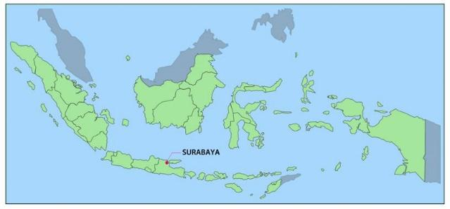

Figure 1. The Position of Surabaya City on the Indonesian Archipelago [53]

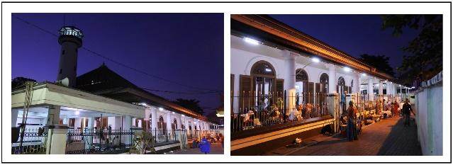

Figure 2. The Grand Mosque of Ampel and the tomb of Sunan Ampel

As nodes, the mosque and the tomb compound are accessible from several corridors. Two of the most used corridors were selected, including the Grand Mosque’s main corridor, tagged as A, and the Ampel Suci corridor, labeled B, as illustrated in Figure 3.

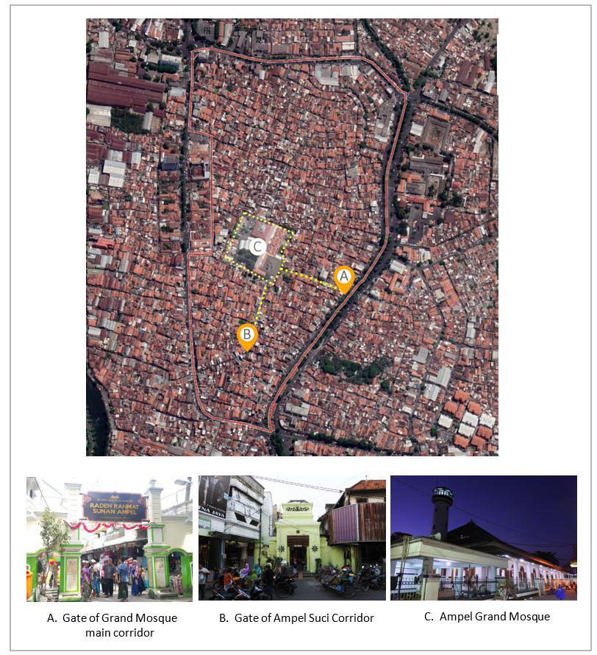
Figure 3. Site of Kampong Ampel, Grand Mosque Ampel as the center, and the two selected corridors

The method used was quantitative, using a survey [54]. The quantitative approach is used after the qualitative phase from the previous research [17][26]. The result was analyzed using multiple linear regression which examines the relation between two or more variables [55]. The regression proposed by Mojtabavi et al. was also used for this kind of research [56].

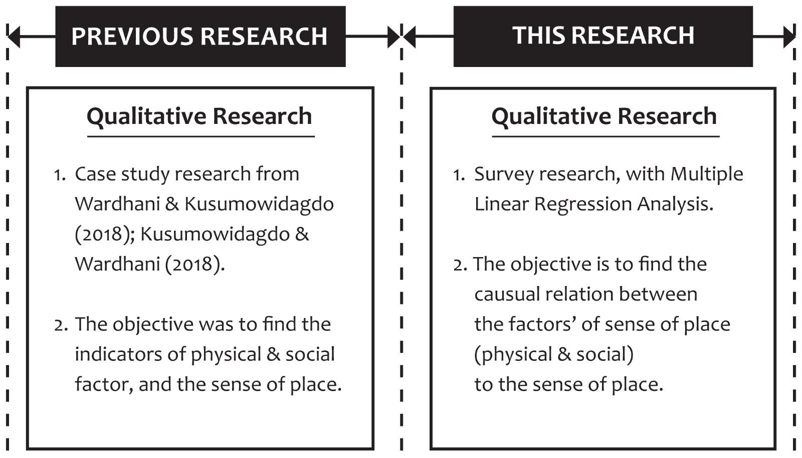
Figure 4. The Flow of the Research

This study used probability sampling to choose the respondents, focusing on simple random sampling. The respondents included 100 pilgrims in each of the corridors, with data obtained around Ramadhan between 6 pm and 9 pm by four surveyors placed in each. This means a total of 8 surveyors assessed 200 respondents in total.
The sample size of 200 in total at two corridor locations is appropriate when viewed at previous research [57], suggests that the proper sample size in research is between 30 and 500, also found in another previous study [58], with a similar theme, used 100 people as a sample then [59], Zahid and Misirlisoy with the title Measuring place attachment, identity, and memory in urban spaces: the case of the Walled City of Lahore, Pakistan. A sample of 220 people was used for 4 street variants. In addition, Wang [60] used 107 people as a sample. This study explores the moderating effect of the visiting history on balancing risk perception, place attachment, and travel intention. Moreover, data was also retrieved through interviews and simultaneous documentation with the residents managing the area, who also double as the leading figures of the Arab community in the Ampel area.
The survey questionnaires and variables were obtained from previous qualitative studies [16][17][26]. The independent variables were physical and social aspects, while the dependent variable was the sense of place. The two aspects are similar, but some differences were observed between corridors A and B. The indicators of the sense of place aspect varied for both corridors. The interaction in people-place relationships has been reported to be influenced by the sense of place [23] triggered both by physical and social factors [10][23]. It has also been discovered to exist in corridors, and the indicators have been described in the previous study [16][17].

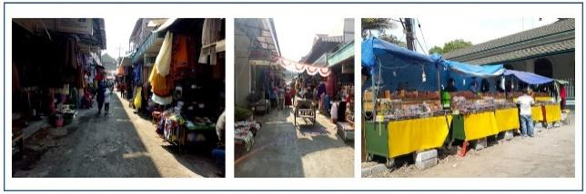
Figure 5. The physical factors of corridor A

For corridor A, the independent variables for the physical aspect [17] were authentic gate, product diversity, natural lighting, corridor dimension, and commercial space harmony (Figure 5). In contrast, according to Kusumowidadgo & Wardhani [16], the social aspect includes the presence of narrative or history and memory, crowdedness, religious atmosphere, lifestyle attributes, interaction, and activity.

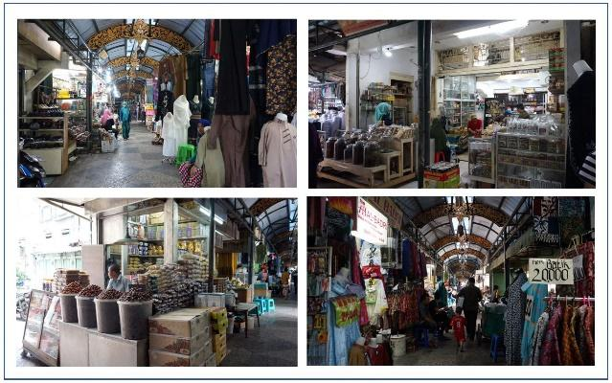
Figure 6. The physical factors of corridor B

Moreover, for corridor B, the independent variables of the physical aspects [17] were the authentic gate, product diversity, ceiling ornament, the connecting road to the settlement, commercial space harmony, and artificial lighting (Figure 6), while the social aspects are the same with corridor A except for the inclusion of the existence of Arab merchants [26]. These indicate that both locations have the same variables but different indicators due to the variations in their features. However, corridor A has fewer physical and social factors indicators than B (Figures 7 and 8).

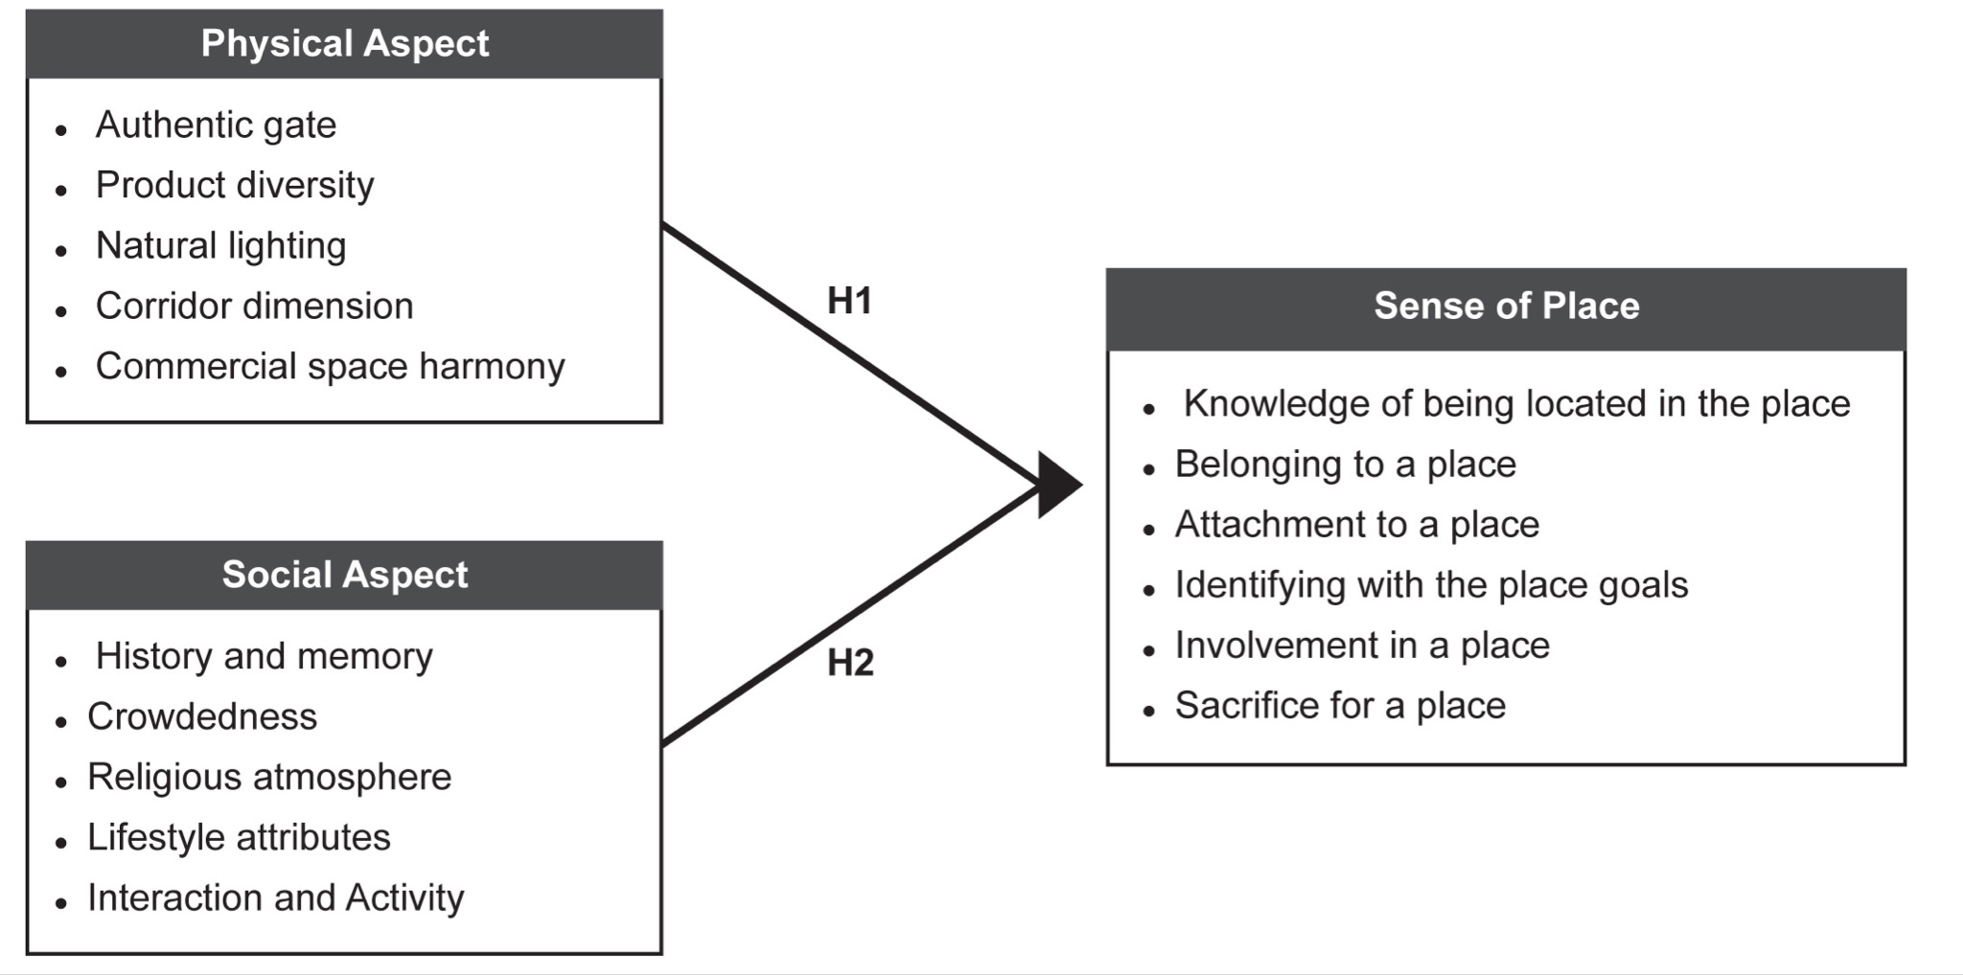
Figure 7. The Variables and Indicators of Corridor A

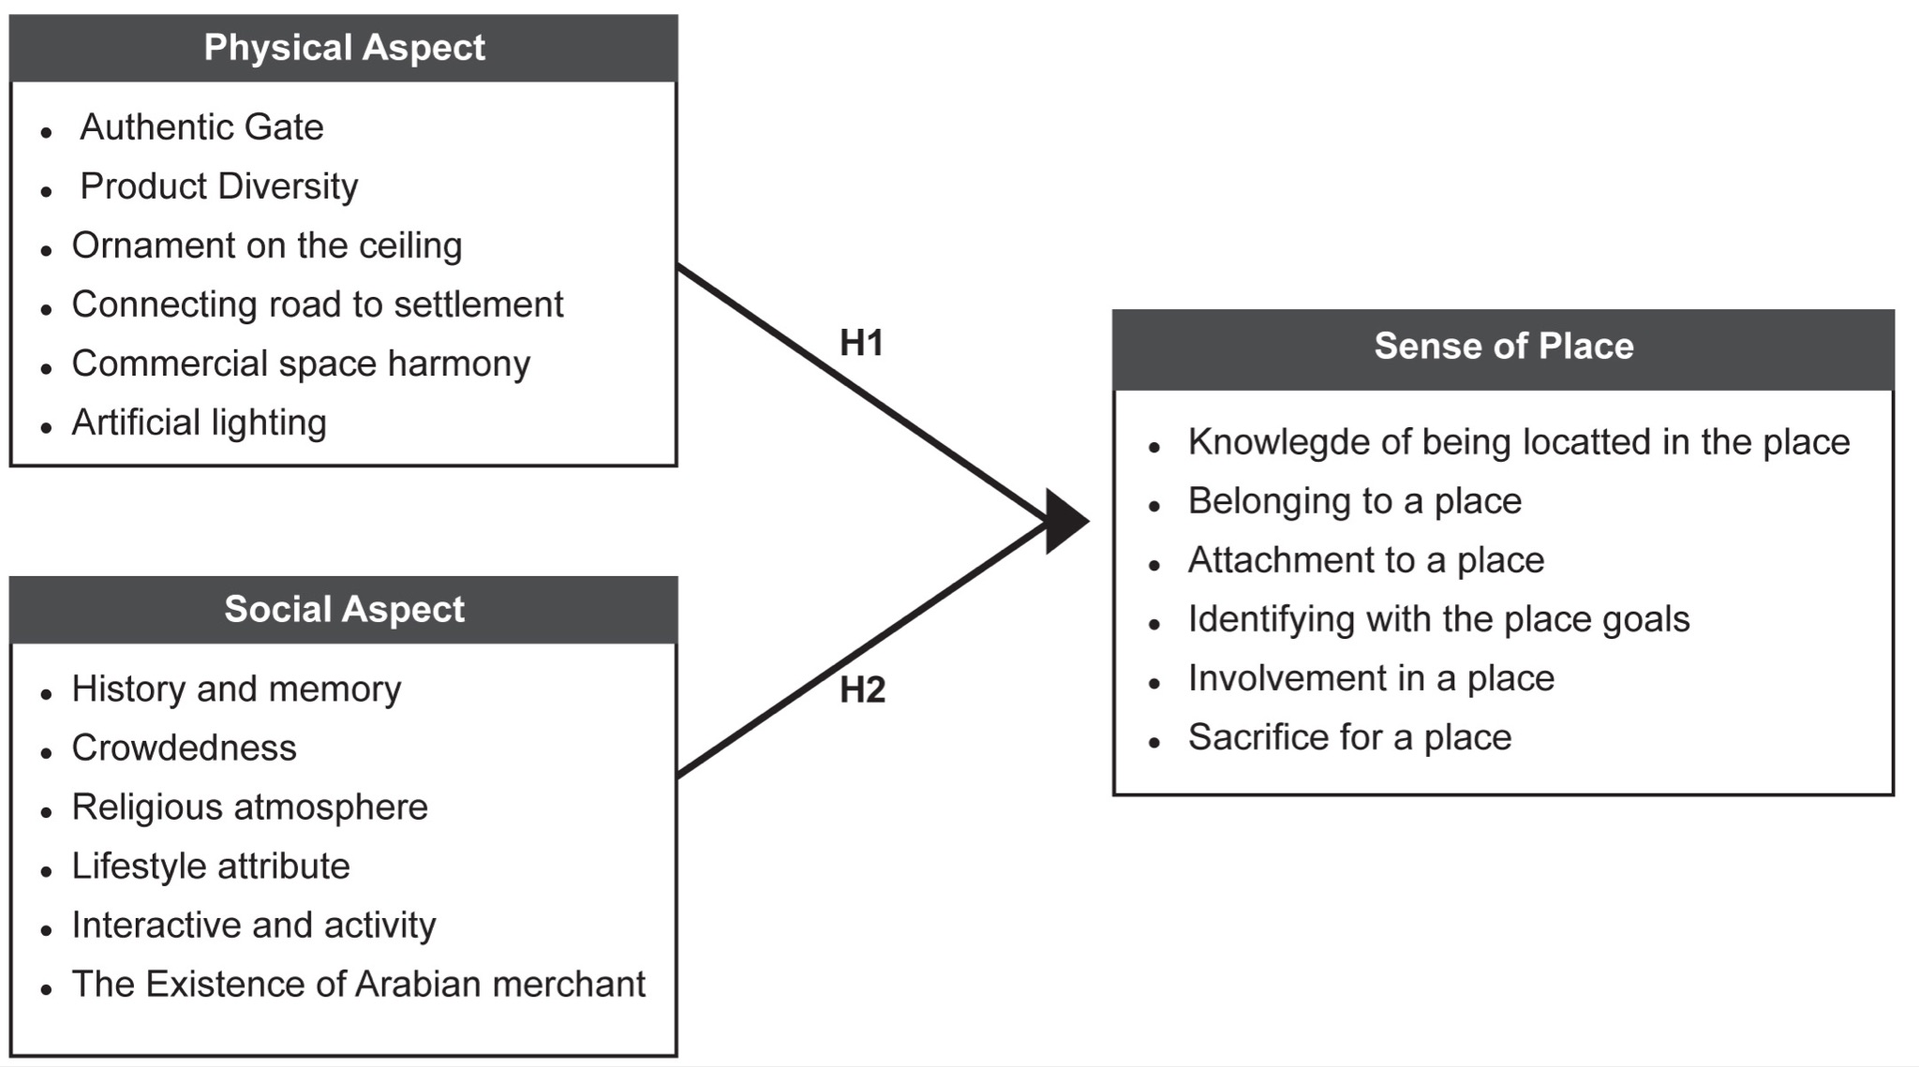
Figure 8. The Variables and Indicators of Corridor B

- RESULT AND DISCUSSION
The findings from both corridors were discussed separately. These to included a summary of the respondents’ characteristics, descriptive statistical results of the visitors’ perceptions of the physical and social factors in forming the sense of place and its subsequent level, as well as and the multiple linear regression or inferential analysis to determine the effect of the factors on the sense of place. The steps are schemed below in Figure 9.

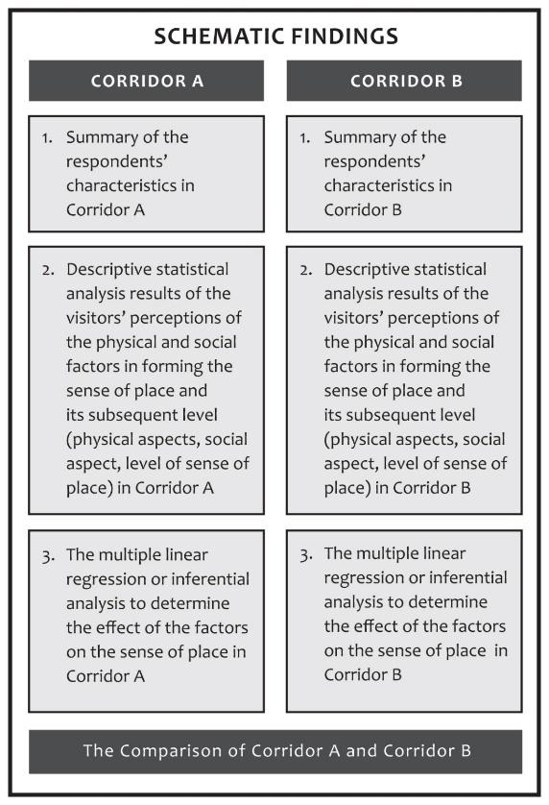
Figure 9. Schematic Findings

- SUMMARY OF THE RESPONDENTS’ CHARACTERISTICS
The results showed there were more men (62%) than women (38%), and most of the respondents were found to be mature, as observed, with those between 25 and 40 being 65%. The majority, represented by 90%, visited due to their spiritual relationships, such as pilgrimages and prayers. At the same time, the remaining was due to commodified relationships, such as shopping in the corridor area and several other purposes because the location is a historical site for the Surabaya region (narrative) or to bring a memento and souvenir from the pilgrimage site. Furthermore, the level of the sense of place in the area was higher, as shown in the following details.

- DESCRIPTIVE ANALYSIS
The following table presents the descriptive analysis of the physical and social variables, and the level of sense of place.

- RESPONDENT’S RESPONSE REGARDING PHYSICAL ASPECT VARIABLE OF CORRIDOR A

Table 1. Respondent’s Response Regarding Physical Aspect Variable of Corridor A
No | Statement |  | Frequency (number of respondents) on Likert Scale |  |  |  |  | Actual Score | Ideal Score
No | Statement |  | 5 | 4 | 3 | 2 | 1 | Actual Score | Ideal Score
1 | Easily recognized gate or authentic gate | F | 19 | 46 | 27 | 2 | 27 | 391 | 500
 |  | % | 19,0% | 46,0% | 27,0% | 2,0% | 27,0%
2 | Product Diversity | F | 18 | 43 | 39 | 0 | 39 | 418 | 500
 |  | % | 18,0% | 43,0% | 39,0% | 0,0% | 39,0%
3 | Well-organized products in stores/stores layout or commercial space harmony | F | 7 | 30 | 56 | 7 | 56 | 393 | 500
 |  | % | 7,0% | 30,0% | 56,0% | 7,0% | 56,0%
4 | Good corridor dimension | F | 53 | 33 | 14 | 0 | 14 | 453 | 500
 |  | % | 53,0% | 33,0% | 14,0% | 0,0% | 14,0%
5 | Natural lighting | F | 45 | 34 | 17 | 4 | 17 | 437 | 500
 |  | % | 45,0% | 34,0% | 17,0% | 4,0% | 17,0%
 |  |  | Total |  |  |  |  | 2092 | 2500

Table 1 shows the highest score from the responses on the physical aspect, which was held by statement number 4, which is the excellent corridor dimension, with 453 points. In comparison, the lowest was found with number 1 for the easily recognized gate, with 391 points. The total score was 2092, which lies in the excellent category, as shown by the position of the continuum line in the interval range of 1700 – 2100 in Figure 10.

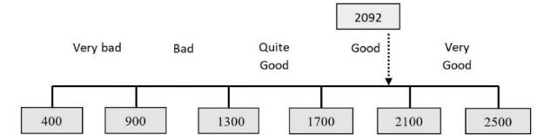
Figure 10. The Variables and Indicators of Corridor A

- RESPONDENT’S RESPONSE REGARDING PHYSICAL ASPECT VARIABLE OF CORRIDOR A

Table 2. Respondent’s Response Regarding Social Aspect Variable of Corridor A
No | Statement |  | Frequency (number of respondents) on Likert Scale |  |  |  |  | Actual Score | Ideal Score
No | Statement |  | 5 | 4 | 3 | 2 | 1 | Actual Score | Ideal Score
1 | I feel history and memory | F | 58 | 37 | 5 | 0 | 5 | 458 | 500
 |  | % | 58,0% | 37,0% | 5,0% | 0,0% | 5,0%
2 | Masses and crowds are part of the ambiance | F | 19 | 46 | 35 | 0 | 35 | 419 | 500
 |  | % | 19,0% | 46,0% | 35,0% | 0,0% | 35,0%
3 | I feel a strong religious influence | F | 37 | 35 | 27 | 0 | 27 | 433 | 500
 | I feel a strong religious influence | % | 37,0% | 35,0% | 27,0% | 0,0% | 27,0%
4 | I see a distinct lifestyle which is linked to the religious atmosphere | F | 47 | 42 | 11 | 0 | 11 | 447 | 500
 |  | % | 47,0% | 42,0% | 11,0% | 0,0% | 11,0%
5 | I feel a friendly interaction between sellers and buyers | F | 19 | 39 | 36 | 6 | 36 | 407 | 500
 |  | % | 19,0% | 39,0% | 36,0% | 6,0% | 36,0%
 |  |  | Total |  |  |  |  | Total | 2164

Table 2 shows the highest score for the Social Aspect, recorded in statement number 1 with 458 points, while the lowest was in statement number 5 with 407 points. Overall, the variable had a total of 2164, which lies in the outstanding category, as shown by the position of the continuum line in the interval range of 2100 – 2500 in Figure 11.

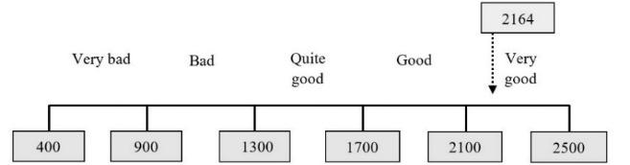
Figure 11. Continuum Line of Social Aspects Variable

- RESPONDENT’S RESPONSE REGARDING PHYSICAL ASPECT VARIABLE OF CORRIDOR A

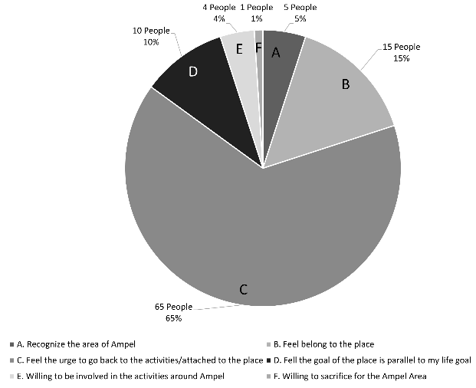
Figure 12. Respondent’s Response Regarding Level of Sense of Place Variable of Corridor

Figure 12 shows the highest score for the level of Sense of Place was 65%, and it was recorded for the urge to go back to the activities attached to the place, while the lowest was observed to be 1% for the willingness to sacrifice for the Ampel area.

- THE IMPACT OF PHYSICAL AND SOCIAL ASPECTS TOWARDS SENSE OF PLACE IN CORRIDOR A
The impact of the physical and social aspects on the sense of place was determined using the multiple linear regression analysis, which comprised of the classical assumption test on corridor A data, multiple linear regression equation, correlation analysis, and coefficient of determination analysis.

- CLASSICAL ASSUMPTION TEST ON CORRIDOR A
The assumption test was conducted before the formulation of the regression analysis to ensure the model provided an estimation that adhered to the BLUE (Best Linear Unbiased Estimator) properties. It included the Normality, Multicollinearity, and Heteroscedasticity Tests. From those tests, it is was concluded that the data were all normally distributed, there was no multicollinearity, and there was no heteroscedasticity problem in the data.

- HYPOTHESIS TESTING FOR CORRIDOR A
For Simultaneous Hypothesis Testing to test whether physical and social aspects jointly possess a significant influence over the sense of place, the following hypothesis testing was thus carried out:
H₀: β₁ = β₂ = β = 0 Signifies that physical and social aspects contributed no significant influences over the sense of place. H1:βi ≠0 Signifies that physical and social aspects simultaneously influence the sense of place. Level of significance (α): 0.05. Testing criteria: reject H0 if the value of F-count > F-tale, accept H1. The F-test statistical value may be understood according to output table 3.

Table 3. Statistical Value for Corridor A
ANOVAª
Model | Sum of Squares | Df | Mean Square | F | Sig.
Regeression | 40,922 | 2 | 20,461 | 68,633 | 0,000b
Residual | 28,918 | 97 | 0,298
Total | 69,840 | 99
- Dependent Variable Sense of Place
- Predictors: (Constant), Social Aspects, Physical Aspects

Table 3 shows that the calculated F-value is 68.633. this value will then be compared with the F-table value of 2.699. The values above show that the F-count value (68.633) > F-table (2.699), thus following the hypothesis testing criteria that H0 rejected, signifying that physical and social aspects together do possess a significant effect over the sense of place. To see in more detail the partial influence of each variable on the dependent variable, the following presents a partial hypothesis test using the t-test.
The Partial Hypothesis Testing (T-Test) to be tested in this partial test are as follows:
H_{o1}: β₁ = 0, the physical aspect does not partially influence the sense of place. Hа₁: β₁ ≠ 0, the physical aspect significantly influences the sense of place.
Table 4. The Partial Hypothesis Testing (T-Test) of Corridor A
Coefficients
Model | Unstandardized Coefficients |  | Standardized Coefficients | t | Sig.
Model | B | Std. Error | Beta | t | Sig.
(Constant) | -4,862 | 0,671 | 0 | -7,247 | 0,000
Aspek Fisik | 0,153 | 0,026 | 0,403 | 5,816 | 0,000
Aspek Sosial | 0,236 | 0,031 | 0,530 | 7,638 | 0,000
a. Dependent Variable Sense of Place

According to the output table 4 above, the t-count value obtained by physical and social aspects reached 5.816. This value will then be compared to the t-table value in distribution table t. With α=0.05, df=n-k-1 =100-3-1=96 for the two-sided test, the t-table value is ±1.985. The values above show that the t-value for the physical aspect (5.816) > t-table (1.985) follows the hypothesis test that H0 is rejected, thus meaning that the physical aspect partially holds a significant influence over the sense of place.
Ho₂: β₂ = 0, the social aspect does not partially possess significant influence over the sense of place.
Hа₂: β₂ ≠ 0, the social aspect does partially possess considerable influence over the sense of place.
Table 5. T-Value of Corridor A
Coefficients
Model | Unstandardized Coefficients |  | Standardized Coefficients | t | Sig.
Model | B | Std. Error | Beta | t | Sig.
(Constant) | -4,862 | 0,671 | 0 | -7,247 | 0,000
Aspek Fisik | 0,153 | 0,026 | 0,403 | 5,816 | 0,000
Aspek Sosial | 0,236 | 0,031 | 0,530 | 7,638 | 0,000
a. Dependent Variable Sense of Place

Table 5 shows that the t-value obtained by the social aspect variable is 7.638. This value will then be compared to the t-table value in the t-distribution table. With α=0.05, df=n-k-1 =100-3-1=96 for the two-sided test, the t-table value is ±1.985. The values above show that the t-table value of the social aspect variable (7.638) > t-table (1.985) follows the hypothesis testing H0 is rejected, meaning that the social aspect partially possesses a significant influence over the sense of place.

- HYPOTHESIS TESTING FOR CORRIDOR A
The multiple linear regression analysis conducted using SPSS software is as follows:
The output shows a value of -4.862, b1 is 0.153, and b2 is 0.236. Therefore, the following equation was formed:
Y = -4,862 + 0,153 X₁ + 0,236 X₂
Correlation analysis calculated the strength of the linear association or link between the independent and dependent variables, and the partial and simultaneous results are presented as follows. The Pearson Product Moment method partially correlated the physical and social aspects of the sense of place. The coefficient values of the dependent and independent variables were interpreted using the guidelines formulated [61] and presented in Table 6.
Table 6. Guideline to Interpret the Correlation Coefficient Value [61]
Coefficient | Correlation Level
0.00 – 0.199 | Very low
0.20 – 0.399 | Low
0.40 – 0.599 | Medium
0.60 – 0.799 | Strong
0.80 – 1.000 | Very strong

The physical aspect, which was 0.580, belongs to the medium correlation level, and since the value is positive, the relationship between the two is one-tailed (directional). It means the higher the physical aspect, the higher the sense of place. The social aspect with 0.665 belongs to the strong correlation level, and since the value is also positive, the relationship between the two is one-tailed (directional). It means the higher the social aspect, the higher the sense of place.

- SIMULTANEOUS CORRELATION
The simultaneous correlation analysis shows the strength of all the links between the independent and dependent variables, and the coefficient value obtained using SPSS is presented as follow:

Table 7. Correlation analysis result Model summary^{b}
Model | R | R Square | Adjusted R Square | Std. Error of the Estimate
1 | 0,765ª | 0,586 | 0,577 | 0,54601
- Predictors: (Constant), Social Aspect, Physical Aspect
- Dependent Variable: Sense of Place

Table 7 shows the value obtained by physical and social aspects towards the sense of place, which is 0.765; the positive sign means the relationship is one-tailed (directional). It means the better the physical and social aspects, the better the sense of place. The value of the coefficient of determination (R-squared) is 0.586, and this means the physical and social aspects contributed 58.6% to the impact on the sense of place. The remaining, 100% - 58.6% = 41.4%, indicates the effects of other variables not assessed. The Beta value was multiplied by Zero Order to determine the variable with the most dominant impact, and the following results were obtained, as shown in Table 8:

Table 8. Coefficients determination Coefficients
Model | Standardized Coefficients | Correlations
Model | Beta | Zero-order
Physical Aspect | 0,403 | 0,580
Social Aspect | 0,530 | 0,665
a. Dependent Variable Sense of Place

Therefore, the impact of X₁ towards Y = 0.403 x 0.580 = 0.234 or 23.4%. The impact of X₂ towards Y = 0.530 x 0.665 = 0.352 or 35.2%. This means social aspects had the most dominant impact on the sense of place, contributing 35.2%, while the physical variable provided the smallest impact, with 23.4%.

- FINDINGS ON CORRIDOR B
  - THE SUMMARY OF RESPONDENTS’ CHARACTERISTICS
The results showed that the respondents were dominated by the female gender, with 53%, compared to the 47% recorded by the males. Most were also found to be employees of private companies, as indicated by 30%, followed by 22% who were self-employed, 14% were housewives, and 17% were civil servants. Moreover, the dominant age was 25-40 years old with 43%, while the rest were 40-65 years with 32% and 16-25 years with 15%. It was also discovered that 43% visited for religious purposes (commodified), 30% to complete pilgrimage (narrative), and 13% to do some shopping (commodified), while the rest had been in the Ampel area for long (biographical).

  - DESCRIPTIVE ANALYSIS
Table 9 presents the descriptive analysis of the physical and social variables and the level of sense of place.

  - RESPONDENT’S RESPONSE REGARDING THE PHYSICAL ASPECT VARIABLE OF CORRIDOR B

The table shows the highest score for the physical aspect, which was obtained by statement number 6, which is the natural lighting with 415 points, while the lowest was found with number 3, which is the ornaments on the ceiling with 325 points. The total score was 2228, which lies in the outstanding category, as shown by the position of the continuum line in the interval range of 2100 – 2500 in Figure 13.
Table 9. Respondent’s Response Regarding Physical Aspect Variable of Corridor B
No | Statement |  | Frequency (number of respondents)  on Likert Scale |  |  |  |  | Actual Score | Ideal Score
No |  |  | 5 | 4 | 3 | 2 | 1 | Actual Score | Ideal Score
1 | Easily recognized gate or authentic gate | F | 21 | 57 | 20 | 1 | 1 | 396 | 500
1 | Easily recognized gate or authentic gate | % | 21,0% | 57,0% | 20,0% | 1,0% | 1,0% | 396 | 500
2 | Product Diversity | F | 9 | 52 | 39 | 0 | 0 | 370 | 500
2 | Product Diversity | % | 9,0% | 52,0% | 39,0% | 0,0% | 0,0% | 370 | 500
3 | Well-organized products in stores/stores layout or commercial space harmony | F | 3 | 34 | 49 | 13 | 1 | 325 | 500
3 |  | % | 3,0% | 34,0% | 49,0% | 13,0% | 1,0% | 325 | 500
4 | Good corridor dimension | F | 19 | 37 | 35 | 9 | 0 | 366 | 500
4 | Good corridor dimension | % | 19,0% | 37,0% | 35,0% | 9,0% | 0,0% | 366 | 500
5 | Natural lighting | F | 8 | 48 | 37 | 6 | 1 | 356 | 500
5 | Natural lighting | % | 8,0% | 48,0% | 37,0% | 6,0% | 1,0% | 356 | 500
Total |  |  |  |  |  |  |  | 2092 | 2500

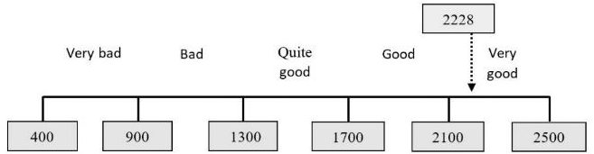
Figure 13. Continuous Lines for Physical Factors

  - RESPONDENT’S RESPONSE REGARDING THE PHYSICAL ASPECT VARIABLE OF CORRIDOR B

Table 10. Respondent’s Response Regarding Social Aspect Variable of Corridor B
No | Statement |  | Frequency (number of respondents)  on Likert Scale |  |  |  |  | Actual Score | Ideal Score
No |  |  | 5 | 4 | 3 | 2 | 1 | Actual Score | Ideal Score
1 | I feel past history and memory | 38 | 38 | 11 | 12 | 1 | 400 | 500 | 500
1 | I feel past history and memory | 38,0% | 38,0% | 11,0% | 12,0% | 1,0% | 5,0% | 500 | 500
2 | Masses and crowds are part of the ambiance | 41 | 46 | 10 | 3 | 0 | 425 | 500 | 500
2 | Masses and crowds are part of the ambiance | 41,0% | 46,0% | 10,0% | 3,0% | 0,0% | 35,0% | 500 | 500
3 | I feel a strong religious influence | 38 | 32 | 27 | 1 | 2 | 403 | 500 | 500
3 | I feel a strong religious influence | 38,0% | 32,0% | 27,0% | 1,0% | 2,0% | 27,0% | 500 | 500
4 | I see a distinct lifestyle which is linked to the religious atmosphere | 15 | 45 | 25 | 13 | 2 | 358 | 500 | 500
4 |  | 15,0% | 45,0% | 25,0% | 13,0% | 2,0% | 11,0% | 500 | 500
5 | I feel a friendly interaction between sellers and buyers | 13 | 44 | 26 | 17 | 0 | 353 | 500 | 500
5 | I feel a friendly interaction between sellers and buyers | 13,0% | 44,0% | 26,0% | 17,0% | 0,0% | 36,0% | 500 | 500
Total |  |  |  |  |  |  |  | Total | 23

Table 10 shows the highest score for the Social Aspect, obtained from statement number 2, with 425 points, while the lowest was in statement number 11, with 5 points. The total score was 2310, which lies in the excellent category, as shown by the position of the continuum line in the interval range of 2040 – 2520 in Figure 14.

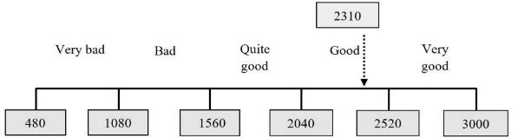
Figure 14. Continuum Line of Social Aspects Variable

  - RESPONDENT’S RESPONSE REGARDING THE LEVEL OF SENSE OF PLACE VARIABLE OF CORRIDOR B

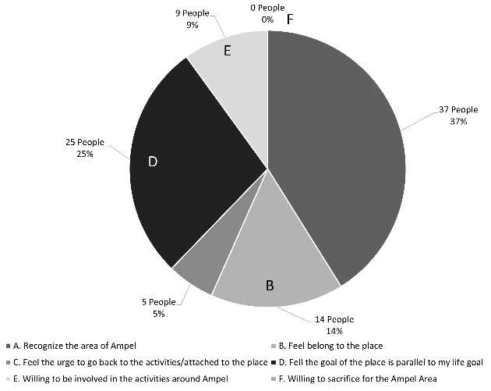
Figure 15. Respondent’s Response Regarding Level of Sense of Place Variable of Corridor

Figure 15 shows the highest percentage, 37%, for the social aspect, obtained from the statement “they recognize the Ampel area.” In contrast, the lowest score, 9%, was recorded for the willingness to participate in activities around Ampel.

  - RESPONDENT’S RESPONSE REGARDING THE LEVEL OF SENSE OF PLACE VARIABLE OF CORRIDOR B
The impact of the physical and social aspects on the sense of place was determined using the multiple linear regression analysis, which comprises the classical assumption test of corridor B, multiple linear regression equation, correlation analysis, and coefficient of determination analysis.

  - CLASSICAL ASSUMPTION TEST ON CORRIDOR B
The assumption Test on Corridor B was conducted before the formulation of the regression analysis to ensure the model provided an estimation that adhered to the BLUE (Best Linear Unbiased Estimator) properties. It included normality, multicollinearity, and heteroscedasticity tests. From those tests, it is concluded that the data were all normally distributed, there was no multicollinearity, and there was no heteroscedasticity problem in the data.

  - HYPOTHESIS TESTING FOR CORRIDOR B
For doing Simultaneous Hypothesis Testing on whether physical and social aspects jointly possess a significant influence over the sense of place, the following hypothesis testing was thus carried out:
H₀: β₁ = β₂ = β = 0 signifies that physical and social aspects do not significantly influence the sense of place.
H₁: β_{i} ≠ 0 signifies that physical and social aspects significantly influence the sense of place.
Level of significance (α): 0.05. Testing criteria: reject H₀ if F-count value> F-table, accept H₁. The F-test statistical value may be understood according to the following output table 10:

Table 11. F Value of Corridor B
ANOVAª
Model | Sum of Squares | df | Mean Square | F | Sig.
Regeression | 100,455 | 2 | 50,227 | 59,202 | 0,000^{b}
Residual | 82,295 | 97 | 0,848
Total | 182,750 | 99
a. Dependent Variable Sense of Place
b. Predictors: (Constant), Aspek Sosial, Aspek Fisik
The output table above shows that the calculated F-value is 59.202. This value will then be compared with the F-table value of 2.699. The values above show that the F-count value (59.202) > F-table (2.699), thus following the hypothesis testing criteria that H0 rejected, signifying that physical and social aspects together do possess a significant effect on the sense of place. To see in more detail the partial influence of each variable on the dependent variable, the following presents a partial hypothesis test using the t-test. Partial Hypothesis Testing (T-Test) to be tested in this partial test are as follows:
Ho1: β1= 0, the physical aspect does not significantly influence the sense of place. Hа₁: β₁ ≠ 0, the physical aspect does partially possess a significant influence over the sense of place.

Table 12. t-Value of Corridor B
Coefficientsª
Model | Unstandardized Coefficients |  | Standardized Coefficients | t | Sig.
Model | B | Std. Error | Beta | t | Sig.
(Constant) | -7,289 | 0,931 | 0 | -7,831 | 0,000
Aspek Fisik | 0,262 | 0,043 | 0,452 | 6,151 | 0,000
Aspek Sosial | 0,169 | 0,028 | 0,441 | 6,000 | 0,000
a. Dependent Variable Sense of Place

According to the output table 12 above, the t-count value obtained by the physical aspect variable reached 6.151. This value will then be compared to the t-table value in distribution table t. With α=0.05, df=n-k-1 =100-3-1=96 for the two-sided test, the t-table value is ±1.985. The values above show that the t-value for the physical aspect (6.151) > t-table (1.985) follows the hypothesis test that H0 is rejected, thus meaning that the physical aspect partially holds a significant influence over the sense of place. Ho₂: β₂= 0, the social aspect does not partially possess a significant influence over the sense of place. Hа₂: β₂ ≠ 0, the social aspect does partially possess a significant influence over the sense of place. The output table 12 above shows that the t-value obtained by the social aspect variable is 6.000. this value will then be compared to the t-table value in the t-distribution table. With α=0.05, df=n-k-1 =100-3-1=96 for the two-sided test, the t-table value is ±1.985. The values above show that the t-table value of the social aspect variable (6.000) > t-table (1.985) follows the hypothesis testing H0 is rejected, meaning that the social aspect partially possesses a significant influence over the sense of place

  - MULTIPLE LINEAR REGRESSION EQUATION FOR CORRIDOR B
The multiple linear regression analysis conducted using SPSS software shows a value of -7.289, b1 is 0.262, and b2 is 0.169. Therefore, the equation is:
Y = -7.289 + 0.262 X1 + 0.169 X2
Correlation Analysis calculated the strength of the linear association or link between the independent and dependent variables, and the partial and simultaneous results are presented as follows. The Pearson Product Moment method partially correlated the physical and social aspects of the sense of place. The coefficient values of the dependent and independent variables were interpreted using the guidelines formulated [61] and presented in Table 3.
The physical aspect, which was 0.618, belongs to the strong correlation level, and since the value is positive, the relationship between the two is one-tailed (directional). It means the higher the physical aspect, the higher the sense of place. The social aspect with 0.612 belongs to the strong correlation level, and since the value is also positive, the relationship between the two is one-tailed (directional). It means the higher the social aspect, the higher the sense of place

  - SIMULTANEOUS CORRELATION
The simultaneous correlation analysis shows the strength of all the links between the independent and dependent variables, and the coefficient value obtained using SPSS is presented as follows:

Table 13. Correlation analysis result Model summary
Model | R | R Square | Adjusted R Square | Std. Error of the Estimate
1 | 0,741ª | 0,550 | 0,540 | 0,92109
- Predictors: (Constant), Social Aspect, Physical Aspect
- Dependent Variable: Sense of Place

Table 13 shows that the value obtained by physical and social aspects towards the sense of place is 0.550, and the positive sign means the relationship is one-tailed (directional). It means the better the physical and social aspects, the better the sense of place. The coefficient of determination analysis was used to determine how significant the impact of independence is on the dependent variables. The value of the coefficient of determination (R-squared) is 0.550, which means the physical and social aspects contributed 55.0% to the sense of place. The remaining 100% - 55.0% = 45.0%, indicates the effects of other unassessed variables. The Beta value was multiplied by Zero Order to determine the variable with the most dominant impact, and the following results were obtained, as shown in Table 14.

Table 14. Coefficients determination Coefficients
Model | Standardized Coefficients | Correlations
Model | Beta | Zero-order
Physical Aspect | ,452 | ,618
Social Aspect | ,441 | ,612
- Predictors: (Constant), Social Aspect, Physical Aspect

Therefore, the impact of X1 towards Y = 0.452 x 0.618 = 0.280 or 28.0%. The impact of X₂ towards Y = 0.441 x 0.612 = -0.270 or 27. This means the physical aspect had the most dominant impact on the sense of place, with a contribution of 28.0%, while the smallest was provided by the social aspect, with 27.0%.

  - SIMULTANEOUS CORRELATION
Both analyses on corridors A and B above are shown in Figure 16 below.

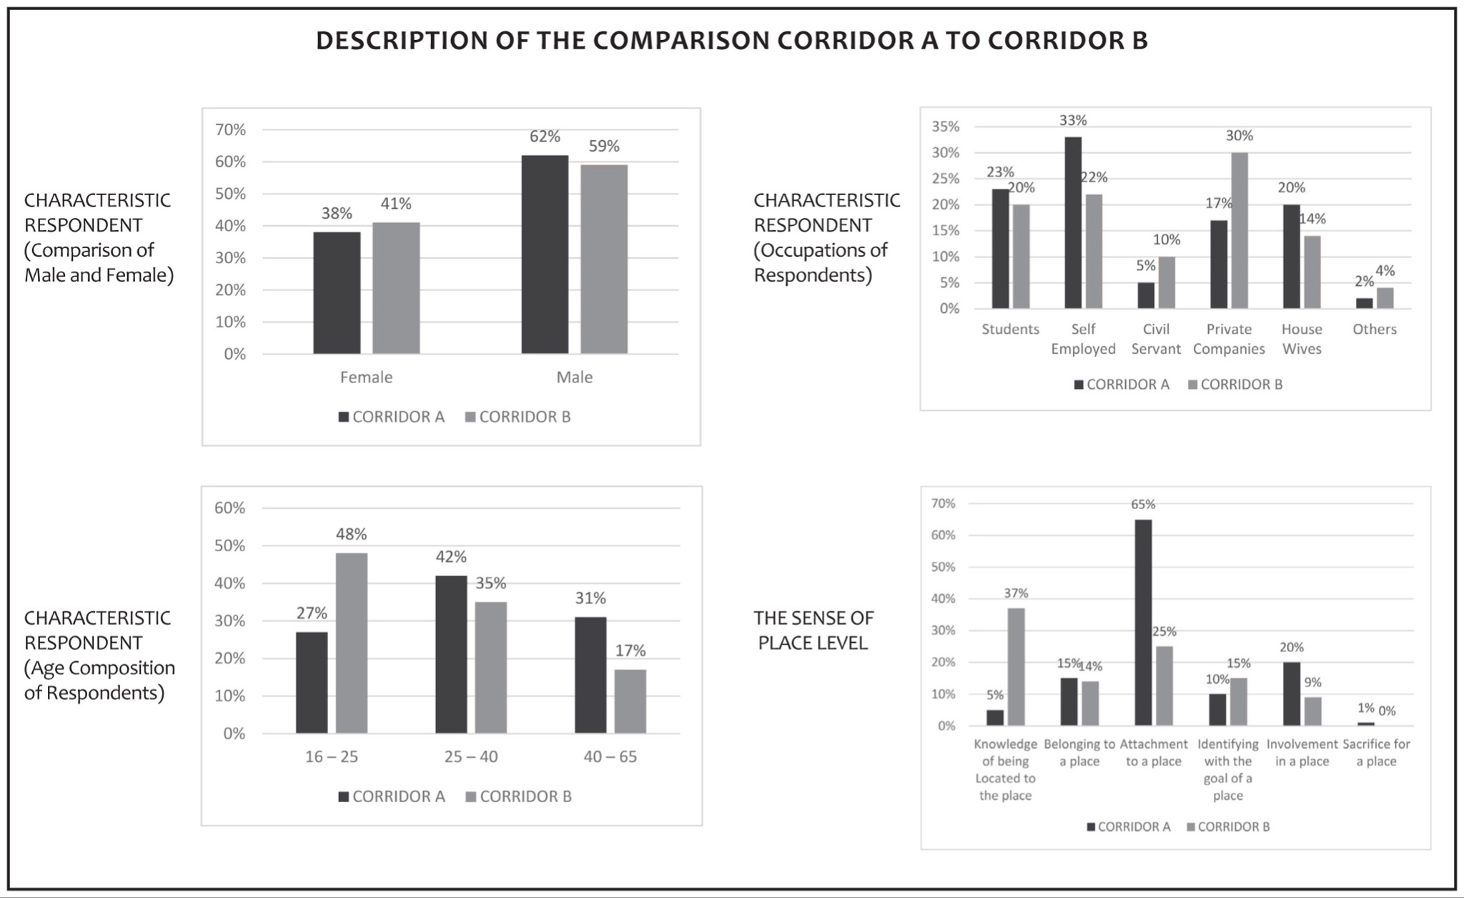
Figure 16. Findings Comparison between Corridor A to Corridor B

- RESULT AND DISCUSSION
The results are discussed in three segments: Corridor A, Corridor B, and the comparison between the two with the focus on the respondent's characteristics, perceptions of the factors influencing the calculation of descriptive statistics, and the effects of physical and social factors in creating a sense of place.

- CORRIDOR A
This is a crowded entrance usually used by groups of visitors on pilgrimage, with a public parking space observed adjacent to this area. The specific physical and social conditions, as well as visitor perceptions, are described as follows. The physical factor indicators perceived by the respondents to be the best, as shown in Table 1, include suitable corridor dimensions, natural lighting, product diversity, store arrangement, and easily recognized gate, as shown in Figure 17.
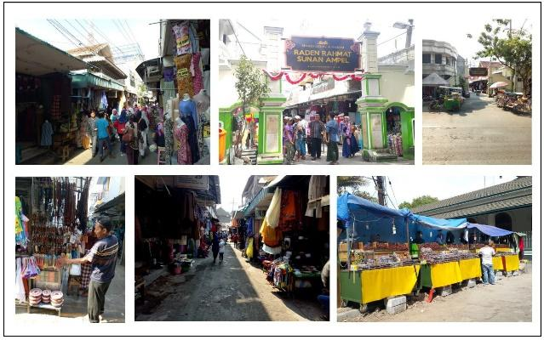
Figure 17. The physical factors of corridor A

Corridor A has a suitable corridor dimension, estimated to be 3 meters in size, allowing pedestrians to and from the Ampel area to flow. It was covered and broader compared to the height of the facade of the perimeter building at a ratio of 1:3/4. The comfort of a suitable corridor dimension led to a sense of place [17][18][20][21][40][62].
Concerning the natural lighting, the corridor is open and tends to feel hot, with daily temperatures varying from 30 to 34 degrees Celsius. However, lighting has been reported to have the ability to provide a different atmosphere, and this uniqueness is one of the drivers of a sense of place [17][18][21][40][62].
Product diversity is one of the identities of this place because different products are being sold by the traders in the area, including several perfume oils and souvenirs from Mecca, adult and children's clothing, food and drink, as well as religious or spiritual goods such as prayer beads, the Quran, and hijab bought by visitors on pilgrimage. It has, however, been reported in previous studies that product diversity is an attraction for shopping areas [15][17][20][21][62].
The aesthetic of the store display and arrangement is pleasing, but the arrangement is not neat compared to a shopping center. Several journals and researchers have attempted to describe the best ways of displaying in a pleasing composition structure [17][20], but the style used to arrange products on the sidewalk of this location is causing an aesthetic disorder.
From the design point of view, corridor A looks untidy; however, this characteristic gives it a distinct attractiveness as a main entrance. Walking along the corridor while looking at goods displayed can provide a new experience to visitors in corridor A. Monitoring and evaluation should also be improved and maintained as efforts to manage have been made. Corridor A becomes the main entrance for tourist groups with large vehicles like buses from different regions.
The indicators of social factors perceived to be the best by the respondents are presented in Table 2. They are associated with their history, distinct lifestyles linked to religion, religious influence, the formation of the crowd, and friendly buyer-merchant interaction (Figure 18). From a historical perspective, Sunan Ampel became the central figure and role model, so the grave of Sunan Ampel became the magnet and center of the arrangement of this area, as studied by Hamiyatun [48]. Distinct lifestyles, such as the use of hijab by women, prayer beads, and Koko (local Moslem) clothes for men, are daily activities in the area. These findings align with the study of Ningrum and Yani [50].

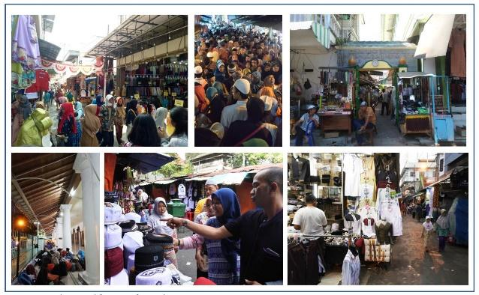
Figure 18. The social factors of corridor A
In this area, density and crowds are caused by two factors: the main activity in trading (buying-selling process) and story-telling along the corridor; second, visitors visiting the odd event of Ramadhan. This factor is an essential aspect of the shopping environment, as shown in previous studies conducted in other commercial areas [15][18][20][21][26].
Friendly buyer-merchant interaction reflects the public hospitality attribute exhibited in this corridor. This aspect is necessary because social interaction is significant in creating a sense of place [10][15][5][21][6][26][50].
Concerning the sense of place level, the third statement focused on the respondents’ attachment to the place, which has the highest number of 65. One of the respondents was even discovered to have felt this corridor has the highest level of sense of place due to the fact it is the main entrance to participate in pilgrimage activities. The area associated with religion can have a sense of place and form a place attachment, as studied by Mazumdar, Mazumdar & Mazumdar, and Nikjoo [36][37][38].
According to the multiple linear regression analysis, physical and social factors were discovered to have contributed to the creation of a sense of place with a value of 56.6%, categorized in the medium range. This means other factors not defined in this research also influence the formation of the sense of place. The medium-scale rating was associated with the visitor’s motivation and knowledge of the area as a location for religious activities.

- CORRIDOR B
This is the Ampel Suci corridor facing Sasak Road, located in a trading area adjacent to the market. As seen in Figure 19, the indicators discovered to have good value in this corridor are natural lighting, easily recognized gates, product diversity, and many openings to other villages, as seen in Figure 19.

Figure 19. The physical factors of corridor B

First, the natural lighting originates from the side area of the corridor, which has many openings to the villages around it. It has been reported in previous studies that good lighting encourages the atmosphere and formation of a sense of place [17][18][20][62][40].
The features and indicators, such as the gates of the corridor, are easily identified, especially because it was built in the 1930s, making it look antique and ancient and providing a unique visual identity. The gates in this area are also symbols that provide hierarchy and meaning [45]. The existence of this focal point serves as a marker for this corridor which has been reported to have the ability to drive a sense of place [10][13][17][18][20][21][40][62]. It is important to note that most of the products sold in this corridor are similar to those in corridor A.
The stores along the corridor have a fairly standard arrangement. They are observed to have survived for a long time without any changes from the beginning of the commercial activities in the corridor. They are built to have an average height of 15 cm from the leveling floor with typical glass shelves, and the number of displays shows the types of products being sold. This is in line with the findings of previous studies that store arrangement in commercial areas contributes to the creation of a sense of place [10][20][21][33][34][40][47][62].
This corridor specifically has a lot of openings to other Kampongs, making the Tomb of Sunan Ampel and the mosque appear at the center of the community. The corridor is the main axis directing the movement of the visitors, especially to the mosque, and this study found that the openings are its specific characteristics.
The ornament in the ceiling attached to the frame is a typical ornamental element of this corridor and serves as a decoration that visually beautifies it. Previous researchers have reported that ornaments used in thematic areas assist in creating a sense of place [10][17][21]. The use of green and yellow colors is interpreted by Islamic philosophy. The yellow color describes the state of humans in the world. The color green symbolizes Earth, Heaven, and Dreams [45]. Compared to the original condition, the corridor’s design has changed. Initially, it was only corridors; however, later on, permanent and temporary small stores and kiosks can be found in some parts of the corridor. The local government has managed the addition of corridor roofs to protect visitors who come from this entrance so they can perform prayers without being interrupted by the weather.
Moreover, ornaments are added to the ceiling frames as accessories. Corridor B attempts to be a transitional room that mediates between the outdoor area, the cemetery area, and the Sunan Ampel Mosque, especially for pedestrians and local visitors. The motifs of gates and other areas are usually in the form of climbing plants, eight-crown flowers, and geometrical shapes because, according to Islam’s teachings, they forbid animal and human ornaments.
The results also showed that the respondents’ overall perception of the social factors of corridor B was excellent. Those with the highest values include “the ambiance of Masses and crowds,” “I can feel a strong religious influence,” “I can feel history,” “a strong Arabian Ambiance,” and “I can feel a religious atmosphere.” These are observed to be the same as those recorded in corridor A except for the history and strong Arabian ambiance.
The past problems of this corridor are inseparable from the history of Sunan Ampel as the propagator of Islam on Java Island, and this contributed a lot to the sense of place with similar findings reported in some literature [48][63]. Meanwhile, the strong Arabian ambiance is reflected in several sellers with Arab descendants and the significant sale of Mecca products in the area. This means the existence of certain ethnicities, as well as the stylish dress and accent of the inhabitants, make a visual and auditory impression and serve as one of the sources of attraction for visitors. Social interaction in the area, in particular, was studied by Ningrum and Yani [50]. This aligns with previous findings that ethnic and unique social conditions aid the formation of a sense of place in this region [21][26].

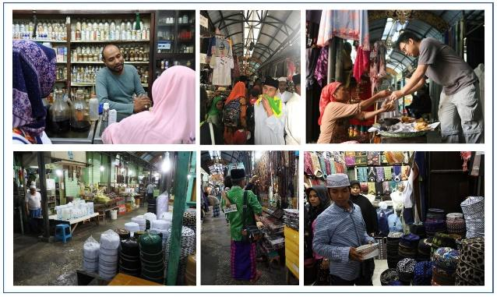
Figure 20. The social factors of Corridor B

According to the multiple linear regression analysis, the highest percentage of visitors' perception of the Sense of Place was recorded with the statement in Figure 14, which involves recognizing the Ampel area as indicated by 37%, followed by the attachment to the place with 25%. Moreover, the physical and social factors also contributed, on average, to the sense of place, as indicated by the medium contribution of 55%, as shown in Figure 15. Each factor was observed to have contributed almost equally, with the physical recorded having 28% while the social was 27%. The relationship between physical and social conditions in creating a sense of place supports the study of Mazumdar, Mazumdar & Mazumdar, and Nikjoo [36][37][38].

- COMPARISON BETWEEN CORRIDOR A AND B
When the characteristics of respondents are compared, it can be found that in both corridors, men were observed to be more frequent, and this could be associated with the fact that data were collected after sunset, when they were freer to be present at the mosque compared to the women. In corridor A, visitors aged between 25 and 65 were more dominant. Most of the respondents in corridor A were self-employed, while those in B were mainly employees.
In corridor A, most visitors represented 85%, reached the sense of place with higher intentionality between levels 3 and 6. This was because it serves as the entrance for pilgrims, individually and in groups, and influences greater intentionality based on spiritual rather than narrative and commodified reasons, which can be understood as the pilgrimage is essential from a Muslim perspective [33]. In corridor B, respondents with a lower sense of place at levels 1 to 2 dominated with 51%, while those with levels 3 to 6 were 49%. It is the entrance through the Sasak Road area with complex trades, and the diverse intentionality was associated with the different relations, including the spiritual due to its function as an area for pilgrimage trips, commodified as a shopping place, and narrative relation based on its historical background. This pilgrim process involves various traditions; one example is souvenirs, which are crucial in extending and commemorating the pilgrimage experience. These souvenirs are tangible reminders of their pilgrimage experience and are often shared with family and friends upon their return [34].

- THE COMPARISON OF THE CORRELATION BETWEEN THE PHYSICAL AND SOCIAL FACTORS AND THE LEVEL OF SENSE OF PLACE
Both corridors were observed to have created a medium sense of place based on the average social and physical factors contribution in the 55-58% range. However, A had a slightly higher attachment value of 58% and 3.6% more than B due to the following:
1. The medium level was between 55 and 58%, considering it is a religious location, and data were obtained at the peak season. However, it supports the statement that these parts of religious areas provide a sense of place, attachment, and loyalty to their visitor [36][37][38].
2. Respondents in corridor A have greater engagement intentionality, as observed in 86% with level three and above for the sense of place compared to the 49% recorded in corridor B. This is because it is the main entrance, with more visitors entering through it to other areas. Gate A is near bus access or large vehicles to pick up groups of pilgrims who will visit. This is also supported by the width of the corridor, which is appropriate and provides comfort to the pilgrims. The comfort of a suitable corridor dimension led to a sense of place [17][18][20][21][62][40]. Moreover, it has more mature visitors between 25 and 65 years compared to the 16-40 years found in corridor B.

- COMPARISON OF THE CONTRIBUTING FACTORS
The results showed that social factors contributed more to corridor A, while the factors were almost the same for corridor B. The multiple linear regression analysis, therefore, showed that the physical and social factors of the corridors located in the historical religious area contributed to shaping the region’s sense of place on a medium scale. Moreover, although two different corridors with slightly different variables and indicators were studied, almost the same medium-scale effect was observed in each, with 58.6% and 56% recorded in corridors A and B, respectively. However, the contributions of the factors are presented in Figure 15.
There are variations in the level of sense of place, and, based on the information provided in Figure 15, corridor A, with more visitors visiting for spiritual-focused relations, was discovered to have a higher level. In contrast, corridor B had more varied levels, with visitors visiting for different activities. Moreover, the age of visitors also determines the level of maturity in their perception of a place, such as the existence of spirituality in the researched area, which further affects the level of sense of place. It was also discovered that the respondents’ relationship with the place also influenced this level. The results are in line with the statement that an area associated with religion can have a sense of place and form a place attachment, as studied by Mazumdar, Mazumdar & Mazumdar, and Nikjoo [36][37][38].

- CONCLUSION
The results showed that the influence of physical and social factors of both corridors on the sense of place is in the medium range. However, this contribution is affected by different indicators such as the reasons for visiting, the age of visitors, and several other attributes.
This research is limited to corridors in historic commercial areas that also function as pilgrimage areas. These corridors are the two main routes to the tomb of Sunan Ampel and the Great Ampel Mosque, with data obtained from 100 pilgrims in each corridor during the month of Ramadan on odd nights, which is the peak of pilgrim visits so that it can be known the factors that are considered essential to form a sense of place from these corridors based on the point of view of this specific group of pilgrims.
Both corridors are recommended to preserve the indicators found to be good in this study, while others should be improved. This should be a collaboration between the Ampel corridor managers, traders, and the Surabaya city government to strengthen the sense of place and ensure it becomes an asset to the city. Additionally, exploring the roles and responsibilities of the Ampel corridor managers, traders, and the Surabaya city government in urban development and placemaking would provide valuable insights into the potential mechanisms for collaboration and improvement. Furthermore, analyzing successful case studies of collaborative urban development initiatives in other cities could offer valuable lessons and best practices that apply to a similar situation in Surabaya.
REFERENCES

[1] Y.-F. Tuan, Space, and Place: The Perspective of Experience. Minneapolis: University of Minnesota Press, 1977.
[2] J. E. Cross, “What is Sense of Place ?,” in The 12th Headwaters Conference, 2001, no. 3, pp. 1–14.
[3] E. C. Relph, Place and Placelessness. London: Pion, 1976.
[4] A. Kusumowidagdo, N. Ujang, M. Rahadiyanti, and N. A. Ramli, “Exploring the Sense of Place of Traditional Shopping Streets through Instagram’s Visual Images and Narratives,” Open House Int., vol. 48, no. 1, pp. 2–22, Jan. 2023, doi: 10.1108/OHI-01-2022-0009.
[5] N. Ujang, “Place Meaning and Significance of the Traditional Shopping District in the City Centre of Kuala Lumpur, Malaysia,” Int. J. Archit. Res., vol. 8, no. 1, pp. 66–77, 2014, doi: 10.26687/archnet-ijar.v8i1.338.
[6] M.-L. Johnstone and D. M. Conroy, “Place Attachment: The Social Dimensions of the Retail Environment and the Need for Further Exploration,” Adv. Consum. Res., vol. 35, pp. 381–386, 2008.
[7] S. Dadfar and F. F. Heydari, “The Impact of Urban Parks on Citizens’ Place Attachment (Case Study: Bagh Mohtasham of Rasht),” Asian J. Water, Environ. Pollut., vol. 15, no. 2, pp. 37–46, 2018, doi: 10.3233/AJW-180016.
[8] A. Debenedetti, H. Oppewal, and Z. Arsel, “Place Attachment in Commercial Settings: A Gift Economy Perspective,” J. Consum. Res., vol. 40, no. 5, pp. 904–923, 2014, doi: 10.1086/673469.
[9] R. Gholamhosseini, “A Living Room in the City: The Place of Public Space in the Everyday Lives of Middle Eastern Women in Greater Brisbane,” The University of Queensland, 2017.
[10] N. Thungsakul and D. Nilsakul, “Place Attachment in an Old Commercial District: A Case Study in Ubon Ratchathani, Thailand,” Kasetsart J. Soc. Sci., vol. 41, no. 1, pp. 169–175, 2020, doi: 10.1016/j.kjss.2018.04.002.
[11] F. Zarrabi and P. Imani, “The Role of Building Façade on Place Attachment (Case study: Apadana and Ekbatan Town),” Int. J. Res. Appl. Sci. Eng. Technol., vol. 7, no. 8, pp. 175–183, 2019, doi: 10.22214/ijraset.2019.8021.
[12] Y. Zhang and T. Wei, “Typology of Religious Spaces in the Urban Historical Area of Lhasa, Tibet,” Front. Archit. Res., vol. 6, no. 3, pp. 384–400, 2017, doi: 10.1016/j.foar.2017.05.001.
[13] J. S. Goussous and N. A. Al-Hammadi, “Place Attachment Assessment of a Heritage Place: A Case Study of the Roman Amphitheater in Downtown Amman, Jordan,” Front. Archit. Res., vol. 7, no. 1, pp. 1–10, 2018, doi: 10.1016/j.foar.2017.12.001.
[14] R. Furlan, A. Petruccioli, and M. Jamaleddin, “The Authenticity of Place-Making: Space and Character of the Regenerated Historic District in Msheireb, Downtown Doha (State of Qatar),” Archnet-IJAR, vol. 13, no. 1, pp. 151–168, 2019, doi: 10.1108/ARCH-11-2018-0009.
[15] S. Shamsuddin and N. Ujang, “Making Places: The Role of Attachment in Creating the Sense of Place for Traditional Streets in Malaysia,” Habitat Int., vol. 32, no. 3, pp. 399–409, 2008, doi: 10.1016/j.habitatint.2008.01.004.
[16] A. Kusumowidagdo and D. K. Wardhani, “Commercial Corridor as a Place for Creating a Great Sense of Place: A Literature Review on Four Locations of Commercial Corridor,” GSTF J. Eng. Technol., vol. 5, no. 1, pp. 1–6, 2018.
[17] D. K. Wardhani and A. Kusumowidagdo, “Authenticity of the Physical Environment that Influences a Sense of Place: A 1ualitative Study at Ampel Street Corridor, Surabaya, Indonesia,” in Cities’ Identity Through Architecture and Arts, 1st ed., London: Routledge, 2018, pp. 213–220.
[18] M. Tandon and V. Sehgal, “Traditional Indian Religious Streets: A Spatial Study of the Streets of Mathura,” Front. Archit. Res., vol. 6, no. 4, pp. 469–479, 2017, doi: 10.1016/j.foar.2017.10.001.
[19] A. Kusumowidagdo, A. Sachari, and P. Widodo, “Shoppers’ Perception on Physical Condition of Shopping Centers’ Atmosphere at Different Lifecycle,” Int. Res. J. Bus. Stud., vol. 5, no. 2, pp. 87–100, 2012, doi: 10.21632/irjbs.5.2.87-100.
[20] A. Kusumowidagdo, A. Sachari, and P. Widodo, “Visitors ’ Perception towards Public Space in Shopping Center in the Creation Sense of Place,” Procedia - Soc. Behav. Sci., vol. 184, pp. 266–272, 2015, doi: 10.1016/j.sbspro.2015.05.090.
[21] N. Ujang and S. Shamsudin, “The Influence of Legibility on Attachment towards the Shopping Streets of Kuala Lumpur,” Pertanika J. Soc. Sci. Humanit., vol. 20, no. 1, pp. 81–92, 2012.
[22] M. Ghouchani and M. Taji, “Promoting Spirituality in the Architectural Thought of the Mosque: A Sense of Place Approach,” J. Islam. Archit., vol. 6, no. 3, pp. 151–159, 2021, doi: 10.18860/jia.v6i3.10303.
[23] M. Najafi and M. K. B. M. Shariff, “The Concept of Place and Sense of Place In Architectural Studies,” Int. J. Humanit. Soc. Sci., vol. 5, no. 8, pp. 1054–1060, 2011, doi: 10.5281/zenodo.1082223.
[24] D. G. Özkan and S. Yilmaz, “The Effects of Physical and Social Attributes of Place on Place Attachment: A Case Study on Trabzon Urban Squares,” Int. J. Archit. Res., vol. 13, no. 1, pp. 133–150, 2019, doi: 10.1108/ARCH-11-2018-0010.
[25] R. C. Stedman, “Is It Just a Social Construction?: The Contribution of the Physical Environment to Sense of Place,” Soc. Nat. Resour., vol. 16, pp. 671–685, 2003, doi: 10.1080/08941920390217627.
[26] A. Kusumowidagdo and D. K. Wardhan, “Investigating a Sense of Place at a Historic Commercial Street Corridor: Visitor Perception of Social Aspects,” in Cities’ Identity Through Architecture and Arts, 1st ed., London: Routledge, 2018, pp. 255–261.
[27] G. Kyle and G. Chick, “The Social Construction of a Sense of Place,” Leis. Sci. An Interdiscip. J., vol. 29, no. 3, pp. 208–225, 2007, doi: 10.1080/01490400701257922.
[28] F. Lyu, “Architecture as Spatial Storytelling: Mediating Human Knowledge of the World, Humans and Architecture,” Front. Archit. Res., vol. 8, no. 3, pp. 275–283, 2019, doi: 10.1016/j.foar.2019.05.002.
[29] R. C. Stedman, “Toward a Social Psychology of Place Predicting Behavior from Place-Based Cognitions, Attitude, and Identity,” Environ. Behav., vol. 34, no. 5, pp. 561–581, 2002, doi: 10.1177/0013916502034005001.
[30] W. Nurjayanti, “Historical, Philosophical, and Contextual Values in Al-Wustho Mangkunegaran Mosque, Surakarta,” J. Islam. Archit., vol. 7, no. 2, pp. 210–219, 2022, doi: 10.18860/jia.v7i2.15609.
[31] S. Shamai, “Sense of Place : An Empirical Measurement,” Geoforum, vol. 22, no. 3, pp. 347–358, 1991, doi: 10.1016/0016-7185(91)90017-K.
[32] F. Steele, The Sense of Place, 1st ed. Boston: CBI Pub Co, 1981.
[33] M. M. Mujib, “Tradisi Ziarah dalam Masyarakat Jawa: Kontestasi Kesalehan, Identitas Keagamaan dan Komersial,” Ibda’ J. Kebud. Islam, vol. 14, no. 2, pp. 205–225, 2016, doi: 10.24090/ibda.v14i2.673.
[34] H. Kaell, “Of Gifts and Grandchildren : American Holy Land souvenirs,” J. Mater. Cult., vol. 17, no. 2, p. 1, 2012, doi: 10.1177/1359183512443166.
[35] N. Ujang and K. Zakariya, “Attachment and the Value of Place in the Life of the Users,” Procedia - Soc. Behav. Sci., vol. 168, pp. 373–380, 2015, doi: 10.1016/j.sbspro.2014.10.243.
[36] S. Mazumdar and S. Mazumdar, “Religion and Place Attachment: A Study of Sacred Places,” J. Environ. Psychol., vol. 24, pp. 385–397, 2004, doi: 10.1016/j.jenvp.2004.09.003.
[37] S. Mazumdar, “Religious Place Attachment, Squatting, and ‘‘ Qualitative ’ ’ Research: A Commentary,” J. Environ. Psychol., vol. 25, pp. 87–95, 2005, doi: 10.1016/j.jenvp.2004.09.003.
[38] A. Nikjoo, M. S. Tehrani, M. Karoubi, and A. Siyamiyan, “From Attachment to a Sacred Figure to Loyalty to a Sacred Route: The Walking Pilgrimage of Arbaeen,” Religions, vol. 11, no. 145, pp. 1–12, 2020, doi: 10.3390/rel11030145.
[39] J. Zacharias, “The Impact of Layout and Visual Stimuli on the Itineraries and Perceptions of Pedestrians in a Public Market,” Environ. Plan. B Urban Anal. City Sci., vol. 23, pp. 23–35, 1997, doi: 10.1068/b240023.
[40] J. Zacharias, “Choosing a Path in the Underground: Visual Information and Preference,” in Associated Research Centers for the Urban Underground Space International Conference, 2002, pp. 1–9.
[41] S. Shamsuddin, A. B. Sulaiman, and N. H. Jaafar, “The Traditional Shopping Streets and Its Attractions to the Users,” in Urban Design Issues in the Developing World: The Case of Malaysia and Nigeria, 1st ed., Skudai: Universiti Teknologi Malaysia, 2008, pp. 42–63.
[42] N. Ujang, “Defining Place Attachment in Asian Urban Places through Opportunities for Social Interactions,” in 6 th Asia Pacific International Conference on Environment-Behaviour Studies, 2016, vol. 1, no. 1, pp. 28–35, doi: 10.21834/e-bpj.v1i1.191.
[43] F. Haq, “Islamic Spiritual Tourism: An Innovative Marketing Framework,” Int. J. Soc. Entrep. Innov., vol. 2, no. 5, pp. 438–447, 2013, doi: 10.1504/IJSEI.2013.059320.
[44] P. Wahyudie, Antariksa, L. D. Wulandari, and H. Santosa, “Local Wisdom of Gapura in Sunan Ampel Mosque based on the Place Attachment Theory,” Civ. Eng. Archit., vol. 9, no. 7, pp. 2147–2159, 2021, doi: 10.13189/cea.2021.090704.
[45] A. G. Syafi’i, “Warna dalam Islam,” J. An-Nida’, vol. 41, no. 1, pp. 62–70, 2017, doi: 10.24014/an-nida.v41i1.4637.
[46] H. Hidayat, “Simbolisasi Warna dalam Al- Qur’an,” MAGHZA J. Ilmu Al-Qur’an dan Tafsir, vol. 5, no. 1, pp. 36–50, 2020, doi: 10.24090/maghza.v5i1.3638.
[47] T. C. Melewar and H. Skinner, “Why Would Anyone Come to Corfu to Have a Heineken ?,” Qual. Mark. Res., vol. 23, no. 4, pp. 891–906, 2020, doi: 10.1108/QMR-05-2018-0044.
[48] N. Hamiyatun, “Peranan Sunan Ampel dalam Dakwah Islam dan Pembentukan Masyarakat Muslim Nusantara di Ampeldenta,” Dakwatuna J. Dakwah dan Komun. Islam, vol. 5, no. 1, pp. 38–57, 2019, doi: 10.36835/dakwatuna.v5i1.321.
[49] I. Indrawati, N. Nurhasan, and S. Soetomo, “The Shifting of Islamic Heritage from Education Center to Worship Tomb (The Effect of the Political Policy),” J. Islam. Archit., vol. 7, no. 1, pp. 11–18, 2022, doi: 10.18860/jia.v7i1.15127.
[50] T. A. Ningrum and M. T. Yani, “Pola Interaksi Sosial Antar Pedagang di Wilayah Ampel Surabaya,” J. Mhs. Univ. Negeri Surabaya, vol. 2, no. 3, pp. 497–511, 2015.
[51] C. N. Schulz, Genius Loci: Towards a Phenomenology of Architecture. New York: Rizzoli, 1979.
[52] D. V Canter, The Psychology of Place. New York: Architectural Press, 1977.
[53] D. Daniswari, “Batas Wilayah Indonesia: Astronomis dan Geografis,” Kompas.com. 2022.
[54] J. W. Creswell and J. D. Creswell, Research Design: Qualitative, Quantitative, and Mixed Methods Approaches, 5th ed. Thousand Oaks: SAGE Publications, 2018.
[55] J. F. Hair, W. C. Black, B. J. Babin, and R. E. Anderson, Multivariate Data Analysis, 7th ed. London: Pearson, 2009.
[56] S. M. Mojtabavi, G. Motalebi, and S. H. G. Far, “An Analysis of Influential Factors in Developing a Sense of Place Attachment (Case Study: Tajrish Bazaar),” Bagh-E Nazar, vol. 18, no. 105, pp. 37–54, 2022, doi: 10.22034/BAGH.2021.293542.4931.
[57] Sugiyono, Metodelogi Penelitian Kuantitatif, Kualitatif, dan R&D, 1st ed. Bandung: Alfabeta, 2019.
[58] W. D. Yumnahanin and S. Rukayah, “Correlation between Visual Characters and Sense of Place in Kampung Pelangi Semarang,” J. Archit. Environ., vol. 22, no. 2, pp. 141–152, 2023, doi: 10.12962/j2355262x.v22i2.a16873.
[59] A. Zahid and D. Misirlisoy, “Measuring Place Attachment, Identity, and Memory in Urban Spaces: Case of the Walled City of Lahore, Pakistan,” J. Archit. Urban., vol. 45, no. 2, pp. 171–182, 2021, doi: 10.3846/jau.2021.15183.
[60] F. Wang, T. Xue, T. Wang, and B. Wu, “The Mechanism of Tourism Risk Perception in Severe Epidemic—The Antecedent Effect of Place Image Depicted in Anti-Epidemic Music Videos and the Moderating Effect of Visiting History,” Sustain., vol. 12, no. 13, pp. 1–16, 2020, doi: 10.3390/su12135454.
[61] Sugiyono, Statistik Nonparametris untuk Penelitian. Bandung: Alfabeta, 2015.
[62] G. Carmelino and T. Hanazato, “The Built Environment of Japanese Shopping Streets as Visual Information on Pedestrian Vibrancy,” Front. Archit. Res., vol. 8, no. 2, pp. 261–273, 2019, doi: 10.1016/j.foar.2019.01.003.
[63] A. S. Budiarto, Indriastjario, and A. B. Sardjono, “The Urban Heritage of Masjid Sunan Ampel Surabaya, Toward the Intelligent Urbanism Development,” Procedia - Soc. Behav. Sci., vol. 227, pp. 601–608, 2016, doi: 10.1016/j.sbspro.2016.06.121.

