 |  | JOURNAL OF ISLAMIC ARCHITECTURE  P-ISSN: 2086-2636 E-ISSN: 2356-4644  Journal Home Page: http://ejournal.uin-malang.ac.id/index.php/JIA
IMPROVED ACCESSIBILITY FOR PEOPLE WITH DISABILITIES AT THE SHEIKH ZAYED GRAND MOSQUE USING A UNIVERSAL DESIGN APPROACH
Bambang Suhardi^{a*}, Muhammad Fawad Nurazizi^{b}, Irwan Iftadi^{c}
ªDepartment of Industrial Engineering, Universitas Sebelas Maret, Indonesia
^{b}Department of Industrial Engineering, Universitas Sebelas Maret, Indonesia
^{c}Department of Industrial Engineering, Universitas Sebelas Maret, Indonesia
*Corresponding Author: bambangsuhardi@staff.uns.ac.id
ARTICLE INFO |  |  | ABSTRACT
Volume: 8  Issue: 1  Page: 269-282  Received: August 28th, 2023  Accepted: October 10th, 2023  Available Online: June 15th, 2024  DOI:  http://dx.doi.org/10.18860/jia.v8i1.23412 |  |  | People with disabilities must be considered as one of the Sheikh Zayed Grand Mosque user groups. This happens because of the lack of accessible facilities and it is not in accordance with the standards set by the government. Therefore, it is necessary to conduct a research to determine whether the Sheikh Zayed Grand Mosque has met the accessibility criteria. The research aims to determine the accessibility of the Sheikh Zayed grand mosque. The results of the assessment are used as a basis for making improvements in the mosque accessibility. The method used is filling out an accessibility check sheet. The checklists are developed from the regulation of the Minister of Public Works and Housing of the Republic of Indonesia number 14/PRT/M/2017 and universal design. The level of accessibility is also determined based on the same regulation and universal design. The areas studied include: circulation/corridor, entrance/exit, ramp, stair/lift, handrail, wudu area, toilet, prayer room, parking area, as well as signs and information. The results of the accessibility index assessment showed that six areas of the mosque were categorized as accessible, two areas of the mosque were categorized as less accessible, and two areas of the mosque were categorized as inaccessible. Proposed improvements were made to the circulation area, ramps, stairs/elevators, handrails, wudhu areas, toilets, prayer rooms, parking areas, as well as signs and information.  Keywords:  Accessibility; Disabilities; Mosque; Regulation; Universal Design

- INTRODUCTION
Mosque is one of the very important facilities for Muslims to fulfill their obligations both for normal individuals and individuals with disabilities. In its development, mosque does not only serve as a place of worship, but it has other functions such as social, educational, and economic functions. With the development of the function of this mosque, the visitors will also improve, in terms of having different purposes including worship, tourism, education, social and others.
People with disabilities are one of the groups of mosque users who need to be considered because of the lack of accessible facilities and it is not in accordance with the standards set by the government for people with disabilities. The importance of accessible facilities provided for people with disabilities in the mosque needs to be considered so that people with disabilities can reach a place both inside and outside the mosque without obstacles.
Accessibility in the mosque environment is an important issue that needs to be discussed to create public spaces that are friendly and comfortable for all people [1]. Accessibility provides convenience for people with disabilities to achieve an equality of opportunity in all aspects of life [2]. A person with disabilities is any person who experiences physical, intellectual, mental, or sensory limitations over a long time who, in interacting with the environment may experience obstacles and difficulties to participate fully and effectively with other citizens based on equal rights [3]. The government and society must ensure the availability of inclusive public facilities to achieve equal rights for people with disabilities, having no difference compared to the general public.
The design of public facilities needs to consider the principles of universal design. Universal design is a design to create products, environments, programs, and services that everyone can use without the need to specifically design something for certain parties. Still, the design can also be used by the community in general [4]. The construction of places of worship needs to integrate the principles of universal design into the architectural design of the mosque so that it can be accessed and used by all worshipers. In the convention on the rights of persons with disabilities, accessibility, particularly for persons with disabilities, has been discussed and regulated in the regulation of The Ministry of Public Works and Housing number 14/PRT/M/2017 [5]. However, there are still many accessibility issues in Indonesia to be evaluated.
In real situations, disability-friendly places of worship are still very limited in Indonesia. It is the government's responsibility to provide public facilities, including mosques, to be disability-friendly. Sheikh Zayed Grand Mosque is a new mosque inaugurated on November 17, 2022, and is the largest mosque in Surakarta (Figure 1). The survey showed that Sheikh Zayed Grand Mosque is not friendly to people with disabilities. These are indicated from: 1) ramp access to enter the mosque yard is too steep for wheelchair users, 2) the handrail provided on the ramp is not strong, 3) parking areas, prayer areas, and toilets are not disability-friendly, 4) installation of signs that are less communicative for mosque visitors, 5) installation of safety signs that are not appropriate.

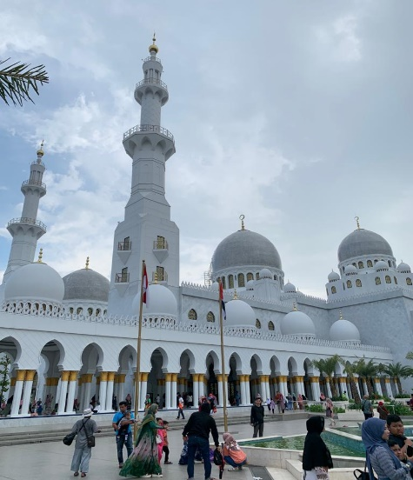
Figure 1. Sheikh Zayed Grand Mosque
Based on these problems, it is necessary to do a research to evaluate the accessibility of the Sheikh Zayed Grand Mosque and provide suggestions for improving its facilities. The evaluation of mosque accessibility in this study is based on the regulation of The Ministry of Public Works and Housing number 14/PRT/M/2017 [5] and Universal Design Handbook [6].
Previous research [7] only assessed the accessibility of four mosque facilities based on the Malaysian Standard of MS 1184; 2004. Evaluation of the wudu or ablution room was performed by Yumadhika and Sholihah [8] using the regulation of The Ministry of Public Works and Housing number 14/PRT/M/2017 [5]. Meanwhile, Aji, et.al (2022?) [9] evaluated the accessibility of seven mosque facilities using the regulation [5].

- METHODS
The data collection was conducted by conducting interviews with mosque administrators and people with disabilities who happened to be in the mosque. People with disabilities in this study are people with physical disabilities (quadriplegic) and people with sensory disabilities (deaf and blind). The references used in this research are the regulation of The Ministry of Public Works and Housing number 14/PRT/M/2017 [5], Universal Design Handbook [6], and the research conducted by Maftuhin [10].
This research will be divided into 3 stages as follows:
1. Evaluate the accessibility of mosques using the checklists developed from the regulation of The Ministry of Public Works and Housing number 14/PRT/M/2017 [5] and Universal Design Handbook [6]. The checklist is shown in Table 1. Steps to evaluate the accessibility of the mosque are as follows:
a) Observing the condition of the mosque in accordance with the indicators contained in the checklist.
b) Making documentation of the condition of the mosque
c) Holding a discussion with the mosque administrator regarding the accessibility condition of the mosque based on the indicators contained in the checklist.
d) Filling out a checklist based on observations and discussions conducted with the mosque administrator.
e) The checklist assessment validation process is compared with the standards list in the regulation of The Ministry of Public Works and Housing number 14/PRT/M/2017 [5] and Universal Design Handbook [6].
2. Calculate the value of the mosque accessibility index with the following conditions:
a) Each answer choice for each sub-aspect of the accessibility assessment indicator was given weight. The weight of the accessible assessment was two, the weight of the less accessible assessment was one, and the weight of the non-accessible assessment was zero.
b) The accessibility assessment recapitulation process was calculated by weight and divided by the maximum score.
c) The results of the accessibility index calculation are compared with the accessibility index in Table 5 [10]; if the accessibility index results show a range between 0.00-0.33 is considered not accessible, 0.34-0.66 is considered as less accessible, and 0.67-1.00 is considered as accessible.
3. Make suggestions for improvements to mosque facilities based on accessibility index values. Mosque facilities that are repaired are the facilities with inaccessible criteria.

- RESULT AND DISCUSSION
An observation of the visitors with disabilities was carried out to determine the activities in the mosque area, ranging from dating to completion of the prayer activities [11]. Starting from the particular parking area for people with disabilities to entering the mosque area through the ramp area, which is equipped with a handrail. The next one is passing through the circulation area of the mosque down to the wudu area located in the basement area using the provided elevator. In the basement area, there is a wudu area and toilets for people with disability. After performing wudu, people with disabilities go upstairs (second floor is provided for male visitors and 3rd floor is provided for female visitors) to do the prayer. In the prayer area, there are no special areas for people with disabilities and signs of disability instructions. Currently, people with disabilities pray and intermingle with other visitors. After praying, people with disabilities return to the parking area. The total number of areas completed with the access for people with disabilities ranging from coming to exiting the mosque is ten areas. Among them are circulation, entrance/exit, handrail, ramp, stairs/elevator, wudu rooms, toilets, prayer rooms, parking areas, as well as signs and information.

Table 1. Mosque Accessibility Assessment
Mosque Area | Evaluation Criteria | Sources | Accessible (A)  Score = 2 | Less Accessible (LA)  Score = 1 | Not Accessible (NA)  Score = 0
Circulation
1 | The circulation path can be traversed by wheelchair users (> 92 cm) | [5] | √
2 | Circulation paths can be traversed by 2 wheelchairs users (> 184 cm) | [5] | √
3 | The circulation path can be traversed by one wheelchair user and one pedestrian (>152 cm) | [5] | √
4 | Non-slip floor surface | [5] |  | √
Entrance/Exit
5 | Doors are easy to use (not heavy and hard) | [5] | √
6 | The door handle should not be slippery and should not a rotary lever one | [5] | √
7 | Entrance/exit doors have an effective opening width of>90 cm, and other doors >80 cm. | [5] | √
Ramp
8 | Available ramp for access to the next floor | [5] | √
9 | Ramp has a slope of 1:10 for indoors and 1:12 for outdoors | [5] |  |  | √
10 | The ramp width is at least 95 cm without safety edge and 120 cm with safety edge | [5] | √
11 | There are handrails on-ramp | [5] | √
12 | The texture of the floor is rough | [5] |  |  | √
Stairs/Elevator
13 | The height of the steps is not more than 18 cm and is less than 15 cm | [5] | √
14 | The step width is at least 30 cm | [5] | √
15 | The stairs use non-slip material; the edges are given step nosing material. | [5] |  |  | √
16 | The slope of the steps should not be more than 35 degrees | [5] | √
17 | The stairs are equipped with a strong handrail | [5] | √
18 | Equipped with braille letters in the elevator | [5] | √
19 | The minimum lift length is 120 cm and the width is 230 cm | [5] | √
20 | The inner elevator panel is installed with a maximum height of 90 cm from the face of the elevator floor. | [5] | √
Handrail
21 | The handrail is exceeded by at least 30 cm | [5] | √
22 | The handrail is not made of sharp and rough surfaces. | [5] | √
23 | The handrail is easy to grip (not too large and too small in diameter). | [5] | √
24 | There are braille plates on the handrail providing the visual impairment direction information. | [5] |  |  | √
25 | The handrail is firmly fixed and does not wobble. | [5] |  |  | √
Wudu area
26 | Wudu areas floor using coarse material is not slippery | [5] | √
27 | There is a drainage hole on the wudu room floor. | [5] | √
28 | The distance of the faucet in the wudu area is 80-100 cm, with a faucet height of 80-100 cm. | [5] | √
29 | Handrail is available for disabled and elderly | [5] | √
30 | Benches are available for the disabled people and elderly | [5] | √
31 | Types of taps that are easy to turn on/turn for the quadriplegic | Principle No.1 [6] |  | √
32 | The design is uniformly applied to the outside and inside of the wudu room. | Principle No.1 [6] |  |  | √
Toilet
33 | The minimum size of the toilet is 80 x 155 cm | [5] | √
34 | Toilets are available for both preferences, sitting and squatting, as well as the ones for children. | [5] |  |  | √
35 | There is a toilet with a size that wheelchair users can reach | [5] | √
36 | The handrails are available on the toilet wall for wheelchair users, the disabled people, and the elderly. | [5] | √
37 | Toilet doors for people with disabilities are equipped with self-closing hinges. | [5] |  |  | √
38 | The disabled toilet door is easy to open and light | [5] |  |  | √
39 | There are urinals and the heights are > 40 and < 60 | [5] | √
Prayer room
40 | The door size is within easy reach of a wheelchair user (≥ 120 cm). Seats are available for wheelchair users, the disabled people, and the elderly. | [5] | √
41 | OHP/infocus is available for the Islamic preaching. Information or Islamic preaching are also given in sign language | Principle No. 3 [6] |  |  | √
42 | There are differences in texture and color on each shaf so that the visually impaired ones are able to know the direction of the qibla and the straightness of the prayer. | Principle No. 7 [6] |  |  | √
43 | There is a particular area for the disabled people. | Principle No. 7 [6] |  |  | √
Parking area
44 | The parking lot is neatly arranged, and vehicles occupy the reserved area | Principle No.6 [6] |  |  | √
45 | Differentiated car and motorcycle parking spots | [5] | √
46 | There is a disability parking lot | [5] |  | √
47 | Safe and comfortable parking area for people with disabilities | [5] |  |  | √
Sign & Information
48 | Guided information is available at the entrance that is useful for wheelchair users, the disabled people, and the deaf. | Principle No.4 [6] |  |  | √
49 | The signal informing people about the prayer time is provided. These are given in form of lamps attached to the minarets of mosques, wudu rooms, and toilets for the deaf. | Principle No.4 [6] |  |  | √
50 | Textured map of the entrance or access for the visually impaired is available. | Principle No.4 [6] |  |  | √
51 | Installing information of areas for the disabled people. | [5] |  |  | √
52 | Information signs use embossed or braille letters. | [5] |  | √
53 | Installing clear information on each facility while ensuring that all signs are installed in places that are easily accessible and visible to workers and visitors. | [5] | √
54 | Color and shape of signs are in accordance with the OHS standard. | [5] | √
55 | Signs are made of qualified and durable materials | [5] |  | √
56 | OHS information is easy to understand | [5] |  | √
Total A = n1*2; LA = n2*1; NA = n3*0 |  |  | 32 x 2 = 64 | 6 x 1 = 6 | 18 x 0 = 0
Total = A + LA + NA |  |  | 70
Accessibility index = (A + LA + NA) / (N total x K ideal)  Note: n1 = number of accessible indicators, n2 = number of less accessible indicators, n3 = number of not accessible indicators, N total = n1 + n2 + n3, K ideal = 2 |  |  |  | 70/112 = 0.625  Less accessible

- MOSQUE ACCESSIBILITY ASSESSMENT AREA
Ten areas of the mosque identified in this study are: circulation, entrance/exit, handrail, ramp, stairs/elevator, wudu rooms, toilets, prayer rooms, parking areas, and signs and information. Proposed improvements refer to the assessment results in Table 1. The areas of mosques studied are summarized in Table 2.
Table 2. Assessment Area
Mosque Area | Documentation | Information
Circulation | 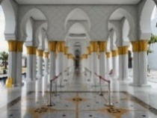 | The width of the circulation is 800 cm, and the distance between the supporting poles is 140 cm in the rear circulation and 170 cm in the side circulation. This is in accordance with the minimum standard of circulation for disabilities.
Entrance/Exit | 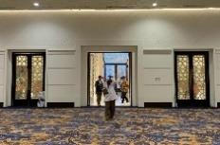 | The entrance/exit is divided into the inner area door and the outer area door. The size of the outer door is 210-255 cm, and the inner door is 140-215 cm. This size is in accordance with the minimum standard set by PUPR in making the size of public building doors, which is 80-90 cm on the inner door and 170 cm on the outer door.
Ramp | 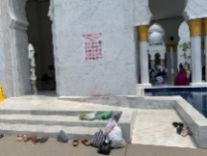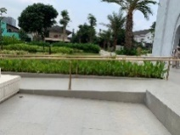 | The ramp at the mosque is spread into 3 parts. The ramp in the mosque yard has a width of 130 cm, a length of 585 cm, and a slope of 9⁰. However, the slope of the ramp is not appropriate. The PUPR Regulation emphasizes that the ramp application outside the building is one: 12 or 6⁰.
Stairs/elevator | 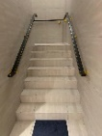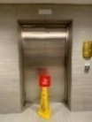 | There are 6 sections of stairs and 2 elevators that are evenly distributed in the male and female areas. All stair and elevator sizes are in accordance with existing standards. However, the overall condition of the stairs is not equipped with step nosing.
Handrail | 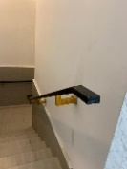 | In terms of size and materials used, all existing handrails are in accordance with existing regulations and principles. However, none contains braille letters that aim to help visually impaired visitors.
Wudu area | 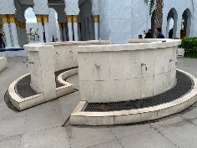 | Overall, the size and layout of the wudu room are in accordance with the standard needs. On the other hand, the condition of the wudu space outside the mosque lacks uniformity with the wudu space in the basement, which is not equipped with sticker instructions.
Toilet | 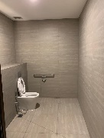 | The toilet built for people with disabilities uses a heavy/hard door and swings inward. This condition makes it very difficult for visitors with disabilities to use the toilet independently.
Prayer room | 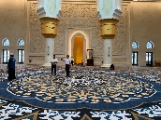 | The prayer area does not have a special area for worshippers with disabilities. Secondly, there is no difference in the texture of the shaf to determine the line of the prayer, and there are no projector tools to help deaf worshippers participate in religious activities performed in the mosque.
Parking area | 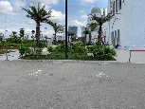 | Two special parking spaces for people with disabilities are provided. It is found that the parking area for people with disabilities is not safe enough to meet the standards of existing regulations. Also, the visitor vehicles that are parked are not in accordance with the designated area.
Signs & Information | 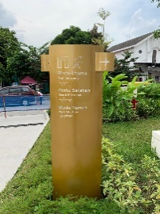 | There are several discrepancies between the current signage conditions and the applicable regulations. This is found in the absence of complete signs for people with disabilities, signs that are not equipped with braille, direction signs that are less informative, safety signs that are not in accordance with safety regulations, and the absence of an information available at the entrance of the mosque.
Observations and measurements of mosque facilities are carried out to determine the specifications of all existing facilities and whether the specifications are in accordance with the regulation of The Ministry of Public Works and Housing number 14/PRT/M/2017 [5] and Universal Design Handbook [6] after collecting the data on ten areas of the mosque. Then, recapitulation of the accessibility index from 10 mosque areas was performed. The value of the mosque accessibility index is calculated at the data processing stage by applying the following formula [9]. Accessibility Index:

$$\frac{A +LA+NA }{N total x K ideal}$$
Where:
A : number of accessible x 2
LA : number of less accessible x 1
NA : number of not accessible x 0
N total : total number of indicators
K ideal : score ideal = 2

For example, the calculation is carried out by multiplying the total number of each area by 2 for accessible, 1 for less accessible, and 0 for not accessible. Then, it is divided by the total number of assessment areas listed. The following is an example of calculating the circulation area at the Sheikh Zayed Mosque, Surakarta.
Accessibility Index:

A = 3*2; LA = 1*1; NA = 0*0; N total = 4

= $\frac{6+1+0}{4*2}$

Accessibility Index = $\frac{7}{8}$
Accessibility Index = 0.875 (accessible)

Table 3 summarizes the accessibility index values of the 10 mosque areas.

No | Area | Accessibility Index | Description
1. | Circulation | 0.875 | Accessible
2. | Entrance/Exit | 1 | Accessible
3. | Ramp | 0.6 | Accessible
4. | Stairs & Lifts | 0.875 | Accessible
5. | Handrail | 0.6 | Accessible
6. | Wudu Room | 0.7 | Accessible
7. | Toilet | 0.5 | Less Accessible
8. | Prayer Room | 0.25 | Not Accessible
9. | Parking Lot | 0.375 | Less Accessible
10. | Signs & Information | 0.3 | Not Accessible

Chart 3 indicates that the door/entrance area of the Sheikh Zayed Grand Mosque has the highest accessibility index value, which means that the entrance/exit of the mosque can be accessed by people with disabilities safely and comfortably. The maximum value of the accessibility index assessment is 1, and the lowest is 0.00 [10]. Hence, indicated by Table 3, most of the Sheikh Zayed Grand Mosque areas get proposed improvements in each area even though they are still included in the accessible category. It happens because it does not match the accessibility criteria in Table 1. Proposed improvements will refer to the regulation of The Ministry of Public Works and Housing number 14/PRT/M/2017 [5] and Universal Design Handbook [6].

- PROPOSED CIRCULATION IMPROVEMENTS
Four assessment criteria showed 1 less accessible criterion, and the rest are accessible. A less accessible criterion is the use of a smooth textured floor design. In several incidents when observations were being made, the researcher accidentally encountered visitors who fell because they slipped because of being less careful when the floor was wet. So, given the proposed improvements, considering the texture of the floor material that is not too slippery to adjust the comfort and safety of visitors is essential. This refers to the regulation of The Ministry of Public Works and Housing number 14/PRT/M/2017 [5].

- PROPOSED IMPROVEMENTS RAMP
Five criteria show that three of them are inaccessible, and the rest are accessible. The criteria are not accessible; the floor used in the ramp area is smooth textured, and the ramp located on the steep entrance in the courtyard of the mosque is not in accordance with the standard slope ramp. The proposed improvements are making adjustments to the ramp, whose size is not in accordance with the standard refers to the regulation of The Ministry of Public Works and Housing number 14/PRT/M/2017 [5]. The proposed ramp is shown in Figure 2.

Current Condition | Improvements suggestion
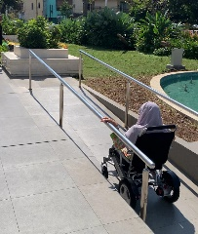 | 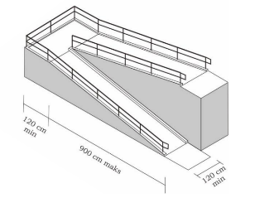
Figure 2. Ramp’s height adjustment

- PROPOSED REPAIR OF STAIRS/LIFT
The eight criteria show that seven criteria are accessible and one criterion is not accessible. Criteria that are not accessible are related to the use of step nosing on the steps. Overall, the stairs in the Sheikh Zayed Grand Mosque of do not use step nosing. Thus, the proposed improvements in addition to step nosing in the stairwell area are given. This refers to the regulation of The Ministry of Public Works and Housing number 14/PRT/M/2017 [5]. The following proposed improvements are given in Figure 3.

Current condition | Improvements Suggestion
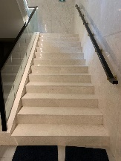 | 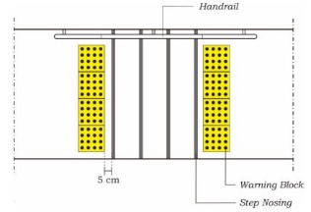
Figure 3. Preparation of Step Nosing on the steps of the mosque

- PROPOSED IMPROVEMENTS OF HANDRAIL
Using five criteria, it can be shown that three criteria are accessible and 2 criteria are not accessible. The criteria that are not accessible include the absence of braille letter at the end of the handrail given as information for the visually impaired people, and the handrail installed in the courtyard of the mosque has been shaky, so it endangers the visitors. Therefore, the addition of braille letters on the handrail is proposed, which refers to the regulation of The Ministry of Public Works and Housing number 14/PRT/M/2017 [5].

Current Condition | Improvements suggestion
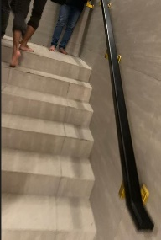 | 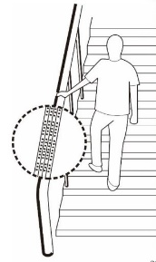
Figure 4. Addition of braille letters at the end of the handrail

Then, the principle of universal design number 5 and Occupational Safety Regulations on the construction of public facilities should be taken into account. The handrail used on the ramp in the mosque courtyard does not comply with accessibility requirements. Because it is still less than a year, the handrail provided is shaky and dangerous for visitors with disabilities, especially wheelchair users and the elderly. So, it is advisable in the construction of facilities to pay more attention to careful planning, including the selection of building materials that are strong and resistant to anticipated workloads, proper structural calculations, and safe placement in accordance with safety standards [12].

- PROPOSED IMPROVEMENT OF WUDU ROOM
Using the seven criteria, it is shown that that five criteria are accessible, one criterion is less accessible, and one criterion is not accessible. The non-accessible criteria are the uniformity of facilities in the wudu area, and 1 less accessible criterion is that the faucet is not easy to use. The picture below is one example of the inconsistency between the wudu room in the park, and inside the mosque with the presence of the faucet usage instructions sticker on the wudu room inside. With this, it was found that some visitors were still confused about using the wudu faucet in the mosque garden because there were no instructions for using it.

Current condition | Improvements Suggestion
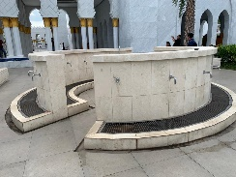 | 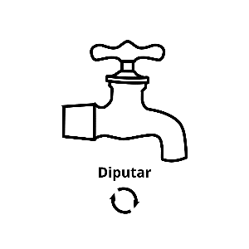
Figure 5. Wudu room conditions are not uniform

Referring to Universal Design Handbook [6] about Equitable Use, the definition of this term is providing the same means of use for all users, identical whenever possible, or at least equivalent. So, it is recommended to standardize existing facilities to give the impression of neat and helpful for first-time visitors and less menau-related procedures for using wudu facilities provided.

- PROPOSED TOILET REPARATION
Using seven criteria, it is shown that three criteria assessment is not accessible and the rest are accessible. The non-accessible criteria include the fact that there are no toilets for children, and the doors used in disabled/elderly toilets are difficult to use. Hence, the proposed improvements are given, which are using doors with two directions (push and pull) to be more friendly to people with disabilities based on the suggestions given by visitors with disabilities and refers to the regulation of The Ministry of Public Works and Housing number 14/PRT/M/2017 [5] as the Figure 6.

Current Condition | Improvements Suggestion
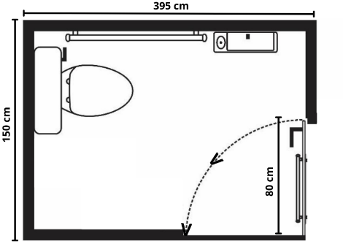 | 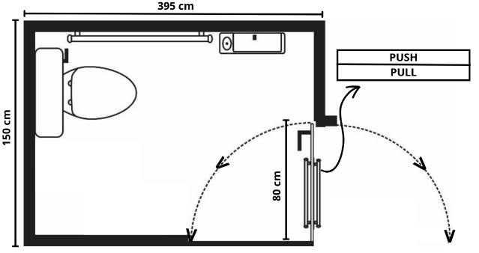
Figure 6. Suggested Design of Toilets for people with disabilities

Then, the provision of toilets for children at the Sheikh Zayed Grand Mosque is not urgent because the size of the toilet used is already the average size that, in his estimation, can be reached by children. The standard toilet size for children is 75x100 cm, while the toilet at the Sheikh Zayed Grand Mosque is 155x135 cm.

- SUGGESTION OF PRAYER ROOM IMPROVEMENTS
Using four criteria, it is shown that one criterion is accessible and three are inaccessible. Three criteria are not accessible; namely, there is no special area for pilgrims with disabilities, there is no difference in color and texture in the shaf to help blind pilgrims distinguish shaf, and the unavailability of projector tools at the mosque facilities when the event took place at the mosque.
Refers to [6] the explanation of the definition, design is tailored to the basic capabilities of the user and the basic intuition of all user capabilities and is also related to giving shape and boundaries that are firm and clear in every design.
The following are proposals for the addition of a special prayer area for disabled pilgrims and the provision of textured lines in the shaf [13].

Current Condition | Improvements Suggestion
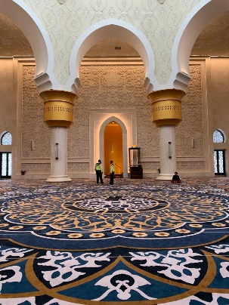 | 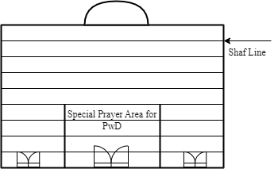 | 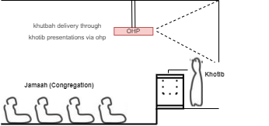
Figure 7. (a) proposed design of Prayer Room (b) addition of OHP/Infocus [13]

The benefits of projector tools in mosque activities are to provide accessibility and good inclusiveness in worship activities, making it easier for worshippers to follow Islamic preaching, lectures or recitation of the holy verses of the Quran. Using projector tools, mosque users can see text or images displayed on the big screen, including those sitting behind or away from the pulpit [14].

- SUGGESTION IMPROVEMENTS OF THE PARKING LOT
Using four criteria, it is shown that there are one accessible criterion, one less accessible criterion with disability parking conditions that is not in accordance with the standard, and two criteria that are not accessible. The visitor parking conditions are not in accordance with those provided; also, the disability parking areas are unsafe. So, the proposed improvements to make adjustments to the layout of parking and special access disability, which refers to the regulation of The Ministry of Public Works and Housing number 14/PRT/M/2017 [5] [15] are given. It explains the definition that the design can be used efficiently and comfortably to minimize the risk of accidents. The suggestion is given in Figure 8.

Current Condition | Improvements Suggestion
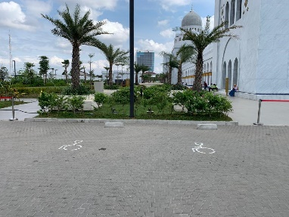 | 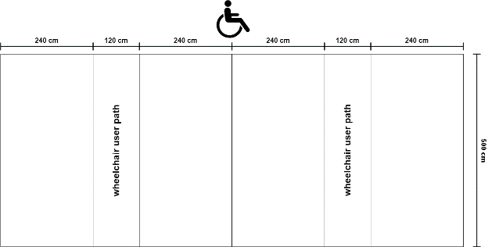  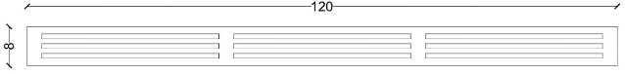
Figure 8. (a) the suggested design of Disabled Parking (b) the addition of a connecting bridge

- IMPROVEMENTS SUGGESTION TO SIGNS & INFORMATION
By using nine criteria, it is shown that two criteria are accessible, three criteria are less accessible, and four criteria are not accessible. Less accessible criteria include information signs that did not use braille letters, the signs used are not made of visitor-friendly materials and the safety information installed is not informative enough. Inaccessible criteria include unavailable signs and information on the entrance; the information is unclear; there are no signs of prayer time markers, textured maps, or complete disability information.
Refers to the regulation, The Ministry of Public Works and Housing number 14/PRT/M/2017 [5] states that signs or braille letters should be able to be read by visually impaired people and other disabled people. The characters and background of the signs must be made of non-glare materials. Referring to the regulation of The Ministry of Public Works and Housing number 14/PRT/M/2017 [5], it explains the definition of product design that is equipped with supporting information important to the user where the information provided is tailored to the user's ability. So, the proposed improvements with the addition of braille letters on information signs, providing information stands in the entrance area, is given [16] [17].

Current Condition | Improvements Suggestion
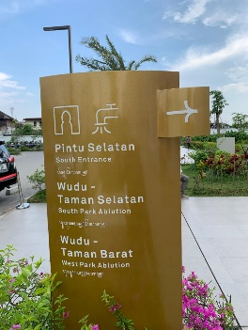 | 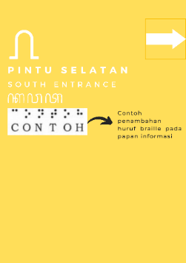
Figure 9. Addition of Braille Letters on information signs

Current Condition | Improvements Suggestion
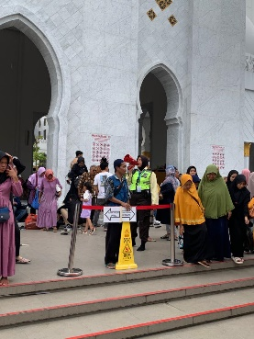 | 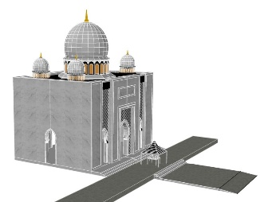  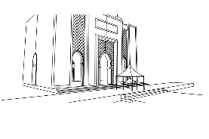
Figure 10. The addition of information stands on the entrance

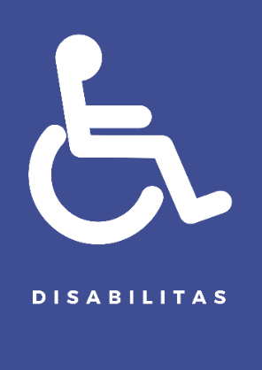

Figure 11. Addition of Particular Signs for People with Disabilities
The information guide at the mosque's entrance is expected to help visitors to walk easily, comfortably, and safely. The addition of disability signs provided in the Sheikh Zayed Grand Mosque area is a mandatory thing to do. The placement of signs must be adapted to the access that people with disabilities may have. One of them is to be placed in the parking area or entrance area. This greatly affects their safety and comfort in accessing the facility.

- THE ROLE OF SAFETY IN MOSQUE ACCESSIBILITY
At the Sheikh Zayed Grand Mosque, safety signs such as gathering point signs, evacuation routes, and prohibitions should not be brought into the mosque area. In addition to playing a role in providing safety information for visitors, safety aspects must also be considered in the construction of mosque facilities.
The material used to make safety signs is not in accordance with its designation. The safety signs used in the prayer area use acrylic material, while those used in the basement area use plastic paper. Ideally, it should be uniformed to give a neat and uniform impression. This refers to Universal Design Handbook [6], which provides all users the same means of use. Then, we recommend that the material used should be acrylic because acrylic properties are stronger than plastic paper, durable, and strong when exposed to water as seen in Figure 12.

Evacuation routes in the basement area | Evacuation route in prayer area
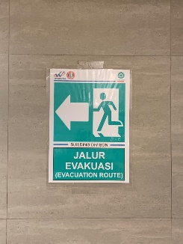 | 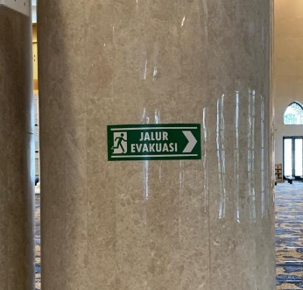
Figure 12. Differences in the use of materials in evacuation signs

The use of color displays must also be considered in its application, it is essential to prevent a blurry or unclear effect when the letters are read from a normal distance of at least 2 m. The use of a good color display is according to safety standards as shown in the Figure 13-16.

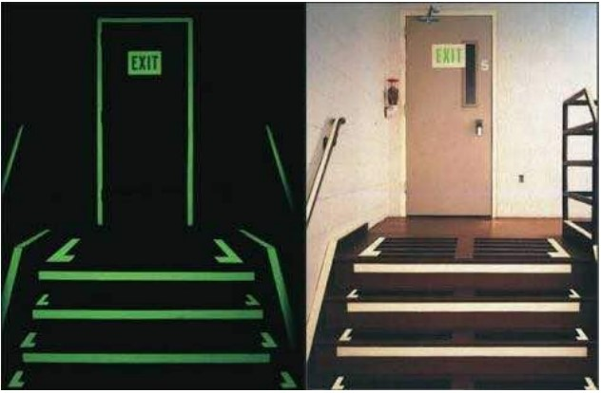
Figure 13. (A) when it is dark (b) when it is normal
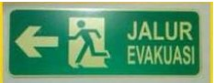
Figure 14. Normal Condition
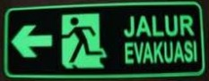 | 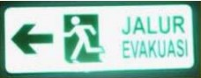
Figure 15. Without Light | Figure 16. Exposed to Searchlight

- CONCLUSION
Based on the assessment of the accessibility of Sheikh Zayed Grand Mosque, it is proven that this mosque is not yet friendly to people with disabilities. The results of the assessment of ten mosque areas obtained the following results: there are six accessible areas (circulation, entrance/exit, ramp, stairs & elevator, handrail, and wudu Room), two less accessible areas (toilet and parking lot), and two inaccessible areas (prayer room and signs & information). Suggestions were made to areas and sub-areas with less accessible and non-accessible values. It would be better if, when building a mosque, you consider the aspect of accessibility for people with disabilities. Suggestions for further research include the statement affirming that accessibility should be expanded not only for people with disabilities but also elderly people and children.

REFERENCES
[1] M.I. Nurhakim, “Mendisabilitaskan Manusia Merajut Kesetaraan Aksesibilitas Rumah Ibadah Bagi Kaum Difabel.”Jurnal Ilmu Al Qur'an dan Hadist, vol. 2, no. 2, pp. 128-142, 2019. DOI: https://doi.org/10.35132/albayan. v2i2.74.
[2] A. Retyaka.A and D. A. Himawanto, “Aksesibilitas Bagi Difabel Pada Bangunan Masjid,” Vitruvian Jurnal Arsitektur, Bangunan & Lingkungan, vol.7, no.3, pp. 137-144, 2018.
[3] C. R. N. Keumala, “Pengaruh Konsep Desain Universal Terhadap Tingkat Kemandirian Difabel: Studi Kasus Masjid UIN Sunan Kalijaga dan Masjid Universitas Gadjah Mada,” INKLUSI: Journal of Disability Studies, vol. 3, no. 1, pp. 19-39, 2016. DOI: https://doi.org/10.14421/ijds.030102.
[4] A. Valentine, I. G. Ardana, and D. Thamrin, “Kajian Implementasi Universal Design Pada Interior Perpustakaan Umum di Balai Pemuda Kota Surabaya,” Dimensi Interior, vol. 15, no. 1, pp. 16-25, 2017. doi: https://doi.org/10.9744/interior.15.1.16-25
[5] PUPR, Peraturan Menteri Pekerjaan Umum dan Perumahan Rakyat Republik Indonesia Nomor 14/PRT/M/2017 Tentang Persyaratan Kemudahan Bangunan Gedung, Kementerian Pekerjaan Umum dan Perumahan Rakyat Republik Indonesia, Jakarta, 2017
[6] W.F.E. Preiser and K.H. Smith, Universal Design Handbook, New York: Mc Graw Hill, 2011.
[7] N. Utaberta, A. Sabil, and M. D. Niya, “The Evaluation of Universal Design and Accessibility For People With Disabilities In Masjid Putra By Using Malaysian Standard of Ms 1184:2014, ‘Universal Design And Accessibility In The Built Environment - Code Of Practice," International Journal for Studies on Children, Women, Elderly and Disabled, vol. 4, pp. 185–190, 2018
[8] R. Yumadhika and A.B. Sholihah, "Design of Mosque Wudu Areas for Disabled: Evaluation of Ministeral Regulation of Public Works and Public Housing No. 14/2017", Journal of Architectural Research and Design Studies, vol. 3, no. 1, pp. 10-23, 2019. doi: https://doi.org/10.20885/jars.vol3.iss1.art2
[9] I. W. R. Aji, B. Suhardi, and I. Iftadi, “Evaluation and Design Accessibility of Mosque's Facilities for People with Disabilities," J. Islam. Archit., vol. 7, no. 2, pp. 306–313, Dec. 2022, doi: https://doi.org/10.18860/jia.v7i2.17380.
[10] A. Maftuhin, “Aksesibilitas Ibadah bagi Difabel: Studi atas Empat Masjid di Yogyakarta”, INKLUSI, vol. 1, no. 2, pp 249-268, 2014, doi: https://doi.org/ 10.14421/ijds.010207

[11] A. A. Rahim, N. A. Abd. Samad, C. R. C. Rahim, and A. Badhrulhisham, “Providing Accessibility for Persons with Disabilities ( PwDs ) in Malaysian Existing Mosques,” UD 2014, Campus LTH Lund Univ. 15-18 june 2014, 2014.
[12] V. W. Y. Tam, I. W. H. Fung, Y. T. Tsang, and L. Chan, “Development of a universal design-based guide for handrails: An empirical study for Hong Kong elderly,” Sustainability, vol. 10, 4233, pp. 1-32, 2018. DOI: https://doi.org/10.3390/su10114233.
[13] H. Kurniawan, “Familiarity in Designing a Mosque: A Practice of Universal Design,” UIA 2011 Tokyo World Congress Programme Work Programme-Architecture for All Regious I, II, III & IV - Oral Precentations, pp. 1-12, September 26, 2011, DOI: http://doi.org10.13140/RG.2.2.28069.19687.
[14] O. Tutal, “Universal Access in Historic Environment and Accessibility of The Haci Hasan Mosque in Eskisehir”, ICONARP International Journal of Architecture & Planning, vol.6, Issue 1, pp. 126-141, 2018, DOI: https://doi.org/10.15320/ICONARP.2018.41
[15] D. Wicaksono., Diharto, and T. Munasari, "Kajian Elemen Aksesibilitas Ramp (Bagi Penyandang Disabilitas) pada Fasilitas Umum Fakultas Teknik UNNES", Indonesian Journal of Conservation, vol. 9 no. 2, pp. 106-118, 2020, DOI: https://doi.org/10.15294/ijc.v9i2.27273
[16] A. A. Rahim and N. A. Abd. Samad, “Universal Design from Islamic Perspective: Malaysian Masjid,” Journal of Architecture, Planning & Construction Management, vol. 4 no. 2, pp. 1-13, 2014, DOI:https://doi.org/10.31436/japcm.v4i2.548
[17] J. Gual, M. Puyuelo, and J. Lloveras, “Universal Design and Visual Impairment: Tactile Products For Heritage Access,” International Conference on Engineering Design ICED11, 15-18 August 2011, Technical University of Denmark, Denmark, 2011

