 |  | JOURNAL OF ISLAMIC ARCHITECTURE  P-ISSN: 2086-2636 E-ISSN: 2356-4644  Journal Home Page: http://ejournal.uin-malang.ac.id/index.php/JIA
TYPOLOGY OF KHĀNQĀH SPACE IN THE ARCHITECTURE OF THE ISLAMIC PERIOD OF ĪRĀN UNTIL THE QĀJĀR PERIOD
Nigar Nassiri^{a*}, Akram Hosseini^{b}
ªFaculty of Engineering, Islamic Azad University-North Tehran Branch, Tehrān, Iran
^{b}Faculty of Architecture and Urbanism, Ferdowsi University of Mashhad, Mashhad, Īrān
*Corresponding Author: akram.hosseini@um.ac.ir
ARTICLE INFO |  |  | ABSTRACT
Volume: 8  Issue: 2  Page: 545- 568  Received: August 23th, 2023  Accepted: April 21st, 2024  Available Online: December 1st, 2024  DOI: 10.18860/jia.v8i2.23418 |  |  | The current study aims to investigate the typology of Īrānian Khānqāhs and to identify the architectural patterns of these spaces. Qualitative research methods and comparative analysis were employed. Numerous Khānqāhs of Īrān are currently either abandoned, destroyed, or located outside the borders of Īrān's political geography. In this study, all Īrānian Khānqāhs constructed up to the end of the Safavid period, which are located within the current political geography of the country, were examined. Either their structures or their architectural documents are still available. Due to the variety of types of Khānqāhs of the later period (Qajar), this study does not include them. The results show that their plans were more introverted than extroverted, with residential and devotional uses. They were classified into five types: 1) Khānqāh in Urban complex (Arsin), 2) Urban Khānqāh-Mosque, 3) Khānqāh-Tomb (Boqʿih), 4) Suburban Khānqāh-Zāwīyih and 5) Khānqāh-Village, based on scale and settlement quality in residential complexes. Their spatial patterns are also analyzed. The results showed that the architecture of the Khānqāhs follows three patterns including, Chāhār_Ṣoffih (four-platform), a dome, and a central courtyard. In this study, a general comparison was conducted between the architecture of Iranian Khanqahs and the secluded spaces in Christian architecture. Before the arrival of the Mongols in Iran, the common patterns in the architecture of mosques, mosque schools, tombs, or rabats of Iran were also used in the architecture of Khānqāhs. The prevalence of building churches in the Azerbaijan region of Iran, following the plurality and religious freedom of the Il-khānid period, caused the model of a small number of Khānqāhs to follow the model of Byzantine churches. The Khānqāh's architectural evolution reflects a deep respect for tradition, intricately weaving influences from diverse cultures. It plays a positive and harmonizing role as a unifying space for various religions.  Keywords:  Typology; Khānqāh Architecture; Privacy; Īrān Architecture; Islamic Period

- INTRODUCTION
A Khānqāh is a privacy space for tazkiah, austerity, and contentment. Sufi dervishes took such social distances that they were in solitude with God and relationships with people. Khānqāhs served both general and private functions; The former ranged from the assembly, the hearing, and the table, while the latter included taking a Zāwīyih, Chilla, zikr utterance, repenting, and shaving one's head and eyebrows. A Sufi master, pīr or Sheikh, supervised these practices [1].
Centuries ago, developments in the history of Sufism created a particular type of architecture in Khānqāhs [2]. Subsequently, the architectural atmosphere of the Khānqāhs has influenced the developments of Sufism and played a key role in the rise of Sufi tariqas(orders); on the other hand, the progress of Sufi tariqas(orders) and their empowerment in society has also had a reciprocal effect on improving the design quality of Khānqāhs.
In the Great Islamic Encyclopedia, the developments of Khānqāhs are divided into four periods: 1- The early period, from the establishment of Rabāṭs in Abbādān, in the early Abbasid period to the emergence of Khānqāhs in Khorāsān, which were governed according to the customs and rules attributed to “Abu Saʿīd Abu_al_Khiyr” (1048 AD) [3]; 2-The expansion of Sufi Khānqāhs and Rabāṭs, simultaneously with the formation and development of Madrasa, from the time of the Seljuq sovereignty over Baghdād (1055 AD) to the end of the Abbasid Caliphate (1258 AD); 3- The emergence of a network of Khānqāhs and Rabāṭs in the Mongol era, which was accompanied by the spread of Sufi practices throughout the Islamic world, to the decline of Khānqāhs in the Safavid era. The Safavid period is known as the period of Khānqāh destruction and their weakening for political and social reasons; and 4- Khānqāhs in the modern period (Qājār and Pahlavī dynasties and the Islamic Republic), the destruction and weakening of Khānqāhs in the Safavid period indicates the beginning of a new era of Khānqāh and Sufism in these three periods [4]. In addition to changing the government's view of Sufism and Khānqāh spaces, this period coincides with the emergence of modernism in Iran, which changed many cultural trends [4].
Khānqāhs had an introverted, residential, and devotional structure regardless of location. They served no connective role between cities since they would be defunct if they were unattended by regular dervishes. The Khānqāhs and Zāwīyihs in Khorāsān had a flag erected on the roof to be easily detected by passersby [5]. The economic resources of Khānqāhs, how to manage them, and the power of the Sheikh mainly affected their formation, extent, and architecture. The founder and the resident disciples provided part of the financial resources, originally through farming and begging, which was used to undervalue the self; besides that, reliance on daily work was popular among all residents of Khānqāhs [5] [6]. An alternative was gifts and votive offerings from those in power, the Sheikhs and wealthier members called fotoh, which means relief. Although the offerors' sense of belonging to a tariqa(order) was important in accepting offers, Khānqāhs could hardly resist the fotoh (relief). It was not only because of the Khānqāh’s financial need but also because of the kings and politicians' strong desire to take advantage of the Sufis’ spiritual influence. Loans, economic production, and endowments were other sources of income [7]. “Mofīdī” Khānqāh, “Sheikh ʿObaiyd_ullāh Aḥrār” Khānqāh, and “Sheikh Ṣafī” Khānqāh are instances of Khānqāhs with extensive endowments [8].
Theoretical and practical mysticism and the resulting Sufism have such ancient roots in Islamic Īrān [9] that several villages in Īrān and Afghānīstān were, and still are, called "Khānqāh". “Ardabīl”, “Khoy”, “Ᾱẕarshahr”, “Miyānih”, “Zanjān”, “Pāvih”, “Arāk”, “Sāvih”, and “Bardiskan” have some such villages.
The influence of Khānqāhs on the education of writers and mystics is evident in the history of Īrānian literature. Many Khānqāhs are named after the mystics and Sheikhs who have written mystical poems. “Abu Saʿīd Abu_al_Khiyr” and “Shāh Niʿmatul_lāhvalī” are two examples.

  - RESEARCH HYPOTHESIS, QUESTIONS, AND OBJECTIVES
Since squandering and futility are unacceptable among Muslims, spatial flexibility is highly popular in Īrānian buildings. This creates similar underlying patterns in Islamic architecture in Īrān, so architectural types of Khānqāhs could resemble these patterns. However, the combination of permanent with temporary residence and covert with overt tariqa (order) has made identification and recognition of this space possible.
The research questions this study seeks to answer are as follows: 1- What are the components and elements of Īrānian Khānqāhs built before the Qājār period? And what is the position of each of these components based on their hierarchy, concepts, and nature of privacy? Do they have any particular spatial hierarchy for the purpose of building the Khānqāh? 2- What types are Khānqāhs classified into in terms of scale and settlement quality? And 3- What patterns do the architecture of Īrānian Khānqāh spaces conform to?
Upon answering these questions, further studies can be conducted to compare the types and architectural patterns of Īrānian with other countries' Khānqāhs. This can produce a reliable research resource and improve professional knowledge. The ultimate goal is to understand the nature of private spaces to enable the feasibility of spaces that spiritually nurture modern humans.

- METHODS
Numerous Khānqāhs of Īrān are currently either abandoned, destroyed, or located outside the borders of Īrān's political geography. In this study, all Īrānian Khānqāhs constructed up to the end of the Safavid period, which are located within the current political geography of the country, were examined. Either their structures or their architectural documents are still available.
The political conditions of the Qājār period and the socio-cultural effects of the relations between Īrān and other countries during this period have brought numerous changes in the number and mode of operation of Khānqāhs in this period. Therefore, this study excluded the Qājār period Khānqāhs.
Sufism rituals were sometimes carried out in Sufi private spaces, including their homes. So, although they may be referred to as Khānqāhs, they are excluded from this study because the architecture of these spaces differs from Khānqāhs’ requirements.
The total number of Khānqāhs identified in this study was 31. Four of them were excluded from the study because they lacked valid documents. The map of Īrān shows the geographical distribution of 27 Khānqāhs in ten provinces in Īrān. The city of Yazd has four, Iṣfahān three, and Mashhad and Māhān two Khānqāhs (Figure 1 & 2).

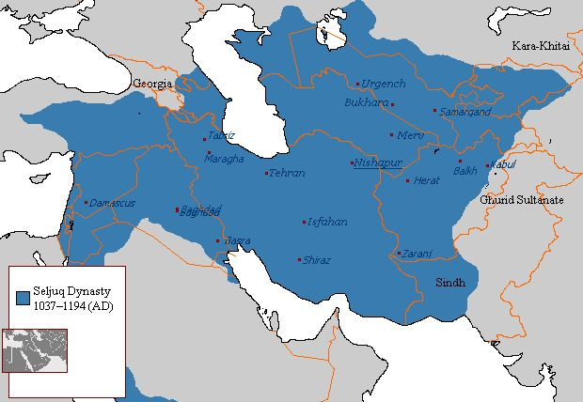 | 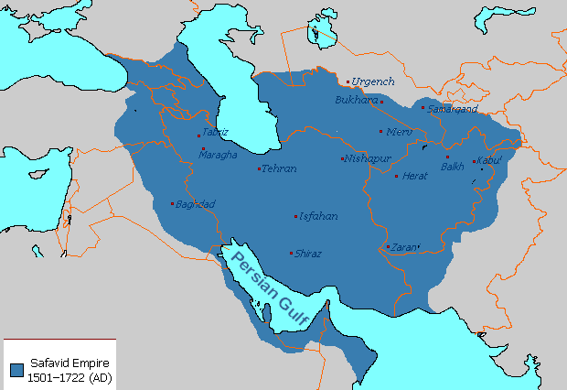
Figure 1. Greater Īrān, From Seljuq Dynasty (1037-1194 AD) to Safavid Empire (1501-1736 AD)

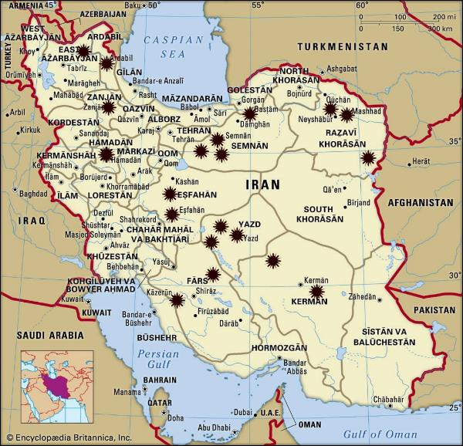

Figure 2. Distribution Map of Khānqāhs studied in Īrān

- RESULT AND DISCUSSION
Mo’īn" Encyclopedic Dictionary describes Khānqāh as a house. It means a place where, for the first time since the 10th AD, Sufis, dervishes, Sheikhs, and sālīks gathered. They worshiped God, lived, acquired the basics of religion and tariqa (order) principles, and practiced asceticism, intuition, and self-purification to reach the truth [10]. They also learned the basics of Sufism from Hadith, interpretation, and the words of the Sheikh [11] [12]. The term Khāngāh is composed of “Khān” and “Gāh”. The word "Khān" means 1- Caravanserai and 2- House, Temple, and Place of worship. In the combination of Khān+Gāh, "Khān" means 1- Tablecloth, 2- A large pallet, and 3- Porch and house. While the suffix "Gāh" means 1- Throne, 2- Time, and 3- Place [7] [13].
Since the first part of the compound is Persian, the word's origin is Persian, too, and is combined with "Gāh". "Maqrīzī" (1460 AD), an Egyptian author, believed it was a Persian word and stated that khawāniq was the plural form of khānkāh, a Persian word that means a house. The origin of it is believed to be Khunqāh, which is the place where the sultan eats food. As the author of "Farhang-I Ānandrāj" suggests, Khānqāh means Khorangāh, and Khorangeh and Khorneh meaning the porch where the sun falls. Khorānaq is the Arabic form of khavernih and khorangāh. Kings of Persia ate bread and stew in the court and front of the porch facing the sun. They believed the sanctity of the sun would purify and bestow nobility on their food [14].
The word Khanak was developed in Islam around the 10th AD and became a place of worship and privacy for Sufis [7]. Those Khānqāhs where a pīr lived or was buried were called astanih (Threshold). Tekyih is another term that is used to convey the same meaning. However, after the Safavid era, they were used to name tombs of Shiite scholars [7]. It then turned into places for ta'ziyah performances and mourning ceremonies. Khānqāh was also referred to as a monastery, a place of worship, a rabāṭ, langar (the Khānqāh feeding center), a Zāwīyih, an astāneh (Threshold), a dowayreh [6], Zāwīyih [16], also a Jama'at_khana (Gathering place) and a rabāṭ [17]. Rabāṭ’s history stretches back longer compared to Khānqāh’s. They are the origin of Khānqāhs. They were places for gatherings of Sufis. They were also used for defending borders in Islamic countries [7]. Rabāṭs, as Khānqāhs, were more common in Irāq and Baghdād. The term "Rabāṭ" was also preferred in Persia when referring to a Khānqāh [18]. In Persian and Arabic, it means a border checkpoint, Caravanserai, Khānqāh, Guest house, Castle, Temple, Orphanage, and the house of science (Dar Al_ʿilm). Rabāṭs, as Muḥammad Al-Naʿīmī suggests, sometimes originally served as a military castle, followed by being used as a caravanserai, and then the place for gatherings of dervishes [18].
Imām_bārih or Imām_bārā refers to "Imām_Khana" and is also sometimes called a Khānqāh. They are buildings in India where Shiites gather to hold their religious ceremony in the month of Muḥarram in the Hijri calendar [19] [20]. Africans and Turkish used the terms " Zāwīyih" and "Tekke", respectively [21].

- ARCHITECTURAL COMPONENTS BY PRIVACY LEVELS
The architecture and facade of a Khānqāh reflect its social, devotional, and educational functions. It includes both public and private spaces with permanent and temporary accommodations where privacy is the function. Four Characteristics of privacy space, including explanatory, divisive, elementary allocative, and transcendental allocative elements in the form of semi-open, open, and closed spaces, can be seen in the architectural components and organs of Khānqāhs [22] (Figure3).

Figure 3. Privacy levels of Khānqāh

- 1. Explanatory elements
The traditional Iranian architecture of urban Khānqāhs is characterized by the forecourt/frontage, a spacious area in front of the pīshtāq (entrance īwān) [23]. The pīshtāq, a covered semi-open space, distinguishes access from passage areas and is a common feature [23]. Entrances with simple or intricate designs [24] are typically positioned in the middle of one ṣahn's side [1] [25], fulfilling both structural and aesthetic roles. Unlike other Iranian buildings, Khānqāhs lack minarets and vestibules. The ravāq/pishgāh (Portico), an indoor passage with columns and continuous vaults, often encircles a ṣahn. Some Khānqāhs feature a hashti/keriās (vestibule), enhancing the entrance's grandeur [26].

- 2. Divisive elements
In Khānqāh architecture, distinct spaces play significant roles. The roof serves as an active zone, especially for women during sermons [24], resembling a shabistān in mosques. The ṣahn (Courtyard), centrally or south-positioned, is an expansive area crucial to Khānqāh life [24]. Each Khānqāh has a Ṣoffih or īwān [1], a semi-open space linking the closed Jamā’at_Khana and the open ṣahn. Sufis gather in the Ṣoffih during favorable weather [1], and the Sheikh's throne becomes a focal point for assemblies [27]. The tomb of the founder or Sheikh is located in the ṣahn, dome, or hojra.

- 3. Elementary allocation elements
Jamā’at_Khana (Dome House) or Zikr_Khana, or Sama'_Khana: It can be said that the Sufi spends time in privacy yet overtly in this space. As the main part of a Khānqāh, it was the place of preaching and samā'. It was also a place for the gatherings of Sufis, either for individual practice, worship, and rest [1] [27] when Sufis and even Sheikhs put their Zāwīyihs around the jama’at_Khana [27] or for communal activities and practices, meals, wearing of khirqa, zikr repeating Jama'at prayer, Sufi gatherings, and dances, or the sitting of the Sheikh with his companions [28]. It resembled a dome with a ṣahn in the physic of the Khānqāh and the Ṣoffih on top of the ṣahn. The Jamā’at_Khana and ṣahn connected directly or sometimes through a Ṣoffih, connected. The ṣahn was surrounded either circularly or on both sides by hojras. The pīr would, at times, have his Zāwīyih in the Jama’at_Khana [1].
Libraries within mosques, madrasas, and Khānqāhs, typically donated by founders or the public, are maintained by designated individuals [28]. The multifaceted nature of Sufi life is reflected in Khānqāh facilities, including libraries, Marafiq (related to house commodities), Tahārat_Khana for ablution [4], small pools, bathhouses, and food warehouses (Khazīna) [27]. This arrangement combines spiritual practice, education, and communal living in the Khānqāh setting.

- 4. Transcendental allocation elements
Masjid_Khana was an independent prayer hall in some Khānqāhs. Small mosques inside other buildings were also called masjid_Khana. Zāwīyih and HojraorKhana were rooms in Khānqāhs, depending on the size and prestige of the Khānqāh. They were the resting place for the Sheikh, the present and passing Sufis, and servants of the Khānqāh [27].
Monastery-Khānqāh was a hojra that usually accommodated one person. The Sheik exclusively used it for privacy and worship [24]. Hazira was surrounded by four walls. It was probably an enclosed area in a Khānqāh or Jamā’at_Khana used for individual worship [27].

- THE MEANING OF TYPES AND TYPOLOGY OF KHĀNQĀH ARCHITECTURE
Types, similar to space and shape, can be interpreted based on the user's viewpoint. Although distinctly defined and can be referred to as the representative of a group of objects with common properties, the definition of "properties" can vary depending on its interpretation. Types as a generational branch have been a special category of buildings considered by historical-evolutionary researchers. They believe the existing buildings are formed of a simple type that has developed over time. The responsibility of the architect-researcher is to reconstruct the evolutionary chain of a particular building [29].
Two approaches, genotype and phenotype, derived from genetics, are proposed in the typology of architecture and its social interpretation. The interaction between phenotype and genotype throughout this life cycle is as follows:
Environment + genotype + random variation = phenotype
Although the discussion on the genotype of a building has more flexibility than the phenotype of a building, many architectural organs with different environmental conditions, ranging from the mental and psychical environments of the architect, employer, and society, have more diverse phenotypes.
Typology is semantically associated with pattern categorization and development. It also extracts the roots of form from old time and space. Therefore, with categorization and preparation of spatial patterns, it takes a more accurate path.

- CLASSIFICATION AND SPATIAL PATTERNS
To make an initial classification of Khānqāhs to investigate their typology, their material, physical, and morphological aspects, along with Rob Krier's approach (1975 AD) examining formal aspects and historical position, are used [30]. Upon classification, its patterns have been extracted through a formal analysis to introduce a set of physical elements as genotypes and phenotypes of Khānqāh architecture. This resembles the method of the Muratori School (1948 AD) employing the historical-evolutionary approach. This introduction had a material and physical nature and determinism, over time, in its focus [30].
Where the Khānqāhs built in the public arena were located, their management and construction financial sources, and how much support they received from the rulers and the public affected their location in residential complexes. Their location allocation was done by certain individuals through a time-spatial period. They served as a private place. So, Khānqāhs were not off-road resting places. On several scales, they were constructed near different residential complexes such as villages and cities or inside cities.
Two elements contribute more to this classification and analysis: being equal in scale and settlement quality in residential complexes, so regarding spatial qualities, plans with the same value and scale fall under the same category. Their typology is then classified according to whether they are introverted or extroverted, having single or multi-īwāns and having domes or courtyards to provide a more accurate analysis of this space.
The project economy, management system, the power of the Sheikh/ pīr, and the amount of endowment and property of Khānqāhs affected their space formation and extension. So, they functioned as the main criteria for the classification of the architectural spaces of Īrānian Khānqāhs in the Islamic period. Therefore, six main categories can be identified regarding the proximity of the Khānqāh to the residential area and the similarities of the architectural design with other similarly designed public spaces. (Table 1-5)
1) Khānqāh in Arsan (Urban complex), 2) Urban Khānqāh-Mosque, 3) Khānqāh-Tomb, 4) suburban Khānqāh-Zawiyah, 5) Khānqāh-Village, and 6) Khānqāh-House.
The last category is significant within the residential contexts where either other building has replaced old Khānqāh-houses with no traces left or the house’s inner space has been considered in the contemporary period and functioned as a Khānqāh. The current study excludes its investigation and requires further research.
This study excludes the Khānqāhs that are destroyed or have their use changed. So, only the physical space of the Khānqāh, regardless of their location and historical position, is considered. So, among 27 investigated Khānqāhs, three categories are identified in urban areas. In terms of scale and urban location, they are divided into those located in Arsin, approximately to mosques, or solely. One category is identified in the suburbs and one in the villages. These include tombs and Khānqāh-Mosques, too.
The patterns of the architectural space can be either introverted or extroverted, with or without the central courtyard. The plans are more regular than irregular. Courtyards are more popular in introverted plans. They, however, appear on two sides in extroverted ones, such as “Sheikh Oliā Kāzirun” Khānqāh (N.20). The number of īwāns varies from one to four. Not all Khānqāhs have minarets. In the later period, such as the Safavid period, minarets were used in the “Sheikh Shāhāb Al_Dīn Aharī” Khānqāh (N.21). Its distinction from the mosque, lack of attraction, and the public's spirit of contentment made minarets unpopular (Table 6). In addition, the orientation towards the qibla and particular atmosphere had a significant presence only in the first centuries, and it almost disappeared in the Middle and Contemporary periods [31].

Table 1. First Category, Khānqāh in Urban complex (Arsin)
 | Plan(s) of Khānqāhs in Arsin | Additional Information
N.1: Sheikh Ṣafī al-Dīn Ardabīlī Complex and Khānqāh, Ardabīl Province (14th and 16th AD) [32][33] | 1-Entrance, 2- Garden courtyard, 3- Small courtyard, 4 large courtyards, 5- Jannat Sar Mosque, 6- Chīnī-Khānih (old Khānqāh), 7- Qandīl-khānīh, 8- Sheikh Ṣafī shrine, 9-Sheikh tomb, 10-Shahīd Khānih | 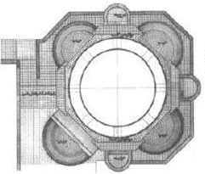  Khānqāh (Chīnī-Khānih) plan
N.2: Shāh Niʿmatullāh Valī Khānqāh, Kirmān Province (15th AD Timurid Period) [34][35] | 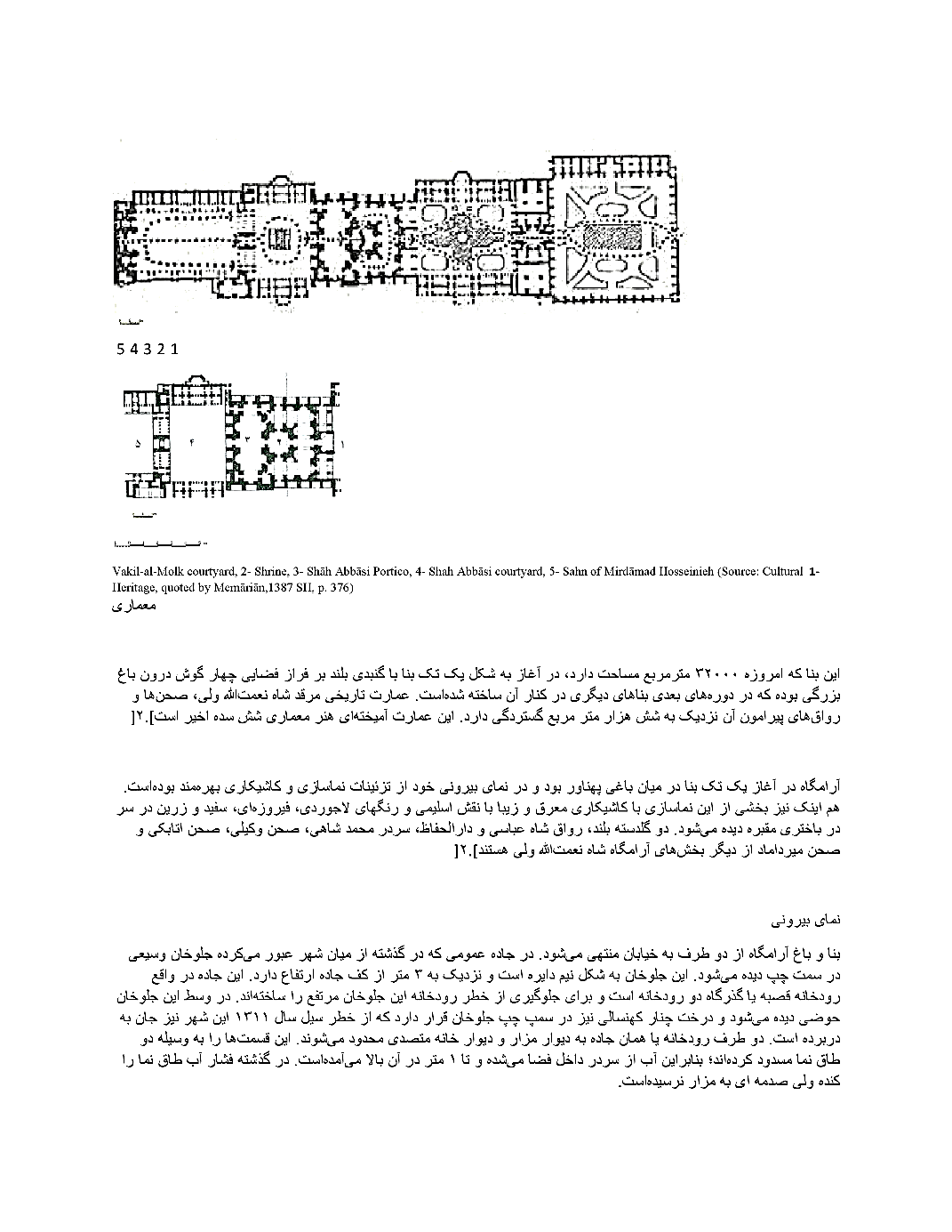 | 1-Vakil-al-Molk courtyard, 2- Shrine, 3- Shāh ʿabbāsī Portico, 4- Shāh ʿabbāsī courtyard, 5- Sahn of Mīrdāmād Ḥussainiyih
N.3: Shāh Valī Complex and Khānqāh, Yazd Province (15th AD) [33]
N.4: Towḥīd Khānih, Iṣfahān Province (16th AD/ Safavid period) [35] |  | 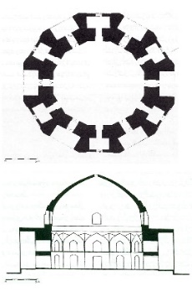  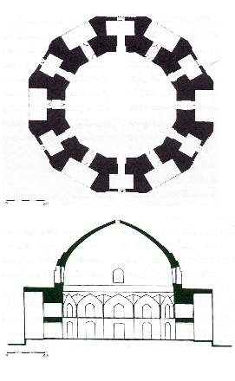

Table 2. Second Category: Urban Khānqāh-Mosques
 | Plan(s) of Khānqāhs in Arsin | Additional Information
N. 5: Bāyazīd Basṭāmī Khānqāh, Simnān Province (1306 AD) [33] | 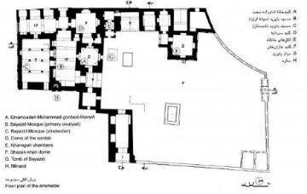  A- Imāmzādih Muḥammad dome, B- Bāyazīd mosque (Shabistān), C- Bāyazīd mosque (nave), D- Dome of the cellar, E- Khānqāh rooms, F- Ghāzān Khān dome, G- Bāyazīd shrine, H- Minaret | 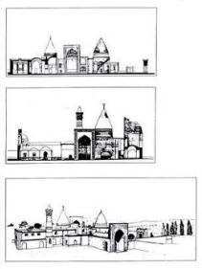
N. 6: Abdul Ṣamad Khānqāh, Iṣfahān Province (6th and 14th AD) [36] | 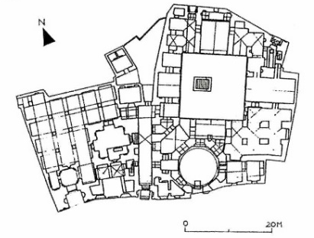  Jamiʿ Mosque and Khānqāhh

Table 3. Third Category, Khānqāh-Tomb (Boqʿih)
 | Plan(s) of Khānqāhs in Arsin | Additional Information
N. 7: Alī Ibn Sahl Khānqāh, Iṣfahān Province (9th AD, [33] | 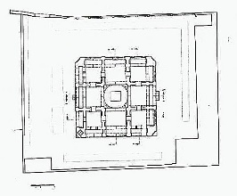 | 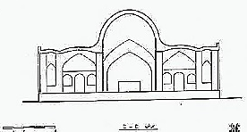
N. 8: Sheikh Abu al-Masʿoud Rāzī Khānqāh, Iṣfahān Province (9th AD, Timurid period) [36][33] | 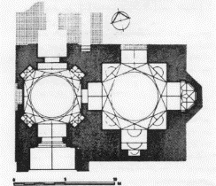 | 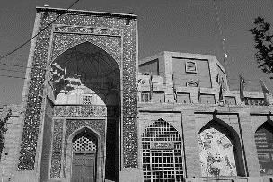
N. 9: Sulṭān Sheikhdād Complex, Yazd Province (1325 AD) [33] | 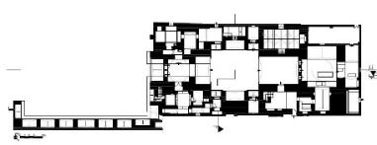 | 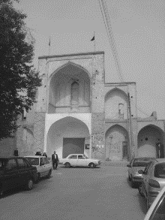
N. 10: Tomb of Sheikh Muḥammad Khānqāh, Yazd Province, (1390 AD/ Āl-i-Moẓaffar period) [33] | 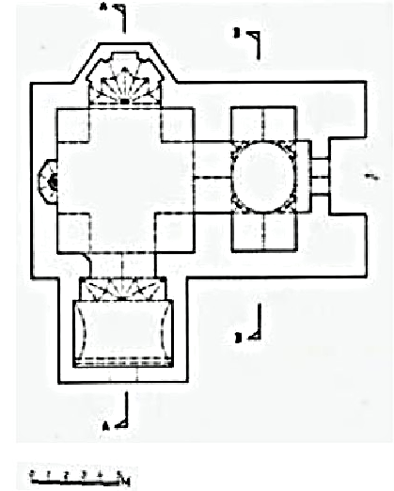  1.5 | 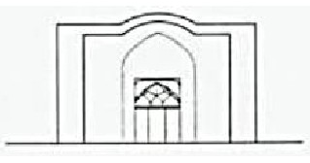
N. 11: Tomb of Sheikh Aḥmad and Sheikh Muḥammad Fahhādān, Yazd Province (14th AD) [33] | 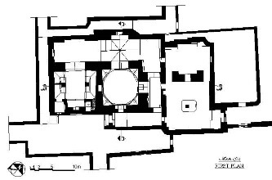  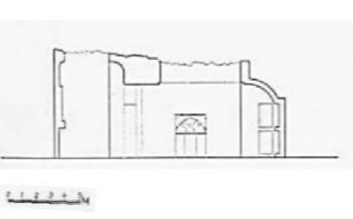 | 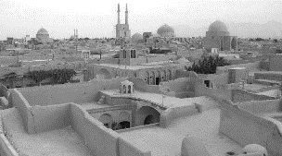
N. 12: Gonbad-i-Sabz Dome, Khorāsān Rażavī Province  (16th AD/Safavid period) [34][33] | 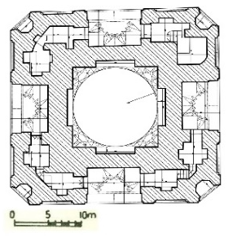 | 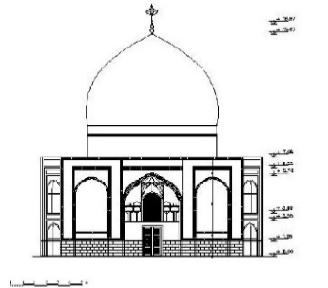
N. 13: Tomb of Seyed Jalīl and Seyed Khalīl (Tomb of Seyed Moṣallā), Yazd Province (16th AD) [33] | 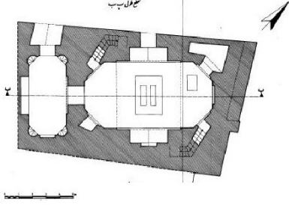 | 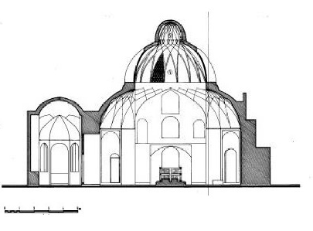

Table 4. Fourth Category, Suburban Khānqāh-Zāwīyih
 | Plan(s) of Khānqāhs in Arsin | Additional Information
N. 14: Abu Saʿīd Abu Al-Khiyr, Khānqāh, Kirmān Province (8th AD) [33] | 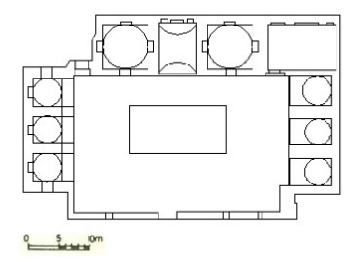 | 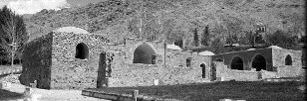  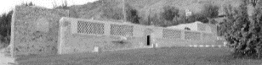
N. 15: Tomb of Imāmzadih Khiżr, Hamadān Province (10th AD) [37] | 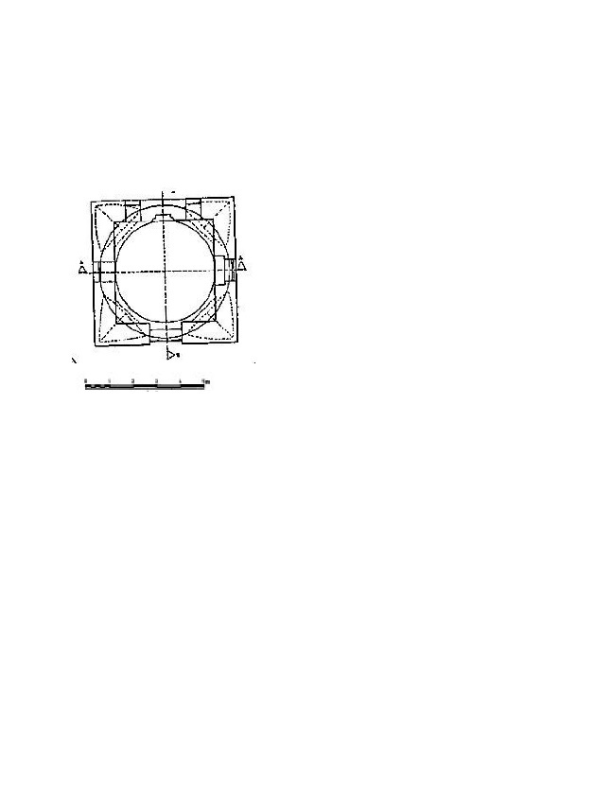 | 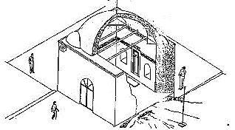
N. 16: Khānqāh and the tomb of Sheikh Maḥmoud Mazdaqānī, Simnān Province (13th-14th AD) [33] |  | 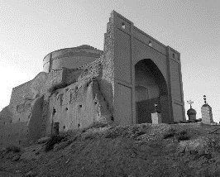
N. 17: Sheikh Zayn al-Dīn Abī Bakr ʿAlī Khānqāh, Khorāsān Rażavī Province (14th-16th AD) [33] | 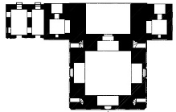 | 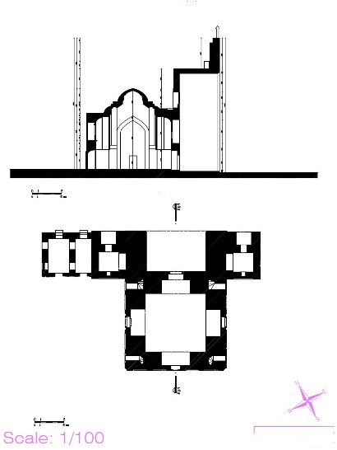
N. 18: Chalabī oğlu Khānqāh and Tomb, Zanjān Province (1327 AD/ Ilkhānid period) [34][33] | 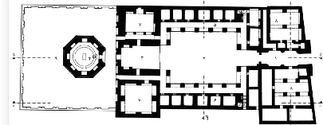  1- Entrance, 2- Sahn, 3- Īwān, 4- Tomb, 5- Portico, 6- Hojra(cell), 7- Jamā’t-Khānih, 8- Corner of servants, 9- Yard | 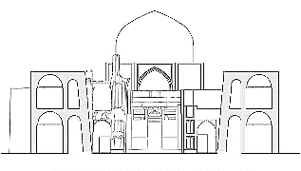
N. 19: Hāruniyih Khānqāh, Khorāsān Rażavī Province
(14th AD/ Timurid period) [33]
N. 20: Khānqah ʿOlīyā, (Tomb of Sheikh Amīn al-Dīn Balyānī), Fārs Province (1310 AD) [33] | 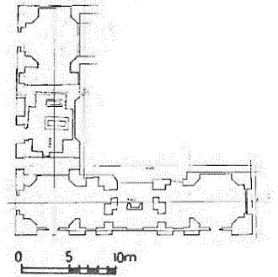 | 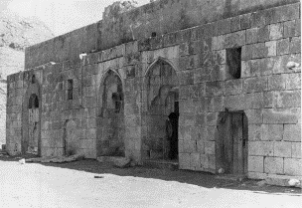
N. 21: Sheikh Shāhāb al-Dīn Aharī Khānqāh, East Azerbāijān Province (16th AD/early Safavid period) [38][34] | 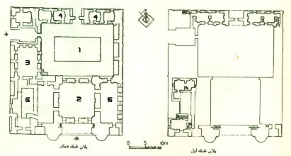 | 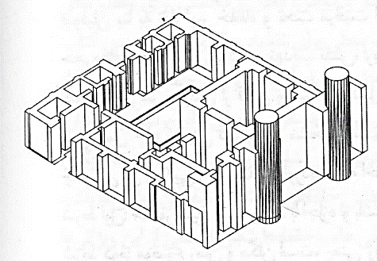  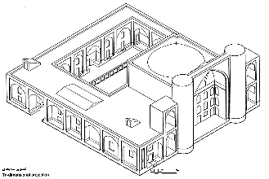

Table 5. Fifth Category, Khānqāh-Village
 | Plan(s) of Khānqāhs in Arsin | Additional Information
N. 22: Khānqāh and the tomb of Sheikh ʿAlā 'al-Dowlih Simnānī, Simnān Province (14th AD/ Ilkhānid period) [38][33] | 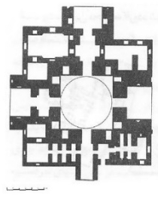 | 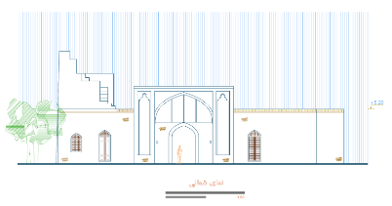
N. 23: Bāghmazār Veīrānī, Khorāsān Rażavī Province (13th-14th AD/Ilkhānid period) [33] | 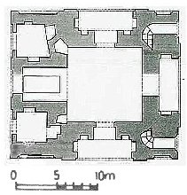  (Archive of Khorāsān Rażavī Cultural Heritage Office) | 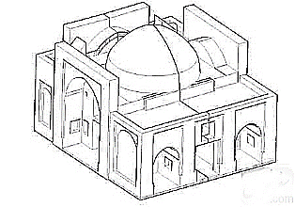
N. 24: Shāh Sulṭān Maḥmoud Complex, Yazd Province (13th AD) [36][33] | 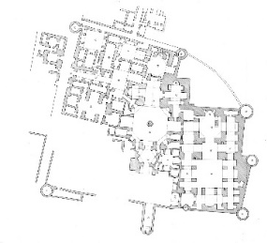  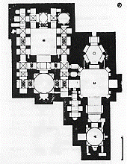  A-Tomb of Maḥmoud Shāh, B- Mosque, C- Khānqāh  (Annonymous, 1999, 283; Wilber & Others, 1996, 986) | 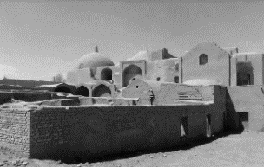
N. 25: Sheikh Quṭb al-Dīn ʿAbdul Salām Khānqāh, Kirmān Province (14th AD) [33] |  | 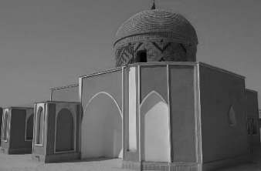
N. 26: Sheikh ʿAlī Banīmān Khānqāh, Yazd Province (1379 AD) [34][33] | 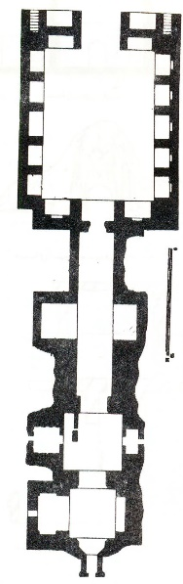 | 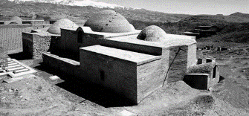
N. 27: Imāmzādih Shohadā Khānqāh, Fārs Province (mid-14th to late 15th AD) [39] | 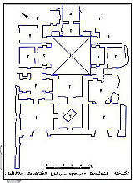 | 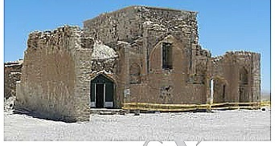

Table 6. Architectural space patterns of 27 Khānqāhs

*"N" indicates the studied Khānqāh displayed in the left column of Tables 1-5.

First Category, Khānqāh in Urban complex (Arsin) |  | Pattern (1) -1: Introverted, central courtyard with dome, single īwān with an irregular plan, and connected square |  |  | Pattern (1) -2: Introverted, central courtyard with dome, four-īwān with the regular plan, and pishtaq (entrance īwān) detached square |  |  | Pattern (1) -3: Introvert, Double-domed, single īwān with 3 arches, with an irregular plan, urban forecourt, and detached square |  | Pattern (1) -4: Extroverted, central courtyard with a detached circular dome in the center of the courtyard, with the regular plan and detached square |  | Second Category: Urban Khānqāh-Mosques | Pattern (2) -1 Introverted, a dome adjacent to a mosque with 2 or 4 īwāns, with an irregular plan, urban forecourt space
 |  | N.1: Sheikh Ṣafī al-Dīn Ardabīlī Complex and Khānqāh, Ardabīl Province (14th and 16th AD) |  |  | N.2: Shāh Niʿmatullāh Valī Khānqāh, Kirmān Province (15th AD Timurid Period) |  |  | N.3: Shāh Valī Complex and Khānqāh, Yazd Province (15th AD) |  | N.4: Towḥīd Khānih, Iṣfahān Province (16th AD/Safavid period)) |  | Second Category: Urban Khānqāh-Mosques | N. 5: Bāyazīd Basṭām Muḥammad Khānqāh, Simnān Province (1306 AD)  N. 6: Abdul Ṣamad Khānqāh, Iṣfahān Province (6th and 14th AD (
Third Category, Khānqāh-Tomb (Boqʿih) | Pattern (3) -1: Extroverted, domed, without īwān, courtyard with a regular plan |  | Pattern (3) -2: Introverted, double-domed, single īwān with an irregular plan |  |  |  | Pattern (3) -3: Introverted, central courtyard with dome, four-īwān with the irregular plan, and connected square | Pattern (3) -4: Introverted, domed, single īwān with an irregular plan | Pattern (3) -5: Introverted, domed, without īwān with an irregular plan |  |  | Pattern (3) -6: Extroverted, domed, four-īwān with regular and centered plan |  | Pattern (3) -7: Introverted, double-domed without īwān, with an irregular plan
Third Category, Khānqāh-Tomb (Boqʿih) | 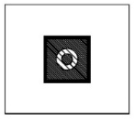 |  |  |  |  |  |  | 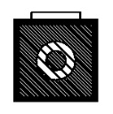 |  |  |  |  |  | 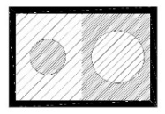
Third Category, Khānqāh-Tomb (Boqʿih) | N.7: ʿAlī Ibn Sahl Khānqāh, Ṭoqchī Iṣfahān Province (9th century AD) |  | N.8: Sheikh Abu al-Masʿoud Rāzī Khānqāh, Masʿoudīyih Neighborhood, Iṣfahān Province (9th century AD) |  |  |  | N.9: Sulṭān Sheikhdād Complex, Sheikhdād Tomb, Yazd Province (1325 AD) | N.10: Tomb (Boqʿih) of Sheikh Muḥammad Khānqāh, Fīrouz-Ābād District, Yazd Province, (1390 AD) | N.11: Tomb (Boqʿih) of Sheikh Aḥmad and Sheikh Muḥammad Fahhādān, Yazd Province (14th century AD) |  |  | N:12: Green Dome (Gonbad Sabz), Khorāsān Rażavī Province, (16th AD) |  | N.13: 13- Tomb (Boqʿih) of Seyed Jalīl and Seyed Khalīl (Tomb of Seyed Moṣallā), Yazd Province (16th century AD)
Fourth Category: Suburban Khānqāh-Zāwiyahs | Pattern (4) -1: Introverted, central courtyard, three-sided, with a regular plan  Pattern |  |  | Pattern (4) -2: Extroverted, domed, with a regular plan, and terrace |  |  | Pattern (4) -3: Extroverted, the dome, with a regular plan, single īwān with forecourt | Pattern (4) -4: introverted, central courtyard with dome, two-īwān, with a regular plan, and tomb in the center of the courtyard | Pattern (4) -5: extroverted, domed, single īwān with a Regular plan |  | Pattern (4) -6: extroverted, without īwān, with a regular plan |  |  | Pattern (4) -7: introverted, central courtyard with dome, three-īwān, with a regular plan and 2 minarets
Fourth Category: Suburban Khānqāh-Zāwiyahs | 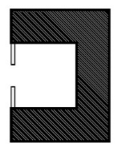 |  |  |  |  |  |  |  | 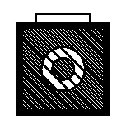
Fourth Category: Suburban Khānqāh-Zāwiyahs | N.14: Abu Saʿīd Abu Al-Khiyr, Khānqāh, Kirmān Province (8th century AD) |  |  | N.15: Tomb of Imāmzadih Khiżr, Khiżr, Hamadān Province (10th century AD) |  |  | N.16: Khānqāh and Tomb of Sheikh Maḥmoud Mazdaqānī, Semnān Province (13th-14th century AD/Il-khānid period)  N.17: Sheikh Zayn al-Dīn Abī Bakr ʿAlī Khānqāh, Khorāsān Rażavī Province (14th-16th century AD, Timurid period) | N.18: Chalabī oğlu Khānqāh and Tomb, Zanjān Province (1327 AD/Il-khānid period) | N.19: Hāruniyih Khānqāh, Khorāsān Rażavī Province (14th century AD/Timurid period) |  | N.20: Khānqah ʿOlīyā, (Tomb of Sheikh Amīn al-Dīn Balyānī), Fārs Province (16th century AD, early Safavid period) |  |  | N.21: Sheikh Shāhāb al-Dīn Aharī Khānqāh, East Azerbāijān Province (16th century AD,10th century AH, early Safavid period)
Fifth Category: Khānqāh-Villages | Pattern (5) -1: Extroverted, the dome, three-īwān with a regular plan |  |  |  |  | Pattern (5) -2: Introverted, central courtyard with the dome, three-īwān, pishtaq (entrance īwān) with a regular plan |  | Pattern (5) -3: Extroverted, domed, single īwān courtyard with a regular plan |  | Pattern (5) -4: Extroverted, central courtyard with the dome, without īwān, with a regular linear plan |  |  |  |  | Pattern (5) -5: Extroverted, domed, Without īwān with a regular plan
Fifth Category: Khānqāh-Villages | 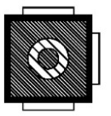 |  |  |  |  |  |  | 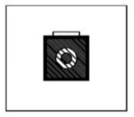 |  | 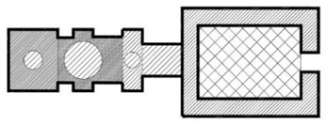
Fifth Category: Khānqāh-Villages | N.22: Khānqāh and Tomb of Sheikh ʿAlā 'al-Dowlih Simnānī, Semnān Province (14th century AD/ Il-khānid period)  N.23: Bāghmazār Veīrānī, Khorāsān Rażavī Province (13th-14th century AD) |  |  |  |  | N.24: Shāh Sulṭān Maḥmoud Complex, Sheikh Taqī al-Dīn Dādā Khānqāh (known as Sheikhdād founder of the Dādāiyih dynasty), Yazd Province (13th century AD) |  | N.25: Sheikh Quṭb al-Dīn ʿAbdul Salām Khānqāh, Kirmān Province (14th century AD) |  | N.26: Sheikh ʿAlī Banīmān Khānqāh, Yazd Province (1379 AD) - Tomb of Sheikh ʿAlī Banīmān, (Known as Bābā Sheikh ʿAlī Bīdākhavīdī) |  |  |  |  | N.27: Imāmzādih Shohadā Khānqāh (Sulṭān Ibrāhim), Fārs Province (mid-14th Century to late 15th century AD)

- TYPOLOGY OF KHĀNQĀHS
The typology of Īrānian traditional architecture consists of three main types, including Chāhār_Ṣoffih, a dome, and a central courtyard, along with the īwān as an important feature in Īrānian architecture. This typology was also evident in the architecture of Īrānian Khānqāhs up to the Qājār period.
This study defines īwāns as follows: 1) the arch that is higher than its adjacent components, whose aesthetic aspect comes before its use and acceptable ostentation; 2) the arch, generally high but not necessarily higher than other adjacent elements, connected to the central space, and 3) in an evolutionary definition, the pīshtāq (entrance īwān) that is higher than the adjacent components, connected to the central space.
Traditionally, an entrance or pīshtāq (entrance īwān) differs from an īwān in the Islamic architecture of Īrān. This study conforms to this distinction, too. A pīshtāq (entrance īwān) is, originally, a great and tall door that marks the entrance to such public places as schools, caravansaries, mosques, and tombs. Public introverted spaces are more likely to have this element. For example, the īwān of “Gonbad-i-Sabz” (N.12), Mashhad, is not taller than its surroundings but is conventionally a tall entrance to the middle of the building, with a remarkable aesthetic value. “Sulṭān Sheikhdād” Khānqāh (N.9) is another example. It has a central courtyard with an īwān that leads to no other spaces. The īwān is higher than the surrounding space and aesthetically valuable. However, the pishtāqs (entrance īwān) of the entrance to “Alī ibn Sahl” Khānqāh (N.7), Iṣfahān, are not tall and, therefore, cannot be considered an īwān.
A Ṣoffih is equally important since they are interchangeably used. In Khorāsān, any indoor space, whether with a curve or a flat cover, was referred to as a Ṣoffih or chaftih. In other places, it was also referred to as īwāns and halls covered with arcs (tāqs). In another definition, a Ṣoffih is a roofless platform higher than the level of the yard and is usually placed in front of closed spaces. In the typology made for the Khānqāhs of the Islamic period of Īrān until the Qājār era, only the physic of any space named "Khānqāh" is investigated (Table 7).

Table 7. Type Analysis
- Dome Type Analysis
Double-Domed | Single Dome |  |  |  | Without Īwān |  | With Īwān | Single Īwān
N.8 | N.15 |  |  |  | N.15 |  | N.16 | Single Īwān
N.8 | N.23 |  |  |  |  |  | N.10 | Single Īwān
N.8 | N.24 (Regular polygon plan) |  |  |  |  |  | N.10 | Single Īwān
N.8 | N.16 |  |  |  |  |  | N.17 | Single Īwān
N.11 | N.5 (Regular polygon plan) |  |  |  | N.5 (Regular polygon plan) |  | N. 19 | Single Īwān
N.11 | N.6 (Regular polygon plan) |  |  |  | N.6 (Regular polygon plan) |  | N.8 | Single Īwān
N.3 | N.10 |  |  |  |  |  | N.2 (with 3 arcades) | Single Īwān
N.3 | N.17 |  |  |  |  |  | N.24 | Three Īwān
N.3 |  |  |  |  | N.11 |  | N.23 | Three Īwān
N.13  (Lattice dome) | N.19 |  |  |  | N.13 |  | N.12 | Four Īwān
N.13  (Lattice dome) | N.12 |  |  |  |  |  | N.12 | Four Īwān
- Central Courtyard Type Analysis
Without Īwān |  |  | With Īwān
Four-sided | Three-sided | Two-sided | Four-Īwān |  |  | Three-Īwān | Two-Īwān | Single Īwān
N.26 | N.14 | N.20 | N.9 |  |  | N.21 | N.18 | N.1
N.4 | N.14 | N.20 | N.2 |  |  | N.21 | N.18 | N.1
- Chāhār Ṣoffih (Four-Platform) Type Analysis
Without Īwān |  |  |  | With Īwān
N.7 |  |  |  | N.22 (Three-Īwān)
N.27 |  |  |  | N.25 (Singe Īwān on the west of the building)

Three Khānqāhserve as the head of a branch or genotype for the others:
- Central courtyard type: 8thAD., “Abu Saʿīd Abu Al_khiyr” Khānqāh (N.14), Kirmān province.
- Chāhār_Ṣoffih type: 9thAD, “Alī Ibn Sahl” Khānqāh (N.7), Iṣfahān City, Iṣfahān Province.
- Dome type: 10th AD., Tomb of “Imāmzadih Khiżr” (N.15), Northeast of Hamadān city.
Phenotypes mainly contain īwān-included, two-dome, and axial types. “Sheikh Oliā” Kāzirun (N.20) (1310 AD), and “Towḥīd_khānih” Khānqāh (N.4), Naqsh Jahān Square, Iṣfahān (Safavid period), are two exceptions that have traces of pre-Islamic and western architecture and its rotundas as a place of worship. Studying them requires further research.
The genotype of “Abu Saʿīd Abu Al_khiyr” Khānqāh (N.14), Kuhbinān, also resembles the form of quadrangular Īrānian Khanas including hojras. Then the hojra, in conjunction with the dome, is located around the sides of a central courtyard. That type shares the same phenotype with the architectural design of Īrānian Masjid-Madrasas. This similarity between a very old Khānqāh from the 8th Century and the form of a house has a particular meaning similar to the meaning of the word “Khānqāh”, which is derived from the word “house” and “place" to eat and feed in the literature.
The 13th AD construction of “Shāh Sulṭān Maḥmoud” Khānqāh (N.24), known as Sheikhdād, the founder of the Dādāiyih dynasty, marks the beginning of constructing Khānqāhs near mosques. These Khānqāhs had a regular design with a regular polygonal plan, a dome, and an independent central courtyard. The Mosque-Khānqāhs built afterward had a smaller space.
“Sheikh Maḥmoud Mazdaqānī” Khānqāh and tomb (N.16), Mo'min-abād village, Sorkhih city, Semnān province, built in the Ilkhanid period, has a high īwān. Its effect on the architecture of the Khānqāh of “Sheikh Zayn Al-Dīn Abī Bakr” (N.17), Taybād, Khorāsān Rażavī, in the Timurid period is evident. They are the two Khānqāhs with an īwān and dome.

- The Influence of Churches on Form Processing of Khānaqāhs
Īrān is culturally wider than the current geographical borders. A large range of khānqāhs in ancient Īrān from the Seljuq to the Safavid era can be identified in the surrounding countries, the oldest and most famous of which were selected in Uzbekistān, Turkmenistān, Kazākhstān, Afghānīstān and the Anatolian region of Turkiye for initial review. However, each of these areas needs independent research. In the current study, this brief review also paves the way for productive future research and confirms the drawing Greater Īrān khānqāh design’s inspiration from the various styles of churches. For a brief overview, these several khānqāhs and buildings with similar plans were selected from the countries of Greater Īrān from the Seljuq to Safavid eras to study the subject more carefully (Figure 4):
  - Abu Saʿīd Abu_al_Khiyr Mausoleum, Ahal Province, Turkmenistan (967 - 1049)
- KhājihʿAbdullāh Anṣāri Khānqāh (SheikhʿAmoiyih or Sheikh ʿAmoo), Herāt City, Afghānīstān (About 11th AD)
- Boyalı Külliyesi (Kureyş Baba Kümbeti), Afyon karahisar City, Afyon Province, Turkiye (12th AD)
- The Pīr Ḥusayn Khānqāh and Mausoleum, Southwest of Bāku, Azerbāyjān (1280 AD)
- Mausoleum of Khājih Aḥmad Yasāvī, Turkistān City, Kazākhstān (1389-1405 AD/ Timurid Period) [32].
- Nadir Dīvan Biygī Khānqāh at the Lab-ī-Hūż Complex in Bukhārā, Uzbekistān (1620 AD)

Figure 4. Evolution of the Khānqāh [40]

The first khānqāh that has no trace of it was near the current mausoleum of “Abu Saʿīd Abu_al_Khiyr” in Greater Khorāsān, located in Turkmenistān now. This kind of khānqāh-village can be mentioned as a primary model for placing the pīr tomb next to its khānqāh, which has been repeated in many other spatial patterns. Furthermore, three recesses of the walls seemed to be designed in the existing plan, such as the recluse space for Chilla, which is close to the main function of the ruined building. These recesses can be seen in similar buildings with high īwāns in the Il-khānidand Timurid periods, such as “Sheikh Zayn al-Dīn Abī Bakr” Khānqāh (N.17), Taybād, and the tomb of Khānqāh and Tomb of “Sheikh Maḥmoud Mazdaqānī” (N.16), Sorkhih, which is similar to the chapels in churches which is used for Christian ceremonies (Table 8).
The first available records of the existence of chapels in churches date back to the early Christian house churches. In the schematic plan of the Gothic churches, the chapels have a specific place around the altar. The chambers or cells or hojras around a courtyard or Jamā’at_Khana (Dome House), for the retreating space of Sufis, have the same functions as them. The connection of these spaces with the atmosphere of solitude is related to sharing the idea of solitude with God in monotheistic religions.
Another example of older khānqāhs in neighboring countries, which are debatable in the courtyard type with a linear and irregular spatial pattern, is the “Boyalı Külliyesi Kārāhisār” in Turkiye, 12th Century, and the khānqāh of “Pīr Pīrsaʿat” or “Pīr Ḥusayn Bāku” in Azerbaijān, 1242AD which is in the category of village-khānqāhs. “Boyalı Hanikah” (khānqāh) was built in Byzantine architecture. Several chambers around the central corridor, a tomb, and a solitary prayer hall were built beside it, suitable for Chilla. “Pīr Pīrsaʿat" Khānqāh in Bāku is also in the category of khānqāh-suburban Zāwiyah and has a combination of house and castle. The chambers are formed near the walls surrounding the building and are closer to the Rabāt design and its definitions.
Even though these types were built earlier than those that have been studied up to the Safavid era in this study, these types have certain differences in classification and styles. The most famous and impressive church of the early Christian period is the Church of the Holy Sepulcher, built-in Golgotha, the northwest quarter of the old city of Jerusalem, around 345 AD. In this church, which is known as the place of the crucifixion and the tomb of the Holy Christ and is respected by all the followers of Abrahamic religions. The shape of the rotunda is used. This form seems to have and will have the greatest impact on similar buildings. In the following, octagons and circles are forms that have been used extensively in the architecture of Medieval and Renaissance churches, and many baptisteries are designed in these forms. This era corresponds to the period of expansion of khānqāhs in Islamic countries. However, the full circular form is not seen in Īrānian khānqāhs more, except for the “Allah Allah Dome” in “Sheikh Ṣafī Al-Dīn Ardabīlī” Complex and Khānqāh (N.1) in Ardabil, but multi-sided plans, built instead. In Īrānian architecture, the circular form has been used more for tomb towers.

Table 8. Chapel Design Process from Christian Churches to Islamic Khānqāhs

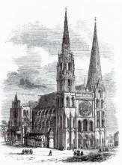 |  |  | 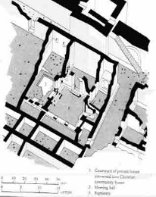
Roman Gothic Style, Chartres Cathedral of Notre Dame, 80 km southwest of Paris, France, 1194 AD [43][44] |  |  | 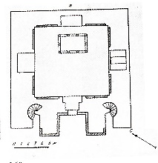  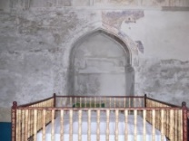  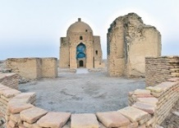  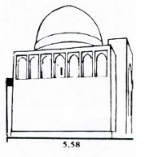  The Dura-Europos house church, built ca. 232 AD [41][42]
 |  |  |  |  |  |  | Mausoleum of Abu Saʿid Abi’l-Ḵayr, 11CE [45][46][46][45]
Timurid period, About 14th -15Th AD |  |  |  | Il-khānid period period, About 13th -14th AD
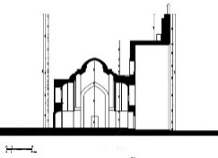  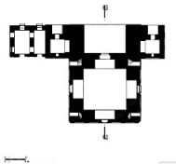  N.17 |  |  |  | N.16
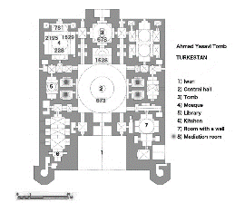  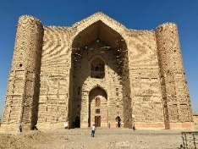 |  |  |  | 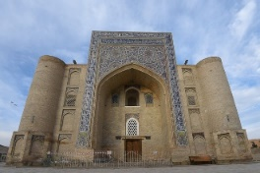  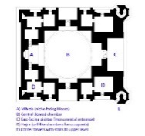
Mausoleum of Khwāje Ahmad-e Yasavī, Turkistan City,  Kazākhstān [32] |  |  |  | Nadir Divan-begi Khānqāh at the Lab-i-Hauz Complex in Bukhara, Uzbekistān [47]
Castle-House Type, About 13 AD |  |  | Byzantine Church Style, Court Type, Anatoly, About 12 AD
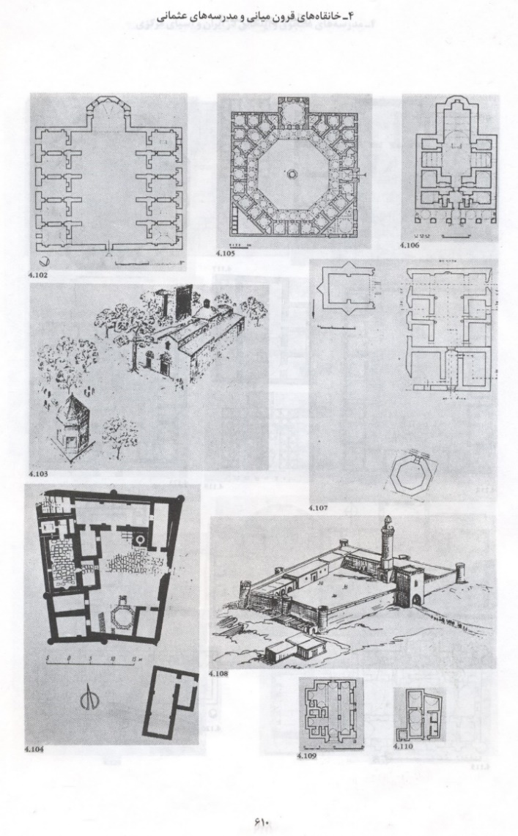 | 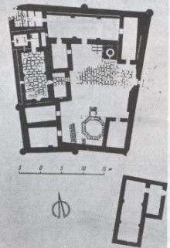  The Pīr Huseyn Khanqah and Mausoleum [45] |  | 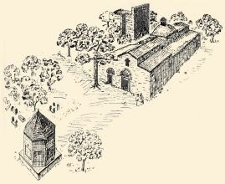  Boyalı Külliyesi, Afyonkarahisar City, Afyon Province, Turkiye [45]

The history of the circular plan and a regular polyhedron (12 sides) reaches Herāt and Gāzār-Gāh area, Afghānistān which is attributed to “Sheikh ʿAmoīyih”. In the Timurid period near the ruined khānqāh of Rigestān Square, a building called Chāhar-Su, 15th Century is similar to it, and finally, in the Safavid period, the plan of “Towḥīd_Khānih” Khānqāh (N.4) in Naqsh_Jahān Square of Iṣfahān has such a form. “Sheikh ʿAmoīyih”, in Gāzār-Gāh of Herāt, 11th CE and “Towḥīd_Khānih” Khānqāh (N.4) in Naqsh_Jahān Square of Iṣfahān and the Chāhār-Su plan, have a multi-sided plan, the multi-sided plan is used in church chambers. Therefore, these similarities provide a strong hypothesis that Khānqāh design is influenced by the churches and Rotundas. The design of religious spaces in European architecture has expanded from the Pantheon to churches (Table 9).

Table 9. An Overview of Circular and Octagonal Plans in Churches and Khānqāhs
Church of the Holy Sepulchre, Northwest Quarter of the Old City of Jerusalem(al-Quds), About 345 AD [43]
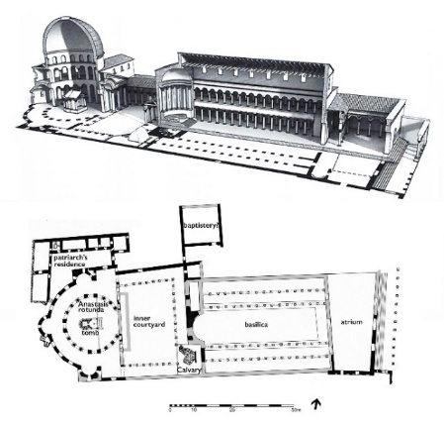
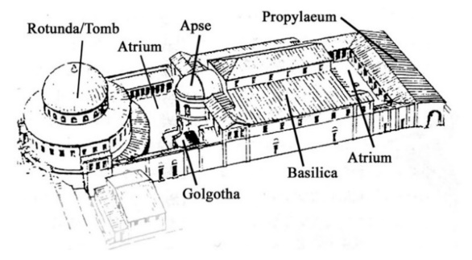
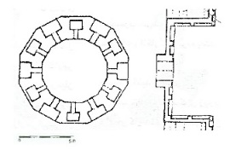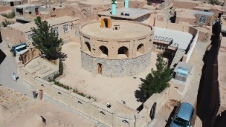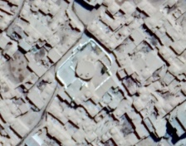
Khwaja Abdullah Ansari Khānqāh, Afghānīstān [48] N.4
The similarity Between Baptisary and Chillakhanas (Prayer Hall)

Byzantine Style |  | Pilgrimage Church in Renaissance Style
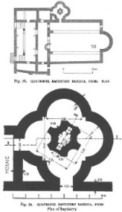
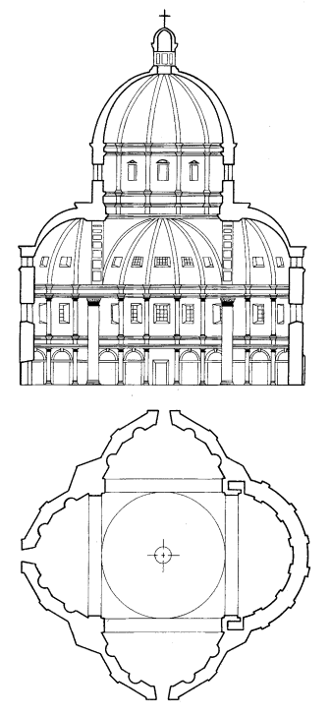
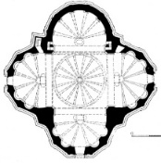

Quatrefoil Baptistery Basilica, Stobi, Gradsko, Vardar, Statistical, Republic of North Macedonia, 5th AD [49] |  | Santa Maria Della Consolazione, Italy,1508-1512 AD [43]
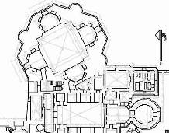
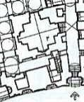
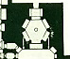
N.24 | N.6 |  | N.1

Table 10. An Overview of the Effects of Church Patterns on Khānqāhs in Greater Īrān
Christian Pattern1: Introverted, with an irregular plan, with court
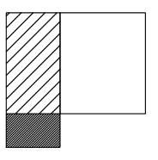
The Dura-Europos house church, built ca. 232 AD
Islamic Pattern5: Extroverted, Domed, single Īwān with Rampart and regular plan | Islamic Pattern4: Extroverted, Domed, single Īwān with a regular plan |  | Islamic Pattern3: Extroverted, Domed, single Īwān with a regular plan |  | Islamic Pattern2: Introverted Courtyard, with Rampart, Minar, and irregular plan |  | Islamic Pattern1: Introverted, with a regular plan, with a court and a tomb
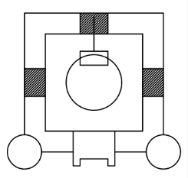 | 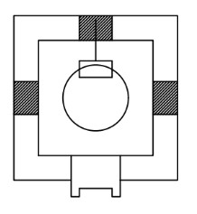 |  | 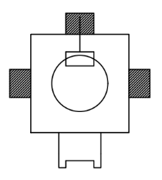 |  | 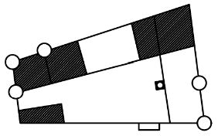 |  | 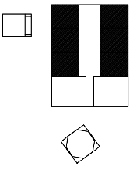
Nadir Dīvan-biygī Khānqāh | N.17 |  | N.16 |  | Pīr Ḥusayn Khānqāh |  | Boyalı Külliyesi
Christian Pattern5: Introverted, with a regular plan |  | Christian Pattern4: Introverted, with a regular plan |  | Christian Pattern3: Extroverted, with a regular plan, with court |  | Christian Pattern2: Extroverted, Domed, with a regular plan, with court
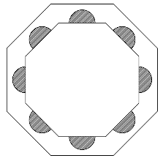 |  | 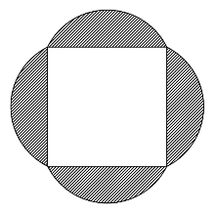 |  | 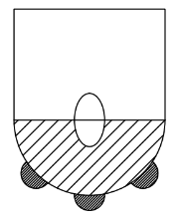 |  | 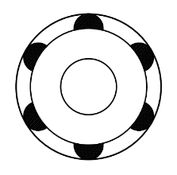
Islamic Pattern7: Extroverted, Domed, with a regular plan |  |  |  | Islamic Pattern6: Extroverted, with a regular plan
 |  |  |  | 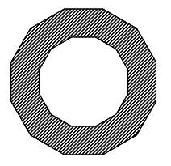
N.4 |  |  |  | Khājih ʿAbdullāh Anṣāri Khānqāh
In the Greater Īrān, there are two categories of khānqāh-house and khānqāh-castle outside the city. The courtyard types, with both regular and irregular patterns, are seen as different types from the Īrānian types, including the Chāhār_Ṣoffih, dome, and the central courtyard type (Table 10). The Il-khānid period, referring to the Mongol rule in Iran during the 13th and 14th centuries, was marked by a notable degree of religious tolerance. Unlike other Mongol rulers, the Il-khāns were relatively open to various religious practices. Under the Il-khānid dynasty, there was significant religious freedom, allowing diverse religious communities to coexist. This tolerance extended to Christians, Muslims, and other religious groups. The Il-khāns even employed individuals from different religious backgrounds in administrative positions, contributing to a sense of religious pluralism. One notable example of this tolerance is the construction of churches in the Azerbaijan region of Iran alongside Islamic structures. This reflects a period where different religious communities were able to practice their faiths with a certain level of acceptance and coexistence under Il-khānid rule.
Before the Mongol era in Iran, architectural patterns in mosques, mosque schools, tombs, and rabats were also incorporated into Khānqāhs. However, the churches with the Byzantine form built in the Il-khānid period in the Azerbaijan region influenced the architecture of the Khānqāhs. Khānqāh and Tomb of “Sheikh ʿAlā 'Al-Dowlih Simnānī” (N.22), located in Sufī-Ābād village, built in 14th AD, this building has a unique plan like churches in the shape of the Greek cross. All these cases are signs of the influence of the founders of these spaces from the method of monasticism in churches.
Two elements contribute more to this classification and analysis: being equal in scale and settlement quality in residential complexes, so regarding spatial qualities, plans with the same value and scale fall under the same category. Their typology is then classified according to whether they are introverted or extroverted, having single or multi-īwāns and having domes or courtyards to provide a more accurate analysis of this space. The project economy, management system, the power of the Sheikh/ pīr, and the amount of endowment and property of Khānqāhs affected their space formation and extension. So, they functioned as the main criteria for the classification of the architectural spaces of Īrānian Khānqāhs in the Islamic period. Therefore, six main categories can be identified in terms of the proximity of the Khānqāh to the residential area and the similarities of the architectural design with other similarly designed public spaces. (Tables 1-5)
1) Khānqāh in Arsan (Urban complex), 2) Urban Khānqāh-Mosque, 3) Khānqāh-Tomb, 4) suburban Khānqāh-Zawiyah, 5) Khānqāh-Village, and 6) Khānqāh-House.The last category is significant within the residential contexts where either other building has replaced old Khānqāh-houses with no traces left or the house’s inner space has been considered in the contemporary period and functioned as a Khānqāh. The current study excludes its investigation and requires further research.

- KHĀNQĀH DESIGN FROM THE LAST TO THE FUTURE
In different periods of human history, sometimes people sought refuge in areas far from the cities to be safe from the persecution of the government system. For example, until about a century ago, some villages were built away from the main roads to be out of reach of the tax authorities. As for hermitage with a religious color, it seems that from around the third century AD, with the rise of the Roman Empire "Desius" and his fierce struggle with the followers of Christ, Christians took refuge in the mountains and deserts to escape his persecution. They were forced to be hermits and isolated from society; thus, the seed of monasticism was sown in society as a religious matter.
This shows that isolationism has nothing to do with the teachings of Christianity and did not even exist among Christians in the first three centuries AD. Only after that, it appeared as a practical solution to escape from the oppression of the rulers. Searching in the texts of divine religions also negates seclusion in the spirit of teachings revealed by divine prophets. The Qur'an also considers monasticism and celibacy as Christian heresy. (Al-Hadid/27) Seclusion in Islam has a time limit and is not recommended permanently. It can be argued, based on the Qur'an, Sunnah, and rational reasoning, that the advice of Islam is based on socialism and has many rules regarding the development of human relations, cooperation, and peaceful life. Therefore, it can be said that the Khānqāh has non-Islamic roots, and seclusion first became common in temples and churches.
In Iran, freedom, security, and health were directly related to staying away from oppressive rulers, which led to the emergence of Khānqāhs in distant areas. In this way, Khānqāhs were formed as private spaces considering social distances for study, contemplation, and re-awakening, with multiple spatial distinctions. Over time, the architecture of the Khānqāh underwent extensive transformations, but the spirit of respect for experience accompanied these changes.
Centuries ago, the evolution of Sufi history gave birth to a type of architecture in Khānqāhs. The architectural atmosphere of the Khānqāh, with a long presence in the history of Sufism, played a vital role in the rise of Sufi tariqa (order). Sometimes, after the death of a truth seeker Sheikh, his disciples would build a shrine on his grave, and a Khānqāh would be formed. Then, the charity would donate an endowment for the continuation of the Sheikh's thoughts, and when this Khānqāh was worn out, another person would rebuild it, or it would turn it into a space like a mosque, but the nature of the space remains unchanged.
The reason to construct Khānqāhs for solitude and how to form them is debatable. The disappearance of their spatial structure also needs investigation. Khānqāhs were at the peak of prosperity and expansion in the Islamic world until the 10th and 11th centuries, but they began to decline after that. Several factors, such as the serious opposition of religious scholars to Sufism, especially teachings that conflict with the essentials of religion (both in beliefs and practices and customs), and the anti-western policies of Khānqāhs, have affected their decline. Lack of economic and political support, lack of support for mystics and the approaches of Sheikhs, disruption of the required spatial organization, and shifting from the public architectural space to private and explanation to allocation are probable causes. This decline did not happen equally in all Islamic lands. For example, the Khānqāh in the neighboring country of Iran, Turkey, has become a part of the culture of this country and has a strong representation in the cultural tourism field.
In contemporary times, emerging methods of seclusion along with superstitious or austere beliefs are seen a little in some informal spaces and mainly private houses inside the cities. The government does not support this movement and does not recognize it officially. It takes place in a place with neither a specific spatial feature nor its doctrine registered and supervised by civil institutions. Due to the lack of a special spatial feature, these spaces fail to present the spatial dialectic between truth-seekers and Irfan students. They are even accused of making deviations. Since Khānqāhs and the construction of specific architectural spaces for them had fallen into decline, institutional Sufism declined either. The Khānqāh space is uninspiring without a dialectic between dervishes and mystical practices. This procedure may cause extensive harm to society and individuals interested in mysticism and Sufism. Examining the reason and nature of solitary spaces and their theoretical values and clarifying the advantages and disadvantages of their ideas would create a more quality and updated method for those who seek this thought.
The reason for the formation of secluded spaces in urban houses is unclear. Maybe because, unlike the past, less remote places are accessible to today's large human population. On the other hand, the complexity of modern life relationships has brought social interactions into a new field; therefore, new social studies are needed to evaluate the mentality of the contemporary generation about isolation. Most of the Khānqāhs are abandoned and in the process of being destroyed and need to be renovated. While trying to introduce the distorting culture of seclusion, this study documents its spatial forms before they are completely out of reach. These places' typology helps preserve their values and registers a document for future generations.

- CONCLUSION
The current research studied 27 Khānqāhs located in urban public areas, except for Khānqāh-Khanas, which are generally located in residential areas. They fell under 5 categories. Three main types and thirteen subtypes, with and without an īwān, were identified in the contemporary era. (Out of 31 Khānqāhs from this period, three were ruined, and one had a hypothetical plan.)
Seven suburban Khānqāhs were dominant, with a greater impact on the typology system of Khānqāhs. The representatives of the central courtyard type and dome type were “Abu Saʿīd Abu_al_Khiyr” Khānqāh (N.14) in the 10th AD, respectively. “ʿAlī Ibn Sahl” Khānqāh, Iṣfahān, 9th AD, which is located in the middle of a garden, with traces of being outside the urban space, was identified as the oldest Chāhār_Ṣoffih type. They constitute the three main genotypes of pre-Qājār Khānqāhs in Īrān. The remaining 24 Khānqāhs were interpreted according to their phenotypes.
There were three phenotypes from “ʿAlī Ibn Sahl” Khānqāh (N.7), thirteen phenotypes from Tomb of Imāmzadih Khiżr (N.15), and eight phenotypes from “Abu Saʿīd Abu Al_khiyr” (N.14). Six of these eight phenotypes were a combination of the central courtyard genotype with the genotype of the Tomb of Imāmzadih Khiżr (N.15) and its dome type. Five central courtyard buildings with a dome were formed based on the same axis. It shows that the dominant gene in the system of typology of Īrānian Khānqāhs is based on the dome and then the central courtyard and Chāhār_Ṣoffih. Studying the spatial system of Īrānian Khānqāhs shows that the dome is located in the space of the Jama'at_Khana, the center of Khānqāh practices.
However, pre-Islamic spaces and designing methods of private spaces for monks and pilgrims in Christianity have left some traces on the design of Īrānian Khānqāhs. Further studies are required to investigate these. It, however, reflects the influences Christianity and temple rituals have had on the development of practical mysticism and Īrānian Sufism. Regarding the similarity between the Khānqāh architecture and other spaces, the architecture of the tombs, in terms of the centrality of the dome, has a similar phenotype to the design of Khānqāhs. This is also evident in the architecture of masjid-madrasas (mosque-school), caravanserais, and Rabāṭs in terms of hojrā confinement at the edges of the building. Original Chāhār_Tāghīs and simple cubes show the basic form of this similarity. However, the main association between Khānqāhs and the space of masjid-madrasas, dominated by education and worship, is that they are used for permanent and temporary residence.
Genotypically, on the other hand, a branch of Khānqāhs is different. Their spaces range from solitude and pre-Islamic worship to the Islamic period and monastic traditions. This revolution has gradually taken place.
The design of Chāhār_Ṣoffih in Īrānian houses, with the Greek cross of the churches, creates a new type of Khānqāhs. This is a new generation of solitude and the Īrānianized phenotype of a monastery.
Turning to the spatial pattern, the introverted type is dominant within cities and rural-urban residential contexts. The extroverted type, however, is strongly evident in this space category, as well as suburban spaces. The dome is an important space and is not limited to “Sheikh Oliā Kāzirun” Khānqāh (N.20). This place was used as a residence for dervishes and was inspired by the style of the Anāhītā Temple in Bishāpour of Fars province in Īrān. Decorations distinguish the periods and thinking styles of Sufism. Regardless of their similarities, various types of Khānqāhs are distinguished from masjid-madrasas and caravanserais through their symbolism and employment of particular signs. Khānqāhs generally had no minarets, unlike their similarly planned spaces. Such later types as “Sheikh Shāhāb Al-Dīn Aharī” Khānqāh (N.21), built in the Safavid period, had a minaret. It more likely was to suggest an Islamic atmosphere that existed in masjid-madrasas.
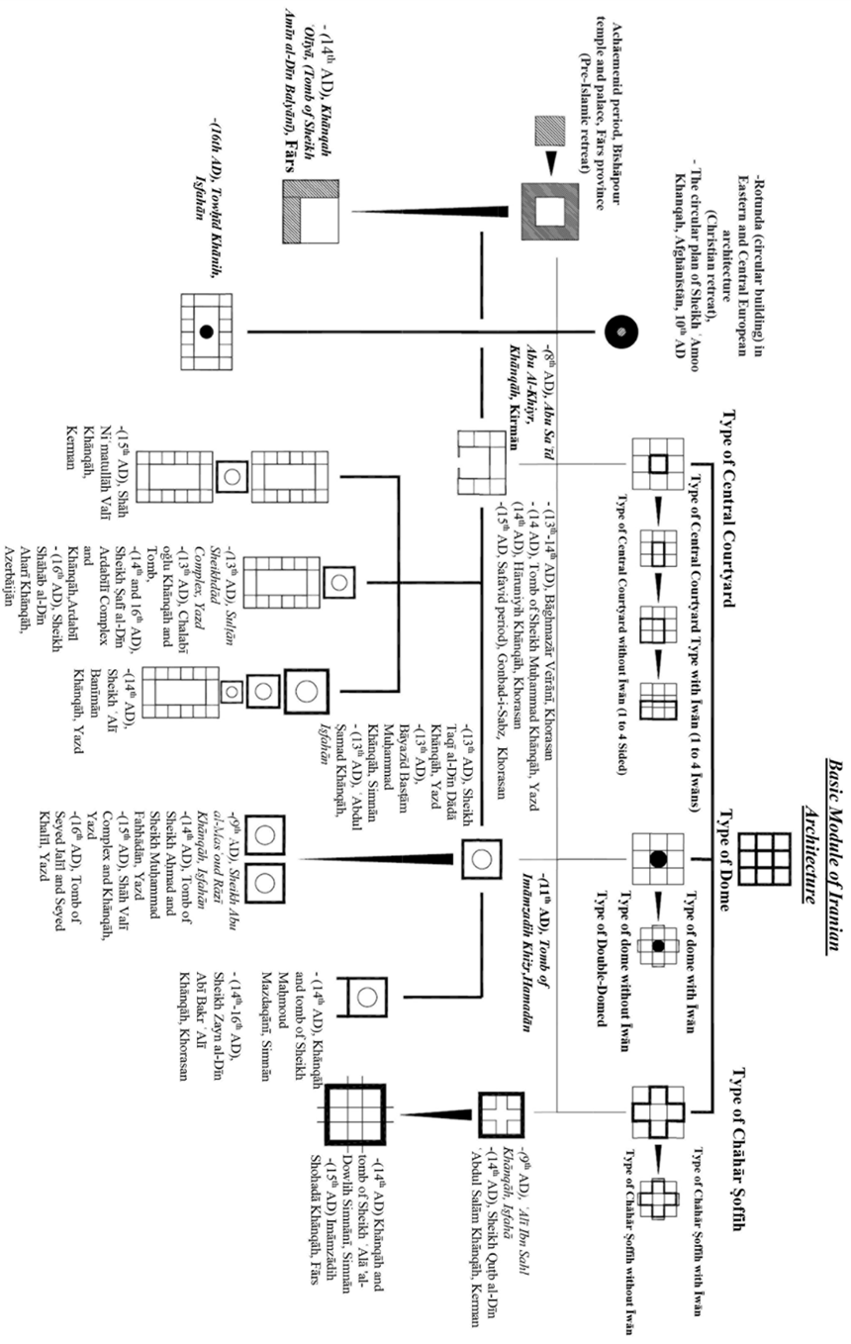
Nevertheless, the idea of "poverty" and "reliance on God for living" was prevalent in such an atmosphere. This also affected the design of building elements. (Figure 5)

Figure 5. Iranian Khānqāh Typology until the End of the Safavid Period
The area of the Khānqāh is relatively small. It suggests an atmosphere of poverty and austerity. In general, the diversity of types is associated with the diversity of thoughts on progress to God and this space. Its spatial structure, however, distinguishes it from other Īrānian practical spaces.
The architecture of Khānqāhs is closely related to the culture of other countries. Their influences on the architecture are evident. Optimistically, the Khānqāh unites different religions.

ACKNOWLEDGEMENT
The research of the corresponding author is supported by a grant from Ferdowsi University of Mashhad (N.2/2/55148).

REFERENCES
[1] M. Qayyomī Bīdhindī, and S. Solṭānī, “Lost Architecture, Khānqāh in Khorāsān in the Fifth Century”, Scientific-Research J. of Īrānian Architectural Stud., Vol. 2, PP. 65-85, Sept. 2014.
[2] J. Shabī, Encyclopedia of Persian Language and Literature, first Ed., Tihrān, Īrān: Academy of Persian Language and Literature, 2009.
[3] H. Asthari, "Emergence and Expansion of Khanqah in Iran," New Hist. J., No. 1, PP. 1-17, Sept.2010.
[4] G. Böwering and M. Melvin-Koushki, “Kānaqāh”, Encyclopaedia Iranica; Vol. XV, Fasc. 5, PP. 456-466, Accessed: Sept. 22, 2021. [Online]. Available: “https://www.iranicaonline.org/articles/kanaqah.
[5] M. Sarrāf, Letters of Gentlemen (including seven Fotovvat-Nāmihs), H. Carbon, Transl. Tihrān: French Institute for Scientific Research in the Valley of Īrān, 1973.
[6] M. I. A. Ibn Baṭuṭa, Ibn Baṭuṭa Travelogue, M. A. Movaḥid Trans., Tihrān: Book Transl. and Publishing Company, 1958.
[7] M. Kīyānī, History of Khānqāhs in Īrān, Tihrān: Tahoorī Publications, Second Ed., 2001.
[8] Z. Ṣafā, History of Literature in Īrān and the Realm of Persian Language, Tihrān: Fīrdowsī Publications, 1984.
[9] C. E. Bosworth, “The Rise of the Karāmiyya in Khurasan,” J. of Muslim World, Vol. 50, PP. 5-14. 1960, doi 10.1111/j.1478-1913.1960.tb01059.x.
[10] M. Mo’in, “Khānqāh”, Mo’īn Encyclopedic Dictionary, 1971.
[11] M. I. Turdimurodovich, “The Analysis Of Town-Planning Conditions Of Placement Of Hanakah Buildings In The Structure Of Central Asian Cities”, Int. j.of scientific & technology research, volume 7(4), PP. 238-240, Apr. 2018.
[12] M. I. Turdimurodovich, G. B. Djurakulovich, E. I. Quziyevich, “The Role and Place of The Khanqahs in Spreading the Mysticism and Spiritual Purification to The Peoples of Central Asia”, Int. j. of scientific & technology res., vol. 9(3), PP. 561-563, Mar. 2020.
[13] M. Ho. Tasbihi, “Khanqah”, Vahid J., Vol. 36, PP. 1036-1039, Nov. 1966.
[14] M. P. I. G. Moḥīyiddin Shād, Anāndrāj Comprehensive Persian Dictionary, By M. Dabīr Sīyāqī, Tihrān, First Ed., Īrān: Khayyām Book store Publications, 1957.
[15] P. Chelkovsky, Taʿziyih (Invocation and Drama in Īrān), D. Hātamī, Transl. Tihrān: Scientific and Cultural Publications, 1988
[16] A.Y. Bākharzī, Orād al-AḥbābveFuşuş al- Ādāb, By Ī. Afshār, Tihrān: Univ. of Tihrān Press, 1974.
[17] F. Dāvoodī Moqadam, “Introduction of Khorāsān Khānqāhs and their Functions,” Quart. J. of Khorāsān Cultural and Social Stud., vol. 10 (1), PP. 93-117, Jan. 2016, doi: 20.1001.1.26766116.1394.10.1.5.6.
[18] Ᾱ. K. Alusi, Al-Rabṭ al-Baghdādīyih Fī al-Tārīkhve al-kheṭātal-Mored, vol. 7, Beirut, Lebanon: Beirut Press, 1977.
[19] A. S. Dihlavī, Asifīyih Dictionary, Delhi, India: Sang Mill Printing, 1974.
[20] K. A. Nizami, “Some Aspects of Khānqāh Life in Medieval India,” Studia Islamica, Vol. 8, pp. 51-69, 1957, doi: 10.2307/1595247.
[21] M. R. Adlī, “Khānqāh”, Center of the Great Islamic Encyclopedia; Vol. 21, Accessed: Sept. 22, 2021. [Online]. Available: https://www.cgie.org.ir
[22] “Comparative study of the concept of privacy in the house of the Īrānian introvert and the house of the western extrovert”, J. of Fine Arts (Architecture and Urban Planning), No. 39, PP. 37-46, Sept. 2009, doi: 10.22059/jfaup.2018.68319.
[23] Ḥ. Solṭānzādih, Entrance Spaces in Traditional Īrānian Architecture, First Ed., Tihrān: Cultural Research Office, 1993.
[24] M. Yaqublu and A Nijād Ibrāhīmī, “An Introduction to the Impact of Sufīsm on Īrānian Architecture with the Approach of Cultural History”, J. of Architecture, No. 12, PP. 1-8. Sept. 2019.
[25] M. Qayyomī Bīdhindī, and S. Solṭānī, “Roshtkhar building: Mosque or Khanqah”, Letter of Architecture and Urban planning J., Vol.13, PP. 57-76, Sept. 2013, doi: 2014.93/10.30480.
[26] A. Shahlaei and M. Mohajeri, “In-Between Space, Dialectic of Inside and Outside in Architecture”, J. of Architecture and Urban Development, Vol. 5, No.3, PP. 73-80, 2015
[27] M. I. Munawwar, Introduction to Asrār al-Towḥīd fī Maqāmāt al-Sheykh Abī Saʿīd, M. R. Shafīʿī Kadkanī. Ed., Seventh Ed. Tihrān: Agāh Publications, 2008.
[28] A. A. I. H., Qushayrī, Translation of Qushayrīyih Treatise, B. Forouzānfar, Ed. Tihrān: Scientific and cultural publications, 1982.
[29] G. Ḥ. Mimārīyān and M. A. Ṭabarsā, “Species and Typology of Architecture”, J. of Architecture and Urban Planning of Īrān, No. 6, PP. 103-114, Sept. 2013, doi: 10.30475/isau.2014.61978.
[30] G.Ḥ. Mimārīyān and M. D. Taftī, “Seeking to Find a Novel Concept to Type and Typology in Architecture (Case study: Vernacular Houses in Taft, Type of Tallardar),”, J. of Housing and Rural Environment, Vol. 162, PP. 21-38, Mar. 2018, doi: 10.22034/37.162.21.
[31] Ḥ. Karīmī Malāyir, and N. Gozashtih, “Symbolic Elements in the Architecture of Īrānian Khānqāhs from the 7th AH to the Present”, J. of Mystical Studies, No. 25, pp.63-84, 2017.
[32] M.K. Pīrnīyā, Stylistics of Īrānian Architecture, G.Ḥ. Mimārīyān, Ed. Tihrān, Īrān: Pajohandih Mimār, First Ed., 2010.
[33] Archives of the Ministry of Cultural Heritage, Tourism and Handicrafts of Iran.
[34] Encyclopedia of Historical Buildings of the Islamic Period (Tomb Buildings), Tihrān: Ḥozih Honarī Publications, Second Ed., 1999.
[35] G.R. Kīyānī, “From the Khānqāh to the school: restoration and revival of the dome of Towḥid_Khānih”, Jo. of Aşar, No. 29 and 30, pp.146-158, Sept.1998.
[36] D. N. Wilber, D. Newton, l. Golombek and R. Holod, Timurid Architecture in Īrān and Turan, Transl. K. Afsar and M. Y. Kīyānī, Tihrān: Publications of the Cultural Heritage Organization, First Ed., 1996
[37] M.I. Zāreʿī, “Tomb of Khizr of Hamedān”, Jou. of Aşar, Nos. 33 and 34, pp.192-222, May 2002.
[38] M. K. Pīrnīyā, Īrānian Architecture, G. Ḥ. Mimārīyān, Ed. First Ed. Tihrān: Soroush Dānish, First Ed., 2008.

[39] A. Ebrāhīmzādih, and A. Sāliḥī Kākhkī, “Imām_zādih Shohadā (Sultān Ibrāhīm) Khoramī-Dihbīd Fārs; A Khanqāh from the Il-khānid-Timurid era”, Īrānian Jo. of Archaeological Research, Volu. 8, N. 19, pp. 167-186, Oct.2018.
[40] S. Jābirī, “The Origins of Khānqāh in Irānian Sufism”, J. of Research in Arts and Humanities, No. 24, pp. 1-7, May 2020.
[41] T. Sprague, “Dura-Europos: Excavating Antiquity”, Yale University Art Gallery, Accessed: Sept. 23, 2021. [Online]. Available: http://media.artgallery.yale.edu/duraeuropos/dura.html
[42] B. Witherington, “The Church in the House in Dura-Europos”, The Bible and Culture, Accessed: Sept. 23, 2021. [Online]. Available: https://www.beliefnet.com/columnists/bibleandculture/2010/01/the-church-in-the-house-in-dura-europos.html
[43] H. Gardner, Gardner's Art Through the Ages, 12th Ed., U.S.A: Thomson Wadsworth, 2004
[44] E. Cole, The Grammar of Architecture, U.S.A: Bulfinch Press, 2002.
[45] R. Hillenbrand, Islamic Architecture: Form, Function, and Meaning, U.S.A: Columbia University Press, 2004
[46] Türkmenistanyň Medeniýet Ministrligi, Accessed: Sept. 2, 2022. [Online]. Available: https://medeniyet.gov.tm
[47] T. M. Ciccone, “Nadir Divan-begi Khanqah, Bukhara, Uzbekistan”, Asian Historical Architecture, Accessed: Sept. 2, 2022. [Online]. Available: https://www.orientalarchitecture.com/sid/1333/uzbekistan/bukhara/nadir-divan-begi-khanqah
[48] “TİKA Continues to Support Islamic Culture”, Tika, Accessed: Sept. 2, 2022. [Online]. Available: https://tika.gov.tr/en/detail-tika_continues_to_support_islamic_culture/
[49] M. Palairet, Macedonia: A Voyage through History, Vol. 1, From Ancient Times to the Ottoman Invasions, Newcastle: Cambridge Scholars Publishing, 2015.

Ta'ziyah is a dramatic stage presentation in commemoration of the martyrdom of Imām Ḥusayn.
One example is Astar-Ābād Tekyih which is used both as a khānqāh and a tekyih [15].
Even an ostentatious īwān, with no use, serves aesthetic purposes, based on the principle of the idea of building an īwān, in Iranian architecture, as an element of beauty and legibility.
Chāhār-Su, Rigestān Square (Behind the Ruined Khānqāh), Samarkand City, Uzbekistān, 15th AD, designed as a market, behind the Shīrdar school of Rīgestān Square in Samarkand, which used to be a khānqāh instead of Shīrdir school
According to Dihkhodā Encyclopedic Dictionary, Arsin refers to an association, gathering, assembly, and party. (It, however, in architecture, means an urban building complex consisting of more than 2 urban uses where generally a market is included.

