 |  | JOURNAL OF ISLAMIC ARCHITECTURE  P-ISSN: 2086-2636 E-ISSN: 2356-4644  Journal Home Page: http://ejournal.uin-malang.ac.id/index.php/JIA
SANJĪDA MOSQUE OF QAZVĪN: FUNCTION AND DATE OF CONSTRUCTION
Leila Ghasemi^{a*}, Zohreh Tafazzoli^{b}
ªCenter for Iranian Architectural Studies, Faculty of Architecture and Urban Planning, Shahid Beheshti University, Tehran, Iran
^{b}Center for Iranian Architectural Studies, Faculty of Architecture and Urban Planning, Shahid Beheshti University, Tehran, Iran
*Corresponding Author: Leila.ghasemi2856@gmail.com
ARTICLE INFO |  |  | ABSTRACT
Volume: 8  Issue: 1  Page: 172-183  Received: August 29th, 2023  Accepted: February 7th, 2024  Available Online: June 15th, 2024  DOI:  https://doi.org/10.18860/jia.v8i1.23419 |  |  | There is a historic monument called the “Sanjīda Mosque” in the old Rah-Rey district in the city of Qazvin. However, the patron and date of its construction are unknown. Regarding the physical evidence in the building, as well as written evidence provided in the restoration reports and the works of some previous researchers on the resemblance of the building form to that of mausoleums, it is plausible that the original building served another purpose before it was modified to function as a mosque. There are various views regarding its original function. Some believe that the building was originally a fire temple later converted into a “mosque.” There is also a famous hearsay that the dome chamber of the Sanjīda building is the burial place of Hasan-i Sabbāh, the leader of the Nizārī Ismāʿīlī sect in Iran. Yet, some others believe that it contains the tomb of one of Imam Mūsā Kāẓim’s (the seventh Shi‘i Imam) descendants. Consequently, the building presents a certain degree of complexity and ambiguity. The areas of ambiguity include the original form and function of the building, the existence of associated urban features, and the cause and date of modifying its function. In this research, we attempted to examine various types of physical and historical evidence to propose and discuss several suppositions regarding the original function of the Sanjīda building. According to the explicit physical evidence, as well as written and contextual evidence, the detailed result suggests that the hypothesis proposing a mausoleum as the original function of the building is more plausible compared to others.  Keywords:  Iranian Architecture; Qazvin; Sanjīda Mosque; Mausoleum; Ismāʿīlīya

- INTRODUCTION
The city of Qazvin is situated in the central North of Iran on a vast, fertile plain South of the Alburz Mountains. It was founded during the Sasanian period, became the capital city under the Safavid Shāh Ṭahmāsb, and later was the seat of the princes of the Qajar dynasty. To its Southeast, in the Rah-Rey district, there is a monument known today as the “Masjid-i Sanjīda (Sanjīda Mosque).” What presently remains of the original construction is a simple freestanding single dome chamber. Although commonly recognized as a mosque [1], its formal appearance suggests otherwise. There are multiple different sayings about this monument. Some believe that it was not initially a mosque. According to the elders, people in the district did not only use the building to perform their prayers but also for supplication because they associated a special sense of sacredness with it. The green ribbons that people tie to the fences of the mosque signify that this belief still prevails in the community. These instances cast doubt on the monument’s function as a mosque. Since there is no dated inscription in the building, no evidence has been found in written sources, and no archaeometric study has been carried out in the building, the dating of the construction remains problematic and indeterminate.
In his Minū-dar, Muḥammad-‘Alī Golrīz describes the building according to his observations and verbal information, introducing it as a “mosque.” Although the identity of its patron is unknown, the monument is sacred to the community [2]. Ardavān Amīrshāhī believes this building to have initially been a mosque and considers it synonymous with a mosque from the 12th century [3]; however, ʿAlī Ḥākemī states that the building was not a mosque at its conception and its architectural typology is more similar to that of a mausoleum [4][5]. According to the studies carried out during the restoration of this monument, in order to determine the original plan and function of the building, the restorers also came to doubt the original function to be that of a “mosque”. There are pictures of two archaeological boreholes and an excavation trench in the restoration documents [6]. Still, they do not provide explicit results regarding the construction date or the function of the building. Although it is mentioned in the Iran National Heritage registration dossier [7] that it was built in the 12th century, no evidence supports this claim. Contextual interrelationships between the building and the city have not been well reviewed, and the written sources are scantly studied. This research [6] is an attempt to search for written and architectural evidence and to reread available archaeological studies to clarify issues and conjecture on the building’s function and date of construction.

- METHODS
The historical research strategy was employed in this study to clarify ambiguous areas regarding the building’s original function and date of construction. The research questions are: What was the original function of the building? and: When was it initially constructed? To answer these questions, several suppositions were proposed throughout the research. The methodical study of texts was the main approach used to discuss these suppositions. The authors' main sources included geographical and historical records, such as general histories, chronicles, and rijāl and ansāb (biographies and genealogies of distinguished men).
Furthermore, the available restoration documents, photographs, and remaining physical evidence inside the building and its implications were examined to identify and analyze any alterations that took place in the building during restoration works. This was aimed to illustrate the pre-restoration condition of the building. Next, several hypotheses were presented regarding the original function of the building. The hypotheses were tested by examining Qazvin's political and religious context, the extant physical evidence, and their implications. The analysis was also used to address the dating of the construction.

- RESULT AND DISCUSSION

  - OVERVIEW
The Sanjīda building is next to the old road from Qazvīn to Rey. Dating from at least before the 16th century [8], it is composed of a single dome chamber with a square plan measuring ca. 9.5*9.5 meters. It has two side walls adorned with facades, one along the old Qazvin Road to Rey having three arched entrances, and the other along Shirazi alley, which is perpendicular to the Rey Road, again with three arched entrances. There is a squat minaret on the West corner of the dome chamber (Figure 1-3). At present, entry to the dome chamber can be made through a newly constructed hypostyle hall (shabistān), added during recent conservation practices. The mihrab [9] is built near one of the doorways on the Southwest side of the chamber (Figure 4). During the restoration works, the interior of the dome vault was fully covered with muqarnas (Figure 4). There are two hemistiches from the Munājāt (confidential talks) of the first Shi’i Imam ‘Alī b. Abī-Tālib on wood inscriptions, installed on two flat eight-pointed stars on the first muqarnas tier (Figure 5-6). Also, the names of Allah, Muḥammad, and ‘Alī can be seen on simple stucco ornaments on the panel work below the first muqarnas tier. These names can also be seen on the tilework on the exterior facade of the dome chamber, executed in square Kufic script (Figure 3). The excavation work in the building has revealed a stone mound under the floor of the dome chamber, whose function and construction date are also unknown. The small underground space which contains this mound is presently called the sardāb (Figure 7-8).
There is no mention of a mosque named “Sanjīda” in historical texts from the pre-Qajar period. The earliest known documents that designate this building with this name are Dāfeʿ lʿghurūr (1856-1858) created by ʿAbd al-ʿAli Adīb al-Mulk, Kitābcha-yi Sarshumāri-i Qazvīn (1880-1882), and Safarnāma (1884-1886) created by Mīrzā Ḥusayn Ḥusaynī Farāhānī. Hence, the building’s name and function remain unidentified before this date. As mentioned earlier, the principal question about this building is its original function.

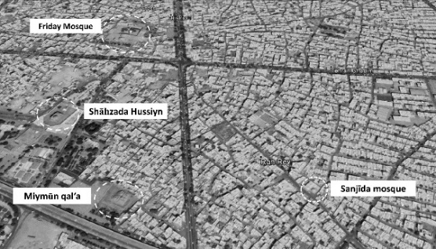 |  | 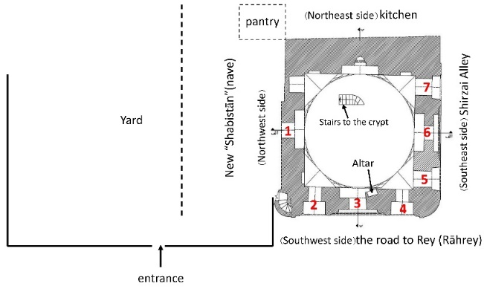
Figure 1. Current location of the Sanjīda building relative to other buildings in Qazvin |  | Figure 2. Plan of the dome chamber aligned with a schematic representation of additions to the Sanjīda building. The numbers 1-7 indicate currently extant arched entrances. The space where the stone mound is located is presently called the sardāb and can be reached via a flight of steps from inside the dome chamber. The depiction of spaces adjoining the dome chamber is only schematic and may not be proportionally accurate
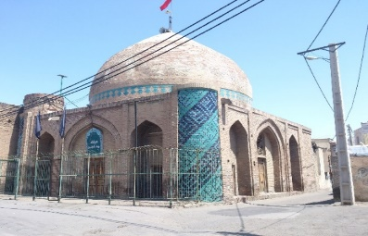  Shirzai Alley  the road to Rey (Rāhrey) | 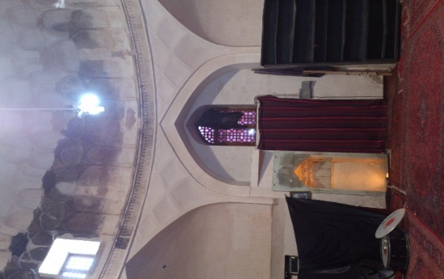  Mihrāb  One of the arched entrances |  | 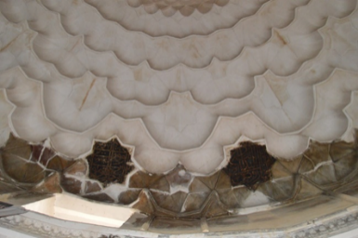
Figure 3. Sanjīda building in Qazvin. 2016. The arched entrances located on the Southwest (Rah Rey) and Southeast (Shirazi Alley) sides can be seen in the photograph | Figure 4. Interior view of the dome chamber, 2016 |  | Figure 5. [Wood] inscriptions installed on the first muqarnas tier, 2017.
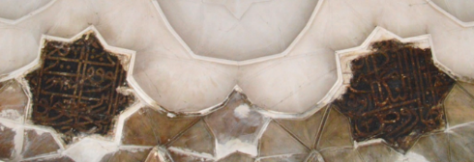 | 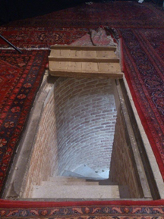 |  | 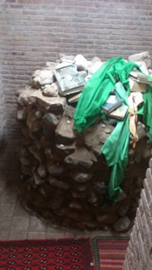
Figure 6. Detailed view of the inscriptions installed on the first muqarnas tier, 2017. | Figure 7. Steps leading to the sardāb; 2016 |  | Figure 8. Stone mound beneath the floor of the dome chamber, 2016

  - PLAUSIBLE FUNCTIONS FOR THE BUILDING
Three plausible functions can be attributed to this building according to the research background, examination of the building form, and its location in the city. First, it may have been initially a “mosque”. Second, it could be a mausoleum. This supposition can be proposed because of the form and physicality of the building, its sense of sacredness among the community as well as old reports pointing to the existence of unmarked grave/s inside the building [10]. Third, it may be neither a mosque nor a mausoleum but a completely different type of building. Each of these hypotheses is tested in this research through various procedures: a methodical search in historical texts, an examination of indirect evidence within Qazvin's political and religious context, and a search for physical evidence in the building.

  - METHODICAL SEARCH IN HISTORICAL TEXTS
To ascertain the original function of the building, we started by examining historical texts. We first studied two key historical documents about Qazvin, al-Tadvīn fi akhbār Qazvīn written by ‘Abd ʼlKarīm b. Muḥammad Rāfiʿī [11],[12] (12th and 13th century) and Tārīkh-i guzīda written by Ḥamd ʼllāh Mustawfī [13] (14th century), and next, we compiled a comprehensive list of mentioned distinguished men (rijāl) and their genealogies (ansāb). The names of almost all places and buildings in Qazvin from the twelve to the fourteen centuries are mentioned in these two books. However, no mention of the name “Sanjīda” is made in either. There is also no reference to a building by this name in pre-Qajar records, which is rather unusual because the building had existed long before. One reason could be that the building previously went by another name [14]. Hence, we searched for old names [of other places] that were somehow related to the Sanjīda building, e.g., “Rāh-Rey” or “Darb-rey” or “gūristān-i kuhanbar”. The Rah-Rey district surrounding the Sanjīda building is an old district situated along the old road from Qazvin to Rey, and according to historical evidence, it existed since at least the Seljuq period [6].
Furthermore, an old cemetery [14],[15] was once situated to the South of Qazvin, with its Eastern boundary abutting the Rah-Rey district. For this, in our text search, we also included the name of the “kuhanbar” cemetery [15] and the Rah-Rey district. Our search in other related texts revealed the names of monuments whose current location or physical state is unknown, indicating that they may have either been destroyed or modified [6]. Since the Sanjīda is a religious building, we also searched for mosques, khanqahs, and mausoleums. Next, we screened the names that were either not located in or unrelated to the Rah-Rey district. Finally, fourteen building names were identified whose locations were not specified, and two of them are likely connected to the Rah-Rey district and the Sanjīda building: Mehr Hīra mosque and Shahr Hīza Khanqah. Besides, two building names are specified in Rāfiʿī’s work whose location was in the Rah-Rey district: AbuʿAbdʼllāh al-Nasāj mosque and Muqrī Qazvīnī mosque. An analysis of all these probable cases is presented next.
al-Nasāj mosque: According to Rāfiʿī’, this mosque is attributed to Aḥmad ibn Muḥammad ibn Dawūd al-Faqīh al-Ashnānī AbuʿAbdʼllāh al-Nasāj Qazvīnī [14], and is located at the end of the road from Qazvīn to Rey [14], probably near the Gate of Rey, inside the Hisār-i Harūni (city walls) [16]. Since the present location of neither the Hisār-i Harūni nor the Gate of Rey is clear today [2], we cannot locate the al-Nasāj Mosque on the map of the Rah-Rey district. Ardavān Amirshāhī and Azīzʼllāh ʿOṭāridī (who emended al-Tadvīn) believe this mosque to be the same as the Sanjīda mosque [20]. However, attributing two different names to a single structure cannot be correct, i.e., al-Nasāj mosque and Sanjīda mosque do not denote the same edifice. Otherwise, we should have come to at least another record succeeding al-Tadvīn that would suggest the survival of al-Nasāj mosque. Yet, even a century later than al-Tadvīn, Ḥamd ʼllāh Mustawfī did not record the name of al-Nasāj mosque in his Tārīkh-i guzīda, although claiming to have included all mosques mentioned in al-Tadvīn [15]. Therefore, it is likely that the al-Nasāj mosque did not exist during Mustawfī’s time. Then again, we will see in the following that according to physical evidence, the probability of the Sanjīda building having originally served as a “mosque” is rather minimal, hence casting doubt on the assumption that the two mosques were synonymous.
Muqrī Qazvīnī mosque: This mosque is attributed to AbuʿAli Ḥusiyn Ibn Muḥammad Ibn Ḥasan Ibn Aḥmad Żarīr Muqrī Qazvīnī [14]. The only information provided by Rāfiʿī’ on this monument is that it was located in the Rah-Rey district. Nevertheless, there is no mention of this mosque in Mustawfī’s work. As discussed previously, the probability of this mosque being the same as the Sanjīda building is minimal, considering the physical evidence found in the latter. It cannot be rejected, though, that the dome chamber of the Sanjīda mosque may have been built on the remains of either the al-Nasāj or Muqrī Qazvīnī mosque. This is suggested by the uncovered stone mound beneath the floor of the dome chamber and the presence of a minaret, which, according to physical evidence, predates the construction of the dome chamber [21],[22] at its West corner.
Mehr Hīra mosque and Shahr Hīza or Sahr Hīza Khanqah: These are the names of an edifice or edifices whose locations are unknown but are likely to be related to the Sanjīda building. According to Mustawfī, the Mehr Hīra mosque, originally a fire temple before the advent of Islam, was among the old mosques of Qazvīn. Although Rāfiʿī does not mention this name in his work, it can be inferred that the Mehr Hīra mosque was related to the Rah-Rey district based on the following facts. In his Tārīkh-i guzīda, Ḥamd ʼllāh Mustawfī mentions that the “Ṭarīq-i Mehr Hīra” [15] had a junction with the “Dardasht” road. We do not currently know where in Qazvin the “Ṭarīq-i Mehr Hīra” went. Mehr Hīra could have been the name of a district in Qazvin or a place outside of it, to which the “Ṭarīq-i Mehr Hīra” and Mehr Hīra mosque were attributed. The late Muḥammad Dabīr Siyāqī writes about “Dardasht” that “copy”: vasht (apparently: Lāviya Dasht)” [7]. In his book, the term “Lāviya Dasht” has also been used as an equivalent of another name. Where he describes the cemetery to the South of Qazvin, he writes that the East border of this cemetery was adjacent to “al-Evmasht min Tariq al-Rey” [14]. Dabīr Siyāqī writes in the entry “al-Evmasht: perhaps Lāviya Dasht” [7]. Based on these facts, al-Evmasht, Dardasht, and Lāviya Dasht may denote the same area that was connected to the Rah-Rey district. Then again, it is possible that the Ṭarīq-i Mehr Hīra (that had a junction with the Dardasht Road) had a connection with the Mehr Hīra mosque and the Rah-Rey district. ‘Abd ʼl-Ḥusiyn Nawāyī, who emended Tārīkh-i guzīda, believes “Mehr Hīra” to be the same as Rāfiʿī’s “Sahr Hīza” in al-Tadvīn [15]. Rāfiʿī does not refer to the Mehr Hīra mosque but records the other appellations in the following word compositions: “Sahr Hīza khanqah,” “Shahr Hīza khanqah,” “Sahr Hīza (Shahr Hīza) ribat,” [14] and once in “Duvayrat al-Fuqahā bi Sahr Hīza.” [14] He has also mentioned quite several Sufis and other individuals associated with this khanqah. Despite the indications of the Khanqah’s functionality during the 12th and early 13th centuries (Rāfiʿī’s lifetime), no mention of its name is made in Tārīkh-i guzīda. In ʿOṭāridī’s (who emended al-Tadvīn) view, “Sahr Hīza” denoted either the patron of the Khanqah or the name of a region. He believes the corrupted [written] form of “Sahr Hīza” to be the result of distortions unwillingly made by different scribes and copyists of al-Tadvīn [20]. Eventually, it seems that ʿOṭāridī takes the name “Sahr Hīza” for a district containing a complex of a mosque, a Khanqah, and a ribāt. It may be that this supposition is based on the inclusive context of the various copies of al-Tadvīn, which he emended. Given the similar handwritten form [in Persian] of Shahr Hīza, Sahr Hīza, and Mehr Hīra, besides the fact that there is no significant number of ancient buildings referred to in historical records, the following arguments can be made:
a. The Mehr Hīra mosque, Sahr Hīza khanqah, and the Sanjīda building may have been three distinct buildings in an urban complex [15];
b. The Mehr Hīra mosque or the Sahr Hīza khanqah may have been the same structure as the Sanjīda building;
c. The Mehr Hīra mosque may have been the same structure as the Sahr Hīza khanqah.
However, there is currently insufficient evidence to support these suppositions and inadequate information regarding the association between “Dardasht” and Rah-Rey district and the Ṭarīq-i Mehr Hīra or their connections with the Sanjīda building.
Initially, we proposed three suppositions on the [original] function of the Sanjīda building: mosque, mausoleum, or neither of them. Our research, into historical records, brought to light other probabilities that besides being a mosque or a mausoleum (which are still plausible), it is also likely that it was originally a Khanqah. As Rāfiʿī’ notes that the remains of Iskandar ibn Aḥmad al-Khiyārajī were buried in the Shahr Hīza khanqah [14], it is also likely that the Sanjīda building served as a type of khanqah-mausoleum. As stated earlier, to further review these hypotheses, we employed various procedures, including examining indirect evidence within the political and religious context of Qazvīn.

  - POLITICAL AND RELIGIOUS CONTEXT OF QAZVĪN
The socio-political and religious context of the city can yield valid information that can be drawn on to evaluate the proposed suppositions on the [original] function of the building. We will focus on Qazvin, its life, and the interrelationship within the city components. Throughout its history, Qazvīn was the stage for the presence of different philosophical schools (nihlas) and esoteric sects, whose followers, however, were many times forced to conceal their faith or resort to the practice of precautionary dissimulation (taqīyya). For this, they probably were faced with no choice but to convert the function of the tomb of their revered figures to save them from destruction. This might also have been the case for the Sanjīda building, resulting in the alteration of its original function.
Moreover, there are also some beliefs and narratives regarding this building. Some writers believe it to have been originally a fire temple. The general public holds different views. Some regard it to be the qadamgāh of the twelfth Shi‘i Imam, for which they gather there on the 20th of Urdibihisht (on May 5) every year to perform the Salāt al-Hājah (prayer of need). Afterward, they proceed to the musallā of the city along the Rey Road and perform the prayer once again (Figure 9). It is publicly held that the twelfth Imam also performed this ritual. Some others, however, believe that this building contains the tomb of one of Imam Mūsā Kāẓim’s descendants, and therefore, they consider it a shrine. The green ribbons tied to the exterior fences are evidence of this belief. Lastly, some say that the Sanjīda building contains the tomb of Hasan-i Sabbāh, the leader of the [Nizārī] Ismāʿīlī sect [17], [18], [19]. Given these considerations, this research needs to study the religious sects and esoteric schools that were active in Qazvin.
Since the early centuries of Islam, Qazvin has been home to followers of the Shāfi‘i [11], [14],[15], [23] madhhab, although there were also Shi‘ī [15],[23],[24] and Hanafi [14],[15] minorities. Furthermore, the followers of esoteric schools such as the Ismāʿīlīs, Sūfis, and Nuqṭavis also flourished in different periods throughout the history of the city. The Ismāʿīlīs, led by Hasan-i Sabbāh, began their political struggle against the central government from the Seljuq era and frequently engaged in the practice of dissimulation (taqīyya) for the sake of their lives. After Hasan II proclaimed the arrival of the Qiāma (Great Resurrection) [25] in Ramadan 559 /June 1164, significant changes occurred within the Ismāʿīlī doctrines, bringing the sect closer to Sufism [25]. After the fall of Alamūt to Hūlāgū Khān, because of the close relationship of the Ismāʿīlī ideas and practices with Sufi traditions and in order to survive “under the mantle of Sufism,” the Ismāʿīlī community reestablished taqiyya [25].
Among other sects that emerged in Iran after the Ismāʿīlī massacre were the Hurūfiyya and Nuqṭaviyya. The Hurūfiyya movement shared similarities with the Ismāʿīlī doctrines, and the Nuqṭaviyya emerged from the Hurūfiyya. Maḥmūd Pasīkhānī founded the Nuqṭavi movement in opposition to the Hurūfi movement. The Nuqṭavī and Ismāʿīlī doctrines share what is designated as interpretation (taʾvīl), esoteric interpretation (taʾvīl-i bātin-i), and a cyclical view (Dawr) of the religious history of mankind [26]. The Nuqṭavīs held more prominent status in Qazvīn than the Ismāʿīlīs, especially during the reign of the Safavid dynasty. Shāh Ṭahmāsb first repressed their movement in 981/1573-1574 but rose again in Saveh, Na’in, Isfahan, and particularly Qazvīn during the final years of his reign [27]. There was a man named Khusru, known as Darvīsh Khusru, who lived in the Darb-i Kushk district of Qazvīn. He resided at a mosque and acquired a considerable number of followers. After a while, “his company grew large.” [28] Following the death of Shāh Ṭahmāsb, Darvīsh Khusru lived in a mosque “next to” [28] his house, and many people sought him out. During the reign of Shāh Abbās I, he built a tikiya in its “whereabouts” [28], and over time, his followers grew in size. Eventually, he and his followers were executed by the order of Shāh Abbās I on the charge of heresy (ilhād) [27]. After the persecution of the Nuqṭavīs during the 16th -17th centuries by the Safavid kings, their remaining followers continued to live on in the guise of Sufism [29].
Other similar historical evidence indicates that the adherents of sects such as the Ismāʿīlīs, Nuqṭavīs, and sometimes even Sufis [30] were coerced into the practice of dissimulation (taqīyya) at various historical periods. In such circumstances, it is not far-fetched to suggest that the followers of the Nuqṭavī sect or Sufi orders in Qazvīn constructed a monument over the tombs of their revered figures but later altered its usage to preserve it at times of government suppression. According to the information above, the sacredness associated with the Sanjīda building by the public, as well as the socio-religious context of Qazvīn, further corroborate the supposition that the building originally served as a mausoleum.

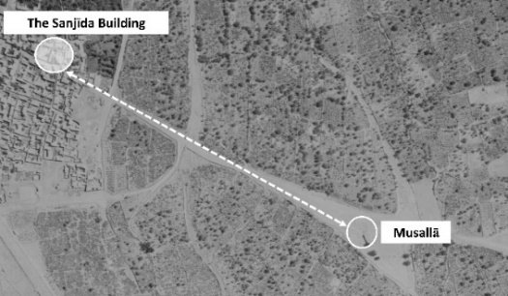 | 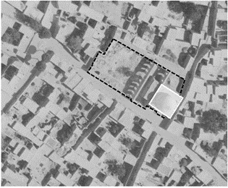
Figure 9. Aerial photograph, 1956. The relative position of the Sanjīda building to the musallā. | Figure 10. Aerial photograph. Dashed lines indicate the boundary lines, and the white square represents the dome chamber
  - SEARCH FOR PHYSICAL EVIDENCE
To learn about the function of a building, the most important type of evidence to look for is its physical features. Hence, the building’s physicality and transformations over time should be examined thoroughly. This examination can be done at two levels: a. examination of building form, construction techniques, and materials; b. building’s location in the urban fabric with respect to nearby roads and other buildings [31].
  - The general form of the Sanjīda building before recent interventions is evident in the aerial photograph of 1964. As we can see in Figure 10, the relative position of the dome chamber and its adjacent roads are the same as today. The dome chamber is located at the corner of a rectangular plot, presumably constituting its boundary lines. Examination of existing evidence [6] in the dome chamber shows that it used to front onto the main road from Qazvin to Rey with arched entrances. Therefore, it is highly plausible that entry into the dome chamber was made through the Rey road (Figure 11-12). The architectural features (evidence) that challenge the idea of the edifice being a mosque include: 1. Direct entry into the dome chamber: because entry to dome chambers in mosques is typically not immediate, this would counter the idea that the building was intended as a mosque. 2. Portal: the entrance portal to the building from the old Rey Road is located within the qibla wall— which is highly controversial. 3. Position of the mihrāb: The awkward position of the mihrāb inside the dome chamber just next to the portal in the qibla wall and incongruous with the building’s geometry suggests that it was a subsequent addition to the building (Figure 13).
In the pictures depicted in restoration documents, more physical evidence can be found before the restoration works were carried out: 1. The interior plan of the dome chamber was a square in the eleventh century, which was altered to an octagon afterward, and again was altered to a square during restoration works in the 1980s (Figure 14-15). 2. Conservation reports point to observations suggesting that the edifice, currently only having two side walls with facades, in all probability had all four sides adorned with facades, indicating the previous presence of four open fronts (Figure 16). 3. The mihrāb is a subsequent addition. Yet, we do not have information on the exact date of its construction [6]. These pieces of evidence challenge the idea that the edifice was originally a mosque and further support the supposition that it was a mausoleum.
  - A map of Qazvin from 1919 (Figure 17) and an aerial photograph from 1956 (Figure 18) are two important records showing gardens in the vicinity of the Sanjīda building, accessible through the Shirazi Alley. They seemed to occupy an even larger area in the Rah Rey district, constituting a portion of the green belt surrounding Qazvin. However, whether deliberately or not, some of these gardens were eradicated and replaced by residential fabric. Therefore, according to the 1919 map and the 1956 aerial photograph, it can be concluded that the Sanjīda building was located along the old road to Rey in an area surrounded by gardens rather than in a built-up area. This further challenges the idea that the edifice was initially a mosque.
Among other important physical evidence in the building that challenges the idea of a mosque usage is the theme of two wood inscriptions installed on two flat eight-pointed stars on the first tier of the muqarnas adorning the base of the dome. There are two hemistichs from the Munājāt (confidential talks) attributed to Imām ‘Alī inscribed on them. The script says, “فها أنا فی روض الندامة ارتع / الهی تری حالی و فقری و فاقتی” which indicates an intimate supplication of man to his God. Since the first muqarnas tier was originally composed of sixteen flat eight-pointed stars, it is almost certain that sixteen hemistichs (eight distichs) of this Munājāt [32]- [33] were inscribed and installed on them. The verses of this Munājāt have also been used in inscriptions in the Shah mosque at Mashhad and on the tombstone of Bāyazīd Basṭāmī at Bastam. All sixteen hemistichs are included in the inscription at the Shah mosque of Mashhad, while only some of its words have been included in the tomb inscription of Bāyazīd Basṭāmī. It is known to us that the original function of the “Shah mosque” of Mashhad is also a matter of controversy. Through the examination of existing evidence, ‘Abdʼl-Ḥamīd Mawlavī states that it was originally the mausoleum of Amir Ghiath al-Din built in the Timurid period, which was later modified with the addition of a minaret and a mihrāb to serve as a mosque [36]. If this statement were true, the inclusion of this Munājāt on the inscription of a mausoleum (the present Shah mosque) and a tombstone, as well as its themes of remorse, regret and seeking mercy, increase the likelihood that the building was initially a mausoleum rather than a mosque.
Accordingly, based on contextual and physical evidence such as the location of the building in the periphery of the city, gardens adjoining it, its position relative to roads, its multiple portals, the probability of all four side walls having been adorned with facades and having open fronts to all four directions, the addition of the mihrāb, an inscription containing the Munājāt of Imām ‘Alī, as well as publicly held beliefs, it is rather unlikely that the building functioned as a mosque. Conversely, the likelihood of it being a mausoleum or other type of religious monument is high.

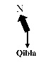  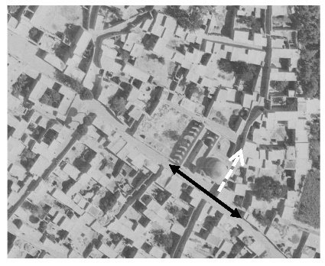 | 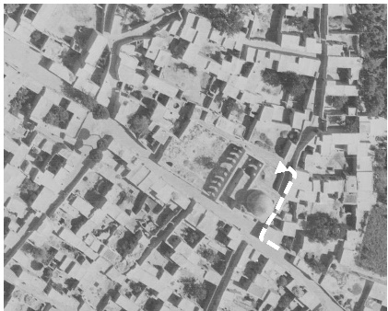 | 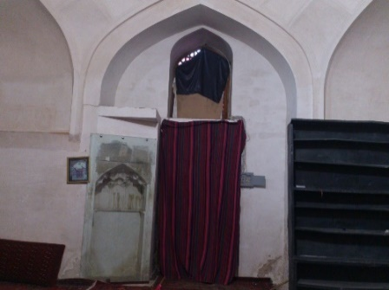  one of the arched entrances  mihrāb
Figure 11. Aerial photograph, 1964, The relative position of the Sanjīda building to the Rah-Rey district and Shirazi alley | Figure 12. Aerial photograph. Assuming access to the Sanjīda building from the Shirazi Alley | Figure 13. The current form of the mihrāb. 2016

Figure 1. Title [source in IEEE format]
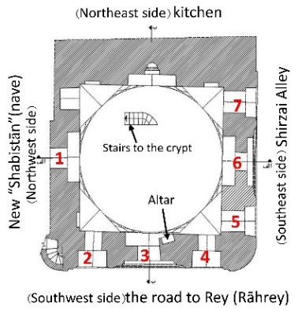 | 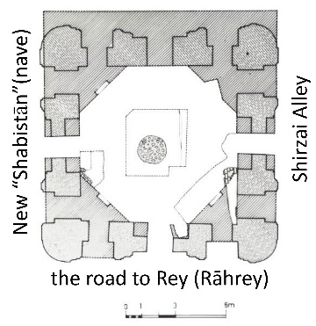 |  | 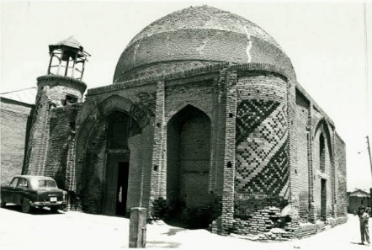
Figure 14. Plan of the dome chamber after restoration works | Figure 15. Plan of the Sanjīda building and its location in the Rah Rey district |  | Figure 16. Dome chamber of the Sanjīda building before conservation interventions. Damages to the building are visible in the photograph, 1975
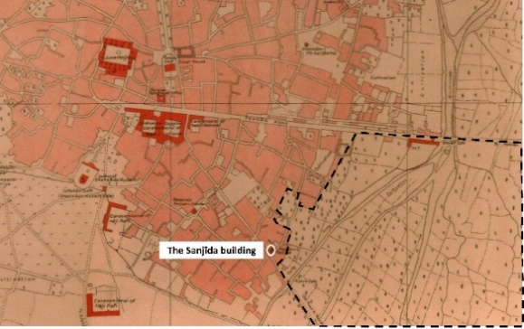 |  | 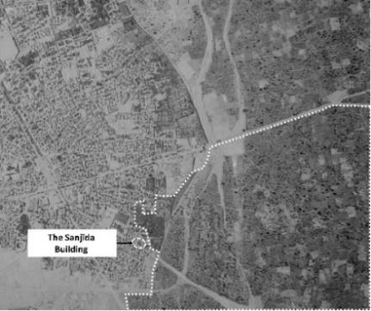
Figure 17. The Sanjīda building is depicted with solid lines, and the boundaries of the surrounding gardens are shown with dashed lines on the 1919 map. [Cyrus Alai, Ancient Maps of Persia: Special maps, p. 326] |  | Figure 18. An aerial photograph depicting the Sanjīda building and its surrounding gardens, 1956. The gardens near the monument, as well as others surrounding the city, can be seen in the photograph

  - THE QUESTION OF DATING THE CONSTRUCTION
Since no dated inscription in the Sanjīda building and no thorough archaeological work has been carried out, its construction date cannot be determined accurately. However, we might be able to ascribe its initial construction to a certain period through some evidence. The physical features (evidence) recorded in restoration documents and registration dossier are important because they show the structure's condition before restoration works (Figure 19-20). The registration dossier contains two pictures taken in 1975 that show the pre-restoration condition of the dome without a completed muqarnas. It is evident from the pictures that the dome is composed of two structural shells. The remaining fragments of the first muqarnas tier indicate the prior existence of a decorative hanging shell of a full-vault muqarnas. The presence of two structural shells and a decorative shell suggests, in the first place, that the edifice dates back to the Timurid period. However, we do not have a record showing that the structural and decorative shells were contemporaneous.

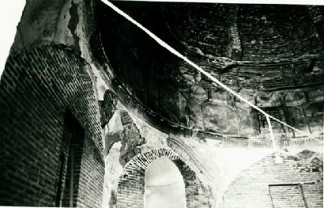  A | 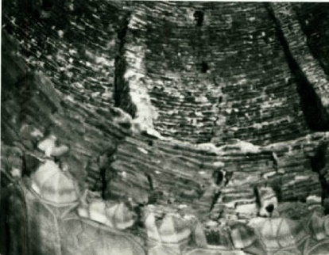  B
Figure 19. (a) and (b) Construction details of the dome. 1975 [Registration dossier] |  | Figure 20. Stiffeners on the inner shell of the dome, 1984 [Documentation Center of Tehran Cultural Heritage Organization]

Moreover, the circular projections at the corners of the Sanjīda building (Figure 3) are reminiscent of some Timurid structures, such as the Ghiathiyya madrasa at Khargird (Figure 21). However, this element also appears in one of the corners of Malik mosque at Kirman (Figure 22), dating to the Seljuq period; hence, this evidence cannot be used to determine the date of the building’s construction conclusively. Therefore, we cannot only date the Sanjīda building based on physical evidence.
The inscription containing the Munājāt of Imām ‘Alī increases the likely association of the building with followers of Sufi orders, Ismāʿīlī or Nuqṭavī sects. As discussed earlier, the Ismāʿīlī, Sufi, and Nuqṭavī esoteric schools were among the prevalent religious organizations active in Qazvin. This Munājāt, however, can be ascribed to each of the three groups without any distinction since Imām ‘Alī was held with reverence and authority by all of them.
‘Alī b. Abī-Tālib was regarded in high esteem by the Ismāʿīlīs, as well as by the Sufis. Daftary states, “… a new syncretic type of Shi‘ism was now arising in Post-Mongol Central Asia, Persia, and Anatolia, which culminated in early Safawid Shi‘ism.” [37] This type of Shi‘ism was transmitted through some Sufi orders (tariqas), which “…remained outwardly Sunni, following one of the Sunni madhhabs, while being particularly devoted to ‘Ali b. Abi Talib and the ahl al-bayt. ‘Ali was included in the spiritual chains (silsilas) of the masters of these Sunni Sufis.” [37] The Nuqṭavīs also were particularly devoted to ‘Alī b. Abī-Tālib and the ahl al-biyt (the Prophet’s family) [26]. Hence, an inscription containing the Munājāt of Imām ‘Alī can be ascribed to any of the mentioned groups.
Furthermore, the inclusion of “sixteen” [wood inscriptions carved with sixteen] hemistichs of the Munājāt of Imām ‘Alī is worthwhile. It could be due to the large dimensions of the dome chamber and, consequently the large dome span. In other words, the builders preferred to choose the muqarnas size so that sixteen flat eight-pointed stars would be used in the first tier. It is also possible that the number sixteen is related to the symbolic nature of numbers in the Nuqṭavī belief system. According to Maḥmūd Pasīkhānī’s teachings in al-Mizān, it may be inferred that certain numbers such as 4, 8, 12, and 16 were of symbolic value for the Nuqṭavīs [29]. Given this numerical symbolism and the presence of the numbers 4, 12, and 16 in the dome chamber of the Sanjīda building, as well as the high esteem in which the Nuqṭavīs hold, Imām ‘Alī raises the question of whether the edifice was associated with the Nuqṭavīs. It is, however, also probable that the edifice was associated with the Ismāʿīlīs or Sufis. Consequently, given the suppression of the Ismāʿīlīs after the fall of the Ilkhanids, the emergence of the Nuqṭavīs in ca. the 15th century, and the persecution of both Sufis and Nuqṭavīs by the Safavid kings, it can be surmised that the initial construction dates back to a period between the 14th and 15th centuries. Additionally, considering the similar ornamentation on the mihrāb of the Sanjīda building (Figure 23-24) with those of some Safavid structures, namely the shrine of Hārūn Vilayat at Isfahan, it can be inferred that the addition was made during the Safavid period.

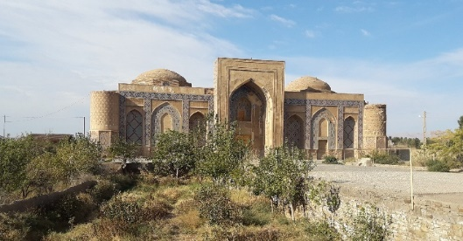 | 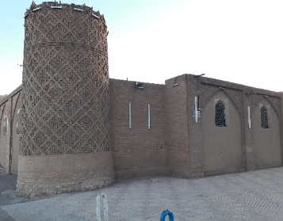
Figure 21. Ghīyas̠īya madrasa at Khargird,2020 | Figure 22. Malik mosque at Kerman,2020

- CONCLUSION
The Sanjīda building is located in the Rah-Rey district in the city of Qazvin. However, its date of construction, patron’s name, and [original] function are unknown. The oldest historical document containing the name “Sanjīda” dates from the Qajar period. The examination of the histories of prominent monuments in the Rah-Rey district led us to believe that it is highly implausible that the Sanjīda “mosque” was the same as either AbuʿAbdʼllāh al-Nasāj mosque or Muqrī Qazvīnī mosque. We proposed suppositions regarding the function of the building: 1. The Sanjīda building may be a mosque; 2. The Sanjīda building may be a mausoleum; 3. The Sanjīda building may be a Khanqah or another type of religious structure. The study of [restoration] documents, physical evidence, and the religious context of Qazvin showed that it is highly unlikely that the building originally served as a mosque. Alternatively, evidence such as oral narratives and public beliefs regarding the sacredness of the building, the existence of an inscription containing the Munājāt of Imām ‘Alī in the dome chamber, the later addition of the mihrāb next to one of the main portals, the likelihood of all four exterior walls having been adorned with facades, and the vicinity of the building to surrounding gardens corroborate the idea that the building was [originally] a mausoleum or another type of religious structure.
Since no dated inscription has been found in the Sanjīda building, it is difficult to determine its construction date accurately. Nonetheless, the dome chamber can be dated to the period between the 14th and 15th centuries based on the politico-religious context of Qazvin in which Ismāʿīlīs, Nuqṭavīs, and Sufis flourished, and the inscription-themed with the Munājāt of Imām ‘Alī whose revered status by all three religious schools was previously discussed. Moreover, the resemblance of the ornamentation on the mihrāb to the ornamentations in other Safavid structures corroborates the notion that it was added during the reign of Safavids. These pieces of evidence, however, are certainly not sufficient for the absolute dating of the building. Additional evidence is required for a more comprehensive analysis.
As mentioned earlier, this research was conducted within interdisciplinary studies. Accurate archaeometric analyses are required to supplement this research. Furthermore, archaeological boreholes or excavations may be conducted to substantiate the primary findings and provide more insight into ambiguous areas

REFERENCES
[1] J. N. Erzen, “Reading Mosques: Meaning and Architecture in Islam,” The Journal of Aesthetics and Art Criticism, vol. 69, no. 1, pp. 125-131, 2011.
[2] M. ‘A. Golrīz, Minū-dar ya bab al-jannat-i Qazvīn, Tehran: Ṭāhā, 1989.
[3] A. Amirshāhī, “Shahr-e Qazvin ta miana-yi qarn-i hashtum-i hijri fargasht-i tarikhi,” in Bāstānshināsī-i Iran dar duriyi Islāmī (43 articles in honor of Dr. Mohammad Yūsif Kīyanī), M. I. Zarī, Ed. Hamedan: Bu-Ali Sina University Press, pp. 41–83, 2011.
[4] ‘A.Hākemī, “Guzareshī dar khusūs-i barresi-i masjid-i Sajīda-yi Qazvin az jahat-i tarikhi va shaye‘a-yi maqbara-yi Hasan Sabbāh,” N.A., Tehran, Tehran, N. 297/24524, 1958.
[5] ‘A.Hākemī, “Sanjīda Mosque,” Norouz newspaper, 17 Jan., p. 1, 1959.
[6] L. Ghasemi, Masjid-i Sanjīda-yi Qazvīn: Barresi-i chīstī, Tehran: Farhangistan-e Honar (Iranian Academy of the Arts), 2022.
[7] M.Dabīr Sīyāqī, Seyr-e tārīkhī-i shahr-i Qazvin va banā-ha-yi ān, Qazvin: Hadīs̠-I Emruz, 2014.
[8] M. Mojābi, “Repairs completed, Sanjida,” N.I.A., Tehran, Form no 3-1-kāf, document no. 220-11796, 1984.
[9] R. B. Serjeant, “Miḥrāb,” Bulletin of the School of Oriental and African Studies, University of London , vol. 22, no. 1/3 , pp. 439-453, 1959.
[10] “Bi la‘nat-i Khoda va nifrīn-i Rasūl Giriftār Shavad,” Norouz newspaper, 20 Dec., p. 4, 1959.
[11] R. Ja‘farian, Tarikh-i tashayyu‘ da Iran az aghāz ta tulu‘-i dawlat-i Safavi, Tehran: Nashr-i ʿElm, 2014.
[12] M. Tabataba’I and H.Darzi Ramandi, “Naqd-i tashih-i al-Tadvīn fi akhbār-i Qazvīn,” Matnshināsī-i Adab-i Fāesī, no, 27, pp. 19-40, Sep 2015.
[13] M. Parhizkari, and Z. Riżai-nasab, “Ḥamd ʼllāh Mustawfī,” in The Centre for the Great Islamic Encyclopaedia: Center for Iranian and Islamic Studies, 1th Ed. Available: The Great Islamic Encyclopedia Online, https://cgie.org.ir/fa/article/236646/ [Accessed: July 27, 2016].
[14] ‘A. ʼlK. Rāfiʿī, al-Tadvīn fi akhbār-i Qazvīn, 4 vol. Beirut: Dār al-kutub al-‘Elmīya, n.d. .
[15] Ḥ. ʼl. Mustawfī, Tārīkh-i guzīda, ‘A. Navaei, Ed. Tehran: Amīr Kabīr, 1960.
[16] M. Qayyoomi Bidhendi, “RE: the location of mosque,” personal email (July 17, 2016).
[17] F. Daftary, “The Earliest Ismāʿīlīs,” Arabica, vol. 38, no. 2, pp. 214-245, 1991.
[18] F. Daftary, “Persian Historiography of the Early Nizārī Ismāʿīlīs,” Iran, vol. 30, pp. 91-97, 1992.
[19] F. Daftary, “The "Order of the Assassins:" J. von Hammer and the Orientalist Misrepresentations of the Nizari Ismailis,” Iranian Studies, vol. 39, no. 1, pp. 71-81, 2006.
[20] A. ʿOṭāridī, al-Tadvīn fi akhbār-i Qazvīn: Ta‘liqat, Beirut: Dār al-kutub al-‘Elmīya, n.d. .
[21] M. G. Brambilla, “RE: Question about the restoration of the mosque,” personal email (July 17, 2016 and November 23, 2016).
[22] S. Sāberī, “RE: Question about the restoration of the mosque,” personal email(June 1, 2016).
[23] ‘A. .J. Qazvini Rāzī, al- Naqż, M. j. Muḥaddis, Ed. Tehran: Anjuman-i Ās̠ār-I Millī, 1979.
[24] Z. M. Qazvini, Athār al-bilad va akhbar al-‘ibad, Beirut: Dār Ṣādir, n.d. .
[25] F. Daftary, Tārīkh va sunnat-hā-yi Ismā‘īlīyya, F. Badra-ī, Ed. Tehran: Farzān rūz, 2012.
[26] F. Daftary, “RE: Question about Nuqṭavīs,” personal email (December 12, 2019).
[27] H. Khumeini, Farhang-i Jāmi‘-i firaq-i Islami, 2 vol. Tehran: Intishārāt-I Iṭilā‘aāt, 2003.
[28] I. b. Turkamān, Tarikh-i ‘Alam-ara-yi ‘Abbasi, Suhilī-i Khāns̄rī, Ed. Tehran: Amīr Kabīr, 1971.
[29] ‘A. R. Zekavati Qaraguzlū, Junbish-i Nuqṭavīyya, Qum: Nashr-I Adyān, 2004.
[30] A. H. Qazvini, Favāyid al-Safaviyya, M. M. Ebrahimi, Ed. Tehran:Muʾasisa Muṭali‘āt va Taḥqīqāt-i Farhangī, 1988.
[31] Otakar Máčel,"Historical research," in Ways to study and research: urban, architectural, and technical design. M. de Jong, Taeke, and D. J. M. Van Der Voordt, Eds. The Netherlands: DUP Science, 2002.
[32] H. Khu’ī, Minhaj al-bira‘a fi Nahj al-balāgha, I. al-mīyānjī, Ed. 15 vol. Tehran: Maktabat al-Islamīya, 1977.
[33] M. H. Miybudī Yazdī, Sharh-i dīvān-i mansūb bi Imām ʿAli, H. Raḥmanī and I. ashk-i shīrīn, Eds. Tehran: Mīrās̠-i Maktūb, 2000.
[34] I. Badinlu, “Munajat-i amir al-mu’minin dar ayini-yi hunar,” Basatīn, no. 1, pp. 189-214, spring and summer, 2014.
[35] M. Nishabūrī Kaidari, “Anvar al-‘uqūl fi ash‘ar-i wasi al-rasūl,” [Online Manuscript], Available: http://dl.nlai.ir/UI/65b5285a-8156-40bf-b259-bd80cf891dde/LRRView.aspx (Accessed Augist 14, 2016).
[36] ‘A. Ḥ. Mawlavī, “Masjid-Ii Shah ya maqbari-yi amir Ghiath al-Din Malik Shah,” Hunar va Mardum, vol. 7, no. 74 &75, Nov. and Dec., 1968.
[37] F. Daftary, A History of Shi'i Islam. London: I.B. Tauris, 2014.

‘Alī Hākemī is introduced as the curator for the National Museum of Iran.
Mahdī Mojābi, building restorer, mentions (in telephone conversation) the likelihood that the building is a mausoleum.
We carried out different analyses of the composition of the mortar in the uncovered stone mound in the dome chamber. These analyses included X-ray fluorescence, X-ray diffraction, and Thermal Gravimetric Analysis. We proposed suppositions based on the results of these analyses. Although more tests are needed in order to substantiate those suppositions, they could not be conducted because of financial and time restrictions.
This building is registered in the Iran National Heritage List by dossier no. 3/1118 in 1975. Other works in which Golriz’s assertions are referenced are Report on the Conservation of the Historic Building of Muhassis and Sanjīda Mosque, doc. 33, in Library and Documentation Center of Qazvin Cultural Heritage Organization.
This paper is based on a detailed historical research project on the Sanjīda building created by Leila Ghasemi
“The additional wall on the Southeast corner of the Sanjīda mosque was removed… an inscription in black ink on stucco was found on this corner dating from the seventeenth century ….”
In this research, we have designated the architectural element on the West corner of the dome chamber as a “minaret.” However, it is necessary to note that this designation is based on what has remained of the original construction and may not be historically justifiable
The interior muqarnas of the dome was executed by Ustād Sha‘r-bāf
The earliest documents we have found
A report published in Norouz newspaper mentions that “It is not a long time since remnants of one or two old graves have been found in the old Sang-chīda {…} mosque located in one of the Southern districts of the city. They may have been hidden from view for centuries in a cellar, bearing obscure and mysterious symbols on them, and only by chance they were uncovered recently {…}.”
The building may have been of another religious type, such as a khānqāh, zāwiya, or a khalwat-khāna. However, it should be reminded that the investigation of spatial and architectural characteristics of khanqahs during the sixth-seventh centuries AH in Qazvin requires another distinct research undertaking
‘Abd ʼlKarīm b. Muḥammad Rāfiʿī Qazvini (d. 623/ 1226) was a Shāfiʿī jurist and author of al-Tadvīn fi akhbār-i Qazvīn. He was a student of Muntajab al-Din Razi. Parts of the book cover the history of Qazvin, while the rest is dedicated to the biographies of prominent men and scholars of Qazvin. There are presently six manuscript copies available of this book. Azīzʼllāh ʿOṭāridī Quchani emended the text based on three of them
Ḥamd ʼllāh Mustawfī was a historian and geographer in the 8th /14th century. Based on an indication in Zafar-nāma, it can be surmised that he was born ca. 680/1281-1282, and as he does not mention any events following 750/1349-1350, most scholars assume that this year marks his passing. His most renowned works include Tārīkh-i guzīda, Zafar-nāma, and Nuzhat al-qulūb
The philological study of the term “Sanjīda” did not prove useful either. Certain claims regarding the etymology of the word lack adequate historical backing and documentation, i.e., a plausible relationship between “Sanjīda” and “Sangīna” (the late M.Dabīr Siyāqī said in telephone interview with Leila Ghasemi) or “Sinjid” (Pro. ‘A. Ashraf Sādiqi said In-person interview with Leila Ghasemi), or “Sang-chīda” that seems to serve more as a supplementary rationale (Pro. ‘A. Ashraf Sādiqi said in the interview).
One of the earliest documents in which the Rah-Rey as well as other districts of Qazvin are recorded is the water distribution inscription of the Qanāt-i Khumar-tāshi in the maqsūra of the Jami‘ Mosque (559/1163-1164).
Based on various sources of evidence including the building form, extant inscriptions, the mihrāb, perceived sacredness, etc. it appears that the original function of the building was related to religious practices
We also examined the mausoleums mentioned in historical texts, none of which designated a monument in the Rah-Rey district that could potentially be the same as, or have a plausible connection to the original structure of the Sanjīda building. Another important point to consider is that since the names we found in our investigation are archaic designations, their exact pronunciations are uncertain. For this, we transliterated them according to our interpretation of how they may have been pronounced
Ardavān Amirshāhī has attempted to delineate the limits of this hisār, but his primary assumptions and arguments are not firmly established
The handwritten form of these names in Persian script are very similar
According to the context of Tārīkh-i guzīda, it appears that “tarīq” refers to “road.”
It is worth mentioning that as of today, a village exists to the North of Qazvin by the name “Hīr.”
Since the handwritten form of these two words is very similar in Persian script, they were likely the result of a mistake in transcription.
Under the Ilkhanid rule, Malik Iftikhār al-Din who was governor of Qazvin and had built “magnificent constructions,” hosted Ibqa’ Khan and his entourage for eighteen days at his residence in the Rah-Rey district. Therefore, it might be possible that the district flourished under the governance of Malik Iftikhār al-Din and was the site of multiple constructions which are unknown today.
The late Dabīr Sīyāqī , in telephone conversation, mentioned a plausible philological relationship between “Sanjīda” and “Mehr Hīra.”
As we stated earlier, an investigation of spatial and architectural characteristics of khanqahs during the 12th -13th centuries requires a distinct research undertaking
The worshippers perform the Salāt al-Hājah in both the Sanjīda “mosque” and the musallā. After that, they attempt to attach the muhrs (used in prostration of prayers) to the stone mound uncovered beneath the Sanjīda “mosque” and to the walls of the musallā, for they believe this attachment means their requests to Allah would be granted. In fact, the same ritual is performed at two different places both of which are located along the same road, thereby evoking the concept of a pilgrimage route
These data are based on interviews conducted by Leila Ghasemi with elderly women during the panjāh-bi-dar ceremony (May 9, 2016) at the musallā of Qazvin
Both Zakarīyā Qazvini and Mustawfī have indicated the existence of a district by the name of “Mahallāt al-Shī‘a.”
By that, we mean restoration documents and remaining pictures of the monument. Some of these documents include dossier nos. 220-2773 and 220-11796 in the National Archive and others include file nos. RE-2844, RE-2845, RE-2846, RE-2848, and RE-2851 which are stored in the library and Documentation Center of Tehran Cultural Heritage Organization and others in the library and Documentation Center of Qazvin Cultural Heritage Organization.
In the Library and Documentation center of the Cultural Heritage in Qazvin, there are some documents such as form number 30201211, 1370-71 and document number 33, in which images of the mihrab of the mosque can be seen before and during restoration.
Here I am now turning over and over on the land of remorse /o my God, you can see my manner, my neediness, and my poverty.
Since the Nuqṭavīs believe “All of which is in the Qur’an is in the Sura al-Fātiḥa, and all of which is in this Sura is in Bismillah, and all of which is in Bismillah is in the bā’ of Bismillah and all of which is in the bā’ is encompassed in the nuqta (dot) under the bā’ and ‘Alī is that dot under the bā’.”
The dome chamber of the Sanjīda building is square. According to the plan drawn by the Technical Office of Qazvin-Zanjan before restoration works, the dome chamber used to have twelve arched entrances. There are sixteen hemistichs of the Munājāt of Imām ‘Alī [on wood inscriptions] in the interior of the dome chamber
Absolute dating of the building can be done by collecting samples and Thermoluminescence testing

