 |  | JOURNAL OF ISLAMIC ARCHITECTURE  P-ISSN: 2086-2636 E-ISSN: 2356-4644  Journal Home Page: http://ejournal.uin-malang.ac.id/index.php/JIA
GENDER AND SOCIO-SPATIAL ASSEMBLAGE AT MASJID AL-IRSYAD KOTA BARU PARAHYANGAN, INDONESIA
Tutin Aryanti^{a*}, Trias Megayantiª, Indah Susantiª, Dian Fitriaª
ªDepartment of Architecture, Universitas Pendidikan Islam, Indonesia
*Corresponding Author: tutin@upi.edu
ARTICLE INFO |  |  | ABSTRACT
Volume: 8  Issue: 2  Page: 371-379  Received: September 7th, 2023  Accepted: February 10th, 2024  Available Online: December 30th, 2024  DOI: 10.18860/jia.v8i2.23476 |  |  | Despite their non-mandatory attendance in the mosques, women have been significant users of mosques in Indonesia. They organize community programs, attend daily prayers, and participate in Islamic learning sessions (kajian). Masjid Al-Irsyad (built in 2009) in Kota Baru Parahyangan, Indonesia, is a popular venue for the kajian among women in the surrounding area. This article examines the design of Masjid Al-Irsyad, its flexible uses as a social space, the design based on gender analysis aspects, women’s preference for space, and the social interactions fostered and hampered by the spatial layout. Based on using data withdrawn from a survey of female mosque users and observations, this article finds that the open plan allows flexible use of space, which better accommodates women’s need for space in the mosque and encourages women’s active participation, and a more equal yet remains “Islamic” interaction in the mosque as an Islamic community center. It also blurs the gendered spatial boundary and hierarchy. The space of Masjid Al-Irsyad is a socio-spatial assemblage that opens a broader opportunity for equal gender relations in the mosque. However, the open plan also reduces women’s privacy, an essential spatial aspect.  Keywords:  gendered space; Islamic architecture; mosque; social space; socio-spatial assemblage

- INTRODUCTION

LOOKING AT ISLAMIC ARCHITECTURE FROM A GENDER PERSPECTIVE
Islamic scholars and Muslims generally assume that the mosque is mainly for men because women’s attendance at the congregational prayers, particularly on Friday prayers, is not compulsory [1]. This assumption has resulted in the exclusion of women as users in the design programming and men’s reluctance to welcome women in the so-called “male public space” [2]. In some countries, women are relegated to the side space—frequently not well-designed—and excluded from the mosque program altogether. Many mosques in Australia practice segregation and varying levels of women’s exclusion [3, 4]. However, studies conducted by Abbott [5, 6], Stowasser [7], and Reda [8] show women’s active participation in the Prophet’s mosque in seventh-century Arabia.
More importantly, Hadith mentions that Prophet Muhammad urged Muslim men to allow their wives to go to the mosque if the women asked for their permission. Hadith of Sahih Muslim in the Book of Prayers mentions, “Ibn Umar reported: I heard the Messenger of Allah said: When your women seek your permission to go to the mosque, you them (permission)” [9]. Another hadith in the same book states, “Salim narrated it from his father (‘Abdullah b. Umar) that the Messenger of Allah said: When women ask permission for going to the mosque, do not prevent them” [10]. There is no prohibition on women’s participation in the mosque.
Scholars have revealed women’s attempts to reclaim the mosque space in non-Muslim countries, for example, in the United Kingdom [11] and Australia [12], and appropriating the mosque space to meet their needs to participate in the Islamic public space [13]. Indonesian Muslim women enjoy freedom in accessing the mosques in the country if compared to their female fellows in other countries, particularly where Muslims are a minority [14]. However, this is not to conclude that the Indonesian mosques have provided women with adequate space that fortifies gender equality. A study by Aryanti identifies the various spatial layouts of women’s prayer space in the mosques of Central Java, Indonesia, and finds that the designs are most possibly nuanced by the ideal of gender relations of the congregations, who are mostly male and represented by the mosque board [15]. The women’s space in the mosque is relatively small compared to men’s, with a ratio of 1:20 to 1:4 [16].
Very few gender studies in the mosques are conducted in social sciences and religious studies. Although, as Weisman argues, gendered space is generated through architectural design [17], and as Spain claims, spatial segregation results in gender discrimination [18], not many architectural studies have been done on this issue. Scholars like Abidin Kusno and Fawaid et al. have studied architecture's social and political aspects but have not included gender issues in the analysis [19, 20]. Investigating the mosque design through a gender perspective is an essential contribution to enriching the study of Islamic architecture, providing insight for architects on a gender-responsive mosque design, and generating gender awareness among architects and architectural scholars.

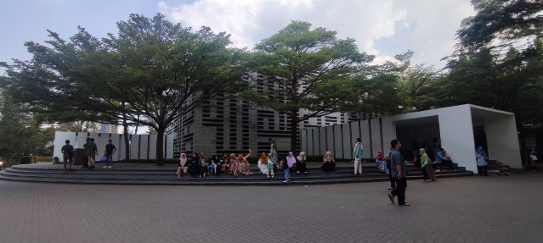

Figure 1. The exterior of Masjid Al-Irsyad, Kota Baru Parahyangan [source: Authors, 2023]

Masjid Al-Irsyad (Figure 1) was built in Kota Baru Parahyangan, Indonesia, in 2009. It is situated on a wide-open site of 8,000 square meters in Kota Baru Parahyangan, a satellite city located on the western outskirts of the city of Bandung, the third largest metropolitan city of Indonesia. The mosque was designed by architect M. Ridwan Kamil and his team at PT. Urbane architectural firm as a religious facility for Muslims in the newly established town. The mosque has been awarded several national and international honors for its peculiar design and eco-friendly response to the sustainability issue [21-23]. In addition to its unique design, the mosque is famous among the town's residents and the vicinity for its Islamic programs. More than a hundred female and male congregations attend the daily prayers, and even more women come on specific days when an Islamic learning session (kajian) is held. The kajian is a public Islamic learning session organized by a mosque or a group of people in which an Islamic scholar or teacher teaches Islam. The kajian is very popular among Indonesian Muslim women. Many of them attend more than one session weekly. Some kajians are open for both sexes, some are for women, and fewer are for males only. As in other mosques in Indonesia, the attendees—female and male, adults and children—are several times more during Ramadhan.
As an Islamic community center where women, children, and older people are users, providing a just mosque space for everyone is required. As a cultural product, architecture plays a vital role in communicating while promoting or denigrating social justice. Masjid Al-Irsyad, a crucial Islamic architecture, may serve as a role model and inspire other architects to design a mosque. Therefore, this article examines the use of space and its architectural design using a gender perspective. The objective is to assess Masjid Al-Irsyad's design in accommodating the congregations' needs, particularly women, and how the space provides opportunities for their empowerment.
In looking at the mosque space through a gender perspective, our discussions are inspired by Henri Lefebvre’s conception of social space [24] and Gilles Deleuze and Guattari’s social assemblage [25]. Lefebvre suggests that space should not be seen as a physical container of human activities. Instead, he argues that space is not neutral or passive but actively produced through daily social practices [24]. In “The Production of Space,” Lefebvre discusses the triad of perceived, conceived, and lived space and how societal forces and power structures shape them. While he explores spatial hierarchies and power, he does not delve into gendered space and how it is connected to societal power relations. Doreen Massey contributes to this conversation by arguing that the gendered experience is deeply intertwined with the space that people occupy and that the gendered space is constantly evolving [26].
The open plan design of Masjid Al-Irsyad implies flexible uses of space in which territories and boundaries are constantly shifting and challenged. In many traditional mosques, territories, and boundaries are defined as fixed spatial aspects that manifest through architectural features and represent social norms. Deleuze and Guattari’s notion of social assemblage explains the flexible elements in a social context. Social assemblage refers to a dynamic, flexible, and non-hierarchical arrangement of human and non-human elements that combine to produce a particular social, political, or cultural phenomenon [25]. Combining these theories, we aim to look at the mosque space and the gender practices that occur within it as two dynamic components that are mutually constitutive. Since an assessment tool for gendered space has not yet been available, we adopted the assessment criteria from the Gender Analysis Pathway, which consists of access, control, participation, and benefit to evaluate women’s empowerment [27, 28].

- METHODS
The research used a qualitative approach, combining interviews and participant observations at Masjid Al-Irsyad, Kota Baru Parahyangan, during daily use and a weekly Islamic learning session (kajian). The informants were selected according to the following criteria: women and men who attended the mosque during the observations and had participated in the mosque programs more than once. We interviewed 17 men and 29 women attendees of Masjid Al-Irsyad, Masjid Salman, Masjid Al-Furqon, Masjid Pusdai, and Masjid Al-Jabbar. All these are community mosques in the Bandung area and are favorites among visitors. The selected participants had visited at least two of the five mosques. We asked participants about their experience and opinion of these mosques’ space and gender-based spatial segregation by comparing the mosques. Additionally, we documented the mosque's architectural layout and elements and observed the use of space by women and men for different activities.
Data obtained from the qualitative interviews were recorded in field notes. We identified the keywords and categorized them into themes, which we use to discuss gendered space in this article. We combine the documentary data and the observation notes to discuss our analysis of how the space is gendered according to its uses and designation.

- RESULT AND DISCUSSION

  - MASJID AL-IRSYAD AT A GLANCE
Masjid Al-Irsyad of Kota Baru Parahyangan has a cubical shape, imitating the Kaaba in Mecca. The surface of the facades is made of stacked concrete blocks left void in several spots to create an Arabic sentence that reads the tawhid Islamic sentence or a statement witnessing God’s oneness. Different from most Indonesian mosques that use single or multiple domes on the roof or a tiered pyramidal roof, as modeled from the traditional mosques, Masjid Al-Irsyad does not have a roof type. Its simple design is considered a celebration of modernism and Muslim’s expression of modernity [29].
The mosque is 11.5 meters tall and covers an area of 970 square meters, designed to accommodate 1,000 congregations. The entire exterior walls are stacked with unpainted concrete blocks. The mosque contains an undivided square prayer hall where both men and women pray. The men pray at the front (close to the mihrab), and the women pray behind them. The prayer hall can be reached through two entrance galleries on the north and east sides of the building. While both women and men use the north entrance, the east entrance can only be accessed by women during daily prayers. At the north of the prayer hall is a smaller building containing the mosque management’s room and ablution areas and toilets, one for men and one for women.

  - THE SPATIAL USES OF THE MOSQUE ACCORDING TO GENDER
Masjid Al-Irsyad is designed as an open-plan mosque because the architects intended to provide a flexible space to accommodate various occasions and programs. In an interview, architect Ridwan Kamil said he provided different spaces for women in his designed mosques. He preferred to design a rear balcony for large mosques, but with limited space, Kamil reserved one-third of the prayer hall for women. He followed a hadith on congregational prayers, mentioning women’s position behind men by putting women’s reserved space at the rear part of the hall.

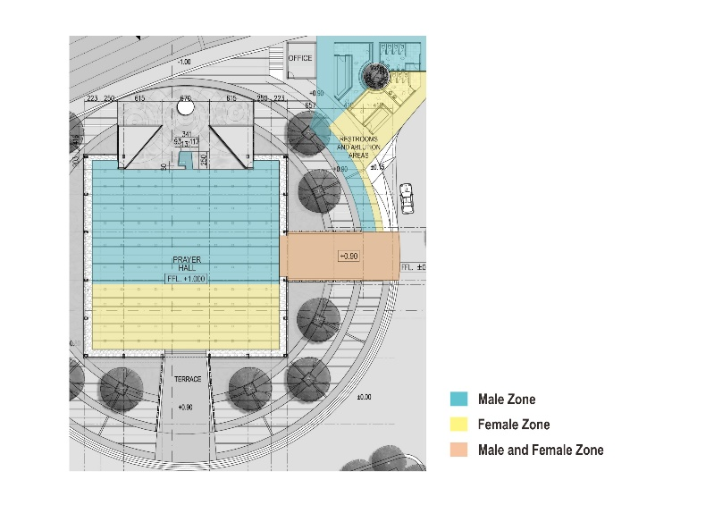 | 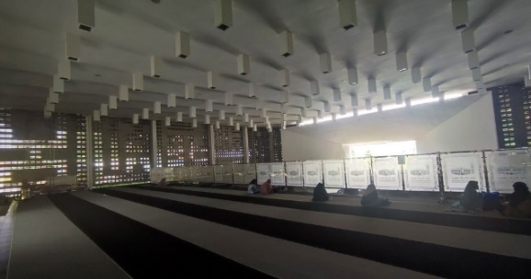
Figure 2. The women's space during the daily prayer [Floorplan: PT. Urbane modified by Authors, 2023; Photo: Authors, 2023]

Accounts on the reconstruction of the Prophet’s mosque in Medina show the open layout of the mosque, known as the hypostyle layout [30-33]. A critical study by Reda reveals no divider between men’s lines at the front and women's at the back. However, this arrangement was changed during the period of the Rightly Guided Successors (Khulafaur Rasyidin). Under Umar ibn al-Khattab (634-644 C.E.), for example, women prayed in a separate room with a separate imam (prayer leader) [8]. While there is no documentation on the layout of the Prophet’s mosque according to gender, Hadith does mention how women and men should position themselves in congregational prayer.
There is no strict spatial separation for women and men at Masjid Al-Irsyad of Kota Baru Parahyangan except for the restrooms and ablution area. The main prayer hall is flexibly used according to the usual number of attendees. During the Friday prayer, the mosque is thoroughly used by men. During daily prayers, the front half of the prayer hall is occupied by men. The mosque attendants installed portable semi-transparent dividers—approximately as tall as 1.50 meters and made of frosted fiberglass—in front of the women’s lines (Figure 2). The congregations usually come and prepare the prayer half an hour before the first call to prayer (athan) and will stay for about half an hour after the congregational prayer to make dua and do the sunnah prayer. During this prayer time, the mosque space is strictly separated for women (behind the divider) and men (in the front of the divider). During the in-between prayer time, the mosque is usually less crowded. Without praying, men and female visitors sometimes come to the open mihrab to enjoy the pond and the space and take some pictures of it.
The restrooms and ablution areas are strictly defined separate spaces for women and men. Some Indonesian mosques, particularly those that are only by male congregations during Friday prayers, temporarily allow men to use women’s restrooms and ablution areas during weekly worship. However, this is not the case in Masjid Al-Irsyad. The mosque board decides to preserve the spatial segregation despite men's temporary use of the mosque.

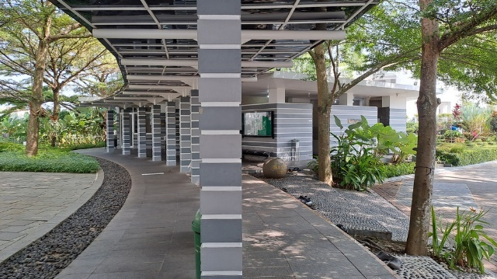

Figure 3. The corridor connecting the central space of the mosque and the restroom and ablution area [source: Authors, 2023]

The restrooms and the mosque management office comprise a side building in the northwest corner of the main prayer hall. There is a corridor with no divider but a signage of the separate men's and women’s paths. Although there is no divider, men and women tend to use the different sides (separated by columns) as they walk out of and to the restrooms (Figure 3). We observed that women and men tended to walk on the different sides of the corridor. Here, the rows of columns subtly communicate the division of sexes in the corridor despite the absence of physical dividers.

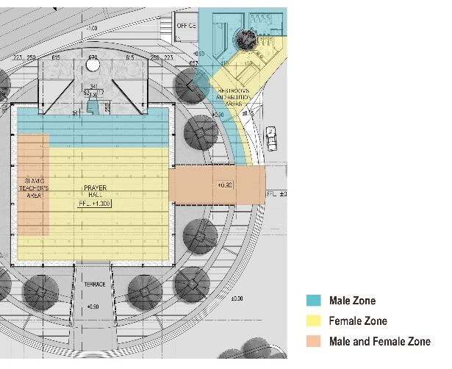 | 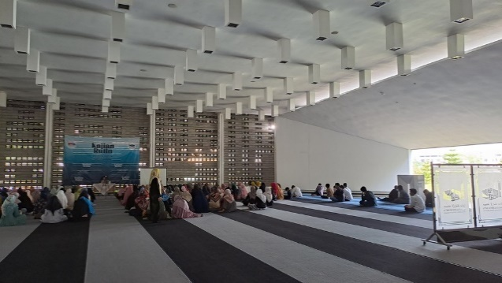
Figure 4. The use of the mosque space by women and men during the kajian [Floorplan: PT. Urbane modified by Authors, 2023; Photo: Authors, 2023]

Spatial segregation in the main prayer hall shifts during the kajian (Islamic learning session) when more women are present. Some women who have regularly attended the kajian at the mosque since 2009 told us that more and more women from anywhere participate in the kajian while fewer men do. In the past, the attendees were divided by a cloth screen, usually installed during prayer time. However, because the kajian is held on weekday mornings, most men go to work and are rarely able to participate. No hijab is installed during the kajian, although the teacher is a male. Short (approximately 50 centimeters tall) wooden dividers are placed between the teacher’s desk and the attendees’ area as an indexical sign to show where their sitting area is (Figure 4). While waiting for the kajian to begin, some women and their little children often come to the pond surrounding the mihrab and look at the fish in it. Some dividers are installed next to the mihrab to provide men with a separate space to do their Dhuha prayer—a sunna prayer held before noon—but this seems to facilitate the praying men with more tranquility.
During the kajian, women and children freely move inside the main prayer hall. They can even access the mihrab area, which is restricted to men during the daily prayers. More interestingly, the spatial orientation is shifted from the qibla in the northwest direction to the southwest direction, or 90 degrees counterclockwise, during the kajian. The qibla is the primary orientation of a mosque space since it is the direction in which prayers should be oriented. Unlike a temple, a mosque does not recognize sacredness, but the lines closest to the qibla have been distinguished as the most privileged spot for those who attend congregational prayers. Shifting the spatial orientation from the qibla to the other direction can create a temporal boundary between the prayer and the kajian, which is deemed less religious.

  - THE MOSQUE SPACE THROUGH WOMEN AND MEN’S EYES AND EXPERIENCES
The space provided at Masjid Al-Irsyad facilitates women’s participation in mosque activities. Some of our female informants felt that the prayer space was adequate for them, even when they came with their little children. The open mihrab and the ventilated walls allow cross-air ventilation and make the mosque's interior relaxed and comfortable for praying and resting, even without an air conditioner. We observed some little children in the Kajian when we visited the mosque. The children comfortably played with others or walked around the prayer hall while their mother listened to the Islamic teacher. Overall, the mosque is a child-friendly environment where women and men can bring their children without worries while praying or attending other mosque activities.
The kajian is the session where women are the primary participants. It is organized by female mosque committee members who invite the teachers, welcome the congregations, show them where to sit, lead the sessions, and take pictures for documentation. The kajian is mainly attended by women from Kota Baru Parahyangan and villages near and far from the vicinity. One of our informants was a 63-year-old woman who came from Sukabumi with his son. She visited Masjid Al-Irsyad to attend the kajian and pray Dhuhr (noon prayer) afterward. She traveled by train and left home at 4:00 am only to join the Islamic learning session, which began at 9:00 am. Other attendees live more than one kilometer from the mosque. They would like to attend the kajian at Masjid Al-Irsyad because of the excellent Islamic teachers, who can ask some questions and discuss them. Some speakers are well-known Islamic teachers whom they often see on television. They also like to come to the mosque because of its convenient environment. Some informants compared with other mosques where guards sometimes watched congregations and were not free to discuss with the Islamic teachers.
Our observation confirms what the informants disclosed. During the kajian, women were well-engaged with the teacher. After the lecture, more than ten women raised their hands to ask questions, while no men did it. Although the Islamic teacher was a man, the women were not reluctant to ask questions and discuss with him.
While women felt welcomed at Masjid Al-Irsyad, they thought the restrooms were inadequate, mainly when many visitors were present. Studies have found that women need more extended time in the restrooms compared to men [34]. To gain equality in public restrooms, Western architects and scholars often recommend unisex restrooms, which can be used alternately by women and men [35]. However, our informants preferred a strict separation in restrooms due to privacy. Some informants also preferred a more closed space in the prayer hall. “I prefer a closed restroom that is connected directly to the women’s prayer room so we are comfortable to remove our socks and hijab while taking the ablution and prepare for the prayer,” said Tasya (20 years old), a girl who came to the mosque for the kajian. “We will not lie down or take a nap, but women sometimes need more space to do private things, like fixing their hijab or breastfeeding their baby…,” Maya (39 years old) said.
The mosque board of Masjid Al-Irsyad has considered a renovation to build more restrooms and enlarge the women’s ablution area. Dr. Hairudin, who has been the chair of the mosque board since its opening, thought that the architect might have considered men as the primary users of the mosque when he designed it. Dr. Hairudin said women are the primary users of the mosque.
In the case of praying, privacy concerns are not only about being unseen but also about not seeing. Although a frosted fiberglass divider allows light penetration and women’s view of the imam’s body movements—as some hadiths require, some women prefer not to see men in front of them while praying. Therefore, regarding privacy, they liked a non-transparent panel that was better for the prayer space.
Although the mosque provides women comfort in using the space, the restrooms and ablution area felt inadequate. Additional water faucets are provided for ablution at the entrance area, but women felt uncomfortable taking the ablution there because they were in an open court.

  - GENDER AND THE SOCIO-SPATIAL ASSEMBLAGE AT MASJID AL-IRSYAD
The design preference of a mosque varies all over the world. Architects of modern mosques often design open-plan mosques due to their flexible use. While most contemporary mosques in Indonesia adopt such a layout, mosques in other countries where Muslims are a minority tend to provide women with a separate room, either as a side room or a semi-open balcony, from where women can see the imam (prayer leader)’s movement without them being seen. Some congregations, both men and women, who prefer the use of a more covered section, think that a separate room is better to preserve women’s privacy and to avoid men’s gaze. On the other hand, an open-layout mosque offers greater flexibility and can accommodate the various activities held in the mosque by different user groups. The absence of a space labeled as a women’s prayer room may eradicate women’s representation of space and thus threaten their space in the mosque [36]. It is perhaps because of the common accommodation of women in Indonesian mosques that women still have their space despite there being none of them labeled as such, and men occasionally occupy their space.
Referring to the Gender Analysis Pathway, women’s status in the mosque can be assessed by looking at their access and control, their opportunity to participate, and the benefits they obtain from the mosque. In Masjid Al-Irsyad, the mosque space is accessible to women almost all the time except during the Friday prayer. They also have access to enlarge the space they need when more women are present, for example, during the kajian. The women actively participate in the prayer, albeit not as the leader. Although a movement of Muslim women in the United States fought for an equal position as a prayer leader of a mixed congregation of women and men in public mosques [37], it may not be the case for Indonesian Muslim women [38]. In Kajian, as observed in many Indonesian mosques and Muslim communities today, women are the most active participants and organizers. In Masjid Al-Irsyad, women actively engaged with the kajian in both roles. They are also involved in mosque management as mosque board members. Discussed in Deleuze and Guattari’s theory, the women's and men’s presence, their shifting roles as organizers, leaders, and participants, and the changing tone of the interactions are all the social assemblage that creates a dynamic gender relation in Masjid Al-Irsyad.
Additionally, following Lefebvre and Massey, the social practices of gender constitute the social space [24, 26]. We follow Kim Dovey and Kenn Fischer’s development of Deleuze and Guattari’s theory into the socio-spatial assemblage to address the way the social assemblage is practiced within space [39] and produce what Lefebvre’s coins as social space [24]. The vibrant and dynamic use of space blurs the gendered borders and the spatial hierarchy in Masjid Al-Irsyad. While in traditional mosques, the mihrab and the front part of the prayer hall are considered male space and forbidden for women [15], those at Masjid Al-Irsyad shift into ungendered space, which is accessible to men, women, and children outside of the prayer times.
The open, flexible space encourages more fluid interactions between women and men and further facilitates women with more opportunities to participate in the mosque. Although without a strict divider, women and men maintain a distance between them [40], as shown in our interviews with the female informants. This finding aligns with the study conducted by Dovey and Fisher, which found that flexible space is suitable for adaptation and for empowering previously marginalized people [39].
All of our male participants appreciate women’s active participation in the mosque. Dr. Hairudin was delighted that women came from far and near places and helped revitalize the mosque. As he had lived in Arab Saudi for fifteen years and Egypt for five years, Dr. Hairudin saw that the practice in Indonesia is a depiction of the ideal Islam where women, who should learn more about Islam because they are their children’s first school, can attend the mosque and participate in Islamic learning programs without any obstacles. Dr. Hairudin encouraged women’s active participation in the mosque by saying so. Another male attendee we interviewed, Dr. Asep, who attended some other mosques besides Masjid Al-Irsyad, also acknowledged women’s active participation in Indonesian mosques, which he saw as a very positive tradition to be preserved. As Nyhagen shows, despite dealing with the gendered space and exclusion in the mosque, women play an essential role in making the mosque a more inclusive space for the community [11].

- CONCLUSION
Architects of contemporary mosques often design open-plan mosques to accommodate the congregations' flexible numbers and activities. Using Lefebvre’s theory of social space, Deleuze and Guattari’s theory of social assemblage and combining them with the Gender Analysis Pathway, this article examines the architectural design of Masjid Al-Irsyad and its spatial uses through a gender perspective. Our study finds that the open-plan mosque allows flexible use of space, encouraging more equal gender relations in various mosque activities and settings. The flexibility facilitates a dynamic use of space and the shifting gender border, resulting in a socio-spatial assemblage that opens more expansive opportunities for gender-responsive space and gender empowerment. In Masjid Al-Irsyad, the socio-spatial assemblage consists of the shifting spatial layout, gendered boundaries, paths, and dividers.

REFERENCES
[1] M. H. Katz, Women in the Mosque: A History of Legal Thought and Social Practice. Columbia University Press, 2014.
[2] S. Mazumdar and A. Mazumdar, "Rethinking Public and Private Space: Religion and Women in Muslim Society," Journal of Architectural and Planning Research, vol. 18, pp. 302-324, 2001.
[3] R. Woodlock, "The Masjid is for Men: Competing Voices in the Debate about Australian Muslim Women's Access to Mosques," Islam and Christian-Muslim Relations, vol. 1, no. 1, pp. 51-60, 2010. doi: https://doi.org/10.1080/09596410903481853.
[4] R. Woodlock and S. Carland, "Muslim Women’s Mosque Access," presented at the The Challenges of Religious Pluralism Conference of the International Society for the Sociology of Religion, Santiago de Compostela, Spain, July 27-31, 2009, 2009.
[5] N. Abbott, "Women and the state on the eve of Islam," The American Journal of Semitic Languages, vol. 58, no. 3, pp. 259-284, 1941.
[6] N. Abbott, "Women and the State in Early Islam," The Journal of Near Eastern Studies, vol. 1, pp. 106-126, 1942.
[7] B. F. Stowasser, Women in the Qur'an, Tradition, and Interpretations. New York and Oxford: Oxford University Press, 1996.
[8] N. Reda, "Women in the Mosque: Historical Perspective on Segregation," American Journal of Islamic Social Sciences, vol. 21, pp. 77-97, 2004. doi: https://doi.org/10.35632/ajis.v21i2.504
[9] "The Book of Prayers," in Sahih Muslim 442d, Book 4, Hadith 153. https://sunnah.com/muslim:442d.
[10] "The Book of Prayers," in Sahih Muslim 442a, Book 4, Hadith 150. https://sunnah.com/muslim:442a.
[11] L. Nyhagen, "Mosques as Gendered Spaces: The Complexity of Women’s Compliance with, And Resistance to, Dominant Gender Norms, And the Importance of Male Allies," Religions, vol. 10, no. 5, p. 321, 2019. doi: https://doi.org/10.3390/rel10050321
[12] N. Ghafournia, "Negotiating Gendered Religious Space: Australian Muslim Women and the Mosque," Religions, vol. 11, no. 12, doi: 10.3390/rel11120686.
[13] S. A. Nageeb, "Appropriating the Mosque: Women’s Religious Groups in Khartoum," Afrika Spectrum vol. 42, pp. 5-27, 2007.
[14] P. V. Doorn-Harder, Women Shaping Islam: Reading the Qur'an in Indonesia. Urbana and Chicago: University of Illinois Press, 2006.
[15] T. Aryanti, "The Center vs. the Periphery in Central-Javanese Mosque Architecture," Dimensi Teknik Arsitektur, vol. 34, no. 2, pp. 73-80, 2007. doi: https://doi.org/10.9744/dimensi.34.2.pp.%2073-80
[16] R. Holod and H.-U. Khan, The Mosque and the Modern World: Architects, Patrons and Designs since the 1950s. London: Thames and Hudson Ltd., 1997.
[17] L. K. Weisman, Discrimination by Design: A Feminist Critique of the Man-Made Environment. Urbana and Chicago: University of Illinois Press, 1994.
[18] D. Spain, Gendered Spaces. Chapel Hill and London: University of North Carolina Press, 1992.
[19] A. Kusno, "'The Reality of One-which-is-two,' Mosque Battles, and Other Stories: Architecture, Religion, and Politics in the Javanese World," Journal of Architectural Education, vol. 57, pp. 57-67, 2003. doi: https://doi.org/10.1162/104648803322336593
[20] A. Fawaid, Z. Zamroni, and H. Baharun, "Contesting Sacred Architecture: Politics of ‘Nation-State’ in the Battles of Mosques in Java," QIJIS (Qudus International Journal of Islamic Studies), vol. 7, p. 129, 07/11 2019, doi: 10.21043/qijis.v7i1.4365.
[21] H. D. Puspitorini, "Kenyamanan Thermal pada Masjid Al-Irsyad Kotabaru Parahyangan, Jawa Barat," JA! UBL, vol. 4, no. 1, pp. 37-44, 2013. doi: 10.36448/jaubl.v4i1.460
[22] A. N. Udjianto Pawitro, Tamdy Septiandi, Arief Hernomo, "Kajian Ekspresi Ruang Luar dan Ruang Dalam pada Bangunan Masjid Al-Irsyad Kota Baru Parahyangan Ditinjau dari Sustainable Design," Reka Karsa, vol. 2, no. 2, pp. 1-12, 2014. doi: https://doi.org/10.26760/rekakarsa.v2i2.460
[23] R. D. Nazhar, "Kajian Makna: Mihrab Masjid Kontemporer Al-Irsyad Kota Baru Parahyangan," Serat Rupa Journal of Design, vol. 1, no. 2, pp. 246-257, 2016. doi: https://doi.org/10.28932/srjd.v1i2.454
[24] H. Lefebvre, The Production of Space. New York: John Wiley & Sons, Inc., 1991.
[25] G. Deleuze and F. Guattari, A Thousand Plateaus. London, England: Bloomsbury Academic, 2013.
[26] D. Massey, Space, Place, and Gender. Minneapolis: University of Minnesota Press, 1994.

[27] A. Hubeis, "Gender Analysis Pathway (GAP) in Policy Outlook and Action Planning in Cooperative and Small-Medium Enterprises," Bureau of Women Empowerment National Planning Board (Bappenas) RI with Expansion Employment Opportunity for Women (EEOW) Project-ILO. Jakarta, 2001.
[28] BPP Nasional, KNP Perempuan, Gender Analysis Pathway (GAP) Alat Analisis Gender Untuk Perencanaan Pembangunan. Jakarta: Kementerian Negara Pemberdayaan Perempuan Republik Indonesia, 2008
[29] Y. Ardhiati, "The New Architecture of Mosque Design to Express the Modernity of Moslems," Global Advanced Research Journal of Arts and Humanities, vol. 2, no. 4, pp. 75-78, 2013.
[30] K. A. C. Creswell, A Short Account of Early Muslim Architecture. Cairo: The American University in Cairo Press, 1989.
[31] J. Johns, "'The "House of the Prophet" and the Concept of the Mosque'," in Bayt Al-Maqdis: Jerusalem and early Islam, J. Johns Ed. Oxford: Oxford University Press, 1999, pp. 59-112.
[32] E. J. Grube and G. Michell, Architecture of the Islamic World: Its History and Social Meaning, with a Complete Survey of Key Monuments. Thames and Hudson, 1978.
[33] J. D. Hoag, Islamic Architecture: History of World Architecture. London: Phaidon Press, 2004.
[34] M. A. Baillie, S. Fraser, and M. J. Brown, "Do Women Spend More Time in the Restroom than Men?," Psychological Reports, vol. 105, pp. 789-790, 2009. doi: https://doi.org/10.2466/PR0.105.3.789-790
[35] R. Colker, "Public Restrooms: Flipping the Default Rules," SSRN Electronic Journal, 01/01 2017, doi: 10.2139/ssrn.2937718.
[36] D. F. Ruggles, "Vision and Power: An Introduction," in Women, Patronage, and Self-Representation in Islamic Societies, D. F. Ruggles Ed. New York: State University of New York Press, 2000, pp. 1-15.
[37] A. Elewa and L. Silvers, "I am one of the People”: A Survey and Analysis of Legal Arguments on Woman-Led Prayer in Islam," Journal of Law and Religion, vol. 26, no. 1, pp. 141-171, 2010, doi: 10.1017/S074808140000093X.
[38] T. Aryanti, "The Claim to Space: Debating Female Religious Leadership in a Muhammadiyah Mosque in Indonesia," The Muslim World, vol. 103, no. 3, pp. 375-388, 2013.
[39] K. Dovey and K. Fisher, "Designing for adaptation: the school as socio-spatial assemblage," The Journal of Architecture, vol. 19, no. 1, pp. 43-63, 2014/01/02 2014, doi: 10.1080/13602365.2014.882376.
[40] T. Aryanti, "Women's Prayer Space: Body and Boundary," The International Journal of the Constructed Environment, vol. 2, no. 3, pp. 177-190, 2012. doi: 10.18848/2154-8587/cgp/v02i03/37343.

