 |  | JOURNAL OF ISLAMIC ARCHITECTURE  P-ISSN: 2086-2636 E-ISSN: 2356-4644  Journal Home Page: http://ejournal.uin-malang.ac.id/index.php/JIA
TRANSFORMATION OF ADAT VALUES INTO BENEVOLENCE AND CONFORMITY IN THE TRADITIONAL HOUSE OF LIMO KOTO KAMPAR RIAU, CASE STUDY LADDER TO STAIR
Ratna Amanati^{a,b*}, Himasari Hananª, Hanson E. Kusumaª
ªSchool of Architecture, Planning, and Policy Development, Institut Teknologi Bandung, Bandung, Indonesia
^{b}Architecture Department, Engineering Faculty, Universitas Riau, Riau, Indonesia
*Corresponding Author: ratnaamanati@gmail.com
ARTICLE INFO |  |  | ABSTRACT
Volume: 8  Issue: 2  Page: 306-317  Received: September 15th, 2022  Accepted: February 2nd, 2024  Available Online: December 30th, 2024  DOI: 10.18860/jia.v8i2.23578 |  |  | The customary stilt houses of Limo Koto Kampar Riau transformed their appearance. The result of the transformation from ladder to stair has developed its philosophical roots with Islamic values into a form that is more practical than symbolic. This study identifies the shift in the orientation of values that occurs by tracing the change from one level to the next through the reasons that become the motivations and goals of the residents in developing their houses. Using the Mean End Chain (MEC) method, it indicated that the value orientations that underlie the transformation from the ladder to the stair are Benevolence-Caring and Conformity-Interpersonal, which contain the postulates of Helpful, Family Security, and Respect Parents. It is just one example of how Adat values have transformed into benevolence and conformity in the traditional house of Limo Koto Kampar Riau. This value orientation has not experienced a shift from Islamic values. There is a transformation of form from the philosophical symbol on the ladder to the practical technical ladder. These findings are beneficial for understanding residents' motivations in developing their homes and contributing to addressing the preservation of traditional architecture.  Keywords:  Benevolence and conformity; practical technical; philosophical symbol; transformation

- INTRODUCTION
Limo Koto Kampar is an ethnic area in the Kampar district of Riau Province, which borders West Sumatra Province. It is part of the Pagaruyung kingdom in Minangkabau, West Sumatra [1]. Now, it is included in the Riau Province [2], where the majority have Malay culture. It is interesting to note that there are several cultural similarities between the Limo Koto people and the Minangkabau people, including ethnicity, language, social procedures, and even the shape of the house [3]. The people of Limo Koto Kampar have a unique culture of migrating, much like their Minangkabau counterparts [4]. Throughout the years, the people of Limo Koto Kampar have adapted and evolved, bringing their traditions and customs wherever they go.
The Limo Koto Kampar house looks unique, and its lontik roof is reminiscent of the gonjong in Minangkabau. The house is built on stilts higher than a human's height, making it stand out even more. However, over time, the house has undergone in its design. With the wave of people returning from Malaysia, the house has gradually transitioned into a pyramid roof with a raised stage that is lower than before. Despite the changes, the Limo Koto Kampar house still looks stunning and is a sight to behold [4].
Both Minangkabau and Malay adhere to customary law based on Islam. "Adat based on Syarak, Syarak based on Kitabullah" refers to this adat legislation [3] [5]. Therefore, God's rules or Syarak govern all customary concerns. In other words, the foundation of adat is Islamic law, which originates from the Book of Allah, namely the Qur'an and Hadith, so there will be no resistance in the future [5].
There are three levels of adat: Custom, Established Custom, and Customary Custom [5] [6]. An unchangeable tradition is a True Custom. "Adat based on Syarak" contains this principle. Natural adat declares the adat that takes God's revelation to the Rasulullah [6]. This custom is not damaged by space and time because humans cannot alter this tradition. The next one is Established Customs, especially Adat, which is now a legal requirement made by past ancestors to regulate human life in society and continues to be enforced by the next generation [6]. Change is possible because of adjustments to the times and the views of the authorities [5]. Adat at this level is like the advice taught by Raja Ali Haji in Gurindam Dua Belas. The third level of adat is Customary Custom. This level has two kinds [6] [7], namely Customary Customs and Customs. A code of conduct is one of the conventions of customary custom. Meanwhile, customs are provisions that become habits from generation to generation, such as ethics related to nature.
The Limo Koto Kampar traditional house is a beautiful example of how building designs can carefully consider the adat values of the surrounding community. This house is not just a place to live; it is a symbol of the perfection of life. The application of customary values is evident in every aspect of the house building, from deliberations and location selection to ceremonies and the construction and installation of every element of the home. The Limo Koto Kampar home pays special attention to the necessity of the components of the steps to access it, making it a truly unique and special place to call home.
The local people call straight wooden staircases with or without ornaments ladders. There are two types of ladders [7] [8]. First is the round ladder, which is a ladder of round wood. The second type is the picak ladder, made of thick, flat boards. Wooden joints on round ladders use a rope tie system. Residents use this ladder by leaning it on the footing board of the door. The arrangement of the ladders, how to tie the ladder ropes, and the parts of each ladder have a specific meaning according to custom.
The ladder represents the idea of Rahmatan Lil Alamin, according to which Islam is kindness toward all of nature [9]. Customary values govern the selection of wood for scaffolding in the rules for logging as a form of utilization and preservation of natural resources [3]. Customary law protects the forest as a source of timber. Customary law regulates the use of forests for the benefit of nature and the next generation [3].
Philosophically, the ladder symbolizes the meaning of Islamic values [9]. For example, the tie-wrapped lilit salari or belit bercengkam system on an arcing ladder is meant to avoid domestic conflicts and field disruptions. It reminds the occupants to maintain harmony and avoid hostility always. The neck above the bend or floor beam symbolizes the mother's affection for her child. It reminds us of the nobility of the mother and parents in the family. The head-level part leaning against the footing board represents the head of the household who upholds the family's dignity. It teaches responsibility towards the family. The number of levels of 5 or 6 on the ladder symbolizes the pillars of Islam and the pillars of faith [9] that teach us to remember Tawhid always [10].
Adat employs the stairs to enforce guest politeness by putting them as a point of transition between the outside and the inside of the dwelling building. When there are no male occupants in the house, the farthest guests can only set one foot on the top rung and the other on the bend of the house [3]. It is an attitude of respect for female residents, especially regarding their privacy.
The Limo Koto Kampar traditional house is an inherited house, that is, a dwelling passed down to the next generation according to the lineage of the house owner. The heir is responsible for looking after and maintaining the house. It is understood from idioms that the house is a setting for ancestral traditions [11] so that the occupants of the house change from generation to generation, from the first generation of the founders to the present generation as its heirs.
Over time, the needs of residents in Limo Koto have changed because of the development. The community has undergone a significant transformation, with a new identity emerging. Changes in intense cultural identity can affect the way of life, education, and subjective awareness of the culture [12]. It has led to changes in the traditional Kampar house, which has had to adapt to the needs of each new generation of residents. One notable change is the ladder element with stairs, which has become increasingly common in stilt dwellings.
Each generation of residents has different needs from the previous generation because of the times. Regional development has played a crucial role in bringing about this change. The community evolves and grows meaningfully with the help of various development initiatives. It is heartening to see how these efforts have paid off and how Limo Koto has emerged as a shining example of progress and development [13]. With the distinct needs of the current occupants, the Limo Koto Kampar traditional house has changed, including the tier element. The stilt house's front ladder is becoming less and less common as modern stairs take their place.
New values that support the growth of these demands have replaced the place of traditional values that served as the foundation for the creation of every component of the house. Instead of the orientation of traditional values, the new value orientation now influences how the house develops. Traditional life in Limo Koto Kampar today is shaky [7]. Many customary provisions are no longer adhered to. Adat only appears to play a role in formal matters such as wedding ceremonies or inheritance dispute resolution. Customs and traditions are loosening, fading, and losing color with time [8]. There are quite a lot of traditional values that have been neglected and extinct due to shifts and changes that keep happening.
Values are essential concepts to predict how someone would act [14]. Value orientation is a group of compatible values [15]. Values can coexist or clash in a behavioral event according to the sinusoidal form of the value orientation model [16], which does not have a hierarchical interest. These fundamental principles form a cohesive framework that serves as the foundation for and can assist in explaining how people decide on their attitudes and actions. Figure 1 is a sinusoidal value orientation model from Schwartz (2012) that allows values to run together because they are not hierarchical.
Religious attitudes in the form of obedience or holding on to religious beliefs and behavior to fulfill religious requests are Schwartz's postulates on the value of tradition. The opposite is also true: Benevolence and conformity values encourage pious behavior in a helpful way [17]. Benevolence and conformity values are socially altruistic attributes that sustain religious principles [14] [15]. Several postulates for Benevolence values, namely Helping, working for the welfare of others, Sincerity or Honesty, Forgiveness, Devotion to close people, and Maintaining family safety [14]. While the Conformity value emphasizes refraining from actions that may cause discomfort or harm others [16], this also involves being courteous and respecting parents [14].
As times change, traditional ways of life can become loose and obscure [7] [8]. It may lead to the decline of altruistic values and their replacement with egoistic ones. People may begin to focus more on personal values rather than on prosocial ones. Sociocultural changes can also lead to modifications in people's identities and lifestyles that conflict with traditional ways of life [18]. As the Limo Koto Kampar community grows, it may shift its identity and lifestyle away from a prosocial culture and towards values that prioritize the individual, potentially distancing itself from benevolence and conformity.
The transformation of building elements from traditional to modern can signify values over time. One of the most significant examples of such a change is the stairs. Thus, the primary objective of this study is to analyze the evolution of traditional values by investigating the shift from ladders to stairs. This shift from the ladder to the stair often occurs in Limo Koto Kampar dwellings. The numerous factors related to this transformation underscore the selection of the Limo Koto Kampar Traditional House as the object of study in this research.
This research reviews changes in occupant values that change building elements. This is what differentiates this research from other previous research. Previous studies of Limo Koto Kampar houses have yet to examine the house's occupants as the main actors who determine the shape of the house.
This statement raises the question of what value orientation is now influencing the alteration of different building components. How can the direction of Islamic principles, which serve as the foundation for traditional values, change to meet the demands of contemporary homeowners? This article will answer this question by taking the case of changing levels into stairs in terms of two main aspects, namely the values of Benevolence and Conformity. The conversation will bridge the value change that has taken place to comprehend the new value orientation that the inhabitants of Limo Koto Kampar have mostly adopted in remodeling their dwellings.

- METHODS
This research examines 50 family-occupied traditional stilt homes in Limo Koto Kampar. There are 44 stair adaptations among the 50 homes. This study uses a sample of occupied houses because it sees the suitability of its function as a residential house occupied by a family with daily household activities.
This study collected data using observation methods and semi-structured in-depth interviews. Observational data collection aims to record changes regarding the materials used, size, shape, and complementary components. Data collection also used semi-structured, in-depth interview techniques with the occupants of the houses to gather information about these changes. The participants discussed their experiences with developing ladders into stairs in the interviews, putting particular attention on the motivations for the creation of these ladders. We will go further into these justifications to see the occupants' new value orientation and why they are changing.
The study's value orientation follows Schwartz's circular value orientation. The reason for using Schwartz's value orientation is that these fundamental values form a coherent system that underlies and can help explain individual decision-making, attitudes, and behavior [16]. This circular form implies that behavior can conform to one or more values. Values that are adjacent support each other, while opposing values are contradictory. These values can work together, whether side by side or at odds, to underlie behavior [19] [20] [21].

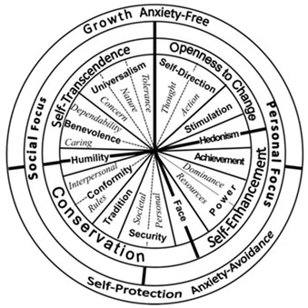

Figure 1. Sinusoidal value orientation model [16]

The data analysis method to explore various reasons for changing the ladder toward value orientation uses the Mean End Chain (MEC) method. MEC is a technique that links a tangible physical element to an intangible value orientation [22]. The outcome can provide insight into someone's behavior towards specific attributes. This strategy offers a means of tying a particular decision to overarching goals and values [23].
The MEC process goes through analysis by building a hierarchical map that places the behavior change at the base level and then carefully locates the reasons for the need to show consequences at the levels above. Value orientation is the last accomplishment that tops the search results. The search for Schwartz's postulates precedes this step. Figure 2 below provides a straightforward illustration of the Hierarchical Value Map (HVM).

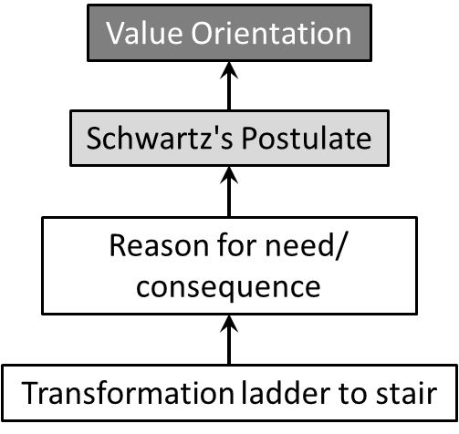

Figure 2. The study's use of the Hierarchical Value Map model

The lines on the HVM will form a tree diagram. Each HVM tree diagram represents each conversion event. A collection of all HVMs will show the frequency of each requirement and the same postulates. Boundary Benevolence and Conformity values are used to calculate the frequency of a change pattern. The pattern of change will show the needs experienced by many people in the transformation behavior and the tendency of the value orientation that many of them adhere to.
Comparing the two patterns is necessary to respond to the purpose of revealing previous and present value orientation changes. The HVM of changing the ladder to the stairs experienced by current occupants forms a pattern with the reasons for their needs. The formation of stairs when building a house first also has a value orientation and reasons of necessity. Comparing the two will answer the question of the change in the directive of the former value with the current one. It will show how far the people of Limo Koto now adhere to these adat values based on Islamic teachings in the development of their recent traditional houses.

- RESULT AND DISCUSSION
The form of a new staircase that replaces the traditional stilt house ladder is a form of a completely new attribute. Figure 3 shows examples of stairs that are now commonly found in Limo Koto Kampar stilt houses. While Figure 4 shows examples of ladders that still survive. The difference is in the material, shape, and size. The appearance of the stairs shows something completely new from the previous form of the steps. With its new form, the traditional values that underlie the initial stages of shape seem to have disappeared or at least have become blurred or shifted. The people of Limo Koto Kampar are no longer interested in holding on to traditional values that are the teachings of Islamic values [7] [8].

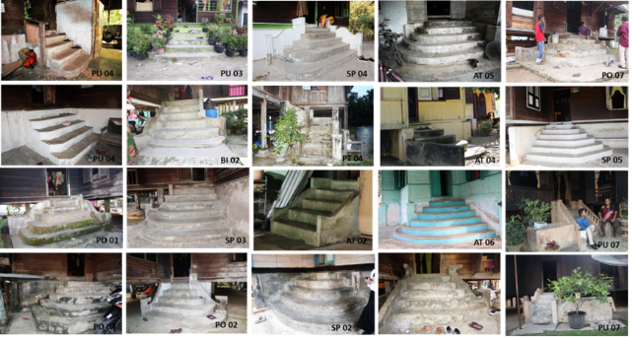

Figure 3. The various forms of stairs that are commonly found in traditional Limo Koto Kampar Riau stilt houses now

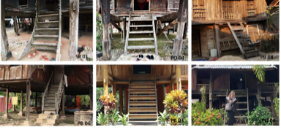

Figure 4. The shape of the ladder that still exists in the traditional Limo Koto Kampar Riau stilt house today

Making HVM is based on changing each level to a ladder. The formulation of needs refers to all the reasons for the interview. By exploring the necessity of Schwartz's postulates, the analysis will reach the final goal, namely the value orientation of Schwartz (2012). Figure 5 presents the HVM of all Benevolence-caring and Conformity-interpersonal gains.

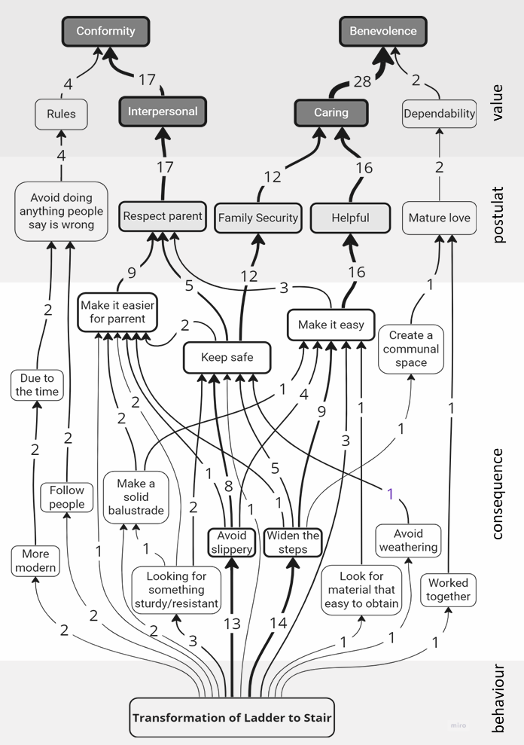

Figure 5. HVM is the result of changing ladders to stairs in the traditional stilted home of Limo Koto Kampar Riau

Of all the needs that arise during interviews, the three necessities that have a high frequency are Make it Easy, Keep Safe, and Make it Easier for Parents. These three needs are not only aimed at facilitating oneself but rather aim to facilitate other people in the family, namely siblings and their parents or children. Residents address these needs with practical design development techniques according to their current conditions. Design principles can also reason the way of development. The most widely disclosed is the Widen the steps and Avoid Slippery methods. Figure 6 also presents the frequency of reasons that emerged from the participants.
In HVM, the reason for the need relates to the postulates [14]. Three postulates emerge with a high frequency. Respect for Parents, Help, and Family Security are the postulates. The three needs with high frequency lead to these three postulates. Thus, the branches of the HVM tree changing the ladder to the ladder are increasingly converging on two value orientations, namely Benevolence-Caring and Conformity-Interpersonal. In other words, the value orientations ladder-to-stair transformation are the values of Benevolence-Caring and Conformity-Interpersonal.
The formation of the HVM based on the reasons for change from the residents showed that their motivation was for the benefit of the welfare of others. They change their attributes not because they adapt to cultural developments and lifestyles [24] or because they want to improve the household economy [25]. The change from the ladder to the stair is also not meant to symbolize pride [26] or even trust [27].
The values of Benevolence-Caring and Conformity-Interpersonal, which are the value orientation of the Limo Koto community, are social altruistic values. Both value orientations are the reasons for the family's needs because benevolence values must be interpreted as a narrower form of in-group altruism [15]. Figure 6 also contains the frequency of postulates and the orientation of the values that appear. The values of Benevolence-Caring and Conformity-Interpersonal that become the value orientation of the Limo Koto community are altruistic social values. Prosocial behavior can be interpreted as benefitting others or society, although not always driven by prosocial values [19]. However, it is significant to note that social behavior is not based on consequences but on motivation [28]. Studies have shown that encouragement of Benevolence and Conformity values is positively related to helping behavior, which is evident across different cultures [17].
The need to help by facilitating close people in the in-group (siblings, children, and parents), keeping them safe, and respecting parents form the values in changing the ladder to the stairs. Another underlying need is choosing durable and sturdy stair-forming materials whose purpose is aimed at these three need factors: facilitating, maintaining safety, and respecting parents.
Islam recommends giving ease and comfort to his sib, as stated in the Qur’an Surah Al-Maidah verse 2: "And help you in (doing) virtue and piety, and do not help each other in committing sins and enmity." Practicing good deeds towards others is an Islamic commandment [29]. For this reason, the people of Limo Koto Kampar changed the ladder to a ladder, which made it easier for siblings, children, and parents to cross it and avoid worrying about accidents. For this benevolent reason, the people of Limo Koto Kampar changed the ladder to stairs, which makes it easier for siblings, children, and parents to cross it and avoid worrying about accidents.
Qur’an Surah Al-Kahf verse 95 also contains, "What my Lord has empowered me to do is better, so help me with strength (humans and tools)". This verse tells when Dzulqarnain, a ruler, intended to help his people build a fort. Dzulqarnain asked the people to be willing to contribute their physical strength through their hands to establish the fortress. Thus, there is cooperation in realizing good intentions [29]. This behavior sets a good example. The Limo Koto Kampar community has implemented this cooperative attitude in developing their ladder to stairs.
Apart from the Qur’an, the Hadith also contains suggestions for helping each other. One Hadith states, "Whoever relieves a believer of one trouble, surely Allah will relieve him of one trouble on the Day of Judgment. Whoever makes it easy for other people's affairs, surely Allah will make it easy for him in this world and the hereafter" (HR Muslim) [30]. God's help to someone also depends on the help he does to people. "Allah will help a servant of His as long as the servant helps his brother" (Muslim Hadith) [31]. The reason for convenience from the people of Limo Koto is also consistent with these two hadiths that always encourage helping each other and helping other people's difficulties.
Islam also strongly encourages its people to save themselves and their families from various threats that endanger human life. Qur’an Surah Al-Baqarah verse 195: "And spend (your wealth) in the way of Allah, and do not throw yourself into destruction, and do good, for verily Allah loves those who do good". This verse clearly shows that Muslims should not be determined to do something that could harm themselves or others [29].
Furthermore, one of the principles that are the main foundation of Islamic teachings is the fiqh proposition of La Dharar Wa La Dhira ra, which means that it is not permissible to commit dangerous and endanger, either to oneself or others. This rule is one of the Islamic laws that are the basis for preventing some harmful actions [32]. This rule is also a theory of goodness by seeking goodness or preventing damage. Hazard prevention is taking preventive action that allows and eliminates the effects of the hazard, including preventing it from happening again.
The Limo Koto people try to keep themselves and their families safe by enlarging staircases, avoiding slippery surfaces, and avoiding using readily worn materials. This action is a case study of how the Islamic law's La Dharar Wa La Dhira ra fiqh principle —which forbids injury to oneself and others— is being put.
Another high frequency of Schwartz's postulates is respect for parents, namely the behavior of changing the ladder to stairs based on honor for their mother, father, or grandmother. Islam knows the term Birrul Walidain, which means filial piety to parents and is obligatory for every child. It is stated in the Qur'an Surah An-Nisa verse 36: "And you should worship Allah and do not associate Him with anything, and you should do well to both parents" [29]. Furthermore, Surah Lukman verse 14 states: "And We oblige a man to do good to his parents..." [29]. Likewise, many other verses in the Qur'an mention the obligation to do good to their parents.
The Hadith related to filial piety is: "God's pleasure is in the parents' pleasure, and Allah's displeasure is in the parents' displeasure" (HR. Tarmidzi). The virtue of Birrul walidain is in the Hadith narrated by Abdur Rahman Abdillah Ibni Mas'ud ra: "I once asked the Prophet SAW which deed is the most loved by Allah?" The Prophet "Salat on time". Then I "What else besides that?" Rasulullah SAW: "Dedicated to both parents," I asked: "What else?" Rasulullah: "Jihad in the way of Allah" (Bukhari and Muslim). People devoted to both parents can use their good deeds to repent to Allah and their difficulties [33].
This study examines the construction of ladders for the Limo Koto house using the HVM to understand how values and consequences shift. Figure 6 illustrates the HVM for creating a ladder on the Limo Koto Kampar stilt house. To make tracing easier, this HVM utilizes the outcomes of the ladder's purpose for comparison. The consequences come from the intent and purpose of making the ladder. These aims and objectives are customary norms that govern all aspects of their lives. Adat norms exist in the adat with the basis of Syarak, Syarak based on the Kitabullah [3][8][9][11]. Additionally, postulates and value orientation are in alignment with Schwartz's principles.

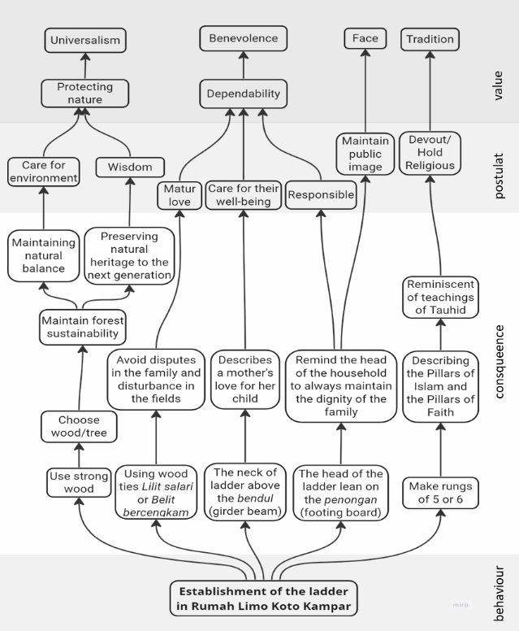

Figure 6. HVM about the start of making a ladder at the Limo Koto Kampar stilt house

Customary norms regarding the consequences of making ladders are managing the forest by paying attention to its sustainability and protecting it for the inheritance of posterity [3]. It is a behavior based on the Islamic teachings of Rahmatan lil alamin [9]. The second is maintaining harmony within the family following the Qur'an At-Tahrim verse 66, Ar Ruum verse 21, and Ukhuwah Islamiyah in general. The third is a picture of a mother's love for her children. A mother's love and affection for her child is a provision from Allah, as mentioned in several verses of the Qur'an, including in Surah Lukman verse 14, namely, "And We command humans (to do good) to their parents. His mother had conceived him in a state of increasing weakness, and weaned him at the age of two". The mother will carry out her role as a mother to the child, from conceiving, giving birth, breastfeeding, nurturing, raising, and educating the child to become an independent adult [29].
Another customary norm in the consequences of the HVM is a warning to the head of the family. The head of the family must maintain the dignity and honor of this family. It means setting a good example and upholding honesty, respect, and responsibility. By doing so, the family can be proud of their reputation and respect in their community. It also helps to raise a sense of unity and belonging within the family, as everyone works together to uphold these significant values. Ultimately, the head of the family plays a crucial role in shaping the culture and identity of the family and should take this responsibility seriously. The Qur'an recognizes the term, Muru'ah, which aims to maintain self-esteem and respect. It follows the Qur'an Surah Al A'raf verse 33. Muru'ah is to keep behavior so that it remains in the most significant state, do all kinds of morals and stay away from bad morals, apply all things that will decorate and beautify personality, and leave everything that will soil and tarnish oneself related to honor [34]. Bukhari's Hadith, which says, "Whoever tries to maintain his honor, Allah will protect his honor, and whoever feels sufficient, Allah will provide sufficiently," strengthens the teachings of muru'ah.
The orientation of values at the beginning of making a ladder is different from when it developed into a stair in the development of a house. Even though the forms are dissimilar, the consequences have the same basis, namely Islamic teachings from the Qur'an and Hadith. At the beginning of making the ladder, symbols gave meaning to Islamic teachings. When converting into a stair, residents apply it directly and technically to be helpful daily. Figure 7 explains the similarities and differences.
The Helpful, Family Security, and respectful parent postulates on the ladder to stair transformation are rooted in Islamic teachings that the people of Limo Koto Kampar have often applied in their daily lives. Because historically Islam has been at the core of the dynamics of local community culture, these teachings innately became the foundation of the behavior of individuals [35]. As a result, individuals continue to uphold Islamic teachings as their guiding principles even when their society changes. The original customary values still serve as the basis for the value orientation that they currently preserve. Islamic teachings do not mean to influence the presence of a physical symbol in a house [36]–[38]. Muslim values are principles of daily life in connection to the Qur’an and the Prophet's Sunnah, and following them in one's home environment is one way to submit to Islamic teachings [39].
Unknowingly, the Limo Koto people continue to use Islamic teachings, which are the basis of their custom, in changing their stilt houses. Precisely unconscious is a cultural awareness [12], namely an awareness of subjective cultural identity as a fundamental guarantee in inheritance from generation to generation that provides practical support in strengthening identity. It proves that the next generations in Limo Koto Kampar still firmly adhere to the notice "Adat based on Syarak, Syarak based on the Book of Allah." Part of this awareness encourages the fulfillment of needs through a series of subtle adaptations in a local way and harmonious continuity [40].
When the thought of a mother's love for her children, it is hard not to imagine the lengths she would go to ensure their safety and well-being. Similarly, the people of Limo Koto Kampar are taking steps to show their affection by improving the safety of the ladders they use. In ancient times, ladders used to have a long neck that rested on a bend or floor beam. However, now, people are moving towards more modern and secure designs. The people of Limo Koto Kampar are changing the steps to be wider than applying wood, not slippery, and using sturdier materials to avoid accidents, such as the danger of slipping, falling, or falling. These changes are necessary to ensure the safety of individuals while using ladders. Wooden boards on ladders can be narrow and slippery when wet, so it is crucial to have a design that prioritizes safety and convenience. It is heartening to see people come together to prioritize the safety of their community.

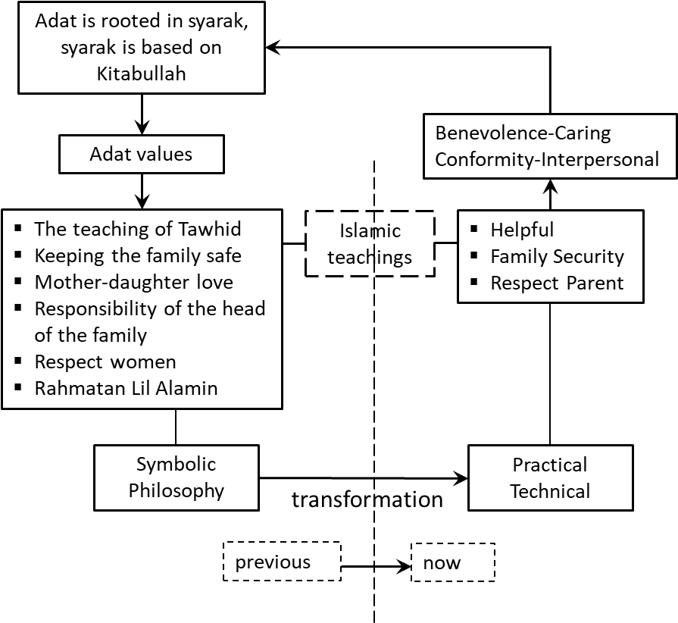

Figure 7. The orientation of the values of the Limo Koto people in the transformation of their adat houses uses the same core values as the basics of traditional values, namely Islamic teachings. The difference is in the way of expression. Disclosure of traditional values used to be philosophically symbolic, but it is now more technically practical

The local community still adheres to the traditional foundations, but the appearance of the attributes of the residential house has changed. It proves that local uniqueness has faded and led to the same form. Thus, globalization has also entered Limo Koto Kampar. Globalization is becoming a critical tool for cultural homogeneity and ending cultural diversity [41]. Cultural imperialism has influenced the structure of the indigenous family and given strength to the globalization movement. This condition is the same as that of Muslim villages, which have experienced changes in physical and economic layout. However, communal harmony, residents' social relations, and Islamic traditions are core elements and values [42]. It shows a sustainable, non-material concept instinctive in vernacular architecture [43].
There are transformations of the form [44] in rumah Limo Koto Kampar. Despite changes in the raw materials, the community still upholds Islamic values deeply rooted in adat. These values have a lasting influence on how people conduct their everyday lives. It is impressive to see how the spirit of the community remains intact, even as they adapt to modern times.
Indigenous education becomes the transmission of customary norms and values from generation to generation, which plays a necessary role in regulating social life [41]. The Limo Koto Kampar community organizes traditional education from family and kinship and applies it directly in daily life. As is the case with Turkish houses that change to meet the needs of different generations in various eras but maintain strong characteristics [45], Limo Koto Kampar houses are also able to preserve the foundations of the character of social life in the community due to traditional education in the family. It is interesting to note that the Limo Koto Kampar traditional stilt house embodies Islamic values in its design through a symbolic and philosophical form. Unlike modern developments, the next generation develops their dwelling technically and practically. It is incredible how traditions can shape architecture and unique ways of design.
- CONCLUSION
The value orientations that currently influence the transformation of traditional Limo Koto Kampar house buildings are Benevolence-Caring and Conformity-Interpersonal. Even though the development of the physical form of the house has slowly left the traditional behind, this value orientation is not a personal-focused value. These values are prosocial values that are part of the traditional values of the Limo Koto Kampar community, namely "Adat based on Syarak, Syarak based on Kitabullah." The structure of houses in the Limo Koto Kampar is not just a physical construction but a reflection of their traditional values. A principal aspect is symbolism and philosophy in the design to convey Islamic teachings. The hope is that they will practice it in their daily lives. However, in its development, the new form answered technical, practical needs in implementing the values of Islamic teachings.
The Benevolence-Caring and Conformity-Interpersonal value orientations are value orientations that are part of Islamic teachings so that they do not conflict with or diminish traditional values. This value orientation provides further evidence that the community of Limo Koto Kampar still holds steadfast to Islamic principles as the foundation for their traditional values in constructing their stilt houses. Their approach has changed from being symbolic and philosophical to becoming more practical and technical.

REFERENCES
[1] Presiden Republik Indonesia, “Undang-Undang No 10 Tahun 1948 tentang Pembagian Sumatera dalam tiga Propinsi,” Yogyakarta, 1948.
[2] Presiden Republik Indonesia, “Undang-Undang Darurat Republik Indonesia No 19 tahun 1957 Tentang Pembentukan Daerah-daerah Tingkat I Sumatera Barat, Jambi, dan Riau,” 1957.
[3] Wahyuningsih and Rivai Abu, Arsitektur Tradisional Daerah Riau. Pekanbaru: Departemen Pendidikan dan Kebudayaan Proyek Inventarisasi dan Dokumentasi Kebudayaan Daerah, 1984.
[4] “Buku Sejarah Kampar (AutoRecovered)," 2018, Accessed: August 15th, 2023. [Online]. Available: https://fliphtml5.com/flqg/tomp#.X3_13xhVkTk.gmail
[5] W. Ghalib, “Adat Istiadat dalam Pergaulan Orang Melayu,” in Masyarakat Melayu dan Budaya Melayu dalam Perubahan, 1st ed., H. S. A. Putra, Ed., Yogyakarta: Balai Kajian dan Pengembangan Budaya Melayu, 2007, pp. 501–520.
[6] Hamidi UU, Masyarakat Adat Kuantan Singingi. Pekanbaru: UIR Press, 2000.
[7] Z. Darussamin, “Kewarisan Adat Limo Koto Kampar,” Al-Fikra: Jurnal Ilmiah Keislaman, vol. 15, no. 2, 2016.
[8] T. Effendy, “Bangunan Tradisional Melayu dan Nilai Budaya Melayu,” in Masyarakat Melayu dan Budaya Melayu dalam Perubahan, 1st ed., H. S. A. Putra, Ed., Yogyakarta: Balai Kajian dan Pengembangan Budaya Melayu, 2007, pp. 597–626.
[9] N. Abuddin, “Islam Rahmatan Lil Alamin Sebagai Model Pendidikan Islam Memasuki Asean Community,” 2016.
[10] W. W. Putra, “Representasi Makna Simbol Ragam Hias pada Rumah Lontiok Kabupaten Kampar Riau (Analisis Semiotika Roland Barthes Mengenai Makna Simbol Rumah Lontiok di Desa Ranah Air Tiris Kabupaten Kampar),” JOM FISIP, vol. 2, no. 1, pp. 1–15, 2015.
[11] T. Effendy and E. Kadir, Ragam Hias pada Bangunan Tradisional Melayu Riau. Pekanbaru: Sebati Riau Art Gallery dan PT Caltex Pasific Indonesia, 2003.
[12] X. Chunai, L. Qin, and Z. Yinzhu, “ICPM-2012. Crisis Management in the Time of Changing World Ethnic Cultural Identity Crisis and Its Adaptation-Taking Blang Ethnic Group in Yunnan Province as an Example,” 2012.
[13] Witrianto, “PECAHAN KK_ DAMPAK SOSIAL RELOKASI PROYEK PLTA KOTOPANJANG DI PERBATASAN SUMATERA BARAT RIAU,” Analisis Sejarah, vol. 4, no. 2, pp. 85–96, 2014.
[14] S. H. Schwartz, “Universals in The Content and Structure of Values: Theoretical Advances and Empirical Tests in 20 Countries,” 1992.
[15] A. Hansla, A. Gamble, A. Juliusson, and T. Gärling, “The relationships between awareness of consequences, environmental concern, and value orientations,” J Environ Psychol, vol. 28, no. 1, pp. 1–9, Mar. 2008, doi: 10.1016/j.jenvp.2007.08.004.
[16] S. H. Schwartz et al., “Refining the theory of basic individual values,” J Pers Soc Psychol, vol. 103, no. 4, pp. 663–688, Oct. 2012, doi: 10.1037/a0029393.
[17] E. Daniel, A. S. Bilgin, I. Brezina, C. E. Strohmeier, and M. Vainre, “Values and helping behavior: A study in four cultures,” International Journal of Psychology, vol. 50, no. 3, pp. 186–192, Jun. 2015, doi: 10.1002/ijop.12086.
[18] A. Mohammadpur and K. Mahmoodi, “Lifestyle and identity in contemporary Iranian Kurdistan (a grounded study of Marivan City),” Qual Quant, vol. 50, no. 5, pp. 1907–1928, Sep. 2016, doi: 10.1007/s11135-015-0243-8.
[19] R. Kesberg and J. Keller, “Donating to the ‘right’ cause: Compatibility of personal values and mission statements of philanthropic organizations fosters prosocial behavior,” Pers Individ Dif, vol. 168, Jan. 2021, doi: 10.1016/j.paid.2020.110313.
[20] A. Bardi and S. H. Schwartz, “Values and Behavior: Strength and Structure of Relations,” Personality and Social Psychology Bulletin, vol. 29, no. 10. pp. 1207–1220, October 01st, 2003. doi: 10.1177/0146167203254602.
[21] K. Leung, A. Au, X. Huang, J. Kurman, T. Niit, and K. K. Niit, “Social axioms and values: A cross-cultural examination,” Eur J Pers, vol. 21, no. 2, pp. 91–111, Mar. 2007, doi: 10.1002/per.615.
[22] Gutman Jonathan, “A Means-End Chain Model Based on Consumer Categorization Processes,” J Mark, vol. 46, no. 2, pp. 60–72, 1982.
[23] H. Coolen and J. Hoekstra, “Values as determinants of preferences for housing attributes,” 2001.
[24] S. Chuapram, R. King, and O. Panin, “Transformation of Local Living: Buddhist Thai Communities and Vernacular Houses around Songkhla Lake Basin Selection and peer-review under responsibility of the Centre for Environment- Behaviour Studies (cE-Bs), Faculty of Architecture, Planning &amp; Sur,” Procedia Soc Behav Sci, vol. 50, pp. 42–54, 2012, doi: 10.1016/j.sbspro.2012.08.014.
[25] B. B. Kertawibawa and I. B. Harun, “Migration and Changing Desa-Kota Interaction Selection and peer-review under responsibility of the Centre for Environment- Behaviour Studies (cE-Bs), Faculty of Architecture, Planning &amp; Surveying, Universiti Teknologi MARA, Malaysia,” Procedia Soc Behav Sci, vol. 50, pp. 55–68, 2012, doi: 10.1016/j.sbspro.2012.08.015.
[26] Arifuddin, “ScienceDirect Cultural and needs-based housing development case study: the Bugis community in Makassar City,” Procedia -Social and Behavioral Sciences CITIES, vol. 227, no. 2015, pp. 300–308, 2016, doi: 10.1016/j.sbspro.2016.06.075.
[27] H. Kamalipour and M. Zaroudi, “Sociocultural Context and Vernacular Housing Morphology: A Case Study,” Current Urban Studies, vol. 2, pp. 220–232, 2014, doi: 10.4236/cus.2014.23022.
[28] R. Sanderson and J. McQuilkin, “Many kinds of kindness: The relationship between values and prosocial behavior,” in Values and Behavior: Taking a Cross-Cultural Perspective, Springer International Publishing, 2017, pp. 75–96. doi: 10.1007/978-3-319-56352-7_4..

[29] Kementerian Agama, “Qur’an Kemenag,” Lajnah Pentashihan musaf Al-Qur’an.
[30] Kementerian Agama Kabupaten Purbalingga, “Mutiara Hadist: Saling Membantu Sesama Muslim." Accessed: August 21st, 2023. [Online]. Available: purbalingga.kemenag.go.id/mutiara-hadist-saling-membantu-sesama-muslim/
[31] Baznas Kota Bandung, “Mudahkan Urusan Saudaramu, Allah Mudahkan Urusanmu.”
[32] Muhammad Nirwan Idris and Kurnaemi Anita, “Analisis Implementasi Kaidah Fikih Lā Ḍarar Wa Lā Ḍirār dalam Kedokteran Modern pada Kasus Tindakan Operasi,” NUKHBATUL ’ULUM: Jurnal Bidang Kajian Islam, vol. 6, no. 1, pp. 50–76, Jun. 2020, doi: 10.36701/nukhbah.v6i1.100.
[33] A. Hofifah, “Astuti, 2021, Berbakti Kepada Orang Tua dalam Ungkapan Hadis,” Jurnal Riset Agama, vol. 1, no. 1, pp. 45–58, 2021.
[34] J. Arroisi and S. Badi’, “Konsep Harga Diri: Studi Komparasi Perspektif Psikologi Modern dan Islam,” Psikologika: Jurnal Pemikiran dan Penelitian Psikologi, vol. 27, no. 1, pp. 89–106, Jul. 2022, doi: 10.20885/psikologika.vol27.iss1.art7.
[35] E. Roza and M. Hum, Sejarah Islam Riau, 2017th ed. Yogyakarta, 2017. [Online]. Available: www.aswajapressindo.co.id
[36] H. Yusof, I. A. Wahab, N. Utaberta, and A. Sabil, “ISLAMIC INFLUENCE ON WOODCARVING MOTIFS IN JOHOR TRADITIONAL MALAY HOUSES,” Journal of Islamic Architecture, vol. 6, no. 4, pp. 313–320, 2021, doi: 10.18860/jia.v6i4.13028.
[37] H. Yusof, I. A. Wahab, A. Sabil, and N. A. Hanapi, “WOODCARVING PANELS IN JOHOR TRADITIONAL MALAY HOUSES INFLUENCED BY THE ISLAMIC PRINCIPLE,” Journal of Islamic Architecture, vol. 7, no. 2, pp. 323–331, Dec. 2022, doi: 10.18860/jia.v7i2.17659.
[38] S. Ahmad, M. Y. Abbas, Mohd. Z. Mohd. Taib, and M. Masri, “Wall Carving Decoration and Motifs Influences Spatial Social Interaction: Is it Intentional or Accidental?,” Procedia Soc Behav Sci, vol. 202, pp. 311–321, Aug. 2015, doi: 10.1016/j.sbspro.2015.08.235.
[39] S. Supriyanta and I. Malik, “Islamic Values in Spatial Function of Javanese Traditional Architecture,” Journal of Islamic Architecture, vol. 3, no. 4, p. 189, Jan. 2016, doi: 10.18860/jia.v3i4.3093.
[40] S. R. Ju, B. M. Kim, and S. I. Ariffin, “Continuation and transformation of traditional elements in colonial vernacular houses in Kampong Bharu, Malaysia,” Journal of Asian Architecture and Building Engineering, vol. 14, no. 2, pp. 339–346, 2015, doi: 10.3130/jaabe.14.339.
[41] K. I. Yankuzo, “Impact of Globalization on the Traditional African Cultures,” Journal of Educational and Social Research, Nov. 2013, doi: 10.5901/jesr.2013.v3n9p43.
[42] E. Nursanty and A. Wulandari, “UNVEILING THE AUTHENTICITY OF ISLAMIC VALUES: THE EVOLUTION AND TRANSFORMATION OF TRADITIONAL VILLAGES,” Journal of Islamic Architecture, vol. 7, no. 4, pp. 595–612, Dec. 2023, doi: 10.18860/jia.v7i4.21258.
[43] S. Alves, “The Sustainable Heritage of Vernacular Architecture: The Historic Center of Oporto,” Procedia Environ Sci, vol. 38, pp. 187–195, 2017, doi: 10.1016/j.proenv.2017.03.105.
[44] R. Krier, Rob Krier - Architectural Composition-Academy Editions (1991). 1991.
[45] T. Kelly, “EVOLUTION of the TRADITIONAL TURKISH HOUSE,” in WIT Transactions on the Built Environment, WITPress, Aug. 2021, pp. PI63–PI75. doi: 10.2495/STR210061

