 |  | JOURNAL OF ISLAMIC ARCHITECTURE  P-ISSN: 2086-2636 E-ISSN: 2356-4644  Journal Home Page: http://ejournal.uin-malang.ac.id/index.php/JIA
A TOPOLOGICAL AND TECHNOLOGICAL TRANSFORMATION MODEL OF MIMAR SINAN’S MOSQUES TO THE PRESENT
Muhammed Emin Akyürek^{a*}
ªDepartment of Architecture, Faculty of Architecture, Samarkand State Architecture and Construction University, Samarkand, Uzbekistan
*Corresponding Author: m.akyurek@samdaqu.edu.uz
ARTICLE INFO |  |  | ABSTRACT
Volume: 8  Issue: 1  Page: 91-105  Received: October 03th, 2023  Accepted: January 12th, 2024  Available Online: June 30th, 2024  DOI:  http://dx.doi.org/10.18860/jia.v8i1.23694 |  |  | 16th-century Ottoman architect Mimar Sinan's mosques are one of the most efficient, refined, and elegant examples of mosque architecture. Sinan's mosques, replicated until today, have also been built widely with modern technology and materials. However, the incompatibility of the structural system and materials seen in many new mosques is identified as a problem in this study. The study aims to develop a novel design with a contemporary structural system and material based on the principles and schemes of Sinan's highly praised and adopted mosques. First, an ideal form was derived by detecting a harmony between Sinan's mosques and the chain model; then, it was transformed and optimized according to the requirements of the timber (CLT) folded plate envisaged to be applied on a small scale. Proportions of the Sinan's mosques, parametric design and Turkish triangle were benefited to define the size and form of the emerging model. Afterward discussed and evaluated in terms of plan, section, and facade. The discussion is focused on structural form yet also mentions design flexibility according to local touch and sites. Finally, a novel, contemporary, and adaptable design model that evokes the image of Sinan's mosques has been proposed.  Keywords:  Islamic Architecture; Structural Form; Chain Curve; Timber Folded Plate; Parametric Design

- INTRODUCTION
Early mosques, such as the Prophet’s Mosque (Masjid an-Nabawi), were multi-pillar, dome-less courtyards and expandable due to population growth. Afterward, new structural forms and space typologies were adopted from different geographies and adapted to the first scheme. In Central Asia, by the influence of earlier religions, iwan and a central dome were favored in mosques [1], [2]. 9-10th century Kara-Khanid period Deggaron Mosque is supposed to pioneer the central domed mosques [3]. Seljuks ruled Iran and Anatolia, and their successors, Ottomans, adopted and progressively developed the central dome. After the conquest of Istanbul, Hagia Sophia, as a landmark of the central dome, became an inspiration and encouragement for Ottoman architects. Curvilinear piers and longitudinal space in Hagia Sophia were not compatible with the spatial requirements of the mosque. In Ottoman mosques, the massive dome and half domes of Hagia Sophia were borrowed and customized to their own style and rectangular base structure on transverse spans. Following these developments, worshippers congregated under central domed monumental mosques, and multiple functions seen in the Masjid an-Nabawi have been organized under the complex.

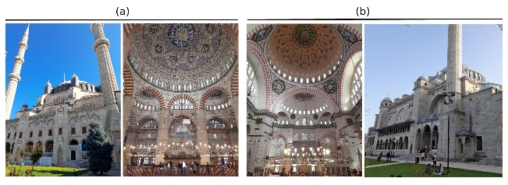
Figure 1. Edirne Selimiye (a) and Istanbul Süleymaniye (b) Mosques as an example of central domed mosques

16th-century Ottoman architect Mimar Sinan's mosques (fig.1) are considered to be refined forms and peaks of central domed mosque architecture [4], [5]. These mosques offer a spacious, undivided prayer hall with allegorical and monumental attributions. Double-skinned and segmented domes of Süleymaniye Mosque enhance the proportions, while four minarets emphasize the parallel harmony with the hillside where it stands. In Selimiye mosque, hollowed and domed towers on eight piers and four equivalent minarets highlight the nearly 32m spanned central dome, making it visible throughout the city. According to some 16th, 17th, and 18th-century texts [6], [7], [8] and contemporary literature [9], [10], [11], this monumentality with a central dome and baldachin was inspired by some Qur'anic verses (see Qur'an 23/17; 31/10; 50/6; 67/3-5; 69/17), emphasizes unity (tawhid), a fundamental principle of Islam.
In historical mosques, some architectural forms were permanently diversified and developed [12]. Muqarnas, Turkish triangle, timber roof (kırlangıç), and ribbed dome (karbandi) are among the elements that compose this architectural language and are seen in nearly the whole Islamic geography (fig.2). These forms consist of independent units that merge in an intricate (girih) and systematic way to form the components of the mosque. According to a widespread view in the contemporary literature [11], [13], [14], the transition from the unit to the whole, which is also seen in Sinan's mosques (Fig.1), is interpreted as another reflection of unity in diversity, i.e., tawhid.

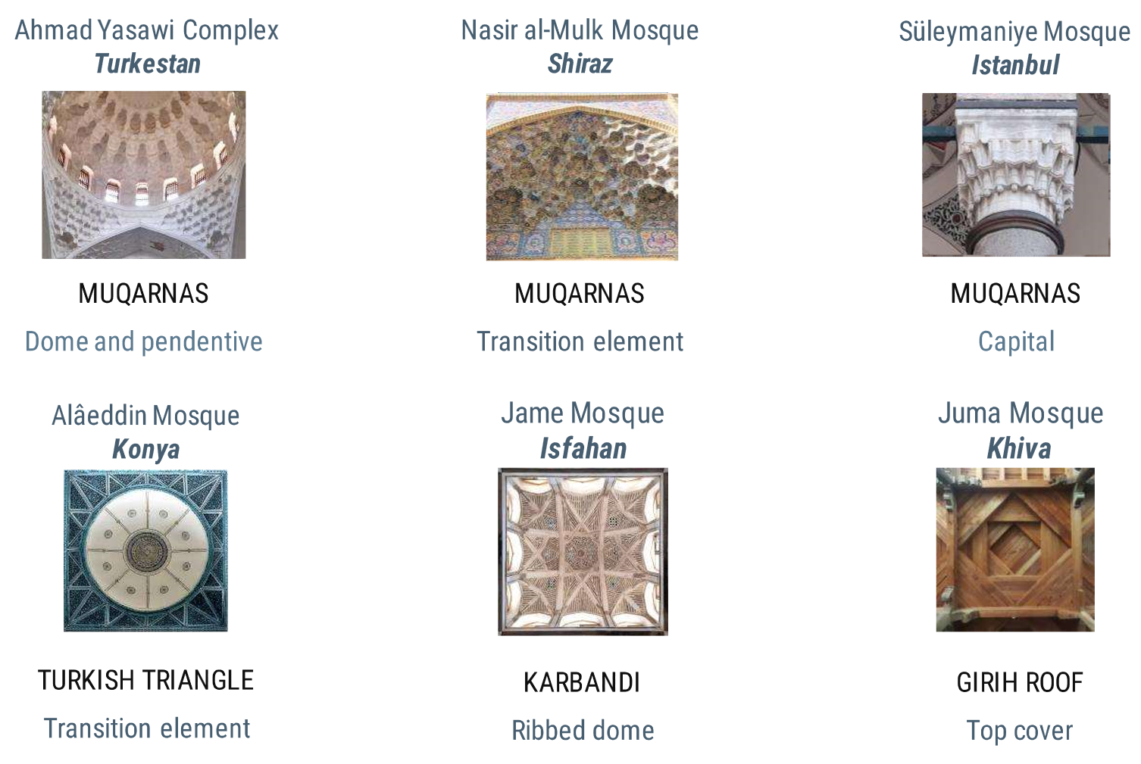
Figure 2. Structural forms commonly used in historical mosque architecture

The disintegration of Muslim countries brings to a standstill the development of architectural forms [15]. In the 20th century, many Muslim countries, under the political pressure and domination of Western countries, declared independence, modernized, and formed a new identity [16]. As a result of the metamorphosis of the dominant culture and technology [17], many mosques have been built that disconnected from the historical background and basic schemes. In recent years, Islamic identity has been reemerged, mosques have been revitalized, and mosque architecture has gained prestige and popularity [18]. Contemporary mosque architecture has been characterized by imitating historical monuments with modern technology, stylizing potent figures such as Sinan's mosques, and a modern approach that commonly ignores aesthetic experience (Fig.3).

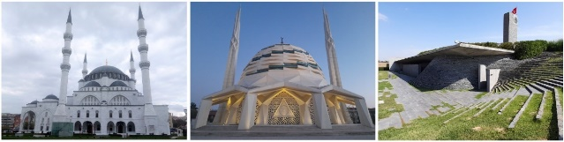
Figure 3. Ankara Melike Hatun, Istanbul Marmara Ilahiyat, and Sancaklar mosques, respectively

The problem of this study is that the traditionalist approach to mosque architecture generally does not reveal an efficient structure with contemporary materials and technology, while the modernist approach is far from common schemes and architectural proportions with symbolic value. A previous study concluded that the ongoing wide popularity of Sinan's mosques is related to the fact that they are more efficient, compact, and elegant than their predecessors and contemporaries [19]. This study discovered an exact correspondence between Robert Hooke's hanging chain theory and Sinan's mosques. Accordingly, a novel structural form is designed in conformity with current material and technology based on the chain model and some qualities and principles of Sinan's mosques. In terms of scale, instead of large mosques built for political reasons and downgraded to a monument [20], neighborhood mosques that aim to respond to the worship needs are taken into focus.
Regarding load-bearing systems and materials, one of the newest trends [21], the timber folded plate (origami), was preferred. The Turkish triangle, frequently seen in Anatolia mosque architecture [22], was favored in identifying the stylistic features. Throughout the model, the scope is in structural form. However, the designers have been offered the freedom to create variations in planning, form-finding, detailing, and cladding according to site and local touches.
First, Sinan's mosques were schematized through topology, which expresses the relative positions of geometric forms and the chain model. They were idealized as a convex form consisting of a square base and an apex. This ideal form was divided into triangles by the structural behavior of timber panels (CLT). The concept of folded plates optimized the triangular boards. The style of the mosque has been identified by constructing an analytical pattern between the folded plate and the Turkish triangle. The dimensional parameters of the model have been defined by proportional relations depending on the selection of folded plate and CLT (cross-laminated timber). Although minarets are not necessary for a call to prayer, they consolidate the religious and sociopolitical identity of the mosque [18] and make it iconic and recognizable. It also serves as a call to prayer by a man's voice from a high position, a characteristic of Islam [23]. Hence, minarets suitable for the mentioned load-bearing system have also been proposed for medium-sized mosques. The model has been discussed in terms of plan, section, and facade. Thus, Sinan's mosques have realized a topological and technological transformation. The resulting model has originality in that it rationalizes Sinan's mosques according to contemporary spatial and structural needs through the chain model. Form modifications depending on the site and local touches, structural optimization, detailing the building elements (nodes, insulation, cladding), etc., are future works of the resulting model. Furthermore, the design method would pave the way for innovative design models with various materials and technologies.

- METHODS
Throughout history, it has been sought to find ways to create wider spans with less material, and structures have gradually evolved into more dynamic and plastic forms. Until the Industrial Revolution, monumental architecture usually had three-dimensional convex curvilinear volumes like a mountain, hill, or fairy chimney. These structures were built of statically compressive masonry. If a rope, cable, or membrane is anchored at two points on the same parallel, a concave curve will be obtained by gravity and become statically tensioned. Suspended structures are designed and built by this concept. If the concave curve is inverted, it will completely be compressed like an egg or an arch. This curve will rise as the supports get closer to each other and become flatter as they move away. This issue, first converted into a mathematical model by Robert Hooke [24], has been a design motivation for contemporary architects and engineers. Chain theory is one of the design motivations of this study as well.
Since the 20th century, structures with various forms, materials, and structural systems have been designed using a physical and mathematical model based on Hooke’s chain theory. Early examples of these structures are Antoni Gaudi's Colònia Güell and La Sagrada Familia churches. These buildings were designed by hanging a string model, then photographed upside down, and built of stone masonry according to this image [25]. A novel version of this model uses a similar method [26]. Heinz Isler has designed and built many free-formed reinforced concrete shells by adopting this approach. These shells are natural (amorphous) forms resulting from the definition of certain support points of a membrane [27]. Likewise, Frei Otto obtained timber grid shells by supporting a grid at various points and then inverting [28]. The chain model was evaluated as an optimization tool and design method for sizing and forming these structures with different forms, materials, and structural systems.

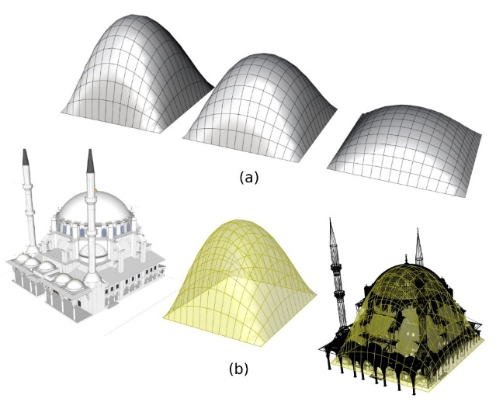
Figure 4. Topological overlapping of chain model and a Sinan Mosque

The physical models exemplified in Fig. 4 can be described mathematically in the two-dimensional plane: The graph of a parabola (Eq.1),
y = x² (1)
The graph of a chain is (Eq.2),
y = $\frac{e^{ax}+e^{-ax}}{2a}$ (2)
can be constructed according to these relations. Here,
x, y = axis
e = 2,71828182845904523536..10
a = Coefficient that gives the peak point of the curve on the y-axis.
The coefficient "a" in the equation is related to the position and does not affect the shape of the curve. Accordingly, simplifying the relation (Eq.3) is obtained,
y = $\frac{e^{x}+e^{-x}}{2}$ (3)
This equation assists the manual dimensioning of the cross-section. Geogebra [29] was utilized to obtain the required curve according to the relation.
If constructed according to the chain curve model, an ideal mosque consists of a rectangular base and an apex. This form requires a three-dimensional model. At this point, Grasshopper's Kangaroo 2 extension assists form finding according to the chain curve, i.e., the force of gravity. Instead of inverting the form, the tool, a physics engine, reverses the force of gravity. Thus, the desired form is obtained (Fig. 4a). A Sinan Mosque with a rectangular-based paraboloid form that fits this constructional and stylistic context description is ignored (Fig. 4b).
A paraboloid or dome geometrically consists of open curves in the vertical section, i.e., parabolas, and closed curves in the horizontal section, i.e., ellipses and circles. A structure formed parabolic is under pressure in the direction of the vertical curves and tension against outward thrust on the horizontal rings. In case of additional load on the structure, since the dome-like form cannot be flattened, membrane stresses will appear on its surface, and when these stresses exceed the resistance limit, the surface will crumble. This problem can be solved by thickening the wall or using tie-rods, clamps, or chains horizontally in masonry buildings. It is known that masonry buildings in Gothic cathedrals and Ottoman mosques were reinforced by iron rods encircling them at different levels to reduce tensile stresses and the cost of using materials [30], [31]. Reinforced concrete, on the other hand, responds to compressive and tensile stresses simultaneously thanks to its steel reinforcements. For this reason, it can be observed that the thickness of reinforced concrete shells is considerably thinner than those of masonry buildings with a similar form.
Fig. 5 identifies an overlap between the chain curve and the sections of Sinan's mosques. In the sections of Sinan's large and medium-sized mosques built by structural concerns, it is observed that the endpoints of the chain curve, as a compressive force, mostly stand within the walls or buttresses, i.e., building borders. Here, the role of the dome tambour, buttress, and pinnacle in absorbing the outward thrust is evident. The chain theory can explain the references to these mosques's height and length dimensions. Here, there is a clear difference between the building boundaries of the Süleymaniye Mosque (a) and the chain curve. This difference is due to the spatial composition that balances the half domes used in the longitudinal section with a series of small domes in the transverse section. In the other examples (b, c, d, e, f), the chain curve is in harmony with the ratio of building height (h) to length (L). This harmony provides another point of bonding the design model to the design philosophy of Sinan's mosques.
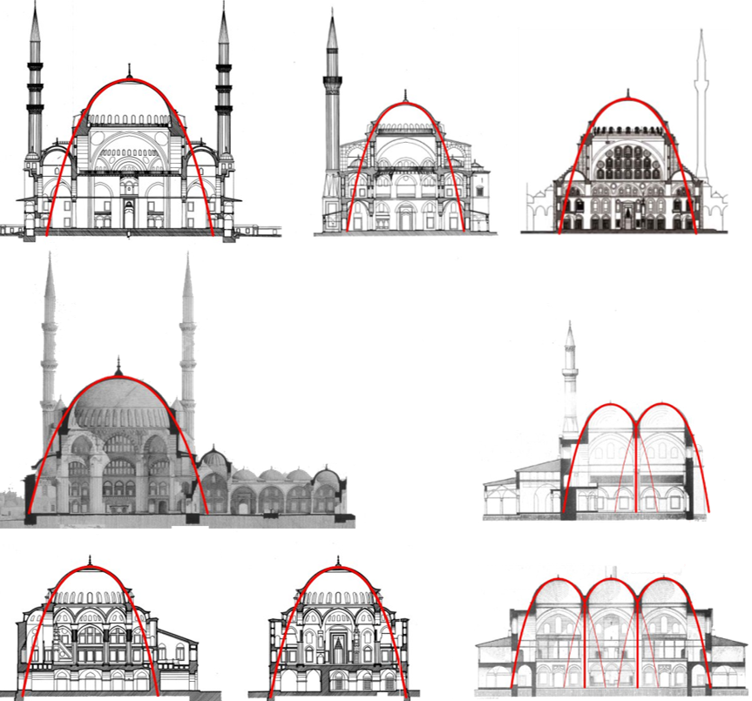
Figure 5. Overlap of the chain model with the sections of some Sinan mosques [Drawings of Ali Saim Ülgen (a,b,e), AD Architectural Group (c), Sedad Çetintaş (d) and Cornelius Gurlitt (f) have been utilized]

Building a contemporary mosque brings reinforced concrete shells into mind due to their ease of forming and ability to absorb compressive and tensile stresses. Indeed, many churches and mosques have been built by this technique worldwide. In Türkiye, the ones emulating Sinan's mosques (such as Şakirin Mosque) have also been constructed. These thin shells are quite efficient for large scale. Folded plates are a better alternative on a small scale due to their simplicity. Reinforced concrete folded plates are less demanding in design, detailing, and construction and are suitable for modular design and prefabrication. Folded plates greatly reduce the membrane stresses on the surface due to increased construction thickness and effects such as bending in the slab, torsion, and buckling in the wall (Fig. 6).

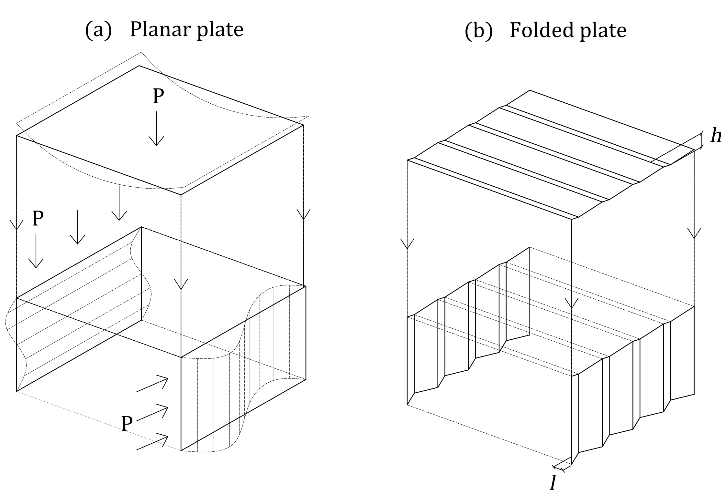
Figure 6. Bending, Torsion, and buckling forces on a planar plate (a) and folded plate (b)

Reinforced concrete folded plates have been preferred for large-span structures since the mid-20th century. On the other hand, these structures need costly formwork and labor, as in reinforced concrete shells [32]. However, recent techniques and materials eliminate this requirement. CLT panel, one of the newest members of the timber group, with high inplane stiffness and load-bearing qualities [33], is a motivation for reconsidering folded plates.

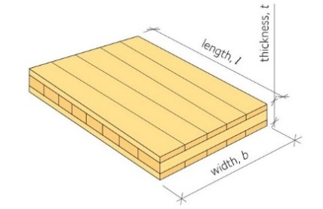
Figure 7. Drawing of a CLT panel [34]

CLT panels are planar elements formed by gluing woods stacked side by side in perpendicular layers (Fig. 7). For the ideal form (chain model), consisting of a rectangular base and apex, to be suitable for this planar configuration, it is necessary to divide the surface into triangles. In this way, as famous Turkish architect Mimar Kemaleddin says, "applying the building rule most appropriate to the nature of matter" [35], the new form is obtained. Through triangulation, the curvilinear surface is divided into planes, and depending on the force exerted, a flattened (a), inflated (c), or, like Sinan's mosques, a balanced volume (b) is achieved (Fig. 8). Whether the number of triangular planes forming the surface increases or decreases, the same topological result (paraboloid) is realized. In other words, the number of planar parts changes provided that the relative positions of the base corners and the apex, which constitute the boundaries of the form, are kept constant. The simplest unit (g) derived is the form most easily constructed from planar elements by the load transfer of the chain curve. As the number of planar parts decreases, the folding becomes more apparent, and the construction thickens; thus, the system becomes more rigid.

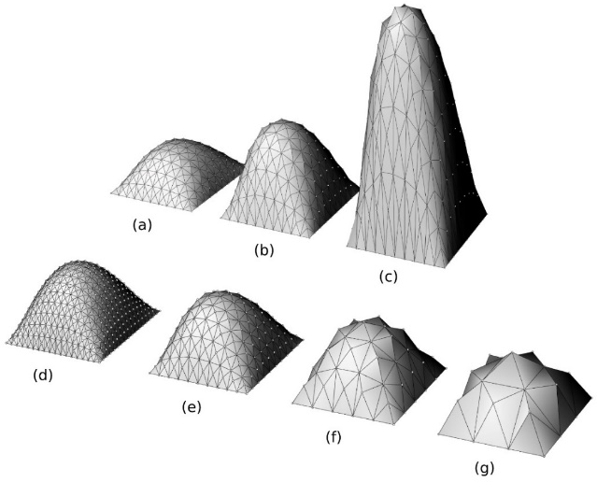
Figure 8. Different sizes and segments of chain models are divided into triangles

In Fig. 9, the sections of Sinan's representative mosques (stereotype) named Kılıç Ali Paşa and Azapkapı are overlaid with the chain curve. Here, the chain curve is organized to remain inside the dome section as much as possible. In both mosques, it is seen that the ends of the chain curve remain within the base space covered by the half domes. Sinan's mosques can be schematized by dividing them into a rectangular substructure, a transition zone of half domes and tromps, and a top cover consisting of a dome. If the curvilinear surfaces of the half dome and the main dome are transformed as planar according to the configuration of the CLT, a type of sectional scheme consisting of points a, b, c, d, and e emerges. Therefore, the proposed type sections utilize the proportions of Sinan's mosques while its structural efficiency converges the ideal with its chain curve.

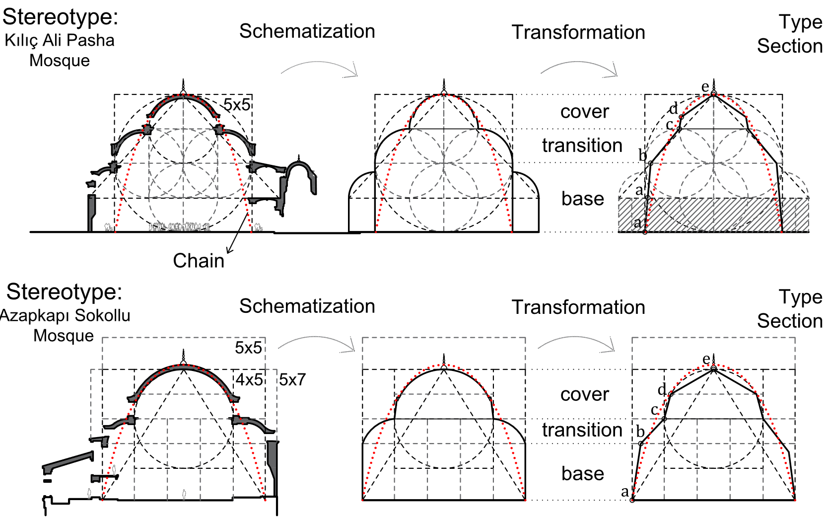
Figure 9. Sectional transformation of curved elements in some Sinan mosques (stereotype) into linear
In the proposed type-section, the chain does not have to be followed. In this case, the wall can be positioned vertically instead of angled. However, in this case, stresses at the joints will increase, and additional rigid connections are needed, apart from the tie-rods connecting the wall and the transition units or the metal nodes [33]. CLT resists compressive and tensile stresses thanks to its wood fibers and perpendicularly positioned layers [36]. Walls and transition elements, the load-bearing elements of the building, are significantly compressed by the dead load. Therefore, respecting the chain curve minimizes the stresses at the joints. In this case, the angled wall is advantageous. The angled wall ensures an efficient form and increases the superstructure's visibility, revealing its plastic form quality. On the other hand, it complicates the opening of the wall and the fixing of the joinery.
Although presenting an ideal form, the triangulation based on the chain model above and the references to the sections of Sinan's mosques does not pose an architectural style. At this point, the Turkish triangle, one of the architectural forms used in mosque architecture, has been considered due to its high analogy with the triangulation required. The transition and the roof have been analytically designed according to the Turkish triangle. The walls define the space are a clear folded plate in harmony with the transition. Folded plates also formed minarets as in the whole structure. Hence, the folded plate characteristic has been defined in the whole structure. The load-bearing system comprises the triangular folded pyramid, transition, and trapezoidal folded plate walls. Fig. 10 summarizes the geometric construction of the model from a principal triangle to the roof, transition, and walls. A preliminary review and evaluation of the model in function, construction, and style will be carried out in the next chapter.

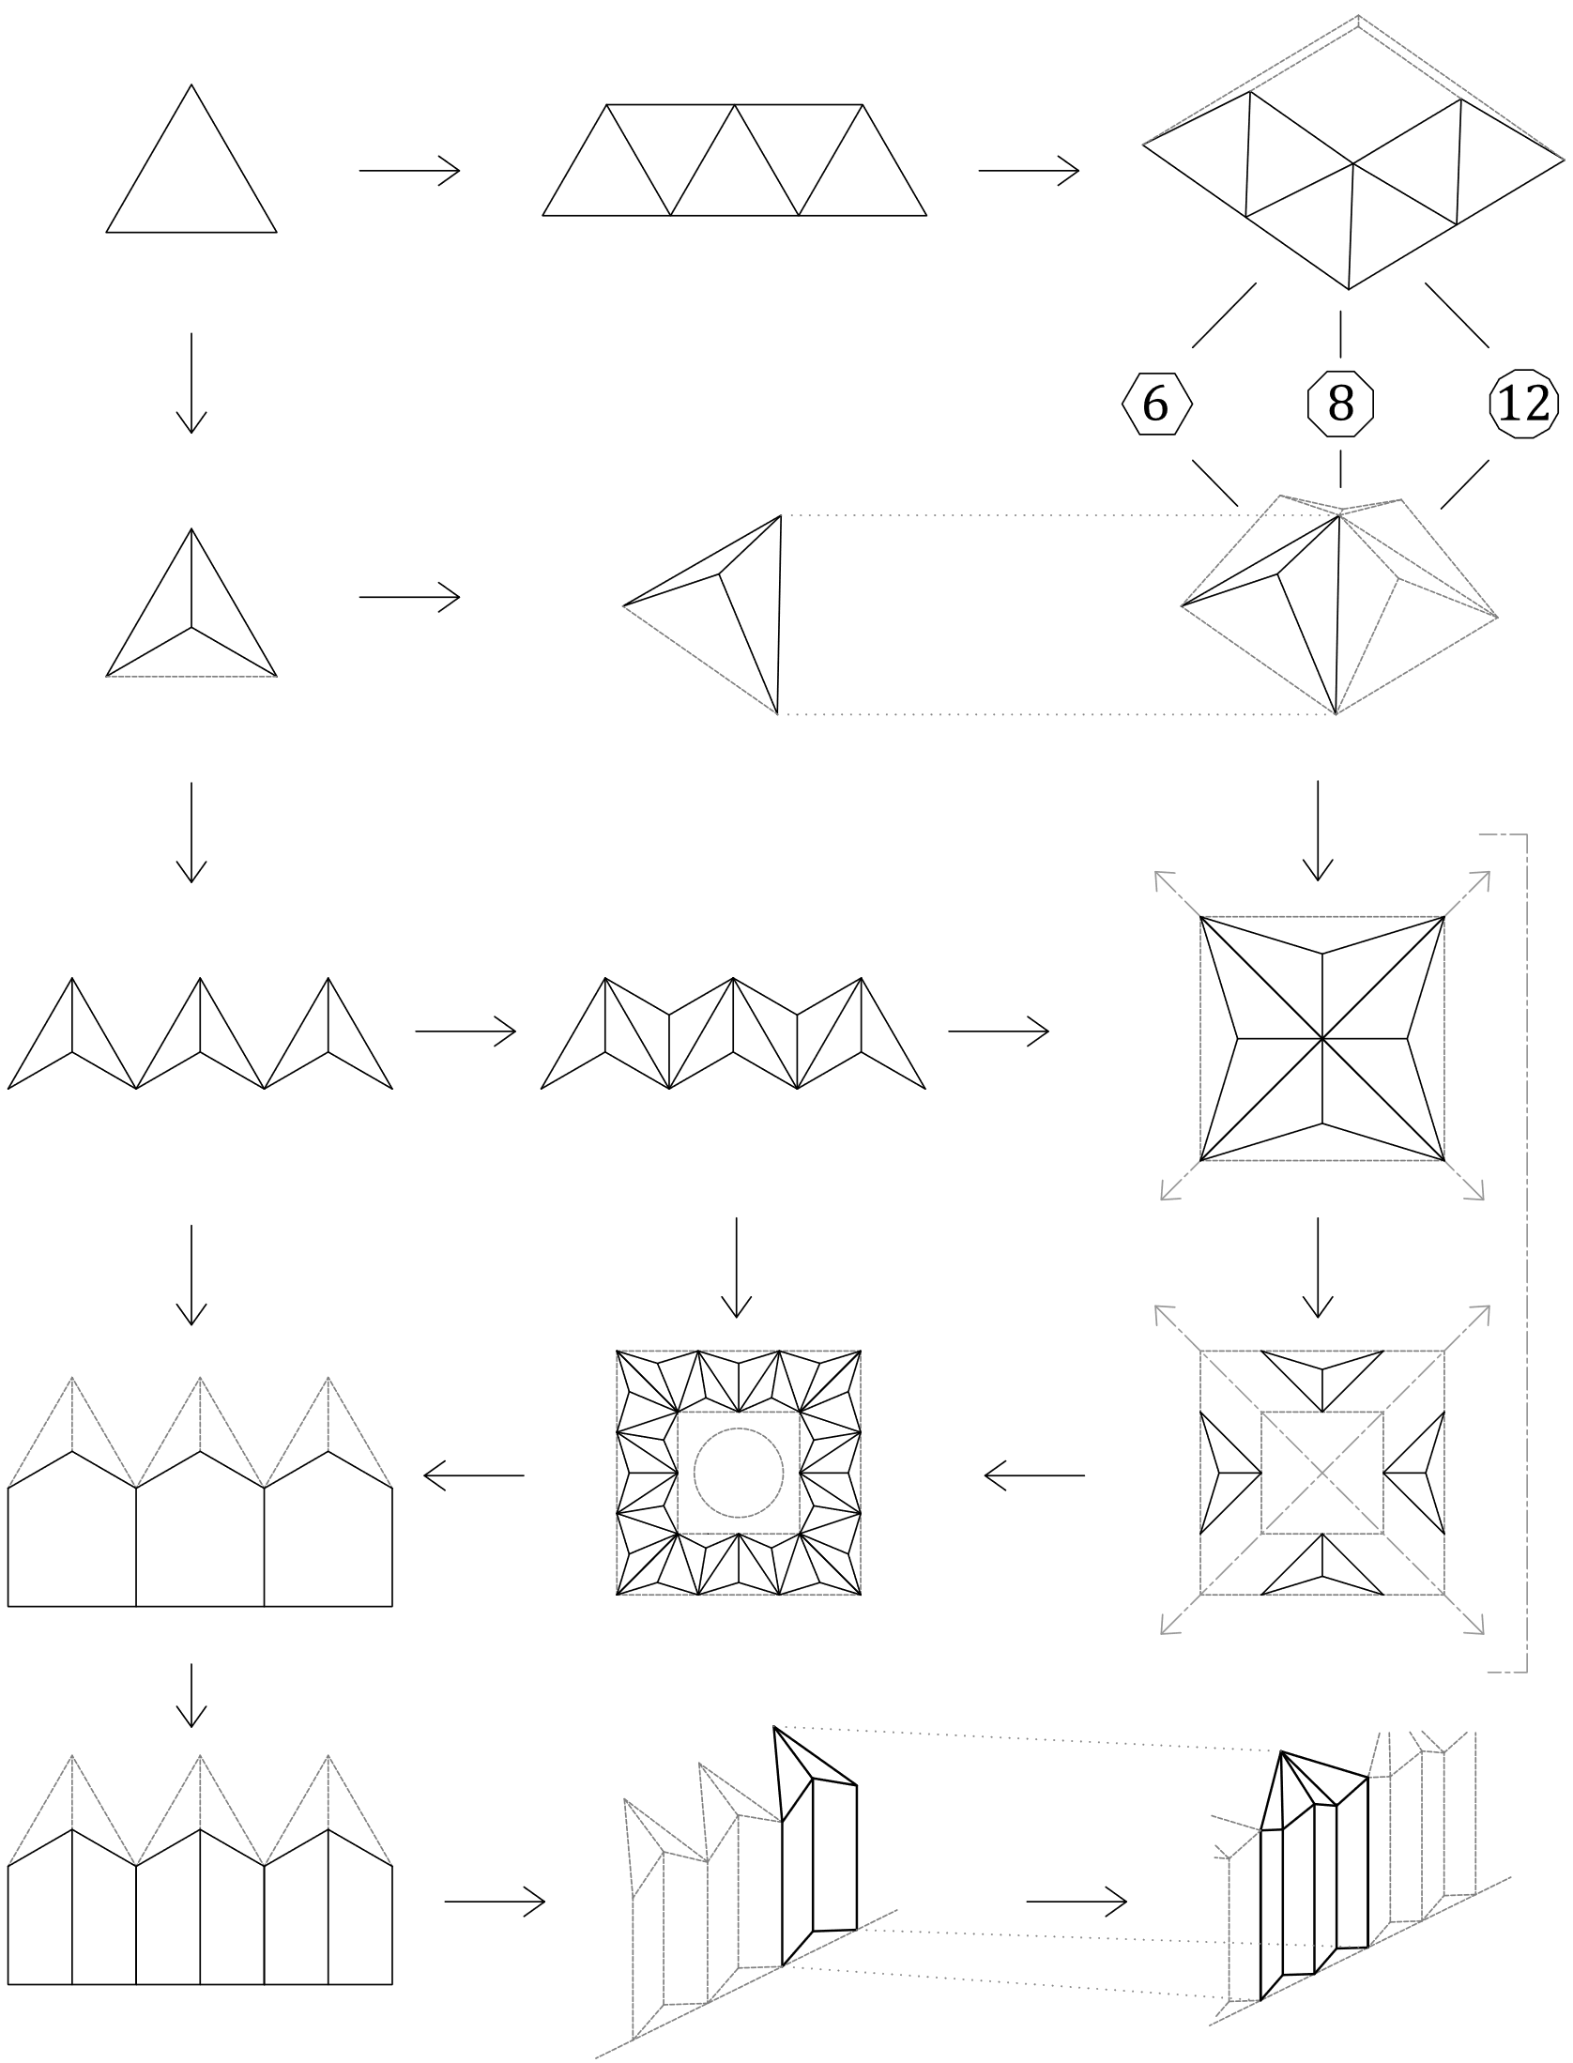
Figure 10. An analytical process of organic bonding between the folded plate and Turkish triangle

The proposed model offers form and size modifications according to certain variables. The parameters have been defined in the interface of a computer-aided design tool (Grasshopper). These parameters, which are seen in the structural elements of the mosque, have been exemplified in Fig. 11. The number of wall units (D1), transition, tambour, top cover (Ö), and minaret (M) vary in size and form according to the relevant parameters.
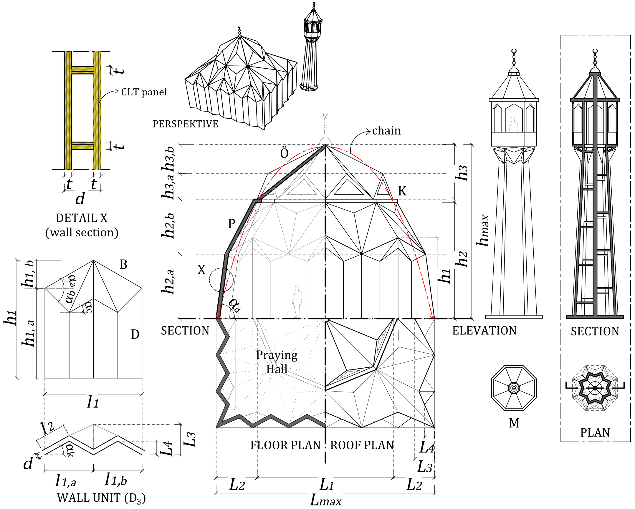
Figure 11. Drawings showing the design parameters of the mosque model

In the preliminary dimensioning of the architectural design, proportional formulas based on the chain curve and material mechanics have been applied. According to the data obtained from section analysis in Fig.17, which will be seen in “sectional order,” the following equation has been obtained between the construction thickness (L3) and the building length (L1) (Eq.4).

L₃ ≥ $\frac{L_{1}}{15}$ (4)

This equation (ratio) corresponds to the ratio of the panel construction (folding) thickness to the building span that has been specified for reinforced concrete prestressed folded plates [37]. Material thickness is included in dimensioning the construction thickness. In the preliminary dimensioning of the mosque, Eq.4 was used.
This study is limited to structural form and omits material mechanics. At this point, as an assumption, the relationship between thickness (t) and span (L) of CLT panels constructed with grade 1 timber, as exemplified in a CLT manual [34], was analyzed (see Fig. 19), and an approximate ratio of 1/30 between the two parameters was detected. This ratio matches the relation between the maximum plate length (l_{max}) and plate thickness (d) specified for reinforced concrete folded plates [37] (Eq. 5). Here, for the preliminary design, based on this correspondence between the two materials, which both resist compressive and tensile stresses, the proportional calculation given in Eq. 5 has been applied to specify the plate thickness (d) of the folded plate, which is like an angled slab.

d ≥ $\frac{l_{maks}}{30}$ (5)

Hence, constructive properties such as dimensional parameters, correlations, and material standards of the mosque model have been determined.

- RESULT AND DISCUSSION
In this chapter, the coherence of the mosque, which is constructed from the bonding of dots, has been discussed based on the motion of its relative positions, and certain concrete data has been reached. These are topics of discussion as a subject of motion:
1. in the horizontal plane: Spatial order
2. in the vertical plane: Sectional order
3. on the surface: Facade order.

  - SPATIAL ORDER
Adapting the model to spatial needs, standards, and observations has benefited. Several historical and contemporary mosques were visited in different places, and human activities were observed and sketched on the model (Fig.12). Presently, mihrab, minbar, and kursi are still considered spatial components. These elements need to be specifically designed for zigzag walls. On the contrary, unlike in Sinan's mosques, it is observed that women's activity and utilization of the side halls for resting, reading, and charging devices stand out. Hence, side halls and niches formed by the folded plates have been utilized to create spatial units apart from the prayer (salah).

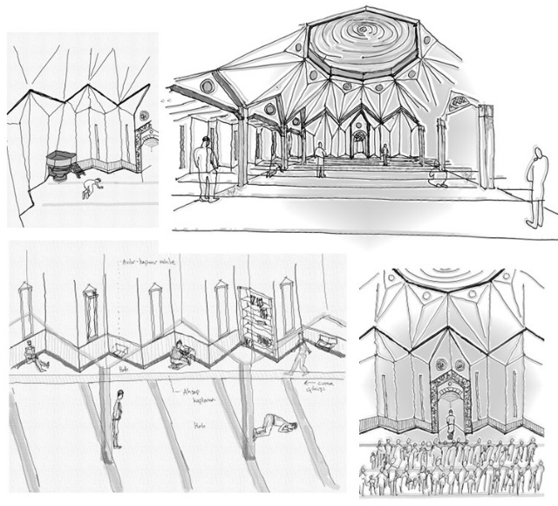
Figure 12. Spatial components of the mosque through sketches

The simplest mosque is the layout of a module space with a square base. This mosque is ideal for construction in a large park, recreational space, or terminal. If customized for a neighborhood mosque, one of the most significant problems is the spatial utilization of the zigzag walls. At this point, an organic qibla niche is created for the mihrab. The minbar and kursi can be adjusted similarly. The zigzag walls that dominate the space provide natural and artificial air conditioning and offer reading, resting, and private praying spaces. If the line separating this part from the harim (prayer hall) is utilized as a corridor, an undivided space is achieved (Fig. 12-13).

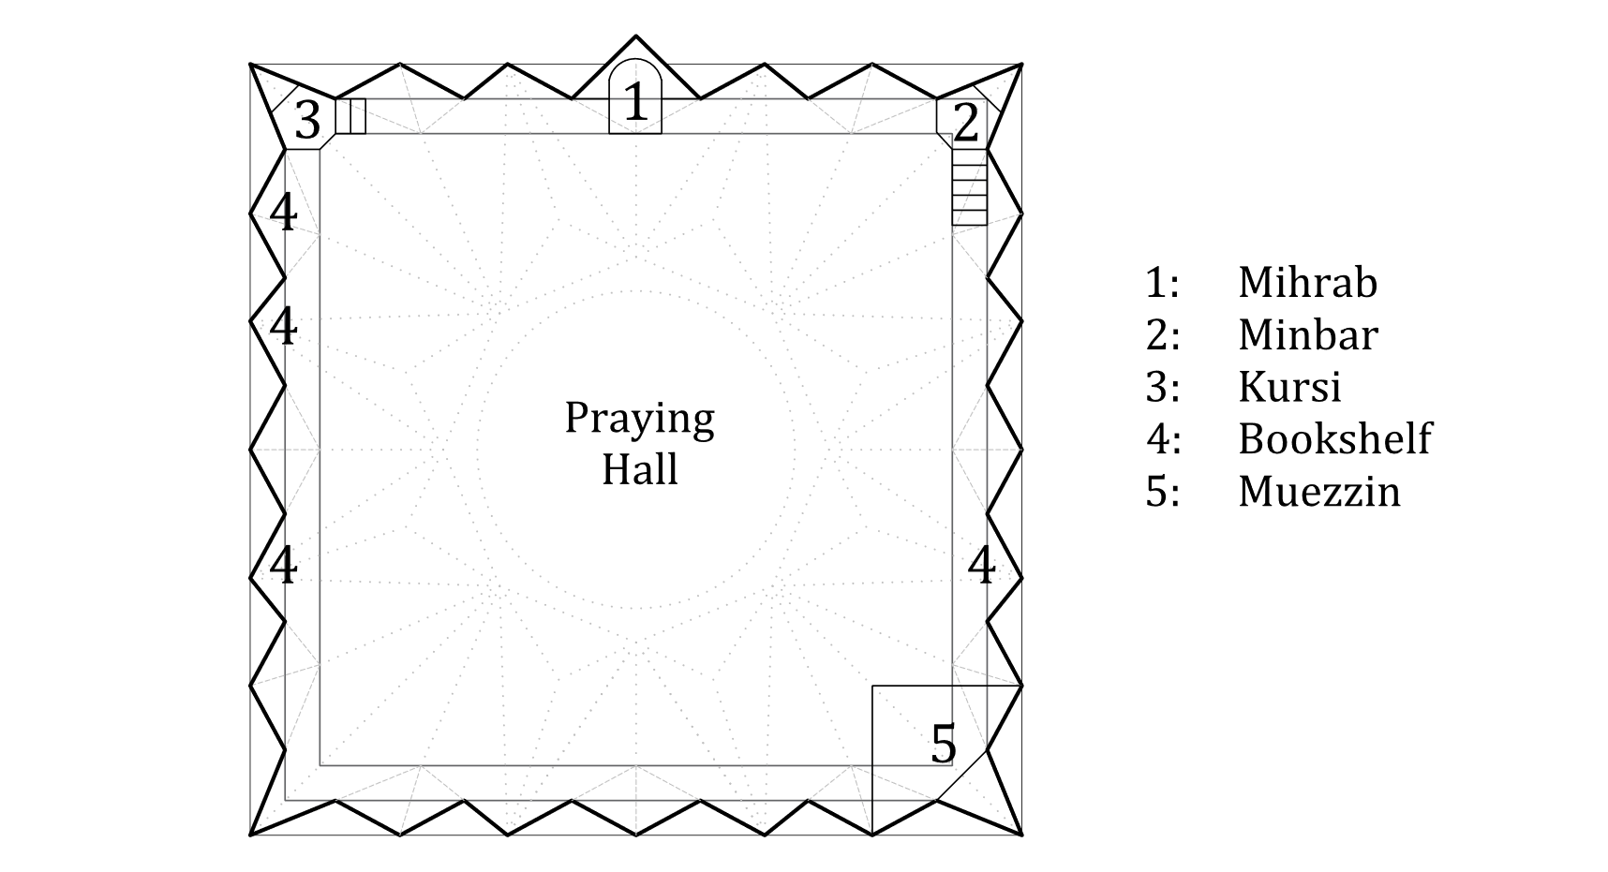
Figure 13. Functional units of the plan module

The module is convenient for a 6-18m span. In case of a need for larger or additional space, another plan scheme can be obtained by adding a "U" planned hall and the rewaq. In cases where a larger floor area is required, multiple repetition of modules is considered. The resulting plan scheme has the flexibility to expand by possible population growth (Fig. 14).

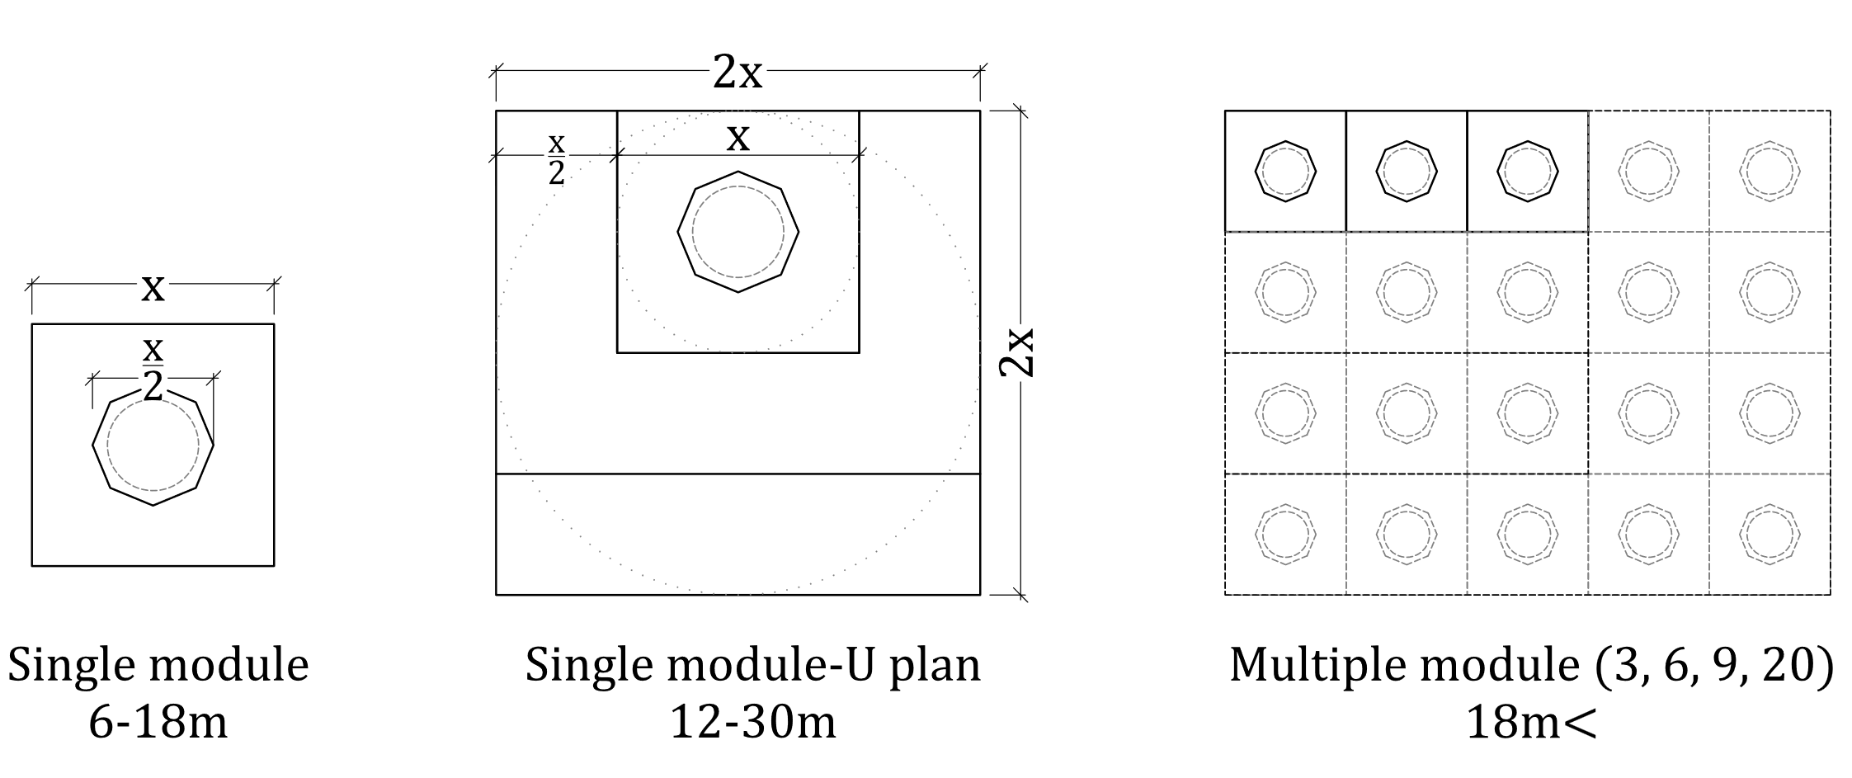
Figure 14. Dimensions and space variations of the plan module

The space of a neighborhood-scale mosque consists of harim, side halls, women's hall, rewaq, imam’s room, and minaret. The mosque model has a single-story structure in which the top cover can be seen in the entire space (Fig. 15a). In this configuration, a "U" plan scheme is obtained by adding the women's hall, side hall, and the rewaq to the module space. Here, the minaret is formed independently from the building. In cases where the mosque's site is limited, and the space requirement is larger, planar slabs can acquire the "U" formed on the second floor. In this case, one unit (a) will expand the mosque's entrance. Hence, the rewaq and minaret can be located in this space (Fig. 15b). Religiously, it is foretold that first-row worshippers will be rewarded (al Bukhari, adhaan, 9). For this reason, the harim has been extended by side halls in both plans. On the models, when the unit size (a) is regulated as 6m, the ground floor area reaches 540 and 720m2, respectively. Considering the usage area of 1 person (0.72m2) in the prayer hall, the capacity on the ground floor is 750 and 1000 people, respectively. In the second type (b) modeled, a total capacity of 1550 people (≈1120m2), including the second floor, is reached. These values correspond to the average dimensions specified by the TDV (Türkiye Diyanet Foundation) [38] in their mosque projects for neighborhoods.

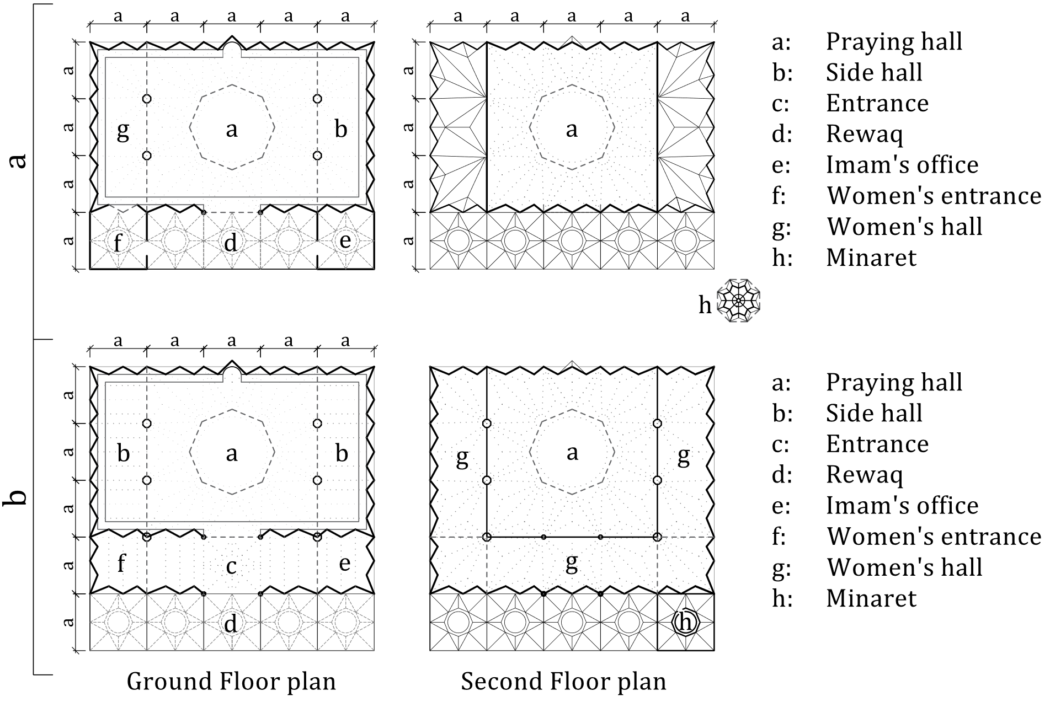
Figure 15. Two examples (a, b) of a complete plan of the model

Square and symmetrical planning is beneficial for structural reasons. Nevertheless, a few asymmetrical solutions are possible according to local circumstances. In the case of "L" planning or later articulation in response to changing requirements, the structural module is highlighted by defining the largest square on the plan. The rest of the plan is articulated to the module, expanding the harim (Fig. 16a, b). Alternatively, in a rectangular plan, the roof or transition elements can be positioned and shaped asymmetrically (Fig. 16c). Spaces like the side hall, minaret, imam's office, and rewaq may have an asymmetrical and clustered organization. The harim requires a large span and can be designed according to the relevant load-bearing system. The other parts can be articulated as independent spaces (Fig. 16d). If an undivided plan is needed, the walls bordering the mosque can be built in zigzags (folded plates). Customized roofing solutions can be developed by the philosophy of the relevant load-bearing system (Fig. 16e). The mosque can also be planned on a trapezoidal site. If the angle of the wall is parallel to the qibla, space becomes more convenient for prayer, minimizing dead space. Defining the load-bearing system using columns in the widest square plan is an efficient option for a trapezoidal site (Fig. 16f).

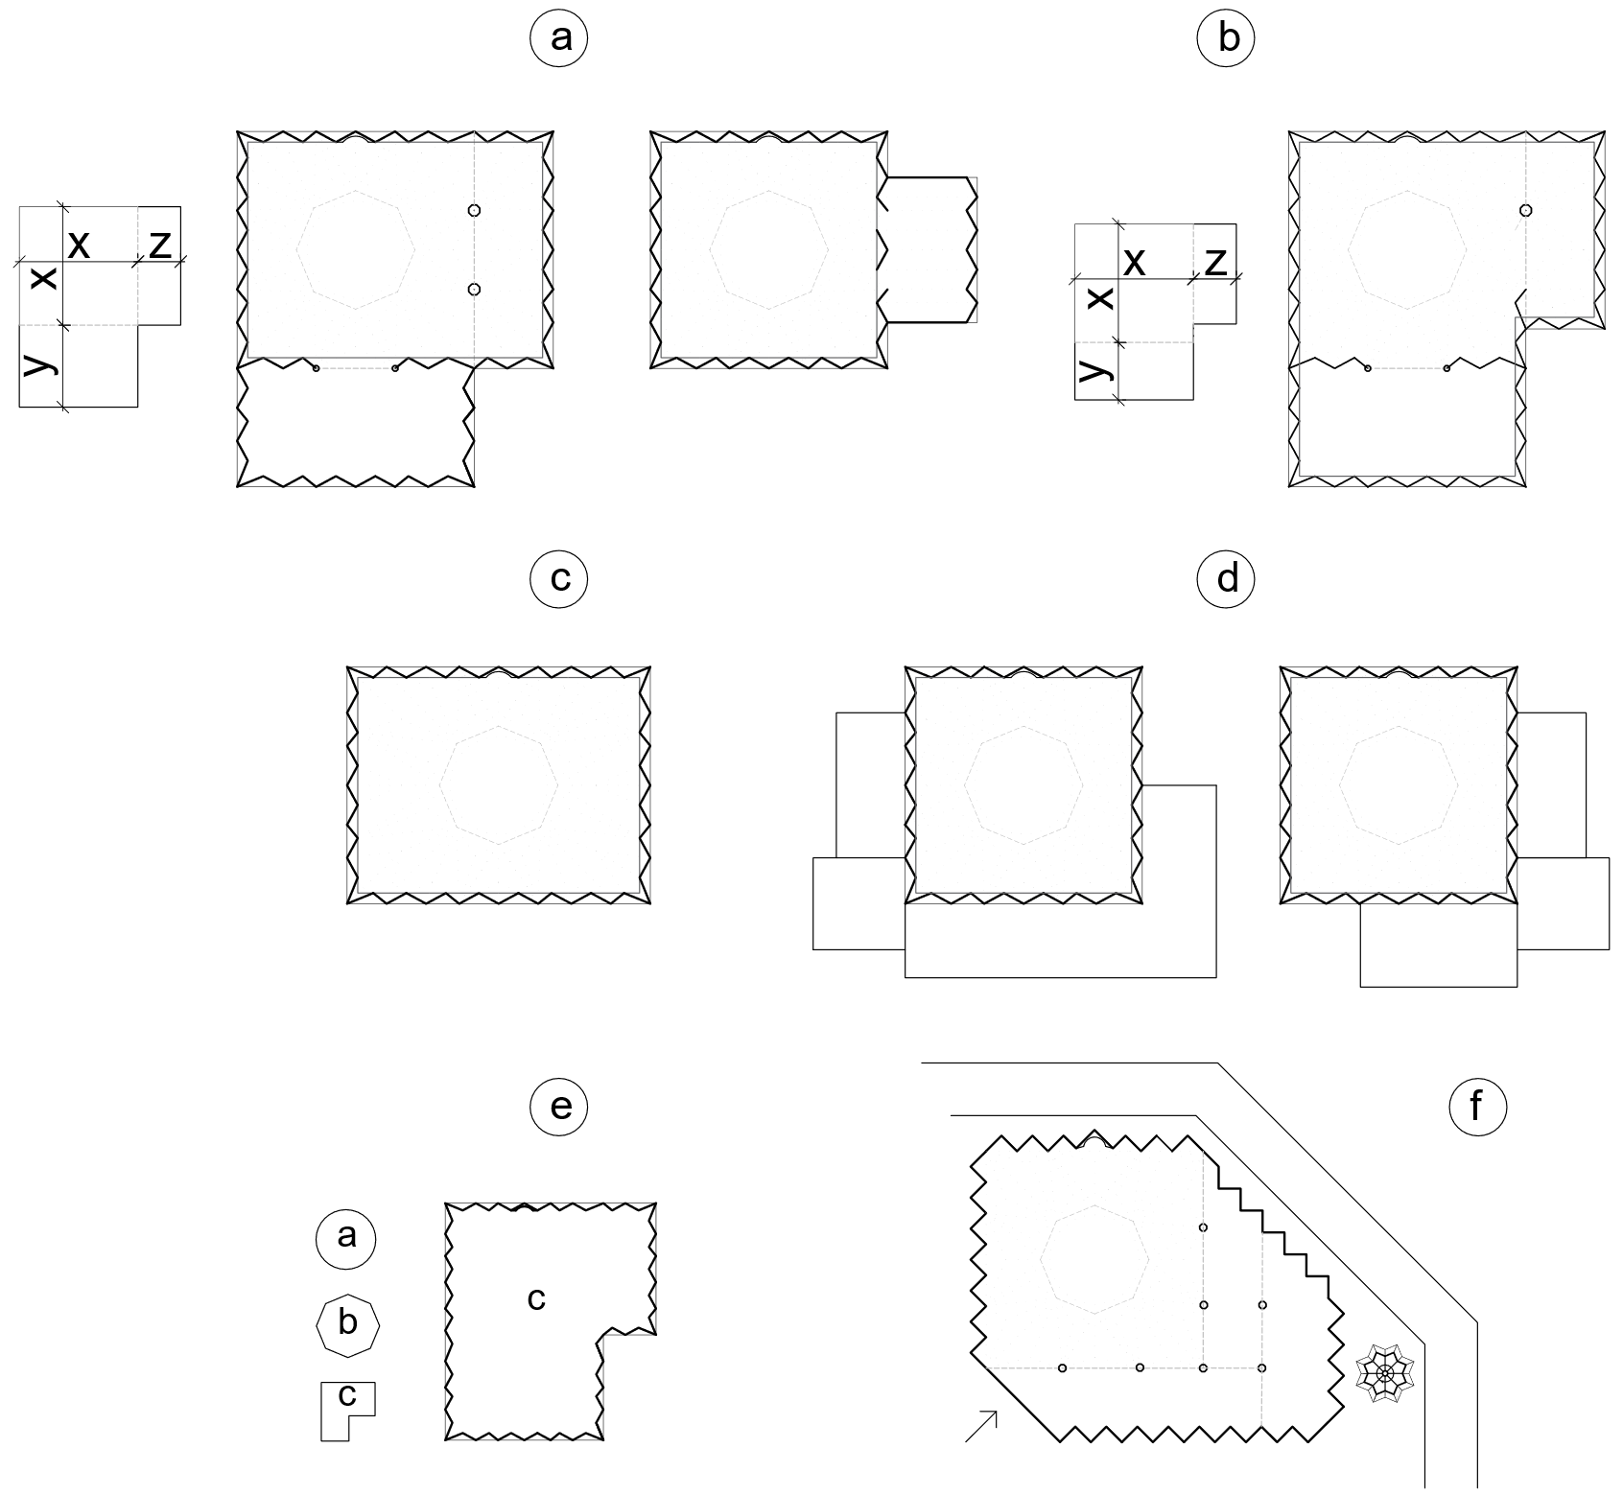
Figure 16. Asymmetric variations of the module
  - SECTIONAL ORDER
Sectional analysis utilizing the overlaps with the chain curve defines the height-length ratio of the model. The analysis of this ratio, widely used in Sinan's mosques, transformed into the design model is shown in Fig. 17. The type-section is a set of dots (a-f) excluding the wall thickness. From bottom to top, the lines consist of the wall (a-b), transition (b-c), ring beam (c-d), the tambour (d-e), and the top cover (e-f). The bottom and top ends of the chain curve indicate the structural boundaries of the mosque. The intersection point with the chain curve was determined as the middle of the ring beam (c-d) and tambour (d-e) lines, and the section has been idealized. The smallest size of the mosque (L1=6m) was considered; hence, the lowest and the highest type sections have been considered per the defined limits. The span of the top cover (L2) was specified according to the maximum tangent captured by the chain curve of a virtual dome.

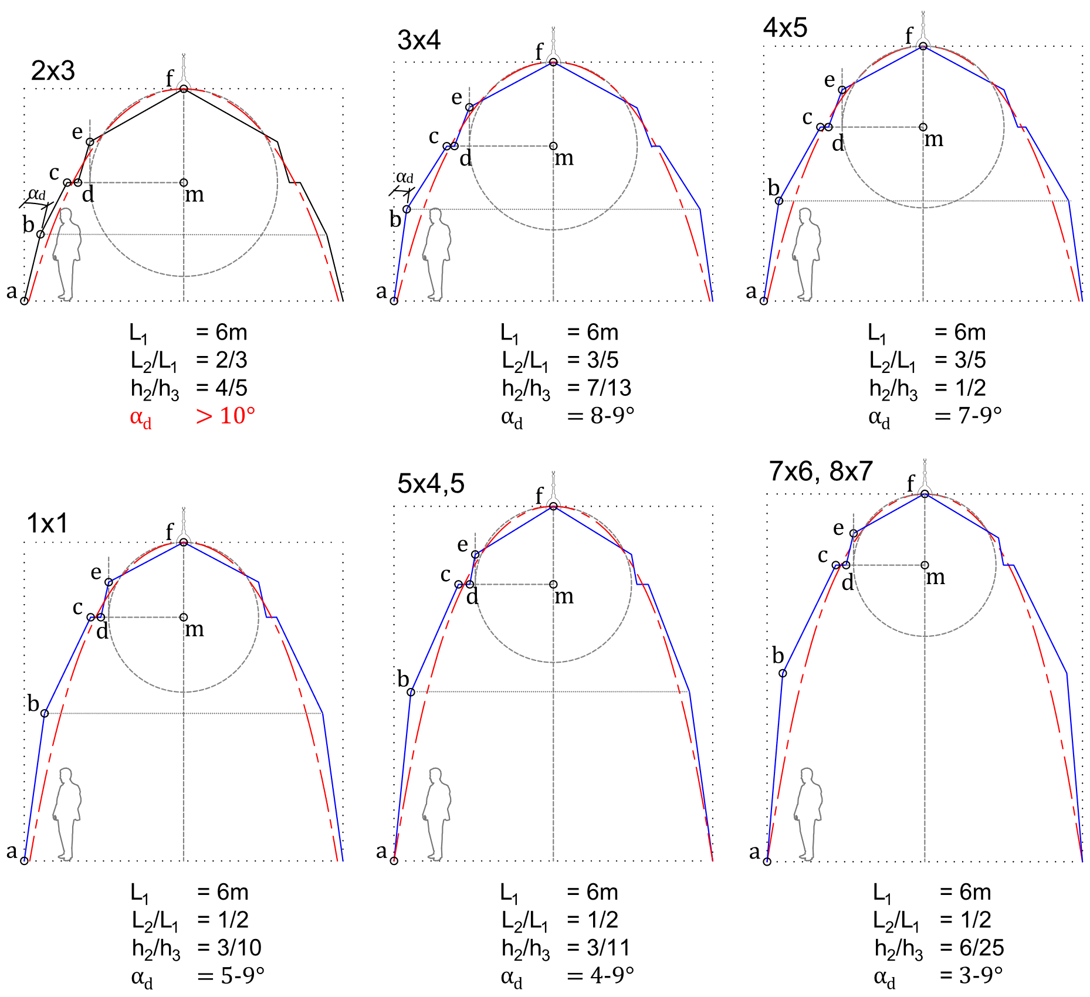
Figure 17. Determination of type sections according to the ratios commonly used in Sinan's mosques

If the section is too short, the wall angle (a-b; α_{d}) and the roof span (L₂) increase (Fig. 17). This, as can be seen in the ratio of 2/3, causes the wall to be inconvenient for human height; and more angled than the specified limit, and the roof to be heavier than the base structure due to the span. The limit ratios that make the building the highest are 7/6 and 8/7. In these examples, the wall angle is quite less (α_{d}). On the other hand, the length of the folded wall should be increased to overlap with the chain curve. Moreover, the canopy span has reached the minimum limit (L₁/L₂=2). Otherwise, the transition will be quite heavy, and the roof will be less visible. These sections are more appropriate in mosques, consisting of multiple modules. Indeed, proportions (7/6; 8/7) constitute the building boundaries of the Piyale Paşa Mosque, which is six domed. Other examples between the short and high boundary cases completely harmonize with the design parameters. These proportions overlap with the chain curve and building boundaries of Süleymaniye (3/4; 4.5/5), Selimiye (4/5; 3/4), Azapkapı Sokollu (3/4), Kadırga Sokollu (1/1; 6/5), Edirnekapı Mihrimah Sultan (6/5; 4.5/5), and Kılıç Ali Paşa (1/1) mosques (see Fig. 5).

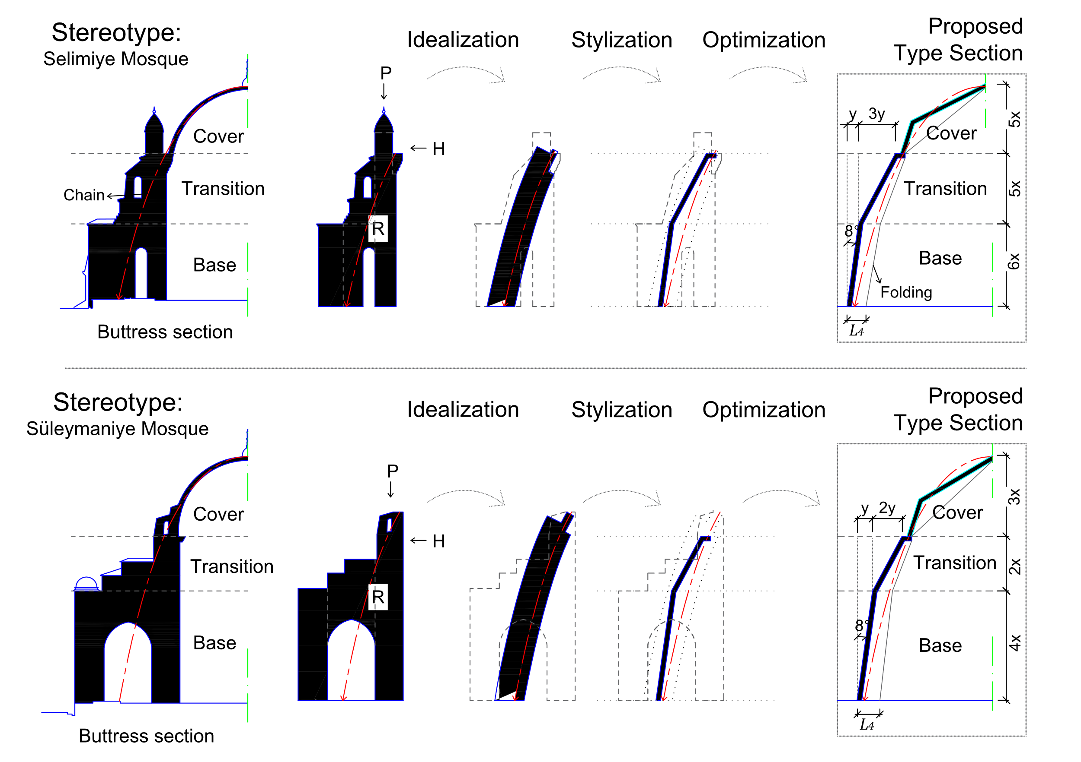
Figure 18. Transformation of the type sections according to the buttress in Selimiye and Süleymaniye Mosques
Although the analysis in Fig. 17 gives the dimensions of the structural elements, it does not define the length and height of the wall and transition. These dimensions are one of the flexibilities of the model. At this point, the buttress morphology of Sinan's mosques has been proposed to identify the overall proportions of the model. In Fig. 18, Selimiye and Süleymaniye mosques are selected as stereotypes, and the buttress morphology characterizing of architecture was analyzed. The two stereotypes have a stylized section staggered with the substructure, transition, and top cover and incorporate the chain curve as the composite force (R). If this section is idealized, a functional section in the form of a paraboloid slice is obtained. The type-section is achieved if this section is thinned and stylized according to the design model. The type section is optimized by determining the dimensions. The proportions reached are not structurally precise. However, they refer to the aesthetic experience learned from Sinan's mosques.
The mosque model is mainly proposed for service area, station, campus, neighborhood, and district scale. In this context, the type sections in Fig. 18 are dimensioned in Fig. 19 for building lengths (L1) of 6, 12, 16, and 18.5m, respectively. The wall, transition, and roof dimensioning are directly scale-dependent parameters. The mosque's folded wall length (L3) and wall construction thickness (d) are determined based on Eq. 4 and Eq. 5, respectively. According to the ratios of the stereotypes in Fig. 15, two different examples with sizes between 36-340m2 have been evaluated. The ratio of the top cover to the base is similar in both examples.
On the other hand, the bottom one gives a higher volume in the same area and span; therefore, the wall construction thickness (d) is greater. Depending on the buttress-transition relationship in stereotypes, the ratio of the wall to the transition is different in the modeled type sections. The bottom has a higher wall, while the top has a wider, heavier transition.

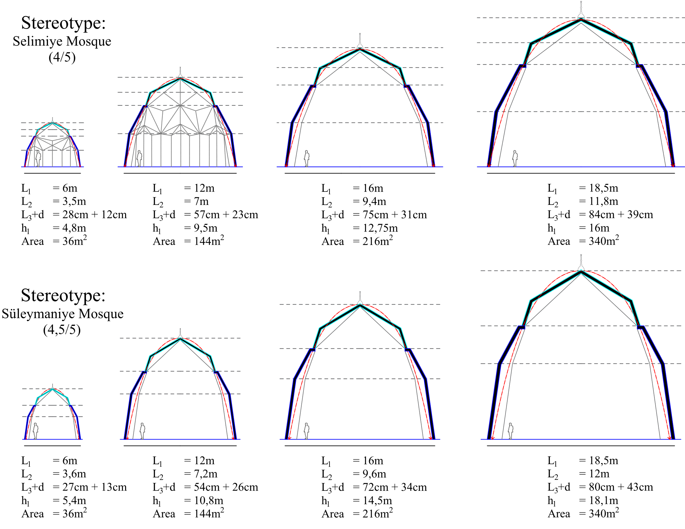
Figure 19. Dimensional analysis of type sections transformed from Sinan's mosques

  - FACADE ORDER
As in Sinan's mosques, the model's exterior reflects architectural tectonics on the facade. In Sinan's mosques, form, color, and texture vary according to the configuration of building elements and local materials. Structural elements must be coated in the model because of the material selection (CLT panels). By modifying the number and geometry of plate units and configuring the wall cavities and coatings, the model would adapt to the regional conditions (Fig.20). CLT panels are prefabricated materials suitable for installation under assurance conditions. Flexibility of detailing and coating with local components depends on material supply.
Sinan's medium and large-scale mosques were utilized to form facade characters and determine the sections' proportions. However, in terms of scale, the design model is closer to the dimensions of Sinan's countryside mosques, generally single-domed and small-sized rather than monumental mosques. Therefore, the analogies at the facade are more appropriate to this scale. In the current era, minarets have lost their functionality regarding calls to prayer due to loudspeakers. Therefore, a simple form without a minaret is adequate where Friday prayers are not required, such as a small (L1=10-15m) masjid in a service area or a terminal.
On the other hand, minarets also consolidate the visibility and indicative quality of the mosque, especially in Muslim-majority regions; also optimizing the facade proportions, as seen in Sinan's mosques. Accordingly, in a medium-sized mosque (L1=10-15m), a modest minaret (also see kiosk minaret) can be integrated into a simple plan scheme due to the sense of representation. The increase in scale (Fig. 20a). The facade proportions of this type, which has a distinct space without attachments, are an outward reflection of the sectional analysis. Hence, the interior-exterior view of the mosque is identical. The proportion of the kiosk minaret has been analyzed about the mosque's tambour, roof, and finial, concerning the common proportions in Sinan's mosques.
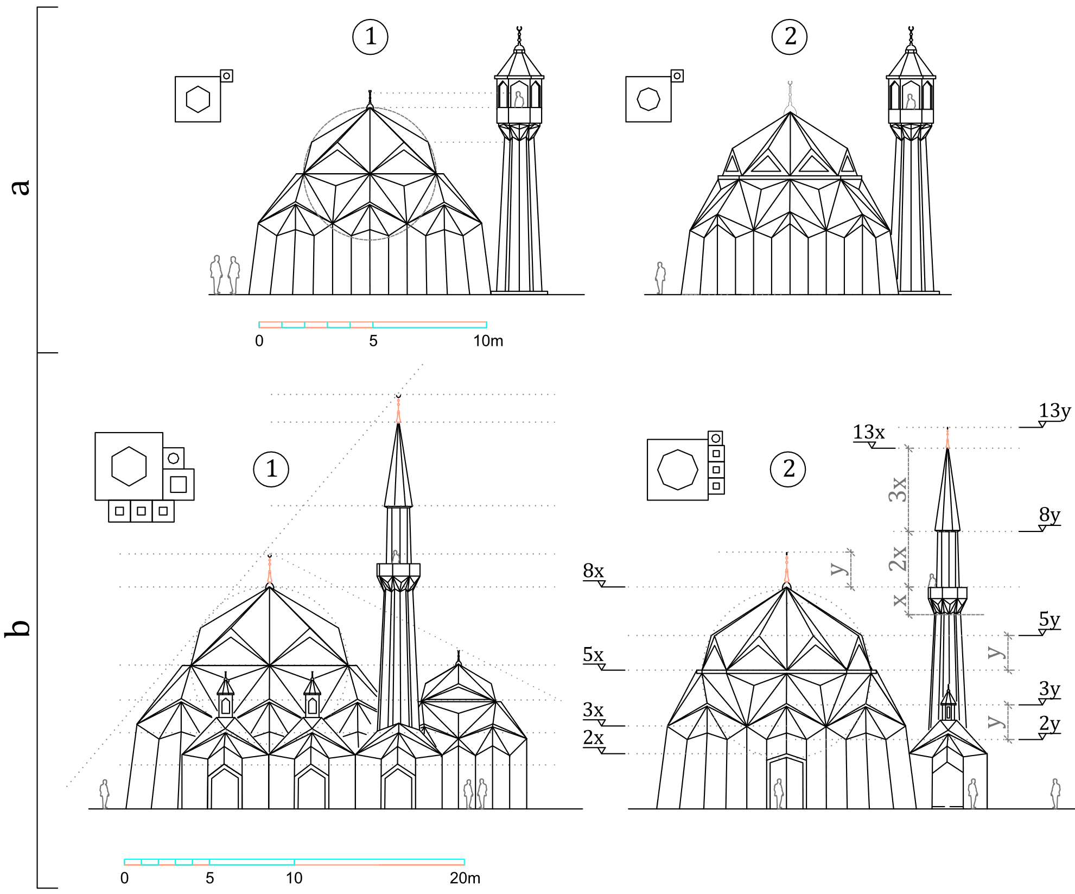
Figure 20. Facades of the mosque model sampled at two different scales (a, b)

Medium and large-sized mosques (L1=10-15m) should have appropriate spatial equipment for Friday prayers, as they are at neighborhood and district scale. In this case, forms such as the rewaq, side hall, women's hall, and minaret are attached to the harim. This type of facade is exemplified in Fig. 20b. Units such as the harim, side hall, and rewaq have cascading and proportional relations in the facade and the plan. The definition of proportions is based on differentiating the units on the facade and people's perceptions of the building elements (left). Building elements have also related and exemplified (right) according to the golden ratio (2, 3, 5, 8, 13...) for the more concrete proportioning. Dimensional relationships of the minaret, as in Sinan's mosques, are proportioned about the roof and finial of the mosque.
.
- CONCLUSION
16th-century Ottoman architect Mimar Sinan's mosques are known as one of the most efficient, refined, and elegant mosques ever. Sinan's mosques were built with masonry techniques in later periods, and in recent years, they have been built widely with contemporary technology and materials. However, many new mosques' structural systems and materials are incompatible. According to the findings in this study, Hooke's chain theory, which is an optimization tool for load distribution, clearly conforms with Sinan's mosques. This study developed a novel design based on the relevant theory and some principles of Sinan's highly admired and adopted mosques with a contemporary structural system and material. The model focuses on the structural form, and the possibilities, such as detailing and cladding with variations suitable for different sites, were reserved for the designer.
The design model has been developed by schematizing Sinan's mosques' relative positions (topology). These mosques were idealized as a square-based convex chain curve, abstracting from its architectural style. This ideal form was divided into triangles by the structural behavior of wood panels (CLT), a sustainable and ecological material. The triangular panels were folded to increase the plane stiffness. Stylistics of the model have been identified by constructing an analytical pattern between the folded plate and the Turkish triangle. The dimensional parameters of the model have been defined by proportional relations depending on the folded plate and CLT selection. The model has been discussed and optimized in plan, section, and facade planes according to the criteria and contemporary standards. The model is articulable in response to population changes and adaptable to various plan geometries thanks to parametric dot correlation. It also enables local touches regarding forming wall cavities, cladding type, finishes, etc. As a result, the mosque model is distinct from Sinan's mosques in terms of structural system, form, material, and construction method. On the other hand, when compared to Sinan's small/medium-sized mosques (Fig.21), it is a natural evolution in terms of central plan, proportion, and rhythm. Thus, a topological and technological adaptation from Sinan's mosques to the present day has been realized.

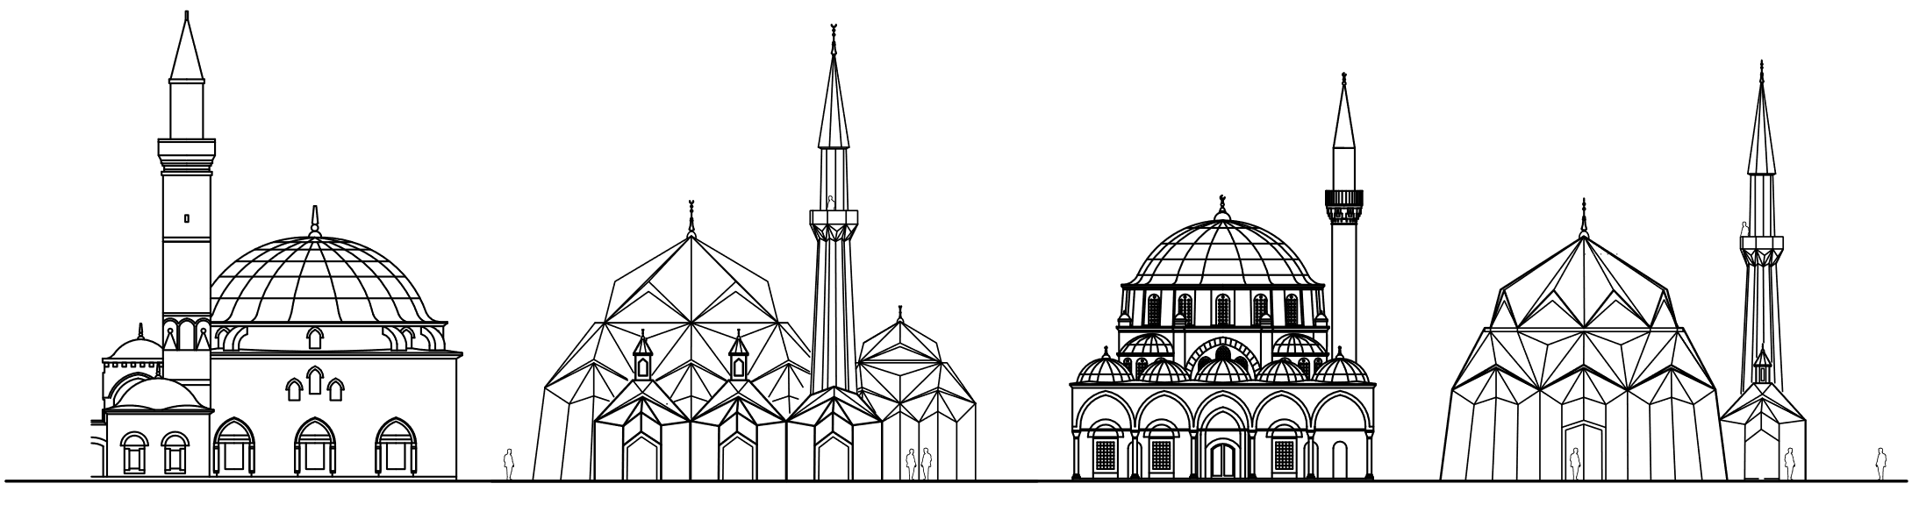
Figure 21. Comparison of the Facades of Sinan's Small Mosques and The Mosque Model
REFERENCES
[1] M. Frishman, Islam and Form of the Mosque (Ed. M. Frishman, H. Khan). London: Thames and Hudson, 1997.
[2] O. Grabar, The Formation of Islamic Art. New Haven: Yale University Press, 1987.
[3] M. Rustamova, Karahanlı Devri Mimarisi ve Bezemeleri. İstanbul: TBBB, 2022.
[4] I. Serageldin, Introduction: Background Study (Ed. Serageldin, I. ve Steele, J.), Architecture of the Contemporary Mosque (pp.8-11). London: Academy Editions, 1996.
[5] D. Kuban, Sinan’ın Sanatı ve Selimiye. (Ed. M. Özgüleş. İstanbul: Türkiye İş Bankası Kültür Yayınları, 2017.
[6] Sâî Mustafa Çelebi, Mimar Sinan and Tezkiret-ül Bünyan (Prep.: M. Sözen and S. Saatçi). İstanbul, Emlak Bankası Yayınları, 1988.
[7] Ca’fer Efendi, Risâle-i Mi’mâriyye (Prep.: İ. A. Yüksel). İstanbul: İstanbul Fetih Cemiyeti, 2005.
[8] M. Dâyezâde, Selimiyye: İnceleme- Metin- Sadeleştirme (Prep.: C. Okuyucu). Ankara: Türk Tarih Kurumu Yayınları, 2019.
[9] R. Garaudy, İslâm'ın Aynası Camiler (Trans. C. Aydın). İstanbul: Timaş Yayınları, 2017.
[10] T. Burckhardt, Doğu’da ve Batı’da Kutsal Sanat: Sanatın İlkeleri ve Yöntemleri (Trans. T. Uluç). İstanbul: İnsan Yayınları, 2019.
[11] S. H. Nasr, İslâmic Art and Spirituality. Albany: State University of New York Press, 1987.
[12] S. K. Yetkin, İslâm Mimarisi. Ankara: Ankara Üniversitesi Basımevi, 1965.
[13] N. Ardalan and L. Bakhtiar, The Sense of Unity: The Sufi Tradition in Persian Architecture (Ed.: W. R. Polk). Chicago: The University of Chicago Press, 1973.
[14] T. Burckhardt, İslam Sanatı: Dil ve Anlam (Trans.: T. Koç). İstanbul: Klasik Yayınları, 2013.
[15] M. A. Al Naim, H. M. Al Huneidi, and N. H. Abdul Majid, Introduction. Mosque Architecture: Present Issues and Future Ideas (pp. xv-xx), Kuala Lumpur: Institut Terjemahan & Buku Malaysia Berhad, 2019.
[16] H. Khan, An Overview of Contemporary Mosque (Ed.: M. Frishman, H. Khan), The Mosque: History, Architectural Development & Regional Diversity (pp. 247-267), London: Thames and Hudson, 1997.
[17] M. Arkoun, The Metamorphosis of the Sacred (Ed.: M. Frishman and H. Khan), The Mosque: History, Architectural Development & Regional Diversity (pp. 268-272), London: Thames and Hudson, 1997.
[18] R. Hakky, R., The Mosque of Tomorrow (Ed.: M. A. Al Naim, H. M., Al Huneidi, and N. H. Abdul Majid), Mosque Architecture: Present Issues and Future Ideas (pp. 65-80), Kuala Lumpur: Institut Terjemahan & Buku Malaysia Berhad, 2019.
[19] M. E. Akyürek and G. Kahraman, "Sinan’ın Camilerinde Yapı Mühendisliği Sanatı," Sanat Tarihi Dergisi, vol. 30, no. 1, pp. 255-283, 2021.
[20] A. Allaham, "Metamorphosis of Mosque Semiotics: From Sacred to Secular Power Metaphorism – the Case of State Mosques," Archnet-IJAR: International Journal of Architectural Research, vol. 13, no. 1, 204-217, 2019.
[21] IASS, About the IASS. URL: https://www.iass-structures.org/About-the-IASS. 2 October 2023.
[22] A. Batur, Osmanlı Camilerinde Örtü ve Geçiş Öğeleri: Sorunlar ve Biçimler. Istanbul Tecnical Universitesy Architecture Faculty (associate professorship thesis), 1980.
[23] O. Hegazy, "Towards a Contemporary Mosque: Rethinking the Prophet-Mosque in Medina via Applying Socio-Semiotics," The International Journal of Religion and Spiritualirt in Society, vol. 4, no. 1, pp. 17-24, 2014.
[24] J. Heyman, The Stone Skeleton: Structural Engineering of Masonry Architecture. Cambridge: Cambridge University Press, 1997.
[25] D. P. Billington, The Tower and the Bridge: the New Art of Structural Engineering. Princeton and Oxford: Prince University Press, 2022.
[26] C. R. M. Meirelles, P. N. Beraldo, and B. M. Nazareth, "Geometric Shape, Structure and Material in Antoni Geometric Shape, Structure and Material in Antoni Gaudí’s Work: The Colònia Güell Crypt and the Templo Expiatorio de la Sagrada Familia," Journal of Civil Engineering and Architecture, vol. 13, pp. 608-621, 2019.
[27] H. Isler, "Concrete Shells Derived From Experimental Shapes," Structural Engineering International, vol. 4, no. 3, pp. 142-147, 1994.
[28] I. Liddell, "Frei Otto and the development of gridshells," Case Studies in Structural Engineering, vol. 4, pp. 39-49, 2015.
[29] Geogebra, Graphing Calculator. URL: https://www.geogebra.org/graphing. 2 October 2023.
[30] T. Vondráčková, V. Nyvlt, and F. Nemec, "Characteristics of Gothic Cathedrals in France and Their Structural Elements," Procedia Engineering, vol. 161, pp. 1751-1756, 2016.
[31] G. Tanyeli, “Hiçbir Üstâd Böyle Kâr Etmemişdir”: Osmanlı İnşaat Teknolojisi Tarihi. İstanbul: Akın Nalça, 2017.
[32] A. Paduart, Betonarme Kabukların Hesap ve Yapımına Giriş (Trans.: H. Karataş). İstanbul: İTÜ Mimarlık Fakültesi Yayınları, 1974.
[33] A. Ceylan and Z. C. Girgin, "Çapraz Lamine Ahşap (CLT) Duvar-Döşeme Birleşiminin Yapısal Davranışının Deneysel İncelenmesi," Megaron, vol. 14, no. 4, pp. 521-529, 2019.
[34] Swedish Wood, The CLT Handbook, CLT structures - facts and planning, 2019.
[35] İ. Tekeli and S. İlkin, Mimar Kemalettin’in Yazdıkları. Ankara: Şevki Vanlı Mimarlık Vakfı Yayınları, 1997.
[36] E. Şanlı and N. Vural, "Çapraz Lamine Ahşap (CLT) Yapı Malzemesinin Strüktürel Açıdan Değerlendirilmesi," Yapı Dergisi, vol. 467, pp. 50-57, 2021.
[37] İ. Aka, F. Keskinel, and T. S. Arda, Betonarme Katlanmış Plaklar. İstanbul: Birsen Kitabevi Yayınları, 1981.
[38] TDV, Örnek Mimari Cami Projeleri. URL: https://tdv.org/tr-TR/medya-odasi/ornek-cami-projeleri/. 2 October 2023.

