 |  | JOURNAL OF ISLAMIC ARCHITECTURE  P-ISSN: 2086-2636 E-ISSN: 2356-4644  Journal Home Page: http://ejournal.uin-malang.ac.id/index.php/JIA
UNCOVERING THE INFLUENCE OF MOSQUE OPENNESS ON SPEECH INTELLIGIBILITY: A SIMULATION STUDY
Muhammad Harish Heruputra ª, Widyarko Widyarko ª, Dalhar Susanto ^{a*}
ªDepartemen Arsitektur, Fakultas Teknik, Universitas Indonesia, Indonesia
*Corresponding Author: dalhar.susanto@ui.ac.id
ARTICLE INFO |  |  | ABSTRACT
Volume: 8  Issue: 4  Page: 998-1011  Received: October 19th, 2023  Accepted: July 31st, 2024  Available Online: December 30th, 2025  DOI: 10.18860/jia.v8i4.23828 |  |  | Mosques, serving as places of worship for Muslims, require a high level of speech intelligibility to achieve the solemnity of worship. Due to rising urban temperatures, many mosques in tropical urban areas are transitioning from their previously open-designed condition, which relied more on natural ventilation, to enclosed ones that rely more on artificial ventilation. This study aims to understand the influence of space openness on speech intelligibility in mosques. Speech intelligibility measures how clear a voice is in a room and is measured by the speech transmission index (STI) method. This research utilizes a quantitative approach, integrating site observations, on-site measurements, and computational simulations. Focusing on Masjid UI as the case study, the study simulates open and enclosed design configurations across three scenarios: full, half-full, and empty rooms. The results show that a mosque with an open design has a higher STI than a mosque with an enclosed design. However, the difference is insignificant due to several supporting factors in the existing condition, such as the square-shaped plan design with a pyramid dome, equal loudspeaker sound distribution, and crowded worshippers’ condition.  Keywords:  Acoustics; Mosque; Spaces’ Openness; Speech Intelligibility

- INTRODUCTION
Islam is one of the fastest-growing religions globally. By 2050, it is estimated that there will be approximately 2.8 billion Muslims worldwide [1]. As a place of worship, mosques exert a profound influence on Islamic culture, serving as symbols, icons, and focal points representing the presence of Islam and the Muslim community [2]. Mosques serve as places of both ritual and social worship, encompassing economics, education, and socio-cultural aspects [3]. Therefore, Barliana [4] asserts that mosques are the most significant artistic and cultural manifestations of Islam within the field of architecture. However, as expressions of Islamic architecture, mosques do not adhere to rigid constraints regarding their construction or form [5]. Embracing a non-prescriptive architectural concept, the development of mosques displays remarkable diversity worldwide, influenced by cultural variations and climatic differences across various regions of the world [2, 6].
Regional architectural identities significantly influence the development of mosques. One example can be seen in Javanese mosques, which incorporate distinctive architectural features such as the addition of four soko guru columns topped with tajug-style roofs and a reduced prominence of minarets [4, 7]. Furthermore, during the early stages of Islamic development, mosques in Indonesia were often designed with pavilion-like structures, influenced by Hindu temples [6, 8]. These mosques were characterized by open designs, lacking walls except for the area around the mihrab. This design choice was influenced by Indonesia's environmental conditions, which favored natural ventilation and the absence of excessive noise pollution during that era [7, 9].
However, the urban heat island phenomenon has become increasingly pronounced, leading to a greater reliance on air conditioning systems to mitigate indoor heat [10, 11, 12]. Given these challenges, mosque design must adapt to the evolving urban environment. This adaptation is not limited to newly constructed mosques, but also applies to existing ones that were originally designed as open-plan mosques, aiming to preserve both thermal comfort and acoustic quality within these spaces [10, 13].
Acoustic comfort in mosques refers to the condition and satisfaction experienced by worshippers with the acoustic environment within the mosque premises [14, 15]. A comfortable acoustic environment in mosques can be achieved through the careful design of the mosque, particularly in its interior spaces [16].
The prayer space within enclosed mosques has a significant impact on the characteristics of sound reflections. Sound reflections can be categorized into two types: early reflections and reverberation. The geometry of space plays a crucial role in influencing these sound reflections [17]. The first factor, room shape, influences how sound gets reflected. Abdou [18] discovered that mosques with a square floor plan exhibit the most favorable sound distribution compared to other floor plan shapes. The second factor is the room's volume. A more extensive room volume results in more extended sound reflections. Ismail [19] observed that domes can extend the reverberation time within mosque interiors. In addition to increasing the room's volume, domes also concentrate sound reflections at a specific point, enhancing sound intensity at those locations (Fig. 1) [20].

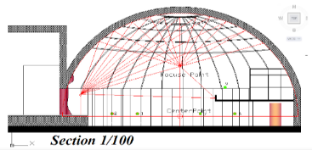

Figure 1. Sound reflection in a dome [20]

Beyond spatial geometry, the choice of materials in mosques also profoundly influences acoustic comfort. Each material possesses two crucial characteristics: absorption and diffusion [17]. Absorption refers to a material's sound-absorbing capacity, measuring how effectively it dissipates sound energy upon contact. Conversely, diffusion refers to a material's ability to disperse sound upon reflection [21]. Materials with higher absorption tend to reduce sound reflections, while those with greater diffusion scatter sound more effectively [22].
The acoustic characteristics of sound reflections within a mosque significantly impact sound intensity. Sound intensity measures the strength of sound and is quantified in decibels (dB) [23]. Long [23] distinguishes three types of sound intensity: sound power level, sound intensity level, and sound pressure level (SPL). Sound measurements in enclosed spaces commonly utilize SPL as it represents sound intensity at a specific point, thereby reflecting the sound intensity perceived by humans [24]. For the same reason, SPL is one of the critical indicators of sound quality within enclosed spaces [25].
The speech intelligibility indicator assesses the perceived sound quality within a mosque. It measures how clearly listeners hear syllables, words, or sentences within a room [23]. Speech intelligibility can be measured using several methods. The globally recognized method, based on the IEC-60268-16 rev. 4 standard from 2011, is the Speech Transmission Index (STI) using the derived method known as STIPA (STI for Public Address systems) [26]. Unlike other methods, STIPA can be applied to assess sound quality in spaces, whether they have sound systems or not [25]. Consequently, STIPA has become the prevailing standard in the contemporary era as sound systems are widely employed.
In the STIPA method, three factors directly influence the STI value. The first factor is SPL (Sound Pressure Level) [25]. The second factor is background noise, which refers to sound sources that have the potential to disrupt acoustic comfort and is measured using the Noise Criterion system [21]. The last factor is reverberation time, which refers to the duration of sound reverberations within a room after the sound source has ceased. This factor can significantly impact sound quality, depending on the room's purpose [23]. These three factors are essential measurements for assessing sound quality in mosques.
As previously mentioned, contemporary mosque designs often feature greater enclosure to improve acoustic quality. However, rather than providing a comprehensive solution, these enclosed mosque designs may potentially introduce new acoustic challenges, particularly the reduction of speech intelligibility within the mosque’s interior [27]. Additionally, Ismail [19] noted that the materials commonly used in mosques are often acoustically reflective, making mosque interiors prone to sound reverberation.
However, there has been a lack of research examining acoustic comfort in present-day mosques [19, 27]. Only a few existing studies related to the acoustics of contemporary mosques have been conducted. Adel [27] investigated the acoustics of mosques in general and concluded that many contemporary mosques have poor speech intelligibility, although speech intelligibility can be improved when the mosque is fully occupied. Meanwhile, Ismail [19] examined how the geometry of a mosque can affect speech intelligibility, finding that large domes, which are common in modern mosques, tend to reduce speech intelligibility.
Previous studies have focused on closed-design mosques, but the acoustic performance of open-designed mosques in the current contexts remains undisclosed, especially given that mosques have transitioned from open to closed designs. Therefore, this study aims to investigate the level of acoustic comfort in open-designed mosques to determine whether an open or enclosed design is more advantageous. The study places particular emphasis on speech intelligibility as a clarity parameter for prayer, as well as reverberation time and background noise, to provide a more detailed assessment of the mosque's acoustic conditions.

- METHODS

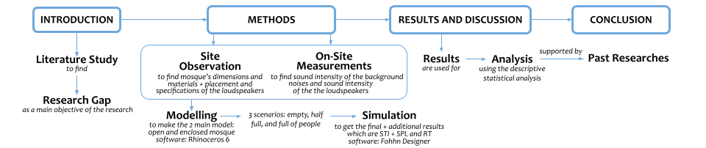

Figure 2. Study Framework

The methodology employed in this study uses quantitative approach conducted through a series of observations, on-site measurements, and simulations to obtain Speech Transmission Index (STI) values under various spatial openness conditions and room occupancy scenarios (Fig. 2). The use of the STI method with simulations distinguishes this research from the conventional STI method, which typically involves on-site measurements. The research subject is the Masjid Ukhuwah Islamiyah, commonly known as Masjid UI, the primary mosque on the Universitas Indonesia campus in Depok. The mosque is strategically located on the border of Jakarta and Depok, West Java, Indonesia, at coordinates -6.36577, 106.83108 (Fig. 3). Covering a total area of approximately 5,000 m², Masjid UI can accommodate up to 2,000 worshippers.

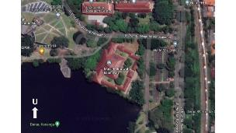 | 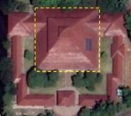
Figure 3. Satellite view and main prayer hall of Masjid UI

This mosque was selected as the case study due to its distinctive characteristics. Apart from its open design, it deviates from conventional mosque architecture by incorporating local architectural elements with its pyramid-shaped roof made of clay materials (Fig. 4). Built in 1987, Masjid UI is currently faces with thermal issues caused by the urban heat island effect and noise disturbances due to the rapid development of the campus and the city, similar to other mosques in the vicinity.

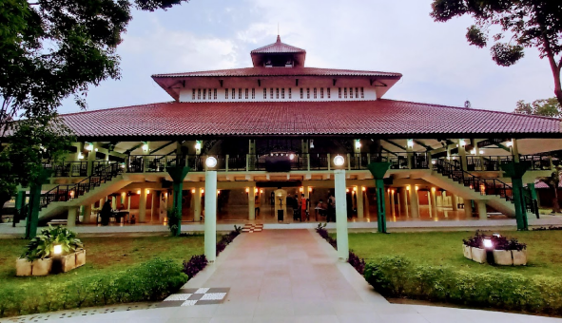

Figure 4. Front view of Masjid UI [28]

To narrow the scope of the study, only the main prayer hall was selected as the object for STI measurements, as it is the space most frequently used for worship (Fig. 3). The prayer hall has a total area of approximately 1,000 m² and a volume of approximately 5,000 m³. The data collection method employed the speech transmission index (STI) using the derivative STIPA method, encompassing both observation and simulation stages.
Observation was conducted in two phases: site observation and on-site measurements. Site observation aimed to gather physical data about the mosque, including its dimensions, materials, and the placement and specifications of loudspeakers. Subsequently, on-site measurements were conducted to acquire sound intensity data, covering both background noise and loudspeaker sound intensity.
Sound intensity was measured using the Decibel X software, a well-established smartphone application known for its accuracy in measuring sound pressure levels (SPL) with a Mobile Apps Rating Score (MARS) above 3.0 [29]. As a reference, an earlier study demonstrated the use of the Decibel X app to measure urban acoustics in a school [30]. The Decibel X software records and displays the SPL values for each frequency throughout the recording, which is necessary for calculating the NC level of background noise. During the SPL measurement, the phone was elevated to 1,6 meters from the floor, representing the worshippers’ ear height. Background noise and loudspeaker measurements were conducted between 11:00 AM and 12:00 PM (WIB), the peak time of mosque activity. Both background noise and loudspeaker measurements were assessed at 12 different locations, with each location measured for 20 seconds (Fig. 5). The observation data then served as the primary input for the subsequent computer simulation process.

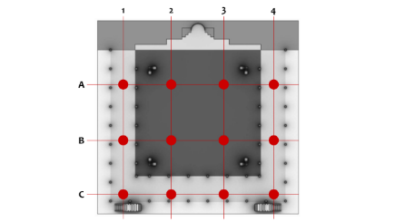

Figure 5. Background noise and loudspeaker measurement mapping

Once the primary data were collected, the computer simulation process, comprising modeling, configuration setup, and simulation, was initiated. Modeling was carried out using Rhinoceros 6 software to define all boundaries of the mosque, including the floor, walls, columns, beams, and roof. Each boundary was grouped into different layers to facilitate material settings in the simulation. The file was then exported to COLLADA (.dae) format and imported into the web-based software Fohhn Designer for further configuration and simulation. Fohhn Designer was selected because it complies with the DIN EN IEC 60268-16 standard for STI simulations, which specifies how to rate speech intelligibility in rooms equipped with sound systems [26]. Settings were configured to control background noise obtained from the on-site measurements, loudspeakers’ placements and sound intensity, and room material properties, with single sound reflection.
Table 1. Explanation of each model variable
Variable | Explanation
MUI-A | Original version of Masjid UI  with an open design
MUI-B | Modified version of Masjid UI  with enclosed design
E | Empty scenario
HF | Half full scenario
F | Full scenario

Two mosque types were considered in the simulation: the open-design (MUI-A, original) and the enclosed-design (MUI-B, modified), each simulated under three scenarios: empty, half-full, and full, as indicated by the codes in Table 1. Rectangle blocks (red-colored) were used to represent worshippers, reflecting variations in worshipper occupancy levels (Fig. 6). The "half-full" scenario represents typical obligatory prayers practiced daily, while the "full" scenario simulates the mosque's use during Friday prayers. These three scenarios were simulated to assess the mosque's acoustic conditions across various situations.
The modified mosque model (MUI-B) was created by adding walls on all sides of the building and windows as openings. The selection of materials for both simulation models was adjusted based on data from site observations with the absorption coefficient values for each material obtained from Fohhn Designer, referencing various books and material manufacturers [31]. The listener plane was positioned 1.5 meters above the floor for plan view simulations and centered at the mosque’s midpoint for vertical section simulations, and was color-coded to represent both SPL and STI values (Fig. 7).

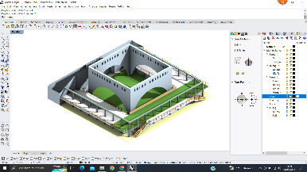  a | 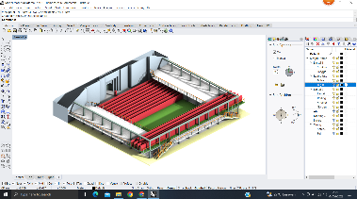  b | 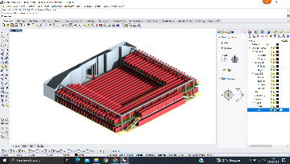  C
Figure 6. Masjid UI in empty scenario with the inner soko guru (a), half-full scenario b), and full scenario (c). The red color represents the worshippers.

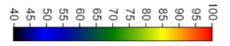
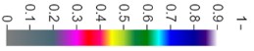
Figure 7. SPL diagram in dBA (top) and STI (bottom) [31]

The simulation process generated three sets of outputs. The primary output was the distribution of (STI) values in the study object. Supporting outputs were the distribution of SPL (A-weighting) values and the reverberation time within the mosque's space. All simulation results were discussed collectively, linking the data with internationally recognized acoustic comfort standards and previous research, as presented in Table 2, to draw comprehensive conclusions.

Table 2. Standard value level of STI, SPL, RT, and BN, and the recommended value for Masjid UI
Parameter | Value |  |  |  |  | Recommended | Source
Parameter | 1 | 2 | 3 | 4 | 5
STI  (bad-excellent) | <0.3  (Bad) | 0.3-0.45  (Poor) | 0.45-0.60  (Fair) | 0.60-0.75  (Good) | >0.75  (Excellent) | At least STI 0.68 for speech auditorium and alike | NTI Audio [25]
SPL standard deviation  (dBA deviation) | <3dBA | >3dBA | - | - | - | <3dBA | Akil [32]
RT  (max for each room’s volume) | 1.6 s  (500m2) | 1.75 s  (1000m2) | 1.9 s  (2500m2) | 2.1 s  (5000m2) | 2.25 s  (10.000m2) | The volume of Masjid UI’s prayer hall is approximately 5000m³, leading to an RT recommendation of 2.1 seconds | Ismail [19]
BN  (NC level) | NC <20 | NC 20 | NC 25 | NC 30 | NC >30 | NC 25 to NC 30 for conference halls and alike | Adel [27]

- RESULT AND DISCUSSION

  - OBSERVATION RESULTS
The mosque’s dimensions obtained during the site observation phase were used to create the Masjid UI model. Most of the mosque's materials are reflective, including ceramic tiles and painted concrete. The only absorptive materials are the carpets in the inner area and on the second floor, as well as a few curtains on the second floor.

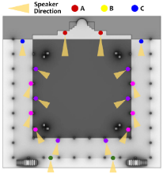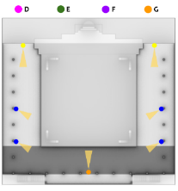
Figure 8. Loudspeakers mapping on the first (left) and 2nd (right) floor in Masjid UI

The observation also identified seven distinct types of loudspeakers used in the case study, positioned as depicted in Figure 8. These loudspeaker types are symmetrically placed on both sides of the mosque, with a consistent mounting height of approximately 2 to 2.2 meters above the floor. Additionally, some loudspeakers are inclined vertically by 7.5° downwards to better target the worshippers.
From the on-site measurements, it was found that the average sound intensity produced by the loudspeakers was 78.8 dBA. The background noise data indicated that within the 125Hz-8000Hz frequency range, the 250Hz frequency exhibited the highest sound intensity, averaging 43.2 dBA. This 43.2 dBA sound intensity at 250Hz corresponds to the NC 30 category. Consequently, an NC 30 background noise level was applied in the simulation.

  - SIMULATION RESULTS
The simulation process generated STI and SPL data both graphically and numerically, while RT data was generated only numerically. The floor plan illustrating the distribution of STI and SPL values is presented in Table 3. The STI values are generally comparable between both models, except for model MUI-B_E, which was uniquely highlighted in purple. As for the SPL values, the color patterns were consistent in both models. However, in model MUI-B, a noticeable shift towards more orange coloration indicates higher sound intensity.

Table 3. STI and SPL layouts in both Masjid UI models
 | STI |  | Total SPL
 | First Floor | Second Floor | First Floor | Second Floor
MUI-A  E | 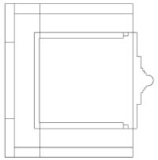 | 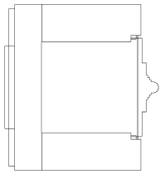 | 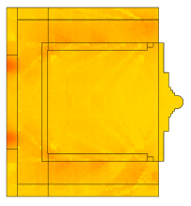 | 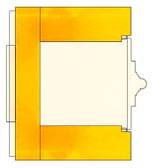
MUI-A  HF | 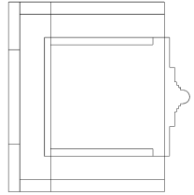 | 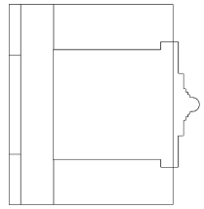 | 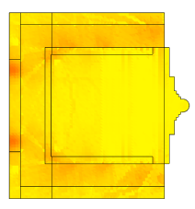 | 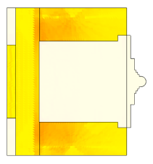
MUI-A  F | 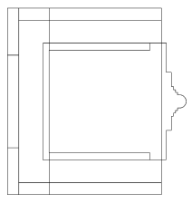 | 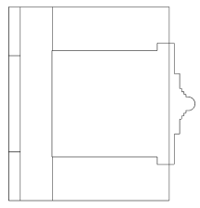 | 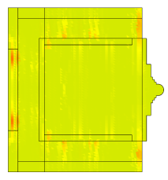 | 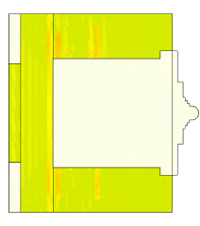
MUI-B  E | 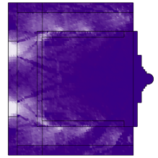 | 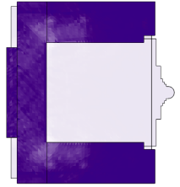 | 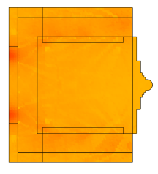 | 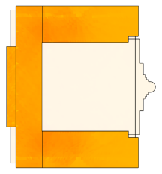
MUI-B  HF | 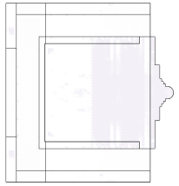 | 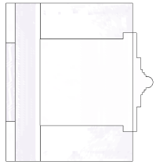 | 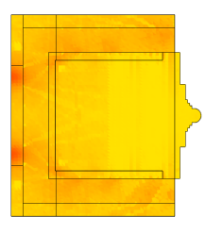 | 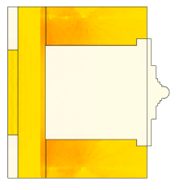
MUI-B  F | 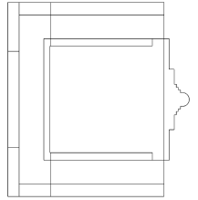 | 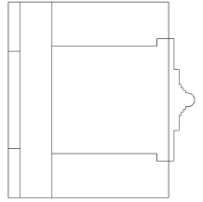 | 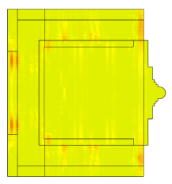 | 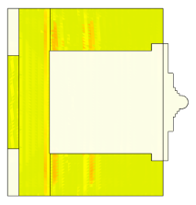

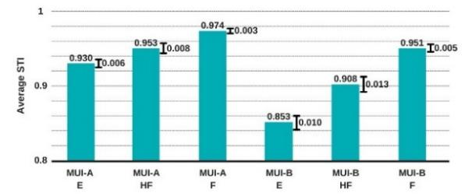

Figure 9. STI average in Masjid UI

Overall, the STI values for both model MUI-A and model MUI-B fall within the range of 0.9 (Fig. 9). The STI values in model MUI-B are slightly lower than in model MUI-A, with model MUI-B_E having the lowest average STI of 0.853. As the number of worshippers increases, the STI values improve in both types of mosques. The increase in worshippers also narrows the gap in average STI between model MUI-A and model MUI-B. When empty, models MUI-A and MUI-B have an STI difference of approximately 0.08, whereas when full, they only differ by 0.02.

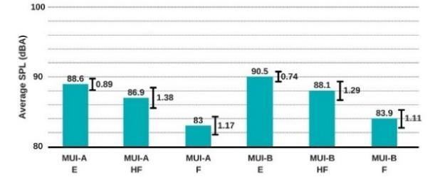

Figure 10. SPL average in Masjid UI

In the SPL (Sound Pressure Level) simulation, SPL calculations were conducted after the sound had reflected once within the room. Overall, the SPL values range between 83 and 90 dBA (Fig. 10). Additionally, model MUI-B exhibits a slightly higher average SPL than model MUI-A, with 1 dBA difference. As the number of worshippers increases, the SPL values decrease in both types of mosques. The distribution of SPL in both models was uniform, indicating no significant variation in SPL intensity across the entire area, as observed in the sound distribution pattern in Table 2. High variations only occur at points near the loudspeakers.

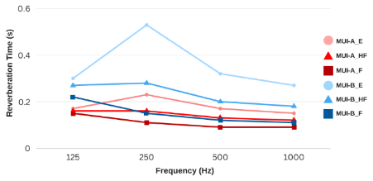

Figure 11. RT average in Masjid UI

In the Reverberation Time (RT) simulation, overall, model MUI-B exhibits slightly higher RT values (Fig. 11). The RT values for both models are relatively small, with values below 0.5 seconds, except for MUI-B_E, where the RT at a frequency of 250 Hz reaches 0.53 seconds. As the number of worshippers increases, the RT values decrease in both types of mosques. Furthermore, with more worshippers, the RT difference between model MUI-A and model MUI-B becomes smaller. At a frequency of 250 Hz in an empty room, the RT difference between model MUI-A and model MUI-B is 0.3 seconds. However, in a fully occupied room at the same frequency, the RT difference is only 0.04 seconds.

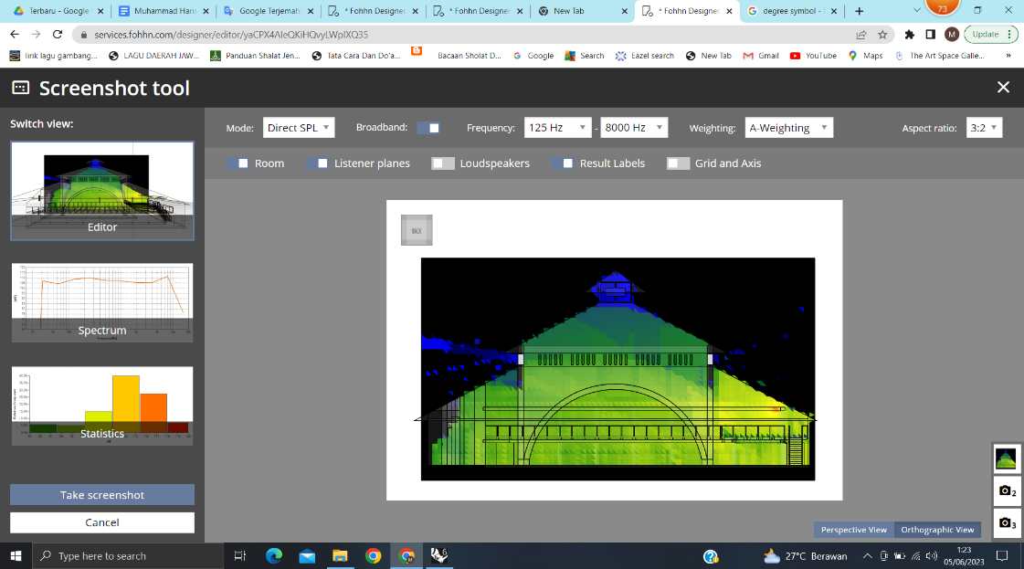

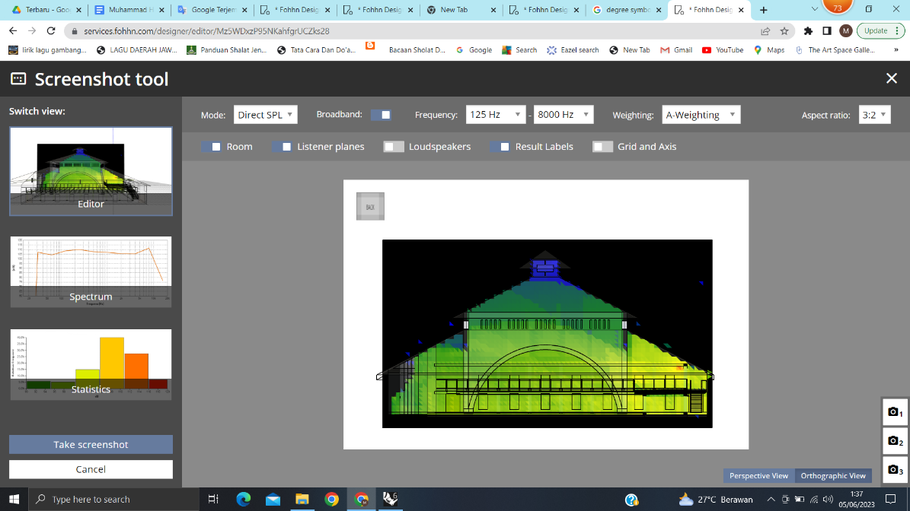

Figure 12. The distribution of SPL through sectional diagrams in the MUI-A model (top) and the MUI-B model (bottom)

Looking at the vertical distribution of SPL, there was no significant difference between model MUI-A and model MUI-B (Fig. 12). Both models exhibit standard deviations exceeding the acceptable standard of 3 dBA (see Table 2). In model MUI-A, the average SPL value was 72.60 dBA with a standard deviation of 8.68 dBA, while in model MUI-B, the average SPL value was 74.29 dBA with a standard deviation of 6.30 dBA. Both models indicate that the vertical sound intensity in the case study was not very high, except in the area near the loudspeakers in the corridor. The roof areas of both models also did not exhibit high sound intensities. The only difference was the presence of some sound escaping through the open façade of model MUI-A. This analysis indicates that vertically, the sound coverage of both models was inadequate, as evidenced by the high and non-uniform deviation across all areas.
Summarizing all the data, almost all parameters exhibited by MUI-A and MUI-B were within the recommended range, except the vertical SPL standard deviation coverage, as shown in Table 4.

Table 4. Comparison of the measured value of STI, SPL, RT, and BN from observation and simulation with the recommended value in Masjid UI
Parameter | Value |  |  |  |  |  | Recommended
Parameter | MUI-A  E | MUI-A  HF | MUI-A  F | MUI-B  E | MUI-B  HF | MUI-B  F | Recommended
STI | 0.930 | 0.953 | 0.974 | 0.853 | 0.908 | 0.951 | STI >0.68 [25]
SPL standard deviation coverage horizontally  (dBA) | 0.89 dBA | 1.38 dBA | 1.17 dBA | 0.74 dBA | 1.29 dBA | 1.11 dBA | <3 dBA [32]
SPL standard deviation coverage vertically  (dBA) | 8.68 dBA |  |  | 6.30 DBA |  |  | <3 dBA [32]
RT Average  (seconds) | 0.180 s | 0.143 s | 0.110 s | 0.355 s | 0.233 s | 0.150 s | 2.1 seconds [19]
BN  (NC level) | NC 30 | NC 30 | NC 30 | NC 30 | NC 30 | NC 30 | NC 25 to NC 30 [27]
Note: A green background in the table indicates that the value is within the recommended range, while a red background indicates that the value exceeds the recommended range.

  - BACKGROUND NOISE
Background noise (BN) in the case study area was primarily dominated by the frequency of 250Hz, indicating that most noise around the mosque was generated by vehicles, as vehicles typically produce low-frequency sounds [33]. According to Othman [16], the background noise level has a significant impact on the comfort of worshipers. However, despite the vehicle noise, the BN levels in both models remained within the NC standard for places of worship, specifically NC 30 [23, 27]. This low level of BN also resulted in a high signal-to-noise ratio (SNR) within the mosque. SNR measures the ratio between the desired main sound and interfering noise, and a higher SNR signifies better sound quality [34]. In simpler terms, lower BN contributed to improved sound quality inside the mosque.
The low BN levels in the case study area were attributed to external and internal factors. Externally, the distance from the mosque to the roads and the surrounding vegetation were two potential factors that could impact BN levels [35]. In addition to being relatively far from the road area, a significant amount of vegetation separates the sound sources from the Masjid UI area. Previous studies show that vegetation can reduce BN levels [35]. According to Ow [36], vegetation with a depth of 5 meters may reduce BN by 9-11 dB. Although not by a significant margin, these two factors could contribute to the reduction of BN levels in the mosque.
Internally, the material of the mosque's corridor walls influenced the BN levels. The corridor walls of Masjid UI are entirely made of red bricks. Granzotto [37] found that red brick walls can reduce sound intensity by 40-45 dB for low-frequency sound, such as vehicle noise, which is the primary noise source around the mosque. Utilizing red brick walls means the case study object had a significant BN reduction factor. The combined BN reduction resulting from both external and internal conditions in the mosque led to low BN levels, which had minimal impact on its acoustic conditions.

D. SOUND PRESSURE LEVEL
With a standard deviation of SPL distribution horizontally below 3 dBA, both case study models, serving as places of worship, exhibit excellent sound coverage [23, 32]. One aspect to note is that the vertical SPL distribution exceeding the standard should not be a concern, as there are no worshippers on the upper levels of the mosque, given that the mosque is only two stories high. A key factor contributing to this excellent sound coverage is the fact that the loudspeakers are positioned close to the worshippers and evenly distributed throughout the mosque, thereby enhancing the signal-to-noise ratio (SNR) [23]. Furthermore, the mosque's geometry features a square floor plan, which is an optimal shape for creating uniform sound distribution [18]. With good sound coverage, it means that the case study mosque has fulfilled one of the expected qualities for the comfort of worshippers [16, 23].
Additionally, the use of reflective materials and the enclosed condition of the space result in model MUI-B having a higher SPL than model MUI-A [17]. However, the difference is insignificant due to the good sound coverage, with all models and scenarios exhibiting below 1.5 dBA of SPL standard deviation (see Table 4). Furthermore, room occupancy has a significant impact on the intensity and distribution pattern of SPL. Elkhateeb [38] explains that the density of worshippers during prayer is 0.8 m² per worshipper, with a distance of 1.2m between rows. Humans are strong sound absorbers in all positions of prayer, with absorption coefficients ranging from 0.54 to 0.7 at mid-frequency when worshiping on a carpet [39]. This means that when prayer occurs in a full scenario, the sound intensity is slightly lower than in the half-full scenario due to the sound being absorbed by more worshippers [38]

- REVERBERATION TIME
Reverberation time (RT) at a frequency of 250 Hz varies in each scenario compared to other frequencies. This is because the materials' average absorption coefficient values at a frequency of 250 Hz are low. Hence, the materials do not absorb sound effectively at this frequency [19]. As a result, sound tends to reflect around the room impacting reverberation during worship. Male voices, such as those of the imam and preacher in the mosque, typically have low-frequency components in the 90-200 Hz [40]. Hence, the RT value at 250 Hz represents the reverberation that occurs during prayer.
As observed in the distribution of SPL, the RT values decrease as the number of worshippers increases [39]. Sound becomes less likely to reflect around in a crowded room, resulting in RT values that are not significantly different in the full scenario for both mosque models.

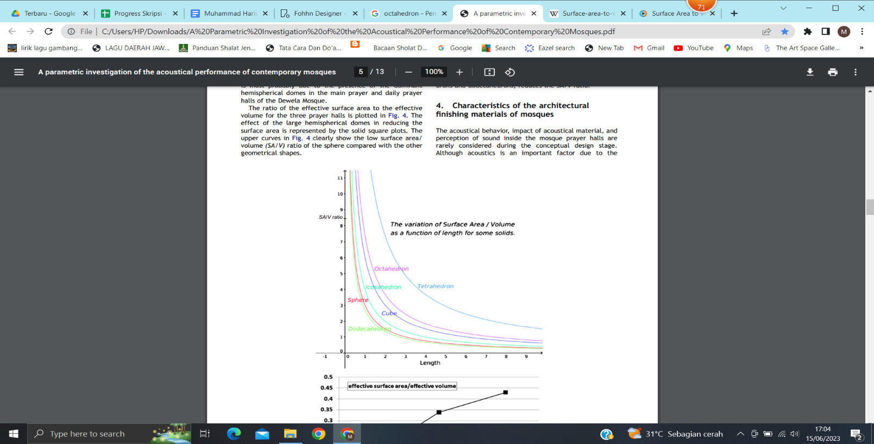

Figure 13. The diagram compares SA/V for each geometry. [19]

Next, the Reverberation Time (RT) in both mosque simulation models is relatively small and corresponds to the standards presented in Table 4 [19]. In a previous study conducted in enclosed mosques, the RT value usually exceeded 1 second [27]. In contrast, in the case study, the highest RT value reaches only 0.53 seconds at a frequency of 250 Hz. The low RT value is due to the roof design of Masjid UI, which is not a dome but a pyramidal roof (tajug/limasan). Ismail [19] explained that a roof's ratio of surface area to volume (SA/V) affects its absorption capabilities. The lower the SA/V ratio, the lower the absorption (Fig. 13). The roof of the study object is a pyramidal roof (a truncated octahedron) with a relatively high SA/V compared to the typical dome-shaped mosque roof [19]. This implies that the pyramidal roof has greater absorption, resulting in a lower RT in the mosque compared to a dome-shaped roof.

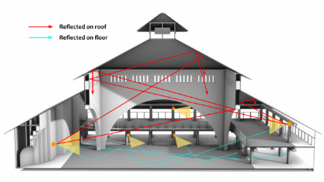

Figure 14. Sound reflection within the interior space of Masjid UI

Moreover, the loudspeakers are directed towards the central area, which lacks walls, as well as towards the carpet and the worshippers, both of which act as sound absorbers [19, 39]. This arrangement minimizes sound reflections within the room (Fig. 14). By positioning the loudspeakers in this manner, the areas of the ceiling that could potentially reflect sound do not produce significant sound reflections, resulting in low RT values in both mosque models.

- SPEECH TRANSMISSION INDEX
The IEC standard released in 2011 explains that STI values above 0.75 fall into the "excellent" category, representing the highest level of intelligibility [26]. All STI values in both simulation models fall into this category, indicating that the mosques have high STI performance (see Table 4). The high STI values in both models are partly due to the background noise (BN) level in the study area, which complies with the standard, i.e., NC 30 [23], minimizing its effect on STI.
In addition to BN, the distribution of SPL in both mosque models also plays a supporting role. Due to the good sound coverage in the mosques, the signal-to-noise ratio (SNR) becomes high [23]. This is further supported by the low BN values, resulting in a higher SNR because BN is a divisor in the SNR formula [41]. In the formula for calculating STI, SNR is one of the variables, and when its value increases, STI also increases [34]. This leads to high STI values in both mosque models.
Reverberation time also affects STI. STI in closed mosques is lower than in open mosques because sound reflects more inside closed spaces, increasing RT and affecting sound clarity [19]. However, the difference in STI remains small, because STI remains above the value of 0.8, which is classified as high STI according to the 2011 IEC standard [26].
Worshipper occupancy, which affects the SPL and RT values, creates a consistent relationship with STI. The higher the number of worshippers within the mosque, the higher the STI value [38]. This relationship is important because mosques are typically not used empty but with worshippers. When prayers are conducted, scenarios such as half-full or full occur more often. This causes the STI to consistently increase when the space is used for prayers, to the extent that MUI-A and MUI-B have equivalent STI values when the mosque is fully occupied. However, the STI is still influenced by the level of spatial openness, as overall, STI in MUI-A is slightly higher than in MUI-B, especially when both are empty.
Furthermore, it is noteworthy that within the context of worship in mosques, particularly during Friday sermons (khutbah), a high Speech Transmission Index (STI) is required. According to Elkhateeb et al. [38], Quranic recitation has a relatively slow word-per-second rate during prayers, making it acceptable to have some reverberation. In fact, according to Elkhateeb and Ismail [42], reverberation during prayers can enhance the sense of devotion. However, this differs for the sermon (khutbah), which has a relatively fast word-per-second rate. Therefore, excessive reverberation should be avoided in the sermon space to ensure the speaker's voice is heard clearly [38].

- CONCLUSION
This study demonstrates that mosques with open designs exhibit slightly higher speech intelligibility levels than those with closed designs, although the difference is not particularly significant. Generally, prayer in mosques involves worshippers who act as sound absorbers, which helps enhance speech intelligibility, especially if the initial acoustic quality of the mosque is poor. The simulation models in this research support the previously established theory that employing roofs with a large surface area-to-volume ratio and placing loudspeakers in appropriate locations can evenly distribute sound throughout the space, thereby improving speech intelligibility. However, although this study proves that whether a mosque is open or closed does not significantly impact speech intelligibility, this conclusion may not generalize to mosques with different volumes, geometries, and loudspeaker placements. Thus, the most effective approach is to incorporate acoustic considerations into the mosque's initial design process to ensure excellent acoustic quality.

ACKNOWLEDGEMENT
This research was made possible with the support of the Indonesia Endowment Fund for Education (LPDP), under the Ministry of Finance of the Republic of Indonesia, through Grant Identification Number 202404220201478.

REFERENCES

- Pew Research Center, "The Future of World Religions: Population Growth Projections, 2010-2050," Pew Research Center, 2 April 2015. [Online]. Available: https://www.pewresearch.org/religion/2015/04/02/religious-projections-2010-2050/. [Accessed 7 July 2024].
- J. M. Nejad, H. Azemati and A. S. H. Abad, "Investigating Sacred Architectural Values of Traditional Mosques Based on the Improvement of Spiritual Design Quality in the Architecture of Modern Mosques (Case Study: Traditional Mosques in Iran)," Int. J. Architect. Eng. Urban Plan, vol. 29, no. 1, pp. 47-59, 2019.
- R. S. M. Haerdy and H. E. Kusuma, "The Relationship Between Mosque Characteristics, Activities, and Perceptions of Spiritual Values," Journal of Islamic Architecture, vol. 7, no. 1, pp. 19-27, 2022. DOI: https://doi.org/10.18860/jia.v7i1.1308

- M. S. Barliana, "Perkembangan arsitektur masjid: Suatu bentuk transformasi dan ruang," HISTORIA, vol. 9, no. 2, 2008.
- I. A. F. I. Wirakusumah, "The dynamics of meaning in mosque architecture: A study of old and modern mosques in West Java Indonesia. Case study: Sang Cipta Rasa Mosque-Cirebon and Salman Mosque-Bandung," ARTEKS; Jurnal Teknik Arsitektur, vol. 7, no. 1, pp. 143-154, 2022. DOI: https://doi.org/10.30822/arteks.v7i1.1457
- M. Frishman and H.-U. Khan, The mosque: History, architectural development & regional diversity new ed edition, New York: Thames & Hudson Ltd., 2002.
- R. T. Novita, L. H. Sari and A. Ariatsyah, "An Appraisal of Indoor Thermal Comfort In A Naturally-Ventilated Modified Old Mosque in Banda Aceh, Indonesia," Journal of Islamic Architecture, vol. 7, no. 3, pp. 364-370, 2023. DOI: https://doi.org/10.18860/jia.v7i3.17131
- N. Utaberta, K. A. Kosman and A. S. M. Tazilan, "Tipologi Reka Bentuk Masjid Tradisional di Indonesia," International Journal of the Malay World and Civilisation, vol. 27, no. 2, pp. 229-245, 2009.
- A. K. Rad, M. Zarei, H. R. Pourghasemi and J. P. Tiefenbacher, "The COVID-19 crisis and its consequences for global warming and climate change," Computers in Earth and Environmental Sciences, pp. 377-385, 2022. Doi: https://doi.org/10.1016/B978-0-323-89861-4.00006-3
- P. Romano, E. Prataviera, L. Carnieletto, J. Vivian, M. Zinzi and A. Zarrella, "Assessment of the Urban Heat Island Impact on Building Energy Performance at District Level with the EUReCA Platform," Climate, vol. 9, no. 3, p. 48, 2021. Doi: https://doi.org/10.3390/cli9030048
- D. P. Sari, "A Review of How Building Mitigates the Urban Heat Island in Indonesia and Tropical Cities," Earth, vol. 2, no. 3, pp. 653-666, 2021. DOI: https://doi.org/10.3390/earth2030038
- D. Susanto, G.A.F. Rahayu "Daylight Analysis in Low-Cost Apartments in Jakarta," in 2018 2nd International Conference on Smart Grid and Smart Cities (ICSGSC), Kuala Lumpur, 2018.
- S. Torresin, R. Albatici, F. Aletta, F. Babich, T. Oberman and J. Kang, "Acoustic Design Criteria in Naturally Ventilated Residential Buildings: New Research Perspectives by Applying the Indoor Soundscape Approach," Applied Sciences, vol. 9, no. 24, 2019. DOI: https://doi.org/10.3390/app9245401.

- E. Azar, W. O’Brien, S. Carlucci, T. Hong, A. Sonta, J. Kim, M. S. Andargie, T. Abuimara, M. E. Asmar, R. K. Jain, M. M. Ouf, F. Tahmasebi and J. Zhou, "Simulation-aided occupant-centric building design: A critical review of tools, methods, and applications," Energy and Buildings, vol. 224, 2020. DOI: https://doi.org/10.1016/j.enbuild.2020.110292 .
- N.-G. Vardaxis, D. Bard and K. P. Waye, "Review of acoustic comfort evaluation in dwellings—part I: Associations of acoustic field data to subjective responses from building surveys," Building Acoustic, vol. 25, no. 4, pp. 151-171, 2018.DOI: https://doi.org/10.1177/1351010X18762687
- A. R. Othman, C. M. Harith, N. Ibrahim and S. S. Ahmad, "The importance of acoustic design in the mosques towards the worshipers’ comfort," Procedia - Social and Behavioral Sciences, vol. 234, pp. 45-54, 2016. DOI: https://doi.org/10.1016/j.sbspro.2016.10.218
- D. M. Howard and J. A. S. Angus, Acoustics and psychoacoustics (5th ed.), New York: Routledge, 2017.
- A. A. Abdou, "Comparison of the acoustical performance of mosque geometry using computer model studies," in Eighth International IBPSA Conference, Eindhoven, The Netherlands, 2003.
- M. R. Ismail, "A paramteric investigation of the acoustical performance of contemporary mosques," Frontiers of Architectural Research, vol. 2, no. 1, pp. 30-41, 2013. DOI: https://doi.org/10.1016/j.foar.2012.11.002
- S. A. Ibrahim and S. A. Hasan, "Acoustical Environment of the Al-Rabat Concert Hall in Baghdad," Civil and Environmental Research, vol. 6, no. 4, 2014.
- M. Ermann, Architectural acoustics illustrated, New Jersey: John Wiley & Sons, Inc., 2015.
- A. Jayanti and W. Widyarko, "Fast fashion synthetic fabric waste as an alternative noise absorbent material," in AIP Conference Proceedings, Vol. 2376, 2021. DOI: https://doi.org/10.1063/5.0063595.
- M. Long, Architectural acoustics, Burlington, MA: Elsevier Academic Press, 2006.
- C. E. Mediastika, Akustika bangunan: Prinsip-prinsip dan penerapannya di Indonesia, Jakarta: Penerbit Erlangga, 2005.
- NTI Audio, "Speech Intelligibility STI," December 2020. [Online]. Available: https://www.nti-audio.com/en/applications/evacuation-systems/speech-intelligibility-stipa. [Accessed 18 April 2023].
- International Electrotechnical Commission, "IEC 60268-16:2011 - Part 16: Objective rating of speech intelligibility by speech transmission index," 28 June 2011. [Online]. Available: https://webstore.iec.ch/publication/1214. [Accessed 2 May 2023].
- A. A. Abdou, "Measurement of acoustical characteristics of mosques in Saudi Arabia," The Journal of the Acoustical Society of America, vol. 113, no. 3, 2003. DOI: https://doi.org/10.1121/1.1531982
- Masjid Ukhuwah Islamiyah, "Tajuk Masjid: Sambutan Ketua Pelaksana Masjid Ukhuwah Islamiyah UI Depok," Masjid Ukhuwah Islamiyah, 17 March 2021. [Online]. Available: https://mesjidui.ui.ac.id/tajuk-masjid/. [Accessed 29 August 2023].
- J. Huyan, C. Ramkissoon, M. Laka and S. Gaskin, "Assessing the Usefulness of Mobile Apps for Noise Management in Occupational Health and Safety: Quantitative Measurement and Expert Elicitation Study," JMIR mHealth and uHealth, vol. 11, 2023. DOI: 10.2196/46846
- S. Kimihiro, S. Fumiaki and O. Akira, "Use of mobile devices with multifunctional sound level measurement applications: Some experiences for urban acoustics education in primary and secondary schools," Urban Sci., vol. 3, no. 4, 2019. DOI: https://doi.org/10.3390/urbansci3040111
- Fohhn, "Fohhn Designer," Fohhn, 27 March 2020. [Online]. Available: https://www.fohhn.com/en/products/fohhn-designer. [Accessed 2 May 2023].
- H. A. Akil and B. Basuki, "ROOM ACOUSTIC IMPROVEMENT FOR OPENING AND CLOSING CEREMONIES ON TRAINING COURSE THROUGH RENOVATION AT PUSBINDIKLAT LIPI," Jurnal Instrumentasi , vol. 40, no. 1, pp. 29-41, 2016.
- Y. Liu, Y. B. Jia, X. J. Zhang, Z. C. Liu, Y. C. Ren and B. Yang, "Noise Test and Analysis of Automobile Engine," Applied Mechanics and Materials, vol. 307, pp. 196-199, 2013. DOI: https://doi.org/10.4028/www.scientific.net/AMM.307.196

- L. Galbrun and K. Kitapci, "Accuracy of speech transmission index predictions based on the reverberation time and signal-to-noise ratio," Applied Acoustics, vol. 81, pp. 1-14, 2014.
- W. Widyarko, "The Acoustic quality of Sekolah Alam Classroom (Case: Sekolah Alam Bandung)," International Journal on Livable Space, vol. 5, no. 1, p. 33–40, 2020.
- L. F. Ow and S. Ghosh, "Urban cities and road traffic noise: Reduction through vegetation," Applied Acoustics, vol. 120, pp. 15-20, 2017. DOI: https://doi.org/10.1016/j.apacoust.2017.01.007
- N. Granzotto, A. D. Bella and E. A. Piana, "Prediction of the sound reduction index of clay hollow brick walls," Building Acoustics, vol. 27, no. 2, pp. 1-14, 2020. DOI: https://doi.org/10.1177/1351010X20903144
- A. Elkhateeb, A. Adas, M. Attia and Y. Balila, "The acoustics of masjids, why they differ from the classical speech rooms," in Conference: The 22nd International Congress on Sound and Vibration, Florence, 2015.
- M. Sabbagh and A. Elkhateeb, "Effect of body posture on sound absorption by human subjects," Applied Acoustics, vol. 183, 2021. DOI: https://doi.org/10.1016/j.apacoust.2021.108317
- R. C. Oliveira, A. C. Gama and M. D. Magalhaes, "Fundamental Voice Frequency: Acoustic, Electroglottographic, and Accelerometer Measurement in Individuals With and Without Vocal Alteration," Journal of Voice, vol. 35, no. 2, pp. 174-180, 2021. DOI: https://doi.org/10.1016/j.jvoice.2019.08.004
- A. Weisser and J. M. Buchholz, "Conversational speech levels and signal-to-noise ratios in realistic acoustic conditions," The Journal of the Acoustical Society of America , vol. 145, p. 349, 2019.
- A. Elkhateeb and M. R. Ismail, "Sound from the past: The acoustics of Sultan Hassan Mosque and Madrasa," Building acoustics, vol. 14, no. 2, pp. 109-132, 2007. DOI: https://doi.org/10.1260/135101007781448037

