 |  | JOURNAL OF ISLAMIC ARCHITECTURE  P-ISSN: 2086-2636 E-ISSN: 2356-4644  Journal Home Page: http://ejournal.uin-malang.ac.id/index.php/JIA
EXPLORING ONTOLOGY OF ARCHITECTURAL ISLAMIC ELEMENTS TO INTERPRET BLIDEN HERITAGE THROUGH ADAPTIVE PATTERNS
Tiar Manel Djazia^{a*}, Farhi Abdallah^{b}
ªInstitute of Architecture and Urban Design, University of Blida 1, Blida, Algeria
^{b}Department of Architecture University of Mohamed Khider, Biskra, Algeria
*Corresponding Author: t.dj.manel@gmail.com
ARTICLE INFO |  |  | ABSTRACT
Volume: 8  Issue: 1  Page: 117-139  Received: October 20th, 2023  Accepted: January 12th, 2024  Available Online: June 15th, 2024  DOI:  http://dx.doi.org/10.18860/jia.v8i1.23881 |  |  | This article relates the traditional housing in an Algerian Islamic city called Blida. Its rich heritage is starting to disappear due to unaware destruction. To preserve its architectural heritage, we propose an experimental ontology of knowledge. It focuses on its mixed architecture's morphological and conceptual qualities to promote a new design adapted to the historic landscape. We have developed a heuristic method. It combines an analog approach with a digital tool. This method is structured from a spatio-temporal process for perceiving architectural language. The analysis of the characteristics begins through a morphological method constitutes the data collection phase of the ontology. Interpreting conceptual qualities concerning natural light is the second step for translation: the information phase. The development of operative paradigms constitutes the third stage for the perception of the learning phase. The resulting diagram illustrates the generative process with semantic modelling in a meaningful protocol. The result of morphology is representative sheets for artefacts, informed by its Morphological context and the sustainable design. Then, the result of the interpretation is the Eco models in qualified sheets represented through adaptive patterns. This protocol forms the conceptual basis of the knowledge ontology.  Keywords:  Islamic heritage; traditional housing; morphological analysis; significant interpretation; adaptive patterns

- INTRODUCTION

  - ARCHITECTURAL ELEMENTS AS SIGNS OF AN IDENTITY-FORMING HERITAGE
The site's history, with its symbolic and emotional charge, represents the potential that can and must be a source of inspiration for creating new values at the historical site [1]. Knowledge of the architectural elements that make up the historical center requires their study and documentation to preserve them as a testimony to a national architectural and cultural identity. Studying these elements has multiple meanings and depends on their historical context and climatic adaptations. Their symbolism is interesting to analyze and decipher, as their significant interpretation reveals past techniques in response to environmental conditions. The significant interpretation mainly concerns visual (morphology and luminosity) and emotional (culture and history of the place) perception.

  - THE ENDURING MORPHOLOGICAL AND CONCEPTUAL CHARACTERISTICS OF THE ELEMENTS
The historical context is crucial for the identification of morphological features. Natural light and sun protection measures are considered decisive factors for visual perception in the world of ideas. Indeed, these architectures integrate various natural lighting devices and are references for quality architecture. Several specialized studies recommend the construction of solid architecture adapted to the climate and inspired by the characteristics of traditional houses. The criteria used are exposure to natural light, “the morphology of cavities to promote air circulation, the orientation and typology of buildings to optimize natural ventilation, etc., the art of rethinking existing structures, a redesign of the discipline” [2].

  - THE CONSTRUCTION OF AN EXPERIMENTAL APPROACH TO RECOGNITION AND PERCEPTION
To contribute to the design of a new architecture through the development of meaningful architectural models, tools and approaches must be developed to match those of the sustainable architectural design market [3]. The important role that architectural elements play in defining recognizable contemporary architecture is also the result of several recent studies on which architecture should be meaningful and not anonymous, as perception is crucial for the degree of acceptance and belonging [4]. “New or rehabilitated architecture becomes an important factor through the communication it generates, its acceptance given by the public or its identity and cultural recognition by citizens” [5]. However, the design process of this architecture should not be a reproduction of old forms and styles. Rather, it is a plastic exercise (form and structure) in which ethics and deontology are essential [6].

  - RESEARCH AIM
We aim to establish an experimental method for preserving and knowing an adapted heritage in a historical center. This knowledge will promote the implementation of a useful database that will contribute to the conception of a new architecture. In addition, our research will provide important support for rehabilitating traditional residential buildings. The method relies on analysis and evaluation tools to propose conceptual solutions that meet morphological, technical, and climatic adaptation requirements.

- METHODS

- PERCEPTION APPROACH OF ARCHITECTURAL LANGUAGE BY SPATIOTEMPORAL PROCESS
To define the significant paradigms for the historical context, we initiate the methodological approach using narrative semiotics to define a spatiotemporal process [1] of reading architectural language (Fig. 1). According to Vitruvius' definition [7], architectural knowledge about an object is acquired through practice (fabric) and through theory (ratiocination). Practice is based on a reflective "preparation" of the material from creation to drawing. The theory takes architectural design as its subject. It illustrates the proportions, qualities, and design of what is being made. For Vitruvius, the project precedes the building. It is a proposal to which a secondary meaning is given by the relationship of the building to a certain knowledge. The building is a proper measure of the objects between their use and difference from the models. As such, the canonical model of narrative semiotics does not apply to architectural space. An imbalance in this model is an introduction to finding a heuristic to develop a grammar of forms appropriate to space and tools for its analysis. A grammar of normative form should be such that it specifies "semantic components and the rules of their assembly; a syntax that gives motivation to the arbitrary" [8]. Spatio-temporal patterns determine actions. These methods articulate concepts with images so that diagrams precede concepts.

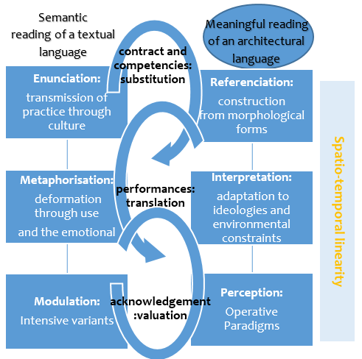
Figure 1. Comparative Perception Diagram
- NECESSITY OF A COGNITIVE DIAGRAM FOR EFFECTIVE PERCEPTION
The project in architecture moves from the form of the container to that of the content (semiotics in architecture). The content in vertical forms represents the substitution values and the references; these are the paradigms. The horizontal content represents the translation values and metaphors; these are the syntagmatics. On the diagonal, it is the angles, the dialogical, and the score values; these are the metonymies. At the first level of articulation, the elements are assembled into a whole organized group according to grammar by emphasizing operations endowed with meaning. The composition of these elements is not only geometric, physical, or aesthetic but responds to the intended uses according to visual values. However, the creative architect must go beyond the acquired codes. The algorithmic nature of the project cannot be reduced to the approach of a design automaton. It must interact with forms of thinking that spring from creative intuition and the diagrams that articulate it (action and perception) (Fig. 2).

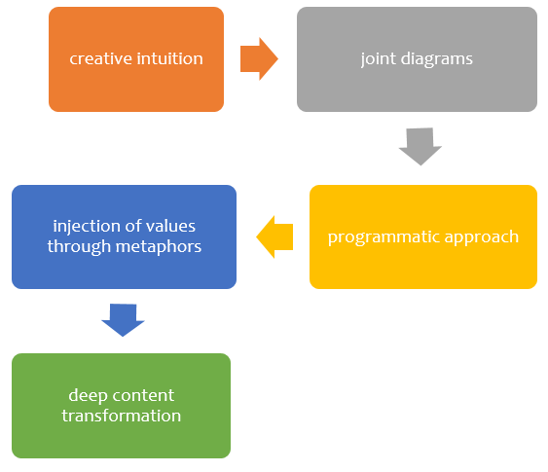
Figure 2. Diagram of thinking with perception and action

The human senses produce sensations that become ideas through recognizing and analyzing our physical and intellectual faculties (Condillac, Treatise on Sensations) [9]. Perception is achieved through our external senses (visibility and lighting) and our internal senses (memory (personal memories and values), imagination, and culture). “Architecture reflects the thoughts and feelings of the inventors” [10].

- CONSTITUTION OF THE ANALYSIS PROTOCOL TOWARDS KNOWLEDGE ONTOLOGY
Data collection
The experiment is based on a mixed approach, which combines a qualitative method concerning the characterization and valorisation of artefacts. Then, it is based on a quantitative method, which includes evaluating the illumination rate. They are structured according to the space-temporal diagram.
The first aspect of the design of knowledge ontology [11] is data collection. The morphology is the most important element that the internal perception elucidates (culture). The data are derived from the morphological characterization [1]. The importance of perceiving the values of these architectures as morphological elements lies in the practical basis of the field of parametric architectural design [12]. Analysing the formal and topological aspects of the architectural elements is an important perspective in the design we use to identify the architectural features of our heritage. We referred to a study focusing on defining form and structure in architectural design [12]. We analysed the different digital tools used in this study that emphasize the morphological and figurative aspects. Three parameters were defined: materiality, usage constraints, and formal and spatial qualities. The digital remains the most informative tool, not the analog, which is limited by the time and space of the physical world. The digital tool is the space of communication and, thus, knowledge transfer between the different actors for the collaborative design of this architecture. However, describing the figurative qualities is necessary to highlight the formal and morphological features in real time. The tools used are drawing, measuring, and sketching. Therefore, exploring the creative potential of this aspect concerning formal elaboration and the challenges of exploring mechanical quality and technological quality with their adaptive values is significant. We started our research methodology with this unified approach, which allowed us to concretize our evolutionary architectural process according to the morphology of the forms, highlighting the formal, technical, and environmental aspects (Fig. 3).

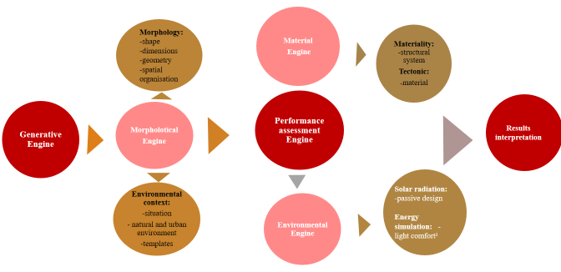
Figure 3. evolutionary process for corpus analysis

Generative engine : Morphological modelling Data collection
Based on the fieldwork we did for the architectural surveys [13] (between 2016 and 2019), in 2020, we included our Master Students II in the architecture and sustainability option. We randomly selected a set of properties from the corpus of the historic centre in Blida City according to three functional selection criteria: a single-family house, a multi-family house, and an institution. Then, a refined qualitative selection was carried out based on the architectural style according to the inside or outside of the historical context. The styles selected after the previous historical study are the Arab-Andalusian style, the Ottoman style, the Neoclassical style, the Neo-Moorish style, the Art Nouveau style, and the Art Deco style, as well as the collectively adapted houses. Their selection thus represents the artefacts of our process. We have carried out a morphological analysis depending on the context. The point is to apply the process to each selected element according to the analysis engines. According to the methodology developed, we defined three engines: the generative engine (contextual), the morphological engine, and the performance evaluation engine. We relied on a research conducted by Pr. Bernard Duprat [14] in selecting our artifacts. This research allowed us to make a significant choice of artifacts according to structural criteria and to capture comparable elements. Conferring to the researcher, the creativity of 19th-century architecture focuses on structure, while motifs are influenced by earlier productions: Antiquity, the Middle Ages, the Renaissance, and the Classical period. Through the analogy involving our historical centre, characterized by mixed architecture [13], the contextual criterion for selection is most valid given the interpretations in the different historical periods.

Performance assessment engine: Environmental evaluation and adaptation
The second step of ontology is evaluating our artefacts according to the usual point of view and selecting the elements that play a role in the façade, especially the environmental aspect and adaptation value. We began by studying passive design elements according to the various traditional fabrics to optimize natural light. Then, a quantitative evaluation of the artefacts is carried out. It is operated through the energetic evaluation of lighting comfort using the ECOTECT software on our objects modelled in REVIT and 3dsMax . After interpreting the data to determine the performance of the elements, they are presented according to the tool's specifications for modelling ECO-MOD. This tool allowed us to validate them conceptually and meaningfully using the three values of "a problem, a constraint, and a solution." Our choice of this assessment tool was made after analysing the different current tools in architectural heritage research and sustainable architecture design. To this end, we have created a synthetic diagram that structures the morphological analysis and the evaluation of the environmental performance of our architectural elements representative of the traditional fabrics. This structural diagram shows the concordance with the spatiotemporal process for meaningful perception (Fig. 4). This diagram shows the different stages of the morphological analysis applied to the two prototypes of traditional houses: the courtyard house and the patio house.

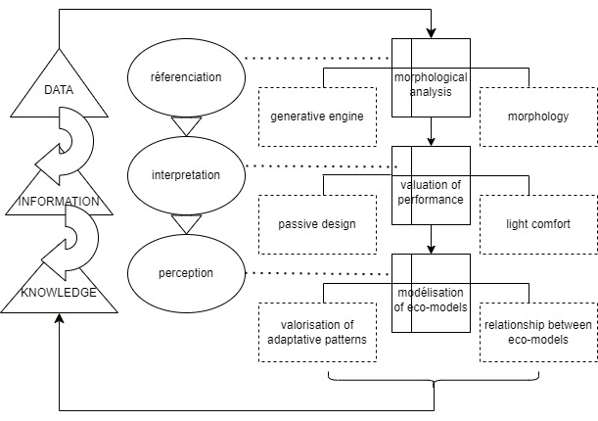
Figure 4: Structural diagram of the experimentation

- EXPERIMENT
  - Morphological modelling
The initial study allowed us to document representative sheets for each artefact, informed by its generic environment, its morphology, and the evaluation of its performance according to the passive design and energy assessment. Analytical sheets are shown, bringing together all the required information. This concerns all traditional houses representative of the architectural heritage of the city of Blida:
- The first result of this analysis is a database of each historic building representative of the architectural language of the historic centre of the city of Blida according to the evolutionary process (contextual perception).
- This data represents information according to the three historical contexts: intramural, extramural, and periphery about their situations in the context, namely; the centre, the corner, or the bank.
- The information is explanatory comments from each analysis engine (generative engine) (table 1 and table 2).
- The environmental engine materialized with the passive development (table 1a and table 2a). Moreover, demonstrative digital modelling of the information for each studied data is represented.
- The quantitative information represents the illumination rate for each historic building in each context. This is done according to the orientation, the situation, and the climatic data. (table 1b and table 2b).
After the first phase of the experimental study and the results obtained, we start the second phase of the knowledge, that of information. We moved to interpreting the analysed data to represent the eco models.
Table 1. Morphological form of courtyard house in Intramuros
Morphological  analysis | COURTYARD HOUSE
Generative  Engine | situation in the tissue | It is located in the mixed Ottoman structure with a high degree of permanence. The property is located on an important axis on the edge of the island. It is a house on the shore. | 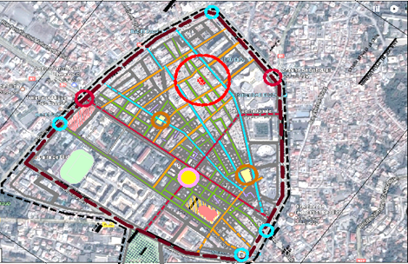
Generative  Engine | Natural and urban environment | A residential building where shops have been opened on the ground floor. It is only accessible from one side and has only one façade | 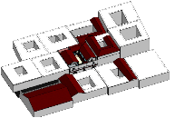  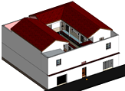
Generative  Engine | gabaris | It is a house with R+1. A compact parallelepiped volume with very few openings on the façade. | 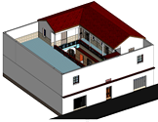  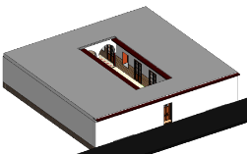
Morphology | shape | The plot has a square shape with an area of 200 m2. The building occupies the entire plot with central rectangular courtyard of 5mx 8.5m | 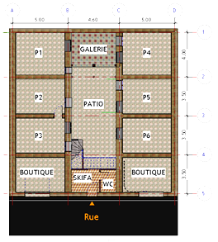  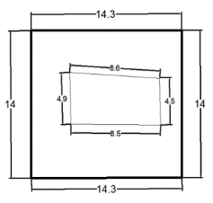  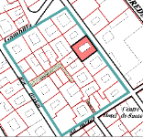
Morphology | dimensions | Built-up area of 160 m2, which is 80% of the total area. The empty area is 40 m2, which is 20% of the area
Morphology | spatial organisation | Organisation around a central courtyard, which is the organisational centre of the building | 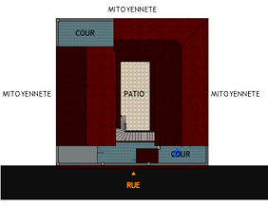  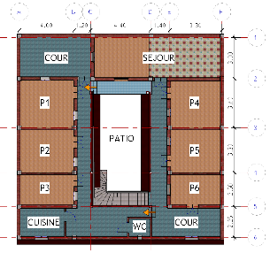
Morphology | 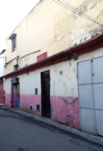  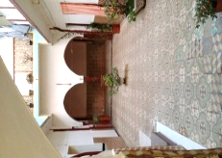  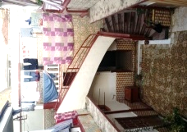  The outside staircase and the skiffa  View on the exterior facade  The Iwan and the courtyard

Table 1a. Passive design form of courtyard house in intramuros
Evaluation of performances | COURTYARD HOUSE
Generative  Engine | materiality | Material engine mixed structural  system load-bearing walls and beams columns | 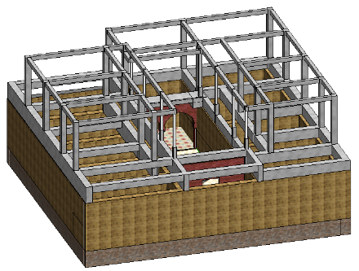  Supporting walls  Portico
Generative  Engine | tectonique | Concrete portico on the load-bearing mud walls of the old structure that becomes the support for the new one, with a vertical relationship between the two characterized by a swinging concrete staircase that occupies part of the courtyard and a timber truss roof covered with tiles. On. Heat: λ= 1.10 W⋅m-1⋅K-1 Permeability: μ= 10 Density: 1,800/ 1,900 g/m3Eco-impact: 33 co2/m3 | 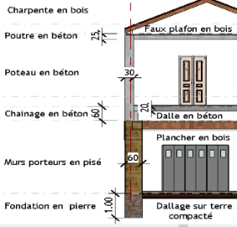  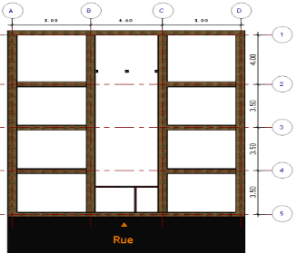
Passive design: | Lighting rate | 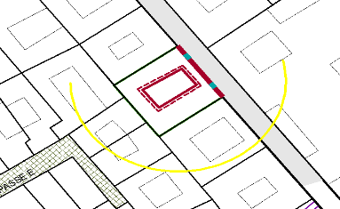  Southeast summer wind  External  façade  Internal façade  Northwest winter wind  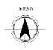 | 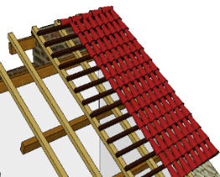  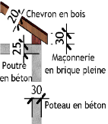  Tile  Wood laths  Wood beam  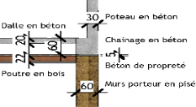  Wood frame  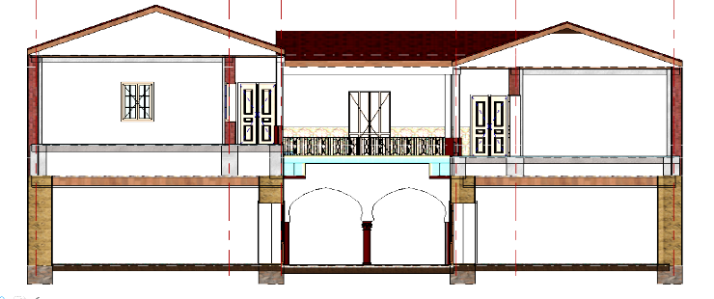  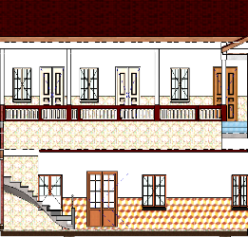
Passive design: | REVIT modelling | 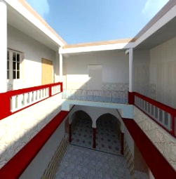  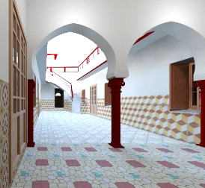
Passive design: |  | A passive design can be realized by optimizing natural light and ventilation. The house built as one story building is considerable. It has a Northeast-facing façade and the lighting problem did not arise, but currently it lacks of lighting, a U-shape, that allows the penetration of sunlight to enter the courtyard. The Southwest façade is hidden by the extension, which creates a shaded area in the Southern part of the house. | 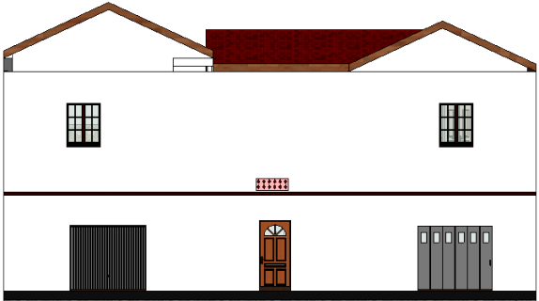  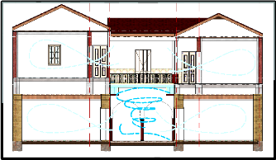

Table 1b. Light comfort form of courtyard house in Intramuros
Evaluation of performances |  | COURTYARD HOUSE
LIGHT COMFORT: | Energy simulation  The analysis of the second hybrid house revealed the presence of several areas of bright and medium Illumination. The brightest area is the central one, Which is the courtyard of the house. The moderately lit areas are the skiffa, the riwak space and some Interior spaces of the rooms. The interpretation of this is that the riwak space adds lighting and filters the sun's rays to the rooms (hierarchical reduction in Intensity). Because these spaces need medium-intensity Lighting. The skiffa is a double source of lighting for the Adjacent space. The lack of openings in the rooms causes darkness inside. It would be better to enlarge the size of the openings or place mirrors on the long facades to reflect the light on the other facades.  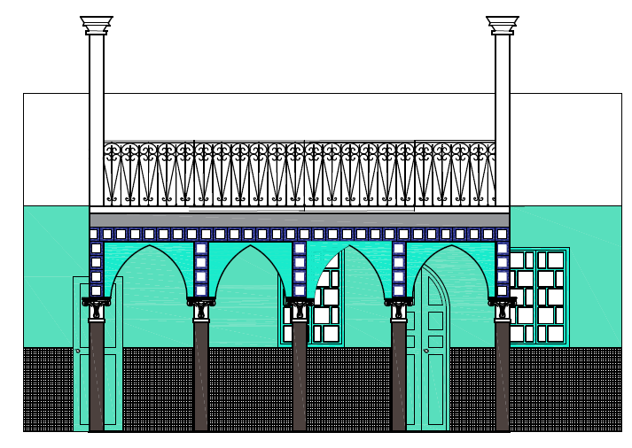  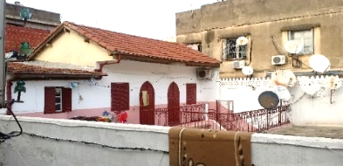  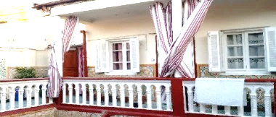  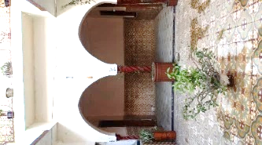  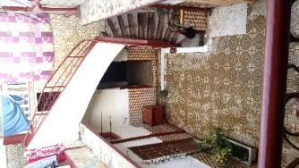  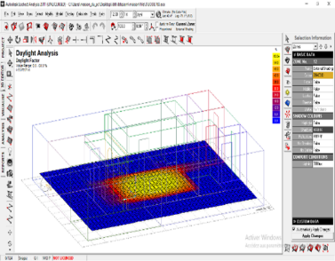  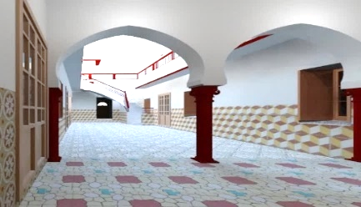  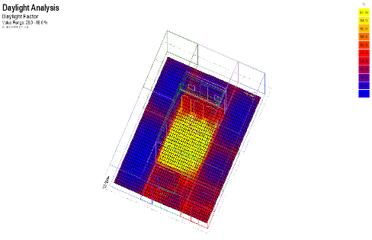  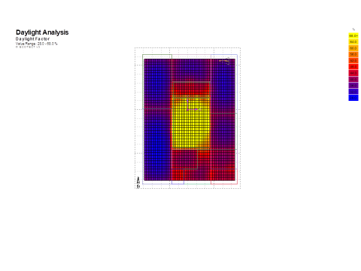

Table 2. Morphological form of patio house in extramuros
Morphological  analysis | PATIO HOUSE
Generative  Engine |  | It is located in a functionally homogeneous traditional fabric. The district called Douirette is located in the South of the historical center in its extramuros part. The house is centrally located on the urban block. | 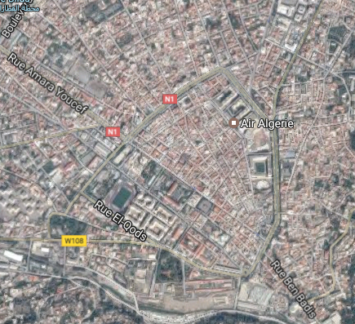  Intramuros  Extramuros
Generative  Engine | Natural and urban environment | The house is located in a dense area and terraced on three sides. It overlooks a secondary road close to a main ring road. Its access is on the street facing a green space. | 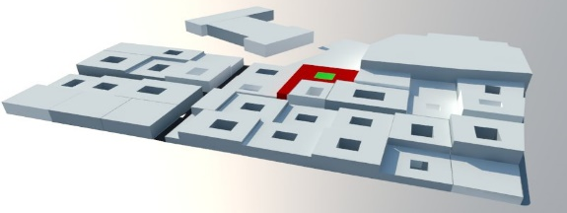
Generative  Engine | gabaris | It is in R+1 with very few openings to the outside. The void represents a surface area of 5.6m x 5.6m and a surface area of 12.38 m x 3.61m
Morphology | shape | Its shape is almost square with the addition of a parapiped volume constituting the entrance through an open space, which is a small courtyard. | 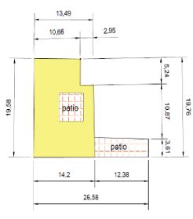  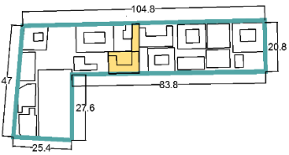  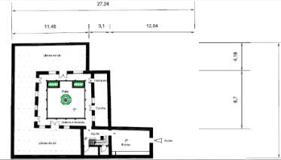
Morphology | dimensions | It is an urban block whose dimensions are as follows: 10.66m/2.95m/19.58/14.2/12.38/3.61/10.87/5.24. The study plot is located in this same island. It is made up of an entity swinging between full & empty and whose dimensions are presented as follows:  Built entity: 19.58m/14.2m/10.66m/2.95m/19.76
Morphology | Spatial organization | 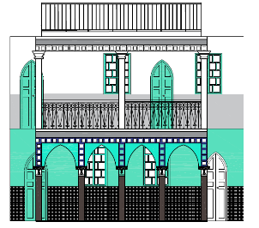  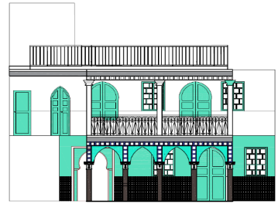  Organization around a central courtyard, which is the organizational center of the building | 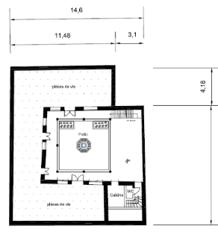  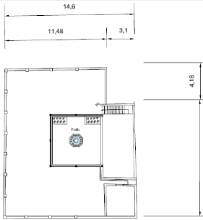
Table 2a. Passive design form of patio house in extramuros
Evaluation of performances | PATIO HOUSE
Generative  Engine  Voutain floor | materiality | Material engine mixed structural system load-bearing walls and beams columns  Materiality, structural system, method of assembly  RDC  Vertical structural system  On the ground floor: the load-bearing walls are made of rammed earth to prevent water infiltration. The upper part is built of terracotta brick. Their thickness varies between 40 and 45cm.  Presence of a supporting arcade gallery (pointed arch, capital) with reinforced concrete molding and filling with cement mortar;  Horizontal structural system;  Solid reinforced concrete slabs with steel reinforcements. Discontinuous system  On the 1st floor: Voutain floor: wooden beams + bricks  R+1 Vertical structural system  Solid brick walls. A gallery in flowerbed system with porticos in reinforced concrete molding and cement mortar filling;  Vertical structural system  in the living spaces in reinforced concrete with steel beams; Full slab in the gallery,  Discontinuous system in the living spaces (bedroom, kitchen, living room, bathrooms); Continuous system in the gallery (the porticos and the slab), a single material. | 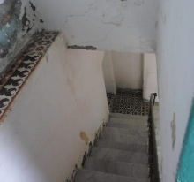  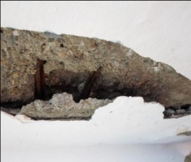  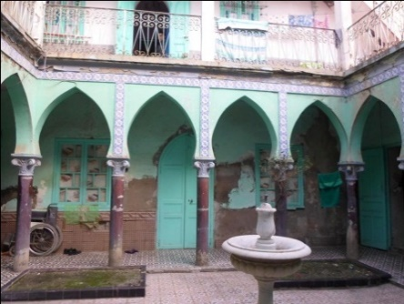  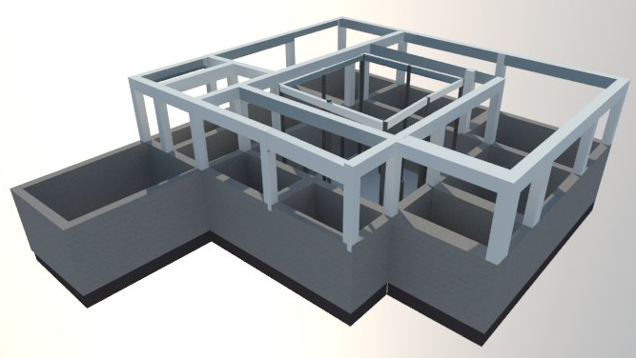  Portico  Supporting walls  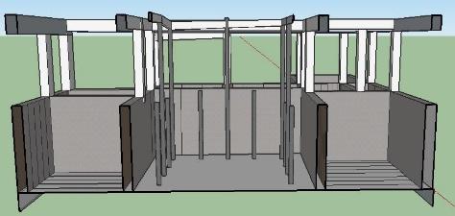  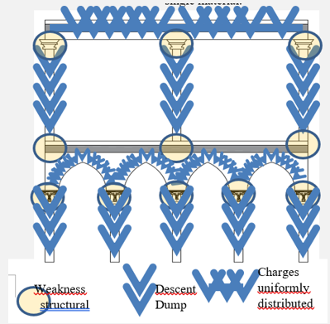
Generative  Engine  Voutain floor | tectonique  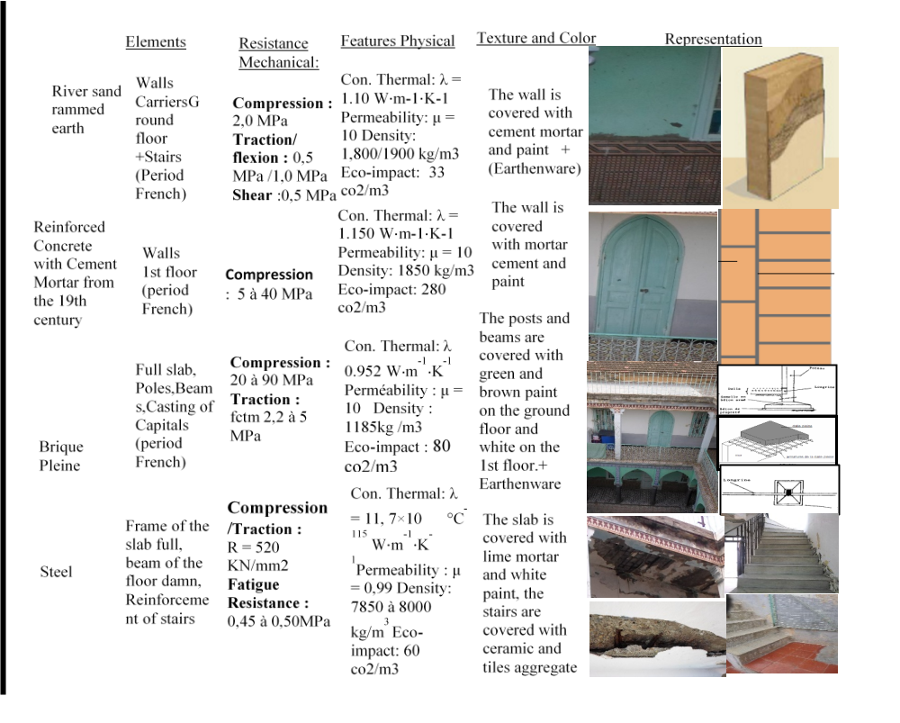 | Concrete portico on the load-bearing mud walls of the old structure that becomes the support for the new one, with a vertical relationship between the two, characterized by a swinging concrete staircase that occupies part of the courtyard and a timber truss roof covered with tiles. On. Heat: λ = 1.10 W⋅m-1⋅K-1  Permeability: μ = 10 Density: 1,800/ 1,900 g/m3Eco-impact: 33 co2/m3  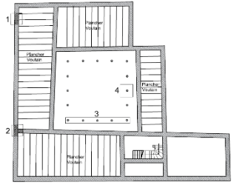  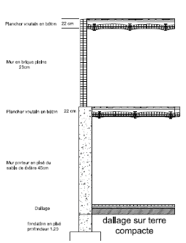  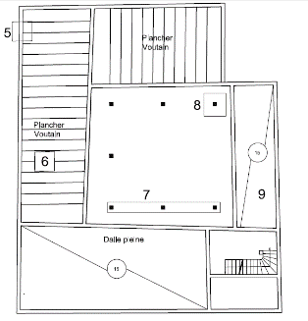  Materials  dam | 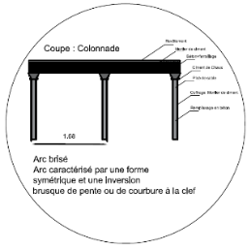  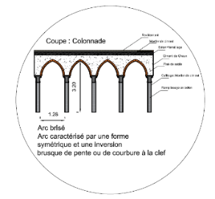  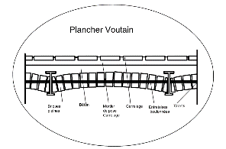  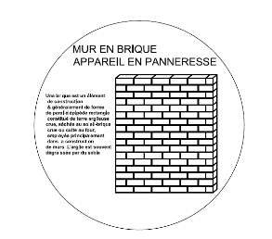  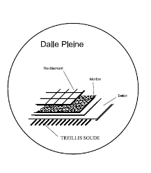  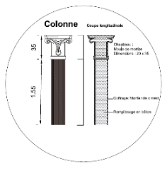  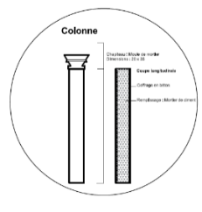  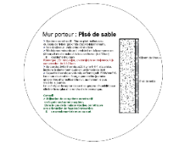  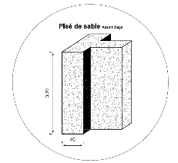
Passive design: | Lighting rate  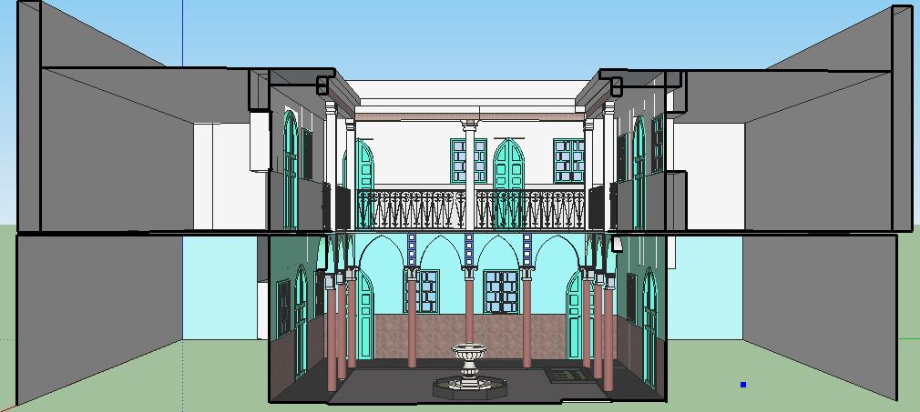  Hot air  Hot air  Hot air  Hot air  Fresh air supply  Transmission through the Patio  Cold air  Cold air  Cold air | Sud 12: 00  Est 6:00  Ouest 20: 00  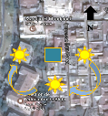 | 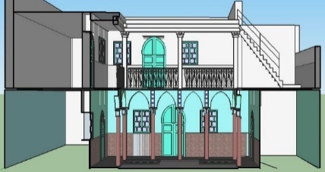  Cold air
Passive design: |  | The traditional type house is ventilated through the patio ‘central regulating element’. Ventilation of living spaces is ensured by doors and windows and air is released through elements called:  “Kamariyettes” located above the doors and it all overlooks the gallery (patio)
Passive design: | REVIT modelling | 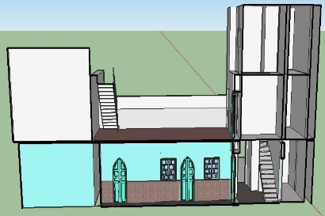 | 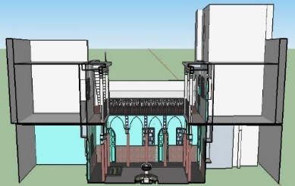
 | Sketch up/ V-Ray rendering | 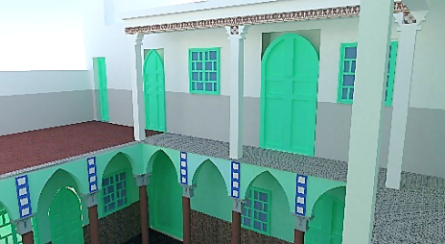 | 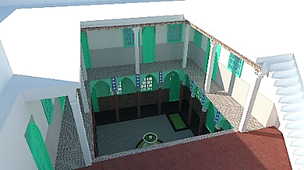

Table 2b: Light comfort of courtyard house in intramuros

Evaluation of performances | PATIO HOUSE
LIGHT COMFORT: | Energy simulation  In the extramuros, the neo-Moorish house, we note the main point of lighting through the central patio and through the surrounding arcades (presence of volumes of false colors indicating the intensity of the flow of light). We also note a significant level of lighting at Skiffa. This is because the skiffa is preceded by an open space, which opens onto a patio and therefore increases the quantity of sunlight penetrating the house. The lighting gradually decreases towards the rooms because the presence of the gallery allows this gradient of light. This is one of the goals sought in traditional houses, in order to maintain privacy in the rooms of the house and protect it from light in the hot seasons. However, a correction can increase the light in rooms while preserving their characteristics. In addition, it can be done by proposing the arrangement of horizontal and vertical windows along the walls of the rooms. This can be positive if they are placed in bright areas, given the size and large opening of the patio of this house.  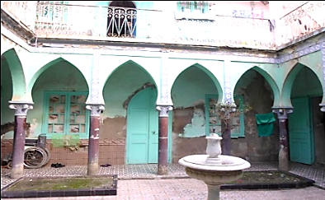  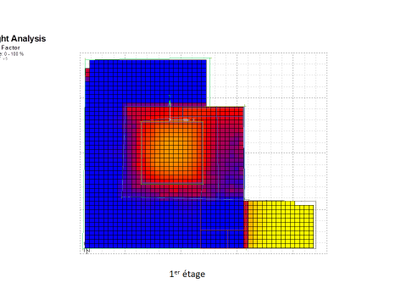  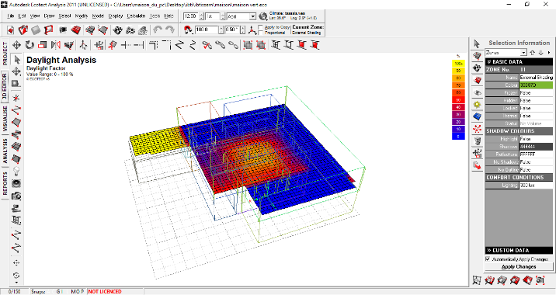

The results of our selection of eco-models are based on three axes:
(1) By generative architectural form: either in a courtyard house or in a patio house (generative engine)
(2) According to the environmental context: their location in the historical centre, intra or extramural (morphological engine)
(3) According to the performance rating, their passive design and light comfort (environmental engine)
The defined eco-models are proposed based on a selected problem, solution, and constraint. In our case, it is the problem of solar rate. These eco-models respond positively to the Ecotect digital lighting tool analysis and are found in at least three traditional designs. The eco-model is presented according to the traditional fabric and the device used for natural lighting.
The eco-models are:
(1) The courtyard house and the patio house:
(2) In the Andalusian structure, the riwak (the anti-room), the interior windows, and the chamsiyates (the claustras). The mixed Ottoman structure includes the courtyard, inner galleries, frame, and passageway.
(3) The kbouts (corbels), the mousharabiehs (mashrabiyas), and the domes are in the equipment. The buildings: courtyards and patios, bay windows, balconies and arched windows.
The relationship between the different eco-models and the impact of their choices are presented in a database space. This space contains all the information about the different solutions of the chosen eco-model. At this stage, in addition to the technical environmental assessment, an ecological reassessment takes place in terms of the advantages and limitations of the eco-model. The relationship between the eco-models can help users to understand each eco-model better. This method relies on the linguistic domain of language reading, which gives words their context (Fig. 5) that allows the reader to understand the meaning of words they are not familiar with and the designer to understand the meaning of the eco-model related through natural grammatical language using NIAM; Natural language Information Analysis Method [15].

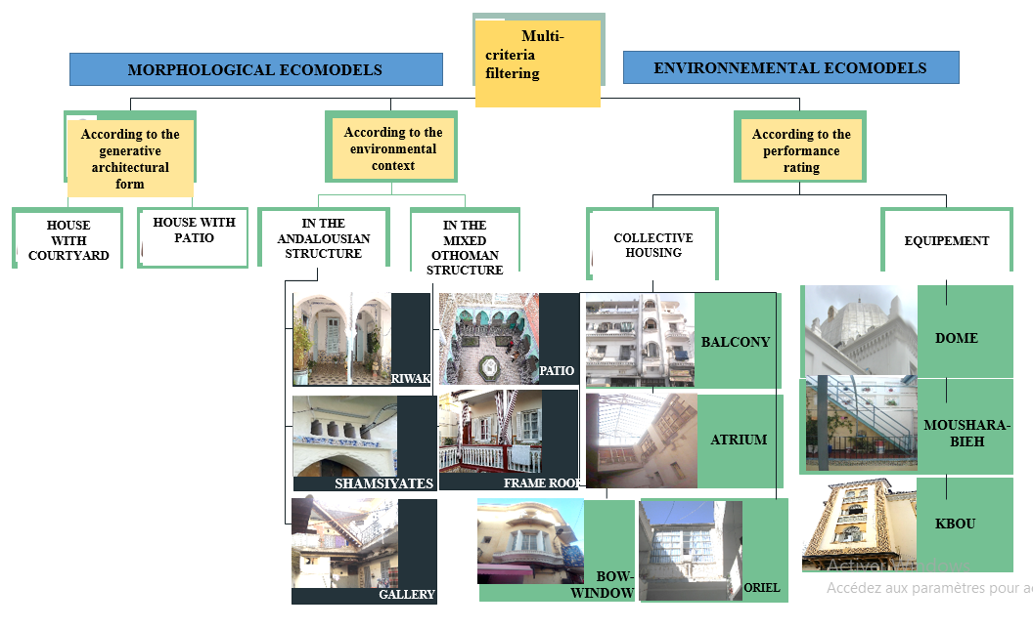
Figure 5: Eco-models validation flowchart

The relationships between the different eco-models can be inclusion, exclusion, or cooperation (Fig. 5a). This eco-model space simplifies the navigation of an eco-model catalogue presenting different solutions to environmental needs, allowing a better formulation of needs and the construction of a choice space according to the design context. In 2018, our eco-models were the subject of validation work with Pr. J.C Bignon in the research laboratory MAP-CRAI (Models and Simulations for Architecture and Heritage) at the Nancy School of Architecture, in 2018. We aligned certain eco-models with others based on their uses and added those that are not yet present in the tool and whose contribution is innovative in terms of their performance and context.

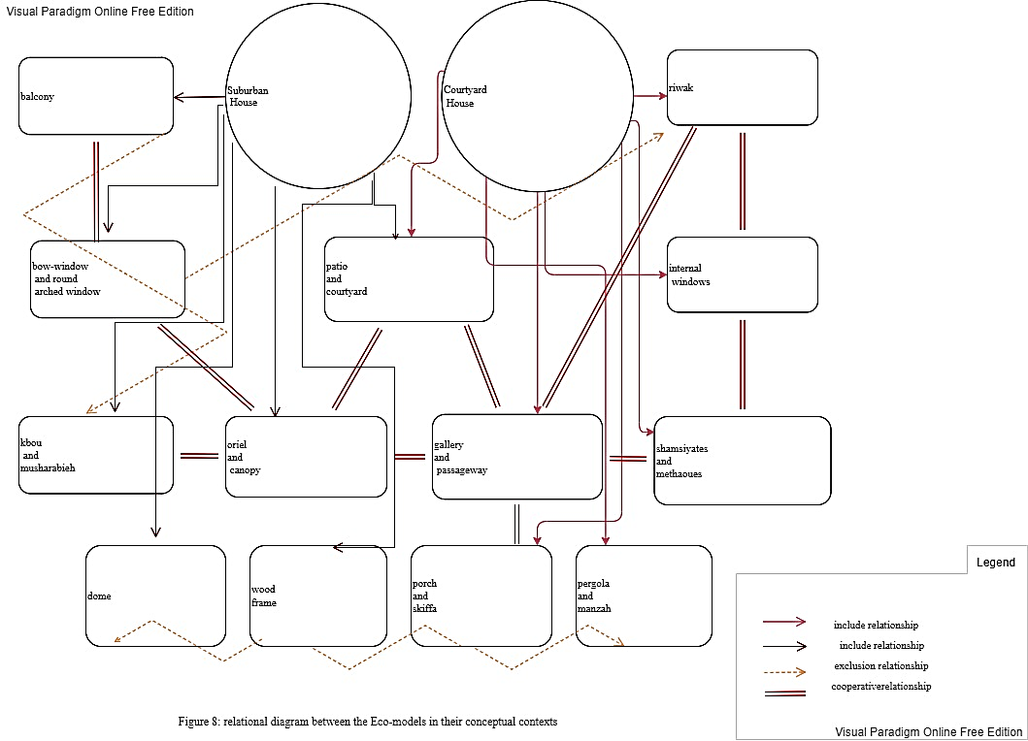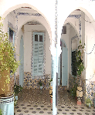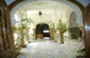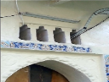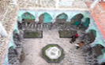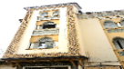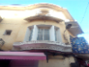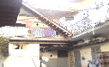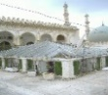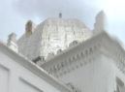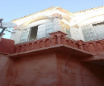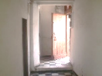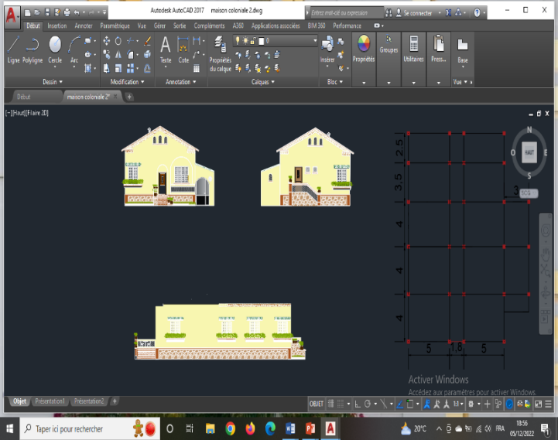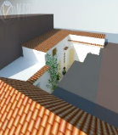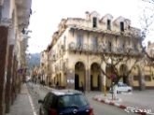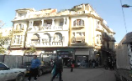
Figure 5a: Relational diagram of the eco-models

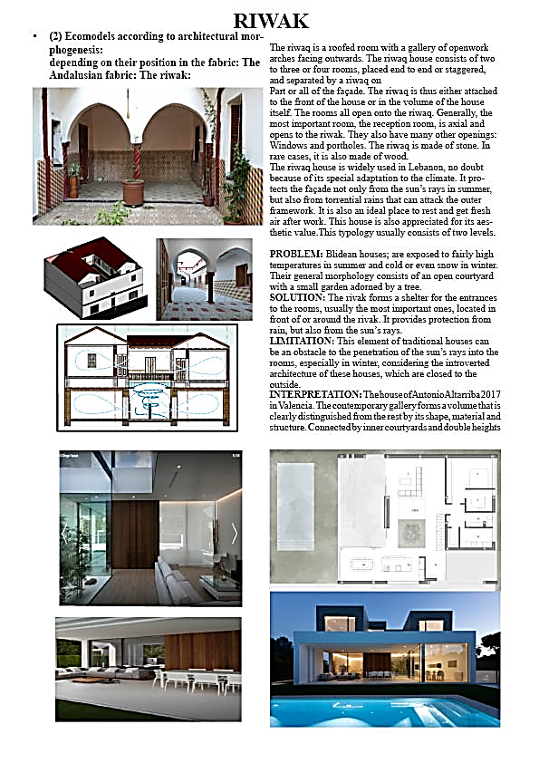
Figure 6: Interpretative sheet

Therefore, the classified and documented artefacts are presented on interpretative sheets for each element, according to the structure of the Eco-Mod models. We have added a space of interpretation represented by analogous elements that we propose; by morphological analogies, and used in contemporary architecture. Interpretations are creative models that can be integrated into the cultural landscape, adopting local architectural heritage (Fig. 6).

- RESULT AND DISCUSSION

- RESULT
- The Data
The mixed experimental method, combining a morphological analysis and a quantitative as well as qualitative environmental assessment, produced meaningful files on the historical buildings studied in different contexts. The comparative analysis between these results and the objectives of this work allowed the formation of adaptive paradigms. The construction of our approach to reading the architectural language for interpretation using the process of significant perception through the spatiotemporal diagram took place in two steps. The first step is to identify the application contexts for the experiments as seen in Table 3.

CONTEXT 01: Intramuros (Central And Corner Position)
- Traditional Arab-Andalusian houses, authentic or modified by use. Morphological features: Inner courtyard, thick adobe walls, riwak [13](called iwan in Syrian architecture), inner courtyard garden (with lemon trees or fountains), and quamariyates (vents);
- Traditional hybrid houses. The morphological features: the balanced staircases, the tiled roofs and the upper floor. These elements have a negative impact on the lighting. The positive elements in the lighting assessment are the windows, the spiral staircases discovered in the courtyard;
- Neo-Moorish houses. The morphological features: the courtyard, the skiffa, the arcades, and the galleries. The newly added elements whose effect is positive are the glass roofs.

CONTEXT 02: Intramuros (Peripheral Location)
- European houses, neoclassical and Art Nouveau. The morphological features are the exterior windows, the balconies, the galleries, the straight staircase, the terrace, the bay windows with corbels, and the patios;
- Context 03: Extramuros (near the periphery);
- Ottoman houses. Morphological features: the courtyard, the gallery, the interior windows, and the quamariyate on the doors

CONTEXT 03: The Extramuros (End Of The Historic Center)
- European houses in the Art Deco and Art Nouveau styles. Morphological elements: the terrace, the pergola, the porch, the veranda and the cylindrical turrets;
- The new elements: Facade consoles (interpretation of kbous), balconies, arched windows, arches in the windows, and nevadas (glass blocks).

CONTEXT 04: Extramuros (Distant Outskirts)
- Adaptable housing

CONTEXT 05: Local Facilities (Intramuros And Extramuros; Near Periphery)
- Ottoman furnishings; hammams. Morphological features: the hexagonal dome, the methaoues (openings in the cupola), the wooden railings and the ceramics;
- Hybrid furnishings; schools. Morphological features: the dome, the kbou, the metal railing;
- Neo-Moorish furnishings; mosques. Morphological features: the bay window, the minaret, the zenithal openings, the claustras and the vaults.

- The Information For Knowledge
After comparing the different situations in terms of historical context and morphological features, in this second phase, we propose ecological solutions using new technologies according to this process. Indeed, by examining the relevance of these architectural elements and their usefulness, we were able to interpret the results obtained and note that certain elements play an important role in bringing people together, involving reflecting and protecting the sun's rays from the outside and interior of buildings [16]. However, certain architectural elements seem insufficient on their own. They must be reinforced by new technological solutions in contemporary architecture which will constitute adaptive models, in order to offer optimal lighting to architectural buildings. To improve lighting in the roof, for example, it is necessary to add zenithal openings, if possible, or to propose another type of contemporary roof that can better capture the light flow [17].

Table 3. The hierarchical set of models

In the intramural context
House type | Devise | Modelization/ simulation | Adaptive interpretation
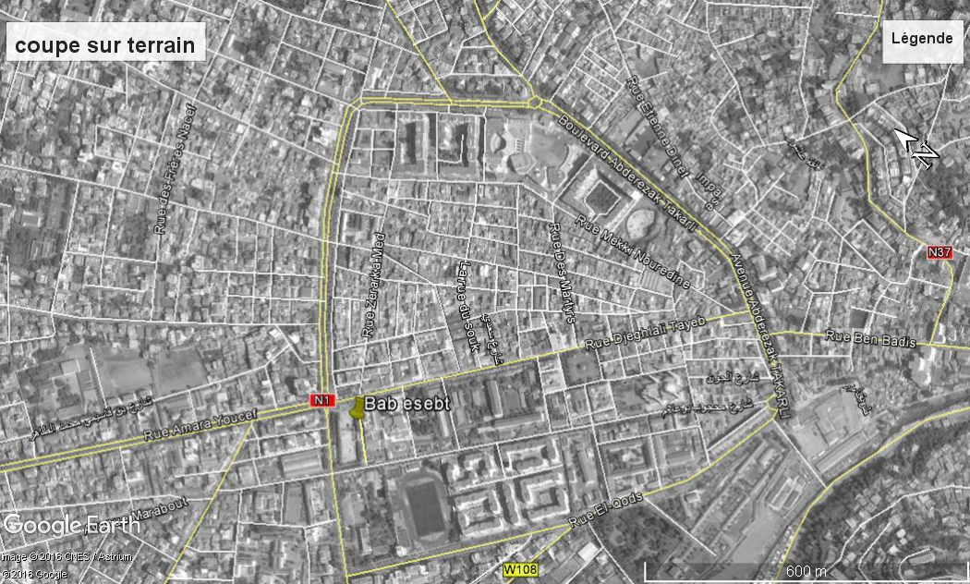  MOORISH houses: | 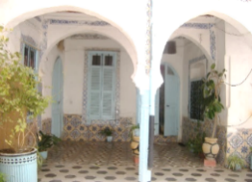  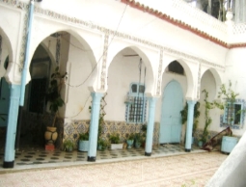  Views of the Riwak | 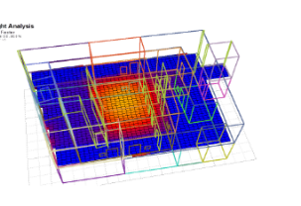 | 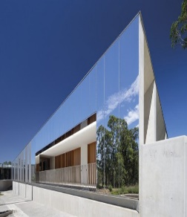  Mirror on façade
HYBRID houses: | 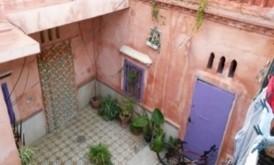  Views of the Patio and  The oriels | 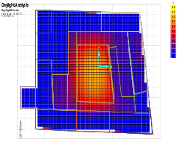  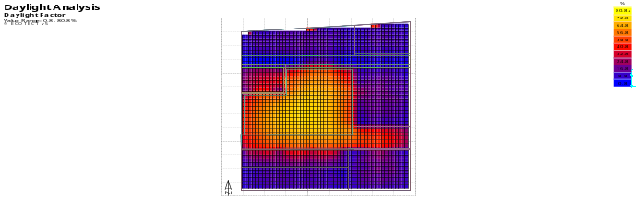  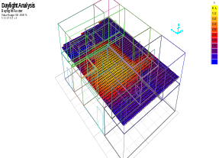  Assessment of  The level  Of natural lighting | 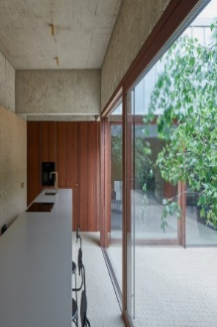  Movable walls of glass and wood animate
NEO MOORISH houses: | 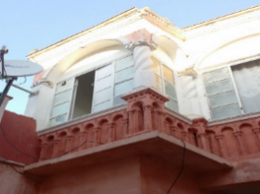  Views of the Manzah  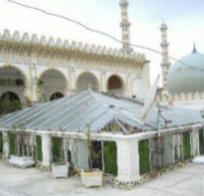  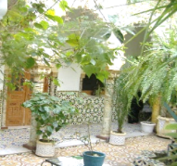  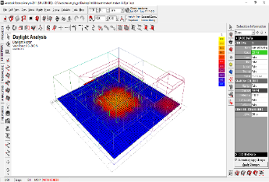  The Canopy Views of the gallery and the Patio | 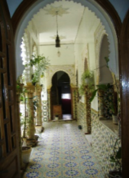  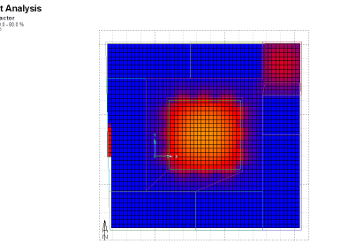  Assessment of  The level of natural lighting | 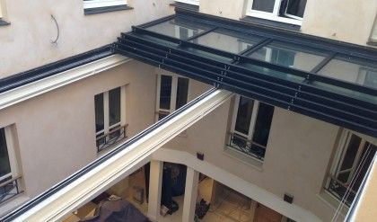  Mobile sliding roof canopy
NEO-CLASSICAL  buildings: | 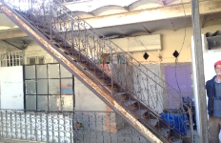  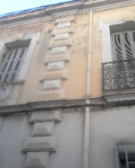  Views of the staircase ladder  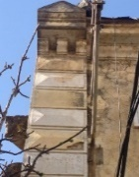  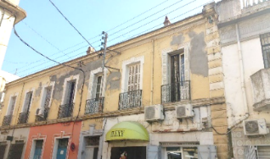  Views of the exterior windows | 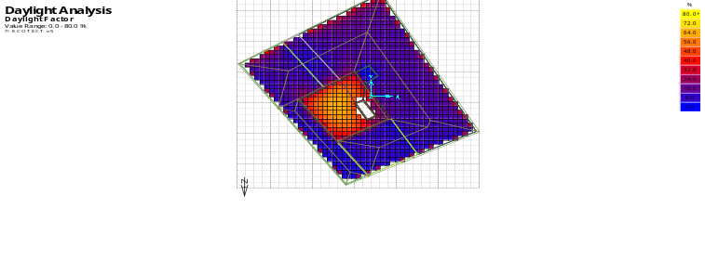  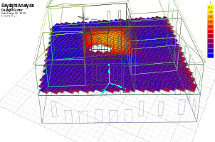  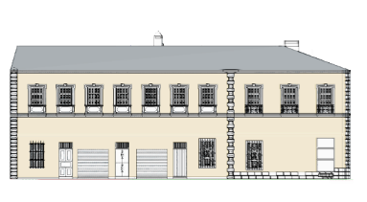 | 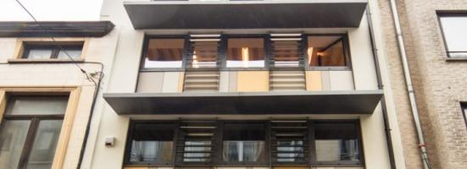  Shelf reflectors are reflective awnings over the windows
ART DECO buildings: | 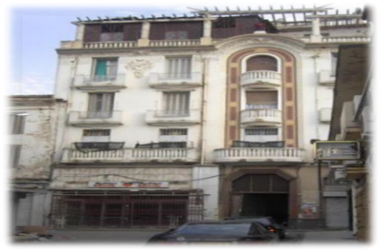  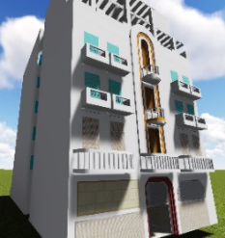  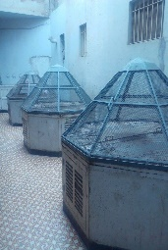  blind terraced facades  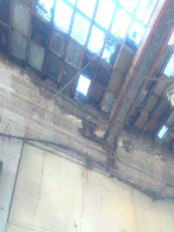  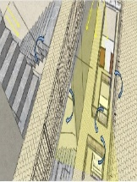  view of the Court | 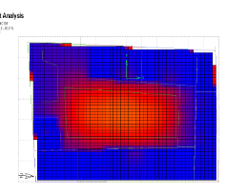  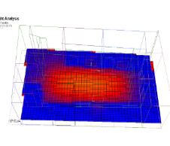  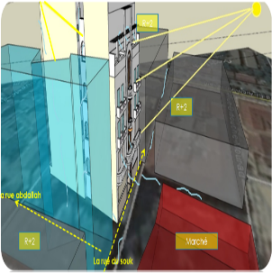  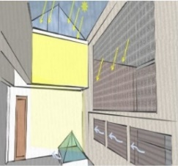 | 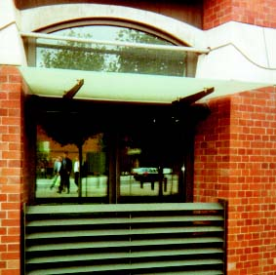  Light shelves
ART DECO buildings: | blind terraced facades  view of the Court |  | Light shelves
ART NOUVEAU buildings: | 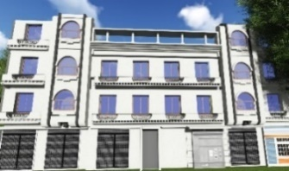  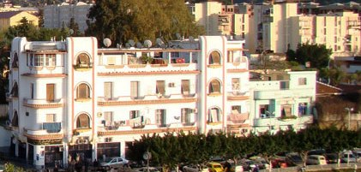  Peripheral window doors | 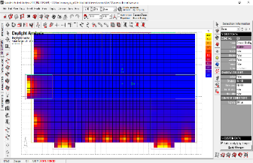  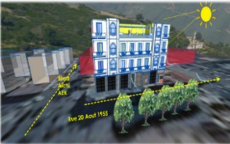 | 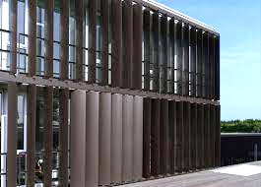  Openings with adjustable blades
OTTOMAN HOUSES: | 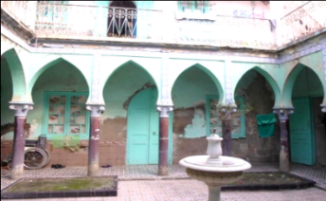  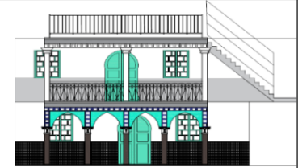  square windows | 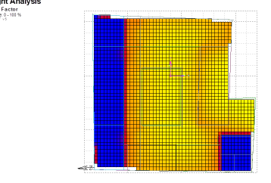  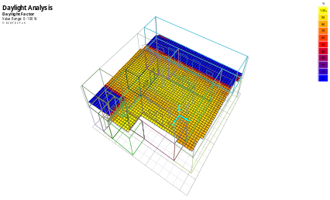 | 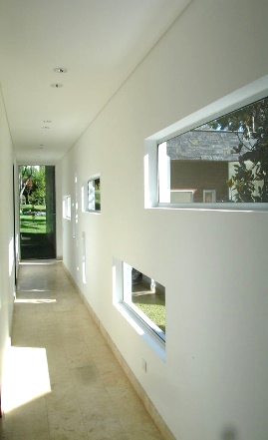  Horizontal windows
INTEGRATED HOUSES type large sets: | 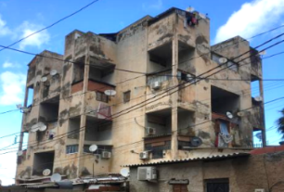  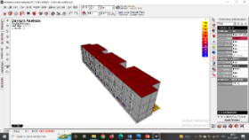  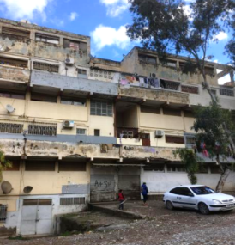  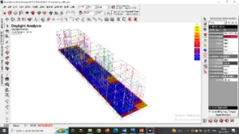  Small windows with brick guardrail | 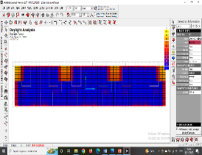 | 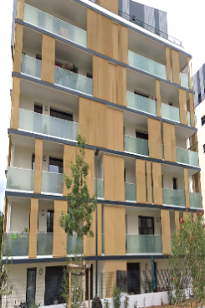  Glazed railing
Service buildings
MOSQUE : | 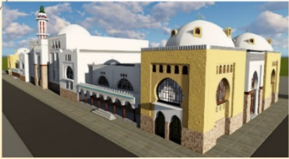  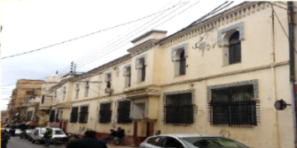  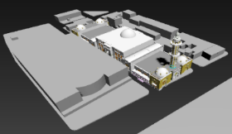  Traditional cupola | 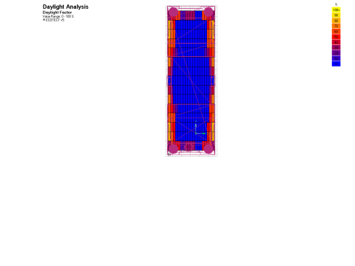  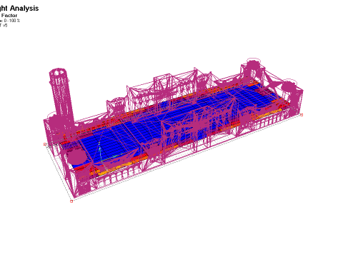 | 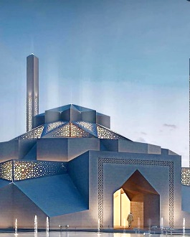  Contemporary mosque cover
SCHOOL : | 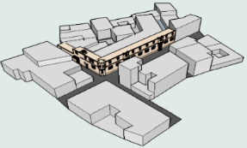  Square external windows | 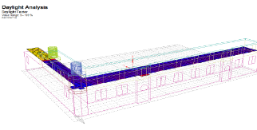  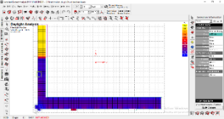 | 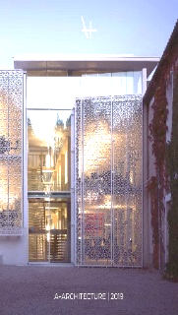  Glazed panel protected by moucharabiehs
HAMMAM : | 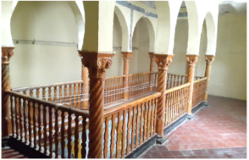  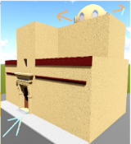  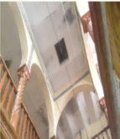  openings in the vaults | 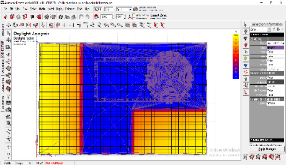  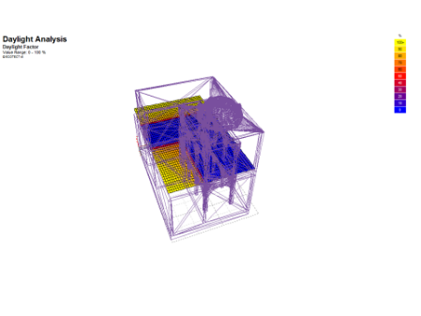 | 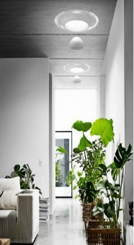  Skylights

- DISCUSSION
The methodology developed in the context of this study brings considerable benefits to the study of cultural heritage, preservation, and knowledge. Indeed, our study adds considerable value to the overall approach. It starts with an in situ investigation to identify a characteristic morphological context, followed by a quantitative and qualitative assessment to arrive at valorization and knowledge finally. Some heritage promotion research relies exclusively on graphic or pictorial sources like the semantic web. However, this is insufficient for considerable information and knowledge on architectural heritage.
The use of domain ontologies provides a broad level for the representation of information, confirmed by the work of Marta Acierno's [18] research group in 2017. This work demonstrates the contribution of ontology to knowledge in the conservation process. However, using ontology to interpret a new architecture is still little considered in favor of decision support tools for planning. These tools do not support the historical context and its intrinsic values. This is also the weakness of the P.P.S.M.VSS , which neglects the aesthetic aspect in the recommendations for preserving the cultural landscape.
The attempts to digitize an ontology have shown us that technological use becomes an important part of heritage preservation, using the heuristic method to combine processes. The modeling results support the work of Silvestri [12], in 2009, who argues that gaining more knowledge about the architecture is still the main purpose of using digital and manual tools. Indeed, thanks to the significant processual perception approach, we have improved the representation of adaptive paradigms. The result clarified that a single method cannot achieve this goal, and the knowledge will be incomplete.
The mixed method successfully conceptualized learning models for the architectural heritage of the historic center of Blida. This highlights the work of Ying Liu [19], in 2020, who evaluated visitors' experiences of digital interpretation in terms of holistic heritage perception and deeper intellectual resonance. The results show that the majority of visitors found digital interpretation gave them a comprehensive understanding of the architecture, history and cultural heritage.
We have sketched a preliminary learning diagram to digitize the methodology developed for heritage professionals. (Figure 7).

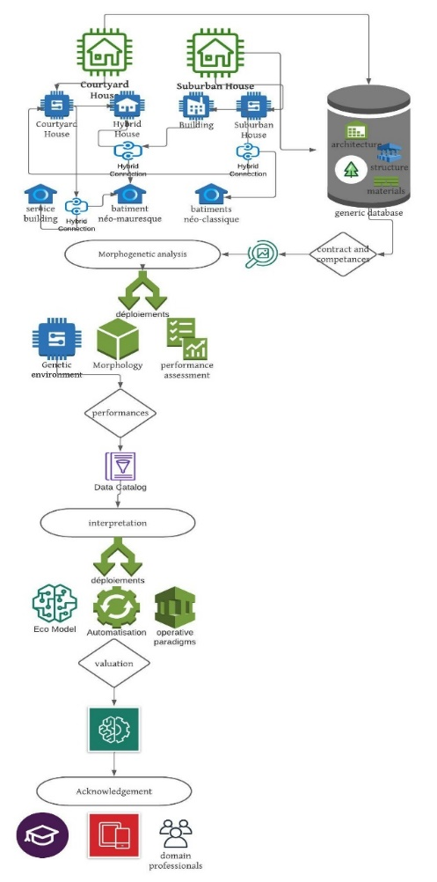
Figure 7: BPMN learning diagram
The digital design of the knowledge ontology following an iterative protocol will help professionals design sustainable and significant projects in a cultural heritage site. It will be a tool to conceptualize and evaluate the impact of their decisions in real-time and space (Figure 8). Opening up areas of knowledge can be shared with other users according to various media, such as a mobile application, a thesaurus for students, or a semantic web project for promotion destined to the interested public.

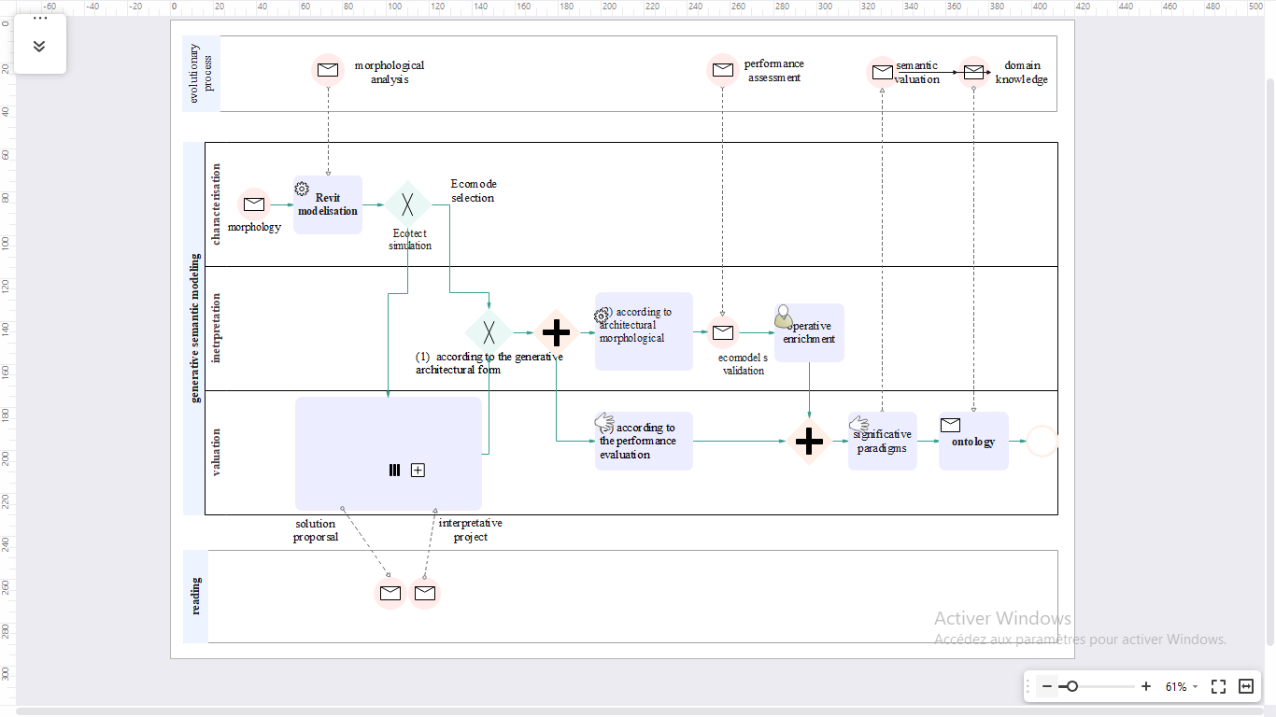
Figure 8: Lucidchar iterative Process

- CONCLUSION
This study aimed to investigate a new approach, based on a perceptual process, for preserving the architectural heritage of the historical center of the city of Blida. The methodology used combines a quantitative and a qualitative method. Starting from a relevant literature review, the methodological implementation combines a morphological analysis, an environmental assessment, and a digital semantic tool. The use of manual tools such as surveys, photos, and digital 2D and 3D modelling tools was therefore developed in a learning process.
Indeed, after exploring existing tools, we decided to use a knowledge ontology. The result of our experiments allowed us to design frameworks representative of adaptive paradigms in the different contexts of the historical center. This global approach has allowed us to propose environmental solutions using new technologies.
However, it must be recognized that the method developed is a tool for architectural heritage knowledge that can be standardized at several levels to respond to different categories of society. For heritage professionals, digitizing the method in a digital tool can contribute to the viability of the method. For civil society, a social study can be conducted to determine the level of acceptance of the proposed new paradigms. This approach will be a collaborative approach to building a new cultural landscape

REFERENCES
[1] N. Bozic, B.D. Bilusic, J. Kranjcevic, "Urban Transformation and sustainable Development of Small Historic Towns Cultural Urban Heritage Development, Learning and Landscape Strategies," Cultural Urban Heritage, Springer, Cham., 2019. doi: https://doi.org/10.1007/978-3-030-10612-6_10
[2] B. Monier-Vinard, “Covid: L’architecture de demain sera forcément plus ‘végétarienne,’” Le Point, Apr. 28, 2020. Accessed: Mar. 11, 2021. [Online]. Available: https://www.lepoint.fr/immobilier/covid-l-architecture-de-demain-sera-forcement-plus-vegetarienne-28-04-2020-2373179_31.php#11.
[3] MY. Thiffault, "Vers une nouvelle définition du patrimoine: l’intégration du développement durable dans l’évaluation patrimoniale", Université des Etudes Supérieures en Aménagement, option; conservation de m'environnement batît, 2011.
[4] B. Kelmendi, "The Norms of Human Living Space," Journal of Modern Civil ENgineering, vol 1, No. 1, pp. 49-55, 2021.
[5] J.Mecarsel, Architecture et présence, entre idée, image et communication, Toulon, 2017.
[6] A. Cisse, “Quelle perception de l’architecture traditionnelle africaine aux yeux de la nouvelle génération?,” in the proceedings of the Terra 2016 conference, Villefontaine, 2018.
[7] C. L. Maufras, VITRUVE DE L’ARCHITECTURE, 1st ed., vol. 1. Paris, 1847. Accessed: Jan. 25, 2018. [Online]. Available: http://remacle.org/bloodwolf/erudits/Vitruve/livre1.htm.
[8] P. Pelligrino, "De la profondeur à la surface, la verticalité: l'architecture d'un monde possible", Langages, vol. 213, No.1, pp.105-118, 2019. doi: https://doi.org/10.3917/lang.213.0105
[9] J. Simonet, Étienne Bonnot de CONDILLAC / TRAITÉ DES SENSATIONS AUGMENTE DE L'EXTRAIT RAISONNE, Paris: Librairie Arthème Fayard, 1984.
[10] B. Assala, La perception sensorielle en architecture, Nantes; ENSAN, 2016.
[11] M. Tommy, "Towards an ontology for the analysis of the conservation status of a heritage building," In Situe Revue des patrimoines, p. 39, 2019.
[12] C. Silvestri, "Perception et conception en architecture non standard, une approche expérimentale", Doctoral Thesis, Montpellier: University of Montpellier II, Mechanics and civil engineering. Doctoral school: Information structures and systems, 2009.
[13] M. D. Tiar, "Mémoire de Magistère en Patrimoine Architectural et Urbain; Identification de l'architecture mauresque; dans le tissu traditionnel mixte de Blida, Analyse des Typologies Architecturales Residentielles", Magister's dissertation, Architectural and Urban Heritage, Algiers: Polytechnic School of Architecture and Urban Planning, 2013.
[14] B. Duprat, M. Paulin, P.D. Catherine, Le système de la façade et de la baie: maisons à loyer urbaines du XIX ème siècle, Lyon: LAF, ENSA, 1995.
[15] R. Dahbi, V. Bombardier, D. Brie, E. Masson, “29èmes Journées Francophones d’Ingénierie des Connaissances, Modélisation de connaissances métier pour la classification de pièces de bois", in 29èmes Journées Francophones d'Ingénierie des Connaissances, IC 2018, 2018.
[16] D. I. Maachi, L'éclairage Naturel; cours de Master II Bioclimatique, Institute of Architecture and Urban Planning at the University of Blida, Blida, 2016.
[17] A. Belakehal, K.T. Aoul, A.Farhi, "Daylight as a Design Strategy in the Ottoman Mosques of Tunisia and Algeria," International Journal of Architectural Heritage, vol 10, No. 6, pp. 688-703, 2016. doi: https://doi.org/10.1080/15583058.2015.1020458
[18] M. Acierno, S. Cursi, D. Simeone, D. Fiorani, "Architectural heritage knowledge modelling: An ontology-based framework for conservation process," Journal of Cultural Heritage, vol. 24, pp. 124-133, 2017. doi: https://doi.org/10.1016/j.culher.2016.09.010
[19] Y. Liu, "Evaluating visitor experience of digital interpretation and presentation technologies at cultural heritage sites: a case study of the old town, Zuoying," Built Heritage, vol. 4, no. 14, pp. 1-15, 2020. doi: https://doi.org/10.1186/s43238-020-00016-4

Spatio- temporal process: it includes the relation between space, temporalities and architecture in design. A spatial design necessarily involves variations in temporality (and vice versa). Indeed, a shift in the meaning of a project occurred through the projection of individual emotions. The perception indicators of time are effective design actions in the constitution of the identity of places by means of architecture. The memory is the result of a process of selection and organization in which we retain what is considered significant and discard what is not.
Generative engine: The generative engine initializes the process by constructing a generic shape. This evolves using an evolutionary process. The evaluation engine determines the geometric and geographical conditions for the energy evaluation of each element. The material engine determines the material properties of the object.
Narrative Semiotic: It is a transformation whose syntax allows the passage from one state to another. The transformation shapes the discourse; using the imagination, it structures it. She uses narrative intuitions through figurative scenes but also abstraction with the aim of modal structuring. The narrative schema has the relational point between narrative semiotics and phenomenology. It is made up of three stages in order, namely; contract and skills, performance and recognition.
This research is based on comparative analysis through attributes allowing a description according to cognitive structuring. It uses homology to break down morphologically comparable elements. It is therefore a question of studying the different component parts, their arrangement, their possible structuring (segment) as well as the variations of their shapes and their possible parts.
Adaptive values: a valuation of passive environmental design and climate adaptive capacity in the studied artifacts. This analysis concerns two factors, the first relates to solar input and the second relates to light comfort based on good environmental practices. The passive design factor analysis touches on all traditional provisions for optimizing the use of natural light by analyzing the architectural elements and the accompanying architectural arrangements, which are compatible with their adaptive role in the face of the climate.
ECOTECT: Software-combining 3D objects; modelled on Revit, with solar analyses. It is designed with the principle that the most effective environmental design is to be validated during the design conceptual stages. Its spacious outputs also make final design validation much easier than other software.
REVIT: software Revit Autodesk is a market-leading design and drawing tool for building information modelling (BIM), providing an optimal response thanks to its collaborative mode and its interoperability with other software
3ds Max: modelling, rendering, and animation software enable one to create expansive worlds and premium designs; creating finely detailed designs and props with intuitive texturing and shading tools, iterating and producing professional-grade renders with full artistic control
ECOMODE: a semantic model made up of four content levels; entry choices, directories, annotations and relationships; an environmental scenario generator that allows users to consult three levels of selection, either; eco-models, HQE or architectural achievements
Pr. J.C Bignon: Professor at the National School of Architecture in Nancy and research director at the Architecture and Engineering Research Centre, UMR CNRS MAP-CRAI, founding member of the Eco-mod generator. http://www.crai.archi.fr/eco.mod/InfoEco.Mod.ph
P.P.S.M.VSS : Permanent Plan for Safeguarding and Promoting Protected Areas (translation : Plan Permanent de Sauvegarde et de Mise en Valeur des Secteurs Sauvegardés)

