 |  | JOURNAL OF ISLAMIC ARCHITECTURE  P-ISSN: 2086-2636 E-ISSN: 2356-4644  Journal Home Page: http://ejournal.uin-malang.ac.id/index.php/JIA
THE RELATIONSHIP BETWEEN ISLAMIC PRINCIPLES AND ARCHITECTURAL SACREDNESS IN ISLAM
Majid Ahsani^{a*}, Sumarni Binti Ismailª, Siyamak Nayyeri Fallah^{b}, Nor Atiah Ismailª, Ali al-Ameen^{c}
ªFaculty of design and architecture at University Putra Malaysia (UPM), Serdang, Malaysia
^{b}Faculty of Architecture at Islamic Azad University Nour Branch (IAUNOUR), Nour, Iran
^{c}Faculty of Built Environment at the University of Malaya (UM), Kuala Lumpur, Malaysia
*Corresponding Author: ahsani.ar@hotmail.com
ARTICLE INFO |  |  | ABSTRACT
Volume: 8  Issue: 2  Page: 530-544  Received: October 23th, 2023  Accepted: April 21st, 2024  Available Online: December 30th, 2024  DOI: 10.18860/jia.v8i2.23918 |  |  | Islamic art and architecture, known globally, were once deeply rooted in Islamic philosophy and carried profound spiritual significance. However, contemporary Islamic architectural creations often imitate the external appearance of past masterpieces while neglecting their underlying spiritual essence. Over the past centuries, architectural design methods have evolved, leading traditional Islamic architectural styles, which once harmonized form and spirituality, to lose their original meanings. Consequently, they have strayed from the primary purpose of Islamic art, which is to serve as a reminder of God. This study seeks to identify the authentic sources of Islamic architecture. Through analytical and descriptive analyses, we delve into the fundamental factors that have shaped prevalent Islamic architectural forms. Building upon the intellectual foundations laid by Titus Burckhardt concerning sacred art, this research examines the prerequisites for creating such art. Finally, this study comprehensively explores Islamic principles and sub-principles related to architecture through content analysis of Sharia texts and compares them to contemporary mosque designs.  Keywords:  Islamic Architecture; Sacred Architecture; Islamic Art; Mosque Architecture; Islamic Design principles

- INTRODUCTION
Islamic architecture describes the construction methods used by Muslim communities beginning in the seventh century [1]. However, some academics distinguish between Muslim and Islamic architecture [2, 3]. Hence, "Does Islamic architecture exist?" has persisted across many historical periods. Are the structures that Muslims have erected during the past 14 centuries considered examples of "Islamic architecture"? Or does it specify a particular style of building that embodies a certain philosophy?
Papadopoulos [4] believed that the origin of Islamic architecture goes back to Byzantine architecture. Some other scholars also believed that Early Islamic architecture was influenced by Roman, Byzantine, Persian, and Mesopotamian architecture and all other lands the Early Muslim conquests conquered in the seventh and eighth centuries [5]. On the other hand, Grube [6] believed that Islamic architecture should be considered as a kind of architecture identified with some special characteristics, such as concentration on the interior, internal spatial communications, and a few general forms with the ability to accommodate a variety of uses. In addition, wherever Islam spread, the local art and architecture came together with Islam to create a fresh, modern style that considered people's cultural and other preferences. In various regions of the world, Islamic architecture is produced using a regional methodology[7, 8].
Prophet’s mosque (Figure 1) in Medina became a base as many other mosques shaped like it, a general type of Muslims mosque[9]. The first mosque, built in the 7th century, was a square plan, traditional Arabian courtyard enclosed by an earthen wall. The muezzin chanted the call to prayer from this point[10]. To date, Islamic architecture is generally identified with special design elements inherited from the first mosque building, such as the courtyard, the altar or Mihrab, and the prayer hall[10, 11]. Since God's remembrance is the ultimate aim of Islamic art, only works that adhere to Islam's original, spiritual, and divine teachings can be regarded authentically Islamic or belonging to the religion.

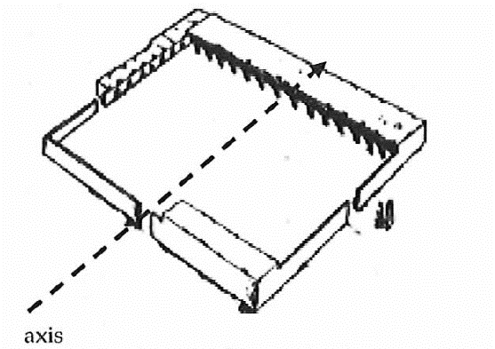

Figure 1. The Prophet's mosque [12]

This section commences with an introduction to the concept of sacred art, elucidating its inherent characteristics. Subsequently, a comparative analysis is conducted to distinguish between traditional mosque construction and the principles governing sacred architecture for mosques.

  - SACRED ART AND ARCHITECTURE
The word “sacred” means something with a divine presence. For example, a mosque is sacred because it is made to be used for remembering and praying to God. It is where man can get closer to God mentally[13]. When Clark and Nikfarjam [14] discuss Saint Thomas Aquinas' thoughts on dimensions of religious art, they mention that the most outstanding feature of any religious art is the pull towards excellence, which is made visible by the tangible symbols and to go beyond the limited order of human life to the higher and final dimension of reality: the liberation from all material constraints[14]. A sacred place, such as a mosque, can affect the sense of spirituality induced by worshipers; it can increase, neutralize, or even decrease it[13]. Mousavi [15], quoting Titus Burkhart, states, "Traditionalists in Islamic art try to display the eternal art”. In sacred and Islamic art, man is considered a comprehensive mirror of God's attributes. Still, in modern art, man is a mirror of carnal attributes, which is the result of Satanism and naturalistic selfishness". As Mousavi [15]states, the analysis of sacred art should be done through a phenomenological perspective. Table 1 summarizes the characteristics of sacred art from the perspective of Titus Burkhart.

Table 1. Characteristics of sacred art according to Titus Burkhart [16]
Characteristics of Sacred Art | Definition and Explanation
Phenomenological Method of Analysis | Pay attention to the deep necessities (climate, environment, time, history, etc.)
Symbolization | Religious art is the face that leads the viewer to the depths of its meanings through symbolism and cryptography.
Art based on wisdom | Rational thought with mystical intuition
Beauty is a manifestation of the general truth | The holy art manifests the beauty of the deity as much as possible.  From the Muslim perspective, aesthetics and beauty are fully associated with attention to God [17].
Monotheism | Axis, center, and the most important goal of creating sacred art
Inanimate image | Islamic art is into Transcendence.
Light is a symbol of unity. | Light symbolizes God and creates unity.
Having objectivity | Visible to the naked eye.
Influencing the subconscious mind | Sacred concepts are rooted in the collective subconscious.
Interpretation | Investigation method.

  - ESSENTIAL PARAMETERS IN SACRED ARCHITECTURE
For the desired quality in sacred art, it is necessary to consider some requirements, as described in the following:

- 1. Principles of Geometry
The Islamic science and principles are based on being exact, as the Quran uses the word "Qadr" several times, meaning the exact magnitude and measure of something. In Surah Talaq, verse 3 in the Quran says, “Indeed, God has set a measure for everything”. Geometry is valued in Islamic art because it is intelligible. It deals with the laws and principles of creation and is seen in their artistic representation, so it is considered sacred. Its nature is also quantitative and qualitative: quantitative in that it governs the order and construction of the patterns and qualitative in that it establishes the proportions of design shapes and functions as a pictorial representation of reality that embodies the order of the universe[18]. Geometric shapes serve as windows into their symbolic essence, hinting at unity. Moreover, they reflect broader values and ideals transcending mere unity[19]. The inception of any Islamic geometric pattern embodies a profound symbolism[20]. Within intricate Islamic geometric patterns, myriad shapes amalgamate to portray a singular image, reinforcing the notion of unity in diversity and multiplicity in unity[18]. Traditional geometry is associated with the symbolic arrangements of space. From the traditional point of view, geometric forms are elements of the diversity of the unity, much like conventional numbers do [21]. Geometry in Islamic art displays the features of the world as a utopia in both abstract and intellectual dimensions and materialistic aspects. The intellectual dimension shows itself in abstract forms; in the material dimension, the semantic symbols emerge in architecture[22]. “In Islamic architecture, each element and subject has an origin and holds meaning behind it. In terms of practice, elements, and principles are not separate in the base but also can be considered similar. In Islamic architecture, this is called “wisdom”. This wisdom is central to adapting spirituality to physical elements and architectural materials. The hidden geometry in Islamic architecture is based on constructing a system that puts everything in its place as a metaphor of the spiritual world, giving each one a unique worth.”[23] Some scholars also concur that the artworks' main objective was to transmit Islamic beliefs rather than to be aesthetically pleasing [24]. The study of sign systems and how they convey and arrange meaning is known as semiotics [25]. The semiotic Method is used to understand symbolic meaning as a component of the design phenomena [26]. According to Burckhardt, geometry is considered a tool for articulating mysterious and sublime concepts [27]. Burckhardt points to geometry as one of the important elements of the mosque and describes it as the best way to show allegory and the internal complexity of Muslim cryptography and symbolism to convey the concept of unity through the process from multiplicity to unity and vice versa [28].
According to verse 2, surah Furqan, “who created all things and made them to an exact measure”, the foundation of nature is based on special proportions. God guides the creatures in a special order towards evolution and desired perfection. From the beginning of his creation, the human eye has been acquainted with the dimensions and proportions by which God shaped nature and the human himself. Therefore, the human subconscious finds everything created based on those proportions. Through these proportions, art conveys its guiding duty and message[29]. The proportion now is known as the golden ratio or, as Meisner and Araujo [30] call it, “the divine proportion” is often found in natural phenomena (Figure 2). In Islamic architecture, geometry is crucial in being precise and inducing a sense of unity and monotheism[31].

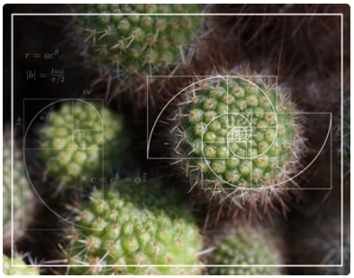

Figure 2. An example of a golden spiral in nature [30]
- 2. Empty Space
Religious art has often reminded man of eternal life after death. Believing in the otherworld has been the subject of conversation, literature, and art throughout centuries. They project in the sculptures in churches, and paintings in different eras, such Imagining Heaven and Hell in Romanesque and Gothic Art[32] (Figure 3), (Figure 4).

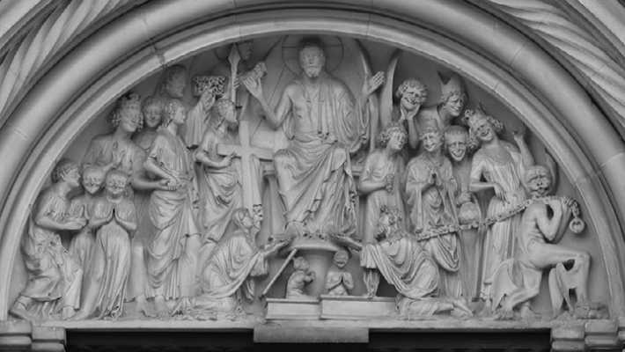

Figure 3. The Last Judgement. Tympanum, Bamberg Cathedral, c. 1230 [32]

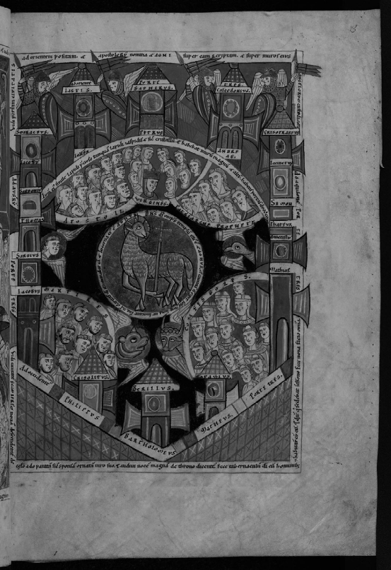

Figure 4. The Heavenly Jerusalem. Haimo of Auxerre, early twelfth century [32]

In architecture, especially Iranian-Islamic architecture, designers try to induce a sense of otherworldliness by creating a paradox, using empty spaces. The definition of Empty Space in ancient Eastern urban planning differs in meaning from its definition in the West. Empty space is defined as negative space in Western architecture, while constructed parts and sculptures are defined as positive space. In this kind of architecture, the empty spaces, known as negative spaces, play a role as the background for the figures or positive spaces[33].
Conversely, in Islamic architecture, space is not defined by objects or the presence of the body; empty spaces can have as much significance and character as any other space. Burckhardt believes that the mosque's space is another crucial component and is a deliberate emphasis for Muslims to convey their monotheistic worldview [34]. A good example of this is the courtyards that have been part of Islamic architecture since the beginning of building the first mosque. The first mosque was the courtyard of Prophet Mohammad’s house[9]. Ever since, the courtyard, as a space has become an inseparable part of Islamic architecture and mosque design (Figure 5).

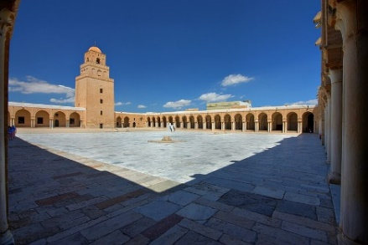

Figure 5. Courtyard, Great Mosque of Kairouan, Tunisia, c. 836-75 [35]

For Muslims, this expansion is accompanied by an increased awareness of the presence of God. Therefore, Empty Space in Islamic architecture and art reflects positive space, which clarifies the material so that its mortal and transient nature is revealed[36]. The void or empty space in Islamic art is created by its static, impersonal, and anonymous quality, enabling man to repose in his ontological center, where he is both the thrall (Abd) of God and their representative (Khalifah) on earth [37].

- 3. Water
Another parameter in understanding this art is water. In Islamic architecture works, water can be found in most courtyards and gardens [38]. According to El Shakhs & Ezzat (2018), water has two crucial roles: firstly, in the process of physical (ablution) and psychological purity, and secondly, in tempering the climate. They also believe that water plays a dual symbolic and functional role in Islamic architecture, representing spiritual purity and being used for ablution, assisting with climate control, and producing microclimates[39]. In religious beliefs, water has two major spiritual concepts. First, water manifests the direct connection between the heavens, often called skies in religious literature, and earth. “…sent down water from the sky” (Al-Hijr surah 15:22). Second, the reflecting character of water emphasizes the fifth dimension of space or perpendicular, and any image of the porch or other building components that reflect the transfer of the image from potential to action. In Islamic architecture, the way to enter the promised utopia, or otherworld, is through water[40]. For instance, the reflection of the sky in the water of the central courtyard in Iranian Islamic architecture represents Sohravardi's mirror phenomenon, and one's gaze is on the infinite depth within [41]. Water and its reflections as a part of decoration help to perceive the effects of Islamic art [42].

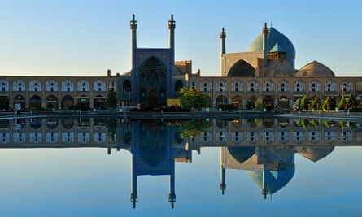

Figure 6. Shah mosque, a UNESCO world heritage site in Isfahan[44]

As a result, with its transcendent approach, the Islamic Iranian city always pursues the ultimate goal of creation, which is the remembrance of God. Art can potentially lead men out of physical passivity to their true nature as worshippers. Water is repeatedly seen in religious Islamic architecture, mosques, and Muslim houses, as it is the essence of purity (Figure 6). As in holy Quran says, “[He] sent down water from the sky upon you, that thereby He purify you...” (Surah Al-Anfal, 8:11).

- 4. The Essence of Human and Architecture
Some philosophers believe that the existence of humans is limited to the physical and material. They believe that material principles can judge human beings, and all analyses are materialistic. According to this analysis, man has perished when his body dies. However, most religions believe human beings are made up of two aspects: physical and spiritual. The core of all the teachings of divine religions is the human soul. As mentioned in the bible, “and may your spirit and soul and body be preserved complete...” (Thessalonians 5:2) or in the Qur’an, God points out the importance of the soul several times. In surah As-Sajdah, 32:9, he says, “He [God] fashioned him [man] in due proportion and breathed into him the soul”. Religious architecture also has two material and spiritual aspects; The form is architecture's outer and material face and guides the audience towards its inner aspect, the soul. The designer infuses the meaning and semantics like a spirit breathed into the material. According to Annemarie, the practice of architecture is not only to cover practical needs but also expressive [43].

- TRADITIONAL VS CONTEMPORARY ISLAMIC ARCHITECTURE
Any monument attributed to Islam in any geographical place has historical, patriotic, cultural, and religious roots in that particular place[41]. These bases had a developing process that evolved architecture. The different cultural influences have caused different styles of Islamic architecture, which has roots in Islamic beliefs and traditions and contexts’ architecture[10]. Forms referred to as Islamic forms are cultural and religious diversity in different parts of the world. To date, designers use the appearance of these forms to design mosques and other contemporary Islamic buildings without looking at them from a phenomenological perspective.
To achieve Islamic architecture, designers should look beyond traditional architecture and analyze Islamic Shari'a text as a guide. Islamic architecture contains propositions that bring together the Islamic sacred art. Contemporary Islamic architecture is an understanding of the traditional architect's view of the text of Islamic Sharia, and such a secondary understanding may not necessarily be correct (Figure 7).

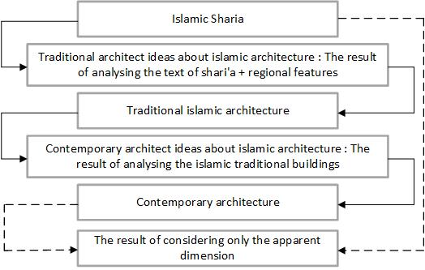

Figure 7. The Relationship between contemporary Islamic architecture and Islamic Sharia

In verse 38 of Surah An'am, God states, "We did not leave anything out of the book." In verse 89 of Surah An-Nahl, He says, "We have sent down to you this Qur'an to clarify the truth of everything, and to guide and have mercy and good tidings for the Muslims." Since the Holy Qur’an is meant to be the guide of all times and all periods, it seems that the sources of Sharia can be used to extract the appropriate parameters for the design of architecture. Therefore, finding those parameters is integral to interpreting and analyzing the sources of Sharia. The meaning of the verses is revealed to man by thinking and interpreting them. In the Holy Qur'an, God has mentioned everything a believer needs for his earthly life for those who think about it. Islam is known as a philosophy. The system of politics, the organization of society, culture, the system of economy, and the system of law in Islamic society must be according to the strategic principles of the Holy Qur'an and the Hadiths of the Prophet[46]. Therefore, Islamic principles can also act as a guidance and framework for art and architecture. Not all architectural work attributed to Islam necessarily has the source of revelation and the Qur’an, thus lacking in the true Islamic attribute. To date, most of the seemingly Islamic architectural work reflects a crusty and superficial imitation of past architectural work attributed to Islam from various parts of the Islam region.
- RESEARCH AIM
This study seeks to explore the architectural elements within Islamic architecture that facilitate the attainment of its primary objective: the remembrance of God. It also aims to assess the appropriateness of conventional architectural forms in serving this purpose. In pursuit of this aim, two secondary objectives emerge: first, an investigation into the underlying philosophy and principles governing sacred art, and second, an examination of Islamic Sharia as a guiding framework for architects and designers in crafting structures that prioritize the remembrance of God as the ultimate goal of Islamic art and architecture. Zikr is a method for revealing all people's innate knowledge of God [47].

- METHODS
To achieve the research objectives, this study presents a definition of sacred art, specifically within the Islamic context, drawing from the perspectives of scholars, particularly Titus Burckhardt. Subsequently, the distinctive attributes of Islamic sacred art are extracted from relevant literature. Following this, a content analysis is employed to extract architectural characteristics in accordance with Islamic Sharia. This step aims to identify the principles and elements guided by the Qur'an and Prophet Hadith that are relevant to sacred Islamic architecture (Figure 8).

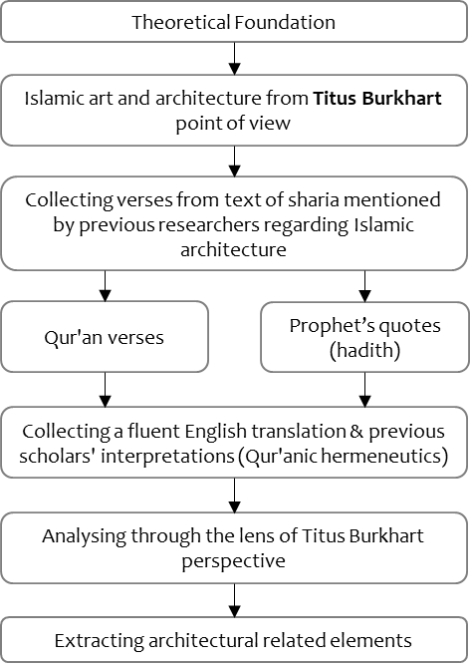

Figure 8. Research design

The study concludes with an analysis synthesizing the elements and principles suggested by the Qur'an and Prophet Hadith to design sacred Islamic architecture. These findings will serve as a valuable guide for future architectural designs in line with Islamic principles.

- RESULT AND DISCUSSION

- RESULT
As widely recognized, the Qur'an and the hadith, comprising the Sharia, offer essential principles guiding various aspects of human life. In this section, we extract and present relevant Qur'anic verses and prophetic quotes associated with sacred art and architecture. These findings are presented in Table 2 and Table 3.

Table 2. Qur'anic verses that can guide sacred art
No | Quranic Verse | Verse Text
1 | An-Nur, 4:35 | - Allah is the light of the heavens and the earth. His light, 1 is like a niche in which there is a lamp; the lamp is in a crystal; the crystal is like a shining star, lit from ˹the oil of˺ a blessed olive tree, ˹located˺ neither to the east nor the West, 2 whose oil would almost glow, even without being touched by fire. Light upon light! Allah guides whoever He wills to His light. And Allah sets forth parables for humanity, for Allah has ˹perfect˺ knowledge of all things.
2 | An-Nur, 4:36 | - ˹That light shines˺ through houses ˹of worship˺ which Allah has ordered to be raised, and where His Name is mentioned. He is glorified there morning and evening.
3 | Al-Baqarah, 2:115 | - To Allah belong to the East and the West, so wherever you turn, you are facing ˹towards˺ Allah.
4 | Adh-Dhariyat  51:56 | - I did not create jinn and humans except to worship Me.
5 | Al-Baqarah  2:163 | - Your God is ˹only˺ One God. There is no god ˹worthy of worship˺ except Him—the Most Compassionate, Most Merciful.
6 | Al-Baqarah  2:55 | - Allah! There is no god ˹worthy of worship˺ except Him, the Ever-Living, All-Sustaining. Neither drowsiness nor sleep overtakes Him. To Him belongs whatever is in the heavens and whatever is on the earth. ....His Seat encompasses the heavens and the earth, and preserving both does not tire Him, for He is the Most High, the Greatest.
7 | An-Nur, 24:27 | - ! Do not enter any house other than yours until you have asked for permission and greeted its occupants.
8 | An-Nur, 24:28 | - If you find no one at home, do not enter it until you have permission. And if you are asked to leave, then leave.
9 | Ali 'Imran  3:103 | - And hold firmly together to the rope of Allah and do not be divided. Remember Allah’s favor upon you when you were enemies, then He united your hearts, so you—by His grace—became brothers. And you were at the brink of a fiery pit, and He saved you from it. This is how Allah makes His revelations clear to you, so that you may be ˹rightly˺ guided.
10 | Al-Hujurat  49:13 | - Indeed, we created you from a male and a female and made you into peoples and tribes so that you may get to know one another. Surely, the most noble of you in the sight of Allah is the most righteous among you.
11 | An-Nisa  4:135 | - Stand firm for justice as witnesses for Allah, even if it is against yourselves, your parents, or close relatives.
12 | Az-Zumar  39:29 | - Allah sets forth the parable of an enslaved person owned by several quarrelsome masters and an enslaved person owned by only one master. Are they equal in condition?
13 | At-Talaq  65:3 | - Allah has already set a measure [destiny] for everything.
14 | Al-Qamar, 54:49 | - Indeed, we have created everything perfectly preordained.
15 | Al-Furqan, 25:2 | - Allah is˺ the One to Whom belongs the kingdom of the heavens and the earth, who has never had ˹any˺ offspring, nor does He have a partner in ˹governing˺ the kingdom. He has created everything, ordaining it precisely.
16 | An-Nahl, 16:80 | - And Allah has made your homes a place to rest and has given you tents from the hide of animals, light to handle when you travel and when you camp.
17 | Al-Ma'idah, 5:2 | - Cooperate in goodness and righteousness, and do not cooperate in sin and transgression.
18 | Al-Hujurat,  49:10 | - The believers are but one brotherhood, so make peace between your brothers. And be mindful of Allah so you may be shown mercy.
19 | Maryam, 19:95 | - And each of them will return to Him on the Day of Judgment all alone.
20 | Al-Baqarah, 1:143 | - And so We have made you [believers] an upright (middle way, moderate, balanced) community so that you may be witnesses over humanity and the Messenger may be a witness over you.
21 | Al-Jathiyah 45:13 | - He ˹also˺ subjected for you whatever is in the heavens and whatever is on the earth—all by His grace. Surely, these are signs for people who reflect.

Table 3. The Prophet's hadith related to sacred art and architecture
No | Hadith
1 | - In one of the events during the Prophet's life in Medina, when one of his companions named "Khalid bin Walid" talked to him about his small house, which was no longer enough for the number of people in his family. In response, the Prophet did not tell him to move to a bigger house or to accommodate the family in several separate houses; instead, the Prophet told him to expand the same house or to build a floor above it.
2 | - “The first thing God created was the mind; the first thing God created was my light.” Prophet (PBUH) Bihar al-Anwar, vol. 1, p. 97, hadith 8.
3 | - The truth (God) is apparent, and at the same time, it is free (does not appear to the eye) from appearance.
4 | - The Prophet (PBUH) said in a hadith that indirectly states the command of the Sunnah regarding the use of available natural resources: "On the Day of Resurrection, even if a person has a sapling in his hand, he should plant it (the Prophet (PBUH))."
5 | - Every building is considered a sin against its owner, except what is built according to need or necessity (the hadith of the Prophet (PBUH)).

- DISCUSSION
The extracted verses and hadith will be analyzed in this part, and architectural elements and principles will be extracted accordingly. In Table 4 and Table 5, Existing verses and hadith from Islamic thinkers are presented as the author's analysis.

Table 4. The analysis of Quranic verses and extracted architectural elements
Verses | Existing Analysis | Author’s Analysis | Architectural Elements
An-Nur, 4:35 | Burkhart: God is compared to light in this verse, and light is a symbol of God and unity | Unity, light can play the role as the symbol of unity | Use of daylighting and creating shadow and light to exemplify the unity in diversity.
An-Nur, 4:36 | It is the mention of God and the remembrance of Him who is always with the true believer throughout his life and in all dimensions and moments. | Zikrullah/ remembrance of God: It is realized by sacred art in all aspects of human life. | Using calligraphy where it is plausible.  Calligraphy is employed for purposes other than decoration; it is more often utilized to express ideas and indicate the state of affairs [48].
Al-Baqarah, 2:115 | The echo of the word and light has sanctified the spaces and forms of Islamic architecture and revived the sense of the presence of the One God in man so that wherever we turn, this presence is felt by us. | Zikrullah: the main pillar of Muslim earthly life  Light, word, or reason flows in the body of architecture and makes it come alive. | - Using lights and shadows purposefully  - Whisper chambers and acoustic characteristics so that when the praying call is played in the mosque, or the Quran is being read, everyone can hear it clearly,  - Using calligraphy
Adh-Dhariyat  51:56 | Islam's interpretation of worship does not simply mean the clichéd repetition of dhikr, but it means knowing God and His will to be present in everything and everywhere [49] | - Remembrance of God is the ultimate goal of Islamic cities.  - Justice  - Unity | In dividing different city parts or building parts, one should be aware of justice and how that space serves God and the Muslim community.
 | Worshiping God as the ultimate goal of life provided the model for the design of the city of Medina, the first base of Islam, for the Prophet in 662 AD. The Prophet started urban design in Medina by building a mosque in the city's center. Then, the plots, properties, and houses were divided among the emigrants, native tribes, and Ansar. The social characteristics of this base became the design standards that were later used in most of the traditional cities of Islam (such as "Fustat" and "Kufah").
Al-Baqarah  2:163 | God is the only deity, and there is no other except him who is the most merciful. | Unity | Using Designs representing unity in diversity
Al-Baqarah  2:55 | The world of existence in Islam is based on the Creator as the single origin and the hierarchy of existence, which is based on the principle of unity and has found harmony and order. |  | Unity in diversity
An-Nur, 24:27, 28 | The hierarchy of entrances, privacy, etc., will effectively keep people safe. | Hierarchy | Hierarchy of entrances and different spaces
Ali 'Imran  3:103 | The concepts of correlation and cohesion are the same as "nation". | Solidarity, Cohabitation: The Formation of a Nation, Urbanization and Collective Life Together with People with The Same Cultures | The design should use cultural design models according to the context’s culture.
Al-Hujurat  49:13 | Encouragement of the Qur'an on the creation of urbanization and social relations; God's standard is not race, wealth, and the like, but holiness. All people are equal before God and are measured only by their righteousness. | - Socializing  - Justice  - Unity | Emphasizing increasing social interaction in design
An-Nisa  4:135 | Islam is the essence of justice; justice is one of the goals of freedom | - Freedom  - Justice | The design should provide enough freedom of movement for its users
Az-Zumar  39:29 | Complete submission to God's will | Humility, Submission: The One Who Is A Servant Of A Lord | In design, one should avoid luxury and excess. It should be simple as it is beautiful.
At-Talaq  65:3 | Engineering in the field of Islamic art recreates the image of the world in two dimensions: abstract and material. | Semanticism, Sacred Geometry | Using geometry
Al-Qamar, 54:49 | In the speech of the 8th Imam, he said to Yunus ibn Abd al-Rahman, do you know what Qadr is? He said no. Next, the Imam said, "Qadr means geometry" [50]. Geometry has an objective example in space. | Sacred geometry: One of the characteristics of sacred art is to employ sacred geometry. | Using geometry
Al-Furqan, 25:2 | The basis of nature is based on special proportions. God guides the creatures of this world towards evolution with a special order, and they reach the desired perfection. | Sacred geometry  Proportions | Using the geometrical propositions and golden ratio in design
An-Nahl, 16:80 | Islam considers the home as a place to strengthen family relationships. | - | Spaces (houses or other places) should be based on improving social bonds.
Al-Ma'idah, 5:2 and  Al-Hujurat,  49:10 |  | Unity | Using Designs representing unity in diversity
Maryam, 19:95 | According to the teachings of Islam, the actions of every Muslim should be in line with the benefit of society or avoid the corruption of society. | - | Improve social interaction and bond.
Al-Baqarah, 1:143 | One of the obligatory principles of Muslims is the principle of moderation in all aspects of life. | Moderation | Being moderate in every aspect of design, from magnitude and direction to decorations
Al-Jathiyah 45:13 | He made all that is in the heavens, and all that is on the earth subject to you, | Semanticism and to provoke thinking | Design should help one think deeper about himself and the world, correlate with nature, and use the best sources without waste.

In Table 5, the extracted hadiths and their analysis are presented

Table 5. Hadith analysis and extracted architectural principles and elements
Hadith No. In Table 3. | Existing Analysis | Author’s Analysis | Architectural Elements
1 | It expresses two important principles: a) using all the necessary measures to prevent a split in the family, and b) giving preference to the life of all members of an extended family together in a single house. | - Preventing family splits: The house should be expandable.  - Humility  - Unity  Hierarchy | - Expandability  Personifying spaces according to the user’s culture.
2 | Light is ultimately a divine word, so light and word have the same identity. In religion, light is an allegory of the presence and manifestation of God in all beings. | The flow of spirit, intellect, word, and light  (Semanticism) | Use of daylight and light and shadow, and calligraphy when plausible  For instance, the mystical approach of "simile and purification" has resulted in the creation of a unique language within the structure of Iranian art; consequently, the mystic artist has employed it as a tool in the philosophy of decoration to bring God's perfection and beauty to life through the embodiment of unity [51].
3 | God is pure at its essence, but at the same time, it appears in its influence and creation; that is, it is both appear and not[13]. | Paradox: It is both outward and inward, both appeared and hidden | It can be achieved by smartly using geometrical-optical illusions
4 | The goal is to preserve the harmony in nature | Applying potential elements and actualizing what God has given to man. | Imitating and learning from nature and using resources correctly
5 | Being precise and not wasteful |  | The building must be according to the needs of society. Any building not considered a necessity is a waste and hurts nature.
Based on Table 4 and Table 5 and the theoretical foundation, architectural principles of sacred art are extracted. Many of them are already being used or have been used in previous mosques worldwide. The point is not to imitate those but to understand the meaning behind them and learn from them. Yet, some historical architectural elements can be reused in future designs by carefully analyzing the context, cultural and social factors, and design goals. Some of the suggested principles, already found in existing mosques, are presented in Table 6.

Table 6. Extracted architectural principles from Sharia and existing examples of them
Extracted Principle And Elements | Examples of existing Sacred Buildings
Geometry | 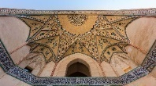  Figure 9. Agha-Bozorg Mosque entrance, Kashan, Iran [52]
Water | 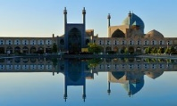  Figure 10. Shah mosque, Isfahan [44]
Empty space | 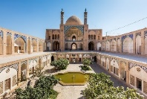  Figure 11 Agha-Bozorg Mosque, Kashan, Iran [52]
Daylighting and a play with shadow and light | 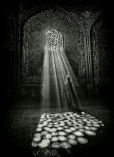  Figure 12. Sheikh-Lotfollah Mosque, Isfahan, Iran [53]
Acoustic perfected | 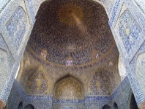  Figure 13. Shah mosque, Isfahan, Iran, Sound bounces back and forth between the floor and ceiling, with the vast dome focusing the sound [54].
Calligraphy | 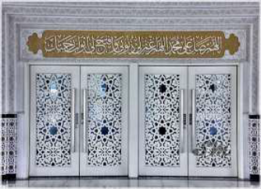  Figure 14. Doorway at Puncak-Alam Mosque with Thuluth inscriptions [55]
Unity in diversity | 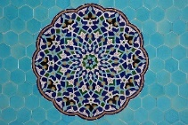  Figure 15. Decorations of Jameh Mosque of Yazd, Motif within motif [56]
Hierarchy of entrances | 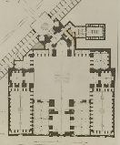  Figure 16 The plan of Shah mosque, Isfahan, Iran [57]

- CONCLUSION
Islamic architecture is known to exist for several centuries now, and during these years, it has evolved in many ways. Islamic sacred architecture, as introduced to all, is somewhat different from what is suggested by the Sharia; therefore, this study aims to understand what kind of elements used in Islamic architecture help achieve its goals, such as remembrance of God, and whether the conventional forms are suitable for this purpose. First, a definition of sacred art is presented to achieve research goals. Later, the architecture characteristics according to Islamic Sharia’ are extracted using content analysis. Results show that many of the characteristics Sharia suggests are already obeyed in historic mosque architecture worldwide. Yet, there is still room for improvement, as characteristics such as simplicity, cultural coordination, expandability, optimum usage of resources, and avoiding wastefulness are yet to be studied and practiced further.
This study tried to bring out and review the sacred aspects of Islamic architecture from the perspective of scholars like Titus Burkhart, which have rarely been addressed in modern studies, and emphasize the basic fundamental principles related to the built environment derived from the text of Sharia including the Quran and hadith of the Prophet and show how these fundamental Islamic principles can combine with architectural elements and deliver highly meaningful messages to the users. In Islamic architecture, it is highly recommended to revert to Sharia's text instead of being only inspired by past architectural works for new creations. Since this study reviewed only a few sources to extract the relevant verses to the built environment from the text of Sharia, it is recommended to investigate more sources for future studies.

REFERENCES
[1] K. Kuiper, “Islamic architecture,” Brittanica. Accessed: Aug. 07, 2023. [Online]. Available: https://www.britannica.com/topic/Islamic-architecture
[2] S. Omer, "Towards Understanding Islamic Architecture," Islamic Studies, vol. 47, no. 4, pp. 483-510, 2008. Available: https://www.jstor.org/stable/20839141
[3] A. Souaiaia, "What Is the Difference between 'Muslim' and 'Islamic'?," Islamic Societies Review, 2016.
[4] A. Papadopoulos, Islamic architecture. Tehran: Markaz Nashr Farhangi Raja, 1989, p. 319.
[5] H. A. R. Gibb, The Encyclopaedia of Islam. Brill, 1998.
[6] E. J. Grube, G. Michell, Ed. Architecture of the Islamic World: Its History and Social Meaning. Michigan: Morrow, 1978.
[7] S. Seyyed Sadr, Encyclopedia of Art. Tehran: Simaye Danesh, 2004, p. 595.
[8] E. Hussein and S. N. N. Rani, "Mosque Layout Design Criteria in Malaysia," Asian Journal of Research in Education and Social Sciences; Vol 5 No 1 (2023): Mar 2023, 03/01 2023.
[9] R. Hillenbrand, "Masdjid," in THE ENCYCLOPAEDIA OF ISLAM, vol. VI, E. C. E. BOSWORTH, B. VAN DONZEL, and LEWIS AND CH. PELLAT, Eds. Leiden, The Netherlands: E.J. BRILL, 1991, pp. 644-706.
[10] N. Hakim, "Mosque Architecture Past and Present," in Sacred Buildings: A Design Manual, R. Stegers, Ed. Basel: Birkhäuser Basel, 2008, pp. 46-53.
[11] B. K. Shrestha and S. Shrestha, "Emerging Mosque Architecture (New Architectural vocabulary in Secular Nepal)," International Journal of Architecture and Urban Development, vol. 4, no. 2, pp. 5-12, 2014.
[12] R. Othman, N. Inangda, and Y. Ahmad, "A typological study of mosque internal spatial arrangement: A case study on Malaysian mosques (1700-2007)," Journal of Design and the Built Environment, vol. 4, 12/01 2008.
[13] G. Aavani, "Metaphysical principles of art," Culture Letter, vol. 16, pp. 132-138, 1994.
[14] N. Clark and O. Nikfarjam, "The supernatural dimension of religious art; A reflection on a text from Saint Thomas Aquinas," Farabi, vol. 61, 2006.
[15] S. R. Mousavi, "Fundamentals of Islamic Art from the Perspective of Titus Burckhardt," Ziba Shenakht, vol. 22, pp. 67-92, 2011.
[16] M. Ahsani and S. N. Fallah, "A comparative study of the sacred dimensions of the architectural work corresponding to Islamic Shari'a," presented at the International Congress of Leading Contemporary Architecture and Urban Planning in Islamic Countries, Mashhad, Iran, 2018.
[17] F. Zahra & S. Shahir, "The Aesthetic Value and Spiritual Aesthetics of Islamic Ornaments in Islamic Architecture", Journal of Islamic Thought and Civilization, vol. 12, pp. 164-175, 2022, doi: 10.32350/jitc.121.08.
[18] L. M. Dabbour, "Geometric proportions: The underlying structure of design process for Islamic geometric patterns", Frontiers of Architectural Research, vol. 1, no. 4, pp. 380-391, 2012, doi: https://doi.org/10.1016/j.foar.2012.08.005
[19] K. M. Al Shomely, N. Ahmed, I. Ibrahim, R. Harb, "Building Assessment Tool for Contemporary Applications in Art and Architecture Inspired by Islamic Geometric Patterns", Civil Engineering and Architecture, vol. 12, no.1, pp. 436 – 458, 2024, DOI: 10.13189/cea.2024.120133.
[20] S. I. HASSAN, "ADAPTING DIGITAL ARCHITECTURE VOCABULARY TO REFORMULATE GEOMETRIC COMPOSITIONS OF ISLAMIC FACADES - CASE STUDY: PROPOSED MODEL FOR ISLAMIC FAÇADE THROUGH DIGITAL VOCABULARY," Architecture and Planning Journal (APJ), Vol. 28, No. 3, Article 31, 2023, DOI: https://doi.org/10.54729/2789-8547.1226
[21] M. Hejazi, “Geometry in nature and Persian architecture,” Build Environ, vol. 40, no. 10, pp. 1413–1427, Oct. 2005, doi: 10.1016/J.BUILDENV.2004.11.007.
[22] H. B. Qahi, Mystical foundations of Islamic art and architecture. Tehran: Sureh-Mehr Publishing Company, 2008.
[23] M. M. Nejad, "The Wisdom of Islamic Architecture: A Search in the Deep Spiritual Structures of Islamic Architecture of Iran," Fine Arts Journal, vol. 9, p. 62, 2004.
[24] J. Shafiq, “Architectural Elements in Islamic Ornamentation: New Vision in Contemporary Islamic Art,” Art and Design Studies, vol. 21, no. July, pp. 11-21, 2014.
[25] R. Kinross, “Semiotics and Designing,” Information Design Journal, vol. 4, no. 3, pp: 190-198, 1984.
[26] M. Holt, “Semiotics and Design: Towards an Aesthetics of the Artificial,” The Design Journal, vol. 20, no. sup1, pp. 332-341, 2017.
[27] S. H. Jalali, N. Tahoori, & I. Etesam, "A comparative study of the views of Titus Burckhardt and Oleg Grabar's model in Islamic architecture", Sophia Perennis, vol. 17, No. 37, pp. 85-106, 2020, doi: 10.22034/iw.2020.228022.1417
[28] T. Burckhardt, "The Spirit of Islamic Art. (S.H. Nasr, Trans.)", Art and People journal, vol. 55, pp 2-7, 1967
[29] H. Ayatollahi, The theoric bases of plastic arts, seventh ed. Tehran, Iran: Samt, 2011.
[30] G. B. Meisner and R. Araujo, The Golden Ratio: The Divine Beauty of Mathematics. Race Point Publishing, 2018.
[31] M. Ahsani, S. B. Ismail, S. N. Fallah, and A. al-Ameen, "The Sense of Unity in the Jameh Mosque of Varamin: A Geometric Analysis," 2023, Journal of Islamic Architecture, vol. 7, no. 3, pp. 371-377, 2023. DOI: https://doi.org/10.18860/jia.v7i3.20945
[32] R. M. Pollard, Imagining the Medieval Afterlife. Cambridge University Press, 2020.
[33] F. D. K. Ching, Architecture: Form, Space, and Order. USA: Van Nostrand Reinhold, 1979.
[34] S. H. Jalali, N. Tahoori, & I. Etesam, "A comparative study of the views of Titus Burckhardt and Oleg Grabar's model in Islamic architecture", Sophia Perennis, vol. 17, no.37, pp. 85-106, 2020, doi: 10.22034/iw.2020.228022.1417
[35] K. Weisbin, "Common types of mosque architecture," Khan Academy, Accessed: Oct. 07, 2023. [Online]. Available: https://www.khanacademy.org/humanities/art-islam/beginners-guide-islamic-world-art/beginners-guide-islamic-art/a/common-types-of-mosque-architecture
[36] H. Stierlin, Ispahan: image du paradis. La Bibliothèque des arts, 1976.
[37] T. Burckhardt, "The void in Islamic art", Studies in Comparative Religion, vol. 4, No. 2, pp. 96-99, 1970
[38] Y. Tabbaa, "Towards an interpretation of the use of water in Islamic courtyards and courtyard gardens", The Journal of Garden History, vol. 7, No. 3, pp. 197-220, 1987, DOI: 10.1080/01445170.1988.10412469
[39] A. El Shakhs & A. Ezzat, "Water in Islamic Architecture: Study of The Water Dispensary", Journal of Architecture and Art and Humanistic Science, vol. 3, No. 12, pp. 1-16, 2018, doi: 10.12816/0047906
[40] H. Corbin, The Voyage and the Messenger: Iran and Philosophy. United States: North Atlantic Books, 1998.

[41] M. Akbari, R. Behbahani, & H. I. Behbahani, "Recognizing the other realm of existence in Iranian introverted architecture by reviewing the mirror phenomenon in Sohrvardi's philosophy", Journal of Philosophical Investigation, vol. 16, No. 40, pp. 306-324, 2022, doi:10.22034/jpiut.2022.50550.3136.
[42] A. A. Dhannoon, "Water Elements in Islamic Architectures". International Transaction Journal of Engineering, Management, & Applied Sciences & Technologies, vol. 12, No. 11, pp. 1-13, 2021. DOI: 10.14456/ITJEMAST.2021.211
[43] A. Schimmel, T. Burckhardt, and W. Stoddart, “Mirror of the Intellect: Essays on Traditional Science and Sacred Art,” Journal of the American Oriental Society, vol. 109, no. 3, pp. 1989.
[44] S. K. Dehghan, "French hotel chains open in Iran as nation braces for wave of tourists", the Guardian, Accessed: Nov. 10, 2023. [Online]. Available: https://www.theguardian.com/world/2015/sep/16/french-hotel-iran-tourists-ibis-novotel-tehran
[45] R. Hillenbrand, Islamic Architecture: Form, Function, and Meaning. Columbia: Columbia University Press, 1994.
[46] H. Mortada, Traditional Islamic Principles of Built Environment, 1st Edition ed. New York: Routledge, 2011.
[47] E. Emirahmetoglu, "The Transformation of the Human Self through Religious Practice in Sufism and Buddhism", Journal of Islamic and Muslim Studies, vol. 7, No.1, pp. 26-60, 2022. doi: https://doi.org/10.2979/jims.7.1.03.
[48] D. Sofron, "Conical Perspective and Fractal Theory:A Comparative and Contrastive Approach", Anastasis. Research in Medieval Culture and Art, vol. 9, pp. 121-130, 2022, Doi:10.35218/armca.2022.1.07.
[49] H. Morteza, Traditional principles of construction in Islam. Iran: Urban Planning and Architecture Study and Research Center, 2008.
[50] H. H. Amoli, Eleven Persian treatises (philosophical, logical, mystical). Iran: Institute of Cultural Studies and Research, 1984.
[51] S. Pourmahmoud, " A STUDY ON SIMILE AND PURIFICATION IN THE “PHILOSOPHY OF DECORATION” OF IRANIAN ISLAMIC ART FROM IBN ARABI’S POINT OF VIEW", Quintana: Revista Do Departamento De Historia Da Arte, vol. 21, 2022, doi: https://doi.org/10.15304/quintana.21.7833
[52] D. Delso. Mezquita de Agha Bozorg, Kashan, Irán, 2016
[53] N. Esmaeili and B. R. Sinclair, "Soul, Space + Time: Exploring Temporality in Architecture With Reference to Sufism", Archidoct, vol. 19, No. 11, 2023.
[54] T. Cox, "Imam Mosque echo", Sound Tourism, Accessed: Oct. 13, 2023. [Online]. Available: https://www.sonicwonders.org/imam-mosque-echo/
[55] Z. Kamarudin, Z. Baydoun, and N. Mahidin, "PROFILING OF ISLAMIC CALLIGRAPHY SCRIPTS USED FOR ARCHITECTURAL DECORATION OF MASJID IN PENINSULAR MALAYSIA," PLANNING MALAYSIA JOURNAL, vol. 18, No. 4, 2020. DOI: https://doi.org/10.21837/pm.v18i14.833
[56] A. Karimzadeh, "Decorations of Jameh Mosque of Yazd", Accessed: Dec 5, 2023. [Online]. Available: https://commons.wikimedia.org/wiki/Category:Decorations_of_Jameh_Mosque_of_Yazd
[57] P. Coste, Monuments modernes de la Perse: mesurés, dessinés et décrits. Paris: A. Morel libraire-editeur, 1867

