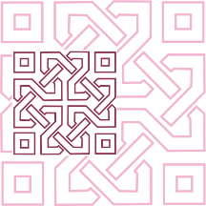 |  | JOURNAL OF ISLAMIC ARCHITECTURE  P-ISSN: 2086-2636 E-ISSN: 2356-4644  Journal Home Page: http://ejournal.uin-malang.ac.id/index.php/JIA
ALGORITHM MODELING IN ISLAMIC GEOMETRIC PATTERN RECONFIGURATION: CASE STUDY OF CHENG HO MOSQUE'S ISLAMIC ORNAMENT
Fajar Ikhwan Harnomo ^{ab}, Andiyan ^{b*}, Tita Cardiah Sumarni ^{c}, Tri Wahyu Handayani ^{d}, Ayu Puspa Wirani^{b}, Rofiqul Umam ^{f}, Nangkula Utaberta^{afgh*}
ª School of Architecture and Built Environment (SABE), UCSI University, Malaysia
^{b} Department of Architecture, Faletehan University, Indonesia
^{c} Department of Interior, Telkom University, Indonesia
^{d} Department of Architecture, Winaya Mukti University, Indonesia
^{e} Department of Applied Chemistry for Environment, Kwansei Gakuin University, Japan
^{f} Faculty of Vocational Studies, Universitas Airlangga, Indonesia
^{g} Department of Interior Design, Institut Teknologi Sepuluh Nopember, Indonesia)
*Corresponding Author: andiyanarch@gmail.com, Nangkula@ucsiuniversity.edu.my
ARTICLE INFO |  |  | ABSTRACT
Volume: 8  Issue: 3  Page: 691-699  Received: October 24th, 2023  Accepted: April 22th, 2024  Available Online: June 30th, 2025  DOI: 10.18860/jia.v8i3.23937 |  |  | The focus of this study is the issue of reorganizing the preexisting Islamic Geometric Patterns found at the Cheng Ho Mosque via the use of computer modeling techniques. The need for computer modeling research for rearranging geometric patterns at the Cheng Ho Mosque may be attributed to many factors. The objective is to use digitization to streamline the ornamental design process. The study methodology used included the analysis of geometric forms, which were then processed and patterned using Parametric Islamic Geometric Patterns with the assistance of Grasshopper software. This study employs the Islamic octagonal archetype, similar to Chinese geometric ornamentation, using circular geometry with a radius input, as discussed in the preceding article. The inclusion of the division shape serves as a necessary limitation to facilitate the cutting of the recurring patterns. The findings indicate that the algorithmic technique is constructed using a collection of parameter inputs organized into four primary components: octagonal basis geometry, repetition procedure, partition or boundary-shaped surface, and material dimension simulation. However, it also demonstrates varying parameter inputs, posing challenges in organizing them accurately to generate the octagonal form. Visual scripts may effectively depict Islamic geometry in open systems that exhibit parametric adaptability to the fundamental principles of division. During the design processing phase, it is possible to exert control over the pattern proportions in some instances.  Keywords:  Facade Design; Grasshopper; Octagonal Archetype; Parametric Islamic Geometric Patterns; Wheel Construction Method

- INTRODUCTION
The problem in this research is that artists have attempted to include geometric decorations and Islamic influences by experimenting with different design possibilities. Patterns are created by combining primary dots, lines, serrations, polygons, and circles to create incredibly different patterns with limitless possibilities. The design is further enhanced by a mosaic arrangement of ceramic materials or wood carvings, which results in a fusion of new pieces. Circles and Braided Circles are two primary geometric forms that are often employed. The circle's radius is the fundamental unit of comparison, while the braided circle is the basic unit of comparison. Quadrilaterals, triangles, and polygons may be formed by dividing the circle's radius into its fundamental unit, the circle's radius[1]. Rounds and squares, pentagons and octagons, and hexagons and octagons, which are often star-shaped, ultimately include components of circles. They are the consequence of the development of repetition and division as well as the elaboration of composition, namely its symmetrical composition, which resulted in the birth of these forms. Ornamental designs may be a component of a larger overall design, and their components may be more essential than the preliminary design in some instances. The star shape is another geometric design seen frequently in Islamic architecture. Star forms may be found in numerous permutations, ranging from corner six (6) to corner sixteen (16), and have been used in various applications, including early shutters, woodcarvings, slab tiles, and needleworks. A stunning optical effect is created through the composition of repetitive geometric patterns, color combinations, and material choices. As a result, it elicits both pleasant and negative emotions[2].
The reason for conducting a case study in this research is, according to the authors, the prevailing method of researching Islamic geometric patterns that concentrates on the formal qualities of historical singularities, with less emphasis on algorithms and the links between different design sections. Consequently, research on Islamic geometric patterns has been conducted, including the computational methods for creating various designs for the examination process[3]. This technique may be readily observed in a research that tries to build a classification system to group designs with similar features by identifying the underlying grid system, a common goal in information visualization. A categorization of Islamic geometric designs into numerous groups is the outcome of this research[4]. Various designs are covered in these categories, from designs with a similar recurring structure, such as groupings of squares or hexagons depending on the design, to designs that use a similar system of proportions[5]. Certain samples were studied because this is a development of our research entitled "Geometric Ornaments Synthesis in Chinese Mosque"[6].
Previous researchers[7] discovered that, first, historical designs correlate with one another beyond the standard dimensions; second, profound morphological links exist within the historical structure of the singularity. In addition, other previous researchers, [8] when investigating Islamic Geometric Patterns, found out an ancient paradigm stating that compositional analysis is the key to success. This study challenges that view. Compositional geometry analysis is needed to analyze IGP design features, which is shown in this work. A more effective method of doing this is discovered by examining design formalism. Other previous researchers [9] point out that the design step is followed by a digital production process, and experimental research is carried out on chosen issues in Islamic patterns throughout the development stage. Moreover, former researchers [10] also express that product design and manufacturing need shorter market time and lower costs to increase productivity; these can be achieved by utilizing Grasshopper (a graphical algorithm editor tightly integrated with RhinoTM's 3-D modeling tools). Additionally, several CAD-based features are employed, such as model feature recognition, the extraction of object properties, and the geometric topology interface. Furthermore, earlier researchers [11] assert that genetic algorithm optimization was used to define the openness's sizes and their cutting angle to minimize solar radiation entrance during the year, maintaining the outdoor view, after the development of a geometry definition had been managed with a parametric modeling approach (Rhinoceros and Grasshopper).
Emphasizing the significance of this study, it aims to discover Islamic geometric patterns using algorithms that use two different techniques, planes and points. It needs to obtain instructions on transforming Islamic geometric designs using the Grasshopper program. Further, using an algorithmic method, this research focuses on building Islamic geometric patterns, which allows the creation of transformations from primary forms and various variants in Islamic geometric patterns. Moreover, this research is also aided by technological complexity via the use of the Grasshopper program in creating transformations or other forms to facilitate the manufacture and mass production of Islamic geometric designs on a large scale [9].
The Cheng Ho mosque was chosen as the study's subject as a continuation of the writers’ previous work, Geometric Ornament Synthesis in Chinese Mosque, which examines the synthesis of geometric ornaments in two cultures as well as identifies and searches for a common thread of cultural acculturation in mosque ornaments. This study looks into ways to install and rearrange geometric patterns in Islamic ornaments used in mosques with Chinese ethnic backgrounds as a follow-up to the previous study.

- THEORETICAL BACKGROUND
- ISLAMIC ARCHITECTURAL ELEMENT
Typical interpretations of Islamic architecture include elements such as the following: The notion of God the Almighty is perceived as endless, and the outcome of the design is a recurring motif that represents the concept of infinitely many possibilities. Because they are all manifestations of God's creation, people and animals are seldom used as ornamental features in religious artwork[12]. Moreover, no one can be compared to the beauty of God's creation. Motif-shaped leaves are often utilized, and they may be modified or simplified. Employing Arabic calligraphy throughout the building's creative interior adds to the overall effect. Generally speaking, calligraphy illustrates passages from the Holy Quran [13].
Islamic architecture is often referred to as "the architecture of the veil" because the beauty of the architecture is found inside the spaces within the structure (the inner courtyard and its chambers), which are not visible from the exterior of the building (from the road) [14]. Furthermore, the utilization of enormous forms, such as giant domes, lofty towers, and a vast inner courtyard, is intended to communicate the message of the ruling powers to visitors. The architectural aspects may distinguish Islamic architecture passed down from the first mosque, erected by Prophet Muhammad in Madina, to the present day [15]. Others originated from adapting elements in churches, temples, and synagogues before Islam arrived. For example, Byzantine architecture adds color to early Islamic architecture via the use of a curving arc shape, a sharp arc generating a three-dimensional (vault), and a massive dome, among other techniques (dome) [16].
The main prayer hall and a large yard are often connected (these traits came from Masjid Al-Nabawi in Madina). Minarets or towers, such as the one seen in the Great Mosque of Damascus, were initially used as towering torches or illumination sources. As a result, the etymology of the Arabic word "nur" might be translated as "light." The orientation of the Kaaba in Mecca is indicated by its Mihrab, which is located on the inner wall. In addition, a giant dome and a small dome (cupola) have been added. The usage of Islamic calligraphy is replacing pictures as a decorative element. A fountain has been added in the outer part, or yard, which has now been replaced with an ablution area (seen above). Bright colors and a strong emphasis on both sides-both the interior and external areas-are employed in this design [17].

- ISLAMIC ARCHITECTURAL ORNAMENT
No unique form of architectural adornment or decoration in Islam can be applied to a specific structure. However, the ornament's form and style are identical across all construction features [18]. Column wrapping, wall coating, ceiling and floor coating, and even window and door ornamentation are all examples of using decorations. It is important to note that ornament in Islamic architecture includes flexibility, scale-free shapes, and materials based on decorations such as calligraphy and geometric patterns[14].

C. CALLIGRAPHY
It is possible to characterize Arabic calligraphy to depict the geometric ornamentation used in Islamic art as a group. This is because the shapes are curved (Arabesque), exactly like the pages of the book, and this is why they are also used on the walls and ceiling of the mosque. Artists nowadays can make calligraphy strokes more abstractly. Muslims see calligraphy as a spiritual art form apart from other forms of expression that cannot be compared to other arts [19]. Aside from being seen as nobler, calligraphy serves as a link between the visual languages of Muslims and the Islamic faith. As a calligraphy component, the Holy Quran has played a vital role in forming the Arabic alphabet and language. The Quran's proverbs and sentences or verses have continued to be a valuable source of inspiration for Islamic calligraphy.

D. ISLAMIC GEOMETRIC ORNAMENT
The artists have experimented with various design options for geometry decorations influenced by Islam to enhance their designs further. Using a mix of primary dots, stripes, serrations, polygons, and circles, the pattern can create diverse and limitless shapes in their possibilities. Designs are enhanced by using mosaic arrangements of ceramic materials or wood carvings, creating novel combinations. Certain fundamental geometric forms are often utilized, including Forms Intertwining Braided Circles and Circles, with the circle's radius serving as the fundamental unit for determining the proportions of the braided circles and circles [20].
The basic unit, formerly the circle's radius, may be processed into the following shapes: a form of four triangles, a triangle, and a polygon. Rectangles, pentagons, hexagons, and octagons, frequently in the shape of a star and later having aspects of a circle, are the most common geometric shapes. These forms were created due to the elaboration of repetition, which is the division, and the elaboration of the composition of the play, the composition of its symmetry [21]. In some instances, the ornament design is a component of the overall design, and the components may be more significant than the preliminary design. In addition to the star form, the square is another geometric pattern observed in Islamic architecture [22]. Innumerable permutations of the star form are possible, ranging from an angle of six (6) to an angle of sixteen (16), and it is used in everything from shutters to wood carving, slabs, tiles, and even needlepoint. Beautiful optical effects are created by repeating the composition of geometric patterns, combining colors, and selecting the appropriate material. As a result, both pleasant and negative sensations are generated. However, technically, it still requires a level of awareness from the community to carry out the health protocol within the mosque environment[23].

E. ARABESQUE
Most structures, manuscripts, items, and textiles are decorated with various flora and plants, alone or in combination with other decorations like calligraphy, geometry, or even a living person's shape. The art of decorative forms of plants continues to be practiced worldwide in all countries where Islam is the main religion, including the United States [24]. Although the artisans' depictions of flora and flowers are accurate, what distinguishes them is their ability to turn the natural shape into an arabesque pattern. The word "arabesque" first appeared in printed papers in the early nineteenth century, after the return of Napoleon's expedition from Egypt [25].
The arabesque element in Islamic art is generally characterized by the extensive use of repeated geometric patterns (polygonal) and the representation of flora or animals (especially birds). Generally, it is employed as a decorative element on the walls of mosques, homes, and other Muslim-owned structures [26]. The selection of geometric forms is based on the Islamic worldview and its perspective on life. Using Arabesque to decorate is an excellent technique to replace pictures of people and animals, which is prohibited in Islam, with repetitive Islamic art [27].

F. ALGORITHMIC MODELING THROUGH GRASSHOPPER
In algorithm-based modeling, the results of a series of procedures are open-ended or, principally, can be used to return a solution to a question or input [28]. Theoretically, algorithm-based modeling consists of a collection of well-defined instructions associated with a computer, where the computational instruction process consists of three stages: the input, the procedure, and the output processes. In another sense, the algorithm is part of the parametric design, which is written in discrete steps of the process and written through a symbolic vocabulary [29]
Regarding architectural design, the algorithm programming language more widely used by architects currently is Grasshopper because it is user-friendly, by adopting visual script-based modeling. Through Grasshopper, algorithm-based modeling in architectural design will be beneficial, including a wide range of community growth, constant improvement, independent user collaboration, and software and hardware interaction. Moreover, grasshopper-based modeling can be used in specific digital fabrication methods, such as additive and formation techniques. The availability of recent fabrication methods facilitates maintenance or building restoration demands. Additionally, the initial and development ideas in this algorithmic modeling of the Islamic Geometric Ornament of 8-fold rosettes are inspired by the previous research of digital weaving pattern investigation for facades [30] and the Parametric House’s teamwork [31].

- METHODS
- THE ANALYSIS OF GEOMETRIC SHAPE
Based on the research previously reviewed [6], the glass and calligraphy sections of Cheng Ho Mosque, one of the mosques in Chinese architectural style that incorporates Islamic geometric ornaments into one of its architectural elements, can be seen in Figure 1. It is the geometric form of an equilateral 8-pointed star, also known as an 8-point star, adopted by the Cheng Mosque. It is the same shape that Islamic geometric patterns have [32]. However, when shown at the Cheng Ho Mosque in an octagonal pattern, it includes crossing lines inside the fundamental adornment.
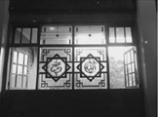
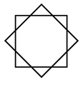
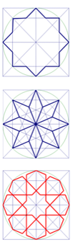

Figure 1. The 8-point star ornaments of Cheng Ho's Mosque (left to the middle) and the Park's 8-point star interpretation (right)

The 8-sided decoration pattern of the Cheng Ho Mosque is a metamorphosis of the fundamental shape of a normal quadrilateral, which is duplicated, and one of the outcomes of the duplication is rotated 45 degrees, according to the Gestalt principle. As long as the octagonal form is created using the rotated regular rectangle's abstraction, the shapes produced by iterations are regular polygonal shapes. However, the iterations are confined to iterations that occur via rotation alone. On the other hand, if this octagonal decoration uses essential geometric components such as points and lines, it will be transformed into various shapes and sizes. To transition the octagonal control from an 8-point star to an 8-star polygon, it is necessary to emphasize the geometry control at the places of intersection of the lines. To convert the basic shape of the octagonal ornament pattern in the Cheng Ho Mosque into an algorithmic procedure using parametrics, it is necessary to create an abstraction that has good flexibility about the basic geometric shape, in this case, using the Wheel construction method approach. It is further described in detail.

- PARAMETRIC ISLAMIC GEOMETRIC PATTERNS
Under the Wheel technique, the current 8-sided design is studied in the manufacturing phases, which include the creation of 2 (two) concentric circles with intersection points coupled with 16 axes centered on the center point of the circle as shown in Figure 2. Furthermore, the octagonal profile's form is determined by the junction of the axes and circles of varying radii drawn on the graph paper. Throughout the investigation, it is necessary to remember that each circle interacts with eight axes in turn as shown by the example in Figure 2.
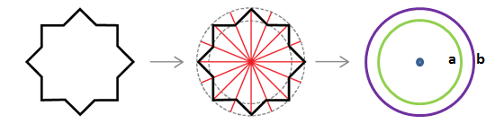
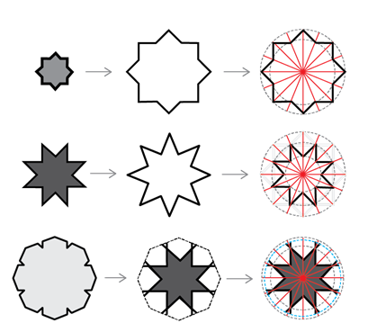

Figure 2. A circle intersects eight axes alternately

To summarize, the Wheel method can create a simple 8-point star by creating two circles with different diameters, one inside the other, and utilizing the existing point of intersection. As previously explained, the points are connected by zigzag interpolated polylines that alternate between the outer and inner circles. Interpolations are ordered consecutively in algorithmic modeling during the codifying process, which is accomplished by employing a list of vertices inside the circle.

Table 1. The abstraction process of IGP was inspired by the Basic IGP [32]

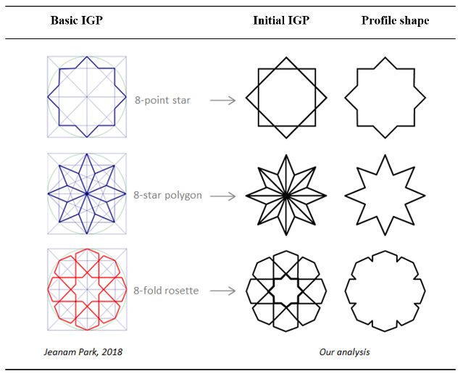

- RESULT AND DISCUSSION
- RECONFIGURATION RESULT
In line with the preceding geometry stages, the Complex IGP (8-Fold Rosette) pattern employs the Gestalt method, resulting in multiple polygon components that can be distinguished as distinct patterns due to their placement on the pattern's surface. Table 1 shows the resulted profile shapes, which include the profile of the 8-point star initial shape, the profile of the 8-star polygon, and the boundary lines of the 8-fold rosette, where the IGP manufacturing step can be initiated by adding three profile lines in succession at the exact midpoint to obtain the complete shape of the geometry of the 8-fold rosette.

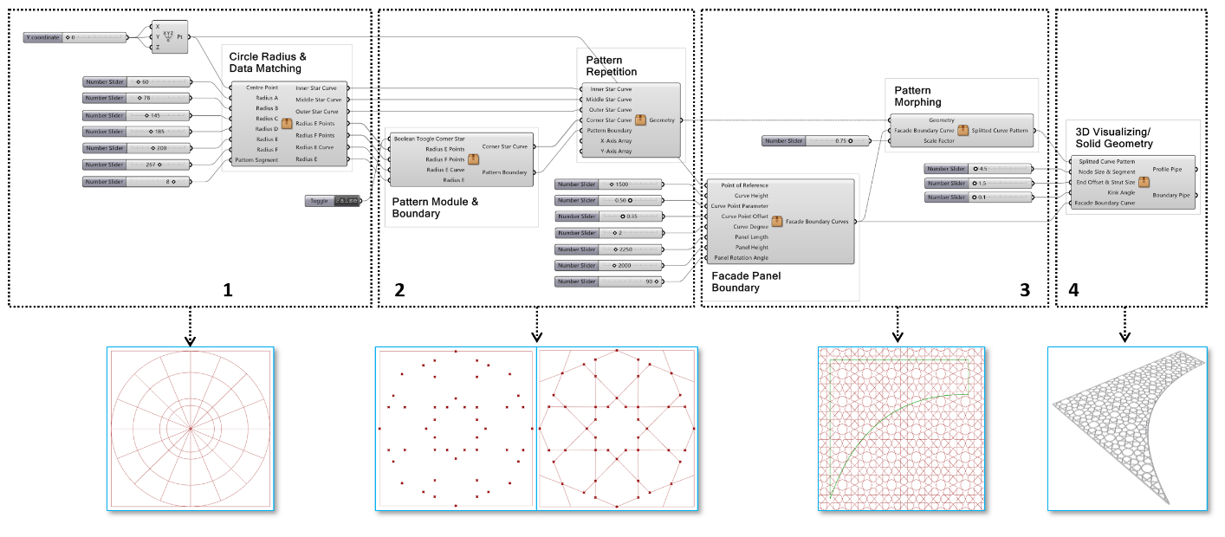

Figure 3. The full algorithmic processes diagram of developed parametric IGP into 3D Model

It is discovered that the analytical procedure for transforming a basic 8-sided design into a complicated 8-fold rosette shape requires about 5 (five) kinds of circles with varying diameters or radii, which are as follows: (a) green; (b) purple; (c) cyan; (d) chocolate; and (e) yellow. It is necessary to provide the color of each circle to assist the process of finding the points that intersect with its axis line, with the smallest diameter circle represented by circle-a (green) and the enormous diameter circle represented by circle-e (yellow).

Table 2. The shape analysis from the IGP profile curves into various circle radius identifications.
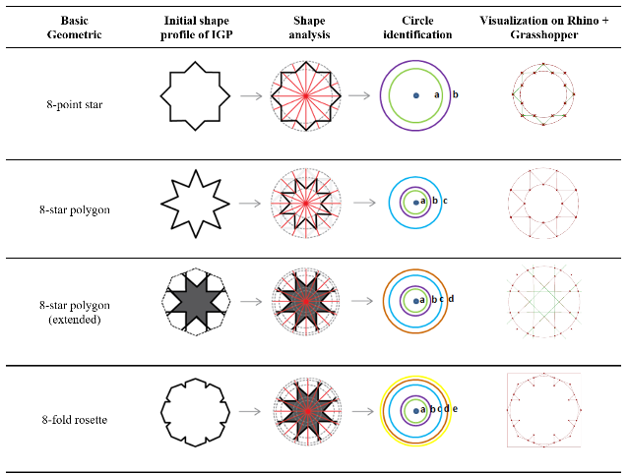

According to the study's findings, it is required to adjust the procedure of creating 8-star polygons to generate two junction points on the circle-d simultaneously (brown). Continuing across until it hits the outer circle, the line at the end of the 8-star polygon may be utilized as a reference point in creating a profile line from the 8-fold rosette using a yellow circle line (circle-e). By using the algorithm technique in Grasshopper, it is possible to produce all of the profiles from Figure 3 simultaneously.

- PATTERN IMPLEMENTATION
Afterward, the geometric patterns developed in the previous phase are used to create repetition patterns, which are then applied to surface-based items as assumptions for the facade/partition panels used in the future. The repetition in this procedure is not accomplished by using a tessellation loop pattern but rather by using a basic repetition pattern using an Array, and the Array system used is a Rectangular Array system. Table 2 shows how to regulate the looping pattern via the x and y axes by specifying the quantification of a given integer on each axis parametrically using a Rectangular Array.
The repetitive pattern is also applied to a 2-dimensional field with a border shape that may be changed to account for changes in the field's circumstances. Using a Boolean Region Difference procedure, which is a process to trim (trim) line patterns from the IGP that have been developed at the boundary of the facade/partition plane, it is possible for the repeating pattern of Islamic ornaments to parametrically and automatically adjust the number of repetitions in the pattern.
By referring to the circle, the design of this Islamic ornament can be interpreted widely, related to the basic parameters inputted to this ornament as depicted in Figure 4. The complexity of the shape can be quickly simulated in the number of segments and radius according to the parameter inputs of the circle radius.
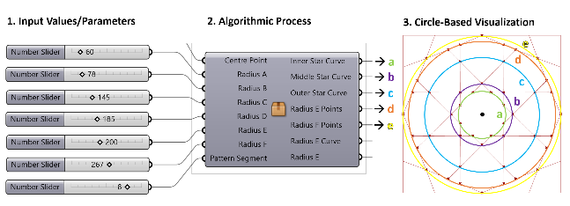

Figure 4. Further iteration is available by controlling the key parameters of the circles and the radial axes as segments

However, the circle diameter number needs to be further researched using the ratio of the mathematical series. Nevertheless, there are areas for improvement in the implementation process of the Wheel construction method through Grasshopper, namely the difficulty of controlling the radius in a rational number arrangement, which is needed to make it easier to determine the ratio for the next iteration. It will be inversely proportional to the shape of the ornament obtained. For example, the 8-fold rosette cannot be maintained in the ideal form of a ratio by multiplying the number in every circle radius parameter before or after its number because the circle's radius will control the shape of the geometry. However, it can still be added and integrated further with algorithms and calculations that are more relevant to mathematical calculations.

- CONCLUSION
The result shows that the pattern anatomy of basic IGP can be elaborated using the concentric circle design approach from the Wheel construction method. Following the method, the whole algorithmic procedures are constructed by the sets of parameter inputs that are clustered into five main parts, which are: (1) the circle-based geometry guidelines; (2) the data matching; (3) the interpolation and pattern making; (3) the boundary and repetition procedure; (4) the boundary-shaped partition or surface; (5) and 3D modeling for fabrication; the first part is the most complex and the fundamental parts in the whole procedure because it consists of five different circles on the radius for the minimum requirements.

REFERENCES

[1] M. Ahmad, “Study of the ornamentation of Bhong Mosque for the survival of decorative patterns in Islamic architecture,” Front. Archit. Res., vol. 7, no. 2, pp. 122–134, 2018, doi: 10.1016/j.foar.2018.03.004.
[2] A. Thalal, “Symmetry in art and architecture of the Western Islamic world,” Crystallography Reviews, vol. 24, no. 2. pp. 102–130, 2018. doi: 10.1080/0889311X.2017.1343306.
[3] B. P. Caboni, “Ghadames (Libya). Surveying data for a reconstructive proposal ofthe ruins locally known as ‘el-Asnam’, the Idols,” DISEGNARECON, vol. 13, no. 25. 2020. doi: 10.20365/disegnarecon.25.2020.2.
[4] Y. A. Lahcen, “Computing technologies to construct an islamic geometric patterns respecting the ‘hasba’ method,” Advances in Science, Technology and Innovation. pp. 249–260, 2021. doi: 10.1007/978-3-030-53440-0_27.

[5] A. Khamjane, “Computer Graphics for Generating Islamic Geometric Periodic and Quasi-periodic Patterns,” Proceedings - 2019 International Conference on Intelligent Systems and Advanced Computing Sciences, ISACS 2019. 2019. doi: 10.1109/ISACS48493.2019.9068879.
[6] T. W. Handayani and T. Cardiah, “Geometric Ornaments Synthesis In Chinese Mosque,” Bandung Creat. Mov., vol. 3, no. 1, 2016.
[7] M. W. Alani, “Algorithmic investigation of the actual and virtual design space of historic hexagonal-based Islamic patterns,” Int. J. Archit. Comput., vol. 16, no. 1, pp. 34–57, 2018, doi: 10.1177/14780771187632.
[8] M. W. Alani, Morphological Code of Historical Geometric Patterns-The Digital Age of Islamic Architecture. London: CUMINCAD, 2016.
[9] A. Agirbas, Teaching Design by Coding in Architecture Undergraduate Education: A Case Study with Islamic Patterns. Istanbul: CUMINCAD, 2017.
[10] P. Kyratsis, A. Manavis, and J. P. Davim, Computational design and digital manufacturing. Springer Nature, 2023. doi: 10.1007/978-3-031-21167-6.
[11] A. Zani, M. Andaloro, L. Deblasio, P. Ruttico, and A. G. Mainini, “Computational design and parametric optimization approach with genetic algorithms of an innovative concrete shading device system,” Procedia Eng., vol. 180, pp. 1473–1483, 2017, doi: 10.1016/j.proeng.2017.04.310.
[12] P. Cromwell, “Looking at Islamic patterns II: making sense of geometry.” psyarxiv.com, 2021. doi: 10.31234/osf.io/kwce4.
[13] E. J. Grube, Architecture of the Islamic World. London: Thames and Hudson, 1987.
[14] S. Moradzadeh and A. N. Ebrahimi, “Islamic Geometric Patterns in Higher Dimensions.,” Nexus Netw. J., vol. 22, no. 0, pp. 777–798, 2020, doi: 10.1007/s00004-020-00486-0.
[15] S. M. A. Fouad, A. Mandour, and ..., “The development of the principles of the Elements of Islamic architectural by using parametric algorithms,” Eng. Res. J., vol. 170, no. 0, pp. 104–122, 2021, doi: 10.21608/ERJ.2021.177301.
[16] M. A. Fouad, A. Mandour, and ..., “The Revival of Islamic Architecture using Parametric Algorithms,” Eng. Res. J., vol. 170, no. 0, 2021, doi: 10.21608/ERJ.2021.177304.
[17] N. Nadyrshine, L. Nadyrshine, R. Khafizov, and ..., “Parametric methods for constructing the Islamic ornament,” E3S Web Conf., vol. 274, 2021, doi: 10.1051/e3sconf/202127409009.
[18] S. N. Hosseini, S. M. Hosseini, and M. HeiraniPour, “The Role of Orosi’s Islamic Geometric Patterns in the Building Façade Design for Improving Occupants’ Daylight Performance,” J. Daylighting, vol. 7, no. 2, pp. 201–221, 2020, doi: 10.15627/jd.2020.18.
[19] E. Makovicky, “Quasicrystalline patterns in western Islamic art: problems and solutions,” Rend. Lincei. Sci. Fis. e Nat., vol. 32, no. 0, pp. 57–94, 2021, doi: 10.1007/s12210-020-00969-9.
[20] M. Majewski, “Understanding Geometric Pattern and its Geometry (part 1).,” Electron. J. Math. Technol., vol. 14, no. 2, 2020.
[21] M. Majewski, “Geometric Pattern and its Geometry Part 4-Geometry from the Mughals’ land.,” Electron. J. Math. Technol., vol. 15, no. 1, 2021.
[22] P. Webster, “Islamic 8-fold fractal flower median (I and II),” J. Math. Arts, vol. 14, no. 1–2, pp. 161–183, 2020, doi: 10.1080/17513472.2020.1734438.
[23] T. Cardiah, A. Andiyan, and A. Rahma, “Implementation of Health Protocols at Mosques during the Covid-19 Pandemic in the city of Bukittinggi,” Rev. Int. Geogr. Educ., vol. 11, no. 5, pp. 3765–3771, 2021, doi: 10.48047/rigeo.11.05.260.
[24] A. Nour, “The Algorithmic Mashrabiya: Reimagining the Traditional Islamic Screen,” scholarscompass.vcu.edu, 2021. doi: 10.25772/NNGS-VC46.
[25] D. Chen, P. Cheng, S. Simatrang, and ..., “Innovative design of caisson lotus pattern in Mogao grottoes based on shape grammar,” J. Phys. Conf. Ser., vol. 1790, 2021, doi: 10.1088/1742-6596/1790/1/012014.
[26] P. Gailiunas, Near-miss Star Patterns. Arizona: Tessellations Publishing, 2020.
[27] M. M. Ibrahim, “The design of an innovative automatic computational method for generating geometric Islamic visual art with aesthetic beauty,” University of Bedfordshire, 2021. [Online]. Available: http://hdl.handle.net/10547/625007
[28] A. Tedeschi and F. Wirz, AAD_Algorithms-Aided Design: Parametric Strategies Using Grasshopper. Japan: Le Penseur Publisher, 2014.
[29] R. F. Woodbury, Element of Parametric Design. New York: Routledge, 2010.

[30] I. Harnomo Fajar and A. Indraprastha, “Computational Weaving Grammar of Traditional Woven Pattern,” in Parametricism Vs. Materialism: Evolution of Digital Technologies for Development in 8th ASCAAD 2016, London: CUMINCAD, 2016.
[31] W. Alhaboob and H. Nabli, “Combinatorial Arabesque: A new concept,” Sci. J. King Faisal Univ., vol. 21, no. 1, 2020, doi: 10.37575/b/sci/2016.
[32] J. Park, “Cultural and mathematical meanings of regular octagons in Mesopotamia: Examining Islamic art designs,” J. Hist. Cult. Art Res., vol. 7, no. 1, pp. 301–318, 2018, doi: 10.7596/taksad.v7i1.1354.

