 |  | JOURNAL OF ISLAMIC ARCHITECTURE  P-ISSN: 2086-2636 E-ISSN: 2356-4644  Journal Home Page: http://ejournal.uin-malang.ac.id/index.php/JIA
SUSTAINABILITY GOALS: A NETWORK ANALYSIS OF RELIGIOUS VALUES FOR ARCHITECTURE EDUCATION AND ETHICS
Aulia Fikriarini Muchlis^{a*}, Dewi Larasati^{b}, Yulita Hanifah^{c}, Anita Andriya Ningsih^{d}, Wienty Triyuli^{e}
ªDepartment of Architecture, Universitas Islam Negeri Maulana Malik Ibrahim Malang, Jawa Timur, Indonesia
^{b}School of Architecture, Planning and Policy Development, Bandung Institute of Technology, Indonesia
^{c}Department of Architecture, Pancasila University, Srengseng Sawah, Jagakarsa, Jakarta Selatan
^{d}Universitas Islam Negeri Maulana Malik Ibrahim Malang, Jawa Timur, Indonesia
^{e}Department of Architecture, Sriwijaya University, Indonesia
*Corresponding Author: auliafikriarini@arch.uin-malang.ac.id
ARTICLE INFO |  |  | ABSTRACT
Volume: 8  Issue: 2  Page: 515-529  Received: November 15th, 2023  Accepted: December 22nd, 2024  Available Online: December 30th, 2024  DOI: 10.18860/jia.v8i2.24196 |  |  | Education, a pivotal mechanism for fostering sustainable development, is crucial in shaping sustainable behavior. This article delves into the Islamic conception of sustainability, an increasingly relevant perspective in today's global context. Establishing a sustainable educational framework within higher education institutions is crucial for achieving sustainability objectives. The selection of Islamic values was based on the understanding that they have the potential to shape human behavior. The data gathered through archival methodologies and the selected textual materials were deemed appropriate for the study's specific context. Expertise was also a key factor in the analytical process. The data underwent examination utilizing both network and content analysis methodologies. The findings reveal that the sustainability principles outlined in the Quran and Hadith provide a comprehensive framework addressing diverse environmental, social, and economic issues. The Quran emphasizes the importance of utilizing and preserving land and water resources to prevent global ecological collapse. Simultaneously, the Hadith advocates for implementing and understanding the principle of sharing among sentient beings to foster social and economic sustainability. This emphasis on education's role in shaping sustainable behavior is inspiring and motivating.  Keywords:  Architecture Education, Content Analysis, Environmental Learning, Sustainable, Religious Value

- INTRODUCTION
Education is a transformative endeavor that aims to cultivate the attitudes and behaviors of individuals or collectives, fostering their intellectual and personal growth through various pedagogical methods, strategies, and practices. Education is a deliberate and purposeful endeavor to cultivate an environment conducive to acquiring knowledge and skills. Its main goal is to help students develop their natural skills, such as religious and spiritual strength, self-discipline, personal growth, intellectual curiosity, good character, and practical skills that are important for their growth, the progress of society, and the improvement of their country.
Higher education is the subsequent stage that must be pursued following secondary education to cultivate enhanced and proficient academic skills capable of implementing, advancing, and generating knowledge in science, technology, and the arts. The advancement of higher education is anticipated to catalyze transformative change across various domains, fostering the cultivation of a novel and improved societal framework. This framework would enable individuals to comprehend their entitlements and responsibilities while actively participating in the nation's developmental endeavors. With this objective in mind, the institution endeavors to assist individuals in acquiring the necessary skills to fulfill future demands. The National Education Law and the Ministry of National Education's National Education Strategic Plan from 2010 to 2014 spell out the basic ideas that must be a part of the development of national education. These plans are especially clear about the need for Education for Development and Sustainable Development (PUP3PB). The Education for Sustainable Development (ESD) is referred to as such by UNESCO. Agenda 21, a program aimed at implementing sustainable development, further bolsters this movement by advocating for educational initiatives that foster sustainable development and enhance public consciousness.
To enhance their academic skills and effectively engage with information in science, technology, and the arts, those who have completed their secondary education must pursue more education. Moving up in higher education brings about big changes in many areas. It will help create a better society where everyone knows their rights and responsibilities and works together with the government to make the country grow and progress. With the purpose mentioned earlier in focus, the institution strives to support individuals in learning the essential abilities needed for the upcoming period. The National Education Law and the National Education Strategic Plan, implemented by the Ministry of National Education between 2010 and 2014, delineate the fundamental principles vital for enhancing education at a national level. As mentioned above, the plans prioritize two key areas: Education for Development and Sustainable Development (PUP3PB). UNESCO uses the term "Education for Sustainable Development" (ESD) to describe this idea. Agenda 21, a plan for achieving sustainable development, supports this movement even more by supporting educational programs, making it easier to use sustainable development methods, and raising awareness about sustainability in the public.
On the other hand, the main role of education in sustainable development has long been recognized. Improving and redirecting education are two of the goals of Agenda 21, adopted at the United Nations Conference on Environment and Development in Rio de Janeiro, Brazil, in 1992, and its Chapter 36 was dedicated to “Promoting Education, Public Awareness, and Training”. The reorientation of education towards sustainable development has been the focus of many initiatives under the authority of the United Nations Decade of Education for Sustainable Development (2005–2014), which was declared after the 2002 World Summit on Sustainable Development was conducted in Johannesburg, South Africa. Education is, furthermore, a part of the top three Rio Conventions, comprising the United Nations Framework Convention on Climate Change (1992), the Convention on Biological Diversity (1992), and the United Nations Convention to Combat Desertification (1994).
The three pillars above lead educational institutions to the concept of sustainability, but in practice, it still needs to be improved in several aspects at the individual, organizational, and even institutional levels [1]. At the individual level, cognitive and social problems occurred. They include a need for more understanding of sustainability so that it cannot reach the affective and behavioral realms. Another barrier is the readiness of the universities, which still need to provide the ability and skill level of sustainable education for the teaching staff. [2], [3], and the institutional level, showing insufficient funds to run the sustainability program [4].
These aforementioned various limitations and constraints could be the cause of the unsuccessful implementation of the concept of sustainability in a university. Therefore, it is crucial to develop awareness in educational institutions to realize the concept of education with sustainability as its orientation. Education is a way to achieve sustainability by giving provisions in the form of knowledge, skills, values, and attitudes to contribute to sustainable development [3], [5]. In addition, education plays a vital role in creating awareness and sensitivity to environmental problems and providing solutions [6], [7].
Education for Sustainable Development (ESD) enables everyone to acquire the knowledge, skills, attitudes, and values necessary to shape a sustainable future. Through education, people can only acquire the knowledge, skills, and values needed to achieve a sustainable society. Regarding this matter, many educational institutions only prioritize scientific truth without considering beliefs and values. To note, Indonesia is a country that possesses numerous values derived from various cultures and religions. In this instance, the community greatly appreciates these values because they powerfully incite environmental responsibility. The Indonesian people also firmly hold and believe in the values derived from religion as fundamental values. Bearing in mind the background of the Republic of Indonesia as a religious country, this paper seeks to elaborate on religious values as the main values in shaping sustainable education in higher education. In addition, values are believed to be part of shaping students'ttitudes and behaviors [8] of students so that the goals of sustainable development can be achieved.

  - RELIGIOUS VALUES AND EDUCATION SUSTAINABLE DEVELOPMENT
Certainly, humans have a major influence on ecological sustainability. Regarding this, we need an education that can create and instill people with a sustainable frame of mind, balance human welfare, balance economy and traditions, and balance culture and the earth's natural resources. Education for sustainable development is one of the educational concepts that was created to improve the quality of life without sacrificing the earth and sought to integrate the values inherent in sustainable development into all aspects and levels of learning.
The existence of environmental problems caused by increasingly complex development forms a concept of sustainable development. Therefore, these problems must be handled comprehensively in all parts of the world. Sustainable development encourages the conservation movement, particularly the environment and the conservation of natural resources, including their management. Environmental education is needed to develop skills and attitudes containing values that support the relationship between life and the environment. [9]. Certainly, humans have a major influence on ecological sustainability. Regarding this, we need an education that can create and instill people with a sustainable frame of mind, balance human welfare, balance economy and traditions, and balance culture and the earth's natural resources. Education for sustainable development is one of the educational concepts created to improve the quality of life without sacrificing the earth and to integrate the values inherent in sustainable development into all aspects and levels of learning.
Education for Sustainable Development (ESD) builds awareness, values, behavior, and character that support sustainable movements [10]. ESD helps the people of the world learn their path to a more prosperous future and also seeks to help people cultivate attitudes, talents, experiences, and skills to make informed decisions and to act on them, both now and in the future, for the good of themselves and others (UNESCO n.d) [10]. ESD can empower students with the expertise, skills, and values needed to support a sustainable concept [11], [12].
Education for Sustainable Development (ESD) also promotes education towards sustainable development and increases public awareness of sustainability. UNESCO (n.d.) says that education for sustainable development (ESD) can be any education that helps people develop "environmental and ethical awareness, values, attitudes, and behaviors consistent with SD and for effective public participation in decision-making and can be formal or informal. The goals of ESD are to provide high-quality educational benefits for everyone, to incorporate the principles, values, and behaviors needed for sustainable development into every educational and learning environment, and to change the values and behavior to create a sustainable future environmentally, economically, and socially [13].
The abovementioned depiction states that higher education is expected to fully contribute to sustainable social change, both during the process of education and after graduation. The university plays an important role in instilling the concept of sustainability in its students and developing the concept of sustainability in several programs at the university. Simply put, universities must determine the main vision of sustainability by following the organizational culture adopted in creating sustainable values. Hence, higher education becomes the hope of society to teach values that lead to determined behavior, especially sustainable behavior. Therefore, higher education needs to add values as elements in the teaching and learning process and cast away doubts about the importance of values in education.

  - VALUE AND CHARACTER BUILDING
Integrating values and practices into all aspects of education and learning can be a passage to achieving sustainable development. Alternatively, implementing sustainable values and concepts will be possible through character building. For providing cognitive and affective knowledge and long-lasting behavior, formal education is one answer because formal education aims to develop learning competencies in the form of values, attitudes, skills, and knowledge [14]. Building character is a process or effort to foster, improve, and shape the nature, character, psychiatric nature, morals, and human beings (society) to show good personality and behavior based on determined values.
Building character is a valuable approach that contributes to the effectiveness of sustainable development initiatives. Building character is an ongoing and perpetual endeavor to foster the continuous enhancement of individuals, ensuring sustained quality improvement for future generations. The cultivation of sensitivity in attitude and the adoption of sustainable behavior are fundamentally grounded in the process of character development. Also, showing a place or setting that follows sustainable principles means working on development that meets the needs of today while raising the standard of living, all without hurting the needs of future generations in terms of the environment, society, or the economy. The objective is to establish a sustainable existence within the university environment [15].
Character building encompasses three dimensions of intelligence: cognitive development via moral understanding (moral concept), emotional development through moral sentiment, and psychomotor development through moral action or behavior [16], [17]. Developing an individual's character encompasses more than mere distinctions between right and wrong, as it holds a deeper significance beyond moral instruction. This process necessitates educators to impart habits that promote virtuous qualities and values within individuals. In this manner, individuals will possess a heightened consciousness, comprehension, solicitude, and dedication toward applying virtuous principles in their everyday existence. [18].
Character education is a deliberate endeavor to cultivate within students a set of moral ideas rooted in cultural and religious foundations. The foundational principles that form the basis of character education encompass the values that promote collective well-being while respecting individual rights and responsibilities within a given societal context. Similarly, sustainable education is approached in a parallel manner, encompassing the cognitive dimension, which pertains to information acquisition; the dynamic dimension, which encompasses values and attitudes; and the behavioral dimension, which manifests in skills. These three characteristics should be recognized as essential competencies that students should possess. These competencies include knowledge about sustainability, personal and emotional attributes characterized by values and attitudes that promote sustainability, and the skills necessary to engage in sustainable actions. In summary, cultivating a conscientious mindset and adopting sustainable development practices are fundamentally rooted in character education, as depicted in Figure 1.

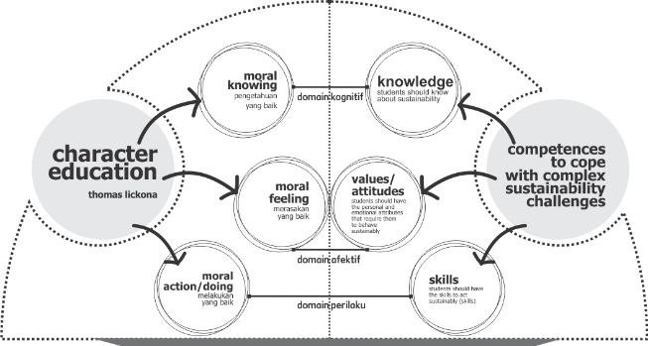

Figure 1. Character education as the basis for sustainable development

Based on the previous explanation, character education can be defined as a systematic procedure aimed at introducing, comprehending, molding, and teaching these principles inside the moral fabric of students' personalities. The ultimate objective is for these values to become deeply ingrained in their lives and manifest in their conduct, demeanor, and deeds. The objective of character education is to foster the development of student's character and instill virtuous values through a comprehensive, integrated, and well-rounded approach. The initial phase of character education and sustainability education involves incorporating values into the cognitive domain, called the moral knowing strategy. This technique employs a value clarification method during the implementation [19], [20].
Value refers to a characteristic or recognition of worth in anything, serving as a foundation for shaping an individual's conduct that potentially results in advantageous outcomes for humanity [21]. Values serve as a guiding framework for individuals to assess the moral worth of their decisions and discern if they align with the concept of goodness. Value plays a crucial role in guiding and motivating human behavior, and value education is an integral component of character education. Given that this process represents the preliminary phase, the objectives to be attained involve acquainting pupils with and facilitating their comprehension of positive and negative values, fostering internalization. The subsequent phase entails incorporating emotional elements, specifically the moral-feeling approach. This stage represents a progression from the initial stage, corresponding to the maturation of cognitive processes. The teaching concept elicits emotional responses from pupils, evoking positive and negative sensations and influencing their beliefs in the principles being taught. By inculcating positive values in pupils, they will experience the advantageous outcomes associated with these values, engage in virtuous behaviors, and develop a genuine affinity for acts of benevolence. In the concluding phase, which encompasses moral conduct, it is anticipated that students will cultivate positive habits to the extent that these habits become ingrained in their character. The behavior in question is predicated upon the individual's acquisition of knowledge, accumulation of experience, and cultivation of consciousness, ultimately establishing a habitual pattern.
The fundamental principles that drive sustainable behavior and foster the development of a sustainable character encompass the ethical connection between individuals and their surrounding environment. The primary aim of societal sustainable development is to establish a framework of values and normative attitudes within society that will foster a harmonious coexistence between humans and the natural environment. The study of environmental ethics involves examining the ethical connection between humans and the natural world, focusing on perceiving nature as a moral entity. This perspective emphasizes the importance of equality and equal rights for all humans, as they are seen as key factors in addressing environmental challenges [22].
Based on the previous discussion, a significant observation is that implementing sustainable development aims to achieve enhanced human development that encompasses the various aspects of human existence, including attitudes and behaviors. The second aspect pertains to safeguarding the environment, encompassing the educational milieu, as a conducive setting for human advancement. It entails preserving and preparing extant natural resources, enabling sustainable utilization and enduring benefits in current and future periods

  - RELIGIOUS VALUES AND EDUCATION
Education is a fundamental entitlement accorded significant importance to attain specific proficiencies. Higher education institutions aim to equip students with the necessary skills and knowledge to effectively engage and collaborate with individuals in society based on their respective abilities. Higher education delineates and establishes knowledge throughout its implementation while teaching values and attitudes. The primary objective of higher education is to equip students with the necessary skills and knowledge to successfully enter the workforce and effectively engage with others in a manner that promotes societal well-being, aligns with UNESCO's assertion that education serves to disseminate knowledge and cultivate competencies that foster transformative changes in behavior, values, and even lifestyle.
Incorporating sustainability into the educational curriculum, particularly through character education, will effectively cultivate a deep understanding and appreciation of this concept among students. Incorporating environmental knowledge within the educational framework is anticipated to influence behavioral modifications substantially, provided that the educational process encompasses not only the transmission of knowledge but also the cultivation of values that are subsequently reflected in one's character and conduct. Education serves as a mechanism for transformation, encompassing not just academic development but also cultivating students' character through the inculcation of positive ideals. Furthermore, it is important to note that educational practice is primarily a moral undertaking rather than a technological one [23], [24].
The development of character education can be significantly enhanced with the incorporation of religious principles, as these values possess a profound influence on shaping one's character. The acquisition of religious knowledge has a significant role in the holistic development of students' lives [25]. Therefore, to achieve a comprehensive understanding, it is essential that the learning process encompasses more than just theoretical knowledge but also involves the practical application of that knowledge. [26] Integrating religion-based character education is inseparable from cultivating moral and religious values among students to enhance faith and piety indirectly. Incorporating religious-based moral ideals on the environment inside educational curricula can offer pupils a comprehensive understanding of the interconnectedness between humans and nature and guidance on appropriate conduct towards the natural world.
The religious values discussed in this study are the basic values of Islam, those derived from the Quran and Hadith. The holy Quran is given by Allah SWT, which contains His instructions and His commands for humans, including a guide for humans to carry out their duties as the Caliphs on earth. Meanwhile, the Hadith is a collection of everything attributed to the Prophet SAW in words, deeds, and statements (taqrir) to complement and strengthen what is written in the Quran. The Quran has also clearly explained how the earth and everything in it should be preserved for the benefit of humans in fulfilling all their needs and achieving sustainable life. Thus, it is hoped that the values explored in this research will increase human awareness of sustainability. In addition, if these values are believed, they can sustainably promote behavior change effectively to support sustainable development. From an Islamic perspective, sustainable value is identical to the Islamic concept of conservation, which indicates that Islam has guided humans to conserve natural resources and manage economic environmental resources, waste, and transportation. [27]. The explanation above affirms that religion supports sustainable achievement [28][29], so religious values are important parts of learning. Religious values also truly need to be understood by students since it is a process of searching for meaning, values, and life goals [29].
This scholarly endeavor seeks to employ religious tenets, which have stood the test of time, as a foundation for environmental education, particularly within design, to foster sustainability and cultivate students who prioritize safeguarding the environment. Religious Values as a Framework The Qur'an and Hadith, timeless repositories of wisdom, encompass profound insights about environmental preservation and practices conducive to sustainable living. Concepts such as the human role as "Khalifah" (caretakers) advocate for the judicious utilization of natural resources.
The values above possess an intrinsic universality that surpasses cultural and geographical distinctions, thereby permitting their application across diverse global architectural contexts. Integrating these ethical values into the pedagogy of sustainable architecture not only promotes a holistic approach to design but connects architects worldwide in a shared mission. A moral framework informed by religious values, particularly those rooted in Islamic tenets, significantly enhances and supplements the sustainable architecture paradigm.
The aforementioned ethical principles emphasize the concepts of stewardship, justice, and balance (Mizan), which are cohesively integrated with the objectives of modern environmental design. Institutions providing architectural education are not just pivotal but also responsible for embedding these principles within the framework of architectural pedagogy. By incorporating sustainability principles informed by religious doctrines into the academic syllabus, prospective architects are equipped and empowered to cultivate a profound comprehension of environmental ethics in their professional practices. This initiative is crucial in fostering future architects who perceive environmental management as a technical responsibility and an ethical imperative.
This research aspires to employ religious convictions as a basis for environmental pedagogy, specifically within the realm of design, to foster sustainability and cultivate students who prioritize ecological preservation. Religious Principles as a Theoretical Framework The Qur'an and Hadith encompass significant perspectives about environmental stewardship and sustainable living methodologies. Concepts such as humanity's role as "Khalifah" (stewards) advocate for the judicious utilization of natural resources.
These universal ideals may be implemented in many global architectural situations, regardless of culture or geography. Integrating ethical ideals into sustainable architecture education promotes a holistic approach to design. An ethical framework based on religious values, particularly Islamic precepts, successfully complements and enhances the sustainable architecture paradigm. These ethical principles support the concepts of stewardship, fairness, and balance (Mizan), which are in sync with the aims of current environmental design. Architectural education institutions significantly impact the development of these ideals in architectural education. By incorporating religiously informed sustainability concepts into the academic curriculum, future architects can develop a thorough awareness of environmental ethics in their professional pursuits. This effort is critical in developing future architects who see environmental stewardship as more than just a technical necessity but also an ethical requirement.
These universal principles can be applied in numerous architectural contexts worldwide, irrespective of cultural or geographical distinctions. The incorporation of ethical principles into the pedagogy of sustainable architecture fosters a comprehensive approach to design. A moral framework rooted in religious doctrines, particularly those of Islam, effectively complements and enriches the sustainable architecture paradigm. These ethical tenets underpin the principles of stewardship, equity, and balance (Mizan), which align harmoniously with the objectives of contemporary environmental design. Institutions dedicated to architectural education are pivotal in cultivating these ideals within the field. Embedding religiously informed sustainability principles into the academic syllabus allows aspiring architects to cultivate a profound understanding of environmental ethics pertinent to their professional endeavors. This initiative is essential in shaping future architects who regard environmental stewardship as a technical and ethical obligation.

- METHODS

- METHOD OF COLLECTING DATA
The data collection approach employed the archive method, which involves gathering data from textual texts. The materials closely linked to Islamic teachings include the Quran, Thematic Quranic Tafseer (Maudhu'i), and Hadith. These sources serve as important references for understanding and interpreting Islamic principles and beliefs, following the Quran as the primary source. The selected Hadith is completely authentic, with no missing text whatsoever. The online interpretation of the Quran and the Hadith Encyclopedia are utilised for conducting a search operation employing keywords.

- DATA ANALYSIS METHOD
The data analysis methodology consists of two distinct stages. The initial stage involves content analysis on textual data, while the subsequent step involves network analysis techniques. The approach employed for examining textual data involves examining books centered on environmental conservation, which have been produced from various interconnected verses of the Quran. Understanding the Quran or comprehending its contents can be accomplished by a singular approach known as the Maudhu'i technique, also referred to as the thematic method. This approach was selected based on its ability to impose constraints on the subject matter, enhancing the specificity of the outcomes. It is achieved by systematically examining verses that pertain to a particular subject or theme. The evaluated results and data are subject to verification by religious specialists to ascertain their suitability and certify their veracity.
Moreover, the present study employs a content analysis approach to ascertain the Islamic sustainability principles as elucidated in the Quran and Hadith. Through content analysis, scholars can quantitatively assess and examine the presence, significance, and interconnections of words, themes, or concepts inside a text [30], [31]. This analytical approach enables researchers to draw specific conclusions or establish particular concepts. [32].
The methodology has garnered significant recognition within scholarly research and has been extensively employed in Quranic studies to ascertain the intended semantic content presented throughout the Quran. Content analysis is employed in several research studies to get insights into critical thinking. Scholars investigating the understanding of health and medicine in the Quran also utilize content analysis techniques. [33], [34]. In this study, content analysis was employed to facilitate the comprehension and integration of the concept of sustainability within religious values into higher education. The aim was to enhance students' and teachers' awareness, knowledge, and attitudes towards sustainability within university settings.
In the second stage, network analysis is carried out to determine the correlation or relationship between keywords to determine the relationship of meaning or value among keywords and the level of importance between values or meanings [35]. Network analysis was first developed for social to reconstruct genealogies [36]. Recently, network analysis has been widely used in research that aims to explore the mapping of keywords in social research on almost all research topics. Most studies that map the keyword relationships in a paper and how often these keywords are mentioned use network analysis [37]. The concept of this method will then be used in the relationship among keywords found in a verse that discusses the topic of sustainability in the Quran. The relationship between keywords is highly correlated if the mapped keywords often appear together in a verse.

- RESULT

- CONTENT ANALYSIS
According to the findings from the search results, 48 distinct keywords were identified, with a cumulative frequency of 458 occurrences. The religious book experts subsequently verify the accuracy and appropriateness of the keywords. The validation results are presented in Figure 2, providing a comprehensive depiction of the findings. Out of the 48 identified keywords, it is observed that most of them are related to the concept of water. The primary focus of this study is rainfall, which constitutes 17.84% of the total subject matter.
Additionally, the advantages associated with rainwater, namely its role in facilitating growth, account for 16.26% of the research content. In addition, the prevailing keywords associated with plants were identified: fruit, accounting for 10.28% of the total; trees, constituting 6.61%; and crops, representing 3.67%. The subsequent terms in descending order of frequency are "land", with a percentage of 2.94%, and "wind", with a percentage of 2.83%. The remaining keywords possess values below 2.5%.
In the context of the hadiths, it is noteworthy that 29 distinct keywords were identified, with a cumulative frequency of 754 occurrences throughout four shahih hadiths that pertain to the concept of sustainability (as depicted in Figure 3). Following the administration of a validity test on the specialists of the Quran, it was determined that all keywords exhibited validity. Of the 29 keywords, the most frequently occurring are in the land domain. Specifically, "grant land" is mentioned 149 times, accounting for 19.79% of the total occurrences. The term "land" is used 103 times, representing 13.68% of the total.

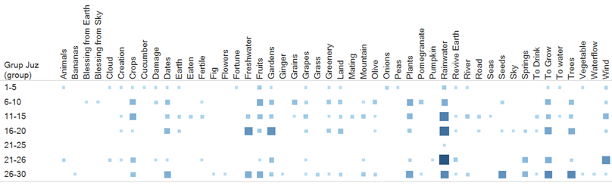

Figure 2. The distribution of keywords with sustainability in the Quran

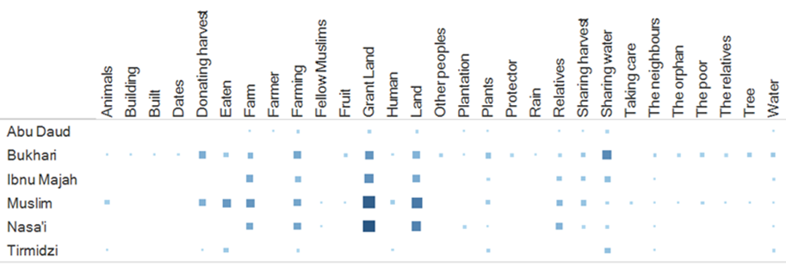

Figure 3. The distribution of keywords with the topic of sustainability in the Hadith

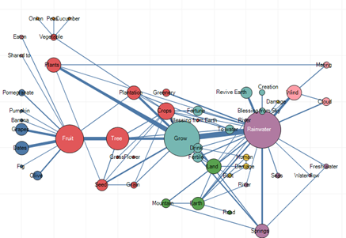

Figure 4. The mapping of keywords based on the results of content analysis of the Quran

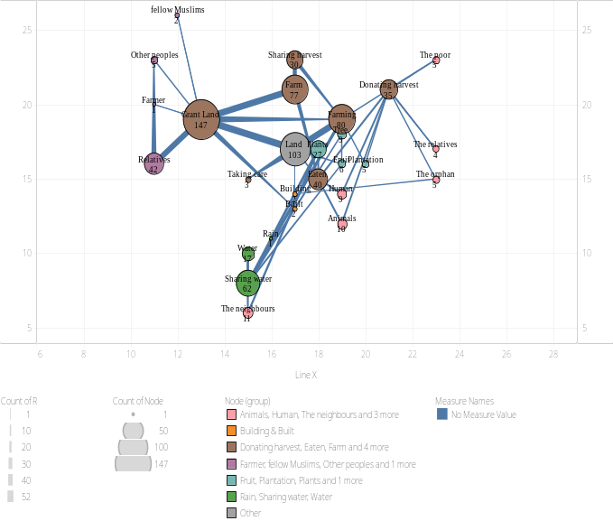

Figure 5. Mapping of keywords from the results of the Hadith

Additionally, the keywords "farming" and "farm" are mentioned 78 times, accounting for 10.36% of the total occurrences. Furthermore, the prevailing keywords linked to sharing include sharing water, accounting for 8.23% of the occurrences; sharing with relatives, accounting for 5.31%; and contributing, accounting for 4.65%. The distribution of agricultural produce constitutes a proportion of 3.59%.
- NETWORK ANALYSIS
The results obtained from the keyword search were subsequently utilized in the network analysis process. The mapping results illustrate the interconnections among terms. The analysis of the Quranic text reveals that the term "rainwater" holds a central position among all the identified keywords. All the keywords provided are directly or indirectly associated with "rainwater". The network analysis findings of the keyword "sustainability", as identified in the Quran, are visually represented in Figure 4.
The network analysis findings indicate a direct correlation between precipitation and keywords such as growth, irrigation, fertility, soil rejuvenation, celestial bestowal, and prosperity. The terms above are associated with the many functions of water, thereby warranting their classification within the category of water functions. Moreover, precipitation directly correlates with various hydrological features such as springs, seas, rivers, watercourses, and freshwater bodies. As mentioned earlier, the terms are inherently linked to water sources, thus warranting their classification into several groups based on the nature of the water source. Additionally, rainwater correlates with terrestrial landscapes, including land masses, mountainous regions, and the Earth's surface. The following keywords are associated with storing rainwater and its application for soil fertilization. Moreover, there is a direct correlation between rainwater and atmospheric phenomena such as wind and clouds. These terms are associated with the phenomenon of rainfall formation. When examining the four categories of water, it becomes evident that the predominant keywords associated with water primarily revolve around its function within the water category, particularly its role in facilitating growth. The findings of this study demonstrate that the Quran emphasizes the role of water in facilitating plant growth, hence indirectly contributing to the production of food in the form of fruits and vegetables. In addition to growth, water significantly correlates with springs and terrestrial environments. This observation highlights the significance of rainwater as a vital water resource on Earth, serving as a crucial element for the sustenance and well-being of various organisms.
Based on the outcomes derived from a comprehensive network analysis, which involved identifying and examining interconnected keywords and concepts in many texts, the discerned keywords indicate a profound thematic interrelation between water—particularly precipitation—and various dimensions of existence development and the ecological system. The most noteworthy correlation exists between precipitation and keywords such as growth, irrigation, fertility, soil rejuvenation, celestial bestowal, and prosperity. These terminologies underscore the multifaceted significance of water, particularly rainwater, in the sustenance and nurturing of life. Rain is not merely regarded as a natural occurrence but as a divine or celestial endowment, accentuating its critical role in agriculture, ecological equilibrium, and human survival. The phrase "celestial bestowal" encapsulates this broader symbolic interpretation, wherein water is perceived not solely as a physical resource but as a benediction or offering from a transcendent entity.
The association between water and its diverse hydrological characteristics, encompassing springs, seas, rivers, and freshwater bodies, further corroborates the pivotal role of water in sustaining ecosystems and human societies. These keywords imply that the Quranic references to water, such as the story of Prophet Moses and the parting of the Red Sea, are not confined to precipitation but extend to additional water sources, such as rivers and seas, which are equally essential for agricultural and human advancement. The categorization of these terms into groups predicated on the type of water source demonstrates an appreciation for water’s varied origins and its pragmatic applications within the natural realm. The linkage of rainwater with particular watercourses or freshwater bodies accentuates its significance as a source of immediate sustenance and a vital component in the overarching hydrological cycle that nourishes the earth and its inhabitants.
Water's spiritual and ecological roles aside, the analysis uncovers a distinct relationship between precipitation and terrestrial landscapes, including land masses, mountainous regions, and the earth's surface. This correlation underscores the dynamic interplay between water and the earth's physical geography. Rainwater is depicted as a transformative force that shapes and rejuvenates the land, converting barren or arid regions into fertile zones capable of sustaining plant life. Keywords associated with soil fertilization and rainwater retention highlight the practical applications of water in agriculture, reinforcing the interconnection between water conservation, soil quality, and sustainable farming methodologies.
Ultimately, the cluster of keywords about 'appropriate site development' underscores the importance of understanding water's role in land and resource management. The Quranic perspective on water, which emphasizes its spiritual and ecological relevance and its function in guiding human practices related to environmental stewardship, is particularly enlightening. The pragmatic applications of rainwater storage and utilization for soil fertilization reflect an early understanding of water management strategies, which are crucial for sustainable development, especially in arid and semi-arid regions. The importance of these keywords suggests that the Quranic perspective on water is multifaceted, integrating aspects of theology, ecology, and practical wisdom in addressing the interactions between humans and the environment.
Furthermore, "to grow" significantly correlates with tree and fruit categories within crop classification. This observation highlights the significance of productive plants' advantageous attributes in sustaining organisms' existence. The Quran provides descriptions of plants that are considered productive and useful, as they can be consumed by humans and shared with both fellow humans and animals.
In the analysis of the Hadith mapping data, it was observed that the term "land" emerged as the focal point among all the keywords. All keywords have a direct or indirect relationship with the primary keyword. Figure 5 displays the network analysis findings of the keyword "Hadith sustainability."
The network analysis findings indicate a direct association between the keyword "land" and the keywords "farming, grant land, built, and taking care." Among the four water-related keywords, the two keywords that exhibit the most significant association with "land" are grant land and farming. The findings of this study indicate that the Hadith emphasizes the significance of utilizing the land for agricultural purposes, intending to distribute the resulting crops among other sentient beings. This concept is elucidated in the Quran in Surah Yunus (10): 24.
Furthermore, an additional significant correlation can be observed in the phrase farming, namely in the concept of "sharing water". The Hadith elucidates the significance of water utilization for land cultivation while acknowledging the potential for water to traverse into adjacent territories, particularly those inhabited by neighboring communities.

- DISCUSSION
The research findings indicate that Islamic principles encompass the concepts associated with sustainability. The Quran elucidates the need to effectively utilize and conserve essential resources such as water and land to mitigate environmental degradation and attain environmental sustainability. In the context of sustainability in economic and social aspects, Hadith elucidates the principles and application of sharing among living entities. Numerous research findings about analogous subjects throughout the Quran similarly underscore the need for human beings as stewards in safeguarding the environment. In this particular scenario, individuals must cultivate a comprehensive understanding of their role as caliphs through education to foster effective sustainability leadership within the framework of Khilafah. Environmental education enhances human resources' number and quality (National, 2004). Additionally, it seeks to improve individuals' understanding and awareness of their rights and duties in environmental management, enhancing their intelligence level in this domain.
Accepting skills-based learning to acquire knowledge and promote sustainability will likely be more readily embraced [38]. In this instance, the learning-by-doing approach can be applied to environmental education. The imperative to impart value and knowledge to students through an active learning process can be effectively achieved by cultivating skills [39]. The findings of a study conducted in Saudi Arabia indicate that a significant proportion, over 40%, of the youth population possesses knowledge regarding the principles and application of sustainability inside educational institutions. Among this group, 18% acquired this knowledge through exposure to social media platforms, while the remaining percentage obtained it through alternative media sources [40]. This study reported that students who possessed knowledge of environmental concepts demonstrated enhanced efficiency in their utilization of water and food and engaged in waste-sorting practices as part of their everyday routines. The significance of the concept of sustainable education in educational institutions is demonstrated.
Nevertheless, understanding this notion does not inherently guarantee a substantial influence on the execution of environmental preservation efforts. The research findings indicate that implementing environmental conservation techniques has a greater influence on the values of sustainable education. The findings of studies investigating active learning events, such as experiential learning, have demonstrated a greater influence on students than traditional learning methods across three key domains of learning: cognitive, emotional, and psychomotor [41] [42].
Table 1 shows how the sustainability values of the Quran can be mapped into sustainable education competencies through learning by doing by studying and conveying the skills described in the Quran to students at the University. For instance, by learning about rainwater harvesting skills using the learning-by-doing method, students can be more grateful for the existence of water so that they can be more economical in using it. Through studying science, students can learn the function of water and how to use it more effectively and efficiently and align with the research results comparing traditional learning systems with the delivery of knowledge and community-based learning about the environment through skill development in environmental conservation [41]

Table 1. The relationship between the value of sustainability in the keywords found in (1) the Quran and (2) Hadith with the competence of sustainable education

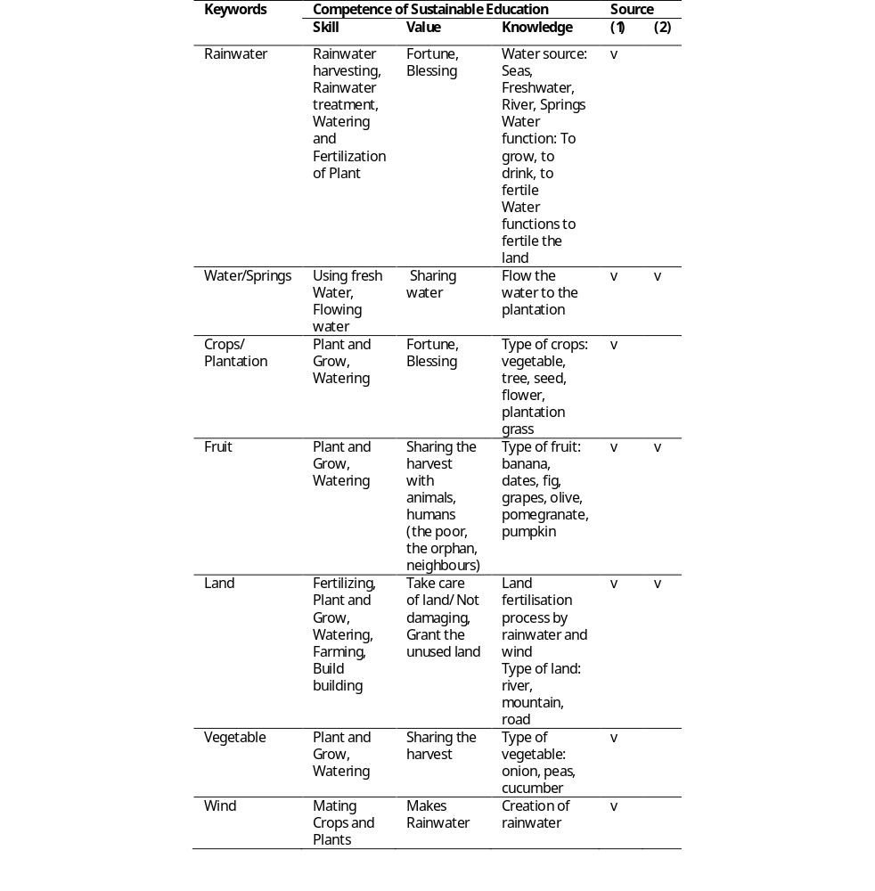
Table 1 illustrates that the Quran underscores the significance of water and soil as fundamental components of human existence. Architects must devise solutions that enhance water efficiency, including rainwater harvesting and wastewater recycling. Rainwater is portrayed as a force that shapes and revitalizes the land, transforming barren or arid areas into fertile spaces capable of supporting plant life. Keywords related to soil fertilization and rainwater storage suggest practical uses of water in agriculture, emphasizing the relationship between water conservation, soil quality, and sustainable farming practices. In a parallel manner, land utilization strategies should integrate both green spaces and agricultural areas to embody the Quranic principles of balanced development and conservation (Surah Al-Baqarah, 2:30). Furthermore, the Hadith accentuates the necessity of resource sharing and the advancement of community welfare. Urban and architectural planning should prioritize community gardens and public water amenities to foster social engagement and equitable distribution of resources, thus aligning with Islamic principles.
An additional illustration of architectural implementation pertains to establishing buffer zones that incorporate urban forests or green spaces to mitigate the adverse effects of urban development on the environment, as exemplified by the Islamic Garden in Alhambra, Spain. Subsequently, using indigenous flora is paramount in enhancing water infiltration into the soil, thereby cultivating an infiltration zone critical in groundwater maintenance and ecosystem protection, like in the Wadi Hanifah Wetla. Furthermore, applying drip irrigation systems within gardens or green spaces minimizes water wastage while ensuring that water is dispensed solely as required, as exemplified by the Date Palm Garden in the UAE.
The findings of this study suggest that the deployment of a skill development-focused approach substantially influences student outcomes compared to the traditional way. According to scientific principles, both approaches contribute to the comprehension of the concept of environmental conservation. However, pupils who are actively participating in conventional educational methods fail to acknowledge the significance of environmental preservation, as indicated by the terms "help," "make," and "understand." Students exhibit heightened concern for their environment concerning its perceived value, influencing their cognitive faculties and encompassing their comprehension. Additionally, this concern impacts their affective aspects, specifically their level of concern and their psychomotor aspects, which pertain to their actions within the environment in their daily lives. Consequently, applying the Quran's teachings through the pedagogical approach of experiential learning, which emphasizes skill development, can contribute to a greater awareness among individuals regarding their environmental responsibilities. Here’s Table 2 for the guidelines for architectural practicals from religious values.

Table 2. Guidelines for Integrating Religious Values into Architectural Practices

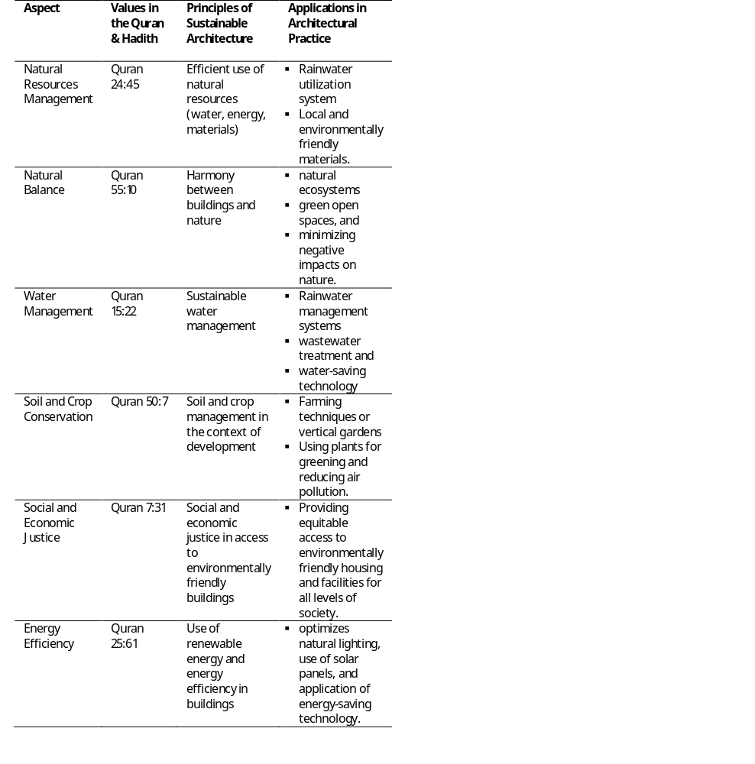

- CONCLUSION
This study uses content and network analysis techniques to examine the holy Quran, which holds significant importance for Muslims as the primary source of instruction in fulfilling their responsibilities as earthly caliphs, encompassing the management of the environment. The current state of human values of environmental awareness exhibits a decline, and education is widely seen as a potential solution to enhance human environmental consciousness. The environmental keywords that pertain to action are emphasized in the Quran and Hadith through the application of content and network analysis methodologies. The phenomenon under consideration involves active human participation, specifically in planting and watering. These activities are closely associated with the concepts of "water" and "farming," which in turn are connected to the notion of "land" as documented in the Hadith. The alignment between sustainable education on Islamic principles and research on environmental education is evident. This alignment emphasizes enhancing students' skills, which influences their knowledge and values, contributing to the development of character education.
There is a growing demand for children to be exposed to sustainable education by implementing character education. This approach aims to enhance the holistic development of students across cognitive, emotional, and psychomotor domains. The present study extensively examines the spiritual ideals that strongly endorse the establishment of sustainable schooling. The caliber of students is expected to be of a higher standard, enabling them to effectively navigate the various obstacles and difficulties encountered, with a particular emphasis on addressing the pressing environmental issues of our time. Utilizing a spiritual values approach, coupled with its integration into practical learning experiences, effectively imparts values and knowledge to students in a more readily acceptable manner.
The notion of sustainability, derived from religious principles, offers a comprehensive approach to addressing sustainable challenges across environmental, social, and economic dimensions. Therefore, it is imperative to cultivate various types of knowledge and their practical application to promote sustainable education within higher education. Furthermore, expanding upon this research by delving into students' proficiency in environmental conduct (experiential learning) through developing a comprehensive curriculum is imperative. It is necessary to conduct an assessment to ascertain the influence and efficacy of integrating Islamic values, namely those about sustainable education, within the curricula of universities. The imperative for advancing Islamic Higher Education in Indonesia arises from recognizing that educational institutions serve as significant reservoirs of knowledge, constituting effective platforms for disseminating knowledge. This becomes particularly pertinent in the context of the sustainable environment.

REFERENCES
[1] T. W. Caesariadi, “Penghalang Sosial dan Psikologis Pada Proyek Konstruksi dengan Prinsip Bangunan Hijau,” Langkau Bentang Jurnal Arsitektur, Vol. 2, No. 1, pp. 86–93, 2015. DOI: https://doi.org/10.26418/lantang.v2i1.13843
[2] A. Kanyimba, M. Hamunyela, and C. D. Kasanda, “Barriers to the Implementation of Education for Sustainable Development in Namibia’s Higher Education Institutions,” Creat Educ, vol. 05, no. 04, pp. 242–252, 2014, doi: 10.4236/ce.2014.54033.
[3] W. Kang, “Perceived barriers to implementing education for sustainable development among Korean teachers,” Sustainability (Switzerland), vol. 11, no. 9, 2019, doi: 10.3390/su11092532.
[4] W. Leal Filho et al., “Identifying and overcoming obstacles to the implementation of sustainable development at universities,” Journal of Integrative Environmental Sciences, vol. 14, no. 1, pp. 93–108, 2017, doi: 10.1080/1943815X.2017.1362007.
[5] N. Roorda and H. van Son, “Education for Sustainable Development,” in Sustainability Science, Dordrecht: Springer, 2016, pp. 335–347. doi: 10.1007/978-94-017-7242-6_28.
[6] M. Kahyaoğlu, “The Research of the Relationship between Environmentally Aware Prospective Teachers’ Qualities and Self Efficacy Beliefs towards Environmental Education,” Procedia Soc Behav Sci, vol. 116, pp. 4493–4497, 2014, doi: 10.1016/j.sbspro.2014.01.973.
[7] A. Altin, S. Tecer, L. Tecer, S. Altin, and B. F. Kahraman, “Environmental Awareness Level of Secondary School Students: A Case Study in Balıkesir (Türkiye),” Procedia Soc Behav Sci, vol. 141, pp. 1208–1214, 2014, doi: 10.1016/j.sbspro.2014.05.207.
[8] J. Slavoljub, L. Zivkovic, A. Sladjana, G. Dragica, and P. S. Zorica, “To the Environmental Responsibility among Students through Developing their Environmental Values,” Procedia Soc Behav Sci, vol. 171, pp. 317–322, 2015, doi: 10.1016/j.sbspro.2015.01.128.
[9] S. Ajaps and R. McLellan, “‘We don’t know enough’: Environmental education and pro-environmental behavior perceptions,” Cogent Education, vol. 2, no. 1, pp. 1–17, 2015, doi: 10.1080/2331186X.2015.1124490.
[10] V. Kioupi and N. Voulvoulis, “Education for sustainable development: A systemic framework for connecting the SDGs to educational outcomes,” Sustainability (Switzerland), vol. 11, no. 21, 2019, doi: 10.3390/su11216104.
[11] R. Laurie, Y. Nonoyama-Tarumi, R. Mckeown, and C. Hopkins, “Contributions of Education for Sustainable Development (ESD) to Quality Education: A Synthesis of Research,” J Educ Sustain Dev, vol. 10, no. 2, pp. 226–242, 2016, doi: 10.1177/0973408216661442.
[12] M. Istiharoh and S. Indartono, “Learning Innovation for Character Education in Global Era: Methods and Assessments,” Advances in Social Science, Education and Humanities Research, Vol. 323, pp. 272–279, 2019, doi: 10.2991/icossce-icsmc-18.2019.50.
[13] M. Barth, G. Michelsen, M. Rieckmann, and I. Thomas, Routledge Handbook of Higher Education for Sustainable Development. NewYork: Routledge, 2016.
[14] W. Tom, C. Kim, L. Wim, V. Joke, L. Rodrigo, and W. Tarah, Sustainable Higher Education - Understanding and Moving Forward, Brussels: Flemish Government, Environment, Nature and Energy Department, 2013.
[15] F. A. Matloob, A. B. Sulaiman, T. H. Ali, S. Shamsuddin, and W. N. Mardyya, “Sustaining Campuses through Physical Character–The Role of Landscape,” Procedia Soc Behav Sci, vol. 140, pp. 282–290, 2014, doi: 10.1016/j.sbspro.2014.04.421.
[16] T. Lickona, “Character Education: Seven Crucial Issues,” Action in Teacher Education, vol. 20, no. 4, pp. 77–84, 1999, doi: 10.1080/01626620.1999.10462937.
[17] V. Sönmez, “Association of Cognitive, Affective, Psychomotor and Intuitive Domains in Education, Sönmez Model,” Universal Journal of Educational Research, vol. 5, no. 3, pp. 347–356, 2017, doi: 10.13189/ujer.2017.050307.
[18] E. E. Suyitno, “Pendidikan Karakter Akan Melahirkan Pribadi Yang Unggul.” Accessed: Nov. 10, 2023 [Online]. Available: https://www.kompasiana.com/ecoedy/pendidikan-karakter-untuk-generasi-muda_5911350e02b0bd2d0d04bc96.
[19] A. C. Breslin, “Values clarification as a methodology in moral education,” Irish Educational Studies, vol. 7, no. 2, pp. 173-190, 1988, Doi: https://doi.org/10.1080/0332331880070215.
[20] B. Bensaid, S. B. T. Machouche, “Exploring the relationship between Islamic religious learning and community: Special reference to ‘Abdul Rahman Ibn Khaldun and Mohammad Tahir Ben Achour,” Multicultural Education & Technology Journal, vol. 7, no. 4, pp. 317–332, 2013, doi: 10.1108/METJ-03-2013-0013.
[21] B. Daroeso, Dasar dan Konsep Pendidikan Moral Pancasila. Surabaya: Aneka Ilmu, 1986.
[22] A. Nasibulina, “Education for Sustainable Development and Environmental Ethics,” Procedia Soc Behav Sci, vol. 214, no. June, pp. 1077–1082, 2015, doi: 10.1016/j.sbspro.2015.11.708.
[23] K. V. Mann, “Chapter 8: Learning and Teaching in Professional Character Development" In Lost Virtue (Advances in Bioethics), Leeds: Emerald Group Publishing, 2015. Doi: 10.1016/S1479-3709(06)10008-4.
[24] N. Sari, “The Importance of Teaching Moral values to The Students,” Journal of English and Education, vol. 1, no. 1, pp. 154–162, 2013.
[25] M. D. C. Olmos-Gómez, R. López-Cordero, S. García-Segura, and F. Ruiz-Garzón, “Adolescents’ perception of religious education according to religion and gender in spain,” Religions (Basel), vol. 11, no. 11, pp. 1–13, 2020, doi: 10.3390/rel11110616.
[26] N. Lourdel, N. Gondran, V. Laforest, and C. Brodhag, “Introduction of sustainable development in engineers’ curricula: Problematic and evaluation methods,” International Journal of Sustainability in Higher Education, vol. 6, no. 3, pp. 254–264, 2005, doi: 10.1108/14676370510607223.
[27] N. H. Abdul Majid and I. Udale Hussaini, “Islam and The Concept of Sustainable Development.” Accessed: Dec. 08, 2019. [Online]. Available: http://medinanet.org/2012/01/islam-and-the-concept-of-sustainable-development/
[28] M. Basedau, S. Gobien, and S. Prediger, “The Ambivalent Role of Religion for Sustainable Development: A Review of the Empirical Evidence,” GIGA Working Papers, No. 297, pp. 290-297, 2017, doi: 10.2139/ssrn.2976174.
[29] A. W. Dodd, “Educating for Character: How Our Schools Can Teach Respect and Responsibility. By Thomas Lickona,” NASSP Bulletin, Vol. 76, No. 545, pp. 119–120, 1992. Doi: 10.1177/019263659207654519.
[30] A. F. Muchlis, D. Larasati, and S. Triyadi, “Identifying Islamic Values on Green Architectural Concept: Quantitative Approaches To Content Analysis,” Journal of Islamic Architecture, vol. 5, no. 4, pp. 221–228, 2019, doi: 10.18860/jia.v5i4.7568.
[31] M. Schreier, Qualitative Content Analysis in Practice. London: Sage Publications, 2012.
[32] K. Krippendorf, Content Analysis an Introduction to Its Methodology. Pennsylvania: Sage Publications, 2004.
[33] A. Mehrandasht, “Surveying Information Ethics in Quran: A Quantitative Content Analysis,” Health, Spirituality, and Medical Ethics, vol. 2, no. 1, pp. 18–25, 2015.
[34] L. D. Laird, J. de Marrais, and L. L. Barnes, “Portraying Islam and Muslims in MEDLINE: A content analysis,” Soc Sci Med, vol. 65, no. 12, pp. 2425–2439, 2007, doi: 10.1016/j.socscimed.2007.07.029.
[35] D. Hevey, “Network analysis: A brief overview and tutorial,” Health Psychol Behav Med, vol. 6, no. 1, pp. 301–328, 2018, doi: 10.1080/21642850.2018.1521283.
[36] L. C. Freeman, The development of social network analysis, vol. 27. 2004.
[37] J. Popp, P. Balogh, J. Oláh, S. Kot, M. H. Rákos, and P. Lengyel, “Social network analysis of scientific articles published by food policy,” Sustainability (Switzerland), vol. 10, no. 3, pp. 1–20, 2018, doi: 10.3390/su10030577.
[38] W. Leal Filho and P. Pace, Teaching education for sustainable development at university level, Cham, Swizterland: Springer International Publishing, 2016, p. 355. doi: 10.1007/978-3-319-32928-4.
[39] J. Wrenn and B. Wrenn, “Enhancing Learning by Integrating Theory and Practice,” International Journal of Teaching and Learning in Higher Education, vol. 21, no. 2, pp. 258–265, 2009.
[40] T. Alsaati, S. El-Nakla, and D. El-Nakla, “Level of sustainability awareness among university students in the Eastern province of Saudi Arabia,” Sustainability (Switzerland), vol. 12, no. 8, pp. 1–15, 2020, doi: 10.3390/SU12083159.
[41] C. S. Dalida, G. A. O. Malto, and C. G. B. Lagunzad, “Enhancing Students’ Environmental Knowledge and Attitudes Through Community-based Learning,” KnE Social Sciences, vol. 3, no. 6, p. 205, 2018, doi: 10.18502/kss.v3i6.2381.
[42] G. Torkar, “Learning experiences that produce environmentally active and informed minds,” NJAS - Wageningen Journal of Life Sciences, vol. 69, pp. 49–55, 2014, doi: 10.1016/j.njas.2014.03.002

