 |  | JOURNAL OF ISLAMIC ARCHITECTURE  P-ISSN: 2086-2636 E-ISSN: 2356-4644  Journal Home Page: http://ejournal.uin-malang.ac.id/index.php/JIA
BUILDING COMPLEXES MORPHOLOGY IN TRADITIONAL PESANTREN OF EAST INDONESIA: A PRELIMINARY STUDY
Nensi Golda Yuli^{a*}, Alfan Firmanto^{b}, Nurman Kholis^{b}, Arif Budi Sholihahª, Putu Ayu Pramanasari Agustianandaª, Harits Fadlly^{b}, Ali Akbar^{b}
ªDepartment of Architecture, Islamic University of Indonesia (UII), Yogyakarta, Indonesia
ªNational Research and Innovation Agency (BRIN), Jakarta, Indonesia
^{c}Institution3, City, Country (Calibri Light 9 Capital Each Word)
*Corresponding Author: nensi@uii.ac.id
ARTICLE INFO |  |  | ABSTRACT
Volume: 8  Issue: 3  Page: 771-778  Received: November 27th, 2023  Accepted: March 15th, 2024  Available Online: June 30th, 2025  DOI: 10.18860/jia.v8i3.23937 |  |  | Traditional pesantren architecture has yet to be defined by a specific building type as it encompasses both educational and residential buildings. Many researchers explore the curriculum and its educational issues, but they often overlook the fact that all activities are closely related to where they occur. The morphology of building complexes identifies the history of buildings, including the reason for their development. This paper explores the morphology of building complexes in traditional pesantren to analyze how far the development of buildings has progressed from the old traditional pesantren since its first existence in Indonesia in general and relate it to vernacular architecture around it. A pesantren in Wajo, South Sulawesi, two pesantrens in East Kalimantan, and a pesantren in Waikabubak, East Nusa Tenggara, are the case studies used to explore the morphology. The research found that all morphologies of traditional pesantren still refer to the traditional pesantren in general. However, there are some modifications because of the needs of the pesantren's capacity and the location's natural setting. Contextualizing pesantren around the community and vernacular architecture is not the main important point for the development because recently they should prioritize santris room occupancy and more accessible building construction strategies.  Keywords:  East Indonesia; Morphology of Building Complex; Traditional Pesantren

- INTRODUCTION
More than 25.000 Islamic boarding schools, which further will be stated as pesantren, have an essential role as educational institutions in Indonesia (www.ditpdpontren.kemenag.go.id/pdpp/statistik). A research conducted since 2006 shows that the development of pesantren buildings needs to be anticipated to maintain distinctive Indonesian characteristics. It is crucial to map and study the spirit of pesantren space and its facilities, through the character of its activities, to guide other new pesantren.
Pesantren has provided much positive learning in terms of building styles. This is proven by the existence of pesantren activities, which have been running continuously for a long time and can facilitate all activities and maintain the contextuality of the building to the surrounding environment. Understanding building typology and morphology can provide benefits for new pesantren that will be built or old pesantren that will be developed so that the value of the building can still reflect the spirit of Indonesian buildings. The impact is shown in how the sense of a place of a settlement is maintained, and pride in pesantren architecture can continue to exist.
Before analyzing building typology, researchers must first find out about building morphology. This strategy considers macro-scale building context to micro-scale building analysis. By analyzing morphology, the changes in the building complex and the reasons of the changes can describe the relation of the building complex and the relation to the building typology. Learning morphology of pesantren may help one to see the development of a group of buildings in educational-residential institutions where the students are strongly affiliated with kyai (Islamic sholar or leader) and, in the context of East Indonesia, can give many variations of pesantren based on their tradition, vernacular architecture, and the affiliation to the pesantren where the kyai studied before.
Pesantrens are educational institutions with a unique character and are closely affiliated with the development of the surrounding community [1]. Three types of religious institutions organize the education system in Indonesia: the madrasa system, pesantren, and a combination of both. The difference lies in the provision of housing facilities and the curriculum used. Pesantren provides housing for students, while madrasas do not [2]. The development of local communities in pesantren environments depends on this institution's potential and extensive influence [3]. It also has a significant role in ensuring the direction of building development in the surrounding areas and implementing Islamic values for the surrounding community [4]. What the buildings in pesantren are like, starting from the style to the building systems used, are also represented in the buildings around traditional pesantren at that time. Traditional pesantrens are defined as pesantrens that run non-classical Islamic education [5] using bandongan (collective teaching) and sorogan (individual teaching) methods to teach and learn classical books ("yellow book" - kitab kuning) [6]. The criteria of traditional pesantren are non-classical education, having traditional aspects, and teaching pure Islamic knowledge [7]. Additionally, the traditional pesantren’s culture and paradigm of thinking were dominated by classic terms: zuhud, taawadu', qana'ah, blessing, or afterlife-oriented [8].
The education system that most traditional pesantren currently run consists of various curricula, most of which are tasawwuf teaching systems and direct teaching methods from the kyai [9]. There are two models of pesantren curriculum implemented in Indonesia, one separated from the government curriculum and one integrated with the government curriculum of the Republic of Indonesia [10].
Traditional pesantren that emphasizes kitab kuning teaching usually places the government curriculum only as an additional supplement and allocates the time for activities outside the teaching process itself [10]. The other combines 50% of the government curriculum and 50% of the pesantren curricula; this model of pesantren is usually run by more modern pesantrens. Apart from the educational curriculum, pesantrens also implement a life skills-based curriculum, which can improve students' knowledge, skills, and behavior as well as provide many benefits in increasing the competency of each student [11].
Research related to pesantren has been conducted since 2006 at the Pesantren Krapyak, Yogyakarta, which focuses on the spatial changes around Pesantren Krapyak [12]. Furthermore, in 2011, a research discussing the design of pesantren buildings was realized through the form of shared spaces, using pesantren buildings in Mlangi, Nogotirto, Yogyakarta as case studies [13]. It conducted a critical analytical study of the meaning of Muslim settlements where many pesantrens grow and develop within them [14]. The last thing to do was to consider the value of space owned by residents in the houses around the pesantren and correlate it with the existence of the pesantren from its inception until now [15]. The latest research conducted in 2021 has inventoried the vernacularity of traditional pesantren in Yogyakarta and Central Java [16], which needs to be further explored in terms of the morphology and typology of traditional pesantren buildings themselves. Apart from looking at pesantren in Yogyakarta and Central Java, similar research has also been carried out in Garut and Pandeglang, West Java, including modern pesantren, to get an initial study of how pesantren architecture has evolved over time.
Learning morphology cannot be separated from the research about typology, while building typologies form the basic spatial grammar of ancient city planning, describe the constitution of building blocks, and have implications for similar rules regarding building morphology, function, places without settlements, and relationships between buildings [17][18]. The typology is built on the abstract concept of place and various cultural norms around it [19][20][21]. It is related to the goals of different social actors involved; economic activities in domestic spaces are the examples [22][23]. Research on typology is essential to simplify multiparametric analysis and analyze the main vernacular characteristics on a wide scale [24]. Local character and regional architectural identity emphasize building forms and architectural typology in certain areas [25].
Changes in buildings due to the changes in the lifestyle of the building occupants and thermal and other physical aspects distinguish the typologies [26]. The building typology has enormous implications for humans, especially for space and occupants' perceptions [27]. Research on building typology by investigating healthy building parameters also discloses the phenomena and strategies for any presence of building diseases, which can be used as a reference in overcoming and providing recommendations to solve building diseases [28]. Typological research can help people to understand the historical aspects of buildings and urban contexts in the past [17]. In conducting building typology research, the architectural parameters observed are building plots in the form of number, orientation, shape, size, length/width ratio, number of building facades, and the building itself, which consists of the number of floors, single or distributed elements [29][30] [31][32][33][34]. Each building typology has a social space configuration and uses a different approach to obtain spatial relations [35].
Morphology is the study of form, and it focuses on the quality of spatial configuration and the context of spatial configuration processes consisting of pattern, hierarchy, and spatial relationship to each other [36][37]. Morphology also studies the changes of form, its relationship, metamorphosis, and the structure of the object [38][39]. Changes in form usually occur in the process of evolution or modification over a long period [37]. Morphological studies monitor the physical form that occurs and the recording of the changing process. Moreover, what is much more important is the change in the idea or process of meaning. Changes can occur for various reasons, including dimensions, cutting or enlargement, adding space or shape, changing colors and arrangement, and using materials that are different from the original material. Morphology in pesantren with mosques, houses of kyai, dormitories, and spatial configuration is the core function supported by other amenities in pesantren [40]. The initial morphology of pesantren can be seen from Ziemek's research [41], which has grouped pesantren into five types, as shown in Figure 1.

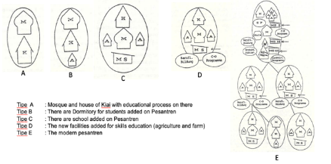

Figure 1. The early morphology of Pesantren [41]

- METHODS
This research employed a qualitative descriptive approach to reveal the morphology of traditional pesantren buildings based on local socio-cultural constructions and Islamic identity in Eastern Indonesia in an increasingly dynamic era. Therefore, anthropological studies were also conducted to discover the perspective of the leaders and organizers of pesantren who were manifested in the pesantren building from its establishment until its development today.
The research was conducted in four traditional pesantrens to analyze the morphology of complex buildings by using a descriptive method and interviews conducted with the head and organizers of the pesantren. Those pesantrens are As 'Adiyah Pesantren , Wajo, South Sulawesi; Baitul Hikmah Pesantren , Waikabubak, West Sumba, East Nusa Tenggara; Syaichona Cholil Pesantren , Samarinda, East Kalimantan; and Syaikh Zainuddin Nahdlatul Wathan Pesantren, Tenggarong Seberang, East Kalimantan). The people involved in the research were 12 informants, the heads, and the organizers of pesantrens. The field surveys distributed to four pesantrens are beneficial to obtain the data about the building complex configuration, the history of pesantren, as well as the changes at the building complex, including the reasons, for the existing morphology. The data analysis was conducted by comparing the early morphology from Manfed Ziemek era to the existing data. The configuration of the building complex also describes the reasons for the changes at the building complex.The methods section describes the rationale for applying specific procedures or techniques to identify, select, and analyze information applied to understanding the research problem, thereby allowing the reader to evaluate a study's overall validity and reliability critically.

- RESULT AND DISCUSSION
The four traditional pesantrens that have been studied are traditional pesantren that taught "yellow book" as the primary curriculum. The configuration of building mass at the building complex refers to the site's existing condition and the vernacular context around it. The configuration of the kyai house, mosque/mushalla, classroom, and dormitory depends on the land availability of pesantren. The vernacular context of the building, from the roof type, building material, and mass configuration, still relies on the nature of the site. Syaichona Cholil pesantren in Samarinda is a good example; it still left the natural river as the primary consideration for setting a building mass. In this pesantren, the mosque is not in the center of the building complex. Like pesantrens in Wajo, Sumba, and Tenggarong, the mosque's position was not a center point of the building complex. Morphological details of the four pesantrens are illustrated in Table 1.

Table 1. Morphological details of the four pesantrens studied
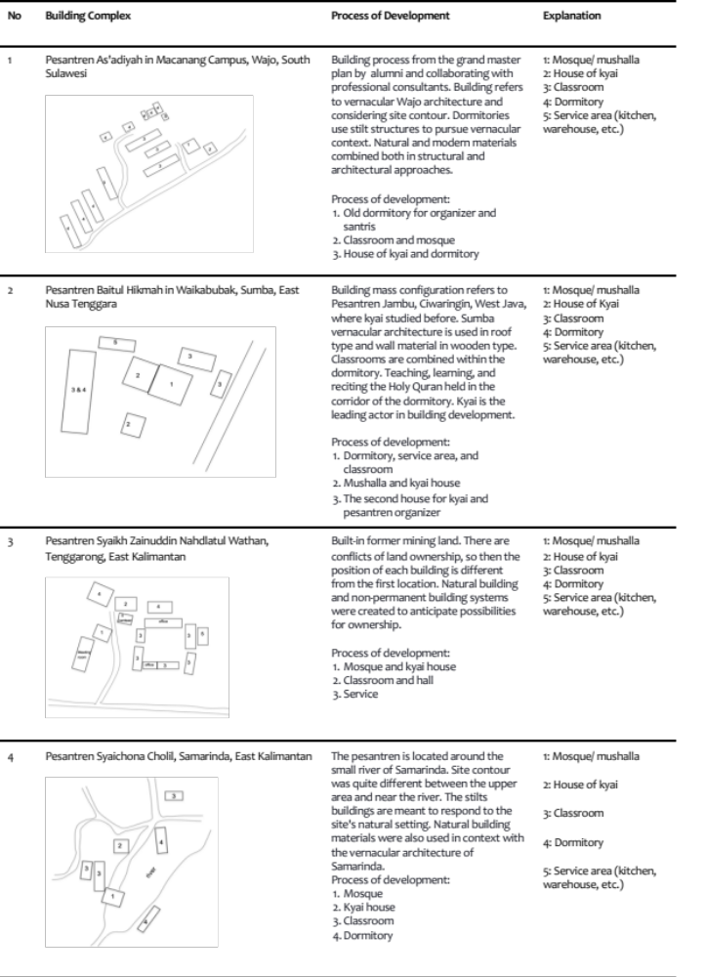
As’adiyah Wajo Pesantren Complex 3 is the largest As'adiyah pesantren compared to other complexes (Figure 2). The master plan was designed from the start and tried to adhere to Wajo architectural precedents in general. The morphology of the pesantren complex consists of a mass of buildings for the school, dormitory, and administrator's house. Most of the building materials used refer to modern materials; only the shape of the building still uses a sloping roof. The dormitory has been designed to be more humane, with rooms filled with 40 students in each room, and every part of the living area is occupied by four santris (students). There have been no changes to the space configuration because it is a new complex. The main actors of pesantren to develop morphology of complex buildings are the alumni. They have a decisive role and leadership in choosing the development model, from the curriculum to physical development. The commitment to use vernacular architecture was the central vision of the alumni to still represent the Wajo context as the manifestation of their founding father, Anre Gurutta As'adiyah.

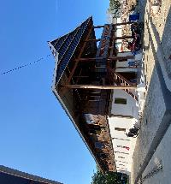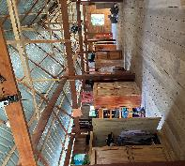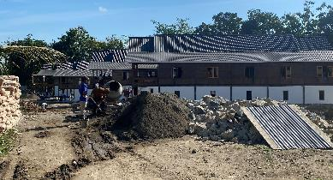

Figure 2. As’adiyah Pesantren Complex 3, Wajo, South Sulawesi

The second location is Baitul Hikmah Pesantren, Waikabubak, East Nusa Tenggara (Figure 3). This pesantren is relatively new in its emergence, but it is the first and pioneering pesantren on Sumba Island. The morphology of the building refers to the Kebon Jambu Pesantren, Ciwaringin, Cirebon, West Java, where the kyai of the Baitul Hikmah Pesantren studied before. The dormitory and study area are in one building, with the hallway used for teaching and learning. The front building representing Sumbanese architecture (roof transformation) is a mosque and hall for large-scale cottage activities.

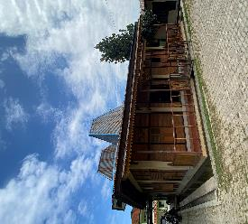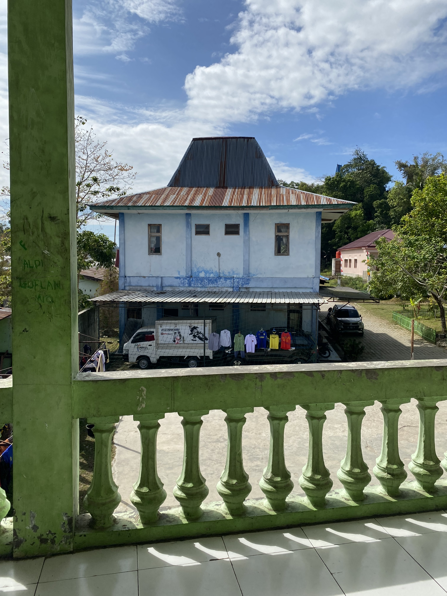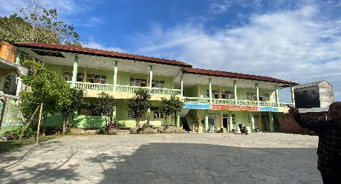

Figure 3. Baitul Hikmah Pesantren, Waikabubak, East Nusa Tenggara

Further, Syaikh Zainuddin Nahdlatul Wathan (NW) Pesantren was built on former mining land, so it has ownership conflicts, which result in the configuration of the building mass being unstable; it changes according to the dynamics of land ownership. There were no changes in the mosque's location due to a change in ownership of the area. The materials used are wooden planks with a semi-permanent building system due to land ownership issues (Figure 4).
The facilities at the Pesantren Syaikh Zainuddin NW, Tenggarong, are complete. The building has a dormitory, classrooms, a mosque, kyai’s house, office space, a teacher's room, and a reasonably large parking yard. The architectural design ideas for Syaikh Zainuddin NW Pesantren were entirely determined by the pesantren leadership and were discussed collectively with all elements of the pesantren involved. In terms of curriculum, this pesantren is affiliated with the Nahdlatul Wathan Islamic boarding school in East Lombok, West Nusa Tenggara. Still, the design of the pesantren needs to refer to that entirely. At the Syaikh Zainuddin NW Pesantren, a combination of traditional and modern architecture is found. Traditional architecture is shown through the design of a stilt house made of ironwood. The space configuration uses a courtyard pattern with the mosque on the westernmost side of the pesantren complex. The classroom buildings and boarding school offices were built in front of the courtyard. Meanwhile, the pesantren residence/dormitory is on the back side of the classroom building, especially to the north of the pesantren complex. This shows a hierarchy of space, the first being the mosque, the kyai's house to the north of the mosque, the school building, the courtyard as a gathering place, the dormitory, and supporting facilities.
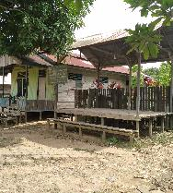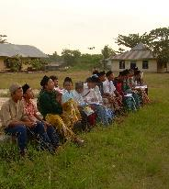

Figure 4. Syekh Zainuddin Nahdlatul Wathon Pesantren

Syaichona Cholil Pesantren in Samarinda is a large area, and the buildings are spread over many areas of the site (Figure 5). The morphology of the building follows the contours of the site by placing the mosque as the center of the mass of the building. At first, the mosque was located close to the kyai’s house and right next to the reservoir. However, as development progressed, a more extensive permanent mosque was built on the edge of the pesantren area with a more comprehensive and flat location precisely for male students. However, the old mosque was still used for female students. The development of the pesantren building area, which is spread out, is due to the contour of the available land, namely a hilly area. The semi-permanent building on the reservoir's edge is a dormitory for male students and caregivers. In contrast, the permanent building next to the old mosque is a dormitory for female students. ​
Kyai is the leading actor in determining the location of buildings in the pesantren area. Permanent multi-story buildings are placed on a relatively broad, flat area, while non-storied semi-permanent buildings are located on land that tends to slope. The area where the kyai or pesantren caretakers live is not renovated into a permanent multi-story building, but it maintains its site and semi-permanent shape. The wood used is ironwood (ulin wood), which has been a primary building material in Kalimantan since the beginning. The form of semi-permanent buildings, both the houses of the kyai and the dormitories for students and caregivers on the slopes near the reservoir, is stilts with a height of approximately one meter from the ground. ​

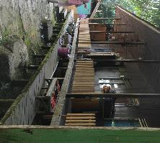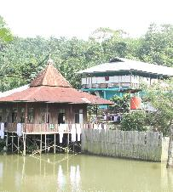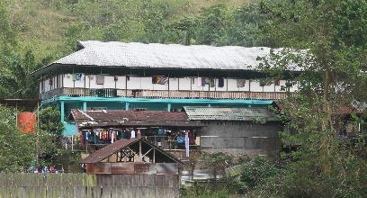

Figure 5. Syaicona Cholil Pesantren , Samarinda

The morphology of the pesantren building still refers to most of the early morphology of pesantren proposed by Ziemek in types C (Baitul Hikmah Pesantren and Syaikh Zainuddin Nahdlatul Wathan Pesantren) and type D (As'adiyah Pesantren and Syaichona Cholil Pesantren). Buildings for kyai, santri dormitories, and mosques appear in every pesantren, but this does not always determine the mosque's position as the center of mass due to the condition of the pesantren's land. The configuration of the mass of the building is inspired by the original huts where kyai used to study, from Madura (Syaichona Cholil Pesantren) and Ciwaringin, Cirebon (Baitul Hikmah Pesantren). The change in the form of increasing the mass of the building was motivated by the issues of land ownership and student capacity. The actors involved in morphological changes are clerics or Islamic scholars, families, and alumni.

- CONCLUSION
Manfred Ziemek's version of the initial morphology of pesantren can still be seen in traditional pesantren in eastern Indonesia through the kyai’s houses, mosques, and student dormitories. Many actors are involved in the development process, from kyais and their families, pesantren administrators, to alumni. Another factor that causes morphological development is geographical factors, where buildings with an enormous scale will be placed on the flattest land, no longer prioritizing the mosque's position as the center of the entire building's existence. From the research conducted in eastern Indonesia, we learn that traditional pesantren tried to set their building with the situation in the location and put the new configuration that is quite different from what usually occurs in other areas of pesantren, especially pesantrens in Java. Ownership issues are found as variations in the existence of the pesantren and any variation of morphology that is adjusted based on the urgent situation of the pesantren. It causes them to be only able to build the building as a non-permanent building type.
This research is a preliminary study to see the traditional pesantren's existence in eastern Indonesia. Several further studies are still needed, especially regarding the process of morphological change itself. The constellation of these changes on the dynamics of the curriculum used in pesantren and the extent to which pesantren morphology refers to the vernacular architecture of the place where the pesantren was founded are also essential.

REFERENCES

[1] M. Thahir, “The role and function of Islamic boarding school: An Indonesian context“. International Journal for Historical Studies, vol. 5, no. 2, pp. 197-208, 2014.
[2] Y. Nakamura, “Possibilities of Modern School Libraries in Pesantren in Indonesia: A Case Study with Two Young Muslim Women”. School Libraries Worldwide Journal, vol. 24, no. 1, pp. 57–70, 2018. Doi: https://doi.org/10.14265.24.1.004.
[3] Y. Zumaroh, “The role of Islamic Boarding School in Society“. Kompasiana. Accessed: March 6, 2018 [Online]. Available: http://www.kompasiana.com/yulianizumaroh/peran-pondok-pesantren-dalam-masyarakat_5562b6fae9afbde416533eec, 2015.
[4] M. Mursyid, A. Yudono, R. Wikantari, and A. Harisah, “Implementation of Islamic Values in Houses around Darul Istiqamah Islamic Boarding School in Maccopa, Maros”, Pertanika Journal of Social Sciences & Humanities, vol. 26, no. 4, pp. 2731 – 2746, 2018.
[5] Wahyoetomo, Perguruan Tinggi Pesantren: Pendidikan Alternatif Masa Depan. Jakarta: Gema Insani Press, 1997.
[6] R. Husni, Arah Baru pendidikan islam di Indonesia, Jakarta: PT. Logos Wacana Ilmu, 2001.
[7] A. R. Assegaf, Politik Pendidikan Nasional, Pergeseran Kebijakan Pendidikan Agama Islam dari Proklamasi ke Reformasi, Yogyakarta: Kurnia Kalam, 2005.
[8] R. Al Hana, “Perubahan-Perubahan Pendidikan di Pesantren Tradisional (SALAFI)”. Tadris: Jurnal Pendidikan Islam, vol. 7, no. 2, pp. 198-213, 2012.
[9] S. Suryadi and M. Mansur, “The Role of Traditional Islamic Boarding School-Based Islamic Studies as Radicalism and Intolerance Flow’s Blocking Agent“. Esensia: Jurnal Ilmu-ilmu Ushuludin, Vol 18, No.2, pp. 225-239, 2017. DOI: https://doi.org/10.14421/esensia.v18i2.1483.
[10] H. Yaqin, “Islamic Boarding School Curriculum in Indonesia: A Case Study in Islamic Boarding School in South Kalimantan“. Jurnal Al Hikmah. Vol. 13, No. 1, pp. 18-38, 2012.
[11] M. Fatkhuronji, R. Ekosiswoyo, T. J. Raharjo, “Life Skill Education Training for Santri in Islamic Boarding School”. The Journal of Educational Development, vol. 3, no. 2, pp. 106-114, 2015.
[12] N. G. Yuli, “Perubahan Spasial Permukiman di Sekitar Pondok Pesantren Krapyak, Bantul Yogyakarta”, Jurnal Pendidikan Arsitektur Indonesia, Vol. 1, No. 1, 2010.
[13] N. G. Yuli, “The Common Room Design of Islamic Boarding School: A Preliminary Research in Yogyakarta Islamic Boarding School“, International Journal of Engineering & Technology IJET-IJENS, Vol. 11, No. 04, pp. 156-163, 2011.
[14] N. G. Yuli, “Muslim Settlement: The Definition, Character and Current Condition”, International Journal of Multidisciplinary Thought, vol. 05, no. 03, pp. 347-354, 2015.
[15] N. G. Yuli, “The Spatial Value of Local Houses around Islamic Boarding School in Mlangi Moslem Settlements, Yogyakarta, Indonesia”, Matec Web of Conference, vol. 277, International Joint Conference on Mettalurgical and Material Engineering (JCMME 2018), 2019.
[16] N. G. Yuli, and S. Haningsih. “Vernakularitas Pondok Pesantren“, Laporan Penelitian Dasar Unggulan Perguruan Tinggi Ristek BRIN. Unpublished, 2021.
[17] C. T. Fisher, A. S. Cohen, R. Solinis-Casparius, F. L. Pezzutti, Bush, M. Forest, and A. Torvinen, “A Typology of Ancient Purépecha (Tarascan) Architecture from Angamuco, Michoacán, Mexico”. Journal of Latin American Antiquity, vol. 30, No. 3, pp. 510-528, 2019, Doi: https://doi.org/10.1017/laq.2019.50.
[18] B. C. Scheer, The Evolution of Urban Form: Typology for Planners and Architects. New York: Routledge, 2010.
[19] M. H. Johnson, “Phenomenological Approaches in Landscape Archaeology“. Annual Review of Anthropology, Vol. 41, pp. 269–284, 2012. Doi: https://doi.org/10.1146/annurev-anthro-092611-145840.
[20] R. W. Preucel, Archaeological Semiotics, New York: Wiley, 2008
[21] S. R. Steadman, Archaeology of Domestic Architecture and the Human Use of Space, London: Routledge, 2016.
[22] P. Allison, The Archaeology of Household Activities, London: Routledge, 2013.
[23] D. M. Carballo, “Advances in the Household Archaeology of High- land Mesoamerica“. Journal of Archaeological Research, vol. 19, pp. 133–189, 2011.
[24] B. M. Pozas, and G. F. J. Neila, “Housing building typology definition in a historical area based on a case study: The Valley, Spain”. Cities Journal, vol. 72, pp. 1-7, 2018, Doi: https://doi.org/10.1016/j.cities.2017.07.020.
[25] R. Abdelkader, and J. H. Park, “Spatial Principles of Traditional Cairene Courtyard Houses in Cairo,” Journal of Asian Architecture and Building Engineering, vol. 17, pp. 245–252, 2018. Doi: https://doi.org/10.3130/jaabe.17.245
[26] F. Karahan, and S. Davardoust, “Evaluation of vernacular architecture of Uzundere District (architectural typology and physical form of building) in relation to ecological sustainable development“. Journal of Asian Architecture and Building Engineering, vol. 19, no. 5, pp. 490–501, 2020, Doi: https://doi.org/10.1080/13467581.2020.1758108.
[27] F. S. Yilmaz, “Human factors in retail lighting design: an experimental subjective evaluation for sales areas“. Architectural Science Review, vol. 61, no. 3, pp. 156-170, 2018. Doi: https://doi.org/10.1080/00038628.2018.1450725.
[28] A. Ghaffarianhoseini, H. Al Waer, H. Omrany, A. Ghaffarianhoseini, C. Alalouch, D. Clement- Croome, & J. Tookey, “Sick building syndrome: are we doing enough?“ Architectural Science Review. Vol 61, No. 3, pp. 99-121, 2018. Doi: https://doi.org/10.1080/00038628.2018.1461060
[29] I. Cetiner & E. Edis, “An environmental and economic sustainability assessment method for the retrofitting of residential buildings“. Journal of Energy and Buildings, vol. 74, pp. 132–140, 2014.
[30] E. G. Dascalaki, K. G. Droutsa, C. A. Balaras, & S. Kontoyiannidis, “Building typologies as a tool for assessing the energy performance of residential buildings — A case study for the Hellenic building stock“. Journal of Energy and Buildings, vol. 43, no. 12, pp. 3400–3409, 2011.
[31] J. M. F. Pardo & I. C. Guerrero, “Subterranean wine cellars of Central-Spain (Ribera de Duero): An underground built heritage to preserve”, Journal of Tunnelling and Underground Space Technology, Vol. 21, No. 5, pp. 475–484, 2006. Doi: http://dx.doi.org/10.1016/j.tust. 2005.07.004.
[32] J. S. C. Astorqui, Estudio tipológico, constructivo y estructural de las casas de corredor en Madrid. Universidad Politécnica de Madrid. Doctoral thesis, Universidad Politectica de Madrid, 2012.
[33] N. E. Karabag & N. Fellahi , “Learning from Casbah of Algiers for more Sustainable Environment”. Journal of Energy Procedia, Vol. 133, pp. 95–108, 2017. Doi: https://doi.org/10.1016/j.egypro.2017.09.376.
[34] N. J. Habraken, The Structure of the Ordinary, Cambridge: MIT Press, 1998.
[35] Z. Aazam, Z, “The Social Logic of the Mosque: a study in building typology”. In Proceedings of the 6th International Space Syntax Symposium Istanbul, pp. 058/1-18, 2007.
[36] C. Norberg-Schulz, Architecture: Meaning and Place, Rizzoli, 1 988
[37] Syahrozi, “Morfologi Bentuk Tampak (Studi Kasus Huma Gantung Buntoi)”, Jurnal Perspektif Arsitektur, vol. 8, No. 1, 2013.
[38] A. Ronald, Kekayaan dan Kelenturan Arsitektur. Jakarta: Muhammadiyah University Press: 2008
[39] I. Setyabudi, A. Antariksa, & A. M. Nugroho, “Tipologi Dan Morfologi Arsitektur Rumah Jengki Di Kota Malang Dan Lawang”. Arsitektur E-Journal, vol. 5, No. 1, pp. 32–46, 2012.
[40] N. G. Yuli, I. F. Maharika, F. Eckardt, “The Architecture of Pesantren: Current Issues, Challenges and Prospect for Design Framework”, Journal of Islamic Architecture, Vol. 7, No. 4, pp. 626-638, 2023. Doi: DOI: https://doi.org/10.18860/jia.v7i4.21006
[41] M. Ziemek, B. Siregar, B. B. Sunjoyo, Pesantren dalam perubahan sosial, LP3S, 1986.

