 |  | JOURNAL OF ISLAMIC ARCHITECTURE  P-ISSN: 2086-2636 E-ISSN: 2356-4644  Journal Home Page: http://ejournal.uin-malang.ac.id/index.php/JIA
THE MOSQUE TYPOLOGY OF ACEH’S NORTHERN-EASTERN REGION, INDONESIA
Nurul Fakriah^{a*}, Maysarah Bakriª
ªUIN Ar-Raniry Banda Aceh, Indonesia
*Corresponding Author: nurul.fakriah@ar-raniry.ac.id
ARTICLE INFO |  |  | ABSTRACT
Volume: 8  Issue: 3  Page: 849-858  Received: November 19th, 2023  Accepted: June 27th, 2024  Available Online: June 30th, 2025  DOI: 10.18860/jia.v8i3.24280 |  |  | This study is an extended research of previous studies on the mosque typology in Aceh Province, Indonesia. Although Aceh is well-known as a “mecca veranda” due to its proximity to Islam, the mosque typology research is still limited. The mosque holds significant value in the Muslim community. This study was conducted in Aceh’s Northern-Eastern route, which covers 90 (ninety) mosques located in 8 (eight) regencies. Using Baiturrahman Grand Mosque as the reference, as suggested in previous studies, the result indicates that the union-shaped mosque as a roof element is the predominant feature replicated by the mosques in Aceh’s Northern-Eastern route. Other elements, such as the column, the opening, and the roof ornamentation, are also replicated by some research objects insignificantly. Differing from the previous research, this study highlights that the minaret is a vital feature, although it is not applied in all research objects. Further research can be carried on toward broader areas with more diverse analytical factors such as time, socio-culture and technology.  Keywords:  Mosque Typology; Islamic Architecture; Mosque Architecture

- INTRODUCTION
Aceh is an Indonesian region recognized as the “veranda of Mecca” because of its proximity to Islam. Historically, Aceh was the center of Islam development in Nusantara and Southeast Asia [1][2][3]. The Acehnese citizens are well-known for their strong adherence to Islam. Therefore, culturally, the people of Aceh are considered practicing Islam in their daily lives. It is reflected in Acehnese culture, which always corporates Islam. It is as stated in Hadih Maja (Acehnese proverb): “Adat bak Poteumeureuhom, hukom bak Syiah Kuala, qanun bak Putroe Phang, reusam bak Laksamana.” (Customs like Poteumeureuhom, legal rulings like Syiah Kuala, regulations like Putroe Phang, and traditions like Laksamana). Moreover, currently, Aceh is the only Indonesian province that applies Islamic Sharia Law as regulated by the Qanun. Nevertheless, the study of Acehnese mosque typology is rarely conducted despite it being an essential building in Muslim society.
The existing research on mosque typology in Aceh has primarily been conducted by Azzahra & Nasution [4] focuses on Banda Aceh’s mosque typology, and Fakriah [5], which focuses on the Western Aceh’s mosque typology. Both pieces of research indicate the tendency toward mosque typology resembling the Baiturrahman Grand Mosque (BGM) in Banda Aceh. Azzahra & Nasution (2018) stated that the role of BGM as Banda Aceh’s landmark contributed to the spread of mosque form resembling the BGM, particularly in Banda Aceh city [4]. Meanwhile, Fakriah [5] argued that the form and the feature of BGM have become the archetype that is duplicated by the majority of mosques in Aceh, and its influence has reached Western Aceh. Both studies are in line with Raap’s study that mentions the mosques’s architecture in Aceh is influenced by the Baiturrahman Grand Mosque [6]. Other studies are mainly conducted in Iran [7] [8][9][10][11][12], in Malaysia [13] [14][15][16], and other country such as Iraq [17], Oman [18], Azerbaijan [19], Greece [20], and Bangladesh [21]. Meanwhile, the study about Indonesian mosque typology was done by Utaberta et al. [22], and the mosque façade typology research was conducted by Humairah & Mastutie [23].
This research is conducted as a follow-up of previous research with the hypothesis that the mosque typology in Aceh imitates the architectural form of BGM by using it as an archetype or a standard reference that is deemed excellent by the community. Based on that hypothesis, this research is carried out in the Northern-Eastern region as the Western region research has been done previously, although not comprehensively.
The studies about typology should ideally have a typological model used as a reference for observing the research object to assess the level of the changes compared to the model [24]. In line with the above theory, this research uses BGM as a model of reference for studying mosque typology in Aceh. The selection of this mosque as the model is based on previous studies that indicate a general similarity between the Acehnese mosque and the BGM [4][5].

- METHODS
This research proceeded by doing a literature review on the BGM characteristics that will serve as a point of reference. The architectural features of BGM that shaped its characteristics are the roof shape, column, opening, minaret [25], and ornament [5] [26]. There is another study that also highlights other elements such as Arabesque interior decoration, the mihrab, calligraphy, muqarnas, porches, and entrance gates [27]. Figure 1 illustrates the research framework. Meanwhile, figure 2 shows the appearance of BGM as the reference.

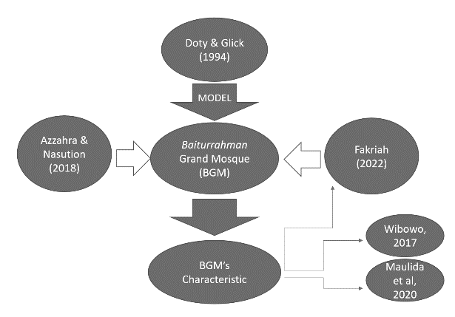

Figure 1. Research framework [Authors]

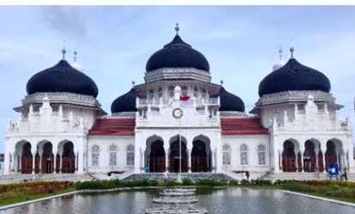

Figure 2. Baiturrahman Grand Mosque (BGM) as the model [5]

This qualitative research focuses on the Acehnese mosque typology. The study commences by undertaking a thorough review of the existing literature on mosque typology and identifying the mosque elements that will serve as the basis for the object observation. The literature review is also conducted to find the theory that can be used as the analysis tool. This research is a continuation and the development of a previous study that examined mosque typology in West Aceh. As the previous study was carried out in West Aceh, which is part of the Western-Southern route, in this study, the research area is expanded to cover the Northern-Eastern route in order to obtain a more comprehensive understanding of the mosque typology that represents Aceh.
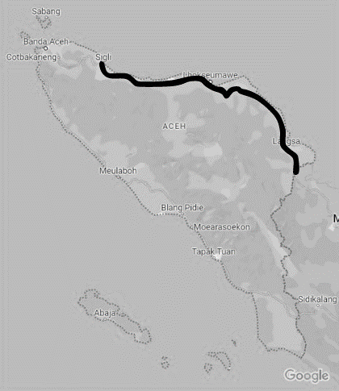

Figure 3. Research location [source: Google Maps with modification from Authors]

However, as Aceh Province has 4269 mosques [28], and 1629 are located in the Northern-Eastern route [28], this research takes samples from each eight regencies located in the Northern-Eastern route. In total, there were 90 mosques observed in this study. Table 1 shows the distribution of sampling.

Table 1. The Distribution of Sample [source: Authors]
Regency | Number
Pidie | 7
Pidie Jaya | 8
Bireuen | 10
Lhokseumawe | 7
Aceh Utara | 13
Aceh Timur | 27
Langsa | 8
Aceh Tamiang | 9
Total | 90

Another data source is BGM’s characteristic data as the control to determine the mosque typology in Aceh. This data source uses secondary data from Fakriah’s study [5], which are the roof, the opening, the column, the minaret, and the façade ornament. The observation is conducted towards those elements and later, it will be compared with the control elements to obtain a valid form representation. Although the previous study result shows most of the Western Aceh mosques do not implement the minaret, in this current research, the assessment of the presence and the minaret form is a part of the observation to determine if there are differences in terms of the existence of minarets located in other regencies in Aceh.

- RESULT AND DISCUSSION
As this research involves 90 research objects, the analysis table for each of them is not displayed in the main part of the article. Rather, it is presented in the appendix. The discussion section describes the research findings that are categorized as the roof, the column and the opening, the minaret, and the façade ornament element. The image elements of BGM as the model are shown in each sub-section.

- THE ROOF
The BGM roof as the model, is shown in Figure 4. It is a black union-shaped dome.

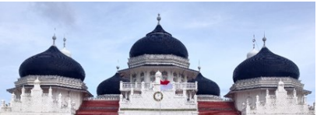

Figure 4. BGM’s roof [5]

The observation reveals that the union-shaped dome is the most common roof style found in Northern-Eastern Aceh. It is aligned with the roof style of BGM. However, several mosques have modified the roof shapes that resemble the union-shaped dome. It is carried out by using a modified half-dome that creates the union-shaped dome. In addition, several types of roofs are found to diverge from BGM, which are the pyramid and stacked roof designs. In this case, although some mosques use those kinds of roof styles, they still incorporate a small dome placed at the top of the roof.
In terms of color, the common colors used for roof coverings are black and green. Nevertheless, some mosques use variations of other colors, such as gradients of green like light green, blue, copper, golden, cream, and white. The black closely resembles the one used in BGM.
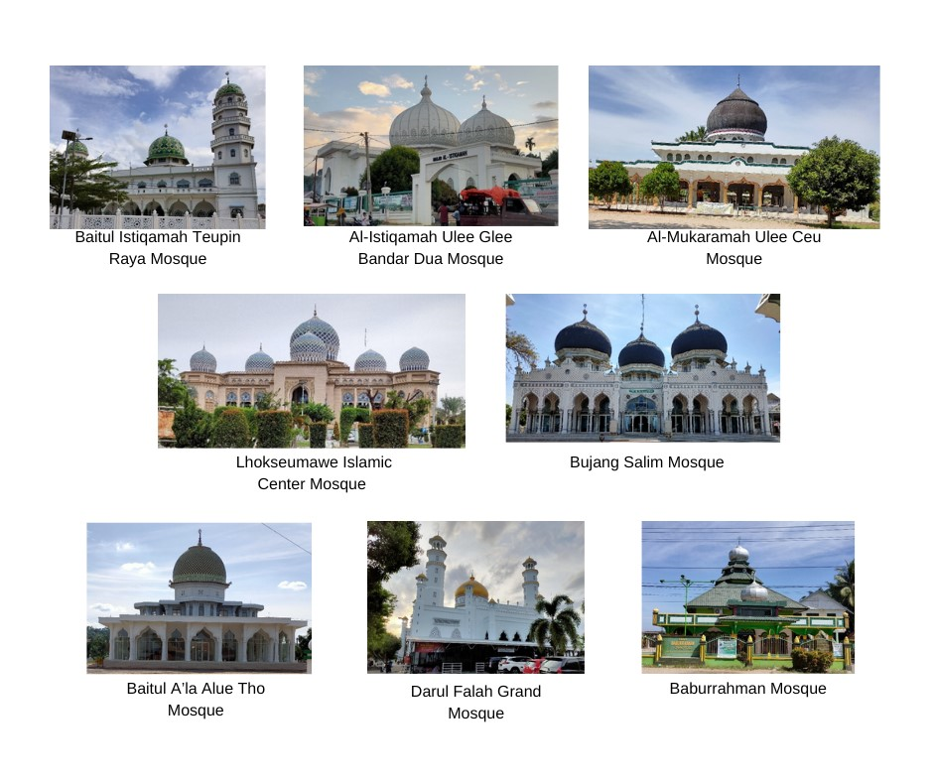

Figure 5. Sampling of mosque’s roof in Northern-Eastern Aceh [Authors]

The number of domes in the Northern-Eastern mosques is also varied. However, the majority of it uses a single dome positioned in the center of the mass building. The amount of domes is generally odd, but there are some mosques with an even number of domes, like the Taqwa Matang Seulimeung Mosque in Langsa City. In terms of the dome arrangement, the even number of dome mosques typically places the domes in the center of the building, with one in the front and another in the backside. For mosques with an odd number of domes, the domes are arranged side by side. If there are more than three domes, it is arranged side by side and in rows at the back. Essentially, their positioning aligns with the overall architectural composition of the mosque.

- THE COLUMN AND THE OPENING
BGM uses a keel arch-shaped door followed by a window design in a smaller size [5]. Figure 6 displays the image of the door and the window of BGM. In the Northern-Eastern Aceh, the common opening shape is the arch such as a pointed arch, horseshoe arch, or round arch. Nevertheless, some mosques use flat arches or regular doors, such as Babuttaqwa Seumadam Mosque and Rawatib Mosque in Birem Bayem. Moreover, most of the arch has been modified in terms of proportion (e.g., wider span), size, shape, and other additional decoration. Related to the color, a variety of colors is used, which differs from BGM. Compared to the roof, the opening shape does not resemble the BGM significantly.

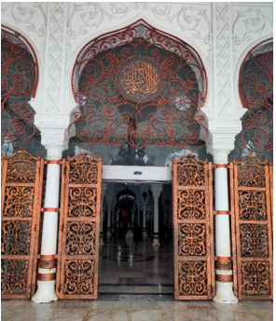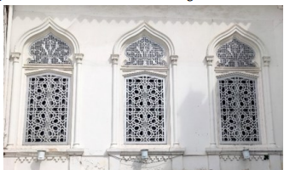

Figure 6. The door and the windows of the BGM [5]

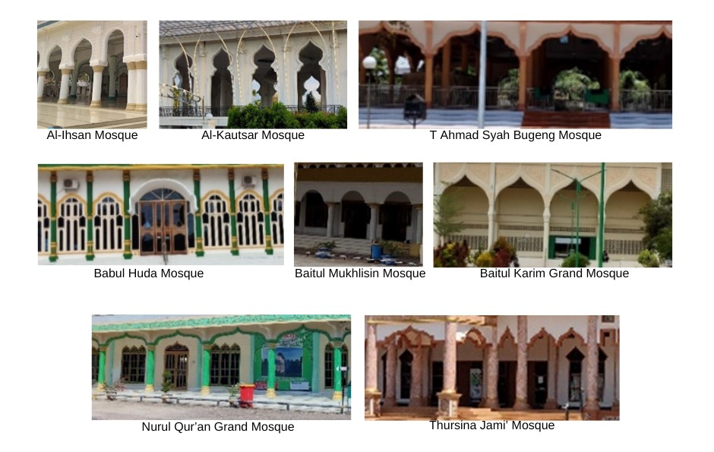
Figure 7. Sampling of the column and opening of the mosque in the Northern-Eastern Aceh [Authors]

Different from the opening, most of the columns follow the BGM typology. However, most of it has been modified in terms of shape, proportion, color, and size. Several notable common features in the column typology in the Northern-Eastern region include the appearance of BGM similar-shape columns but without relief and marble-like colored, giving the impression of marble sections used as pillars/columns. It can be observed in the Jami’ Thursina Kuala Simpang Mosque, the Baiturrahim Lhok Nibong Mosque, the Al-Ikhsan Grand Mosque in Lhoksukon, the Al Munawwarah Meurah Dua Mosque, the Al-Ikhlas Teupin Punti Mosque, and the Al Mukarramah Ulee Ceu Mosque. Additionally, some columns are painted in a single solid color, as if it was made from a single piece of stone forming the column. Shape modification is also seen in square-base columns and rectangular-base columns. There is a variety in terms of the column size.

C. THE MINARET
BGM has two types of minarets: one attaches to the main building and another is separate from the mosque in 200 meters distance [5]. Figure 8 shows two types of minarets in BGM. Meanwhile, most of the Northern-Eastern mosques have no minaret. Nevertheless, a minority of the mosques also have minaret. Compared to BGM’s minaret, some of it has the same form while others are in different shapes. This finding aligns with the previous study that states the West Aceh mosques have no minaret [5]. The minaret is located in various places. Some include it as a part of mosque architecture, other locates it separately from the mosque.

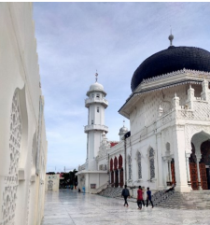
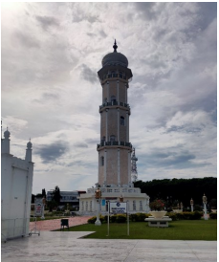

Figure 8. The minarets of the BGM [5]

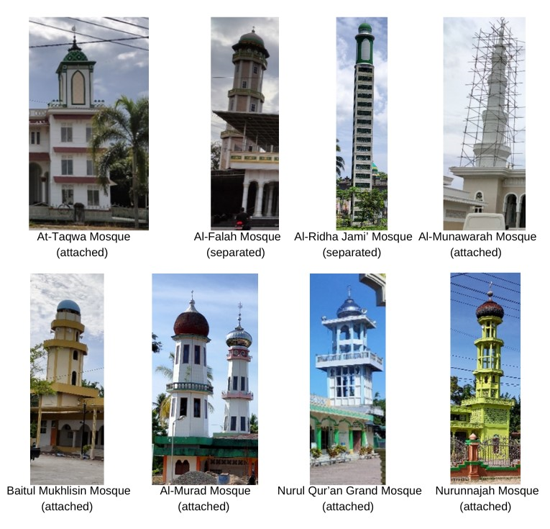

Figure 9. A sampling of the mosque’s minaret in the Northern-Eastern Aceh [Authors]

Twenty-two mosques attach the minaret to the mosque mass which are At-Taqwa Lampoh Saka Mosque, Baitul Ala Lil Mujahidin Mosque, Baitul Huda Blang Malu Mosque, Baitul Istiqamah Teupin Raya Mosque, Islamic Center Pidie Jaya Mosque, Al-Munawarah Muara Satu Mosque, Baiturrahim Banda Sakti Mosque, Baitul Mukhlisih Baktiya Barat Mosque, Baitul Mukarramah Meudang Ara Mosque, Baitul Ghafur Pante Bidari Mosque, Baitul Karim Simpang Ulim Grand Mosque, Baitul Muttaqin Darul Aman Mosque, Babussa’adah Peudawa Puntong Mosque, Al-Murad Keude Peureulak Mosque, Darul Falah Langsa Great Mosque, Taqwa Matang Seulimeng Mosque, Nurul Quran Langsa City Grand Mosque, Baiturrahim Langsa Timur Mosque, Nurunnajah Buket Panyang Dua Mosque, Nurhasanah Karang Baru Mosque, Thursina Kualasimpang Jami’ Mosque, dan Babuttaqwa Seumadam Mosque. Meanwhile, 14 mosques that locate the minaret separately are Al-Abrar Caleue Mosque, Al-Falah Lueng Putu Mosque, Al-Ridha Gandapura Jami’ Mosque, Al-Ikhlas Batuphat Mosque, Bujang Salim Keude Krueng Geukueh Mosque, Sultan Malikul Saleh Mosque in Samudra District, Baiturrahim Mosque in Syamtalira Aron District, Sultan Ahmad Mosque in Paya Naden Village, Baitul Aminin Mosque in Langsa City, Darussalam Mosque in Langsa Lama, Salman Alfarisi Mosque in Tualang Cut, Nurul Iman Mosque in Tj. Seumantoh, Syuhada Mosque in Bundar Village, and Al-Huda Karang Baru Grand Mosque. The rest of the mosques, 54 mosques in total, have no minaret.
There is a special character noted in this Northern-Eastern region. Most of the minarets are attached to the mosque, having an integrated structure with the mosque’s part. Sometimes, they are placed on the top of the building. As a result, some mosques attempt to display the distinctive features of minaret characteristics. However, the lack of a major proportion may prevent them from appearing mosque-like. Moreover, the minaret shape in Northern-Eastern Aceh does not entirely adopt or adapt the BGM’s form.

D. THE FAÇADE ORNAMENT ELEMENT
The model for façade ornament is shown in Figure 10. The result displays that most of the Northern-Eastern mosques do not implement façade ornamentation as found in BGM. Many of them do not have any façade ornamentation. Few mosques apply façade ornaments resembling those on BGM. Those are Al-Fuqara Rambayan Lueng Mosque, Grong Grong Mosque, Al-Ikhlas Batuphat Mosque, Bujang Salim Keude Krueng Geukeuh Mosque, Al-Ihsan Grand Mosque in Meunasah Trieng Lhoksukon, Baiturrahim Mosque in Lhok Nibong, and Zadul Mu’ad Mosque in Peureulak. However, there are numerous modifications of the façade ornaments, including variations in colors, texture (the pattern), size, or the material.

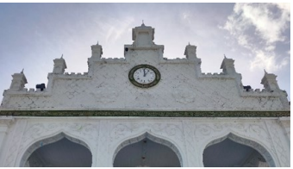

Figure 10. The façade of the BGM [5]

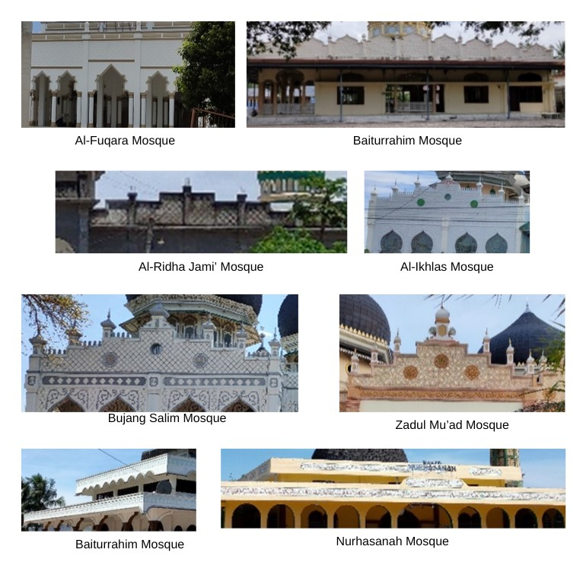
Figure 11. A sampling of the mosque’s façade ornament in the Northern-Eastern Aceh [Authors]

E. THE MINARET IN NORTHERN-EASTERN ACEH’S MOSQUE DESIGN
BGM’s façade applies the Indian Moghul styles [29] [30] and becomes the mosque’s design reference in Aceh [29]. As the most popular building, several imitated mosques can be found in the northern-eastern route from Banda Aceh to Medan [29]. Among the mosque features replicated, yet, this research found that minarets are not commonly found among the research objects located along the study sites. Of all research objects, only 40% of it has a minaret. This finding leads to the discussion about the existence of minaret in northern-eastern Aceh’s mosque design.
Although it is well known as one mosque’s characteristics, precedents did not depict the use of minaret in the earliest mosque in Islam, and there was no designated place for Muezzin [31]. Based on what has come before, it seems clear that the minaret originated during the Umayyad era in Syria [31]. In Southeast Asia, the discussion regarding the minaret highlights the circulation and adaptation of precedents [32]. This suggests that people’s understanding and trading activities influence the appearance and the minaret’s presence in the mosque’s design.
Mosque design incorporates a universal element, referring to a standardized form that the community has universally agreed upon as the typical appearance of a mosque [33]. Among those universal elements, the minaret is a secondary feature that is not obligatory in the mosque design [33]. This statement is supported by the study by [22] that argues the existence of a minaret is more for aesthetic purposes rather than functionality which can be seen in Indonesian mosque buildings. Functionality might be one of the reasons the minaret is not commonly found in research objects along the northern-eastern route of Aceh. In this current day, the adzan is recited by loudspeakers located in the mosque area. Thus, the role of the minaret as a muezzin place is not optimally fulfilled. Society does not perceive the minaret as a functional element, as mentioned by [22] [33].
An interesting thought is provided by Khan, who said that the Muslim community tends to implement noticeable, universally Islamic elements such as the dome and minaret to show the Muslim identity, particularly in Southeast Asia [34]. However, two studies demonstrate that society perceives the dome as the primary identifier of a mosque [35], [36]. Although the later research was done in different provinces, it gives a glance at how the community perceives the mosque’s identity. The first study said that the respondents perceived the dome as the mosque’s identity rather than the minaret, which was believed as the loudspeaker location [35]. As in the research finding, the identity aspects might be reasons for the low minarets implementation in mosques along the northern-eastern route of Aceh. Society perceives the dome as the mosque’s identity. Thus, the existence of the minaret is an additional element in mosque design. The arguments presented are based on referenced sources. However, further data collection using appropriate methods and analysis is necessary to support these opinions.

- CONCLUSION
From the explanation above, it can be concluded that the influence of BGM on Northern-Eastern Aceh’s mosques, particularly in terms of the roof, is the union-shaped dome. Although some modifications can be observed in a few mosques, the basic form of the union-shaped dome remains the primary choice in the mosque’s design in Northern-Eastern Aceh. The research result also reveals the role of the mosque dome as the identity of a religious building found in the northern-eastern route of Aceh which resembles the BGM’s dome.
On the other hand, there are not many mosques in Northern-Eastern Aceh that closely resemble the window designs of BGM. However, these mosques still have the opening as their characteristic. There are many modifications of the pointed arch found in the opening design. The primary modification is in the width opening that generally adjusts to the used column-beam structure. This affects the proportion of the pointed arch, as seen in the BGM. Another modification involves the shape of the arches. Some of them simplify the shape into more geometric forms, while others combine them with other shapes, creating new forms.
BGM’s columns remain the significant element that influenced the Northern-Eastern mosque. The special character emerges from this element in this area. This character is the column body decoration that is made to resemble marble, giving the impression of a solid marble block carved into a pillar. However, there are still columns that apply the relief on the column’s body, as in BGM. Minaret and façade ornament in the Northern-Eastern mosque are not essential elements influenced by the BGM design. Nevertheless, some mosques still apply minaret and façade ornament that resembles the one in BGM.
This study is limited in terms of time and funding, which in turn limits the area of study. Therefore, further research needs to be carried out in other areas of Aceh. In addition, the information about the year of construction can be considered as an aspect of studying the mosque typology in one region. It can be a focus in future research so that the mosque typology can also be categorized based on the construction year.

ACKNOWLEDGEMENT
This research is fully supported by DIPA UIN Ar-Raniry 2022 with contract number 424/PPK-UIN/PUSLIT/III/2022.

REFERENCES

[1] D. Lombard, Kerajaan Aceh Zaman Sultan Iskandar Muda (1607-1636). Jakarta: KPG, 2014.
[2] S. B. A. L. Khan, Sovereign women in a Muslim kingdom: the sultanahs of Aceh, 1641-1699. Singapore: NUS Press Pte Ltd, 2017.
[3] A. Reid, Asia Tenggara Dalam Kurun Niaga 1450-1680 Jilid 2: Jaringan Perdagangan Global. Jakarta: Yayasan Pustaka Obor Indonesia, 2020.

[4] F. Azzahra and M. A. Nasution, “Tipologi Bentuk Masjid di Kota Banda Aceh,” in Seminar Nasional Teknologi Terapan VI, Banda Aceh, 2018, pp. 23–30.
[5] N. Fakriah, “The Typology of Mosques Architecture in West Aceh,” J. Islam. Archit., vol. 7, no. 1, pp. 82–94, 2022, doi: https://doi.org/10.18860/jia.v7i1.12912.
[6] W. Bouwsema-Raap, “The Great Mosque of Banda Aceh: its history, architecture and relationship to the development of Islam in Sumatra,” University of Victoria, 1986.
[7] S. Moradzadeh and A. N. Ebrahimi, “A study of mosques architecture in Iran for finding patterning of Bushehr mosques in the Qajar dynasty,” J. Fine Arts Archit. Urban Plan., vol. 23, no. 2, pp. 87–98, 2019, doi: 10.22059/jfaup.2019.263428.672084.
[8] M.-H. Khadem-zadeh, G.-H. Me’marian, and K. Salavati, “Analytical Typology of Historic Mosques in the Cultural Kurdistan Region,” J. Iran. Archit. Stud., vol. 6, no. 11, pp. 103–124, 2022.
[9] R. P. Khamari, H. Rajab-’Ali, and M.-R. Ravandeh, “Typology of Mosques in Baluchestan of Iran (from the Qajar period to the Present),” J. Iran. Archit. Stud., vol. 6, no. 11, pp. 189–205, 2022.
[10] M. M. Taheri, H. Mazaherian, and S. Khaghani, “Shabistan-based Typology of Iranian Historical Mosques and its Representation via the Geographical Information System.,” J. Fine Arts Archit. Urban Plan., vol. 23, no. 3, pp. 17–26, 2019, doi: 10.22059/jfaup.2019.254564.671988.
[11] M. E. Zarei, “Typology of Kurdistani style mosques in Iran,” JARS, vol. 7, no. 2, pp. 29–42, 2010.
[12] W. S. Sahabuddin, “DOME FORM TYPOLOGY OF ISLAMIC ARCHITECTURE IN PERSIA,” J. Islam. Archit., vol. 4, no. 4, pp. 163–167, 2017, doi: https://doi.org/10.18860/jia.v4i4.4374.
[13] N. Utaberta, D. Sojak, M. Surat, A. Che-Ani, and M. Tahir, “Typological Study of Traditional Mosque Ornamentation in Malaysia – Prospect of Traditional Ornament in Urban Mosque,” Int. Sch. Sci. Res. Innov., vol. 6, no. 7, pp. 457–464, 2012.
[14] A. Bahauddin and H. Ahmad, “SUFISM IN THE ARCHITECTURAL TYPOLOGY OF THE MELAKA TENGKERA MOSQUE, MALAYSIA,” in Islamic Heritage Architecture and Art II, 2018, pp. 161–172. doi: 10.2495/IHA180131.
[15] A. A. Ahmad, A. A. M. Zin, and E. Arbi, “Typology Of Interior Architecture For Traditional Mosques In Peninsular Malaysia From 1700-1900 Ad,” J. Al-Tamaddun, vol. 8, no. 2, pp. 89–100, 2013, [Online]. Available: https://ejournal.um.edu.my/index.php/JAT/article/view/8664
[16] R. Othman, N. Inangda, and Y. Ahmad, “A Typological Study of Mosque Internal Spatial Arrangement: A Case Study on Malaysian Mosques (1700-2007),” J. Des. Built Environ., vol. 4, no. 1, pp. 41–54, 2008.
[17] F. A. Mustafa and Z. K. Ismael, “A typological Study of the Historical Mosques in Erbil City,” Sulaimania J. Eng. Sci., vol. 6, no. 3, pp. 11–28, 2019, doi: https://doi.org/10.17656/sjes.10097.
[18] S. Bandyopadhyay and M. Sibley, “The distinctive typology of central Omani mosques: its nature and antecedents,” in Seminar for Arabian Studies 33, London: Archaeopress, 2003, pp. 99–116.
[19] N. Shojadel, “Analytical Typology of Historical Mosques In West Azerbaijan Province,” Palarch’s J. Archaeol. Egypt, vol. 18, no. 4, pp. 2313–2334, 2021.
[20] M. Loukma and M. Stefanidou, “The morphology and typology of the Ottoman mosques of northern Greece,” Int. J. Herit. Archit., vol. 1, no. 1, pp. 78–88, 2017, doi: 10.2495/HA-V1-N1-78-88.
[21] I. Islam and A. Noble, “Mosque Architecture in Bangladesh: The Archetype and Its Changing Morphology,” J. Cult. Geogr., vol. 17, no. 2, pp. 5–25, 1998, doi: https://doi.org/10.1080/08873639809478318.
[22] N. Utaberta, K. A. Kosman, and A. S. M. Tazilan, “Tipologi Reka Bentuk Masjid Tradisional di Indonesia,” Sari Int. J. Malay World Civilis., vol. 27, no. 2, pp. 229–245, 2009.
[23] S. Humairah and F. Mastutie, “Tipologi fasad bangunan masjid di Indonesia,” Media Matrasain, vol. 10, no. 2, pp. 52–62, 2013. DOI: https://doi.org/10.35793/matrasain.v10i2.4113
[24] D. H. Doty and W. H. Glick, “Typologies As a Unique Form Of Theory Building: Toward Improved Understanding and Modeling,” Acad. Manag. Rev., vol. 19, no. 2, pp. 230–251, 1994, doi: 10.5465/amr.1994.9410210748.
[25] R. R. Wibowo, “Elemen Fisik Masjid Baiturrahman Banda Aceh sebagai Pembentuk Karakter Visual Bangunan,” in Seminar Heritage IPLBI 2017, 2017, p. A-139-A144.
[26] W. Handoko, “KARAKTERISTIK ARSITEKTUR MASJID KUNO DAN PERKEMBANGAN ISLAM DI MALUKU,” J. Penelit. dan Pengemb. Arkeol., vol. 31, no. 1, pp. 39–52, 2013, doi: https://doi.org/10.24832/amt.v31i1.152.
[27] R. Maulida, N. . Siahaan, and I. . Pane, “Eclecticism on the masjid building (case study: Baiturrahman Great Masjid, Banda Aceh City),” in IOP Conference Series: Earth and Environmental Sciences 452, 2020, pp. 1–8. doi: doi:10.1088/1755-1315/452/1/012006.
[28] Badan Pusat Statistik Provinsi Aceh, Aceh Province in Figures. Banda Aceh: BPS Provinsi Aceh, 2023.
[29] I. Hasan, “Architecture and the Politics of Identity in Indonesia - A Study of the Cultural History of Aceh,” The University of Adelaide, 2009.
[30] K. R. Kurniawan and R. A. Kusumawardhani, “The influence of 19th century Dutch Colonial Orientalism in spreading Kubah (Islamic Dome) and Middle-Eastern architectural styles for mosques in Sumatra,” J. Des. Built Environ., vol. 11, no. 1, pp. 1–13, 2012, [Online]. Available: https://mjes.um.edu.my/index.php/jdbe/article/view/5330
[31] R. J. Gottheil, “The Origin and History of the Minaret,” J. Am. Orient. Soc., vol. 30, no. 2, pp. 132–154, 1910, doi: https://doi.org/10.2307/3087601.
[32] I. b. Tajudeen, “Mosques and Minaretes: Transregional Connections in Eighteenth-Century Southeast Asia,” Journal18, no. 4, pp. 1–33, 2017, doi: 10.30610/4.2017.4.
[33] A. Fanani, Arsitektur Masjid, 1st ed. Yogyakarta: Bentang Pustaka, 2009.
[34] H.-U. Khan, “The Architecture of the Mosque, an Overview and Design Directions,” in Expressions of Islam in Buildings, H. Salam, Ed., Singapore: Concept Media, 1990, pp. 109–127.
[35] D. Dailami, M. Bakri, and M. Rahmi, “Student ’ s Perception towards the Mosque ’ s Physical Identity in Banda Aceh,” Bayt ElHikmah J. Islam. Archit. Locality, vol. 1, no. 2, pp. 92–99, 2024.
[36] A. Hildayanti, “Persepsi Masyarakat Terhadap Kehadiran Masjid Tanpa Kubah Di Indonesia,” Teknosains Media Inf. Sains dan Teknol., vol. 16, no. 1, pp. 11–24, 2022, doi: 10.24252/teknosains.v16i1.23914.

