 |  | JOURNAL OF ISLAMIC ARCHITECTURE  P-ISSN: 2086-2636 E-ISSN: 2356-4644  Journal Home Page: http://ejournal.uin-malang.ac.id/index.php/JIA
PLACE MEANING IN MALANG CITY PERIPHERAL MUSLIM SETTLEMENTS: THE UNEXPECTED ROLE OF BUILT ENVIRONMENT AESTHETICS
Farid Nazaruddinª, Purwanita Setijanti^{a*}, Arina Hayatiª
ªInstitut Teknologi Sepuluh Nopember, Surabaya, Jawa Timur, Indonesia
*Corresponding Author: psetijanti@arch.its.ac.id
ARTICLE INFO |  |  | ABSTRACT
Volume: 8  Issue: 2  Page: 340-355  Received: November 21th, 2023  Accepted: March 6th, 2024  Available Online: December 30th, 2024  DOI: 10.18860/jia.v8i2.24297 |  |  | Does the deep religiosity of Muslims significantly shape a neighborhood's meaning, or is it overshadowed by the visual appeal of the built environment? This question becomes relevant when the buildings' aesthetics do not embody the neighborhood's religiosity. To delve into this, research was carried out in the outlying settlements of Malang City, Indonesia, utilizing a mixed-method approach that blends qualitative methods such as observation and interviews with quantitative surveys. The qualitative approach validates the disconnection between the Islamic neighborhood religiosity and the built environment. Additionally, it identifies eight key factors influencing place meaning, encompassing neighborhood religiosity, the aesthetics of the built environment, social connections, and economic opportunities. Factor analysis highlighted that architectural features and qualities of the built environment had a more significant impact on residents' place meaning than the community's religious culture. Therefore, the aesthetic appeal of buildings plays a significantly more significant role in shaping residents' sense of belonging than the Islamic neighborhood religiosity. This unexpected finding challenges traditional assumptions about the strength of Muslim demography and Islamic religiosity in shaping place meaning. It urges urban planners, legislators, and architects to prioritize the aesthetic quality of the built environment when fostering vibrant and meaningful communities for Muslim residents.  Keywords:  Aesthetic; Built Environment; Neighborhood religiosity; Place Meaning; Settlement

- INTRODUCTION
Social, cultural, religious, and artistic elements intricately shape neighborhood identities, especially in Muslim communities [1], [2], where the fusion of religiosity with the physical environment is crucial [3], [4], [5]. The aesthetic appeal of buildings, aligned with Islamic characteristics, reinforces neighborhood identity, fostering a sense of place [6]. This interplay enhances place attachment and overall well-being [7], [8].
However, modern urban development may clash with traditional Islamic elements in some Muslim settlements, affecting place and identity [9], [10]. Changes in city peripheries often prioritize aesthetics without considering local design principles, impacting the religious landscape [11].
The interplay between cultural and religious aesthetics and the formation of place meaning is significant [12], [13]. Since place attachment hinges on the meaning people ascribe to a place [14], [15], Understanding how religiosity and building aesthetics contribute to this meaning is crucial amid rapid urbanization in Muslim settlements.
Regrettably, to the best of our knowledge, there is a scarcity of scientific articles delving into the role of neighborhood religiosity and the aesthetic appeal of buildings in shaping place meaning within these specific contexts. This article is expected to fill this gap.
This study lies in its potential to offer insights for urban planners and architects to create spaces connected to communities. It also aims to provide residents with a perspective fostering appreciation, identity, and attachment.

  - PLACE MEANING IN CITY PERIPHERAL MUSLIM SETTLEMENTS
Interactions between individuals, their social circles, and the physical environment shape place meanings [16]. These meanings deepen as surroundings, activities, and personal narratives coalesce, creating a distinct sense of place [17], [18]. Place meanings vary across supranational, national, local, and individual levels [19]. People attribute meaning to a setting based on their social and cultural background, interacting with the political, social, and cultural context [20]. Shared experiences with loved ones contribute to a place's significance [21], and ties with locals play a role in individual and communal place-making [16]. Settlements nurture layered meanings as hubs of diverse interactions [22].
While the physical environment does not dictate meaning, it sets the stage for experiences and a desire to safeguard meaningful places [19], [23]. Muslim settlements are ideal for understanding place meaning formation, given that diverse social dynamics and religious activities shape experiences. However, urban development on the fringe can introduce economic opportunities, exposing communities to conflicting globalized values. It may alter the built environment, posing a threat to the community's sense of place [24]. It is crucial to acknowledge that various urban developments have the potential to alter these characteristics.
Urban development in Muslim settlements on the urban periphery introduces new economic opportunities and exposure to globalized and modern values, often clashing with traditional Islamic identity. Rapid changes can disrupt place meanings crucial for well-being [11], [25], [26]. Therefore, Understanding and incorporating Islamic cultural values into urban development plans are crucial for Muslim settlements navigating modernization while preserving their unique identity [27].

  - MUSLIM NEIGHBORHOOD RELIGIOSITY
Islam shapes not only a personal faith but also a complete societal framework [28], [29]. It is more than beliefs; it is a divinely ordained code of conduct influencing culture and community life. Religiosity in a community can have varied effects, offering both benefits and drawbacks depending on interpretation and practice [30], [31]. In Muslim settlements, shared faith is a cultural anchor, defining interactions and community life based on Prophet Muhammad's values [32], [33].
Islamic settlements go beyond a Muslim majority [5], [34]. Residents of these settlements actively embody Islamic culture through practices like daily prayers, Friday congregational prayer, and religious education [35], [36]. Festivals like Ramadan and Eid strengthen social bonds, reflecting a rich heritage [37].
Muslim neighborhoods go beyond religious practice, fostering deep religiosity that translates into solid community ties. The shared faith creates a bond of brotherhood and sisterhood, leading to mutual support, shared meals, and community cooperation [38]. These communities become cultural bastions where language, art, music, and cuisine thrive, enriching the broader cultural tapestry [39].

  - THE NEIGHBORHOOD AESTHETIC IN ARCHITECTURE
Islam lacks specific environmental design laws, but core principles like privacy and good neighborliness encourage responsible environmental stewardship [40]. Some scholars propose incorporating key elements like mosques, walkways, communal spaces, and privacy considerations into Islamic neighborhood planning [3]. Central to Islamic identity, Mosques shape neighborhood layouts, reflecting historical and cultural influences [5], [41]. The unique visual identity of the Islamic built environment blends artistic and spiritual elements, impacting residents' and outsiders' perceptions [32], [42]. Notably, in informal and unplanned Muslim settlements on the city periphery, residents directly influence the built environment, reflecting their Islamic identity in design and aesthetics.
Indonesia, the world's most populous Muslim country, illustrates a trend where aesthetics rely less on overtly religious elements, favoring a distinctive tropical aesthetic [43], similar to Muslim-minority communities in the Philippines [44]. Informal settlements evolve based on fundamental needs rooted in economic and practical considerations.
Despite the absence of overtly religious aesthetics, Indonesia has many closely clustered Masjids, enhancing the integration of Islamic character and contributing to a religious aesthetic in the surrounding residential environment.
Recognizing the role of sociocultural factors in shaping residential identity, this study proposes a counter-hypothesis: In Muslim settlements where building aesthetics do not prominently reflect religiosity, the emerging place meaning will be primarily driven by neighborhood religiosity rather than the visual appeal of the built environment.
- METHODS
To address the limitation of qualitative [45], [46] and quantitative methods [14], [47] in place meaning research, this study employed a two-phase research methodology. Initially, the qualitative investigation involved field observations and in-depth interviews with neighborhood leaders, exploring people, social, cultural, and physical aspects. Questions like 'What kind of place do you think your neighborhood is?' were posed, similar to Stedman [14]. Findings were validated using previous research on neighborhood definitions [16], [48], [49], providing corroborating evidence.
Building on qualitative insights, the researchers conducted a quantitative investigation. Key variables from interviews were measured using a structured questionnaire. Given the challenge of directly assessing place meaning [47], the study used factor analysis to explore hidden factors influencing residents' place meaning. The questionnaire comprised descriptive statements about neighborhood surroundings, gauged on a Likert scale. It was distributed to 128 residents in each location, with eligibility criteria of residence for at least two years and age 18 or older.
Exploratory factor analysis (EFA) was employed for quantitative analysis, allowing the exploration of relationships between variables without preconceived assumptions. Factor loadings quantified the correlation strength between an indicator and the underlying factor, with higher absolute values indicating stronger associations. JASP Software [50], [51] was utilized for the analysis.

- THE CONTEXT OF THE STUDY
This study, part of a broader investigation into place attachment in Malang's peripheral settlements, explores residents' assigned meaning to their environment as a critical factor influencing attachment [14]. These communities are characterized by a deeply rooted Islamic identity woven into daily life, with active engagement in religious practices fostering a vibrant Islamic atmosphere [52]. Masjids and Islamic institutions serve as central hubs, enhancing social connection, religious observance, and cultural exchange. The solid Islamic grounding extends to social structures, binding residents through traditions and customs.
A two-phased approach was followed to identify study sites. The first phase involved mapping all peripheral settlements in Malang City, considering physical and social characteristics. The second phase included field observations, prioritizing Islamic neighborhoods with minimal urban development impact. Two communities were selected: Dusun Baran Tempuran in the Cemorokandang precinct and Dusun Baran in the Telogowaru precinct. Both are deeply rooted in Islamic faith and culture, and these communities have histories that exceed a century (Numbers 28 and 33 in Figure 1).

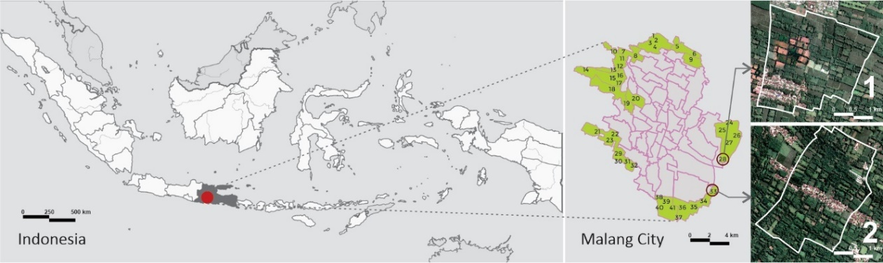

Figure 1. Study locus: Dusun Baran Tempuran (1), Dusun Baran (2) [Source: Adapted from Google Earth]

For each settlement, we identified key individuals to facilitate our research. In Dusun Baran Tempuran, Mr SM, a native resident of 40 years and the community's administrative head provided invaluable insights. His lifelong familiarity with the environment and social dynamics proved crucial. Similarly, in Dusun Baran, Mr. MA, the 45-year-old leader born and raised there, offered comprehensive knowledge as the neighborhood's executive for Islamic culture and traditions.

- RESULT
- SOCIAL AND DEMOGRAPHIC ASPECTS
Both study communities, Dusun Baran Tempuran, and Dusun Baran, embody the religious character typical of Muslim neighborhoods in their social and demographic composition. As of 2022, Dusun Baran Tempuran is home to 134 Muslim families, while Dusun Baran has 128. Neighborly relationships in both settlements are rooted in Islamic values, emphasizing respect and privacy, fostering close-knit bonds despite physical distance.
The social structure in both settlements follows the Malang City pattern, with the head of the community (Ketua Rukun Warga) serving as the official administrative leader, often taking on additional social leadership roles. Islamic activists contribute significantly to maintaining social order, particularly Masjid managers (Takmir) and community imams. However, the Ketua Rukun Warga, while promoting Islamic causes, is not typically seen as a religious leader.
In Baran Tempuran, participants exhibited a balanced gender mix, with an average age of 39. Most fell within the 30s-40s age group, with the youngest participant at 18 and the oldest at 74. Baran mirrored this age distribution, with an average age of 35.7. Participants were a religiously homogenous group, identifying as Muslim, with minimal formal schooling. Agricultural pursuits dominated their families' primary income sources, followed by self-employment and small business ownership (see Figure 2).
The majority actively participated in Islamic community activities, reflecting a commitment to the neighborhood's religious identity. Local events and community life predominantly centered around Islamic traditions and values, as demonstrated by respondents' more substantial alignment with Islamic religious values over cultural or other values. Notably, residents expressed a protective stance toward their culture, disapproving of cultural changes in both Baran Tempuran and Baran (see Figure 3).

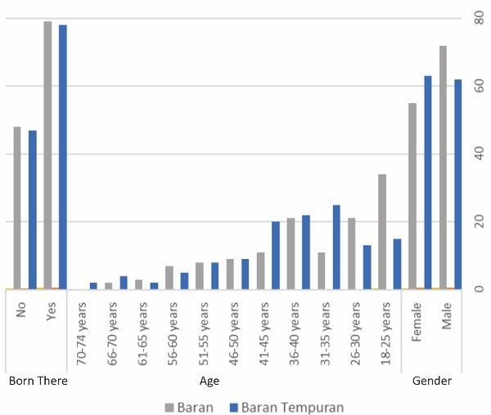 | 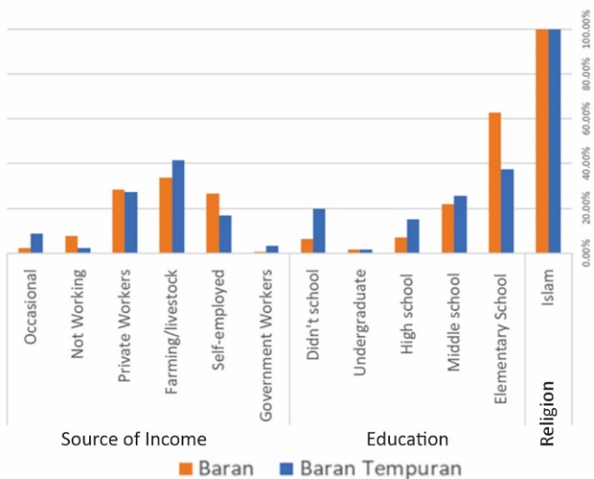
Figure 2. Demographic profile of respondents (left) and Socio-economic profile of respondents (right)

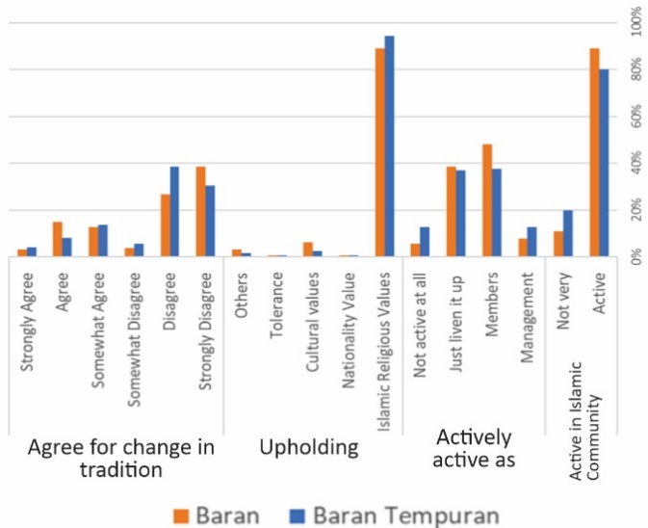

Figure 3. Behavioral support for neighborhood religiousness

- RELIGIOUS AND CULTURAL ASPECTS
The cultural landscape of both settlements reflects a harmonious blend of Islamic values and time-honored Javanese traditions. These interlacing customs permeate residents' identities and inform their daily lives. From traditional ceremonies infused with Islamic prayers to community gatherings guided by Javanese etiquette. These traditions hold deep meaning and form the bedrock of their cultural heritage, which are:
  - Death Commemoration traditions include 'tahlilan', an Islamic practice held on Thursdays or Fridays in homes with 50 or fewer participants (Figure 4). 'Ngelayat/takziah,' mourning condolences, involve most adult residents and are overseen by a Religious Officer (Modin) to ensure adherence to Islamic guidelines [53].

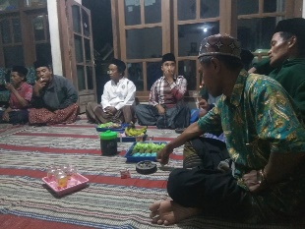 | 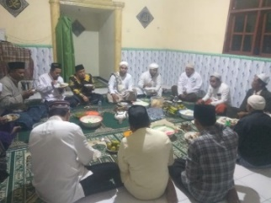
Figure 4. ‘Tahlilan’ (left) and ‘khataman’ in study locus [Source: Provided by respondents]

  - Traditions praising Prophet Muhammad include 'Banjarian,' a weekly Islamic musical performance; 'Dibaan,' a rotating weekly event for reading praise poetry about the Prophet held in homes and masjids; and 'Mawludan Akbar,' an annual celebration on the 12th of the Hijri calendar's Mulud or Robiul Awal month (Figure 5). The 'Mawludan Akbar' occurs after the Asr prayer, with participants reading praises for the Prophet at five homes until 10:00 p.m., centered around Masjid Jami. The entire village follows this tradition.

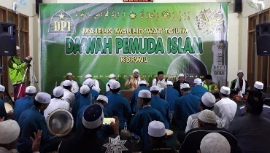 | 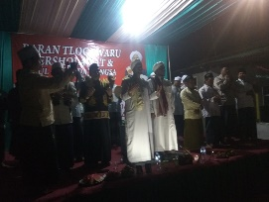
Figure 5. ‘Mawludan’ in study locus [Source: Provided by respondents]

  - Qur'anic recitation traditions include 'Khataman,' a monthly custom in both communities where proficient leaders recite the entire Qur'an aloud in the masjid (Figure 6). The neighborhood resonates with the sound of the Qur'an over the masjid's speakers during this activity.
  - Traditions that commemorate life with a focus on expressing gratitude to Allah (Syukr). 'Selametan' is the usual name for it [38]. This Islamic tradition is typically incidental, such as customs honoring circumcisions, marriages, births, and other occasions. Residents will be invited if the event is in a joyful setting, frequently accompanied by the Islamic music ensemble ‘Banjarian.’
  - Islamic celebration traditions include events like the isra’ mi’raj and Islamic New Year celebrations. During the Islamic New Year in Baran Tempuran, the 'Burdah' praise to Prophet Muhammad is read while 'Tumpeng,' traditional sacred food, is carried around settlements (Figure 6). The culmination involves a feast at Masjid Jami', followed by all village residents adhering to this tradition. In Ramadan, the widely observed 'Sahur Patrol' involves children and teenagers using the 'bedug' drum to awaken residents for the pre-dawn meal.

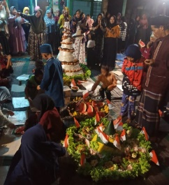 | 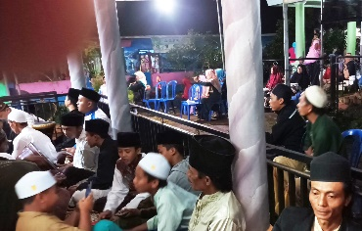
Figure 6. ‘Tumpeng’ feast (left) and ‘isra’ mi’raj’ in study locus [Source: Provided by respondents]

  - Tabligh Akbar traditions aim to enhance community unity through intellectual, spiritual, and social interactions among Muslims (Figure 7). The annual event, held every March at Masjid Jami' in Baran Tempuran, includes the 'Haul Kiyai Sarbini' tradition attended by locals and surrounding communities. This gathering, marked by recitations and lectures, honors the late Kiyai Sarbini, a key figure in founding the Baran Tempuran tradition and constructing the Jami Masjid. Before Ramadan, all masjids in Baran organize a large recital involving not only Baran villagers but also those from nearby villages.

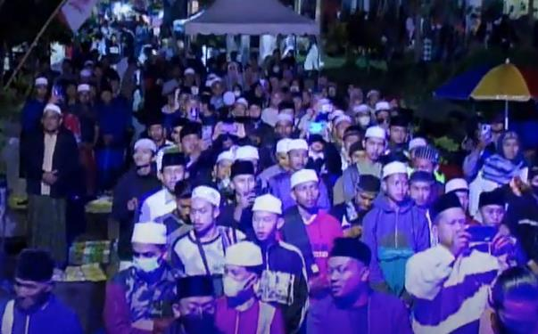 | 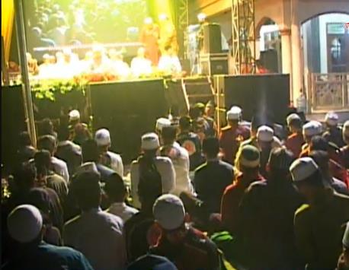
Figure 7. Tabligh Akbar in study locus [Source: Provided by respondents]

  - Nationality-based traditions with Islamic values include the annual 'Agustusan' event in both locations. Despite ample open spaces, it is mainly observed on the main road. This tradition, emphasizing the popular Islamic proverb 'loving your country is part of faith in Allah,' [54] involves all community residents, with approximately 30 individuals making it enjoyable for everyone, especially the kids.
  - Islam's emphasis on community ('Sillaturahim') [55] aligns with cultural traditions in the community. 'Community service,' held annually in both neighborhoods, involves around 50 primarily male participants, while mothers cook in residents' kitchens. Another tradition is 'Arisan' neighbor gatherings, which attract over 30 women on specific days and take place in rotation at each resident's home.

Rituals and customs throughout the year form the fabric of life in these Muslim communities. Interview and activity documentation data reveal a rotational pattern for hosting events, mainly between private homes and masjids. In cases where neither option is suitable, activities extend to streets or designated vacant spaces traditionally used for communal gatherings. Importantly, all locations for these collective activities, except roads, are either non-residential facilities or private property generously offered by residents.
Additional interviews with key community figures unveiled how Islamic religious ethics and social solidarity united by faith (ummah) permeate their daily lives. Beyond acts of Islamic social solidarity, such as charitable acts (zakat and sadaqah) held annually in Ramadan, simplicity and politeness, as tenets of their faith, remain cherished virtues in everyday life. Overall, interweaving religious and cultural aspects creates a social fabric of support and mutual aid, empowering individuals and uplifting the community.

- PHYSICAL ASPECTS
Baran Tempuran covers around 55 hectares, predominantly characterized by lush green spaces. Research and current map data indicate that buildings occupy only 15-20% of the total area, while the remaining 80-85% is dedicated to verdant surroundings. Interviews with settlement leaders reveal that residents mainly utilize this green space for farming sugar cane, corn, oranges, chili peppers, spices, and vegetables.
Baran Tempuran, characterized by its grid-like layout (Figure 8), boasts 188 buildings. Among these, only two showcase prominent Islamic architectural features: two Masjids. The remaining structures predominantly follow a specific style: one-story houses with gable-style clay tile roofs and spacious front terraces. Often, this typology is a result of efficiency and economic considerations.

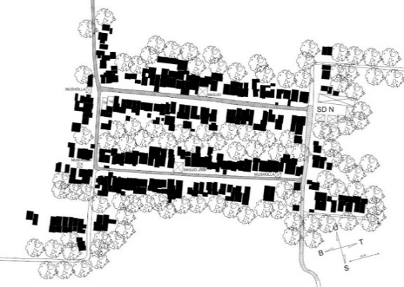

Figure 8. Map of building plots in Baran Tempuran [Source: Author]

As illustrated in Figure 9, these images depict the typical residential structures in Baran Tempuran. These residences typically have a setback five to seven meters from the road (pictures 1-4), resulting in a versatile courtyard often embellished with meticulously maintained, verdant grass. Despite a handful of recent constructions adopting modern-urban trends (picture 2,3) and opting for two-story designs (picture 4), the architectural landscape of Baran Tempuran predominantly reflects a traditional tropical style characterized by gable roofs. Notably, Islamic influences are not universally evident in all residential buildings within this area.

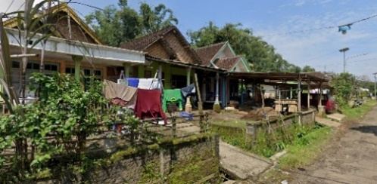 | 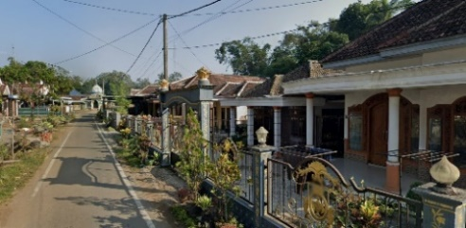
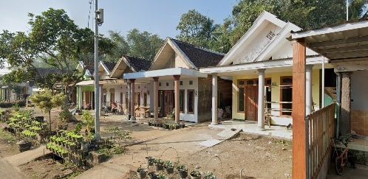 | 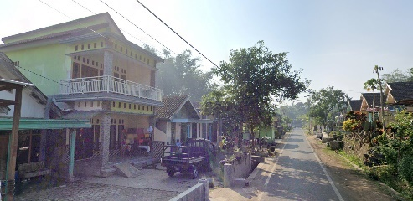
Figure 9. Typical buildings in Baran Tempuran [Source: Author]

Baran Tempuran has two Masjids and three mushollas (small prayer buildings) that serve the community's religious needs of communal prayer. The Masjid "Jami'" takes center stage as the designated space for Friday prayers. Unlike the setback residences, all Masjids stand closer to the road, subtly marking the transition to sacred space. Architecturally, the Masjids embrace either a straightforward Islamic Middle Eastern style or a Javanese style showcasing Islamic aesthetics. At the same time, the Musollas are mostly simple Javanese-Islam style, mainly in the roof shape, with minimum ornamentations.
As evident in Figure 10, Picture 1 features the Jami Mosque, while Picture 2 showcases the second masjid. Notably, these masjids contrast with the prevalent building typology in their surroundings, primarily due to their distinctive shapes and positioning facing the road. However, the masjids' ornamentation and character are relatively understated, with the predominant Islamic feature being the dome shape and some arch elements. Other elements are relatively conventional building components, with minimal incorporation of calligraphy or excessive ornamentation.

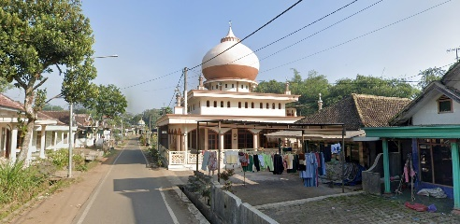 | 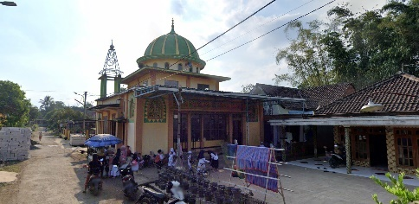
Figure 10. Two Masjids in Baran Tempuran [Source: Author]

Baran Tempuran is also home to resources for Islamic education: kindergartens and elementary schools. Despite their focus on Islamic instruction, their architectural styles exhibit no distinct Islamic features, harmonizing with the overall aesthetics of the residential structures.
Baran, the second study location, presents a distinct contrast in its linear building arrangement (Figure 11). Yet, despite this difference, the overall landscape echoes Baran Tempuran in many ways. Baran occupies a slightly larger land area of approximately 65 hectares and, just like its counterpart, boasts a remarkable expanse of green spaces. These verdant areas, constituting 80-85% of the settlement, serve as vital agricultural and plantation zones.

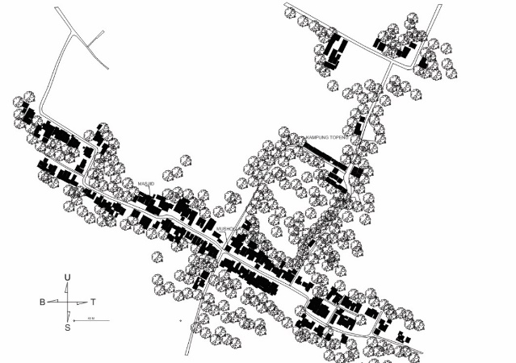

Figure 11. Map of building plots in Baran [Source: Author]

Baran's built environment mirrors Baran Tempuran's typology and aesthetics (Figure 12). The structures maintain a consistent setback of five to seven meters from the road, incorporating a contemporary urban construction trend while retaining distinctive traditional gable roofs (Picture 1-4). Specific structures feature a modern fence as a prominent element of their aesthetic composition (Picture 4).

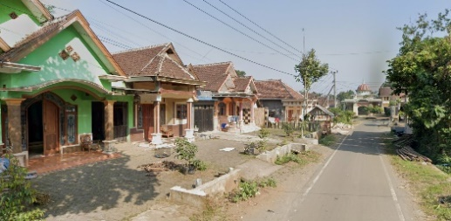 | 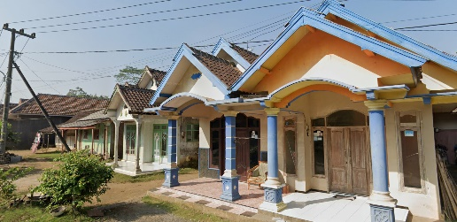
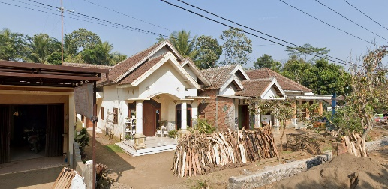 | 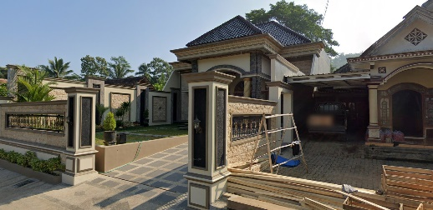
Figure 12. Typical buildings in Baran [Source: Author]

The residential area in Baran comprises 143 buildings, marked by a prominent mosque, two smaller mushollas, and an Islamic Elementary School offering both kindergarten and Islamic education. However, the Musholla and the School adopt a vernacular style with minimal overt Islamic aesthetic elements in their design. The Masjid Jami, used for Friday prayers, shares the typical aesthetics with the mosque in Baran Tempuran. Positioned strategically and featuring a dome-shaped roof (Figure 13), it stands out in the surroundings. Despite incorporating elements reminiscent of Middle Eastern architectural styles, such as arches and a distinctive dome, the mosque does not display an overwhelming Islamic character in its intricate details.

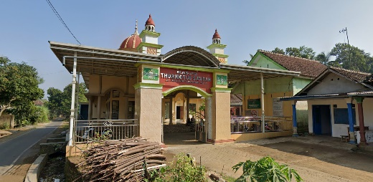

Figure 13. Masjid in Baran [Source: Author]

Hence, it becomes evident that the comprehensive built environment in the two study locations does not entirely encapsulate the neighborhood's religiosity. The architectural landscape in both settlements tends to favor a shared aesthetic, where Islamic influence is predominantly confined to the mosques. Most other buildings seamlessly integrate with an urban-contemporary style, occasionally infused with a touch of tradition.

- MEANING OF PLACE IN THE STUDY LOCATIONS
Deep interviews with settlement leaders, using the open-ended question "What kind of place do you think your neighborhood is?" revealed various perspectives, which were then transcribed and coded.
Key individuals highlighted how neighborhood religiousness and the built environment's aesthetic appeal are critical in shaping meaning. Thematically, other aspects like social dynamics, cultural characteristics, economic activity, and the environment's natural support systems also contribute to residents' perceptions. It resulted in key themes, which are:
• Social quality includes individual, communal, demographic, and, in this case, level of education.
• Environment quality includes building aesthetics and natural aesthetics.
• Cultural quality includes neighborhood religiousness and cultural conditions.
• Economic opportunity.
These themes align with existing research on subjective definitions of neighborhood [48], sustainable neighborhood [49], Urban development [56], [57], and the taxonomy of sustainable development objectives [58], particularly in peripheral settlements [11]. It is worth noting that the results distinctly reflect both the religiosity of the neighborhood and the aesthetic appeal of the built environment.
Subsequently, the research formulated eight critical questions derived from the themes identified in the qualitative findings. These questions aim to capture the diverse meanings residents may associate with their built environment, enabling a more in-depth exploration of residents' perceptions in the subsequent stages of the research. The statements were meticulously crafted to encompass many potential interpretations without becoming exhaustive.
In Analyzing residents' responses (Table 1), the research found that both locations consistently ranked neighborhood religiosity significantly higher than the aesthetic appeal of the built environment. It suggests that their community's social and spiritual aspects hold greater importance than the physical appearance of their surroundings.

Table 1. descriptive statistics for aspects of a place meaning
Descriptive Statistics | Baran Tempuran |  | Baran
 | Mean | % | Mean | %
This place is a quiet place to raise a family (social individual) | 5.65 | 94 | 5.47 | 91
This place is a beautiful place with its buildings (built environment aesthetics) | 5.04 | 84 | 5.03 | 83
This place is a place with lots of natural beauty (natural environment aesthetics) | 5.62 | 93 | 5.50 | 91
This place is a place to seek sustenance (economic) | 5.26 | 87 | 5.17 | 86
This place is suitable for good neighborly living (social communal) | 5.57 | 92 | 5.42 | 90
This place is a place that lags behind the progress of the times (culture) | 3.30 | 55 | 3.39 | 56
This place is educated (demographics) | 4.45 | 74 | 4.60 | 76
This place is religiously Islamic (cultural) | 5.62 | 93 | 5.37 | 89

We employed exploratory factor analysis and parallel analysis to uncover response patterns. The Kaiser-Meyer-Olkin MSA test scores of 0.7 and 0.69 validated the suitability of the indicators for this analysis (Table 2).

Table 2. Kaiser Meyer Olkin test for indicators of environmental meaning
Kaiser-Meyer-Olkin test | Baran Tempuran | Baran
Overall MSA | 0.701 | 0.69

Bartlett's test further reinforced the suitability of the indicators for factor analysis, yielding a p-value of .001 (Table 3). This statistical evidence strongly supports the existence of distinct factors within the responses. The results exhibited high consistency across both studied locations, suggesting a shared pattern of underlying factors.

Table 3. Bartlett's test for the significance of environmental meaning answers
Baran Tempuran |  |  |  | Baran
Bartlett's test |  |  |  | Bartlett's test
Χ² | df | p |  | Χ² | df | p
105.709 | 28 | < .001 |  | 213.190 | 28 | < .001

Exploratory factor analysis (EFA) of the Baran Tempuran data revealed a single factor responsible for 20% of the overall variance in the observed indicators. This factor accounts for a significant portion of the shared patterns within the responses. The order of the indicators, as shown in the factor loadings, demonstrates their relative importance in representing this underlying dimension. Factor loadings measure the strength and direction of the relationship between each indicator and the extracted factor, offering insights into how closely each indicator aligns with the measured core construct.
The EFA in Baran Tempuran revealed a single latent factor, interpreted as "this place is a good place to live," driving the respondents' top definition of the environment. Interestingly, the strongest associations with this factor lie within the social and built environment aspects rather than religious aspects. Notably, "a quiet place to raise a family" emerges as the key indicator, aligning with the social category identified in the interview transcript coding. The neighborhood religiosity indicator, with a moderate factor loading of 0.349 (Table 4), suggests that residents value personal social relationships and peaceful surroundings when defining their ideal environment. While the religious dimension holds some importance, as evidenced by the "religiously Islamic" indicator, it plays a less prominent role in shaping their overall perception of Baran Tempuran as an excellent place to live.

Table 4. Factor Loading of the place meaning in Baran Tempuran
Factor Loadings | Factor 1
This place is a quiet place to raise a family (social individual) | 0.726
This place is suitable for good neighborly living (social communal) | 0.564
This place is a beautiful place with its buildings (built environment aesthetics) | 0.489
This place is educated (demographics) | 0.4
This place is religiously Islamic (cultural) | 0.349
This place is a place that lags behind the progress of the times (culture) | -0.312
This place is a place to seek sustenance (economic) | 0.312
This place is a place with lots of natural beauty (natural environment aesthetics) | 0.175
Note. The applied rotation method is promax.

Baran seems to echo a similar pattern. EFA reveals a single factor explaining 32.2% of the variance, with a comparable arrangement of the most vital indicators, albeit with differing values for the lowest ones. It suggests a remarkable overlap in how neighborhood residents perceive their environment. Notably, the factor loading for the "religiously Islamic" indicator remains consistent at 0.349 across both locations (Tables 4 and 5). The finding underlines a shared level of importance placed on the religious dimension in shaping their understanding of the neighborhoods despite the variations in factor strength.
Examining the factors with the most substantial indicator composition in both study locations revealed a common theme: residents primarily perceive their neighborhoods as communities offering a good quality of life. It aligns with the frequent response of "This place is a good place to live" to the open-ended question, "What kind of place do you think your neighborhood is?"

Table 5. Factor Loading of the place meaning in Baran
Factor Loadings | Factor 1
This place is a quiet place to raise a family (social individual) | 0.859
This place is suitable for good neighborly living (social communal) | 0.635
This place is a beautiful place with its buildings (built environment aesthetics) | 0.562
This place is a place with lots of natural beauty (natural environment aesthetics) | 0.529
This place is a place to seek sustenance (economic) | 0.478
This place is educated (demographics) | 0.374
This place is religiously Islamic (cultural) | 0.349
This place is a place that lags behind the progress of the times (culture) | -0.062
Note. The applied rotation method is promax.

Across both locations, the factor loadings consistently point to "a good place to live" as strongly associated with specific qualities: a peaceful area suitable for raising a family, a friendly neighborhood, and an area with beautiful buildings. While other variables in the table demonstrate some correlation, their impact on this perception is less pronounced. For instance, "This place is religiously Islamic" has a loading of 0.349, indicating that neighborhood religiousness plays a role in residents' perceptions. Still, its influence on the definition of "good place to live" is weaker than the other top-ranking variables.

- DISCUSSION
The qualitative study exposes a thematic disconnect between the religiosity of the Muslim neighborhood and its built environment. Moreover, the significance of Malang City's peripheral Muslim settlements underscores more to uncover, as the dimensions structuring the meaning extend far beyond social and cultural conditions. Residents perceive their communities as dynamic spaces undergoing transformations fueled by hope for a future that upholds sound development principles. This hope aligns with the pillars of sustainable development – economic progress, social cohesion, environmental stewardship, and cultural preservation [59] – suggesting a shared vision for the evolution of their communities.
Despite the robust social and cultural fabric strongly supporting Muslim neighborhood religiosity, this aspect does not significantly shape the overall meaning residents attribute to their communities. Indicators of neighborhood religiosity rank much lower than social quality aspects in contributing to the definition of "a good place to live." Interestingly, the aesthetic appeal of buildings emerges as a far more prominent factor than neighborhood religiosity.
The finding is particularly unexpected, given the solid socio-demographic, cultural, and traditional emphasis on Islam in these communities. This disconnect resonates with previous studies that emphasized the importance of aligning the physical and social dimensions in defining and attributing meaning to the environment [22]. In this context, residents seem to prioritize a harmonious relationship between the aesthetic qualities of their surroundings and the vibrant social fabric of their community, suggesting a nuanced understanding of the factors that contribute to an excellent place to live. Further research is needed to explore the implications of this shift in priorities and how it shapes the residents' lived experiences in these evolving settlements. The study reveals a consistent pattern in the three most influential variables shaping place meaning in both locations. Social connections emerge as the most substantial factor, followed by communality as the second strongest, and the aesthetic of buildings ranked third. It emphasizes the built environment's significant role in shaping residents' perceptions of Muslim settlements in the city periphery.
Similar to how language and art convey messages, the physical characteristics of these communities, from architectural styles to green spaces, silently communicate messages about social relationships, cultural norms, and underlying values [22]. However, our findings suggest that the influence of these cultural and value systems might be more nuanced than initially expected. While overt religious features are not the sole indicator of neighborhood religiosity, their absence might signify a diminished role in shaping the place's meaning. Focusing solely on subtle cues in social interactions and community practices risks overlooking the significant impact of tangible religious symbols and spaces on collective identity, memory, and values. Moreover, relying on these subtle cues can be subjective and prone to misinterpretation, potentially erasing the historical and cultural context embedded within physical structures.
Determining a settlement as Islamic demands a comprehensive approach beyond mere demographics or social-cultural conditions. This study aligns with previous research, emphasizing Islam's need to be expressed pragmatically [5]. It underscores the significance of the built environment as a crucial element supporting the process of Islamic place-making [34], [60]. While traditional assessments focus on observable activities and cultural elements, this research highlights the limitations of purely objective approaches. The inquiry into neighborhood religiousness revealed that residents' perceived sense of their community's Islamic character may not always align with external observations. While seemingly indicative of religious solid commitment, abundant cultural practices may not reflect individual residents' actual beliefs and engagement depth. Subjectivity necessitates incorporating residents' perspectives through qualitative methods like interviews or focus groups. Similarly, the perceived aesthetic appeal of buildings, often seen as positive, relies on subjective interpretations and personal preferences. Recognizing subjectivity in defining and evaluating Islamic settlements is crucial for researchers, policymakers, and planners to avoid imposing singular perspectives and engage meaningfully with these communities.
While aesthetics and physical qualities shape residents' perceptions, it is essential to remember that Islam emphasizes sociality and community building [61]. After the family, the neighborhood serves as one of Muslim communities' most fundamental social units, characterized by successful social interactions based on mutual respect, cooperation, and upholding religious principles. This focus on communal living aligns with the congregational nature of Islam, where gatherings and shared spaces foster a sense of belonging and collective well-being. As Isa et al., [62] highlighted, critical factors in Muslim neighborhood relations include tolerance, natural environment, social needs and comfort, religion, order, economy, knowledge, hygiene, Jannah (paradise), and safety. This research confirms the importance of tolerance, as it underpins harmonious relationships and peaceful coexistence within the community. However, navigating these factors also presents challenges, such as balancing individual needs with community expectations or addressing differences in religious interpretations. Further research is needed to explore these nuances and understand how residents effectively cultivate positive social interactions within their neighborhoods.
A fascinating observation emerges from this study, which reveals that residents do not necessarily see social relationships guided by Islamic values like hospitality and mutual respect as directly tied to the "religiousness" of their neighborhood. This intriguing disconnect could point to two possibilities. Firstly, these values might be so deeply ingrained in the local fabric that they have transcended religious boundaries and become part of the broader Indonesian identity, no longer perceived as distinctly Islamic. Secondly, the construction practices commonly found in Southeast Asia, often shared by non-Muslim communities, may mask any unique Islamic design features in the built environment. While incorporating Islamic architectural elements could enhance the visibility of Islamic principles in the physical environment, it is essential to acknowledge the challenges associated with such interventions. Understanding how residents perceive and interact with their communities' social and physical dimensions is crucial for designing and developing spaces that reflect their aspirations while respecting their evolving identity.
Generally, the aesthetics of Indonesian settlements are not religiously based [44]. This study suggests that Muslims do not place significant importance on the aesthetic aspects of the built environment to support their neighborhood religiosity. It contrasts Hindu settlements, where specific regulations govern the construction of houses [63], underscoring the importance of addressing the character of neighborhood religiosity within the built environment.
This study also sheds light on the residents' perceived meaning-making framework for their environment, revealing a consistently strong relationship between social aspects and physical features in both phases of the research. Notably, the aesthetic qualities of the built environment, including well-maintained buildings and green spaces, emerge as one of the significant components of this framework. This finding significantly strengthens the argument that physical features and qualities can be critical predictors of place attachment [64].
Rapoport argues that the built environment shapes and reflects culture in numerous ways. It can embody cultural values, transmit symbolic meanings, facilitate social interaction, and even define social roles [65]. However, in the context of this research, the built environment at the study locations did not adequately reflect the vibrant and diverse cultural aspects observed within the community. It suggests that while cultural practices can adapt to existing environments, the built environment also has the potential to constrain or shape how traditions are maintained and transmitted. Understanding this dynamic interplay between the physical and cultural realms is crucial for designing spaces that foster a sense of belonging, identity, and cultural continuity for communities.

- CONCLUSION
This study indicates that while social and cultural factors support religiosity in Muslim neighborhoods, they do not significantly impact the overall meaning of the place. Neighborhood religiosity is not a significant factor; instead, aesthetics, such as architectural features, infrastructure, and residential design, play a more significant role. It suggests that the physical aspects of city peripheral Muslim settlements have a more substantial influence on how a place is perceived than neighborhood religiousness. Neglecting social and built environmental aspects in urban development may jeopardize residents' place attachment. To create meaningful places, urban planning in these settlements should prioritize improving the quality of built environment designs aesthetically and as social support. Enhancing infrastructure, implementing practical urban design principles, ensuring accessibility, promoting social relationships, and improving aesthetic qualities can significantly enhance a community's sense of place and well-being.
This study explores the intricate connection between environment, meaning, and urban development in peripheral Muslim settlements. However, it is crucial to acknowledge limitations that prompt further research opportunities. The concepts of neighborhood religiousness and building aesthetic appeal are multifaceted, with single indicators not fully capturing their diverse dimensions. For example, neighborhood religiousness involves individual faith, collective practices, and community values, while aesthetic appeal spans subjective interpretations, cultural references, and functional considerations. Future studies could use multi-item scales or participatory methods for a more comprehensive understanding. While participants in the two settlements are considered typical in this context, the research's focus may limit generalizability to other settings. Cultural background, socio-economic conditions, and historical development could influence the interplay between environment and meaning differently. Recognizing these limitations prompts further research to refine the understanding of how urban development shapes and interacts with diverse facets of environmental meaning across various contexts.

REFERENCES
[1] J. Peng, D. Strijker, and Q. Wu, “Place Identity: How Far Have We Come in Exploring Its Meanings?,” Front. Psychol., vol. 11, p. 294, Mar. 2020, doi: 10.3389/fpsyg.2020.00294.
[2] C. L. Twigger-Ross and D. L. Uzzell, “PLACE AND IDENTITY PROCESSES,” Journal of Environmental Psychology, vol. 16, no. 3, pp. 205–220, Sep. 1996, doi: 10.1006/jevp.1996.0017.
[3] F. A. Safee, M. Y. M. Yunos, N. K. M. Isa, S. M. Kamil, and M. A. Hussain, “Principle of Islamic Neighborhood Planning in Order to Create a Better Neighborhood Community,” 2016.
[4] S. Omer, “Integrating the Islamic Worldview into the Planning of Neighbourhoods,” Journal of Construction in Developing Countries, vol. 12, no. 2, 2007.
[5] M. R. Rahnama, M. Vafaei, and R. Samadi, “Expression of Islamic identity in the design of new neighborhoods on the basis of Islamic components Case Study: West Emamieh neighborhood of Mashhad,” Bagh-e Nazar, vol. 13, no. 41, 2016.
[6] Z. M. M. Shehada, “The Islamic Influence on Built Environment in Ancient Islamic Cities: A Descriptive-Analytic Study,” Journal of Al-Tamaddun, vol. 15, no. 2, 2020.
[7] M. J. Lomas, E. Ayodeji, and P. Brown, “Experiences of place attachment and mental well-being in the context of urban regeneration,” Health & Place, vol. 70, p. 102604, Jul. 2021, doi: 10.1016/j.healthplace.2021.102604.
[8] C. Gilleard, M. Hyde, and P. Higgs, “The Impact of Age, Place, Aging in Place, and Attachment to Place on the Well-Being of the Over 50s in England,” Res Aging, vol. 29, no. 6, pp. 590–605, Nov. 2007, doi: 10.1177/0164027507305730.
[9] J. L. Abu-Lughod, “The Islamic City--Historic Myth, Islamic Essence, and Contemporary Relevance,” International Journal of Middle East Studies, vol. 19, no. 2, pp. 155–176, 1987.
[10] S. Ayata, “Migrants and Changing Urban Periphery: Social Relations, Cultural Diversity and the Public Space in Istanbuls New Neighbourhoods,” International Migration, vol. 46, no. 3, pp. 27–64, Aug. 2008, doi: 10.1111/j.1468-2435.2008.00461.x.
[11] B. A. Portnov and D. Pearlmutter, “Sustainable urban growth in peripheral areas,” Progress in Planning, vol. 52, no. 4, pp. 239–308, Nov. 1999, doi: 10.1016/S0305-9006(99)00016-1.
[12] M. Ghalehnoee, M. Salehinia, and S. Paymanfar, “Meaning of Urban Space between Muslims and Jews,” Armanshahr Architecture & Urban Development, vol. 9, no. 17, pp. 273–284, 2017.
[13] M. Aboutorabi, “Culture, Space, and Place: An Inquiry into the Urban Landscape of Multicultural Cities,” JEA, vol. 6, no. 2, 2018, doi: 10.15640/jea.v6n2a2.
[14] R. C. Stedman, “Is It Really Just a Social Construction?: The Contribution of the Physical Environment to Sense of Place,” Society & Natural Resources, vol. 16, no. 8, pp. 671–685, Sep. 2003, doi: 10.1080/08941920309189.
[15] B. Brown, D. D. Perkins, and G. Brown, “Place attachment in a revitalizing neighborhood: Individual and block levels of analysis,” Journal of Environmental Psychology, vol. 23, no. 3, pp. 259–271, Sep. 2003, doi: 10.1016/S0272-4944(02)00117-2.
[16] P. Gustafson, “Meanings of Place: Everyday Experience And Theoretical Conceptualizations,” Journal of Environmental Psychology, vol. 21, no. 1, pp. 5–16, Mar. 2001, doi: 10.1006/jevp.2000.0185.
[17] H. Hashemnezhad, A. A. Heidari, and P. M. Hoseini, “‘Sense of Place’ and ‘Place Attachment,’” International Journal of Architecture and Urban Development, vol. 3, no. 1, pp. 5–12, 2013.
[18] S. Shamai and Z. Ilatov, “Measuring Sense of Place: Methodological Aspects,” Tijd voor Econ & Soc Geog, vol. 96, no. 5, pp. 467–476, Dec. 2005, doi: 10.1111/j.1467-9663.2005.00479.x.
[19] M. Saar and H. Palang, “The Dimensions of Place Meanings,” Living Rev. Landscape Res., vol. 3, 2009, doi: 10.12942/lrlr-2009-3.
[20] L. C. Manzo, “For better or worse: Exploring multiple dimensions of place meaning,” Journal of Environmental Psychology, vol. 25, no. 1, pp. 67–86, Mar. 2005, doi: 10.1016/j.jenvp.2005.01.002.
[21] G. Kyle and G. Chick, “The Social Construction of a Sense of Place,” Leisure Sciences, vol. 29, no. 3, pp. 209–225, May 2007, doi: 10.1080/01490400701257922.
[22] A. Rapoport, The meaning of the built environment: a nonverbal communication approach. Tucson: University of Arizona Press, 1990.
[23] M. J. Milligan, “Interactional Past And Potential: The Social Construction Of Place Attachment,” Symbolic Interaction, vol. 21, no. 1, pp. 1–33, Feb. 1998, doi: 10.1525/si.1998.21.1.1.
[24] N. Valipoor, “The Impact of the Myth on the Creation of Identity and Sense of Place,” MJSS, Mar. 2016, doi: 10.5901/mjss.2016.v7n2s2p209.
[25] C. Tabernero, E. Briones, and E. Cuadrado, “Changes in residential satisfaction and place attachment over time,” Psyecology, vol. 1, no. 3, pp. 403–412, Jan. 2010, doi: 10.1174/217119710792774771.
[26] M. A. Davenport and D. H. Anderson, “Getting From Sense of Place to Place-Based Management: An Interpretive Investigation of Place Meanings and Perceptions of Landscape Change,” Society & Natural Resources, vol. 18, no. 7, pp. 625–641, Aug. 2005, doi: 10.1080/08941920590959613.
[27] P. Popi, A. Djunaedi, S. Sudaryono, and H. S. Ahimsa Putra, “Morphologycal Changes and Cultural Persistence in a Religious-Historic Urban Kampung: Luar Batang, Jakarta,Indonesia,” Journal of the International Society for the Study of Vernacular Settlements, vol. 2, no. 2, p. 20, 2012.
[28] T. Tinker, “The Enlightenment and its discontents: Antinomies of Christianity, Islam and the calculative sciences,” Accounting, Auditing & Accountability Journal, vol. 17, no. 3, pp. 442–475, Jul. 2004, doi: 10.1108/09513570410545812.
[29] N. M. Isa, “CITIES DESIGN AND PLANNING WITH PEOPLE’S PERCEPTION CONSIDERATION:,” p. 14, 2011.
[30] T. Rashi, “Religious Community and Communal Religiosity: Foundations at the Beginning of the 21st Century,” Religions, vol. 14, no. 6, p. 697, May 2023, doi: 10.3390/rel14060697.
[31] K. I. Pargament, “The Bitter and the Sweet: An Evaluation of the Costs and Benefits of Religiousness,” Psychological Inquiry, vol. 13, no. 3, pp. 168–181, 2002.
[32] T. Rahman, “The Concept of Settlement in Islam,” ijtihad, vol. 12, no. 1, p. 118, Apr. 2018, doi: 10.21111/ijtihad.v12i1.2549.
[33] A. A. Yassin and Dr. N. Utaberta, “Architecture in The Islamic Civilization: Muslim Building or Islamic Architecture,” JIA, vol. 2, no. 2, Dec. 2012, doi: 10.18860/jia.v2i2.2202.
[34] N. Junara, S. Triyadi, and B. S. Budi, “COMPARATIVE STUDIES IN RELIGIOUS SPATIAL PHYSICAL CHARACTERISTICS IN KAMPUNG KAUMAN MALANG, SURAKARTA, AND PEKALONGAN,” JIA, vol. 5, no. 3, pp. 145–150, Jul. 2019, doi: 10.18860/jia.v5i3.4384.
[35] B. Erickson, “Utopian Virtues: Muslim Neighbors, Ritual Sociality, and the Politics of Convivència,” American Ethnologist, vol. 38, no. 1, pp. 114–131, Feb. 2011, doi: 10.1111/j.1548-1425.2010.01296.x.
[36] A. Khan, “Islamic Rituals, A Pillar in Bengali Culture,” City Tech Writer, vol. 8, pp. 55–58, 2013.
[37] M. A. Hidayat, “IBADAT, THE BODY AND IDENTITY: ISLAMIC RITUALS AND THE CONSTRUCTION OF MUSLIM IDENTITY,” JSM, vol. 1, no. 2, p. 1, Oct. 2017, doi: 10.26740/jsm.v1n2.p1-17.
[38] M. R. Woodward, “The ‘Slametan’: Textual Knowledge and Ritual Performance in Central Javanese Islam,” History of Religions, vol. 28, no. 1, pp. 54–89, Aug. 1988, doi: 10.1086/463136.
[39] T. J. Gunn, “Shaping an Islamic Identity: Religion, Islamism, and the State in Central Asia,” Sociology of Religion, vol. 64, no. 3, p. 389, 2003, doi: 10.2307/3712492.
[40] M. Asadi and M. Tahir, “The Social Relationship of Contemporary Residants in Iranian Housing,” e-BANGI, vol. 7, no. 1, p. 8, 2012.
[41] I. K. M. Khalid, N. A. Ismail, O. Mohd Tahir, and N. H. Ismail, “Plant Elements Reinforcing the Sense of Place Identity of The Muslim Malay Royal Town,” JIA, vol. 7, no. 3, pp. 501–510, Jun. 2023, doi: 10.18860/jia.v7i3.14079.
[42] J. N. Erzen, “Islamic Aesthetics: An Alternative Way to Knowledge,” The Journal of Aesthetics and Art Criticism, vol. 65, no. 1, pp. 69–75, 2007.
[43] Z. Ferenc, “Tendencies of transience in the traditional architecture of Insular SouthEast Asia – Sketching theories and possibilities of research in house developmen,” Journal of Comparative Cultural Studies in Architecture, vol. 2, no. 3, pp. 58–80, 2009.
[44] I. Widiastuti, I. Sudradjat, and C. Gantini, “Defining the characteristics of local architecture in Indonesian based on geopolitical and geographical parameters,” presented at the 12th International Seminar on Vernacular Settlements, Bangkok, Thailand, 2023.
[45] D. Smaldone, C. Harris, and N. Sanyal, “The Role of Time in Developing Place Meanings,” Journal of Leisure Research, vol. 40, no. 4, pp. 479–504, Dec. 2008, doi: 10.1080/00222216.2008.11950149.
[46] D. R. Williams, M. E. Patterson, and J. W. Roggenbuck, “Beyond the Commodity Metaphor: Examining Emotional and SYmbolic Attachment to Place,” Leisure Sciences, vol. 14, pp. 29–46, 1992.
[47] J. M. Brehm, B. W. Eisenhauer, and R. C. Stedman, “Environmental Concern: Examining the Role of Place Meaning and Place Attachment,” Society & Natural Resources, vol. 26, no. 5, pp. 522–538, May 2013, doi: 10.1080/08941920.2012.715726.
[48] E. Campbell, J. R. Henly, D. S. Elliott, and K. Irwin, “Subjective Constructions of Neighborhood Boundaries: Lessons from a Qualitative Study of Four Neighborhoods,” Journal of Urban Affairs, vol. 31, no. 4, pp. 461–490, Oct. 2009, doi: 10.1111/j.1467-9906.2009.00450.x.
[49] A. Dehghanmongabadi, “Introduction to Achieve Sustainable Neighborhoods,” vol. 3, no. 9, 2014.
[50] T. J. Faulkenberry, A. Ly, and E.-J. Wagenmakers, “Bayesian inference in numerical cognition: A tutorial using JASP,” J. Numer. Cogn., vol. 6, no. 2, pp. 231–259, Sep. 2020, doi: 10.5964/jnc.v6i2.288.
[51] M. Marsman and E.-J. Wagenmakers, “Bayesian benefits with JASP,” European Journal of Developmental Psychology, vol. 14, no. 5, pp. 545–555, Sep. 2017, doi: 10.1080/17405629.2016.1259614.
[52] G. of Malang City, “Rencana Pembangunan Jangka Menengah Daerah kota Malang 2018-2023,” 2019.
[53] N. H. M. Sari and A. F. R. Fahmy, “Ethnomathematics in Javanese Death Commemoration,” Quadratic: J. Inn. Tech. Math. & Math. Educ., vol. 2, no. 1, pp. 1–6, May 2022, doi: 10.14421/quadratic.2022.021-01.

[54] M. A. Ikhsan, “Nilai - Nilai Cinta Tanah Air Dalam Perspektif Al-Qur’an,” JIPPK, vol. 2, no. 2, pp. 108–114, Dec. 2017, doi: 10.17977/um019v2i22017p108.
[55] A. misfer ali al-ajmi, “The Connection Of The Kinship In The Light Of The Book And The Sunnah Of The Prophet,” Majallat al-Dirasat al-Islamiyyah wa al-Buḥūth al-Akademiyyah, vol. 70, no. 11, pp. 199–248, 2016.
[56] A. D. Basiago, “Economic, social, and environmental sustainability in development theory and urban planning practice,” Environmentalist, vol. 19, no. 2, pp. 145–161, 1999.
[57] B. Giddings, B. Hopwood, and G. O’Brien, “Environment, economy and society: fitting them together into sustainable development,” Sust. Dev., vol. 10, no. 4, pp. 187–196, Nov. 2002, doi: 10.1002/sd.199.
[58] T. M. Parris and R. W. Kates, “Characterizing and Measuring Sustainable Development,” Annu. Rev. Environ. Resour., vol. 28, no. 1, pp. 559–586, Nov. 2003, doi: 10.1146/annurev.energy.28.050302.105551.
[59] O. H. Astara, “Culture as The Fourth Pillar of Sustainable Development,” Sustainable Development, Culture, Traditions Journal, vol. 2A, 2014, doi: 10.26341/issn.2241-4002-2014-2a-1.
[60] N. Junara and T. S. Sugeng, “Spatial pattern of Islamic settlements of kampung Kauman Malang in the perspective of typical Mzab,” IOP Conf. Ser.: Earth Environ. Sci., vol. 213, p. 012038, Dec. 2018, doi: 10.1088/1755-1315/213/1/012038.
[61] S. Qanbari Nik, “Neighborhood Relations in an Islamic Style,” Journal of Islam and Social Studies, vol. 1, no. 4, pp. 108–137, 2014.
[62] N. M. Isa, I. H. Zen, and A. Long, “The Indicator of Factors That Make an Environment Truly Islamic in Malaysia,” Australian Journal of Basic and Applied Sciences, 2014.
[63] I. G. P. Suharta, I. G. P. Sudiarta, and I. W. P. Astawa, “Ethnomathematics of Balinese Traditional Houses,” IRJEIS, vol. 3, no. 4, p. 42, Jul. 2017, doi: 10.21744/irjeis.v3i4.501.
[64] M. Bonaiuto, A. Aiello, M. Perugini, M. Bonnes, and A. P. Ercolani, “Multidimensional Perception of Residential Environment Quality and Neighbourhood Attachment in The Urban Environment,” Journal of Environmental Psychology, vol. 19, no. 4, pp. 331–352, Dec. 1999, doi: 10.1006/jevp.1999.0138.
[65] A. Rapoport, Culture, architecture, and design. Washington: Locke science publishing Company, 2005.

