 |  | JOURNAL OF ISLAMIC ARCHITECTURE  P-ISSN: 2086-2636 E-ISSN: 2356-4644  Journal Home Page: http://ejournal.uin-malang.ac.id/index.php/JIA
SUSTAINABILITY OF THE LIGHTING ENVIRONMENT FOR THE ARCHITECTURE OF THE IMAM ALI SHRINE IN NAJAF AL-ASHRAF
Mahmood Rezooky Janjun^{a*}, Wisam Shamkhi Jaber^{b}
ªDepartment of Architecture, University of Babylon, Babil, Iraq
^{b}Department of Civil Engineering, University of Babylon, Babil, Iraq
*Corresponding Author: eng.mahmood.rezooky@uobabylon.edu.iq
ARTICLE INFO |  |  | ABSTRACT
Volume:8  Issue:3  Page:805-816  Received: November 25th, 2023  Accepted: June 12th, 2024  Available Online: June 30th, 2025  DOI: 10.18860/jia.v8i3.2433 |  |  | The creativity and skill in producing architecture enhance spiritual values by using hidden concepts of mystery, symbolism, and mathematical laws. Therefore, spiritual architectural edifices are useful in terms of their needs, how to deal with them, and the contemplation. One of the examples is the golden dome in the architecture of the shrine of Imam Ali (peace be upon him) in Najaf, Iraq. It is a symbolic and sustainable environmental model. The research problem reveals the need for a relationship between the design of the dome windows and the sunlight entering the shrine room. This study aims to disclose the design creativity and environmental sustainability that Al-Baha’i engineers create, which is a sustainable, luminous, traditional, and spiritual environment with high functionality that adds majesty and beauty to the pillars of the holy shrine. It adopts an analytical-experimental methodology by collecting information and data and establishing a theoretical base for a theoretical framework. Field investigations and photographs that confirm the results of the research problem were taken. This is reinforced by using astronomical mathematical laws.  Keywords:  Architecture; Azimuth; Energy; Environmental Sustainability; Solar Radiation

- INTRODUCTION
Previous studies briefly and vaguely mentioned architectural aspects. They did not investigate the architecture of the shrine of Imam Ali (peace be upon him) and its innovations. Those studies did not address the issues addressed in the present study, such as some of the sustainable and symbolic environmental innovations from the designs of Sheikh Al-Baha’i. Mahbouba indicates that the architecture of Shah Safi al-Din established the rule of sunrise in the holy shrine as well as the correspondence and artistic harmonies that he adhered to [1]. Moreover, during sunrise, the sun penetrates the shrine of Imam Ali (pbuh) every day through one of the windows of the Golden Dome [2]. In another study, it was shown that the shrine of Imam Ali (pbuh) is an astronomical observatory [3]. The article showed how this observatory operates scientifically.
Studies that dealt with the history of the shrine architecture have shown that there was a certain period, 90 years, when the location of the shrine of Imam Ali (pbuh) was not known, as Al-Hassan buried Imam Ali (pbuh) in the back of Kufa in the year 40 AH (660 AD). After that, the shrine was uncovered by his grandson, Imam Al-Sadiq, and from that time, caravans began. Visitors and residents are increasing to this day (Figure 1).

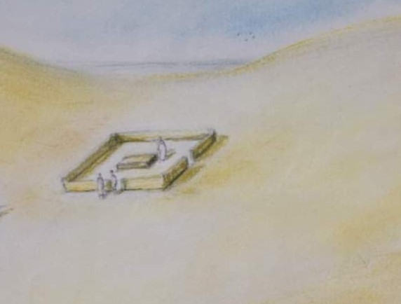

Figure 1. Three-dimensional Figure showing the wall that Imam al-Sadiq, pbuh, surrounded the shrine of Imam Ali, pbuh, in the year 132 AH (749 AD). The researcher’s drawing is according to the description of historical sources.

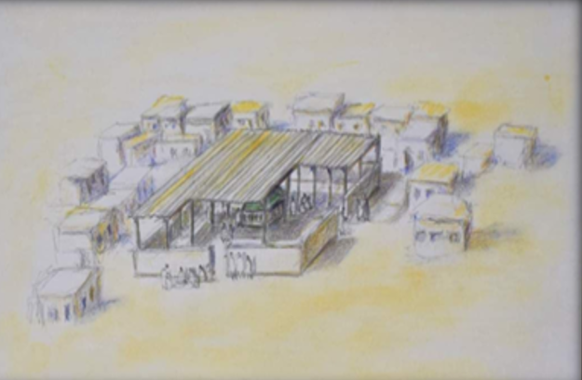

Figure 2. A box was placed by the governor of Kufa, Daoud Al-Abbasi, in the year 273 AH (886 AD) In addition, the external environment began to appear as a mass gathering of some residents.

In the year 273 AH (886 AD) a wooden box was placed on the shrine by the Governor of Kufa, Daoud Al-Abbasi (Figure 2) [4]. Successive governments also paid attention to renewing the architecture of the shrine as a result of being the obsolescence of the building and the inability of the place to accommodate visitors. Thus, the construction of 6 buildings continued. The first one was at the hands of the King of Tabaristan, Sayyid Muhammad al-Saghir (Figure 3) (283 AH/896 AD) [4].

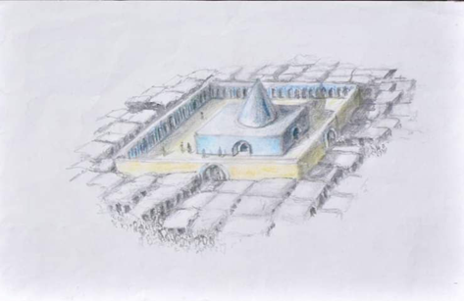

Figure 3. The first building was built by the king of Tabaristan, Muhammad al-Saghir (283 AH/896 AD), consisting of a room surmounted by a conical dome and a courtyard surrounded by a wall containing 70 ions for the comfort of the visitors. We also notice an increase in the population gathering around the shrine building.

The second one was built by Abdullah bin Hamdan Al-Hamdani (Figure 4) (311 AH/923 AD). Zuhur Alqabr Alsharif The third one was constructed by Prince Omar bin Yahya Al-Alawi (Figure 5) (338 AH/949 AD) [5]. As for the fourth building, it was made by Adud al-Dawla al-Buwayhi (Figure 6) (366 AH/976 AD). The fifth building was constructed by Sultan Hassan Al-Jalayri (Figure 7) (755 AH/1345 AD) [6], and the last one was built 410 years ago by Shah Abbas Al-Safavi and his grandson Safi Al-Din; it was designed by Sheikh Al-Baha’i (Figure 8 and Figure 9) (1023 AH/1614 AD) [2][7]. Figure 10 shows that this building remains intact until today. It has been expanded on its Western side through the expansion of the Abu Talib Corridor (2014) with an area of 1271 square meters. After that, the Al-Zahraa courtyard was expanded to an area of 61,000 square meters since 2016 AD [8].

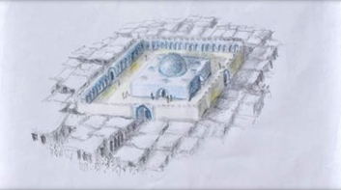

Figure 4. The second building was built by Prince Abdullah bin Hamdan Al Hamdani (311 AH/923 AD). He built a new sanctuary and a great dome here. The development of the urban fabric over time.

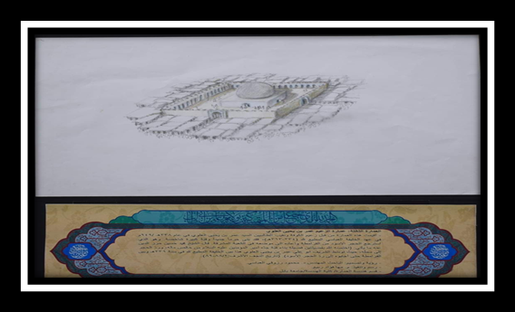

Figure 5. The third building was built by Prince Omar bin Yahya Al-Alawi (3281 AH/949 AD). The development of the urban fabric over time

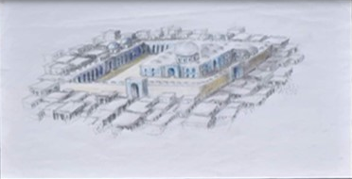

Figure 6. The fourth building was built by Sultan (Adud al-Dawla al-Buwayhi) (366 AH/976 AD)

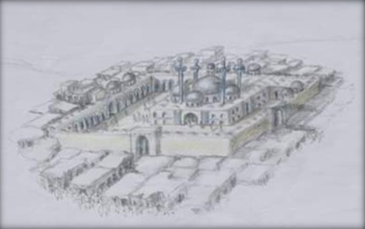

Figure 7. Prince Hassan Al-Jalairi built the fifth building, and it is more luxurious than the previous one (755AH/1345AD) The development of the urban fabric over time.

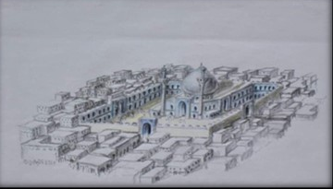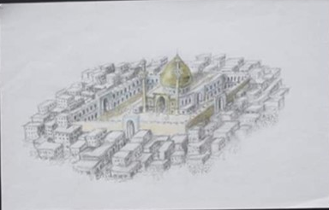

Figure 8. The sixth building is the luxurious building that currently exists. It was built by Shah Abbas Al-Safavi and was completed by his grandson, Shah Safi Al-Safavi, and the architect Sheikh Al-Baha’i in the year 1023 AH (1614 AD).

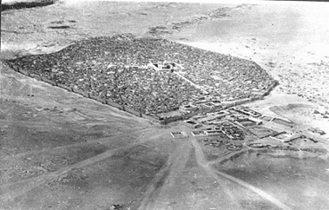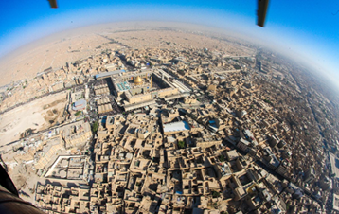

Figure 9. An aerial photo of Najaf in 1918 & 2016 [7].

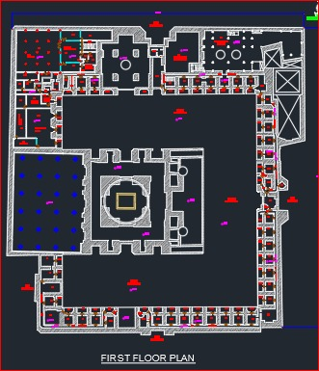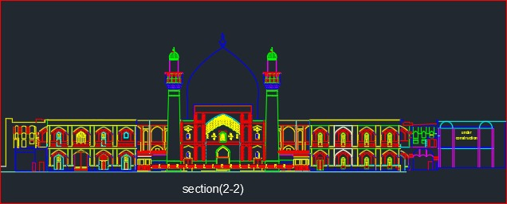

Figure 10. A section of the Holy Imam Ali Dome shows the twelve windows. Research study, Department of Engineering Affairs, in the architecture of the Holy Imam Ali Shrine.

Figure 11 Therefore, the studies that dealt with the history of the architecture of the Holy Shrine, especially the current architecture, did not refer to daylight and the process of utilizing it sustainably in detail. At the same time, the Baha’i designer had this as his purpose in the subject, and aimed to find a relationship, correlated with a sustainable environment, between the daylight situation in the shrine room and in the visitors’.
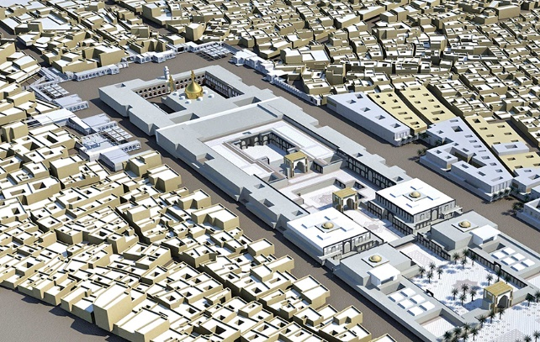

Figure 11. A section of the Holy Imam Ali Dome shows the twelve windows. Research study, Department of Engineering Affairs, in the architecture of the Holy Imam Ali Shrine.

It is found that the optimal use of light during the day and its combination with electric lighting [9], as employed in the library of the Florence Monastery as a pilot project, led to the adaptation and control of lighting using sustainable daylight for such heritage places, by restoring the architectural and historical value sustainably. The sustainability in architectural heritage buildings, along whose paths solar radiation is transmitted, is derived mainly from their spherical, curved, or organic shapes, which in turn enhance models of sustainable heritage buildings [10]. It is instigated that artificial lighting at night in religious heritage buildings and historical sites attracts visitors to observe the beauty of the place and has a spiritual impact, which is why artificial light is important for human activities. Light may disturb the visitor in that environment if it is used unevenly and incorrectly, which negatively affects the spiritual state [11]. Moreover, visits and pilgrimages to holy places may cast doubt on the issue of sustainability if waste, transmission of diseases, and emission of gases are found. Visitors have the desire to visit it during times of distress as well, so a comprehensive review of all the infrastructure of these holy places and the effort of preparing them for an intangible spiritual purpose are required [12].
The addition of a lighting system that was made appropriate for the space of the Jamkaran Mosque in Qom is explained, taking into account the mosque’s plan, height, and internal dimensions based on international lighting systems standards [13]. It is done to reduce artificial energy consumption in the holy places and to improve environmental conditions and sustainability. The process of integrating design and technology to properly build sustainable and efficient buildings, using free energy systems, and using technologies as part of a new and practical attitude called LEED (Leadership in Energy and Environmental Design) pushes designers to consider all available options to make things as sustainable as possible all over the world. There are many classifications, such as the Green Building Councils, the Building Research Foundation Environmental Assessment, the BREEAM Method, and several other methods to help the designer. Finally, environmental sustainability is an imperative necessity in architectural design, which is as follows:
- It is comfortable for the user,
- It uses non-renewable resources,
- It can be less expensive, especially in the long term,
- It is accountable to the society as a whole.
Currently, designers must correct some mistakes by designing sustainable buildings [14].
Sustainable design for the built environment represents the transition of sustainable design from a niche service to a mainstream approach to create healthy and resilient architecture [15]. Accordingly, sustainability has taken a major role in architecture and the construction industry all over the world to achieve infrastructure sustainability, which is one of the critical current global dimensions for measuring the success of the project [16]. In addition, there is a serious effort to understand how issues of culture and sustainability contribute to the sustainability of social quality through architectural projects that benefit the society, especially if the goals of cultural sustainability are adopted, and participation is more effective. The sustainability agenda is capable of achieving social and economic benefits for future generations. This concern was first raised around the developed Western world, drawing on the writings of scholars and others to serve the society [17].

  - LIGHT AS A SUSTAINABLE ELEMENT
There is a relationship between the urban space of the city and the sacred religious places. It reflects the performance of this architectural planning and how this space is used to build a sustainable relationship between the infrastructure of the city as a whole with the space of the holy places and highlight compatibility with natural lighting [18]. It forms the holy places that receive visits, whether major or minor occasions. Among them is a tool for social, cultural, and economic development. In addition to all of that, the most important thing is physical and spiritual renewal [19], Emerald Publishing Limited. The intensity of light is also an important influence in the holy places. Accordingly, standards have been set for the required lighting to improve its environmental sustainability, which will reflect positively on the spiritual aspect of the holy place [20]. The optimal use of light during the day and its combination with electric lighting, as in the library of the Florence Monastery as a pilot project, led to the adaptation and control of lighting using sustainable daylight for such heritage places. It is carried out by restoring the architectural and historical value sustainably [9].
In addition to the sustainability found in heritage architectural buildings, solar radiation travels along its paths, derived mainly from its spherical, curved, or organic shapes, which in turn enhance models of sustainable heritage buildings [10]. Therefore, artificial lighting at night in religious heritage buildings and historical sites attracts visitors to observe the beauty of the place and has a spiritual impact. Therefore, artificial light is important for human activities. Light may cause disturbance to the visitor in that environment if it is used unevenly and incorrectly, which negatively affects the spiritual state [11]. For this reason, we find some religious structures that have applied the level of using the sustainable environment for the well-being of the society members, benefiting from the examples at the local and global levels [12]. As an example of this, the spiritual feeling with the intensity of light in the Nasser al-Mulk Mosque in Shiraz is the evidence of the quality of the interior architecture space of the holy places [21]. The previous research has discussed that light achieves environmental sustainability as well as social and spiritual impacts.

  - THE DOME WINDOWS BENEFIT FROM DAYLIGHT
The natural light entering the building through the windows is related to three factors. Those are the brightness of the sky, the angle associated with the dome, and the ability of the windows to enter the amount of sunlight. This is related to the internal area of the absorbing or reflecting surfaces and their cleanliness compared to the window area. The light value can also be considered from 10 to 50. Sufficient lux with reflective surfaces and increasing window openings lead to dazzle [22].
There are 50 examples of Jewish churches and synagogues that used daylight thoughtfully and aesthetically, far from dazzling [23]. The architects named Mies van Dora and Cropius also emphasized light fire, controlling it, and making sufficient use of daylight entering the building to benefit from it in air conditioning as well [24]. On the other hand, mosques make the most of use of daylight, which is the process of creating light inside the place (and the mosque is the house of light and the light of God) by lighting the walls with reflected light. In this case, mirrors can be utilized since these create a state of peace and enhance spiritual, aesthetic, and symbolic values that mimic heaven [25].

- METHODS
The measurements of the Golden Dome of the shrine of Imam Ali (pbuh) are shown in Figure 12, as mentioned in the guide to the Holy Shrine of Imam Ali (pbuh), 2012. Table 1 shows that the study method was to apply the astronomical laws and investigate the variation of the solar azimuth and zenith angle to figure out the sun rays' directions according to the architectural dimensions toward the holy tomb position to improve the use of sustainable lighting inside the shrine each month.

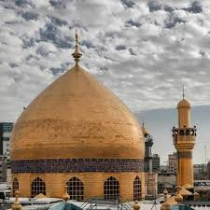

Figure 12. The photographic image of the Imam Ali shrine dome

Table 1. The Golden Dome Measurements.
No. | Subject | Measurement
1 | Height of the dome’s top | 5.60m
2 | Area of the dome from the outside | 51.85m
3 | Number of fences of the dome | 12m
4 | Height of each fence | 4m
5 | Width of the fence | 2.1m
6 | Distance between a golden fence and another | 2.15m
7 | Depth of the golden fence around the tomb | 1.45m
8 | Distance between the shrine and the top of the dome | 23.50m
9 | Distance between the ground to the top of the dome | 30m
10 | The diameter of the dome | 16.60m
11 | Size of the dome | 51,85m
12 | Height of the silver golden shrine | 4m
13 | The Shrine’s Length | 6.35m
14 | The Shrine’s Width | 5.10m

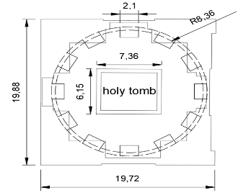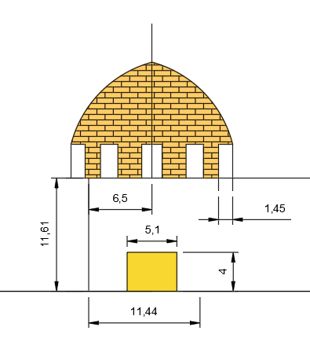
N
A
B

Figure 13. Geometrical dimensions of the study place, A: the plan view and B: the cross-section view.

The analysis part included the application of the astronomical equations [26 – 28]:

$sin δ = 0.39795 ⋅ cos [ 0.98563 ⋅ (N –173 )]$ (1)

$α=\sin^{-1}\left(sin δ sin ∅+cos δ cos ω cos ∅\right)$ (2)

$ω=15 \left(to-12\right)$ (3)

$A= \cos^{-1}\left(\frac{sin δ sin ∅-cos δ cos ω cos ∅}{cos α}\right)$ (4)

Where:
$α$: Angle of sun rays
δ: Sun declination angle
N= Number of days from the first day of January
$∅$: Latitude of a specified location
$ω$: Hour angle
To = Number of hours after midnight
A= Azimuth angle

- RESULT AND DISCUSSION
Table 2 and Figure 13 explain the time, azimuth angle, and zenith angle that were calculated, from which the entry of sunlight is measured during daylight hours, as sunlight passes through the windows located between the east and west sides at the vernal equinox that falls on (3/20, 21, 22) and the summer solstice (20.21.22.6). Meanwhile, the autumnal equinox (20.21.22/9) and the winter solstice (20.21.21.212) are related to how the sun’s rays have crossed an amount of 1.45 m, the thickness of the top of the dome (the depth of the window), until it enters the shrine room. Table 2 shows the Azimuth Angles and Zenith Angles of the Golden Dome.

Table 2. Azimuth angles and zenith angles of the golden dome.
Time (hour) | (3/20,21,22) |  | (20.21.22.6) |  | (20.21.22/9) |  | (20.21.21.212)
Time (hour) | Azimuth Angle | Zenith Angle | Azimuth Angle | Zenith Angle | Azimuth Angle | Zenith Angle | Azimuth Angle | Zenith Angle
7.00 | 99 | 78 | 77 | 66 | 98 | 77 | 118 | 91
8.00 | 108 | 65 | 83 | 53 | 107 | 65 | 126 | 80
9.00 | 119 | 54 | 91 | 40 | 118 | 53 | 136 | 70
10.00 | 133 | 43 | 100 | 28 | 133 | 43 | 149 | 62
11.00 | 154 | 36 | 119 | 16 | 153 | 35 | 164 | 57
12.00 | 182 | 33 | 186 | 9 | 182 | 32 | 181 | 55
13.00 | 206 | 36 | 241 | 16 | 207 | 35 | 196 | 57
14.00 | 227 | 43 | 260 | 28 | 227 | 43 | 211 | 62
15.00 | 241 | 54 | 269 | 40 | 242 | 53 | 224 | 70
16.00 | 252 | 65 | 277 | 53 | 253 | 65 | 234 | 80
17.00 | 261 | 78 | 283 | 66 | 262 | 77 | 242 | 91

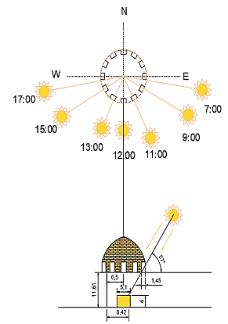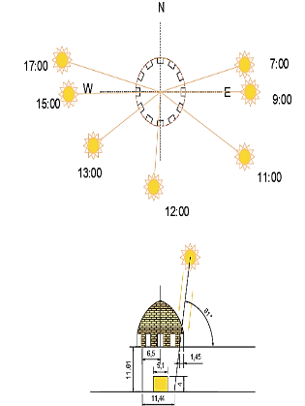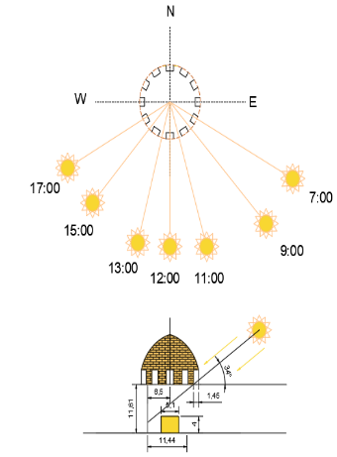
(a) (b) (c)

Figure 13. Solar angles at the days (a) 20-21-22/ March and September, (b) 20-21-22/June, and (c) 20-21-22/December.

Figure 14 shows the magnitudes of the sun's zenith angle as the sun reaches its maximum position on the 21st of each month.
The vertical movement of the sun around the holy place and the zenith angles are shown in Figure 14. The sun rays were found uniformly covering the holy tomb based on the geometrical properties and the elevation of the dome windows. These results revealed the sustainable mixing with architectural sense in the building to get more benefit from the sun’s rays inside the holy room throughout the year.

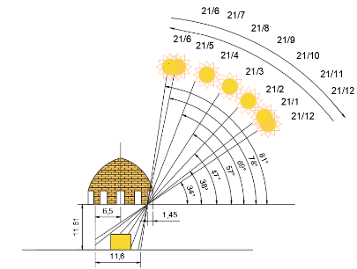

Figure 14. Variation of the maximum angle of solar radiation inside the golden dome with time

Therefore, there is a contemporary, sustainable relationship in religious architecture in general and in particular in the architecture of the shrine of Imam Ali (pbuh). Through its applications, as previous studies mentioned and showed, the tool for planning and designing cities reflects a sustainable relationship to illuminate the religious space. It also leads to spiritual development, with reference to its placement and use. It is ideal for international standards in the case of combining natural and artificial lighting. The architectural forms in heritage buildings must be preserved, and the use of night lighting attracts visitors and improves their well-being. Moreover, the photos revealed this phenomenon in the shrine room, as shown in Figure 15, taken from inside the room of the shrine of Imam Ali, pbuh, clearly shows the fall of the sun’s rays during daylight hours every day. It constitutes a sustainable environmental condition that affects the social and spiritual state of the visitors.

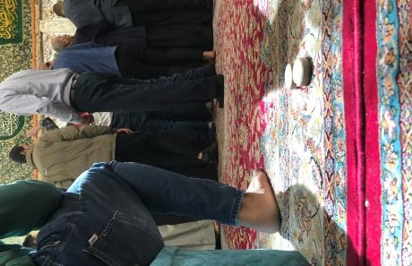 | 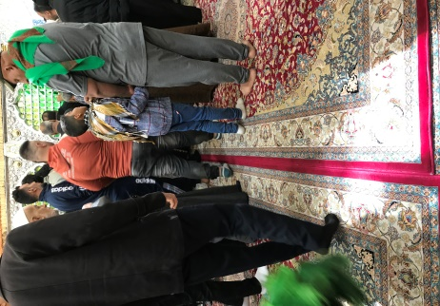 | 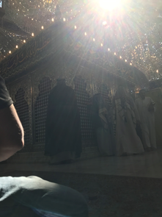 | 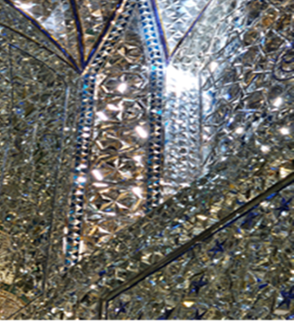
(a) | (b) | (c) | (d)
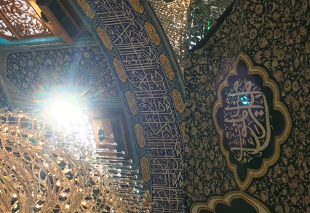 | 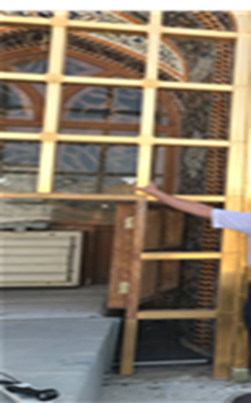 | 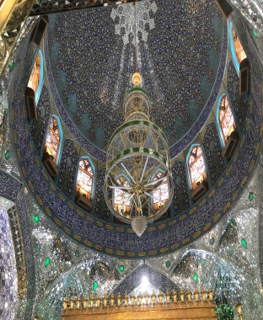 | 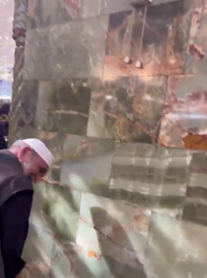
(e) | (f) | (g) | (h)

Figure 15. The environmental sustainability of daily daylight in the shrine room of Imam Ali, peace be upon him

Moreover, the sun shining into the place causes its purification, in addition to the presence of mirrors. The reflector doubles the intensity of light and reduces electrical energy consumption, except on some winter days when the place needs to use some electrical energy. As a comparison with previous research, a number of authors had built their scientific outline about daylight analysis. The identification of the behavior of light that comes through the dome openings to be important sustainable feature in mosques was studied. The analysis of daylight intensity was examined by involving ten mosques in eastern Saudi Arabia, and the author found that the elevation and dimensions of the side openings in the domes play an important role in the distribution of sunlight inside the dome zone [29].
The sufficient sunlight in summer solstice time that penetrates the high openings in the domes of two mosques was investigated, the Ferhadija mosque in Bosnia-Herzegovina and Orhan Gazi mosque in Turkey. The study also showed the architecture of the openings in the domes as the main reasons for the distribution of the light rays toward the indoor areas [30].
The daylight intensity was studied in colonial mosques in Malaysia. The authors examined the daily sun pathway and its impact on the sunlight quantity that can penetrate to the indoor area in the mosques. The authors showed the windows/walls ratio and dome-level windows as important factors for the architectural purpose of achieving sufficient sunlight inside the indoor spaces [31].
The solar angles were studied to examine the behavior of sunlight that comes through the dome windows of the San Lorenzo building in Italy. The study identified the zenith angles of the sun toward the dome. The authors showed images of the light behavior on the inside parts of the building as brightness and darkness zones with respect to the 8 openings along the dome. They explained that these openings had a direct effect on the light behavior in these zones [32].
The current study calculated zenith and azimuth angles for the place of the holy tomb of Imam Ali (Pbuh) according to the openings in the dome and how the vectors of the sun rays can reach the parts of the indoor building. The study showed how the elevation and the dimensions of the windows along the dome were chosen to give the most available daylight from the time when the sun had the lowest zenith angle in December to its highest zenith angle in June. The rays from the subject of the windows opening that faces the plane of the sun lay on the points before the tomb in the space underground the dome in Winter solstice (21-22) December. Further, these move toward the tomb and pass it to its side in March before moves more to about 11.4 meters from the wall facing the sun on June 21-22, afterward moves backward. The results explained the sustainability of brightness inside the hall below the dome along the year at which the artificial lighting can be reduced from Winter Solstice to Summer Solstice. These results showed the point of architecture to set the holy building with better daylight throughout the year.

- CONCLUSION
The results show that the group of twelve golden dome windows has a symbolic value, according to what was mentioned on the one hand, and a luminous value. The zenith angles varied from 34º in December to 81º in June. The pathway of the sun rays from the windows declared architectural creativity and sustainability, as these rays move along the year to reach a floor distance from the wall that is the same height as the tomb room (11.6 m) and cover all the tomb positions. According to the results, all of these lead to lighting and illuminating the shrine room sustainably, environmentally, practically, and symbolically in a way that is commensurate with the architectural mass of the shrine’s architecture and its traditional urban fabric. Al-Baha’i architect (1614 AD/1023 AH) could design the shrine’s architecture, which is approximately 410 years old until 2024, to convey the idea of sustainability, exploiting and linking it from the religious, doctrinal and symbolic aspects in a manner that is consistent with its social and cultural function. Hence, this architecture is designed in an elaborate way that mimics this symbolic and doctrinal relationship between Imam Ali and the sun.
On the other hand, it mimics the interaction of visitors in the place that was designed to suit the spiritual feelings of visitors in the place, the sacred connection between them, and the symbolism of the personality of Imam Ali (pbuh) which represents his closeness to the Prophet Muhammad (Peace Be Upon Him and His Household) and his relationship of faith with Almighty Allah. There were actual, sustainable environmental needs, religious and doctrinal needs linked at the level of the individual and Muslim society in particular, and a traditional cultural needs at the level of humanity. Therefore, the architecture of the shrine of Imam Ali (Pbuh) is historical archaeological architecture with a sustainable environment and High symbolism in all its aspects intended by those who knew the value of symbolism and humanity historically. Thus, he bestowed his holiness on the place in which he was revealed and, on the city, and its fabric. Indeed, with his presence, the Barren, sandy desert place became a populous city and one of the reasons for its emergence and construction socially, religiously, culturally, economically, and an attraction for tourism and visits.
.
RECOMMENDATIONS
The present study concluded that the Imam Ali shrine room constitutes a sustainable environmental light phenomenon, which was proven theoretically and practically through astronomical laws and charts, in addition to taking pictures that confirm this. Moreover, the present study recommends studying the environmental sustainability of the architecture of the shrine of Imam Ali from human and ideological perspective. The correlation of this to the visitors and studying the environmental sustainability of the architecture of the Imam Ali Shrine in terms of ventilation and sustainable cooling. The development of virtual simulation programs can be an upcoming idea for students of architectural engineering departments to increase awareness of design knowledge and astronomical engineering creativity. Creating an attractive atmosphere on the days of the solstices and equinoxes inside the shrine room and informing visitors and delegations of this astronomical phenomenon can be some of the expected results. It can also be noted that great attention was paid to removing the ventilation and cooling ducts, which created an obstacle to the full entry of sunlight. Raising all the decorations in the dome’s windows allows sunlight to enter the shrine room smoothly and illuminate the place naturally and sustainably.

REFERENCES

[1] J. Al Mahbouba, The Investigator, the past and present of Najaf. Beirut, Lebanon: Dar Al-Athwaa, 1986.
[2] S. M. Al-Fartousi, Marqed Wa Thaieh of Imām 'Alī. Najaf: Imam Ali Shrine, 2010.
[3] M. R. H. Janjun, “The role of astronomical phenomena in shaping the architecture of the Imam Ali Holy Shrine. (The dome and minarets as a model),” AIP conference proceedings, vol. 2806, pp. 020005, Jan. 2023, doi: https://doi.org/10.1063/5.0163388.
[4] G. Taawos, Farhat Algharii. Najaf: AlHaideryia, 2015.
[5] K. A. AlDeemiri, Hayat Al-hayawan Al-kubra. Beirut, Lebanon: Dar Almarifa, 2013.
[6] H. I. A. Shrine, "The Appearance of the Holy Grave", 2020. Accessed: November 1, 2023. [Online]. Available: https://www.imamali.net/?id=4362
[7] I. A. Media Network, "Areial Photo", 2022 Accessed: November 1, 2023. [Online]. Available: https://media.imamali.net/?id=1377&sid=349.
[8] I. A. Media Network, "Fatima Al-Zahra Shrine Project", 2020, Accessed: November 1, 2023. [Online]. Available: https://www.imamali.net/?id=2214
[9] C. Balocco, M. Cecchi, and G. Volante, “Natural Lighting for Sustainability of Cultural Heritage Refurbishment,” Sustainability, vol. 11, no. 18, p. 4842, Sep. 2019, doi: https://doi.org/10.3390/su11184842.
[10] F. S. Andujar, I. Rodriguez-Cunill, and J. M. Cabeza-Lainez, “The Problem of Lighting in Underground Domes, Vaults, and Tunnel-Like Structures of Antiquity; An Application to the Sustainability of Prominent Asian Heritage (India, Korea, China),” Sustainability, vol. 11, no. 20, p. 5865, Oct. 2019, doi: https://doi.org/10.3390/su11205865.
[11] D. Bista et al., “Lighting for Cultural and Heritage Site: An Innovative Approach for Lighting in the Distinct Pagoda-Style Architecture of Nepal,” Sustainability, vol. 13, no. 5, p. 2720, Mar. 2021, doi: https://doi.org/10.3390/su13052720.
[12] F. Zagonari, “Comparing Religious Environmental Ethics to Support Efforts to Achieve Local and Global Sustainability: Empirical Insights Based on a Theoretical Framework,” Sustainability, vol. 12, no. 7, p. 2590, Mar. 2020, doi: https://doi.org/10.3390/su12072590.
[13] R. Abdollahi, “Design of lighting system for sacred places with the approach of improving technical and economic conditions,” Ain Shams Engineering Journal, vol. 12, no. 3, 2021, doi: https://doi.org/10.1016/j.asej.2021.02.021.
[14] M. M. Rashid, G. M. Chowdhury, and T. Sultana, “Comparative Study Between Energy Performances of Non-Renewable and Renewable Source Based Grid-Tied HVAC Systems in Subtropical Climates,” Journal of engineering for sustainable buildings and cities, vol. 3, no. 3, Aug. 2022, doi: https://doi.org/10.1115/1.4055639.
[15] R. Fleming and S. H. Roberts, Sustainable design for the built environment. New York: Routledge, 2019.
[16] B. Xue, B. Liu, and T. Sun, “What Matters in Achieving Infrastructure Sustainability through Project Management Practices: A Preliminary Study of Critical Factors,” Sustainability, vol. 10, no. 12, p. 4421, Nov. 2018, doi: https://doi.org/10.3390/su10124421.
[17] C. Go-Sam and C. Keys, “Mobilising Indigenous Agency Through Cultural Sustainability in Architecture: Are We There Yet?,” The Handbook of Contemporary Indigenous Architecture, pp. 347–380, 2018, doi: https://doi.org/10.1007/978-981-10-6904-8_14.
[18] J. Gil-Mastalerczyk, “Unconscious aspects of sustainability in modern and postmodern religious architecture in Poland,” E3S Web of Conferences, vol. 10, p. 00107, 2016, doi: https://doi.org/10.1051/e3sconf/20161000107.
[19] A. Cugini, “Religious tourism and Sustainability: From Devotion to Spiritual Experience*,” Tourism in the Mediterranean Sea, pp. 55–73, Mar. 2021, doi: https://doi.org/10.1108/978-1-80043-900-920211006.
[20] P. Matracchi and A. S. habibabad, “Prioritizing the effect of ‘Light’ in the religious places and environments with an emphasis on the sense of spirituality,” Ain Shams Engineering Journal, vol. 13, no. 1, Jun. 2021, doi: https://doi.org/10.1016/j.asej.2021.05.028.
[21] K. A. Shinde and D. H. Olsen, “Reframing the Intersections of Pilgrimage, Religious Tourism, and Sustainability,” Sustainability, vol. 15, no. 1, p. 461, Dec. 2022, doi: https://doi.org/10.3390/su15010461.
[22] M. Fontoynont, Daylight performance of buildings. New York: Routledge, 2014.
[23] M. J. Crosbie and A. Hasnovic, Houses of God : religious architecture for a new millennium. Mulgrave, Victoria: Images Publishing, 2006.
[24] O. Verkaaik, Religious architecture: anthropological perspectives. Amsterdam, Netherlands: Amsterdam University Press, 2013.
[25] C. A. Brebbia and A. M. Boquera, Islamic heritage architecture. United States: WIT Press, 2016.
[26] Pavel Navitski et al., “Utilization of Solar Energy for Water Desalination and Purification Using Solar Concentrator,” E3S Web of Conferences, vol. 434, pp. 01043–01043, Jan. 2023, doi: https://doi.org/10.1051/e3sconf/202343401043.
[27] I. Ourraoui and A. Ahaitouf, “Investigation of the feasibility and potential use of sun tracking solutions for concentrated photovoltaic Case study Fez Morocco,” Energy Reports, vol. 8, pp. 1412–1425, Nov. 2022, doi: https://doi.org/10.1016/j.egyr.2022.08.071.
[28] M. T. Hussein and S.N. Albarqouni, “Enhanced Model of One Axis-Two Positions Manual Tracking Photovoltaic Panels for Lighting Projects in Palestine,” IASTED Technology Conferences, Jan. 2010, doi: https://doi.org/10.2316/p.2010.700-013.
[29] E. K. Aljofi, “The Potentiality of Domes on Provision of Daylight in Mosques,” International Journal of Applied Engineering Research, vol. 13, no. 7, pp. 5103–5112, 2018
[30] A. S. Hassan and Y. Arab, “Lighting Analysis of Single Pendentive Dome Mosque Design in Sarajevo and Istanbul during Summer Solstice,” Arab World Geographer, vol. 15, no. 2, pp. 163–179, Jun. 2012, doi: https://doi.org/10.5555/arwg.15.2.m0g8207v8222723x.
[31] A. N. Z. Sanusi, A. F. A. Jamil, F. Abdullah, and R. Othman, “Effective Daylight Design Strategies of Colonial Mosques in Malaysia,” Asian Journal of Environment-Behaviour Studies, vol. 6, no. 18, pp. 27–45, May 2021, doi: https://doi.org/10.21834/ajebs.v6i18.381.
[32] S. Panahiazar and M. Matkan, “Qualitative and quantitative analysis of natural light in the dome of San Lorenzo, Turin,” Frontiers of Architectural Research, vol. 7, no. 1, pp. 25–36, Mar. 2018, doi: https://doi.org/10.1016/j.foar.2017.11.005

