 |  | JOURNAL OF ISLAMIC ARCHITECTURE  P-ISSN: 2086-2636 E-ISSN: 2356-4644  Journal Home Page: http://ejournal.uin-malang.ac.id/index.php/JIA
ISLAMIC CONTEMPORARY ARCHITECTURE AS AN APPROACH FOR SOCIAL SUSTAINABILITY IN THE URBAN PARKS DEVELOPMENT
Eman S. Abowardah^{a*}, Mustafa G. Ramadan^{b}
ªPrince Sultan University, Riyadh, Saudi Arabia
^{b}Dar Al Uloom University, Riyadh, Saudi Arabia
*Corresponding Author: esabry@psu.edu.sa
ARTICLE INFO |  |  | ABSTRACT
Volume: 8  Issue: 2  Page: 469-486  Received: December 9th, 2023  Accepted: February 22nd, 2024  Available Online: December 1st, 2024  DOI: 10.18860/jia.v8i2.24663 |  |  | Reviving Islamic urban heritage while enhancing contemporary identity is an important goal in all Islamic countries. Historical places can be an important part of society instead of being a burden, and they can be redeemed as cultural assets that can be used for their original function. Accordingly, this study focuses on the Al-Azhar Park project, considered one of the pioneering sustainable urban development projects recently opened in Cairo, Egypt. It is a promising restoration attempt to establish public parks by improving the cultural, social, and economic aspects of the adjacent Islamic historical area. Hence, this study aims to highlight a potential approach for designing sustainable parks by documenting one of the leading Islamic contemporary urban development projects. The study follows a descriptive and analytical research method by analyzing the integrity between architectural features in Al-Azhar Islamic Park and the historic Islamic urban around it. The aim is to show how landscape design can be used as a tool to enhance behavioral responses and activities. The results show that the bottom-up development method is the most effective strategy that prioritizes the local community's needs while restoring the Islamic historical sites and creating new functions suitable to generate the necessary income for the buildings and respond to the local community needs.  Keywords:  Sustainable Park; Cultural Assets; Social Sustainability; Community Involvement; Environmental Considerations

- INTRODUCTION
The various urban rehabilitation and development projects for the Islamic historical sites should stem from the needs and priorities of the local community and be compatible with the surrounding environmental characteristics, whether social, climatic, or economic, within the framework of reconciliation and intellectual connection between heritage and modernity. In Egypt in the last decade of the twentieth century, the focus of the rehabilitation and restoration projects was to link heritage and contemporaneity to produce projects that are compatible with the surrounding environment and make successful initiatives to reformulate the local conditions and requirements of each region within the framework of globalization theses. Al-Azhar Park project is considered one of the pioneering sustainable Islamic urban revival and development projects recently opened in Cairo. It is a serious attempt to renew and move away from stereotypes in establishing public parks by improving the cultural, social, and economic aspects of the adjacent Islamic historical area to improve living conditions there [1]. Thus, achieving social sustainability in the urban rehabilitation and restoration projects in the Islamic heritage sites is important for achieving the universal sustainable development goals and the Egypt 2030 vision. Considering and achieving social sustainability in architecture involves a collaborative effort between the community, architects, and builders [2].
Engaging with the community and getting their input, ideas, and concerns is essential to creating a thriving, sustainable community [3]. Architects and builders should work closely with the local community to design and build structures that contribute to the long-term well-being of people and reflect the architectural Islamic cultural aspect in the area. Thus, good outdoor design ensures good social relations and a sense of belonging to the place and enhances the sense of place attachment [4]. Hence, this study aims to highlight a potential approach for designing sustainable Islamic parks by documenting one of the leading Islamic contemporary urban development projects in the Islamic historical context in the heart of the Fatimid Cairo, Egypt, which is the Al-Azhar Park Project, by following a descriptive research method through field observations and analytical research method. Therefore, a set of design principles was developed to provide insights into the community's cultural values, the influence of Islamic architectural heritage in Cairo's urban development, and their role in shaping the identity of a continuously changing society.
The study analyzes the integrity between architectural features in Al-Azhar Islamic Park in Cairo, Egypt, and the historic Islamic urban around it. It shows how the landscape design can enhance behavioral responses and activities by creating a cultural heritage park. The study follows an evaluative methodology to emphasize the social sustainability aspects of designing Al-Azhar Islamic Park as a leading contemporary urban development project in Egypt and a successful example of a historic urban park. This research paper aims to monitor and document Al-Azhar Islamic Park by following a logical approach divided into three main parts; the first part presents the design considerations that must be considered in communal park projects to be compatible with the local community's needs. The second part presents the analysis of the Al-Azhar Park project to identify the design considerations that were taken into account in the park to be compatible with the needs of the community, in addition to identifying methods for intellectually linking heritage and contemporaneity through the various architectural treatments in the park to achieve social sustainability. The third part of the research paper comes up with good practices, lessons learned, and recommendations that help find different methods of intellectual communication between heritage and contemporaneity to draw a better futuristic picture of architecture and urbanism compatible with the surrounding environment. Leading architectural thought continues and contributes to the development of Egyptian society and social sustainability as a pillar for sustainable development in the transformation decades.

  - SOCIAL SUSTAINABILITY IN ISLAMIC ARCHITECTURE
Since God has maintained the universe's balance since the beginning of creation, the concepts of sustainable development have been present in the Holy Qur'an and Hadith for ages; hence, the idea is not new to Muslims. This demonstrates how the idea of sustainable development was ingrained in Islamic thought in the seventh century. Still, it was not until the twentieth century that it was applied to a contemporary setting. The UN General Assembly defined sustainable reuse according to the World Heritage concept, which considers several cultural, economic, social, ecological, and environmental factors [5]. The Arab Islamic countries want to fortify their national identity values and augment local investments in tourism offerings by conserving their natural environment and historical legacy [5].
Social sustainability in architecture has become one of the most important considerations as it merges the physical realm, cultural considerations, and social considerations in design to support the well-being of society through enhancing cultural life and encouraging the engagement of people and space [3]. Social sustainability can be incorporated into contemporary architectural design using green spaces (gardens and parks). These spaces promote physical and mental well-being. Another way architects can promote social sustainability is by designing buildings that are accessible to all people regardless of their physical limitations [6]. Sir Peter Hall [7] clarified that social sustainability refers to social interaction, security, access to services and opportunities, and participation in collective civic activities. According to the concept of social sustainability, development should satisfy everyone's basic needs and offer every group in a society equal opportunity to meet the standards necessary to achieve a higher standard of living while keeping the specific socio-cultural traditions [8]. In fact, it states unequivocally that "culture" and "full integration of culture into sustainable development policies" are essential components of any growth that can be deemed sustainable. Environmental considerations should be considered while designing buildings, and local identity should be incorporated into the architectural process [9]. By integrating modern urbanism with local and cultural elements, it can be integrated within the Islamic framework. Architects must develop methods that fit a given area's specific environment and economics. Re-examining a society's cultural manifestation is crucial for this reason. A language that is acceptable and relevant for the setting of a particular culture should be used in architecture founded on suitable technology [8].

- 1. Community Involvement
One of the primary problems of this century is to build cities and communities that are sustainable in the long run and function well socially, economically, and environmentally. Governments, planners, architects, and developers can collaborate to accomplish this, as is already well established [7]. To achieve this, the case for social sustainability in developing and funding new settlements must be strengthened by a cogent body of facts and real-world experience, as well as by creative partners ready to test novel ideas. It is impossible to overlook the potential for sustainable development that results from adapting modern urbanism to local situations by applying Islamic urban concepts. Engaging with the community is an essential goal to achieve social sustainability. Architects should collaborate with the local community to contribute to the long-term well-being of people in the area. Involving the community in the design's ideas and concerns is important as a collaborative effort between the community and architects [10]. Social sustainability can enhance communal wellness in addition to physical wellness. Incorporating communal spaces and social areas like parks, cafes, plazas, libraries, and public squares encourages socializing and promotes social interaction between users. This promotes the growth of robust communities, which is necessary for general well-being.

- 2. INCLUSIVITY IN DESIGN
Inclusivity in design means promoting social interaction through enhancing well-being and encouraging physical activities in public spaces and parks by making them accessible to all people, regardless of their abilities, which leads to a more resilient, healthy, and livable community. Further, social inclusion is related to the support and encouragement of social interaction and networks, which can create a fair, just, and resilient society. The benefits of high-quality parks and green spaces are not just aesthetic; they are economic, social, and environmental, with complex interrelations between these issues

  - SOCIAL SUSTAINABILITY IN URBAN PARK DESIGN
The links between social sustainability and urban forms are frequently drawn when discussing how physical features affect social components [3]. Hence, social relationships and activities within a community impact the degree of social sustainability and the built environment [11]. Similarly, Korolova and Treija [12] emphasize that in a European setting, the goals of urban parks are more concerned with societal issues, health, education, and urban regeneration than with the actual plants and vegetables that can be harvested. According to Glennie [13], urban parks are crucial for neighborhoods because they promote user interactions and enhance place attachment. Additional research has revealed that parks and gardens can serve as learning centers, allowing users to advance their knowledge and abilities in gardening, sustainability, and the environment [14]. Social sustainability for the urban parks can be achieved through complying with the local community's needs.

  - PARKS DESIGN CONSIDERATIONS TO ACHIEVE SOCIAL SUSTAINABILITY
A successful communal urban space is a space that allows successful social relations to be established while successfully meeting the needs of users and complying with local community needs. One of the most important basic goals of public park design is to enjoy the environment and its natural components. Therefore, park design must be compatible with the existing environmental system and not fundamentally change it to ensure a balance between the new and the existing. The public park should meet the needs of the residents of the surrounding area by performing a set of functions [15]:
• Environmental function: help the area eliminate pollution and upgrade the environment through green and water elements.
• Social function: to provide the possibility of contact with the surrounding society and the integration of its various classes.
• Psychological function: as outer space generates many different feelings in the human psyche, these feelings must be considered and provided for what develops them in space through the presence of different and varied elements in the garden.
• Economic function: the availability of various commercial and professional services to serve the park.
The architectural identity and appearance should reflect the local context and surrounding environment [16]. It can be said that to design a successful park linked to the surrounding local environment, a group of design considerations must be considered for the park to meet the community's needs in the surrounding local environment. These considerations must be integrated so that this does not negatively affect the design process. These considerations are divided into four parts: site, environmental, functional, Aesthetic, sensory, and visual considerations

- . METHODS
The study follows a descriptive and analytical research method by focusing on analyzing the integrity between architectural features in Al-Azhar Islamic Park and the historic Islamic urban around it. The aim is to show how landscape design can be used as a tool to enhance behavioral responses and activities. The chosen case study is analyzed qualitatively as part of the study approach. As a first step, the literature review identified four criteria that best describe the successful park design that is linked to the surrounding local environment. In particular, the approach is structured according to three phases: (i) definition of the four criteria, (ii) the case study analysis, and (iii) the results and discussion in context.

- RESULT AND DISCUSSION

- DEFINITION OF THE FOUR CRITERIA
It can be said that in order to design a successful park linked to the surrounding local environment, a group of design criteria must be taken into account in order for the park to meet the needs of the community in the surrounding local environment, and it is necessary that these criteria be integrated with each other so that this does not negatively affect the design process, and these criteria are divided into four parts: site considerations - environmental considerations - functional considerations - Aesthetic, sensory, and visual considerations. Each criterion was, in turn, divided into sub-criteria to better define its characteristics in detail.

- 1. Site Considerations
It is necessary to identify the natural or built characteristics of the site and study its suitability for the various needs. It is necessary to study the natural contour lines, the shape of the land, the general conditions of the site, and the surrounding environment, as the nature of the site may impose on the designer some determinants that must be taken into account [17]. It is noticeable that the shape of the land is one of the most important visual elements. When the architectural project is in a well-studied relationship with the shape of the land, an integration can be reached between the site and the design approach to produce an integrated project that is harmonious with the site and compatible with its formal characteristics. The form-making must have a balance reflecting universal design that merges the global architectural approach and territorial identity [15].

- 2. Environmental Considerations
One of the most important goals to be achieved in public park projects is to create a suitable environment for the users' needs to increase their belonging to the place and their attachment to it, as the feeling of climatic and environmental comfort is considered one of the most important factors that attract people to the public garden and make them merge with it and its spaces. Environmental considerations can be divided into three parts:
  - Natural environmental considerations, represented in (temperature, humidity, wind intensity, the degree of solar radiation, and the amount of lighting), must be taken into account how to deal with the climate for the benefit of the design process by modifying the effects of the climate to improve any undesirable conditions, and this can be achieved by choosing the optimal orientation for the project in relation to the surrounding climatic conditions, as well as choosing the appropriate formation of the voids, their construction materials, and their colors [18].
  - Urban environmental considerations: They are limited to two factors, namely noise and air pollution, as the shape of the land, the vegetation, and the water element are three elements that may affect the perception of noise and reduce it. Exploiting the site's topography, such as slopes, elevations, or depressions, are natural barriers to noise control [18].
  - Green Infrastructure: By constructing resilient, healthy, and habitable urban areas, green infrastructure integration in architecture supports social sustainability. Green infrastructure uses permeable surfaces, plants, and water management techniques. The heat island effect is lessened, rainwater is absorbed, stormwater runoff is decreased, and biodiversity is encouraged by these factors. An interconnected network of green infrastructure can benefit a community in many ways, including better health and wellness, fewer floods, and the development of new wildlife habitats [18].

- 3. Functional Considerations
Each space must have a specific shape and size, which makes it suitable for its function [17]. At the beginning of the design process, it is necessary to determine the set of activities and functions that will be practiced in the public park, as they affect the determination of the shape and size of the spaces and the methods of their formative treatments, as well as the width of the corridors. Among the most important elements that affect the function expression of the spaces within the park are the following:
1 - Botanical elements: The method of distributing trees, flowerbeds, and green spaces determines the function of each part of the garden. For example, a group of trees that are stacked in rows helps confirm entrances and define movement paths [4]. As for flowerbeds, they help define spaces and differences in floor levels.
2 - Water elements: when used in the garden, the variety resulting from the reflections of the sky and the surrounding buildings makes the space pulsate with movement, and functionally, it is used to achieve enclosure or separation and honestly express a group of feelings that the designer wants to show in the space [18]. Furthermore, the presence of water surfaces and their aesthetic value contribute significantly to controlling the surrounding area's temperature, assisting in creating a small climate region within and outside the structure [19]. For example, water fountains give a sense of vitality, and movement is visible.
3 - Complementary elements: They are among the important elements that are indispensable in the coordination of the site and play a specific functional role in addition to their aesthetic considerations, the most important of which are lighting poles - seats - guiding panels - sculptures, and the shape and type of each of them is chosen according to its function and its place in the garden and its relationship With buildings, floors, and the shape of the void.
4 - Paving: The shape and type of paving have a strong influence on the reflection of the function of the space, as it affects directing the movement in certain important directions, and its aim may be to achieve the required link between the different parts of the space [20].

- 4. Aesthetic, Sensory, And Visual Considerations
One of the most important goals that must be achieved in public garden projects is to reach a set of aesthetic and sensory values that result from the successful formative relationships between lines, colors, materials, and sizes that make up the architectural space. Among the most important aesthetic considerations that must be taken into account in the design of public parks are the following:
- Aesthetic values: It is a set of formal and aesthetic principles and values through which design elements can be arranged within the framework of the design output to reach a set of aesthetic relationships that directly affect the viewer's perception of spaces when dealing with the built environment. The most important values are unity and diversity, proportion, scale, rhythm, balance, enclosure, harmony, and contrast [21].
- Perceptual formative effects: It is a set of visual characteristics of the architectural form of space, distinguishing it from the rest of the forms and affecting how it is perceived and identified. These characteristics are summarized in the geometric shape, size, color, texture, position, orientation, and a group of spatial relationships represented in (surrounding, gradient, overlapping, and juxtaposition) [22].

- THE CASE STUDY ANALYSIS: AL AZHAR PARK IN CAIRO
Urban Parks are considered social interaction centers that enhance various activities, and accordingly, urban parks play an effective role in achieving social sustainability [23]. The distribution of landscape elements constitutes clear indicators of their users' cultural, economic, and social levels [23]. Al-Azhar Park project (Figure 1) is considered one of Egypt's pioneering contemporary urban development projects. One of its most important objectives was to work on increasing and improving the rare green surface in the city of Cairo by converting the waste burial complex in the study area in the heart of Historic Cairo into a public park to serve as an incentive for Development [24]. The main goal was to reconnect ancient heritage in its creative forms with the rapidly changing opportunities and demands of modern life to improve the life quality for local communities by investing in their cultural heritage. With its stunning views of Fatimid, Mamluk, and Ottoman-era monuments, Al-Azhar Park has emerged as Cairo's green hub. Egyptian tourists and foreign visitors are drawn to the park's lakes and fountains. Al-Azhar Park is considered one of Egypt's most significant social and environmental initiatives during the past three decades since the establishment of this park in 2005 [4]. Despite the spread of poverty in the adjacent neighborhood of Al-Darb Al-Ahmar, it is one of the richest regions in the world with Islamic architecture heritage. Hence, the park project was intended to be a case study of the development challenges in its various forms, which range from reviving the environment to restoring the surrounding cultural monuments.

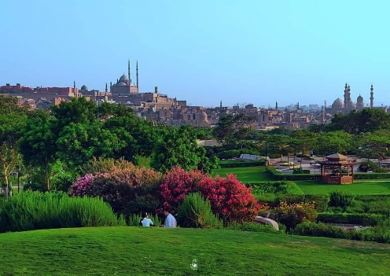  - The skyline of historic Cairo from the park | 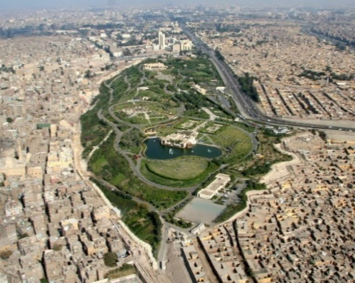  (b) The location of the park in the heart of Cairo
Figure 1. Al Azhar Park is in the heart of Historic Cairo [25].

- 1. The Project Beginning and the Participating Parties
The construction phase for the project began in 1997 AD, and it was opened on an area of 30 hectares (74 acres) on March 25, 2005 AD. The project was an active participation of the Aga Khan Foundation and several international, national, and local bodies, such as the Egyptian-Swiss Development Fund, the International Antiquities Fund, the French Institute of Antiquities, and the Social Fund for Development [1].
Al-Azhar Park is an impetus for cultural and economic development, and its effects extend to include improving the quality of life for 200,000 people from the neighboring Al-Darb Al-Ahmar area [2]. Whereas, after the establishment of Al-Azhar Park, it replaced the study site, which served as the backyard of the Al-Darb Al-Ahmar neighborhood (which was used over the centuries as a dump for rubble and marginal stones) and turned into a front yard for the historic city. Although the project began as a project to design and build an urban public park, it included additional elements of the project such as the restoration of 1.5 km of the Ayyubid historical fence, the restoration of monuments and historical buildings in the neighboring areas, as well as a large development program aimed at reviving the social and economic aspects of the neighboring historic city.

- 2. The Location of the Garden and Its Importance
The park occupies an elevated position surrounded by the most important neighborhoods of Islamic Cairo, which are major destinations for visitors to the city [4]. In the west lie the Fatimids city and its extension (Al-Darb Al-Ahmar) with all its wealth of mosques, schools, and shrines. In the south are the mosque and school of Sultan Hassan and the Ayyubid castle, and in the east, the city of Mamluk tombs. It can be said that the high location of this site, which was formed by the rock minerals that accumulated over the centuries, now offers high viewing points overlooking Cairo, as well as a wonderful panorama that adds splendor to the view of Fatimid Cairo [2], as shown in (Figure 2) and (Figure 3).

- 3. Design Considerations in Al-Azhar Park to Respond to the Local Community Needs
One of the most important goals of the project was compatibility and meeting the needs of the local community in the areas surrounding the park, which play a crucial role in achieving social sustainability and compatibility with the environmental characteristics of the surrounding area.

1 - Site Consideration
The project aimed to maximize the skillful use of the site and its elevated topography and unique vistas overlooking historic Cairo to take full advantage of the site's opportunities. One of the design objectives was to highlight the contrast between the flat and elevated parts of the site.

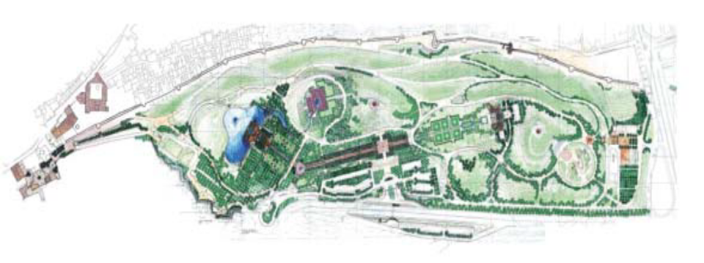
Al-Darb Al-Ahmar
Ayyubid historical fence
Figure 2. Al-Azhar Park location - surrounded by the most important neighborhoods of Islamic Cairo [25]

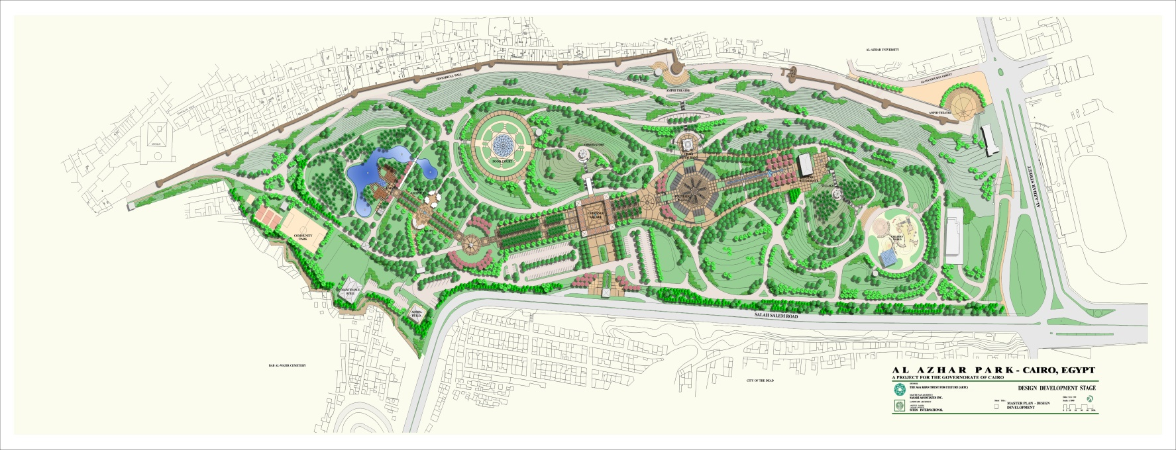
Ayyubid historical fence
Secondary entrance through Ayyubid historical fence
Gardens on top the southern water tank
Main spine connecting all park’s parts
Café in the lake
Main entrance
Citadel view from the top hill restaurant
Playground over the northern water tank

Figure 3. Site plan of Al-Azhar Park [26]

The project faced several challenges, such as high salinity lands, and the agricultural challenges were also great; as horticultural tests were conducted, many soil tests were set up to determine the most suitable types of plants and trees for the soil, terrain, and climate. Also among the most important challenges at the site is the presence of three pure water tanks in the garden, each of which has a diameter of 80 meters, so they were integrated to be part of the design of the garden in a creative way by creating an interactive design between them and the coordination elements and exploiting them in the work of small artificial lakes above them and plantings in a distinct style that hide the presence of these water tanks as shown in (Figure 4). The capacity of the warehouses has been increased to accommodate the specific loads of plants and landscaping above each tank. The top of the southern tank was used for seating areas under the trees, while the top of the central tank, which extends in one line with the main park, contains a basic garden, and the top of the northern tank was used as children's play area as shown in (Figure 5).

2 - Environmental Considerations
The realities of high seasonal temperature, low humidity, and rare rainfall imposed aggressive standards on the garden's farming systems. Al-Azhar Park project coincided with a final phase of development and research projects involving desert reclamation and the development and application of new irrigation methods in Egypt. Therefore, the decision was made to establish a limited plant nursery for horticultural testing, along with a larger plant nursery near the site to prepare the main stock and provide most of the strains and plant quantities required by mid-2000.
On the other hand, many environmental architectural treatments have been used in the park to overcome high temperatures. Water elements such as fountains and waterfalls were mainly used in the park to moderate the air temperature, as shown in (Figure 6), and mashrabiyas (wooden latticed openings) were also used to treat openings for top hill restaurants, side lake cafeterias, and internal courtyards to improve the temperature inside the buildings as shown in (Figure 7). It is noted that most of the building materials used are local natural and Egyptian materials, such as granite with its distinctive colors. It was widely used in paving the floors and some fountains using a hammering method while roughening its surface to break the reflections of the sun on it and reduce the severity of slippage when passing over it. Likewise, Egyptian Galala marble was used, distinguished by its durability in implementing Benches and lighting elements, as shown in (Figure 8). As for the stone in the garden, it is of sand and limestone types from quarries around Cairo. Egyptian dolomite stones were also used to construct waterways and waterfalls because they can withstand water and pressure, as shown in Figure 6.

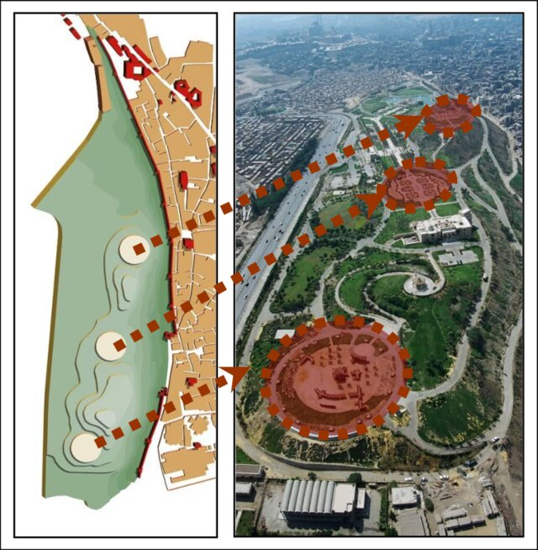

Figure 4. Three water tanks were integrated with the design [27]

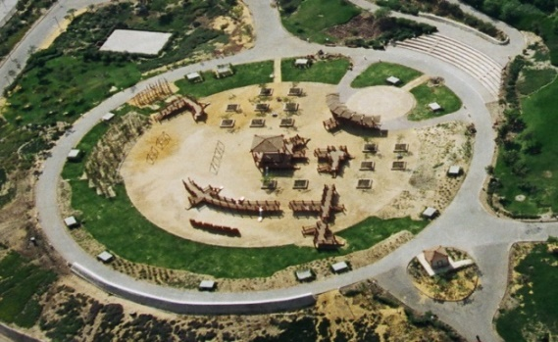

Figure 5. Using the top of the northern water tank as a playground [28]

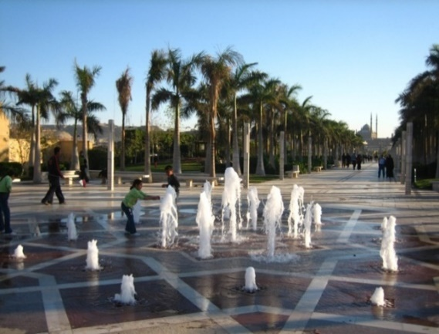 | 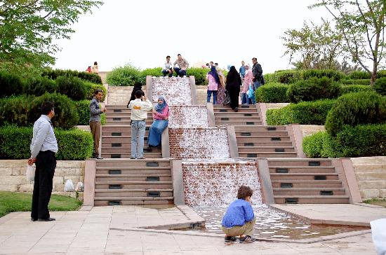
Figure 6. Islamic fountains and waterfalls were mainly used in the park [29].
[Source: https://www.gardenvisit.com/gardens/al-azhar_park]

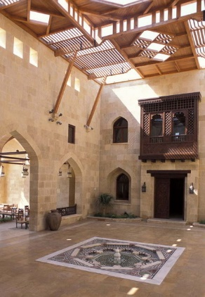  - Mashrabiya in the interior of the restaurant | 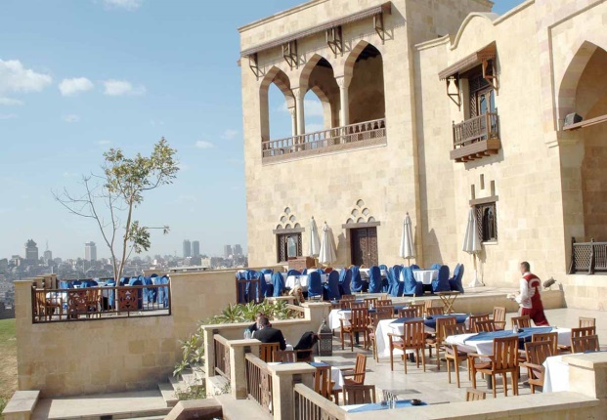  - Mashrabiya in the exterior of the restaurant
Figure 7. Using the Mashrabiya design in the Top Hill restaurant [28]

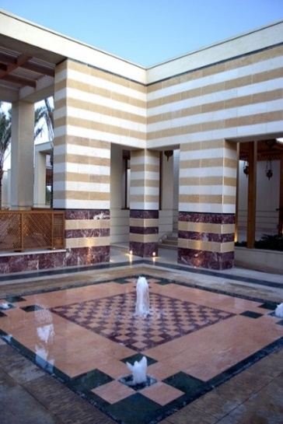  - Different types of Egyptian marbles and granites in the outdoors | 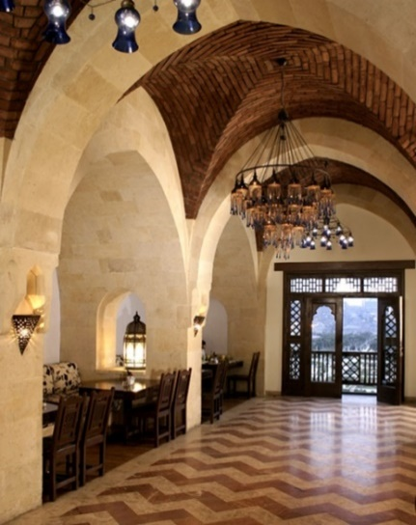  - Types of Egyptian marbles and granites in the indoors
Figure 8. Uses different types of Egyption marbels and granites outdoors and indoors [28]

3 - Functional Considerations
Al-Azhar Park was distinguished by its diverse terrain, which helped in the use of many architectural elements to show the diversity and difference in levels. Among the most important elements that influenced the expression of the function of the spaces within the park are the following:

PLANT ELEMENTS
The plant elements used in each part of the garden varied according to the function of each space. The cultivated areas in the garden were divided into four main parts: (the western slopes areas - the orchard areas - the border areas - and areas of a special nature). For example, the slopes area (the western area) represents the area adjacent to the historical wall. It is characterized by a steep slope of up to 2:1. Therefore, soil covers were used to withstand conditions of lack of irrigation water due to the slopes and protect the historical wall from water, in addition to plants with a dry desert nature such as cactus. As for the shading trees used in the seating areas, care was taken in choosing them to be low in height so as not to block the view of the path overlooking Salah al-Din Citadel, as shown in (Figure 9). In the border areas near the cemetery, dense plants and types of evergreen trees, some of which have thorns, were used to create a barrier between the garden and the cemeteries. Likewise, in the garden wall area overlooking Salah Salem Street, a barrier of dense trees was used to withstand pollution, prevent dust, and create a screen to block noise. In contrast to the orchard area, which overlooks the lake, trees were used for shade, fruit trees, willow, and papyrus trees, as well as plants and flowers with distinctive shapes and contrasting colors to give the form of an aesthetic, artistic painting.
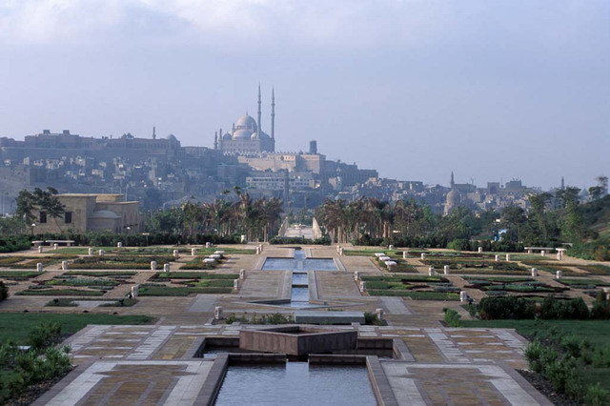

Figure 9. Low tree height to not block the view of the path overlooking Salah al-Din Citadel [28]

WATER ELEMENTS
The entire design of the garden connects an entire axis of waterways that begin in the north of the hill above the main water tank and descend in the direction of the castle, as shown in (Figure 9). An important landmark on the site finally flows into the main free-forming lake, considered the garden's main water element. Several fountains and waterfalls of various shapes were used. The fountains in the park varied in shape along the watercourse, but most of them took the shape of the Islamic star, as shown in (Figure 10).

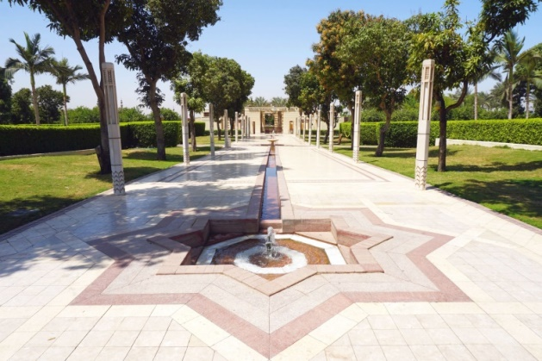

Figure 10. Fountains took the shape of the Islamic star [30]

COMPLEMENTARY ELEMENTS
The lighting units are one of the distinctive elements in the garden, which took a distinct unified shape stemming from Islamic architecture to give the garden a unique character. The stone benches installed in the retaining walls were also used to serve as stops for viewing and contemplating the various spaces in the garden.

PATHWAYS AND PEDESTRIANS
A network of secondary winding roads surrounds the park's main areas, leading to all graded levels providing the visitor with diverse and rich spatial and visual experiences. The park has wide-dimensioned pedestrian roads, allowing for comfortable circulation throughout the park site and along the main park. There are many types of paving and flooring used in the garden, and they were designed according to the functions of the spaces. Soil was used on the floors next to the historical wall, and Egyptian granite, sandstone, interlocking concrete tiles, and cast-on-site concrete floors were used in the rest.

4 - Aesthetic, sensory, and visual considerations
The language of architectural formation that links the elements and spaces of the project was characterized by diversity and distance from boredom and monotony due to the use of two different styles of architectural formations, where an overlap was achieved between the free organic style represented by the curved shapes of the green areas and the regular geometric pattern represented by the main path and the clear circles whose presence was imposed by the water tanks, as shown in Figure 11. Interestingly, the designers combined green plants, stone, and water to achieve the creative trilogy that the Muslim architect used in his architecture, embodying his cosmic idea and giving unity and integration in the various natural details. The buildings that constitute the park's main features have been used to serve as the main attractions for the residents of Cairo so that the entire site is transformed into a lively destination befitting the history and culture of this city.
On the other hand, the park's design was characterized by organic lines and forms, achieved through site landscaping elements with a unified design, giving the park a distinctive general character, as shown in Figure 11. Also, one of the manifestations of achieving unity is the use of entrances to the garden with a unified general style, which confirms the integrity and integration of the formation. As for the colors used in all the park parts, they are specific and harmonious. They are represented in two main colors: the beige color of the artificial stone and the brown color of the wood used in the benches and pergolas, which makes the visitor feel the simplicity, calm, and harmony among all the elements of the garden. Additionally, the interaction, overlap, and vitality between the group of elements that make up the garden appeared through the use of disparate relationships that appeared in several treatments, including the flatness of the land versus its slope in other areas, highlighting the contrast in planting with regular geometric patterns versus free formations, and also the green grass carpets extending across from the plants. Cultivated desert along the slopes overlooking the city.

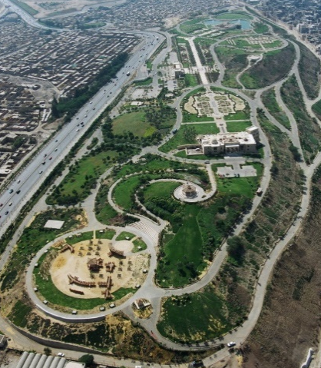  - Main aerial view of the park | 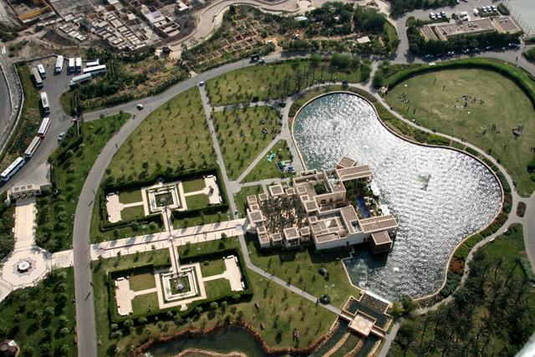  - The Lakeside café
Figure 11. The intervention of geometrical patterns, organic lines, and circles in the park site [28]

- 4. Merging Heritage and Contemporary Styles
Al-Azhar Park is an urban park that is a vital component of the essential part of the urban heritage and infrastructure of Cairo city. It is crucial for promoting community development and facilitating social contact through integration with the surrounding environment [25]. Al-Azhar Park project is considered an attempt to intellectually link the Islamic heritage with its spirit derived from the surrounding site and contemporary concepts represented in modern construction methods and modern soil treatment methods used in the park, as shown in Figure 12. Promoting the area's development while paying close attention to the local heritage, culture, and tradition was one of the main goals of the planning and design process [24]. This goal, represented by the intellectual interconnection between heritage and contemporary styles, was achieved through a group of architectural treatments in several axes, including compatibility and connection with the surrounding site and the adjacent Islamic historical buildings. In addition to developing a program to rehabilitate the historical buildings adjacent to the park, drawing inspiration from a group of treatments and Islamic heritage vocabulary, and preparing a program for developing the Al-Darb Al-Ahmar area adjacent to the park [31].

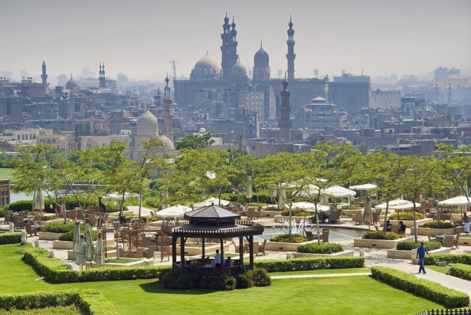

Figure 12. Linking the Islamic heritage spirit from the surrounding site and the contemporary park concepts represented in modern construction [28]

- 5. Compatibility with the Surrounding Site and Islamic Historical Buildings
Al-Azhar Park site is distinguished by its presence in an area full of Islamic antiquities and buildings from different eras, so the main idea of the park project depends on the visual connection with the surrounding Islamic archaeological sites. For example, the main axis of the project, which represents the backbone of the park, descends from the north towards the south, pointing to the Citadel of Saladin to strengthen the visual connection to it, as shown in (Figure 13), is also oriented towards visual angles to overlook the Islamic monuments panoramic scene in the surrounding area. Care was also taken to provide a clear and direct view of Saladin Citadel from all angles of the garden. Also, one of the most important treatments that confirmed the idea of linking the garden design with the needs of the local community is the idea of integrating the three water tanks into the garden plan honestly and sensitively and using them in a way that is proportional to the garden design and its divisions. During the park's development process, several important architectural landmarks and facilities were included to meet the needs of all types of visitors. The design of these important landmarks and facilities involves searching for a creative relationship between the important architectural landmarks (the top hill restaurant and the café next to the lake) and the architecture of old Islamic Cairo. The designs of these buildings are in line with the Islamic and traditional architectural design of historic Cairo. It was also taken into account that these buildings, which constitute the main features of the park and benefit from its stunning open views, are the main attractions for the residents of Cairo so that the entire site is transformed into a lively seat befitting the history and culture of Cairo.
On the other hand, the proposed park entry system has contributed to emphasizing the importance of the former city gate sites as natural and historically appropriate linking sites between the park and the surrounding area, and three entrances are now being revived: Bab al-Barqiya, Bab al-Mahrouq, and Bab al-Wazir. All these connection points are seen as meeting places to enhance interaction between the visitor, the community, and the environment surrounding the park.

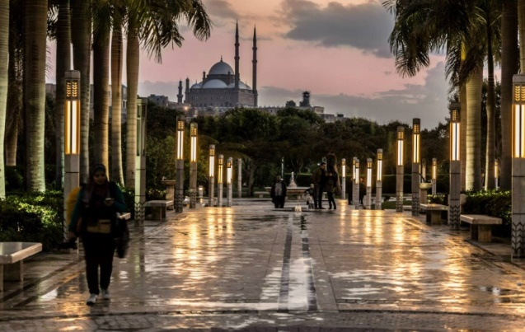

Figure 13. The central axial spine points toward the Salah Eldin citadel to emphasize the visual connection [28]

- 6. Rehabilitation Program for the Adjacent Historic Buildings
The area adjacent to the park (Al-Darb Al-Ahmar neighborhood) contains a group of the best Islamic historical buildings in Cairo. There are about 65 historical buildings registered by the Supreme Council of Antiquities in that area, and the long-term restoration of these buildings is considered crucial to preserving the architectural character of the area and attracting visitors. The Aga Khan Foundation for Culture has chosen three projects to restore and reuse to complement the Al-Azhar Park project in serving the community and the surrounding environment, which are the restoration project for the Umm Sultan Shaaban Mosque, the restoration of the Khair Bey Complex (which consists of a group of interconnected buildings that will be used as training halls on administrative issues and will also be used As a place for recreational and cultural events and for meeting residents and visitors of the neighborhood), and repairing the old Darb Shaghlan School and modifying it for reuse (it currently includes the neighborhood center and the offices of the Aga Khan Foundation for Culture) [5].
The rehabilitation of Darb Shaghlan School (located along the historical wall) provides an opportunity to create a community center in a neighborhood that severely lacks important facilities. The goal of reusing the school is to take advantage of the building's proximity to the historical wall and Al-Azhar Park, as well as its potential that can be harnessed. To serve the community, this edifice will be used as a common center for the community and visitors and provide recreational, educational, and community services. Also, one of the archaeological areas that was taken into consideration for re-exploitation is Aslam Square due to its proximity to Bab al-Mahrouq (one of the main gates on the eastern side of the Ayyubid Wall), as the gate was connected to Aslam Square. It is scheduled that Al-Azhar Park will be connected to Aslam Square and the Mahroug Gate, and Aslam Square will be gradually prepared. To function as a pedestrian link and forum for commercial activity and social interaction in the Aslam area. One of the important open spaces, the Tablita market on the main pedestrian axis linking the heart of the Fatimid city to Al-Azhar Park, will also be improved.
On the other hand, the wall of Ayyubid City, discovered during the excavation process to pave the western slopes, as shown in (Figure 14), is considered one of the most important archaeological discoveries of the past decades. It was decided to restore it to represent a distinctive linking element between the park and the surroundings. It is considered an attractive visual and effective linking point and provides access to adjacent historical areas (Darb Al-Ahmar district). This allows visitors to enter the city from the park and vice versa. The wall is an important fence and background curtain for the park, in addition to its role as an attraction for visitors. One of the most important goals of the restoration of the wall is to preserve and reinvent the Ayyubid Wall as part of a broader urban program and to achieve harmonious integration between the park project and the traditional urban fabric on the one hand and the contemporary life of Darb Al-Ahmar on the other hand.

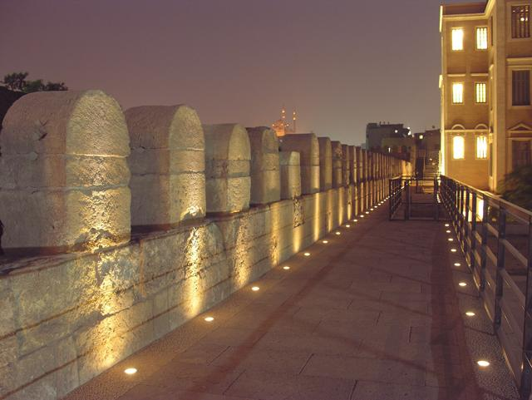 | 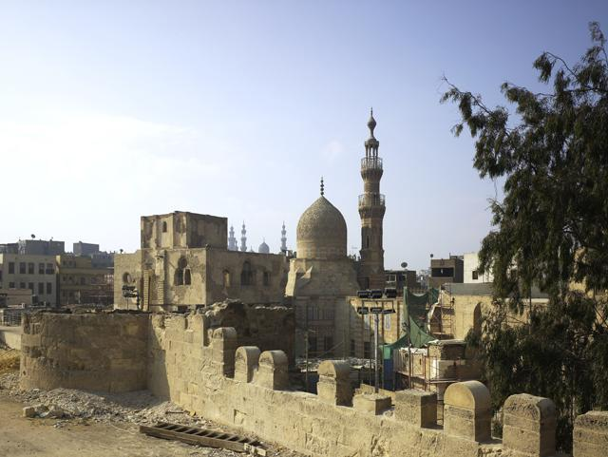

Figure 14. The restoration of the historical Ayyubid wall [25].

- 7. Inspiring the Treatments and Vocabularies from Islamic Architecture
The park was built according to the Islamic character, whether in its architecture or the philosophy of its coordination and landscaping. The main idea of designing the park depends on the presence of a main axis (the Kasbah) that connects the entire garden from north to south, as shown in Figure 15 and Figure 16. It is inspired by the shape of the Islamic city, especially the city of Cairo when it was established by the Fatimids. Most of the garden design characteristics are based on drawing inspiration from the traditional character of public places in the urban planning of Islamic societies. Persian and Indian elements are also reflected in the formations of the water elements through the use of a series of water channels and fountains in the shape of the Islamic star (figure 16). Thus, the design of the park was inspired by the style of Islamic gardens in different historical periods and geographical regions of the Islamic world, where the design was built based on organizing the various spaces in the style of an Islamic garden and using the shaded seating places inspired from the takhtboush or the covered arcades (bawaki) in the Fatimid style used in the park buildings as shown in (figure 17). Many Islamic vocabularies, such as mashrabiyas, arcades, inner courtyards, and domes, were used. The main gates of the garden were also designed in the Islamic style in terms of shape and building materials represented by stones. Likewise, the design of the subsidiary paths in the garden follows Islamic geometric shapes in the form of a square, circle, and octagon (Figure 18).
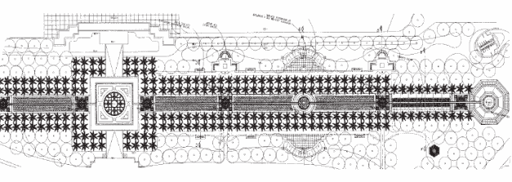
Figure 15. The main axial central park's spine (Qasabah) is inspired by old Islamic city design [32]

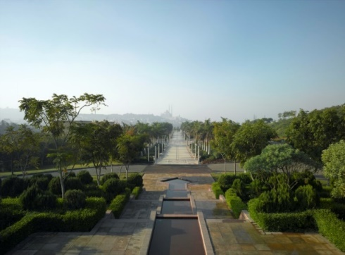

Figure 16. Using a series of water channels, fountains, and waterfalls inspired by Islamic water features and elements [25]

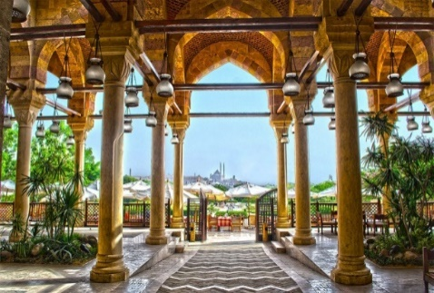  - the covered arcades (bawaki) from the Fatimid style | 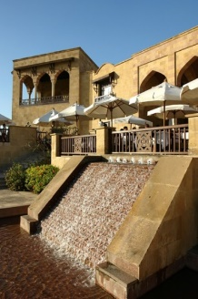  - The shaded seating places inspired by the (takhtboush)

Figure 17. using the shaded seating places inspired by the (takhtboush) or the covered arcades (bawaki) in the Fatimid style [28]

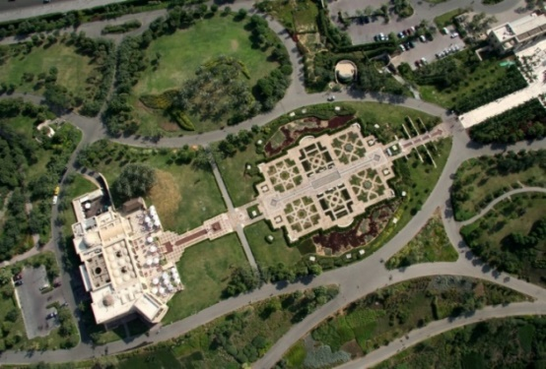 | 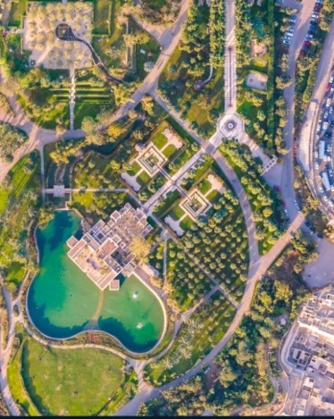

Figure 18. Mimicking the Islamic geometrical patterns in the main and secondary paths [28]

On the other hand, it was taken into account that the buildings in the park, which constitute its main landmarks, take advantage of their stunning open views to serve as the main attractions for the residents of Cairo so that the entire site is transformed into a lively seating area befitting from the history and culture of Cairo. Among these buildings is the Rabwah (hill-top) Restaurant (Figure 19), whose design was inspired by Fatimid Islamic architectural styles. Its design is harmonious and symmetrical, with a central axis running north to south through the inner courtyard decorated with palm trees. The colonnade was also used at the entrance to the building, and the entrance was projected to the outside. As in Fatimid architecture, it has a shaded rest area (takhtboush) before reaching the balcony garden, as well as the gates in the balcony with pointed arches. The internal spaces of the dining halls were covered with vaults. As for the lakeside café building (Figure 20), located on the side of the lake, it is an abstract Islamic art in its interpretation of the architecture of historic Islamic Cairo by referring to several contemporary reductionist interpretations of the Islamic Cairo architecture. Its design is based on a group of highly geometric booths in different styles. It is rectangular and includes wooden curtains made of lathed wood with detailed designs inspired by Islamic mashrabiyas. On the eastern side of the building, these compartments are surrounded by a central square courtyard decorated with palm trees, an Islamic fountain in the middle, and passing water channels inspired by ancient Islamic gardens. Most of the design vocabularies for both buildings are derived from the history of old Cairo [25].

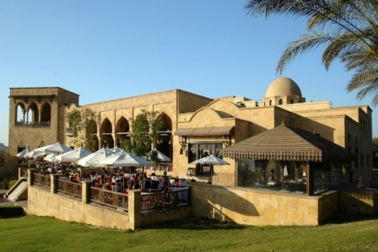

Figure 19. The top-hill restaurant (Arabwah) design is inspired by the Fatamid Architecture style ( Mashrabiyah – Takhtaboush- dome- Arcades) [28]

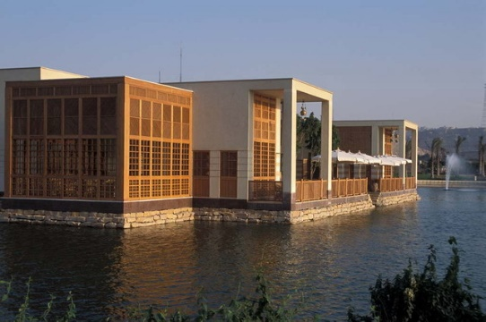

Figure 20. Lakeside Café on top of the lake presents the abstract Islamic art using Islamic geometric and ornaments [28].

- 8. DEVELOPMENT OF AL-DARB AL-AHMAR AREA
Al-Darb Al-Ahmar neighborhood is an urban triangle with dense buildings in the heart of Islamic Cairo. One of the most important goals set during the construction period of the park is to achieve integration between the park project and the development of the Al-Darb Al-Ahmar area and to revive the Ayyubid Wall that connects them, in an attempt to meet the needs of the community and develop it around the park project. The strategy developed for Al-Darb Al-Ahmar focuses on an integrated program for natural and economic revitalization to improve living conditions, preserve the natural fabric, maintain the current population, and achieve balanced development throughout the region. This strategy views restoration as a comprehensive rehabilitation process to make the neighborhood more attractive with its open spaces and archaeological landmarks. The basis of this unified strategy for restoration and development is the establishment of a local association for the development of Al-Darb Al-Ahmar to serve as a tool for the continued participation of all stakeholders in the region [27].
A plan has been developed to improve the public squares in the neighborhood and organize their relationships with the entrances to Al-Azhar Park through the Ayyubid Wall. They are now being developed, and the entrances to the park are made through them. The Aga Khan Trust for Culture partnered with local NGOs, neighborhood representatives, and individual residents of the area, surveyed the social and economic needs of the residents, and held several meetings to identify development priorities as perceived by the local community. A strategy was followed based on the direct participation of residents and local institutions in the gradual rehabilitation of existing residential and commercial properties as well as a phased improvement of the urban environment, and community participation is considered the best way to achieve lasting results.
The project became a catalyst for a whole series of rehabilitation projects in the surrounding areas, as the project to establish Al-Azhar Park as well as the maintenance of the historical wall constituted an encouraging incentive for the rehabilitation of the Al-Darb Al-Ahmar neighborhood, so the group of agencies embarked on a series of projects to raise urban efficiency and contribute to improving conditions and livelihood in the area adjacent to the park, by providing cultural, social, economic and institutional support. The area, which was filled with debris and waste for 500 years, has been transformed into an entertainment and recreation area and at the same time serves as a green lung for the city of Cairo, which is one of the least green residential areas in the world. The restoration of the Ayyubid Wall, in turn, reinforced the idea of benefiting from the park project not only as a green public space, but also as a panoramic platform from which one can enjoy viewing and reinterpreting the built heritage of Old Cairo, thus turning the Wall into a cultural asset and one of the living elements for the revitalization of Islamic Cairo in the future. Developing activities related to promoting a deeper understanding of cultural heritage among visitors and residents and developing local skills and capabilities to preserve Islamic Cairo. Many training programs were implemented to acquire various skills in conjunction with the work that was done to restore the Ayyubid Wall. Grants were provided to train young craftsmen from the region in construction work with stones. The construction of the park encouraged the rediscovery of some lost skills, such as the restoration of mashrabiyas.
The construction of this park and the restoration of historical monuments are considered an impetus for economic and social development and improving the general living situation in the surrounding area. At the same time, the park provides a new and suitable location overlooking wonderful views of the many architectural riches of that historic city. This park, with its central location, is a major new resource for attracting visitors. Partnership between the private and public sectors can represent an effective mechanism for developing the value of economic, cultural, or social assets that are not exploited, appreciated, or even known. The top-down development method is ineffective. Development must start from the bottom and stem from the needs and priorities of the local community. The best ideas in Al-Darb Al-Ahmar development project came from the residents of the neighborhood. Historical monuments can be an important and vital part of the society life instead of being a burden that leads to the depletion of resources, by reusing these historical buildings using modern methods and returning these cultural assets to their original function as an integral part of daily life. Al-Azhar Park is a livable example of the Enhancement of local distinctiveness by empowering the needs of the local people through the emphasis on the essence of interiority by creating meaningful places and spaces to make people belong to the place. Ensuring the future management and long-term sustainability of the Ayyubid Wall by establishing programs for permanent restoration and maintenance as well as monitoring future changes and transformations.

- CONCLUSION
According to the study, urban community parks can contribute to the social sustainability in several ways and support socioeconomically vulnerable neighborhoods in their efforts to achieve it. The interactions that take place in the parks are the main source of creation for many of these elements. The study provides more evidence that urban community parks can serve as centers of education. Furthermore, research shows that in socioeconomically vulnerable locations, urban community parks can have a significant financial impact. Furthermore, the study discovers that urban community parks enable social sustainability remnants to be seen and utilized. The need to enhance the urban sense of city residents to serve as a catalyst for attracting indirect private investments in sustainable urban rehabilitation, encouraging residents' participation and enhancing institutional capacity. Reconciling conservation and development is an essential requirement for achieving improvements in the quality of life in deteriorating historical places. The study highlights the importance of reusing historical structures and creating new jobs suitable to generate the necessary income for the buildings and the local community. The study shows the need to improve services and public open spaces, rehabilitate historic residential neighborhoods and open spaces with the support of the local community, and create opportunities for employment, training, and the advancement of local crafts. The proposed interventions promote continuity and not radical transformation, with the aim of integrating and harmonizing what remains of the ancient past with the current reality and studying its future uses in appropriate and sustainable ways. There is a need to link conservation operations with programs capable of enhancing economic development and job opportunities for the local community in the future. It is an essential goal to achieve compatibility with community requirements and surrounding environmental conditions in modern sustainable urban development projects.

FUNDING
This research is funded by Prince Sultan University, Riyadh, Saudi Arabia.

ACKNOWLEDGEMENT
The authors would like to acknowledge the support of Prince Sultan University for paying the Article Processing Charges (APC) of this publication. The author would like to thank Prince Sultan University for their support.

REFERENCES
- U. Nassar, Landscape as a Tool to Enhance Behavioural Response and Activities: An Evaluative Methodology to Historic Urban Parks - Al-Azhar Park, Cairo, Egypt: LAP LAMBERT Academic Publishing, 2013.

- A. M. SALAMA, "Media coverage and users' reactions: Al Azhar park in the midst of criticism and Post occupancy evaluation", METU Journal of the Faculty of Architecture, Vol. 25, No.1, pp. 105-125, 2008.

- E. Danielsson, "Cultivating social sustainability through urban community gardens – Evaluating urban community gardens as a planning strategy to foster social sustainability in socio-economic vulnerable neighbourhoods". Master’s thesis, Linköping, Sweden: Linköping University, 2022.

- K. A. Ismail, "Comprehensive Analysis of Al-Azhar Park Project, Cairo, Egypt: A Tool for Sustainability", UMRAN conference, KAED, IIUM, 2009.

- S. Mazzetto, "Heritage conservation and reuses to promote sustainable growth", Materials Today: Proceedings, Vol. 85, pp. 100-103, 2023. https://doi.org/10.1016/j.matpr.2023.05.269.

- M. Itma, S. Monna, "The Role of Collective Spaces in Achieving Social Sustainability: A Comparative Approach to Enhance Urban Design", Sustainability, vol.14, pp. 8756, 2022, https://doi.org/10.3390/su14148756

- S. Woodcraft, T. Hackett, & L. Caistor-Arendar, Design for social sustainability A framework for creating thriving new communities, UK: The young foundation, 2011.

- S. Abdussamad, "Islamic Perspectives: An Alternative to the Existing Model of Social Sustainability in Architecture", Astrolabe: A CIS Student Research Journal, Vol. 3, pp. 1-29, 2021.

- M. Moscatelli, "Rethinking the Heritage through a Modern and Contemporary Reinterpretation of Traditional Najd Architecture, Cultural Continuity in Riyadh," Buildings, vol. 13, no. 6, p. 1471, Jun. 2023, doi: 10.3390/buildings13061471.

- I. M. Lami and B. Mecca, "Assessing Social Sustainability for Achieving Sustainable Architecture", Sustainability, Vol.13, No. 1, pp. 142, 2021. doi: https://dx.doi.org/10.3390/su13010142

- E. Eizenberg, and Y. Jabareen, "Social sustainability: A new conceptual framework", Sustainability, Vol. 9, No. 1, pp. 68, 2017. DOI: 10.3390/su9010068

- A. Korolova, and S. Treija, "Urban gardening as a multifunctional tool to increase social sustainability in the city", Architecture & Urban Planning, Vol. 14, No. 1, pp. 91–95, 2018. DOI: 10.2478/aup-2018-0012

- C. Glennie, "Growing together: Community coalescence and the social dimensions of urban sustainability", Sustainability, Vol. 12, No. 22, pp. 9680, 2020. DOI: 10.3390/su12229680

- C. G. Wadumestrige Dona, G. Mohan, and K. Fukushi, "Promoting urban agriculture and its opportunities and challenges – A global review", Sustainability, Vol. 13, No. 17, pp. 9609, 2021. DOI: 10.3390/su13179609

- M. Krier, Urban space. London, UK: Academy Editions, 1990.

- M. H. Masridin and Al. S. Ismail, "Critical Regionalism Approach for Djami Mosque Design Towards The Aesthetics of Sustainability", Journal of Islamic Architecture, Vol. 7, No. 2, pp. 220-232, 2022. doi: https://doi.org/10.18860/jia.v7i2.17135

- J.O. Simonds, Landscape Architecture. N.Y.: Mc Graw, Hill Book Company, 1984.

- C. Tandy, Handbook of urban landscape. London: The Architectural Press, 1991.

- S. Dwidar, H. Sirror, A. Derbali, D. Abdelgawad, and A. Abdelsattar,"Importance of Internal Courtyards in Designing Historical and Contemporary Masjid", Journal of Islamic Architecture, Vol. 7, No. 2, pp. 356-363, 2022. doi: 10.18860/jia.v7i2.16065

- N.K. Booth, Basic Elemenys of Landscape Architecture Design. N.Y.: Elsiver Publishing company, 1983.

- M. Hocine and C. N. Chabbi, “Reuse of djenane abd-el-tif, an emblematic islamic garden in Algiers”, Journal of Islamic Architecture, Vol. 3 No. 3, pp. 135-142, 2015, doi: https://doi.org/10.18860/jia.v3i3.2750

- S. A. Saad, "Space, Architecture, and Power. The Top-Down and Bottom-Up Place making in Historic Arabic-Islamic Cities", Journal of Islamic Architecture, Vol. 7, No.1, pp. 28-38, 2022. DOI http://dx.doi.org/10.18860/jia.v7i1.11730

- R. A. Moussa,"A Responsive Approach for Designing Shared Urban Spaces in Tourist Villages", Sustainability, Vol. 15, No. 9, pp. 7549, 2023. doi: 10.3390/su15097549

- A. M. Salama, "Media coverage and users' reactions: Al Azhar Park in the midst of criticism and Post Occupancy Evaluation", METU Journal of the Faculty of Architecture, Vol.1, pp: 105-125, 2008.

- G. Otte, Aga Khan Trust for Culture, Geneva: The Cultural Agency of the Aga khan development network, 2007

- C. Rashti, M. Stino, “Converting a Derelict Site into an Urban Park”, Historic Cities Support Programme, The Azhar Park Project in Cairo and the Conservation and Revitalisation of Darb al-Ahmar, Geneva: The Aga Khan Trust for Culture, 2001

- U. Nassar, "Principles to Evaluate Historic Designed Landscape of Urban Parks - Case Study of Al-Azhar Park" Port-Said Engineering Research Journal. Vol.14, pp: 180-193, 2010.
- “The Green Lung in the Heart of Cairo”, Al-Azhar Park, Accessed: December 8, 2023. [Online]. Available: https://azharpark.com/,

- T. Musgrave, “Al-Azhar Park”, Garden Visit, 2007. Accessed: December 8, 2023. [Online]. Available: https://www.gardenvisit.com/gardens/al-azhar_park

- J. Crane, “Cairo – the Coptic Quarter, Al-Azhar Park, and other sights”, Jonty Travels, 2023, Accessed: December 8, 2023. [Online]. Available: https://jontynz.com/2023/09/14/cairo-the-coptic-quarter-al-azhar-park-and-other-sights/

- H. M. Assem, O. S. Tolba, and S. S. Ashour, "The restorative effect of different landscape design settings on adults: the case of al-azhar park in cairo", Journal of Engineering and Applied Science (faculty of engineering, cairo university), Vol. 67, No. 5, pp. 1001-1018, 2020.

- “Al-Azhar Park, Picture of Working drawing details”, Egypt Architecture Online. Accessed: December 8, 2023. [Online]. Available: https://www.egyptarch.net/azharpark/azhardetail.htm

