 |  | JOURNAL OF ISLAMIC ARCHITECTURE  P-ISSN: 2086-2636 E-ISSN: 2356-4644  Journal Home Page: http://ejournal.uin-malang.ac.id/index.php/JIA
IMPLEMENTING SUSTAINABILITY IN URBAN DESERT REGIONS THROUGH SOLAR ORIENTATION, THE ISLAMIC VERNACULAR ARCHITECTURE OF THE M'ZAB KSOUR IN PARTICULAR
Krimo Dahmaniª, Khalil Bachir Aouissi^{a*}, Saif Eddine Chettahª
ªInstitute of Architecture and Urban Planning, OVAMUS Laboratory, University of Blida1, Algeria
*Corresponding Author: aouissi_khalil@univ-blida.dz
ARTICLE INFO |  |  | ABSTRACT
Volume: 8  Issue: 2  Page: 408-422  Received: January 26th, 2024  Accepted: April 24th, 2024  Available Online: December 15th, 2024  DOI: 10.18860/jia.v8i2.25531 |  |  | This study investigates the role of solar orientation in creating sustainable urban land systems in desert regions, using the Ksour of M'Zab in Algeria as a case study. The Ksour are vernacular Islamic and millenarian cities inhabited for centuries, and their urban design has evolved to respond to extreme climatic conditions, particularly insolation. Through a geometric analysis of the road system, this study demonstrates how the optimal orientation of urban lanes ensures the integration of extreme climatic conditions and creates comfortable streets for pedestrians. The study compares two old Ksour (El Atheuf and Beni Yezguen) with a new Ksar (Tafilalet) and statistically evaluates their solar orientation. The results show that solar orientation is a crucial tool for understanding the sustainability of desert cities. Thus, traditional knowledge and contemporary design practices can be integrated to create sustainable urbanism in arid environments. This study contributes to the growing body of knowledge on sustainable architecture by providing insights into how traditional knowledge can create resilient cities in challenging environments and promote sustainable development.  Keywords:  Geometric analysis; Ksour of M'Zab; Solar orientation; Sustainability; Vernacular; Islamic architecture

- INTRODUCTION
Cities in deserts may get exceedingly hot, especially in the summer, making them vulnerable to long-term, harmful, and progressively severe thermal conditions [1]. The climate may greatly impact people's lives, especially by allowing or prohibiting more outside activities. Temperature and its changes influence our everyday activities, affecting our comfort. Given the varied nature of the human situation, thermal comfort is defined as a feeling of well-being, an absence of discomfort, or a state of mind that is content with the thermal environment [2]. A person sitting in the sun next to a window can absorb radiant heat [3], and surfaces inside a home can exchange heat with other surfaces through radiation, affecting the interior ambient temperature [2]. As a result, architectural discourse and practice were required to experiment with the connection between climatic patterns and people's daily lives and habits [4], [5]. The relationship between energy and society must also be examined to develop methods for changing energy use. For studying and comprehending this link, it is crucial to understand and apply energy language to the social interrelationships of our living environment and technology [6].
Sunlight is regarded as an important source of energy. Its duration is a key factor in establishing the seasons, particularly sunshine duration. Following Le Corbusier, especially his article published in 'Techniques et Architecture' issue, Fradet, the France engineer from France's National Scientific Research Center (CNRS) conference, also discussed solar efficiency. That was most likely the first climate diagrams published in the French architectural press. Diagrams of suggested building heights and other design ideas were included with indications of the sun path and shading charts for the Parisian latitude [4]. In the desert area of the Northern Hemisphere, the longer the sunlight lasts each day in each place, the more effective this sunlight is, and the more the soil heats up, so more antiseptic effect of light can be felt, which is so well known. It exerts its beneficial action on organized beings, both plants and animals. The yearly cycle of insolation was, therefore, amplified in the Northern Hemisphere, which, for example, boosted the dynamism of its summer monsoon. Insolation is not a negative thing, but it will be tough if summer temperatures exceed 50° C for a lengthy period, as it is in desert areas where the health and well-being problem is dependent on daily exposure to sunlight, which can induce sunstroke by walking in the sun during this season [7]. Sunstroke would occur if someone went bareheaded in the sun at midday because the energy that drops from the sun changes certain vibrations and may cause brain warmth. In this circumstance, the patient had to be immediately put in the shade [8]. However, how can we avoid this problem occurred in hot desert regions like Algeria's Ksour (Ksar in singular), which are historic building complexes that form a tight urban tissue in Algeria's desert areas, where we cannot plant trees due to the rocky nature of the implementation site?
Filhol and Besancenot [9] discovered a substantial association between self-aggression curves and sunshine length in their study on behavior and meteorology. This curve is connected to the amount of time spent in the sun. Interior thermal conditions are conceptualized as the physiological presence of a universal subject in a specific area to prevent the consequences of insolation. Such a subject may move the louver and adjust the lever to cover the sun as it moves across the sky, which would otherwise impact the interior's experience. Thus, for this system to work correctly, social practices and embodied habits are essential [4]. According to Bardov [10], premises windows should face North and South in the equatorial zone (long premises parallel to the equator to decrease direct insolation) and Southeastern-Southwestern in the Northern Hemisphere (premises length should be oriented along the heliothermal axis). This North-South orientation is especially crucial in hot urban desert regions (HUDs), where sunshine is critical for outdoor space design [11]. Desert residents avoid aligning their windows towards the North-South axis, where the outside space formed by the walls of the buildings provides shade due to the use of curved routes, as ancestral know-how of Ksour designers [12].
There are several options when considering the fabric of the building itself. In Phoenix, instead of reflecting glass, the orientation, texture, and form of the outer envelope is a more fundamental approach to influencing the impact of solar radiation on a building [6]. When the University of Bologna faculty was being built, a long, straight central corridor parallel to the heliothermal axis connected all of the building blocks and provided access to the expansive drawing rooms—one for each course and each floor—at every level [13]. This heliothermal axis has lately been criticized, with "the analysis of the average annual temperatures" of the façades revealing that the average thermal equality desired by the heliothermal axis proponents is only attained for a building oriented exactly North-South. The average temperature asymmetry grows as one gets away from the North-South axis in all other directions [14].
Some projects take a more in-depth look at the impact of solar systems and thermal stress. As in an Italian study of the Albergo dei Pevori monument, the computation hypothesis considered the various uses: teaching areas, libraries, museums, religious worship buildings, accommodation, and the relative use of each over 24 hours. In addition to individual uses, Franco and Magrini [15] examined the room's position concerning the heliothermal axis and any barriers that may reduce solar contribution to natural illumination. This heliothermal axis has been incorporated into the design of various buildings, such as Renzo Piano's County Museum of Art-LACMA in Los Angeles. The building "embraces" the landscape by creating circumstances for listening to and merging with the natural environment. A series of overlapping planes and thin diaphragms produce 'depth,' which is not visual. The building, located next to a clearing traversed by a river, is oriented toward the heliothermal axis to maximize the use of the passive cooling system [16].
Jane Jacobs [17] outlines some of the elements that make cities operate in the local order of the street. These depend on the relationship between the city's physical fabric and the weave of social interaction within it. The street represents the interface between urban and architectural scales, with shared functional features between the building exterior and the open urban canopy. The street's strategic importance is also related to its function: from a design standpoint, the street network of an urban entity serves as the primary support for mobility, urban activity, and social life, and it even reflects cultural specificities [18]. The direction of exterior circulation spaces, as a support for social life and social practices during the day, is one of the best possibilities for the long-term survival of Saharan Ksour. Because the alley system corresponds with outdoor space as a location for living, socialization, and gathering in Saharan Vernacular Islamic architecture, the North-South orientation is not recommended and should be minimized. Saharan Ksour is a living testimonial of the man-made landscape incorporating physical buildings that harmonize with the surrounding nature and climate.
Along with this, cultural, social, economic, and environmental factors and construction techniques are all involved [19], [20]. The depth of the designs of the morphology of vernacular Islamic cities without the need for architects' perspectives but instead via proven wisdom and knowledge has proven its control, perfect integration, and ability to blend harmoniously with the site. We can place cities in the triad Man-technique-environment only after treating them properly and sufficiently, as is the case of the Saharan Ksour in Algeria.
Among the most famous ones, M'Zab's Ksour (Algeria) is realized through an identical morphological composition using indigenous construction materials, transferring ancestral knowledge on a regional scale. Mozabite social practices are adopted and sheltered against the detrimental effects of the region's harsh climatic circumstances, particularly the duration of insolation and the oppressive desert temperature. Preserving vernacular Islamic urban form and social life demonstrates thermal stress avoidance. As a heritage for humanity, the Ksour of M'Zab's sustainability demonstrates an adapted urban design in which the inhabitants-designers have succeeded in assuring people's movement without thermal stress. The limited availability of solar radiation is due to their compactness, shading from neighboring buildings, limitations in building orientation, urban regulation constraints, size constraints, and limited space for solar collection compared to the building’s area [21]. Simultaneously, the individual micro-climatic conditions around urban buildings broadly define the building's performance.
In comparison with the M'zab case, other research strive to explore the link between this sustainable historical value and the environment. In Italy, for example, on considering the issue of energy performance in historic areas, only a few regions, such as Umbria, Toscana, and Friuli Venezia Giulia, referred to the importance of the relationship between buildings and environment, both natural and constructed [22]. As well as the aspects related to their interactions, the study of the environmental conditions includes climate and microclimate, heliothermal paths and prevailing winds, building or nature, and artificial context relations. Vernacular Islamic architecture traits may be intriguing and enlightening for those studying them.
Examining the means chosen to combat harsh sunlight in basic and experimental approaches demonstrates the importance of considering vernacular solutions that have endured over time. Vernacular Islamic architecture reflects a specific civilization's construction methods, use of space, materials used, and tastes and needs [23]. The primary purpose of this study is to understand the design of vernacular Islamic Ksour through solar orientation, which the Mozabites chose to face the morphology and harshness of existence, where the sun is low in the sky in winter, welcomed to warm the buildings, but rejected by a simple overhang in summer [6]. This demonstrates another characteristic of the endurance of vernacular Islamic architecture [24]. These Ksour were recognized as a World Heritage Site by UNESCO in 1982 for their ideals and vernacular Islamic solutions adopted by this arid climate and local culture. In responding to the avoidance of solar shocks inside and outside inhabited areas, these millennia-old urban fabrics demonstrate tremendous wisdom and knowledge.

- METHODS
The oasis of Ghardaïa is located in the South of Algeria between 32° and 33°20' North latitude and 0°4' and 2°50' East longitude (Figure1). It is about 610 km by road from Algiers. Ghardaïa is the largest of five upland settlements amidst valuable, finite irrigated palm groves, where there was a need for defense and stone as an available building material [25]. The settlement of this desert region resulted in extraordinary urban and architectural designs that considered the dry climate, winds, dust, and excessive sunlight. The Ibadite society, which remained homogeneous as long as it remained closed to itself by a deliberate choice of its members, elaborated a specific architecture that materially translated the relatively complex structures of its organization, way of life, and thought.

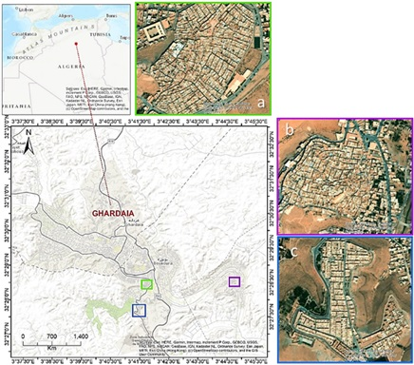

Figure 1. Location of the desert Ksour of the M'Zab Valley (a: Ksar of Beni Yezuguen; b: Ksar of El Ateuf; c: Ksar of Tafilalet)
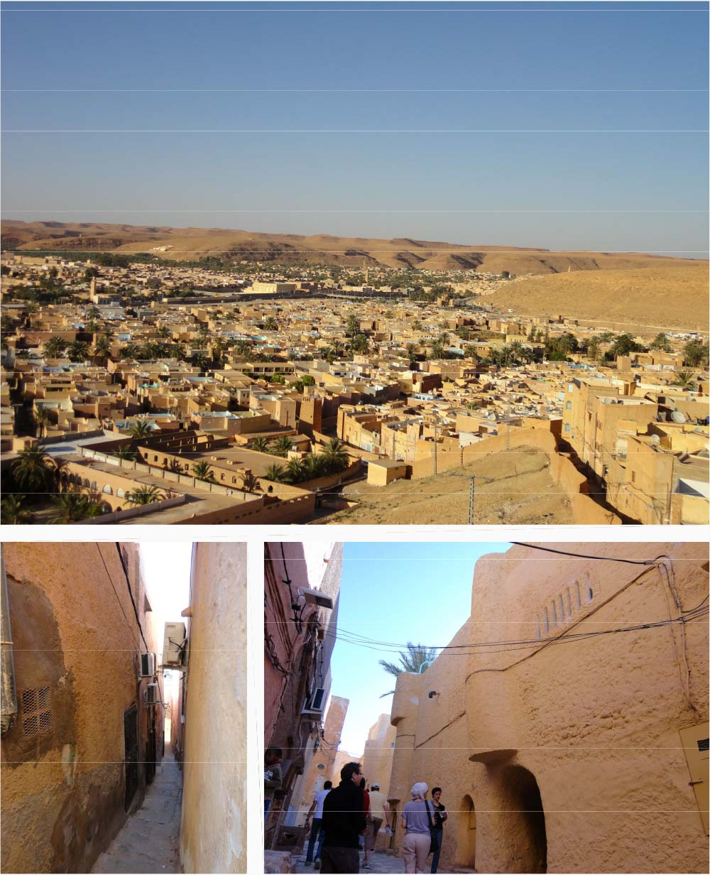

Figure 2. Photos of various locations Ksar of Beni Yezuguen

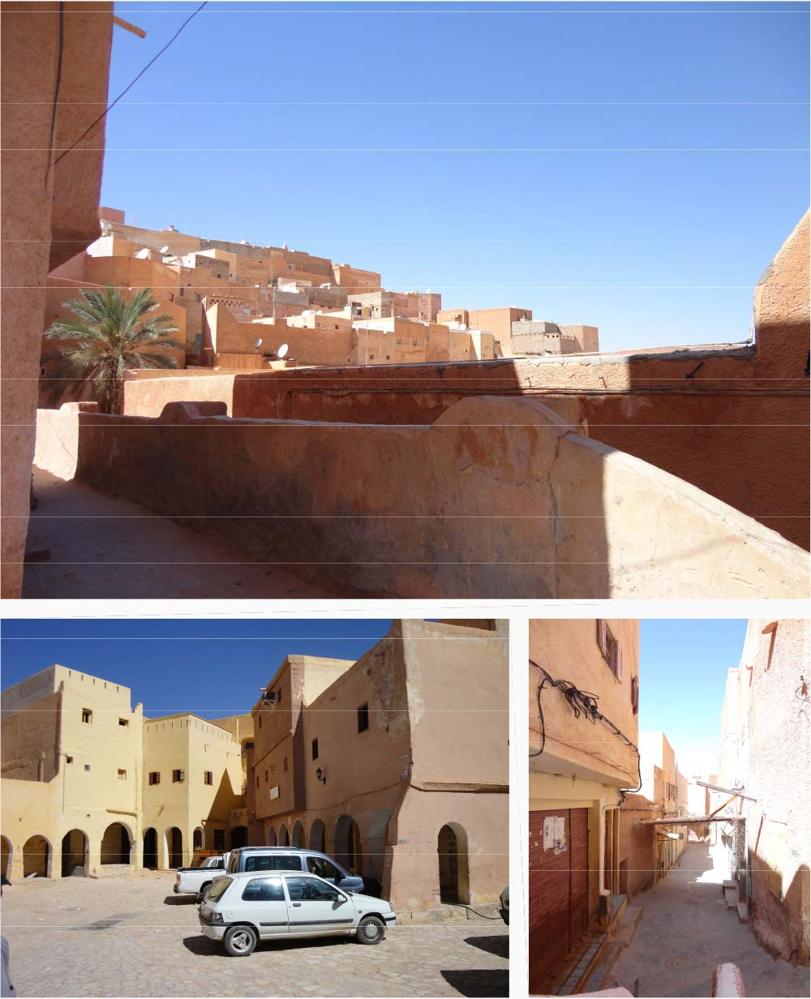

Figure 3. Photos of various locations Ksar of Beni Yezuguen

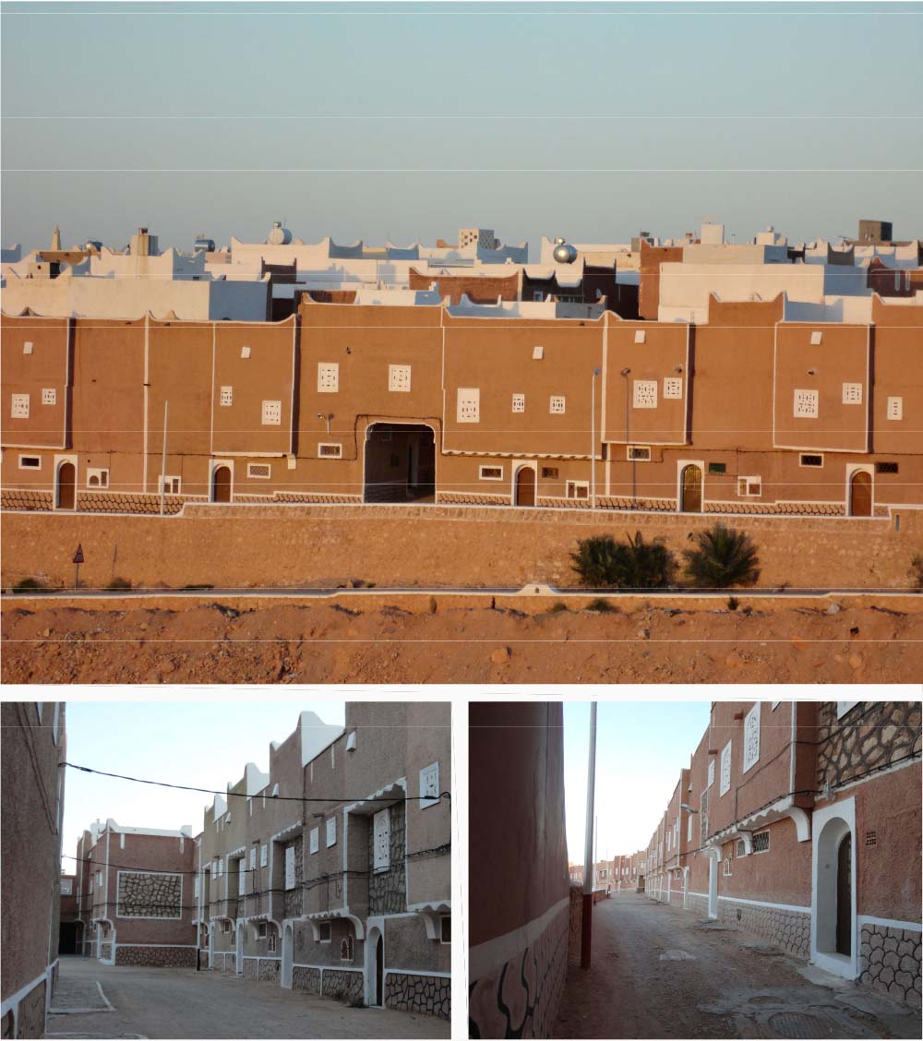

Figure 4: Photos of various locations Ksar of Tafilalet

The Mozabites (inhabitants of M'zab) achieved a real miracle, preserving the water stored under the sand and rocks of the Sahara despite the high temperatures. The average annual temperature in Ghardaïa is 21.1°C (Table 1), but it can easily reach 40°C in summer. According to Köppen and Geiger, summer in Ghardaïa begins at the end of June and ends in September, which makes this climate a BWh (hot desert climate). Whereas the average amount of sunlight hours per month ranges from 10.5 (March) to 11.1 (September), which can last to 12.8 hours in June.

Table 1. Weather & Climate in Ghardaïa [26]
Months | 01 | 02 | 03 | 04 | 05 | 06 | 07 | 08 | 09 | 10 | 11 | 12
Avg. temperature °C | 9.5 | 11.4 | 15.9 | 20.3 | 25.1 | 30.1 | 33.6 | 32.7 | 27.9 | 22.2 | 14.5 | 10.3
Min. temperature °C | 4.5 | 5.7 | 9.5 | 13.4 | 18 | 22.8 | 26.3 | 25.8 | 21.6 | 16.3 | 9.4 | 5.6
Max. Temperature °C | 14.9 | 17 | 21.8 | 26.4 | 31.1 | 36.2 | 39.7 | 38.5 | 33.5 | 27.6 | 19.8 | 15.5
Precipitation / Rainfall mm (in) | 11  (0) | 4  (0) | 7  (0) | 7  (0) | 4  (0) | 1  (0) | 1  (0) | 2  (0) | 8  (0) | 7  (0) | 8  (0) | 6  (0)
Humidity(%) | 52% | 42% | 33% | 27% | 23% | 20% | 17% | 20% | 29% | 37% | 48% | 56%
Rainy days (d) | 2 | 1 | 1 | 1 | 1 | 0 | 0 | 1 | 1 | 1 | 1 | 1
Avg. Sun hours (hours) | 8.7 | 9.5 | 10.5 | 11.5 | 12.3 | 12.8 | 12.6 | 12.0 | 11.1 | 10.1 | 9.1 | 8.5

The morphological relationship of the site to the urban fabric is ideal and carefully considered, as are the local and durable materials. The introversion of the house is a kind of sun avoidance and a typical social norm in which everyone is treated equally. In addition, the winding alleys of the Mozabite city are often roofed as they gradually rise to the mosque at the highest point, providing the pleasant sensation of walking through shaded underground tunnels [25]. Simple direct-light and sun-space components, sensibly applied to the street façade of small structures in narrow streets, have been effective for winter while providing efficient daylighting and natural ventilation in summer [27], [28].
Five historic Ksour have been constructed in the Ghardaïa oasis. The Ksar of Ghardaïa (of the same name) is the youngest, founded in 1053 (426 Hijri); the oldest, El Ateuf, was founded in 1011 (401 Hijri), followed by Bou Noura, Melika, and Beni Isguen. They arose when the persecuted Ibadite sect was forced to evacuate Kairouan, Tiaret, and Sedrata before finding refuge in the oasis of Ghardaïa [25]. This study focuses exclusively on two vernacular Islamic Ksour (El-Ateuf and Beni Isguen) on the one hand and a new ksar on the other. The old Ksar of El-Ateuf is mainly characterized by its two mosques and minarets rising towards the blue African sky, symbolizing the city's bloodshed and pride in introducing Ibadism to the M'zab. The Ksar of Beni Isguen, the most mysterious of the M'zab cities, depicts a holy city whose gates were once sealed at night, and only the city's inhabitants were allowed to enter after dark. Although this is no longer the case, the city remains the most traditional in M'Zab. As for the Ksar of Tafilalet, it is very recent, having been created in 1997 (1417 Hijri) to alleviate the housing crisis that affected not only Ghardaïa but the entire country.
The methodological approach begins with a study of the lanes morphology using satellite imagery of the selected Ksour, followed by a computational evaluation of the reflection of sunlight in the three Ksour. The computation is based on global criteria for the movement of the sun and the actual lengths of the wind paths of the Ksour (Figure 5). Because solar radiation affects not only walls and ceilings but also surfaces that people walk on throughout the day, such as public areas and streets, reducing the amount of sunlight in hot desert cities is critical to the city's existence. We calculated the circles of the angles of the sun's rays for June 21st, September 21st, and December 21st, as well as their solstices, using Ernest Neufert's formula. To accomplish this task, the writers used the vector computation program, Autocad. They then performed a statistical analysis comparing the two old Ksour with the new one. It was performed to provide a neutral mathematical explanation for this solar orientation anomaly in these desert vernacular Islamic and sustainable communities. The equation is mathematically based on specific factors, in this example the sunshine index, the importance of which may be described by a coefficient and is directly related to the sunlight zones, the number and size of the lanes per zone. Thus, the next step conducted was selecting the orientation zones of the lanes based on the seasons, the orientation of the lanes based on the road network of each Ksar (circular or chessboard), and the quantities sought of each constituent. These are expressed in the unit distance and angles of inclination using the following formula:
(Number Zone(Lanes)*100/N Total(L))*((Angle max + Angle min)/2)/360°.
The outcome reveals the role of isolation in the global direction of cities as determined by their designers. The main advantage of the approach is the availability of a powerful tool, in this case, the algebraic calculation, which allows for the systematic search for answers.

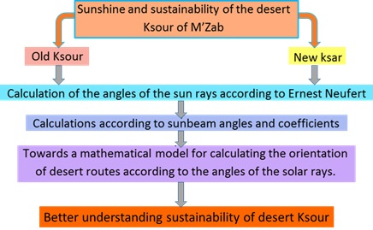

Figure 5. Methodological framework of the study

- RESULT
The manual and experimental computations performed on 1273 lanes in the three Ksour, including their 1273 angular inclination concerning the North-South axis, led to the results shown in Figure 6. The results show the long-standing dominance of the effect of the sun on the orientation of buildings, windows, and roads in the vernacular Islamic architecture of the Ksour.

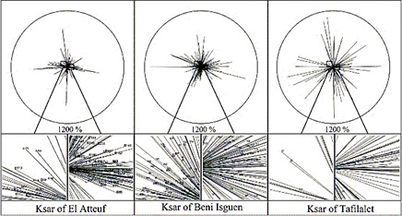

Figure 6. Solar projection circles of the street network and its orientation in the three Ksour

By evaluating the morphology of the alleys exposed to sunlight in the three Ksours, the results are shown in Figure 7, 8, and 9.

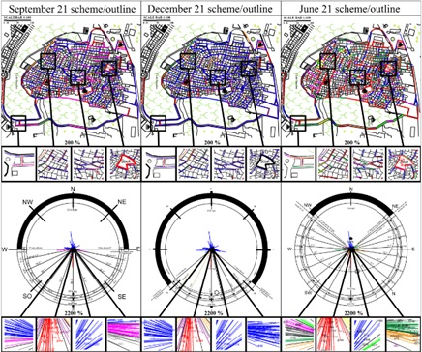

Figure 7. Street network and its orientation in the Ksar of El Atheuf

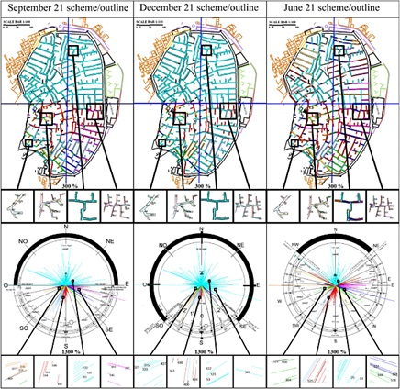

Figure 8. Street network and its orientation in the Ksar of Beni Yezeguen
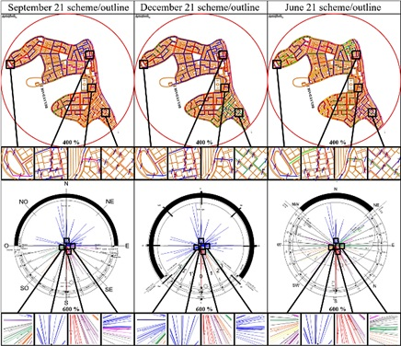

Figure 9. Street network system and its orientation in the Ksar of Tafilalet

Due to new building technology, solutions of all kinds in modern urbanization are becoming increasingly technological. When the sun is shining, movable insulation with a reflective surface allows the temperature of the building to quickly adapt to the solar radiation [29]. In vernacular Islamic architecture, however, the walls limit the exterior spaces, resulting in a deeper reflection. Thus, the influence of solar radiation and its persistence in ancient Ksour show that it is not only a matter of building materials. Following international standards, the computations led to the results which are given respectively for December, when insolation is the lowest; for June, which corresponds to the summer solstice, considered as the period when insolation reaches its peak; and finally, for September, which heralds the equinox period. The number of lanes according to their orientation expresses the results (see Figure 10, 11, 12 & 13).

Figure 10. Computation of the sunshine of the lanes in accordance with the coefficients in December.

Figure 11. Computation of the sunshine of the lanes in accordance with the coefficients in June.

Figure 12. Computation of the sunshine of the lanes in accordance with the coefficients in September.

Figure 13. illustrates the computation of insolation importance of the three Ksour according to the coefficients of the normalized areas.

Figure 13 confirm the results of the study, according to which vernacular Islamic architecture is a behavioral and local architecture that is entirely in line with the notion of sustainability. The computation of the solar radiation from a system of coefficients for each insolation area shows that the result is positive in the three cases studied. This explains the importance of solar exposure in desert areas. The results are very close in both modern and vernacular Islamic urbanism solstices. However, in the summer period, the vernacular Islamic Ksar gave more importance to insolation exposure than the modern Ksar did, and vice versa for the winter period. According to the results, this explains a fundamental point in ancient Ksour's design, where designers consider shade a priority. In contrast, modern designers think of avoiding direct exposure to sunlight.

- DISCUSSION
Following the empirical results and comparing the computation of the lanes systems of the old and new designs of the Ksour in Ghardaïa, we discovered that vernacular Islamic and modern Ksour may be utilizing sensors and regulators of energy and sunlight for sustainable living by adapting their design and morphologies to the location (Figure 14,15 & 16). According to the findings, there is a significant difference between the two designs regarding lane orientation, particularly during warmer seasons. Unlike recent Ksour, shaded lanes were prioritized, and sunshine should be avoided in the old ones. Avoiding solar shocks is no longer crucial in modern Ksour where motorization had vastly shortened trips both in space and time. Whereas, sinuous lanes could no longer be adopted, allowing wide mechanical traffic routes. The new Ksar of Tafilalet was designed rapidly thanks to a unique preconceived plan, whereas the design of the previous Ksour took about 10 centuries. This fact can be explained by the involvement of generations of designers in the old and some in the recent Ksour. Incorporating fundamental vernacular Islamic design aspects in the modern Ksar has given the old Ksour's ancestral know-how an intergenerational, ongoing, and sustainable character.

Figure 14. Footprints of the lanes and their angles according to the sunshine (Ksar El Atheuf)

Figure 15. Footprints of the lanes and their angles according to the sunshine (Ksar Beni Yezeguen)

Figure 16. Footprints of the lanes and their angles according to the sunshine (Ksar Tafilalt)

The old architectural know-how has made millennium buildings harmonious with their surroundings [30]. It has employed natural and local materials and energy-saving measures such as solar architecture, natural ventilation, and rainwater collection. The concern for insolation in Ksour's design is also multigenerational and entrenched in Ksour's vernacular Islamic architecture. Sunlight is carefully addressed in the form, position, and morphology of each piece of the vernacular Islamic Ksour. Their implementation on a high-altitude location required a radio-concentric shape for the urban fabric's morphology. This technique allows for various options using feasible and researched slopes and sun orientation. In vernacular Islamic urbanism, the objective is always to restore as many shady places as possible in the exterior and alleyways, as demonstrated in Figure 10. By combining extended time and design unity on a human and small scale, vernacular Islamic Ksour's long design period has affected its urban fabric's overall design. It is a housing or, more broadly, an island. Storytellers design the twisting routes and outside areas to represent the interior and exterior.
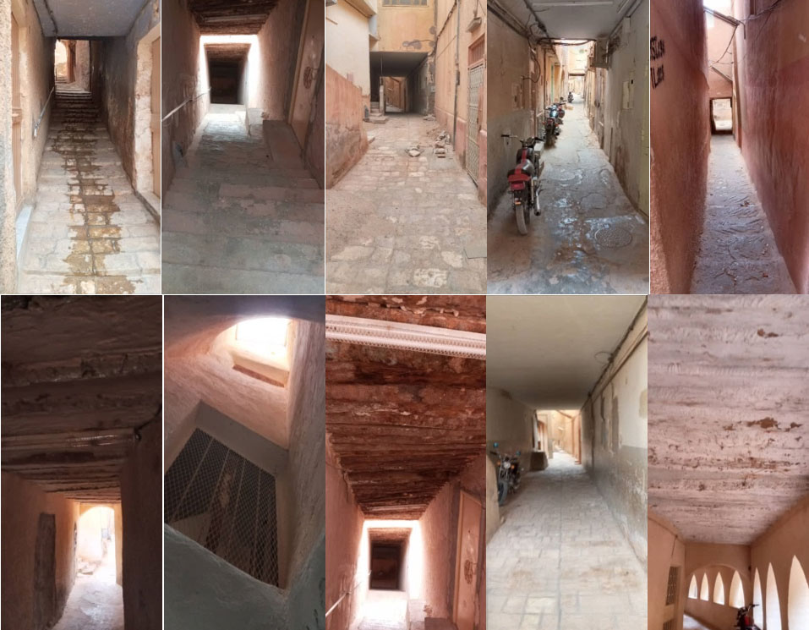

Figure 17. Prevalence of shaded lanes in the vernacular Islamic architecture of M’zab

On the other hand, the new Ksar used a geometric approach with rectilinear lanes as the design unit. The street is the unit of orientation in the new Ksar since the involvement of cars and motorcycles has influenced the general design in its temporary and unitary aspects. The longer the street, the less importance its direction has in the final computation, significantly impacting the total appraisal of sunlight, which differs in vernacular Islamic architecture. The sinuous curve of the vernacular Islamic Ksour road system indicates the designers' strong desire to prevent solar shocks and the emphasis on the population's health by avoiding sunstroke-induced diseases. Temporality in vernacular Islamic architecture is subjugated to the journey on foot in the external areas. However, cars and motorcycles have shortened travel times with the new design. This fact explains our findings regarding the importance of sunlight duration and its effects on vernacular Islamic and modern urban fabrics. The solutions for a complete orientation may be provided numerically in both cases: radio concentric and chessboard

- CONCLUSION
In conclusion, two mathematical formulae can be obtained to better orientate the axes of future urban production by considering the insolation factor in desert environments, such as the great Algerian South or even the cities of the great North African Sahara. This contribution makes it possible to take advantage of ancient know-how to produce vernacular Islamic cities. Two situations are distinguished according to the urban form of the fabric, namely, a radio concentric configuration and a checkerboard configuration.

  - FOR A RADIOCONCENTRIC SYSTEM
The computation is based on the solar circle from Ernest Neufert's book [31], regarded as worldwide standardized. The pathways are calculated using A° (max and min angle) and the zone Z belonging to Ernest Neufert's normalized circles.
The potential ownership area of the lanes is:
((Amax+Amin)/2)/360°=A%..................................................................................1
As a result of (Z), the following cases were obtained: Favourable (F), Unfavourable (Uf), Less Favourable (Lf), Less Unfavourable (Luf), and Very Unfavourable (Vuf).
The following computation is based on the number of lanes (L):
NL= (NZone(L)*100/NTotal(L))* ((Amax+Amin)/2)/360°………………………....2
We get the following linear equation if we apply this formula for June.
NL=(NZoneL*100/NTotalL)*((0°+27,7°)/2)/360°+(NZoneL*100/NTotalL)*((27,7°+50,8°)/2)/360°+(NZoneL*100/NTotalL)*((50,8°+60,0°)/2)/360°+(NZoneL*100/NTotalL)*((60,0°+81,8°)/2)/360°+(NZoneL*100/NTotalL)*((81,8°+94,3°)/2)/360°+(NZoneL*100/NTotalL)*((94,3°+105,2°)/2)/360°+(NZoneL*100/NTotalL)*((116,1°+127,3°)/2)/360°+(NZoneL*100/NTotalL)*((180°+127,3°)/2)/360°………….….3

This linear equation also applies to the other months of the year for computing insolation according to the standardized zones in December and September.
  - FOR CHEQUERED SYSTEM
For a chequered system, we have the following data:
Horizontal lanes : (H) : Lhorizolal=Σ ((Amax+Amin)/2)/360°=A% ………….…..4
Vertical lines (V) : Lvertical= Σ ((180°)-(Amax+Amin))/2)/360°=A% ……....….5
This computation is subject to the number of lanes:
N(L)Horizontal = ((NZoneL*100/NTotalL)* (Amax+Amin)/2)/360°……………....…..6
N(L)vertical = (NZoneL*100/NTotalL)* ((180)-(Amax+Amin))/2)/360°……………..7
The same formula (3) applies to regular chequered lanes:
D(L) horizontal=(DZoneL*100/DTotalL)* ((Amax+Amin)/2)/360°……………….…..8
D(L) vertical=(DZoneL*100/DTotalL)* ((180°)-(Amax+Amin))/2)/360°…………….9
Equation (4) also applies to the other months of the year for determining insolation for December, March, and June.

Through the adaptability of its design to intense sun radiation, this study aims to analyze and explain another facet of the sustainability of the ancient and intergenerational vernacular Islamic desert Ksour. Solar radiation is one of the most crucial indicators of human progress for the habitability of these dry zones. Thermal insulation and roofing must fulfill strict specifications. Without the view of architects, light and sunlight are regarded as key aspects of architecture in general and in vernacular Islamic buildings in particular. After considering this notion in the millennium architecture of Ksour, which is regarded as a heritage for mankind and sustainable at the same time, it is discovered that the sun is given significant priority and importance in every urban expression of the city. Where each piece of land is different and unique, vernacular Islamic architecture prioritizes the avoidance of solar shocks to maintain the public health of the residents. The vernacular Islamic morphological feature may be noticed through the several segments of the lanes. Each section of the Ksar narrates the tale of its creation from generation to generation. This vision has the same principles as a 10-century-old ancestral notion.
The modern architecture of Ksour prioritizes shaded areas as a design principle, taking into account the short duration of design, realization, availability of techniques, and duration of passage of the inhabitants by allowing the avoidance of solar shocks and better-developed sanitary conditions. Man has succeeded in creating urban fabrics by prioritizing the well-being of the residents, preventing dust via windows and urban doors, and avoiding solar shocks by seeking control of regions of direct encounter with hurting sun rays, particularly during the summer. The preservation and sustainability of heritage are sacrificed to the human desire to develop toward behavioral urbanization. Further, the use of indigenous materials in desert locations is complemented by incorporating local environmental conditions, where shade is essential, particularly in outdoor settings. In a dry region, social activities such as walking in meandering and shady routes for most of the day are a better answer for avoiding the sun's rays and the emergence of illnesses, as scientific study has shown. As André Ravéreau prophesied, the evolution of the vernacular Islamic city through time has taken a lengthy period, with each component teaching lessons for subsequent structures and generations.

REFERENCES
- J. Pal, A. Dey, S. Ghosh, D. K. Bhattacharya, and T. Mukherjee, "Analysis of Similarity Between Protein Sequences Through the Study of Symbolic Dynamics", Computational Advancement in Communication Circuits and Systems. Lecture Notes in Electrical Engineering, New Delhi: Springer, 2015. doi: https://doi.org/10.1007/978-81-322-2274-3_24

- T. R. Bynum, Insulation Handbook, McGraw Hill Professional, 2000.

- S. Mirrahimi, M. F. Mohamed, L. C. Haw, N. L. N. Ibrahim, W. F. M. Yusoff, A. Aflaki, "The effect of building envelope on the thermal comfort and energy saving for high-rise buildings in hot–humid climate," Renewable and Sustainable Energy Reviews, vol. 53, pp. 1508-1519, 2016. doi: https://doi.org/10.1016/j.rser.2015.09.055

- D. A. Barber, Modern Architecture and Climate: Design Before Air Conditioning, New Jersey: Princeton University Press, 2023.

- S. Chang, W. He, H. Yan, L. Yang, C. Song, "Influences of vernacular building spaces on human thermal comfort in China's arid climate areas," Energy and Buildings, vol. 244, 2021. doi: https://doi.org/10.1016/j.enbuild.2021.110978

- G. Frantam, "Solar Architecture," in ASC/AIA Forum 75, Arizona, 1975.

- T. Henri, Dictionnaire peul du corps et de la santé, Diamaré: KARTHALA , 2007.

- P. Deunov , B. Douno and D. De Angelis, The Health Book, streetLib eBooks, 2002.

- G. Filhole and J. P. Besancenot, Risques pathologiques, rythmes et paroxysmes climatiques, John Libbey Eurotext, 1992.

- V. G. Bardov, Hygiene and ecology, NOVA KHYHA publishers, 2009.

- A. Cao, Q. Li and Q. Meng, "Effects of Orientation of Urban Roads on the Local Thermal Environment in Guangzhou City," Procedia Engineering, no. 121, pp. 2075-2082, 2015. doi: https://doi.org/10.1016/j.proeng.2015.09.209

- S. Al Khaled, P. Coseo, A. J. Brazel, C. Cheng and D. J. Sailor, "Between aspiration and actuality: A systematic review of morphological heat mitigation strategies in hot urban deserts," Urban Climate, vol. 31, no. 100570, 2020. doi: https://doi.org/10.1016/j.uclim.2019.100570

- G. Predari, D. Prati and A. Massafra, "Modern Construction in Bologna. The Faculty of Engineering by Giuseppe Vaccaro," in Digital Modernism Heritage Lexicon, Springer, 2022, pp. 233-258.

- A. Harzallah, D. Siret, E. Monin and J. Bouyer, "Controverses autour de l’axe héliothermique : L’apport de la simulation physique à l’analyse des théories urbaines," in Repenser les limites : l’architecture à travers l’espace, le temps et les disciplines, Paris, 2005.

- F. Giovanna and A. Magrini, Historical Buildings and Energy, Springer Cham, 2017.

- A. Acocella and D. Turrini, Sienese travertine, Alinea, 2010.

- J. Jacobs, The Death and Life of Great American Cities: The Failure of Town Planning, Penguin, 1964.

- Y. Jiang, D. Song, T. Shi and X. Han, "Adaptive Analysis of Green Space Network Planning for the Cooling Effect of Residential Blocks in Summer: A Case Study in Shanghai," Sustainability, vol. 10, p. 3189, 2018.

- A. V. Nguyen and S. Reiter, " Bioclimatism in architecture: An evolutionary perspective," International Journal of Design & Nature and Ecodynamics, vol. 12, no. 1, pp. 16-29, 2017. doi: 10.2495/DNE-V12-N1-16-29

- A. Kaihoul, L. Sriti, K. Amraoiu, S. D. Turi, F. Ruggiero, "The effect of climate-responsive design on thermal and energy performance: A simulation based study in the hot-dry Algerian South region," Journal of Building Engineering, vol. 43, 2021. doi: https://doi.org/10.1016/j.jobe.2021.103023

- A. Bassoud, H. Khelafi, A. M. Mokhtari and A. Bada, "Evaluation of summer thermal comfort in arid desert areas. Case study: Old adobe building in Adrar (South of Algeria)," Building and Environment, vol. 205, no. 108140, 2021. doi: https://doi.org/10.1016/j.buildenv.2021.108140

- P. De Joanna and D. Francese, Sustainable Mediterranean Construction. Sustainable Environment in the Mediterranean Region: from Housing to Urban and Land Scale Construction, Franco Angeli, 2012.

- M. Salameh, B. Touqan, "Traditional passive design solutions as a key factor for sustainable modern urban designs in the hot, arid climate of the United Arab Emirates," Buildings, vol. 12, no. 11, p. 1811, 2022.

- A. M. R. a. L. S. Boumerzoug, "Thermal analysis of the vernacular architecture in the Ziban, Algeria," Pollack Periodica, vol. 17, no. 3, p. 123–128, 2022. doi: https://doi.org/10.3390/buildings12111811

- A. E. J. Morris, History of Urban Form Before the Industrial Revolution, Routledge, 2013.

- Climate Data, "Climate Data," 2023. [Online]. Available: https://pt.climate-data.org/. [Accessed December 12th 2023].

- F. Haghighat and J. J. Jong-Jin Kim, Sustainable Built Environment, EOLSS Publications, 2009.

- A. Aboelata, "Vegetation in Different Street Orientations of Aspect Ratio (H/W 1:1) to Mitigate UHI and Reduce Buildings’ Energy in Arid Climate," Build. Environ., vol. 172, p. 106712, 2020. doi: https://doi.org/10.1016/j.buildenv.2020.106712

- H. Stanley and H. S. Scofield, Comprehensive Planning for Passive Solar Architectural Retrofit, United States Air Force Engineering and Services, 1980.

- A. Naidja, S. Chettah and D. Farid, "Human Ingenuity through Vernacular islamic Architecture in Arid Environments, the Case of the Ancient Core of Biskra," International Journal of Innovative Studies in Sociology and Humanities, vol. 7, no. 4, pp. 1-14, 2022.

- E. Neufert, Architect's data, Wiley BlackWell, 2002.

